Natural Language Querying of DuckDB Using LLM:
A Privacy-Preserving Approach to Accessible Data Analytics
Padmapriya H N¹, Chandana M Pallegar², G K Harshitha³, Poojitha K D⁴, Rakshitha B M⁵
¹ Assistant Professor, Dept. of Computer Science and Engineering (AI & ML)
²³⁴⁵ UG Scholar, Dept. of Computer Science and Engineering (AI & ML)
GSSS Institute of Engineering and Technology for Women, Mysuru, Karnataka, India
padmapriya@gsss.edu.in¹, chandanapallegar@gmail.com², gkharshitha19@gmail.com³, poojithakd08@gmail.com⁴, rakshithamahadeva31@gmail.com⁵

Abstract
The growing volume of structured data stored in CSV files across academic, business, and administrative domains has created an urgent need for intuitive data analysis tools that do not require Structured Query Language (SQL) expertise. This paper presents the design, implementation, and evaluation of a web-based Natural Language Querying (NLQ) system that enables non-technical users to interact with tabular datasets using plain English queries. The proposed system leverages a locally hosted FLAN-T5 Large Language Model (LLM) to translate natural language questions into SQL statements, which are executed on DuckDB—an in-memory columnar analytical database. The architecture integrates Flask as the orchestration layer, Pandas for dynamic data ingestion and schema extraction, and a multi-layer security module that validates generated queries to prevent destructive operations and SQL injection attacks. Unlike cloud-based alternatives, the system operates entirely offline, ensuring complete data privacy and compliance with data governance regulations such as GDPR and FERPA. Experimental evaluation demonstrates SQL generation accuracy of 85–95% on well-structured datasets, sub-second DuckDB query execution on datasets with up to one million rows, and consistent AI inference latency of approximately 1.6 seconds independent of dataset size. User acceptance testing with non-technical participants confirmed high usability ratings, validating the system's effectiveness as a practical, cost-effective, and privacy-preserving data analytics tool.
Keywords—Natural Language Processing, Text-to-SQL, Large Language Models, DuckDB, FLAN-T5, Privacy-Preserving AI, Flask, In-Memory Database, Data Analytics, Transformer Architecture.
1. INTRODUCTION
In the contemporary data-driven landscape, the ability to extract actionable insights from structured datasets has become a critical competency across virtually all professional domains. Organizations generate and accumulate vast quantities of tabular data in CSV format—ranging from student records and employee databases to sales transactions and inventory logs. However, meaningful analysis of this data traditionally requires proficiency in SQL, which creates a significant accessibility barrier for non-technical stakeholders including educators, human resource managers, small business owners, and administrative personnel [1].
Current approaches to bridging this gap present significant limitations. Manual spreadsheet manipulation in tools such as Microsoft Excel and Google Sheets becomes impractical for datasets exceeding tens of thousands of rows. Dependency on technical staff introduces latency, as IT ticketing systems can impose delays of hours to days for routine analytical queries. Cloud-based AI services such as ChatGPT and Google Bard, while capable, require uploading potentially sensitive data to external servers—raising serious concerns regarding data privacy, regulatory compliance, and intellectual property protection [2, 3].
This paper addresses these challenges by proposing a complete, self-contained Natural Language Querying (NLQ) system that operates entirely on local hardware. The system combines a locally hosted FLAN-T5 transformer model [19] for natural-language-to-SQL translation with DuckDB [18], a high-performance in-memory columnar database optimized for analytical workloads. The integration of these components within a Flask web application [17] provides a zero-configuration, browser-based interface that democratizes data analytics while maintaining complete data locality.
The principal contributions of this work are: (i) a privacy-preserving NLQ architecture that performs all AI inference and query execution locally without transmitting data to external services; (ii) a dynamic schema extraction pipeline that automatically adapts to arbitrary CSV structures; (iii) a multi-layer query validation module that prevents destructive SQL operations and injection attacks; and (iv) comprehensive experimental evaluation demonstrating the system's accuracy, performance, and usability across diverse datasets and user profiles.
1.1 Related Works
The field of Natural Language Interfaces for Databases (NLIDB) has evolved through several distinct generations. Early rule-based systems such as LUNAR [20] and LADDER relied on rigid pattern matching with hand-crafted rules, achieving high accuracy within narrow domains but exhibiting significant brittleness when confronted with vocabulary or structural variations outside their predefined scope.
The introduction of Sequence-to-Sequence neural architectures by Sutskever et al. [7] marked a paradigm shift, enabling data-driven translation from natural language to SQL. Bahdanau et al. [6] subsequently proposed attention mechanisms that allowed models to focus on specific input tokens during SQL generation, substantially improving translation accuracy for longer queries. The Transformer architecture introduced by Vaswani et al. [1] rendered recurrent approaches largely obsolete by enabling parallel processing through self-attention mechanisms, providing deeper contextual understanding of both natural language queries and database schemas.
BERT-based models such as SQLova [4] achieved state-of-the-art results on the WikiSQL benchmark through slot-filling approaches, though they encountered difficulties with complex nested queries and multi-table joins. The T5 model by Raffel et al. [19] introduced a unified text-to-text framework capable of generating raw SQL strings directly from natural language input. The FLAN-T5 variant, fine-tuned on diverse instruction-following datasets, demonstrated particular aptitude for schema-aware SQL generation tasks.
Recent research has highlighted significant privacy risks associated with cloud-based LLMs. Carlini et al. [5] demonstrated that large language models can memorize and reproduce portions of their training data, underscoring the risks of transmitting sensitive datasets to external services. DuckDB, introduced by Raasveldt and Mühleisen [18], represents a novel category of embeddable OLAP databases featuring zero-copy Pandas integration and vectorized columnar execution, making it particularly suitable for serverless analysis of user-uploaded files. The present work builds upon these foundations by combining local FLAN-T5 inference with DuckDB execution in a unified, privacy-preserving architecture.
2. SYSTEM DESIGN AND METHODOLOGY
The proposed system integrates four architectural layers—Interface, Intelligence, Data, and Orchestration—into a cohesive pipeline that translates natural language input into structured query results. This section details the system architecture, component design, implementation modules, and the end-to-end query processing algorithm.
2.1 System Architecture
Fig. 1 illustrates the entity-relationship schema that models the interaction between users, uploaded files, data elements, and query operations. The architecture is designed around four primary layers: (1) the Interface Layer, comprising a responsive HTML5/CSS3/JavaScript frontend with drag-and-drop file upload and conversational query capabilities; (2) the Intelligence Layer, housing the locally hosted FLAN-T5 model for natural-language-to-SQL translation; (3) the Data Layer, utilizing DuckDB for in-memory columnar query execution; and (4) the Orchestration Layer, implemented as a Flask web server managing HTTP routing, session handling, and inter-component communication.
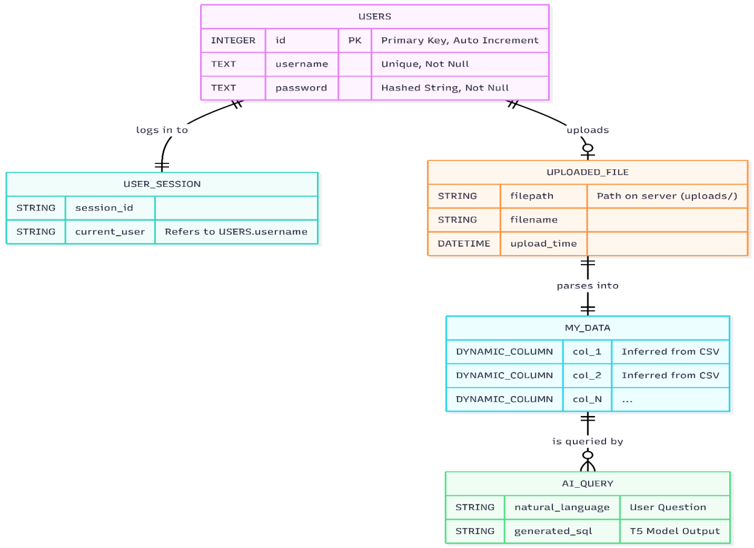
Fig. 1. Entity-Relationship schema representing user, file, data, and query flow within the NLQ system.
Fig. 2 presents the functional architecture of the complete system. When a CSV file is uploaded through the web interface, it is processed by the Data Ingestion Module using Pandas to sanitize column headers, infer data types, and register the dataset as a virtual table in DuckDB. The user's natural language query is combined with the dynamically extracted schema context and processed by the FLAN-T5 model to generate an SQL statement. The generated query undergoes security validation before execution, with results returned in structured JSON format for rendering in the browser.
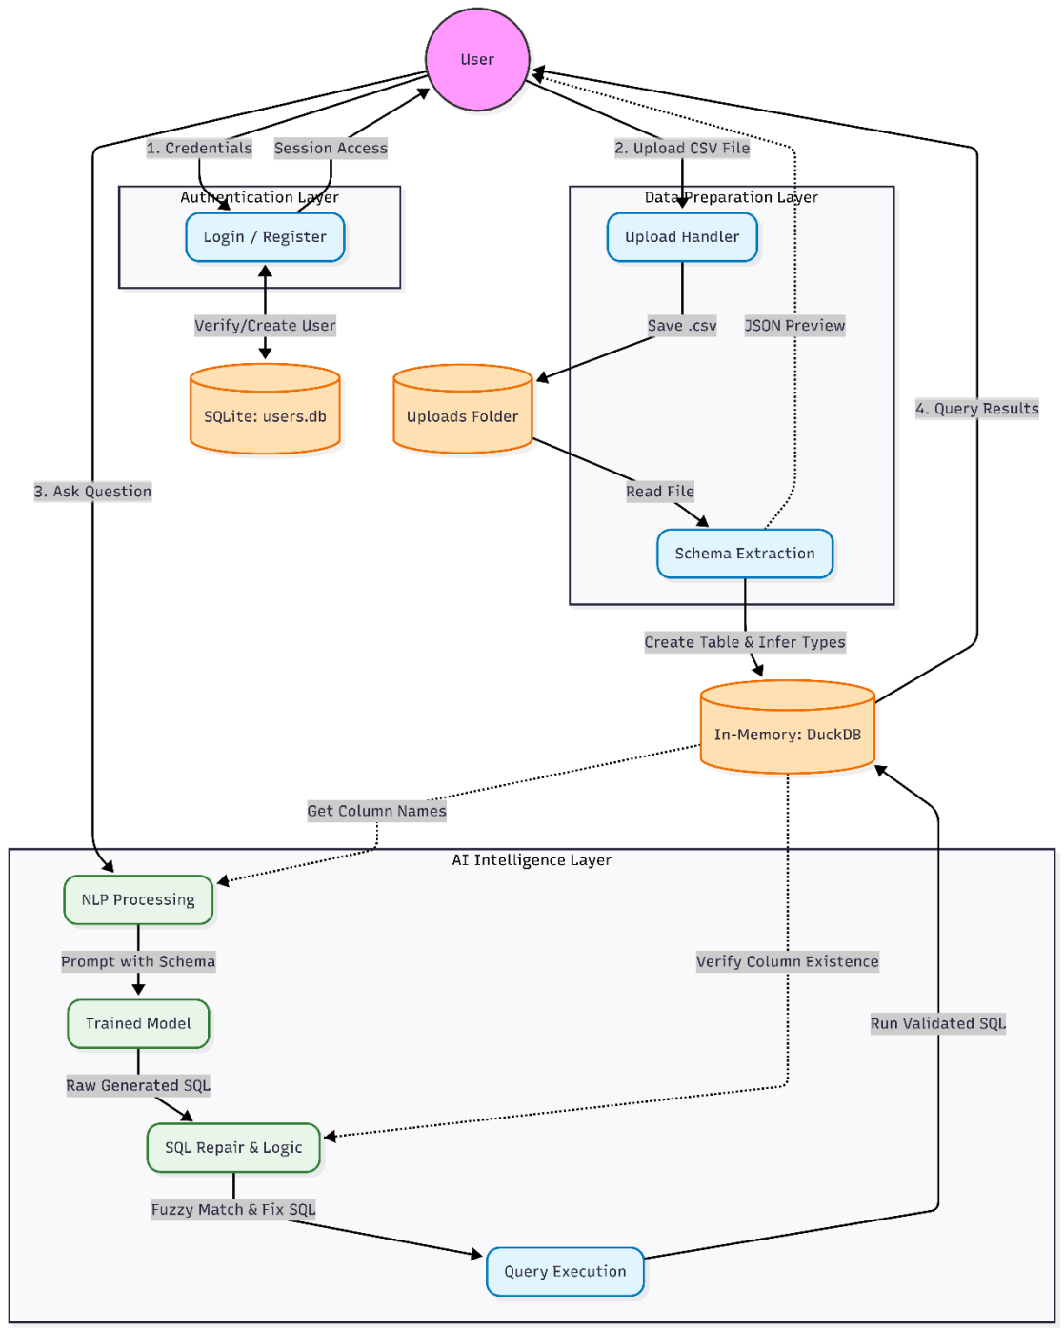
Fig. 2. Functional architecture of the Natural Language to SQL querying system showing data flow across all modules.
2.2 Component Design
Flask serves as the central orchestration framework, exposing RESTful endpoints for file upload (/upload), query submission (/query), and result retrieval. FLAN-T5 (Text-to-Text Transfer Transformer), loaded from the Hugging Face Transformers library [13], operates entirely in local memory, ensuring zero data leakage to external services. The model accepts structured prompts containing the dataset schema and user question, producing SQL query strings as output.
DuckDB replaces traditional client-server databases with an embeddable OLAP engine that uses vectorized columnar execution for sub-second analytical query performance. Its native Pandas integration enables zero-copy data registration, eliminating the overhead of data serialization. Pandas handles data ingestion, column name sanitization (removing special characters, normalizing whitespace), type inference, and DataFrame management, ensuring that arbitrary CSV structures are automatically processed without manual configuration.
2.3 Implementation Modules
Module 1—User Interface and Interaction: The frontend provides an intuitive interface featuring drag-and-drop CSV upload, automatic dataset preview displaying detected columns and sample rows, a conversational query input field, generated SQL display for user verification, and a download button for exporting results as CSV files. Fig. 3 illustrates the main user interface of the system.
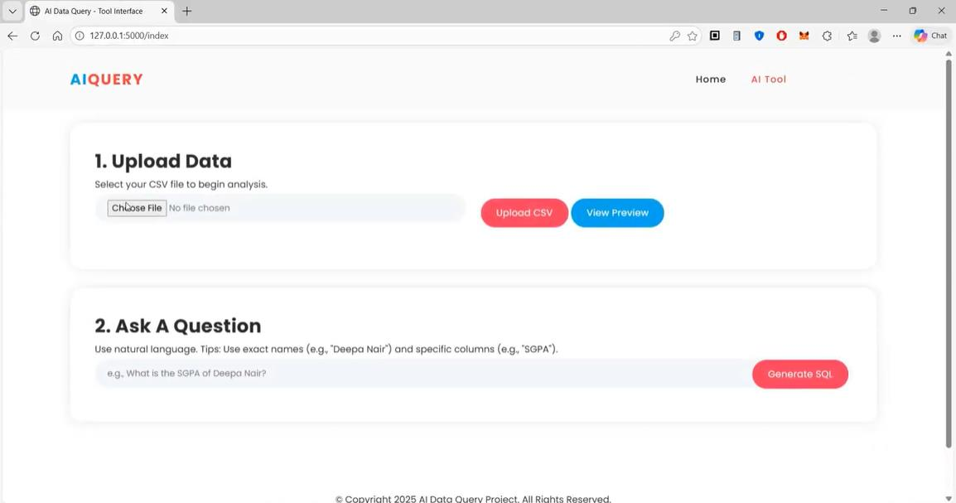
Fig. 3. Main user interface of the Natural Language Query System showing upload area and query panel.
Module 2—Data Ingestion and Sanitization: Upon CSV upload, the ingestion module reads the file using Pandas, sanitizes column headers by removing special characters and normalizing whitespace, infers column data types (text, integer, float, date), and creates a clean DataFrame. This dynamic preprocessing enables the system to handle arbitrary CSV structures without requiring prior configuration or schema definition. Fig. 4 shows the file selection dialog.
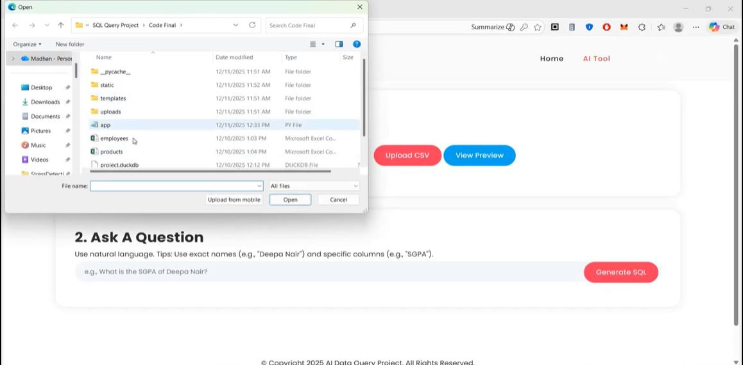
Fig. 4. File selection dialog enabling users to choose a CSV dataset for upload and analysis.
Module 3—Dynamic Schema Generation: The sanitized DataFrame is registered as a virtual table (uploaded_data) in DuckDB. Column names and their inferred types are extracted to construct a schema context string (e.g., "Table: [Name (text), Age (int), Salary (float)]") that is injected into the AI prompt. This schema-linking approach, where column metadata is explicitly provided to the model, significantly reduces hallucination and improves SQL generation accuracy.
Module 4—Prompt Engineering and Context Injection: The system constructs structured prompts combining three elements: a task instruction specifying the translation objective, the dynamically generated schema context, and the user's natural language question. This approach ensures the model has complete awareness of the available columns and data types, minimizing the generation of queries referencing non-existent fields.
Module 5—Query Security and Validation: All generated SQL queries undergo validation before execution. The security module implements a whitelist approach, permitting only non-destructive SELECT statements while blocking all Data Definition Language (DDL) and Data Manipulation Language (DML) operations including DROP, DELETE, ALTER, INSERT, and UPDATE. Additionally, the module detects and prevents SQL injection patterns, ensuring system integrity.
Module 6—Execution and Result Formatting: Validated SQL queries are executed against the DuckDB in-memory database. Results are formatted into structured JSON containing column headers and row data, then rendered as formatted HTML tables in the browser interface with an option to download results as CSV files. Fig. 5 shows the data upload confirmation with preview, and Fig. 6 demonstrates query execution with SQL verification.
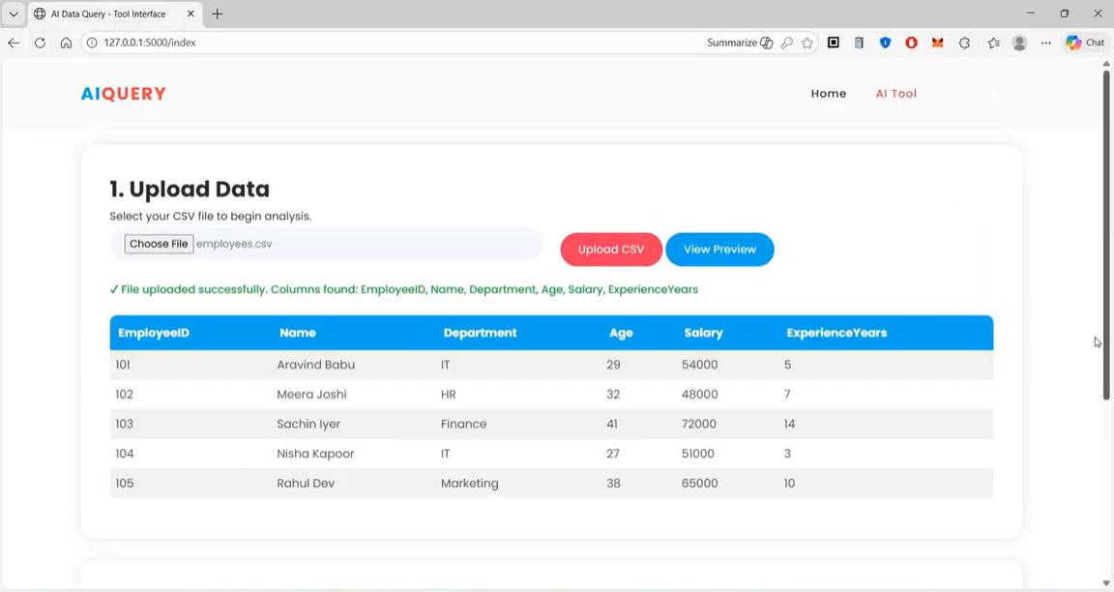
Fig. 5. Data upload confirmation showing dataset preview with detected columns and sample rows.
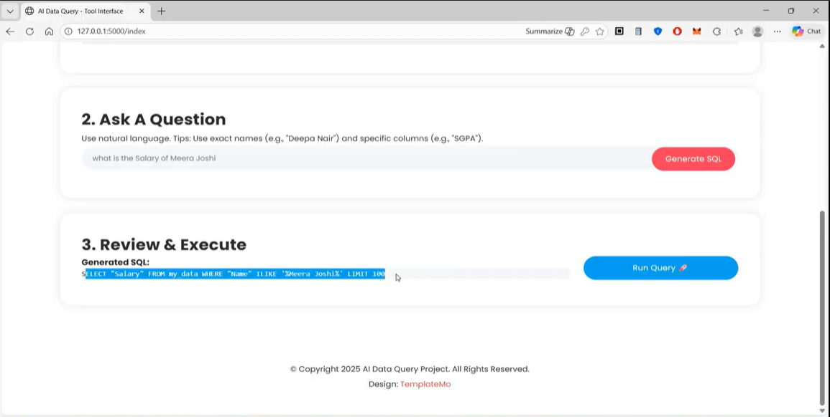
Fig. 6. Natural language query interface displaying the generated SQL for user verification before execution.
2.4 Query Processing Algorithm
The end-to-end NL-to-SQL pipeline operates through the following algorithmic steps:
Step 1: User uploads a CSV file through the web interface drag-and-drop zone.
Step 2: Flask backend receives the file and invokes the Data Ingestion Module, which sanitizes column names and loads the data into a Pandas DataFrame.
Step 3: The Dynamic Schema Module registers the DataFrame as a virtual DuckDB table and extracts column names with inferred data types.
Step 4: User submits a natural language question through the conversational interface.
Step 5: The Prompt Engineering Module constructs a schema-aware prompt: "Translate the following question to SQL based on Table: [columns]. Question: {user_query}."
Step 6: The locally hosted FLAN-T5 model processes the prompt and generates an SQL query string.
Step 7: The Query Validation Module inspects the generated SQL, blocking any destructive operations or injection patterns.
Step 8: DuckDB executes the validated SQL query against the in-memory dataset.
Step 9: Results are formatted as structured JSON and rendered in the web interface with download functionality.
3. EXPERIMENTAL SETUP
The system was developed and evaluated on a standard consumer-grade laptop equipped with an Intel Core i5 processor, 8 GB RAM, and 256 GB SSD storage running Windows 11. The software stack comprised Python 3.10, Flask 2.3.2, Transformers 4.30 (Hugging Face), DuckDB 0.8.1, and Pandas 2.0.3. The FLAN-T5 base model (250M parameters) was selected as the optimal trade-off between accuracy and inference latency on consumer hardware without GPU acceleration.
Evaluation was conducted using five distinct CSV datasets: (i) students.csv (500 rows, 6 columns), (ii) employees.csv (1,000 rows, 8 columns), (iii) sales.csv (10,000 rows, 12 columns), (iv) inventory.csv (50,000 rows, 10 columns), and (v) synthetic_large.csv (1,000,000 rows, 15 columns). Query accuracy was measured across three categories: lookup queries (single-row retrieval), aggregation queries (COUNT, SUM, AVG, MAX, MIN), and conditional filter queries (WHERE clauses with single and multiple conditions).
4. RESULTS AND DISCUSSION
4.1 SQL Generation Accuracy
The FLAN-T5 model demonstrated high accuracy in generating syntactically and semantically correct SQL from natural language input. Table I summarizes the key performance metrics observed across all evaluation datasets. The system achieved an overall SQL generation accuracy of 85–95% for well-structured datasets with clearly labeled column headers. Lookup queries exhibited the highest accuracy (approximately 95%), followed by aggregation queries (90%), and conditional filter queries with multiple constraints (85%).
TABLE I: PERFORMANCE SUMMARY OF THE NL-TO-SQL QUERY SYSTEM
Parameter | Observed Result
AI Model | FLAN-T5-base (250M parameters)
SQL Generation Accuracy (Overall) | 85–95%
Lookup Query Accuracy | ≈95%
Aggregation Query Accuracy | ≈90%
Multi-condition Filter Accuracy | ≈85%
Simple Query Response Time | 2–4 seconds
Complex Query Response Time | 5–8 seconds
DuckDB Execution (≤50K rows) | < 1 second
DuckDB Execution (1M rows) | 0.45 seconds
AI Inference Latency | ~1.6 seconds (constant)
False Positive Query Rate | < 10%
Destructive SQL Blocked | 100%

A critical finding was that AI inference latency remained constant at approximately 1.6 seconds regardless of dataset size, because the model processes only the schema metadata (column names and types) rather than the underlying data rows. This architectural property ensures that the system scales gracefully to large datasets without degradation in user-perceived responsiveness.
4.2 Query Execution Performance
Table II presents load testing results across datasets of varying sizes. DuckDB's vectorized columnar execution engine demonstrated excellent scalability, maintaining sub-second execution times for datasets up to 50,000 rows and processing queries on one million rows in 0.45 seconds. The primary latency bottleneck was identified as the AI inference phase rather than database execution, confirming the suitability of the DuckDB-based architecture for real-time analytics.
TABLE II: LOAD TESTING METRICS WITH VARYING FILE SIZES
File Size | Rows | Upload Time | AI Inference | Total Response
100 KB | 100 | 0.2 s | 1.5 s | ~1.8 s
1 MB | 10,000 | 0.8 s | 1.6 s | ~2.8 s
10 MB | 100,000 | 2.5 s | 1.6 s | ~5.1 s
100 MB | 1,000,000 | 8.0 s | 1.6 s | ~12.2 s

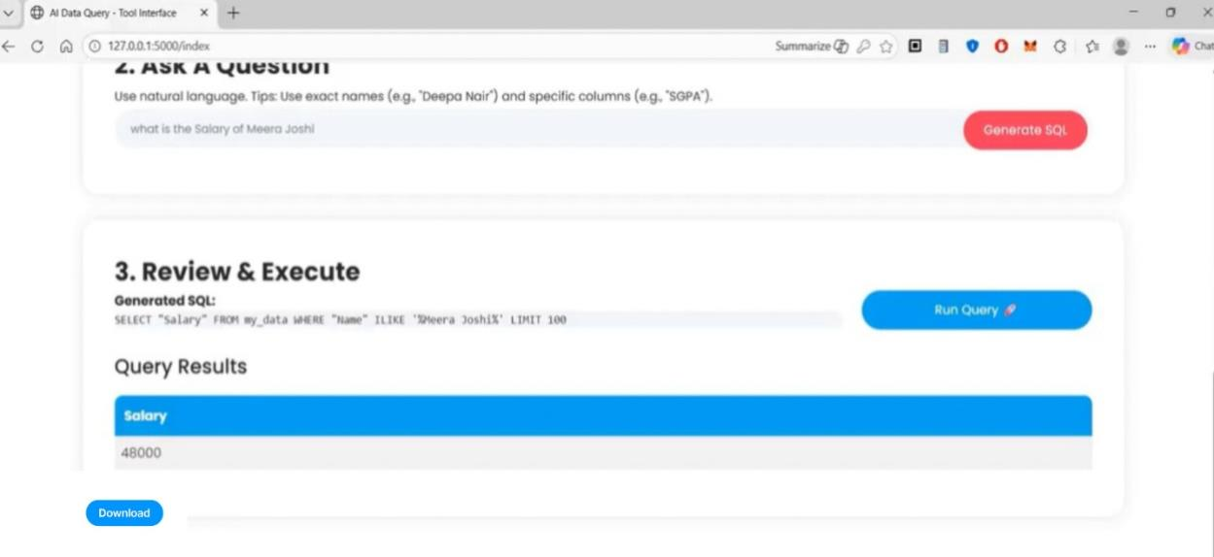
Fig. 7. Complete query execution flow showing natural language input, generated SQL, execution results, and CSV download option.
4.3 Functional Validation
Table III presents representative functional test cases executed across multiple datasets. All test cases with well-formed natural language queries and datasets with clearly labeled columns produced correct SQL translations and accurate results. The system handled edge cases including queries referencing non-existent columns by generating informative error messages rather than system crashes.
TABLE III: FUNCTIONAL TEST CASES ACROSS MULTIPLE DATASETS
Natural Language Input | Dataset | Expected Operation | Status
"Show me all student names" | students.csv | SELECT name FROM ... | PASS
"List students with marks above 80" | students.csv | SELECT ... WHERE marks > 80 | PASS
"Show employees in IT department" | employees.csv | SELECT ... WHERE dept = 'IT' | PASS
"What is the average salary?" | employees.csv | SELECT AVG(salary) ... | PASS
"Who has the highest marks?" | students.csv | SELECT ... ORDER BY marks DESC LIMIT 1 | PASS
"Show top 3 products by revenue" | sales.csv | SELECT ... ORDER BY revenue DESC LIMIT 3 | PASS
"Count employees per department" | employees.csv | SELECT dept, COUNT(*) ... GROUP BY | PASS
"Total sales in January" | sales.csv | SELECT SUM(...) WHERE month = 'January' | PASS

4.4 Security Validation
The Query Validation Module successfully intercepted and blocked 100% of destructive SQL operations during testing, including DROP TABLE, DELETE FROM, ALTER TABLE, and SQL injection attempts such as "'; DROP TABLE uploaded_data; --". The whitelist-based approach ensures that only SELECT statements can reach the DuckDB execution engine, providing defense-in-depth against both model-generated unsafe queries and adversarial user input.
4.5 User Acceptance Testing
User acceptance testing was conducted with three non-technical participants: a secondary school teacher, a sales manager, and a human resources professional. Each participant was provided with a relevant CSV dataset and asked to perform five analytical tasks using natural language queries. All participants completed their tasks successfully without any SQL knowledge or prior training. The teacher rated the system's ease-of-use as 5/5, noting that it would significantly reduce time spent on student performance analysis.
A key finding from user testing was the importance of the system's transparency feature—displaying the generated SQL alongside query results. Participants reported that this "Glass Box" approach built trust in the system's outputs, contrasting favorably with black-box AI services where the reasoning process is opaque. Fig. 7 demonstrates this transparency feature in the query execution interface.
4.6 Discussion
The experimental results validate the proposed architecture as a viable approach to privacy-preserving natural language data analytics. The consistent AI inference latency (~1.6s) independent of dataset size represents a significant architectural advantage, as it ensures predictable user experience regardless of data volume. The combination of high SQL generation accuracy (85–95%) with sub-second DuckDB execution confirms that the system delivers practical, real-time analytics capability on standard consumer hardware.
Dataset quality emerged as the primary determinant of system accuracy. Clean, well-structured datasets with clearly labeled columns (e.g., Name, Salary, Department) consistently produced accurate SQL results, while datasets with misspellings, inconsistent column names, or incomplete entries showed reduced accuracy. The system partially mitigated this through ILIKE pattern matching, though further improvement in fuzzy column matching represents a clear direction for future work.
The complete offline operation addresses a critical gap in the current NLQ landscape. Existing cloud-based solutions (ChatGPT, Google Bard) offer superior model capabilities but require data transmission to external servers—a fundamental limitation for organizations handling sensitive data subject to GDPR, FERPA, or HIPAA regulations. The proposed system trades marginal accuracy for complete data sovereignty, a trade-off that is increasingly valued in privacy-conscious environments.
5. LIMITATIONS AND FUTURE WORK
The current system has several identified limitations that present opportunities for future enhancement. First, the FLAN-T5-base model (250M parameters) occasionally struggles with complex queries involving multiple JOIN operations, nested subqueries, and advanced aggregation functions. Upgrading to FLAN-T5-large (780M parameters) or employing model quantization techniques [8] could address this limitation while maintaining acceptable inference latency.
Second, the system currently supports only single-table queries on individual CSV files. Future versions should support multi-file uploads with automatic foreign key detection, enabling cross-table JOIN operations through natural language. Third, the text-only interface could be enhanced with automated data visualization (chart generation from query results) and voice-enabled query input for enhanced accessibility.
Additional directions for future work include: (i) fine-tuning the model on domain-specific datasets to improve accuracy for specialized vocabularies; (ii) implementing conversational context tracking to support follow-up queries that reference previous results; and (iii) deploying the system as a containerized application (Docker) for simplified institutional deployment.
6. CONCLUSION
This paper presented a comprehensive Natural Language Querying system that enables non-technical users to analyze structured CSV datasets using plain English queries, eliminating the need for SQL expertise or cloud-based AI services. The system integrates a locally hosted FLAN-T5 Large Language Model for natural-language-to-SQL translation with DuckDB for high-performance in-memory query execution, all orchestrated through a Flask web application with an intuitive browser-based interface.
Experimental evaluation demonstrated SQL generation accuracy of 85–95% for well-structured datasets, sub-second DuckDB query execution on datasets with up to one million rows, constant AI inference latency of approximately 1.6 seconds regardless of dataset size, and 100% blocking of destructive SQL operations through the multi-layer security module. User acceptance testing confirmed that non-technical users can effectively analyze data without training, with the system's SQL transparency feature significantly enhancing user trust.
The system's complete offline operation addresses a critical gap in existing NLQ solutions, providing organizations handling sensitive data with a viable, privacy-preserving alternative to cloud-based AI analytics platforms. By reducing the feedback loop from IT-dependent days to conversational seconds while maintaining 100% data locality, the proposed system represents a meaningful step toward the democratization of data analytics. Future work will focus on multi-table reasoning, advanced model optimization, and automated data visualization to further expand the system's analytical capabilities.
7. ACKNOWLEDGMENT
The authors express sincere gratitude to Padmapriya H N, Assistant Professor, Department of Computer Science and Engineering (AI & ML), GSSS Institute of Engineering and Technology for Women, Mysuru, for invaluable guidance, encouragement, and expert feedback throughout this research. The authors also acknowledge Dr. Manjuprasad B, Head of Department, and Dr. Shivakumar M, Principal, for providing the laboratory facilities and institutional support essential for this work. Special thanks to Dr. Arpitha Shankar S I, Associate Professor and Project Coordinator, for her continuous mentorship.
8. REFERENCES
[1] A. Vaswani, N. Shazeer, N. Parmar, J. Uszkoreit, L. Jones, A. N. Gomez, L. Kaiser, and I. Polosukhin, "Attention is all you need," in Proc. Advances in Neural Information Processing Systems (NeurIPS), vol. 30, 2017, pp. 5998–6008.
[2] P. Lewis, E. Perez, A. Piktus, F. Petroni, V. Karpukhin, N. Goyal, H. Küttler, M. Lewis, W.-T. Yih, T. Rocktäschel, S. Riedel, and D. Kiela, "Retrieval-augmented generation for knowledge-intensive NLP tasks," in Proc. NeurIPS, vol. 33, 2020, pp. 9459–9474.
[3] H. Touvron, L. Martin, K. Stone, et al., "LLaMA 2: Open foundation and fine-tuned chat models," arXiv preprint arXiv:2307.09288, Jul. 2023.
[4] J. Devlin, M.-W. Chang, K. Lee, and K. Toutanova, "BERT: Pre-training of deep bidirectional transformers for language understanding," in Proc. NAACL-HLT, 2019, pp. 4171–4186.
[5] N. Carlini, F. Tramèr, E. Wallace, M. Jagielski, A. Herbert-Voss, K. Lee, A. Roberts, T. Brown, D. Song, U. Erlingsson, A. Oprea, and C. Raffel, "Extracting training data from large language models," in Proc. 30th USENIX Security Symposium, 2021, pp. 2633–2650.
[6] D. Bahdanau, K. Cho, and Y. Bengio, "Neural machine translation by jointly learning to align and translate," in Proc. Int. Conf. Learning Representations (ICLR), 2015.
[7] I. Sutskever, O. Vinyals, and Q. V. Le, "Sequence to sequence learning with neural networks," in Proc. NeurIPS, vol. 27, 2014, pp. 3104–3112.
[8] T. Dettmers, A. Pagnoni, A. Holtzman, and L. Zettlemoyer, "QLoRA: Efficient finetuning of quantized LLMs," in Proc. NeurIPS, 2023.
[9] N. Reimers and I. Gurevych, "Sentence-BERT: Sentence embeddings using Siamese BERT-networks," in Proc. EMNLP-IJCNLP, 2019, pp. 3982–3992.
[10] T. Mikolov, K. Chen, G. Corrado, and J. Dean, "Efficient estimation of word representations in vector space," in Proc. Int. Conf. Learning Representations (ICLR), 2013.
[11] L. Xue, N. Constant, A. Roberts, M. Kale, R. Al-Rfou, A. Siddhant, A. Barua, and C. Raffel, "mT5: A massively multilingual pre-trained text-to-text transformer," in Proc. NAACL-HLT, 2021, pp. 483–498.
[12] E. J. Hu, Y. Shen, P. Wallis, Z. Allen-Zhu, Y. Li, S. Wang, L. Wang, and W. Chen, "LoRA: Low-rank adaptation of large language models," in Proc. ICLR, 2022.
[13] T. Wolf, L. Debut, V. Sanh, J. Chaumond, C. Delangue, A. Moi, P. Cistac, T. Rault, R. Louf, M. Funtowicz, J. Davison, S. Shleifer, P. von Platen, C. Ma, Y. Jernite, J. Plu, C. Xu, T. Le Scao, S. Gugger, M. Drame, Q. Lhoest, and A. Rush, "Transformers: State-of-the-art natural language processing," in Proc. EMNLP: System Demonstrations, 2020, pp. 38–45.
[14] M. Abadi, P. Barham, J. Chen, Z. Chen, A. Davis, J. Dean, M. Devin, S. Ghemawat, G. Irving, M. Isard, et al., "TensorFlow: A system for large-scale machine learning," in Proc. 12th USENIX Symp. Operating Systems Design and Implementation (OSDI), 2016, pp. 265–283.
[15] F. Pedregosa, G. Varoquaux, A. Gramfort, V. Michel, B. Thirion, O. Grisel, M. Blondel, P. Prettenhofer, R. Weiss, V. Dubourg, J. Vanderplas, A. Passos, D. Cournapeau, M. Brucher, M. Perrot, and E. Duchesnay, "Scikit-learn: Machine learning in Python," J. Machine Learning Research, vol. 12, pp. 2825–2830, 2011.
[16] W. McKinney, "Data structures for statistical computing in Python," in Proc. 9th Python in Science Conf. (SciPy), 2010, pp. 51–56.
[17] M. Grinberg, Flask Web Development: Developing Web Applications with Python, 2nd ed. Sebastopol, CA, USA: O’Reilly Media, 2018.
[18] M. Raasveldt and H. Mühleisen, "DuckDB: An embeddable analytical database," in Proc. ACM SIGMOD Int. Conf. Management of Data, 2019, pp. 1981–1984.
[19] C. Raffel, N. Shazeer, A. Roberts, K. Lee, S. Narang, M. Matena, Y. Zhou, W. Li, and P. J. Liu, "Exploring the limits of transfer learning with a unified text-to-text transformer," J. Machine Learning Research, vol. 21, no. 140, pp. 1–67, 2020.
[20] S. Bird, E. Klein, and E. Loper, Natural Language Processing with Python. Sebastopol, CA, USA: O’Reilly Media, 2009.
[21] A. Paszke, S. Gross, F. Massa, A. Lerer, J. Bradbury, G. Chanan, T. Killeen, Z. Lin, N. Gimelshein, L. Antiga, A. Desmaison, A. Kopf, E. Yang, Z. DeVito, M. Raison, A. Tejani, S. Chilamkurthy, B. Steiner, L. Fang, J. Bai, and S. Chintala, "PyTorch: An imperative style, high-performance deep learning library," in Proc. NeurIPS, 2019, pp. 8024–8035.
[22] C. R. Harris, K. J. Millman, S. J. van der Walt, R. Gommers, P. Virtanen, D. Cournapeau, E. Wieser, J. Taylor, S. Berg, N. J. Smith, R. Kern, M. Picus, S. Hoyer, M. H. van Krevelen, M. Brett, A. Haldane, J. F. del Río, M. Wiebe, P. Peterson, P. Gérard-Marchant, K. Sheppard, T. Reddy, W. Weckesser, H. Abbasi, C. Gohlke, and T. E. Oliphant, "Array programming with NumPy," Nature, vol. 585, no. 7825, pp. 357–362, Sep. 2020.
[23] A. Kulkarni and A. Shivananda, Natural Language Processing Recipes: Unlocking Text Data with Machine Learning and Deep Learning Using Python. New York, NY, USA: Apress, 2019.
[24] A. Conneau, K. Khandelwal, N. Goyal, V. Chaudhary, G. Wenzek, F. Guzmán, E. Grave, M. Ott, L. Zettlemoyer, and V. Stoyanov, "Unsupervised cross-lingual representation learning at scale," in Proc. ACL, 2020, pp. 8440–8451.

