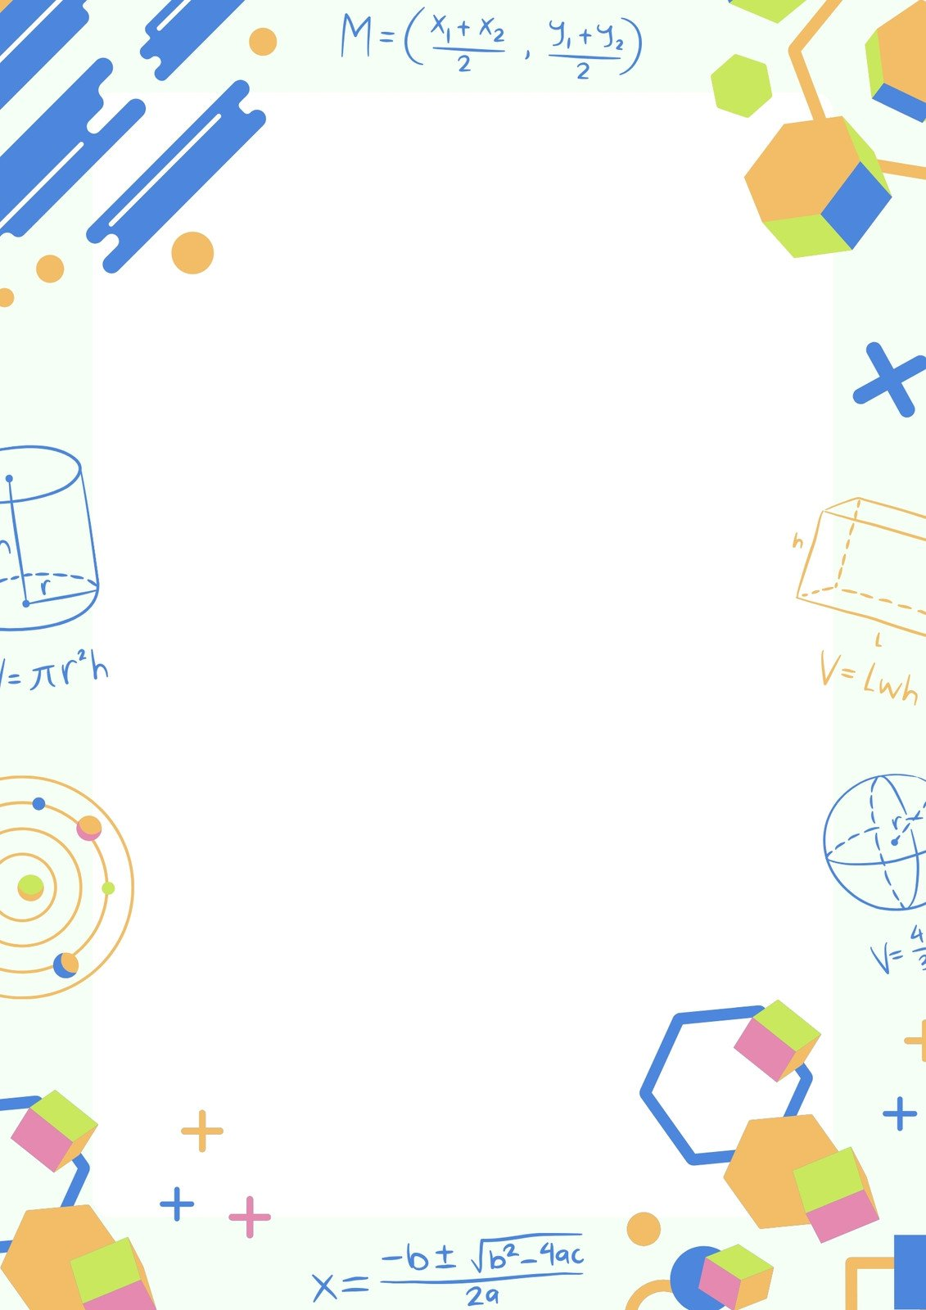S

APPLIED MATHEMATICS

PROJECT

CODE: 241

CORRELATION ANALYSIS

SRI SATHYA SAI HIGHER SECONDARY SCHOOL