A)

By observation we can see that a line with the following formula will separate most of the data point.

(i2) = -(i1) + 1

Using this line, the minimum error will be 2/12 due to 2 Class -1 points below the line.

B)

To sepearte the data point provided, we decided that we would need three lines. These would be

(i2) = -(i1) + 1

1 – 1 (i1) – 1(i2) = 0

W10 = 1 W11 = -1 W12 = -1

(i2) = (i1) – 0.05

-0.05 + 1 (i1) – 1(i2) = 0

W10 = -0.05 W11 = 1 W12 = -1

(i2) = -0.02 (i1) + 0.08

0.08 – 0.02 (i1) – 1(i2) = 0

W10 = 0.08 W11 = -0.02 W12 = -1

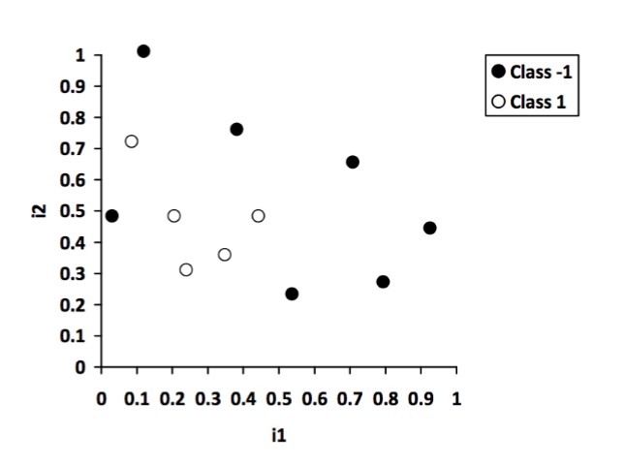

The data points that are within these lines will be classified as Class 1 and outside as Class -1.