**Introduction to Python**

1. **Install Anaconda**

Download Python on your computer via Anaconda (<https://www.anaconda.com/products/individual>). Scroll down to the section called “Anaconda Installers” and choose the appropriate Python 3.9 graphical installer. This depends on whether you have a Windows or Mac OS.

Anaconda comes with Anaconda Navigator, which is a desktop GUI that you can use to launch applications in Anaconda, e.g., Jupyter Notebook, and manage packages and environments without using command-line. You are welcome to use the Anaconda Navigator for this class, but we will be providing setup instructions here and on homework assignments that use command-line. See the Anaconda Navigator User Guide (<https://docs.anaconda.com/anaconda/navigator/>) for more info on using Anaconda Navigator.

1. **Set up a conda environment for this course**

A conda environment is a directory that contains specific packages that you have installed. When you install Anaconda, a base conda environment is created that contains default packages that are installed with Anaconda. The base environment is activated by default when you launch an application in Anaconda. You can run the Python tutorial below in your base environment and install packages needed for this course in your base environment, **but I highly recommend that you create a new environment specific to this course and only install the packages for this course in that environment.** This way, none of the packages you install for this course will affect any packages in your base environment (e.g., if a package you install for this course requires an old version of a package and downgrades that package when you install it).

* 1. Open your command-line shell: Mac users, you can use Terminal for this; Windows users, you can use the Command Prompt for this (you can alternatively use Anaconda Prompt for this on Mac or Windows)
  2. Create a new environment:

conda create --name <myenv>

(replace <myenv> with a name for the environment)

* 1. Activate your new environment to install packages within it:

conda activate <myenv>

**\*note: you will have to activate the environment each time you open a new**  **terminal/command prompt session**

Below is an example of activating an environment named “che_379”. Notice that in the first line, before I have activated the environment, “(base)” appears before the usual user@host prompt. This indicates that I am in the base environment. Once I activate che_379, “(base)” changes to “(che_379)” to indicate that I am now in the che_379 environment.

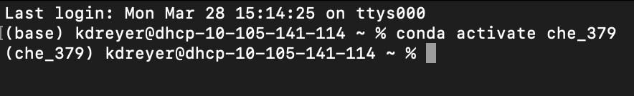

* 1. Install necessary packages using using conda install <package name> and enter y when prompted with “Proceed ([y]/n)?”:

conda install jupyter

conda install numpy

conda install scipy

conda install matplotlib

conda install pandas

conda install seaborn

1. **Run ChE379_PythonTutorial.ipynb in your new environment**
   1. Download ChE379_PythonTutorial.ipynb from the course website
   2. Launch Jupyter Notebook in your command-line shell (you can also launch Jupyter Notebook from the Anaconda Navigator):

jupyter notebook

**\*note: you should be in your new environment that you created and activated in #2 when you launch Jupyter Notebook.**

* 1. Navigate to your folder with ChE379_PythonTutorial.ipynb within the Jupyter Notebook window and open the file. Run each cell in the tutorial and familiarize yourself with how the code is set up.