What my project actualy does

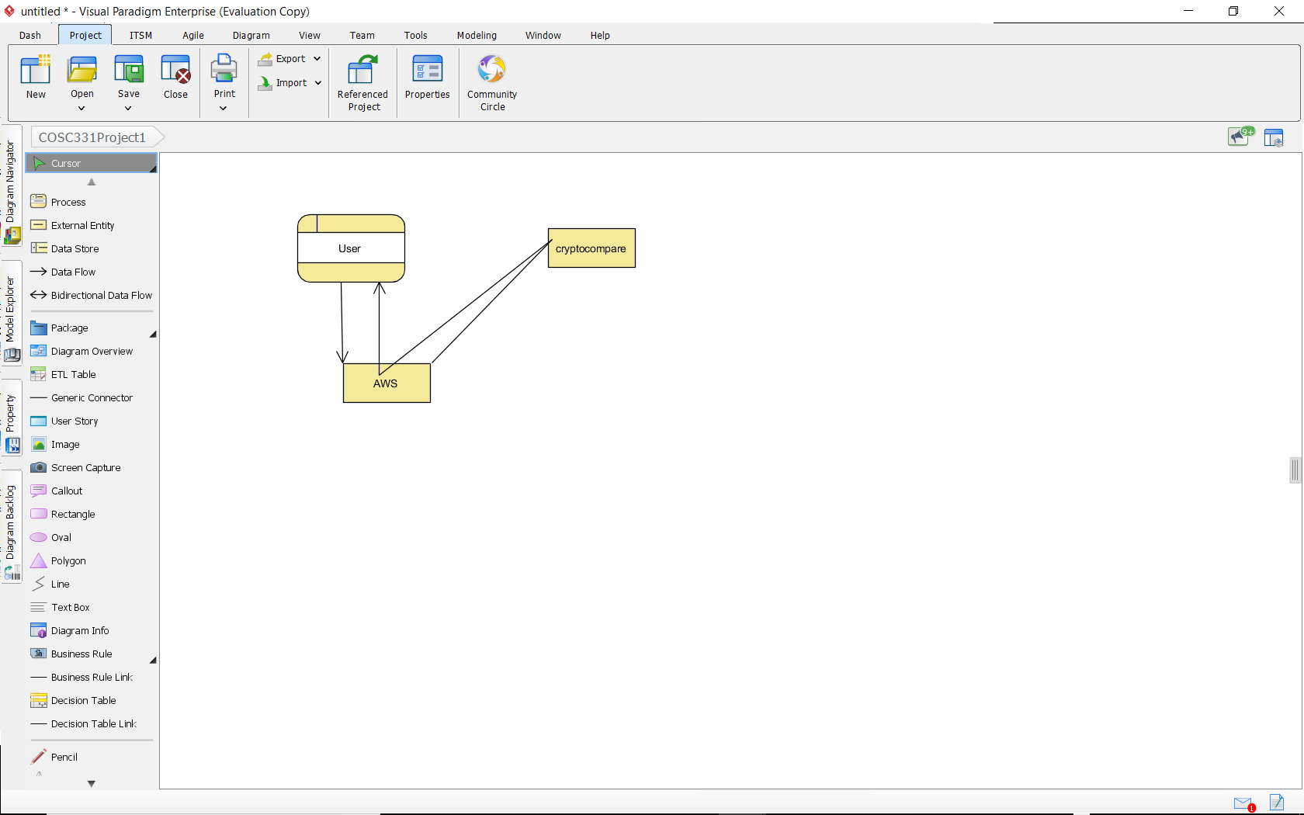

The user enters the crypto they have and how much of it they have into AWS/the webpage my code is on then my code asks cryptocompare’s api for the price per coin which point my code then provides a nicely formatted output of their token name and their coins total value.

I have no idea how to show that in a data flow diagram