Document
Project Summary
Date: 2026-08-05 | Version: 1.0

Table of Contents
BIL-Loan-Approver — Project Summary
Executive Summary
Architecture Overview
Processing Pipeline
Core Components
Backend API
Evaluation Pipeline
Frontend
API Contracts / Message Schemas
Review detail response
Rule 3 asset shape
Review actions
Infrastructure & Deployment
Extension Patterns
Rules & Anti-Patterns
Dependencies
Code Structure
Notes

BIL-Loan-Approver — Project Summary

Executive Summary
BIL-Loan-Approver is an agentic loan-compliance system that reviews pledged loans against three deterministic rules before they are reported. It combines a Python/FastAPI backend, a React/Vite frontend, an OPA/Rego rule engine, SQLite persistence, and an AI-assisted Rule 3 remediation flow for substitute collateral suggestions.
The system is designed around a strict separation of concerns. The pipeline computes rule inputs, OPA makes the pass/fail decision, the review layer records human actions, and the UI gives reviewers a fast queue with manual, ignore, and accept-suggestion workflows.
The project is optimized for a large dataset. loans.csv is streamed in batches, FX rates are cached per run, PDF company data is parsed once into companies.json, and review/report endpoints query SQLite instead of reloading everything into memory.

Architecture Overview
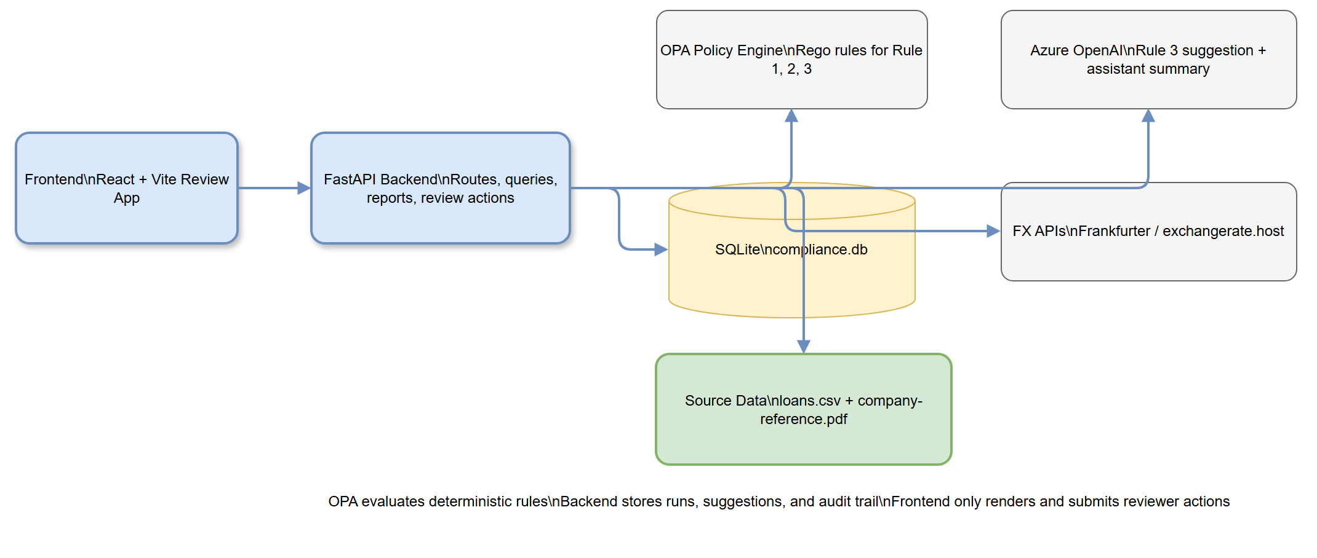
High-Level Architecture
Editable diagram source
BIL-Loan-Approver has five main layers: the React review/dashboard app, the FastAPI API surface, the deterministic evaluation pipeline, the remediation/assistant layer, and the persistence and policy layers underneath. OPA runs as a separate container and evaluates the Rego rules, while the backend stores runs, review decisions, audit history, and generated suggestions in SQLite.
The architecture intentionally keeps rule decisions out of the model layer. Rule 1 and Rule 2 are fully deterministic; Rule 3 uses retrieval plus an LLM only to suggest substitute collateral, then pauses for human review before anything is applied.

Processing Pipeline
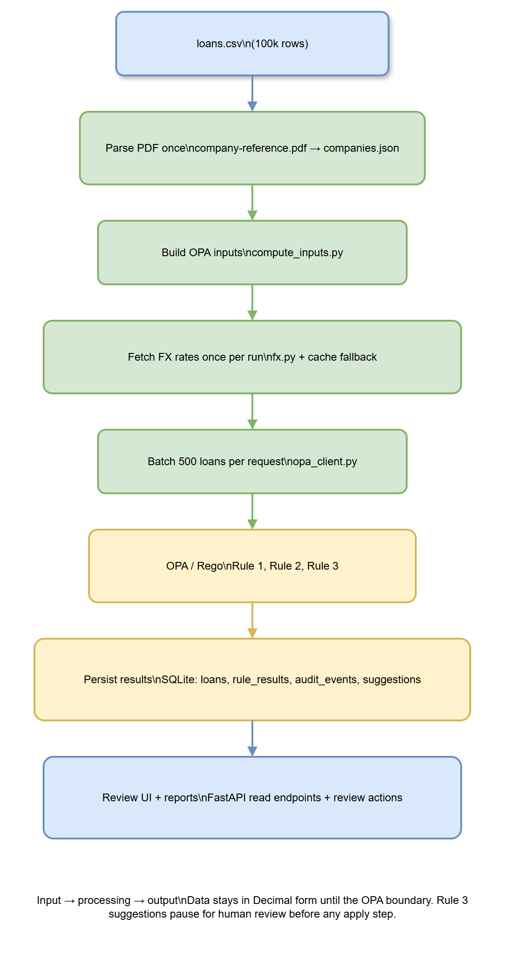
Processing Pipeline
Editable diagram source
The evaluation path is a batch pipeline. run_evaluation.py streams loans.csv, loads or builds companies.json, fetches FX rates once per run, computes OPA inputs for each loan, sends batches of 500 loans to OPA, and persists results to SQLite.
Rule 1 uses converted EUR values, Rule 2 uses a country-to-currency lookup derived from the company reference data, and Rule 3 uses the pledged asset value compared with the loan value in the original currency. The same company reference data later powers the review UI and the Rule 3 asset picker.

Core Components
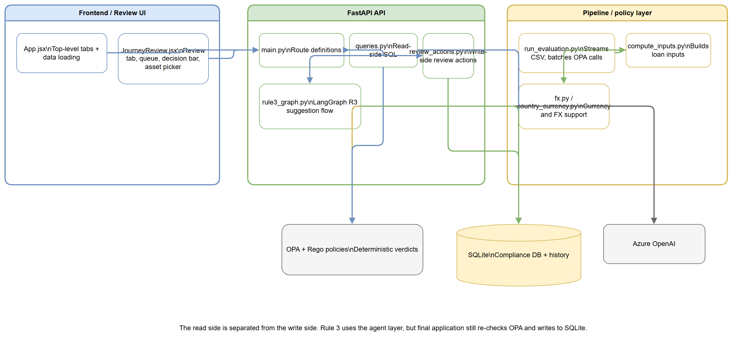
Component Relationships
Editable diagram source

Backend API
Component | Responsibility
backend/app/main.py | FastAPI routes for dashboard, review, history, reports, assistant, and run triggers
backend/app/queries.py | Read-side SQL for queues, summaries, history, and per-loan detail views
backend/app/reports.py | PDF and CSV report generation
backend/agent/review_actions.py | Applies reviewer decisions and writes audit updates
backend/agent/rule3_graph.py | LangGraph flow for substitute-asset suggestion

Evaluation Pipeline
Component | Responsibility
backend/pipeline/run_evaluation.py | Orchestrates the full evaluation pass
backend/pipeline/compute_inputs.py | Builds OPA-ready loan inputs
backend/pipeline/fx.py | Loads FX rates with fallback caching
backend/pipeline/country_currency.py | Static country-to-currency lookup
backend/pipeline/opa_client.py | Sends batches to OPA
backend/pipeline/parse_pdf.py | Parses the company reference PDF into companies.json
backend/pipeline/db.py | Creates and migrates SQLite tables

Frontend
Component | Responsibility
frontend/src/App.jsx | Root shell, tab navigation, and global data loading
frontend/src/JourneyReview.jsx | Review experience for rule failures and human-in-the-loop actions

API Contracts / Message Schemas

Review detail response
GET /api/review/loan/{loan_id} returns a per-loan object used by the review panel. Important fields include:
Field | Meaning
run_id | Active evaluation run
id, co, hq, industry, ccy | Loan identity and company context
value, valueNum | Loan amount for display and calculations
rule_failed | Rule currently being reviewed
fix | Suggested fix payload from the backend
reasoning | Human-readable explanation from the agent or deterministic fallback
assets | Rule 3 company asset list for manual selection
via | Whether the suggestion came from llm or fallback
computed | Whether a suggestion has already been computed
evidence | Supporting evidence links and page references
impact | Recheck scope after decision

Rule 3 asset shape
Rule 3 asset entries include these properties:
Field | Meaning
name | Asset description
value | Asset value in the company currency
qualifies | Whether the asset clears the 50% threshold
coverage | Coverage ratio against the loan value
current | Whether this is the pledged asset already on the loan
pdfPage | PDF page number for the company reference entry

Review actions
POST /api/review/{loan_id}/rule1/decide, rule2/decide, and rule3/decide accept reviewer actions. The Rule 3 flow supports a human gate: generate the suggestion first, then apply it only after review. Batch endpoints follow the same pattern for large review passes.

Infrastructure & Deployment
The OPA policy engine runs in its own container via docker-compose.yml. The backend is a FastAPI application run with Uvicorn, and the frontend is a Vite app that proxies /api requests to the backend during local development.
The runtime data lives in data/ and is intentionally regenerated: compliance.db, fx_cache.json, and companies.json are created or refreshed as the pipeline runs. The source inputs are the loan CSV and the company reference PDF.

Extension Patterns
If you add a new backend read view, place it in backend/app/queries.py and expose it through backend/app/main.py as a thin route wrapper. If you add a new mutation or review action, put the write logic in backend/agent/review_actions.py so review decisions stay centralized and auditable.
If you add a new deterministic rule, implement the rule in backend/policies/, compute any required inputs in backend/pipeline/compute_inputs.py, and keep the rule evaluation itself inside OPA. If the rule needs human-facing remediation, add the suggestion logic in the agent layer and surface it through the review UI.
If you extend the Review tab, update frontend/src/JourneyReview.jsx. That file already owns the loan detail panel, rule-specific review states, batch review flow, and the manual Rule 3 asset picker.

Rules & Anti-Patterns
• Keep rule verdicts deterministic.
• Do not call the LLM to answer Rule 1 or Rule 2.
• Do not fabricate data that is not present in the source PDF or CSV.
• Do not load the full dataset into the browser at once.
• Do not let the UI apply a Rule 3 suggestion without a visible human-review step.
• Keep FX conversion and country lookup in the pipeline, not in Rego.
• Keep read-side SQL separate from write-side review actions.

Dependencies
Layer | Dependencies
Backend | FastAPI, Uvicorn, python-dotenv, requests, truststore, pdfplumber, python-multipart, pytest, reportlab, langgraph, langchain-openai, openai
Frontend | React, React DOM, Vite, lucide-react, papaparse, recharts, Tailwind CSS tooling, oxlint
Policy engine | Open Policy Agent (OPA) with Rego policies
Storage | SQLite
Reporting | ReportLab

Code Structure
BIL-Loan-Approver/
├── backend/
│ ├── app/
│ ├── agent/
│ ├── pipeline/
│ ├── policies/
│ └── tests/
├── frontend/
│ └── src/
├── DOCS/
│ └── (original design/spec documents)
├── docs/
│ ├── diagrams/
│ └── project-summary.md
├── data/
│ └── (runtime cache and database artifacts)
├── docker-compose.yml
└── Hackathon Brief/
└── BRIEF.md

Notes
This summary is based on the code in the workspace, not on assumptions. The existing DOCS/Architecture.md file contains a more detailed mermaid overview of the same system, while this document is intended to be the shareable project summary that can be exported to Word.

