System Proposal Document:

Karima Williams

July 27, 2019

Southern New Hampshire University

Karima Williams

**Background**: Davis Consulting is a growing medium-sized technology consulting firm that specializes in providing solutions to clients involving computer software and hardware, semiconductor, IT services, storage, components and peripherals sectors(Bain & Company, n.d.). Davis Consulting’s clients include six of the seven largest technology mergers, two of the four top software manufacturers and several key participants in the computer software industry. Our experience extends nationwide and garners an annual revenue of $100 million. Davis Consulting ranks second in size to the leading competitor, Thomas Consulting, Inc. Fifty percent of Davis Consulting’s revenues are from its main office state, North Carolina; while the other 50 percent originate from other regions of the United States.

**Problem Statement**: In view of an increasing clientele, Davis Consulting has revamped its business model within the last three years. As we continue to assist more clients in different regions across the country, website management has become more difficult. Until now, our content management system(CMS) has been simple and allowed a small team of up to two members management of content. As our workforce expands, the current CMS has become ineffective to properly manage website content creation. This inefficiency has resulted in higher costs and increased employee rate of replacement which we have noticed over the last 12 months(Project Management Docs, n.d.). In order to create website content more effectively, reduce costs, and improve employee turnover, Davis Consulting must switch to an extensive CMS as outlined in this business case(Project Management Docs, n.d.). By doing so, employees will assume a greater role in managing website content, and the company can manage its administration from one central platform. Switching to an extensive CMS will enable Davis Consulting to manage its web content and employee administration in a seamless and consolidated manner. This technology shift will reduce overhead costs associated with the huge workforce required to manage these tasks. Employees will have more sovereignty to manage administrative tasks and create website content. The company will also benefit from more prompt and precise financial analysis as a result of our corporate managers’ ability to enter and continuously update their financial data. This real-time approach reduces errors, improves cycle time, and is freely available to any authorized user.

**Audience**: Several alternatives were examined to determine the best way to leverage technology to enhance business processes and reduce overhead costs within Davis Consulting. The outlook defined within this document allows us to reach corporate objectives of constantly improving efficiency, reducing costs, and capitalizing on technology. The recommended CMS will methodically allow employees to manage the heavy flow of website content and allow adequate time to train all employees and managers on administrative functions. The CMS is compatible with all other current IT systems and will improve the efficiency and accuracy of reporting throughout the company(Project Management Docs, n.d.). Some of the ways that this technology will achieve proper results are:

•Employees will be able to enter and edit, create, publish, archive/distribute content, data, and information quickly and efficiently as a small two-person team instead of having to train multiple people to use the CMS(Pickard-Whitehead, 2018).

•Employees in the administrative department will only perform their routine duties such as reviewing incoming documents, conducting research, supervising clerical staff and preparing reports(U.S. Bureau of Labor Statistics, n.d.).

•Unqualified employees will not have to register for training which reduces the weight of managers and training staff.

**Project Scope**

Within the current case study, Davis Consulting’s management team has decided to switch to an extensive CMS to manage website content more effectively so that the company can manage its administration from one central platform. Switching to an extensive CMS will enable Davis Consulting to manage its web content and employee administration in a seamless and consolidated manner. This technology shift will reduce operating costs associated with the huge workforce required to manage these tasks. Employees will have more sovereignty to manage administrative tasks and create website content. The company will also benefit from more prompt and precise financial analysis as a result of our corporate managers’ ability to enter and continuously update their financial data. This real-time approach reduces errors, improves cycle time, and is freely available to any authorized user.

**Work Breakdown Structure**

The success of a development project depends on the involvement of stakeholders at different levels. This CMS expansion must be validated by the stakeholders. When managing a project, one of the most essential parts of the planning process is the identification of the relevant project management stakeholders involved at each step in the life cycle of a project(Clarizen, 2017). Through the Software Development Life Cycle (SDLC), the stakeholders would involved in the planning, designing, developing, testing, and deployment process of the CMS expansion. Amid the stakeholders of the project are the following key roles: Systems Analyst, Project Manager, Project Team, and Project Sponsor(Clarizen, 2017).

System Analyst

The Systems Analyst is involved in every phase of the SDLC cycle. To start, the Systems Analyst works with the stakeholders to figure out purpose of expanding the existing CMS, blueprint the requirements and understand the project scope. The Systems Analyst does cost-benefit analysis, and evaluates business processes to deliver the best solutions(Rosenblatt & Tilley, 2016).

Project Manager

The Project Manager aligns the project to business goals, manages stakeholders, and communicates the project status, and milestones(Corporate Education Group, n.d.). The Project Manager also effectively manages resources to keep the project within the specified budget. The Project Manager and the Systems Analyst are the main components of the success of this project.

Project Team

The Project Team will actively work on different phases of the project. They are in-house staff and external consultants working on the project on a full-time or part-time basis. They provide expertise and document the process(Villanova University, 2019).

Project Sponsor

The Project Sponsor have a stake in the project’s outcome, they work closely with the project manager. They participate in high-level project planning and sign off on approvals needed to advance each phase(Villanova University, 2019).

**Project Monitoring and Control Plan**

Monitoring and controlling processes involve tracking project performance with the planned project management activities. It is a control function that takes place at all stages of a project(GreyCampus, n.d.). The controls are applied to different areas of the project such as: scope, time, cost, quality, risk, and communications(GreyCampus, n.d.). The plan of attack to make sure all controls are adhered to is working with the project manager to balance the requirements of different areas to control the project through monitor and control project work.

The Project Manager will come across changes during the course of the project. Project Managers makes sure the project is in optimal shape or use existing organizational performance procedures to identify project performance(GreyCampus, n.d.). Project managers can manage resources and risk by communicating with key stakeholders by creating progress reports that include cost analysis, defects, risks, and other changes that could affect the project timeline(Rosenblatt & Tilley, 2016).

**Timeline**

The estimated amount of time for implementation is 40 days. The following charts are a visual representation of this timeline.

**Resource Chart**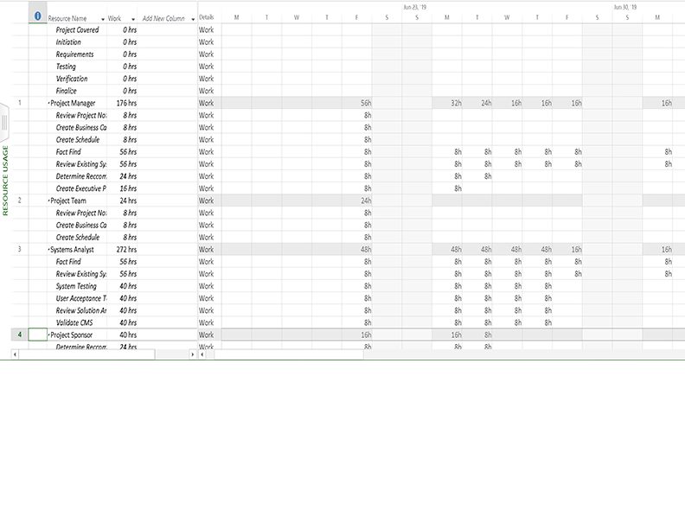

**Gantt Chart**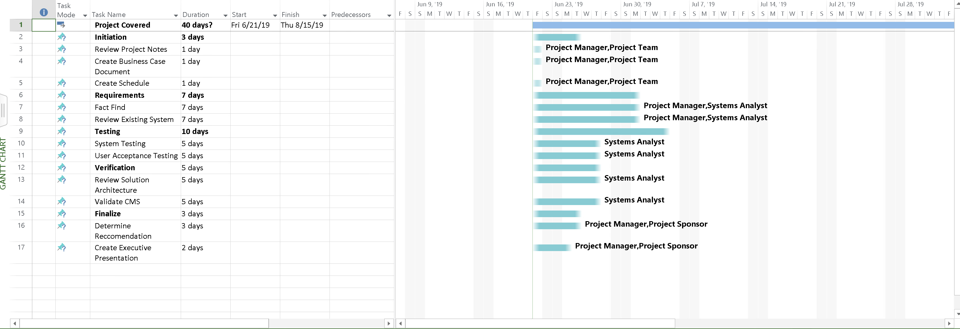

**Cost Chart**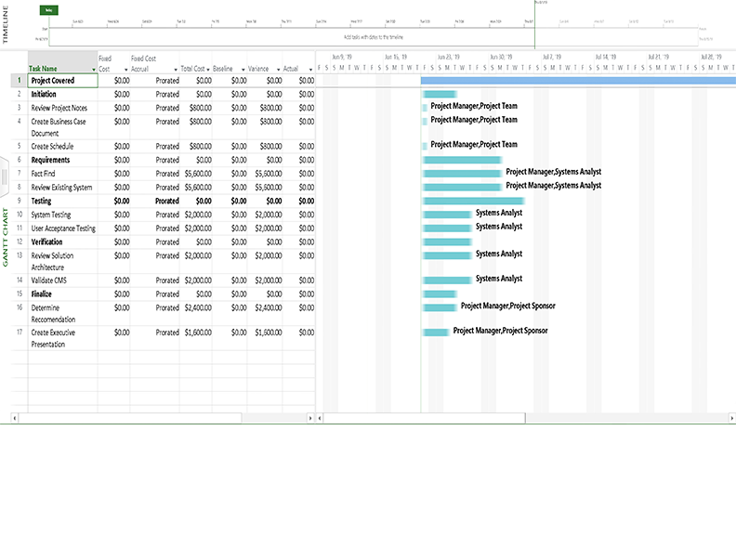

**Requirements Model**

|  |  |  |  |  |
| --- | --- | --- | --- | --- |
| **Outputs** | **Inputs** | **Processes** | **Controls** | **Performance** |
| * Website content is produced by the CMS. * Accurate financial analysis report. | * Employees will enter and edit content, data, and information that is to be stored within the CMS. * Corporate managers enter and continuously update their financial data. | * The CMS stores information * Employees manage website content. * Employees manage administrative tasks. | * Employees can change stored content within the CMS. * Managers can hire and fire employees. | * The CMS will improve accuracy and efficiency of reporting throughout the company. * Employees and managers are trained on administrative tasks. |

Requirements modeling in software engineering is the planning stage of a software system(Kypridemos, n.d.). The process begins when a business, in this case, Davis Consulting updates an existing system for better efficiency throughout the company. The company will be able to create website content more effectively, reduce costs, and improve employee turnover by updating the CMS. Requirements are the conditions that a proposed solution must fulfill in order to resolve the business problem (Kypridemos, n.d.). Identifying the requirements includes every stakeholder, even the nontechnical ones.

**Process Model**

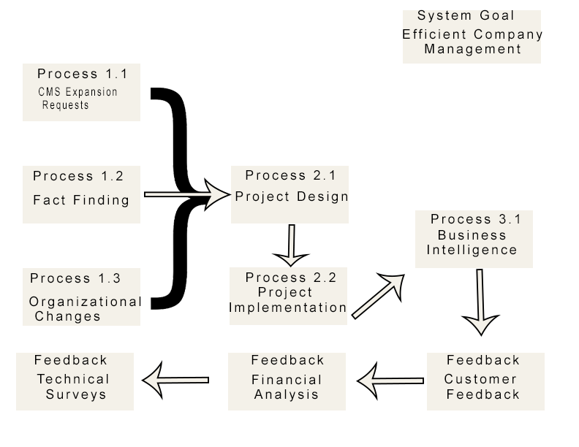

Data process modeling visually represents data and enforces business rules and regulatory compliances on the data (Guru99, n.d.). The process model for Davis Consulting makes sure all of the data objects such as company requests, feedback, project design/implementation, and business analysis, which are database requirements are accurately represented. Exclusion of data will lead to faulty reports and incorrect results (Guru99, n.d.). Data process models emphasize the organizational structure of the data. The data objects in the case of Davis Consulting, all come together to accomplish one goal, which is efficient company management.

**Data Flow Diagram**

A data flow diagram maps out the information flow for a system; it is displayed using symbols such as rectangles, circles and arrows, as well as short text labels (Lucid Software Inc, n.d.). Data flowcharts can be simple or very intricate. The data flow diagram for this case is used to model an efficient flow of data through a business process (Lucid Software Inc, n.d.). This data flow diagram details the process of information entered, edited, and deleted within a CMS by different users.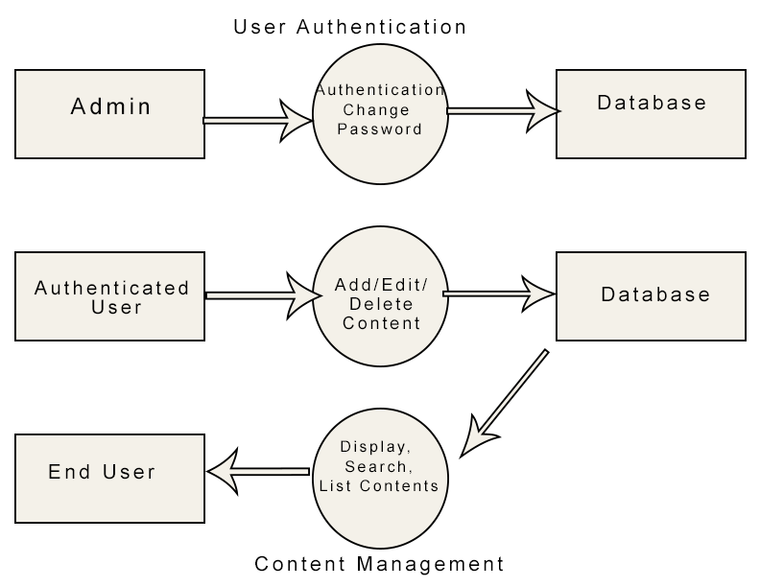

**Data Dictionary**

|  |  |  |  |  |  |
| --- | --- | --- | --- | --- | --- |
| **#** | **Name** | **Type** | **Null** | **Default** | **Extra** |
| **1** | **id** | **int(5)** | **No** | ***None*** | **AUTO_INCREMENT** |
| **2** | **admin_name** | **varchar(100)** | **No** | ***None*** |  |
| **3** | **content_text** | **text(1000)** | **No** | ***None*** |  |
| **4** | **content_image** | **text(1000)** | **No** | ***None*** |  |
| **5** | **domain** | **varchar(100)** | **Yes** | ***NULL*** |  |
| **6** | **active** | **tinyint(1)** | **No** | **1** |  |
| **7** | **created_on** | **datetime** | **No** | **0** |  |
| **8** | **updated_on** | **datetime** | **No** | **0** |  |

A data dictionary is a file that contains a database's metadata and includes records about other database objects, such as data ownership, and data relationships to other objects (Techopedia, n.d.). This data dictionary includes how information entered and edited within the CMS is displayed, it also includes an automatically assigned id for every entry created and a timestamp. The data dictionary is very important for all relational databases. Database administrators are the only ones allowed to use the data dictionary (Techopedia, n.d.).

**Object Modeling**

An object model diagram shows the relationship between instantiated classes and the relationship between these objects in the system(Visual Paradigm, n.d.). They are best used to explain small pieces of a complex software system. The object diagram should be derived from the corresponding class diagram(Visual Paradigm, n.d.). This object model diagram illustrates the contents of a CMS database and shows how they are related. This small diagram has the class name above the object attributes(Visual Paradigm, n.d.).

**Use Case Diagram**

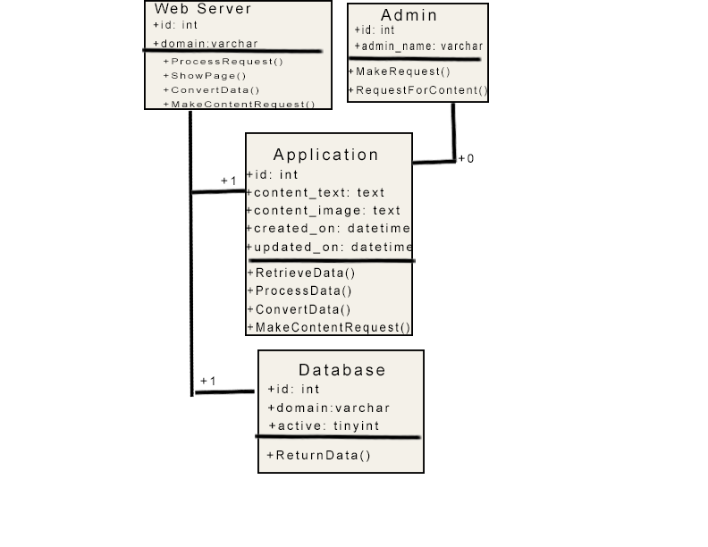

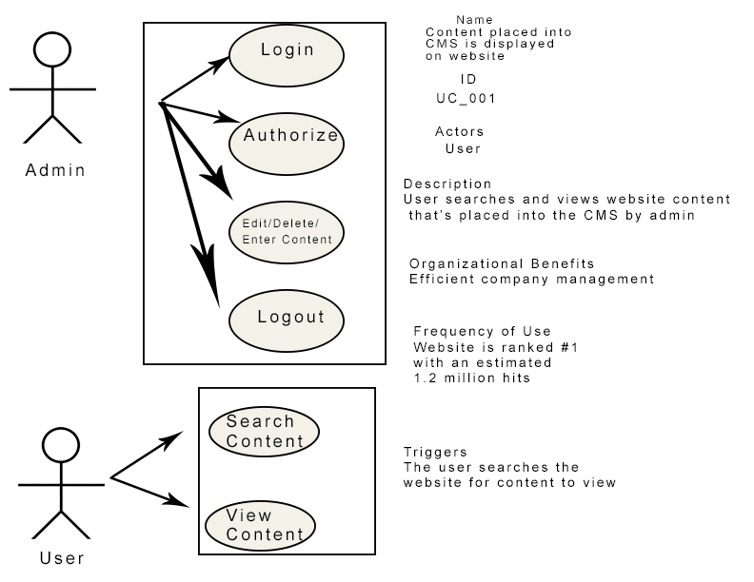

|  |  |
| --- | --- |
| Name of Use Cases | CMS |
| Actor | User |
| Description | User searches and views website content that’s placed into the CMS by admin |
| Successful Completion | 1. User types searchable content into search bar and clicks search. 2. User navigates site |
| Alternative | 1. User searches for content that isn’t included on the site 2. User gets 404 error message |
| Precondition | User has searched for something and clicked around the site. |
| Postcondition | User found the information they were searching for |
| Assumptions | None |

A use case diagram is a UML behavior diagram, which uses actors and use cases to model system functionality(SmartDraw, LLC, n.d.). Use cases are defined by a set of actions, services, and functions that shape the system’s performance(SmartDraw, LLC, n.d.). In this case, the "system" is a CMS. The actors are the users that search the website for content to view that has been placed into the CMS database by administrators.

**Davis Consulting Systems Design Document Specifications**

1. **Introduction**

1.1 Purpose

1.2 Project Scope

**2. Data Design**

2.1 Entity Relationship Diagrams (ERD)

2.2 3NF Table

**3. User Interface Design**

3.1 Human Computer Interactions (HCI)

3.2 Graphical User Interfaces (GUI)

**4. System Architecture**

4.1 Corporate Organization and Culture

4.2 Enterprise Resource Planning

4.3 Cost of Ownership

4.4 Scalability

4.5 Integration, Interface, and Security Requirements

**5. Feasibility**

5.1 Operational & Technical

5.2 Economic & Scheduling

**1.**

**Introduction**

This Systems Design Document has been created to summarize the proposed system design for the updated and latest Davis Consulting Content Management System (CMS). The purpose for the CMS is to replace the insufficient, outdated CMS currently utilized by Davis Consulting. Through testing, and deployment of the CMS; Davis Consulting will refine company management, tracking, and reporting. This document and the technological specifications cataloged included follow all of Davis Consulting’s technological rules and infrastructure.

**1.1 Purpose**

The purpose of this System Design Document is to deliver a report for use of the new CMS. This Systems Design Document was produced to ensure that the CMS meets the specifications listed in the CMS project requirements documentation in addition to the Davis Consulting’s Executive Board mentioning improvements to existing employee administration practices and tools. The System Design Document lays out the system architecture, software, hardware, database design, and security.

**1.2 Project Scope**

Within the current case study, Davis Consulting’s management team has decided to switch to an extensive CMS to manage website content more effectively so that the company can manage its administration from one central platform. Switching to an extensive CMS will enable Davis Consulting to manage its web content and employee administration in a seamless and consolidated manner. This technology shift will reduce operating costs associated with the huge workforce required to manage these tasks. Employees will have more sovereignty to manage administrative tasks and create website content. The company will also benefit from more prompt and precise financial analysis as a result of our corporate managers’ ability to enter and continuously update their financial data. This real-time approach reduces errors, improves cycle time, and is freely available to any authorized user.

2.

**2.1 Entity Relationship Diagrams (ERD)**

This entity-relationship diagram (ERD) shows the logical relationships and interaction among the components that are involved with the Davis Consulting CMS, such as the admin and user and provides an overall view of the system and a blueprint for creating physical data structures. The admin uses a username and password to login and produce website content such as text and images for the user to view.

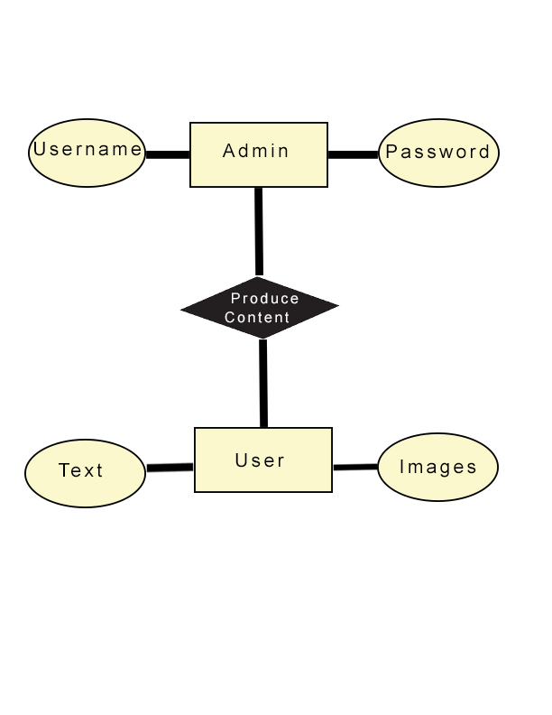

**2.2 3NF Table**

This third normal form (3NF) table is derived from the ERD above and is the third step in normalizing the database. All column references that are not dependent on the primary key should be removed(Techopedia, n.d.). The primary keys referenced are Admin ID, Usersame, Password, and Content Update.

**Table_Detail**

|  |  |  |  |
| --- | --- | --- | --- |
| Admin ID | Username | Password | Content Update |
| 1 | Mike1 | Dsdsrew | 07/01/19 |
| 2 | Ross4 | Mnfsdoi | 06/18/19 |
| 3 | Sally8 | Eiuwuoiwe | 07/10/19 |

**Table_Username**

|  |  |  |
| --- | --- | --- |
| Username | Password | Content Update |
| Mike1 | Dsdsrew | 07/01/19 |
| Ross4 | Mnfsdoi | 06/18/19 |
| Sally8 | Eiuwuoiwe | 07/10/19 |

**Table_Update**

|  |  |
| --- | --- |
| Admin ID | Content Update |
| 1 | 07/01/19 |
| 2 | 06/18/19 |
| 3 | 07/10/19 |

3.

**3.1 Human Computer Interactions (HCI)**

Human-Computer Interaction (HCI) is the study of how people interact with computers in order to enhance technological experiences(Murphy, 2018).  There are five design principles of human interaction, which are: affordance, perceivable, feedback, constraints and consistency(Murphy, 2018). These design principles in the case of the Davis Consulting CMS are focused on the ease of navigation and content creation/editing.

|  |  |  |
| --- | --- | --- |
| Usability Feature | Usability Feature | Goal |
| Affordance | New button, Edit button, Delete button, Cut button, Copy button, and Paste button | For admin to create and edit website content for users to view. |
| Perceivable | Folder symbol with red asterisk, pen and paper symbol, X symbol, scissors symbol, duplicate paper, symbol, clipboard symbol | The folder is used to symbolize creation of a new document, the pen and paper symbolize editing a document, the X and scissors symbolize deletion and cutting a document, and the duplicate paper, clipboard represent copying and pasting a document. |
| Feedback | Warning, Status display, Let users know what’s going on | Warning- Information of action with important consequences, Status display-information about internal system status, Let users know what’s going on- information about system has registered a user action. |
| Constraints | Clicking buttons to perform actions | If an action such as editing website contents is needed, the corresponding buttons must be clicked. |
| Consistency | Content creation and editing buttons are all in the top left corner, files containing content are below the buttons | The CMS is easy to navigate as far as editing and creating content is concerned. |

**3.2 Graphical User Interfaces (GUI)**

A GUI is an interface that uses icons to interact with electronic devices, rather than only text(Computer Hope, 2018). GUI operating systems are easier to use because commands are already programmed(Computer Hope, 2018). The GUI elements of the Davis Consulting CMS consists of basic content creation and editing buttons, notification/warning area, folder icons, and additional buttons for database management.

| GUI Element | Purpose |
| --- | --- |
| New button, Edit button, Delete button, Cut button, Copy button, and Paste button | Content creation and editing |
| Folder icons | Store content |
| Additional buttons | Database management |
| Notification/warning area | Notifies and warns user of the importance of system actions |

4.

**4.1 Corporate Organization and Culture**

Davis Consulting has a proven track record of helping clients build thousands of cultural transformations that involve behavioral changes, in addition to supporting the cultural redesign of more than 2,000 companies during alliance assimilations(Bain & Company, n.d.). Davis Consulting has more than 70 partners experienced in organization work and a team of global culture experts. Our various culture diagnostic implements quality tools such as interviews, sentiment analysis, culture surveys, focus groups and more to evaluate the culture and generate an attested case(Bain & Company, n.d.).

**4.2 Enterprise Resource Planning**

Davis Consulting’s ERP system improves equipment management, procurement procedures, labor resources allotment, and increased planning and control to shorten WIP times(Enterprise Resource Consulting, n.d.). This allows our multiple national companies’ systems to be integrated into one database for consolidated reporting. Upgraded job costing and estimating accuracy will generate ROI as well as a cutback in selling, general, and administrative costs(Enterprise Resource Consulting, n.d.).

**4.3 Cost of Ownership**

Private equity investors must consider the total cost of ownership (TCO) (Capko, n.d.). The TCO in the case of Davis Consulting focuses on costs of hardware, software, employees expenses and workforce management. The TCO includes recruitment, time and attendance, and the software systems utilized to manage, process and support this activity (Capko, n.d.).

$ in 1,000s

|  |  |  |  |  |  |
| --- | --- | --- | --- | --- | --- |
|  | Acquisition Costs | Operating Costs | Change Costs | Total | % of  TCO |
| Software | 274 | 82 | 138 | 494 | 2.9% |
| Hardware | 539 | 97 | 71 | 707 | 4.1% |
| Personnel | 55 | 8,873 | 5,952 | 14,879 | 86.2% |
| Davis Consulting | 146 | 543 | 459 | 1,149 | 6.7% |
| Facilities | 0 | 15 | 15 | 29 | 0.2% |
| Total | 1,104 | 9,610 | 6,634 | 17,258 |  |
| % of TCO | 5.9% | 55.7% | 38.4% |  | 100.0% |

**4.4 Scalability**

Davis Consulting is looking to add more partners which will be supported by juniors will do the back-end work(Jerrat, 2014). The partners associate with clients and take on new projects. Sales cycles will be increasingly long, complex and competitive. The more client work, the more person-hours; which will make the business scalable on a linear basis, proportionate to the number of consultants(Jerrat, 2014).

**4.5 Integration, Interface, and Security Requirements**

Both publishing/creative content must be stored in a single repository, which prevents superfluous data and erroneous metadata concurrence(Quark Software Inc, n.d.). All users must access assets and use functionality through the well-known user interface so that everyone can continue using preferred tools(Quark Software Inc, n.d.). The CMS uses several security and integrity controls to ensure that the system and its data components are protected(Project Management Docs, n.d.). The first implementation is user authorization. All CMS users will be assigned an authorization level and given operation permissions. These users will be disallowed to perform any CMS interactions outside of assigned spots. Managers will provide these authorization levels. The next implementation is data backup. The CMS database will be backed up in concordance with Davis Consulting IT Security Policies. This will provide reversion in the event of database subversion or system failure(Project Management Docs, n.d.).

5.

**5.1 Operational & Technical**

Before the implementation of the new CMS, the outdated CMS had become ineffective to properly manage website content creation. This inefficiency resulted in higher costs and increased employee rate of replacement over the span of 12 months(Project Management Docs, n.d.). By implementation of the new CMS, website content will be created more effectively, costs reduced, and improved employee turnover. By doing so, employees will assume a greater role in managing website content, and the company can manage its administration from one central platform. Switching to an extensive CMS will enable Davis Consulting to manage its web content and employee administration in a seamless and consolidated manner. This technology shift will reduce overhead costs associated with the huge workforce required to manage these tasks. Employees will have more sovereignty to manage administrative tasks and create website content.

**5.2 Economic & Scheduling**

The company will also benefit from more prompt and precise financial analysis as a result of our corporate managers’ ability to enter and continuously update their financial data. This real-time approach reduces errors, improves cycle time, and is freely available to any authorized user. Employees in the administrative department will only perform their routine duties such as reviewing incoming documents, conducting research, supervising clerical staff and preparing reports(U.S. Bureau of Labor Statistics, n.d.).

References

Bain & Company. (n.d.). *Technology*. Retrieved from https://www.bain.com/industry-expertise/technology/

Bain & Company. (n.d.). *Winning Culture*. Retrieved from <https://www.bain.com/consulting-services/organization/winning-culture/>

Capko, C. (n.d.). *Understanding the Total Cost of Ownership*. Retrieved from https://www.adp.com/-/media/PDF/PE-TCO.ashx?la=en&hash=93C80606B2C42302E3CA5FD1C951B1FDA2B9789E

Clarizen. (2017, December 19). *Who Are Project Management Stakeholders?* Retrieved from https://www.clarizen.com/project-management-stakeholders/

Computer Hope. (2018, November 13). *What is a GUI (Graphical User Interface)?* Retrieved from <https://www.computerhope.com/jargon/g/gui.htm>

Corporate Education Group. (n.d.). *What is a Project Manager and How Do I Become One?*  Retrieved from https://www.corpedgroup.com/resources/pm/WhatisaPM.asp

Enterprise Resource Consulting. (n.d.). *ERP Selection Consultant - ERP Implementation Consultant*. Retrieved from <http://www.enterpriseresourceconsulting.com/>

GreyCampus. (n.d.). *Monitor and Control Project Work*. Retrieved from https://www.greycampus.com/opencampus/project-management-professional/monitor-and-control-project-work

Guru99. (n.d.). *What is Data Modelling? Conceptual, Logical, & Physical Data Models*. Retrieved from https://www.guru99.com/data-modelling-conceptual-logical.html

Jerrat, N. (2014, May 12). *On scaling your professional services or consulting business.* Retrieved from https://www.publishmyweb.com/articles/blog-on-scaling-your-professional-services-or-consulting-business

Kypridemos, A. (n.d.). *Requirements Modeling in Software Engineering: Classes, Functions & Behaviors*. Retrieved from https://study.com/academy/lesson/requirements-modeling-in-software-engineering-classes-functions-behaviors.html

Lucid Software Inc. (n.d.). What is a Data Flow Diagram. Retrieved from https://www.lucidchart.com/pages/data-flow-diagram

Murphy, L. (2018, April 27). *5 Design Principles Of Human Computer Interaction*. Retrieved from <http://www.lukemurphy.info/5-design-principles-of-human-computer-interaction/>

Pickard-Whitehead, G. (2018, April 16). *What is a Content Management System and How Can it Help Your Business?* Retrieved from https://seoland.in/what-is-a-content-management-system-and-how-can-it-help-your-business/#.XQgyjC2ZMlI

Project Management Docs. (n.d.). *Business Case Template*. Retrieved from https://www.projectmanagementdocs.com/template/project-initiation/business-case/#axzz5q6AG9Euf

Project Management Docs. (n.d.).*System Design Document*. Retrieved from [https://www.projectmanagementdocs.com/template/project-documents/system-design-document/#axzz5tyySNZZf](https://www.projectmanagementdocs.com/template/project-documents/system-design-document/%23axzz5tyySNZZf)

Quark Software Inc. (n.d.). *Content Management System Integration*. Retrieved from http://www.quark.com/Solutions/Content-Automation/CMS-Integration.aspx

Rosenblatt, H. J. & Tilley, S. (2016). *Systems Analysis and Design 11th Edition*. Boston, MA: Cengage Learning

SmartDraw, LLC. (n.d.). *Use Case Diagram*. Retrieved from https://www.smartdraw.com/use-case-diagram/

Techopedia. (n.d.). *What is a Data Dictionary?* Retrieved from https://www.techopedia.com/definition/27752/data-dictionary

U.S. Bureau of Labor Statistics. (n.d.). *Secretaries and Administrative Assistants : Occupational Outlook Handbook*:. Retrieved from https://www.bls.gov/ooh/office-and-administrative-support/secretaries-and-administrative-assistants.htm

Villanova University. (2019, May 03). *Project Team Roles and Responsibilities*. Retrieved from https://www.villanovau.com/resources/project-management/project-team-roles-and-responsibilities/

Visual Paradigm. (n.d.). *What is Object Diagram?* Retrieved from https://www.visual-paradigm.com/guide/uml-unified-modeling-language/what-is-object-diagram/