Change Log
01/09/2018 | Utsavi Dave | Instruction on Build Project

Steps to Setting Up Project

- Create new folder for project

- Open Visual studio open team explorer and click on manage connections and click on clone.

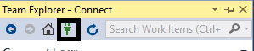

- Click on clone.

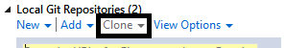

- Go to your Bitbucket account

- Clone From repository there using
https://UtsaviDave@bitbucket.org/PaymentsGuy/colsys.git

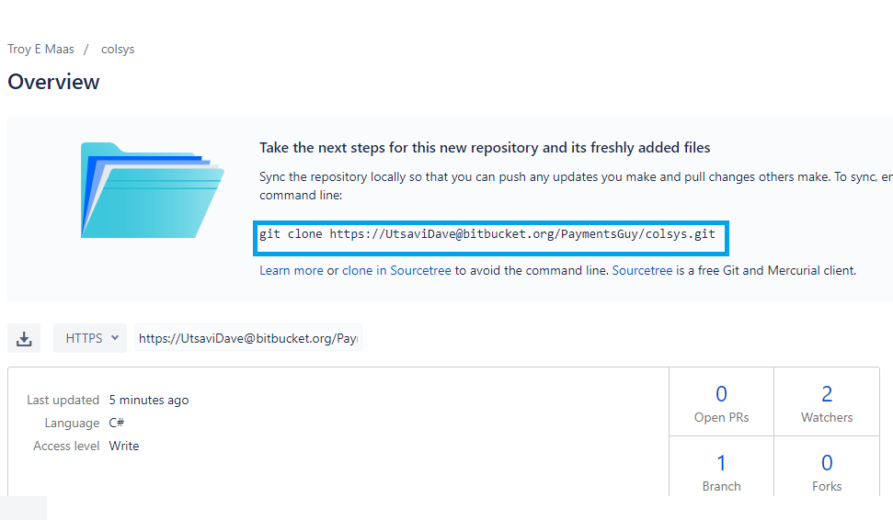

- Add clone URL and set particular location to download project in local PC.
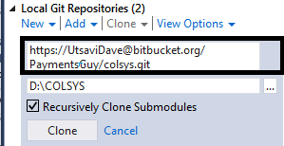
Insert clone URL here
Choose location of your project in system
- To open project solution in visual studio go to project folder open colsys.WebAPI project then open colsys.ALL.sln file.

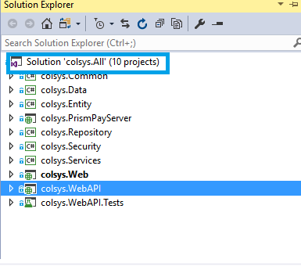
- There must be 10 projects in solution.
- Now Clean Solution and Rebuild solution.
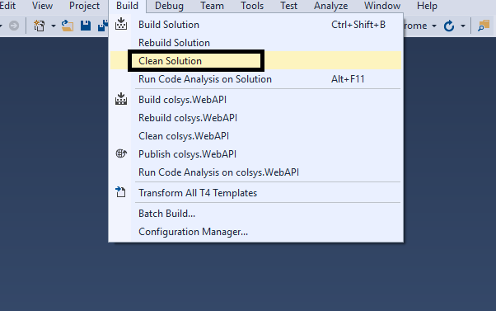

- If you get errors of assembly reference like below then close entire project , open it again clean solution and rebuild solution.
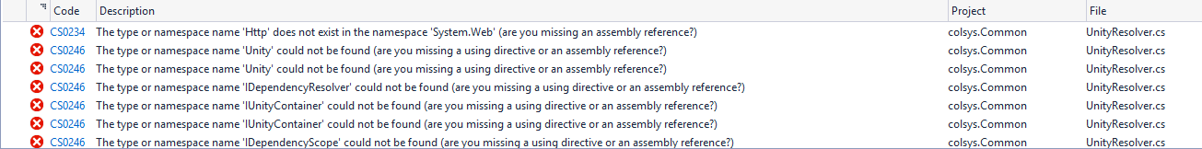

- Run Project.
- If errors doesn’t removed then update your solution with latest edmx in colsys.Entity project.
- Right click and click on Update Model From Database

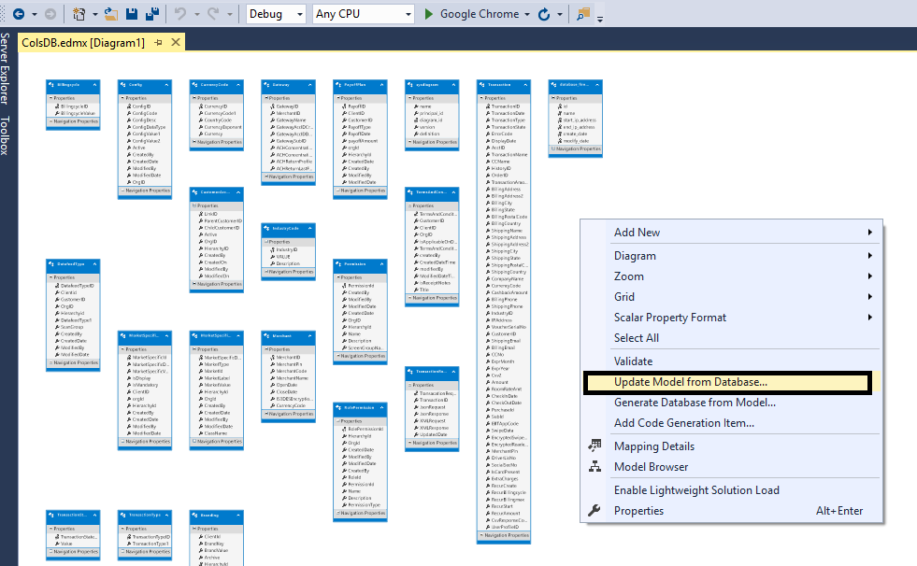
- Pop up like below will come select check box of Tables,Views and store procedures and Function to get latest changes from database ,then click on finish.
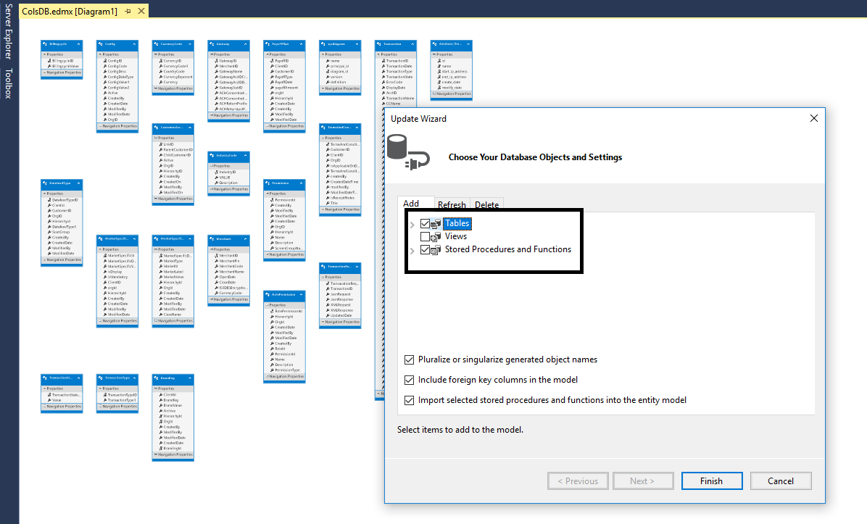
- Now clean and rebuild solution.
- If still find errors to build project successfully then open edmx file right click and click on Model Browser.
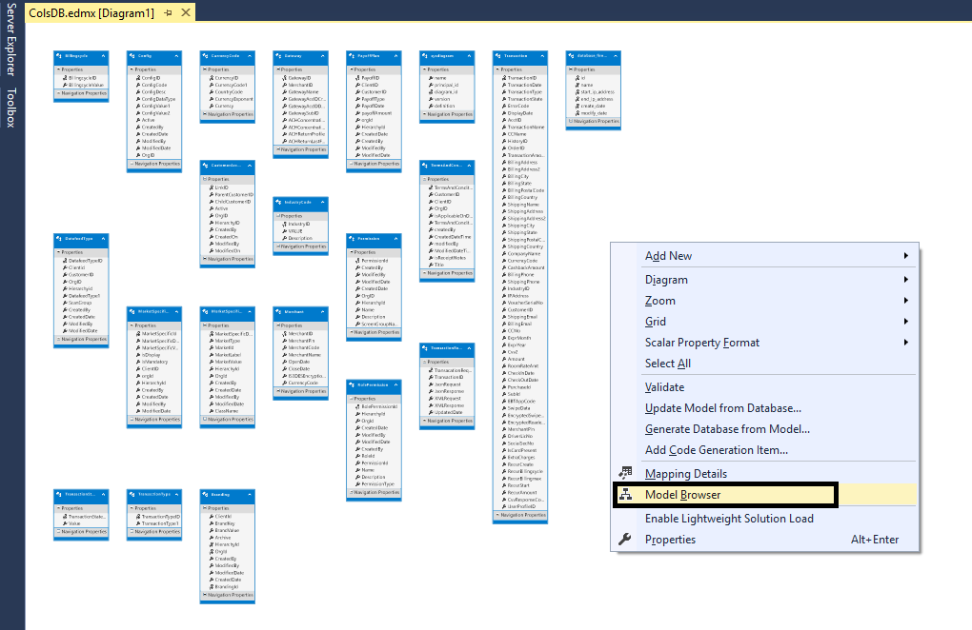
- Now delete all contents from Entity type ,Complex Type, Function Imports, Tables/Views, Store procedure/ Functions.

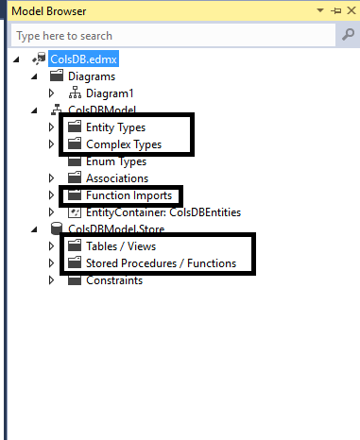
- Now update model from database and get latest edmx.
- Clean solution and rebuild solution.

