
e-Yantra Robotics Competition - 2014
Implementation Analysis – Cargo Alignment Robot

<Team ID>
Team leader name
College
Email
Date

<This report contains three sections:
1. Preparing the Arena
2. Design Analysis
3. Algorithm Analysis
Teams have to answer question/s from these sections according to their understanding of the theme and the given Firebird V robot. >

Preparing the Arena (5)
<Prepare the arena according to the steps given in Section 3: Arena, of the rulebook. Take a photo of the complete arena such that the entire arena is clearly visible in the photo. Insert the image here>

Design Analysis
Q-1. How will you detect the correct/incorrect position of blocks? (10)
<List the sensor(s) you would use to detect the block. Give a brief description of the working of the sensors>

The sensors used to detect the block and their orientations are the proximity sensors and the sharp sensor.

- Under normal conditions the proximity sensor placed in front of the bot will be used. The proximity sensor consists of an IR LED and a photo diode. The proximity sensor can detect objects up to a certain distance which will be determined during calibration. In the absence of the obstacle there is no reflected light hence no leakage current will flow through the photo diode and output voltage of the photo diode will be around 3.3V. As obstacle comes closer, more light gets reflected and falls on the photo diode and leakage current flowing through the photo diode starts to increase which causes voltage across the diode to fall. The value returned (within a range depending on lighting conditions and other conditions) if the object is present, will determined during calibration. If the white face of the cube is facing the bot, the value returned will be smaller when compared to the value when the black face is facing the bot. These values will be determined and the correct placing of the cube will also be determined accordingly.

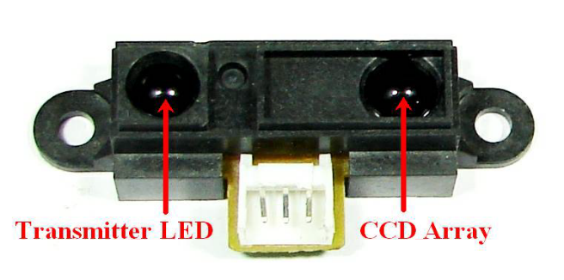
Infrared range finder

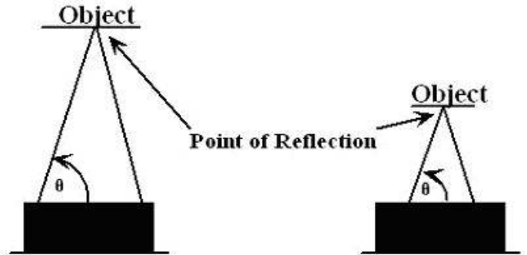

Distance measurement based on the angle of reflection

- The proximity sensors on the side of the bot will be used to detect cubes from the side (depending on the navigation scheme) while scanning two rows at a time.
- The additional sensors and the proximity sensor will be used to detect the correct orientation of cubes from the side in D2.
- The sharp sensor at the front will be used to check whether a cube is present behind another cube and its orientation again is determined by the additional sensors given.

Q-2. Draw a labeled diagram to explain how you have planned to place the sensors on/around the robot? (10)
<Draw a neat diagram to show the positions of sensors on and around the robot. Show all the sensors you are using in designing the theme. Justify placement of the sensors shown in your diagram>
Q-3. Teams have to make the robotic arm for picking up/rotating the blocks in the arena.

- Choose an option you would like to use to position the robotic arm on the robot and why? (5)

- Front 2. Back 3. Right/Left 4. On both sides

Answer: Front

< Justify your choice for placement of the robotic arm.
Word-limit: 300 words
>

- The placement of the arm at the front of the bot is thought of by the team as the navigation would be simpler in this case. Even though this might not be the most efficient placement in terms of time taken to complete the task, it will make the navigation much simpler and less erroneous.
- The placement of the two arms on either side of the bot would lead to heavy difficulties during calibration of the different servos on either side which might lead to improper gripping and misplacement of the cube.
- By placing the arm at the front of the bot the error is minimized significantly and the navigation is simplified and can be easily implemented.

- Draw a diagram to show the robotic arm and how it is mounted on the robot. Also show the mounting of the white line sensor. (10)
<Draw figure(s) to show how you are planning to mount the robotic arm and white line sensor on the robot. >

Q-4. Choose the actuator you will use to design the robotic arm. (5)
- DC-Motor 2. Servo Motor 3. Stepper Motor 4. Others

Answer: Servo motor

Justify your answer by stating the advantage of the chosen actuator over others. Also give reasons for not using other actuators.

- Servos are fully self-contained, the velocity and angle control loops are very easy to implement.
- Servo motors are easily affordable and available.
- Servos have precision positioning which is of utmost importance in an application like ours.
- Unlike Dc motors servos have built in gearing and feedback control loop circuitry. Also servos don’t require a motor driver IC
- Stepper motors have many more poles than servo motors. One rotation of a stepper motor requires much more current exchanges through the windings than a servo motor. So a stepper draws more current. Thus servo motor is preferred over stepper motor.
- Servos have feedback. They take the value from the motor’s encoder and check the difference between that and the commanded input thus providing effective feedback.

Q-5. How will you detect the block positions in Division 1 and Division 2? Which sensor/s are required to detect the block positions? Explain your algorithm to detect the blocks in both divisions. (15)
<
Answer format: Bulleted form
Step 1:
Step 2:
Step 3…etc.
>

Step 1: Enter D1 and turn left to detect whether a block is present or not using the front proximity sensor, if the block is present check its orientation. If the block is present then lift it and check whether any block exists behind using the sharp sensor. Correct the blocks orientation if wrong.
Step 2: if the block exists and is incorrectly placed go and change its orientation.
Step 3: if the block is not present come back and check whether block is present in the next row using the sharp sensor. If the sharp sensor detects the cube then it’s present in the farthest node, check for its correctness and go change orientation if wrong.
Step 4: similarly scan the right side and continue till row 1.

Step 5: After D1 is done, enter through the gate using the side proximity sensors and detect the wall using the front proximity or the sharp sensor.
Step 6: follow the wall using the side proximity sensors and detect the opening using the same.

Step 7: Enter D2 and check for the cube using the front and the side proximity sensors (might change depending on navigation). Check for orientation using the extra sensors given and accordingly correct position if wrongly placed.

Q-6. (15)
a. How will you connect the white line sensor? Show the schematic pin connection diagram.
<Draw figure(s) to show how you are planning to connect the white line sensor on the robot. >
Answer format:
Step 1:
Step 2:
Step 3…etc.
>

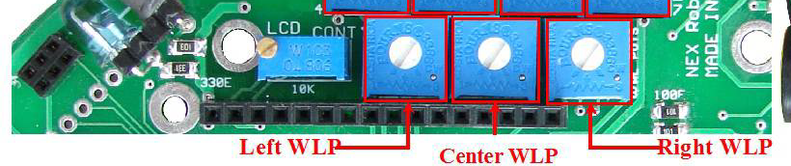

Potentiometers to calibrate the white line sensors

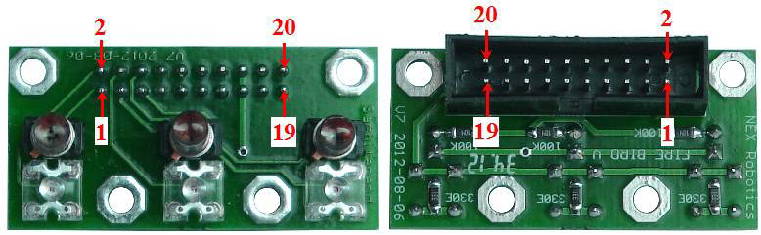

White line sensor connector pin config on the sensor board

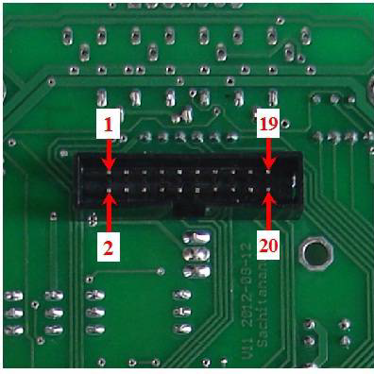

White line sensor pin config on the main board

Pin No. Function

1. White line sensor 1 (Left sensor) Data Out
2. White line sensor 1 LED via potentiometer
3. White line sensor 2 (Center Sensor) Data Out
4. White line sensor 2 LED via potentiometer
5. White line sensor 3 (Right sensor) Data Out
6. White line sensor 3 LED via potentiometer
15. GND
16. GND
17. White Line switch (Jumper). Refer to figure 3.41a and 3.41b
18. White Line switch (Jumper). Refer to figure 3.41a and 3.41b
19. 3V3 Sensor supply
20. 3V3 Sensor supply

b. Upload a video to show the threshold values of white line sensor for detecting black and white colors of a block.
<
For video: Place the white line sensor near the block and display black and white values on the Liquid Crystal Display (LCD). Instructions to upload the video are given on the portal.
>

c. Threshold value obtained: white = _____________ Black = _____________
<
Determine the threshold value using the white line sensor values.
>

Algorithm Analysis

Q-1 Draw a flowchart illustrating the algorithm used to complete the entire task. (50)

<
The flow chart should elaborate on every aspect of completing the entire task. Follow the standard pictorial representation used to draw the flowchart. There is no restriction on the number of pages for showing the complete algorithm
>

