**CPJB009 - Java Case Study: Database connectivity, Integration &Performance Testing Submission**

**Source code:**



**Screenshots captured:**

1. Database properties:

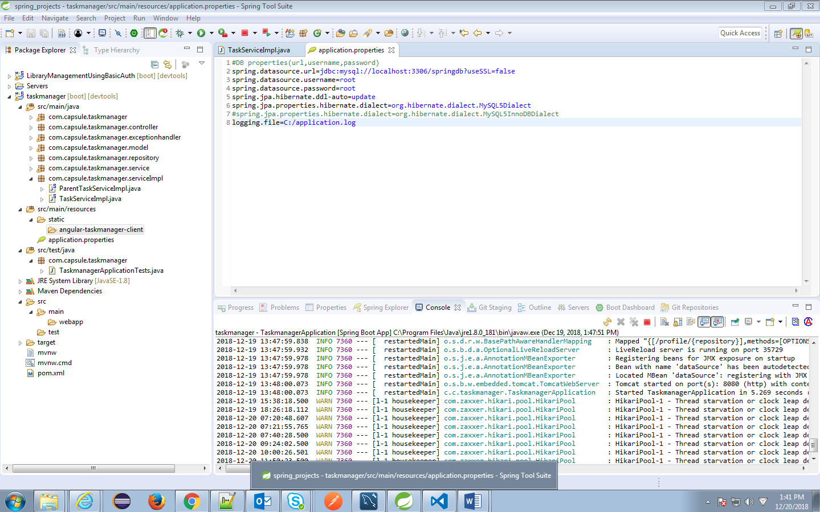

1. MySQL Tables:

**Task table:**

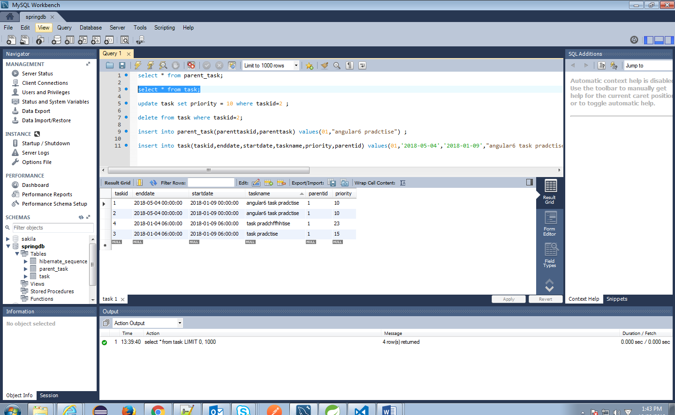

**Parent Task Table:**

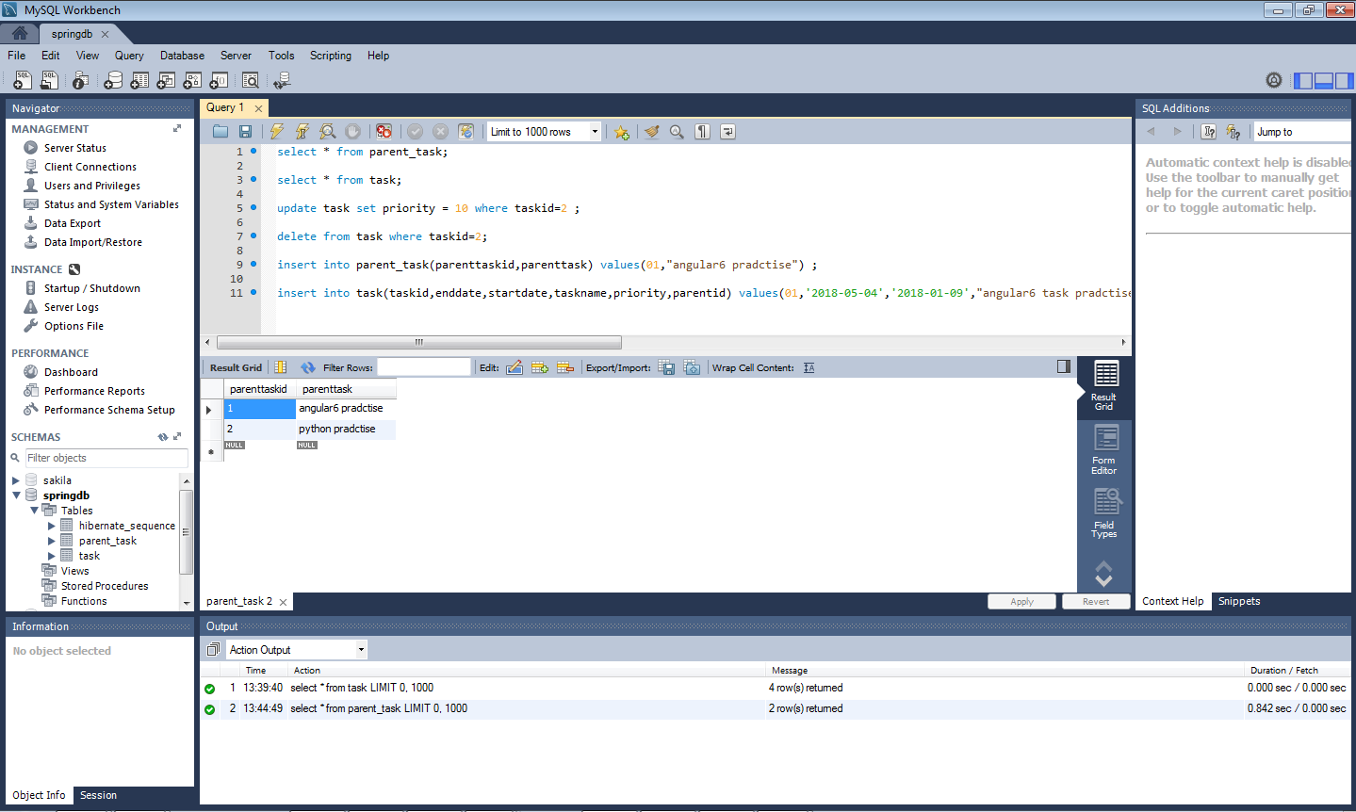

1. Test cases for RESTFul Services:
2. GetAllTask Test Case:

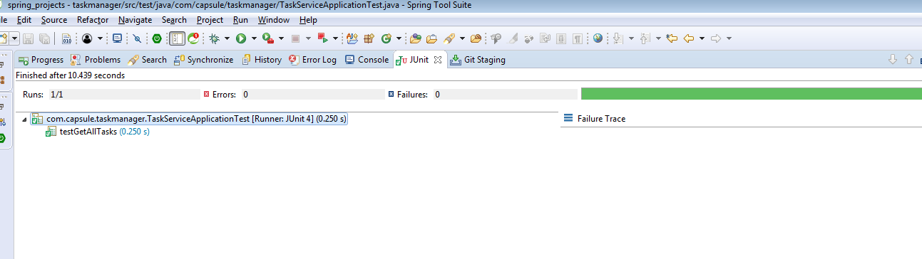

1. GetTaskById Test Case:

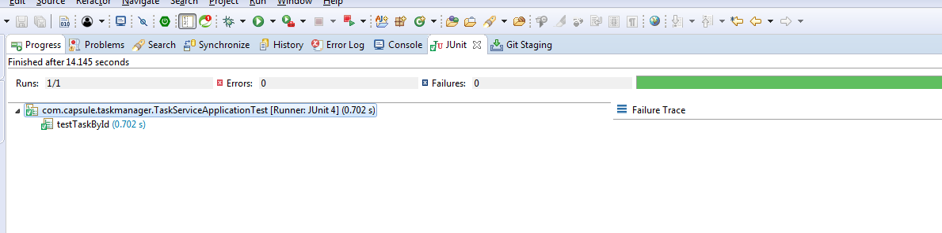

1. Add Task Test Case:

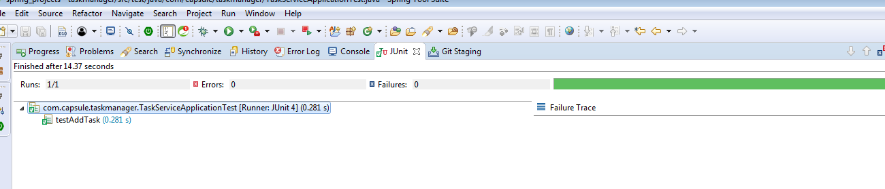

1. Update Task Test Case:

