**CPJB009 -Java Case Study: Deployment Submission**

**Source code:**



**Task Manager Application Deployment Specification:**

**Deployment & Infrastructure:**

|  |  |  |
| --- | --- | --- |
| **Technology** | **Framework(s)/SDK/Libraries** | **Version** |
| Apache Tomcat |  | 8.0.23(embedded) |
| Node |  | 10.2.0 |
| Dependency Management Tool | NPM | 5.6.0 |
| Apache Maven |  | 3.5.3 |

**Editors:**

|  |  |
| --- | --- |
| **Editor** | **Version** |
| Visual Studio Code | 1.9.1 |
| Spring-STS | 3.9.3 RELEASE |

**Screenshots captured:**

1. Spring Boot Application console:

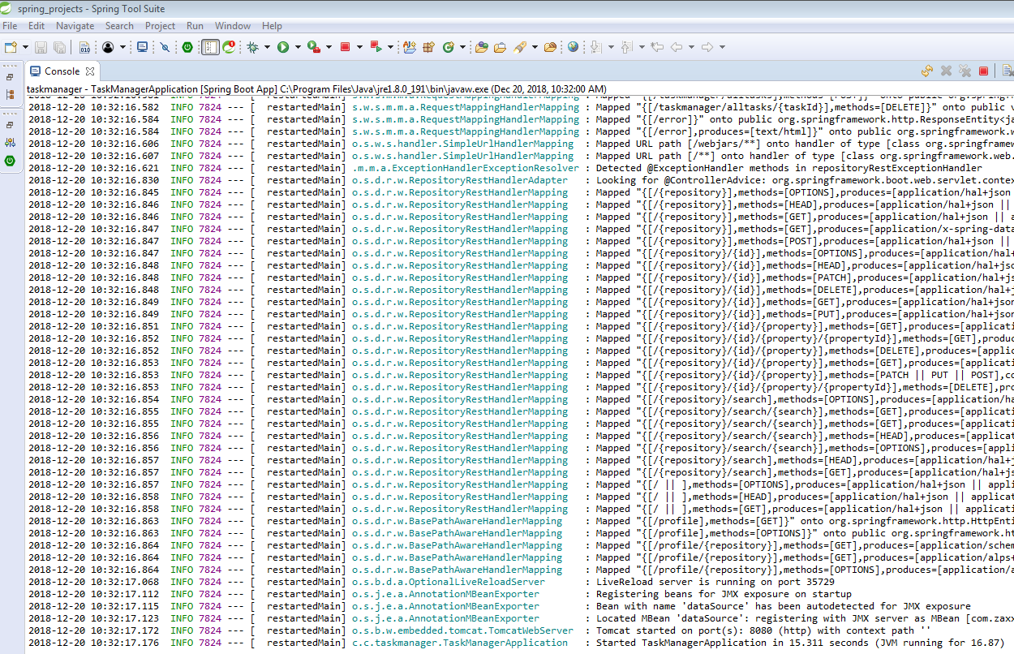

1. Angular CLI Console:

