**Java Final Certification**

**Source code:**

**Angular client Code: Spring Boot Application**:



**Front End Layer:**

|  |  |
| --- | --- |
| **Framework(s)/SDK/Libraries** | **Version** |
| Angular | 6.1.10 |
| Bootstrap | 4.1.3 |
| CSS | 3 |
| HTML | 5 |
| Type Script | 2.9.2 |
| JQuery | 3.3.1 |

**Middle Tire Layer:**

|  |  |  |
| --- | --- | --- |
| **Technology** | **Framework(s)/SDK/Libraries** | **Version** |
| Java Stack | Spring Boot | 2.0.5 |
| JDK | 1.8 |
| MAVEN | 3.5.3 |

**Database & Integration Layer:**

|  |  |  |
| --- | --- | --- |
| **Technology** | **Framework(s)/SDK/Libraries** | **Version** |
| Java Stack | Spring RESTful | 2.0.5 |
| MySQL | 5.7 |

**Ancillary Layer:**

|  |  |  |
| --- | --- | --- |
| **Technology** | **Framework(s)/SDK/Libraries** | **Version** |
| Source Code Management Tool | GIT | 2.19.1.windows.1 |
| Build Tool/Java Stack | Maven | 3.5.3 |
| Testing Tool/Java Stack | JUnit | 4.12 |
| Testing Tool/Java Stack | Spring Test | 5.0.9 |

**Deployment & Infrastructure:**

|  |  |  |
| --- | --- | --- |
| **Technology** | **Framework(s)/SDK/Libraries** | **Version** |
| Apache Tomcat |  | 8.0.23(embedded) |
| Node |  | 10.2.0 |
| Dependency Management Tool | NPM | 5.6.0 |
| Apache Maven |  | 3.5.3 |

**Editors:**

|  |  |
| --- | --- |
| **Editor** | **Version** |
| Visual Studio Code | 1.9.1 |
| Spring-STS | 3.9.3 RELEASE |

**Screenshots captured:**

1. Add Project

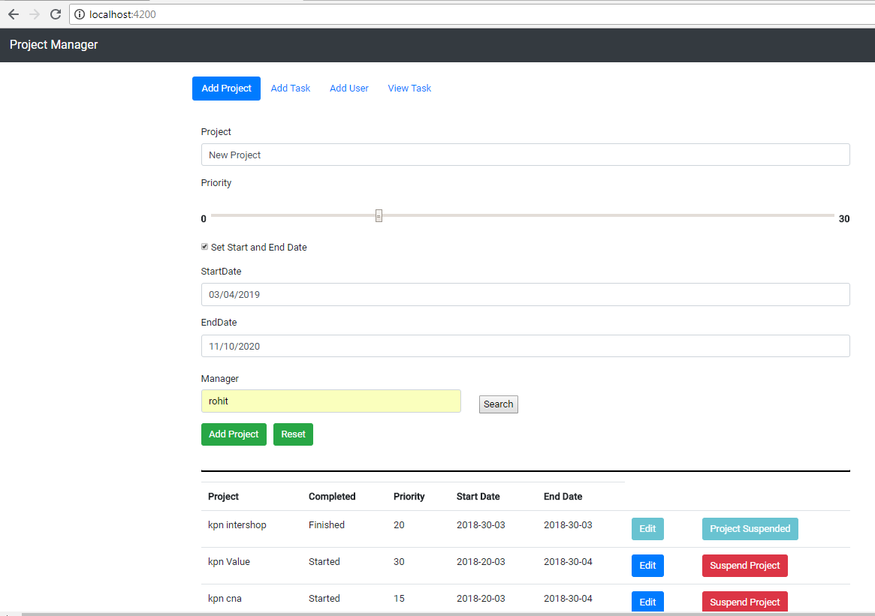

1. Project List with newly added project

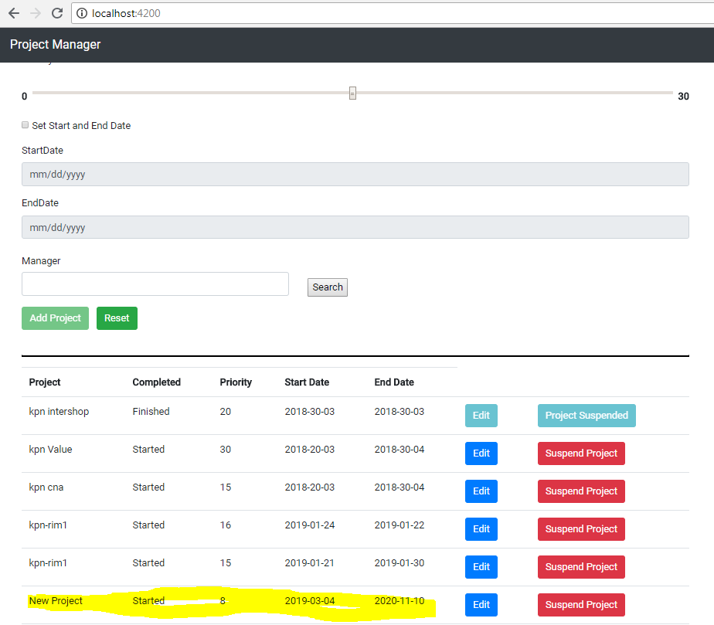

1. Add User

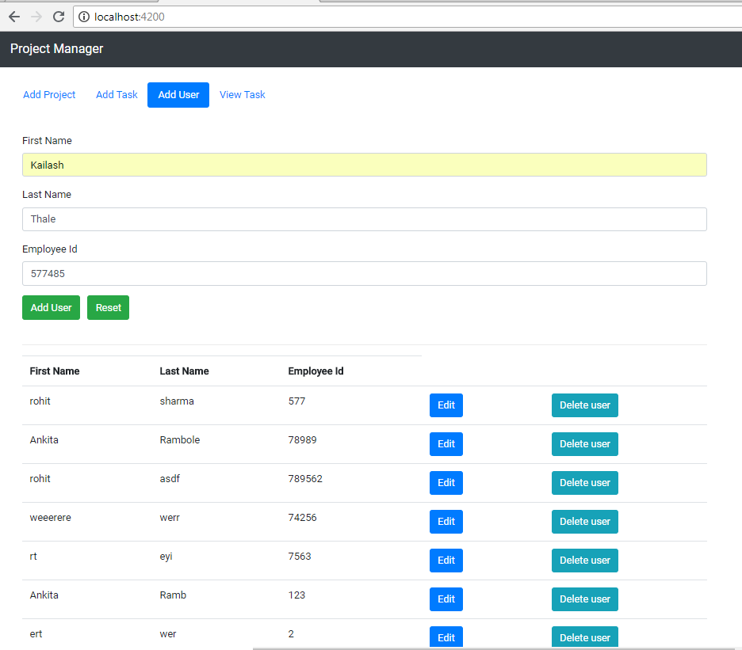

1. Edit User

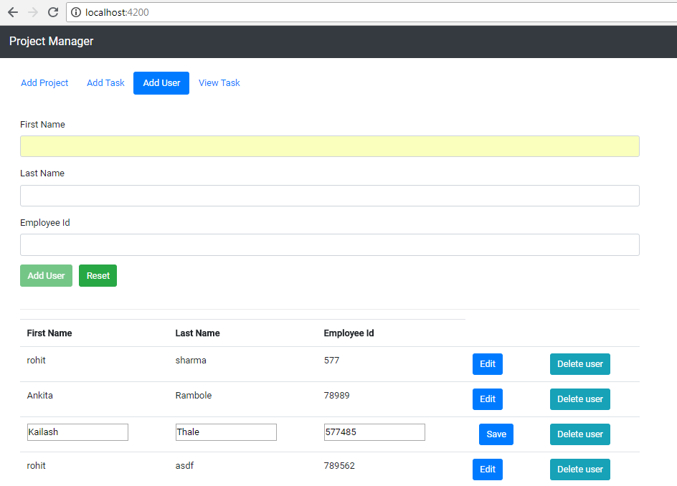

1. Add Task

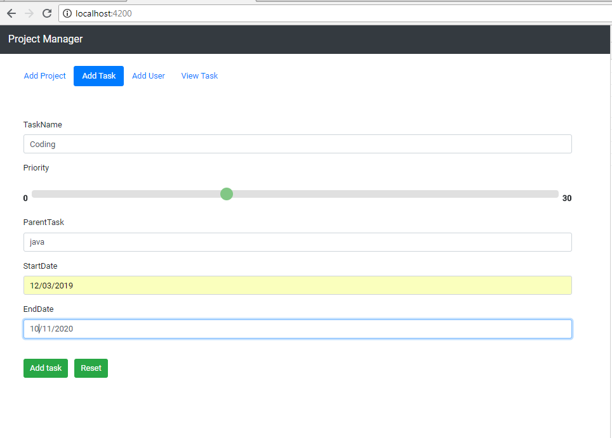

1. View Task

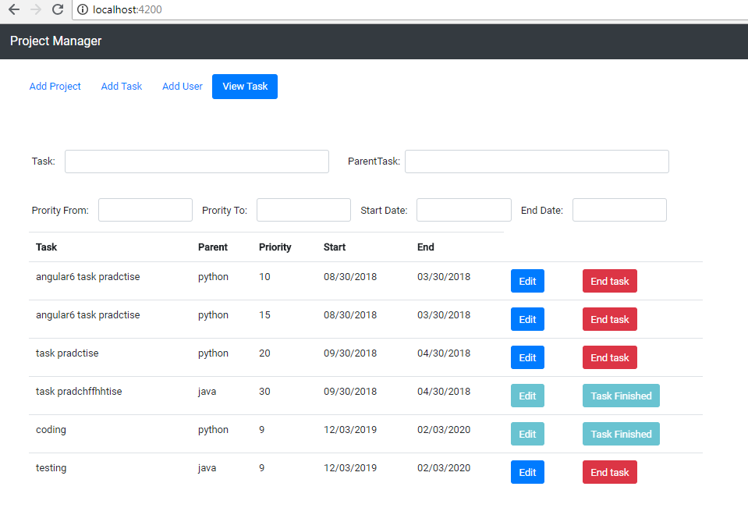

**Screenshots of database and DB connection:**

1. Database properties:

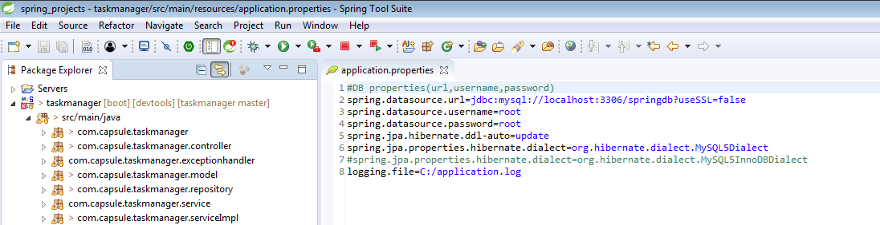

1. MySQL Tables:

**Task table:**

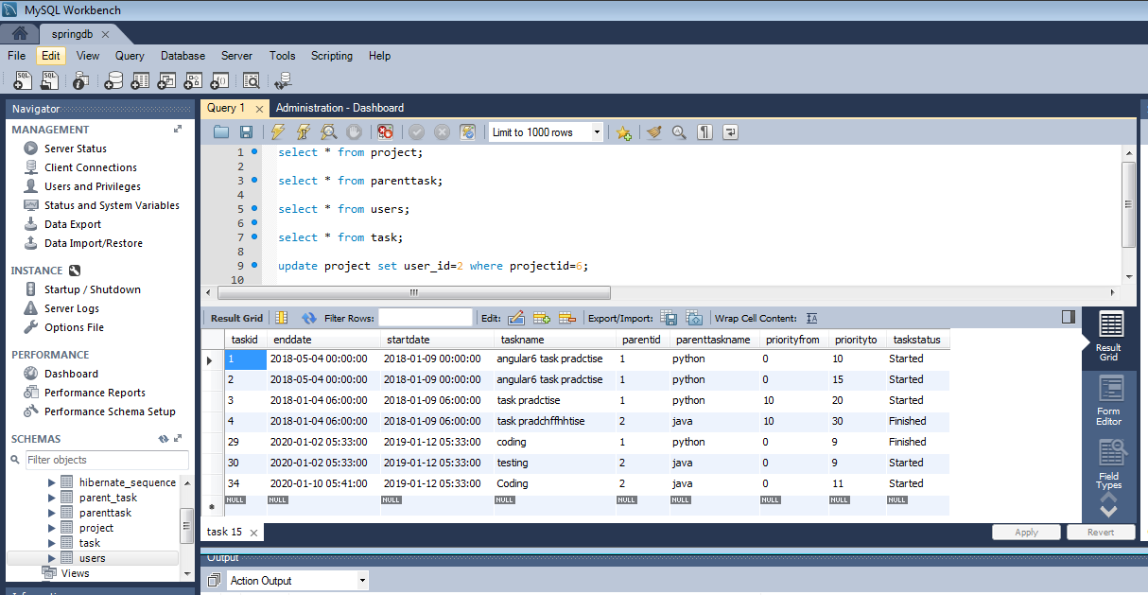

**Parent Task Table:**

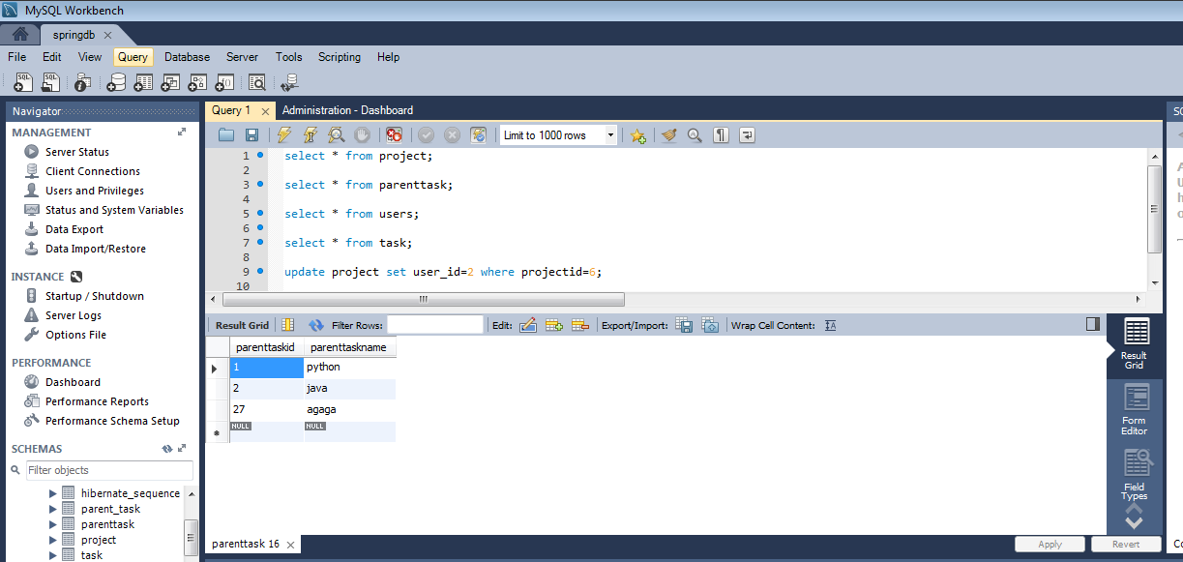

**Project Table:**

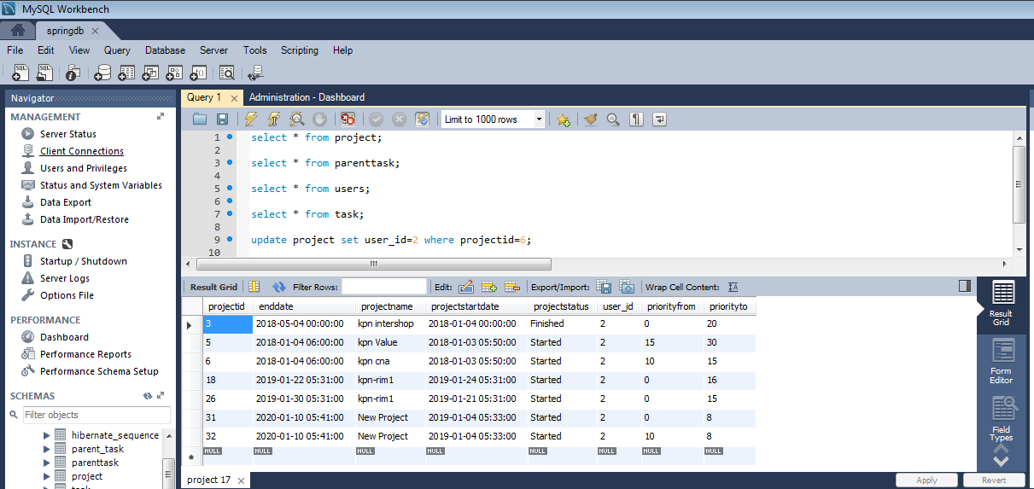

**Users Table:**

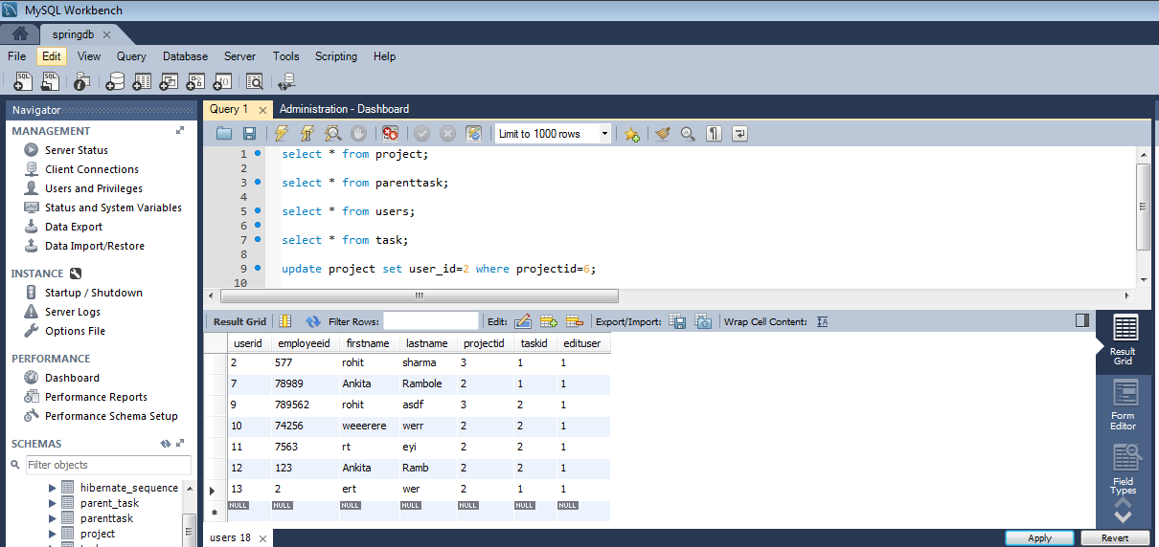

**Test cases for RESTFul Services:**

1. GetAllTask Test Case:

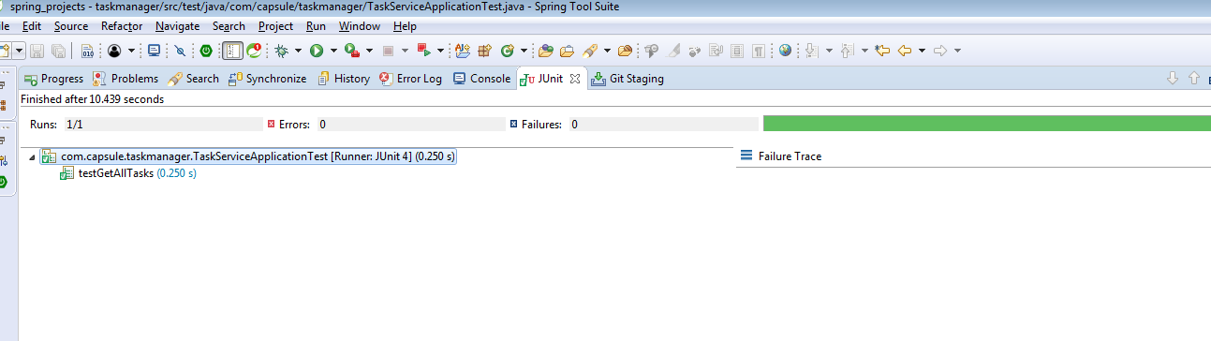

1. GetTaskById Test Case:

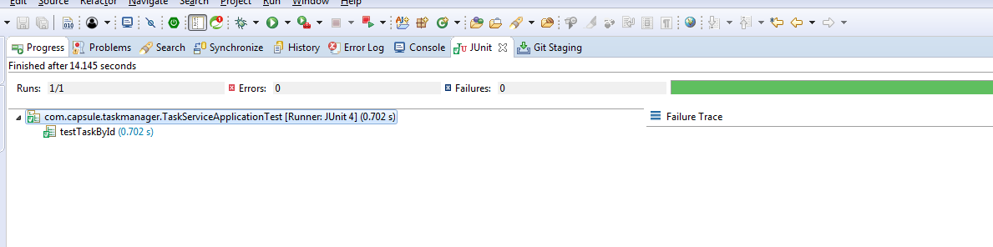

1. Add Task Test Case:

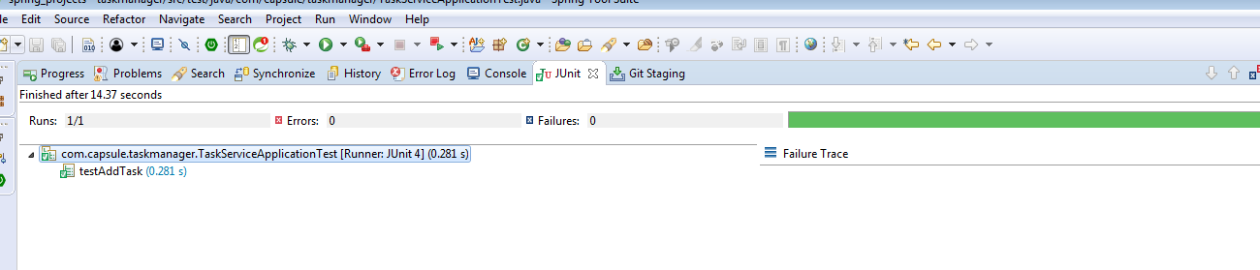

1. Update Task Test Case:

