**Runbook (Automation Account)**

In Azure, a runbook is an automated workflow that performs a series of predefined tasks or operations. It is a set of instructions or scripts that can be executed to automate various processes and operations within Azure or across different systems and platforms.

Azure runbooks are commonly used in Azure Automation, which is a cloud-based service that provides process automation and configuration management for Azure resources and external systems. Runbooks can be created, scheduled, and executed within Azure Automation.

Runbooks can be authored using different scripting or programming languages, such as PowerShell, Python, or a graphical editor. They can perform a wide range of tasks, including resource provisioning, configuration management, backup and restore operations, patch management, monitoring and alerting, and more.

Runbooks can be triggered manually or automatically based on specific events or schedules. For example, a runbook can be triggered when a new virtual machine is created, a specific time interval is reached, or an external system sends a webhook request.

By using runbooks in Azure, organizations can streamline and automate their workflows, reduce manual effort, ensure consistent operations, improve operational efficiency, and achieve faster and more reliable execution of tasks and processes.

**Use Case:**

**1. Provisioning and Deprovisioning Resources:** Runbooks can automate the creation and deletion of Azure resources, such as virtual machines, storage accounts, databases, or network configurations. This streamlines the resource management process and ensures consistent deployments.

**2. Configuration Management:** Runbooks can be used to automate the configuration of Azure resources, including setting up networking, configuring security rules, applying desired state configurations, and managing application settings. This helps maintain consistency across environments and reduces manual configuration efforts.

**3. Backup and Restore:** Runbooks can automate the backup and restore operations for Azure resources, such as virtual machines, databases, or storage accounts. This ensures data protection and simplifies the recovery process in case of accidental data loss or system failures.

**4. Patch Management:** Runbooks can automate the process of applying patches and updates to Azure resources, including virtual machines and operating systems. This helps ensure that systems are up to date with the latest security patches, bug fixes, and feature enhancements.

**5. Monitoring and Alerting:** Runbooks can monitor Azure resources and trigger automated actions based on specific events or conditions. For example, a runbook can be triggered when CPU usage exceeds a threshold, and it can automatically scale up resources or send notifications to relevant stakeholders.

**6. Scheduled Maintenance Tasks:** Runbooks can be scheduled to perform routine maintenance tasks, such as database optimization, log file cleanup, or periodic system health checks. This helps ensure the smooth operation of Azure resources and minimizes manual intervention.

**7. DevOps and CI/CD** **Pipelines**: Runbooks can be integrated into DevOps and continuous integration/continuous deployment (CI/CD) pipelines. They can automate deployment processes, configuration updates, and testing, ensuring efficient and consistent application releases.

**8. Compliance and Governance:** Runbooks can be used to enforce compliance policies and governance rules within Azure environments. For example, a runbook can periodically scan Azure resources for non-compliant configurations and automatically remediate them or generate compliance reports.

**9. Troubleshooting and Remediation:** Runbooks can automate troubleshooting and remediation tasks in response to incidents or alerts. They can perform diagnostic checks, collect logs, and initiate recovery actions to minimize downtime and reduce the time taken to resolve issues.

**10. Cost Optimization:** Runbooks can be used to automate cost optimization measures, such as scaling down resources during non-peak hours or decommissioning unused resources. This helps optimize resource utilization and reduce unnecessary costs.

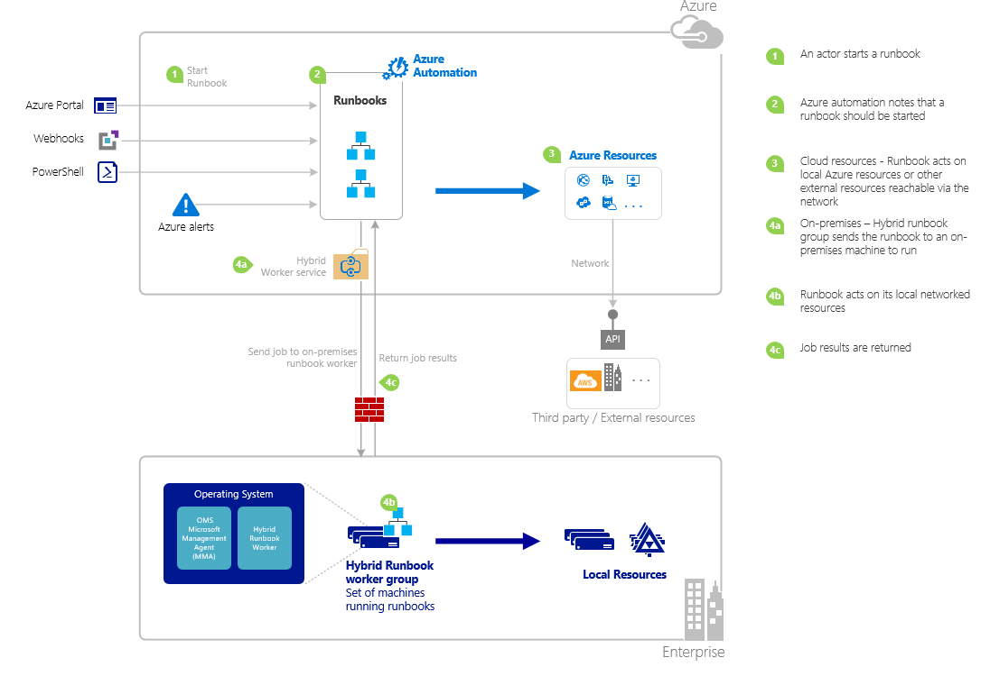

**1. Runbook Creation and Storage:**

- Runbooks are created either by writing scripts in PowerShell, Python, or by using the graphical runbook editor.

- The runbooks are stored within the Azure Automation Account, which serves as a central repository for managing and organizing runbooks.

**2. Trigger or Schedule:**

- The execution of runbooks can be triggered by different events or schedules.

- Triggers can be events like webhook requests, Azure service events, or manual triggering.

- Schedules allow runbooks to be executed at specific times or intervals, based on a predefined schedule.

**3. Runbook Execution:**

- When a trigger event occurs or a scheduled time is reached, the runbook execution process begins.

- The Automation Account initiates the execution of the specified runbook.

**4. Access to Assets:**

- Runbooks can access assets such as credentials, variables, and connections to external systems.

- These assets are securely stored within the Automation Account and can be referenced by the runbooks during execution.

- For example, a runbook may require a stored username and password to authenticate with an external system.

**5. Integration Modules:**

- Runbooks can leverage integration modules that provide additional functionality and pre-built cmdlets or functions.

- Integration modules are imported into the Automation Account and made available to the runbooks.

- These modules expand the capabilities of the runbooks and enable them to interact with Azure services or perform specific tasks.

**6. Logging and Output:**

- During runbook execution, logging and output information are generated.

- This information includes execution details, errors, debugging information, and any custom output generated by the runbook.

- The Automation Account captures and stores this logging and output data.

**7. Monitoring and Alerting:**

- Azure Monitor and Azure Monitor Logs can be used to monitor the execution of runbooks.

- Telemetry data from runbook executions can be captured and monitored in Azure Monitor.

- Alerts can be configured to trigger notifications or actions based on specific runbook execution events or conditions.

**How to configure Runbook?**

1. Create an Azure Automation Account:

- In the Azure portal, navigate to the desired subscription and resource group.

- Click on "+ Create a resource" and search for "Automation".

- Select "Automation" from the search results and click "Create".

- Provide the required details such as name, subscription, resource group, and region.

- Choose the desired pricing tier (Free or Basic) for the Automation Account.

**2. Create a Runbook:**

- Inside the Automation Account, navigate to the "Runbooks" section.

- Click on "+ Create a runbook" to create a new Runbook.

- Provide a name and description for the Runbook.

- Choose the desired runbook type: PowerShell, Python, or Graphical (Graphical is recommended for beginners).

- If selecting the PowerShell or Python type, you can enter the script directly. For the Graphical type, you can use the graphical editor to design the Runbook workflow.

**3. Configure Runbook Settings:**

- After creating the Runbook, you can configure various settings based on your requirements.

- Set the desired runbook parameters, such as input and output variables, if applicable.

- Define any necessary connection assets or module dependencies.

- Set the required runbook permissions and access controls.

**4. Test and Publish the Runbook:**

- It's recommended to test the Runbook before publishing it for production use.

- Use the "Test pane" or "Test pane (graphical)" to provide input parameters and execute the Runbook.

- Verify that the Runbook performs as expected and produces the desired output.

- Once satisfied with the testing, click on "Publish" to make the Runbook available for execution.

**5. Trigger and Schedule the Runbook:**

- Runbooks can be triggered manually, based on a schedule, or through external events.

- To manually trigger the Runbook, click on "Start" within the Runbook's overview page.

- For scheduled execution, navigate to the "Schedules" section within the Automation Account and create a new schedule.

- Configure the desired time, frequency, and recurrence pattern for the schedule.

- Alternatively, Runbooks can be triggered by external events or integrations using webhooks or Azure service event triggers.

**6. Monitor and Troubleshoot the Runbook:**

- Azure Automation provides monitoring and logging capabilities for Runbooks.

- View the job history and status of Runbook executions in the "Jobs" section within the Automation Account.

- Monitor the output and logging information to track the execution flow and identify any issues.

- If needed, modify the Runbook script or settings and publish updates to address any identified issues.

**Comparison of the runbook or automation services offered by different cloud providers:**

**1. Azure Automation (Azure):**

- Azure Automation provides a comprehensive automation service with features like Runbooks, integration modules, asset management, and scheduling capabilities.

- It supports PowerShell, Python, and graphical runbooks for scripting automation tasks.

- Azure Automation integrates well with other Azure services, enabling seamless orchestration and automation of workflows within the Azure ecosystem.

- It offers advanced monitoring, logging, and troubleshooting capabilities for runbooks.

- Azure Automation has a pay-as-you-go pricing model based on the number of job run time minutes.

**2. AWS Systems Manager (AWS):**

- AWS Systems Manager provides a suite of management tools for AWS resources, including automation capabilities.

- AWS Systems Manager Automation enables you to create automation documents (similar to runbooks) using JSON or YAML.

- It supports AWS service actions, AWS CLI commands, and custom scripts for automation.

- AWS Systems Manager integrates with other AWS services and provides a centralized platform for managing automation tasks.

- It offers features like parameter store, inventory management, and compliance checks.

- Pricing for AWS Systems Manager is based on the number of automation documents executed and the number of API operations used.

**3. Google Cloud Deployment Manager (Google Cloud):**

- Google Cloud Deployment Manager is a service for managing infrastructure deployments on Google Cloud.

- While it is primarily focused on infrastructure provisioning and management, it can be used for automation tasks as well.

- Deployment Manager uses YAML or Python templates to define and execute deployments.

- It integrates with other Google Cloud services and supports custom templates and configuration files.

- Google Cloud Deployment Manager provides monitoring and logging capabilities for deployments.

- Pricing for Deployment Manager is based on the resources created and managed.

**4. IBM Cloud Automation Manager (IBM Cloud):**

- IBM Cloud Automation Manager is a service that enables the automation of infrastructure provisioning and application deployments.

- It supports defining workflows using YAML templates and uses Terraform and Ansible for resource provisioning and configuration management.

- IBM Cloud Automation Manager provides integration with IBM Cloud services and supports multi-cloud deployments.

- It offers features like self-service catalogs, policy-based governance, and role-based access control.

- IBM Cloud Automation Manager provides monitoring and analytics capabilities for deployments.

- Pricing for IBM Cloud Automation Manager is based on the resources provisioned and managed.

**Pricing:**

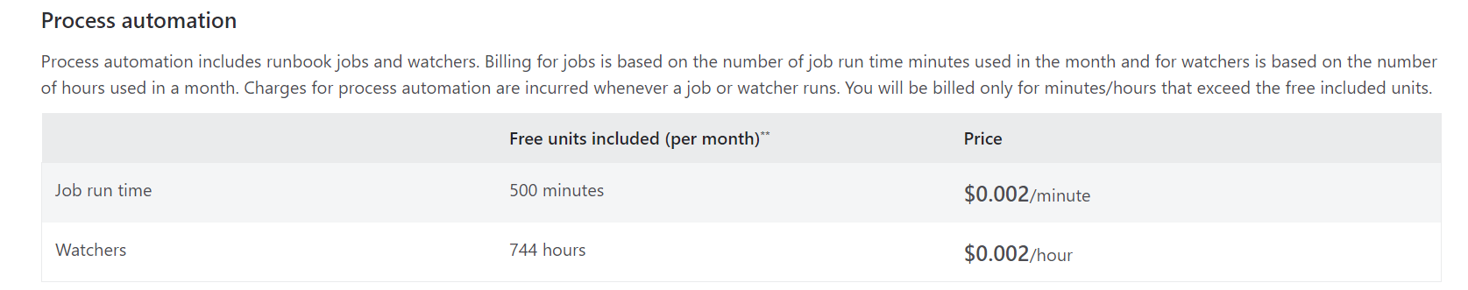

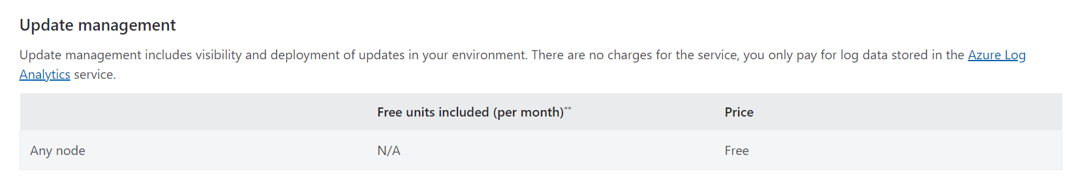

**Configuration management:**

