**Prerequisites**

1. Make sure that the Elder Law Answers Content Terminal is installed on your website and is connected to your Elder Law Answers Account

**Installation:**

1. Go to <https://github.com/kdu2030/herndonlawscraper>. You should see the page below:

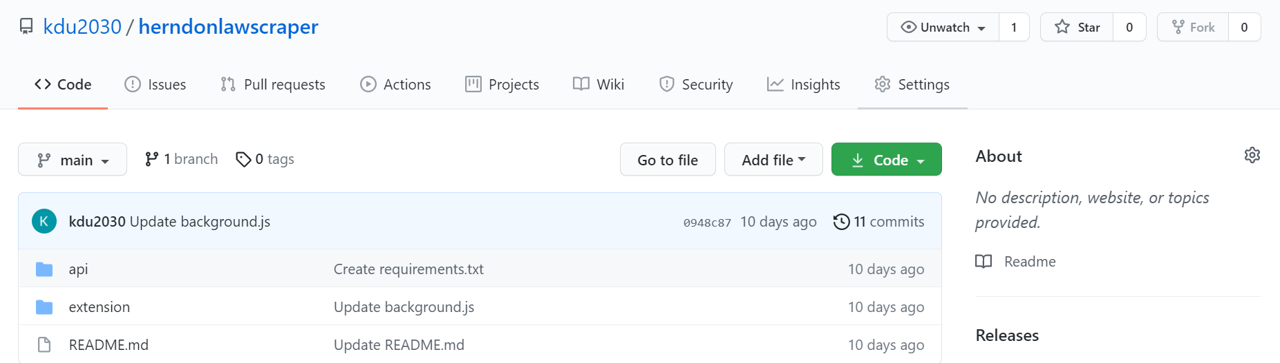

1. Click on the button. In the dropdown menu, select the “Download Zip” option.
2. Extract the zip. You should now have a folder named “herndonlawscraper-main”. Inside the folder, you should find another folder called “herndonlawscraper-main”. Inside that folder, you will find two folders and a ReadMe file. It should look like this in your file explorer:

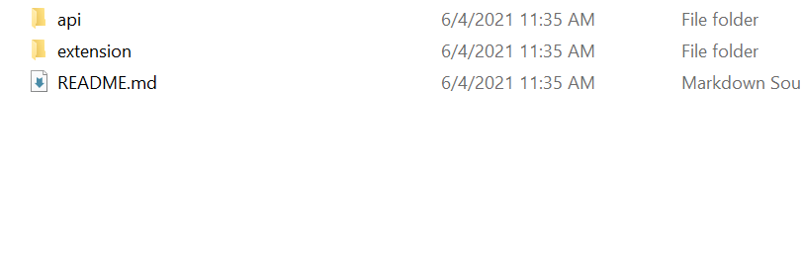

1. The api and the README file are unimportant. However, do not move any of the files in the extension folder. Those files are what make the extension work on Chrome.
2. In your Chrome browser, go to chrome://extensions. You should see a screen like this:

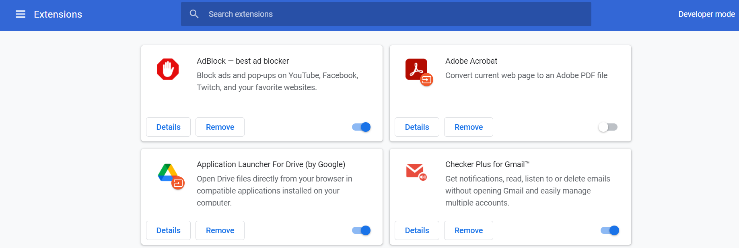

1. On the top right corner, there should be a setting called Developer Mode. Turn that on.



1. Once developer mode is on, your extension page should change. There should be three buttons that appear - Load Unpacked, Pack Extension, and Update.



1. Click on the Load unpacked button. A file explorer window should pop up, asking you to choose a folder. Navigate to the extension folder within the herndonlawscraper-main folders.

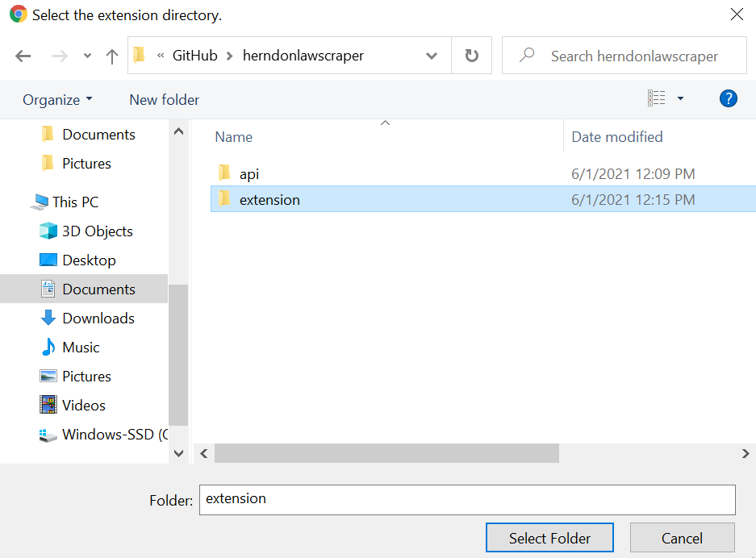

1. Click Select Folder. Then, you should see a new extension in the chrome://extensions page, as shown below:

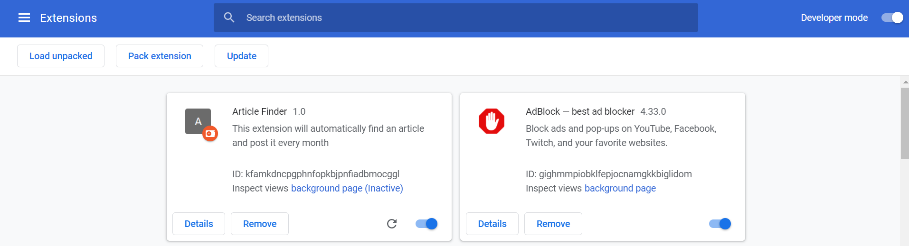

**Using the Extension:**

1. In Chrome, next to the URL box, you should see a puzzle piece icon. Click on the icon to access your extensions.



1. In the extensions menu, click on Article Finder.

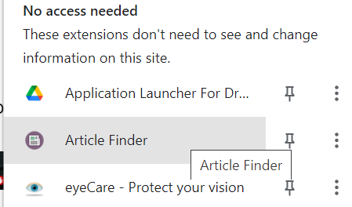

1. A window should appear that looks like this:

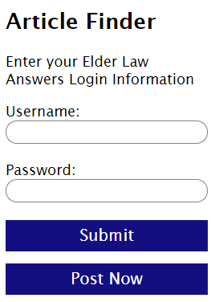

1. Type your Elder Law Answers login information into the two text boxes. Then, click the submit button. The login information should disappear after you click submit. This is normal.
2. Click Post Now for the extension to find an Elder Law Answers article and post it to your website immediately. Otherwise, the extension will find the newest Elder Law Answers article and post it on your website every Monday.