Class04.R

keilynduarte

2025-01-16

x<-1:50  
plot(x,sin(x))

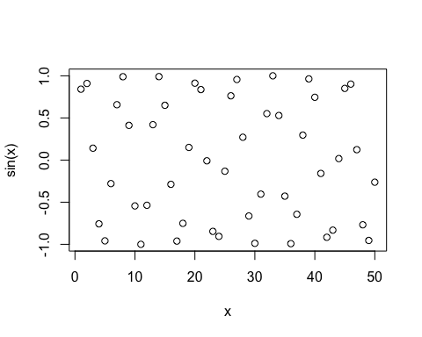

#Make this nicer  
plot(x,sin(x), col="pink", type="l", lwd=3)

