P2PSE – A Peer-to-Peer Support for Multiplayer
Games

Felipe Jung Vilanova, Carlos Eduardo Bezerra , Marcos Rates Crippa, Fábio Reis Cecin, Cláudio Fernando Resin Geyer
Universidade Federal do Rio Grande do Sul
Bento Gonçalves, 9500,
Porto Alegre, RS, Brazil
+55 (51) 33160000
{fjvilanova, carlos.eduardo, mrcrippa, fcecin, geyer}@inf.ufrgs.br

ABSTRACT
Nowadays, a very popular genre of games is the multiplayer one, because of its highly interative nature. Among those games, a category that is growing in popularity is the Massive Multiplayer Online Games (MMOG), which are real time games, played through the Internet, where thousands of players interact in a virtual world. The successfully commercial MMOGs, in this moment, are implemented using some variant of the client-server paradigm. This model presents simple design, facilitates the the security control and the detection and treatment of cheating. However, it lacks scalability. The cost of maintaining the server becomes excessive with the increased number of customers. One approach to deal with this situation is distributing the MMOG simulation. The changes in the virtual world of the game would be processed by the machines of the customers, without interference from the server. This distribution can be made using peer-to-peer techgnology.
In this paper, we describe a network engine, called P2PSE, which supports real-time multiplayer games on client-server and peer-to-peer networks. The aim of this engine is to provide a hybrid network structure, which provides support for partially decentralized MMOGs, ensuring scalability and flexibility, while guaranteeing the basic properties of a client-server model, such as security and consistency. We first examine in more details the distributed models to game support. Afther that, we talk about the P2PSE project and the characteristics of the network engine architecture developed in the project. And finally we present a simulation of the architecture in comparison with the traditional client-server model.
Categories and Subject Descriptors
C.2.1 [Computer-Communications Networks]: Network Architecture and Design - Distributed Networks; I.6.0 [Computing Methodology]: Simulation and Modeling - General.
General Terms
Algorithms, Design, Experimentation, Performance, Reliability, Security.
Keywords
Peer-to-peer, Descentralization, Scalability, Multiplayer Games, Hybrid Topologies, Instanced Game, Distributed Systems.

Permission to make digital or hard copies of all or part of this work for personal or classroom use is granted without fee provided that copies are not made or distributed for profit or commercial advantage and that copies bear this notice and the full citation on the first page. To copy otherwise, or republish, to post on servers or to redistribute to lists, requires prior specific permission and/or a fee.
NetGames’08, October 21–22, 2008, Worcester, Massachusetts, USA.

INTRODUCTION
Multiplayer games are a very popular game genre, due to their highly interactive nature. Among those games, a class that is growing in popularity is MMOGs (Massively Multiplayer Online Games). MMOGs are real-time multiplayer games played through the Internet, where a great number of players (usually thousands) play within a persistent-state virtual world. Successful examples include EverQuest [Entertainment a] and Ultima Online [Origin ].
The most common network model used on MMOGs is client-server. In this model, the client only sends its data to the server-side (that can operate on a single machine, a cluster or distributed on a grid) and receives frequent updates from the server. The server process all the data from the clients, and broadcasts all the results that occur on the virtual world back to the them. Some advantages of this model are: being simple in design; cheating can be efficiently detect and stopped; retaining control over access to the game; and being a predictable model.
The main disadvantage of the client-server model is the lack of scalability. The cost of maintaining the server-side become excessive with the increase in the number of clients. When talking about commercial games, the usual approach is to continuously expand the number of machines on the server-side. That is a reasonable solution, however it is not suitable for projects on a budget such as those from small companies or research groups.
One way of dealing with the above problem is to fully or partially distribute the MMOG simulation. All the changes on the game world would be registered and dealt within the client-side, with no interference of the server-side. Security and world state consistence are issues on that model, because there isn’t a point where the changes in the virtual world can be evaluate and consider legal or illegal. The main challenge of our project is thus to provide a partially decentralized support model for MMOGs, while retaining the basic properties of the client-server model such as security, consistency and scalability [Schiele et al. 2007].
In this paper a hybrid model is proposed, combining the security and consistency of the client-server model with the scalability and flexibility of the distributed model. In sections 2 and 3 we discuss about Client-server and Peer-to-Peer models. The P2PSE (acronym in portuguese for “P2P for Entertainment Software”) architecture, is explained in section 4. Section 5 presents the simulations we made to compare client-server and peer-to-peer models. Section 6 presents conclusions on the topic.

CLIENT-SERVER MODEL
The client-server paradigm is undoubtedly the most currently used in the implementation of Internet real-time multiplayer games. Commercial examples of these games include Doom, Quake (IDSOFTWARE 2008) and Half-Life (VALVE 2008), all them 3D real time action games. In any client-server game, massively multiplayer or not, the players interact with the environment and with other players through a client program. Each client has a network connection only with the server. The server is responsible for receiving the information of each client and passing updates to the other clients. There are several different manners to implement the communication protocol between the client and the server, some of them are safer, other of them are more efficient in some cases.
Regardless of the technique used, the server is responsible for maintaining an updated state of the game as the game time runs. As the game is a real time simulation, it is necessary that the state of the game is frequently recalculated. In general, the server is configured to update the state using a fixed and relatively small size frequency of updates. The server is also scheduled to periodically send update messages to all clients.
A distributed game can, at least in theory, use the centralized simulation of the client-server paradigm to accommodate thousands of simultaneous clients. For this to occur, the server must have processing power (CPU and, indirectly, memory) and enough transmission data rate (network). The first commercial games considered massively online multiplayer, as Meridian 59, handled the game from a single computer server.
In practice, however, it can be difficult to host on a single machine all the processing power required to perform the simulation, in real time, of a virtual world inhabited by thousands, or even millions, of players (IGDA 2004). One solution to this problem, commonly used in commercial MMOGs as EverQuest (SONY 2008) and PlanetSide (SONY 2006), is to sub-divide the virtual world and simulate each sub-division by an individual machine, for example, a particular computer in a cluster of computers. But even using the clusters to mitigate the problem of the server processing cost, still remains the problem of network consumption. The MMOG server, a single machine or a cluster, will need an Internet connection with low latency and high bandwidth, where it will communicate in real time with hundreds, thousands or millions of clients.

PEER-TO-PEER MODEL
Peer-to-peer systems (P2P) are distributed systems, with an extremely dynamic and decentralized framework, for sharing computer resources through direct communication between its components. Systems where the storage capacity, the processing cycles and the information of each participant can be exploited by all. In recent years, there has been a steady increase in the context of research and development of systems based on peer-to-peer networks. The increasing popularization of the high bandwidth Internet access and the proliferation of mobile devices and technologies for wireless access, make the clients equipments increasingly able to act not only as consumers of information, but also as producers. Problems typically difficult to be treated in a distributed way, become viable to be solved in whole or in part, through collaborative computing, without the need for the participation of central entities (Clarke 2002), (KELLER 2002) or, at least through hybrid architectures, where the central entity has a limited role in the network (COHEN 2003), (PELLEGRINO; DOVROLIS 2003), (ANDERSON et al. 2003).
As discussed above, the support systems for the current comercial MMOGs are, in their vast majority, based on a central simulation philosophy (GAUTHIERDICKEY; ZAPPALA; LO 2004), sice the state of the game updates are computed or authorized by servers located in "trusted" administrative areas.
In this context, there is a growing interest in research and development of more "decentralized" (or “peer-to-peer”) architectures for MMOGs supporting. The scientific models proposed seek to decentralize, in general, as a way to increase scalability (regarding costs) of the model and to reduce dependence on nodes in allocated "trusted" areas. Other benefits include the elimination of the central points of failure (BHARAMBE 2002), as well as the increasing of responsiveness.
Some of these proposals do not address the protection against cheaters problem, such as Mercury (BHARAMBE 2002) and "The Communications Architecture for Massive Multiplayer Games" proposed by Fiedler et al. (2002). Both architectures address the scalability problem by proposing a solution based on the publisher-subscriber paradigm. In this paradigm, the virtual world is divided into smaller pieces, usually called "cells", and each participant can choose to sign (or participate) in only a few cells. Thus, each subscriber of a cell only needs to exchange update messages with subscribers of the same cell. The architectures also deal with other fundamental problems, such as the problem of responsiveness to commands generated by each participant.
Recentemente, observa-se que as propostas de arquiteturas de suporte a MMOGs que utilizam modelos de distribuição “peer-to-peer” estão se tornando cada vez mais adequadas à realidade da Internet e às necessidades dos MMOGs comerciais. Existem propostas acadêmicas de modelos descentralizados, totalmente “peer-to-peer”, e também de modelos híbridos, que combinam as vantagens dos modelos cliente-servidor e peer-to-peer. Porém, alguns destes modelos não oferecem garantias de proteção contra jogadores trapaceiros, o que é uma característica essencial para a implementação de soluções para a Internet. Na seção seguinte, será detalhada a proposta de solução visada pelo projeto P2PSE para aumentar a escalabilidade de um MMG através do emprego de um modelo descentralizado de simulação, e ao mesmo tempo garantir que este modelo seja suficientemente resistente a trapaças para que sua aplicação comercial seja viável.

P2PSE PROJECT
The P2PSE Project proposes the architecture of a new framework for MMOGs, which supports adventure games (RPGs), action games, and other games that require frequent state updates in a massively multiplayer context, as well as provides a drastic reduction in the cost of processing and communication in the "server side". This model was implemented in a network engine, which will be available as free software.
The P2PSE project is a distributed simulation model, and also a library (in reality, a stack of C/C++ libraries) that implements the instanced game model, which will be described in section 4.1. The instanced game model is the price to pay, in consistency, for a simple approach in unifying security, consistency and scalability in a decentralized MMOG support model.

The Instanced Game Model
Several MMOGs, like PlanetSide [Entertainment b] and World of Warcraft [Blizzard] offer to the player the illusion of one or several large and contiguous virtual spaces where all the gaming takes place. Those spaces are divided in segments, and each server machine or group of server machines are responsible for one segment. A warping system is necessary to tied all segments together, allowing the player to move from one space to the other transparently.
The game Guild Wars introduces a new game model, which will be referenced to as the instanced game model [Cecin et al. 2006]. There is two virtual spaces on Guild Wars: the social space and the action space. The first kind is a medium-sized virtual space where a significant number of players can socialize, trade virtual goods and organize game sessions. Because of the nature of this space, low consistency requirements are necessary. Game sessions happen on the action space, which is a small-sized virtual space where a small number of players gather to play a game session. Higher consistency requirements are necessary on that space because of its fast nature.
The relationship between the two spaces is as follows. When a game session ends, the players involved in it return to the social space. All the traits of the characters (e.g. virtual world money, experience points and statistics) are updated with new information from the session. The social space is designed as a contiguous world, as mentioned in the beginning of this section. The action spaces are created dynamically to support temporary game sessions with a small number of players. This space is destroyed after the session ends.
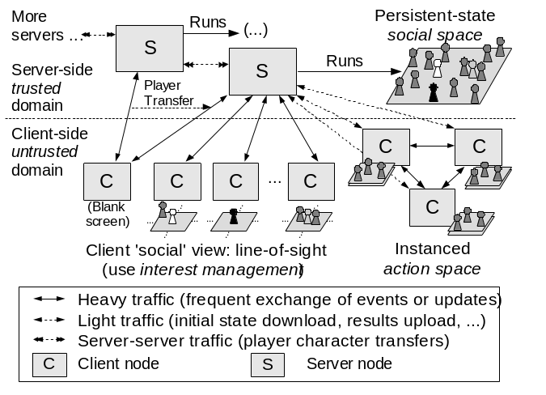
Figure 1: The instanced ’social vs. action’ MMOG.

.

Guild Wars, as far as we can tell, follows the client-server model. Our proposal is to used the instanced game model with a hybrid network architecture model. Since the interactions on the social space (chatting, trading) don’t require high consistency, and there is a necessity of validation of who can play (game accounts,passwords), the server-side will be responsible for coordinating this part of the game. So even a server-side with modest processing capacity and network bandwidth could manage the social space if game quality is scaled down accordingly, for instance by sending less frequent updates to clients. The game sessions would be process only on the client-side machines, avoiding unnecessary processing and communication cost on the server-side. The clients groups would operate within a peer-to-peer dynamics.

P2PSE ARCHITECTURE
Um grupo de bibliotecas de software fornece as funcionalidades associadas ao modelo. Essas bibliotecas são organizadas em camadas, como mostra a Figura 2, cada uma com um grupo de funcionalidades para servir à camada superior. Há três camadas na arquitetura, descritas nas subsub-sessões a seguir. Descrevemos também neste subsection as técnicas de segurança e inteligência artificial utilizadas.
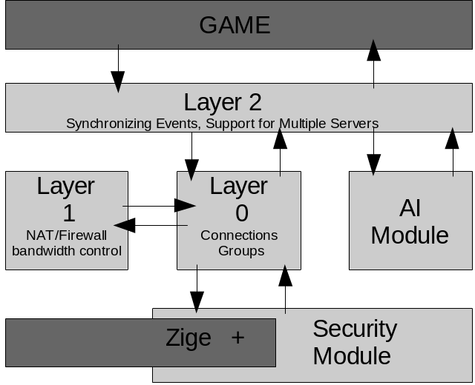
Figure 2: P2PSE Architecture.

Layer 0
A primeira camada da arquitetura P2PSE é responsável pela formação da malha de rede. As conexões dos clientes com os servidores, e dos clientes com os próprios clientes são estabelecidas e gerenciadas nesta camada. As funções básicas de rede para o estabelecimento das conexões (como criação de sockets e gerenciamento de conexões e pacotes) são fornecidas por uma API de baixo nível, ou seja, a arquitetura foi planejada sobre uma biblioteca externa, chamada Zige [REFERENCIA].
O servidor da camada 0 é responsável pelo gerenciamento das conexões com todos os clientes. Ele mantém uma lista com referências e informações sobre a conexão de todos os clientes. O servidor cria, quando iniciado, um grupo para representar o espaço social, chamado de Grupo Social. Todos os clientes que não estiverem em um grupo de ação estão no Grupo Social. Todas as trocas de mensagens entre os clientes que estão no espaço social são feitas através do servidor.
O servidor pode criar novos grupos, vazios, para representar os espaços de ação, ou destruir grupos de ação já existentes. Nos espaços de ação, os clientes comunicam-se diretamente entre si. Para isso, todos os clientes do grupo devem estar interconectados.
Os grupos fornecem aos clientes funcionalidades para troca de mensagens entre eles (Boadcast e Unicast). As conexões entre os membros dos grupos são representadas pelos “peers”. Os clientes, quando em grupos, manterão uma lista de “peers”, que equivale à lista de clientes do servidor. Através desta lista os clientes gerenciam suas conexões com os outros clientes do grupo.
A camada 0 também é responsável pelo controle de timeout das conexões. Em um intervalo de tempo (determinado pela aplicação), o servidor e os clientes enviam pacotes (com ou sem dados) para todas as suas conexões. Se um canal entre o cliente e o servidor, ou entre dois clientes, fica sem fluxo de mensagens durante um determinado período, a conexão é encerrada.

Layer 1
Layer 1 of the P2PSE architecture is responsible for handling connection-related problems between the peers within a group. This layer will ensure that all peers are able to send and receive messages from each other.
We see two main problems that can cause a connection failure between two peers: NAT/Firewall block and bandwidth insufficiency. When the Layer 0 indicates that a message must be send from one peer to another, Layer 1 must verify if there is a direct connection between the peers. If this connection doesn’t exist, an alternative path must be discover, using intermediate peers. After the path is discovered, the proper routing of the message can take place.
Among all peers within a group there are different bandwidth capabilities. It is very likely to occur a situation where a peer doesn’t have enough upload bandwidth to deal with the number of messages that it has to send. Layer 1 will identify such situation and, instead of sending the messages directly to the their destinations, send them to a peer with good upload bandwidth capability, holding him responsible to send the message.
The algorithms and methods that are going to be used to implement this layer are been researched and developed.

Layer 2
A camada superior da arquitetura P2PSE é a responsável por garantir a consistência nos espaços de ação, prover as funcionalidades de suporte a múltiplos servidores e disponibilizar o acesso às funções de toda a biblioteca para a aplicação (no caso, o jogo).
Devido ao fato de a simulação sobre os espaços ação ser realizada pelos próprios peers, não há garantia de coerência. Ou seja, os eventos gerados em uma seção no espaço de ação vistos por um peer do grupo podem ser diferentes ou estar em ordem diversa dos vistos por um outro peer do mesmo grupo, devido à falhas ou atrasos na comunicação, ou até mesmo por trapaça. Então, para garantir que os eventos de uma seção de jogo estejam sincronizados nas visões de todos os membros do grupo, os eventos gerados por cada jogador são enviados ao “super-peer”, que vai ser responsável então pela ordenação deles e por enviar aos outros membros do grupo a lista ordenada de eventos (Figura 4.3). Como a biblioteca de comunicação utilizada (Zige) garante entrega ordenada de mensagens, todos os peers receberão a mesma ordem de eventos.
O super-peer é um dos membros do grupo, eleito pela aplicação, ou o primeiro membro na lista do grupo, caso a aplicação deixe a cargo da camada 2 sua eleição. Caso o super-peer saia do grupo, por motivo qualquer, um outro membro do grupo é eleito como super-peer (pela aplicação ou pela camada 2). A camada 2 oferece suporte para que o estado atual dos eventos seja mantido e transferido ao novo super-peer, e também que seja informado a membros que entrem no grupo já em andamento.
O super-peer, além de ordenar e disseminar os eventos, é o responsável pela comunicação do grupo com o servidor, para informar o resultado da seção de jogo no grupo de ação, quando necessário.
Outra funcionalidade da camada é o suporte a múltiplos servidores. A idéia e que os jogadores possam escolher, entre um número determinado de servidores, em qual irão jogar. Parra isso foi criado o conceito de “servidor mestre”. O servidor mestre hospeda uma base de dados que contém, além do cadastro de todos os servidores disponíveis para jogar, o dados relativos a todos os jogadores, como nome de usuário, senha e estado no jogo. A lista de servidores é disponibilizada aos clientes através de um índice (chamado de “Yellowpages”). Esse índice deve ser executado em uma máquina diferente do servidor mestre, para isolar a base de dados e garantir maior segurança.
Todos os servidores mantêm uma conexão com o servidor mestre (da mesma forma com que mantêm com os clientes), e através dela informam ao servidor mestre as atualizações nos dados dos jogadores. Ao iniciar, o servidor mestre consulta em sua base de dados os servidores cadastrados, e então estabelece conexão com cada um deles. Por motivos de segurança, o servidor mestre não aceita pedidos de conexão, somente ele pode estabelecer as conexões.
O estado dos servidores (conectado / desconectado) é informado pelo servidor mestre ao “Yelowpages” toda vez que um servidor conectar ou desconectar. O servidor mestre tenta, periodicamente, restabelecer a conexão com os servidores desconectados.
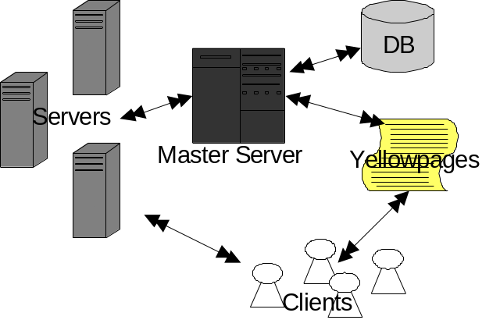
Figure 3: Multiple Serves Support.

Uma otimização pretendida futuramente nesta camada, que pode ajudar a reduzir a quantidade de dados que o servidor tem de lidar no espaço social é determinar uma área de interesse [Morse et al. 2000] para o jogador, para adaptar a freqüência das atualizações de mensagens apenas para essa área. Ou seja, todas as informações relativas aos jogadores ou ambientes que estão muito longe do jogador, e não podem afetá-lo, serão enviadas com menor freqüência que as relacionadas a objetos que estão dentro de uma área de interesse do jogador. O tamanho desta área é dependente do jogo.

Artificial Intelligence Module
A abordagem para detecção de fraudadores foi focada nos pacotes de dados que trafegam na rede durante o jogo, nos emissores e receptores desses dados e em como eles são utilizados durante o funcionamento do sistema. Só são considerados os pacotes que interferem diretamente na trapaça a ser detectada.
Desta maneira, o módulo de detecção de fraudes é implementado de forma independente, e funciona como um “anexo” ao P2PSE, que, a partir de um protocolo para passagem de parâmetros, informa os dados de um determinado jogador e recebe como resposta um valor correspondente a um “índice de fraude” realizada por esse jogador no período analisado.
A abordagem adotada foi de considerar somente os dados de movimentação como entrada para o módulo de detecção de fraudes. Apesar de parecer pouca informação, é a partir da movimentação que jogadores mal-intencionados realizam boa parte das trapaças. Exemplos simples são conseguir uma velocidade maior do que a velocidade limite oficial do jogo (tipo mais comum de trapaça em MMOGs) ou então, saltando diretamente para posições estratégicas.
Desta forma, a idéia é analisar uma série de movimentos do jogador, a fim de detectar anormalidades na movimentação. Cada jogador será analisado individualmente, a partir de seu histórico de movimentos regressos, com o uso de Redes Neurais Artificiais (RNAs). RNA's, por sua grande capacidade de generalização e reconhecimento de padrões, apresentam resultados satisfatórios em tarefas similares ao problema abordado no projeto P2PSE. A idéia é identificar no conjunto de dados coletados, ao menos um movimento considerado como fraude, o que classifica o resultado do conjunto como fraudador. O que a RNA deverá fazer é identificar e classificar os padrões aceitáveis e não aceitáveis de velocidades e as relações entre elas.
Considerando que a tarefa consiste em classificação de padrões de comportamento, a partir de exemplos, optou-se pelo uso de RNA do tipo Perceptron Multicamadas, completamente conectado, com aprendizado supervisionado, a partir de um algoritmo de retropropagação de erros. A justificativa da escolha está em esta ser a categoria de RNA mais comumente utilizada em diversas aplicações de classificação, devido a sua simplicidade de entendimento e implementação, bem como a gama de variações possíveis para determinadas aplicações mais específicas.

Security Module
O objetivo do módulo de segurança é garantir comunicação segura, ou seja, garantir que uma mensagem enviada por um cliente ou pelo servidor chegue com segurança no seu destino. E isso deve ser feito de forma transparente à aplicação. Por transparente entende-se que ele exige pouca (ou, em alguns contextos, nenhum) interface com a aplicação que o utiliza, e que tem pouca influência (em relação a mensagens adicionais ou ao tamanho das mensagens) sobre o modelo de fluxo de dados utilizado pela aplicação.
Esse módulo fornece abstrações para lidar com os algoritmos criptográficos no contexto de jogos distribuídos, com a distribuição de chaves (para não exigir a presença de servidores desenvolvendo funções específicas) e com o estabelecimento de sessões de comunicação segura, para então permitir que a aplicação realize comunicação conforme suas exigências de confidencialidade, integridade e autenticidade.
No protocolo de comunicação segura, todos os pacotes enviado, tanto pelos clientes quanto pelos servidores, são interceptados logo antes de serem colocados na rede (pacotes gerados pela Zige). Em cada uma deles, coloca-se um pequeno cabeçalho com informações de controle usados para garantir a confidencialidade, integridade e autenticidade dos dados, quando requisitados.

SIMULATIONS
Place Tables/Figures/Images in text as close to the reference as possible (see Figure 1). It may extend across both columns to a maximum width of 17.78 cm (7”).
Captions should be Times New Roman 9-point bold. They should be numbered (e.g., “Table 1” or “Figure 2”), please note that the word for Table and Figure are spelled out. Figure’s captions should be centered beneath the image or picture, and Table captions should be centered above the table body.
peer dynamics.
Table 1. Table captions should be placed above the table
Graphics | Top | In-between | Bottom
Tables | End | Last | First
Figures | Good | Similar | Very well

References

CONCLUSIONS

The heading for subsubsections should be in Times New Roman 11-point italic with initial letters capitalized.

REFERENCES
- Bowman, M., Debray, S. K., and Peterson, L. L. 1993. Reasoning about naming systems. ACM Trans. Program. Lang. Syst. 15, 5 (Nov. 1993), 795-825. DOI= http://doi.acm.org/10.1145/161468.161471.
- Ding, W. and Marchionini, G. 1997 A Study on Video Browsing Strategies. Technical Report. University of Maryland at College Park.
- Fröhlich, B. and Plate, J. 2000. The cubic mouse: a new device for three-dimensional input. In Proceedings of the SIGCHI Conference on Human Factors in Computing Systems (The Hague, The Netherlands, April 01 - 06, 2000). CHI '00. ACM Press, New York, NY, 526-531. DOI= http://doi.acm.org/10.1145/332040.332491
- Tavel, P. 2007 Modeling and Simulation Design. AK Peters Ltd.
- Sannella, M. J. 1994 Constraint Satisfaction and Debugging for Interactive User Interfaces. Doctoral Thesis. UMI Order Number: UMI Order No. GAX95-09398., University of Washington.
- Forman, G. 2003. An extensive empirical study of feature selection metrics for text classification. J. Mach. Learn. Res. 3 (Mar. 2003), 1289-1305.
- Brown, L. D., Hua, H., and Gao, C. 2003. A widget framework for augmented interaction in SCAPE. In Proceedings of the 16th Annual ACM Symposium on User interface Software and Technology (Vancouver, Canada, November 02 - 05, 2003). UIST '03. ACM Press, New York, NY, 1-10. DOI= http://doi.acm.org/10.1145/964696.964697
- Y.T. Yu, M.F. Lau, "A comparison of MC/DC, MUMCUT and several other coverage criteria for logical decisions", Journal of Systems and Software, 2005, in press.
- Spector, A. Z. 1989. Achieving application requirements. In Distributed Systems, S. Mullender, Ed. Acm Press Frontier Series. ACM Press, New York, NY, 19-33. DOI= http://doi.acm.org/10.1145/90417.90738

Columns on Last Page Should Be Made As Close As Possible to Equal Length

