GitHub Actions Workflow:

Docker Hub Deployment:
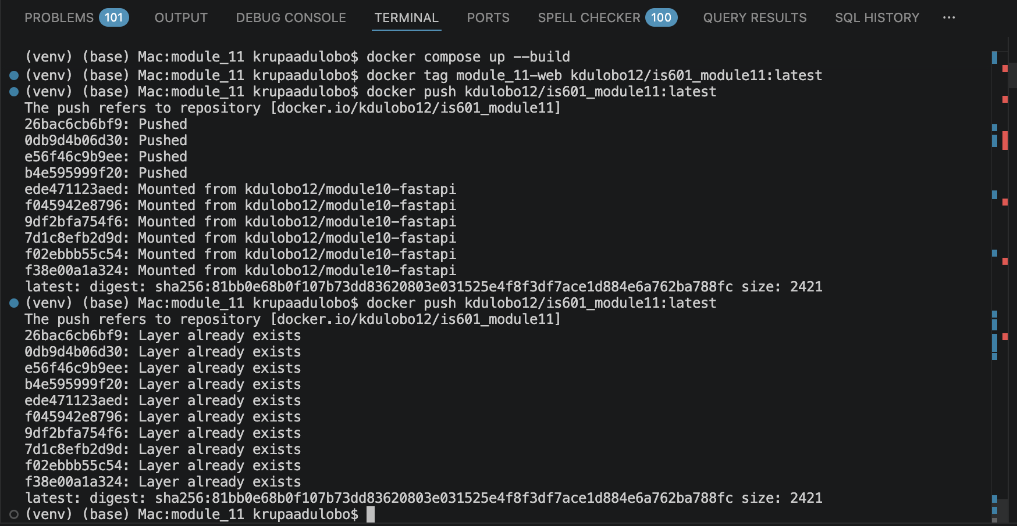

Link: https://hub.docker.com/r/kdulobo12/is601_module11

