Final_Group3
Alexis McCartney, Marvelle Horton, Kristen Durkin
2025-12-05

Process
Load Data -> Clean Data -> Scale Data -> Split Data -> Pick K -> Run K -> Analysis -> Visuals

Load Data
This file contains the YTD variables we will use for clustering for 2023.
df <- read.csv("Group3Data.csv") #read csv file
View(df) #Visual Check

Step 1: Remove variables that have significant missing values
Check and see if there are any values missing in each column:
colSums(is.na(df)) #Count N/A values in each column
## U.S..Department.of.Energy..The.Energy.Information.Administration..EIA.
## 0
## X
## 0
## X.1
## 0
## X.2
## 0
## X.3
## 0
## X.4
## 0
## X.5
## 0
## X.6
## 0
## X.7
## 0
## X.8
## 0
## X.9
## 0
## X.10
## 0
## X.11
## 0
## X.12
## 0
## X.13
## 0
## X.14
## 0
## X.15
## 19
## X.16
## 0
## X.17
## 0
## X.18
## 0
## X.19
## 0
## X.20
## 0
## X.21
## 0
## X.22
## 0
## X.23
## 0
## X.24
## 0
## X.25
## 0
## X.26
## 0
## X.27
## 0
## X.28
## 0
## X.29
## 0
## X.30
## 0
## X.31
## 0
## X.32
## 0
## X.33
## 0
## X.34
## 0
## X.35
## 0
## X.36
## 0
## X.37
## 0
## X.38
## 0
## X.39
## 0
## X.40
## 0
## X.41
## 0
## X.42
## 0
## X.43
## 0
## X.44
## 0
## X.45
## 0
## X.46
## 0
## X.47
## 0
## X.48
## 0
## X.49
## 0
## X.50
## 0
## X.51
## 0
## X.52
## 0
## X.53
## 0
## X.54
## 0
## X.55
## 0
## X.56
## 0
## X.57
## 0
## X.58
## 0
## X.59
## 0
## X.60
## 0
## X.61
## 0
## X.62
## 0
## X.63
## 0
## X.64
## 0
## X.65
## 0
## X.66
## 0
## X.67
## 0
## X.68
## 0
## X.69
## 0
## X.70
## 0
## X.71
## 0
## X.72
## 0
## X.73
## 0
## X.74
## 0
## X.75
## 0
## X.76
## 0
## X.77
## 0
## X.78
## 0
## X.79
## 0
## X.80
## 0
## X.81
## 0
## X.82
## 0
## X.83
## 0
## X.84
## 0
## X.85
## 0
## X.86
## 0
## X.87
## 0
## X.88
## 0
## X.89
## 0
## X.90
## 0
## X.91
## 0
## X.92
## 0
## X.93
## 0
## X.94
## 0
## X.95
## 0
Returned data does not show significant missing values for the YTD variables.

Step 2: Focus on last 6 YTD column
(First we count all the columns then select the last 6)
num_cols <- ncol(df) #total columns
ytd <- df[, (num_cols-5):num_cols] #grab last 6 columns (YTD data)
head(ytd)
## X.90 X.91
## 1
## 2
## 3
## 4 Year-To-Date
## 5 Total Fuel Consumption\nQuantity Electric Fuel Consumption\nQuantity
## 6 4,962 4,962
## X.92 X.93
## 1
## 2
## 3
## 4
## 5 Total Fuel Consumption\nMMBtu Elec Fuel Consumption\nMMBtu
## 6 29,007 29,007
## X.94 X.95
## 1
## 2
## 3
## 4
## 5 Net Generation\n(Megawatthours) YEAR
## 6 2,748 2023
colSums(is.na(ytd)) #double check for missing values
## X.90 X.91 X.92 X.93 X.94 X.95
## 0 0 0 0 0 0
Results show that the YTD columns do not have any missing values.
YTD Columns: X.90 = Total Fuel Consumption Quantity X.91 = Electric Fuel Consumption Quantity X.92 = Total Fuel Consumption MMBtu X.93 = Elec Fuel Consumption MMBtu X.94 = Net Generation (Megawatthours) X.95 = YEAR

Step 3: Remove YEAR from clustering data since it’s constant
ytd_noyear <- ytd[, c("X.90", "X.91", "X.92", "X.93", "X.94")] #Drop YEAR column since it's constant
head(ytd_noyear) #confirm remaining columns
## X.90 X.91
## 1
## 2
## 3
## 4 Year-To-Date
## 5 Total Fuel Consumption\nQuantity Electric Fuel Consumption\nQuantity
## 6 4,962 4,962
## X.92 X.93
## 1
## 2
## 3
## 4
## 5 Total Fuel Consumption\nMMBtu Elec Fuel Consumption\nMMBtu
## 6 29,007 29,007
## X.94
## 1
## 2
## 3
## 4
## 5 Net Generation\n(Megawatthours)
## 6 2,748

Step 4: Remove any non-numerical data from the set
ytd_clean <- ytd_noyear[!is.na(as.numeric(ytd_noyear$X.90)), ] #keep only numerical rows
## Warning in `[.data.frame`(ytd_noyear, !is.na(as.numeric(ytd_noyear$X.90)), :
## NAs introduced by coercion
head(ytd_clean) #check the cleaned data
## X.90 X.91 X.92 X.93 X.94
## 7 577 577 3,373 3,373 319
## 8 0 0 672 672 183
## 9 0 0 174 174 51
## 10 0 0 473,183 473,183 138,682
## 15 0 0 0 0 0
## 16 0 0 1,755,486 1,755,486 514,504

Step 5: Remove any special characters like commas
ytd_clean <- as.data.frame(lapply(ytd_clean, function(x) as.numeric(gsub(",", "", x)))) #remove special characters
str(ytd_clean)
## 'data.frame': 12301 obs. of 5 variables:
## $ X.90: num 577 0 0 0 0 0 0 0 0 0 ...
## $ X.91: num 577 0 0 0 0 0 0 0 0 0 ...
## $ X.92: num 3373 672 174 473183 0 ...
## $ X.93: num 3373 672 174 473183 0 ...
## $ X.94: num 319 183 51 138682 0 ...
Now the data is all numerical & clean.

Step 6: Scale the data
We scale so that all features contribute equally to the k-means distance calculation.
ytd_scaled <- scale(ytd_clean)
head(ytd_scaled)
## X.90 X.91 X.92 X.93 X.94
## [1,] 4.8286914 5.0733614 -0.11476895 -0.11476728 -0.177458927
## [2,] -0.2250483 -0.2195277 -0.11511610 -0.11511442 -0.177626510
## [3,] -0.2250483 -0.2195277 -0.11518011 -0.11517843 -0.177789163
## [4,] -0.2250483 -0.2195277 -0.05438652 -0.05438485 -0.006964982
## [5,] -0.2250483 -0.2195277 -0.11520247 -0.11520079 -0.177852006
## [6,] -0.2250483 -0.2195277 0.11042176 0.11042340 0.456131190
str(ytd_scaled) #confirm data is all numbers
## num [1:12301, 1:5] 4.829 -0.225 -0.225 -0.225 -0.225 ...
## - attr(*, "dimnames")=List of 2
## ..$ : NULL
## ..$ : chr [1:5] "X.90" "X.91" "X.92" "X.93" ...
## - attr(*, "scaled:center")= Named num [1:5] 25.7 23.9 896341.3 896328.4 144334.4
## ..- attr(*, "names")= chr [1:5] "X.90" "X.91" "X.92" "X.93" ...
## - attr(*, "scaled:scale")= Named num [1:5] 114 109 7780574 7780575 811542
## ..- attr(*, "names")= chr [1:5] "X.90" "X.91" "X.92" "X.93" ...
Scaling makes our mean roughly 0 and standard deviation roughly 1 (z-scores)
colMeans(ytd_scaled) #Confirmation of scale
## X.90 X.91 X.92 X.93 X.94
## 1.252792e-17 1.221428e-17 -2.859946e-19 -8.055091e-18 -1.191475e-17
apply(ytd_scaled, 2, sd) #Confirmation of standard deviation
## X.90 X.91 X.92 X.93 X.94
## 1 1 1 1 1

Step 7: Split into training/test data sets
Split the scaled dataset into a training set (75% of observations) and a test set (25%). The training set will be used to determine the optimal number of clusters and to build the k-means segmentation.
set.seed(123)
n <- nrow(ytd_scaled)
train_idx <- sample(1:n, size = 0.75 * n) #randomly select 75% of data for training
train <- ytd_scaled[train_idx, ] #training set
test <- ytd_scaled[-train_idx, ] #test set
dim(train) #check training dimensions
## [1] 9225 5
dim(test) #check test dimensions
## [1] 3076 5
Confirmation: data is split.

Step 8: Elbow Plot
The elbow method helps determine the number of clusters by plotting the total within-cluster sum of squares (WSS) for different values of k.
wss <- sapply(1:10, function(k) {
kmeans(train, centers = k, nstart = 20)$tot.withinss #get total WSS for each k
})
plot(1:10, wss, type = "b",
xlab = "Number of Clusters (k)",
ylab = "Within-Cluster Sum of Squares (WSS)",
main = "Elbow Method")
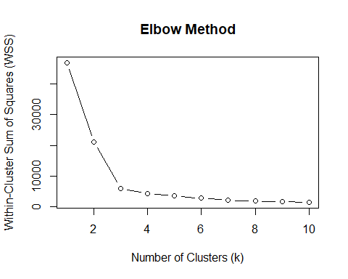
#look where elbow - this shows when adding more would not be benefical
Results:
Cluster 1 = very high WSS with everything lumped together. k = 2 = largest change. k = 3 = “elbow” point.
Using the elbow method,a clear bend at k = 3 can be seen. While the WSS decreases sharply from k = 1 to k = 3, the reduction beyond k = 3 is minimal. This indicates that 3 clusters provide an ideal balance.

Step 9: Silhouette (Confirmation)
library(cluster)
## Warning: package 'cluster' was built under R version 4.5.2
avg_sil <- sapply(2:10, function(k){
km <- kmeans(train, centers = k, nstart = 20) #Run k means
ss <- silhouette(km$cluster, dist(train)) #run silhouette for clustering
mean(ss[, 3]) #avg silhouette for k
})
plot(2:10, avg_sil, type = "b",
xlab = "Number of Clusters (k)",
ylab = "Average Silhouette width",
main = "Silhouette Method")
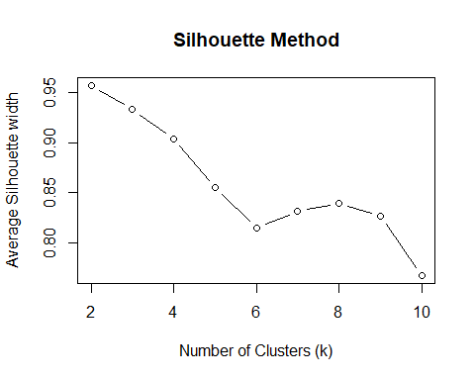
#Higher values mean more defined clusters
Confirmation k = 3
Based on the elbow method, it’s observed to have a clear bend at k = 3, indicating diminishing returns beyond this point. Although the silhouette method peaked at k = 2, the value for k = 3 remained high, suggesting well separated clusters.
For this reason we selected k = 3 as the optimal number of clusters.

Step 10: Run K-means with k = 3
Now we actually run the final clustering model using k = 3.
set.seed(123)
km_final <- kmeans (train, centers = 3, nstart = 25) #final k means model
km_final$size #how many plants are in each cluster
## [1] 8845 308 72
km_final$centers #cluster center scaled
## X.90 X.91 X.92 X.93 X.94
## 1 -0.1671690 -0.1643987 -0.08400851 -0.08400731 -0.07659297
## 2 4.8973956 4.8452545 -0.11489970 -0.11492738 -0.17330537
## 3 -0.2250483 -0.2195277 11.09621193 11.09621148 10.39407454

Step 11: Cluster Interpretation
Cluster sizes: Cluster 1: 8845 plants Cluster 2: 308 plants Cluster 3: 72 plants
Cluster 1 -> Low values
Slightly lower than average fuel use Slightly lower than average heat content Slightly lower electricity generation
Cluster 1 contains units with below average fuel consumption and below average electricity generation. This suggests these units operate at relatively low levels of activity compared to the rest of the dataset.
Cluster 2 -> Mid-high values
Higher than average fuel use Mid range fuel energy content Mid range generation levels
Cluster 2 shows higher fuel consumption than Cluster 1 but does not reach the higher levels seen in Cluster 3. These units demonstrate moderate fuel use and moderate electricity output
Cluster 3 -> high values
Extremely high fuel consumption Extremely high MMBtu Extremely high electricity generation
Cluster 3 onsists of the highest intensity units in the dataset. They consume substantially more fuel and generate much more electricity than the other clusters. Although small in count, these units represent the most operational activity.

Step 12: Add IDs and Visualize
Now we attach the cluster labels back to the training data and plot the clusters.
train_clusters <- as.data.frame(train) #transition from training to data frame
train_clusters$cluster <- km_final$cluster #add labels to clusters
head(train_clusters) #data preview
## X.90 X.91 X.92 X.93 X.94 cluster
## 1 -0.2250483 -0.2195277 -0.1152025 -0.1152008 -0.1778520 1
## 2 -0.2250483 -0.2195277 -0.1152025 -0.1152008 -0.1575093 1
## 3 -0.2250483 -0.2195277 -0.1135647 -0.1135630 -0.1732497 1
## 4 0.3792984 0.4134175 -0.1151511 -0.1151494 -0.1778027 1
## 5 -0.2250483 -0.2195277 -0.1015800 -0.1015783 -0.1395743 1
## 6 -0.2250483 -0.2195277 -0.1051805 -0.1051788 -0.1496908 1
library(factoextra) #package for easy k-means cluster visualizations
fviz_cluster(
list(data = train, cluster = km_final$cluster),
geom = "point", #show each plant as a point
ellipse.type = "convex", # draw convex hulls around clusters (Mod 6)
main = "K-Means Clustering (k = 3)"
)
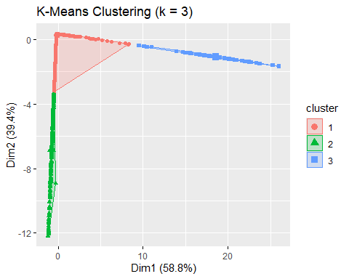
# This visual reduces our 5 scaled variables into a 2D space so we can actually see how well the clusters separate.
# The convex ellipses help outline the grouping structure,which is exactly how we learned to interpret cluster quality in mod 6.

