**Business Model & Business Model Canvas**

Before going into how to use the Business Model Canvas (BMC), let me give you some introduction or rather a technical explanation on the basics; or what exactly is Business Model and Business Model Canvas.

A good recent definition of a business model provided by Osterwalder & Pigneur; business model is a description of “how an organization creates, delivers and captures value” this is because every entrepreneurs who wants to start a new venture need to answer some basic questions such as, What is your business model? How will you earn money? Answering these questions require a framework for describing a business.

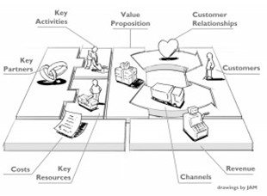

**Business Model Canvas** is actual a strategic management tool; a convenient visual framework for talking about a business model, which allows us to develop and sketch out new or existing business models. It is a visual template pre-formatted with the nine blocks of a business model. the pre-formatted visual template/poster format chart enables the nine elements of a business model to be captured and discussed by the *organization*. An *organization* can be a single entity (individual) or a collection of entities (a group of people) working together to deliver a product or service that creates value for a customer.

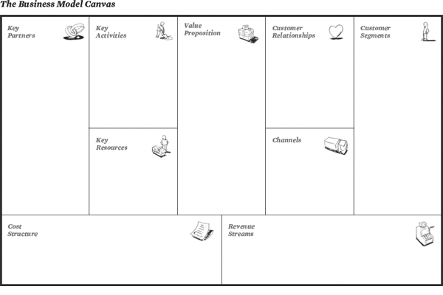

Below are the nine elements mentioned above with simple explanations of what they are and guiding questions to better understand each elements. The question/s can also be used as a guide to know what to write in the block provided for each elements.

Legends**: E** = Explanation, **Q** = Question/s

**Value Proposition**

**E**: The products and services a business offers. Quoting Osterwalder (2004), a value proposition "is an overall view of products and services that together represent value for a specific customer segment. It describes the way a firm differentiates itself from its competitors and is the reason why customers buy from a certain firm and not from another."

**Q**: What do we offer? What core value do you deliver to the customer? What value do we deliver to a customer in a given segment? What needs do we satisfy?

**Customer Segments**

**E**: The target audience for a business' products and services.

**Q**:For whom do we aim to create value? Which classes are you creating values for? Who are our most important customers?

**Channels**

**E**: The means by which a company delivers products and services to customers. This includes the company's marketing and distribution strategy.

**Q**: How do we reach each customer segment? Through which channels that your customers want to be reached? What is easiest for the customer? Which channels work best? How can they be integrated into your and your customers’ routines?

**Customer Relationship**

**E**: The links a company establishes between itself and its different customer segments. The process of managing customer relationships is referred to as customer relationship management.

**Q**: How do we build and maintain these? What relationship that the target customer expects you to establish? How can you integrate that into your business in terms of cost and format? How do they fit effectively in both the customer’s world and our own?

**Key Partner/s**

**E**: The business alliances which complement other aspects of the business model. Have a good relationship with other business that completes or provide benefits/advantages to the business model.

**Q**:Who are our Key Partner/s and why? What Key Resources do they provide and what Key Activities do they carry out? What’s in it for them (motivation/profit/advantage/benefit)? What relationship should we have (suppliers/expertise/technology etc)?

**Key Activities**

**E**: The activities necessary to execute a company's business model.

**Q**: What are the most important things you must do to make your business work? What key activities does your value proposition require? What activities are important the most in distribution channels, customer relationships, revenue stream…?

**Key Resources**

**E**: The resources that are necessary to create value for the customer.

**Q:** What resources are essential to deliver our Value Propositions through the Channels and maintain our Customer Relationships? What key resources does your value proposition require? What resources are important the most in distribution channels, customer relationships, revenue stream…?

**Cost Structure**

**E**: The monetary consequences (cost of capital/money) of the means employed (to be used) in the business model.

**Q**: What costs are involved in our Business Model? Which are largest? What is fixed and what is variable? What drives/causes them? What are the biggest cost in your business? Which key resources/activities are most expensive?

**Revenue Streams**

**E**: The way a company makes money through a variety of revenue flows. A company's income.

**Q**: For what will our customers pay? How much? How would they prefer to pay? For what value are your customers willing to pay? What and how do they recently pay? How would they prefer to pay? How much does every revenue stream contribute to the overall revenues?

**The Use of Business Model Canvas**

If you have heard or read about BMC before, you may have skipped to this section of the article because what I have presented above is just the basics of BMC that you might have already know. In this section, I would try my best to explain how to use the BMC.

In my opinion, it is very easy to use BMC for entrepreneurs in order to start a business especially people such as myself who only have minimal formal knowledge in business and some experience in running a microscopic scale business. In my perspective, BMC is like a big picture to the business that entrepreneurs will venture into. It shows all the important elements that entrepreneurs need to know and prepared for before starting a business. This will ensure entrepreneurs to be well prepared and covered all the basics before starting the business to avoid any problems especially during the early stage of the business due to lack of planning. However, although BMC can avoid problems as mentioned above but it is still not problem free and full proof because it depends on how well the individual or group prepared the business model. Based on my experience, there are no full proof business model as it also depends on the execution of the business model and problems may arise in the business anytime and at any part of the business unexpectedly. Nonetheless, personally, it is better to venture into unfamiliar territory having some knowledge/idea, a big picture or even a simple but complete map of what is ahead rather than nothing at all.

Business Model Canvas is also easy to use because entrepreneurs can start from anywhere or any block on the canvas. Entrepreneurs can start by filling out one of the blocks on the canvas with their idea/s and slowly start to brainstorm and fill out the rest of the block on the canvas and in no time, they may already have a complete business model although it may be very simple. It is not important where or on which block entrepreneurs start from but what is really important is that all the block on the canvas is filled out to have a complete business model.

Business Model Canvas is especially easy to use for entrepreneurs who does not really have much formal knowledge or training in business as they can start using BMC as a checklist at the beginning stage after all the blocks on the canvas is filled out as mentioned above. Using BMC as a checklist can also mean that entrepreneurs can revisit the canvas anytime if problems arise at any stage of the business to check if there is problem on any block on the canvas which may happen during the planning stage or creating the business model.

Hence, these are the usage and some advantages of Business Model Canvas. What have been mentioned above is very simple usage of the Business Model Canvas as an introduction to BMC.