**QUESTION 1:**

select o.orderNumber,p.productName,c.customerName,pa.amount,pa.checkNumber

from orders as o inner join orderdetails on o.orderNumber=orderdetails.orderNumber

inner join products as p on orderdetails.productcode=p.productcode

inner join customers as c on o.customerNumber=c.customerNumber

inner join payments as pa on pa.customerNumber=c.customerNumber

where o.orderNumber=10100;

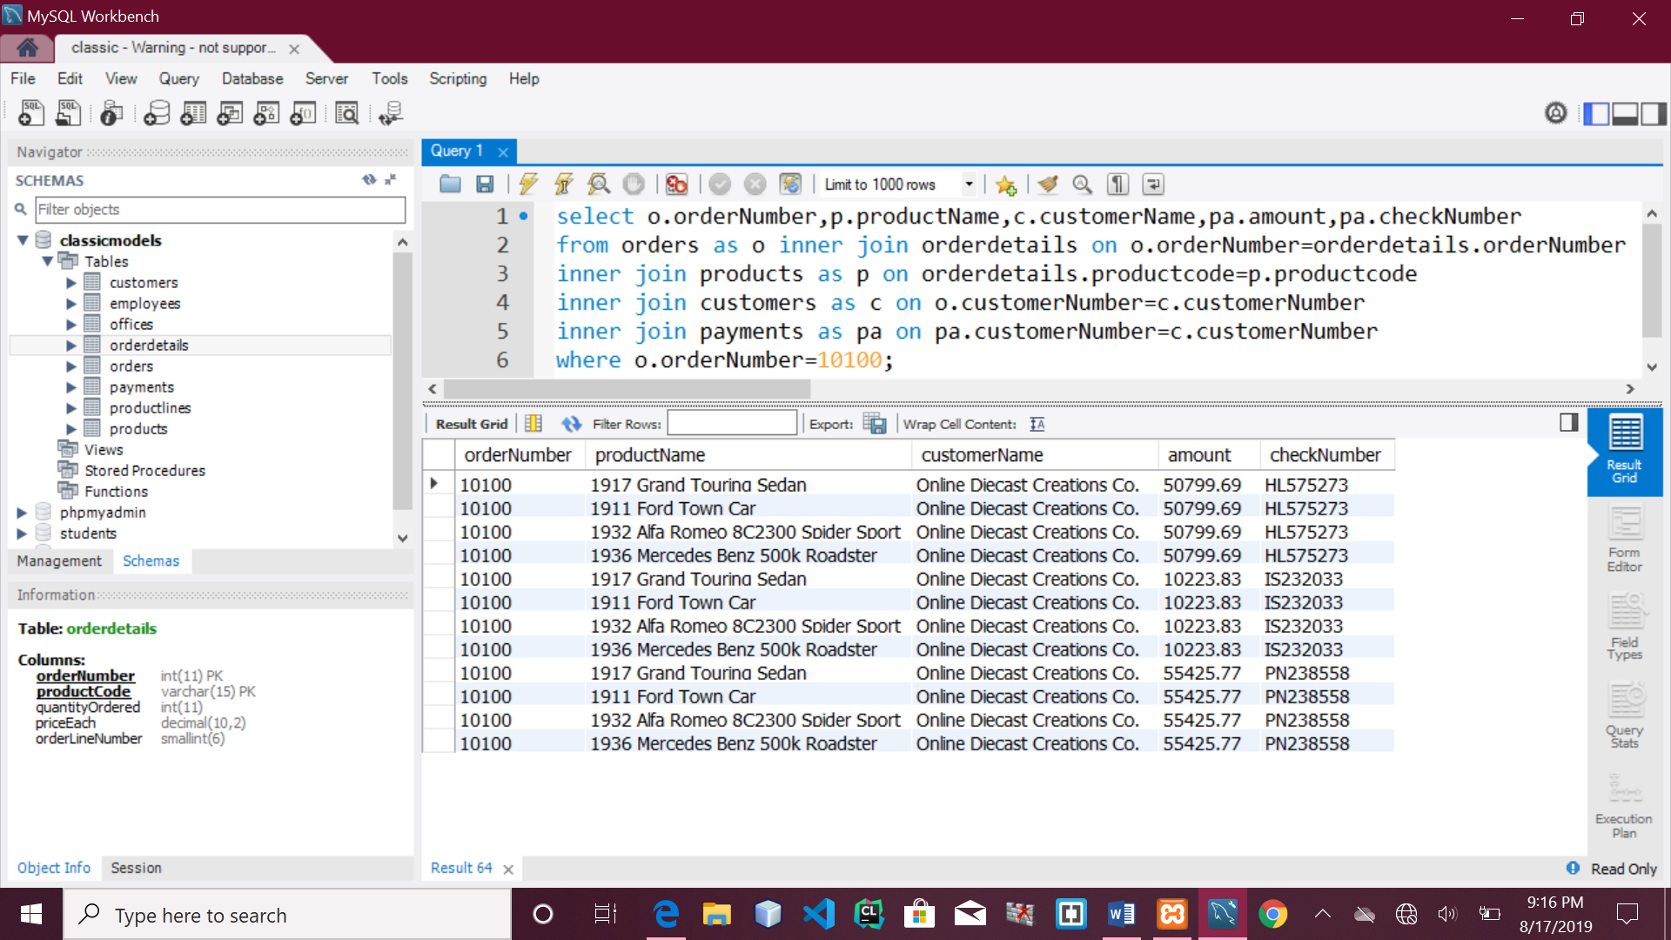

**QUESTION 2:**

select o.orderNumber,SUM(pa.amount)

as total_paid_amount_for_the_order_10100

from orders as o INNER JOIN orderdetails

on o.orderNumber=orderdetails.orderNumber

INNER JOIN products as p on orderdetails.productcode=p.productcode

INNER JOIN customers as c on o.customerNumber=c.customernumber

INNER JOIN payments as pa on pa.customerNumber =c.customerNumber

where o.orderNumber=10100;

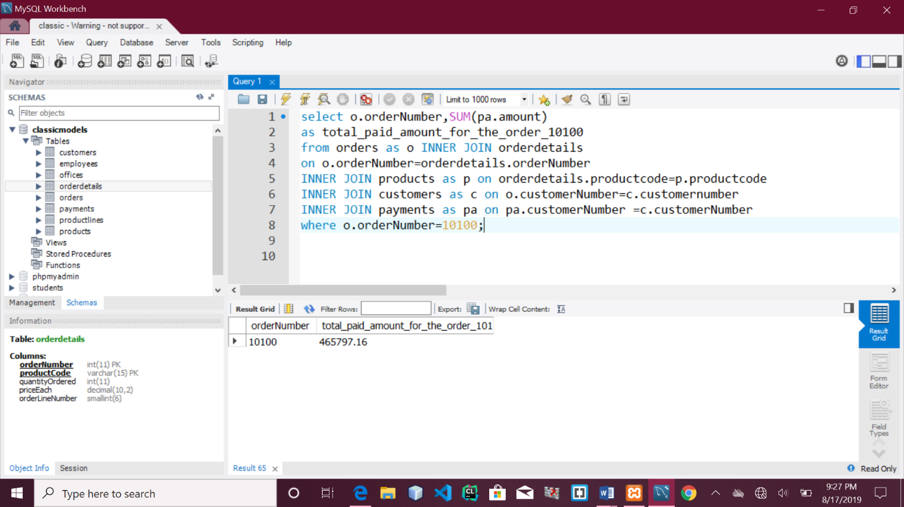

**QUESTION 3:**

select DISTINCT o.orderNumber,pa.checkNumber from orders as o

INNER JOIN orderdetails on o.orderNumber=orderdetails.orderNumber

INNER JOIN products as p on orderdetails.productcode=p.productcode

INNER JOIN customers as c on o.customerNumber=c.customerNumber

INNER JOIN payments as pa on pa.customerNumber=c.customerNumber

where o.orderNumber=10100;

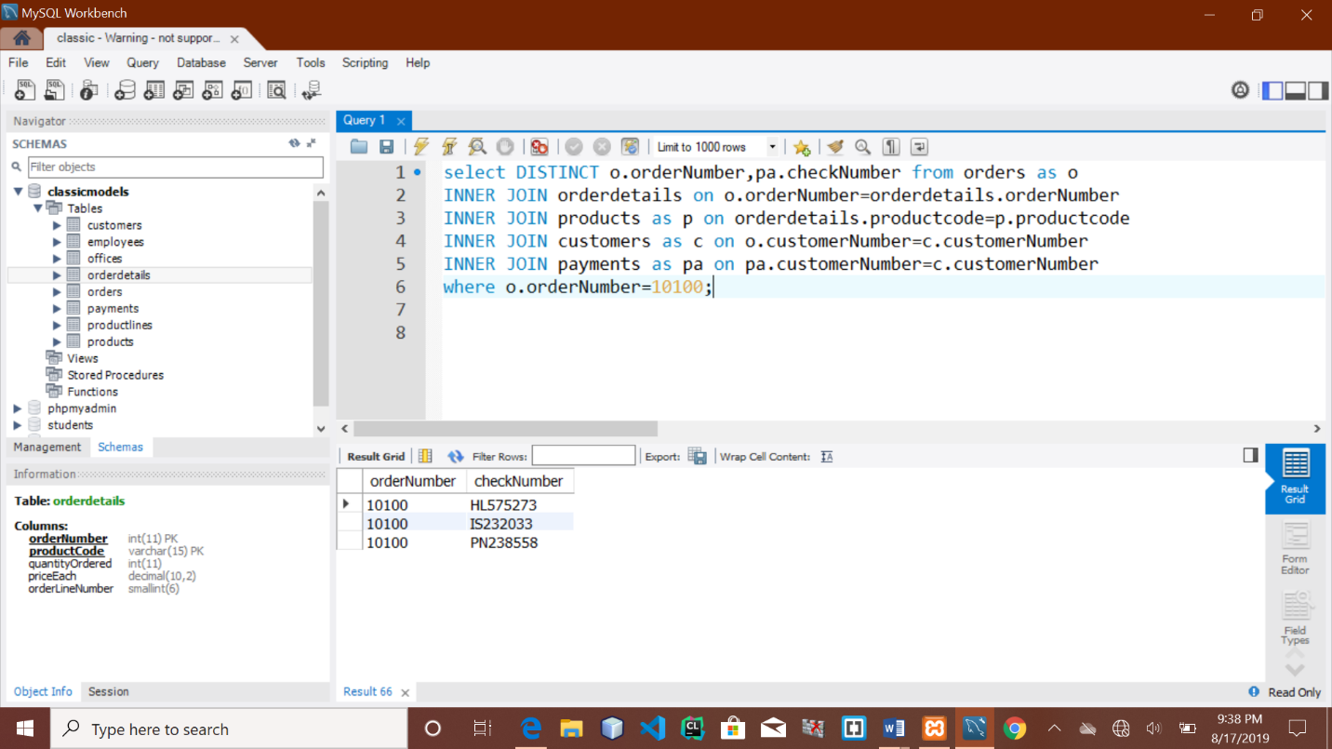

**QUESTION 4:**

select MIN(quantityInStock) as min_value_in_quantityInStock,

MAX(quantityInStock) as max_value_in_quantityInStock from products;

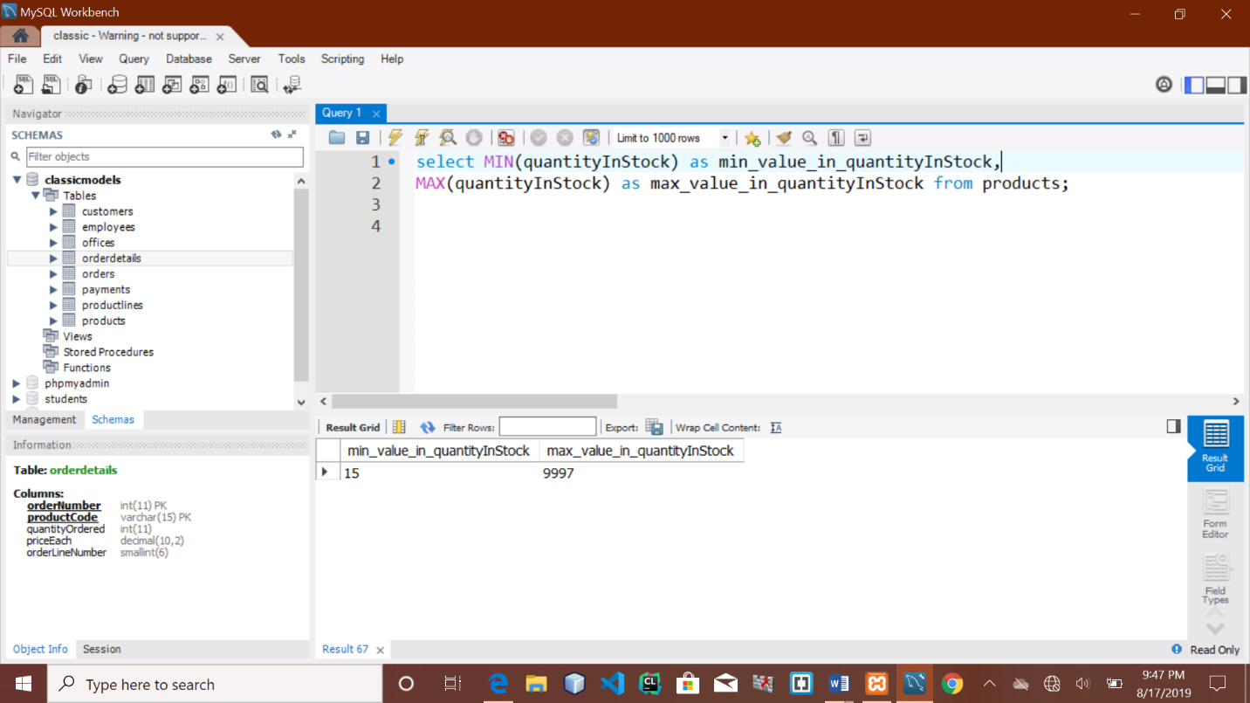

**QUESTION 5:**

select p.productcode,p.productline,pr.htmlDescription

from products as p INNER JOIN productlines as pr on

p.productline=pr.productline

where p.productline=(select productline from productlines

where productline='Classic Cars')

AND (productcode='S12_3380' or productcode='S12_3891' or productcode='S12_3990');

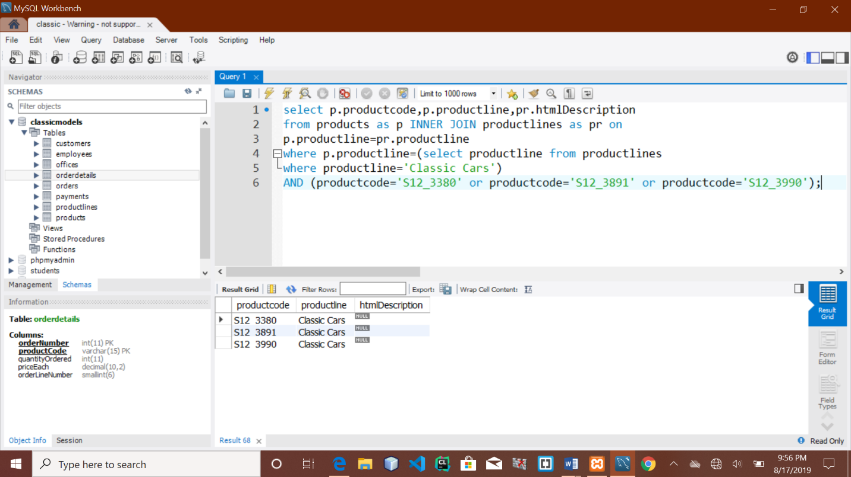

**QUESTION 6:**

select COUNT(*) from productlines where htmlDescription=NULL;

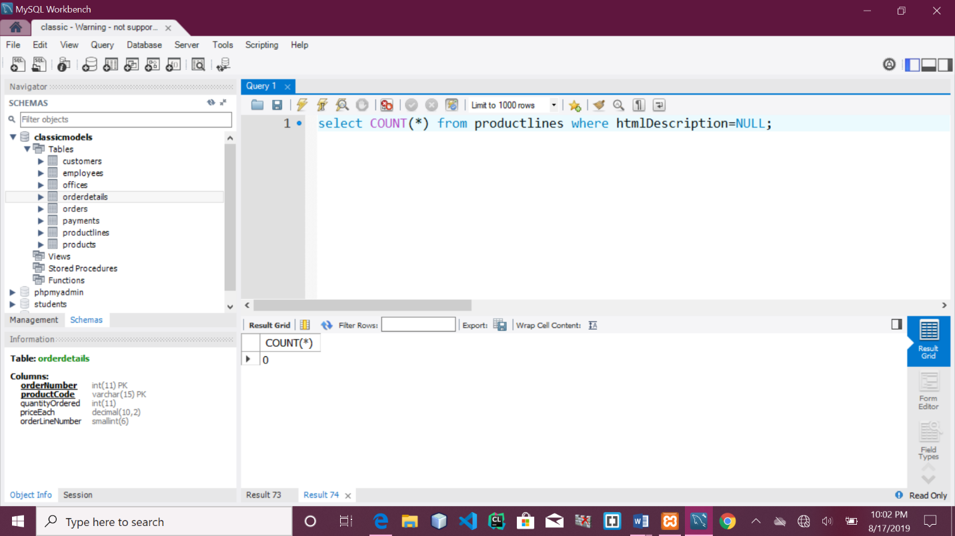

**QUESTION 7:**

select DATE_FORMAT('2019-07-18 12:49:24','%d %b %a') as output;

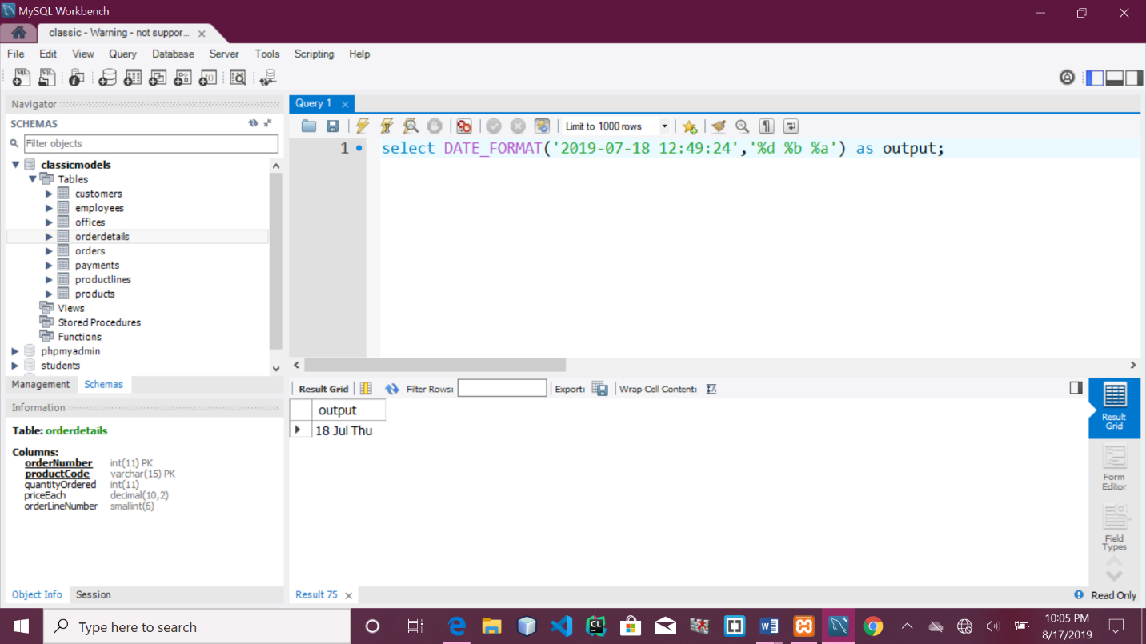

**QUESTION 8:**

select amount from payments order by amount DESC LIMIT 2,1;

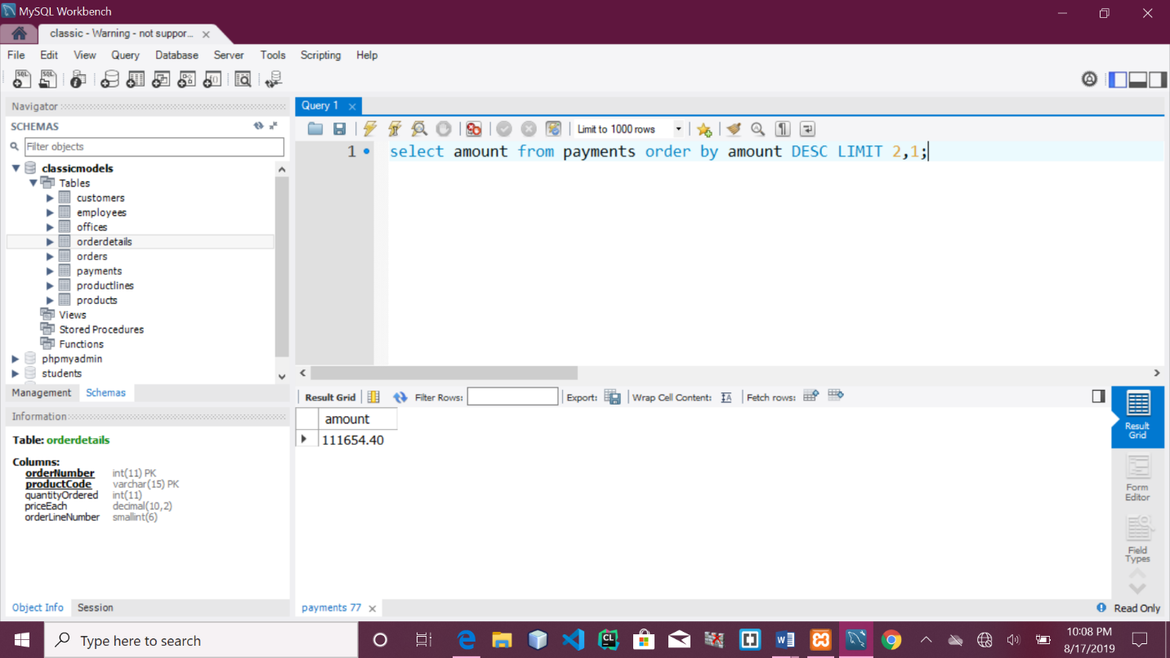

**QUESTION 9:**

select contactFirstName from customers where contactFirstName LIKE 'C%a '

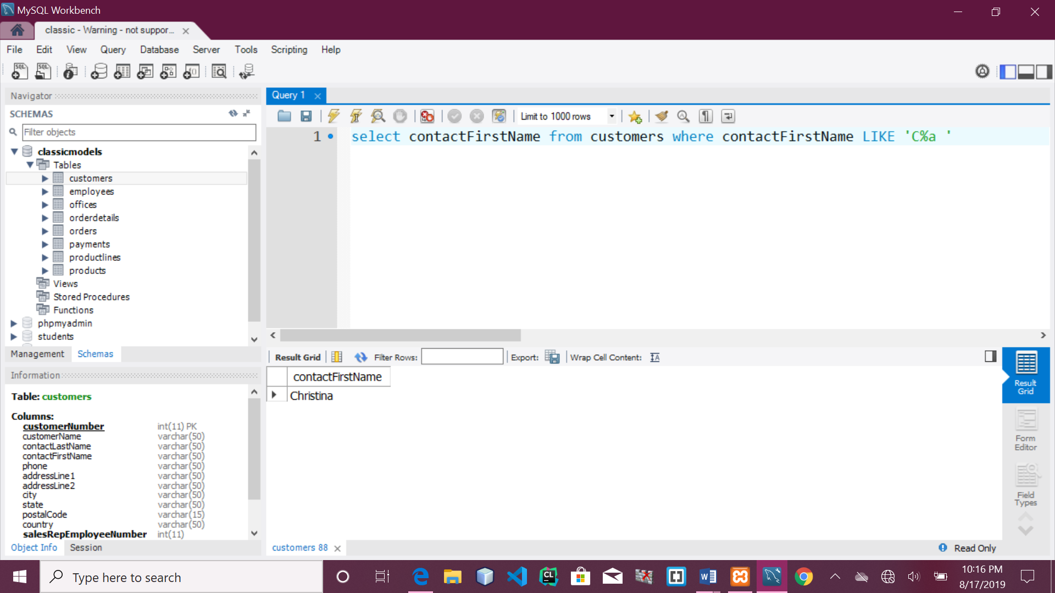

**QUESTION 10:**

select pr.productline,pr.textDescription,pr.htmlDescription,

pr.image from productlines as pr INNER JOIN products as p

on p.productline=pr.productline where pr.productline <> p.productline;

