Woody vegetation communities on office developments are heterogenous and meaningfully influenced by development and landscaping choices

# Highlights

* Distinct vegetation communities on office developments dominated by native or ornamental species
* Native vegetation communities less common and easily missed in small simple random sample
* Measured neighborhood- and site-scale socio-economic variables did not explain variation in vegetation communities
* Development and landscaping choices drive meaningful differences in vegetation habitat

# Abstract

Vegetation communities and the habitat they provide are significantly impacted by humans in social-ecological systems. Yet the urban matrix must provide sufficient resources to support successful local species conservation. Thus understanding factors shaping vegetation communities and the resulting habitat quality and quantity available to other trophic levels in the urban matrix facilitates decision-making to support local species. Vegetation habitat on residential property is increasingly well studied, yet these efforts have not extended to commercial land uses. I examined the tree and shrub communities on office developments in Redmond and Bellevue, Washington, USA, and the variation explained by socio-economic context and development and landscaping choices. Woody vegetation communities were heterogenous within this understudied single urban land use. Using flexible beta clustering and indicator species analysis, I found that woody tree and shrub communities grouped by origin (native or ornamental). Development and landscaping choices, not socio-economic variables, better explained plant community structure

# Introduction

Land development and subsequent landscaping decisions influence urban land patterns of vegetation community composition, abundance, and distribution through disturbance and succession mechanisms (Avolio et al., 2018; Faeth et al., 2011; Lehmann et al., 2014; Pickett et al., 2008). These patterns of the vegetation community alter ecosystem service provision and habitat quality and quantity in social-ecological systems (Byrne, 2007; Faeth et al., 2011; Lehmann et al., 2014).

In the Puget Sound region, development has replaced fire as the primary disturbance driver and precursor to new forest stands (Gibb and Hochuli, 2002; Halpern and Spies, 1995; Sharpe et al., 1986; Walcott, 1899). The mechanisms of disturbance when clearing and grading land for development include removing most vegetation, removing topsoil, and compacting soil with heavy equipment [Andres and Smith (2004); Dorney et al. (1984); McKinney (2002); Grimm et al. (2017); Turner (2005); Figure 1]. Decisions made by developers and land owners at the time of development determine the extent of disturbance and influence future site conditions. For example, choosing to preserve existing trees determines legacy vegetation and influences important stand characteristics like tree age (Dorney et al., 1984).

Multiple processes determine the path of vegetation succession following disturbance. In social-ecological systems, both ecological succession processes like dispersal and regeneration from seed banks and socially mediated vegetation management influence vegetation succession (Zipperer, 2010). However, the latter has become the dominant plant establishment process contributing to succession (Dorney et al., 1984; Faeth et al., 2011; Goodness, 2018; Grimm et al., 2017; Heezik et al., 2014; Widrlechner, 1990). Species composition, abundance, and distribution, and patch structure are among the vegetation patterns impacted by land owner decisions (Faeth et al., 2011). The plants chosen are generally ornamental introduced shrubs, trees, or grasses, though using native species in landscaping is becoming more common (Blair, 1996; Burghardt et al., 2009; Faeth et al., 2011; Germaine et al., 1998; Heezik et al., 2014; McKinney, 2002). Once planted, these require significant energy and material inputs to arrest succession and maintain the desired aesthetic (Faeth et al., 2011; LeBauer and Treseder, 2008; Lepczyk et al., 2004; Zipperer, 2010). Along with trees retained through tree preservation policies, these landscape plantings represent a significant portion of the vegetation on site and of the habitat quality and quantity available to other organisms (Avolio et al., 2018; Faeth et al., 2011).

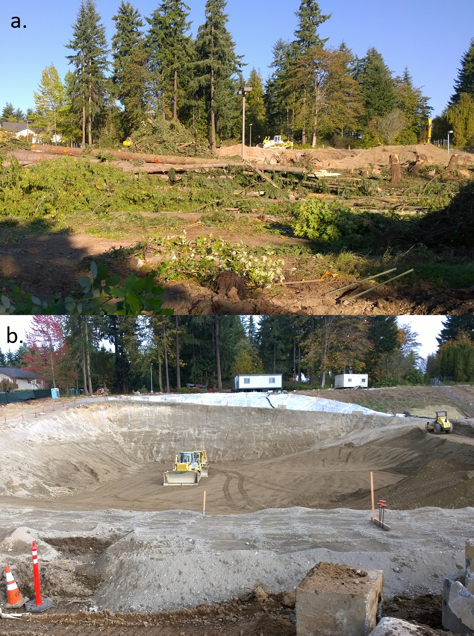

Figure 1 Commercial development project located in Redmond, WA illustrating: a. clearing the site of vegetation and b. grading the site and digging foundation.

Social factors motivating developer and land owner decisions in social-ecological systems are diverse. On office developments, development and landscaping choices are informed by a complex mix of trends in landscape design, office development marketing, regulations, landscape budget, expert opinion, and plant availability (Avolio et al., 2018; Conway, 2016; Dorney et al., 1984; Widrlechner, 1990). On residential properties, neighborhood socio-economic variables including neighborhood age and wealth may explain much of the variation in planting choices (Avolio et al., 2018; Clarke et al., 2013; Hope et al., 2003; Leong et al., 2018). Developers for all land uses are often motivated by cost and investment decisions (**???**); mass construction paired with removing existing vegetation is purportedly cheaper, though preserving vegetation may be less expensive in the long run (McKinney, 2002).

In addition to social motivations, public policy both restricts and incentivizes developer and land owner actions when developing and landscaping urban land. Woody vegetation is responsible for aesthetic components of the landscape important to community identity and key ecosystem services like shade provision, rainwater interception, carbon sequestration, and primary productivity (Collins et al., 2011; Conway, 2016; Elmendorf, 2008; Goodness, 2018; Wolf, 2005). As a result, many municipalities (including those in the study area) have adopted clearing and grading permitting processes, impervious surface maximums and minimums via parking space requirements, tree protection policies, canopy cover goals, and vegetation planting policies (DeLaria, 2008; Environmental Protection Agency, 2011; Young, 2011). These have historically been important for determining urban vegetation in North America (Dorney et al., 1984). For example, tree preservation policies dictate decisions that impact legacy vegetation, the abundance of old trees, and provision of native tree habitat.

Together this combination of remnant, spontaneous, and planted natives and ornamentals create vegetation communities and patterns in cities broadly and on office developments specifically (Dorney et al., 1984; McKinney, 2002; Wittig, 2010). Because other biological communities are largely determined by available vegetation, landowner choices in planting vegetation impact food webs and biodiversity (Avolio et al., 2018; Faeth et al., 2011, 2005). For example, some common horticulturally-modified ornamental species like *Prunus* L. are used less by native bees than related plants (Mach and Potter, 2018). Introduced ornamentals are also unlikely to support the same insect species, or the same biomass or diversity of fauna as native habitat (Burghardt et al., 2009; Crisp et al., 1998; McKinney, 2002; Rebele, 1994). If insect populations and biomass change due to cultivated ornamental vegetation, species at higher trophic levels will also be impacted (Burghardt et al., 2009; Faeth et al., 2011; Marzluff et al., 2001).

Different decisions when developing and landscaping urban parcels will result in different quantity and quality of habitat available to other organisms (Alberti, 2005; Alberti et al., 2003; Polasky et al., 2005; Rosenzweig, 2003). For conservation efforts to be successful, the matrix in which preserves are situated, including the built environment, must provide sufficient resources for local species (Fahrig, 2001; Fischer et al., 2006; Miller and Hobbs, 2002; Polasky et al., 2005; Rosenzweig, 2003). This will require working with private landowners to alter private actions to support conservation of locally important vegetated habitat (Goddard et al., 2010; Miller and Hobbs, 2002).

Understanding the types of vegetation that result and the actions that create them is important for urban plant ecology and conservation. While vegetation surveys in urban areas have classified vegetation communities and examined human actions on residential neighborhoods and public open space (Dana et al., 2002; Hope et al., 2003; Lehmann et al., 2014), this research has generally not been extended to other land use types including office developments and other commercial land uses (Bourne and Conway, 2014; Snep et al., 2011). This oversight means that there are important land uses in cities for which we lack information about the composition of vegetation communities.

To fill this gap, I examined vegetation community composition on office developments in Bellevue and Redmond, Washington, USA. Specifically, I was interested in 1) the types of tree and shrub communities present on office developments; 2) how these communities are related to other choices such as percent impervious surface; 3) whether socio-economic conditions or development and landscaping outcomes explain observed variation in vegetation communities. I hypothesized that vegetation communities on office developments would be heterogeneous. I also hypothesized that neighborhood scale socio-economic variables found significant in explaining vegetation patterns on residential property were not significant on office developments (commercial property; Avolio et al., 2018; Conway, 2016; Hope et al., 2003), but that site-scale socio-economic variables were. Finally, I hypothesized that development and landscaping actions explain variation in tree and shrub community structure.

I found that vegetation communities are highly variable across office developments, and that development and landscaping actions best explain this variability. Unlike residential property, variation in vegetation communities on office developments are explained more by development and land management actions and are not driven by neighborhood or site scale socio-economic variables. The observed variability in woody vegetation suggests differences in habitat quality and quantity available to other organisms within one land use and has significant implications for how urban ecologists should approach sampling site design. Studies using a limited number of sites per land use are potentially drawing incorrect conclusions about vegetation and habitat potential based on the distribution of vegetation communities on each land use (McIntyre et al., 2000).

# Materials and Methods

## Study area and site selection

Redmond (2017 population 64,000) and Bellevue (population 144,000) are located east of Seattle in King County, Washington (United States Census Bureau, 2017). Both cities share a similar ecological history, a similar disturbance timeline for logging and agriculture, and have grown considerably since the opening of the Evergreen Point Floating Bridge (SR 520) in 1963. They are at similar elevations (< 500 ft) and experience the same climate and weather. The initial sampling frame was limited to Redmond and Bellevue north of I-90 and excluded developments in Bellevue’s central business district and contained 492 properties (Table 1; Figure 2).

I used disproportionate stratified random sampling to ensure that my sample included sites across the entire vegetation gradient. >>XXXX<< office development parcels met the initial study criteria of office use as defined by the King County Assessor’s Office. I grouped adjacent parcels with the same owner and similar age built (within 3 years) to create a unit of analysis based on human action not cadastral boundaries.

I then classified the vegetation at each potential study site into type categories using a brief visual estimation during site visits in early 2014 (Figure 2, Table 1). Sites with no vegetation, with wetlands, or those that were currently under construction or undergoing landscape replanting were excluded from the analysis (87 sites). The remaining pool of 405 potential sites had no notable hydrological features on site.

Table 1 Vegetation type assignment criteria and strata size. Sites without vegetation and those with wetlands present were excluded from further analysis.

|  |  |  |  |  |  |
| --- | --- | --- | --- | --- | --- |
| Vegetation Type | Tree Cover | Shrub Richness | Strata Size | Sampled (n) | Notes |
| High (HH) | 30% native tree cover | > 5 native shrub genera | 10 | 5 |  |
| Medium Canopy (MC) | 30% native tree cover | No requirement | 22 | 3 |  |
| Medium Diverse (MD) | 15% tree cover | > 5 native shrub genera | 53 | 4 |  |
| Medium (MM) | 15% tree cover | > 5 shrub genera | 264 | 3 |  |
| Low (LL) | < 10% tree cover | < 5 shrub genera | 56 | 5 |  |
| No Vegetation (LP) | No trees | No shrubs | 71 | 0 | Excluded from further analysis |
| Wetlands (WW) | No requirement | No requirement | 10 | 0 | Wetland present, excluded from further analysis |

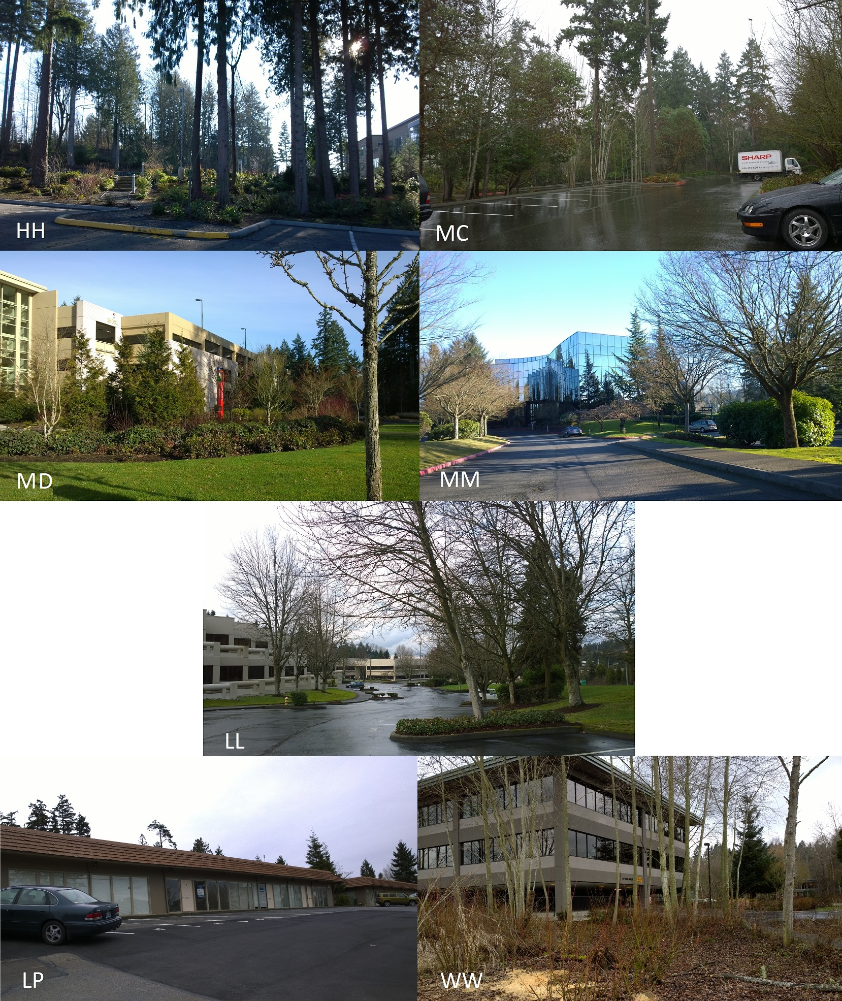

Figure 2 Examples of each vegetation type, from top left to bottom right: High (HH); Medium Canopy (MC); Medium Diverse (MD); Medium (MM); Low (LL); no vegetation (LP; excluded); wetlands (WW; excluded).

I conducted stratified random sampling on sites with HH, MC, MD, MM, and LL vegetation. I restricted the sampling pool to sites in the 25th to 85th percentile of site area and the 15th to 85th percentile of surrounding impervious surfaces. These limits were imposed to avoid confounding factors based on the smallest strata (HH).

I requested property access through three mailings sent to the property owner or manager on file in the King County Assessor’s database (Dyson et al., 2018). I targeted vegetation categories underrepresented in my sample in the second and third mailings. Of 46 mailed requests, 20 (43.5%) received no response or were not deliverable. Of the 26 (56.5%) responses received, 6 (23.1%) of were rejected and 20 (76.9%) were accepted (Table 1, Figure 3).

Commercial use of sample sites included light industrial, white collar office space, and medical/dental offices. Some sites were fully leased to tenants, while others were either partly or fully owner-occupied. Company size ranged from less than 10 to many thousand employees.

Thirteen,seven

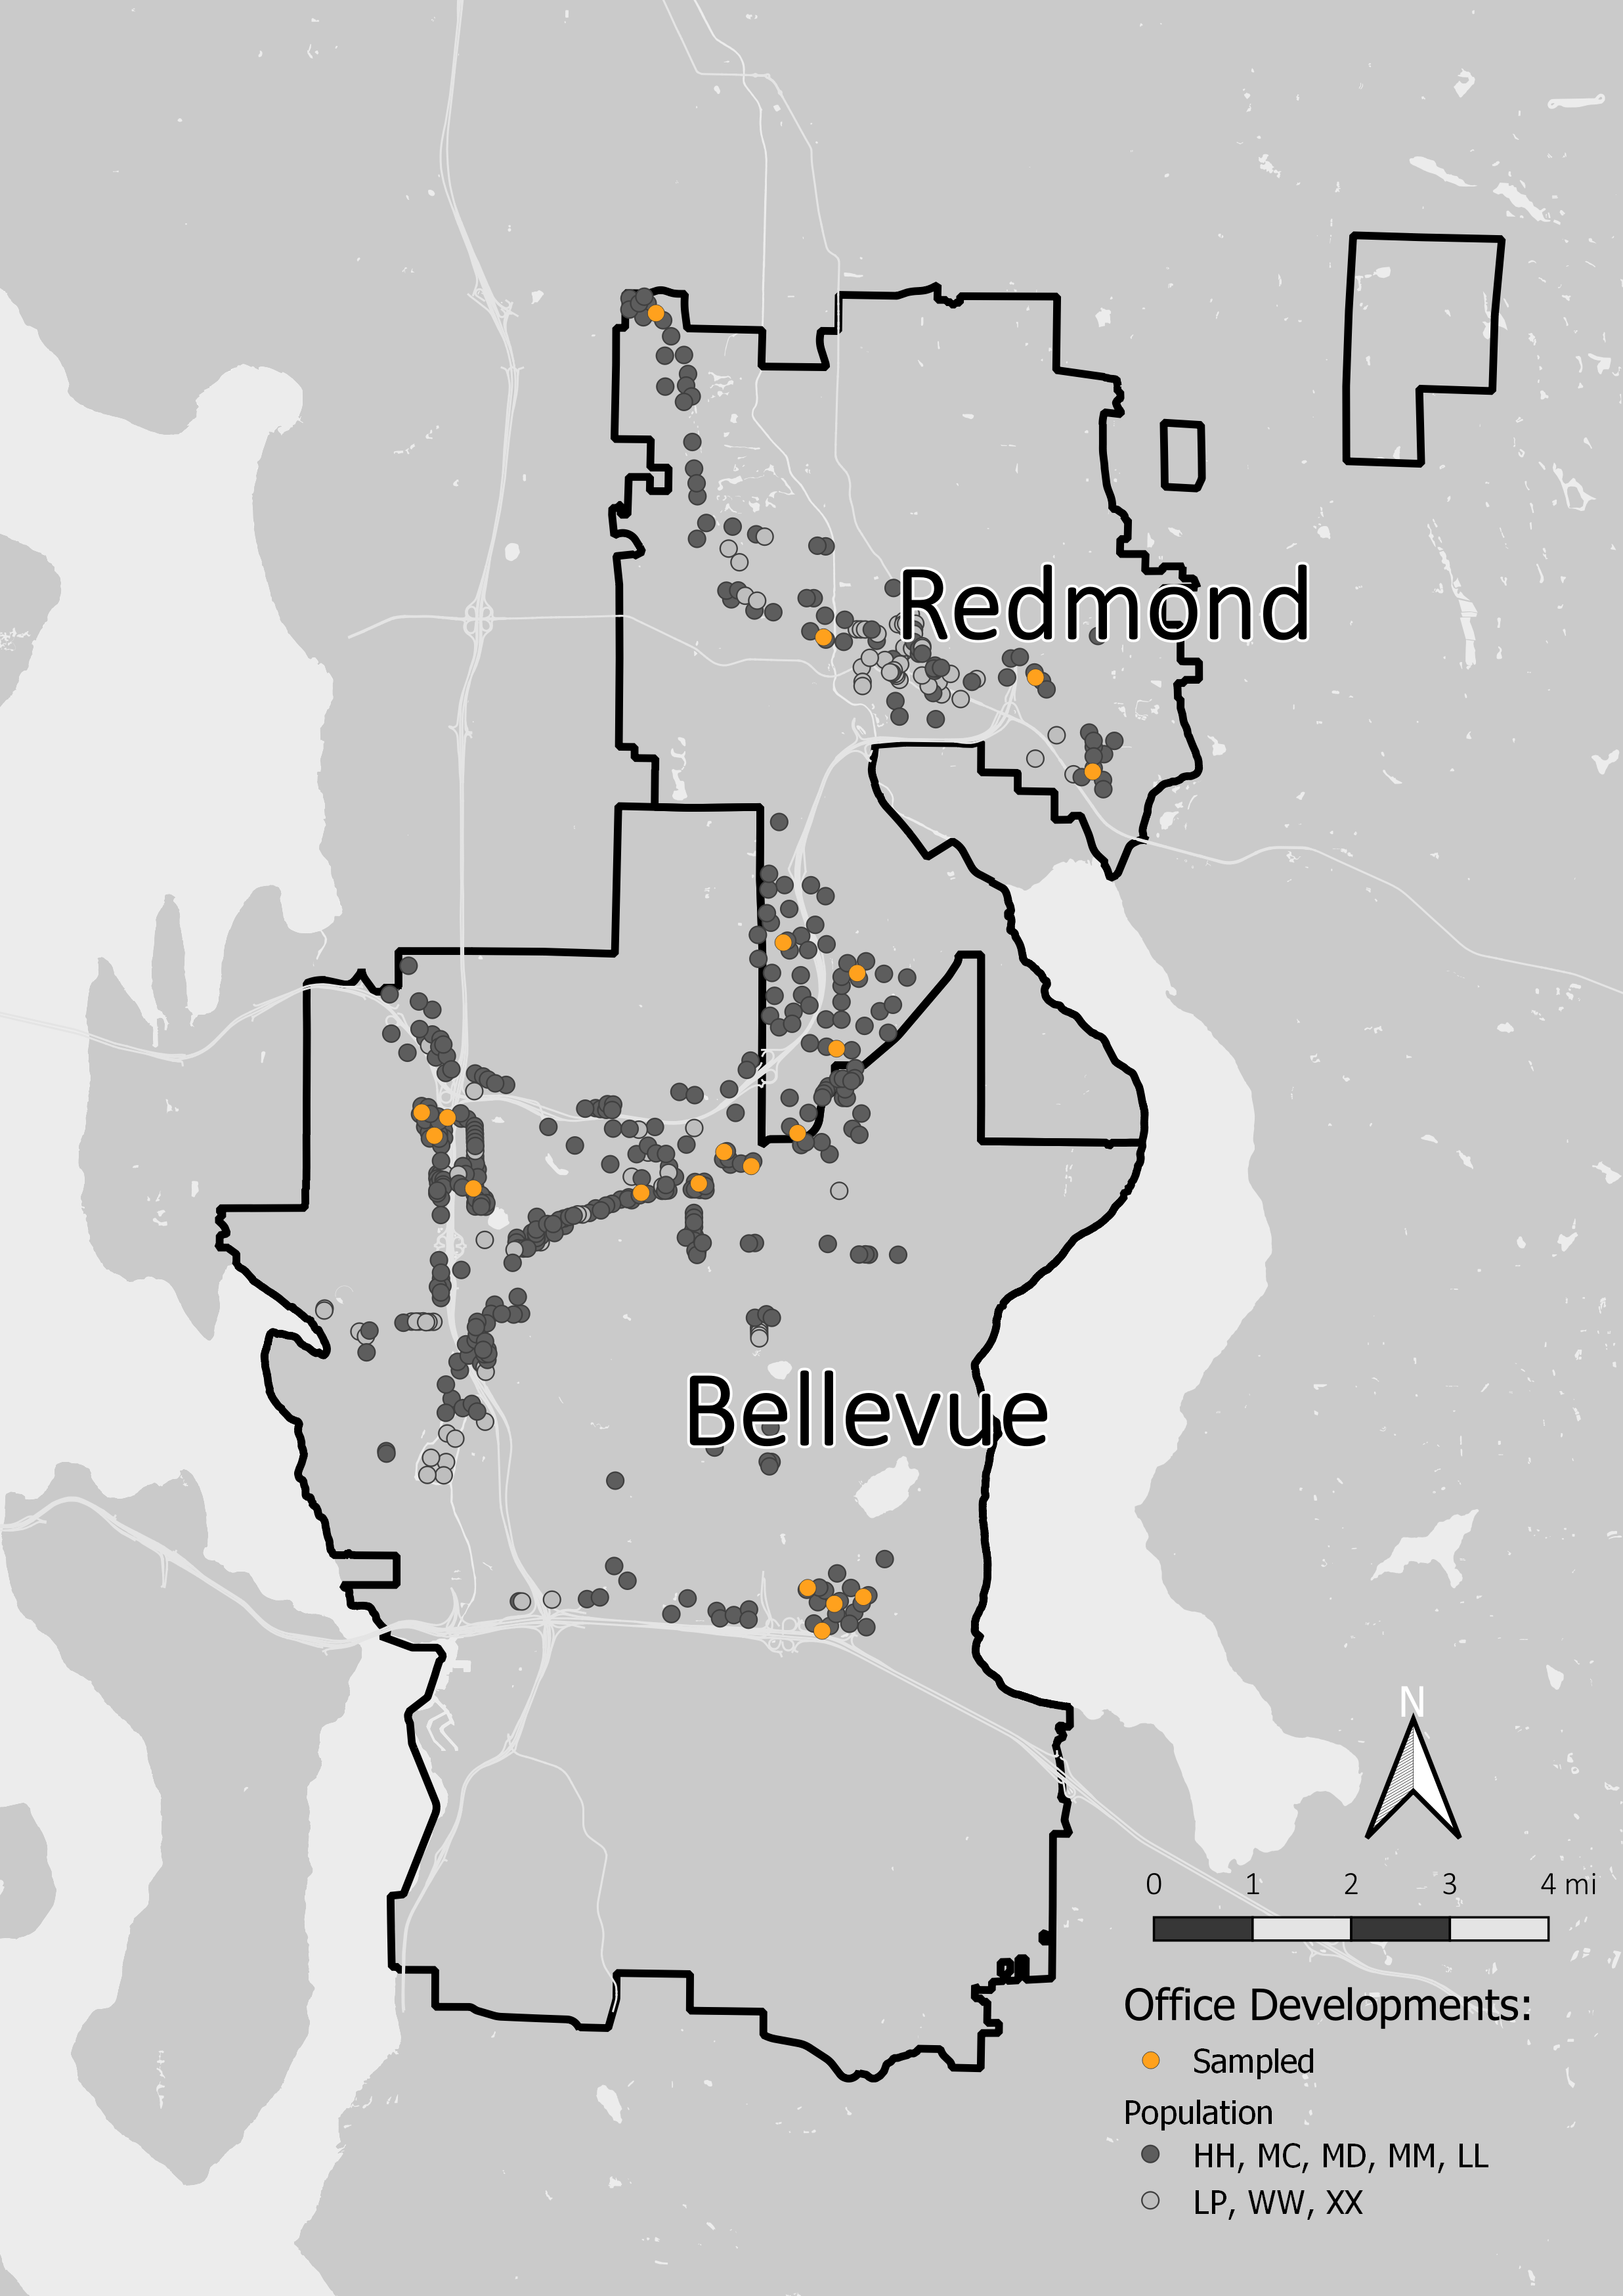

Figure 3 Map of office development study sites in Redmond and Bellevue, Washington. The population of office developments with High (HH), Medium Canopy (MC), Medium Diverse (MD), Medium (MM), and Low (LL) vegetation are represented with dark gray circles; excluded sites (no vegetation/LP, wetlands/WW, and under construction/XX) are represented with light gray circles. Sampled sites are shown with orange circles.

## Independent variables

Independent variables used in this analysis are defined in Table 2. Previous research identified neighborhood socio-economic variables (median income, demographics) as significant (Dana et al., 2002; Grove et al., 2014; Hope et al., 2003; Martin et al., 2004; QGIS Development Team, 2016; Walker et al., 2009); these are included for comparison and to test whether surrounding residential property impacts residential developments. Commercial property variables include building quality and assessed land value. Unfortunately, other measures were incorrect or incomplete. For example, some buildings received tax breaks following the 2008 recession, resulting in an appraised value of 1,000 USD when the building’s market value was greater than 5,000,000 USD.

I measured the height of dominant native conifers with a Nikon Forestry Pro Laser Rangefinder; this proxy measure was used as tree cores were not collected due to liability concerns (Dyson et al., 2018). I used historical records and site construction plans to determine whether each site had a stand of 3 adjacent tree predating site development. I used *Pseudotsuga menziesii* (Mirb.) Franco, *Thuja plicata* Donn ex D. Don, and *Tsuga heterophylla* (Raf.) Sarg. counts to calculate native conifer density.

After recording broad ground cover material types on paper maps, I hand digitized them in QGIS to calculate area (QGIS Development Team, 2016). Pervious cover types recorded include dense vegetation, dirt/litter, lawn (turf grass including moss and forb species), gravel, dense ivy, mulch, and water. I used semi-structured interviews of property owners, managers, and landscaping services along with site visits to obtain maintenance regime variables (Dexter, 1970; Harvey, 2011).

Table 2 Definition of independent variables used in PERMANOVA and correlation analysis (Homer et al., 2015; King County Department of Assessments, 2014; King County GIS Center, 2014; United States Census Bureau, 2016; Xian et al., 2011). Summary statistics for independent variables for both the population of office developments in Redmond and Bellevue and the sample of sites studied (87 and 20 sites, respectively). Median income ($) and % foreign born are included to compare patterns in commercial developments with patterns found significant in residential research.

|  |  |  |  |  |
| --- | --- | --- | --- | --- |
| Variable Name | Definition | Data Source | Population | Sample |
| **1. SOCIO-ECONOMIC SITE AND NEIGHBORHOOD VARIABLES** | | | | |
| Area (acre) | Site area, in acres. | King County Assessor | Range: 0.14-42.51;  Mean(SD): 3.61(5.51) | Range: 0.63-5.39;  Mean(SD): 2.57(1.58) |
| Town | Location, Bellevue or Redmond. | King County Assessor | Bellevue: 281  Redmond: 123 | Bellevue: 13  Redmond: 7 |
| Building Age (in 2017) | Age of building on site (or mean age for multiple buildings) in 2017. | King County Assessor | Range: NA-NA;  Mean(SD): NA(NA) | Range: 9-42;  Mean(SD): 32.08(9.77) |
| Building Quality | Categorical ‘quality class’ assigned to buildings on the site | King County Assessor | Below Average: 11  Average: 146 Average/Good: 96  Good: 120  Good/Excellent: 25 | Below Average: 0  Average: 7  Average/Good: 4  Good: 7  Good/Excellent: 2 |
| Appraised Land Value per Acre | Appraised land value divided by site area. One missing assessed land values were replaced with population median land value. | King County Assessor | Range: 214673.23-6086305.24;  Mean(SD): 1845520.33(904065.06) | Range: 578266.03-3028352.75;  Mean(SD): 1679109.71(623031.13) |
| Impervious w/in 500 m (%) | Percent impervious surface within 500 m of the site’s perimeter. | National Land Cover Database 2011 Percent Developed Imperviousness dataset updated in 2014 | Range: 1949.32-8111.33;  Mean(SD): 5577(1163.21) | Range: 4875.49-6696.33;  Mean(SD): 5676.05(628.97) |
| Median Income | The median income of residents for the site’s block group | American Community Survey 2014 5-year block group | Range: 42368-194107;  Mean(SD): 81408.04(24957.4) | Range: 42368-134643;  Mean(SD): 80477.5(22179.18) |
| Percent Foreign-Born | The percent of residents born outside of the United States for the site’s block group. | American Community Survey 2014 5-year block group | Range: 14.58-86.14;  Mean(SD): 38.99(16.68) | Range: 14.58-86.14;  Mean(SD): 40.63(18.29) |
| **2. DEVELOPMENT AND LANDSCAPING ACTION VARIABLES** | | | | |
| Stands Predate Development | Binary variable indicating presence of a cluster of three+ trees that predate development. (Development) | Site survey | NA | Yes: 12 No: 8 |
| Median Height of Dominant Conifer | Median height (m) of five dominant native conifer trees; age proxy. (Development) | Site survey | NA | Range: 0-40.6;  Mean(SD): 25.82(12.99) |
| Density of Native Conifers | Total density of Douglas-fir, western redcedar, and western hemlock (Development/Landscaping). | Site survey | NA | Range: 0-61.29;  Mean(SD): 22.47(19.25) |
| **3. GROUND COVER MATERIAL AND MAINTENANCE REGIME** | | | | |
| Ground Cover Types (%) | Ground cover types on site including lawn, mulch, and impervious surface. | Site survey | NA | Mean (SD) Grass: 7.28 ( 6.94 );  Impervious: 66.44 ( 10.49 );  Dirt/Litter: 5.96 ( 7.96 ) |
| Dead Wood (count) | Total abundance of stumps, logs, and snags on site. | Site survey | NA | Range: 0-40.6;  Mean(SD): 25.82(12.99) |
| Irrigation | Binary variable indicating whether irrigation is used during the summer months. | Interviews and site survey | NA | Yes: 16  No: 3 |
| Mulch, Herbicide, and/or Fertilizer Application | Binary variables (3) indicating whether landscaping crew applies mulch, herbicides, or fertilizers to a site. | Interviews and site survey | NA | Mulch Y/N: 17/3  Herbicide Y/N: 13/4  Fertilizer Y/N: 15/3 |

## Vegetation data collection

I censused vegetation communities in summer of 2015. Each tree and shrub was identified to species or genus (Dirr, 2009, 1997; Sibley and others, 2009). Trees with DBH < 4" were excluded. All “significant” trees in Redmond and Bellevue’s zoning codes are greater than 6" or 8" DBH, respectively. Following Daniels and Kirkpatrick (2006), I grouped conifers <2 m into a broad class of dwarf conifer species. Ten individual trees (0.506%) and 14 shrubs (0.174%) could not be identified; these were given a unique identifier code for multivariate community analysis. Some tree and shrub species were grouped at the genus level due to the abundance of very similar cultivars in the landscaping trade, including *Prunus* L. sp. and *Malus* Mill. sp.

I assigned tree and shrub genera to one of three provenance categories—native, non-native, or ambiguous (U.S. Geological Survey, 1999; USDA, 2016). The ambiguous category was used for genera including both native and non-native cultivated species that are difficult to distinguish, and/or frequently interbred and sold as crosses. For example, some *Mahonia* Nutt. sp. are native (*M. aquifolium* (Pursh) Nutt. and *M. nervosa* (Pursh) Nutt.), while others originate in Asia (*Mahonia japonica* (Thumb.) DC.) and many hybrids are bred and sold by nurseries (e.g. *Mahonia x media* “Charity” Brickell).

In total, I observed 1,978 individual trees and 8,039 individual shrubs (Supplemental Table A). The 20 office developments I sampled varied in tree and shrub abundance, density, and effective species richness (Table 3).

Table 3 Observed tree and shrub communities on sampled sites.

|  |  |  |  |  |  |
| --- | --- | --- | --- | --- | --- |
| Metric | Minimum | Maximum | Mean | S.D. | Median |
| Tree Abundance | 10.00 | 240.00 | 98.90 | 64.40 | 86.00 |
| Tree Density (#/acre) | 15.23 | 104.84 | 43.46 | 26.16 | 31.42 |
| Tree Species Richness | 3.00 | 16.00 | 8.60 | 3.68 | 7.00 |
| Tree Shannon Diversity (H’) | 0.64 | 2.17 | 1.48 | 0.43 | 1.55 |
| Tree Effective Species Richness (exp(H’)) | 1.90 | 8.75 | 4.76 | 1.89 | 4.71 |
| Native Conifer Abundance All Sizes | 0.00 | 216.00 | 49.80 | 57.58 | 28.00 |
| Native Conifer Density All Sizes (#/acre) | 0.00 | 61.29 | 22.47 | 19.25 | 19.73 |
| Shrub Abundance | 71.00 | 1789.00 | 401.95 | 439.02 | 220.50 |
| Shrub Density (#/acre) | 39.65 | 404.01 | 153.06 | 99.70 | 125.66 |
| Shrub Species Richness | 8.00 | 41.00 | 18.65 | 7.28 | 18.50 |
| Shrub Shannon Diversity (H’) | 1.74 | 3.05 | 2.33 | 0.31 | 2.34 |
| Shrub Effective Species Richness (exp(H’)) | 5.68 | 21.14 | 10.74 | 3.59 | 10.38 |
| Native Shrub Species Richness | 0.00 | 10.00 | 4.00 | 2.62 | 4.00 |

## Data Analysis

Woody vegetation analysis methods are summarized in Figure 4. I standardized tree and shrub abundance data and ground cover area by total site area in acres. This transformation preserves parcel boundaries as the unit of analysis and reflects developer and landowner actions during and following development that determine the amount of impervious surface and pervious area, the number of trees preserved, and the number of trees and shrubs planted. Between site standardization (e.g. Wisconsin standardization) was not used as the vegetation on all sites was completely censused.

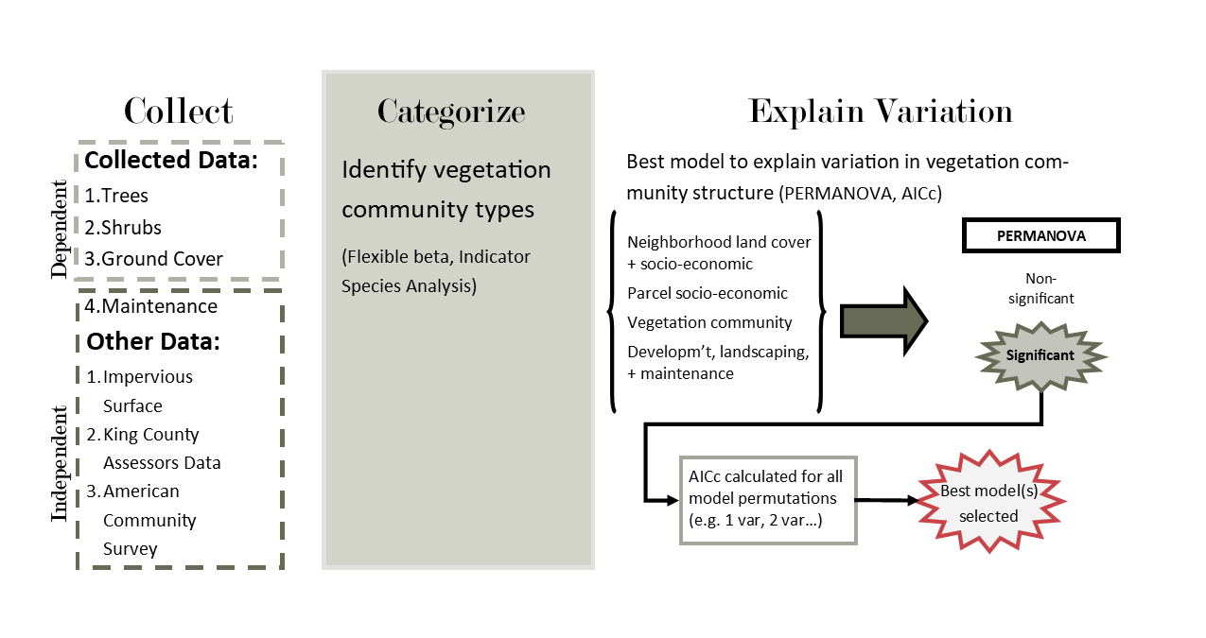

Figure 4 Summary of vegetation data analysis methods.

### Identifying and describing vegetation clusters on office developments

I used flexible beta clustering and indicator species analysis to delineate vegetation community clusters on office developments. I used the agnes {vegan} function with beta = -0.5 to produce an ecologically interpretable dendrogram with minimal chaining (Breckenridge, 2000; Dufrêne and Legendre, 1997; McCune et al., 2002; Milligan, 1989; Oksanen et al., 2017). I performed indicator species analysis, which assesses the predictive values of species as indicators of the conditions at site groups, using multipatt {indicspecies} (De Caceres and Legendre, 2009; De Cáceres, 2013; De Cáceres et al., 2010). I ran the permutation-based function 100 times and took the mean of the indicator statistics generated for each species (Dyson, 2018).

After identifying vegetation community typologies, I used simple univariate PERMANOVA models to test if ground cover (%) differed between groups and Pearson’s Chi-squared test to test if maintenance regime differed (adonis2 {vegan} and chisq.test {stats}; Oksanen et al., 2017). PERMANOVA is a permutation based implementation of ANOVA/MANOVA that avoids assumptions about underlying distributions of community structure and can be used with non-Euclidian distance matrices (Anderson, 2001). Bartlett tests of homogeneity find no difference between group variances (bartlett.test {stats}).

### Explaining variation in tree and shrub community structure

I used a multi-step approach to avoid transforming independent variables or using ordination to collapse related variables, as these actions make results less interpretable for urban planners and other professionals without back transformation. I first tested each variable individually in a simple multivariate PERMANOVA model. I used ANOVA to test for significant differences in dispersion for categorical variables (anova {stats} and betadisper {vegan}; Oksanen et al., 2017). I then constructed models using all variables with significant pseudo-*F* values ( 0.05) in all possible single and multiple variable model combinations. I used a custom AICc function based on residual sums of squares to compare model fit (Dyson, 2018).

Non-metric multidimensional scaling (NMDS) is a rank-based ordination technique that is robust to data without identifiable distributions, can be used with any distance or dissimilarity measure (McCune et al., 2002). I used 100 repetitions of the metaMDS {vegan} implementation of NMDS to find a stable minima (McCune et al., 2002; Oksanen et al., 2017).

# Results and Discussion

I found that woody vegetation communities on office developments in Redmond and Bellevue, Washington are heterogenous with multiple groups identified by cluster analysis (Table 3). This within land use heterogeneity suggest implications for how urban ecologists sample. Additionally, I found evidence that development and landscaping outcomes, not socio-economic variables, are behind major divisions in vegetation groups in contrast with previous research (Clarke et al., 2013; Hope et al., 2003; Luck et al., 2009). This impacts the quality and quantity of habitat provided by woody vegetation on office developments, with important implications for conservation and public policy.

## Woody vegetation groups observed on office developments

I identified two groups of each tree and shrub vegetation based on flexible beta cluster analysis (flexible beta = -0.5; agglomerative coefficients of 0.871 and 0.772 respectively; Table 4). Using indictor species analysis, I found the Native Tree group (11 sites) is characterized by *Thuja plicata*, *Acer macrophyllum* Pursh, *Arbutus menziesii* Pursh, and *Alnus rubra* Bong, while the Ornamental Tree group (9 sites) is characterized by *Acer rubrum* L. The Native Shrub group (11 sites) is characterized by *Acer circinatum* Pursh, *Corylus sp.* L., *Gaultheria shallon* Pursh, *Mahonia sp.* Nutt., *Symphoricarpos sp.* Duham., and *Vaccinium parvifolium* Sm., and the Ornamental Shrub group (9 sites) by *Prunus laurocerasus* L.

Table 4 Rank abundance of tree and shrub species for each community group identified by flexible-beta analysis. Mean abundance per site in group in parenthesis.

|  |  |  |  |  |
| --- | --- | --- | --- | --- |
| Rank | Native Tree Group | Ornamental Tree Group | Native Shrub Group | Ornamental Shrub Group |
| 1 | **Pseudotsuga menziesii (58.6)** | **Pseudotsuga menziesii (11.2)** | **Gaultheria shallon (107)** | Prunus laurocerasus var. zabeliana (54) |
| 2 | **Thuja plicata (20.4)** | Acer rubrum (10.9) | Berberis Mahonia gp. (85.5) | Rhododendron sp. (30) |
| 3 | **Acer macrophyllum (19.4)** | Acer platanoides (10.4) | Rhododendron sp. (31.1) | **Cornus sericea gp. (23.4)** |
| 4 | Acer rubrum (3.1) | Pinus nigra (8) | **Acer circinatum (19.9)** | Lonicera pileata (15.1) |
| 5 | **Alnus rubra (2.2)** | **Callitropsis nootkatensis  (5.4)** | **Cornus sericea gp. (18.9)** | Viburnum davidii (13.7) |
| 6 | **Arbutus menziesii (1.7)** | Acer saccharum (4.8) | **Vaccinium ovatum (18.3)** | Berberis thunbergii (13.1) |
| 7 | Populus tremuloides (1.5) | Fraxinus americana (3.9) | Viburnum davidii (14.1) | Ilex crenata (10.1) |
| 8 | Liquidambar styraciflua (1.2) | Prunus subg. Cerasus (3.3) | **Symphoricarpos sp. (13.4)** | Gaultheria shallon (10) |
| 9 | Prunus subg. Cerasus (0.8) | Thuja plicata (2.3) | **Ribes sanguineum (12.5)** | Ornamental conifer (9.8) |
| 10 | **Callitropsis nootkatensis  (0.7)** | Fraxinus pennsylvanica (1.9) | Arbutus unedo (11.3) | Osmanthus x burkwoodii gp. (8.2) |

In addition to the origin of tree and shrub species, the two groups are distinct in the average abundance of trees and shrubs per site (Native Tree mean = 117.091, Ornamental Tree mean = 76.667 with Pr(>*F*) = 0.168; Native Shrub mean = 491.182, Ornamental Shrub mean = 292.889 with Pr(>*F*) = 0.369 ). The median height of dominant native conifers was also significantly different between Native and Ornamental clusters for trees and shrubs (tree mean values = 33.2 m and 16.8 m with Pr(>*F*) = 0.002; shrub mean value = 32.727 m and 17.378 m with Pr(>*F*) = 0.004). However, there was no difference in area between Native and Ornamental clusters for either trees or shrubs ( tree Pr(>*F*) = 0.424; shrub Pr(>*F*) = 0.24).

Other differences between the groups are also of interest. Associated ground cover on Native and Ornamental Tree sites differed significantly for percent impervious surface cover on site but not grass or combined dirt and liter cover. Native and Ornamental Shrub sites only differed for percent grass cover. Dead wood was significantly more abundant on Native Tree sites than Ornamental Tree sites (mean value = 13.364 and 2.444 with Pr(>*F*) = 0.018), but not between shrub site groups. Irrigation, mulching, herbicide, and fertilizer application had only three “no” responses and thus I cannot draw any well supported conclusions.

Finally, there was substantial co-occurance between Native and Ornamental groups. Of the 20 office developments surveyed, nine sites belong to both native tree and shrub community groups, and seven sites belong to both ornamental tree and shrub community groups.

## POPULATION EXTRAPOLATION

The heterogenity I observed within a single land use has important implications for sampling design in urban ecology. In the population of 405 office developments studied here, the Native Tree and Shrub communities are more rare than Ornamental Tree and Shrub communities. More precisely, extrapolation suggests there are approximately 70 Native Tree and 335 Ornamental Tree developments for a ratio of around 1:5 developments, and 152 Native Shrub and 253 Ornamental Shrub developments for a ratio of around 2:5 developments (Table 5). Note the accuracy of these estimates will be influenced by the medium vegetation group (MM), as it is large and proportionally undersampled, and the relatively small sample size.

Table 5 Category overlap between visually estimated vegetation class and Native and Ornamental groups derived from flexible-beta clusteringfor trees and shrubs. LL = low vegetation; MM = medium vegetation; MD = medium w/diverse shrubs; MC = medium w/canopy cover; HH = high vegetation

|  |  |  |  |  |  |
| --- | --- | --- | --- | --- | --- |
| **Tree Cluster** | **LL** | **MM** | **MD** | **MC** | **HH** |
| **Native** | 1 | 0 | 2 | 3 | 5 |
| **Ornamental** | 4 | 3 | 2 | 0 | 0 |
| **Shrub Cluster** | **LL** | **MM** | **MD** | **MC** | **HH** |
| **Native** | 0 | 1 | 3 | 2 | 5 |
| **Ornamental** | 5 | 2 | 1 | 1 | 0 |

In this system, the choice of sampling design can result in very different conclusions when comparing different land uses or examining one land use across the urban gradient (e.g. Blair, 1999; Bourne and Conway, 2014). For example, consider a small random sample of the entire population of 405 office developments in Bellevue and Redmond. This sample would contain all or almost all sites dominated by ornamental trees with a low chance of sampling the ecological communities found on sites dominated by native trees.

If we consider the number of trees per site, the sample would not capture the fat right tail of sites with very high tree abundance (Figure 5). If this sample is taken as representative of the whole population, it would lead to misleading conclusions about the range of vegetation communities on office developments alone or in comparison with other land uses, and potential sollutions already extant on the landcape may be overlooked (McIntyre et al., 2000). Thus, how researchers sample determines patterns found. In this research, I found diverse vegetation communities and important trends because I stratified along a vegetation gradient; however other gradients were not fully sampled (Dyson, 2019).

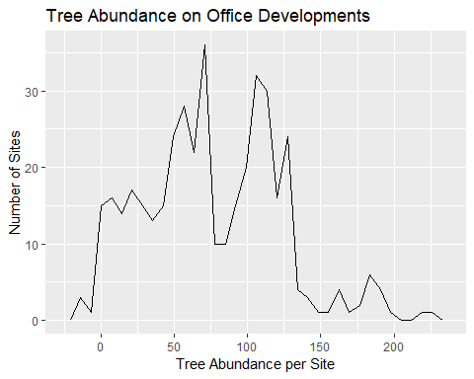

Figure 5 Extrapolated distribution of the number of trees on office developments based on observed mean and standard deviations for each vegetation class used in sampling (HH, MC, MD, MM, LL).

Thus it is worth reiterating that researchers should choose their sampling strategy carefully based on research questions and the underlying distribution of key variables in urban contexts with long environmental gradients (Ellis and Schneider, 1997; McIntyre et al., 2000; Telford and Birks, 2011). If the phenomena of interest is related to vegetation structure or community composition, you must search out sites representing all vegetation types to measure the entire gradient instead of sampling only along an urban gradient. Here, collecting visual informatin on different types of vegetation communities prior to sampling improved sampling design. Other studies have sampled based on native/non-native planting aesthetics based on knowledge of local landscaping patterns (e.g. Lerman and Warren, 2011).

## Socio-economic variables do not explain variation in tree or shrub community composition

### Neighborhood-scale

Neighborhood-scale socio-economic variables found important in residential land use research did not significantly explain variation in woody vegetation community composition on office developments (Clarke et al., 2013; Fraser et al., 2000; Hope et al., 2003; Luck et al., 2009; Martin et al., 2004; Schmid, 1975). This supports my hypothesis that neighborhood socio-economic variables specific to residential property are not necessarially important for commercial properties.

When coupled with similar findings in municipal parks, these results suggest that different socio-economic drivers, motivations, and preferences drive vegetation community composition on each land use type (Faeth et al., 2011; Kinzig et al., 2005; Leong et al., 2018; Martin et al., 2004). This mismatch means that urban ecologists cannot assume that the same variables or mechanisms explain variation for all land use types, and ecosystem models must reflect this.

For socio-economic variables to be significant drivers of vegetation on office developments, the surrounding socio-economic context would need to influence developer and landowner choices of trees and shrubs. This could occur in areas where office developments are adjacent and visible to residential property. However, zoning code in Bellevue and Redmond—as in much of the United States—actively separates and screens the different land uses from one another.

Alternative explainations for different drivers of woody vegetation community on office developments include the intended audience, developer motivations, and differences in study design. Unlike residential properties, where homeowners use vegetation choices to signal to their neighbors, owners of office developments are signalling to prospective and existing tenants (Cook et al., 2012; Laverne et al., 2003; Levy and Peterson, 2013; Nassauer et al., 2009; Peterson et al., 2012). Studies examining why landscape architects make planting decisions are fewer in number than residential homeowners. In Toronto, factors like site aspect, appearance, and available space rate more highly in species selection than whether species are native and nearby canopy composition for landscape architects, however city staff try to plant native species whenever possible (Conway, 2016). Differences in study design may also be responsible; other studies use index response variables with univariate regression (Hope et al., 2003; Martin et al., 2004), measures dependent on effort (Karlik and Winer, 2001; Martin et al., 2004), and plot or transect designs which confound different actors and outcomes (**???**). Additionally, limiting my sampling design with respect to surrounding impervious surface reduced my ability to detect the influence of this variable on vegetation community composition.

### Site-scale

Site-scale socio-economic variables were also not significant in explaining variation in tree or shrub community composition on office developments. This includes site age, building quality (proxy for rent extraction), and assessed land value (land rent gradient). This is surprising and fails to support my hypothesis.

Site age was suggested as a determinant of woody vegetation community composition by studies on residential properties (Avolio et al., 2018; Boone et al., 2010), landscaping professionals I interviewed, and my examination of contemporaneous landscaping plans filed with the cities of Bellevue and Redmond. Landscaping professionals mentioned trends in plant popularity, including *Pieris japonica* (Thunb.) D. Don ex G. Don in the late 1980s and increasing use of native plants since 2000. Alternative explainations for this finding include: building age is a poor measure for landscaping age due to replanting; an interaction between age and landscaping budget; or that only a subset of office developments are planted with in vogue landscape plants, such as the “Medium” (MM) group which was undersampled.

## Development and landscaping outcomes are related to vegetation community composition

Tree preservation appears particularly important for characterizing woody vegetation communities on office developments. The outcome of development and landscaping actions are associated with the first NMDS axis for the tree community and the Native Tree cluster (Figure 6). Fitted environmental vectors found strong relationships with median dominant native conifer height (a proxy for stand age), native conifer density, the presence of stands predating development, and dead wood abundance (particularly stump abundance).

These outcome variables also significantly explained variability in shrub community structure using PERMANOVA. The best supported models included median dominant native conifer height, Native vs. Ornamental Tree cluster, native conifer density, and the presence of stands predating development (Table 6). This supports my hypothesis that these actions impact vegetation communities on office developments. This also agrees with clustering results and suggests that a suite of decisions is being made either to retain more trees and plant native shrubs or retain fewer trees and plant ornamental trees and shrubs.

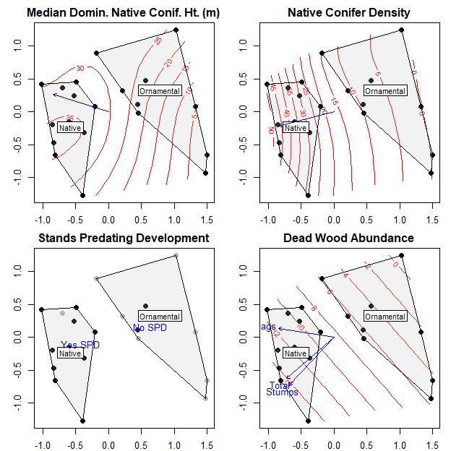

Figure 6 Two dimensional NMDS representation of tree community composition. Median dominant native conifer height, native conifer density, and the presence of stands predating development are associated with the first NMDS axis. Dead wood is associated with both axes. Black dots represent sites with stands predating development, gray dots sites without. Ordination has not been rotated prior to plotting.

Table 6 PERMANOVA model summary comparing multivariate models of shrub community composition.

|  |  |  |  |
| --- | --- | --- | --- |
| Model | Pseudo-F | p-value | Delta AICc |
| Median Douglas Fir Height (m) | 3.29 | 0.001 | 0.00 |
| Tree Group Membership | 3.10 | 0.002 | 0.18 |
| Native Conifer Density | 2.98 | 0.002 | 0.29 |
| Tree Group + Median DF Height (m) | 2.60 | 0.001 | 0.81 |
| Median DF Height (m) + Native Conifer Density | 2.39 | 0.001 | 1.19 |
| Stands Predate Development | 2.35 | 0.015 | 0.90 |
| Median DF Height (m) + Stands Predate Development | 2.31 | 0.001 | 1.34 |
| Tree Group + Native Conifer Density | 1.99 | 0.006 | 1.94 |
| Tree Group + Stands Predate Development | 1.94 | 0.005 | 2.05 |
| Stands Predate Development + Native Conifer Density | 1.88 | 0.010 | 2.15 |
| Median Household Income ($) | 1.31 | 0.177 | 1.95 |

Development and landscaping outcomes are the end point of economic decision making processes poorly studied in urban ecology. While the coarse socio-economic variables examined here were not significant, developer and landowner motivations and decisionmaking were not considered explicitly. For example, developers may consider ease of construction based on site conditions, relative cost of different construction approaches, preferences of the landowner and customer specifications, previous company experience or company aesthetic, and development regulations (Conway, 2016; Dorney et al., 1984; which impose costs on developers; Grimes and Mitchell, 2015; Häkkinen and Belloni, 2011; Nappi-Choulet, 2006). These considerations may influence financing available to developers, financial risk, and the appeal of the completed project to potential renters (Laverne et al., 2003). Further, when considering multiple competing options—such as different landscaping choices—developers and landowners may satisfice. That is, they search through alternatives until one meets an acceptability threshold, and that is the option chosen.

## Implications for urban habitat quality and quantity

As local biological communities are largely determined by available remnant, spontaneous and planted vegetation, varying stand age and abundance on native conifers mean that office developments provide varying habitat quality and quantity to other organisms (Avolio et al., 2018; Faeth et al., 2011, 2005; McKinney, 2002; Wittig, 2010). For example, native vegetation is more likely to support native insects and native birds than ornamental plantings (Belaire et al., 2014; Burghardt et al., 2009; Chong et al., 2014; Dyson, 2019; Narango et al., 2018; Paker et al., 2014; Pennington and Blair, 2011). One estimate suggests native vegetation volume must be above 70% in order to maintain populations of native insectivorous bird species (Narango et al., 2018). Further research should expanding this research to encompass the whole range of urban land use types, as well as investigating the mechanistic links between landscape patterns and processes at both site- and landscape-scales.

The variation in woody vegetation communities on office developments suggests better habitat conservation during and following development is possible. We can point to actions and policies more likely to contribute high quality habitat and benefit other trophic levels, including tree preservation policies, promoting native tree and shrub planting, and removing policy barriers to native vegetation (**???**; Dyson, 2019).

However, the motivations driving exemplary adoption of these actions are currently opaque. Anecdotes shared during fieldwork suggest owner-occupied office space, cost, and personal values and connections to nature may be important factors in determining development and landscaping actions, as with homeowners (**???**; beumer2018; Helfand et al., 2006; Kendal et al., 2012; Kiesling and Manning, 2010; Nassauer, 1993; Peterson et al., 2012). Further research should attempt to better understand developer and landowner decisionmaking in order to improve quality and quantity on commercial property (Uren et al., 2015). These include interviews to better understand tree preservation and planting motivations (Conway, 2016; Häkkinen and Belloni, 2011); aesthetic preference studies as on residential developments (Harris et al., 2012; Larson et al., 2009); tracing decision making pathways based on previous land use (Yang et al., 2017); and expanding on this research to better capture various maintenance regimes.

# Conclusion

I found that developments in Bellevue and Redmond, Washington, are heterogenous with distinct Native and Ornamental Tree and Shrub vegetation communities. My research provides a counterpoint to residential land use studies that found neighborhood socio-economic conditions important in determining vegetation communties. This research also provides evidence that different development and landscaping choices meaningfully influence urban vegetation and result in this divergent community composition across office developments. Future research needs to examine motivations behind these choices in order to improve the quality and quantity of habitat available in urban ecosystems.

# Supplemental Tables

Table 7 All tree species observed.

|  |  |  |  |  |
| --- | --- | --- | --- | --- |
| Taxa | #/Site  Range | Total Abundance | Mean Abundance | Abundance SD |
| Acer ginnala | 0–2 | 2 | 0.10 | 0.447 |
| Acer macrophyllum | 0–47 | 218 | 10.90 | 17.146 |
| Acer platanoides | 0–50 | 100 | 5.00 | 12.074 |
| Acer rubrum | 0–33 | 132 | 6.60 | 9.725 |
| Acer saccharum | 0–24 | 43 | 2.15 | 6.523 |
| Alnus rubra | 0–7 | 29 | 1.45 | 2.305 |
| Arbutus menziesii | 0–12 | 19 | 0.95 | 2.685 |
| Betula occidentalis | 0–3 | 3 | 0.15 | 0.671 |
| Betula papyrifera | 0–2 | 7 | 0.35 | 0.745 |
| Betula pendula | 0–2 | 3 | 0.15 | 0.489 |
| Carpinus sp. | 0–3 | 3 | 0.15 | 0.671 |
| Cedrus deodara | 0–4 | 13 | 0.65 | 1.387 |
| Cercidiphyllum japonicum | 0–5 | 5 | 0.25 | 1.118 |
| Cercis canadensis | 0–6 | 8 | 0.40 | 1.392 |
| Cupressus nootkatensis | 0–39 | 57 | 2.85 | 8.911 |
| Fagus sylvatica gp. | 0–1 | 2 | 0.10 | 0.308 |
| Fraxinus americana | 0–26 | 35 | 1.75 | 6.051 |
| Fraxinus pennsylvanica | 0–16 | 17 | 0.85 | 3.573 |
| Gleditsia triacanthos | 0–8 | 9 | 0.45 | 1.791 |
| Liquidambar styraciflua | 0–11 | 24 | 1.20 | 3.156 |
| Liriodendron tulipifera | 0–4 | 7 | 0.35 | 0.988 |
| Magnolia grandiflora | 0–5 | 11 | 0.55 | 1.432 |
| Malus sp. | 0–4 | 6 | 0.30 | 0.923 |
| Picea omorika | 0–6 | 6 | 0.30 | 1.342 |
| Pinus contorta | 0–8 | 8 | 0.40 | 1.789 |
| Pinus nigra | 0–42 | 75 | 3.75 | 10.944 |
| Pinus strobus | 0–1 | 1 | 0.05 | 0.224 |
| Pinus sylvestris | 0–7 | 17 | 0.85 | 2.059 |
| Platanus occidentalis | 0–2 | 3 | 0.15 | 0.489 |
| Populus nigra | 0–9 | 9 | 0.45 | 2.012 |
| Populus tremuloides | 0–17 | 17 | 0.85 | 3.801 |
| Populus trichocarpa | 0–4 | 13 | 0.65 | 1.268 |
| Prunus sp. | 0–9 | 39 | 1.95 | 2.819 |
| Prunus subg. Padus | 0–2 | 2 | 0.10 | 0.447 |
| Pseudotsuga menziesii | 0–204 | 746 | 37.30 | 50.751 |
| Quercus palustris | 0–4 | 8 | 0.40 | 1.231 |
| Quercus rubra | 0–9 | 11 | 0.55 | 2.038 |
| Robinia pseudoacacia | 0–3 | 3 | 0.15 | 0.671 |
| Sorbus aucuparia | 0–1 | 1 | 0.05 | 0.224 |
| Taxus brevifolia | 0–1 | 1 | 0.05 | 0.224 |
| Thuja plicata | 0–53 | 245 | 12.25 | 15.269 |
| Tilia sp. | 0–1 | 1 | 0.05 | 0.224 |
| Tsuga heterophylla | 0–3 | 5 | 0.25 | 0.716 |
| Ulmus sp. | 0–4 | 4 | 0.20 | 0.894 |
| Unknown Broadleaf 1 | 0–2 | 2 | 0.10 | 0.447 |
| Unknown Broadleaf 2 | 0–1 | 1 | 0.05 | 0.224 |
| Unknown Broadleaf 3 | 0–1 | 1 | 0.05 | 0.224 |
| Unknown Broadleaf 4 | 0–1 | 1 | 0.05 | 0.224 |
| Unknown Broadleaf 5 | 0–2 | 2 | 0.10 | 0.447 |
| Unknown Broadleaf 6 | 0–1 | 1 | 0.05 | 0.224 |
| Unknown Cedar 1 | 0–1 | 1 | 0.05 | 0.224 |
| Unknown Cedar 2 | 0–1 | 1 | 0.05 | 0.224 |

Table 8 All shrub species observed.

|  |  |  |  |  |
| --- | --- | --- | --- | --- |
| Taxa | Abundance Range | Total Abundance | Mean Abundance | Abundance SD |
| Abelia grandiflora | 0–29 | 29 | 1.45 | 6.485 |
| Acer circinatum | 0–75 | 265 | 13.25 | 19.628 |
| Acer palmatum | 0–9 | 17 | 0.85 | 2.183 |
| Amelanchier alnifolia | 0–4 | 4 | 0.20 | 0.894 |
| Arbutus unedo | 0–63 | 125 | 6.25 | 17.262 |
| Arctostaphylos sp. | 0–15 | 15 | 0.75 | 3.354 |
| Aucuba japonica | 0–4 | 7 | 0.35 | 0.988 |
| Berberis Mahonia gp. | 0–359 | 1007 | 50.35 | 93.443 |
| Berberis thunbergii | 0–93 | 144 | 7.20 | 21.222 |
| Buxus sp. | 0–52 | 65 | 3.25 | 11.548 |
| Calluna vulgaris | 0–25 | 28 | 1.40 | 5.576 |
| Cistaceae sp. | 0–39 | 56 | 2.80 | 9.328 |
| Cornus florida gp. | 0–6 | 12 | 0.60 | 1.569 |
| Cornus sericea gp. | 0–162 | 419 | 20.95 | 43.685 |
| Cornus sericea gp. | 0–162 | 419 | 20.95 | 43.685 |
| Cornus sericea gp. | 0–162 | 419 | 20.95 | 43.685 |
| Corylus sp. | 0–58 | 109 | 5.45 | 13.249 |
| Cotoneaster sp. | 0–39 | 85 | 4.25 | 9.296 |
| Crataegus sp. | 0–4 | 11 | 0.55 | 1.146 |
| Cytisus scoparius | 0–6 | 9 | 0.45 | 1.395 |
| Daphne sp. | 0–4 | 4 | 0.20 | 0.894 |
| Dasiphora fruticosa | 0–19 | 19 | 0.95 | 4.249 |
| Elaeagnus commutata | 0–31 | 31 | 1.55 | 6.932 |
| Enkianthus campanulatus | 0–2 | 2 | 0.10 | 0.447 |
| Erica sp. | 0–6 | 16 | 0.80 | 1.609 |
| Escallonia sp. | 0–17 | 40 | 2.00 | 5.301 |
| Euonymus alatus | 0–41 | 127 | 6.35 | 13.620 |
| Euonymus japonicus | 0–15 | 76 | 3.80 | 5.197 |
| Euphorbia sp. | 0–21 | 56 | 2.80 | 5.662 |
| Forsythia sp. | 0–63 | 76 | 3.80 | 14.059 |
| Gardenia sp. | 0–3 | 3 | 0.15 | 0.671 |
| Gaultheria shallon | 0–393 | 1267 | 63.35 | 115.281 |
| Hebe sp. | 0–21 | 31 | 1.55 | 5.094 |
| Hibiscus syriacus | 0–2 | 2 | 0.10 | 0.447 |
| Holodiscus discolor | 0–7 | 7 | 0.35 | 1.565 |
| Hydrangea sp. | 0–6 | 15 | 0.75 | 1.860 |
| Hypericum calycinum | 0–29 | 71 | 3.55 | 8.894 |
| Ilex aquifolium gp. | 0–11 | 30 | 1.50 | 2.947 |
| Ilex crenata | 0–29 | 138 | 6.90 | 10.711 |
| Kalmia latifolia | 0–2 | 2 | 0.10 | 0.447 |
| Lavandula sp. | 0–43 | 46 | 2.30 | 9.592 |
| Leucothoe fontanesiana | 0–5 | 8 | 0.40 | 1.273 |
| Leycesteria formosa | 0–17 | 17 | 0.85 | 3.801 |
| Lonicera pileata | 0–136 | 136 | 6.80 | 30.411 |
| Lonicera sempervirens gp. | 0–9 | 9 | 0.45 | 2.012 |
| Nandina domestica | 0–106 | 168 | 8.40 | 23.359 |
| Oemleria cerasiformis | 0–44 | 146 | 7.30 | 11.721 |
| Ornamental conifer | 0–40 | 177 | 8.85 | 11.431 |
| Osmanthus x burkwoodii gp. | 0–64 | 76 | 3.80 | 14.348 |
| Philadelphus lewisii | 0–2 | 2 | 0.10 | 0.447 |
| Photinia x fraseri gp. | 0–22 | 66 | 3.30 | 6.131 |
| Physocarpus opulifolius | 0–9 | 9 | 0.45 | 2.012 |
| Pieris japonica | 0–11 | 34 | 1.70 | 3.310 |
| Prunus laurocerasus | 0–33 | 101 | 5.05 | 9.344 |
| Prunus laurocerasus var. zabeliana | 0–134 | 581 | 29.05 | 37.841 |
| Rhaphiolepis indica | 0–4 | 4 | 0.20 | 0.894 |
| Rhododendron sp. | 4–76 | 612 | 30.60 | 21.507 |
| Rhus sp. | 0–18 | 25 | 1.25 | 4.115 |
| Ribes sanguineum | 0–47 | 143 | 7.15 | 14.057 |
| Rosa sp. | 0–26 | 46 | 2.30 | 6.760 |
| Rosmarinus officinalis | 0–1 | 1 | 0.05 | 0.224 |
| Rubus bifrons | 0–35 | 119 | 5.95 | 10.655 |
| Rubus laciniatus | 0–25 | 25 | 1.25 | 5.590 |
| Rubus spectabilis | 0–25 | 48 | 2.40 | 6.954 |
| Sambucus sp. | 0–3 | 3 | 0.15 | 0.671 |
| Sarcococca confusa | 0–51 | 69 | 3.45 | 11.528 |
| Spiraea japonica gp. | 0–51 | 57 | 2.85 | 11.412 |
| Spiraea nipponica | 0–52 | 59 | 2.95 | 11.651 |
| Styrax japonicus | 0–5 | 11 | 0.55 | 1.317 |
| Symphoricarpos sp. | 0–58 | 148 | 7.40 | 14.848 |
| Syringa vulgaris | 0–1 | 2 | 0.10 | 0.308 |
| Thuja occidentalis | 0–14 | 31 | 1.55 | 4.006 |
| Vaccinium ovatum | 0–155 | 205 | 10.25 | 34.727 |
| Vaccinium parvifolium | 0–7 | 26 | 1.30 | 2.273 |
| Vaccinium sect. Cyanococcus | 0–5 | 5 | 0.25 | 1.118 |
| Viburnum davidii | 0–69 | 278 | 13.90 | 22.525 |
| Viburnum plicatum | 0–6 | 11 | 0.55 | 1.701 |
| Viburnum tinus | 0–31 | 101 | 5.05 | 9.644 |
| Unknown B gp. | 0–1 | 1 | 0.05 | 0.224 |
| Unknown C gp. | 0–2 | 2 | 0.10 | 0.447 |
| Unknown F gp. | 0–1 | 1 | 0.05 | 0.224 |
| Unknown G gp. | 0–1 | 1 | 0.05 | 0.224 |
| Unknown J gp. | 0–1 | 1 | 0.05 | 0.224 |
| Unknown K gp. | 0–1 | 1 | 0.05 | 0.224 |
| Unknown L gp. | 0–1 | 1 | 0.05 | 0.224 |
| Unknown N gp. | 0–5 | 5 | 0.25 | 1.118 |
| Unknown S gp. | 0–1 | 1 | 0.05 | 0.224 |

# Works Cited

Alberti, M., 2005. The effects of urban patterns on ecosystem function. International Regional Science Review 28, 168–192.

Alberti, M., Marzluff, J.M., Shulenberger, E., Bradley, G., Ryan, C., Zumbrunnen, C., 2003. Integrating humans into ecology: Opportunities and challenges for studying urban ecosystems. AIBS Bulletin 53, 1169–1179.

Anderson, M.J., 2001. A new method for non-parametric multivariate analysis of variance. Austral Ecology 26, 32–46.

Andres, C.K., Smith, R.C., 2004. Principles and practices of commercial construction. Pearson/Prentice Hall.

Avolio, M.L., Pataki, D.E., Trammell, T.L., Endter-Wada, J., 2018. Biodiverse cities: The nursery industry, homeowners, and neighborhood differences drive urban tree composition. Ecological Monographs 88, 259–276.

Belaire, J.A., Whelan, C.J., Minor, E.S., 2014. Having our yards and sharing them too: The collective effects of yards on native bird species in an urban landscape. Ecological Applications 24, 2132–2143.

Blair, R.B., 1999. Birds and butterflies along an urban gradient: Surrogate taxa for assessing biodiversity? Ecological applications 9, 164–170.

Blair, R.B., 1996. Land use and avian species diversity along an urban gradient. Ecological Applications 6, 506–519. <https://doi.org/10.2307/2269387>

Boone, C.G., Cadenasso, M.L., Grove, J.M., Schwarz, K., Buckley, G.L., 2010. Landscape, vegetation characteristics, and group identity in an urban and suburban watershed: Why the 60s matter. Urban Ecosystems 13, 255–271.

Bourne, K.S., Conway, T.M., 2014. The influence of land use type and municipal context on urban tree species diversity. Urban ecosystems 17, 329–348.

Breckenridge, J.N., 2000. Validating cluster analysis: Consistent replication and symmetry. Multivariate Behavioral Research 35, 261–285.

Burghardt, K.T., Tallamy, D.W., Gregory Shriver, W., 2009. Impact of native plants on bird and butterfly biodiversity in suburban landscapes. Conservation Biology 23, 219–224.

Byrne, L.B., 2007. Habitat structure: A fundamental concept and framework for urban soil ecology. Urban Ecosystems 10, 255–274. <https://doi.org/10.1007/s11252-007-0027-6>

Chong, K.Y., Teo, S., Kurukulasuriya, B., Chung, Y.F., Rajathurai, S., Tan, H.T.W., 2014. Not all green is as good: Different effects of the natural and cultivated components of urban vegetation on bird and butterfly diversity. Biological Conservation 171, 299–309.

Clarke, L.W., Jenerette, G.D., Davila, A., 2013. The luxury of vegetation and the legacy of tree biodiversity in los angeles, ca. Landscape and urban planning 116, 48–59.

Collins, S.L., Carpenter, S.R., Swinton, S.M., Orenstein, D.E., Childers, D.L., Gragson, T.L., Grimm, N.B., Grove, J.M., Harlan, S.L., Kaye, J.P., others, 2011. An integrated conceptual framework for long-term social–ecological research. Frontiers in Ecology and the Environment 9, 351–357.

Conway, T.M., 2016. Tending their urban forest: Residents’ motivations for tree planting and removal. Urban forestry & urban greening 17, 23–32.

Cook, E.M., Hall, S.J., Larson, K.L., 2012. Residential landscapes as social-ecological systems: A synthesis of multi-scalar interactions between people and their home environment. Urban Ecosystems 15, 19–52.

Crisp, P.N., Dickinson, K., Gibbs, G., 1998. Does native invertebrate diversity reflect native plant diversity? A case study from new zealand and implications for conservation. Biological Conservation 83, 209–220.

Dana, E., Vivas, S., Mota, J., 2002. Urban vegetation of almeria city—a contribution to urban ecology in spain. Landscape and Urban Planning 59, 203–216.

Daniels, G., Kirkpatrick, J., 2006. Comparing the characteristics of front and back domestic gardens in hobart, tasmania, australia. Landscape and Urban Planning 78, 344–352.

De Caceres, M., Legendre, P., 2009. Associations between species and groups of sites: Indices and statistical inference, Ecology.

De Cáceres, M., 2013. How to use the indicspecies package (ver 1.7.1). Catalonia, Centre Tecnològic Forestal de Catalunya.

De Cáceres, M., Legendre, P., Moretti, M., 2010. Improving indicator species analysis by combining groups of sites. Oikos 119, 1674–1684.

DeLaria, M., 2008. Low impact development as a stormwater management technique. The Rocky Mountain Land Use Institute.

Dexter, L., 1970. Elite and specialized interviewing.

Dirr, M., 2009. Manual of woody landscape plants: Their identification, ornamental characteristics, culture, propagation and uses. Stipes Publishing LLC.

Dirr, M., 1997. Dirr’s hardy trees and shrubs: An illustrated encyclopedia. Timber Press, Inc.

Dorney, J.R., Guntenspergen, G.R., Keough, J.R., Stearns, F., 1984. Composition and structure of an urban woody plant community. Urban Ecology 8, 69–90.

Dufrêne, M., Legendre, P., 1997. Species assemblages and indicator species: The need for a flexible asymmetrical approach. Ecological monographs 67, 345–366.

Dyson, K., 2019. Parcel-scale development and landscaping actions affect vegetation, bird, and fungal communities on office developments (PhD thesis).

Dyson, K., 2018. Custom community ecology helper r scripts.

Dyson, K., Ziter, C., Fuentes, T.L., Patterson, M.S., 2018. Conducting urban ecology research on private property: Advice and lessons learned in the field. PeerJ Preprints. <https://doi.org/10.7287/peerj.preprints.26457v1>

Ellis, J.I., Schneider, D.C., 1997. Evaluation of a gradient sampling design for environmental impact assessment. Environmental Monitoring and Assessment 48, 157–172.

Elmendorf, W., 2008. The importance of trees and nature in community: A review of the relative literature. Arboriculture and Urban Forestry 34, 152.

Environmental Protection Agency, 2011. Assessing street and parking design standards to reduce excess impervious cover in new hampshire and massachusetts.

Faeth, S.H., Bang, C., Saari, S., 2011. Urban biodiversity: Patterns and mechanisms. Annals of the New York Academy of Sciences 1223, 69–81.

Faeth, S.H., Warren, P.S., Shochat, E., Marussich, W.A., 2005. Trophic dynamics in urban communities. BioScience 55, 399–407.

Fahrig, L., 2001. How much habitat is enough? Biological conservation 100, 65–74.

Fischer, J., Lindenmayer, D.B., Manning, A.D., 2006. Biodiversity, ecosystem function, and resilience: Ten guiding principles for commodity production landscapes. Frontiers in Ecology and the Environment 4, 80–86.

Fraser, E., Kenney, W.A., others, 2000. Cultural background and landscape history as factors affecting perceptions of the urban forest. Journal of Arboriculture 26, 106–113.

Germaine, S.S., Rosenstock, S.S., Schweinsburg, R.E., Richardson, W.S., 1998. Relationships among breeding birds, habitat, and residential development in greater tucson, arizona. Ecological applications 8, 680–691.

Gibb, H., Hochuli, D.F., 2002. Habitat fragmentation in an urban environment: Large and small fragments support different arthropod assemblages. Biological conservation 106, 91–100.

Goddard, M.A., Dougill, A.J., Benton, T.G., 2010. Scaling up from gardens: Biodiversity conservation in urban environments. Trends in ecology & evolution 25, 90–98.

Goodness, J., 2018. Urban landscaping choices and people’s selection of plant traits in cape town, south africa. Environmental Science & Policy 85, 182–192.

Grimes, A., Mitchell, I., 2015. Impacts of planning rules, regulations, uncertainty and delay on residential property development.

Grimm, N.B., Pickett, S.T., Hale, R.L., Cadenasso, M.L., 2017. Does the ecological concept of disturbance have utility in urban social–ecological–technological systems? Ecosystem Health and Sustainability 3, e01255.

Grove, J.M., Locke, D.H., O’Neil-Dunne, J.P., 2014. An ecology of prestige in new york city: Examining the relationships among population density, socio-economic status, group identity, and residential canopy cover. Environmental management 54, 402–419.

Halpern, C.B., Spies, T.A., 1995. Plant species diversity in natural and managed forests of the pacific northwest. Ecological Applications 5, 913–934.

Harris, E.M., Polsky, C., Larson, K.L., Garvoille, R., Martin, D.G., Brumand, J., Ogden, L., 2012. Heterogeneity in residential yard care: Evidence from boston, miami, and phoenix. Human Ecology 40, 735–749.

Harvey, W.S., 2011. Strategies for conducting elite interviews. Qualitative Research 11, 431–441. <https://doi.org/10.1177/1468794111404329>

Häkkinen, T., Belloni, K., 2011. Barriers and drivers for sustainable building. Building Research & Information 39, 239–255.

Heezik, Y.M. van, Freeman, C., Porter, S., Dickinson, K.J., others, 2014. Native and exotic woody vegetation communities in domestic gardens in relation to social and environmental factors. Ecology and Society 19, 17.

Helfand, G.E., Park, J.S., Nassauer, J.I., Kosek, S., 2006. The economics of native plants in residential landscape designs. Landscape and Urban Planning 78, 229–240.

Homer, C.G., Dewitz, J.A., Yang, L., Jin, S., Danielson, P., Xian, G., Coulston, J., Herold, N.D., Wickham, J., Megown, K., 2015. Completion of the 2011 national land cover database for the conterminous united states-representing a decade of land cover change information. Photogramm. Eng. Remote Sens 81, 345–354.

Hope, D., Gries, C., Zhu, W., Fagan, W.F., Redman, C.L., Grimm, N.B., Nelson, A.L., Martin, C., Kinzig, A., 2003. Socioeconomics drive urban plant diversity. Proceedings of the national academy of sciences 100, 8788–8792.

Karlik, J.F., Winer, A.M., 2001. Plant species composition, calculated leaf masses and estimated biogenic emissions of urban landscape types from a field survey in phoenix, arizona. Landscape and Urban Planning 53, 123–134.

Kendal, D., Williams, K.J., Williams, N.S., 2012. Plant traits link people’s plant preferences to the composition of their gardens. Landscape and Urban Planning 105, 34–42.

Kiesling, F.M., Manning, C.M., 2010. How green is your thumb? Environmental gardening identity and ecological gardening practices. Journal of Environmental Psychology 30, 315–327.

King County Department of Assessments, 2014. King county assessments data.

King County GIS Center, 2014. King county gis data portal.

Kinzig, A., Warren, P., Martin, C., Hope, D., Katti, M., 2005. The effects of human socioeconomic status and cultural characteristics on urban patterns of biodiversity. Ecology and Society 10.

Larson, K.L., Casagrande, D., Harlan, S.L., Yabiku, S.T., 2009. Residents’ yard choices and rationales in a desert city: Social priorities, ecological impacts, and decision tradeoffs. Environmental management 44, 921.

Laverne, R.J., Winson-Geideman, K., others, 2003. The influence of trees and landscaping on rental rates at office buildings. Journal of Arboriculture 29, 281–290.

LeBauer, D.S., Treseder, K.K., 2008. Nitrogen limitation of net primary productivity in terrestrial ecosystems is globally distributed. Ecology 89, 371–379.

Lehmann, I., Mathey, J., Rößler, S., Bräuer, A., Goldberg, V., 2014. Urban vegetation structure types as a methodological approach for identifying ecosystem services–Application to the analysis of micro-climatic effects. Ecological Indicators 42, 58–72.

Leong, M., Dunn, R.R., Trautwein, M.D., 2018. Biodiversity and socioeconomics in the city: A review of the luxury effect. Biology Letters 14, 20180082.

Lepczyk, C.A., Mertig, A.G., Liu, J., 2004. Assessing landowner activities related to birds across rural-to-urban landscapes. Environmental Management 33, 110–125.

Lerman, S.B., Warren, P.S., 2011. The conservation value of residential yards: Linking birds and people. Ecological Applications 21, 1327–1339.

Levy, D., Peterson, G., 2013. The effect of sustainability on commercial occupiers’ building choice. Journal of Property Investment & Finance 31, 267–284.

Luck, G.W., Smallbone, L.T., O’Brien, R., 2009. Socio-economics and vegetation change in urban ecosystems: Patterns in space and time. Ecosystems 12, 604.

Mach, B.M., Potter, D.A., 2018. Quantifying bee assemblages and attractiveness of flowering woody landscape plants for urban pollinator conservation. PloS one 13, e0208428.

Martin, C.A., Warren, P.S., Kinzig, A.P., 2004. Neighborhood socioeconomic status is a useful predictor of perennial landscape vegetation in residential neighborhoods and embedded small parks of phoenix, az. Landscape and Urban Planning 69, 355–368.

Marzluff, J.M., Bowman, R., Donnelly, R., 2001. A historical perspective on urban bird research: Trends, terms, and approaches, in: Avian Ecology and Conservation in an Urbanizing World. Springer, pp. 1–17.

McCune, B., Grace, J.B., Urban, D.L., 2002. Analysis of ecological communities. MjM software design Gleneden Beach, OR.

McIntyre, N.E., Knowles-Yánez, K., Hope, D., 2000. Urban ecology as an interdisciplinary field: Differences in the use of “urban” between the social and natural sciences. Urban ecosystems 4, 5–24.

McKinney, M.L., 2002. Urbanization, biodiversity, and conservation the impacts of urbanization on native species are poorly studied, but educating a highly urbanized human population about these impacts can greatly improve species conservation in all ecosystems. BioScience 52, 883–890.

Miller, J.R., Hobbs, R.J., 2002. Conservation where people live and work. Conservation biology 16, 330–337.

Milligan, G.W., 1989. A Study of the Beta-Flexible Clustering Method. Multivariate Behavioral Research 24, 163–176. <https://doi.org/10.1207/s15327906mbr2402_2>

Mullaney, J., Lucke, T., Trueman, S.J., 2015. A review of benefits and challenges in growing street trees in paved urban environments. Landscape and Urban Planning 134, 157–166.

Nappi-Choulet, I., 2006. The role and behaviour of commercial property investors and developers in french urban regeneration: The experience of the paris region. Urban Studies 43, 1511–1535.

Narango, D.L., Tallamy, D.W., Marra, P.P., 2018. Nonnative plants reduce population growth of an insectivorous bird. Proceedings of the National Academy of Sciences 115, 11549–11554.

Nassauer, J.I., 1993. Ecological function and the perception of suburban residential landscapes. Managing Urban and High Use Recreation Settings. General Technical Report, USDA Forest Service North Central Forest Experiment Station, St. Paul, MN 98–103.

Nassauer, J.I., Wang, Z., Dayrell, E., 2009. What will the neighbors think? Cultural norms and ecological design. Landscape and Urban Planning 92, 282–292.

Oksanen, J., Blanchet, F.G., Friendly, M., Kindt, R., Legendre, P., McGlinn, D., Minchin, P.R., O’Hara, R.B., Simpson, G.L., Solymos, P., Stevens, M.H.H., Szoecs, E., Wagner, H., 2017. Vegan: Community ecology package.

Paker, Y., Yom-Tov, Y., Alon-Mozes, T., Barnea, A., 2014. The effect of plant richness and urban garden structure on bird species richness, diversity and community structure. Landscape and Urban Planning 122, 186–195.

Pennington, D.N., Blair, R.B., 2011. Habitat selection of breeding riparian birds in an urban environment: Untangling the relative importance of biophysical elements and spatial scale. Diversity and Distributions 17, 506–518.

Peters, D.P., Lugo, A.E., Chapin, F.S., Pickett, S.T., Duniway, M., Rocha, A.V., Swanson, F.J., Laney, C., Jones, J., 2011. Cross-system comparisons elucidate disturbance complexities and generalities. Ecosphere 2, 1–26.

Peterson, M.N., Thurmond, B., Mchale, M., Rodriguez, S., Bondell, H.D., Cook, M., 2012. Predicting native plant landscaping preferences in urban areas. Sustainable Cities and Society 5, 70–76.

Pickett, S.T., Cadenasso, M.L., Grove, J.M., Nilon, C.H., Pouyat, R.V., Zipperer, W.C., Costanza, R., 2008. Urban ecological systems: Linking terrestrial ecological, physical, and socioeconomic components of metropolitan areas, in: Urban Ecology. Springer, pp. 99–122.

Pickett, S.T., Cadenasso, M.L., Grove, J.M., Nilon, C.H., Pouyat, R.V., Zipperer, W.C., Costanza, R., 2001. Urban ecological systems: Linking terrestrial ecological, physical, and socioeconomic components of metropolitan areas. Annual review of ecology and systematics 32, 127–157.

Polasky, S., Nelson, E., Lonsdorf, E., Fackler, P., Starfield, A., 2005. Conserving species in a working landscape: Land use with biological and economic objectives. Ecological applications 15, 1387–1401.

QGIS Development Team, 2016. QGIS geographic information system. Open Source Geospatial Foundation.

Rebele, F., 1994. Urban ecology and special features of urban ecosystems. Global ecology and biogeography letters 173–187.

Rosenzweig, M.L., 2003. Reconciliation ecology and the future of species diversity. Oryx 37, 194–205.

Schmid, J.A., 1975. Urban vegetation: A review and chicago case study. Department of Geography, University of Chicago, Chicago, Illinois.

Sharpe, D.M., Stearns, F., Leitner, L.A., Dorney, J.R., 1986. Fate of natural vegetation during urban development of rural landscapes in southeastern wisconsin. Urban Ecology 9, 267–287.

Sibley, D., others, 2009. Sibley guide to trees. Alfred A. Knopf; Distributed by Random House.

Snep, R.P., WallisDeVries, M.F., Opdam, P., 2011. Conservation where people work: A role for business districts and industrial areas in enhancing endangered butterfly populations? Landscape and Urban Planning 103, 94–101.

Telford, R.J., Birks, H.J.B., 2011. Effect of uneven sampling along an environmental gradient on transfer-function performance. Journal of Paleolimnology 46, 99.

Turner, M.G., 2005. Landscape ecology: What is the state of the science? Annu. Rev. Ecol. Evol. Syst. 36, 319–344.

U.S. Geological Survey, 1999. Digital representation of “atlas of united states trees” by elbert l. little, jr.

United States Census Bureau, 2017. Population and housing unit estimates.

United States Census Bureau, 2016. American community survey 5yr block group.

Uren, H.V., Dzidic, P.L., Bishop, B.J., 2015. Exploring social and cultural norms to promote ecologically sensitive residential garden design. Landscape and Urban Planning 137, 76–84.

USDA, N., 2016. The plants database.

Walcott, C.D., 1899. Nineteenth annual report of the united states geological survey to the secretary of the interior 1897 - 1898: Part v – forest reserves.

Walker, J.S., Grimm, N.B., Briggs, J.M., Gries, C., Dugan, L., 2009. Effects of urbanization on plant species diversity in central arizona. Frontiers in Ecology and the Environment 7, 465–470.

Widrlechner, M.P., 1990. Trends influencing the introduction of new landscape plants. Advances in new crops. Timber Press, Portland, OR 460–467.

Wittig, R., 2010. Biodiversity of urban-industrial areas and its evaluation–a critical review. Urban biodiversity and design: S 37–55.

Wolf, K.L., 2005. Business district streetscapes, trees, and consumer response. Journal of Forestry 103, 396–400.

Xian, G., Homer, C., Dewitz, J., Fry, J., Hossain, N., Wickham, J., 2011. Change of impervious surface area between 2001 and 2006 in the conterminous united states. Photogrammetric Engineering and Remote Sensing 77, 758–762.

Yang, J., Yan, P., He, R., Song, X., 2017. Exploring land-use legacy effects on taxonomic and functional diversity of woody plants in a rapidly urbanizing landscape. Landscape and Urban Planning 162, 92–103.

Young, R.F., 2011. Planting the living city: Best practices in planning green infrastructure—Results from major us cities. Journal of the American Planning Association 77, 368–381.

Zipperer, W.C., 2010. The process of natural succession in urban areas. The Routledge Handbook of Urban Ecology 187.