Software Instruction

\* The instruction takes the data of Maduwang watershed and GXAJ-IE model as an example.

Step1. Download the dataset “Input and output data.rar” from Zenodo and click the folder “Maduwang”.

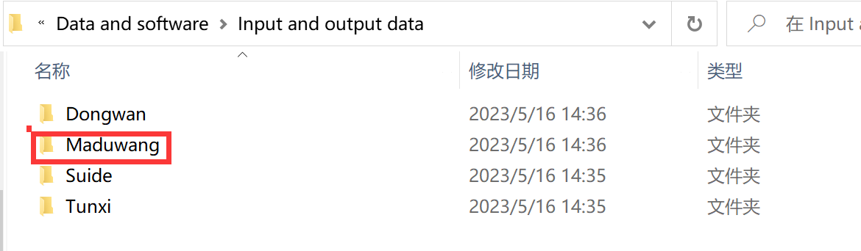

Step2. Copy the folder “Input” and “Output” in the path “Input and output data\Maduwang\” to the path “Software\GXAJ-IE\”; copy the database “TopographySys-GXAJ-IE.mdb” in the path “Input and output data\Maduwang\SYS\” to the path “Software\GXAJ-IE\ SYS\”.

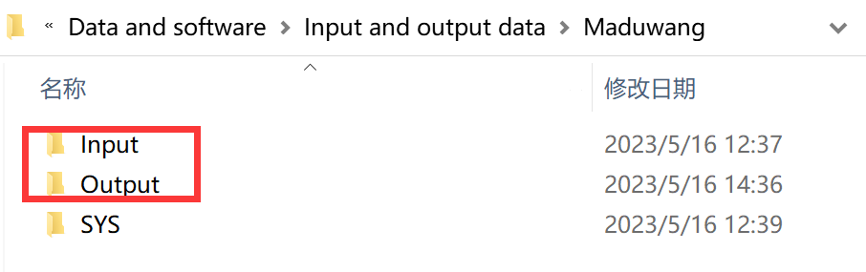

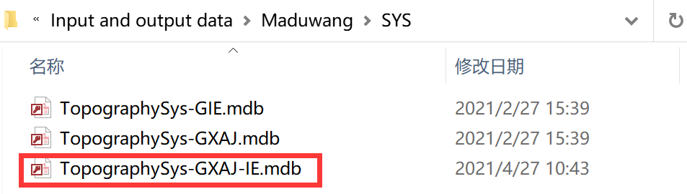

Step3. Change the name of the database “TopographySys-GXAJ-IE.mdb” in the path “Software\GXAJ-IE\ SYS\” to “TopographySys.mdb”.

Step4. Start the executable file “GXAJ-IE.exe”; click “流域时段选取”; choose “次洪模型” at the drop-down list of “选择计算时段”;



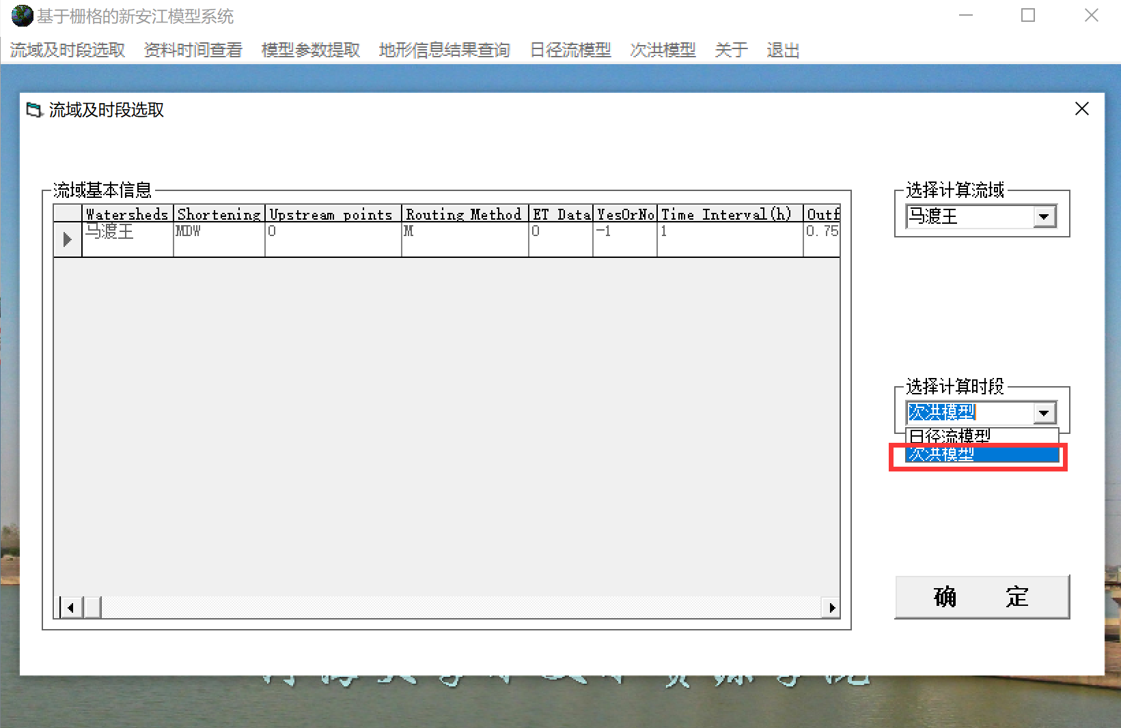

Step5. Click the button “参数率定” at the drop-down list of “次洪模型”;

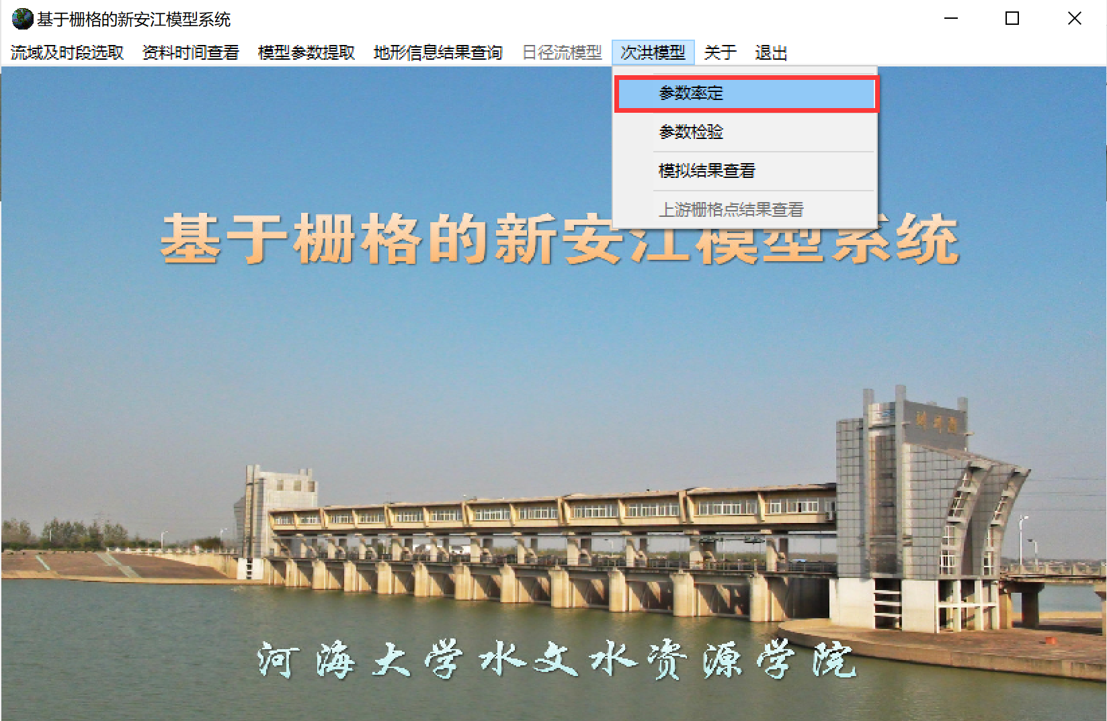

Step6. Finish model running;

Step7. Check the model output in the database “TopographySys.mdb”.