IC900F Remote Controller User’s Manual

Joe Haas, KE0FF

02/05/2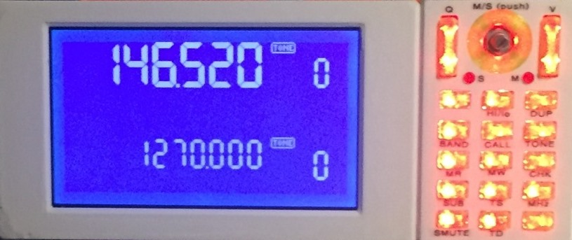4

Introduction

This manual describes the operation of the IC900F, an alternate Remote Controller for the IC900 radio. The mechanical and electrical elements peculiar to the IC900F are also discussed, but all other aspects the operator is referred to the IC-900A Instruction Manual, published by ICOM.

Contact information

The author/designer may be contacted at the following email address:

Joe Haas, KE0FF

email: joeh@ke0ff.org

web: www.ke0ff.org

github: https://www.github.com/ke0ff/

Forward

This project was born by an intersection of chance and whimsy to create an alternate controller for the IC-900. Mostly, it serves those who find themselves without such a controller, but in the process, a number of enhancements have been introduced which make the alternate device much more desirable than the original. While some measure of continuity from the original is maintained, new features have blurred that line considerably. Thus, the experienced IC-900 user may find that some considerable “re-learning” is needed to adapt to the new way of doing things.

Such change has not been undertaken lightly. I am a strong supporter of “better”, not so much do I support “newer”. Too many developers like to think that their brand of new is better than the previous version. While I am biased somewhat, I hope that you will agree that most of what I present as “new” is also “better”.

One aspect that most all should agree is better is that this project is open-source. All of the electrical, software, and 3D models are available via my github repo. Not that that helps much, my source code often baffles even me after I’ve been away from it for a time, but it is the best I can manage given the skills and time I have – this is pursued as a hobby, not a business enterprise. You are free to modify any aspect of the design within the confines of the github license(s). I will assist as best I am able.

It should be noted that the IC-900 “OPT” modules (CTCSS squelch and DTMF coded squelch) are not currently supported. These may come in time, as user demand might influence. For now, they should not be installed.

Connections

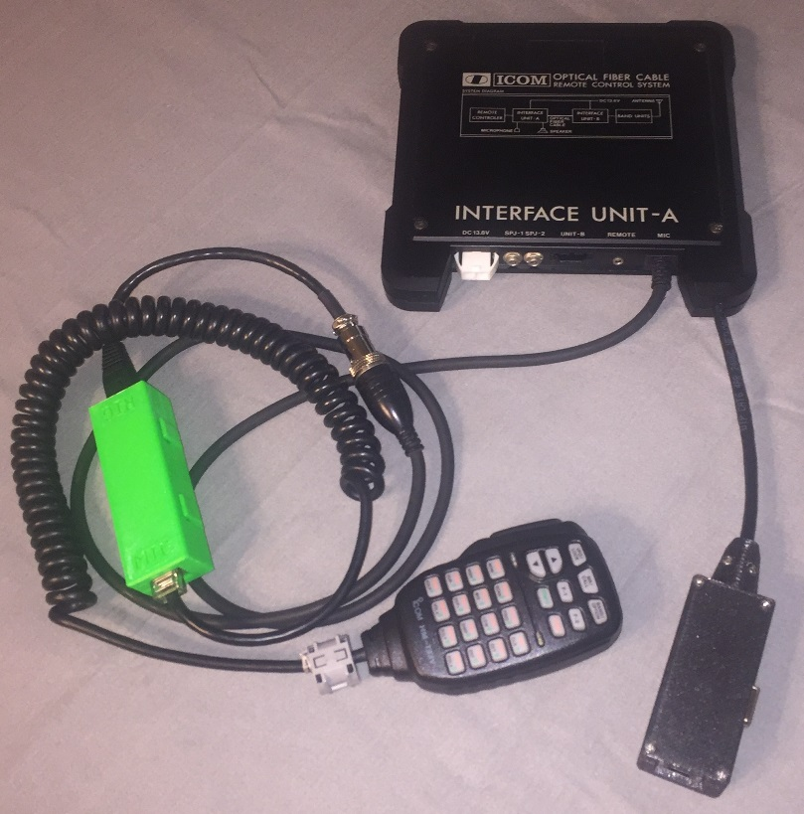Figure 1: Modified IC-900 A-Unit and HM-133 Adapter (the controller connection unit is pictured in the lower right of the image)

In order to get the benefit of the HM-133 microphone, the new controller requires that the A-unit be modified to facilitate the serial connection from the HM-133 to the controller. Figure 1 illustrates a modified A-unit for reference. The hardware to accomplish this also provides an RJ-45 connection for the remote unit. A standard Ethernet cable is recommended so that the signal pairing is correct. *Note: The RDU connection is NOT compatible with the HM-133. Care must be exercised to avoid connecting the HM-133 to the RDU connection*.

The HM-133 features an adapter cable that connects to the A-unit 8-pin circular connection for the system microphone. A standard, HM-14 (or equivalent) microphone can still be used in place of the HM-133. The connection is seamless and requires no special consideration from the operator.

The controller connection unit features the RJ-45 connection to the Remote Unit and also a 9-pin DSUB connector for a 115.2 Kbaud serial connection to a PC. This connection is used to save and restore memory settings for the radio and requires a custom program to perform the memory management transfers. A separate user’s guide is available for this interface.

All other connections are covered in the IC-900 documentation provided by ICOM.

Operation Overview

The IC900F has many similarities with the original IC900 controller. The display format is very similar, and the radio maintains a main/sub band approach just as with the original controller. Figure 2 illustrates the display symbology for the IC900F.

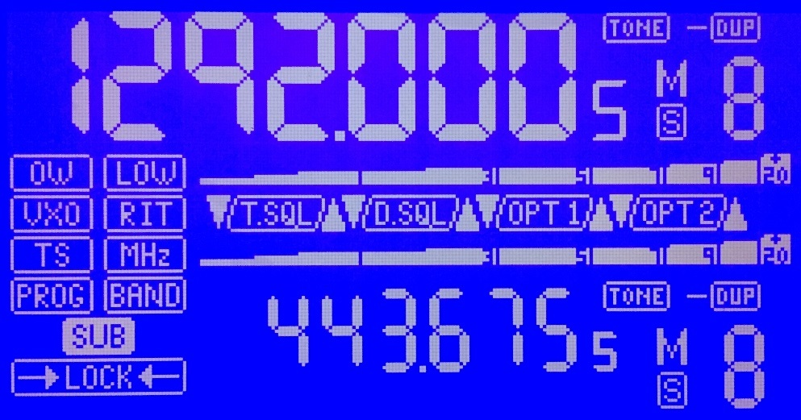Figure 2: IC900F display symbol reference

The “5” in the 100’s digit of the frequency displays is not utilized as a numeric digit. It flashes to indicate when the CHECK mode is invoked.

The SQL and OPT symbols are not currently used and should not appear in normal operation.

PROG, BAND, and OW are not currently used.

The volume and squelch controls utilize the S-meter tapes to display the setting when it is adjusted. However, the memory channel is employed to display fine-steps in these adjustments:

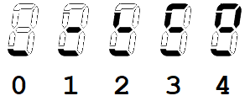As the squelch or volume is adjusted up or down, the above patterns convey the fine-step status of those adjustments. These symbols persist only as long as the S-meter tapes are indicating the adjustment setting.

**7-Segment Alpha-Numeric Font**

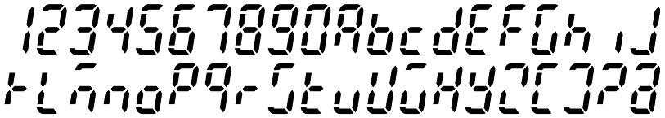

This font is used to convey messages in the frequency area and also to indicate memory channels above “9”. Frequency messages can provide up to 6 characters at a time, but a scrolling feature allows up to 16 characters to be displayed. Apart from some system messages, this feature can display memory “names”. These are descriptive strings of text (up to 16 characters) that describe the memory in a human-readable format (the **MHz** key pressed in MEM mode toggles the display of these messages). These messages are not currently programmable from the IC900F controls, they must be managed off line and uploaded from a PC.

While the font depicted above is generally easily read by the average person, there are some characters that require explanation. These are K, M, U, V, and W. As can be seen from the font map, these characters are somewhat cryptic. They represent the best compromise to create an alphabet with limited segments. In addition, “X” is represented by an upper-case “H”, and “H” is represented as a lower-case “h”. It should be noted that there is no concept of “case” in this font. Upper and lower case characters are employed as needed to achieve maximum clarity. The “opposing” case for any given character is not used even if an easily distinguished pattern is possible in 7-segments.

Control Button Layouts

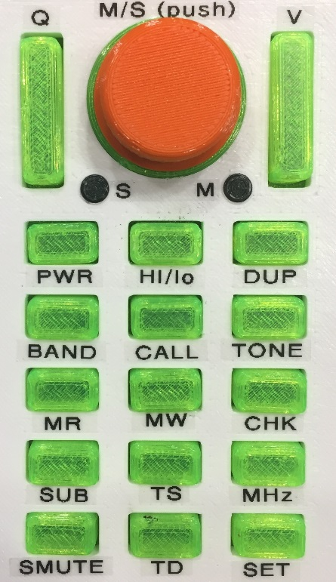

Figure 3: IC900F Button Layout

The control buttons for the IC900F follow a similar layout to those of the original. Figure 3 illustrates the front panel buttons and dial. Most of the buttons retain their original nomenclature, but there are a couple of exceptions: VFO is now called BAND, the LOCK and DIM slide switches are replaced by a single push button located at the side of the unit.

From top to bottom:

Q: Squelch toggle – up increases squelch, down decreases. Push-hold increases or decreases to the limit.

Dial: CW increases display number (mem#, frequency, etc…), CCW decreases. Pushing the dial swaps the main/sub bands.

V: Volume toggle – up increases volume, down decreases. Push-hold down sets the volume to 0.

PWR: Press to turn power on/off.

HI/lo: Toggles RF power setting.

DUP: Cycles through duplex settings (+/-/S). Push-hold invokes duplex offset frequency adjust mode.

BAND: Cycles through available band modules. *Note: This button has no effect if 2 or less modules are installed*.

CALL: Enters 4-channel call memory loop. Dial or mic up/dn buttons cycle through the 4 available call channels. Press-hold programs the VFO into the current call slot.

TONE: Toggles the CTCSS encode function on/off. Press-hold invokes the tone frequency entry mode.

MR: Memory recall – enters mem mode. Dial or mic up/dn buttons cycle through the 30 available memory channels.

MW: Press-hold to write the VFO settings to the current memory slot.

CHK: If DUP is displayed, this button flips the TX/RX frequencies. Press-hold flips TX/RX and opens the squelch (even if DUP is not displayed).

SUB: Toggles the control focus between the main and sub bands.

TS: Toggles between the “A” and “B” tuning step sizes. Push-hold invokes the step-size select mode which allows one of 3 combinations of step size (in KHz): 5/10, 5/25, or 10/25.

MHz: Toggles the MHz mode on/off. When on, frequency steps are in MHz (dial or mic up/dn buttons). When “MHz” is off, the TS step size is in effect. Press-hold puts the frequency into “thumbwheel mode” (more on this later). The MHz button is used to exit the thumbwheel mode.

SMUTE: Toggles the sub-band speaker mute. Press-hold mutes both main and sub bands. The frequency digits flash for the muted band(s).

TD: no-op. This button is not currently used.

SET: Used to toggle to next memory bank (0 – 9).

DIM/LOCK: Press-release toggles the LED and LCD back-light brightness. Press-hold invokes the LOCK mode which locks the buttons and mic controls. Press-hold releases the LOCK mode.

HM-133 Key Layouts

The HM-133 interface provides an extra set of features not easily available with the existing controller buttons. Figure 4 shows the HM-133 keypad with a description of the key functions to follow. *Note: Many of the HM-133 key functions do not match the key nomenclature*.

The HM-133 features a FUNC key that is used to modify the key mapping. The descriptions below note the status of the FUNC modifier when it changes the effect of a key. *Note: The DTMF key is not used. If pressed accidentally, simply press it again to deactivate the status LED indication*.

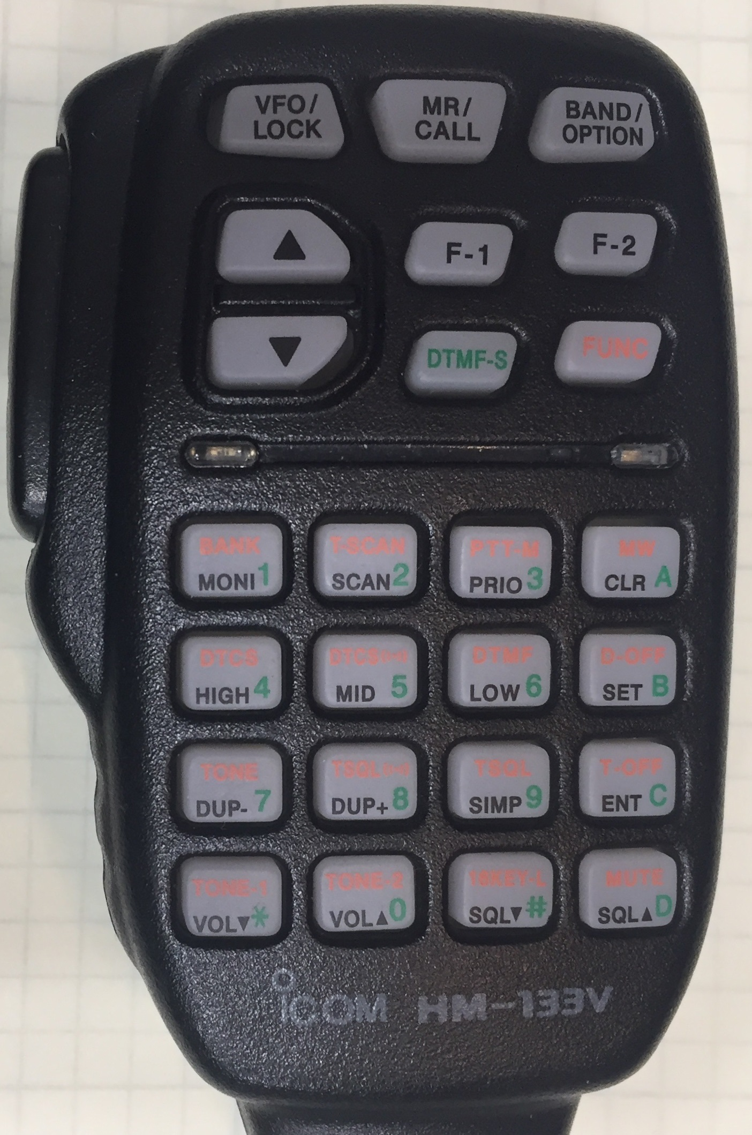Figure 4: HM-133 Key layout

From top to bottom (FUNC key modifier INACTIVE):

VFO/LOCK: **MHz**

MR/CALL: **CALL**

BAND/OPTION: **M/S** swap

UP arrow: **UP** button

F-1: **MR**

F-2: **HI/LO**

DN arrow: **DN** button

DTMF-S: not used

FUNC: **FUNC** (key shift)

PTT ACTIVE:

Lower 16 keys correspond to the standard DTMF layout and transmit DTMF tones when pressed

PTT Inactive:

Digits 0-9: Direct frequency entry

*: direct freq entry abort

#: Direct freq accept (enter)

A: **CHK**

B: **TONE**

C: **SUB**

D: **SMUTE**

Figure 5: HM-133 Key layout

From top to bottom (FUNC key mode active):

VFO/LOCK: **MHz**

MR/CALL: **CALL**

BAND/OPTION: **M/S** swap

UP arrow: **UP** button

F-1: **MR**

F-2: **HI/LO**

DN arrow: **DN** button

DTMF-S: not used

FUNC: **FUNC** (key shift)

PTT ACTIVE:

Lower 16 keys correspond to the standard DTMF layout and transmit DTMF tones when pressed

PTT Inactive:

1: **Backlight** increase

2: n/a

3: **SQL** increase

A: **VOL** increase

4: **Backlight** decrease

5: n/a

6: **SQL** decrease

B: **VOL** decrease

7: **-DUP**

8: **+DUP**

9: **S**

C: **PTTsub** interrogate

*: **TS**

0: n/a

#: n/a

D: **PTTsub** cycle

Press-release vs. Press-hold

The IC900F responds to press-release and press-hold actions on all of the key/button entry points. Generally, an initial press will generate a “beep” at the beep/alert speaker (a piezoelectric speaker mounted inside the controller). Holding the button pressed for longer than approximately 1 second constitutes a “press-hold” and one or more additional beeps will be issued by the alert speaker. *Note: Buttons that have no function associated with press-release or press-hold will not issue any beep acknowledgment*.

PTTsub mode

The PTTsub mode is a feature that allows the operator to modify the radio behavior between transmit and receive operations. The “problem” to be solved was expressed when operating in full-duplex with a sub-band receive path. In this scenario, it was desired to hear the sub-band when transmitting, but mute the sub band when receiving. From this origin, a more complex set of options was devised.

*Note: This feature can only be configured via the HM-133 interface. The LCD frequency display will show the status of the mode as a scrolling text message when the HM-133 keys are activated*.

**PTTsub: OFF**

The IC900F behaves just like the IC900 and most all other dual-band radios, it does nothing in particular to the SUB or main band frequency selections other than what the DUP setting dictates.

**PTTsub: SMUTE**

The IC900F toggles the sub-band mute status when transmitting. Depending on how the operator sets the SMUTE manually, this will either mute on TX or unmute on TX.

**PTTsub: MCALL**

Swap to the main call channel (the current slot, manually selected) on TX. Returns to previous state (memory or VFO) on RX.

**PTTsub: SCALL**

Activates the sub call channel (the current slot, manually selected) on TX. Returns the sub-band to previous state (memory or VFO) on RX.

Thumbwheel Mode

The thumbwheel mode allows the operator to quickly change the operating frequency by adjusting each digit in the frequency value successively, starting at the most significant progressing to the least significant. Press-hold the **MHz** button (or corresponding HM-133 **MHz** key) to enter the thumbwheel mode (a double beep signifies the mode has been activated. The most significant (adjustable) digit for the given band will start to flash. The dial or mic U/D buttons will adjust the flashing digit. Once the desired value is displayed, press-release the **MHz** digit to advance to the next digit to the right (it will start to flash). Once the entire frequency is correct, press-hold MHz to exit the thumbwheel mode. At this point the new frequency is accepted and transferred to the VFO. *Note: prior to this “acceptance” the VFO still contains the original frequency*. Press-release of the **MHz** key will continually cycle through the available digits until a press-hold of **MHz** is initiated.

Direct Frequency Entry

Using the HM-133, it is possible to directly enter the desired VFO frequency. As with the thumbwheel mode, the VFO will retain its original frequency until the new entry is completed. To use this entry mode, ensure that the HM-133 **FUNC** shift is not activated and PTT is not pressed. Using the HM-133, press the numeric digits for the new frequency starting at the most significant digit proceeding to the 5KHz digit (any digit other than **5** or **0** entered for the 5 Khz position will be rounded to the nearest 5 KHz). The new frequency will appear as it is entered on the display. If an error is made, press “*” to abort and re-enter. Once the frequency on the display is correct, press “#” to accept the new frequency. *Note: The new frequency may be any within the limits of the currently installed band modules – the controller will switch to the new module once the entry is accepted. Frequencies entered for modules not installed will be ignored*.

Table 1 illustrates the operating limits imposed by the current software. *Note that these limits allow operation outside current amateur allocations. It is up to the operator to ensure that the IC900F is operated in accordance with all FCC rules and regulations*.

<table1 goes here, listing band limits for each band>