Kenwood (knock-off) DTMF Microphone Modification Joe Haas, KE0FF 10/03/2026
Assembly Instruction
The following materials are required:
One (1) Kenwood KMC32 keypad microphone
One (1) KW DTMF adapter board (assembled)
Wire-wrap wire (multiple colors)
Solder (63/37, no-clean flux)
Kapton tape
Assembly Steps:
- Open the microphone and remove the connector board (5 screws) and keypad board (4 screws). !! DO NOT TOUCH THE KEYPRESS PADS !!
- Remove all of the components indicated in below (including resistors). Using solder braid, clean all pads of solder (including pads that did not have components removed. It is important that this area be as flat as possible.
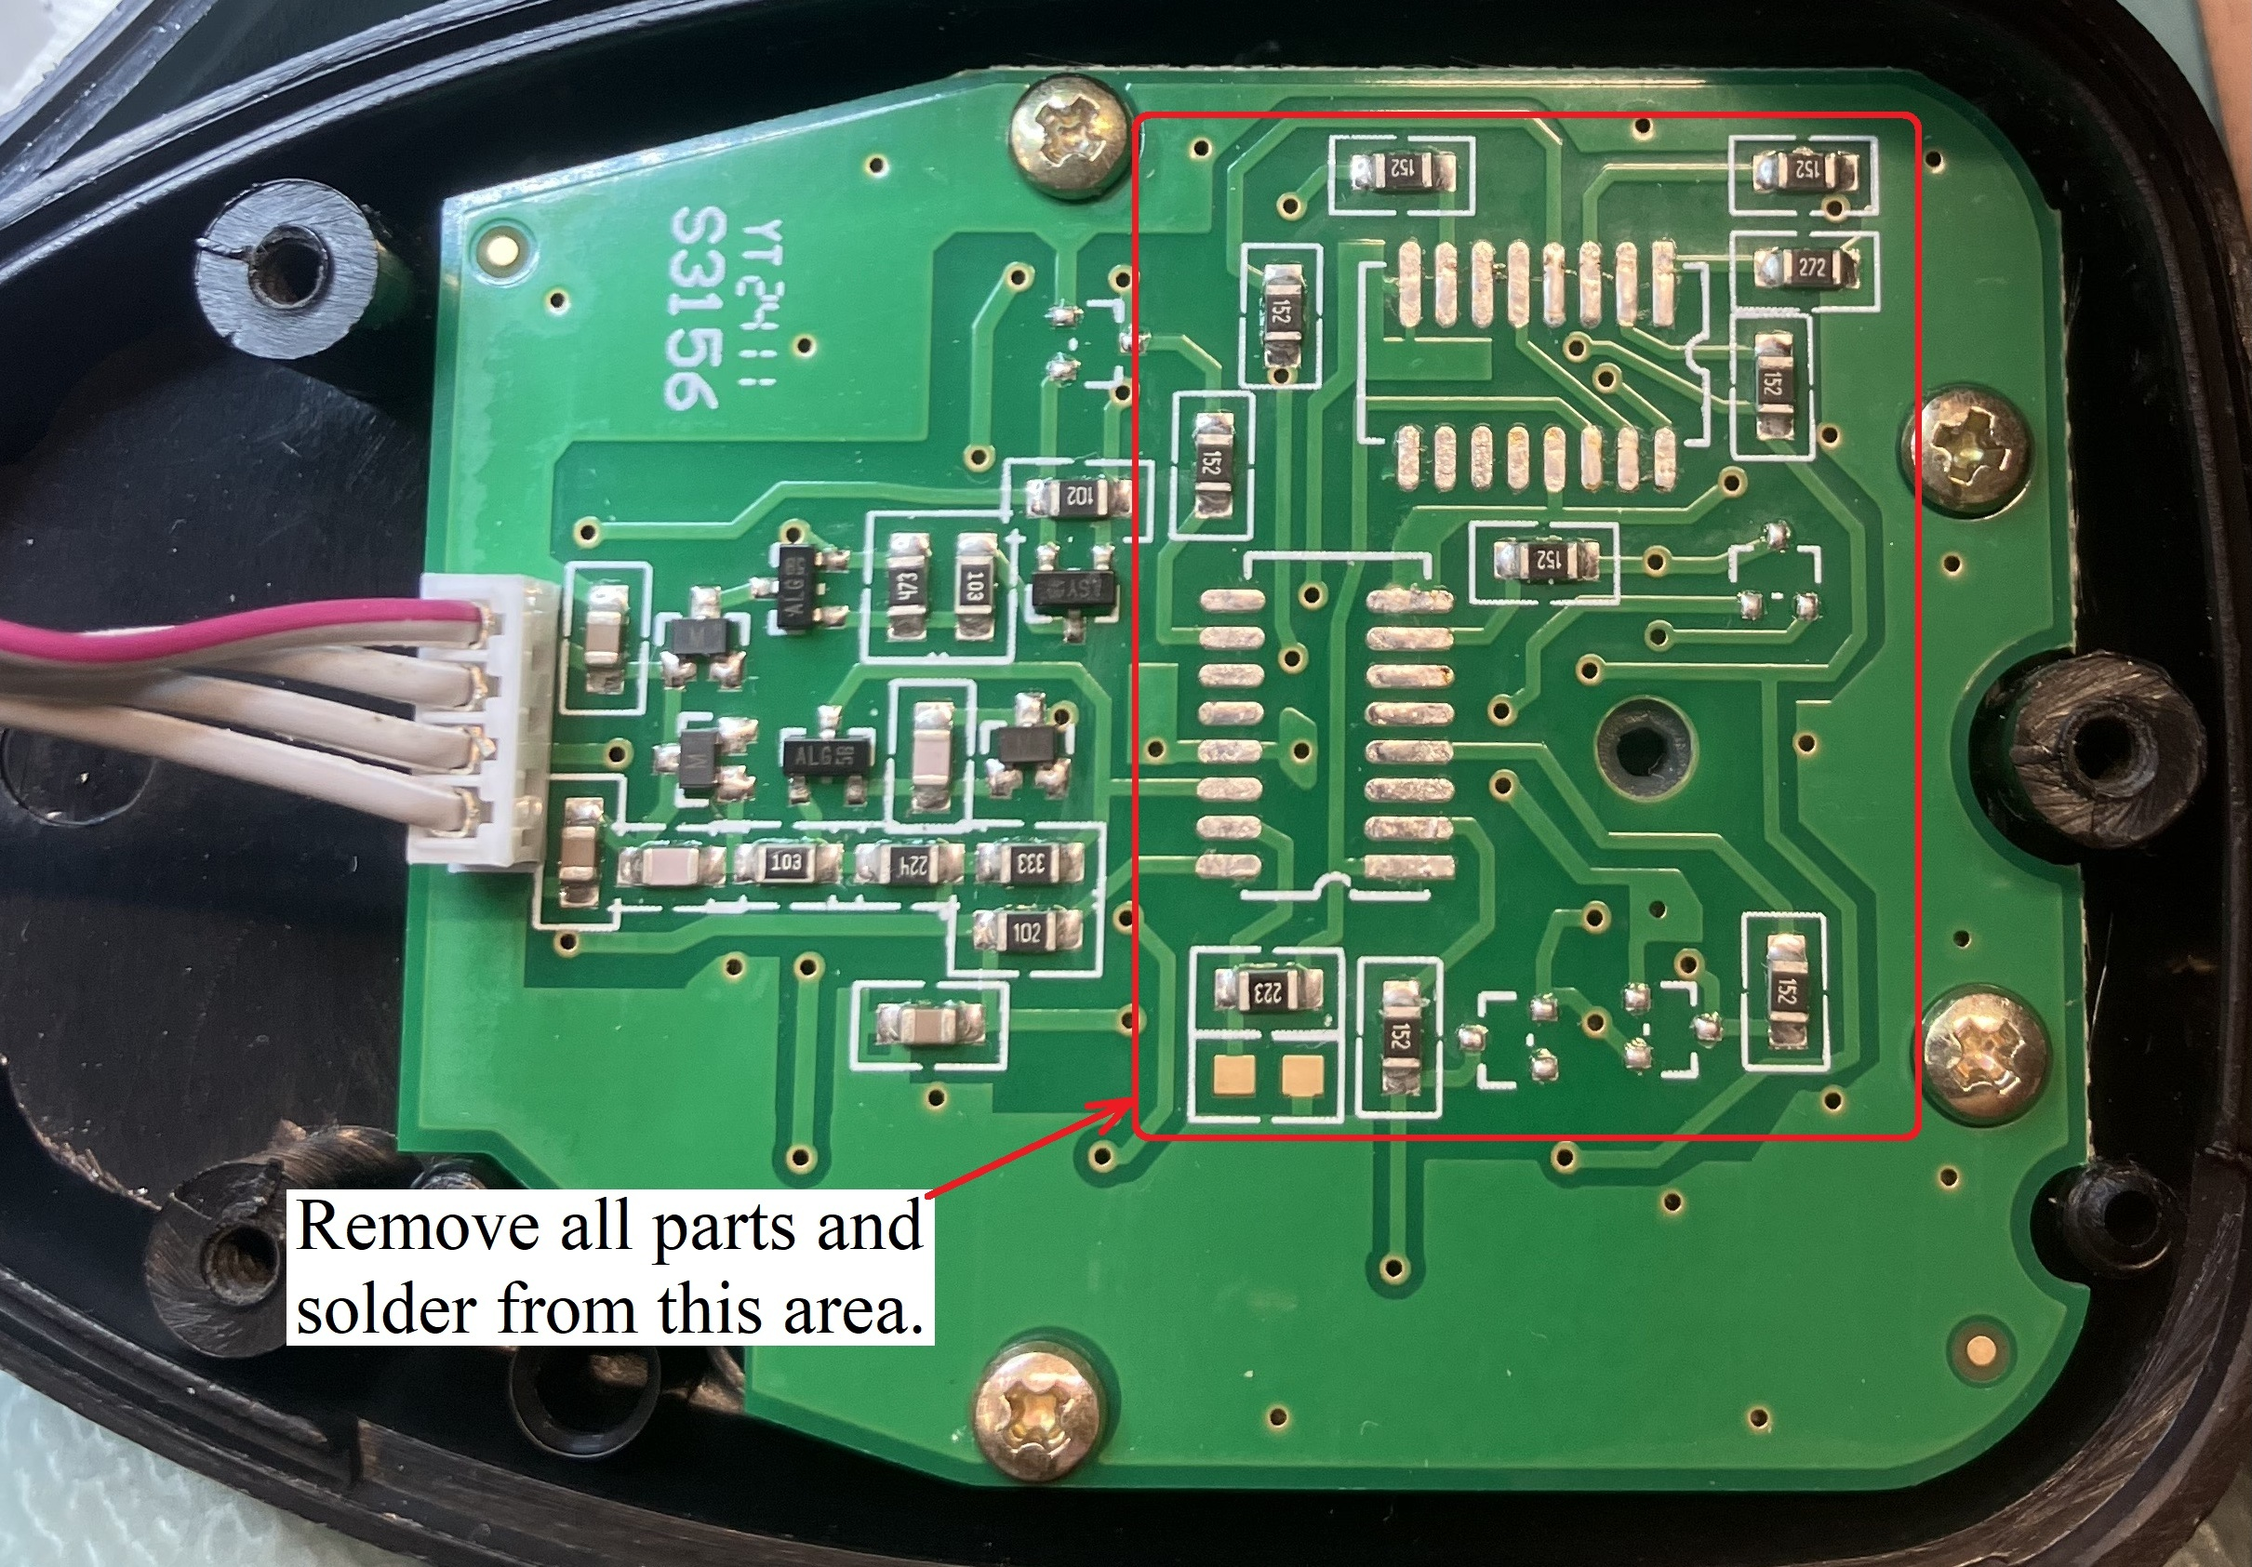
- Use rubbing alcohol (sparingly) to remove residual flux from the affected area of the board.
- Apply solder to form "bumps" and vertical jumpers at the locations indicated below. For the two (2) resistor pads indicated (vacated in step 2), place 30 AWG jumper wire (bare) between pads with a vertical tail (centered on pad). The vertical wire will pass through "r2" and "c3" on the KW DTMF pcb.
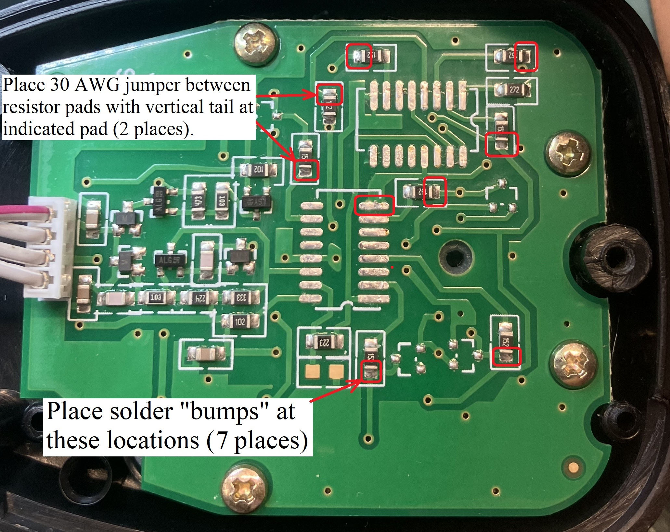
- Note the connection wire-list on the back of the KW DTMF CCA (to be used later):
  - /PTT = RJ45-5
  - /UP = RJ45-1
  - /DN = RJ45-8
- If not already applied, place Kapton tape on the bottom of the KW DTMF pcb. Expose the "r" and "c" pads with an Xacto knife.
- Place the KW DTMF PCB into the keypad PCB by threading the vertical jumpers through "r2" and "c3". Carefully align the "r" and "c" pads to the solder "bumps". Using a very fine-tipped soldering iron, solder the "r" and "c" pads to the solder bumps. Solder the vertical jumper wires also (use the minimum heat necessary).
- Twist two different colored wire-wrap wires (approx 5 inches in length). Solder the wires to the TONE and MICE pads on the KW DTMF PCB. Route the wires to the existing connector on the keypad PCB and follow those wires over to the connector PCB (refer to wire list indicated in step 5). Cut to length, strip, and solder to the connector board.
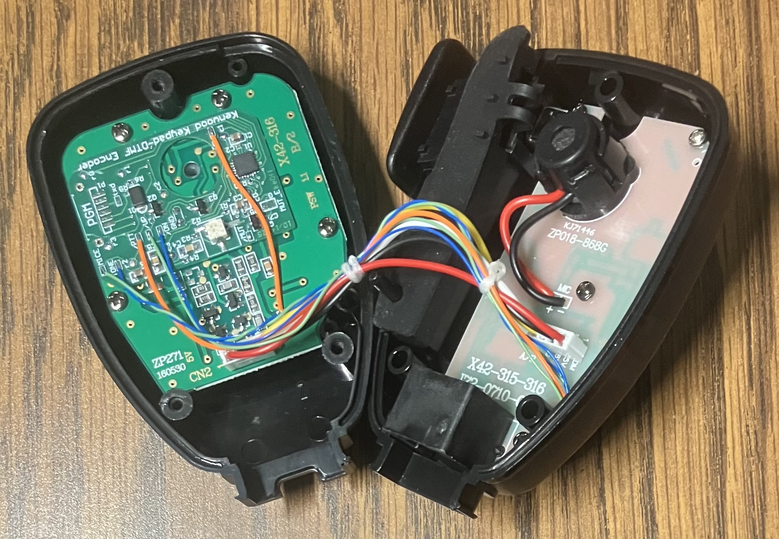
- Re-assemble boards to the housing, and the housing clam-shells.

