IC-900F Remote Controller User’s Manual

Joe Haas, KE0FF

12/23/24

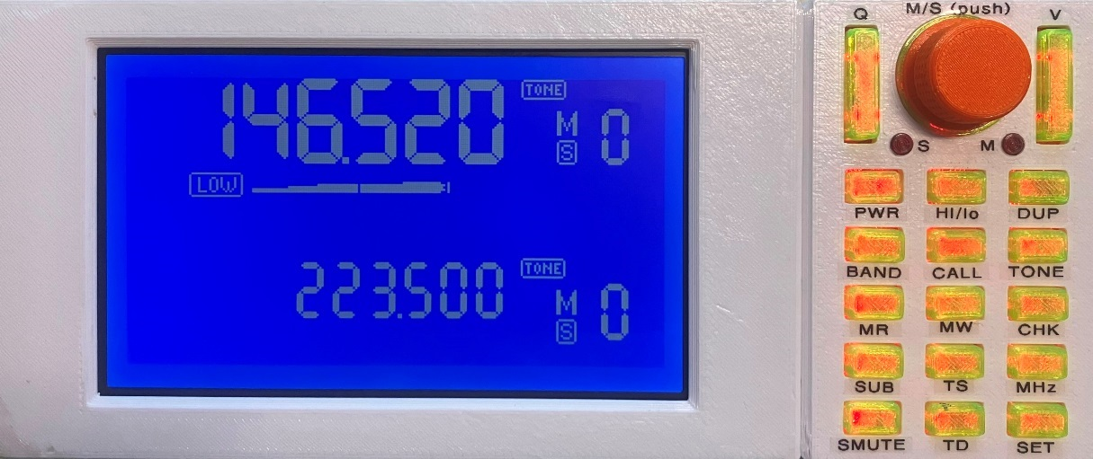

Introduction

This manual describes the operation of the IC-900F, an alternate Remote Controller design for the IC-900 radio. The mechanical and electrical elements peculiar to the IC-900F are also discussed, but for all other aspects of the IC-900 radio system, the operator is referred to the IC-900A Instruction Manual, published by ICOM.

This project was born by an intersection of chance and whimsy to create an alternate controller for the IC-900. Mostly, it serves those who find themselves without such a controller, but in the process, a number of enhancements have been introduced which, in many ways, makes the alternate device much more desirable than the original. While some measure of continuity from the original operation and display is maintained, new features have blurred that line somewhat. Thus, the experienced IC-900 user may find that some “re-learning” is needed to adapt to the new way of doing things.

Such change has not been undertaken lightly. “Better” is usually new, but “new” is not always better. Too many developers like to think that their brand of new is better than the previous version. While I am biased somewhat in this case, I hope that you will agree that most of what I present here as “new” will also be welcomed as “better”.

One aspect that most all should agree is better is that this project is open-source. All of the electrical, software, and 3D models are available via my github repo. Not that that helps much, my source code often baffles even me after I’ve been away from it for a time, but it is the best I can manage given the skills and time I have – this is pursued as a hobby, not a business enterprise. You are free to modify any aspect of the design within the confines of the github license(s). I will assist as best I am able.

It should be noted that the IC-900 “OPT” modules (CTCSS squelch and DTMF coded squelch) are not currently supported. Support for them may come in time, as user demand might influence, but for now, they should not be installed.

Contact information

The author/designer may be contacted at the following:

Joe Haas, KE0FF

email: joeh@ke0ff.org

web: www.ke0ff.org

github: https://www.github.com/ke0ff/

Connections

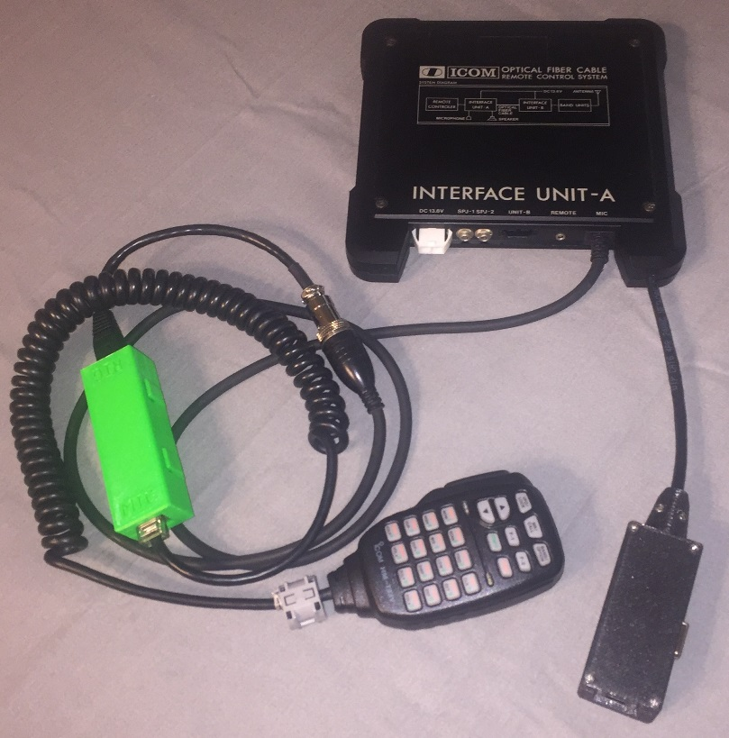Figure 1: Modified IC-900 A-Unit and HM-133 Adapter (the controller connection unit is pictured in the lower right of the image)

In order to get the benefit of the HM-133 microphone features, the new controller requires that the A-unit be modified to facilitate the serial connection from the HM-133 to the controller. Figure 1 illustrates a modified A-unit for reference. The hardware to accomplish this also provides an RJ-45 connection for the remote unit. A standard Ethernet cable is recommended so that the signal pairing is correct. ***Note: The RDU RJ-45 connection is NOT compatible with the HM-133. Care must be exercised to avoid connecting the HM-133 to the RDU connector***.

The HM-133 features an adapter cable that connects to the A-unit 8-pin circular connection for the system microphone. A standard, HM-14 (or equivalent) microphone can still be used in place of the HM-133. The connection is seamless and requires no special consideration from the operator.

The controller connection unit features an RJ-45 connector for the Remote Unit cable and also a 9-pin DSUB connector for a standard COM port connection to a PC (115.2 Kbaud, N81). The PC connection is used to save and restore memory settings for the radio (future enhancements will provide a custom program to perform real-time CAT control of the radio) and is described later in this document.

All other connections are covered in the IC-900 documentation provided by ICOM.

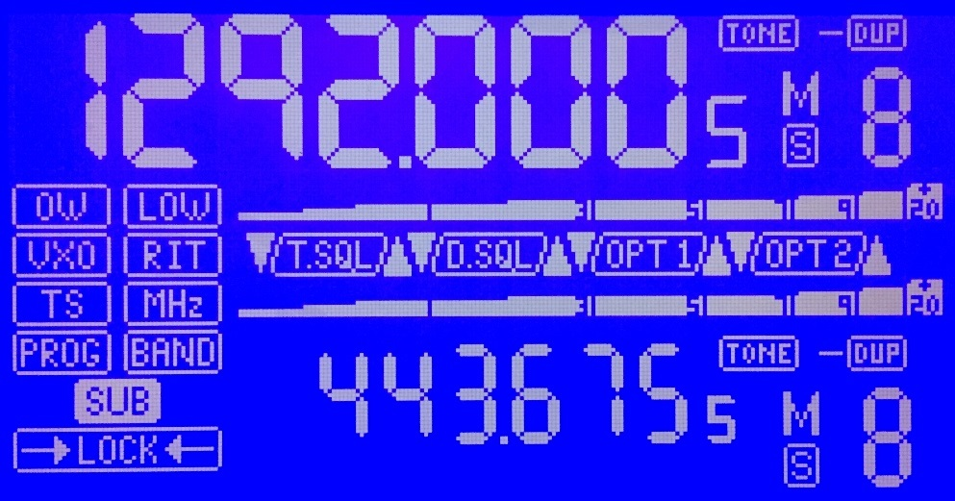Figure 2: IC-900F display symbol reference

Operation Overview

The IC-900F has many similarities with the original IC-900 controller. The display format was designed to closely mimic the original IC-900 LCD symbology, and the radio maintains the main/sub band approach just as with the original controller. Figure 2 illustrates the display symbology for the IC-900F.

The “5” in the 100’s digit of the frequency displays is not utilized as a numeric digit. It flashes to indicate when the CHECK mode is invoked.

The SQL and OPT symbols are not currently used and should not appear in normal operation.

PROG and BAND are not currently used. OW is now FUNC and is used to indicate when the HM-133 FUNC mode is active.

The volume and squelch controls utilize the S-meter tapes to display the setting when it is adjusted. However, the memory channel is employed to display fine-steps in these adjustments:

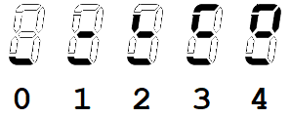As the squelch or volume is adjusted up or down, the above patterns convey the fine-step status of those adjustments. These symbols persist only as long as the S-meter tapes are indicating the adjustment setting.

**7-Segment Alpha-Numeric Font**

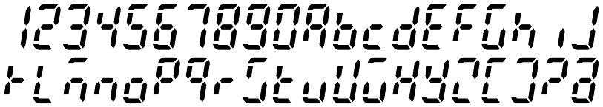

This font is used to convey messages in the frequency area and also to indicate memory channels above “9”. Frequency messages can provide up to 6 characters at a time, but a scrolling feature allows up to 16 characters to be displayed. Apart from some system messages, this feature can display memory “names”. These are descriptive strings of text (up to 16 characters) that describe the memory in a human-readable format (the **MHz** key pressed in MEM mode toggles the display of these messages). These messages are not currently programmable from the IC-900F controls, they must be managed off line and uploaded from a PC.

While the font depicted above is generally easily read by the average person, there are some characters that require explanation. These are K, M, U, V, and W. As can be seen from the font map, these characters are somewhat cryptic. They represent the best compromise to create an alphabet with limited segments. In addition, “X” is represented by an upper-case “H”, and “H” is represented as a lower-case “h”. It should be noted that there is no concept of “case” in this font. Upper and lower case characters are employed as needed to achieve maximum clarity. The “opposing” case for any given character is not used even if an easily distinguished pattern is possible in 7-segments.

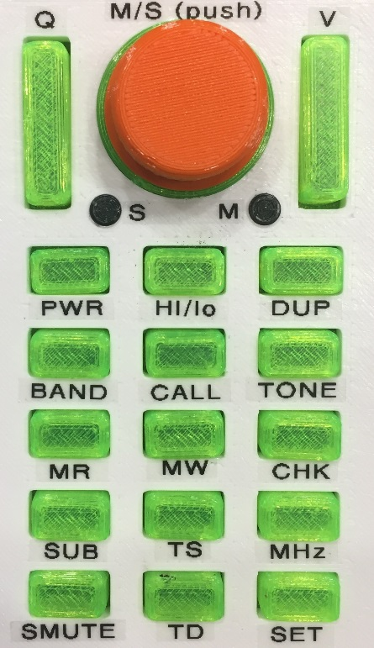Control Button Layouts

Figure 3: IC-900F Button Layout

The control buttons for the IC-900F follow a similar layout to those of the original. Figure 3 illustrates the front panel buttons and dial. Most of the buttons retain their original nomenclature, but there are a couple of exceptions: VFO is now called **BAND**, and the **LOCK** and **DIM** slide switches are replaced by a single push button located at the side of the unit.

From top to bottom:

**Q**: Squelch toggle – up increases squelch, down decreases. Push-hold increases or decreases to the limit.

**Dial**: CW increases display number (mem#, frequency, etc…), CCW decreases. Pushing the dial swaps the main/sub bands.

**V**: Volume toggle – up increases volume, down decreases. Push-hold down sets the volume to 0.

**PWR**: Press to turn power on/off.

**HI/lo**: Toggles RF power setting.

**DUP**: Cycles through duplex settings (+/-/S). Push-hold invokes duplex offset frequency adjust mode.

**BAND**: Cycles through available band modules. *Note: This button has no effect if 2 or less modules are installed*.

**CALL**: Enters 4-channel call memory loop. Dial or mic up/dn buttons cycle through the 4 available call channels. Press-hold programs the VFO into the current call slot.

**TONE**: Toggles the CTCSS encode function on/off. Press-hold invokes the tone frequency entry mode.

**MR**: Memory recall – Toggles between mem and VFO mode. Dial or mic up/dn buttons cycle through the 30 available memory channels.

**MW**: Press-hold to write the VFO settings to the current memory slot.

**CHK**: If ±DUP is displayed, this button flips the TX/RX frequencies. Press-hold flips TX/RX and opens the squelch (even if DUP is not displayed).

**SUB**: Toggles the control focus between the main and sub bands.

**TS**: Toggles between the “A” and “B” tuning step sizes. Push-hold invokes the step-size select mode which allows one of 3 combinations of step size (in KHz): 5/10, 5/25, or 10/25.

**MHz**: Toggles the MHz mode on/off. When on, frequency steps are in MHz (dial or mic up/dn buttons). When “MHz” is off, the TS step size is in effect. Press-hold puts the frequency into “thumbwheel mode” (more on this later). The MHz button is used to exit the thumbwheel mode. In mem mode, toggles mem text-name display on/off.

**SMUTE**: Toggles the sub-band speaker mute. Press-hold mutes both main and sub bands. The frequency digits flash for the muted band(s).

**TD**: no-op. This button is not currently used.

**SET**: (HOLD until beep) Used to advance to the next “radio” bank (0 – 9).

**DIM/LOCK** (located on the side of the unit): Press-release toggles the LED and LCD back-light brightness. Press-hold invokes the LOCK mode which locks the buttons and mic controls. Press-hold releases the LOCK mode.

HM-133 Key Layouts

In addition to duplicating most of the front panel button features, the HM-133 interface provides an extra set of features not available with the existing controller buttons. Figure 4 shows the HM-133 keypad with a description of the key functions to follow. *Note: Many of the IC-900F key functions do not match the HM-133 key nomenclature*.

The HM-133 features a **FUNC** key that is used to modify the key mapping. The descriptions below note the status of the FUNC modifier when it changes the effect of a key. *Note: The DTMF key is not used. If pressed accidentally, simply press it again to deactivate the status LED indication*. The descriptions below list the HM-133 nomenclature followed by the IC-900F function name. Functions that have the same name as the front panel buttons perform in exactly the same way as described for the front panel.

When the FUNC mode is active, the “FUNC” annunciator is illuminated on the LCD (originally, the “OW” that is next to the LOW annunciator). *Note: The IC-900F FUNC annunciator mode is active only after the first press of an active “FUNC function”, not when the FUNC button is first pressed*.

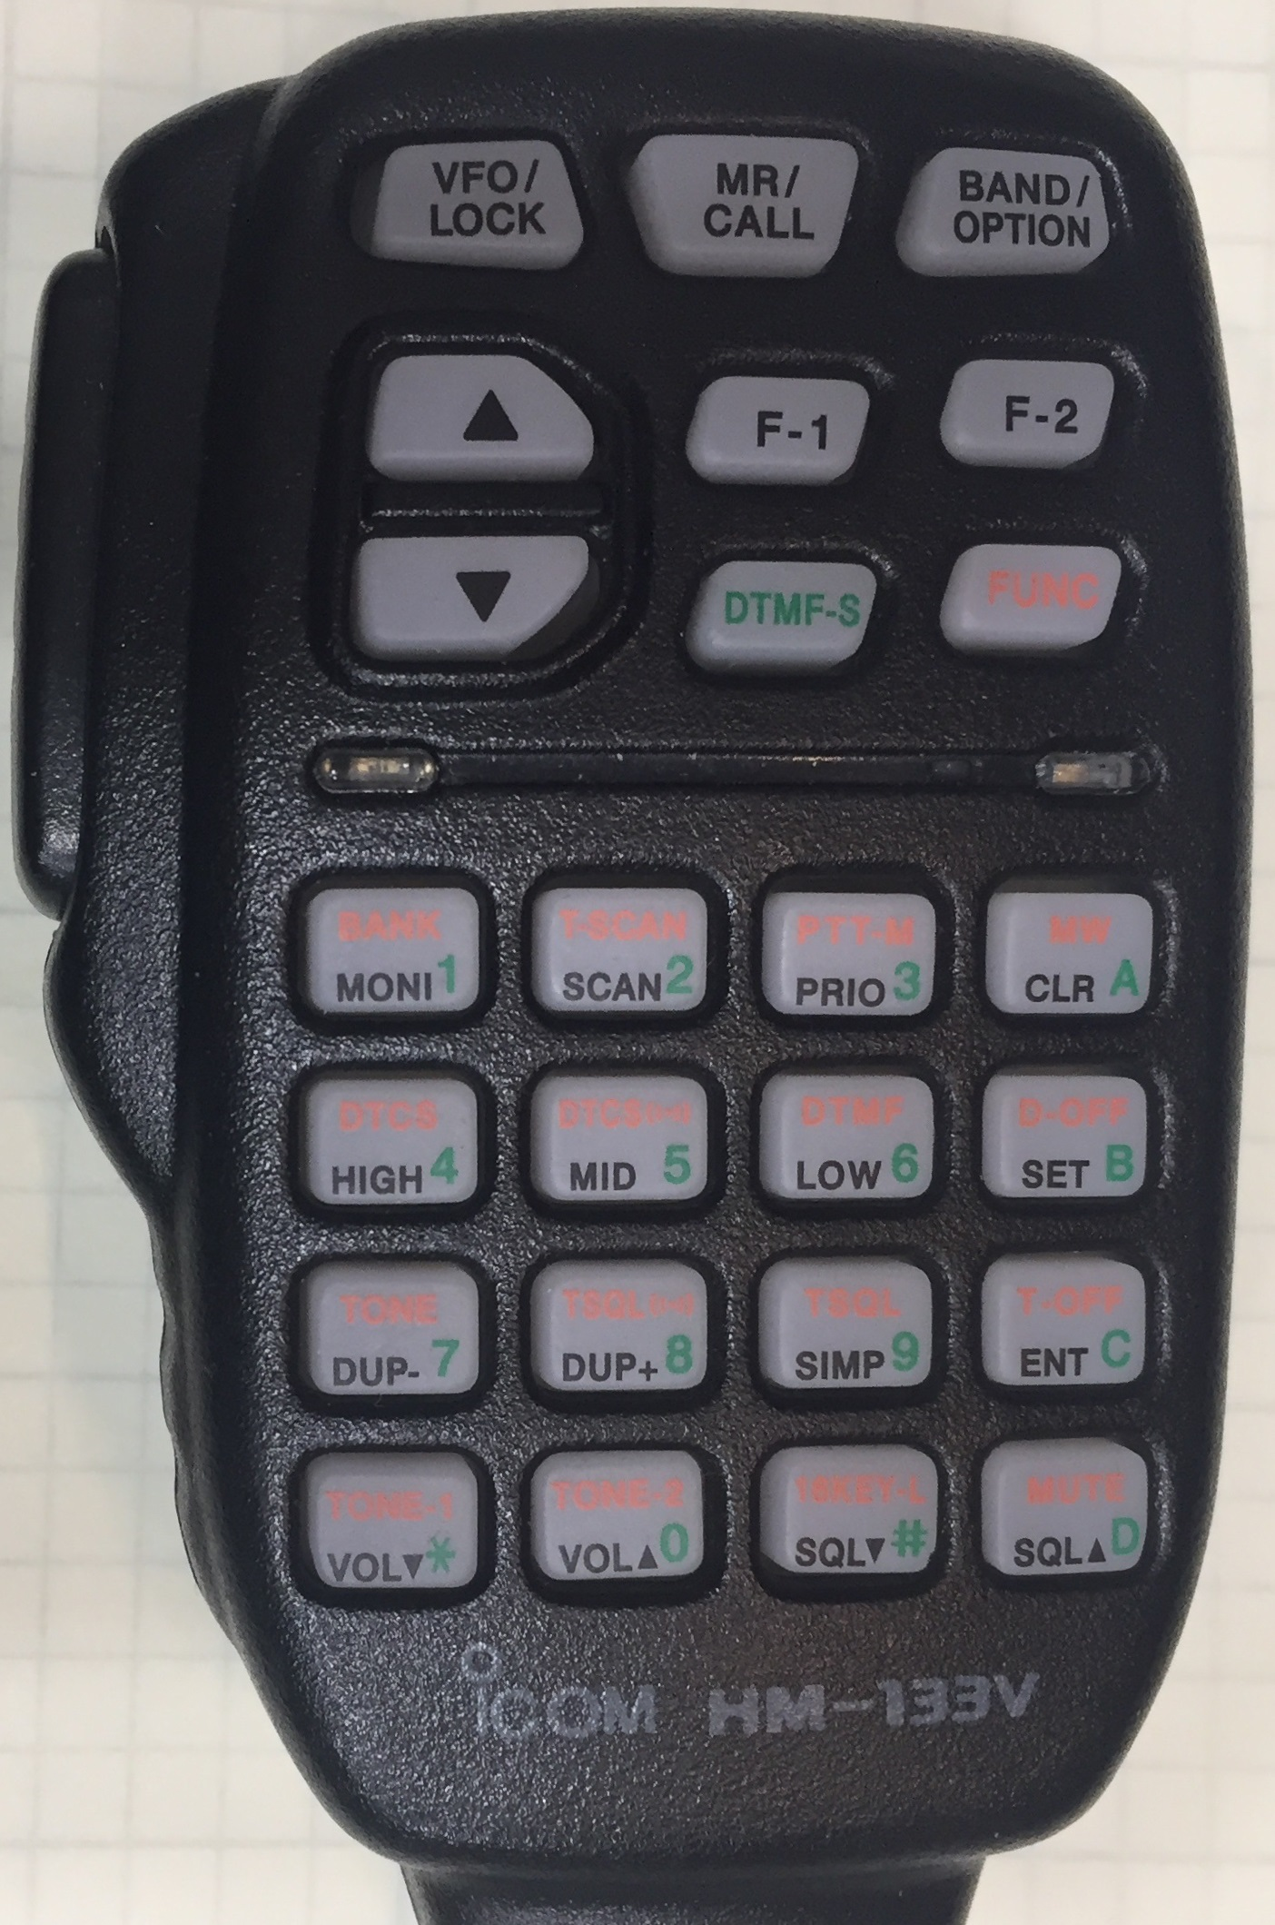Figure 4: HM-133 Key layout

From left-to-right, top to bottom (FUNC INACTIVE):

VFO/LOCK: **MHz**

MR/CALL: **CALL**

BAND/OPTION: **M/S** swap

UP arrow: **UP** button

F-1: **MR**

F-2: **HI/LO**

DN arrow: **DN** button

DTMF-S: not used

FUNC: **FUNC** (key shift)

PTT ACTIVE:

Lower 16 keys correspond to the standard DTMF layout and transmit DTMF tones when pressed

PTT Inactive:

Digits 0-9: Direct frequency entry

*: direct freq entry abort

**#**: Direct freq accept (enter) -or- **CHECK** if no DFE operation is in progress

A: **TONE**

B: **SUB**

C: **BAND**

D: **SMUTE**

Figure 5: HM-133 Key layout (repeated for reference)

From top to bottom (FUNC key mode active):

VFO/LOCK: **MHz**

MR/CALL: **CALL**

BAND/OPTION: **M/S** swap

UP arrow: **UP** button

F-1: **MR**

F-2: **HI/LO**

DN arrow: **DN** button

DTMF-S: not used

FUNC: **FUNC** (key shift)

PTT ACTIVE:

Lower 16 keys correspond to the standard DTMF layout and transmit DTMF tones when pressed

PTT Inactive:

1: **Backlight** increase

2: **Radio bank** (+)

3: **SQL** increase

A: **VOL** increase

4: **Backlight** decrease

5: **Radio bank** (-)

6: **SQL** decrease

B: **VOL** decrease

7: **-DUP**

8: **+DUP**

9: **S**

C: **PTTsub** interrogate

*: **TS**

0: n/a

#: n/a

D: **PTTsub** mode cycle

Press-release vs. Press-hold

The IC-900F software can differentiate press-release and press-hold actions on all of the key/button entry points. Many buttons respond to both, while some respond to only one or neither. Generally, an initial press will generate a “beep” at the beep/alert speaker (a piezoelectric speaker mounted inside the controller) if the button is supported. Holding the button pressed for longer than approximately 1 second constitutes a “press-hold” and one or more additional beeps will be issued by the internal alert speaker (again, if the hold feature is supported for that button). *Note: Buttons that have no function associated with press-release or press-hold will not issue any beep acknowledgment*.

PTTsub mode

The PTTsub mode is a feature that allows the operator to modify the radio behavior when transitioning between transmit and receive operations. The “problem” to be solved by this feature was expressed when operating in full-duplex with a sub-band receive path. In this scenario, it was desired to hear the sub-band when transmitting, but mute the sub band when receiving. From this origin, a more complex set of options was devised.

*Note: This feature can only be configured via the HM-133 interface. The LCD frequency display will show the status of the mode as a scrolling text message when the HM-133 keys are activated. Once the desired setting is displayed, the operator simply waits for the display to return to normal after about 5 seconds and the new setting is stored*.

**PTTsub: OFF**

The IC-900F behaves much like the IC-900 and most all other dual-band radios – it does nothing in particular to the SUB or main band frequency selections in response to TX or RX transitions other than what the DUP setting dictates.

**PTTsub: SMUTE**

The IC-900F toggles the sub-band mute status when transmitting. Depending on how the operator sets the SMUTE manually, this will either mute on TX or un-mute on TX.

**PTTsub: MCALL**

Swap to the main call channel (the current slot, manually selected) on TX. Returns to previous state (memory or VFO) on RX. If the call channel is selected when pressing PTT, the radio will TX on the VFO/MEM. If VFO/MEM are selected, the IC-900F will TX on the CALL channel.

**PTTsub: SCALL**

Activates the sub call channel (the current slot, manually selected) on TX. Returns the sub-band to previous state (memory or VFO) on RX. In this mode, the TX frequency is determined by the DUP status and behaves as it normally would. The only effect is that the sub-band CALL channel is toggled at the TX/RX transitions.

Backlight Adjust

When adjusting the back-light setting, the adjustment affects the current mode (bright or dim) and is saved in NVRAM so it is retained when the power is cycled.

Thumbwheel Mode

The thumbwheel mode allows the operator to quickly change the operating frequency by adjusting each digit in the frequency value successively, starting at the most significant progressing to the least significant. Press-hold the **MHz** button (or corresponding HM-133 **MHz** key) to enter the thumbwheel mode (a double beep signifies the mode has been activated. The most significant (adjustable) digit for the given band will start to flash. The dial or mic U/D buttons will adjust the flashing digit. Once the desired value is displayed, press-release the **MHz** digit to advance to the next digit to the right (it will start to flash). Once the entire frequency is correct, press-hold MHz to exit the thumbwheel mode. At this point the new frequency is accepted and transferred to the VFO. *Note: prior to this “acceptance” the VFO still contains the original frequency*. Press-release of the **MHz** key will continually cycle through the available digits until a press-hold of **MHz** is initiated. *Note: thumbwheel mode only allows frequencies to be selected within the range of the currently selected band*.

Direct Frequency Entry

Using the HM-133, it is possible to directly enter the desired VFO frequency. As with the thumbwheel mode, the VFO will retain its original frequency until the new entry is completed. To use this entry mode, ensure that the HM-133 **FUNC** shift is not activated and PTT is not pressed. Using the HM-133, press the numeric digits for the new frequency starting at the most significant digit proceeding to the 5KHz digit (any digit other than **5** or **0** entered for the 5 Khz position will be rounded to the nearest 5 KHz). The new frequency will appear as it is entered on the display and will “slide to the left” as more digits are entered. If an error is made, press “*” to abort and re-enter. Once the frequency on the display is correct, press “#” to accept the new frequency. *Note: The new frequency may be any within the limits of the currently installed band modules – the controller will switch to the new module once the entry is accepted. Frequencies entered for modules not installed will be ignored*.

|  |  |  |  |
| --- | --- | --- | --- |
| **Band** | **Lower frequency limit** | **Upper frequency limit** | **Max offset** |
| 10m | 27.000 | 40.000 | 13.000 |
| 6m | 45.000 | 60.000 | 15.000 |
| 2m | 130.000 | 170.000 | 40.000 |
| 220 | 215.000 | 228.000 | 13.000 |
| 440 | 420.000 | 470.000 | 50.000 |
| 1296 | 1200.000 | 1310.000 | 900.000 |

Table 1. Frequency vs. Band Limits. All frequencies in MHz.

Table 1 illustrates the operating limits imposed by the current software. *Note that these limits allow operation outside current amateur allocations. It is up to the operator to ensure that the IC-900F is operated in accordance with all FCC rules and regulations*. Generally, the performance of the ICOM modules outside the operating frequency ranges published in the ICOM literature results in very poor performance and is not recommended.

Radio Bank Select

The IC-900F has 3 times the number of memories per band as compared with the original IC-900 controller. In addition, there are 10 banks of memories that may be selected either by the SET key or using the Fn-shift-2 or Fn-shift-5 keys. The current bank setting is displayed on the LCD just beneath the SUB-Band memory area (lower right-hand corner of the screen). “BNK 0” through “BNK 9” is displayed to indicate the current bank. With the combination of 30 memories per band and 10 banks of memories, the IC-900F can hold up to 300 memories for each band. Note that this is in addition to the 4 call memories per band, per bank, giving up to 40 call memories per band.

Memory ID Order

Due to the increased number of memories and the fact that the IC900 display allocates only a single digit for the memory ID number to be displayed ,an alpha-numeric sequence is used to order the memories. Some characters are excluded to improve the distinction between memory numbers. The following illustrates the sequence of 30 memory ID characters from lowest to highest:

0 1 2 3 4 5 6 7 8 9 A B D E F G H J K L M N P R S T U W Y Z

The sequence for the 4 call channels:

( ) [ ]

Serial Communications

The serial communications link to the IC-900F is a standard RS-232 serial connection operating at 115.2 Kbaud, no parity, 8 data bits, and one stop bit. The commands are human-readable and may be entered via a terminal emulator if the handshaking is set correctly. A custom PC application has been deployed which simplifies the operation and allows some CAT (Computer Automated Transceiver) control capabilities.

For off-line data maintenance, a small adapter is provided that allows the IC-900F to be powered by itself and a PC serial connection established. In this scenario, the handshaking limits are not an issue. This is intended for simple upload/download operations to configure the radio parameters and memories. *NOTE: If a direct terminal connection is used, the HM-133 buttons (other than UP/DOWN) will not be recognized as long as the terminal connector is attached to the IC-900F*.

With the current software release, the only viable interface is to use a PC with a terminal emulator application and a USB RS-232 dongle (unless you are using a PC with a build-in RS-232 COM port) to connect your PC to the IC-900F. TerraTerm is recommended as it is known to work with the IC-900F command-line interface(follow this link for TerraTerm: *https://ttssh2.osdn.jp/*)

When executing TerraTerm for the first time, select “Serial” and chose the com port associated with the USB dongle (some trial and error may be required to identify the USB COM port#e). Under “Setup→Serial Port”, set the baud rate to 115200, 8 bit, Parity=none, Stop = 1, Flow control = none, Transmit delay = 1msec/char, 400 msec/line. The COM port may also be selected in this dialog box. Other settings should work well with the defaults.

Using the IC-900_MEM_MAP0.xls spreadsheet (available at the github repo: https://github.com/ke0ff/RDU_IC900/tree/main/Documentation) edit the desired memories making sure to use all upper case characters for the STRING field.When finished, copy and paste the “command line (output) fields that were modified into a text file and save the file to convenient location on the PC hard drive. *Note: Unused memories may be deleted from the file to reduce upload time*.

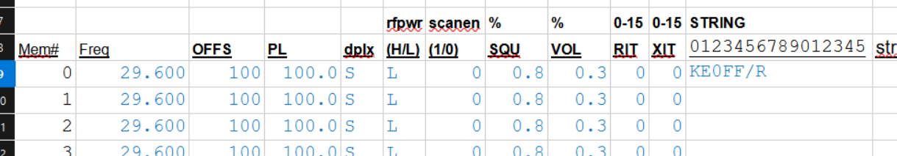Figure 6: Memory management spreadsheet excerpt

To upload the memories, confirm that the IC-900F is connected to TerraTerm by pressing the “?” key followed by <ENTER>. You should see several lines of help screen text. In TerraTerm, go to “File→ Send file…” and select the text file saved from the spreadsheet output. The contents of the file should be visible as they are sent to the IC-900F. This process is rather slow and can take a couple of minutes to send the entire memory space. Watch for “error” results in the terminal window.

Consistent errors during file transfer may indicate a problem with the output data. Occasional errors may indicate that the delay timings are not high enough. Under “Setup→Serial Port”, increase the msec/line value (in increments of 50). If the errors persist beyond 500 msec/line, there may an issue with the spreadsheet or the data entry (the spreadsheet is supposed to provide error checking, but this has not been exhaustively tested).

The memory data is stored in non-volatile memory and no other actions are necessary. Disconnect the serial connection when finished uploading the memory data.