Cypress usb products

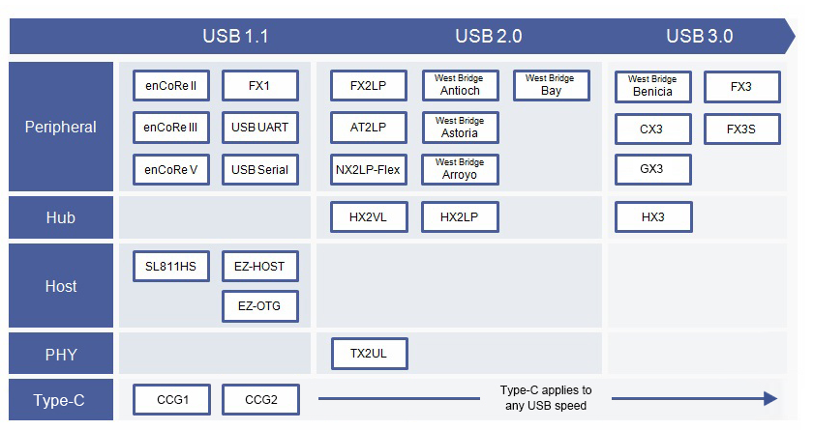

EZ-USB® FX2LP™ (CY7C68013A/14/15/16A) USB 2.0 microcontroller.

FX: Flexible LP: Low Power 2: USB2.0

我选取的产品：CY7C68013A-56LTXC，AX516板子决定的

我写的firmware VendorID: 0xFACE, ProductID: 0x0050

The Serial Interface Engine

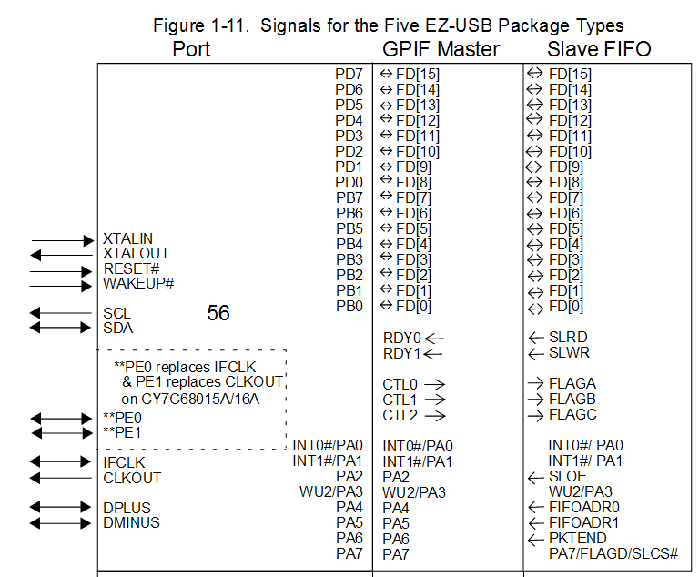

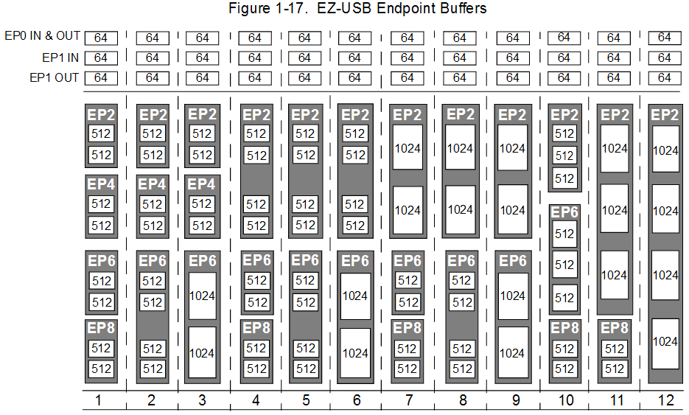

Control Endpoint EP0

initialize

USBIE,

interrupt\_control

USBIRQ,

Data transfer

SETUPDAT,

EP0BCH, EP0BCL,

[ SUDPTRH : SUDPTRL ], a 16-bit pointer,

SUDPTRCTL

RENUM=1, the EZ-USB passes all USB requests except Set Address to the firmware via the SUDAV interrupt

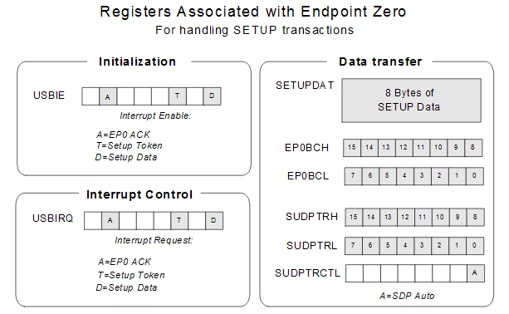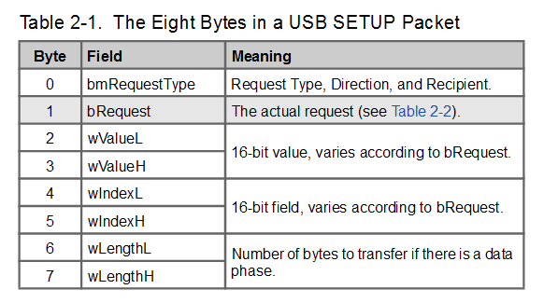

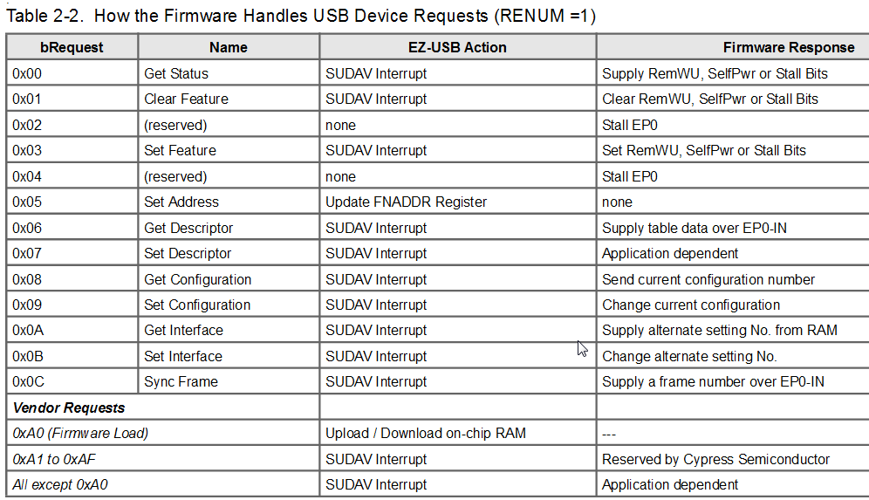

Each endpoint has a STALL bit in its EPxCS register. If this bit is set, any request to the endpoint returns a STALL hand shake rather than ACK or NAK.

Startup Modes：

1. no i2c-eeprom, no address/data bus-memory, RENUM=0
2. i2c-eeprom, 0xC0 in its first byte, download firmware from host
3. i2c-eeprom, 0xC2 in its first bye, download firwmare from eeprom
4. EA-pin ties high, i2c-eeprom not meets 2. and 3., address/data bus-memory

Startup Modes { i2c-eeprom } details:

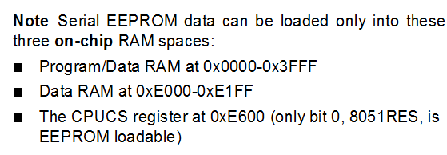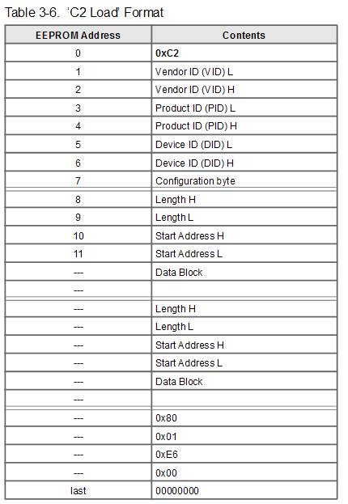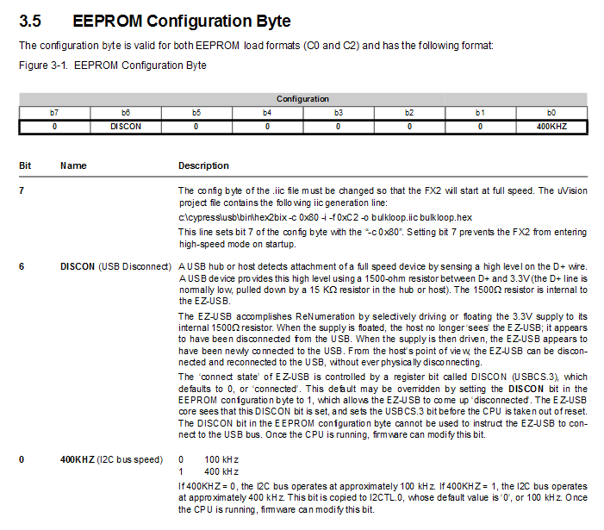

一开始RENUM=0, Default\_USB\_Device, firwmare download, RENUM=1.

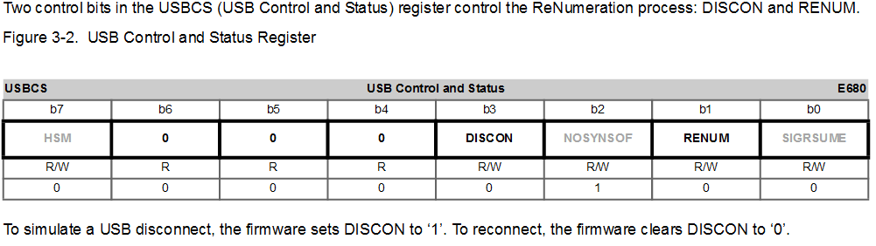

EXIF Register — SFR 0x91 为什么都写着 must be cleared by software.

为什么 可以 set in software to generate relative interrupt

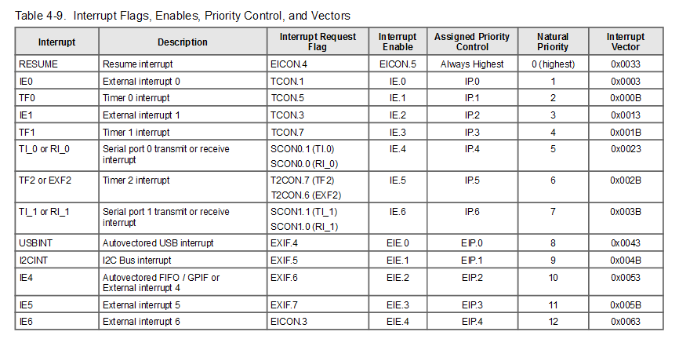

Interrupt sampling, 4 pin-clockout cylce。

IE0~6 的边缘触发，高低电平触发。

Interrupt Latency

Interrupt process, interrupt handler

Ram, not identical with 8051, internal\_data, external\_data, external\_program

Internal\_ram: lower-128, upper-128, sfr.

Upper-128 -> only indirect addressing

Sfr -> only direct addressing, seperate upper-128 and sfr.

8051的外部ram是 哈佛结构的，内部ram是冯诺依曼结构

download_firmware

Download firmware process:

1. Select Mon, select the .hex file
2. S EEPROM, select the .iic file then download automatically
3. Load Mon, download the .hex file

改vid 和 pid

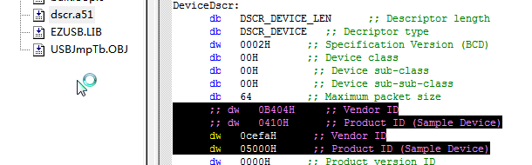

改FIFO大小，有两处，descriptor中的endpoint描述，和EPxFIFOPFH。

读/写 要delay的寄存器。读写的前后都要，但两个连续的delay可以省略一个。

