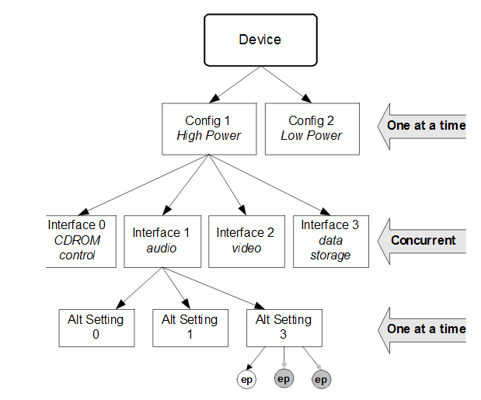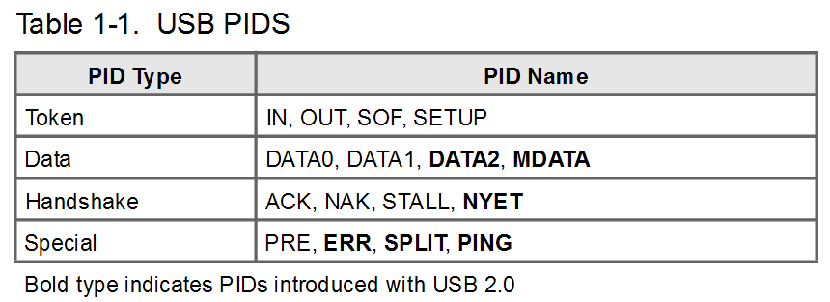

4 Transfer Types

Bulk

Interrupt

Isochronous

Control

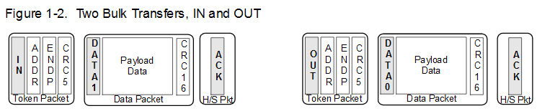

Bulk data is ‘bursty,’ traveling in packets of 8, 16, 32, or 64 bytes at full speed or 512 bytes at high speed. Bulk data has guaranteed accuracy, due to an automatic retry mechanism for erroneous data. The host schedules bulk packets when there is available bus time. Bulk transfers are typically used for printer, scanner, or modem data. Bulk data has built-in flow control provided by handshake packets.

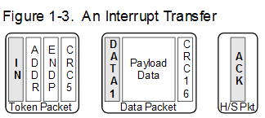

Interrupt data is like bulk data; it can have packet sizes of 1 through 64 bytes at full speed or up to 1024 bytes at high-speed. Interrupt endpoints have an associated polling inter-val that ensures they will be polled (receive an IN token) by the host on a regular basis.

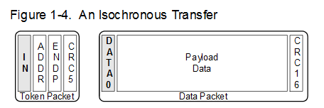

Isochronous data is time-critical and used to *stream* data like audio and video. An isochronous packet may contain up to 1023 bytes at full speed, or up to 1024 bytes at high speed.

Time of delivery is the most important requirement for isoch-ronous data. In every USB frame, a certain amount of USB bandwidth is allocated to isochronous transfers. To lighten the overhead, isochronous transfers have no handshake (ACK/NAK/STALL/NYET), and no retries; error detection is limited to a 16 bit CRC.

Isochronous transfers do not use the data-toggle mecha-nism. Full-speed isochronous data uses only the DATA0 PID; high-speed isochronous data uses DATA0, DATA1, DATA2 and MDATA.

In full-speed mode, only one isochronous packet can be transferred per endpoint, per frame. In high-speed mode, up to three isochronous packets can be transferred per end-point, per microframe. For more details, refer to the Isochro-nous Transfers discussion in Chapter 5 of the USB specification.

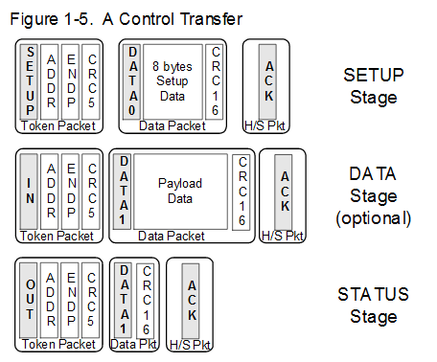

Control transfers configure and send commands to a device. Because they are so important, they employ the most exten-sive USB error checking. The host reserves a portion of each USB frame for Control transfers.

Control transfers consist of two or three stages. The SETUP stage contains eight bytes of USB CONTROL data. An optional DATA stage contains more data, if required. The STATUS (or handshake) stage allows the device to indicate successful completion of a CONTROL operation.

lsusb, product description is come from libudev

Host dectect usb devices by usb device D+ pull high