Trick 1: Dis/appearing Coins

Platform: PyCharm Environment: Python 3.10

First, I set up a color detection module with three parameters: hue, saturation, and brightness. Adjusting these parameters allows me to isolate the specific colors I want, effectively removing the background and keeping only the coins in the image. Strictly speaking, this system can be applied to various backgrounds.

The second step involves using the **mediapipe** library. The functions for hand recognition within this library are imported and combined with predefined gestures. When a specific gesture appears in the image, the coins are then hidden.

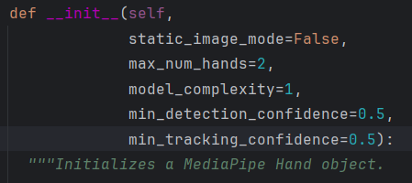

Details within the hand recognition function.

def __init__(self,

static_image_mode=False,

#For video detection, use false. For image detection, use true.

max_num_hands=2,

# How many hands can be detected at most.

model_complexity=1,

# Model complexity: 0 or 1. A higher value results in greater accuracy.

min_detection_confidence=0.5,

# Hand detection strictness: 0-1, where a higher value makes the detection more stringent. Too high may miss detecting hands, and too low might incorrectly identify non-hands as hands.

min_tracking_confidence=0.5):

# Tracking strictness: 0-1. A higher value makes tracking more strict, potentially requiring re-detection. Lower values allow for more flexibility, but the hand's position might drift.

System display

Step 1: Remove the background from the image.

Step 2: Start changing the gesture triggering conditions.

Step 3: When the gesture equals [OK], trigger the mechanism to hide the coins.

Step 4: When the gesture is released, the coins appear.

The video is attached in the file.