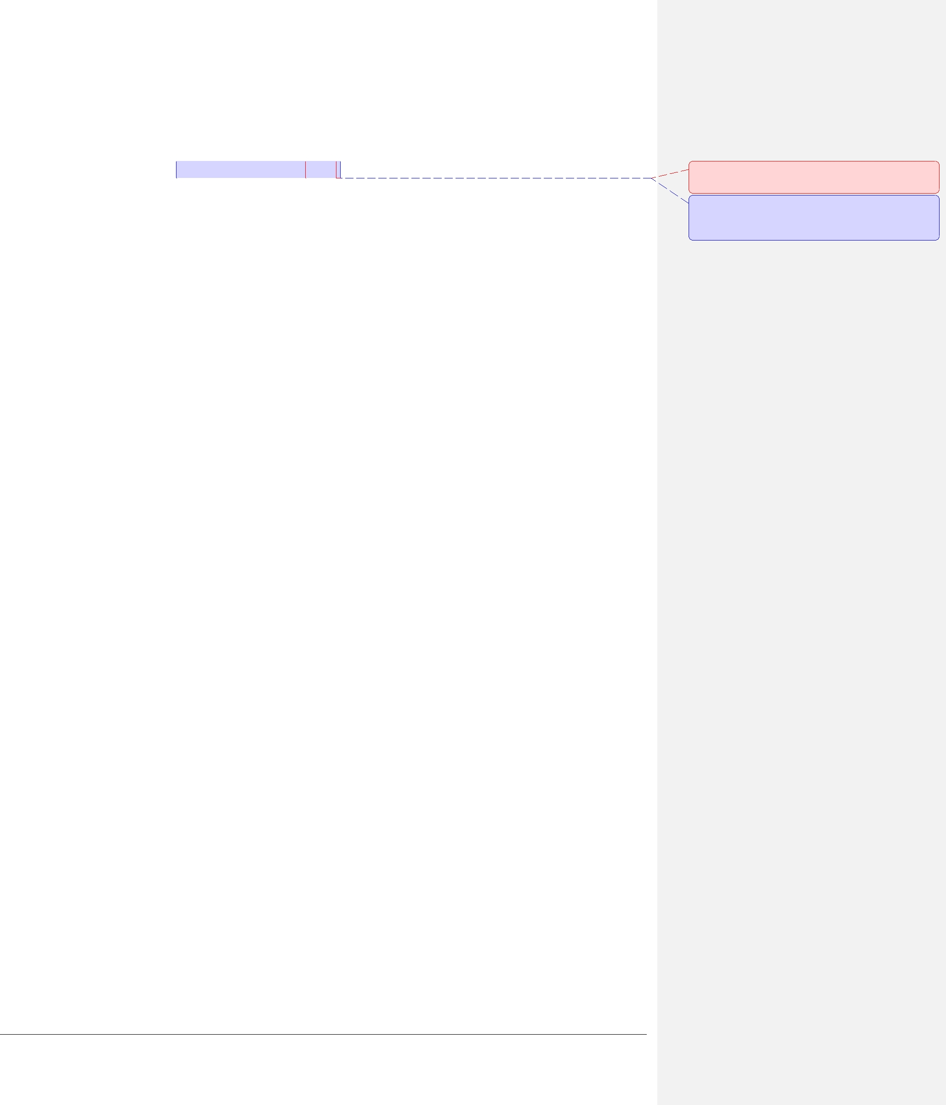

**4.1.8 MCAPI_INITIALIZE2**

**NAME**

mcapi_initialize2 – Initializes an MCAPI node.

**SYNOPSIS**

#include <mcapi.h>

void mcapi_initialize(

MCAPI_IN mcapi_domain_t domain_id, MCAPI_IN mcapi_node_t node_id,

MCAPI_IN mcapi_node_attributes_t* mcapi_node_attributes, MCAPI_IN mcapi_param_t* mcapi_parameters,

MCAPI_OUT mcapi_info_t* mcapi_info, MCAPI_IN mcapi_boolean_t start, MCAPI_OUT mcapi_status_t* mcapi_status

);

**DESCRIPTION**

mcapi_initialize2() initializes the MCAPI environment on a given MCAPI node in a given MCAPI domain in the same manner as mcapi_initialize() .The difference is the start parameter that controls whether the node is marked as valid at the end of the initialization. If start is MCAPI_TRUE then the call is the same as mcapi_initialize(). Otherwise the initialization is completed without marking the node as valid. Use the mcapi_node_start() function to complete the runup and make the node available to other nodes for communication.

**Comment [S6]:** I suggest we ask the techwriter for advice on this.

**Comment [ML7]:** Do you want to keep thisbrief description? Note difference to MRAPI doc.

**RETURN VALUE**

On success, *mcapi_status is set to MCAPI_SUCCESS. On error, *mcapi_status is set to the appropriate error defined below.

**ERRORS**

MCAPI_ERR_NODE_INITFAILED The MCAPI environment could not be initialized.

MCAPI_ERR_NODE_INITIALIZED The MCAPI environment has already been

initialized.

MCAPI_ERR_NODE_INVALID The parameter is not a valid node.

MCAPI_ERR_DOMAIN_INVALID The parameter is not a valid domain.

MCAPI_ERR_PARAMETER Incorrect mcapi_parameters or mcapi_info

parameter. Note, mcapi_parameters can be a

NULL pointer, if the MCAPI version is

1.000, for backwards compatibility

purposes.

MCAPI_ERR_GENERAL Implementation specific error not covered by other

status codes. Specifics must be documented.

**SEE ALSO**

mcapi_node_start(), mcapi_finalize()