Detect and display the number of drug types in the tray using the camera

Le Cong Minh
Ho Chi Minh City University of Technology
Ho Chi Minh City, Viet Nam
1612016@hcmut.edu.vn
Le Trung Luom
Ho Chi Minh City University of Technology
Ho Chi Minh City, Viet Nam
1611952@hcmut.edu.vn
Dang Thanh Tin
Ho Chi Minh City University of Technology
Ho Chi Minh City, Viet Nam
dttin@hcmut.edu.vn

Abstract—We present an approach to the detection and classify of drugs and describe a working, near-real-time drugs classify system which tracks an object (drug) and then classify drugs by comparing the shape and color of a drug with other drugs. Our approach treats drugs recognition as a two-dimensional recognition problem. Our research uses cameras to retrieve the image data of the drugs and use the python language to process drug (2D) classification of drugs. This software can be combined with doctors to create a datasheet of drugs for the machine learning algorithm to receive drugs without entering a name.
Keywords—detect drugs, shape detection, classify drug

Introduction
Currently, due to the development of medicine, more and more drugs are produced with different shapes and colors. The pharmacological classification and testing of pharmacists are also very complicated and time-consuming. The particular problem to be solved is the pharmacist's pressure in the classification work of the drugs, so devices have been created to help this work easily and conveniently. My group approached the direction of drug classification based on differences in shape, size, and color. In my research, we built the debut of creating the drug database which will have drug images and their names. This database will be used for methods such as neural networks, deep learning or machine learning. This work is quite labor-intensive and time-consuming. It is important primary work so we focused on the development of the software that can to identify drugs quickly. Furthermore, we can save the information about this drug. We aim to develop a simple and accurate model. Moreover, we harbor the quick classification of drugs in the pharmacy of manufacturing. This paper has seven sections. Section II presents the method to detect and find drug contours. Section III mentions creating an image of only one drug and a rotate image algorithm. Section IV presents the method template matching algorithm and displays the classified drugs. Section V flow chart. Section VI shows the experimental results, review, development and Section VII concludes the work.

Background and related work
As mentioned, methods such as neurons network are quite complicated. The following are studies related to the topic of using a neural network “An automatic drug image identification system” [1]. They proposed an automated drug image recognition system. Use content-based image retrieval to extract features of drug images and use neural networks, fuzzy methods, and relevant feedbacks, perform drug identification. The features used to recognize drugs include colors, shape, ratios, magnitudes, and textures. They used these five features in combination with a dynamic weight setting for drug identification. Their datasheet is provided by local polyclinics provides less than 300 different drugs in Taiwan, collects the number of drugs' images to test the system Hence, the system can be applied to the clinic's drug recognition for patients and pharmacists.

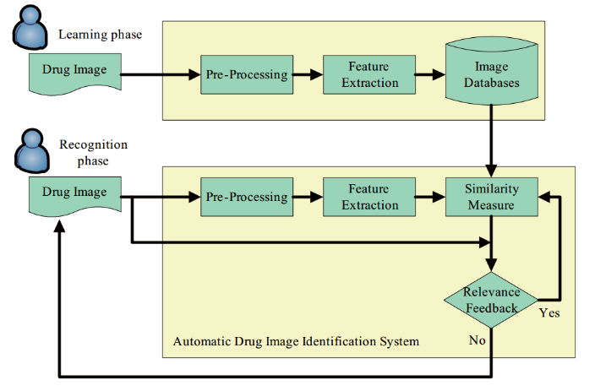
- Workflow of automatic drug image identification system [1]
In the second research “Drug dispenser and quantity input” [2], the product is a type of machine that can classify the counter drug. The drug dispenser has a memory for Storing data on the initial number of drugs in each of the drug feeders, a processor for calculating the number of drugs currently remaining in each drug feeder by subtracting the number of drugs discharged from each feeder from the initial number of drugs in each drug feeder, and a display for displaying the name of drugs if the number of drugs currently remaining in any drug feeder is smaller than a predetermined value. With this arrangement, an operator can easily see which drug feeders are short of drugs without directly checking the respective feeders by removing them from shelves. The workload on operators for drug replenishment is thus reduced.
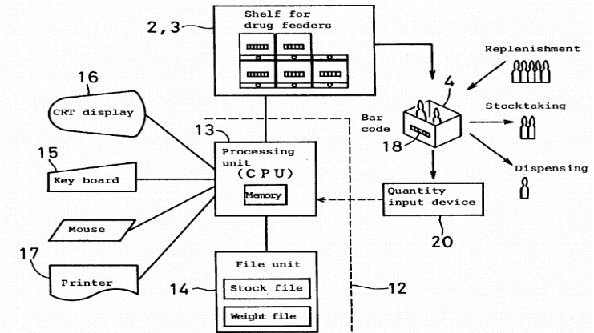

- Block diagram of the drug dispener [2]
Another research “Pharmaceutical Pill Recognition Using Computer Vision Techniques” [3], this research identifies drugs to help their doctors and patients with unidentified prescriptions or misbranded drugs. With nine out of ten people in the US over 65 years old who take more than one prescription pill being prone to misidentifying their pills. We learned the image processing method and the "Shape detect" method of this research.

Detect and find drugs contours

Create drugs contours
Detect contours of drugs become easy after using library OpenCV 3 [20]. First, we get a picture of the camera with 640 x 480 pixels. In fact, after 10 frames, we get a frame because it reduces noise. Then, we have an image which is an 8-bit color (Each pixel is represented by 8 bits). Next, we convert the color image to a grayscale image. This grayscale image has pixels that are valued only in an amount of light. The value of this grayscale image is from 0 to 255, value 0 is color white and value 255 is color black.
The letters on the drugs is a bad influence on the algorithm edge detection because that algorithm will regard the letters as the edges. So, we use the algorithm of blurring Gaussian blur [4], it will blur the letters that appear on the drugs. Theoretical formula to be able to blur as follows:
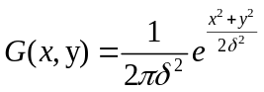 (1)
This formula (1) in [5,6] and in my research, we use value: x = y = 9, σ = 0.84089642[4]. With the value before, it barely blurs without losing the image.
You know, the drugs have the same or different shapes. As a result, we want to detect the drugs, we will completely depend on comparing the shapes together. In OpenCV supplied an algorithm to create that shapes, it is Canny edge detection [9]. We determine the edge that surrounds the drug. Now in the image, these edges only have the pixels which are represented 2 value 0(color white) or 255(color black). So, the Canny edge detector is a very strong algorithm. Thanks to taking the derivative in the direction of the Gradient:
(2)
The gradient direction is given by :
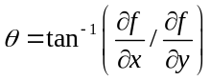 (3)
The edge strength is given by the gradient magnitude :
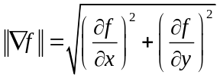 (4)
That 3 formula (2) (3) and (4) above in [8] is normal root operation in Canny edges detection. Moreover, the Gradient can find a different level of light, so it can sketch the shape of the drug. Finally, the result you get is a binary image with “thin edges” [9] of drugs in Fig. 3.
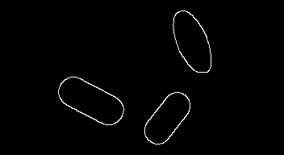
- Contours of drugs

Finds drug contours and separate the one from the others
The edges of drug contour are separated so that is easy to find this contour. We have the edge of the opened curve or the closed curve. Consequently, we have to scan all the images and find all of the closed curves. However, some objective factors the edge is not closed, we will appropriately dilate the pixels to connect this edge.
In my research, we find contours with the use of statements in image processing library OpenCV. The way to proceed is to find contours of drugs and then it saves all points of these contours into an array. This array has all the location points of contours [10].
To create list contours by Grabcut [11], each drug will out of the image all drugs. The method Grabcut depend on the image that processed canny detection. It will consider 2 pixels near each other because the image binary has only 2 values 0 (color black) or 255 (color white). Then, it will partition 2 values out. As a result, if the edge has value 255 (color white) is continuous, the Grabcut will return the matrix of this contour [12]. Next, the Grabcut will create a list of contours. And then we will see this list of contour as the key to represent a drug. The contour is indexed from left to right and from top to bottom in the image. When we indicate an index in an array, we will have a contour to process after.

Create a image only one drug and rotate image algorithm

Create image only one drug
From the contours of drugs that have processed by Grabcut, we will create the image original color of one drug. Clearly, we cut this drug from the original color follow the shape is this contour. We will create 2 images: One binary image content all contours of drugs and the other is original color image content all drugs.
We use bitwise operation AND [13] and the characteristics table:
- Characteristics Table
x | y | x and y
0 | 1,0 | 0
1 | 0 | 0
1 | 1 | 1

First, we have 2 images: the original color image, the binary contours image that has been filled with white color. Then, we use the draw contour algorithm in library OpenCV [10] to have this binary image. We take the original color image AND original color image by using a mask image is the binary image above. Because using bitwise operation: 1 AND 1 equal 1, Similar to the same pixels value that will AND itself, such as 2 AND 2 equal 2 or 255 AND 255 equal 255… In this work, we use bitwise operation AND base on the mask image so there are 2 cases: the value of one pixel in mask image is 255 (color white) and 0 (color black). If the mask image has a value 255, the bitwise AND will operate. And the other case, the bitwise operation will not operate and return value 255. In my research, we use bitwise operation AND in library OpenCV [14]. When two pixels have exactly alike value, so they will be retained. Opposite, this pixel in the original color image will be set value 255 (color black). After using this way, we have the image of all drugs in black background and the one's color image only one drug.

Rotate image algorithm
In the original color image, the drugs have many angles which is very different, so we don’t easily compare them with the others. Due to rotating drug shaft so that 2 drugs have the same angle drug shaft.
This Rotate algorithm that rotates image one drug an angle θ degree. Specifically, take the image matrix multiplied by the rotation matrix:
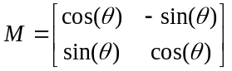
Where the matrix has 2-dimensional. If the n-dimensional matrix, we use the following matrix:
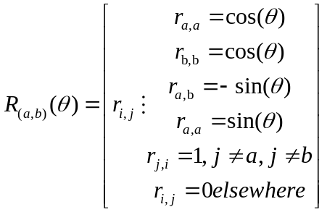 (5)
With the theory and formula (5) in [15] as above, each time we will rotate the image at an angle θ. When rotating to 360 degrees, the processing rotates will stop. The more angle θ is small, the more accuracy of the algorithm is good whereas it takes more time for processing. In this research, we use Adrian's to rotate the image (correctly) algorithm [16]. Because the rotating image in library OpenCV will happen “cut off”. Thus, we use Adrian's algorithm, which keeps the frame of the image.
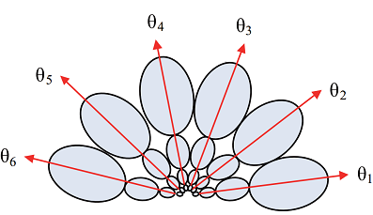
- Rotate Algorithm [1]

Template matching algorithm and display the classified drugs

Template matching algorithm
Template matching is a simple algorithm, it only needs to image grayscale. It will compare 2 images. Using Template matching [17] compares the formula image as follows: First, We will compare the template image with the source image. If the error is less than the specified error, it will return the correct value. Errors are calculated through the theoretical formula as follows, SAD (Sum of absolute differences) [18]
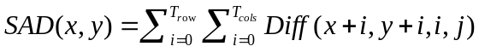
We’ll call the template T(x_{t}, y_{t}) where (x_{t}, y_{t}) represent the coordinates of each pixel in the template[17]. In my research, we use the comparison function of library OpenCV to get the template image and match the image with the source image which has the image before. The template image is image one drug which has rotated by the rotate image algorithm and the source image is the grayscale image. By taking the template image to scan the entire image frame above and returning the coordinates of the upper corner of the image received. We use the following error formula (6) in [19]:
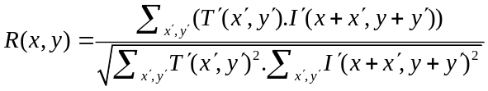 (6)

Display the classified drugs
We will display each image of the classified drug and let the user enter it. To initialize this, as if you created the list of drugs, we will display the drug so that a doctor or a pharmacist can enter the name of this drug.
Display images result only with different drugs and when the doctor or pharmacist typing the name of the drug, it will display the name on this image. Consequently, look more and help the doctor easily check which drug is the same. We use the command in OpenCV to display the image and type the name of the drug.

Flow chart
Image from camera
Grayscale image
Create drugs contours
Rotate image one drug
Take one drug compare all drugs
Create the image clearly with classified drugs

- Flow chart

Experimental result

Data
The group has completed product classification. Here are the visual inspection results when changing the same index of comparison algorithms and the closest distance of the two pills that the program can identify. These indicators greatly affect classification results, so users need to deliberately use them.
Table of statistical results when changing the index is the same when comparing, with low light conditions and using LED lights of smartphones. Identify five type drugs each of two pills. We found that with the same percentage of 89 – 96%, all the drugs were identified.

- Table The Same Percentage 1
 | The same percentage (%) | Result
Test 1 | 85 | Identify three pills
Test 2 | 88 | Identify four pills
Test 3 | 89 - 96 | Exactly
Test 4 | 97 | Wrong identification

Test 1  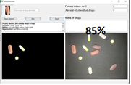 | Test 2  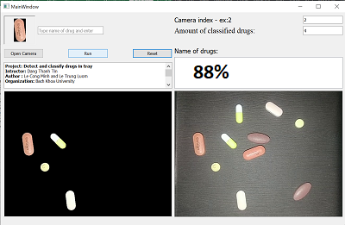
Test 3  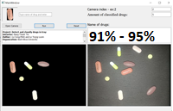 | Test 4  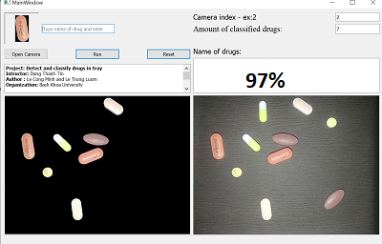

- Images illustrating the tests the same percentage 1
Table of statistical results when changing the index is the same when comparing, with daylight conditions in the room to open fluorescent lights. Identify five type drugs each of two pills. With this test, the same percentages are 92-94% to correctly identify.
- Table The Same Percentage 2
 | The same percentage (%) | Result
Test 1 | 85 | Identify three pills
Test 2 | 88 | Identify four pills
Test 3 | 92-93 | Exactly
Test 4 | 94 | Exactly
Test 5 | 95 | Wrong identification
Test 6 | 96 | Wrong identification

Test 1  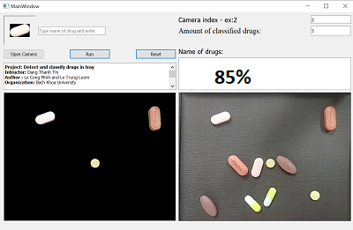 | Test 2  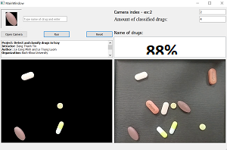
Test 3  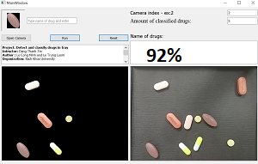 | Test 4  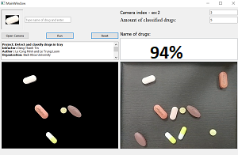
Test 5  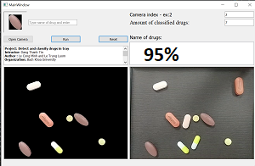 | Test 6  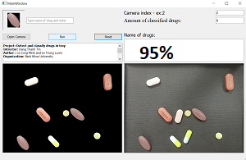

- Images illustrating the tests the same percentage 2
Test the smallest distance between the two pills that the software can recognize across the drug tray.

Type 1  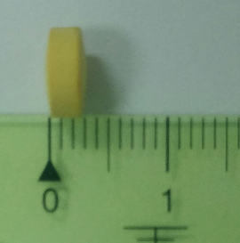 | Type 2  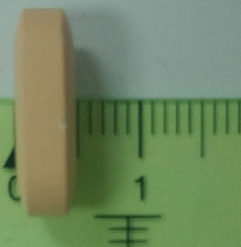 | Type 3  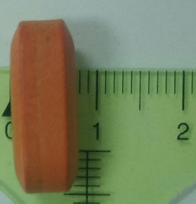

- Images of test type drug
- Table Smallest Distance
Table Head | Position on the tray | Smallest distance (cm)
Type 1 | Center of the tray (1) | 0.1
Thickness (0.3 cm) | Bound of the tray (2) | 0.2
 | Between (1) and (2) | 0.1 - 0.2
Type 2 | Center of tray | 0.1
Thickness (0.5 cm) | Bound of the tray | 0.25
 | Between (1) and (2) | 0.1 - 0.25
Type 3 | Center of tray | 0.12
Thickness (0.75 cm) | Bound of the tray | 0.3
 | Between (1) and (2) | 0.12 - 0.3

Center of the tray
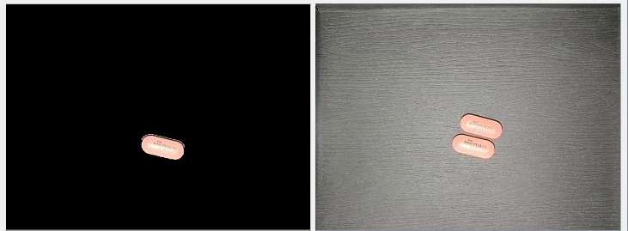
Bound of the tray
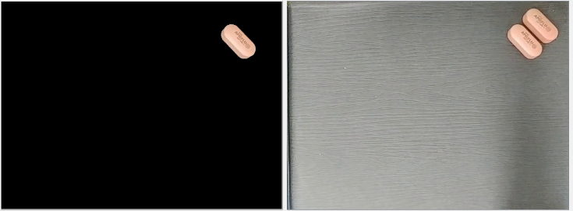

- Image depicting the position of the drug

Review
The product classification of the group is mainly classified according to the difference in shape and size. As for the color part, it is still limited (for example, two pills must have a contrasting color to identify it). Regarding the interface of the software, the finishing group is quite good, the user can easily use it because it has instructions before using on the interface of the program.
The GUI of the program is in Fig. 10 with useful and easy function.
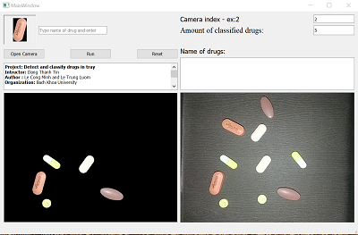

- GUI of program

Development
With this software, we can combine with pharmacists to create datasheets for approaches to neuron networks and machine learning. From there can be identified without a pharmacist, to avoid confusion as to interfering with patients. Just the software connected to the camera can identify the name and type of drug.

Conclusion

Advantages
We have finished sorting drugs with different size shapes and displaying them on a computer screen so that pharmacists can enter names and classify them. Ability to handle quite quickly in real time. Product after packaging takes up a small amount of ease of use. Use smartphones as cameras with software that supports both iOS and Android operating systems and with PCs with Windows, Mac, and Ubuntu. They are popular operating systems for users to easily access our products. The product is quite useful to help pharmacists can sort drugs quickly and easily. Avoid confusion when checking classification as well as medication allocation.

Disadvantages
Because capsules of capsules have reflective shells, it makes the operation of “canny” algorithm not good, leading to the inability to scan the margin of the pills. The tray and camera only cover about more than 30 drugs, when the number of drugs and the number of types is high, it must be processed slowly because the number of loops increases. The background of the tray must be a dark color and contrasting with the medicine then the new recognition algorithm is good.

References

- Rung-Ching Chen, Yung-Kuan Chan, and Ying-Hao Chen, “An automatic drug image identification system based on multiple image features and dynamic weights,” ICIC International, vol. 8, pp. 2995–3013, January 2011.
- Shoji Yuyama,Naoki Koike,and Hirohisa Shimizu,”Drug dispenser and quantify input device,”,U.S Patien 6 364 517, 1892, Apr. 2, 2002.
- Charlen Tay and Mridul Birla, “Pharmaceutical Pill Recognition Using Computer Vision Techniques,” B657 Computer Vision final research. May. 2016
- Wikipedia, Gaussian blur .[Online]. Available: https://en.wikipedia.org/wiki/Gaussian_blur, accessed November 2018
- Shapiro, L. G. & Stockman, G. C: "Computer Vision", page 137, 150. Prentice Hall, 2001.
- Mark S. Nixon and Alberto S. Aguado “Feature Extraction and Image Processing,” Academic Press, 2008, p. 88.
- Wikipedia, Canny edge detector .[Online]. Available: https://en.wikipedia.org/wiki/Canny_edge_detector#Development_of_the_Canny_algorithm, accessed June 2019
- Wikipedia, Image gradient .[Online]. Available: https://en.wikipedia.org/wiki/Image_gradient#cite_note-dip3-2, accessed May 2019
- Canny edge detection .Available: https://opencv-python-tutroals.readthedocs.io/en/latest/py_tutorials/py_imgproc/py_canny/py_canny.html, accessed June 2019
- Contours begin .[Online]. Available: https://docs.opencv.org/3.4.5/d4/d73/tutorial_py_contours_begin.html, accessed May 2019
- Grabcut Available: http://www.cs.ru.ac.za/research/g02m1682/, accessed June 2019
- Wikipedia, Bitwise Operation .[Online]. Available: https://en.wikipedia.org/wiki/Bitwise_operation, accessed May 2019
- Arithmetic operations on .[Online]. Available: imageshttps://docs.opencv.org/3.4.5/d0/d86/tutorial_py_image_arithmetics.html , accessed May 2019
- Antonio Aguilera and Ricardo Pérez-Aguila, “General n-Dimensional Rotations,” México 72820, Cholula, Puebla, 2004
- Rotate images correctly .[Online]. Available: https://www.pyimagesearch.com/2017/01/02/rotate-images-correctly-with-opencv-and-python/, accessed May 2019

- R. Brunelli, Template Matching Techniques in Computer Vision: Theory and Practice, Wiley, ISBN 978-0-470-51706-2, 2009
- Wikipedia, Sum of absolute differences .[Online]. Available: https://en.wikipedia.org/wiki/Sum_of_absolute_differences, accessed May 2019
- Wikipedia, Template matching .[Online]. Available: https://en.wikipedia.org/wiki/Template_matching#cite_note-1
- Wikipedia, Template matching .[Online]. Available: https://docs.opencv.org/3.4.5/d4/dc6/tutorial_py_template_matching.html, accessed May 2019
- Joe Minichino and Joseph Howse, Learning OpenCV 3 Computer Vision with Python Second Edition, Packt Publishing, Sept. 2015

