**To: Paige Altemare, Daniel Sederholm, Neal Krentz**

**From: Daniel Gil**

**CC: Dr. Stefan Boltzman**

**Re: Re: Heat Exchanger Networks**

This report describes in detail how we will be able to:

1. Determine the efficacy (overall heat transfer coefficient) of four heat exchangers to transfer heat between two streams of water.
2. Test several designs of heat exchanger networks to determine the best possible (most cost-effective) design for the process in question.

In order to fulfill this, the following team has been assembled to complete the tasks.

* Daniel Gil is the foreman for this lab. His main responsibility is to coordinate the team to run the experiments safely and effectively.
* Neal Krentz and Daniel Sederholm are the hardware operators for this lab. They are responsible for building heat exchanger networks. They are going to manually operate the various valves and heat exchangers.
* Paige Altemare is the software operator for this lab. She is responsible for recording the data and controlling the flow rates of various streams using the mass flow controller (MFC) or by directing the hardware operators to change flow rates.

**Theory**

Heat exchangers are used to efficiently transfer heat energy from one fluid to another fluid. Heat exchangers are useful because many processes require that certain streams of fluid be at specific temperatures. Heat exchangers are often used to regulate the temperatures of fluid streams by transferring heat between a process stream and a cooling/heating fluid stream. Thermal integrations can reduce usage of cooling/heating fluid streams by transferring heat between two (or more) process streams. A well-designed heat exchanger network can save energy costs by using minimizing cooling or heating fluid usage, and by maximizing thermal integrations.

Pinch condition is when the temperatures of the fluid streams in opposite sides are equal or nearly equal. When the pinch condition happens, the heat exchanger cannot effectively transfer heat because the temperature gradient is too small. Pinch conditions should be avoided when rating heat exchangers. If the pinch condition occurs somewhere along the middle of the heat exchanger, the area of the heat exchanger for heat transfer changes. Then, it becomes to properly calculate the overall heat transfer coefficient, ***U***. The rule of thumb with heat exchangers is that they should be implemented so that the temperature difference between the fluid streams is at least 10°C.

**Task (1) Determining the overall heat transfer coefficient $(U)$**

The first task is to determine ***U*** for four heat exchangers using water. There are two shell and tube (ST) and two plate and frame (PF) heat exchangers available. The heat transfer coefficients, ***h1*** and ***h2*** are functions of flow characteristics and heat exchanger geometry. Therefore, ***U*** is a function of the heat exchanger geometry, the thermal properties of the fluid, and the flow characteristics of the system (see equation [1] below).

$$\frac{1}{UA}=\frac{1}{h_{1}A_{1}}+\frac{1}{h_{2}A_{2}}+\frac{L}{kA}+R_{fouling} [1]$$

The heat exchanger geometry and the thermal properties of the fluid are staying constant for each heat exchanger. However, the flow characteristics is still variable. Therefore, we will be calculate U as a function of flow rate. Equation [5] can be used to calculate ***U*** of PF heat exchangers. Equation [7] can be used to calculate ***U*** of ST heat exchangers. The derivations of equations [5] and [7] are outlined below.

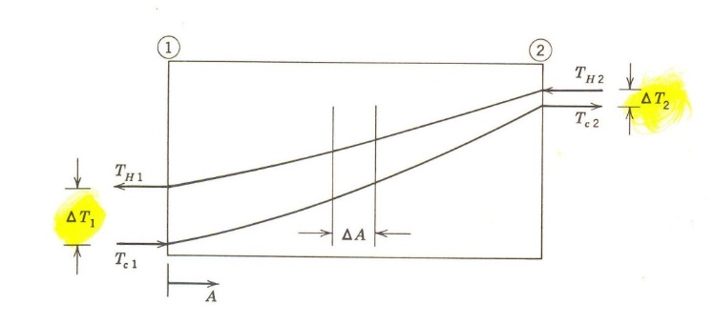It is important note that the numerator in equation [5] and [7] can be defined in two ways. It can be defined as the energy that the hot process stream lost to the cold stream, or vice versa. In a perfectly insulated heat exchanger, all of the heat lost by one fluid is gained by the other fluid in the heat exchanger. In our process, our goal is to decrease the temperature of the hot liquid. Therefore, the heat duty of the hot fluid *losing heat* will be used to evaluate ***U***.

**Thermal Energy Balance:**

$Q=\dot{m}C_{p}\left(T_{o}-T_{i}\right)=\dot{m}C_{p}\left(t_{o}-t_{i}\right) [2]$

**Duty of a Heat Exchanger:**

Figure 1.Temperature profile of a counter-current heat exchanger.

$Q=UA∆T_{lm}$ $[3]$

$∆T_{LM}=\frac{∆T_{2}-∆T_{1}}{ln\frac{∆T_{2}}{∆T_{1}}} [4]$

The heat duty in equation [2], ***Q***, is equivalent to ***Q*** in equation [1]. The heat duty of a true counterflow heat exchanger can be expressed simply as the heat duty that either fluid experienced.

Combining and rearranging equations [2] and [3] yields the following equation that can be used to solve for ***U***.

$$U=\frac{mC_{p}\left(T_{o}-T_{i}\right)}{A∆T_{LM}} [5]$$

***U*** will be calculated as a function of flow rate, since its value depends on flow conditions. ***ΔTLM*** will be calculated from the measurements of four steady-state temperatures (Ti,To,ti,to) shown in Figure 1.

For heat exchangers that are not true counterflow, an additional term, $F$, is required for equation [3].

$Q = UAΔT_{lm}F$ $[6]$

Which leads to an equation similar to equation [5]:

$$U=\frac{mC_{p}\left(T_{o}-T_{i}\right)}{A∆T_{LM}F} [7]$$

$F$ is the ratio of the heat duty of the actual heat exchanger to the heat duty of a true counterflow exchanger of equal area and terminal fluid temperatures. For S&T heat exchangers with one shell pass, and any multiple of two tube passes, F is defined as**¹**:

$$F=\frac{[\sqrt{R^{2}+1}/(R-1)]•log⁡[(1-P)/(1-PR)]}{log⁡[(a+\sqrt{R^{2}+1})/(a-\sqrt{R^{2}+1})]} [8]$$

$$R=\frac{T_{i}-T_{o}}{t_{o}-t_{i}} [9]$$

$$P=\frac{t_{o}-t_{i}}{T_{i}-t_{i}} [10]$$

$$a=\left(2/P\right)-1-R [11]$$

**Task (2) Design the optimal heat exchanger network**

Our calculations indicate that the absolute minimum flow rate of cooling water that can be utilized is **3.03 L/min**. This calculation is derived from the thermal energy balances. It assumes that the initial cooling water temperature is 20°C, and that its final outlet stream temperature is the same as the inlet hot stream temperature of 80°C. This flow rate is the theoretical limit of the cooling water flow rate in the heat exchanger network.

The most practical heat exchanger network will meet two terms. First, it has to meet the process specifications. Two, the average temperature of the output cooling liquid will be as close to 80°C as possible. We will use the network shown in Figure 2. Depending on the values of ***U*** that were found for each heat exchanger, the placement of the heat exchangers and the flow rate of the cooling water will be adjusted.

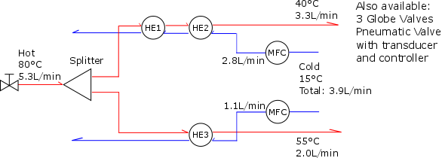

Figure 2. The general flow diagram of the heat exchanger network to be tested. HE1, HE2, and HE3 are generic; two ST heat exchangers and one PF heat exchanger can go anywhere the three HE symbols are. The flow rates of the cooling water is based on Aspen simulation, and the experimental values are not expected to be the same.

**Safety**

In this process, workers will be working closely with steam and hot-water pipes. All workers should be attentive at all times to watch out for any dangers. They should notify Adriaan Riet and Dr. Wainright, the supervisor of this plant, as soon as they can in an emergency.

* Be aware of all hot machinery and equipment
* Wear standard lab attire: closed-toed shoes, lab coats, and lab goggles.
* When working with the machinery or equipment, wear insulated leather gloves.
* If there is a leak in the steam pipe or hot water pipe, the steam valve can be turned off. If the steam pipe bursts, all workers should leave the area to keep themselves safe from getting burned.
* Keep all electrical equipment dry.
* Keep the temperature and pressure of all equipment in the allowable range. For all liquid water in the equipment, the temperature should not exceed 90°C. Localized heat may cause the liquid to boil. Keeping all water below 90°C provides additional assurance that the water will not boil and cause hazards. The maximum pressure that the heat exchangers can withstand is 450 psig.
* Turn off the steam and the hot water stream before being redirecting it to another piece of equipment.
* With minor burns, cold water should be run over the burn area. In the case that someone is gravely injured and cannot save themselves, from whatever cause, one should not attempt to save the injured if the act also puts themselves in danger.

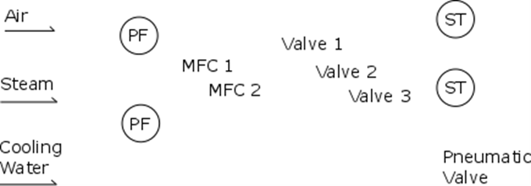

Figure 3. Figure showing the general location of equipment, when facing the apparatus. The foreman will brief the team about the specifics of each equipment before the experiment.

**Methods**

**Calibration**

Objective: Assess the status of thermocouples. The thermocouples should already be operational, but they will be examined to make sure they are still calibrated. Port 10 on the Elvis is currently unreliable, so it will not be used. We will record if there are any significant offsets between the thermocouples at atmospheric temperature. The offset is not going to be independent of temperature, but this quick measurement should still give an indication of the reliability of the instruments. This is not meant to be a full calibration. If there is an apparent need for a full calibration, procedure B should be followed instead.

**Procedure A:**

1. Start recording data. The thermocouples should be reading the atmosphere temperature.
2. When there is enough sampling, determine the mean temperature and calculate the offset between each thermocouple.

**Procedure B:**

1. Prepare four samples of water with different temperatures. Put a glass thermometer in each of them. Temperatures should be close to 20°C, 40°C, 60°C, and 80°C each.
2. Remove each thermocouple from the heat exchangers.
3. Take one thermocouple and measure the temperatures of the four samples of water. Record the reading on the thermocouple and the glass thermometer.
4. Repeat step 3 for the other thermocouples.
5. The recorded data can be used to estimate any significant deviations between thermocouples.
6. Put all of the thermocouples back to their original places.

**Task (1) Determine *U* of heat exchangers**

Objective: Test each heat exchanger to determine the overall mass heat transfer coefficient ($U$), and determine which ST heat exchanger is fouled. The four temperature terminals of the ST and the PF heat exchangers will be recorded as a function of cooling water flow rate ($\dot{V}$). Hot water flow rate will be kept constant throughout the experiment.

Procedure:

1. Direct the flow of the cold stream into the tube side of the first shell and tube heat exchanger, which will be designated as S&T **C**. Adjust the flow rate of the cold stream to 6 L/min.
2. Direct the flow of the hot stream into the shell side[1] of S&T **D**. Check the flow rate, it should be constant at 5.3 L/min.
3. Let the temperatures reach steady-state, and then record data (temperatures and flow rate).
4. Decrease the cold stream flow rate to 4 L/min, let system reach steady-state, and then record data again.
5. Repeat step 4 with the flow rate at 2 L/min.
6. Turn off the flow of the steam.
7. Turn off the flow of hot water stream.
8. Turn off the flow of the cold stream.
9. Test the next S&T and both P&F (**A & B**) following steps 1 through 7.
10. Analyze the data to calculate $U_{actual}$ as a function of $\dot{V}$.
11. Compare $U_{actual}$ and $U_{theoretical}$ for S&T, also determine which S&T is fouled. This step will take place after the experiment.

**Task (2) Design the optimal heat exchanger network**

Objective: Design a heat exchanger network that meets the following specifications. An inlet stream of hot liquid (water) at 80oC flowing at a rate of 5.3 L/min is to be cooled to two streams. The first cooled stream is to be 55±2oC flowing at a rate of 2.0±0.2 L/min. The second cooled stream is to be 40±20C and its flowrate is to be 3.3±0.2 L/min. The flow rate of the cooling water is to be minimized. Up to three heat exchangers can be used, and only one of them can be PF.

A preselected network design will be tested and optimized. The optimal heat exchanger network will use the least amount of cooling water. The design shown in Figure 2 are simulation results from AspenPlus, assuming that both S&T has overall heat transfer coefficient ($U$) equal to 1000 W/m2•K, and P&F has equal to 2000 W/m2•K. HE1 and HE3 are PF exchangers and HE2 is ST exchanger. Use Figure 2 as a guide to build the optimal network.

Procedure:

1. The same precautions as Part 2 are to be used in Part 3. Make sure to shut-off hot streams before moving the tubes. Also make sure that the cold water stream is the first one in and the last one out of each heat exchanger when getting setting up heat exchangers.
2. HE1, HE2, HE3 will be two S&T and 1 P&F. Various combinations and positioning of the heat exchanges will be tested. Using the picture above as a guide, direct the flow of each stream through heat exchanger and splitters as shown.
3. Turn on the cold stream flowing to 5 L/min.
4. Adjust the hot stream to 80oC flowing at a rate of 5.3 L/min.
5. Adjust the cold stream to the specified flowrate. The specified flowrate will be calculated from the data obtained in Part 2.
6. Let the system reach steady-state. Observe if the outlet process fluid streams match all specifications. Record data.
7. Modulate the cold stream flow rate to achieve the specifications of the process streams. Record data at steady-state.
8. Try a new combination of heat exchangers, and follow steps 1 through 7 again. Try total of 4 combinations.

1. It is best to direct the cold stream into the tube side of an S&T for multiple reasons. The flowrate of a tube side is much easier to control, since there are no baffles that disrupt mass transport. Also, cleaning the tube side if much easier than the shell side, if the cooling water can foul the heat exchanger. The process fluid should go into the shell side because the pressure drop (which can be a process constraint) can be tuned with design of the heat exchanger on the shell side. However, if the process fluid is corrosive, it should go into the tube side. Corrosion-resistant materials are expensive. Putting the corrosive fluid in the shell side requires that the entire heat exchanger be made of corrosion-resistant materials. Alternatively, only the tubes, tubesheets, heads and channels need to be made of corrosion-resistant materials if the corrosive fluid goes in the tube side.

   |  |  |
   | --- | --- |
   | S&T Exchanger Model [4] | BCF |
   | Size | 3014 |
   | Pass | 4-Pass |
   | Baffle Spacing | Narrow = O |
   | Surface Area | 4.3 ft² |
   | Max. Tube Side | 12 gpm |
   | Max. Shell Side | 24 gpm |
   | Max. Temperature | Shell Side - 300 ºFTube Side - 150 ºF |
   | Design Pressure | Shell Side - 300 psiTube Side - 150 psi |
   | Material | Brass ShellCast Iron BonnetsCopper TubesZinc Anodes |
   | In/Out Bonnet | 3-093-7-03-115-01, Cast Iron Bonnet |
   | Reversing Bonnet | 3-112-7-03-815-01, Cast Iron Bonnet |
   | Gasket For In/Out Bonnet | 3-298-8-03-113-02, Replacement Compressed Fiber Gasket |
   | Gasket For Reversing Bonnet | 3-298-8-03-113-03, Replacement Compressed Fiber Gasket |
   | Zinc Anode | 3-386-9-03-101-02, Heat Exchanger Zinc Anodes |

   |  |  |
   | --- | --- |
   | F&P Exchanger Model [5] | FP5X12 |
   | No. of Plates | 10 |
   | MPT Connect. | 1 |
   | GPM Max. | 20 |
   | Width (inches) | 4.9 |
   | Length (inches) | 12.2 |
   | Depth (inches) | 1.3 |
   | Max. Temperature (°F) | 450 |
   | Max Pressure (psig) | 450 |
   | Plate Material | 316L Stainless Steel |
   | Copper Braze Alloy | 99.90% |
   | Connection Material | 304/304L Stainless Steel |
   | Side A Volume (L) | 0.283 |
   | Side B Volume (L) | 0.368 |

   2 MFC with less than 4 liters/min flowrate. Foxbono

   |  |  |  |  |
   | --- | --- | --- | --- |
   | Stream | Fluid | Temperature (°C) | Flow Rate (L/min) |
   | Input Process Fluid | Water | 80 | 5.3 |
   | Output Process Fluid 1 | Water | 55 | 2 |
   | Output Process Fluid 2 | Water | 40 | 3.3 |
   | Coolant | Water | 15 | 6 (max) |

   **References**

   1. "Standard Guide for Heated System Surface Conditions that Produce Contact Burn Injuries (C 1055-92)." American Society for Testing and Materials, Philadelphia, PA.

   2. Scheme for the Identification of Piping Systems, ANSI A13.1-1975, American National Standards Institute. New York, NY: American Society of Mechanical Engineers.

   3. "Preventing Burns from Insulated Pipes," Chemical Engineering, Vol. 88, No. 15 (July 27, 1981), pp. 58-64.

   4. http://catalog.southgateprocess.com/item/em-standard-xchange-straight-tube-fixed-tubesheets/cf-br-straight-tube-fixed-tubesheet-heat-exchanger/5-030-03-014-005-4

   5. http://www.raley-bros.com/PDF%20Files/FPfrontbackconnects.pdf