## 

## 

**Final poe —**  [***PROG7311***](https://myvc.iielearn.ac.za/webapps/blackboard/execute/courseMain?course_id=_175276_1)

Keagan Tomlinson

ST10084431

Varsity College

[***PROG7311***](https://myvc.iielearn.ac.za/webapps/blackboard/execute/courseMain?course_id=_175276_1)

Nash Ramckurran

Performance

Caching

Hashing

Entity Framework

Git - Version Control

Database Optimization

Asynchronous Operations

Content Delivery Networks (CDNs)

Load Balancing and Scaling

Front-End Optimization

Code Profiling and Performance Monitoring

Minimise External Service Dependencies

software development methodology

Agile Methodology

Waterfall Methodology

Hybrid Methodology

Devops

GitHub

Kanban

Docker

Unit Testing

Flow of Control Diagram

Frameworks

Combining the Zachman Framework and TOGAF

Zachman Framework

TOGAF

Site

Improvements

User Manual

Purpose of the User Manual

Target Audience

System Overview

Getting Started

Accessing the Website

Login

Farmer Features

Adding a New Product

Employee Features

Adding a New Farmer

Viewing Farmer's Products

Filtering Products

Troubleshooting

Common Issues and Solutions

Frequently Asked Questions (FAQ)

Accountant's Guide - Maximising Accuracy for Increased Income

Head of Marketing's Guide - Enhancing Efficiency and Visual Appeal

Store Manager's Guide - Streamlining Operations for Efficient Training

Works Cited

## 

## 

## 

## 

## Performance

### Caching

Implement caching techniques to store frequently accessed data, such as product information, inventory data, and user-specific settings. Utilise caching libraries like Redis or the built-in caching capabilities of ASP.NET to improve response times and reduce load on the database server. Ensure appropriate cache invalidation techniques are implemented to maintain data accuracy and freshness.(Amazing Enyichi Agu)

### Hashing

Utilise hashing algorithms (e.g., SHA-256 or MD5) to optimise performance and enhance data integrity and security. Apply hashing to sensitive data like passwords or critical stock information, storing fixed-length hash values in the database. This approach enables quick comparisons during authentication or data validation processes while protecting sensitive data.

### Entity Framework

Leverage Entity Framework, a popular ORM framework in the .NET ecosystem, to optimise interactions with the Azure SQL database. Utilise features like query optimization, lazy loading, and caching provided by Entity Framework. Optimise database queries through proper indexing, avoiding excessive joins, and utilising asynchronous operations. These practices can significantly enhance response times and overall performance.

### Git - Version Control

Utilise version control systems like Git to enable efficient collaboration, code integration, and continuous deployment practices. Follow branching strategies, conduct code reviews, and adhere to proper commit practices to prevent issues that may degrade performance. Utiliser Git's versioning capabilities for easy rollbacks and identifying performance-related changes.(Git-scm.com, 2023)

### Database Optimization

Regularly analyse and optimise the database schema, indexes, and query execution plans to ensure efficient data retrieval and manipulation. Implement database caching mechanisms like SQL Server Query Store or Azure SQL Database Query Performance Insight to identify and resolve performance bottlenecks. Consider employing database partitioning and sharding techniques to distribute data across multiple servers, improving scalability and reducing response times.(Zola, 2021)

### Asynchronous Operations

Implement asynchronous programming techniques in the C# ASP.NET web app to improve responsiveness and free up server resources. Utilise asynchronous database access methods and asynchronous HTTP requests to external services to minimise blocking and waiting times.

### Content Delivery Networks (CDNs)

Leverage CDNs to cache static content (e.g., images, CSS, JavaScript files) closer to the user's location, reducing latency and improving page load times. Utilise CDN capabilities for content compression and minification to further optimise file sizes and transfer speeds.

### Load Balancing and Scaling

Employ load balancing techniques such as Azure Load Balancer or Application Gateway to distribute incoming traffic across multiple servers, improving performance and ensuring high availability. Implement auto-scaling mechanisms to dynamically adjust resources based on traffic demands, preventing performance degradation during peak periods.

### Front-End Optimization

Optimise client-side performance by minimising the number of HTTP requests, leveraging browser caching, and using techniques like lazy loading for images and content. Implement client-side caching mechanisms such as local storage or session storage to store frequently accessed data and reduce server round-trips.

### Code Profiling and Performance Monitoring

Utilise performance profiling tools to identify and optimise performance bottlenecks within the codebase. Implement logging and monitoring solutions like Azure Application Insights or ELK Stack to track application performance, identify issues, and proactively address them.

### Minimise External Service Dependencies

Reduce the number of external service calls and optimise their usage. Consider batching requests, implementing caching mechanisms, or leveraging asynchronous processing for external integrations to improve performance.

## 

## 

## 

## 

## 

## 

## software development methodology

### Agile Methodology

I would recommend the Agile methodology for the development effort of the stock management website. Agile is a highly suitable choice for this project due to its iterative and incremental approach, flexibility, and emphasis on collaboration and adaptability.

The stock management website development may involve evolving requirements and the need for frequent updates based on changing business needs. Agile methodologies, such as Scrum or Kanban, allow for regular iterations or sprints, enabling the development team to deliver working software at frequent intervals. This iterative approach ensures that stakeholders have the opportunity to provide feedback and steer the project direction as it progresses, resulting in a solution that better aligns with their evolving requirements.

The stock management domain often involves complex business rules, various user roles, and a significant amount of data handling. Agile methodologies encourage cross-functional team collaboration, including close cooperation between developers, testers, and business stakeholders. This collaboration allows for faster decision-making, quick resolution of issues, and effective knowledge sharing. It enables the development team to gain a deeper understanding of the domain and build a solution that meets the specific needs of the stock management domain.

Agile methodologies also promote adaptability to change. As market demands or business requirements shift, Agile teams can quickly respond and adjust their development efforts. This flexibility is particularly valuable for a stock management website, where the ability to incorporate new features, handle evolving inventory needs, or integrate with external systems may be critical for the success of the application.

In summary, the Agile methodology is well-suited for the stock management website development effort due to its iterative nature, emphasis on collaboration, adaptability to changing requirements, and ability to deliver a solution that closely aligns with stakeholder expectations.

Feedback: The motivation provided for selecting the Agile methodology is well-supported. It highlights the advantages of Agile in addressing evolving requirements, facilitating collaboration, and enabling adaptability. It also specifically connects the characteristics of Agile to the requirements and challenges of developing a stock management website. Overall, the motivation provides a clear rationale for choosing Agile as the recommended methodology.

### Waterfall Methodology

While Agile is a recommended methodology for the stock management website development effort, there are cases where the Waterfall methodology may be suitable. The Waterfall methodology follows a sequential approach, where each phase of the development life cycle is completed before moving to the next phase.

For projects with well-defined and stable requirements, where changes are expected to be minimal, the Waterfall methodology can be a viable choice. In the case of a stock management website, if the requirements are well-documented and unlikely to change significantly during the development process, the Waterfall methodology can provide a structured approach.

The Waterfall methodology places a strong emphasis on thorough upfront planning and documentation. This can be advantageous for the stock management website development, as it requires clear understanding and definition of inventory management processes, business rules, and data handling requirements. With proper planning and documentation, potential risks and challenges can be identified early on, minimising the likelihood of major disruptions during development.

Furthermore, the Waterfall methodology allows for a more straightforward and linear progression of development activities. This can be beneficial when there is a need for a comprehensive, end-to-end implementation of stock management features without frequent iterations or changes in direction. If the stock management website project has a fixed scope, budget, and timeline, the Waterfall methodology can provide a predictable and controlled approach.

However, it's important to note that the Waterfall methodology may have limitations in handling evolving requirements, adapting to changing market demands, and incorporating feedback throughout the development process. It is less flexible compared to Agile methodologies, which thrive in dynamic and rapidly changing environments.

Feedback: The motivation provided for the Waterfall methodology is well-presented. It acknowledges the suitability of Waterfall in cases where requirements are stable and well-defined, which can be applicable to certain scenarios of stock management website development. The rationale for emphasising upfront planning, documentation, and a structured approach aligns with the nature of the Waterfall methodology. Additionally, the answer highlights the potential limitations of Waterfall in handling changing requirements and adaptability. Overall, the motivation provides a clear explanation for considering the Waterfall methodology as an alternative in specific project contexts.

### Hybrid Methodology

Another software development methodology that can be considered for the stock management website development effort is the Hybrid methodology. The Hybrid methodology combines elements from different methodologies to create a customised approach that suits the specific needs of the project.

For the stock management website, where requirements may have some level of stability but also potential for change, a Hybrid methodology can provide the necessary flexibility and adaptability. By blending aspects of Agile and Waterfall methodologies, the development team can leverage the strengths of both approaches to achieve the desired outcome.

With a Hybrid methodology, the project can benefit from the comprehensive planning and upfront documentation of the Waterfall methodology. This allows for a clear understanding of the stock management processes, business rules, and data handling requirements. By defining these aspects in detail at the beginning, potential risks can be identified and addressed early on.

At the same time, incorporating Agile principles into the Hybrid methodology enables the development team to adapt to changing requirements and incorporate iterative feedback. Regular iterations or sprints can be used to deliver working software at frequent intervals, allowing stakeholders to provide input and make adjustments as needed.

By customising the Hybrid methodology, the development team can determine the appropriate balance between planning and flexibility based on the specific characteristics of the stock management website project. This approach provides a structured framework while allowing for mid-course corrections and the ability to incorporate new features or accommodate evolving inventory needs.

However, it's essential to carefully manage the integration of Agile and Waterfall elements in the Hybrid methodology. This includes effective communication, collaboration, and coordination between teams, as well as proper monitoring and adjustment of the development process to ensure a cohesive and efficient workflow.

Feedback: The motivation provided for the Hybrid methodology is well-explained. It highlights the advantages of combining Agile and Waterfall methodologies to achieve a balance between structure and flexibility for the stock management website development. The answer emphasises the benefits of comprehensive planning and upfront documentation while incorporating iterative feedback and adaptability. It also acknowledges the importance of effectively managing the integration of the two methodologies. Overall, the motivation provides a clear rationale for considering the Hybrid methodology as a suitable approach for the project.

## Devops

DevOps is a set of practices that combines software development (Dev) and IT operations (Ops) to improve collaboration, communication, and efficiency throughout the software development lifecycle. It emphasises automation, continuous integration and delivery, and close collaboration between development and operations teams. By adopting DevOps practices, organisations can streamline the development process, increase deployment frequency, and ensure faster time to market for their applications. DevOps promotes a culture of shared responsibility, where developers and operations work together to build, test, and deploy software in a more efficient and reliable manner.

### GitHub

Git is a widely used distributed version control system that allows developers to track changes in their codebase and collaborate effectively. It provides a way to manage multiple versions of code, enabling developers to work on different features or bug fixes simultaneously. With Git, developers can create branches, commit changes, merge code, and handle conflicts. It also offers features like branching models (such as GitFlow), pull requests, and code review integrations, which enhance collaboration and code quality. Including a screenshot of Git in your documentation can visually illustrate the concepts and workflows associated with version control.

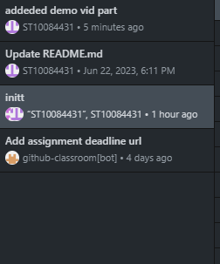

### 

### 

### 

### 

### Kanban

Kanban is an agile project management methodology that focuses on visualising and optimising workflow. It helps teams visualise their work, limit work in progress, and continuously improve their delivery process. Kanban uses a board with columns representing different stages of work, such as "To Do," "In Progress," and "Done." Each work item is represented as a card that moves through the columns as progress is made. This visual representation provides transparency, facilitates collaboration, and enables teams to identify bottlenecks or areas for improvement. By adopting Kanban, teams can enhance their productivity, optimise resource allocation, and ensure a steady flow of work.

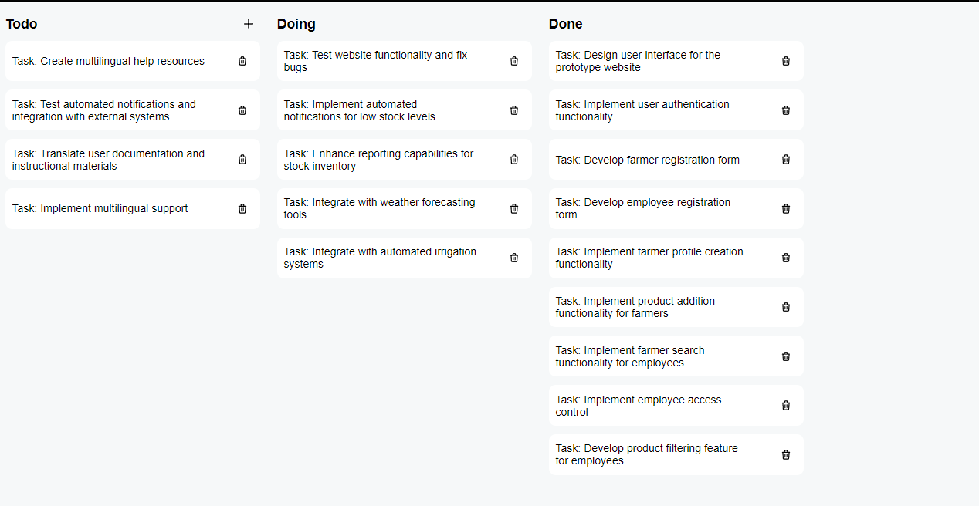

### Docker

Dockerfile is a text file that contains instructions for building a Docker image. Docker is a containerization platform that allows applications to be packaged into isolated, lightweight containers. A Dockerfile specifies the base image, dependencies, environment variables, and commands required to build and configure the container. By using Docker and Dockerfile, developers can create reproducible and portable environments for their applications. This simplifies the deployment process, improves scalability, and enables consistency across different environments. Dockerfile plays a crucial role in automating the creation of Docker images and ensures that the application can be easily deployed and run on any system supporting Docker.

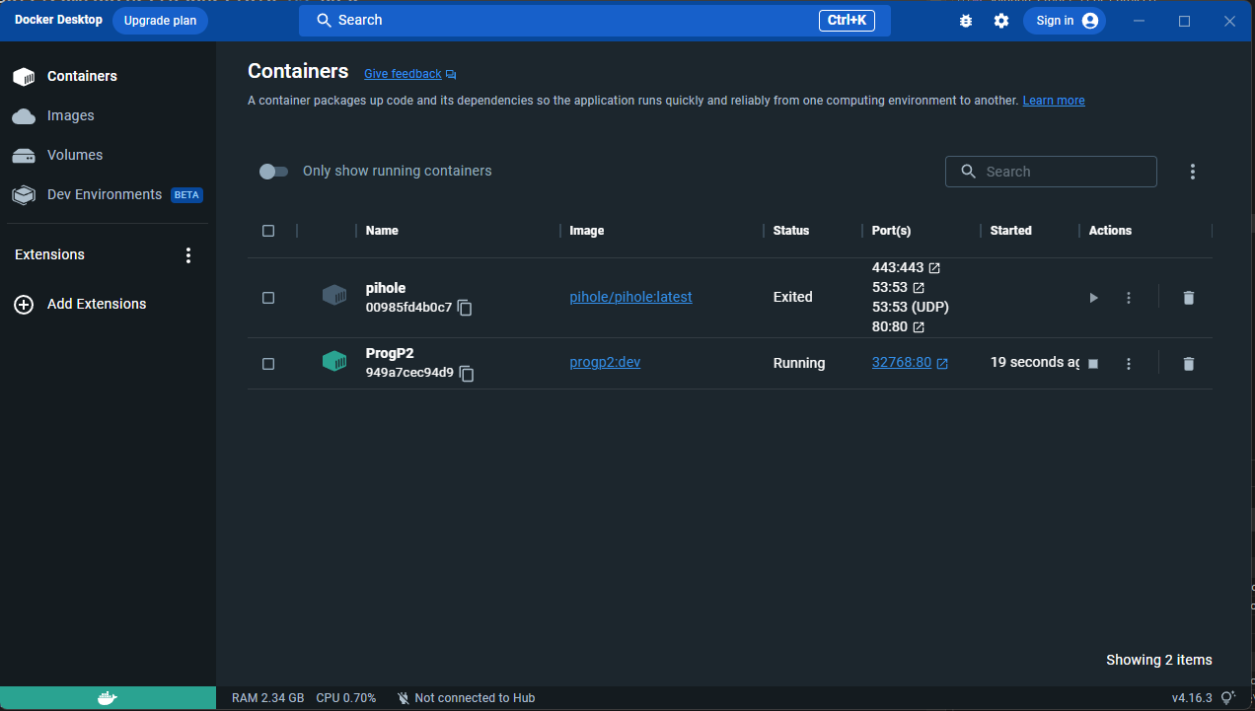

### Unit Testing

Unit testing is a software testing practice that focuses on verifying the correctness of individual units or components of code. It involves writing test cases that target specific functions, methods, or classes to ensure they behave as expected. Unit testing helps identify bugs or issues early in the development process, improves code quality, and promotes maintainability. By automating unit tests, developers can run them frequently, detect regressions, and validate changes made to the codebase. Adopting unit testing as part of the development process contributes to a more robust and reliable application.

### Flow of Control Diagram

A flow of control diagram, also known as a control flow diagram, is a graphical representation that illustrates the sequence and flow of control within a program or system. It depicts the different paths, decisions, and conditions that determine the execution flow of the software. By visualising the control flow, developers can better understand the logic of the program, identify potential issues or bottlenecks, and optimise the code. Flow of control diagrams can be created using various tools or notations, such as flowcharts, UML activity diagrams, or specialised software development environments. Including a flow of control diagram in your documentation can provide a clear and concise representation of the program's control flow.

## 

## Frameworks

### 

### Combining the Zachman Framework and TOGAF

would provide a robust and comprehensive approach to address the various aspects of enterprise architecture and ensure alignment with business objectives. Both frameworks offer unique perspectives and methodologies that complement each other.

The Zachman Framework provides a structured matrix that helps identify and document different viewpoints and artefacts within the enterprise architecture. Its focus on multiple perspectives (What, How, Where, Who, When, and Why) ensures that all key aspects are considered during the development process. By adopting the Zachman Framework, developers and architects can systematically analyse and document requirements, processes, data, and systems, facilitating effective communication and collaboration.

TOGAF, on the other hand, is a widely adopted industry-standard framework that offers a comprehensive methodology for developing and managing enterprise architectures. It provides a structured approach with clear guidelines and best practices across multiple architectural domains (Architecture Vision, Business Architecture, Data Architecture, Application Architecture, and Technology Architecture). By following the TOGAF methodology, developers and architects can ensure consistency, interoperability, and alignment with business goals.

Combining the strengths of the Zachman Framework and TOGAF allows for a holistic and systematic approach to enterprise architecture. The Zachman Framework provides a foundation for identifying and documenting different perspectives, while TOGAF provides a methodology for planning, designing, implementing, and managing enterprise architectures.

By using both frameworks together, the development team can benefit from the clarity, structure, and comprehensive nature of TOGAF, while leveraging the detailed perspectives and documentation provided by the Zachman Framework. This combination promotes effective communication, collaboration, and decision-making throughout the development process, ultimately leading to a well-aligned stock management website that meets the business objectives.(White, 2022)

Overall, the combination of the Zachman Framework and TOGAF provides a powerful approach to enterprise architecture, enabling a comprehensive understanding of the stock management website project and ensuring its successful development and alignment with business goals.

### 

### 

### 

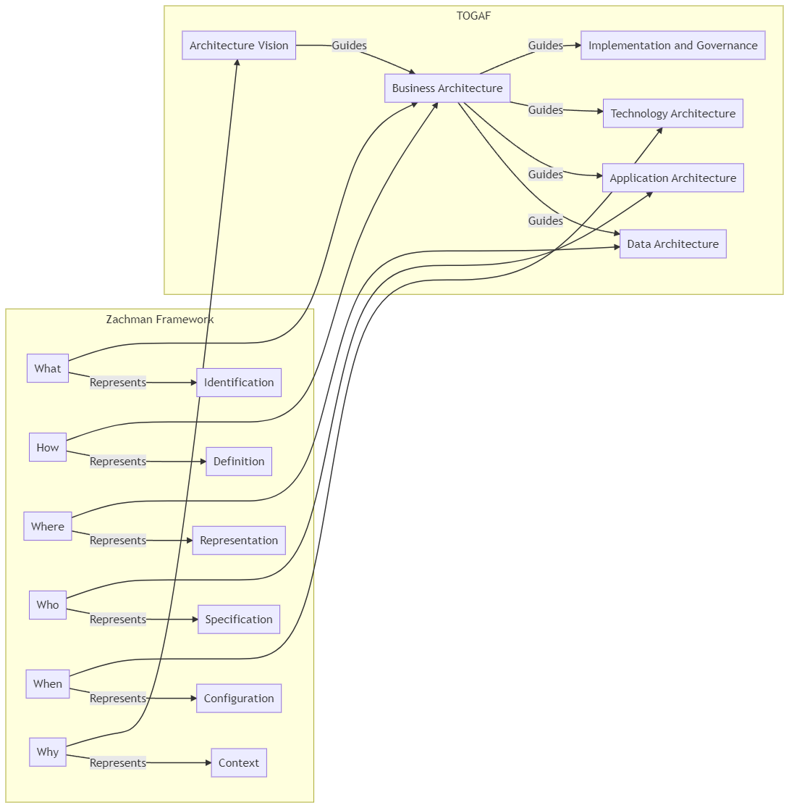

### 

### Zachman Framework

The Zachman Framework is an enterprise architecture framework that provides a structured approach to defining and organising various aspects of an enterprise's architecture. It consists of a 6x2 matrix, with six rows representing different perspectives (What, How, Where, Who, When, and Why) and two columns representing stakeholders (Planner and Owner). Each cell in the matrix represents a specific view or artefact that needs to be considered when designing an enterprise architecture.(Learn.org, 2021)

The Zachman Framework helps organisations align their business objectives with their technology capabilities. It promotes a holistic understanding of the enterprise by considering multiple viewpoints and stakeholders. By using this framework, developers and architects can systematically analyse and document requirements, processes, data, and systems from different perspectives. This comprehensive approach enhances communication, collaboration, and decision-making throughout the development of the stock management website.(Visual-paradigm.com, 2022)

Structured Approach: The Zachman Framework offers a structured approach to defining and organising various aspects of an enterprise's architecture. By using this framework, developers and architects can systematically analyse and document requirements, processes, data, and systems from different perspectives. This structured approach ensures that all essential elements are considered, leading to a more comprehensive and robust solution for the stock management website.

Alignment of Business Objectives: The Zachman Framework helps organisations align their business objectives with their technology capabilities. By mapping business objectives to specific views or artefacts within the framework, developers can ensure that the stock management website addresses the core needs of the business. This alignment ensures that the website's functionalities and features support the organisation's goals and objectives.

Holistic Understanding: The Zachman Framework promotes a holistic understanding of the enterprise by considering multiple viewpoints and stakeholders. With the framework's six rows representing different perspectives (What, How, Where, Who, When, and Why), developers can capture and address the diverse needs and requirements of various stakeholders involved in the stock management website. This comprehensive approach ensures that the website meets the needs of different user groups, departments, and business units.

Enhanced Communication and Collaboration: By using the Zachman Framework, communication and collaboration among stakeholders are greatly improved. The framework provides a common language and structure for discussing and documenting the enterprise architecture. Developers and architects can effectively communicate their ideas, requirements, and design decisions to stakeholders, ensuring that everyone has a shared understanding of the stock management website. This enhanced communication and collaboration streamline the development process, leading to a more efficient and effective implementation.

Informed Decision-Making: The Zachman Framework facilitates informed decision-making throughout the development of the stock management website. The framework's matrix structure helps identify gaps, overlaps, and inconsistencies in the enterprise architecture. By considering various viewpoints and artefacts, developers and architects can make well-informed decisions regarding the design, implementation, and integration of different components. This enables the organisation to make strategic choices that align with its long-term goals and vision.

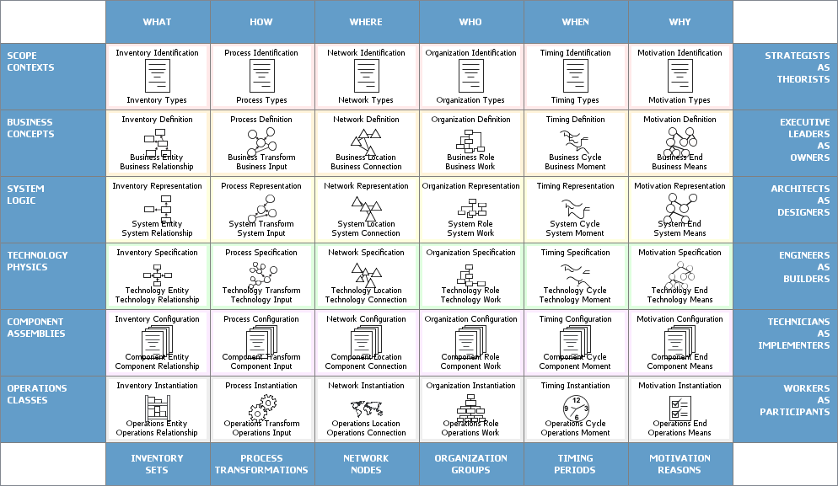

### 

### TOGAF

(The Open Group Architecture Framework): TOGAF is an industry-standard enterprise architecture framework that provides a comprehensive approach for designing, planning, implementing, and managing enterprise architectures. It consists of multiple architectural domains, with each domain representing a specific area of focus. The five main domains in TOGAF are Architecture Vision (A), Business Architecture (B), Data Architecture (C), Application Architecture (D), and Technology Architecture (E).(White, 2022)

TOGAF enables organisations to align their business goals and IT strategy by providing a structured methodology for developing and maintaining enterprise architectures. It provides a set of best practices, guidelines, and a common vocabulary for enterprise architects and developers to ensure consistency and interoperability across different architectural domains.

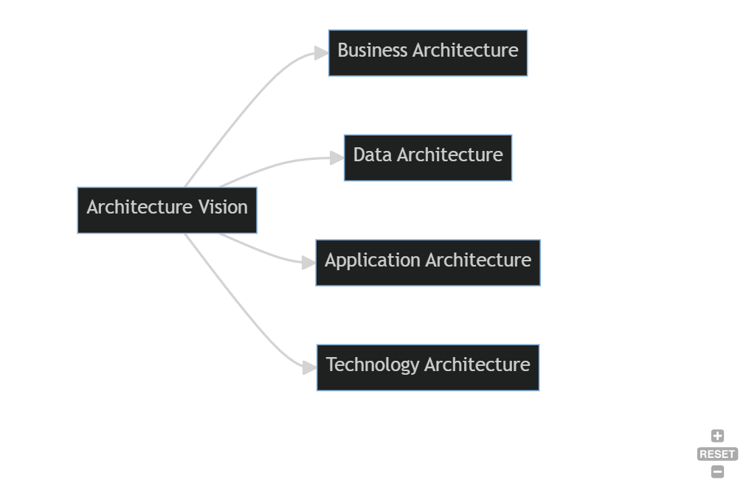

By using frameworks like the Zachman Framework and TOGAF, developers and architects can ensure a structured and systematic approach to designing and managing the enterprise architecture of the stock management website project. These frameworks enhance communication, documentation, and decision-making, ultimately contributing to the successful development and alignment of the website with business objectives.

## Site

### Improvements

Automated Notifications for Low Stock Levels: Implement automated notifications that alert farmers when stock levels of specific mushroom varieties are running low. This proactive feature will help farmers avoid stock shortages and enable them to take timely action, such as initiating reordering or adjusting production plans.

Reports and Analytics on Stock: Enhance the website's reporting capabilities to provide comprehensive insights into stock inventory. Generate detailed reports and analytics that highlight stock levels, turnover rates, popular mushroom varieties, and other relevant metrics. These reports will enable farmers to make data-driven decisions, optimise their inventory management, and identify potential areas for improvement.

Integration with External Systems: Enable seamless integration with external systems commonly used in the mushroom farming industry. For example, integrate with weather forecasting tools to provide weather-related insights for crop planning, or integrate with automated irrigation systems to optimise water usage based on stock inventory and moisture requirements. This integration will streamline operations, enhance efficiency, and provide farmers with a holistic view of their farming processes.

Multilingual Support: Implement multilingual support on the website to accommodate farmers who prefer using languages other than English. Offer language options that align with the target user base, allowing farmers to access and interact with the website in their preferred language. This feature will enhance user experience, facilitate better understanding of the system, and increase overall usability.

User-Friendly Multilingual Documentation: Provide user documentation and help resources in multiple languages to support farmers in using the website effectively. Translate the user manual, tooltips, and other instructional materials into the supported languages, ensuring that farmers can access clear and concise guidance in their native language. This will further enhance usability, reduce learning barriers, and increase user satisfaction.

## 

## 

## User Manual

### Purpose of the User Manual

This user manual provides instructions and guidance on using the Farm Central Stock Management website. It explains the various features available to both farmers and employees, allowing users to effectively manage their farm-related products.

### Target Audience

This user manual is intended for users of the Farm Central Stock Management website. It is designed for both farmers and employees who need assistance in navigating and utilising the website's functionalities.

### System Overview

The Farm Central Stock Management website is a prototype designed to help farmers and employees manage farm-related products. It offers a database of farmers and associated products, allowing users to add new products, view product details, and apply filters for specific information.

### Getting Started

### Accessing the Website

To access the Farm Central Stock Management website, follow these steps:

1. Open your preferred web browser.
2. Enter the website's URL provided by your system administrator.
3. Press Enter or click on the "Go" button.

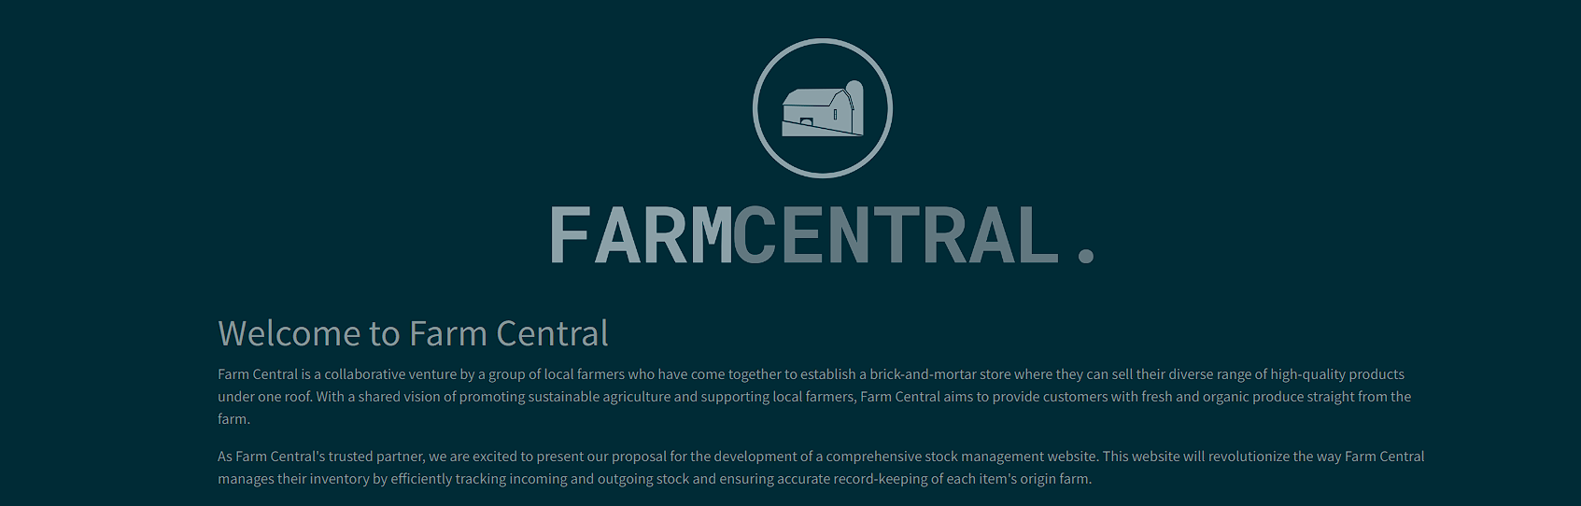

### Login

The Farm Central Stock Management website offers two user roles: farmer and employee. Each user role requires authentication through a login process.

* 1. On the website's home page, click on the " Login" button.
  2. Enter your login credentials, including your username and password.
  3. Click on the "Login" button to access your account.

### Farmer Features

### Adding a New Product

After logging in as a farmer, you can add a new product to your profile in the database by following these steps:

1. On the home page click “products”

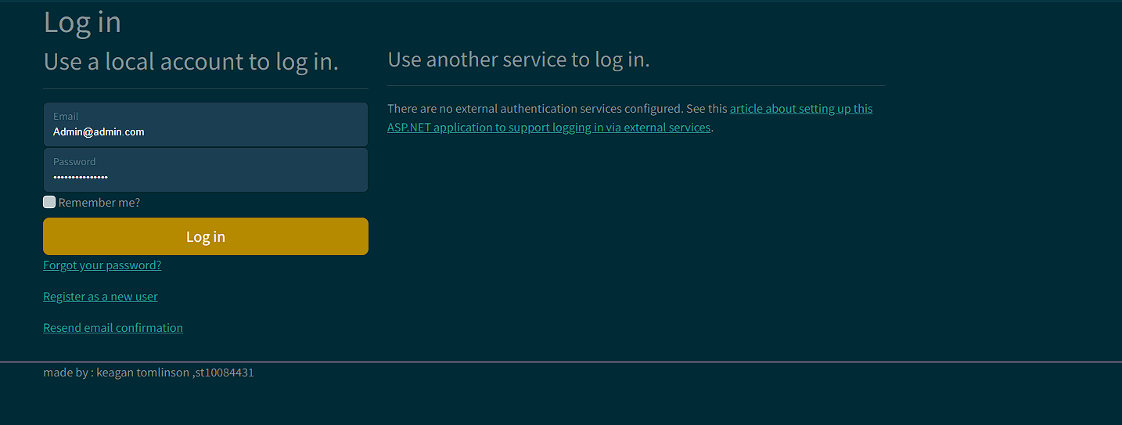

1. On the farmer or navigation menu, locate the "Add Product" option and click on it.

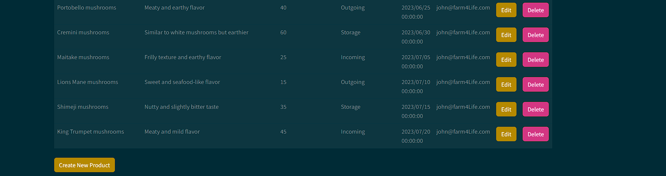

1. Fill in the required information for the new product, including the product name, description, quantity, and any other relevant details.

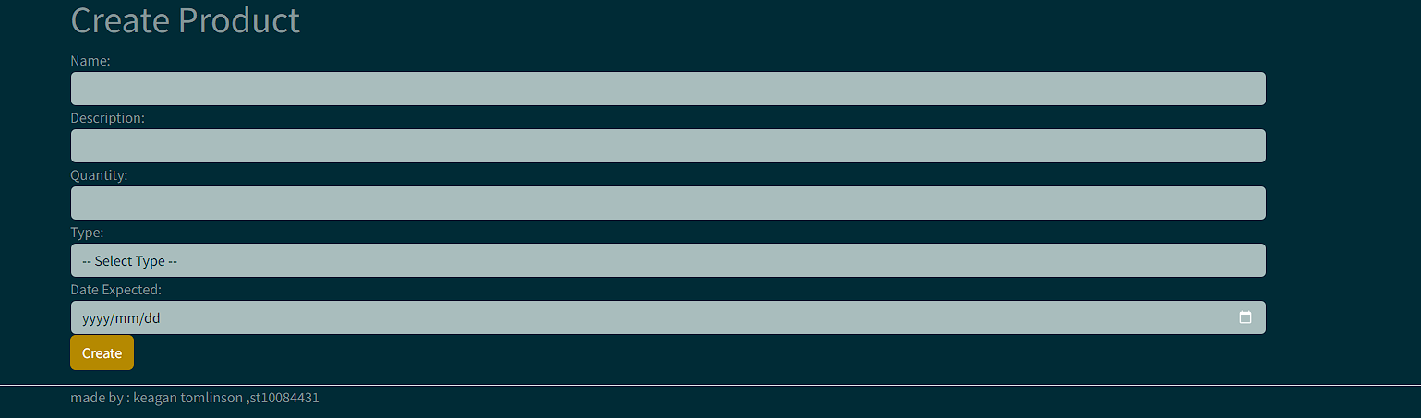

1. Click on the "create” button to add the product to your profile in the database.

### Employee Features

### Adding a New Farmer

As an employee, you can add a new farmer to the database by following these steps:

1. Log in to the Farm Central Stock Management website using your employee credentials.
2. On the employee dashboard or navigation menu, locate the "Register" option and click on it.
3. Enter the necessary details for the new farmer, such as email and password
4. Click on the “register” button to add the farmer to the database.

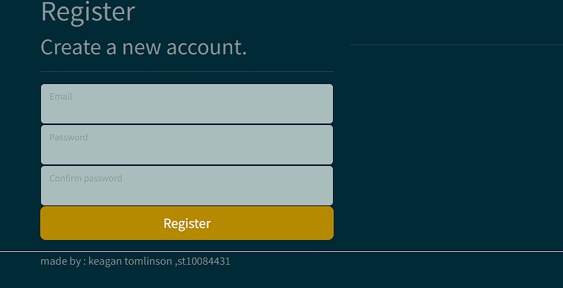

### Viewing Farmer's Products

To view the list of all products supplied by a specific farmer, follow these steps:

1. Log in to the Farm Central Stock Management website using your employee credentials.
2. On the main page , locate the "products" option and click on it.

.

1. The system will display the list of products supplied by the selected farmer, including details such as the product name, quantity, and other relevant information.

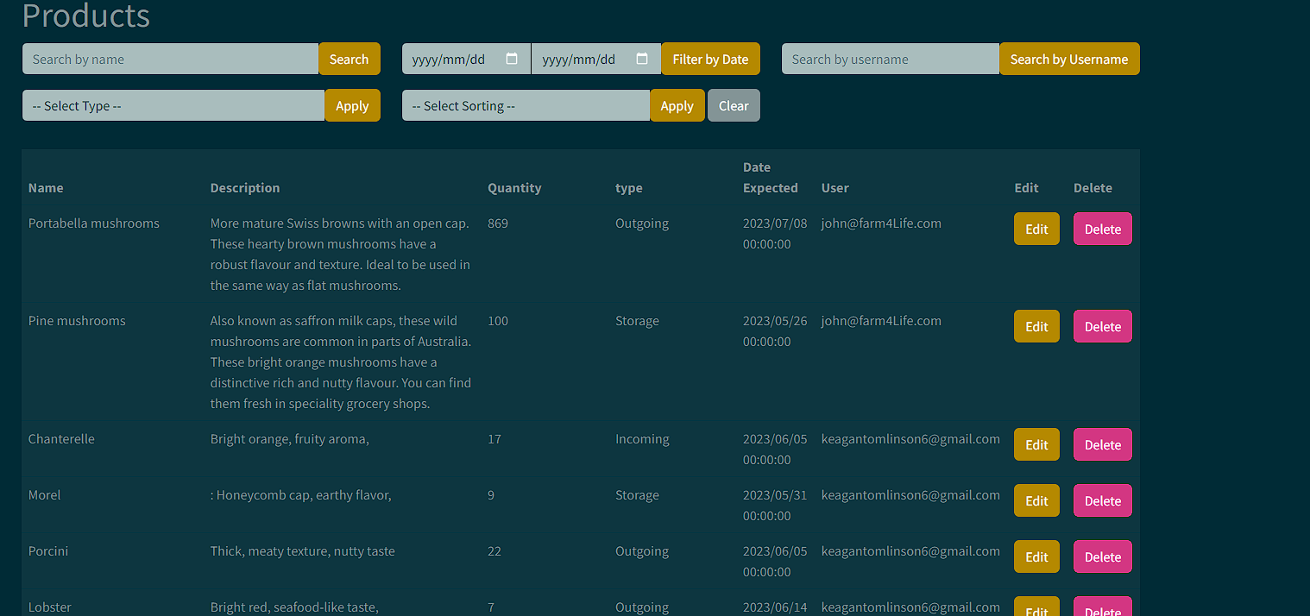

### Filtering Products

To filter the displayed list of products supplied by a specific farmer according to the date range or product type, follow these steps:

1. Log in to the Farm Central Stock Management website using your employee credentials.
2. On the main page , locate the "products" option and click on it.
3. Search the desired farmer from the list of available farmers.
4. On the farmer's details page, locate the filter options.
5. Choose the desired date range or product type filter criteria.
6. Click on the "Apply" button to update the displayed list of products according to the selected filters.

## Troubleshooting

### Common Issues and Solutions

* Issue: Unable to access the website.
  + Solution: Ensure that you have a stable internet connection. If the problem persists, contact your system administrator for assistance.
* Issue: Forgot login credentials.
  + Solution: Use the "Forgot Password" option on the login page to reset your password. If further assistance is needed, contact your system administrator.
* Issue: Encountering errors or unexpected behaviour.
  + Solution: Refresh the webpage and try again. If the issue persists, report the problem to your system administrator, providing any error messages or details you encounter.

## Frequently Asked Questions (FAQ)

Q: Can I add multiple products at once as a farmer? A: Currently, the system only supports adding one product at a time. You can repeat the process to add multiple products.

Q: How can I update my contact information as a farmer? A: Contact your system administrator or customer support to update your contact information in the system.

Q: Can employees view all the farmers' products? A: No, employees can only view the products supplied by specific farmers and not the entire database of products.

Q: Is there a limit to the number of farmers and products in the system? A: The system's capacity may vary based on its configuration. Contact your system administrator to inquire about any limitations.

For more questions or specific inquiries, contact your system administrator or customer support.

## 

## 

## 

## 

## 

## Accountant's Guide - Maximising Accuracy for Increased Income

Dear Accountant,

Welcome to the Farm Central Stock Management website! We understand that accuracy is of utmost importance to you, as it directly impacts the income of each farmer. With our platform, you can achieve greater efficiency and precision in managing farm-related data. Here's how the system can benefit you:

1. Streamlined Data Management: Our user-friendly interface and robust database structure allow you to easily view and verify farmer-specific data. By ensuring accuracy, you contribute to maximising the income of every farmer.
2. Real-Time Insights: With the ability to access real-time data, you can generate comprehensive reports on farmer income, product sales, and financial metrics. This empowers you to make informed decisions and optimise financial strategies.
3. Integrated Systems: Our platform seamlessly integrates with external accounting or financial systems, promoting consistency and reducing the risk of errors or discrepancies. This facilitates smoother operations and reduces the workload on your end.
4. Efficient Communication: Our system facilitates direct communication channels between accountants and farmers, ensuring prompt resolution of any discrepancies or issues. Transparent and efficient communication leads to accurate financial records.

By embracing the Farm Central Stock Management website, you'll enhance your ability to maintain accurate data, optimise financial processes, and contribute to the success of farmers. Embrace this opportunity to streamline your accounting operations and achieve financial excellence.

Should you require any further information or assistance, please don't hesitate to reach out. We are here to support you every step of the way.

## Head of Marketing's Guide - Enhancing Efficiency and Visual Appeal

Dear Head of Marketing,

We are thrilled to present the Farm Central Stock Management website, a platform that aligns perfectly with your bubbly and visually-oriented nature. Our system offers a quick and easy process for farmers, ensuring their experience is seamless and efficient. Here's how our platform caters to your needs:

1. Intuitive User Interface: Our website boasts a visually appealing and user-friendly interface, designed to optimise the user experience for farmers. The streamlined navigation and simplified workflows make the drop-off process a breeze.
2. Visual Enhancements: We understand the importance of aesthetics in marketing. Our system allows you to showcase products with appealing images and provide comprehensive product descriptions, enhancing the overall visual appeal for farmers and customers.
3. Streamlined Workflows: By minimising complex procedures and automating manual tasks, we provide farmers with a hassle-free experience. This efficiency will allow you to focus on creating impactful marketing strategies and driving business growth.
4. Collaborative Feedback: We value your input! Our development team welcomes your suggestions for further enhancing the user experience. By actively participating in the system's development, you can shape the platform to align with your marketing goals.

Embrace the Farm Central Stock Management website to optimise marketing efforts, create a visually captivating experience for farmers, and drive growth for your organisation. We are excited to embark on this journey with you.

If you have any questions or need further information, please feel free to contact us. We are committed to supporting your marketing endeavours.

## Store Manager's Guide - Streamlining Operations for Efficient Training

Dear Store Manager,

We understand the importance of efficiency and training when it comes to implementing new systems. The Farm Central Stock Management website is designed to simplify your training process and streamline operations within the store. Here's how the platform can benefit you:

1. Intuitive User Interface: Our website offers an intuitive and user-friendly interface, making it easier for your store employees to navigate the system. This reduces training time and ensures a smoother transition to the new platform.
2. Comprehensive Training Resources: We provide comprehensive training resources, including tutorials, documentation, and dedicated support channels, to facilitate the training process. These resources will empower you to efficiently train your store employees.
3. Improved Operational Efficiency: By implementing the Farm Central Stock Management website, you'll notice increased efficiency in managing stock and accessing farmer information. This will free up time for you and your staff to focus on other critical store operations.
4. Collaborative Support: Our team is dedicated to supporting you throughout the implementation process. Whether you have questions, require additional training materials, or need assistance, we are just a call or email away.

Embrace the Farm Central Stock Management website to streamline operations, improve training efficiency, and empower your store employees. We are excited to partner with you to achieve operational excellence.

Should you have any questions or need further information, please don't hesitate to reach out. We are here to support you every step of the way.

Feel free to adapt and personalise these guides to suit your specific bidding process and the needs of your audience. Best of luck with your bid, and we hope the committee members recognize the immense value the Farm Central Stock Management website can bring to your organisation.

Reference list

Amazing Enyichi Agu (2023). *How JavaScript’s Asynchronous Operations Work in the Browser*. [online] freeCodeCamp.org. Available at: https://www.freecodecamp.org/news/javascript-asynchronous-operations-in-the-browser/ [Accessed 22 Jun. 2023].

Fortinet. (2022). *What Is Caching Data and How It Works? | Fortinet*. [online] Available at: https://www.fortinet.com/resources/cyberglossary/what-is-caching#:~:text=Caching%20Definition&text=Caching%20Data%20is%20a%20process,they%20can%20be%20accessed%20faster. [Accessed 22 Jun. 2023].

Git-scm.com. (2023). *Git - About Version Control*. [online] Available at: https://git-scm.com/book/en/v2/Getting-Started-About-Version-Control [Accessed 22 Jun. 2023].

jcjiang (2023). *Entity Framework documentation hub*. [online] Microsoft.com. Available at: https://learn.microsoft.com/en-us/ef/ [Accessed 22 Jun. 2023].

Learn.org. (2021). *What Is Database Optimization?* [online] Available at: https://learn.org/articles/What_is_Database_Optimization.html#:~:text=Database%20optimization%20involves%20maximizing%20the,the%20foundation%20of%20performance%20enhancement. [Accessed 22 Jun. 2023].

Visual-paradigm.com. (2022a). *What is Zachman Framework?* [online] Available at: https://www.visual-paradigm.com/guide/enterprise-architecture/what-is-zachman-framework/ [Accessed 22 Jun. 2023].

Visual-paradigm.com. (2022b). *What is Zachman Framework?* [online] Available at: https://www.visual-paradigm.com/guide/enterprise-architecture/what-is-zachman-framework/ [Accessed 22 Jun. 2023].

White, S.K. (2022). *What is TOGAF? An enterprise architecture methodology for business*. [online] CIO. Available at: https://www.cio.com/article/228328/what-is-togaf-an-enterprise-architecture-methodology-for-business.html#:~:text=TOGAF%20is%20an%20enterprise%20architecture,objectives%20around%20enterprise%20software%20development. [Accessed 22 Jun. 2023].

(Zola, 2021), A. (2021). *hashing*. [online] Data Management. Available at: https://www.techtarget.com/searchdatamanagement/definition/hashing#:~:text=Hashing%20is%20the%20process%20of,the%20implementation%20of%20hash%20tables. [Accessed 22 Jun. 2023].