Canadian Artificial Intelligence Policy Proposal

Prepared by:
[Team Name]

Team Members:
[Names]

Prepared for: Government of Canada
Innovation, Science and Economic Development Canada (ISED)
Treasury Board of Canada Secretariat

Date:
[Insert Date]

Email: “fake email” Phone Number: “fake number”

1.0 Executive Summary

2.0 Problem Definition

Artificial intelligence has emerged as a defining technology of the 21st century, reshaping global economic competition, national security, and productivity growth. Countries such as the United States and China are investing heavily across the full AI value chain, from research and infrastructure to commercialization and large-scale deployment, creating an increasingly competitive geopolitical landscape.

Within this context, Canada is widely recognized as a global leader in AI research and talent. Canada ranks first in the G7 for AI talent concentration growth, with an average annual increase of 38% since 2018, and holds approximately 10% of the world’s top-tier AI researchers []. Canadian researchers have also played a foundational role in the development of modern AI, including deep learning breakthroughs recognized by the Turing Award. In addition, Canada consistently ranks first in the G7 for AI-related publications per capita, demonstrating sustained research excellence. However, this strength is not translating into economic leadership. Despite ranking fifth globally in AI capacity, Canada lags behind peer nations in commercialization, adoption, and industrial deployment []. Industry stakeholders consistently identify high compute costs as a major barrier to AI adoption, and Canada remains behind other G7 nations in high-performance computing infrastructure, an essential component for scaling AI innovation [].
Moreover, Canada’s position in global AI ecosystems highlights this disconnect. While it excels in research output, it lacks representation among the world’s leading AI commercialization hubs. Evidence also suggests weaker performance in patent generation and product development, indicating challenges in translating research into market-ready solutions. This imbalance, strong upstream research capacity but weak downstream commercialization, represents the central challenge for Canada’s AI strategy.
***Include figure for summary supporting above claims***
***A conceptual diagram showing Canada’s strength in research vs. weakness in adoption/commercialization***
This leads to the central research question guiding this proposal:
“What policy interventions would most efficiently close Canada’s research-to-commercialization gap in AI?”

3.0 Key Findings from Data Analysis

3.1 Overview of Key Findings

Our analysis integrates multiple datasets and policy indicators to evaluate Canada’s position across the AI value chain. Canada’s strengths and weaknesses were observed from various perspectives, including Policy & Governance and Responsible AI, Research & Development and Science & Medicine, as well as Economy. The findings reveal a consistent pattern: Canada performs strongly in upstream capabilities (research and talent) but underperforms in downstream outcomes (adoption, commercialization, and economic impact).

3.2 Key Findings from Policy & Governance and Responsible AI Perspective
Canada performs strongly in Government Strategy, Operating Environment, and responsible AI research, indicating a solid institutional and intellectual foundation. However, Canada remains behind leading countries such as the United States, United Kingdom, Germany, and France in overall governance competitiveness. The Policy & Governance analysis found that Canada has comparatively low legislative activity and more limited public-sector AI procurement, suggesting that policy intent has not yet translated into large-scale implementation. At the same time, the Responsible AI analysis ranked Canada only 7th of 13 countries in composite RAI performance, despite ranking 5th in RAI research output. Canada also participates in only 4 of 9 major governance frameworks tracked in the analysis, with a weighted policy score of 6.0 out of 14.0, placing it well behind countries such as Germany and France, which benefit from broader participation in binding European governance frameworks.
Compared with leading countries, Canada’s performance is uneven across dimensions. The United States demonstrates strong implementation through large-scale procurement and deployment, while Germany and France combine moderate research output with stronger regulatory leadership and broader participation in international governance mechanisms. The United Kingdom appears more balanced, performing well across governance, research, and implementation. These comparisons suggest that global leaders distinguish themselves not only through strong strategies or research institutions, but through visible, measurable, and coordinated execution of policy and responsible AI practices. Canada’s main gap is therefore not the absence of strategy, but the limited conversion of research and policy capacity into governance influence, public trust, and large-scale deployment outcomes.
***Figure 2:***
Comparative AI competitiveness ranking (Canada vs. US, China, EU, etc.)

3.3 Key Findings from Research & Development and Science & Medicine Perspective
Canada’s strongest performance appears in research and talent development, but these strengths are not translating proportionally into development output or translational impact. Canada ranks 1st in the G7 for AI talent concentration growth, with an average annual growth rate of 38% since 2018, and holds approximately 10% of the world’s top 0.5% AI researchers, ranking 3rd globally on this measure. Canada also ranks 1st in the G7 for AI-related papers per capita and produced more than 6,000 AI-related publications in 2022. These strengths have been supported by CIFAR, the three National AI Institutes, and the Canada CIFAR AI Chairs program, which together form a globally recognized research ecosystem.
At the same time, Canada’s scores in the broader innovation pipeline are much weaker. In the country-level AI index analysis, Canada’s strongest scores are in Infrastructure (77) and Government Strategy (100), but its scores in Research (31), Development (26), and especially Commercial (15) are much lower. This suggests that Canada has built strong enabling conditions for AI, but not a proportionate level of downstream innovation output. The R&D analysis also notes that Canada has produced relatively few notable AI models and remains weaker in patent-rich product development and commercialization than peer countries. In the Science & Medicine analysis, Canada benefits from strong upstream conditions for AI-enabled research, but lags leading countries in development and real-world translational capacity. The overall pattern is that Canada performs well in generating knowledge, but less well in converting that knowledge into deployable systems, products, and sector-specific innovation—especially in areas such as health and healthcare where translation requires more compute, stronger development infrastructure, and closer research-to-industry pathways.
The comparison with leading countries reinforces this point. The United States combines strong research with dominant model development and commercialization capacity. China pairs large-scale development and infrastructure with stronger industrial execution. Canada, by contrast, remains more academic in orientation. Its challenge is not whether it has enough AI research excellence, but whether it can move more projects through the mid-to-late innovation stages—validation, prototyping, pilot deployment, and commercialization. This research-to-translation gap is especially important in science and medicine, where AI’s value depends not only on scientific discovery, but on whether those discoveries become usable clinical, industrial, or public-sector tools.
***Figure 3:***

3.4 Key Findings from the Economy Perspective
The economy-focused analysis shows that Canada has built a substantial AI economic base, but still trails the global leaders in adoption, scale, and commercialization intensity. Canada has more than 140,000 active AI professionals, over 670 AI startups with at least one USD $1M+ investment in the last five years, and more than $8.6B in venture capital invested in Canadian AI companies in 2022, representing roughly 30% of all Canadian VC activity. Canada also ranks 5th globally on the Stanford AI Vibrancy Index and 5th out of 62 countries for AI capacity. These are strong indicators that Canada has a credible AI economy with real depth in talent, startups, and research-industry partnerships.
However, the economic data also highlights a clear execution gap. Canadian businesses have been relatively slow to adopt AI solutions compared with international peers, and this is particularly problematic because business adoption is what converts national AI capacity into broad-based productivity growth. The cluster analysis also shows that countries outperforming Canada economically include the United States, China, and the European Union, indicating that Canada is not yet in the top commercialization tier. The same materials note that while Canada has seen strong patent growth, infrastructure constraints and adoption gaps remain major barriers. The federal AI strategy itself identifies infrastructure gaps and technological sovereignty as key challenges to scaling AI adoption. Altogether, the economic evidence suggests that Canada has the ingredients of a strong AI economy, but not yet the level of demand-side adoption, scaled deployment, and firm-level execution seen in the leading countries.
The economic comparison is especially important because it connects directly to national competitiveness. The United States leads through scale, deep capital markets, and widespread deployment. China leads through industrial integration and state-supported scaling. The European Union, while less dominant in frontier model development, benefits from larger coordinated markets and stronger industrial clusters. Canada’s relative weakness lies in the final step: converting AI talent and research into widespread productivity gains across the economy. This is why the central challenge across all three analytical perspectives is the same: Canada’s AI strategy has been highly successful at building supply, but less successful at generating translation and demand.

***Figure 4:***

4.0 Policy Recommendations
4.1 Overview

4.2 Recommendation 1: National Responsible AI Governance and Adoption Program
4.2.1 Overview of Recommendation 1
This section outlines the implementation of the National Responsible AI Governance and Adoption Program over a 1–3 year horizon. The program directly addresses the gaps identified in Sections 2 and 3, including limited legislative activity, low public-sector AI deployment, weak international governance participation, and low public AI literacy.
4.2.2 Overview of Recommendation 1

 | Timeline | Cost | Responsible Agencies | Success  Metrics
Recommendation 1 | 1-3 years | $250-450M | ISED, Treasury Board, Global Affairs, CIFAR | - legislative activity  - AI procurement  - AI literacy ranking
Recommendation 2 | 1-2 years | $18-40M each year | Mitacs, ISED, NRC-IRAP, ESDC | - Conversion of research into patents/products  - Industry retention rates
Recommendation 3 | 5 years (Launch 2027) | ~$2B over 5 years | Finance Canada, ISED, BDC | - AI adoption from 12% to 25%  - Sector-specific adoption growth

1 Executive Summary (0.5 page)
- the problem
- top findings
- three recommendations
- projected impact on Canada's AI competitiveness score

2 Problem Definition (1 page)
- Start broad (global AI race, geopolitical context)
- Narrow to Canada's specific gap:
  - Strong research
  - weak translation, adoption, and commercialization
Canada's genuine strengths (establish credibility before the gap):
  - #1 in G7 for AI talent concentration growth — 38% average annual growth since 2018 (CIFAR, 2023)
  - #3 globally for top-tier AI researchers — holds 10% of the world's most elite researchers (CIFAR, 2023)
  - #1 in G7 for AI-related papers per capita every year since 2019 (CIFAR, 2023)
  - Turing Award — Bengio, Hinton, LeCun — Canada's researchers literally invented deep learning
The gap that follows:
- 5th globally in AI capacity (Deloitte) — but Canadian businesses slow to adopt vs. international peers (CIFAR, 2023)
- Only 3 of the top 25 global AI clusters are in the EU/Canada combined — and Canada holds none of the top 25 (EU Commission)
- 45% of Canadian AI firms cite high compute cost as the top barrier to growth (ISED, 2024)
- Canada is lagging all G7 nations in HPC resources — the infrastructure that converts research into products (ISED, 2024)
- ICTC finding: Phase 1 left Canada "relatively weaker in patent-rich, product development and commercialization"
- Include one figure justifying this -
- Propose a research question for the next section:
  - “What policy interventions would most efficiently close Canada's research-to-commercialization gap in AI?”

3 Key Findings from Data Analysis (2.5 pages)
- 3 figures:
  - A comparative ranking figure (overall AI competitiveness scores across countries)
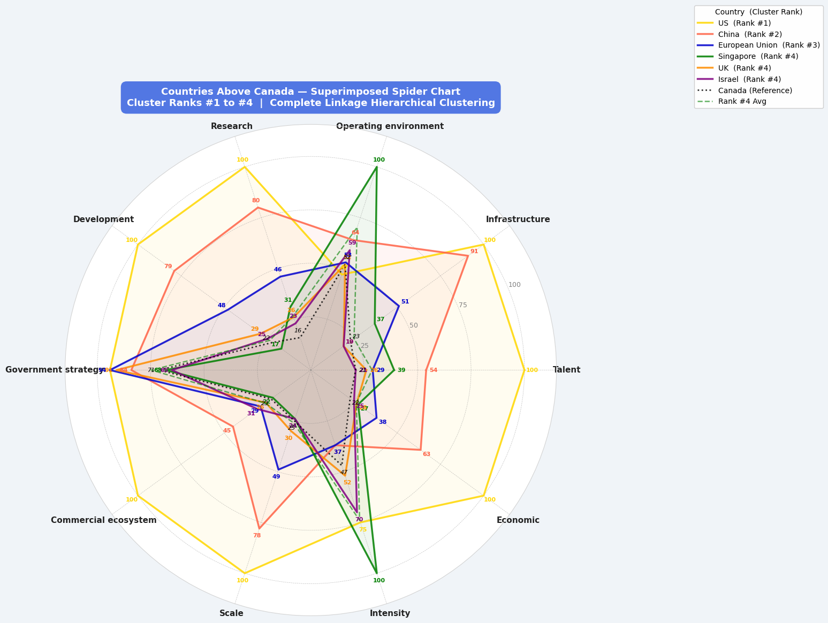
Figure 1: Canada's AI R&D profile compared to leading nations across key innovation indicators (publications, citations, patents, notable models). Data normalized to 0–100 scale.
  - A scatter or correlation plot showing the relationship between a key driver (e.g., R&D spending as % of GDP, or patent output) and AI competitiveness
  - An adoption/commercialization gap figure (e.g., the Statistics Canada business adoption numbers vs. peer countries)

3.1 Key Findings from Part 1
The combined analysis of Policy & Governance and Responsible AI (RAI) performance reveals a consistent pattern in Canada’s AI ecosystem. Canada performs strongly in Government Strategy, Operating Environment, and research output, indicating a solid institutional and intellectual foundation. However, Canada ranks below leading countries such as the United States, the United Kingdom, Germany, and France in overall competitiveness.
From the Policy & Governance analysis, Canada shows relatively low levels of legislative activity and public-sector AI procurement, suggesting a limited scale of policy implementation. At the same time, the Responsible AI analysis indicates that Canada ranks only 7th in composite RAI performance and demonstrates a significant gap in policy engagement and public AI literacy.
A key structural issue is that Canada produces strong AI and RAI research but does not fully translate this into governance leadership, international influence, or large-scale implementation.
3.2 Interpretation of Canada’s Position
Compared to leading countries, Canada’s performance is uneven across dimensions. The United States demonstrates strong implementation through procurement and large-scale deployment. European countries such as Germany and France achieve higher rankings through participation in binding governance frameworks and regulatory leadership. The United Kingdom shows a balanced approach across governance, research, and implementation.
These comparisons highlight that global leaders distinguish themselves not only through strong strategies or research but through visible, large-scale, and coordinated execution of policy and responsible AI practices.
3.3 Alignment with Existing Canadian Frameworks
Canada has strong foundational strategies, including:
- The Canadian Sovereign AI Compute Strategy (2024)
- The AI Strategy for the Federal Public Service (2025–2027)
- The Pan-Canadian AI Strategy (CIFAR)
These frameworks emphasize capacity building, responsible AI, and institutional readiness. However, the results from Part 1 indicate that these frameworks are not yet fully reflected in measurable outcomes such as legislative activity, procurement scale, global governance participation, or public literacy.
The main challenge is therefore not the absence of strategy, but the lack of translation from strategy into visible and measurable outcomes.
3.4 Strategic Proposal: National Responsible AI Governance and Adoption Program
To address these gaps, this report proposes a unified national initiative: the National Responsible AI Governance and Adoption Program.
This program integrates policy, governance, and responsible AI into a single coordinated effort aimed at strengthening Canada’s global position.
The proposal focuses on three core objectives:
First, to scale policy implementation through increased legislative activity and public-sector AI adoption. Canada’s current policy outputs are limited relative to leading countries, and expanding both regulation and procurement is necessary to improve visibility and impact.
Second, to strengthen Canada’s position in international AI governance. Canada currently participates in a limited number of global frameworks compared to leading countries. Increasing participation in international agreements and regulatory initiatives would enhance Canada’s influence and policy credibility.
Third, to embed responsible AI practices and improve public AI literacy. Canada’s low ranking in AI literacy highlights a critical gap in public understanding and trust. Expanding education, workforce training, and responsible AI standards is essential for long-term competitiveness.
3.5 Summary
Overall, Canada’s AI ecosystem is characterized by strong strategy and research capacity, but weaker execution, governance visibility, and public engagement. The proposed integrated program addresses these gaps by combining policy implementation, international governance leadership, and responsible AI adoption into a unified national strategy.
This approach enables Canada to convert its existing strengths into measurable improvements in global AI competitiveness.

4 Strategic Recommendations (4 pages)
For each
- the status quo gap it addresses
- the proposed intervention
- implementation details (required all 4 @ rubric) - one supporting figure or table
  - cost estimate
  - responsible agency
  - timeline
  - success metric

4.1 Overview
This section outlines the implementation of the National Responsible AI Governance and Adoption Program over a 1–3 year horizon. The program directly addresses the gaps identified in Part 1, including limited legislative activity, low public-sector AI deployment, weak international governance participation, and low public AI literacy.

4.2 Recommendation: National Responsible AI Governance and Adoption Program
Description:
Establish a coordinated national program that integrates AI policy expansion, public-sector AI deployment, international governance participation, and responsible AI education.

Rationale
The Part 1 analysis shows that Canada’s primary challenge is not strategy, but implementation and visibility. Canada ranks strongly in Government Strategy and research output but lags in legislative activity, procurement, and governance influence.
At the same time, the Responsible AI analysis highlights gaps in policy engagement and public literacy. Together, these findings indicate a structural disconnect between Canada’s capabilities and its global positioning.

Key Components
1. Policy and Legislative Expansion
- Develop sector-specific AI regulations
- Increase legislative engagement and policy visibility
2. Public-Sector AI Deployment
- Expand procurement and deployment of AI solutions
- Scale pilot programs into operational systems
3. International Governance Participation
- Increase participation in global AI frameworks
- Strengthen Canada’s role in OECD, UN, and G7 AI initiatives
4. Responsible AI Literacy and Workforce Development
- Launch national AI literacy programs
- Expand training for public servants and the workforce

Estimated Cost
$250–450 million over 1–3 years.
The proposed $250–450 million envelope is modest relative to Canada's established pattern of AI investment and is grounded in direct precedent. Canada's Budget 2024 alone committed a $2.4 billion package to secure Canada's AI advantage [1], including $100 million for the NRC AI Assist Program, $50 million for workforce solutions, and $50 million for the Canadian AI Safety Institute. [2] Earlier phases of the Pan-Canadian AI Strategy offer further anchors: the second phase allocated $160 million for talent and research, $48 million for knowledge mobilization, and $40 million for computing capacity [3][4] — all within a similar multi-year, multi-component structure to what is proposed here.
International comparisons further validate the range. In the UK, the government committed £2 billion for AI from 2026–27 to 2029–30, including a 20-fold expansion of its AI research resource and sovereign AI capabilities [5]; at an earlier, more comparable stage, its AI Research Resource program received £300 million in initial funding [6] — a close analogue to this proposal. The $250–450 million figure intentionally excludes infrastructure-heavy spending (such as Canada's $2 billion Sovereign Compute Strategy) and focuses exclusively on the governance, procurement, international participation, and literacy gaps identified in Part 1, making it a targeted and fiscally defensible investment.

Timeline
1–3 years (phased implementation)

Responsible Entities
- Innovation, Science and Economic Development Canada (ISED)
- Treasury Board of Canada Secretariat
- Global Affairs Canada
- CIFAR and research institutions

Success Metrics
- Increase in the number of AI-related legislative frameworks
- Increase in AI procurement value and number of deployments
- Increase in the number of international AI governance frameworks joined
- Improvement in Canada’s AI literacy ranking (target: move into top 25 globally)

4.3 Overall Impact
This integrated program directly addresses both Policy & Governance and Responsible AI gaps:
- strengthens policy implementation and visibility
- increases international influence
- improves public trust and literacy
- aligns research leadership with governance outcomes
Together, these actions position Canada to move from a strong foundational player to a global leader in responsible AI governance.

4.1 Translational AI R&D Mission Stream

4.1.1 Current Status Quo
The first phase of the Pan-Canadian AI Strategy was built mainly around research, talent, national institutes, and societal implications. The ICTC report says this worked well for early-stage innovation, but it left Canada relatively weaker in “patent-rich, product development and commercialization.” The 2020 impact report similarly says Canada’s ecosystem serves to translate research into applications, but also makes clear that more work is needed as global competitors scale both R&D and commercialization.

4.1.2 Proposed Intervention
Create a dedicated Translational AI R&D Mission Stream under the renewed Pan-Canadian AI Strategy, focused on 3–4 nationally strategic domains where Canada already has research credibility but weak translation. A strong shortlist would be (note: health and clinical care is a top option, others were found with quick searches):
- AI for health and clinical care
- AI for drug discovery / life sciences
- AI for advanced materials / clean technology
- AI for public-sector science and decision support
The health/life-sciences component fits especially well because the existing strategy already highlights research in drug discovery and machine learning for health through the Canada CIFAR AI Chairs and national institutes. The Federal AI Strategy also explicitly says AI can accelerate scientific discovery, and the Treasury Board expects departments to identify high-value use cases, support data readiness, and ensure access to compute and common infrastructure.

4.1.3 Implementation Details
The program should fund projects at TRL (technology readiness level) 4–8 rather than only early-stage basic research. Eligible consortia should include at least:
- one university or national AI institute,
- one industry or startup partner,
- and, for the health stream, one health-system or hospital partner.
For the healthcare stream, the program should require a translational plan that includes:
- dataset access or interoperability plan,
- validation and evaluation plan,
- deployment setting,
- procurement or adoption pathway,
- and IP/commercialization strategy.

4.1.4 Cost, Timeline & Metrics
A credible first phase would be $75M–$150M per year for 3 years, carved partly from a future renewal envelope of the Pan-Canadian AI Strategy or from an incremental ISED appropriation. Relative to the federal budget already documented, that is still small. Mitacs alone currently receives over $166M in federal support annually and that total federal expenses in 2024–25 were $547.3B.
Responsible Agencies
- ISED as lead
- CIFAR and the three National AI Institutes as delivery partners
- Health Canada / CIHR / NRC for the health and translational-science streams
- potentially Treasury Board Secretariat where federal science departments are involved
Timeline
- 6–9 months: design and consultation
- Year 1: first call for proposals
- Years 2–3: pilot portfolio and evaluation
- End of Year 3: renew / scale successful streams
Success Metrics
Use 3 metrics, but pick one as the official success metric for the assignment:
- official metric: number of translational AI projects reaching pilot deployment or regulatory validation
- secondary metrics: AI patents filed, number of Canadian-owned models/products launched, follow-on private investment raised

4.2 Sovereign Compute for Sector-Targeted R&D

4.2.1 Current Status Quo
The Federal AI Strategy explicitly says the Canadian Sovereign AI Compute Strategy invests in public and commercial computing infrastructure to support the Canadian AI ecosystem and safeguard Canadian data and IP. Treasury Board’s strategy also says departments should ensure access to the infrastructure and compute needed for AI research and development.

4.2.2 Proposed Intervention
Add a Sectoral Compute Access and Model Development Window to the Sovereign AI Compute Strategy. Instead of treating compute primarily as generic infrastructure, reserve a portion of national compute capacity for projects in strategic sectors with clear translational potential:
- medical imaging and clinical models,
- drug discovery and multimodal biomedical models,
- public-interest science models,
- advanced manufacturing and natural resources.

4.2.3 Implementation Details
Create a competitive access process with 3 tiers:
- Tier 1: university and institute-led model research
- Tier 2: startup/scale-up product development
- Tier 3: translational consortia in high-priority sectors such as health
Each award should bundle:
- compute allocation,
- cloud credits or public-HPC access,
- engineering support,
- and commercialization milestones.
For healthcare, require that funded projects use data-governance and interoperability standards aligned with federal digital and privacy policies, since Treasury Board stresses data readiness, common infrastructure, and responsible AI adoption.

4.2.4 Cost, Timeline & Metrics
Rather than proposing an entirely new billion-dollar line item, propose reallocating 5%–10% of the program’s effective annual deployment toward sector-targeted access and model-development support. For a simpler figure in the report, propose $50M–$100M per year within the broader compute envelope for a 3-year pilot.
Responsible Agencies
- ISED as lead
- compute infrastructure administrators / national research compute partners
- CIFAR + national AI institutes
- Health Canada / CIHR / NRC for health-specific windows
Timeline
- 6 months: define sectoral access criteria
- 12 months: first cohort launched
- 24 months: evaluation against output metrics
- 36 months: scale-up if effective
Success Metrics
Official metric:
- number of Canadian-developed AI models, prototypes, or products produced using sovereign compute and advanced to pilot/commercial stage
Other helpful metrics:
- compute utilization by Canadian startups and researchers,
- patents or publications generated per compute allocation,
- number of health-AI solutions validated or deployed.

4.3 Mitacs–IRAP AI Talent Platform

4.3.1 Current Status Quo
Mitacs already connects post-secondary researchers with firms through paid research placements. In 2024-25, it leveraged more than $166M in federal support into over $345M in R&D investment and delivered 20,885 internships through 7,202 projects []. A Statistics Canada result says participating firms saw average gains of 9% in revenue, 16% in sales, and 11% in labour productivity by the third year after support []. At the same time, several weaknesses highly relevant to AI strategy were identified: it is too broad and not AI-specific, SME absorptive capacity is weak, review times are too slow for AI, retention is not guaranteed, and IP rules are decentralized.

4.3.2 Proposed Intervention
Create a Mitacs–IRAP AI Translational Talent Program, consisting of:
- an AI-specific Accelerate stream,
- an AI readiness advisory service for SMEs,
- a fast-track 2-week review pathway,
- post-placement retention incentives,
- and a standardized AI IP framework.
This option directly targets the core weaknesses identified in the R&D analysis:
- low notable AI model production,
- weak commercialization,
- industry-academia gap,
- low patent output,
- and talent-retention risk.
It also fits broader comparative evidence. The OECD examples highlight that leading countries often use test beds, advisory support, compute access, and commercialization-oriented intermediaries to help firms adopt AI and scale. The UK’s Digital Catapult is a good example of tailored advisory support and access to infrastructure for firms that lack internal capacity.

4.3.3 Implementation Details
Create a dedicated AI stream within Mitacs Accelerate, focused on:
- AI model development
- Healthcare AI applications (diagnostics, clinical tools)
- Industry-driven R&D projects
Implementation Steps
- Define AI as a priority funding category within Mitacs
- Require:
  - 1 academic partner
  - 1 industry partner
- Prioritize projects at TRL 4–8

4.3.4 Cost, Timeline & Metrics
- AI-specific Accelerate stream: $10M–$25M/year
- AI readiness advisory service: $3M–$5M/year
- Fast-track review: $200K–$400K/year
- Post-placement retention incentives: $5M–$10M/year
- Standardized IP framework: $500K–$1M one-time
Total: $18M–$40M/year plus a one-time $500K–$1M. This would represent roughly an 11%–24% increase over current annual federal support for Mitacs and less than 0.01% of the total federal budget.
Responsible Agencies
- Mitacs
- ISED
- NRC-IRAP
- ESDC for retention incentives
- CIFAR as strategic partner for AI mission alignment
- Universities Canada and IP partners for the IP framework
Timeline
- 6–12 months for fast-track review,
- 1 year for SME advisory pilots,
- 1–2 years for AI-specific placements and retention incentives,
- 1–2 years for IP framework development and initial adoption.
Success Metrics
- Percentage of Mitacs AI placements that convert into deployed products, patents, or permanent hires within 12 months

Potential summary paragraph introducing recommendations (will change once all recommendations are finalized):
“Canada’s current AI strategy architecture has been highly successful in building enabling conditions for AI — including research talent, national institutes, public investment, and policy leadership — but less successful in converting those strengths into frontier model development, patents, and large-scale commercialization. The evidence from our quantitative analysis and the uploaded policy reports suggests that the core challenge is not whether Canada has an AI strategy, but whether existing strategies are sufficiently connected to late-stage translational R&D and commercialization pathways. We therefore recommend strengthening Canada’s AI strategy not by replacing the Pan-Canadian AI Strategy, the Sovereign AI Compute Strategy, or federal AI adoption frameworks, but by linking them more tightly through mission-driven translational R&D funding, sector-targeted compute access, and a more specialized Mitacs–IRAP collaboration platform.”

https://www.ontario.ca/document/report-intellectual-property-in-ontarios-innovation-ecosystem

4.4 National AI Adoption & Productivity Fund

4.4.1 Current Status Quo
Canada has world-class AI talent and startups, but official business adoption is still shallow. Statistics Canada reported that 12.2% of businesses had used AI over the previous 12 months in Q2 2025, and only 14.5% planned to use it over the next 12 months in Q3 2025. Adoption is especially weak in sectors that matter for broad productivity, including transportation and warehousing, where only 6.6% of firms planned AI use over the next year. Deloitte’s 2025 Canada report says Canada is falling behind in adoption and risks missing a 5% to 8% GDP boost over the next decade if it does not act.

4.4.2 Proposed improvement
Create a National AI Adoption and Productivity Fund focused on SMEs and mid-market firms in logistics, manufacturing, construction, health, and agriculture. The fund should combine:
- A temporary AI investment tax credit for software integration, model deployment, workflow redesign, and worker training;
- AI vouchers for SMEs to buy implementation support;
- Sector-specific playbooks and demonstration projects;
- A requirement that funded projects show measurable productivity or quality gains within 12–18 months.
This directly targets the execution gap that IBM identified between AI ambition and scaled ROI.

4.4.3 Implementation Details
Finance Canada and ISED would launch a 5-year refundable tax credit for qualified AI adoption spending, paired with a voucher stream administered through BDC, regional development agencies, and the National AI Institutes. Priority should go to firms adopting AI into core operations, not only back-office chatbots. Use the 2025 SME AI adoption blueprint as the policy chassis, because it already frames SME adoption as a G7 productivity issue and notes that uptake is concentrated in a few knowledge-intensive sectors while transportation, manufacturing, and agriculture lag.

4.4.4 Cost, Timeline & Metrics
About C$2.0B over 5 years: roughly C$1.2B for the tax credit, C$500M for SME vouchers and implementation grants, and C$300M for sector demonstrators and measurement capacity. This would be a larger, more adoption-focused complement to the federal AI Compute Access Fund and existing SME-oriented efforts.
Responsible Agencies
Finance Canada, ISED, BDC, CRA, regional development agencies, NRC-IRAP, National AI Institutes, provincial economic ministries.
Timeline
Design in 2026, launch in Budget 2027, first claims/grants within 9 months, mid-course review at 24 months.
Success Metrics
Raise official business AI use from 12.2% to 20% by 2028 and 25% by 2030; double AI use in transportation and warehousing from 6.6% expected use to at least 13% within 3 years; require funded firms to report productivity, cycle-time, defect-rate, and revenue-per-employee changes.

5 Projected Impact & Storytelling (1 page)

- projected trajectory of Canada's AI competitiveness score under your proposed policies vs. baseline
- 1 figure: a line chart with baseline vs. projected scenario over a 5-year horizon
- include a sample PR message or tweet template - satisfy part 4 storytelling requirement

6 Conclusion (0.5 page)
- Call to Action
- Recap
- urgency framing
- next steps

References
https://vooban.com/en/articles/2024/11/canada-invests-24-billion-in-ai-where-and-how
https://www.vanguard.ca/en/insights/ai-economic-growth-effects
https://oecd-opsi.org/publications/hello-world-ai/
https://oecd-opsi.org/wp-content/uploads/2019/11/AI-Report-Online.pdf

Responsible AI & Policy and Givernance sectio refrences:
References
[1] Office of the Prime Minister of Canada, "Securing Canada's AI advantage," pm.gc.ca, Apr. 7, 2024. [Online]. Available: https://www.pm.gc.ca/en/news/news-releases/2024/04/07/securing-canadas-ai
[2] Government of Canada, "Question Period Notes: Secure Canada's Global AI Advantage," open.canada.ca, 2024. [Online]. Available: https://search.open.canada.ca/qpnotes/record/ic,ISI-2024-QP-00009
[3] Government of Canada, "Government of Canada launches second phase of the Pan-Canadian Artificial Intelligence Strategy," canada.ca, Jun. 22, 2022. [Online]. Available: https://www.canada.ca/en/innovation-science-economic-development/news/2022/06/government-of-canada-launches-second-phase-of-the-pan-canadian-artificial-intelligence-strategy.html
[4] CIFAR, "CIFAR announces plans for second phase of the Pan-Canadian Artificial Intelligence Strategy," cifar.ca, Jun. 22, 2022. [Online]. Available: https://cifar.ca/cifarnews/2022/06/22/cifar-announces-plans-for-second-phase-of-the-pan-canadian-artificial-intelligence-strategy/
[5] UK Government, "UK Spending Review to invest in AI, skills and employment support," staffingindustry.com, Jun. 12, 2025. [Online]. Available: https://www.staffingindustry.com/news/global-daily-news/uk-spending-review-to-invest-in-ai-skills-and-employment-support
[6] Computer Weekly, "Labour axes £1.3bn AI funding promised by the Conservatives," computerweekly.com, 2024. [Online]. Available: https://www.computerweekly.com/news/366599760/Labour-axes-13bn-AI-funding-promised-by-the-Conservatives

Figures:
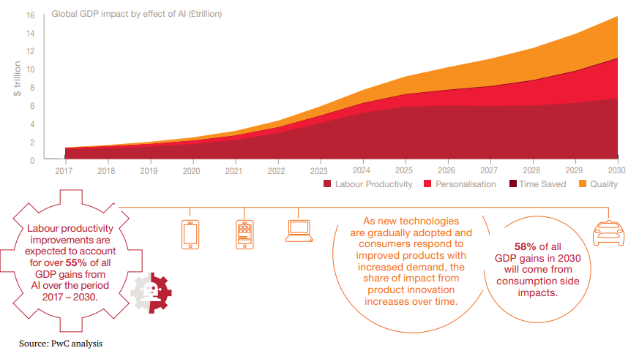
Source: https://www.pwc.com.au/government/pwc-ai-analysis-sizing-the-prize-report.pdf

