Compiled by

Anthony Halstead

Keagon King

Gabe Pierre

Aspen Jacobsen

Jon Lyle

Jose Duran

Drake Strait

Murder At Hollowstone Manor

Last updated: July 25, 2023

# Overview -Executive summary

## Elevator Pitch / High Concept

**Murder At Hollowstone Manor**, is a Mystery Horror game in a haunted mansion where players solve puzzles and find clues to discover the murderer and escape using/experiencing randomized killers and crafting items.

## Genre

Mystery/Horror

## Design Pillars

* Fear
* Thought Provoking
* Rewarding

## Key/Exotic Features

* Puzzle Solving

Solving puzzles, interact with npcs, finding components, and crafting items to progress through the game.

* Randomized Aspects

Randomly selected killers, murder weapons, murder rooms, and clues

## Win Condition / Player Goal

Solve puzzles, uncover clues, reveal killer, murder weapon, room of murder, and escape the mansion.

## Loss Condition / Continuation

Fail to guess the killer or die to the killer.

# Comparable products

### Clue

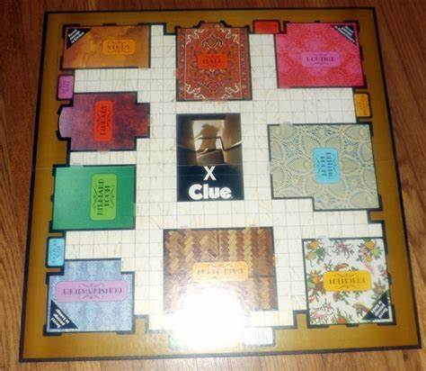

Board Game where you find out who the killer is, what weapon is used, and what room the murder happened in. Each game is randomized by selecting cards from each category and putting them in an envelope. Whichever options are not found by each player, those options are the answer. The randomized mechanic is the inspiration.

### Phasmaphobia

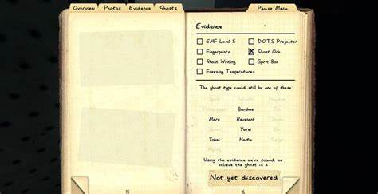

Find clues to figure out which ghost/poltergeist is haunting the house. The ideas of the puzzles and clues are the inspiration.

### Among Us

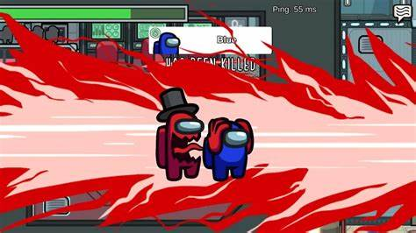

Go around and complete quests before the killer kills you. The inspiration is the killer killing you before your quest are complete and guessing who the killer is.

### RESIDENT EVIL Puzzle

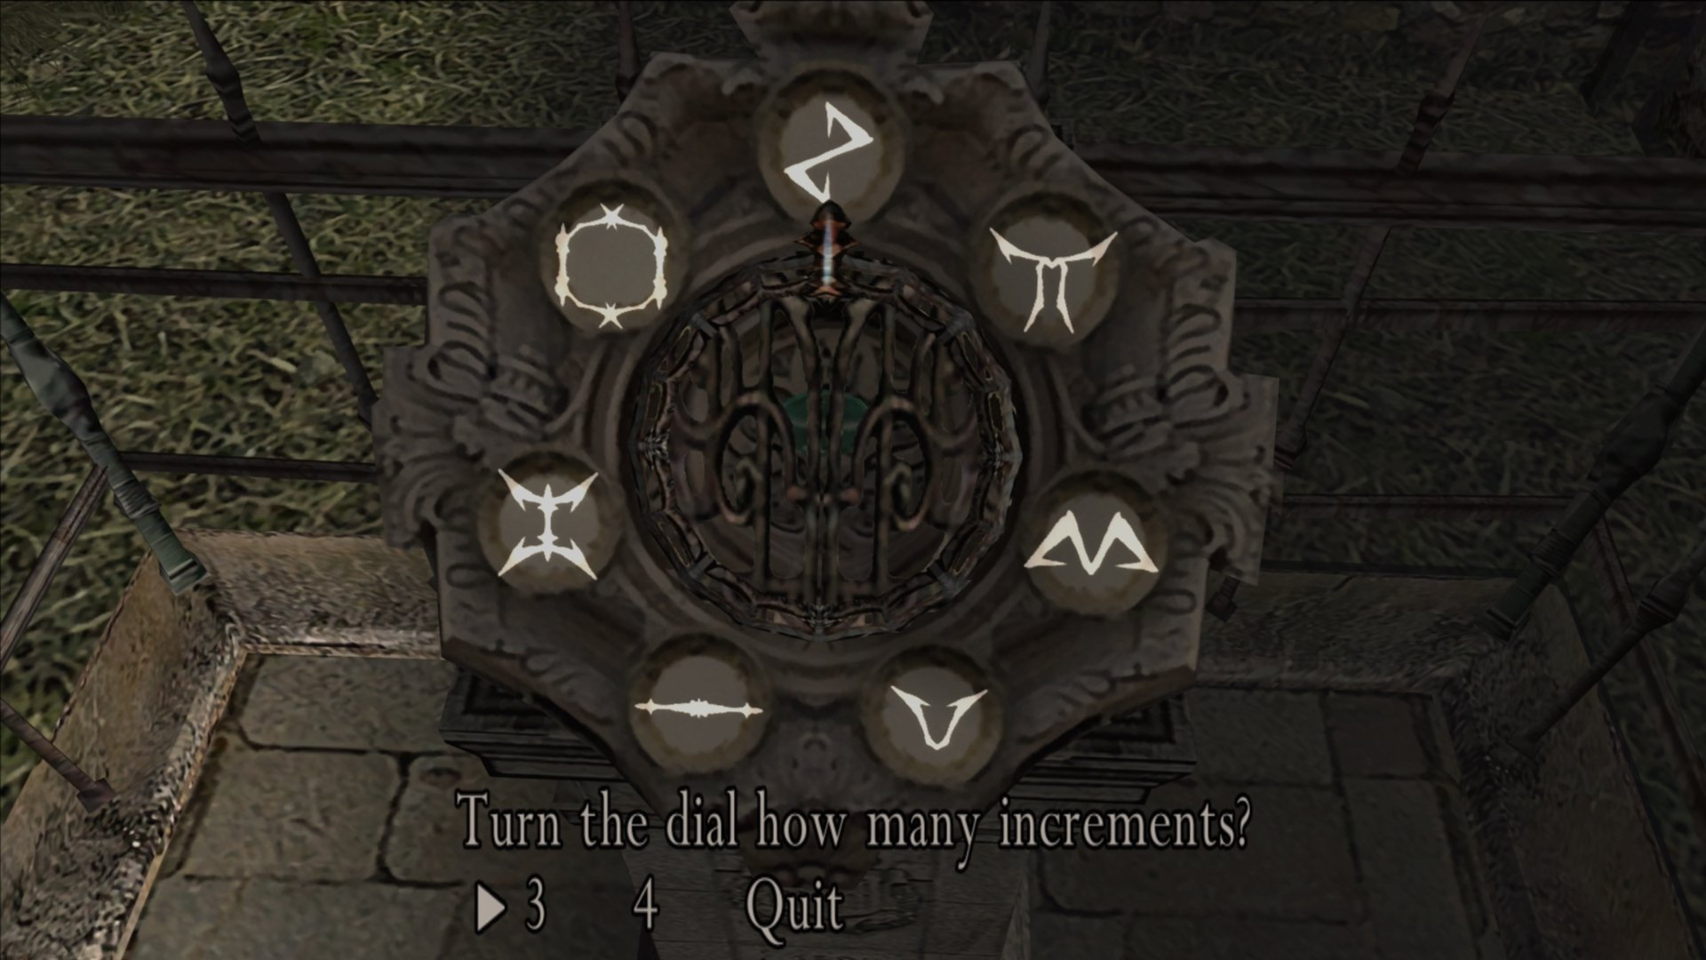

Resident Evil is a zombie action puzzle game. The player is able to complete different puzzles to progress in the game which is inspiration to our game.

# Art and Production Design

### Art / visual Style

Low-poly/ Halloween/Horror/Atmospheric

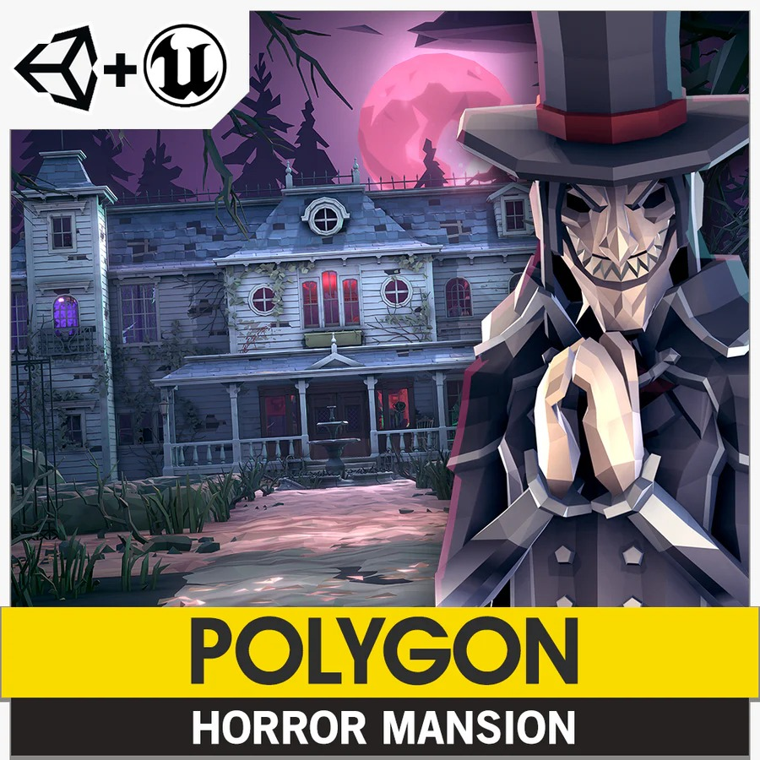

# Scope

### Game Events/Progress

1. Day 1 starts, puzzles become available to solve to get into new areas
2. Day 1 Ends, an NPC dies NPC becomes available as an apparition you can talk to.
3. This continues to day 7
4. On the final day the player will go to the main gate and make a guess as to who the killer is, what weapon was used, and what room it happened in.

### Worlds/Levels

One Level, potentially more

The level is meant to be the area in which the entire game takes place. There are puzzles that the player has to solve in the scene. Solving each puzzle opens a clue the player will use to guess the killer, weapon of choice, room the murder took place in.

1 hour 45 minutes total play time

# Mechanics / Features / Functionality

## Puzzle Mechanic

Puzzles will be set along the map for opening doors, collecting items, and progressing the game.

## Crafting Mechanic

Different items will be crafted to finish puzzles, unlock characters, and progress the game.

## Dialogue Mechanic

Dialogue will be given from NPCs to give lore and clues about the killer.

## INVENTORY Mechanic

Items will be able to be stored into a system viewable for the player.

## Randomization MECHANIC

This will randomize the killers, murder weapon, and the murder room to give the game replay ability and different games each time.