knitr::include_graphics(here::here("study5", "figs", "fig00_pract-choice-by-gender-and-cond-bar.png"))

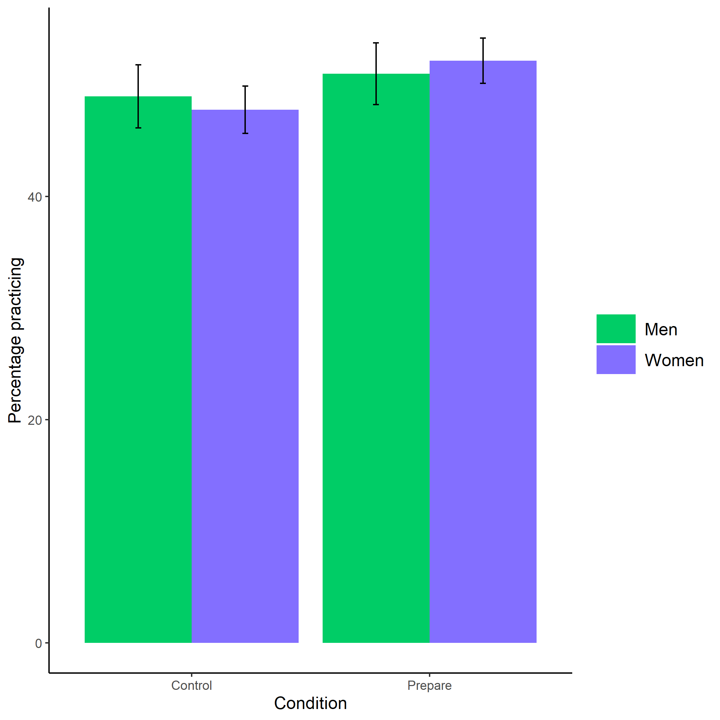

Proportion of men and women who chose to prepare by condition. Error bars represent standard errors.

knitr::include_graphics(here::here("study5", "figs", "fig03_perc-task-gender-pract.png"))

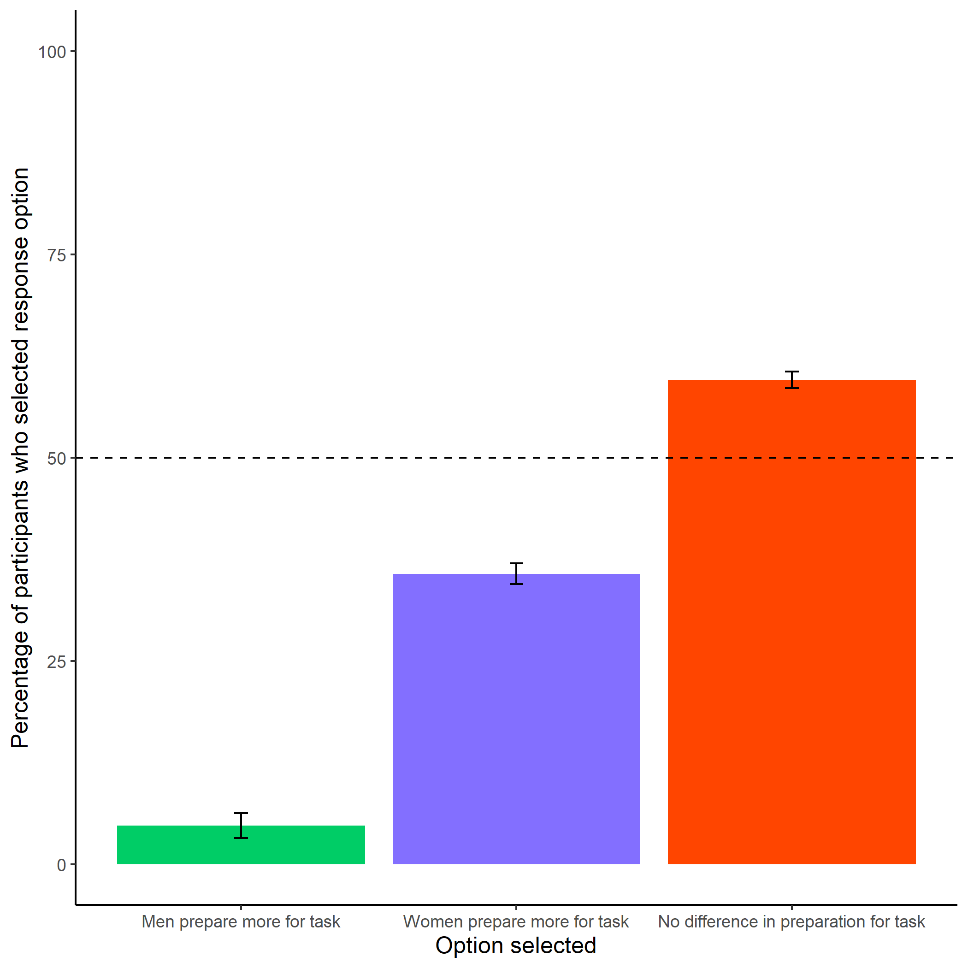

Participants’ perceptions of gender differences in the choice to practice on the task. Error bars represent standard errors.

knitr::include_graphics(here::here("study5", "figs", "fig06_better-gender-guess.png"))

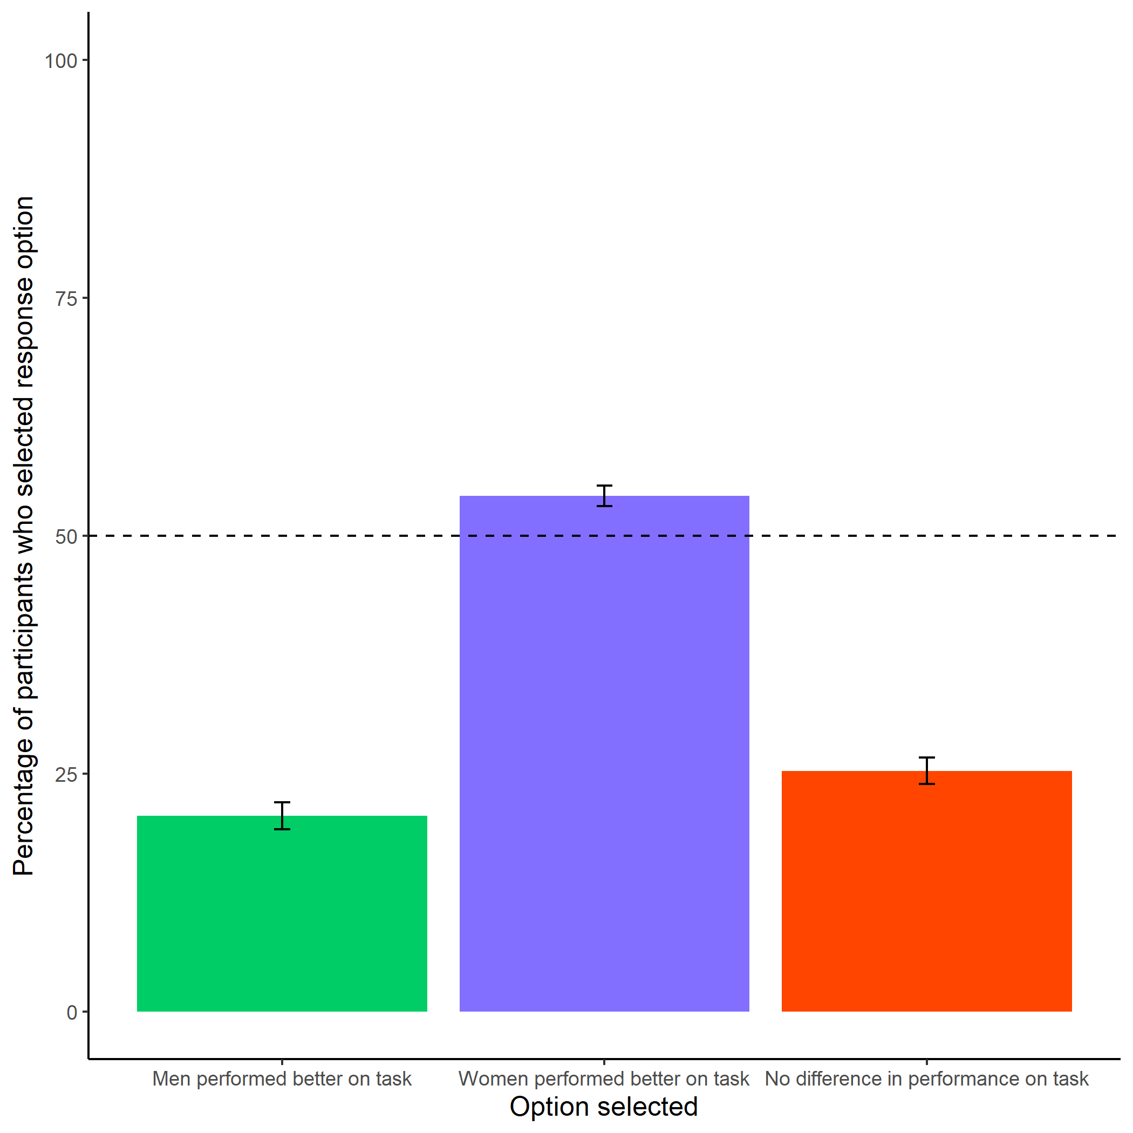

Participants’ perceptions of gender differences in performance on the task. Error bars represent standard errors.

knitr::include_graphics(here::here("study5", "figs", "fig04_perc-gen-gender-pract.png"))

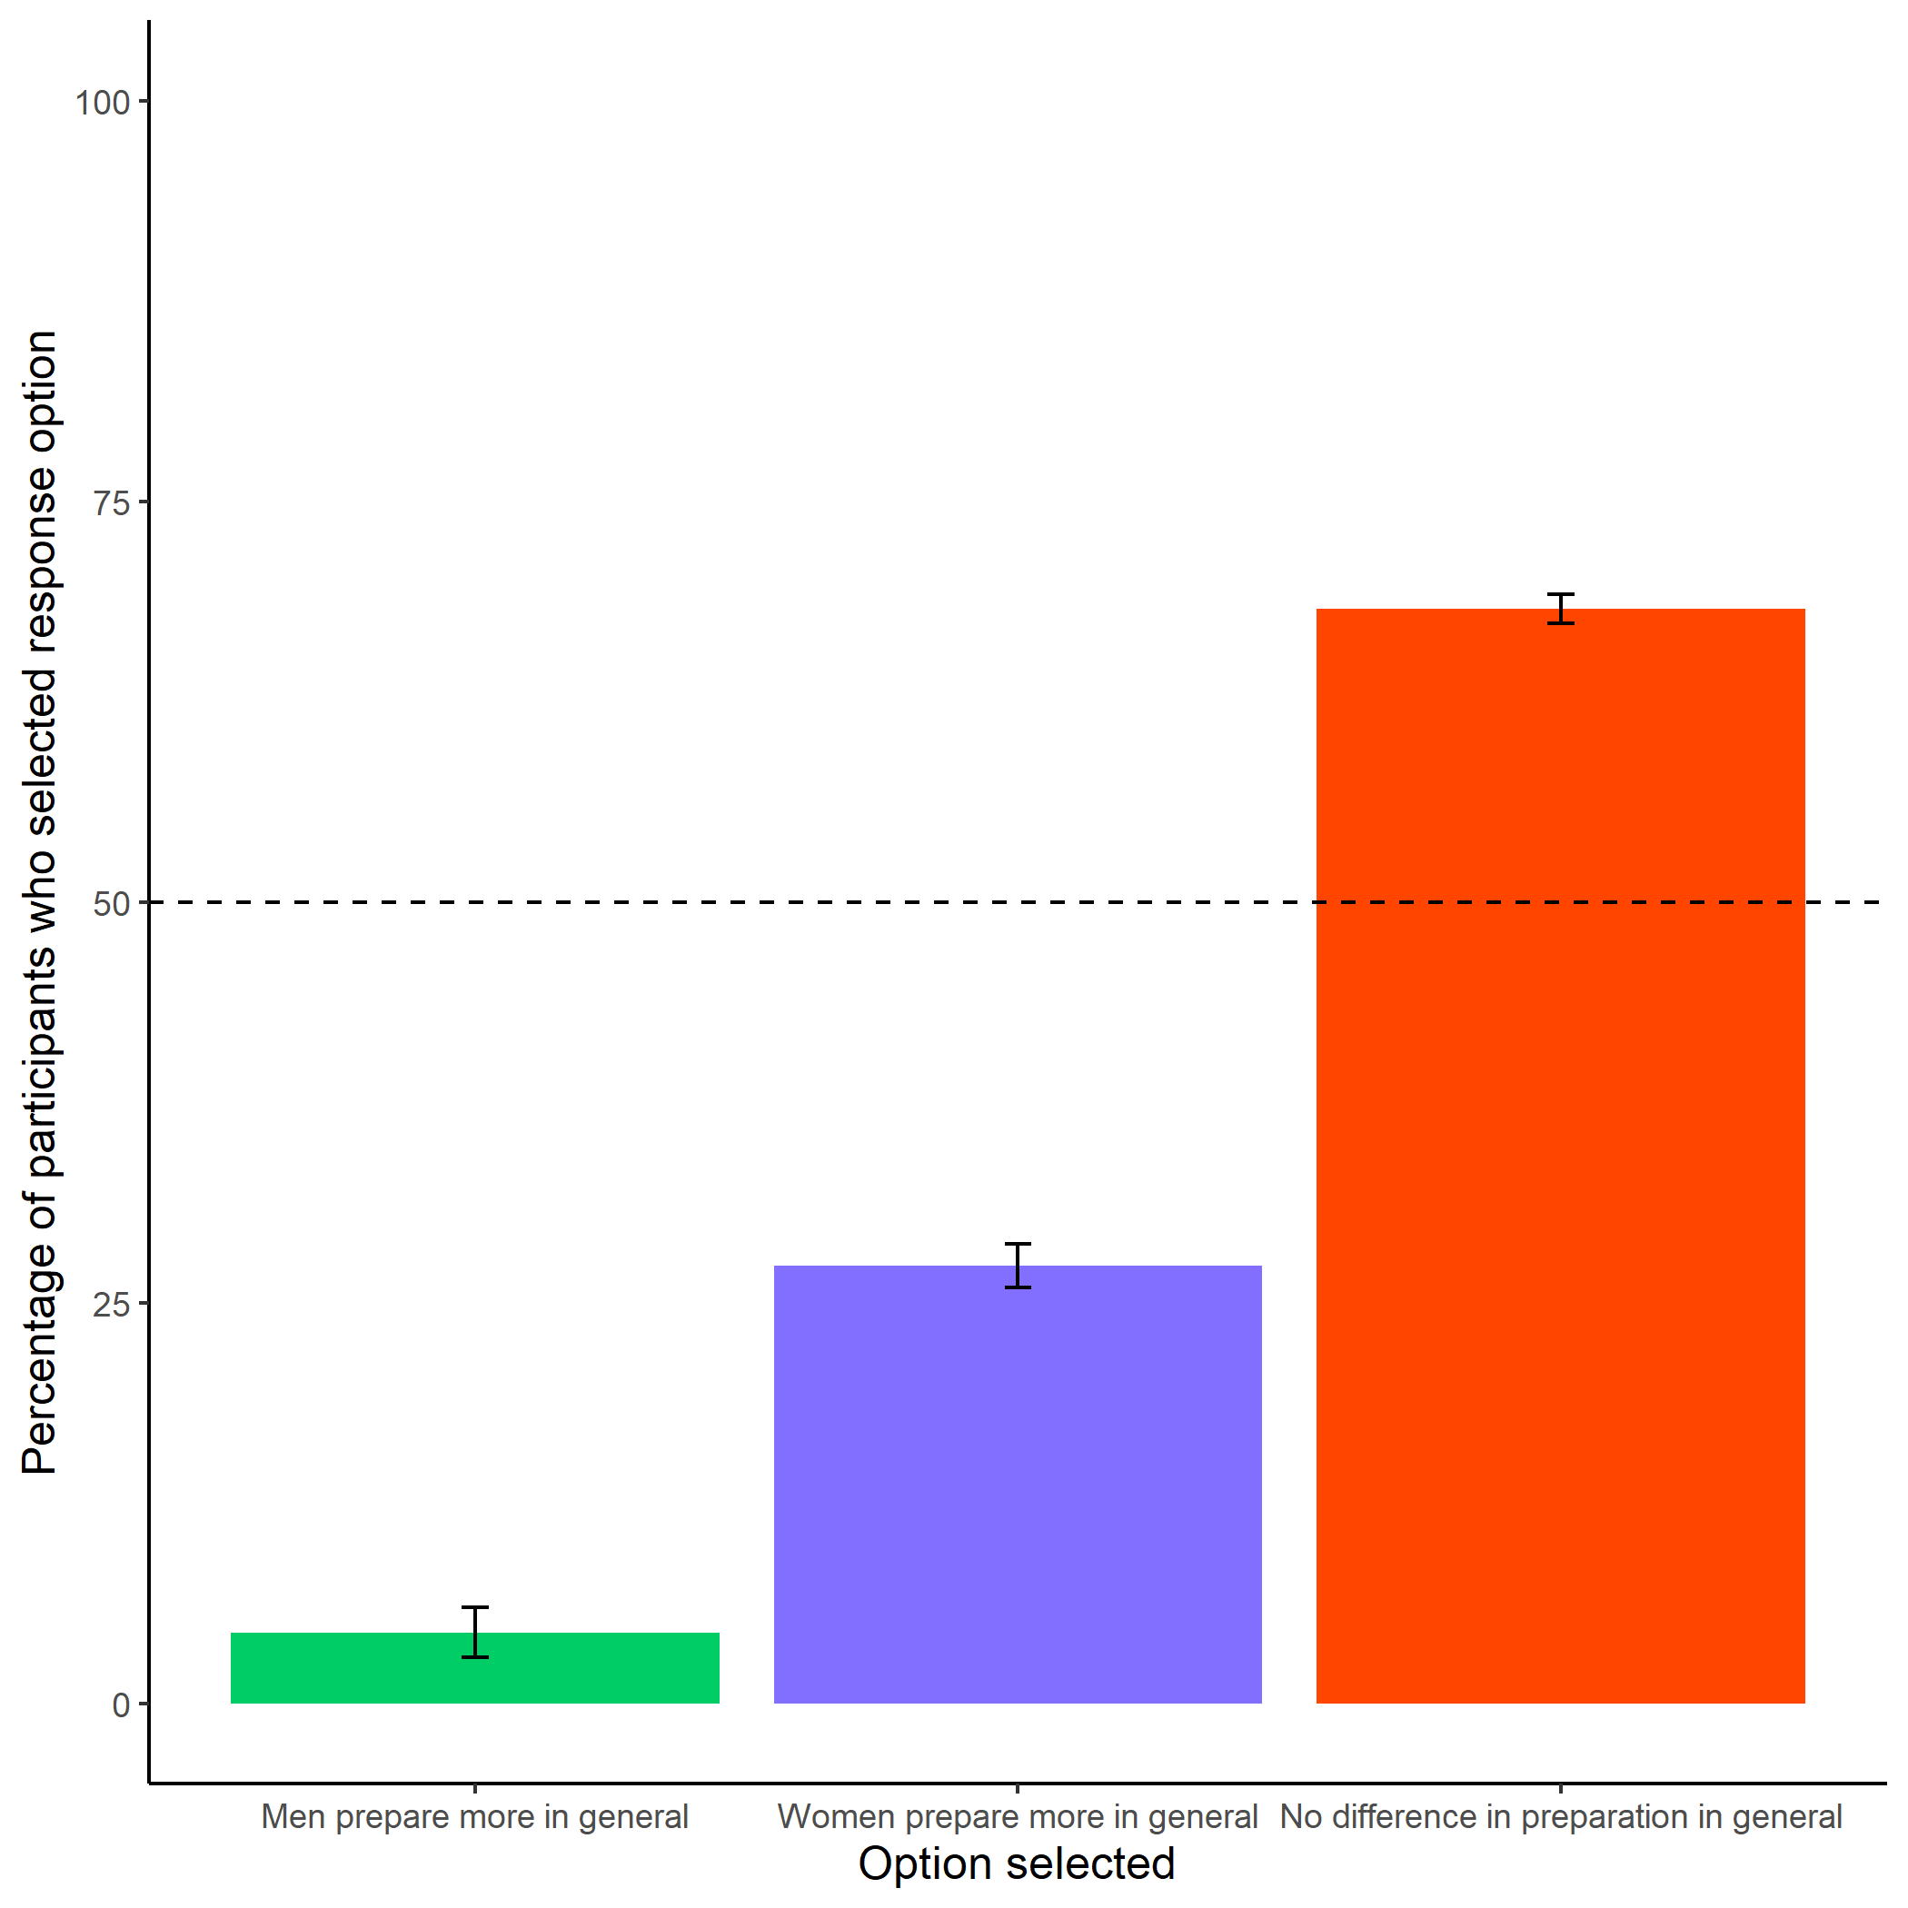

Participants’ perceptions of general gender differences in choice to practice. Error bars represent standard errors.

knitr::include_graphics(here::here("study5", "figs", "fig01_pract-choice-by-gender.png"))

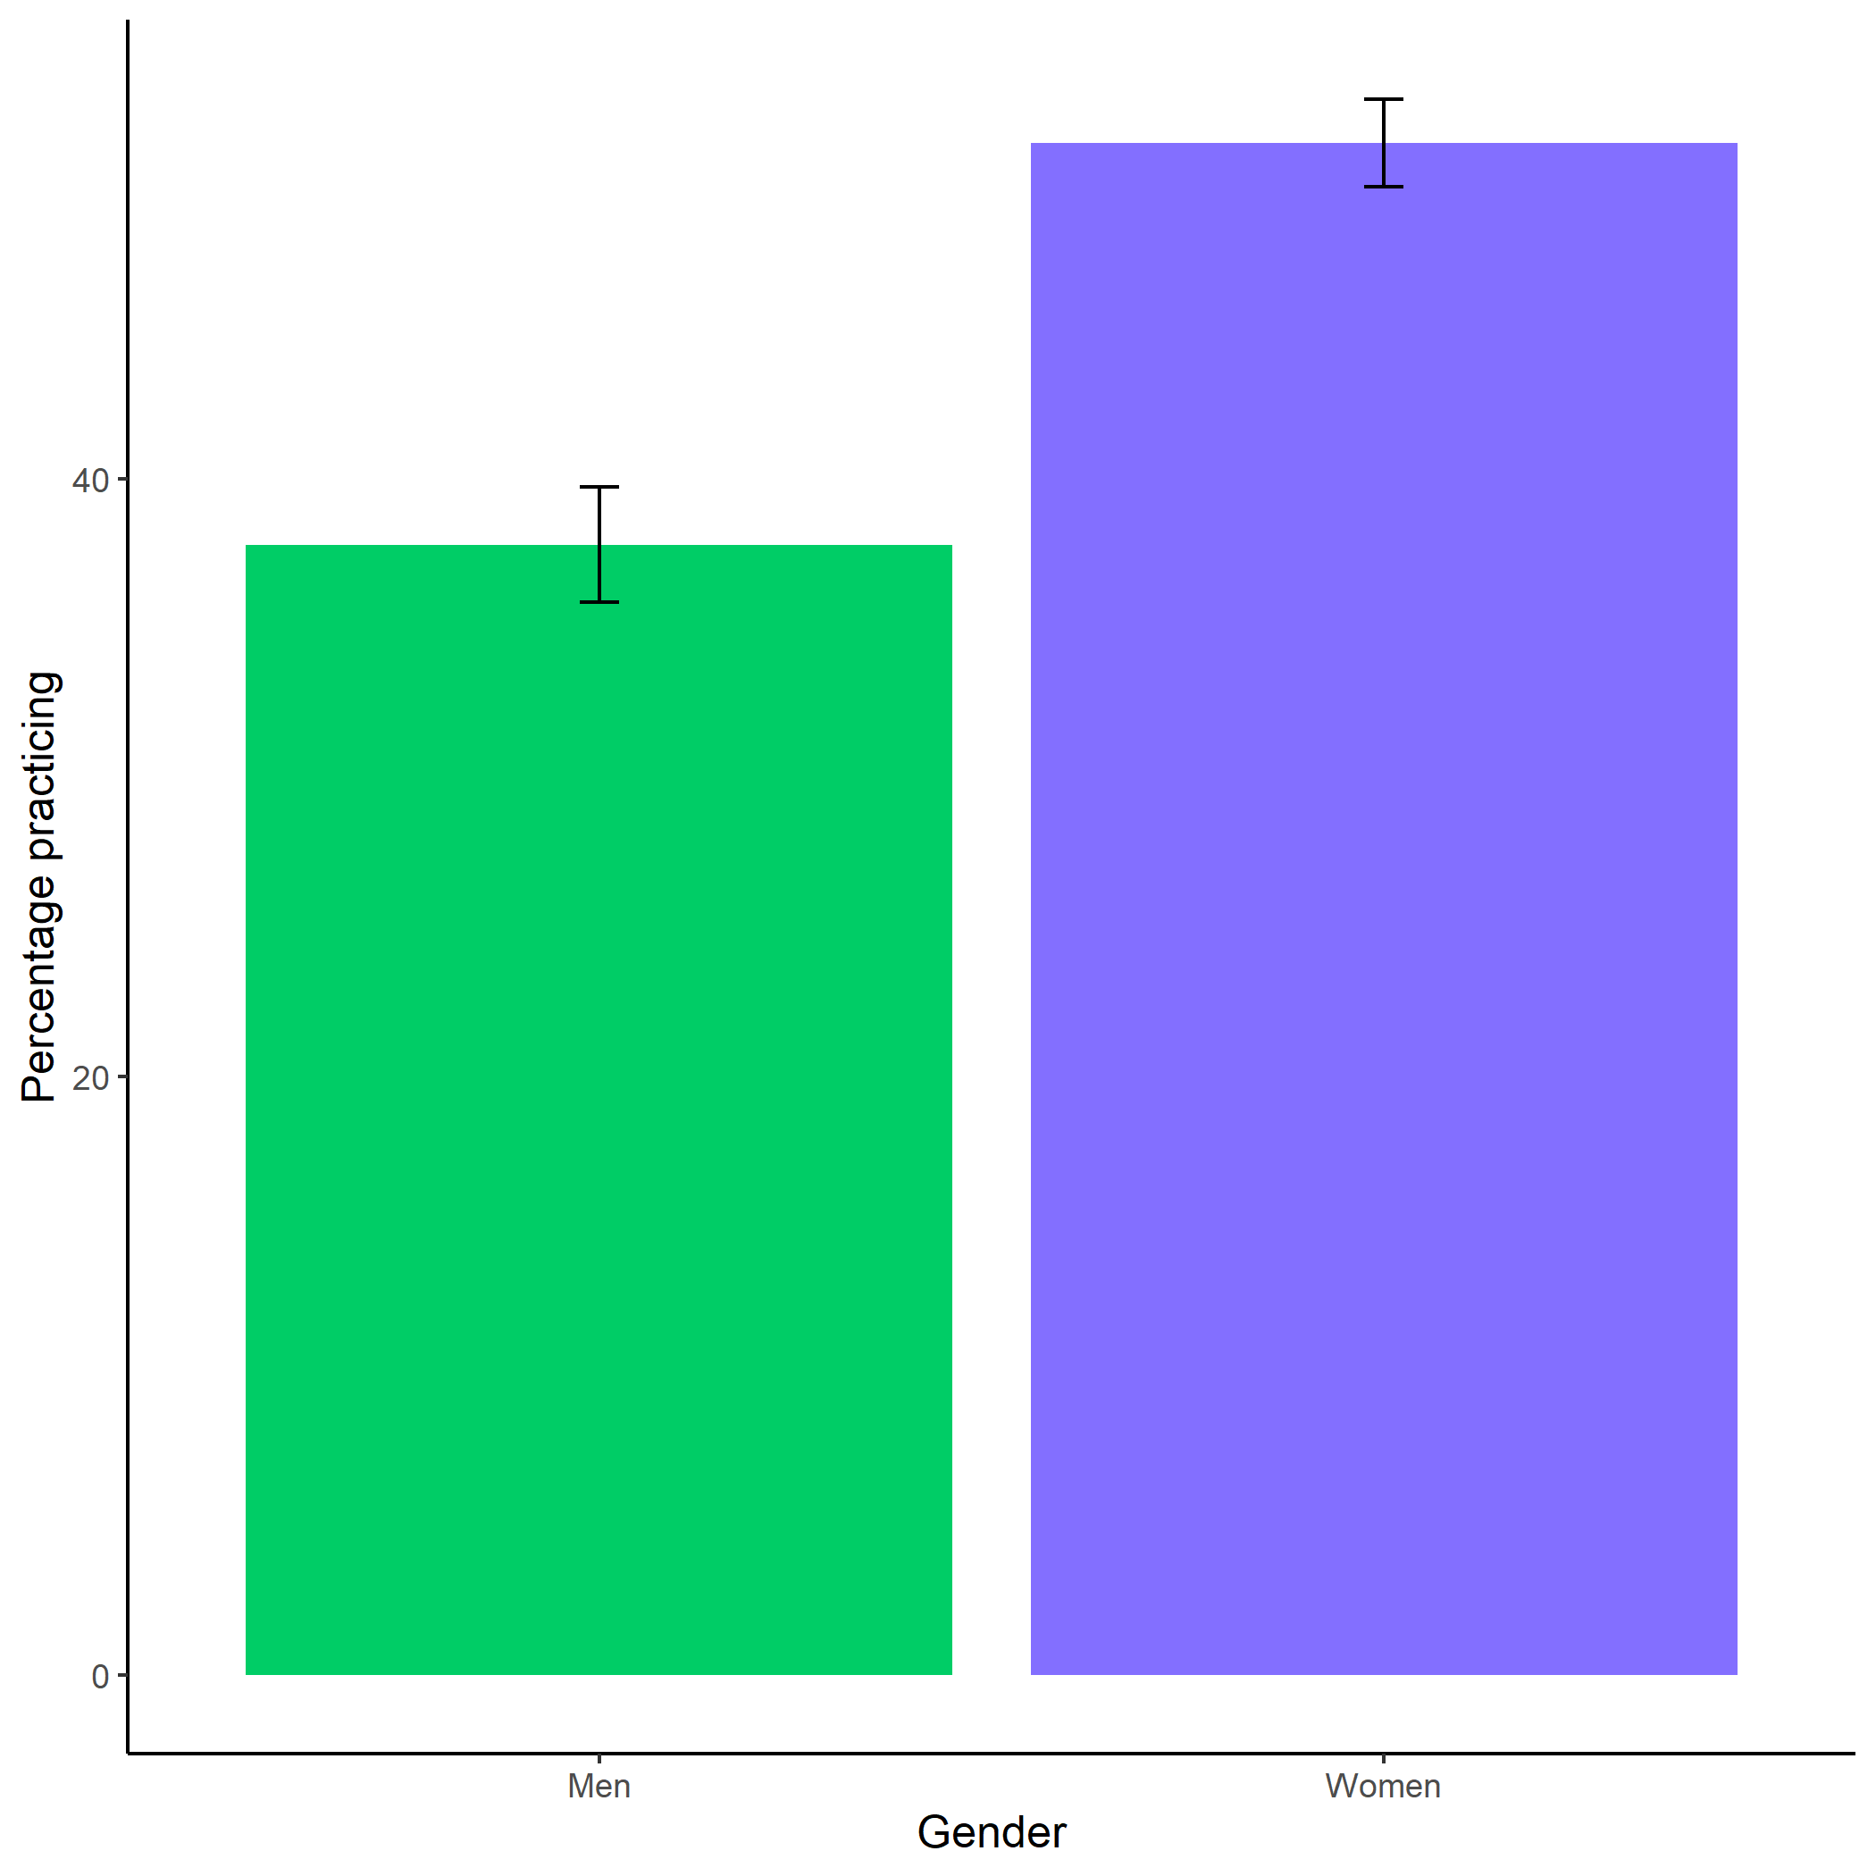

Participants’ perceptions of general gender differences in choice to practice. Error bars represent standard errors.

knitr::include_graphics(here::here("study5", "figs", "fig05_perc-gender-comp-F.png"))

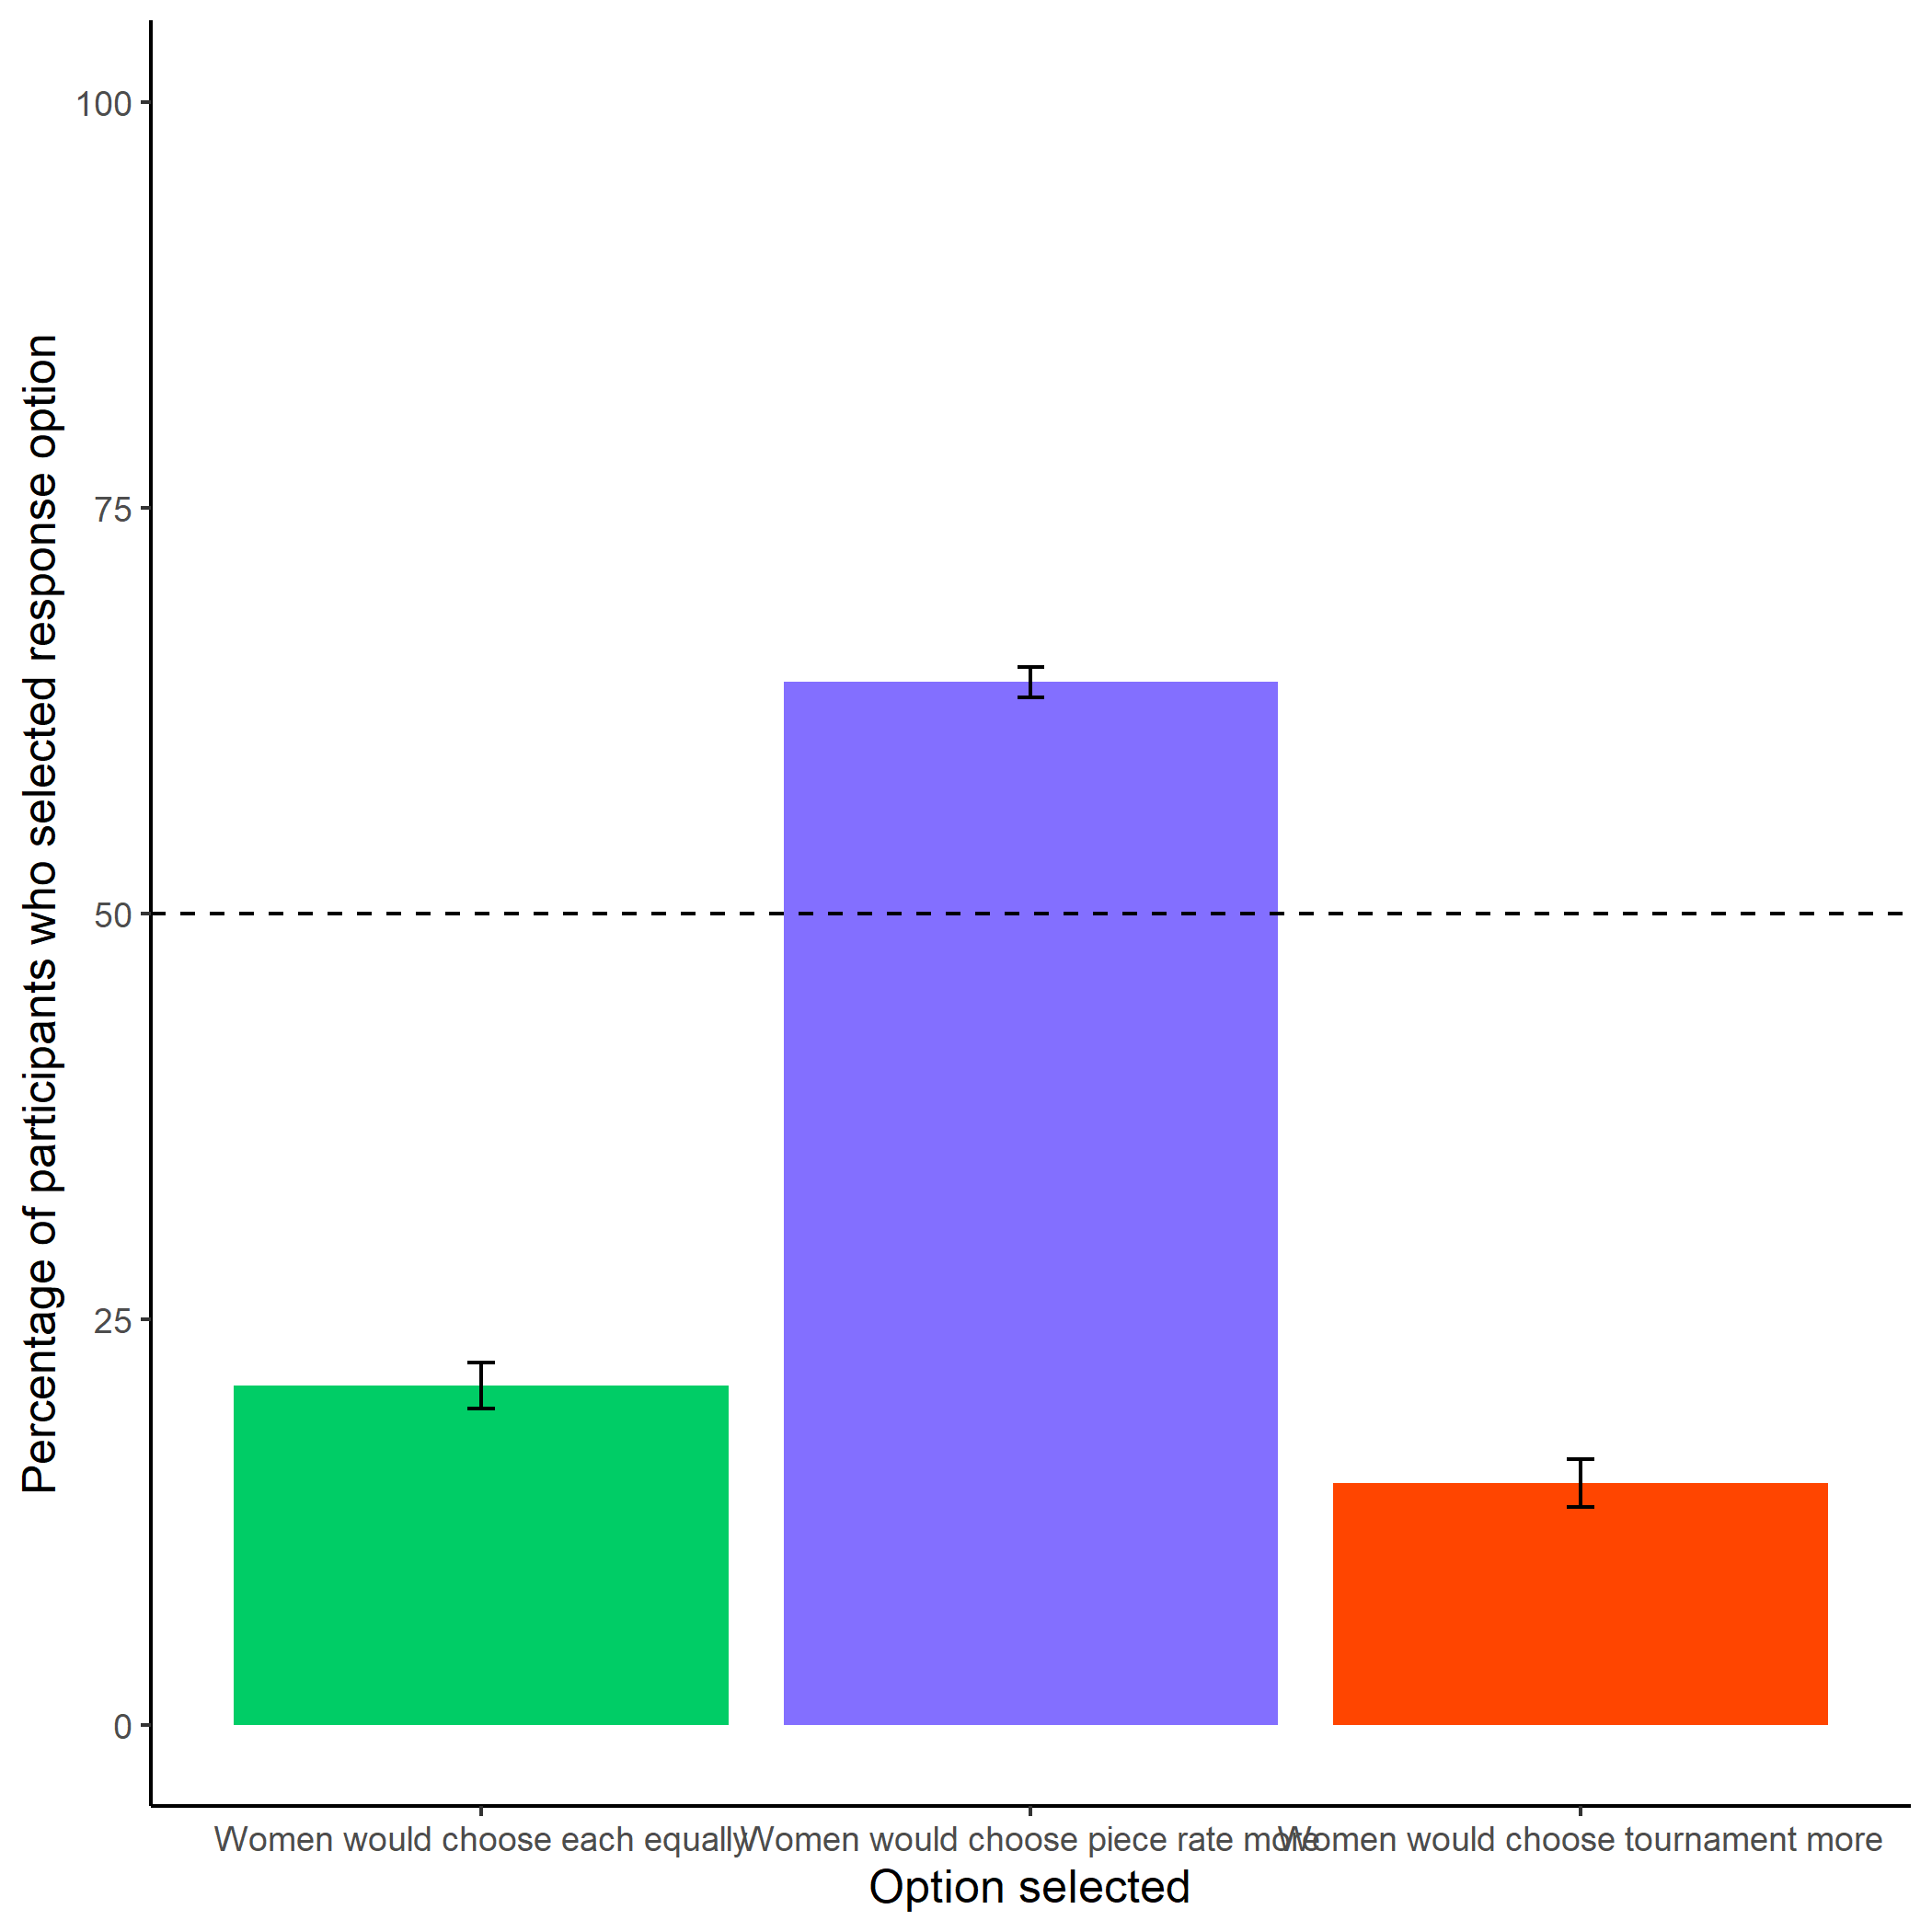

Participants’ perceptions of women’s preferences between the competitive tournament payment scheme and non-competitive piece-rate payment scheme. Error bars represent standard errors.

knitr::include_graphics(here::here("study5", "figs", "fig07_perc-gender-comp-M.png"))

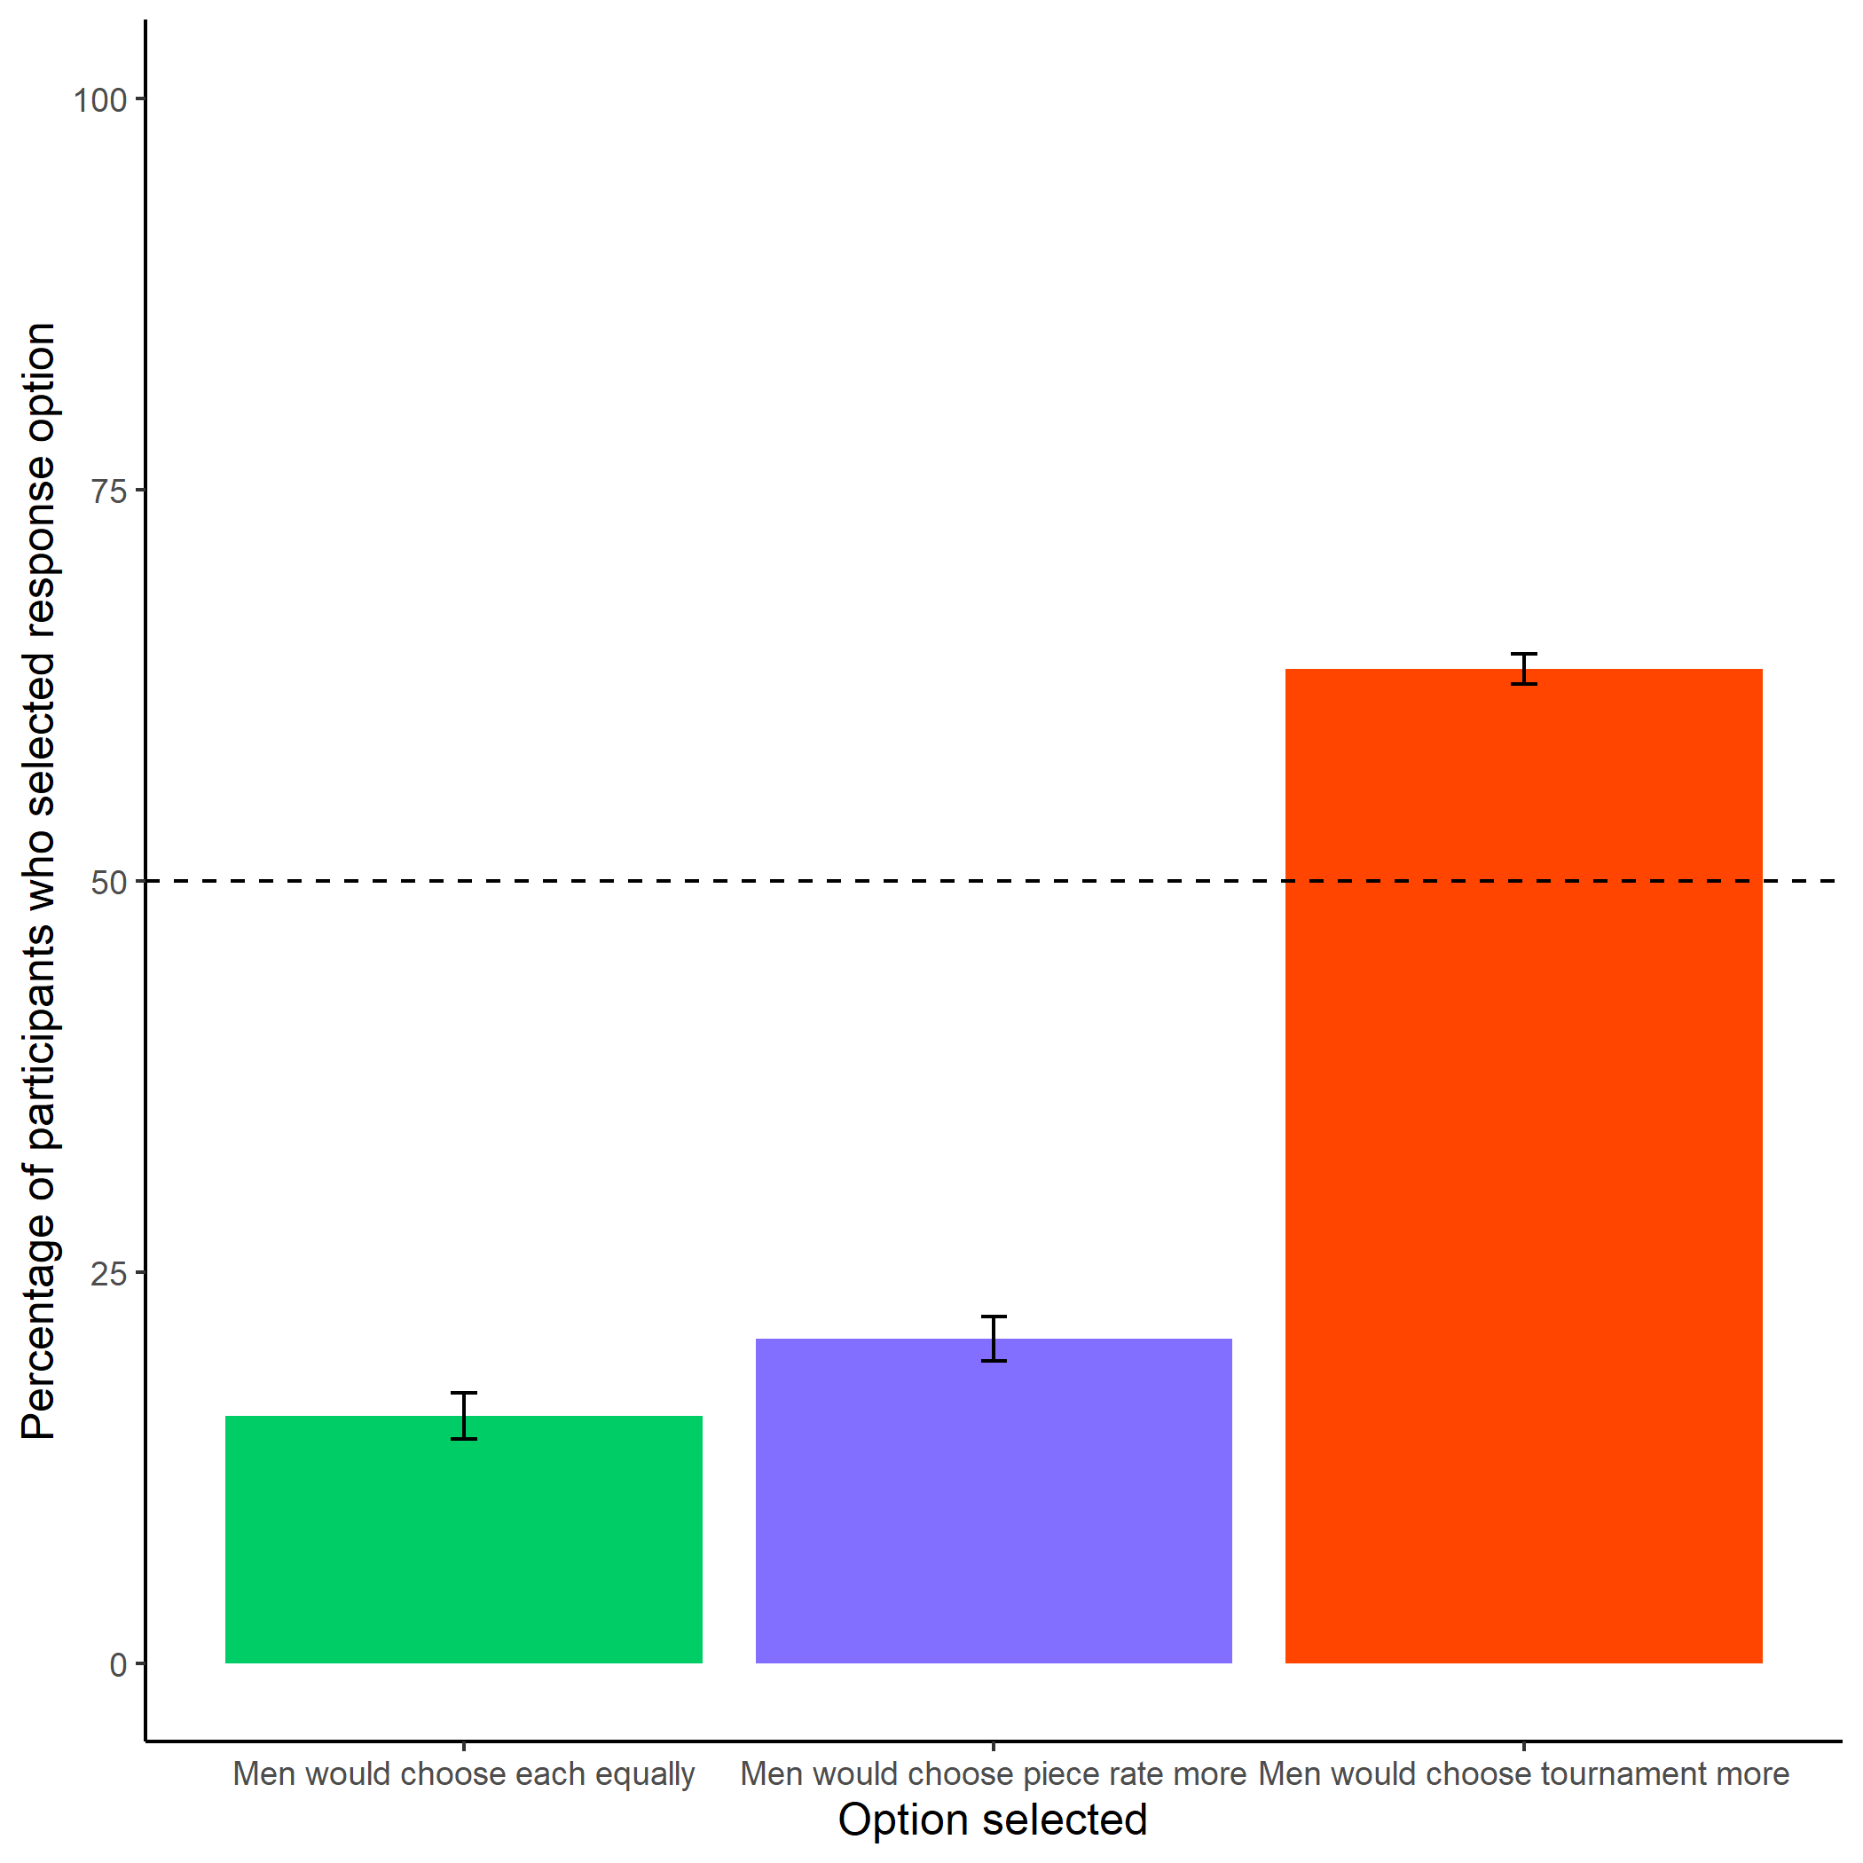

Participants’ perceptions of men’s preferences between the competitive tournament payment scheme and non-competitive piece-rate payment scheme. Error bars represent standard errors.

knitr::include_graphics(here::here("study5", "figs", "fig02_perceived-prac-dev-by-gender.png"))

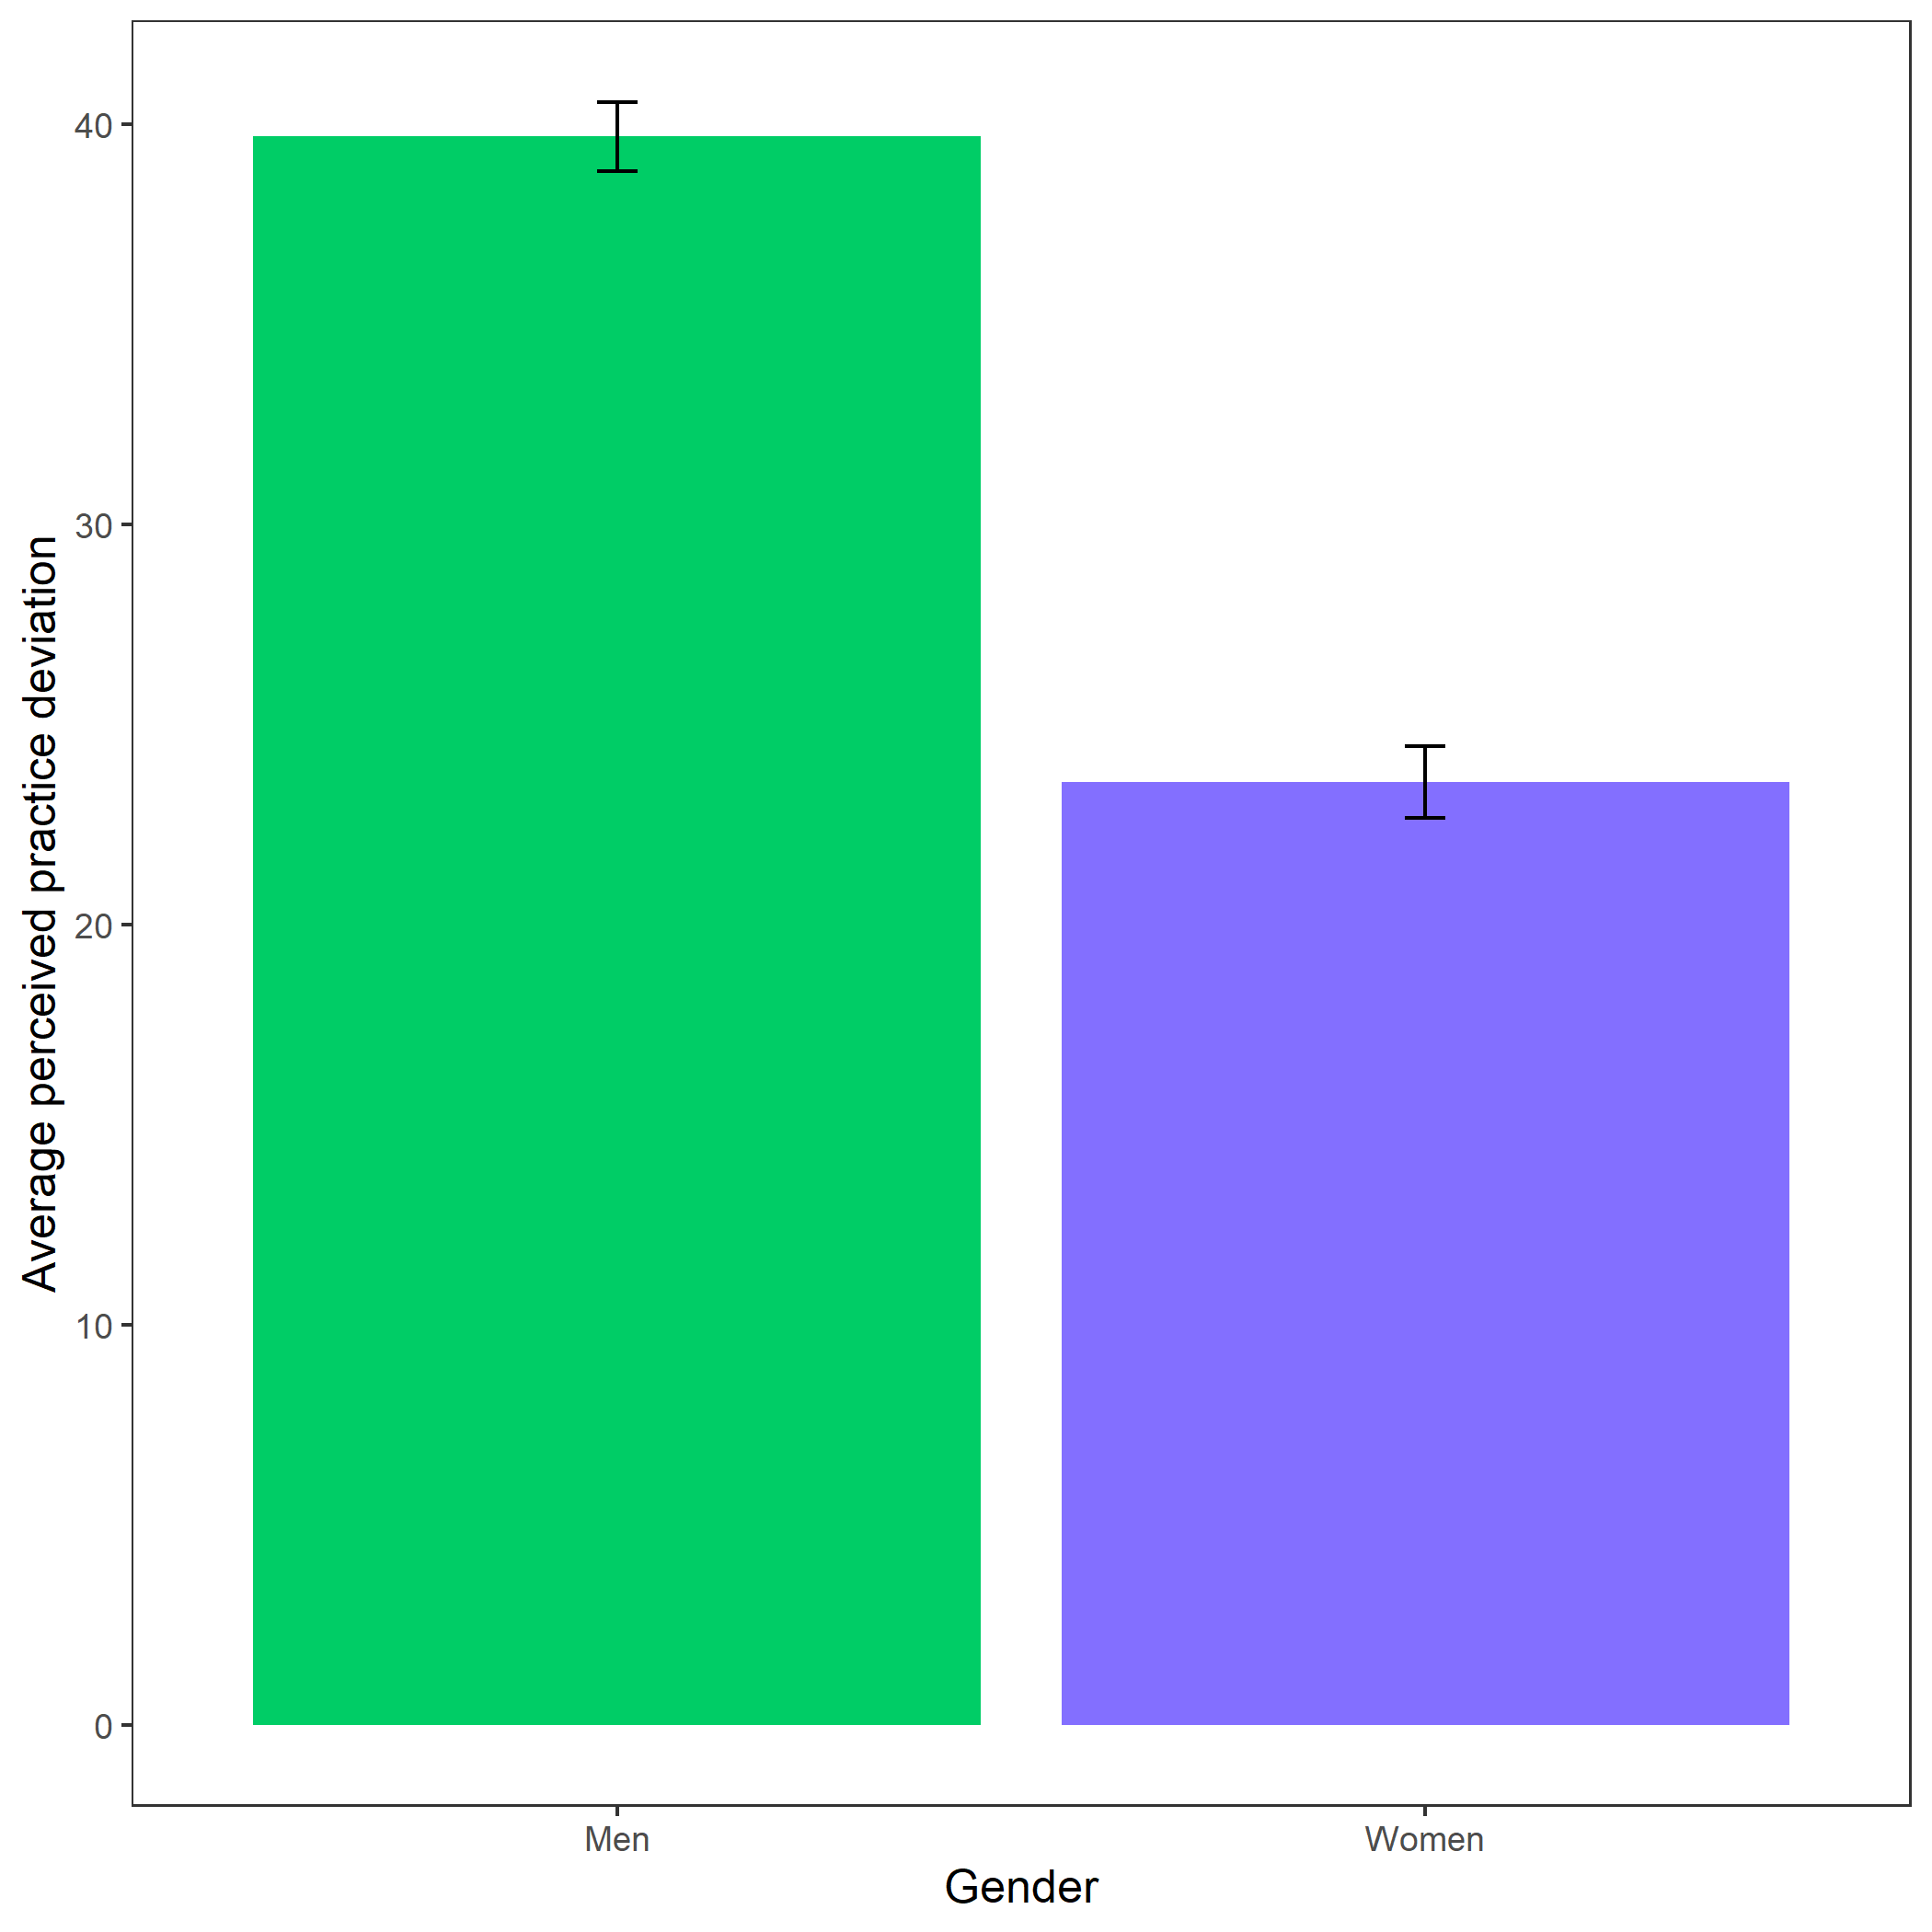

Perceived practice deviation based on participant gender. Error bars represent standard errors - insert denominators for SE bars..