# 1 Chapter 1

## 1.1 Introduction

Women have surpassed men in education outcomes, like college attendance and graduation rates (Blau and Kahn 2017; Goldin 2006; Stoet and Geary 2014), but continue to be underrepresented in top management positions in nearly all sectors (Bertrand and Hallock 2001). And, a sizable gender gap still persists worldwide (Blau and Kahn 2017). Traditional economic variables, such as household division of labor and discrimination, account for some, but not all, of these disparities (Blau and Kahn 2017). As such, researchers have begun to consider psychological gender differences, including the predilection for competition, as means of understanding persistent gender gaps in labor market outcomes (for review, see Niederle and Vesterlund 2011).

Research suggests women are, on average, less competitive than men (for review, see Niederle and Vesterlund (2011)). Foundational work on gender differences in competitiveness operationalized competitiveness as the choice of a tournament payment scheme, that reaps potentially higher earnings but requires outperforming an opponent, over a piece-rate scheme, where participants are paid per unit of work they produce (Niederle and Vesterlund 2007). In this paradigm, women are less likely to enter tournaments while completing mathematical problems, even when they would have earned more by competing (Niederle and Vesterlund 2007). Numerous conceptual replications over the past 15 years suggest that the gender difference in willingness to compete is robust (see Niederle and Vesterlund 2011; **Niederle2017a?**; **Niederle2017b?** for review). Notably, this effect has been replicated in diverse populations (e.g., across age groups and cultures) (Apicella and Dreber 2015; Buser, Niederle, and Oosterbeek 2014; Sutter et al. 2016; Andersen et al. 2013; Buser, Peter, and Wolter 2017; Sutter and Rutzler 2010; Dreber, Essen, and Ranehill 2014; Mayr et al. 2012) and with a diverse set of tasks (Apicella and Dreber 2015; Saccardo, Pietrasz, and Gneezy 2018; Bjorvatn, Falch, and Hernæs 2016; Sutter and Glätzle-Rützler 2015; Frick 2011; Samek 2019). Importantly, this laboratory measure of competitiveness predicts labor market outcomes, including education choices (Buser, Niederle, and Oosterbeek 2014; Zhang 2012), entrepreneurial decisions [e.g., investment, employment; Berge et al. (2015)], and earnings (Reuben, Sapienza, and Zingales 2015). In other words, competitive preferences may contribute to the gender gap in labor market outcomes (Blau and Kahn 2017). Thus, understanding why men and women differ in levels of competitiveness and whether interventions exist that can reduce or eliminate the difference may be key for solving the pernicious gender gaps in the labor market.

Both confidence and risk attitudes have been implicated in driving gender differences in willingness to compete (Niederle and Vesterlund 2011; Veldhuizen 2017). However, the extent to which confidence and risk attitudes account for the gender difference in willingness to compete is debated. The foundational research in this literature suggests that confidence and risk attitudes do not completely explain gender differences in competitiveness, since there remained a residual gap after controlling for these factors (Niederle and Vesterlund 2007). As a result, the unexplained component of the original gender effect was taken as evidence of a distinct “competitiveness” trait, separate from risk attitude and confidence (Niederle and Vesterlund 2007, 2011). Conversely, recent work correcting for measurement error (Gillen, Snowberg, and Yariv 2019) and using experimental techniques to isolate the effects of the competitiveness trait (Veldhuizen 2017) suggests that risk attitudes and confidence can fully explain the gender gap in the choice to compete.

Regardless of whether competitiveness is a “stand-alone” trait, it is clear that both confidence and risk attitudes influence how men and women react to competitions. For instance, even in the original study by Niederle and Vesterlund (2007), 27% of the gender gap in tournament entry was explained by men being more overconfident than women about their relative performance on the task. As such, interventions designed to co rrect men’s over confidence, increase women’s confidence and decrease their perceptions of risk and uncertainty in competitive contexts may help reduce the gender gap in competitiveness.

Confidence is conceptualized as the accuracy of one’s perceived performance or ability on a task (Beyer and Bowden 1997). Within the literature on the gender gap in competitiveness, confidence is operationalized as the belief about one’s relative performance during a competition, where individuals who have inaccurately high (low) ratings of their performance are deemed overconfident (underconfident). If an individual does not believe their performance is higher than the individuals they are competing against, they are unlikely to make the decision to compete for fear of missing the opportunity to earn money.

While most individuals are overconfident (**Alicke2013?**; **Dunning2004b?**), there is ample research to suggest that women are less (over)confident on average than men across a number of domains (Mobius et al. 2011; Niederle and Vesterlund 2011, 2007; Croson and Gneezy 2009; Lundeberg, Fox, and Puncochaf 1994; Bertrand 2010; Beyer 1990; Beyer and Bowden 1997; **Jakobsson2013?**). Because women are less overconfident, they compete less often than they should, given their actual ability (Niederle and Vesterlund 2007). Confidence too may help explain why, in some situations, the gender gap in competitiveness may be reduced or eliminated. For instance, women tend to compete more when tasks are female-typed or gender-neutral (Iriberri and Rey-Biel 2017; Boschini et al. 2014, 2019; Apicella and Dreber 2015; Grosse and Riener 2010; Günther et al. 2010; Dreber, Essen, and Ranehill 2014, 2011; Shurchkov 2012), when they are facing other female opponents (Datta Gupta, Poulsen, and Villeval 2013; **Booth2012?**), or when competing against themselves [Apicella, Demiral, and Mollerstrom (2017); insert cites from here: <https://www.sciencedirect.com/science/article/pii/S0014292121001306?casa_token=-TmBt5-XsdMAAAAA:g-SfgLpuWqjY1lBKbp1xzp0lhj9Ibl9z6DCm-D3Xf6vRHGHHK_x_1ABc5Erf25FjdZ2Uf1NLpn4> - aka = Bönte et al., 2017; Klinowski, 2017; Carpenter et al., 2018; Apicella et al., 2020; Demiral and Mollerstrom, 2020]. For example, Apicella et al. (2017) document a gender difference in confidence when women and men are competing against other individuals, but not when they are competing against themselves (i.e., their own past performance). There are several non-mutually exclusive and potentially interacting explanations that could account for women’s relatively lower (over)confidence, including differences in performance or ability, experience, innate psychological differences, and stereotype threat (Steele 1997; Spencer, Steele, and Quinn 1999; Spencer, Logel, and Davies 2016). In the latter case, for instance, women may decide to forgo competitions because they either believe negative stereotypes about their ability to perform certain tasks, or because stereotypes provoke enough anxiety to reduce confidence (Günther et al. 2010; Grosse and Riener 2010; Iriberri and Rey-Biel 2017; Shurchkov 2012; **Burow2017?**). Taken together, this body of research suggests that interventions designed to increase confidence in women, may embolden them to compete more.

A second variable that has been identified as a possible explanation for gender differences in competitiveness is risk attitude, typically construed as the preference for a certain gain over a gamble, even if the gamble has an equal or greater monetary expectation (Kahneman and Tversky 1982). Researchers investigating gender differences in risk attitudes find that men are typically more risk-seeking than women (Eckel and Grossman 2008; Charness and Gneezy 2012; Croson and Gneezy 2009; Bertrand 2010), including in hunter-gatherers (Apicella, Crittenden, and Tobolsky 2017), but see (**Harrison2007?**) for an exception. While most studies report a gender difference, the difference appears to be small to medium (**Filippin2016?**) and culturally-dependent [Anderson, et al. 2013; Gneezy, Leonard, and List (2009)].

Competitive payment schemes are inherently riskier than piece-rate payment schemes because the variance in returns is greater. With piece-rate payment schemes, individuals are guaranteed a certain amount for every unit they produce. Moreover, there typically exists uncertainty in competitions since one’s relative performance is unknown (Niederle and Vesterlund 2011). Indeed, some of the gender gap in competitiveness is explained by men and women’s differing risk attitudes (Niederle and Vesterlund 2011). In fact, some recent work suggests that nearly 30% of the gender gap in competitive choices can be explained by risk attitude (Gillen, Snowberg, and Yariv 2019; Veldhuizen 2017).

Preparation or training on a task may increase one’s confidence (Gist and Mitchell 1992; Schunk 1981, 1982; Usher and Pajares 2008), and decrease risk (CITE), since people usually are able to observe an improvement in their performance over time. Thus, in the current set of studies, we examine whether and how preparation may influence willingness to compete. Lent et al. (1996) found that college students listed past accomplishments as the most influential factor in determining their confidence. Moreover, research directly comparing the effects of mastery experiences (via preparation), vicarious experiences (e.g., watching others perform a task), and a control treatment without any intervention on confidence, found that mastery increased confidence significantly more than vicarious experiences and the control treatment (Bandura, Adams, and Beyer 1977). Other research suggests that men and women’s confidence is similar in domains in which they have expertise, but the confidence gap emerges when it is assessed in less knowledgeable domains (**Sarsons2016?**). This suggests that gaining expertise, perhaps through practicing, may selectively boost women’s confidence. (**Roll2011?**) found that practicing mathematics problems, using an intelligent tutoring system, significantly decreases under confidence but has no effect on rates of over confidence. This too suggests that practicing may preferentially benefit women who are more likely than men to be underconfident. That said, if practicing only helps with under-confidence, when most people, including women, are overconfident, then its application may be limited.

Preparation, and the feelings of preparedness or self-efficacy that follow, may also decrease the perceived riskiness of competitions. With increased self-efficacy, individuals may believe they can reduce risk or overcome adversity. Surprisingly little work has explored how preparation impacts men’s and women’s risk attitudes. However, some experimental work suggests that manipulating perceived competence on a task by giving participants positive feedback about their performance on a task can lead to significantly more risk-taking behavior (**Krueger1994?**). The researchers were able to rule out the role of mood in driving the results by giving some participants positive feedback on one task and negative feedback on another. For these participants, risk-taking increased in the positive feedback condition and decreased in the negative feedback condition. Interestingly, (**Gysler2002?**) find that knowledge – in this case, understanding of financial markets – and confidence in that knowledge, negatively correlate with women’s risk aversion, but positively correlate with men’s risk aversion. This suggests that preparation may disproportionately increase risk-taking in women. Finally, there is evidence that risk attitudes play a greater role in predicting decisions to compete when individuals are competing against other individuals, rather than themselves (i.e., their own past performance), possibly because there is more uncertainty in estimating an opponent’s ability versus one’s own ability (Apicella, Demiral, and Mollerstrom 2017).

Surprisingly, little work has explored how preparation impacts men and women’s confidence, risk attitudes, or their willingness to compete. We know of only one study that has explored how delaying a competition, and in some cases, offering an opportunity to study, affects decisions to compete. In a working paper, (**Charness2021?**) examine whether gender gap entry rates change when a future opportunity to study for the task is made available. The authors hypothesized that women would be more likely to compete when there is an opportunity to study for the task. Contrary to their prediction, the authors found that providing an option to study leads to directionally more male entries into future planned tournaments and directionally less female entries into these tournaments, resulting in a significant gender gap. However, this gap was only present during the initial, provisional sign-up period. When the actual choice was made later – sometime between one and five days – the gender difference disappeared. Of those men who returned to complete the study, some switched into the non-competitive payment scheme. The authors suggest that the results may be explained by men being overly confident in their future selves’ resolve to study.

The current study

We examine the role of preparation on the gender differences in willingness to compete through three experiments. However, unlike (**Charness2021?**), we do not introduce a significant time delay in our studies. That is, experiments took place in a single session, thus minimizing any potential for gender differences in beliefs about future behavior to affect our results.

In the first experiment, we test whether simply knowing that there will be an opportunity to prepare before performing a task affects the gender gap in willingness to compete. That is, we manipulate participants’ knowledge of whether they will have time to prepare before they make their decision to compete. We anticipated that participants with this information would be more inclined to compete compared to participants without this information and that this effect would be stronger for women, who tend to be relatively less confident. Thus, we expected a main effect of condition and an interaction between gender and condition on the choice to compete . In the second experiment, we examined how actual preparation influences the decision to compete. That is, we manipulated whether participants were required to prepare before making the decision to compete. Again, we expected that women in the preparation condition would be more inclined to compete than women in the no preparation condition; [WHAT ABOUT MEN?]. Finally, in experiment 3, we examine how an unlimited amount of preparation affects gender differences in the willingness to compete. Across all experiments, we measured gender differences in actual preparation after administering the treatment and eliciting preferences to compete. Finally, we monetarily incentivized participants in both studies to correctly predict whether men or women would prepare and compete more. The research design, hypotheses, measures and analyses were pre-registered unless otherwise stated and all analyses were conducted in R statistical software (version 4.0.4).

## 1.2 Study 1

### 1.2.1 Methods

We recruited workers on Amazon Mechanical Turk for Study 1, and those who opted into the study had to pass several screening questions. Specifically, participants included in the paid portion of the study had to (i) identify their nationality as American and live in the United States, (ii) identify as a man or a woman, and (iii) be using a computer (rather than a phone or tablet). If they did not meet these criteria, they did not proceed to the paid portion of the study. Additionally, upon reviewing the data, we had reason to suspect that some participants completed the study more than once. Specifically, some participants had the same IP address, MTurk ID, and were of the same gender. When entries matched on all three identifiers, we included only the first entry and excluded all subsequent entries. The final sample consisted of 1056 participants (53.6% women), with an average age of 37.74 (*SD* = 13.19) years. 54 participants (53.7% women) dropped out of the study before finishing and we use their data when available.

Participants were told they would be completing a timed multiplication task could choose how they would be paid for their performance. We chose a multiplication task because we expected participants’ performance to improve with practice. Indeed, research suggests that rehearsing and recalling associative memories can speed up retrieval of those memories (Rundus 1971). The task involved solving problems from multiplication tables 1-12 as quickly as possible within a two-minute period. They were provided an example of a question with the correct response and had to answer three practice problems correctly to proceed, as a test of their comprehension. After completing the comprehension questions, participants were randomly assigned to either a “knowledge of preparation” condition or a control condition. Participants in the “knowledge of preparation” condition were presented the following text:

“There is an option to practice/study before completing the multiplication task that is available to all participants. If you take this opportunity to practice/study, we will provide you with materials that may help boost your performance in the multiplication task. You will have unlimited time to practice/study before completing the task. You can stop practicing/studying at any point.”

Participants assigned to the control condition simply proceeded without seeing this text. Then, all participants were asked to choose how they wanted to be paid. They were given two options, either a piece-rate payment scheme or a tournament payment scheme. They first read a description of each payment scheme, and had to correctly answer X comprehension questions before making their selection.

Under the piece-rate scheme participants were told that they would be paid $.10 for every problem answered correctly. Under the tournament scheme, participants were told that they would be paid $.20 for every problem they answered correctly, but only if they answered more questions correctly than a randomly assigned competitor. The order of presentation of the tournament and piece-rate payment options was randomized for participants. Importantly, just before making their decision, p articipants in the experimental condition were reminded that they would have the option to prepare before completing the task After choosing a payment scheme, participants in both conditions were given an opportunity to prepare before the multiplication task. If they chose not to prepare, they proceeded to the timed multiplication task. If they chose to prepare, participants were presented with each multiplication table, 1 through 12, in sequential order. Each multiplication table provided products of numbers up to 12. Thus, participants could use the tables to study. Additionally, participants were asked if they wanted to complete practice problems. If they said yes, participants were asked to solve all multiples in that table and could only proceed to the next table if they answered all the questions correctly.

Once they completed all practice questions for a given times table, they were shown the multiplication table again and were asked if they would like to continue solving problems from that table or move onto the next multiplication table. This process was repeated for each multiplication table. Thus, we had two measures of preparation behavior: the decision to practice and the total number of times participants completed each multiplication table. The decision to practice measure conceptually captures a participants’ baseline willingness to prepare, before they know what the preparation will involve. Thereafter, the total number of preparation rounds reflects participants’ willingness to repeatedly prepare.

Following the preparation portion of the study, participants moved on to the paid portion of the study. They were required to solve as many problems as possible in two minutes. After completion, participants were told how many problems they answered correctly and completed a series of incentivized follow-up questions, including a measure of confidence and perceptions of gender differences. For these measures, participants were told one of these questions would be selected for a possible bonus payment, and if they answered the selected question correctly, they would earn a bonus of $.10. For the measure of confidence, participants were asked to correctly predict their relative performance compared to all other participants completing the task by indicating the decile of their score. Notably, the item was phrased so participants did not need to understand the word “decile,” but were asked instead: “If my performance is compared to that of all participants that completed the task, I think my score was…” with the options for responses ranging from “Better than all other participants” to “Better than none of the other participants” with 10% increments in between (e.g., “Better than 50% of participants”). Participants were also asked to correctly predict whether men or women 1) correctly solved more problems 2) spent more time practicing before completing the multiplication task, and 3) chose the tournament payment option more.

Finally, participants completed a measure of risk aversion, where they answered if they generally are willing to take risks or try to avoid taking risks (Dohmen and Falk 2011) on a 10- point scale with 0 meaning participants are “Not at all willing to take risks” and 10 indicating participants are “Very willing to take risks.” To determine whether participants used additional tools to improve their performance on the task, we also asked participants about their use of calculators and perceptions of calculator use on the multiplication task. Neither of these measures was incentivized.

### 1.2.2 Results

An equal number of participants were assigned to both conditions (control= 50%). Of the males who completed the study, 49.9% were randomly assigned to the control condition. Of the females who completed the study, 50.09% were randomly assigned to the control condition.

Contrary to previous data in this literature (Niederle and Vesterlund 2007), minority of participants (15.41%) chose to compete, Despite the small proportion of participants who chose to compete, we still replicate the gender gap in the choice to compete, where a greater share of men (19.59%) compared to women (10.78%) chose to compete. A logistic regression revealed that this gender difference in the choice to compete is significant, $b=-0.73$, 95% CI $[-1.23$, $-0.24]$, $z=-2.90$, $p=.004$. Contrary to our predictions, we do not find evidence of a significant interaction between gender and condition on the decision to compete, $b=0.06$, 95% CI $[-0.63$, $0.76]$, $z=0.18$, $p=.861$ (see Figure 1.1), suggesting that knowledge of the ability to prepare did not change women and men’s behavior to different degrees.

As hypothesized, women were 75.47% more likely to take advantage of the opportunity to practice relative to men, $b=0.56$, 95% CI $[0.31$, $0.82]$, $z=4.37$, $p<.001$, while controlling for the decision to compete (see Figure 1.2). As an exploratory analysis, we tested whether gender and the choice to compete interact to predict the choice to prepare, but did not find evidence for an interaction, $b=0.12$, 95% CI $[-0.60$, $0.86]$, $z=0.33$, $p=.740$.

In further support of gender differences in preparation, women completed 87.79% more rounds of preparation relative to men, Mwomen=XX, SD=xx; Mmen=XX, sd=XX, $b=0.63$, 95% CI $[0.46$, $0.80]$, $z=7.32$, $p<.001$ (see Figure 1.3). Thus, we have evidence that women prepare more both 1) before they know what the preparation entails and 2) after they have had the chance to experience the preparation. One can imagine that these would be driven by distinct psychological mechanisms, where 1) captures whether a person generally takes advantage of any opportunity to prepare, regardless of what it involves, while 2) measures a person’s willingness to persist in their preparation, even after exerting effort previously during preparation. The fact that we find gender differences across two different forms of willingness to prepare suggests that the findings are robust.

This gender difference in preparation aligned with participants’ incentivized intuitions , where participants predicted women, relative to men, would o spend more time preparing for the multiplication task, $χ^{2}(1,n=1056)=15.67$, $p<.001$ (see Figure 1.4), and in general, $χ^{2}(1,n=1056)=447.11$, $p<.001$ (see Figure 1.7). One possible explanation for participants’ predictions is that they expected men to outperform women on the task, which would lead women to compensate by preparing more. However, participants did not expect any gender differences in performance on the task, $χ^{2}(1,n=1056)=1.02$, $p=.313$ (see Figure 1.5). Additionally, participants accurately predicted that women were less likely to choose to compete, $χ^{2}(1,n=1056)=716.24$, $p<.001$ (see Figure 1.6), suggesting that they did not believe women prepare more because they were more likely to compete.

## 1.3 Study 2

### 1.3.1 Methods

Participants were recruited on Amazon Mechanical Turk using the same screening criteria as Study 1. Also, if participants had an identical IP address, MTurkID, and gender, we excluded their second response. The final sample consisted of 1088 participants (50.64% women), with an average age of 38.54 (*SD* = 12.5) years. 62 participants (51.61% women) dropped out of the study before finishing.

As in Study 1, participants included in the study were told they would be completing a two-minute multiplication task (identical to the one used in Study 1) and would be able to choose a payment scheme for their performance. The instructions and payment per question were identical to Study 1. After being told about the rules for the multiplication task and passing the same comprehension questions used in Study 1, participants were randomly assigned to either a preparation condition, where they were told they would complete several rounds of preparation before completing the multiplication task, or a control condition, where they were told they would complete several rounds of a counting task before continuing. Participants were randomly assigned to each condition. The participants in the preparation condition completed 12 rounds (one round per multiplication table), with 6 problems per round. The problems for each round were selected at random. Participants in the control condition were asked to complete 5 questions where they counted the number of zeros in a matrix of zeros and ones. After a 30-second break following completion of their respective tasks, all participants chose a payment scheme for the multiplication task, where the order of presentation was counterbalanced. That is, half of participants saw the tournament scheme presented as the first option and half saw the piece-rate payment scheme presented first.

After choosing a payment scheme, participants in both conditions had the option to spend (extra) time preparing for the multiplication task. Again, we had two measures of preparation behavior: the decision to practice and the total number of times participants completed the multiplication table. If they chose to prepare, participants were given two minutes to complete a randomly selected set of problems from all 12 multiplication tables. Once they finished the first two-minute preparation round, participants could opt into 4 more rounds of preparation, each two minutes long, before they moved on to the paid portion of the study.

Then, participants completed the paid multiplication task for two minutes. We included many of the same follow-up questions as in Study 1, including risk aversion, confidence, and perceptions of gender differences in preparation, competitiveness, and performance. Participants were incentivized to answer the questions about their confidence and perceptions of gender differences correctly, and were paid at the same rate as Study 1. We also asked participants if they wished they had more time to prepare for the multiplication task and included measures of their fatigue, field-specific ability beliefs, and interest in the multiplication task all on 1 (Strongly disagree) to 7 (Strongly agree) scales. For the fatigue scale, participants rated how fatigued and mentally exhausted they felt (Milyavskaya et al. 2018). Participants indicated the degree to which they “enjoyed completing the multiplication task” for the interest scale (Milyavskaya et al. 2018). Finally, to measure field-specific ability beliefs, we asked participants how much they perceived success in math depends on ability versus effort through six questions (e.g., “If you want to succeed in math, hard work alone just won’t cut it; you need to have an innate gift or talent”) (Meyer, Cimpian, and Leslie 2015).

### 1.3.2 Results

An equal number of participants were assigned to both conditions (control= 50.05%). Of the males who completed the study, 50.09% were assigned to the control condition and of the females who completed the study, 50% were assigned to the control condition.

We replicated the effect of gender on the choice to compete: 19.18% of men chose to compete compared to 13.43% of women. However, we do not find evidence of a significant effect of condition on the choice to compete among women, $b=-0.29$, 95% CI $[-0.79$, $0.21]$, $z=-1.14$, $p=.255$ (see Figure 1.8), contrary to our hypotheses.

Despite no evidence for the effect of condition (whether they completed relevant preparation or irrelevant preparation) on the choice to compete among women, we replicate the effects found in Study 1, where women were significantly more likely to prepare for the task, even after being forced to prepare in the preparation condition (see Figure 1.12). Women were 18.57% more likely to take advantage of the opportunity to prepare relative to men $b=0.17$, 95% CI $[0.00$, $0.34]$, $z=1.99$, $p=.047$, while controlling for the decision to compete (see Figure 1.12). Again, we find that these results align with participants’ expectations, where they were significantly more likely to expect women to choose to prepare in general, $χ^{2}(1,n=1088)=513.72$, $p<.001$ (see Figure 1.11), despite expecting men to choose to compete more often, $χ^{2}(1,n=1088)=580.69$, $p<.001$ (see Figure 1.10) and expecting no gender differences in performance on the task, $χ^{2}(1,n=1088)=0.51$, $p=.473$ (see Figure 1.9).

## 1.4 Study 3

### 1.4.1 Methods

Participants were recruited on Amazon Mechanical Turk using the same screening criteria as Studies 1 and 2. Unlike Study 2, where we filtered out second responses based on identical IP addresses, we used Qualtrics’ fraud detection software to filter out responses that were suspicious either because they were likely 1) bots and/or 2) duplicate responses. For all main analyses, we will exclude participants who have 1) Q_RecaptchaScore less than .5 (indicating the respondent is likely a bot) 2) Q_RelevantIDDuplicate equal to 1 (indicating the response is likely a duplicate) 3) Q_RelevantIDDuplicateScore greater than or equal to 75 (indicating the response is likely a duplicate) or 4) Q_RelevantIDFraudScore is greater than or equal to 30 (indicating the response is likely fraudulent and a bot).

The final dataset consists of 1155 participants (47.01% women), with an average age of 38.92 (*SD* = 11.83) years. Of the final sample, 45 participants (44.44% women) dropped out of the study before finishing and 67 participants were flagged by Qualtrics’ fraud detection software as suspicious based on the aforementioned criteria. We include analyses for the full sample in the appendix and all results are unchanged. As in Studies 1 and 2, participants included in the study were told they would be completing a two-minute multiplication task (identical to the ones used in previous studies) and would be able to choose a payment scheme for their performance. After being told about the rules for the multiplication task and passing the same comprehension questions used in the previous studies, participants were assigned to either an unlimited preparation condition, where they could complete as many practice multiplication problems as they want, with the option to opt out of the practice at any time before moving on to the multiplication task, or a control condition, where they were told they could complete as many rounds of a subtraction exercise as they wanted before the multiplication task. An equal number of participants were randomly assigned to both conditions (control= 49.96%), with even representation of men and women across conditions, confirming there was random assignment to conditions based on gender. Participants across both conditions were given the option to study the multiplication (preparation condition) or subtraction (control condition) tables for as long as they wanted. We measured both the decision to study the respective table within each condition, along with the amount of time that participants who chose to study the tables spent on that page. Next, participants within each condition were given the option to practice problems from the tables within their respective condition. Practice problems were created by randomly drawing pairs of numbers from 1 to 12 and asking participants to multiply them together. Participants across both conditions were able to complete 10 problems at a time before being prompted to indicate whether they would like to continue completing problems. Like the previous studies, we measured the decision to practice multiplication problems (or in the case of the control condition, complete subtraction problems), along with the number of rounds participants completed and number of questions answered (as a proxy for number of problems practiced).

Afterwards, all participants chose a payment scheme for the multiplication task, described and counterbalanced in the same way as in Studies 1 and 2. Then, participants completed the paid multiplication task for two minutes. We included many of the same follow-up questions as in Studies 1 and 2, including measures of risk attitudes, confidence, and perceptions of gender differences in preparation (for participants in the preparation condition), competitiveness, and performance. Like before, participants were incentivized to answer the questions about their confidence and perceptions of gender differences correctly, and were paid at the same rate as Studies 1 and 2. Participants also completed a manipulation check, where they were told about the two conditions, and were asked which of the conditions they thought was more helpful in boosting scores on the paid multiplication task. Finally, they completed some demographic questions and provided feedback on the study before being paid for their participation.

### 1.4.2 Results

## 1.5 Contrasting results with previously found effects - gender effects on risk attitudes, confidence, choice to compete, and performance

We start by exploring gender differences across the main variables of interest to compare the characteristics of our sample to previous samples and provide context for the subsequent analyses. First, we replicated the effect from the previous studies of gender on the choice to compete when gender is included as the only predictor in the model: 19.61% of men chose to compete compared to 9.21% of women, $b=-0.63$, 95% CI $[-1.10$, $-0.17]$, $z=-2.67$, $p=.008$. However, like the previous two studies, when running regressions including control variables (i.e., task score, risk attitudes, confidence), we find that the effect of gender on the choice to compete is not significant, $b=-0.14$, 95% CI $[-0.66$, $0.36]$, $z=-0.56$, $p=.579$, suggesting the effect is explained fully by risk attitudes, $b=0.32$, 95% CI $[0.24$, $0.40]$, $z=8.10$, $p<.001$, and task score, $b=0.02$, 95% CI $[0.01$, $0.02]$, $z=3.42$, $p=.001$.

On the other hand, we replicate effects from the literature of gender on both confidence, INSERT MODEL, and risk attitudes, INSERT MODEL, where women tend to be less confident with regards to their performance on the task and generally more risk averse relative to men.

Another important consideration when interpreting any main effects found in this study is whether there are gender differences in task scores. If there are differences in task scores, it may explain any observed differences in the choice to prepare and the perceived benefits of the preparation condition overall. When including gender by itself as predictor of performance, we find that women have significantly lower task scores (INSERT MODEL 03: exploratory19). However, when controlling for confidence and risk attitudes, the effect of gender is not significant, (INSERT MODEL 03: exploratory19), suggesting that these variables explain the gender difference in task scores. Specifically, we find that confidence positively predicts task scores (that is, those who are more confident tend to have higher task scores), while risk attitudes negatively predict task scores (that is, individuals who are more risk seeking tend to have lower scores) (INSERT MODEL 03: exploratory20).

## 1.6 Main effects of condition on choice to compete (both among women & in general) & related exploratory analyses

Contrary to our a priori hypotheses, we find evidence of a significant effect of condition on the choice to compete among women, INSERT MODEL (see Figure 1.13), such that women in the control condition (doing subtraction problems to prepare) are significantly more likely to compete than women in the multiplication preparation condition, even after controlling for the effects of risk attitudes, confidence, and task score, INSERT MODEL. This effect holds when excluding potentially fraudulent responses based on the aforementioned criteria, INSERT MODEL.

Importantly, the effect only holds when focusing on the subset of participants that identify as women. When broadening the analyses to the full dataset, the effect of condition on choice to compete is no longer significant, INSERT MODEL (with just condition as a predictor) (see Figure 1.14). To explore this effect further, we looked into how much women were choosing to practice across conditions, which may provide insight into the motivations behind the greater decision to compete among women in the control condition. That is, it is possible that women in the control condition decided to complete subtraction problems at similar rates as women in the preparation condition, and if so, this may have led them to compete more because the subtraction tables felt easier than the multiplication tables, and therefore boosted their confidence or reduced perceptions of risk. Contrary to this possibility, we find that women in the practice condition tended to choose to study, INSERT MODEL, and practice, INSERT MODEL, the multiplication tables at significantly higher rates relative to women in the control condition. Additionally, we do not find evidence that condition predicts perceptions of risk, INSERT MODEL, nor confidence, INSERT MODEL. Thus, it seems unlikely that the actual act of reviewing and practicing subtraction problems led women to compete more in the control condition by boosting confidence or reducing perceptions of risk (NOTE TO SELF: although one possible issue with this interpretation is that we are asking about a person’s general risk attitudes, not specifically how risk-seeking/averse they are feeling in the moment/wrt to the task at hand, unlike confidence - which is measuring how they are feeling about their performance on the task relative to others - so perhaps only confidence should be included as a control within this specific analysis since we’re talking about potential explanations for the effects found within the context of the task and how they may be affected by practicing - Coren & Emily, would love to hear thoughts).

In further evidence of the perceived utility of the preparation condition for improving performance, participants across both conditions tended to believe when asked in the manipulation check that practicing multiplication problems would be more likely to improve performance on the paid multiplication task than practicing subtraction problems, INSERT MODEL. Overall, these effects suggest that women in the preparation condition were less likely to compete when given the opportunity to prepare, despite thinking that preparing helps performance. We explore some possible explanations for the effect of condition on choice to compete among women in light of the effects found in previous studies in the discussion section.

## 1.7 Gender differences in the decision to practice

Our next pre-registered hypothesis focused on the effects of gender on decisions to prepare. Thus, all subsequent analyses focus on the subset of participants that were assigned to the preparation condition (N = 571).

We do not replicate the effect found in both previous studies of gender on the decision to practice multiplication problems, INSERT MODEL (03: exploratory2); instead we find XXX. However, this discrepancy could be explained by the lower number of participants in the preparation condition relative to previous studies given the random assignment to condition. For this reason, we may have had less power in estimating the effects of gender on the choice to prepare. It is also possible that differences in the design of this study relative to the previous two studies drove the differences, which will be further explored in the discussion section.

We also explored how many practice problems were left empty as a measure of preparation, and like previous studies, did not find an effect of gender, INSERT MODEL. Finally, we tested whether the number of practice rounds differed across genders, and unlike previous studies, did not find evidence for this hypothesis, INSERT MODEL. There are a few possible explanations that we did not replicate the effect of gender on the number of practice rounds chosen, which will be explored further in the discussion section.

Unlike the previous studies, this study separated the decision to study tables and amount of time studying tables from the decision to practice and number of problems completed, so we had the novel opportunity to explore questions about gender differences in studying here. Though we do not find evidence that there are gender differences in the decision to study the multiplication tables, INSERT MODEL, among those who did choose to study (N = 234; 40.98% of participants in the preparation condition), we find that women studied for INSERT seconds longer than men on average, INSERT MODEL.

Again, we contrast these results about gender differences in preparation with previous studies in the discussion section, with some possible explanation for the deviation from results found in previous studies.

## 1.8 Perceptions of gender differences in performance, competition, and preparation

Like the previous two studies in this chapter, we explored participants’ perceptions of gender differences to see whether there tends to be consistency in beliefs about gender differences in performance on the multiplication task, along with gender differences in the choice to prepare and compete, and if so, whether these beliefs aligned with the actual results found. Importantly, participants were incentivized to guess the study results correctly to reduce the likelihood that participants would respond in a socially desirable way.

First, participants were significantly more likely to choose “women” (XX%) than “men” (XX%) or “no difference” (XX%) when asked about gender differences in tendencies to prepare, both on the multiplication task (among participants in the preparation condition), INSERT MODEL, and in general, INSERT MODEL. Though participants consistently expected women to be more likely to prepare than men, they did not expect that there would be a gender difference in performance, where participants were significantly more likely to indicate “no difference” compared to “men” or “women” when asked if they thought men or women correctly solved more multiplication problems on average, INSERT MODEL. Despite thinking that there would be no gender difference in performance and expecting women to prepare for the task more, participants consistently expected men to be more likely to compete, rather than expecting women to compete more or expecting no difference in willingness to compete across genders, INSERT MODEL. Thus, these results mirror results found in previous studies, suggesting that there are consistent beliefs about gender differences in competitiveness and preparation, despite the consistency in beliefs about a *lack* of gender differences in performance. We discuss these findings about participants’ beliefs in light of the actual study results in the discussion section.

## 1.9 Discussion

## 1.10 Describing goals of research and main descriptive findings

Previous research suggests that women tend to be more risk-averse (Croson and Gneezy 2009; Dohmen et al. 2011; Eckel and Grossman 2008; Bertrand 2010) and less confident (Bertrand, Goldin, and Katz 2010; Lundeberg, Fox, and Puncochaf 1994; Mobius et al. 2011; Barber and Odean 2001; Croson and Gneezy 2009), which affects their decisions to compete. Since confidence and risk attitudes may be affected by the opportunity to prepare, women may be more likely to compete when they have the opportunity to prepare before entering a competition. Through three experiments, we explored whether knowing one has the opportunity to prepare affects gender differences in competitiveness and whether there are gender differences in tendency to prepare.

First , we replicate the effect of gender on the choice to compete when gender is included as the only predictor in the model. In other words, women in our sample chose to compete less than men. T he gender difference in the choice to compete goes away when controlling for task score, risk, and confidence across all three studies, suggesting that the effect of gender may be explained by other factors. There are a couple of possible reasons we do not replicate the gender difference in competitiveness using our study design. There might be something unique about the task or online nature of the competition (Apicella, Demiral, and Mollerstrom 2020; **Charness2021?**; Apicella, Crittenden, and Tobolsky 2017) that leads us to find different effects than the literature. In line with this possibility, (**Charness2021?**) suggest that gender gap in the choice to compete depends upon circumstances and beliefs.

Though we do not consistently find evidence for the gender difference in competitiveness when controlling for other predictors, we find evidence that gender consistently predicts risk and confidence across studies, replicating previous effects found within the literature (Croson and Gneezy 2009; Dohmen et al. 2011; Eckel and Grossman 2008; Bertrand 2010; Bertrand, Goldin, and Katz 2010; Lundeberg, Fox, and Puncochaf 1994; Mobius et al. 2011; Barber and Odean 2001). Next, we explored the effects of our preparation manipulations on the choice to compete across studies.

## 1.11 Summarizing effects of preparation condition on choice to compete

First, we find no evidence that preparation increases men or women’s willingness to compete. In fact, in Study 3 we find that women in the control condition were significantly *more* likely to compete than women in the control condition, despite believing that practicing helps performance on the main task both based on their behavior and their responses to the manipulation check question. We explored whether the unexpected effect in Study 3 was driven by increased perceptions of risk or reduced confidence when participants were assigned to the practice condition relative to the control condition, and did not find strong evidence for either of those possible explanations.

One possible reason women assigned to the preparation condition competed less is that they might not have felt as though they were practicing as much as others, leading them to avoid the competition altogether because they expected to be at a disadvantage if they had chosen to compete. That is, even though they might choose to practice multiplication problems, they still may not have felt like they practiced enough relative to others. It is possible that the unlimited nature of the preparation led participants to think more about how much they were preparing relative to others than they would have if all participants were required to practice for the same pre-determined amount of time (like in Study 2). It is also possible the unlimited nature of the preparation, in combination with perceptions of the limited ability of the control task to help with performance on the main task, may have led women in the control condition to feel less pressure to prepare for the task and as a result, led them to compete more because they felt ironically more relatively prepared than women in the preparation condition.

Notably, this effect only holds among the subsample of participants that identify as women. When testing this hypothesis among the entire sample of participants, we do not find strong evidence that condition affects the decision to compete, similar to Studies 1 and 2. Thus, if the hypothesized explanation for the effect of condition on the choice to compete is valid, it is possible that women are especially susceptible to feelings of underpreparation relative to others when they have unlimited time to prepare, which may lead to a range of possible adverse outcomes, such as unnecessary overpreparation and a failure to enter competitive environments when they would otherwise outcompete others and earn more. Since we cannot directly test this hypothesis within the context of the current study, we include questions about perceptions of one’s own preparation in the study in Chapter 2 and explore how gender relates to perceptions of relative preparation within that chapter.

## 1.12 Summarizing effects of gender on practice

Despite the lack of evidence for the effect of preparation on the choice to compete, we discovered a sizable gender difference in preparation. Here, we focus on the decision to practice problems as our main dependent variable, because it is the most consistent measure of preparation across all studies and had the most power across studies relative to other means of quantifying preparation (e.g., the number of practice problems left empty and the number of practice rounds completed). In Study 1, we found that women were 75.47% [DOUBLE CHECK] more likely to choose to complete practice problems compared to men. We replicated this finding in Study 2, where women were 18.62% [DOUBLE CHECK] more likely to choose to practice problems, even though half of participants were required to prepare for several rounds of practice beforehand. This effect holds despite no strong evidence that there is a gender difference in performance on the multiplication task and after controlling for participants’ decision to compete. Importantly, across two out of the three studies, we find no gender difference in task performance when controlling for gender differences in risk and confidence, so the gender difference in the decision to practice does not seem to be driven by gender differences in the actual need to practice. Finding the effect of gender on the decision to practice is especially noteworthy because we are drawing from a participant pool (MTurk) where participants could be earning money for their participation through a nearly limitless supply of other studies, so the opportunity costs of preparing may be greater for MTurkers relative to other participant populations, suggesting that this effect could be even stronger when the opportunity costs are lower.

### 1.12.1 Possible reasons for Study 3 deviation

Notably, we do not replicate the effect of gender on the choice to practice problems in Study 3. Although we cannot be completely certain what may be underlying our inability to replicate the effect from the previous studies, we describe a few possible explanations here. First, Studies 1 and 2 measured the decision to complete practice problems *after* participants chose to compete, while Study 3 measured the decision to practice problems *before* the decision to compete, as necessitated by the main manipulation within the study. Thus, the differences in the results across studies could be explained by the effects of the decision to compete on the choice to practice that are not captured in Study 3. In other words, not knowing they might not have to compete could have reduced motivation to practice. There are also fewer participants that are offered the opportunity to practice in Study 3 (N = INSERT) relative to Studies 1 (N = INSERT) and 2 (N = INSERT) by nature of the study design (i.e., manipulating unlimited opportunity to prepare) so Study 3 likely had less power to detect the effect than previous studies. Finally, the structure of practicing itself varied across the three studies. For instance, Studies 1 and 2 did not offer participants the opportunity to study multiplication tables as a separate decision from the choice to practice problems, whereas in Study 3, participants were first asked whether they would like to study multiplication tables, *then* afterwards were asked whether they would like to practice problems. Perhaps being asked whether they would like to study before being asked whether they would like to practice problems reduced participants’ interest in completing practice problems. Thus, like the gender difference in the choice to compete, it is likely that gender differences in preparation are shaped by context, INSERT BASED ON RESULTS FROM CHAPTER 2: as suggested by the findings in Chapter 2.

### 1.12.2 Describing previous literature with similar effects

To our knowledge, these studies are the first to demonstrate a gender difference in preparation among adults who must explicitly opt into preparation. However, previous findings within educational contexts have found that women are more likely than men to value dedication and mastery (Leslie et al. 2015; Kenney-Benson et al. 2006), emphasize the importance of hard work (Mccrea, Hirt, and Milner 2008; Hirt and Mccrea 2009; Mccrea et al. 2008), and spend more time preparing than men for an intellectual evaluation when they were told that practice improved future performance (Kimble and Hirt 2005). For instance, in a study examining school-aged children’s approach to learning math, researchers found that girls, compared to boys, reported being more motivated to “master” their schoolwork and engage in more effortful learning strategies (Kenney-Benson et al. 2006). In one study looking at whether delaying competition affects gender differences in the willingness to compete while providing opportunity to study, (**Charness2021?**) did not find a significant difference in the choice to prepare (*N* = 202). Although it is worth noting that, though the effect is non-significant, women are directionally more likely to prepare in this study. Since studying gender differences in the choice to prepare was not one of the main foci of their research, contrary to ours, it is entirely possible they did not have sufficient power to detect the effect of gender on the choice to prepare as a result.

### 1.12.3 Possible explanations for the gender difference in preparation

The observed gender difference in preparation observed in Studiess 1 and 2 may be driven by women’s relatively greater desire to reduce uncertainty around their future performance (given their greater average risk aversion) and/or increase their performance (given their lower average confidence). Indeed, mastery is an important driver of confidence (for review, see Gist and Mitchell 1992; Usher and Pajares 2008). While it is possible that confidence and risk aversion may be driving the gender difference in preparation, it is important to note that preparation in our studies did not increase competitiveness in either men or women. Because participants were able to choose to prepare in Study 2, we are unable identify whether preparation causally affected confidence and/or risk aversion. Future work should examine the bidirectional relationships between confidence and preparation and risk and preparation. Of course, other explanations for the gender differences in preparation may also exist, including relative differences in real or perceived opportunity costs, how rewarding it is to prepare, and/or enjoyment on the task, and we encourage future work to explore these alternative explanations.

## 1.13 Summary of effects of perceptions of gender differences

Finally, we showed that participants accurately predicted the observed gender differences in preparation, regardless of their own choice to prepare or compete and despite thinking women and men perform equally well on the multiplication task. This suggests that they observe these gender differences in preparation directly in their own lives and/or have learned about stereotypes surrounding gender differences in preparation. There is extensive work suggesting that beliefs about identity-based behavior affect subsequent behavior (Babcock, Bowles, and Bear 2012; Bowles, Babcock, and Lai 2007; Toosi et al. 2019; Smith and Huntoon 2014; Benjamin, Choi, and Strickland 2010; Bertrand, Kamenica, and Pan 2015; Akerlof and Kranton 2000). Thus, if future work confirms our hypothesis that women may be overpreparing (relative to their actual skill level) before performing, it would be important to consider interventions that focus on changing beliefs about gender differences in preparation, perhaps by changing norms (Miller and Prentice 2016), which has been shown to be an effective strategy for affecting subsequent behavior.

## 1.14 Summary

While we built off an extensive literature on gender differences in competitiveness, we have unearthed a new gender difference in preparation. As this is a new area of research, there are many promising and exciting avenues for future exploration, all of which have the potential to inform policy. First, future work should explore whether these results generalize to other populations and tasks. Second, future work should examine the impact of preparation on performance. Do women overprepare? Do men underprepare? What are the opportunity costs of preparing? Also, it would be important to think about ways that women could be equally rewarded *without* having to compete - that is, reimagining how to support women being productive in ways that work for them. And finally, how do competitions themselves affect gender differences in the choice to prepare?

Much of the research on gender differences in competitiveness is focused on designing interventions to increase women’s competitiveness, with less attention paid to potential downstream consequences of these interventions. Here we show that preparation has no impact on willingness to compete, while discovering a gender difference in preparation, along with robust perceptions of gender differences in preparation. Future work should explore the implications of these findings further in organizational contexts, where these effects may have a long-lasting impact on gender differences in economic outcomes.

We also find evidence that competition choice is related to the decision to spend extra time practicing, such that participants across both genders included in the study who chose to compete are more likely to choose to practice relative to participants who chose the piece rate payment scheme. Thus, it is possible that the observed gender difference in preparation could be exacerbated when participants are required to compete, which we experimentally test in Chapter 2 of this dissertation.

## 1.15 Figures

## 1.16 Study 1

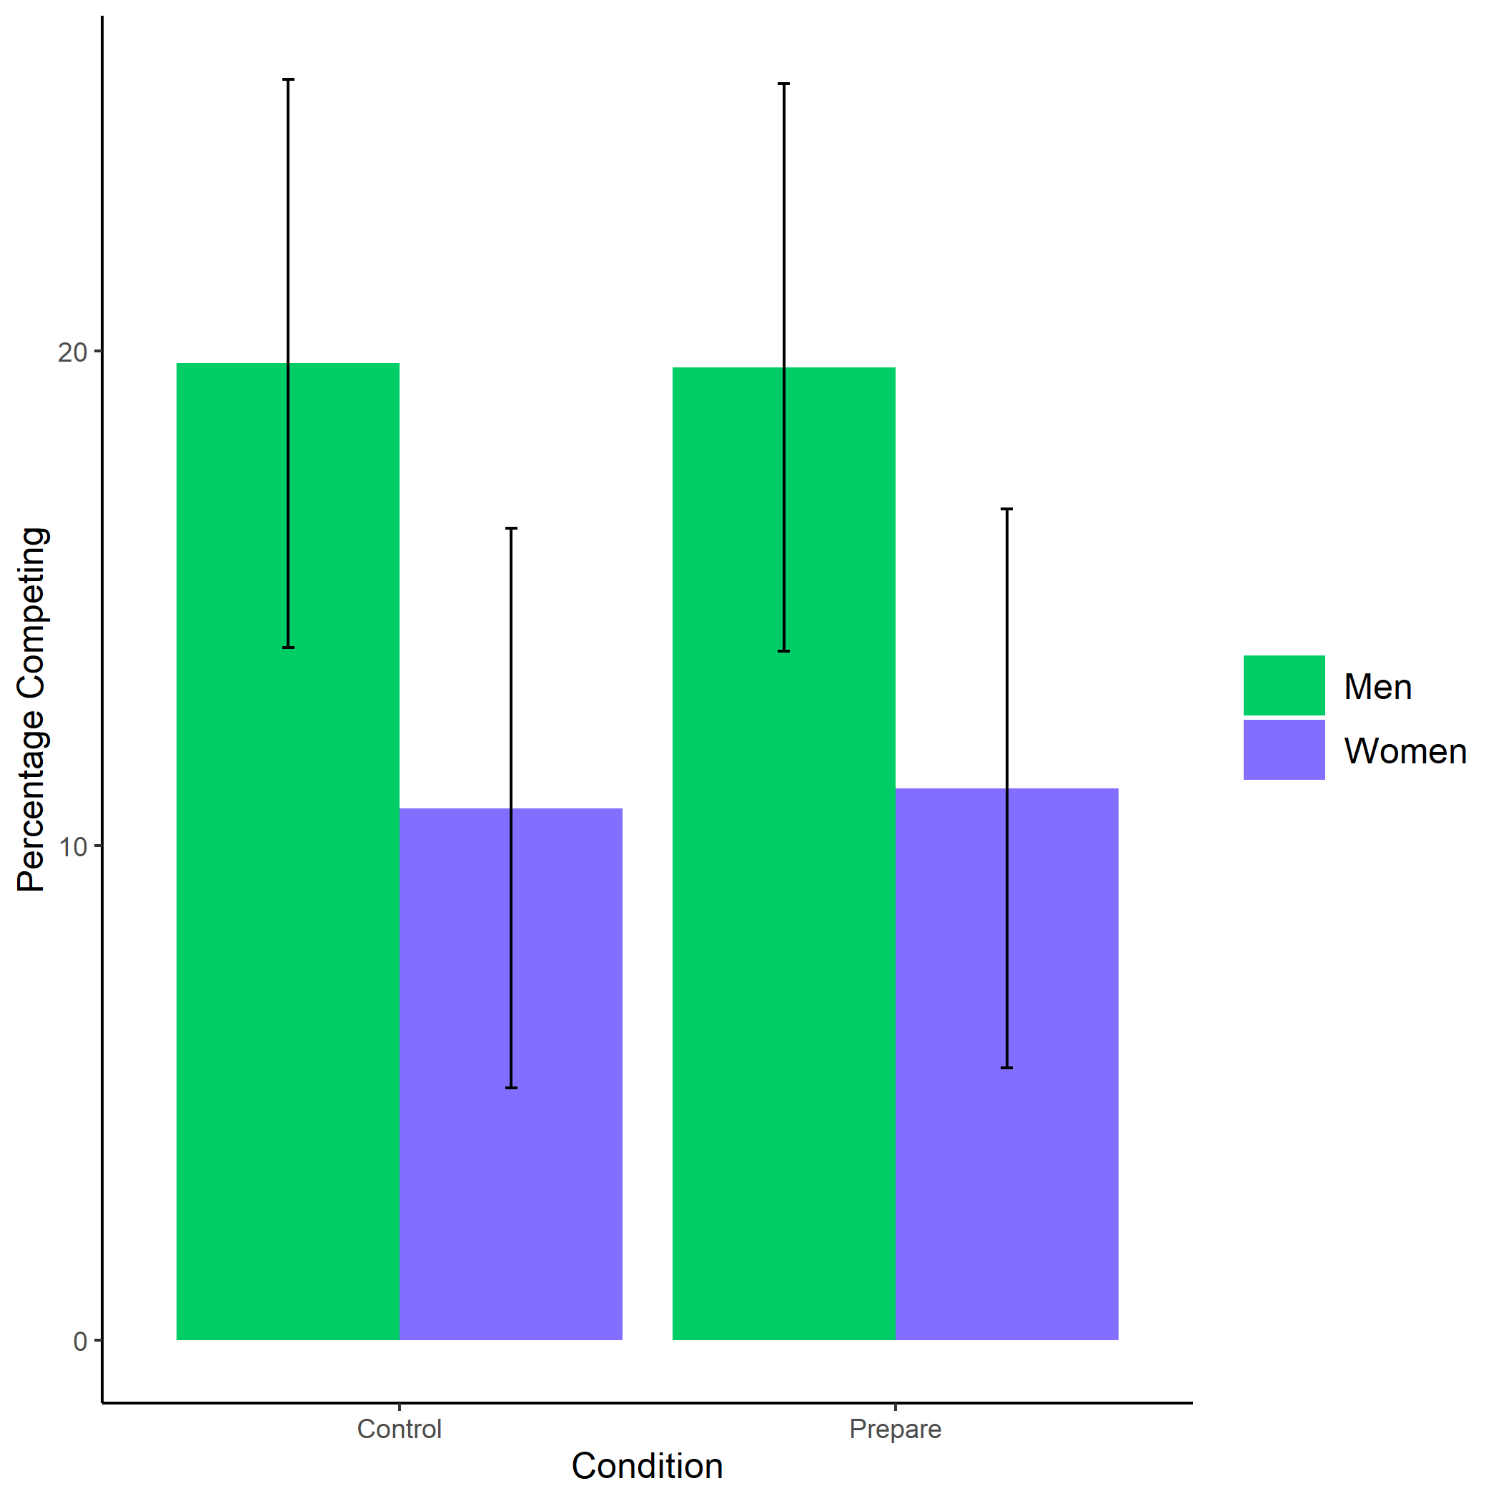

*Figure 1.1: Proportion of male and female participants who chose to compete by condition (XXX vs XXX) in Study X. We do not find evidence for the hypothesized interaction between gender and condition on the choice to compete, nor do we see a main effect of condition on the choice to compete. Error bars represent standard errors.*

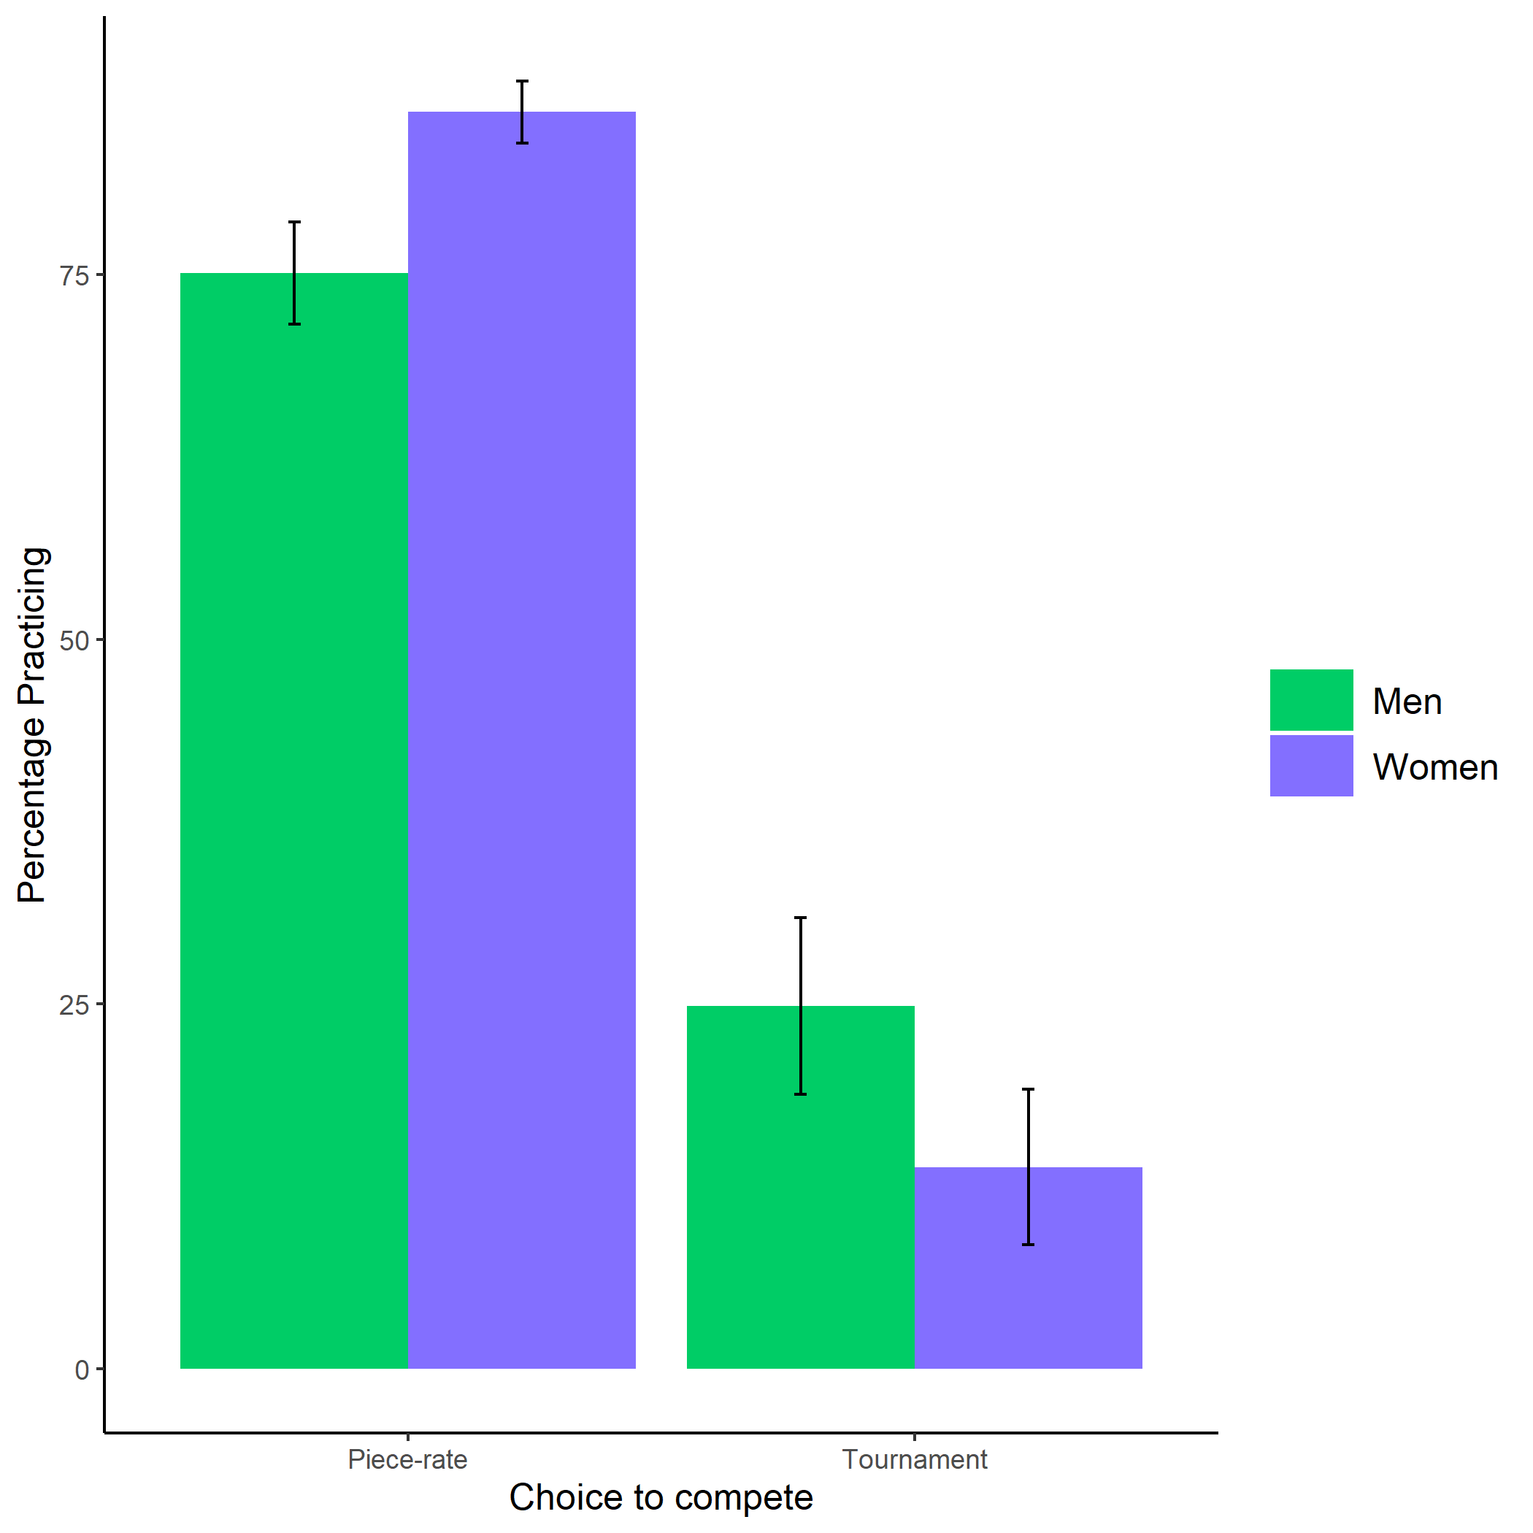

*Figure 1.2: Proportion of male and female participants in study X who chose to prepare by choice to compete. Women are significantly more willing to prepare, even before they know what the preparation involves. There is no interaction between gender and choice to compete on the decision to prepare. Error bars represent standard errors.*

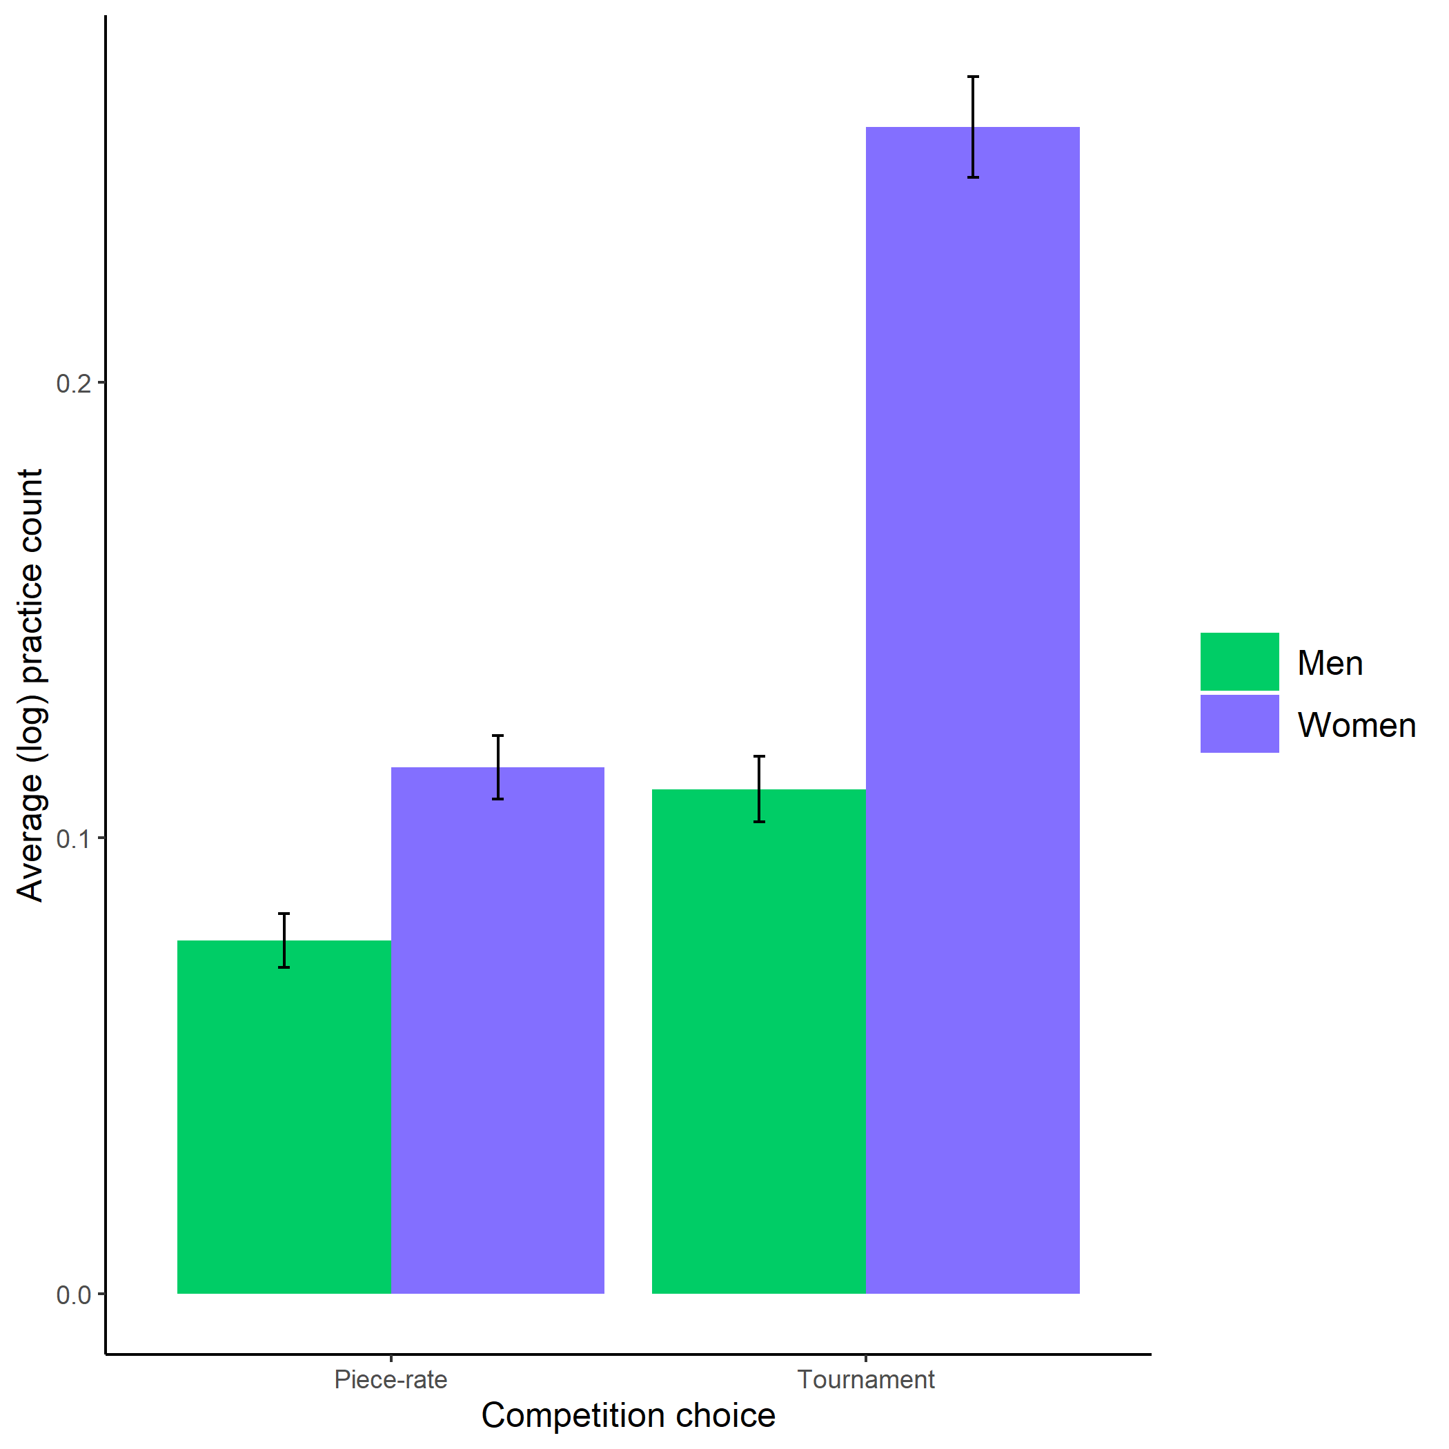

*Figure 1.3: Average (log-transformed) practice count based on participant gender and competition choice in study X. We find further evidence of a gender difference in the choice to prepare using a different metric of the choice to prepare: the number of times a participant chooses to persist in their practice effort by repeatedly practicing. Here, we find evidence of a significant interaction between gender and the choice to compete on the choice to practice, where women who chose to compete are significantly more likely to practice. However, the small size of this cell must be considered when interpreting this interaction. Future research is needed to ensure this effect replicates. Error bars represent standard errors.*

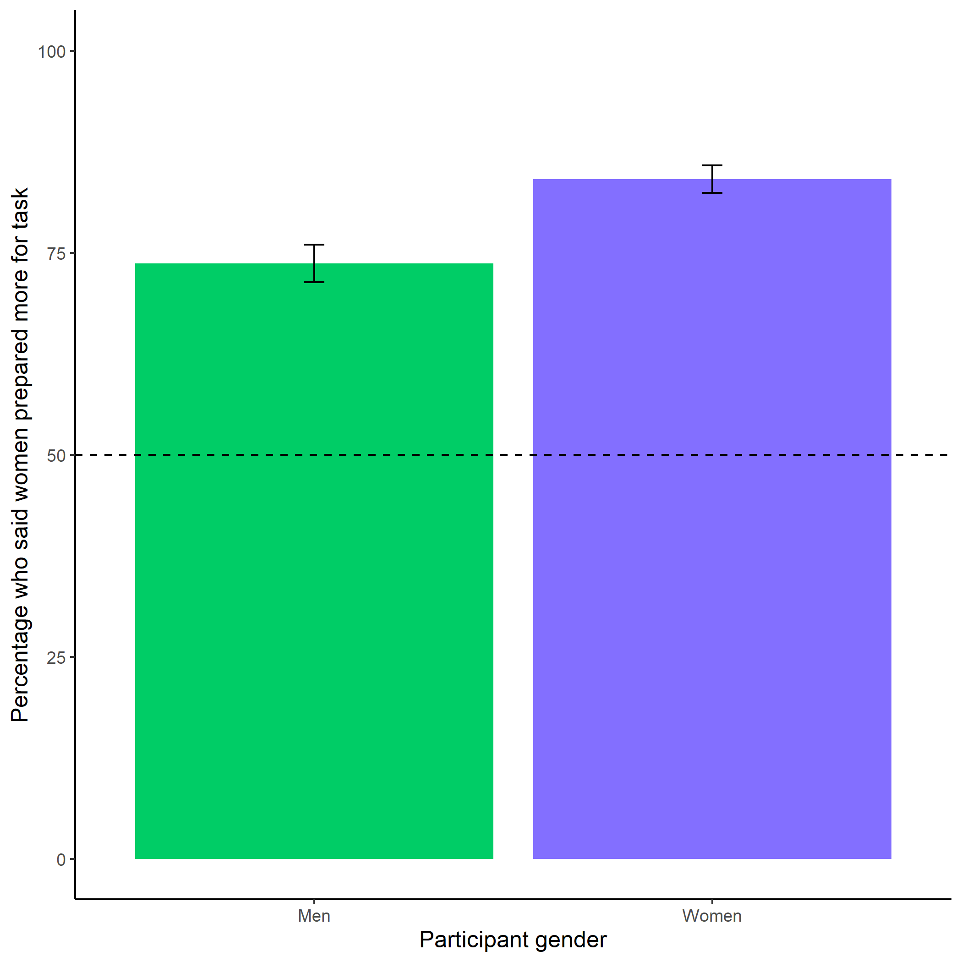

*Figure 1.4: Participants’ perceptions of gender differences in the choice to practice on the task in Study X. Both men and women correctly predict*  *that women will be more willing to practice before completing the multiplication task. Women are especially likely to state women will prepare more for the task. Error bars represent standard errors.*

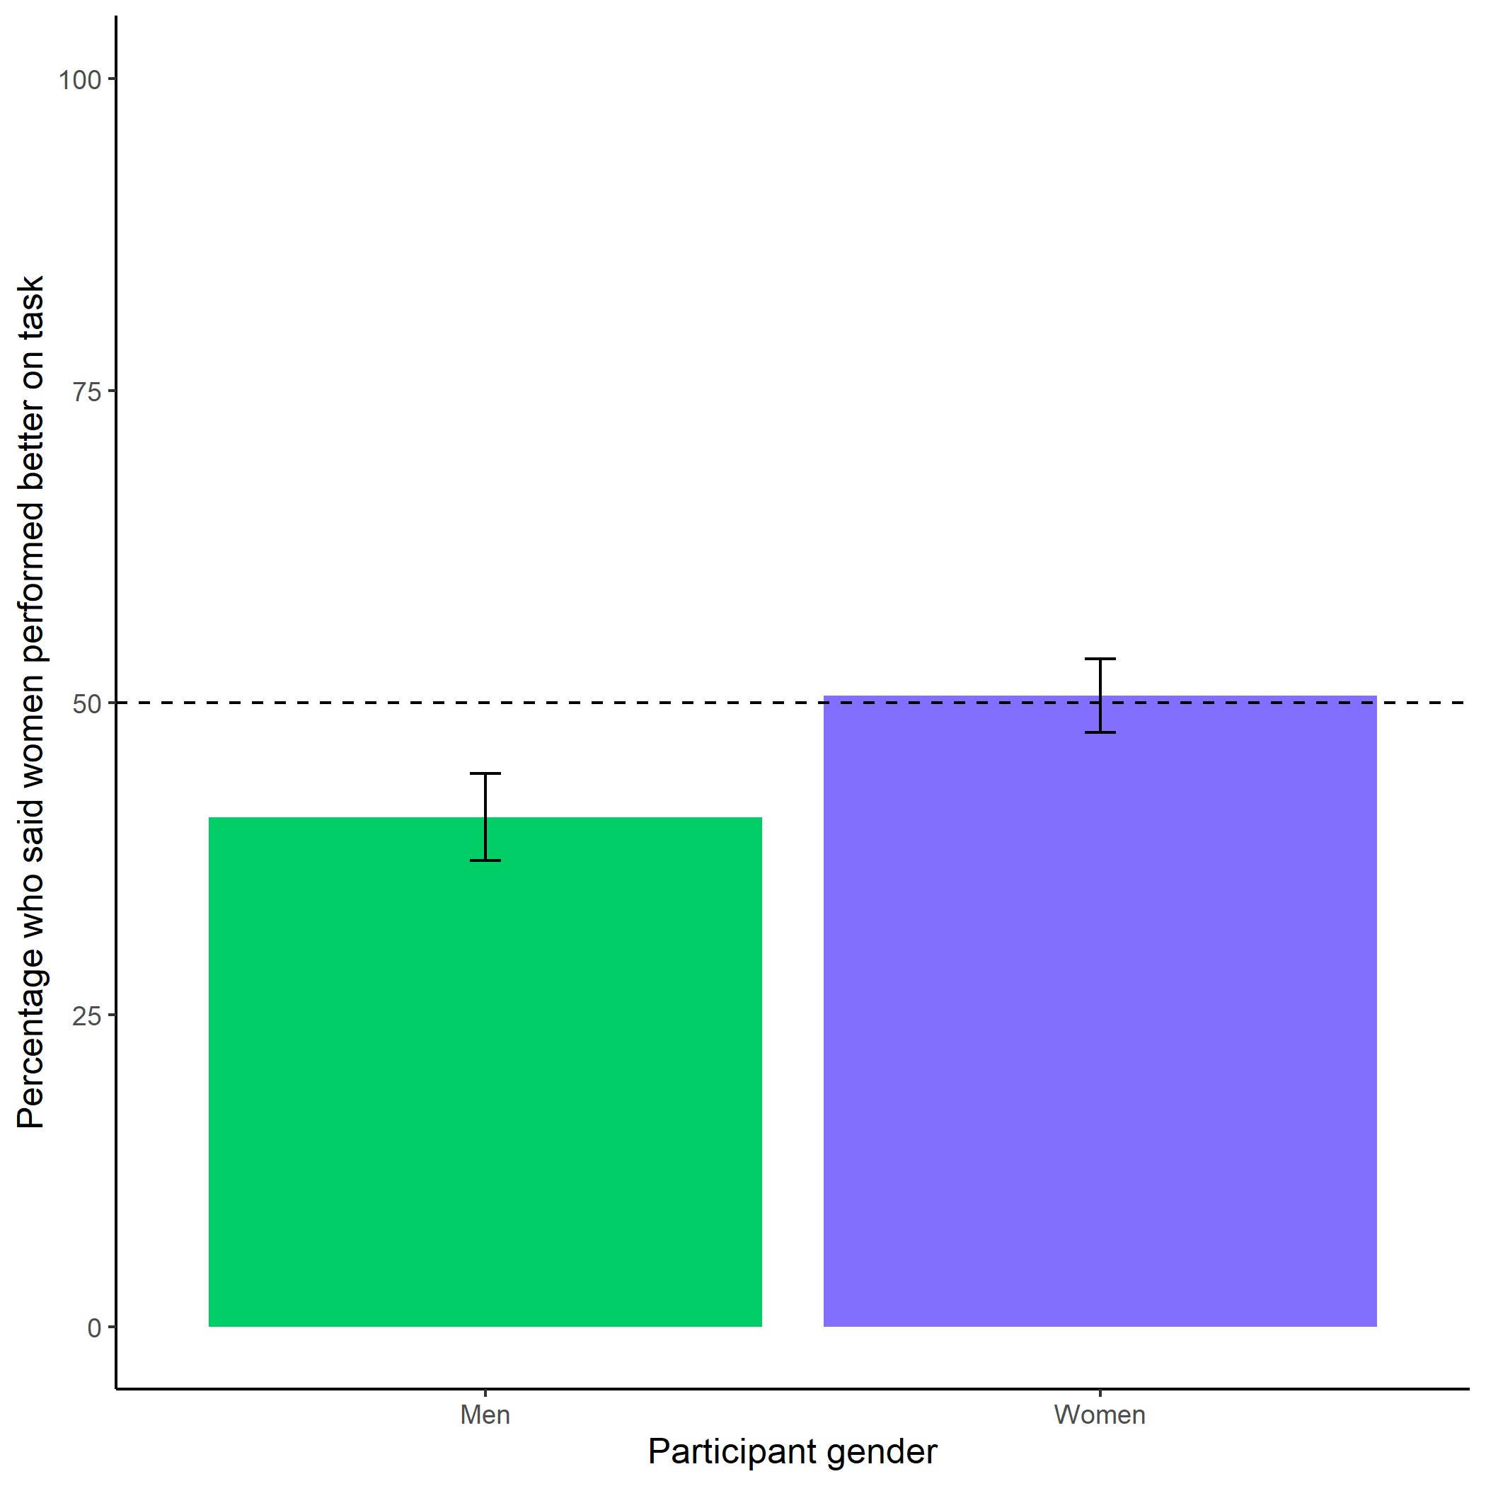

*Figure 1.5: Participants’ perceptions of gender differences in performance on the task in study x. Participants were equally likely to predict that women (vs. men) would perform better on the task, suggesting that participants did not have strong stereotypes about gender differences in performance on the multiplication task. Error bars represent standard errors.*

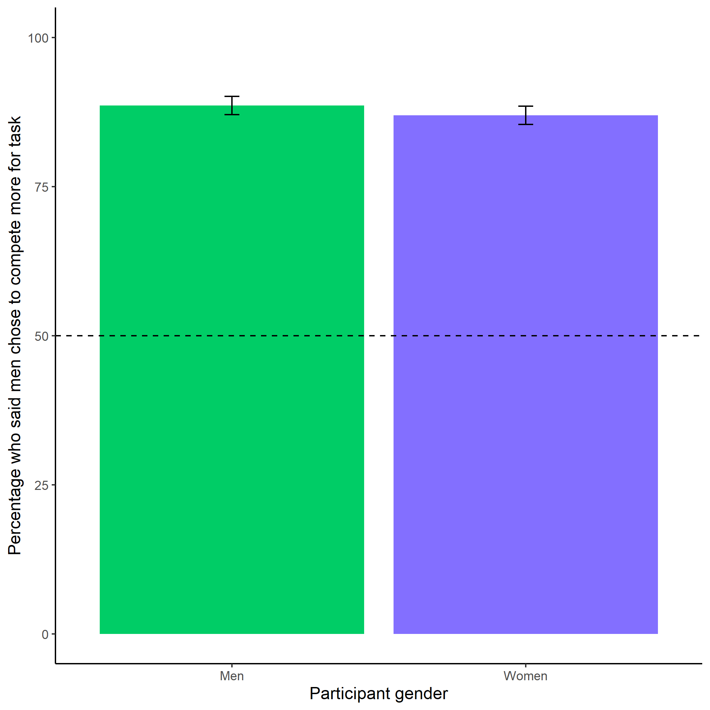

*Figure 1.6: Participants’ perceptions of gender differences in choice to compete in study x. Both men and women were significantly more likely than chance to correctly state that men would be more likely to choose to compete during the multiplication task, suggesting strong stereotypes about gender differences in competitiveness. Error bars represent standard errors.*

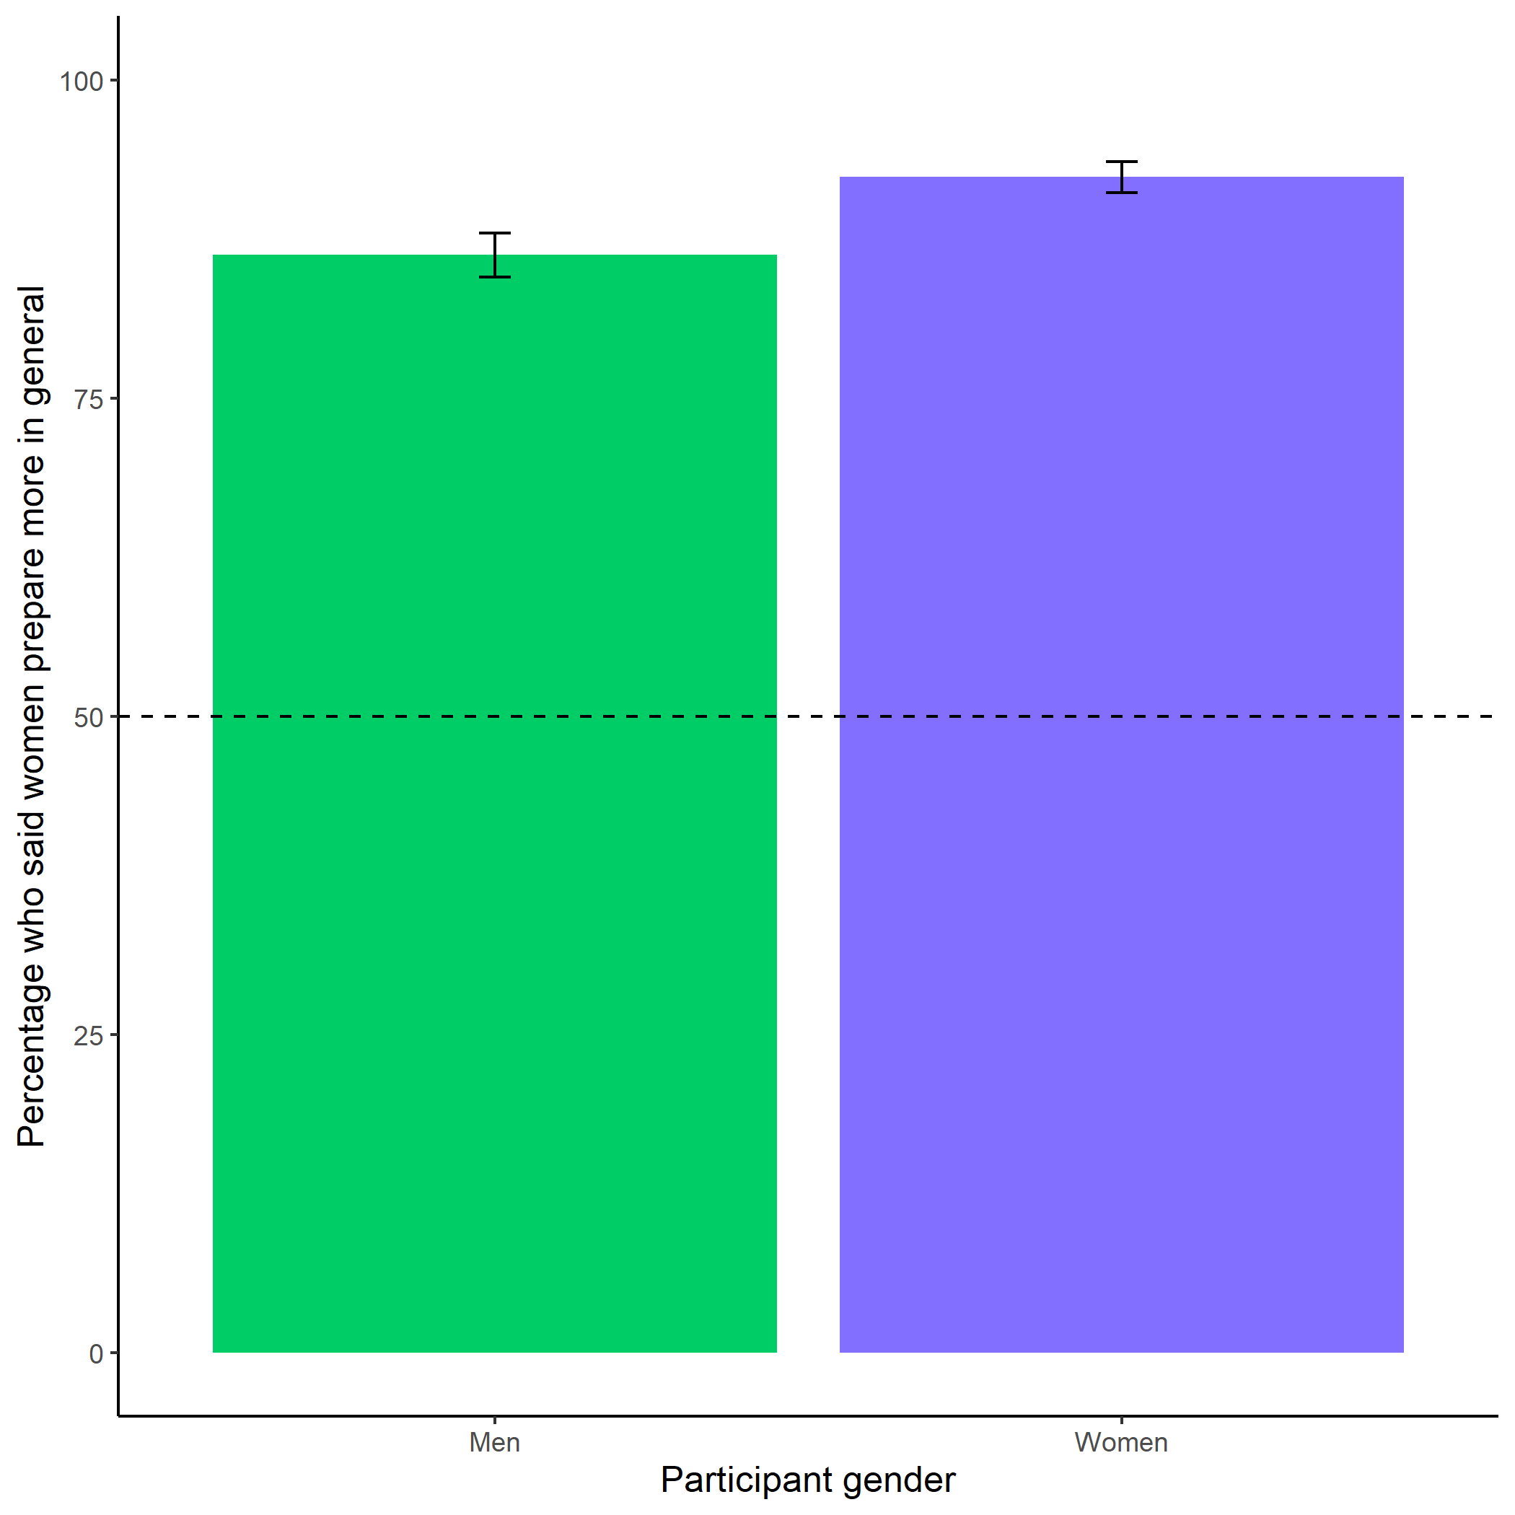

*Figure 1.7: Participants’ perceptions of general gender differences in choice to practice in study X. Both men and women (but especially women) were significantly more likely than chance to say that women prepare more in general than men. Again, these findings suggest that participants observe these gender differences directly or are aware of stereotypes about gender differences in the choice to prepare. Error bars represent standard errors.*

## 1.17 Study 2

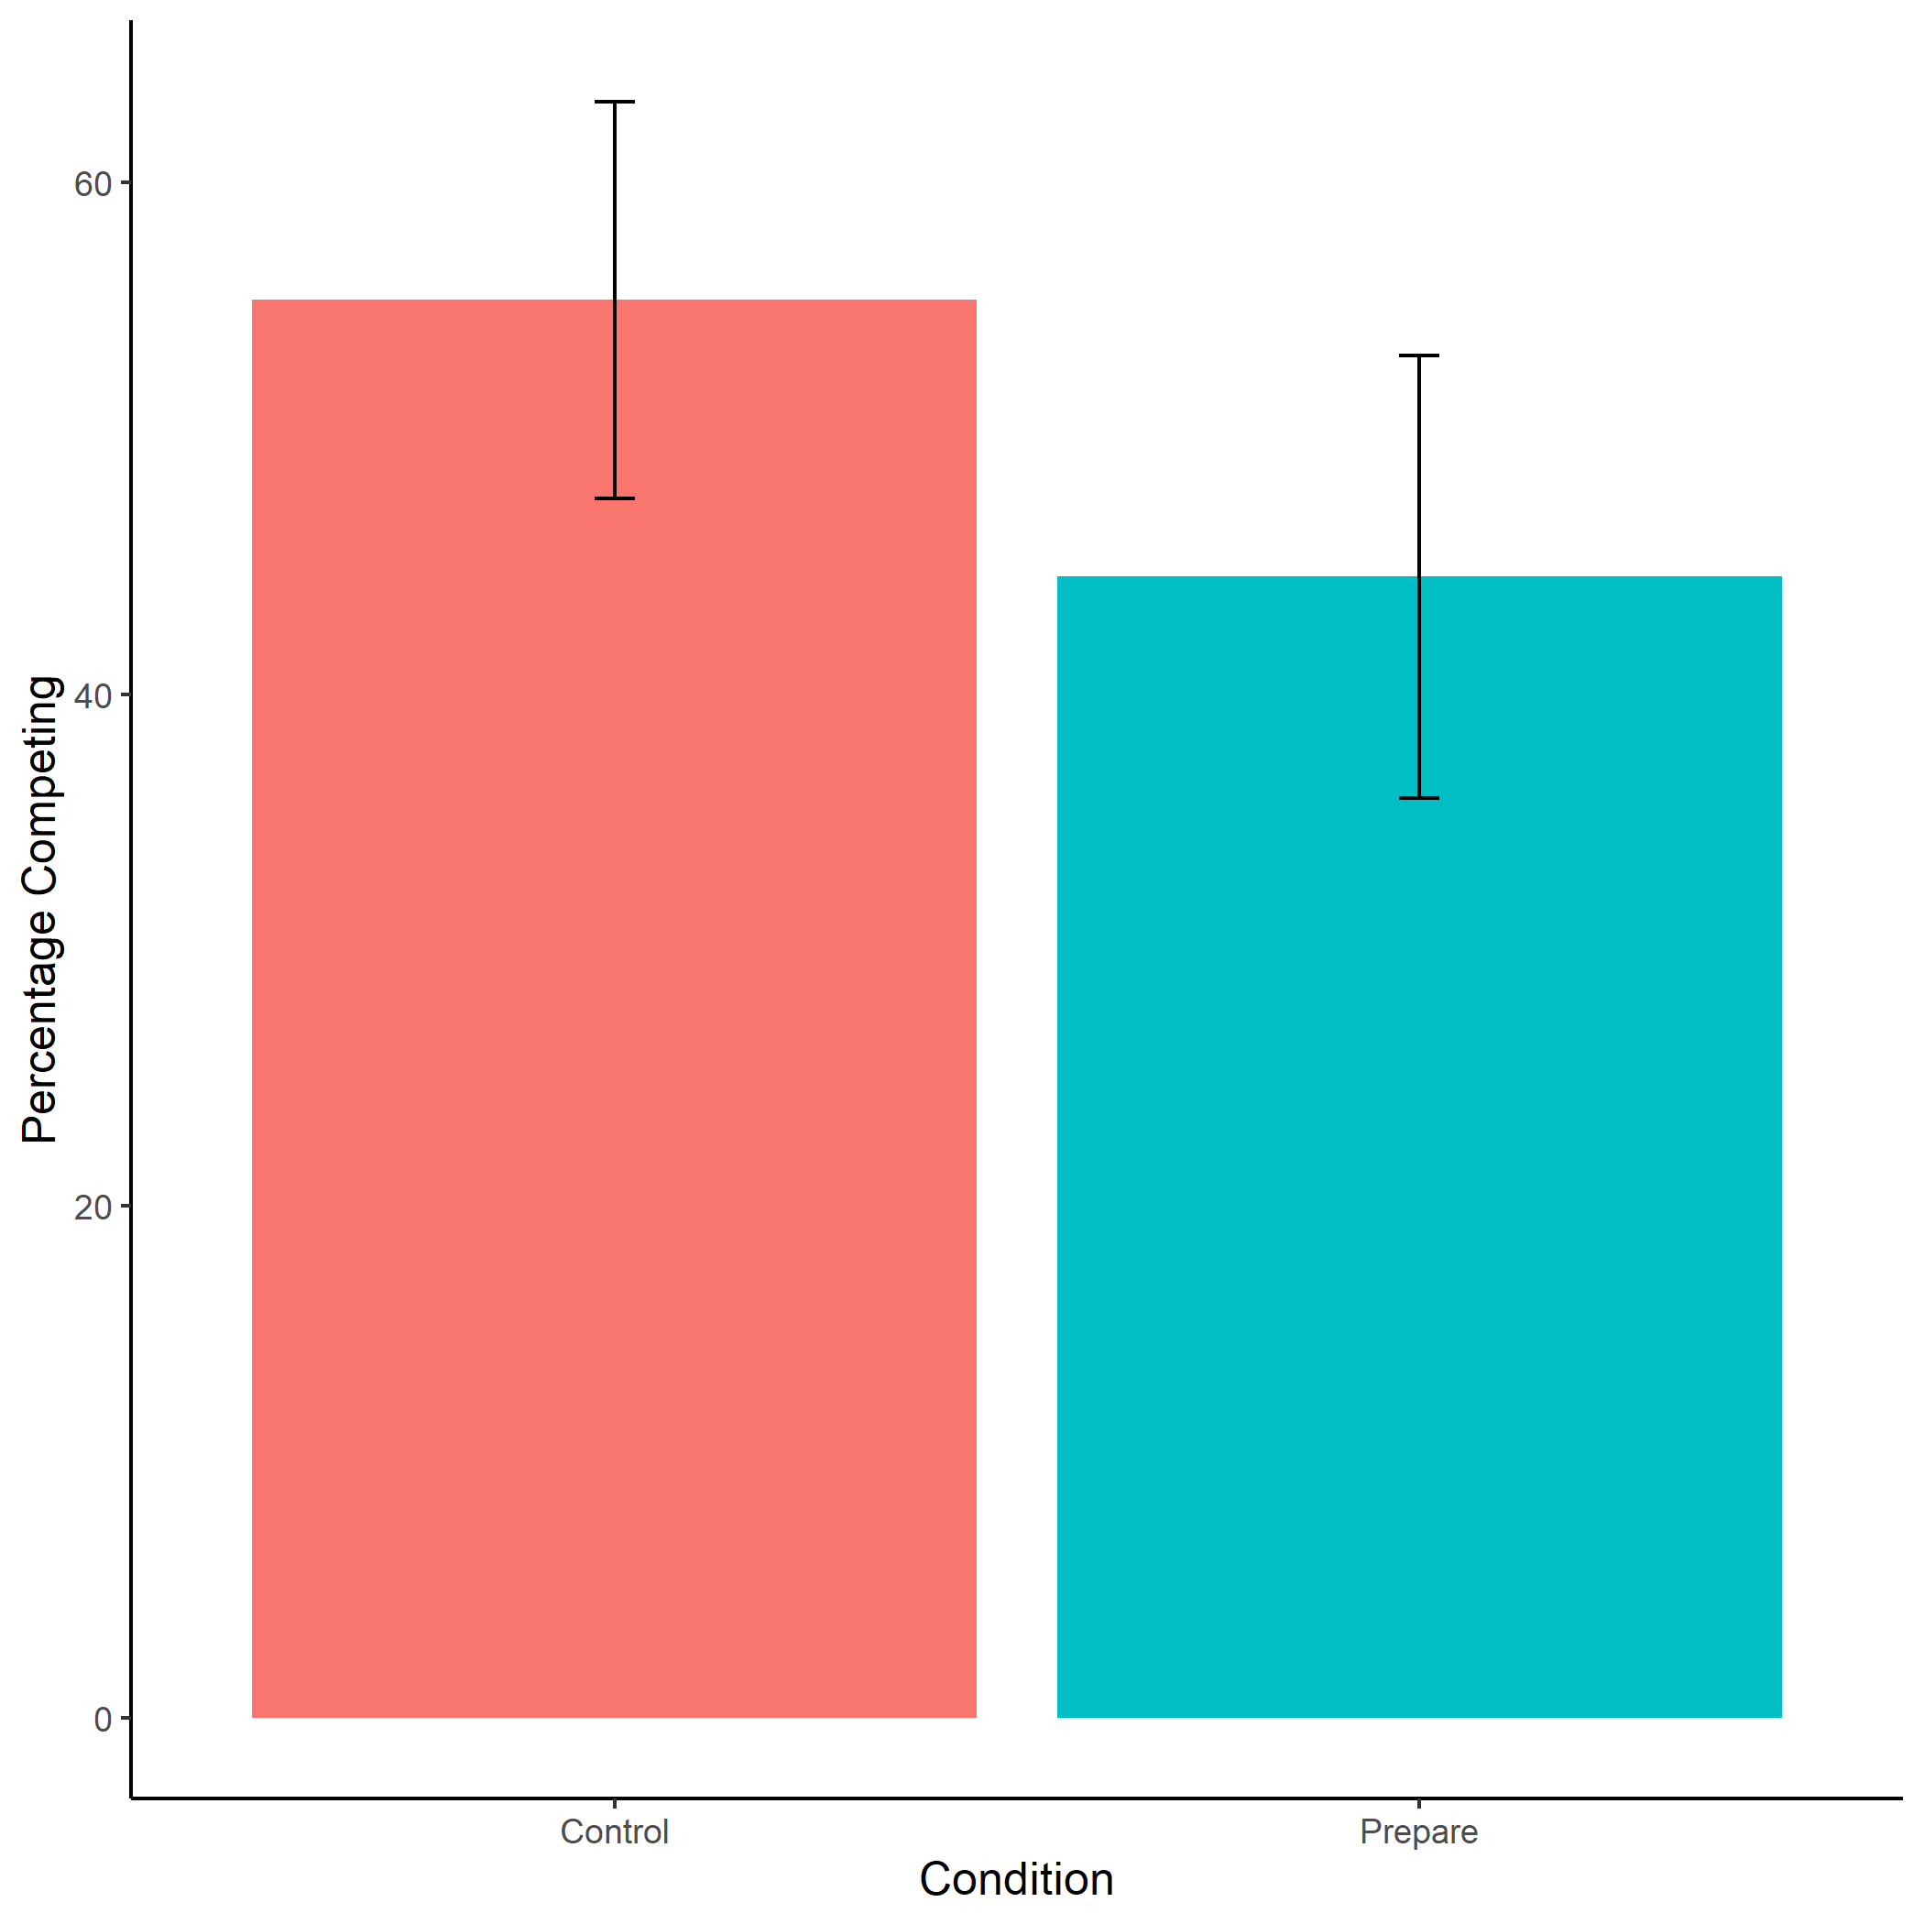

*Figure 1.8: Proportion of female participants who chose to compete by condition. We do not find evidence of the hypothesized effect of condition on the choice to compete, there were no significant differences in entry into competition between women in the control vs. prepare conditions. Error bars represent standard errors.*

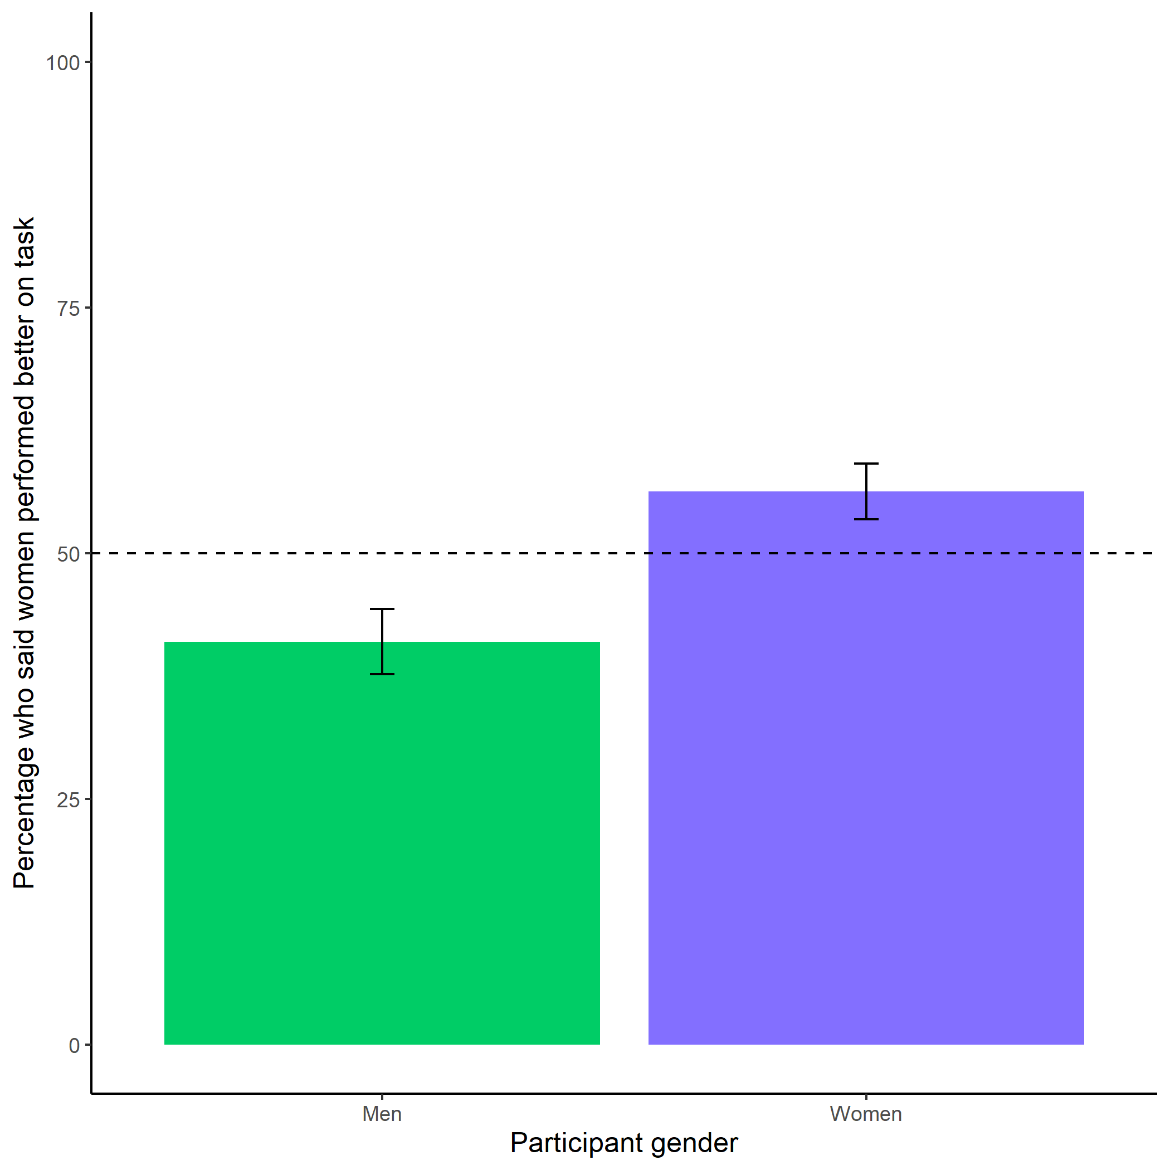

*Figure 1.9: Participants’ perceptions of gender differences in performance on the task. We replicate the effect from Study 1, where participants were not significantly more likely than chance to anticipate that one gender would perform better on the task. Error bars represent standard errors.*

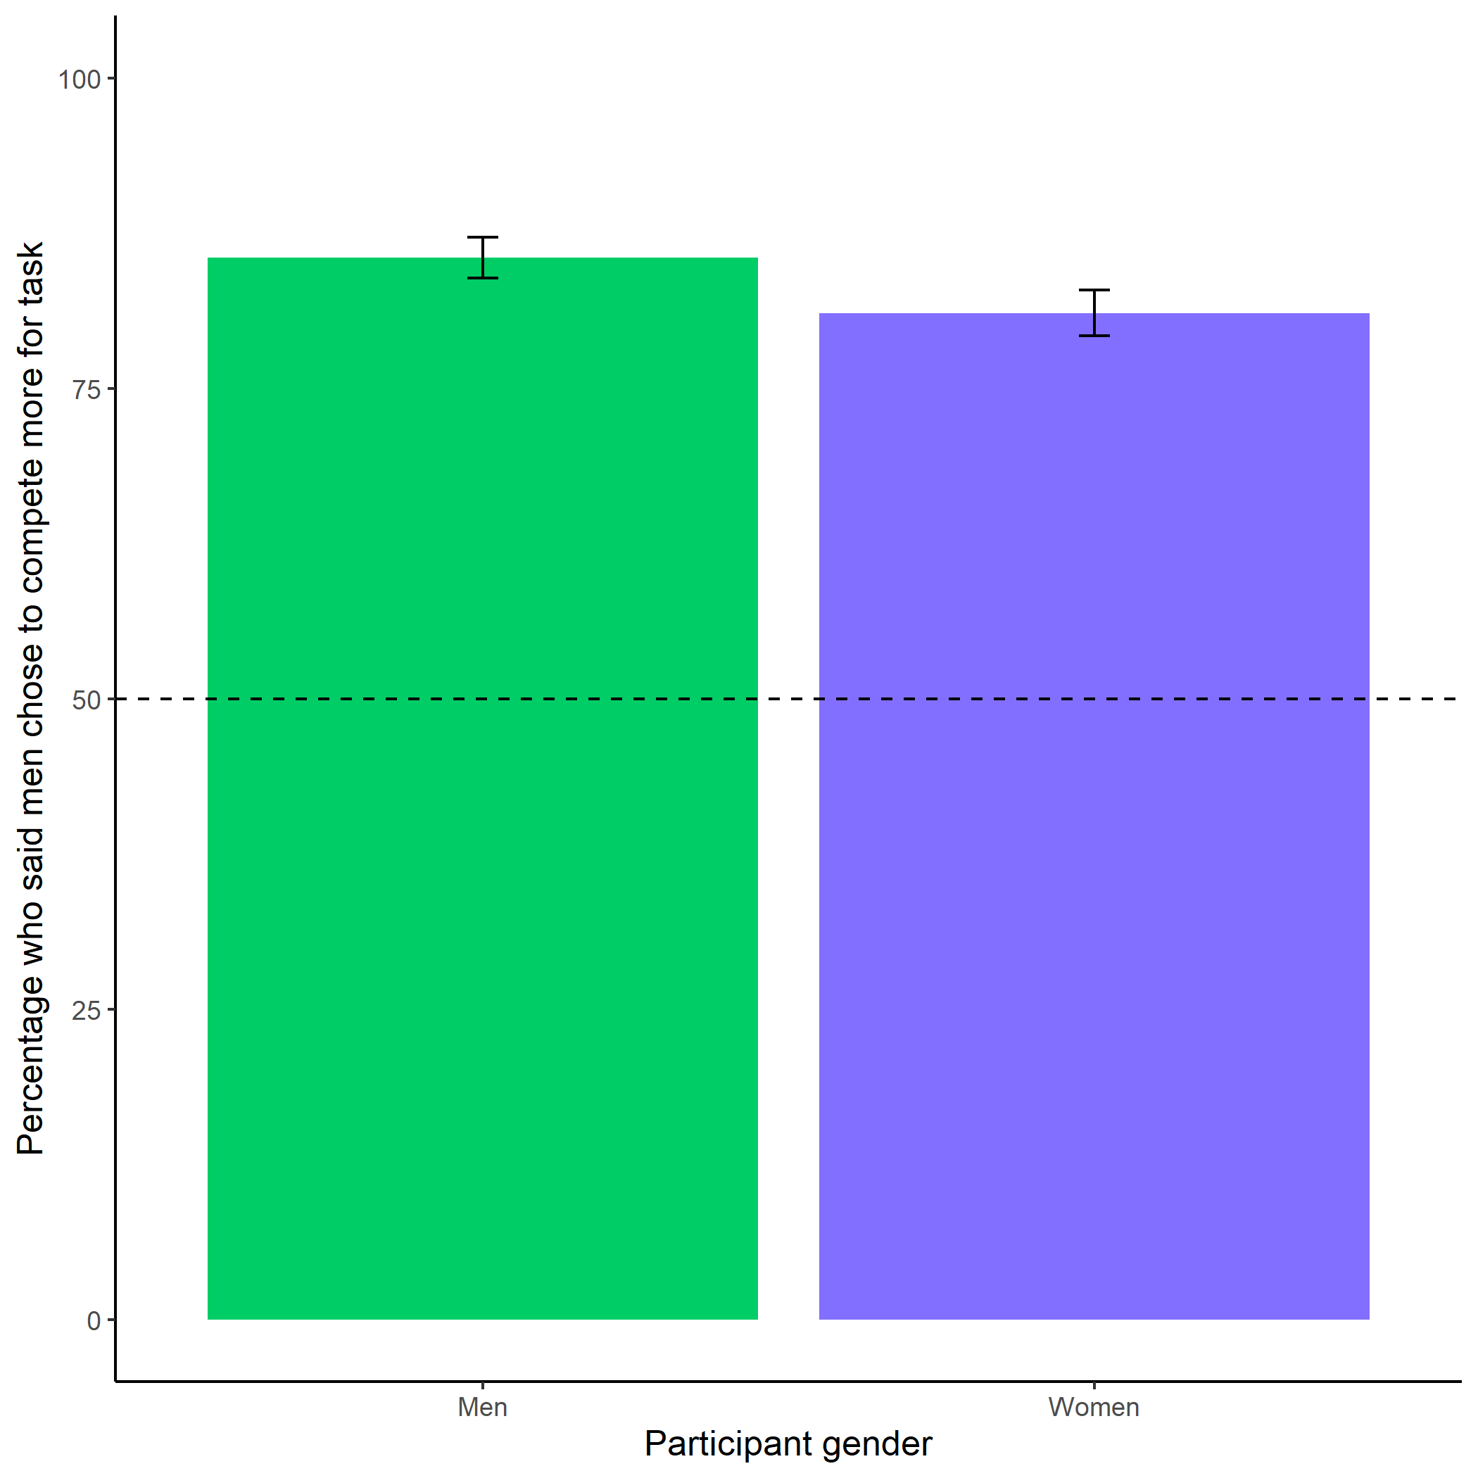

*Figure 1.10: Participants’ perceptions of gender differences in choice to compete. Replicating the finding from Study 1, participants (especially men) in Study 2 are significantly more likely than chance to state that men chose the competitive payment scheme. Error bars represent standard errors.*

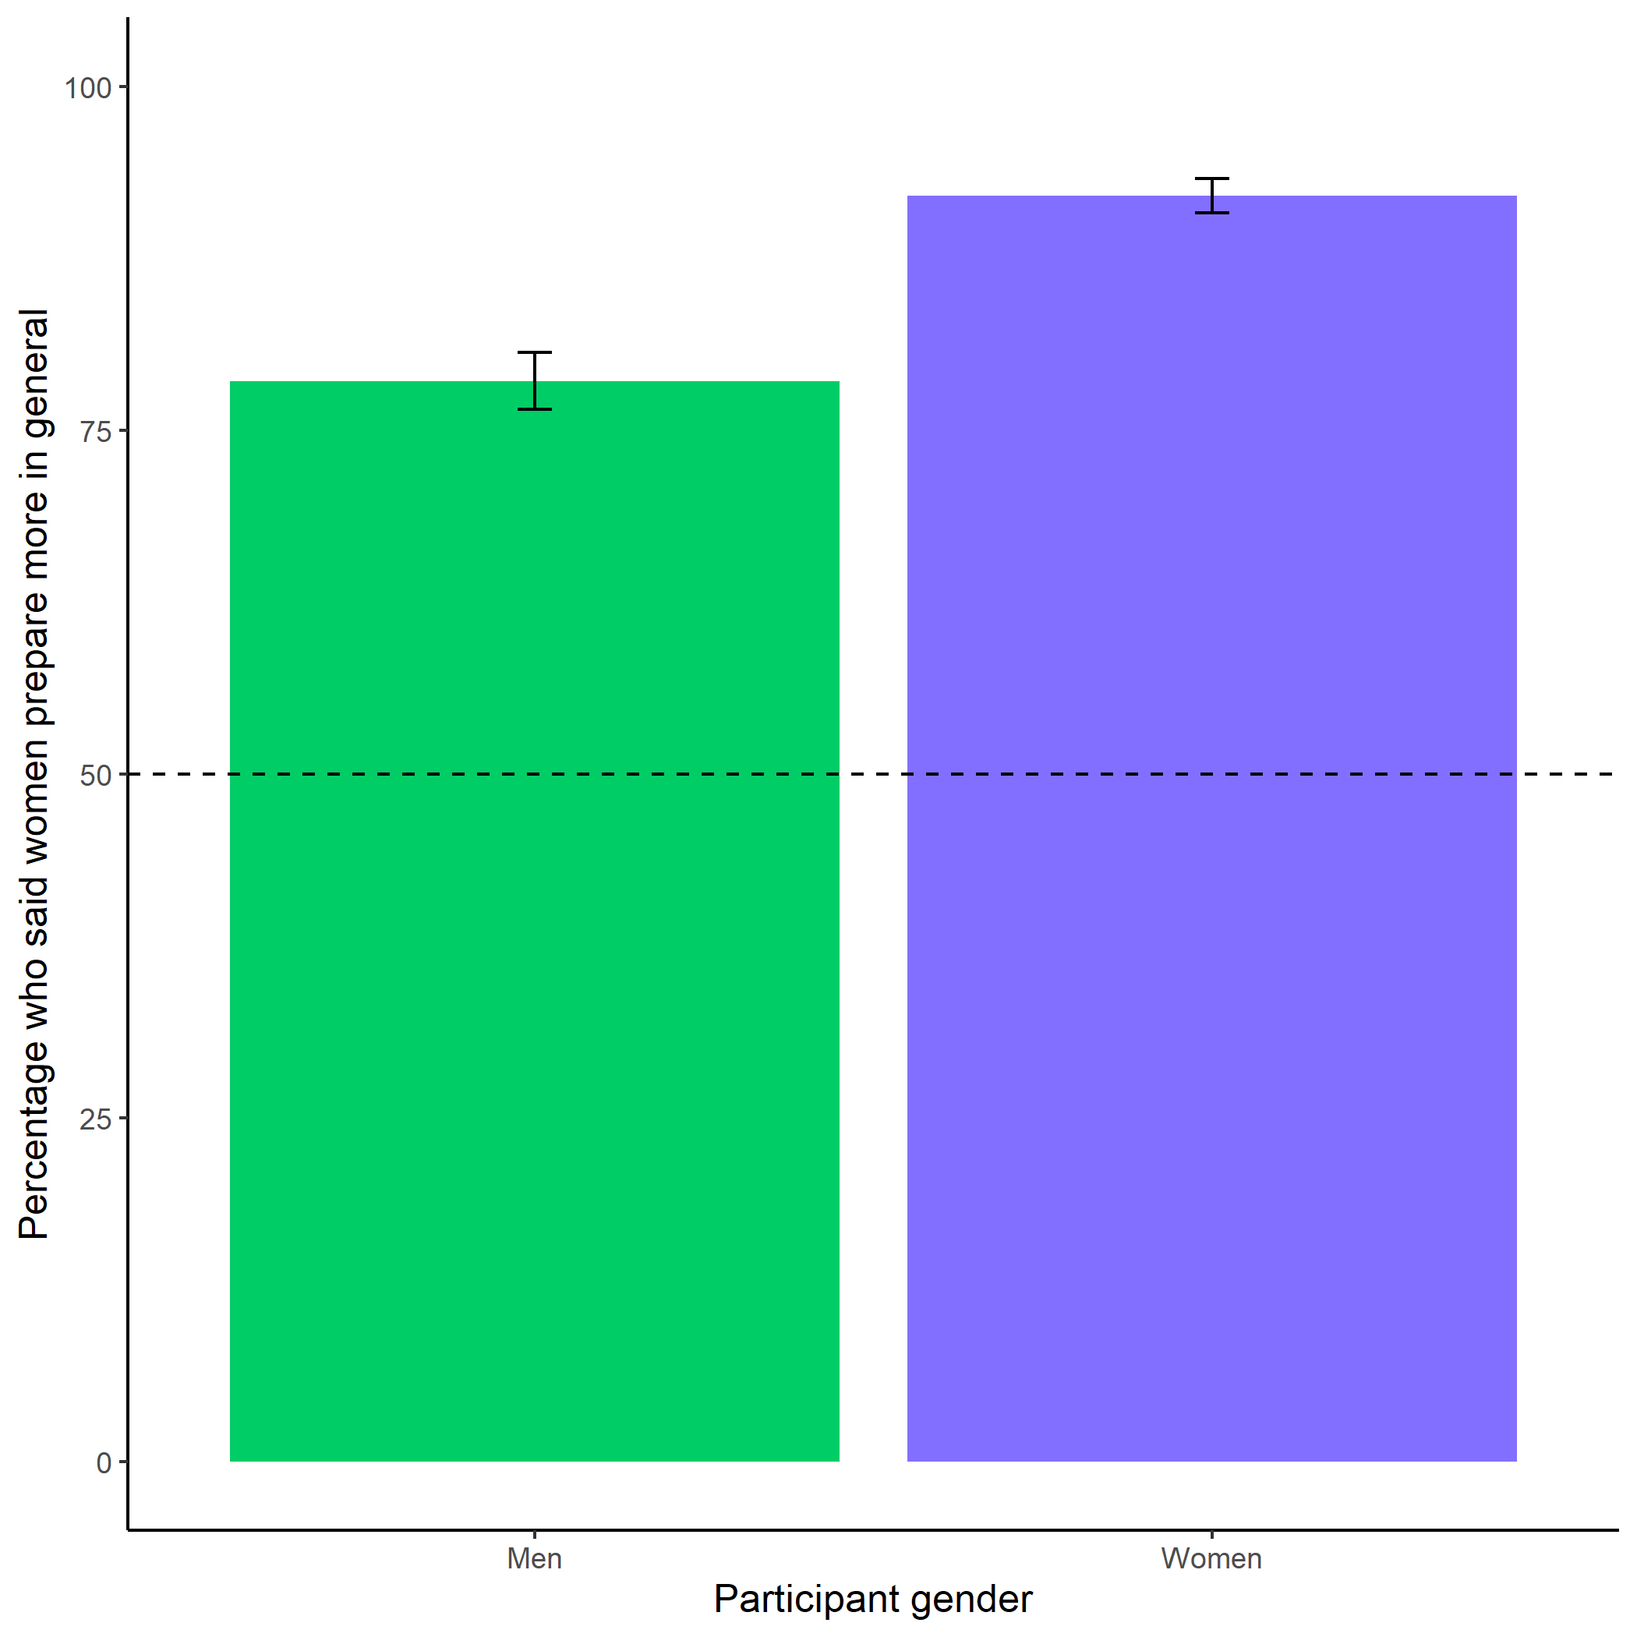

*Figure 1.11: Participants’ perceptions of general gender differences in choice to prepare. We replicate the findings from Study 1, where participants (especially women) are significantly more likely than chance to state that women prepare more in general than men. Error bars represent standard errors.*

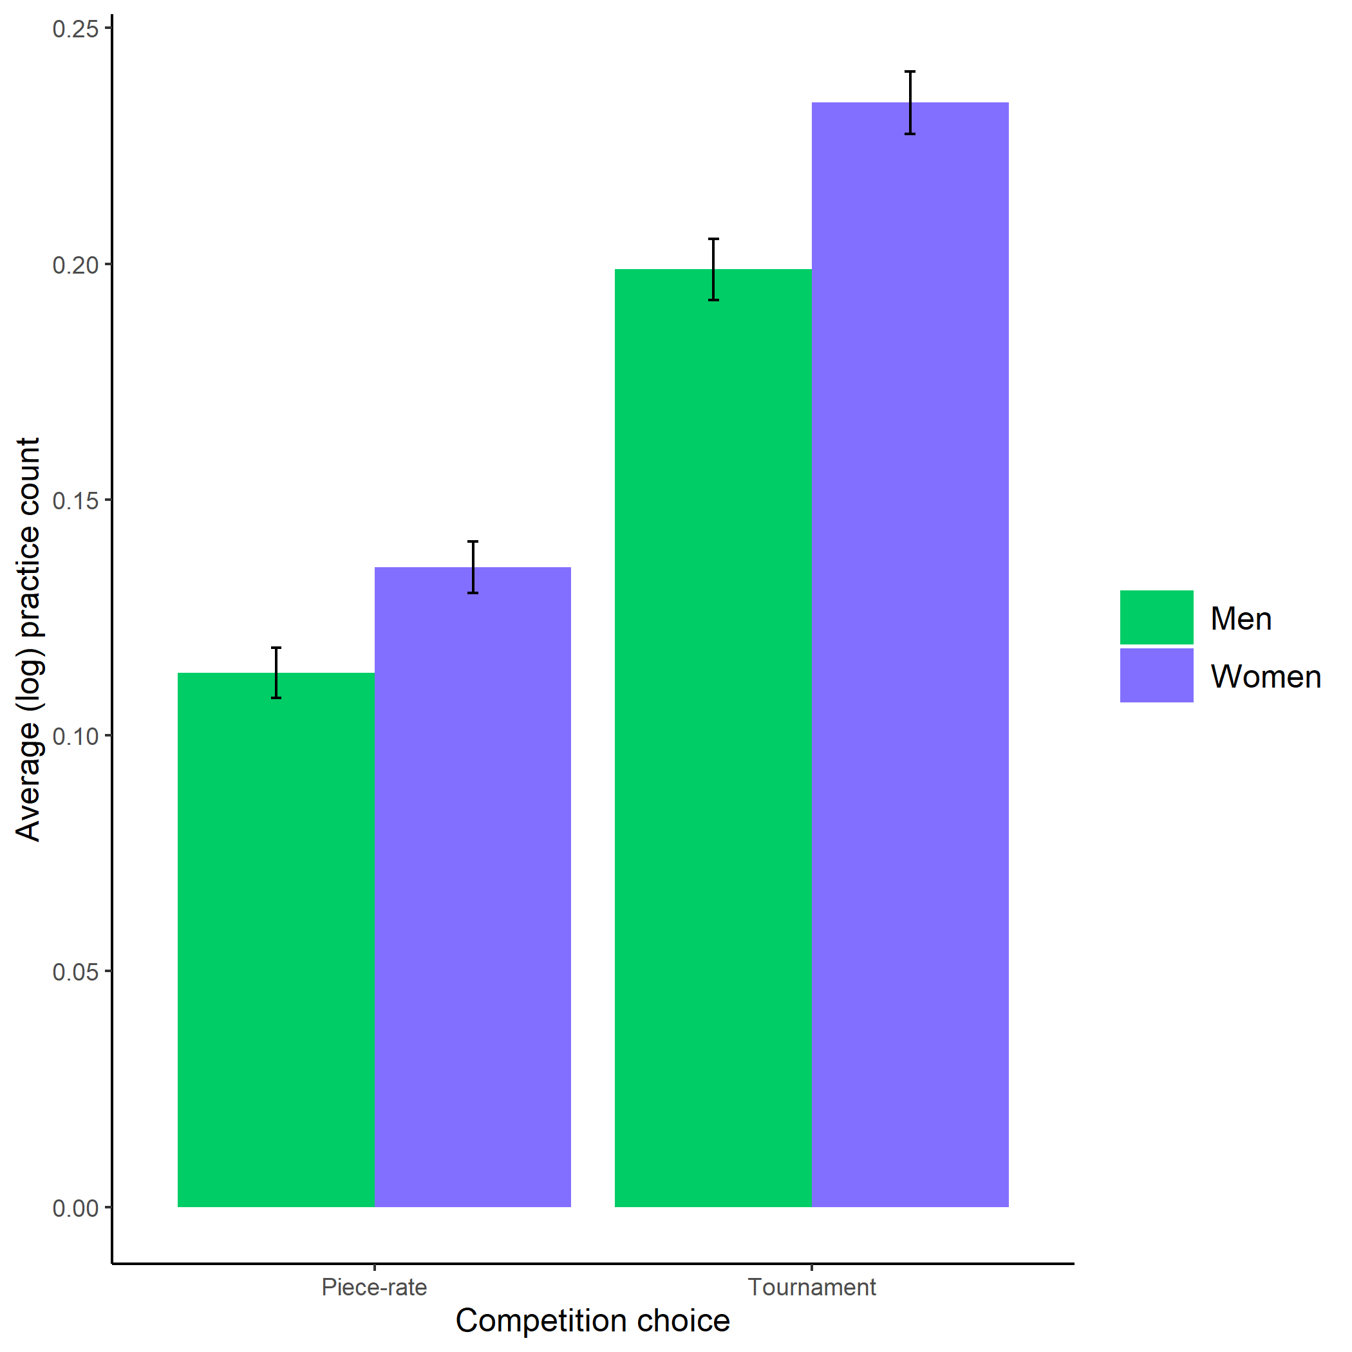

*Figure 1.12: Gender differences in the number of extra preparation rounds chosen across participants’ choice in a payment scheme. Here, we show that the gender gap in the choice to prepare is robust, even when half of the women are forced to prepare in the preparation condition. Error bars represent standard errors.*

## 1.18 Study 3

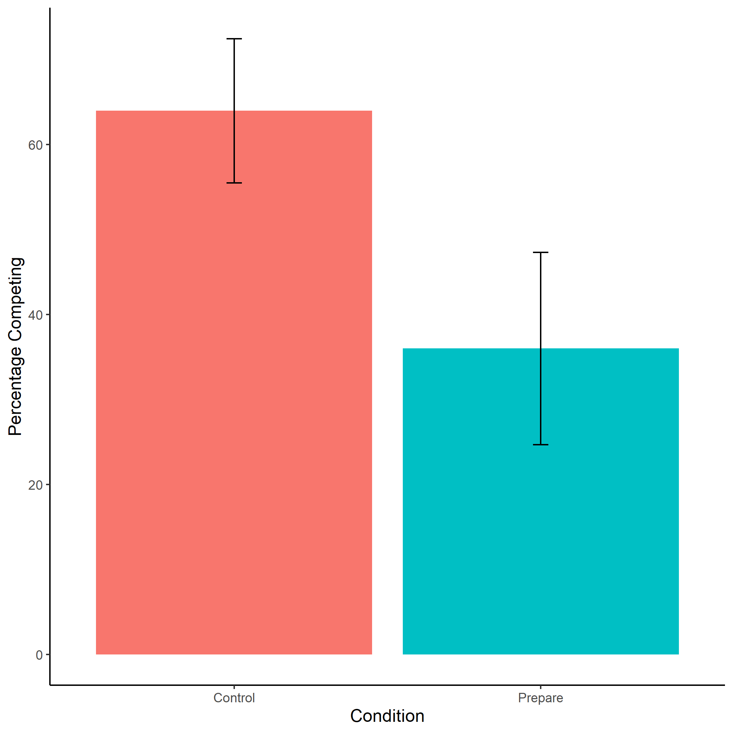

*Figure 1.13: Proportion of participants that identify as women who chose to compete by condition. We do not find evidence of the hypothesized effect of condition (XXX vs XXX) on the choice to compete. On the contrary, women in the control condition were significantly more likely to choose to compete than women in the preparation condition. Error bars represent standard errors.*

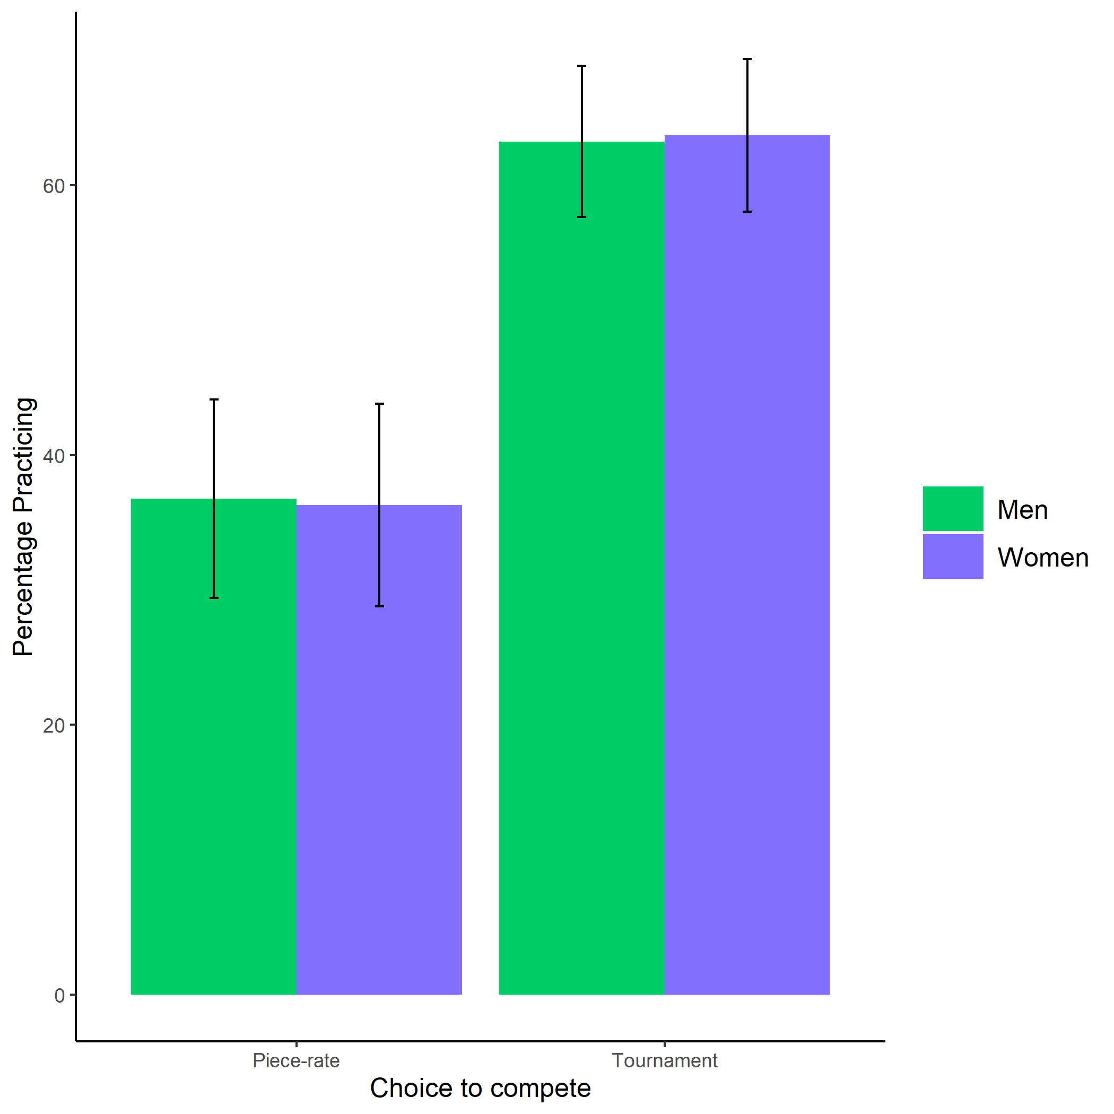

*Figure 1.14: Proportion of participants who chose to practice*  *by condition (XXX vs XXX) and gender. We do not find evidence of the hypothesized interaction effect between condition and gender on the choice to prepare* *. Error bars represent standard errors.*

Akerlof, George A., and Rachel E. Kranton. 2000. “Economics and identity.” *The Quarterly Journal of Economics* 115 (3): 715–53.

Andersen, Steffen, Seda Ertac, Uri Gneezy, John A List, and Sandra Maximiano. 2013. “Gender, competitiveness, and socialization at a young age: Evidence from a matrilineal and a patriarchal society.” *Review of Economics and Statistics* 95 (4): 1438–43.

Apicella, Coren L., Alyssa N. Crittenden, and Victoria A. Tobolsky. 2017. “Hunter-gatherer males are more risk-seeking than females, even in late childhood.” *Evolution and Human Behavior* 38: 592–603.

Apicella, Coren L., Elif E. Demiral, and Johanna Mollerstrom. 2017. “No gender difference in willingness to compete when competing against self.” *DIW Discussion Papers*.

———. 2020. “Compete with others? No, thanks. With myself? Yes, please !” *Economic Letters* 187: 1–3.

Apicella, Coren L., and Anna Dreber. 2015. “Sex differences in competitiveness: Hunter-gatherer women and girls compete less in gender-neutral and male-centric tasks.” *Adaptive Human Behavior and Physiology* 1 (3): 247–69. <https://doi.org/10.1007/s40750-014-0015-z>.

Babcock, Linda, Hannah Riley Bowles, and Julia Bear. 2012. “A model of when to negotiate: Why women don’t ask.” In *The Oxford Handbook of Economic Conflict Resolution*, 313–31. <https://doi.org/10.1093/oxfordhb/9780199730858.013.0022>.

Bandura, Albert, Nancy E Adams, and Janice Beyer. 1977. “Cognitive processes mediating behavioral change.” *Journal of Personality and Social Psychology* 35 (3): 125–39.

Barber, Brad M., and Terrance Odean. 2001. “Boys will be boys: Gender, overconfidence, and common stock investment.” *The Quarterly Journal of Economics* 116 (1): 261–92.

Benjamin, Daniel J., James J. Choi, and A. Joshua Strickland. 2010. “Social identity and preferences.” *American Economic Review* 100 (4): 1913–28. <https://doi.org/10.1257/aer.100.4.1913>.

Berge, Lars Ivar Oppedal, Kjetil Bjorvatn, Armando Jose Garcia Pires, and Bertil Tungodden. 2015. “Competitive in the lab, successful in the field?” *Journal of Economic Behavior and Organization* 118: 303–17. <https://doi.org/10.1016/j.jebo.2014.11.014>.

Bertrand, Marianne. 2010. “New Perspectives on Gender.” In *Handbook of Labor Economics*, 4b:1545–92.

Bertrand, Marianne, Claudia Goldin, and Lawrence F. Katz. 2010. “Dynamics of the gender gap for young professionals in the financial and corporate sectors.” *American Economic Review* 2 (3): 228–55.

Bertrand, Marianne, and Kevin F Hallock. 2001. “The gender gap in top corporate jobs.” *Industrial and Labor Relations Review* 55: 3–21.

Bertrand, Marianne, Emir Kamenica, and Jessica Pan. 2015. “Gender identity and relative income within households.” *Quarterly Journal of Economics*, 571–614. <https://doi.org/10.1093/qje/qjv001.Advance>.

Beyer, Sylvia. 1990. “Gender differences in the accuracy of self-evaluations of performance.” *Journal of Personality and Social Psychology* 59 (5): 960–70. <https://doi.org/10.1037/0022-3514.59.5.960>.

Beyer, Sylvia, and Edward M. Bowden. 1997. “Gender differences in self-perceptions: Convergent evidence from three measures of accuracy and bias.” *Personality and Social Psychology Bulletin* 23 (2): 157–72.

Bjorvatn, Kjetil, Ranveig Falch, and Ulrikke Hernæs. 2016. “Gender, context and competition: Experimental evidence from rural Uganda.” *Journal of Behavioral and Experimental Economics* 61: 31–37.

Blau, Francine D., and Lawrence M Kahn. 2017. “The gender wage gap: Extent, trends, and explanations.” *Journal of Economic Literature* 55 (3): 789–865. <https://doi.org/10.1257/jel.20160995>.

Boschini, Anne, Anna Dreber, Emma Von Essen, Astri Muren, and Eva Ranehill. 2019. “Gender, risk preferences and willingness to compete in a random sample of the Swedish population.” *Journal of Behavioral and Experimental Economics* 83 (September): 101467. <https://doi.org/10.1016/j.socec.2019.101467>.

Boschini, Anne, Anna Dreber, Emma von Essen, Astri Muren, and Eva Ranehill. 2014. “Gender and economic preferences in a large random and representative sample.” *SSRN Electronic Journal*. <https://doi.org/10.2139/ssrn.2443315>.

Bowles, Hannah Riley, Linda Babcock, and Lei Lai. 2007. “Social incentives for gender differences in the propensity to initiate negotiations: Sometimes it does hurt to ask.” *Organizational Behavior and Human Decision Processes* 103: 84–103. <https://doi.org/10.1016/j.obhdp.2006.09.001>.

Buser, Thomas, Muriel Niederle, and Hessel Oosterbeek. 2014. “Gender, competition and career choices.” *The Quarterly Journal of Economics* 129 (3): 1409–47. <https://doi.org/10.1093/qje/qju009.Advance>.

Buser, Thomas, Noemi Peter, and Stefan C Wolter. 2017. “Gender, competitiveness, and study choices in high school: Evidence from Switzerland.” *American Economic Review: Papers & Proceedings* 107 (5): 125–30.

Charness, Gary, and Uri Gneezy. 2012. “Strong Evidence for Gender Differences in Risk Taking.” *Journal of Economic Behavior and Organization* 83 (1): 50–58. <https://doi.org/10.1016/j.jebo.2011.06.007>.

Croson, Rachel, and Uri Gneezy. 2009. “Gender differences in preferences.” *Journal of Economic Literature* 47 (2): 448–74. <https://doi.org/10.1257/jel.47.2.448>.

Datta Gupta, Nabanita, Anders Poulsen, and Marie Claire Villeval. 2013. “Gender matching and competitiveness: Experimental evidence.” *Economic Inquiry* 51 (1): 816–35. <https://doi.org/10.1111/j.1465-7295.2011.00378.x>.

Dohmen, Thomas, and Armin Falk. 2011. “Performance pay and multidimensional sorting: Productivity, preferences, and gender.” *American Economic Association* 101 (2): 556–90. https://doi.org/<http://dx.doi.org/10.1016/j.poly.2014.08.015>.

Dohmen, Thomas, Armin Falk, David Huffman, Uwe Sunde, Jürgen Schupp, and Gert G. Wagner. 2011. “Individual risk attitudes: Measurement, determinants, and behavioral consequences.” *Journal of the European Economic Association* 9 (3): 522–50. <https://doi.org/10.1111/j.1542-4774.2011.01015.x>.

Dreber, Anna, Emma Von Essen, and Eva Ranehill. 2011. “Outrunning the gender gap — boys and girls compete equally.” *Experimental Economics* 14 (4): 567–82. <https://doi.org/10.1007/s10683-011-9282-8>.

———. 2014. “Gender and competition in adolescence: Task matters.” *Experimental Economics* 17: 154–72. <https://doi.org/10.1007/s10683-013-9361-0>.

Eckel, Catherine C, and Philip J Grossman. 2008. “Men, women, and risk aversion: Experimental evidence.” In *Handbook of Experimental Economics*, 1:1061–73. <https://doi.org/10.1016/S1574-0722(07)00113-8>.

Frick, Bernd. 2011. “Gender differences in competitiveness: Empirical evidence from professional distance running.” *Labour Economics* 18 (3): 389–98. <https://doi.org/10.1016/j.labeco.2010.11.004>.

Gillen, Ben, Erik Snowberg, and Leeat Yariv. 2019. “Experimenting with measurement error: Techniques with applications to the Caltech cohort study.” *Journal of Political Economy* 127 (4): 1826–63.

Gist, Marilyn E, and Terence R Mitchell. 1992. “Self-efficacy: A theoretical analysis of its determinants and malleability.” *The Academy of Management Review* 17 (2): 183–211.

Gneezy, By Uri, Kenneth L Leonard, and John A List. 2009. “Gender differences in competition: Evidence from a matrilineal and a patriarchal society.” *Econometrica* 77 (5): 1637–64. <https://doi.org/10.3982/ECTA6690>.

Goldin, Claudia. 2006. “The rising (And then declining) Significance of gender.” In *The Declining Significance of Gender?*, 67–101. <https://doi.org/10.1177/009430610703600317>.

Grosse, Niels, and Gerhard Riener. 2010. “Explaining gender differences in competitiveness: Gender-task stereotypes.” *Jena Economic Research Papers*.

Günther, Christina, Neslihan Arslan Ekinci, Christiane Schwieren, and Martin Strobel. 2010. “Women can’t jump?-An experiment on competitive attitudes and stereotype threat.” *Journal of Economic Behavior and Organization* 75 (3): 395–401. <https://doi.org/10.1016/j.jebo.2010.05.003>.

Hirt, Edward R, and Sean M Mccrea. 2009. “Man smart, woman smarter ? Getting to the root of gender differences in self-handicapping.” *Social and Personality Psychology Compass* 3: 260–74.

Iriberri, Nagore, and Pedro Rey-Biel. 2017. “Stereotypes are only a threat when beliefs are reinforced: On the sensitivity of gender differences in performance under competition to information provision.” *Journal of Economic Behavior and Organization* 135: 99–111.

Kahneman, Daniel, and Amos Tversky. 1982. “The psychology of preferences.” *Scientific American* 246 (1): 160–73.

Kenney-Benson, Gwen A, Eva M Pomerantz, Allison M Ryan, and Helen Patrick. 2006. “Sex differences in math performance: The role of children’s approach to schoolwork.” *Developmental Psychology* 42 (1): 11–26. <https://doi.org/10.1037/0012-1649.42.1.11>.

Kimble, Charles E, and Edward R Hirt. 2005. “Self-focus, gender, and habitual self-handicapping: Do they make a difference in behavioral self-handicapping?” *Social Behavior and Personality* 33 (1): 43–56.

Lent, Robert W., Steven D. Brown, Mark R. Gover, and Sukhvender K. Nijjer. 1996. “Cognitive assessment of the sources of mathematics self-efficacy: A thought-listing analysis.” *Journal of Career Assessment* 4 (1): 33–46. <https://doi.org/10.1177/106907279600400102>.

Leslie, Sarah-Jane, Andrei Cimpian, Meredith Meyer, and Edward Freeland. 2015. “Expectations of brilliance underlie gender distributions across academic disciplines.” *Science* 347 (6219): 23–34. <https://doi.org/10.1081/E-EWS>.

Lundeberg, Mary A, Paul W Fox, and Judith Puncochaf. 1994. “Highly confident but wrong: Gender differences and similarities in confidence judgments.” *Journal of Educational Psychology* 86 (1): 114–21.

Mayr, Ulrich, Dave Wozniak, Casey Davidson, David Kuhns, and William T. Harbaugh. 2012. “Competitiveness across the life span: The feisty fifties.” *Psychology and Aging* 27 (2): 278–85. <https://doi.org/10.1037/a0025655>.

Mccrea, Sean M, Edward R Hirt, Kristin L Hendrix, Bridgett J Milner, and Nathan L Steele. 2008. “The worker scale: Developing a measure to explain gender differences in behavioral self-handicapping.” *Journal of Research in Personality* 42: 949–70. <https://doi.org/10.1016/j.jrp.2007.12.005>.

Mccrea, Sean M, Edward R Hirt, and Bridgett J Milner. 2008. “She works hard for the money: Valuing effort underlies gender differences in behavioral self-handicapping.” *Journal of Experimental Social Psychology* 44: 292–311. <https://doi.org/10.1016/j.jesp.2007.05.006>.

Meyer, Meredith, Andrei Cimpian, and Sarah-Jane Leslie. 2015. “Women are underrepresented in fields where success is believed to require brilliance.” *Frontiers in Psychology* 6: 1–12. <https://doi.org/10.3389/fpsyg.2015.00235>.

Miller, Dale T., and Deborah Prentice. 2016. “Changing Norms to Change Behavior.” *Ssrn*, 339–63. <https://doi.org/10.1146/annurev-psych-010814-015013>.

Milyavskaya, Marina, Brian M Galla, Michael Inzlicht, and Angela Duckworth. 2018. “More effort, less fatigue: How interest increases effort and reduces mental fatigue.”

Mobius, Markus M, Muriel Niederle, Paul Niehaus, and Tanya S Rosenblat. 2011. “Managing self-confidence: Theory and experimental evidence.” *NBER Working Paper*.

Niederle, Muriel, and Lise Vesterlund. 2007. “Do women shy away from competition? Do men compete too much?” *The Quarterly Journal of Economics* 122 (3): 1067–1101. [https://web.stanford.edu/{~}niederle/Niederle.Vesterlund.QJE.2007.pdf](https://web.stanford.edu/%7B~%7Dniederle/Niederle.Vesterlund.QJE.2007.pdf).

———. 2011. “Gender and competition.” *Annual Review of Economics* 3: 601–30. <https://doi.org/10.1016/j.labeco.2009.08.002>.

Reuben, Ernesto, Paola Sapienza, and Luigi Zingales. 2015. “Taste for competition and the gender gap among young business professionals.” *NBER WORKING PAPER SERIES*.

Rundus, Dewey. 1971. “Analysis of rehearsal processes in free recall.” *Journal of Experimental Psychology* 89 (1): 63–77.

Saccardo, Silvia, Aniela Pietrasz, and Uri Gneezy. 2018. “On the size of the gender difference in competitiveness.” *Management Science* 64 (4): 1541–54.

Samek, Anya. 2019. “Gender differences in job entry decisions: A university- wide field experiment.” *Management Science* 65 (7): 3272–81.

Schunk, Dale H. 1981. “Modeling and Attributional Effects on Children’s Achievement: A Self-Efficacy Analysis.” *Journal of Educational Psychology* 73 (1): 93–105.

———. 1982. “Progress Self-Monitoring: Effects on Children’s Self-Efficacy and Achievement.” *The Journal of Experimental Education* 51 (2): 89–93.

Shurchkov, Olga. 2012. “Under pressure: Gender differences in output quality and quantity under competition and time constraints.” *Journal of the European Economic Association* 10 (5): 1189–1213.

Smith, Jessi L, and Meghan Huntoon. 2014. “Women’s Bragging Rights: Overcoming Modesty Norms to Facilitate Women’s.” *Psychology of Women Quarterly* 38 (4): 447–59. <https://doi.org/10.1177/0361684313515840>.

Spencer, Steven J., Christine Logel, and Paul G. Davies. 2016. “Stereotype Threat.” *Annual Review of Psychology* 67 (1): 415–37. <https://doi.org/10.1146/annurev-psych-073115-103235>.

Spencer, Steven J., Claude M. Steele, and Diane M. Quinn. 1999. “Stereotype threat and women’s math performance.” *Journal of Experimental Social Psychology* 35 (1): 4–28. <https://doi.org/10.1006/jesp.1998.1373>.

Steele, Claude M. 1997. “A threat in the air: How stereotypes shape intellectual identity and performance.” *American Psychologist* 52 (6): 613–29. <https://doi.org/10.1037/0003-066X.52.6.613>.

Stoet, Gijsbert, and David C Geary. 2014. “Sex differences in academic achievement are not related to political, economic, or social equality.” *Intelligence* 48: 137–51. <https://doi.org/10.1016/j.intell.2014.11.006>.

Sutter, Matthias, and Daniela Glätzle-Rützler. 2015. “Gender differences in the willingness to compete emerge early in life and persist.” *Management Science* 61 (10): 2339–54. <https://doi.org/10.1287/mnsc.2014.1981>.

Sutter, Matthias, Daniela Glätzle-Rützler, Loukas Balafoutas, and Simon Czermak. 2016. “Cancelling out early age gender differences in competition: an analysis of policy interventions.” *Experimental Economics* 19 (2): 412–32. <https://doi.org/10.1007/s10683-015-9447-y>.

Sutter, Matthias, and Daniela Rutzler. 2010. “Gender differences in competition emerge early in life.” *Working Papers in Economics and Statistics*.

Toosi, Negin R, Shira Mor, Zhaleh Semnani-Azad, Katherine W Phillips, and Emily T Amanatullah. 2019. “Who can lean in? The intersecting role of race and gender in negotiations.” *Psychology of Women Quarterly* 43 (1): 7–21. <https://doi.org/10.1177/0361684318800492>.

Usher, Ellen L, and Frank Pajares. 2008. “Sources of self-efficacy in school: Critical review of the literature and future directions.” *Review of Educational Research* 78 (4): 751–96. <https://doi.org/10.3102/0034654308321456>.

Veldhuizen, Roel van. 2017. “Gender differences in tournament choices: Risk preferences, overconfidence or competitiveness?” *Dicussion Paper* 14.

Zhang, Y. Jane. 2012. “Can experimental economics explain competitive behavior outside the lab?” *Unpublished Manuscript*, 1–45. <https://doi.org/10.2139/ssrn.2292929>.