Women prepare more than men in competitive and non-competitive environments,  
which aligns with gender stereotypes

Keana Richards

Gender gaps in economic outcomes persist, despite women’s gains in education. Various explanations have been proposed for these persistent gaps, including gender differences in competitiveness. In both lab and field studies, women tend to compete less than men, despite performing just as well s. Various interventions have attempted to reduce the gender difference in competitiveness by encouraging women to compete more.Here we test whether preparation can reduce the gender gap in competitiveness, an intervention that has not been explored in previous research. Preparation before a competition likely improves performance, increases confidence, and reduces perceptions of risk associated with competing.,And, prior research has found that both confidence and risk attitudes explain some, if not all, of the gender difference in competitiveness. Across three studies in Chapter 1, we experimentally test how variations of preparation (i.e., knowledge of an opportunity to prepare, limited opportunity to prepare, and unlimited opportunity to prepare) before performance affect gender differences in willingness to compete. We also measure participants’ choice to prepare and elicit their beliefs about whether men or women will prepare more. First, we show that the preparation intervention does not increase women’s competitiveness across studies. Instead, we discover a novel gender difference in the choice to prepare before performance regardless of one’s competitiveness, risk aversion, and confidence. This finding aligns with participants’ incentivized beliefs - the majority of participants correctly predicted that women would practice more than men. Given this novel finding, the study in Chapter 2 experimentally tests whether the gender difference in preparation may be exacerbated in competitive environments relative to non-competitive environments. Overall, across both chapters of the dissertation we find that women choose to prepare more than men regardless of whether they were competing (either by choice or by random assignment), which aligns with beliefs about gender differences in preparation. Chapter 1 also shows the ineffectiveness and potential negative consequences of an intervention attempting to encourage women to compete more. Given the results from this dissertation, we implore future research to focus on exploring interventions that change the system to be more gender-inclusive rather than attempting to encourage women to compete. Also, future research should explore the boundary conditions, moderators, and mediators of the newly discovered gender difference in preparation.

Table of Contents

# Introduction

Women’s labor force participation has increased exponentially over the past several decades (Goldin 2006a; U.S. Labor Bureau of Statistics 2020), rising from 32% to 57% between 1960 and 2018 (where women here are defined as 16 years or older) (U.S. Labor Bureau of Statistics 2020; Blau and Kahn 2017; Eagly et al. 2019), while men’s participation has decreased over the same period (from 82% to 69%). As a result, the gender gap in labor force participation fell to a 12% difference. Additionally, women have been increasingly entering previously male-dominated occupations (Blau, Brummund, and Liu 2013; Reskin and Roos 2009; England 2010).

Despite progress towards gender equality (e.g., women’s suffrage, a reversal of the gender education gap, women’s increased participation in the labor market) (Goldin 2014, 2006a, 2006b; Blau, Ferber, and Winkler 2010, 2014; Blau, Brummund, and Liu 2013; Bianchi et al. 2012; Sayer 2005), gender gaps in the labor market persist (Blau and Kahn 2017; Goldin 2014; Hegewisch and Hartmann 2014; Bertrand and Hallock 2001; Blau, Ferber, and Winkler 2014; Levanon and Grusky 2016; Blau and Kahn 2006; Blau, Brinton, and Grusky 2006). One of the most highly cited and tangible metrics for gender disparities in the labor market is the gender wage gap (Blau and Kahn 2000, 2006; Blau and Kahn 2017; Nyhus and Pons 2012; McGee, McGee, and Pan 2015; Goldin 2014; Hegewisch and Hartmann 2014; Bertrand and Hallock 2001). Recent unadjusted estimates suggest women earn only 79.3% of what men earn (Blau and Kahn 2017).

In the past, gender gaps in education and full-time labor market experience explained a large proportion of the gender wage gap (i.e., 27% in 1980) (Blau and Kahn 2017). As women’s education and labor force experience has increased over time (Goldin 2006a), the impact of these variables on the gender wage gap has decreased (e.g., 8% in 2010) (Blau and Kahn 2017). Since there has been a slowing convergence of the wage gap in recent years (Blau and Kahn 2006), identifying and understanding the factors that perpetuate gender differences in labor market outcomes, such as the persistent gender wage gap, is crucial for achieving gender equality in the long-term.

One area that has been explored extensively within the economics literature is gender differences in competitiveness, both in terms of the choice to compete [cites], to a lesser extent, response to competitions (e.g., performance during competition) (U. Gneezy, Niederle, and Rustichini 2003; U. Gneezy and Rustichini 2004; Günther et al. 2010; Samak 2013). These studies typically find that women choose to compete less than men, and that they tend to respond less to competition (that is, their performance does not significantly increase to the extent that men’s performance does in competitive contexts). Research suggests these gender differences in competitiveness may have implications for real-world economic outcomes (Buser, Niederle, and Oosterbeek 2014; Zhang 2012; Buser, Peter, and Wolter 2017a; Buser, Peter, and Wolter 2017b; Samek 2019; Berge et al. 2015; Reuben, Sapienza, and Zingales 2015; Reuben, Wiswall, and Zafar 2017). For instance, Buser, Niederle, and Oosterbeek (2014) show that the typical measure of competitiveness used in the lab explains about 20% of gender differences in the choice in an academic track for students entering high school. On the other hand, Reuben, Sapienza, and Zingales (2015) show that gender differences in competitiveness explain about 10% of gender differences in earnings among MBA graduates. Considering these findings, researchers began exploring interventions to increase competitiveness, including enacting gender quotas (Niederle, Segal, and Vesterlund 2013; Sutter et al. 2016), replacing other-competition (i.e., competing against performance of other individuals) with self-competition (i.e., competing against one’s previous performance) (Bönte, Procher, and Urbig 2018; Carpenter, Frank, and Huet-Vaughn 2018; Klinowski 2019; Apicella, Demiral, and Mollerstrom 2017, 2020), and relaxing pressure during competitions (Shurchkov 2012), among many others (see Niederle 2017a for a review). We expected that preparation may serve as a viable intervention for increasing women’s competitiveness (i.e., choice to compete), since preparation may increase confidence in one’s performance and/or reduce perceptions of risk of competition entry, factors that have been well-established as contributors to the gender gap in competitiveness [cites], if not factors that fully explain the gender gap [cites].

Thus, it is possible that giving people the chance to prepare would reduce gender disparities in competition, but might also result in opportunity costs for women. Yet, prior interventions have not tested the effects of offering individuals the opportunity to prepare before entering a competition. We address this gap in the literature on gender differences in competitiveness through a series of experiments in Chapter 1 where we offer participants variations of the opportunity to prepare (i.e., knowledge of preparation, limited opportunity to prepare, and unlimited opportunity to prepare). We test whether the gender gap in competitiveness is eliminated in the preparation conditions relative to the control conditions. Our research in Chapter 1 also had the explicit goal of identifying whether there are any gender differences in preparation, since any observed gender differences in the tendency to (over)prepare could create opportunity costs for those who choose to prepare. Given the well-established gender differences in risk attitudes and confidence, we reasoned that they might contribute to differences in the desire to prepare before performance. Results from Chapter 1 showed that there are in fact gender differences in preparation, though we did not find gender differences in competitiveness after controlling for gender differences in risk attitudes and confidence. Given these intriguing and novel results, the experiment in Chapter 2 tests whether the gender difference in preparation would be exacerbated in competitive settings, such that women would be especially likely to prepare before entering a competitive, relate to non-competitive, setting. Chapter 2 also seeks to understand the gender difference in preparation further by exploring whether women are more likely to perceive that they prepare less than others relative to men, especially in competitive settings. Overall, these findings have implications for the literature on gender differences in competitiveness and also contribute more generally to our understanding of how interventions intended to reduce gender differences may have negative downstream consequences (e.g., potential opportunity costs of (over)preparing). In addition, we discover a novel gender difference in preparation, which we encourage future research to explore further.

# 1 Chapter 1: Effects of preparation on gender differences in willingness to compete

## 1.1 Introduction

## 1.2 Gender gaps persist despite women’s success in education - researchers are focusing on psychological differences, such as competition preferences, as explanation

Women have surpassed men in education outcomes, like college attendance and graduation rates (Blau and Kahn 2017; Goldin 2006b; Stoet and Geary 2014), but continue to be underrepresented in top management positions in nearly all sectors (Bertrand and Hallock 2001). And, a sizable gender gap still persists worldwide (Blau and Kahn 2017). Traditional economic variables, such as household division of labor and discrimination, account for some, but not all, of these disparities (Blau and Kahn 2017). As such, researchers have begun to consider psychological gender differences, including the predilection for competition, as means of understanding persistent gender gaps in labor market outcomes (for review, see Niederle and Vesterlund 2011).

## 1.3 Gender differences in competitiveness

Research suggests women are, on average, less competitive than men (for review, see Niederle and Vesterlund (2011); Croson and Gneezy (2009); Niederle (2017b); Shurchkov and Eckel (2018)), conditional on ability and other factors relevant to competitiveness. Foundational work on gender differences in competitiveness operationalized competitiveness as the choice of a tournament payment scheme, that reaps potentially higher earnings but requires outperforming an opponent, over a piece-rate scheme, where participants are paid per unit of work they produce (Niederle and Vesterlund 2007; although see **Saccardo2017?** for an arguably more sensitive test of gender differences in competitiveness). In this paradigm, women are less likely to enter tournaments while completing mathematical problems, even when they would have earned more by competing (Niederle and Vesterlund 2007). Numerous conceptual replications over the past 15 years suggest that the gender difference in willingness to compete is robust (see Niederle and Vesterlund 2011; Niederle 2017a, 2017b for review). Notably, this effect has been replicated in diverse populations (e.g., across age groups and cultures) (Apicella and Dreber 2015; Buser, Niederle, and Oosterbeek 2014; Sutter et al. 2016; Andersen et al. 2013; Buser, Peter, and Wolter 2017b; Sutter and Rutzler 2010; Dreber, Essen, and Ranehill 2014; Mayr et al. 2012) and with a diverse set of tasks (Apicella and Dreber 2015; Saccardo, Pietrasz, and Gneezy 2018; Bjorvatn, Falch, and Hernæs 2016; Sutter and Glätzle-Rützler 2015; Frick 2011; Samek 2019). However, there is evidence that the task used during competition affects the size of the gender gap. For instance, some research suggests that when the task is female-typed or gender-neutral, the gender gap in willingness to compete may be reduced or eliminated (Iriberri and Rey-Biel 2017; Boschini et al. 2014, 2019; Apicella and Dreber 2015; Grosse and Riener 2010; Günther et al. 2010; Dreber, Essen, and Ranehill 2014, 2011; Shurchkov 2012). Drawing from the psychology literature on stereotype threat (Steele 1997; Spencer, Steele, and Quinn 1999; Spencer, Logel, and Davies 2016), negative stereotypes about women’s ability to perform male-typed tasks (e.g., math, mental rotation) may produce anxiety and undermine performance. As a result, women may decide not to engage in a competition because they either believe the stereotype or because the stereotype provokes enough anxiety to reduce performance (Günther et al. 2010; Grosse and Riener 2010; Iriberri and Rey-Biel 2017; Shurchkov 2012).

## 1.4 Choice to compete as measured in lit predicts real world outcomes, so interventions may reduce gender gaps

Importantly, this laboratory measure of competitiveness predicts labor market outcomes, including education choices (Buser, Niederle, and Oosterbeek 2014; Zhang 2012; Buser, Peter, and Wolter 2017a; Buser, Peter, and Wolter 2017b), entrepreneurial decisions [e.g., investment, employment; Berge et al. (2015)], and both expected and actual earnings (Reuben, Sapienza, and Zingales 2015; Reuben, Wiswall, and Zafar 2017). Thus, understanding why men and women differ in levels of competitiveness and whether interventions exist that can reduce or eliminate the difference may be key for solving the pernicious gender gaps in the labor market. In fact, many of the most crucial time points during one’s career (e.g., during job interviews, university and post-baccalaureate entrance exams, going up for promotion) for determining later success require competing against others for a limited number of slots and substantially higher earnings.

## 1.5 Risk attitude and confidence as proposed mechanisms for gender difference in competitiveness

Both confidence and risk attitudes have been implicated in driving gender differences in willingness to compete (Niederle and Vesterlund 2011; Veldhuizen 2017). However, the extent to which confidence and risk attitudes account for the gender difference in willingness to compete is debated. The foundational research in this literature suggests that confidence and risk attitudes do not completely explain gender differences in competitiveness, since there remained a residual gap after controlling for these factors (Niederle and Vesterlund 2007). As a result, the unexplained component of the original gender effect was taken as evidence of a distinct “competitiveness” trait, separate from risk attitudes and confidence (Niederle and Vesterlund 2007, 2011). Conversely, recent work correcting for measurement error (Gillen, Snowberg, and Yariv 2019) and using experimental techniques to isolate the effects of the competitiveness trait (Veldhuizen 2017) suggests that risk attitudes and confidence can fully explain the gender gap in the choice to compete.

Regardless of whether competitiveness is a “stand-alone” trait, it is clear that both confidence and risk attitudes influence how men and women react to competitions. For instance, even in the original study by Niederle and Vesterlund (2007), 27% of the gender gap in tournament entry was explained by men being more overconfident than women about their relative performance on the task. As such, interventions designed to correct men’s overconfidence, increase women’s confidence, or decrease women’s perceptions of risk and uncertainty in competitive contexts may help reduce the gender gap in competitiveness.

### 1.5.1 Gender differences in confidence

Within the literature on the gender gap in competitiveness, confidence is operationalized as the belief about one’s relative performance during a competition, where individuals who have inaccurately high (low) ratings of their performance are deemed overconfident (underconfident) (Niederle and Vesterlund 2011; also see overplacement in Moore and Healy 2008; Moore and Schatz 2017). If an individual does not believe their performance is higher than the individuals they are competing against, they are unlikely to make the decision to compete for fear of losing.

While most individuals are overconfident (Alicke and Govorun 2013; Dunning, Heath, and Suls 2004), there is ample research to suggest that women are less (over)confident on average than men across a number of domains (Mobius et al. 2011; Niederle and Vesterlund 2011, 2007; Croson and Gneezy 2009; Lundeberg, Fox, and Puncochaf 1994; Bertrand 2010; Beyer 1990; Beyer and Bowden 1997; Jakobsson, Levin, and Kotsadam 2013; although see Bandiera et al. 2022). Because women are less overconfident, they compete less often than they should, given their actual ability (Niederle and Vesterlund 2007). Confidence too may help explain why, in some situations, the gender gap in competitiveness may be reduced or eliminated. For instance, women tend to compete more when tasks are female-typed or gender-neutral (Iriberri and Rey-Biel 2017; Boschini et al. 2014, 2019; Apicella and Dreber 2015; Grosse and Riener 2010; Günther et al. 2010; Dreber, Essen, and Ranehill 2014, 2011; Shurchkov 2012), when they are facing other women (Datta Gupta, Poulsen, and Villeval 2013; Booth and Nolen 2012), or when competing against themselves (Apicella, Demiral, and Mollerstrom 2017, 2020; Bönte, Procher, and Urbig 2018; Carpenter, Frank, and Huet-Vaughn 2018). For example, Apicella, Demiral, and Mollerstrom (2017) document a gender difference in confidence when women and men are competing against other individuals, but not when they are competing against themselves (i.e., their own past performance). There are several non-mutually exclusive and potentially interacting explanations that could account for women’s relatively lower (over)confidence, including differences in performance or ability, experience, innate psychological differences, and stereotype threat (Steele 1997; Spencer, Steele, and Quinn 1999; Spencer, Logel, and Davies 2016). In the latter case, for instance, women may decide to forgo competitions because they either believe negative stereotypes about their ability to perform certain tasks, or because stereotypes provoke enough anxiety to reduce confidence (Günther et al. 2010; Grosse and Riener 2010; Iriberri and Rey-Biel 2017; Shurchkov 2012; Burow et al. 2017). Taken together, this body of research suggests that interventions designed to increase confidence in women, may embolden them to compete more.

### 1.5.2 Gender differences in risk attitude

A second variable that has been identified as a possible explanation for gender differences in competitiveness is risk attitudes, typically construed as the preference for a certain gain over a gamble, even if the gamble has an equal or greater monetary expectation (Kahneman and Tversky 1982). Researchers investigating gender differences in risk attitudes find that men are typically more risk-seeking than women (Eckel and Grossman 2008; Charness and Gneezy 2012; Croson and Gneezy 2009; Bertrand 2010), including in hunter-gatherers (Apicella, Crittenden, and Tobolsky 2017), but see (Harrison, Lau, and Rutström 2007) for an exception. While most studies report a gender difference, the difference appears to be small to medium (Filippin and Crosetto 2016) and culturally-dependent (B. U. Gneezy, Leonard, and List 2009).

Competitive payment schemes are inherently riskier than piece-rate payment schemes because the variance in returns is greater. With piece-rate payment schemes, individuals are guaranteed a certain amount for every unit they produce. Moreover, there typically exists uncertainty in competitions since one’s relative performance is unknown (Niederle and Vesterlund 2011). Indeed, some of the gender gap in competitiveness is explained by men and women’s differing risk attitudes (Niederle and Vesterlund 2011). In fact, some recent work suggests that nearly 30% of the gender gap in competitive choices can be explained by risk attitudes (Gillen, Snowberg, and Yariv 2019; Veldhuizen 2017).

## 1.6 Why preparation may eliminate gender gap in competitiveness by changing confidence and/or risk attitude

Preparation or training on a task may increase one’s confidence (Gist and Mitchell 1992; Schunk 1981, 1982; Usher and Pajares 2008), since people usually are able to observe an improvement in their performance over time. In fact, there is evidence that preparation (as measured through studying) does causally affect academic performance among university students (**Stinebrickner2007?**). In line with increased confidence after preparation or training, Lent et al. (1996) found that college students listed past accomplishments as the most influential factor in determining their confidence. Moreover, research directly comparing the effects of mastery experiences (via preparation), vicarious experiences (e.g., watching others perform a task), and a control treatment without any intervention on confidence, found that mastery increased confidence significantly more than vicarious experiences and the control treatment (Bandura, Adams, and Beyer 1977). Other research suggests that men and women’s confidence is similar in domains in which they have expertise, but the confidence gap emerges when it is assessed in less knowledgeable domains (**Sarsons2016?**). This suggests that gaining expertise, perhaps through practicing, may selectively boost women’s confidence. Roll et al. (2011) found that practicing mathematics problems, using an intelligent tutoring system, significantly decreases underconfidence but has no effect on rates of overconfidence. This too suggests that practicing may preferentially benefit women who are more likely than men to be underconfident. That said, if practicing only helps with underconfidence, when most people, including women, are overconfident, then its application may be limited.

Preparation, and the feelings of preparedness or self-efficacy that follow, may also decrease the perceived riskiness of competitions. With increased self-efficacy, individuals may believe they can reduce risk or overcome adversity. Surprisingly little work has explored how preparation impacts men’s and women’s risk attitudes. However, some experimental work suggests that manipulating perceived competence on a task by giving participants positive feedback about their performance on a task can lead to significantly more risk-taking behavior (Krueger and Dickson 1994). The researchers were able to rule out the role of mood in driving the results by giving some participants positive feedback on one task and negative feedback on another. For these participants, risk-taking increased in the positive feedback condition and decreased in the negative feedback condition. Interestingly, Gysler, Brown Kruse, and Schubert (2002) find that knowledge – in this case, understanding of financial markets – and confidence in that knowledge, negatively correlate with women’s risk aversion, but positively correlate with men’s risk aversion. This suggests that preparation may disproportionately increase risk-taking in women. Finally, there is evidence that risk attitudes play a greater role in predicting decisions to compete when individuals are competing against other individuals, rather than themselves (i.e., their own past performance), possibly because there is more uncertainty in estimating an opponent’s ability versus one’s own ability (Apicella, Demiral, and Mollerstrom 2017).

## 1.7 Previous literature looking at preparation on competition entry

Surprisingly, little work has explored how preparation impacts men and women’s confidence, risk attitudes, or their willingness to compete. We know of only one study that has explored how delaying a competition, and in some cases, offering an opportunity to study, affects decisions to compete. In a working paper, Charness, Dao, and Shurchkov (2021) examine whether gender gap entry rates change when a future opportunity to study for the task is made available. The authors hypothesized that women would be more likely to compete when there is an opportunity to study for the task. Contrary to their prediction, the authors found that providing an option to study leads men to be more likely to enter into future planned tournaments and leads women to be less likely to enter into these tournaments, resulting in a significant gender gap. However, this gap was only present during the initial, provisional sign-up period. When the actual choice was made later – sometime between one and five days – the gender difference disappeared. Of those men who returned to complete the study, some switched into the non-competitive payment scheme. The authors suggest that the results may be explained by men being overly confident in their future selves’ resolve to study.

## 1.8 The current experiments

We examine the role of preparation on the gender differences in willingness to compete through three experiments. However, unlike Charness, Dao, and Shurchkov (2021), we do not introduce a significant time delay in our studies. That is, experiments took place in a single session, thus minimizing any potential for gender differences in beliefs about future behavior to affect our results.

In the first experiment, we test whether simply knowing that there will be an opportunity to prepare before performing a task affects the gender gap in willingness to compete. That is, we manipulate participants’ knowledge of whether they will have time to prepare before they make their decision to compete. We anticipated that participants with this information would be more inclined to compete compared to participants without this information and that this effect would be stronger for women, who tend to be relatively less confident. Thus, we expected a main effect of condition and an interaction between gender and condition on the choice to compete. In the second experiment, we examined how actual preparation influences the decision to compete. That is, we manipulated whether participants were required to prepare before making the decision to compete. Again, we expected that women in the preparation condition would be more inclined to compete than women in the no preparation condition, while we did not expect men’s competitiveness to be significantly affected by the preparation manipulation.

Finally, in experiment 3, we examine how an unlimited amount of preparation affects gender differences in the willingness to compete. Across all experiments, we measured gender differences in actual preparation after administering the treatment and eliciting preferences to compete. Finally, we monetarily incentivized participants in both studies to correctly predict whether men or women would prepare and compete more. The research design, hypotheses, measures and analyses were pre-registered on [OSF](https://osf.io/q39a5/) and all analyses were conducted in R statistical software (version 4.0.4). All participants across the three experiments were recruited through Amazon Mechanical Turk (or MTurk), with a guaranteed payment and the opportunity to earn bonuses depending on their performance and the performance of others. Recruiting participants on this platform allowed for efficient data collection while meeting acceptable psychometric standards, such as high test-retest and alpha reliability Chandler and Shapiro (2016).

## 1.9 Study 1

### 1.9.1 Methods

Participants on Amazon Mechanical Turk who opted into the study had to pass several screening questions. Specifically, participants included in the paid portion of the study had to (i) identify their nationality as American and live in the United States, (ii) identify as a man or a woman, and (iii) be using a computer (rather than a phone or tablet). If they did not meet these criteria, they did not proceed to the paid portion of the study. Additionally, upon reviewing the data, we had reason to suspect that some participants completed the study more than once. Specifically, some participants had the same IP address, MTurk ID, and were of the same gender. When entries matched on all three identifiers, we included only the first entry and excluded all subsequent entries. The final sample consisted of 1056 participants (53.6% women), with an average age of 37.74 (*SD* = 13.19) years. 54 participants (53.7% women) dropped out of the study before finishing and we use their data when available.

Participants were told they would be completing a timed multiplication task where they could choose how they would be paid for their performance. We chose a multiplication task because we expected participants’ performance to improve with practice. Indeed, research suggests that rehearsing and recalling associative memories can speed up retrieval of those memories (Rundus 1971). The task involved solving problems from multiplication tables 1-12 as quickly as possible within a two-minute period. They were provided an example of a question with the correct response and had to answer three practice problems correctly to proceed, as a test of their comprehension. After completing the comprehension questions, participants were randomly assigned to either a “knowledge of preparation” condition or a control condition. Participants in the “knowledge of preparation” condition were presented the following text:

“There is an option to practice/study before completing the multiplication task that is available to all participants. If you take this opportunity to practice/study, we will provide you with materials that may help boost your performance in the multiplication task. You will have unlimited time to practice/study before completing the task. You can stop practicing/studying at any point.”

Participants assigned to the control condition simply proceeded without seeing this text. An equal number of participants were assigned to both conditions (control= 50%). Of the men who completed the study, 50.1% were randomly assigned to the control condition. Of the women who completed the study, 49.91% were randomly assigned to the control condition, $χ^{2}(1,n=1056)=0.00$, $p>.999$.

Then, all participants were asked to choose how they wanted to be paid. They were given two options, either a piece-rate payment scheme or a tournament payment scheme. They first read a description of each payment scheme, and had to correctly answer three comprehension questions before making their selection.

Under the piece-rate scheme participants were told that they would be paid $.10 for every problem answered correctly. Under the tournament scheme, participants were told that they would be paid $.20 for every problem they answered correctly, but only if they answered more questions correctly than a randomly assigned competitor. The order of presentation of the tournament and piece-rate payment options was randomized for participants. Participants in the experimental condition were reminded that they had the option to prepare before completing the task. After choosing a payment scheme, participants in both conditions were given an opportunity to prepare before the multiplication task. If they chose not to prepare, they proceeded to the timed multiplication task. If they chose to prepare, participants were presented with each multiplication table, 1 through 12, in sequential order. Each multiplication table provided products of numbers up to 12. Thus, participants could use the tables to study. Additionally, participants were asked if they wanted to complete practice problems for each times table. If they said yes, participants were asked to solve all multiples in that table and could only proceed to the next table if they answered all the questions correctly. Once they completed all practice questions for a given times table, they were shown the multiplication table again and were asked if they would like to continue solving problems from that table or move onto the next multiplication table. This process was repeated for each multiplication table. We originally pre-registered that we would use time spend preparing as a secondary dependent variable of interest outside of the choice to prepare. However, upon reflection, we decided to use a different measure, number of practice rounds completed (*M* = 1.11, *SD* = 2.22), which was collected in the Qualtrics survey instead of the time preparing variable. We decided against using time spent preparing as a secondary dependent variable because of concerns that we were not able to monitor whether participants were actually practicing during that time or were doing other activities, making interpretation of any significant gender differences in the results difficult. For instance, gender differences may arise if women (or men) on MTurk are more likely to be interrupted by other family members while they are working on the computer in general, rather than because of gender differences in desire to prepare. With the number of rounds preparing variable, participants had to make the conscious decision to continue preparing by clicking the “Yes” button every time they wanted to complete a new round of preparation. This variable was encoded as follows: if participants did not chose to practice at all, they had a zero for this variable, whereas participants who said they wanted to practice after made the choice to practice in the first place had a value of one for this variable. For each additional round of practice participants completed thereafter, the variable increased incrementally by one.

Overall, we had two measures of preparation behavior: the decision to practice by itself and the total number of times participants chose to practice thereafter. The decision to practice measure conceptually captures a participants’ baseline willingness to prepare, before they know what the preparation will involve. The number of practice rounds serves as a way to quantify the number of times participants continue to practice after having made the initial decision to prepare, and having seen what the practice rounds look like, which we imagine may reflect different underlying decision processes.

Following the preparation portion of the study, participants moved on to the paid portion of the study. They were required to solve as many problems as possible in two minutes. Participants’ scores on the task were quantified as the number of questions correct within the two-minute time frame allotted, without any penalties for incorrect responses. After completion, participants were told how many problems they answered correctly. We do not include any information about their relative performance since we ask them to guess their relative performance in the confidence measure. Thus, participants following the tournament payment scheme were not told whether they won, since this serves as an indicator of relative performance. We employ this design across all studies in this dissertation.

Then, they completed a series of incentivized follow-up questions, including measures of confidence and perceptions of gender differences. For these measures, participants were told one of these questions would be selected for a possible bonus payment, and if they answered the selected question correctly, they would earn a bonus of $.10.

For the measure of confidence, participants were asked to correctly predict their relative performance compared to all other participants completing the task by indicating the decile of their score. We used a measure of relative performance, rather than a measure of absolute performance (e.g., asking participants to guess their score on the task) because perceptions of relative performance will likely be predictive of the choice to compete given competition inherently require a comparison of one’s performance to the performance of one’s competitors. The confidence measure draws from previous research (Niederle and Vesterlund 2007), but instead of asking participants to indicate whether they won against a randomly selected opponent, we asked them to guess their relative decile to provide us with more information about their relative confidence. Given the difficulty of guessing one’s exact percentile without any information about other participants, deciles are used rather than percentiles to make earning the bonus seem more achievable. Also, the item was phrased so participants did not need to understand the word “decile,” but were asked instead: “If my performance is compared to that of all participants that completed the task, I think my score was…” with the options for responses ranging from “Better than all other participants” to “Better than none of the other participants” with 10% increments in between (e.g., “Better than 50% of participants”). Since task-specific confidence measures tend to be better predictors of behavior than general measures of confidence (see Oney and Oksuzoglu-Guven 2015 for review), the confidence measure assesses participants’ beliefs within the context of the multiplication task used.

Participants were also asked to correctly predict whether men or women 1) correctly solved more problems 2) spent more time practicing before completing the multiplication task, and 3) chose the tournament payment option more. An additional question about perceptions of general gender differences in willingness to prepare that was not incentivized was included after participants respond to the incentivized questions: “For most tasks, do you think men or women generally prepare (i.e., practice and/or study) more?”

Finally, participants completed a measure of risk attitudes, where they answered if they generally are willing to take risks or try to avoid taking risks (Dohmen et al. 2011) on a 10-point scale with 0 meaning participants are “Not at all willing to take risks” and 10 indicating participants are “Very willing to take risks.” There is evidence that risky behavior (i.e., lottery choices) is strongly associated with the risk measure included in the current proposal (Dohmen et al. 2011). Additionally, risk attitude tends to be explained by one underlying trait, with a relatively smaller amount of variation in risk attitude explained by context (e.g., risk attitude during career, health, or financial decisions). Thus, across contexts, risk attitude is likely to be stable and predictive of behavior (Dohmen et al. 2011). To determine whether participants used additional tools to improve their performance on the task, we also asked participants about their use of calculators and perceptions of calculator use on the multiplication task. Neither of these measures was incentivized. These measures are included after completing the task largely because the confidence measure requires participants to state their perceived relative performance on the task.

### 1.9.2 Results

Contrary to previous data in this literature (Niederle and Vesterlund 2007), a minority of participants (15.41%) chose to compete. Despite the small proportion of participants who chose to compete, we still replicate the gender gap in the choice to compete when gender is included as the only predictor in the model, where a greater share of men (20.25%) compared to women (11.19%) chose to compete. A logistic regression revealed that this gender difference in the choice to compete is significant, $b=−0.70$, 95% CI $[−1.05$, $−0.36]$, $z=−3.95$, $p<.001$. However, when including control variables, such as risk attitudes, confidence, task scores, and the hypothesized interaction between gender and condition, we find that the effect of gender is no longer significant, $b=−0.42$, 95% CI $[−0.95$, $0.10]$, $z=−1.56$, $p=.118$, while risk attitudes, $b=0.31$, 95% CI $[0.23$, $0.39]$, $z=7.60$, $p<.001$, confidence, $b=0.01$, 95% CI $[0.00$, $0.02]$, $z=1.45$, $p=.147$, and task scores, $b=0.02$, 95% CI $[0.01$, $0.02]$, $z=3.34$, $p=.001$, are significant, suggesting those variables may fully explain the observed gender difference in willingness to compete.

We observed gender differences in both risk attitudes, $b=−0.85$, 95% CI $[−1.16$, $−0.54]$, $t(1002)=−5.36$, $p<.001$, and confidence, $b=−8.25$, 95% CI $[−10.97$, $−5.54]$, $t(1002)=−5.97$, $p<.001$, in alignment with previous literature (CITES). When included as the sole predictor in a linear regression, we find that gender significantly predicts task scores on the paid multiplication task, $b=−7.31$, 95% CI $[−9.81$, $−4.81]$, $t(1005)=−5.73$, $p<.001$, such that women have lower scores on average, Mwomen=49.14, SD=18.83; Mmen= 56.44, SD =21.63, $b=−4.43$, 95% CI $[−7.72$, $−1.14]$, $t(998)=−2.64$, $p=.008$, which holds in a separate linear regression with other variables included as predictors in the model, $b=−4.43$, 95% CI $[−7.72$, $−1.14]$, $t(998)=−2.64$, $p=.008$.

Contrary to our predictions, we do not find evidence of a significant interaction between gender and condition on the decision to compete, $b=0.06$, 95% CI $[−0.63$, $0.76]$, $z=0.18$, $p=.861$ (see Figure 1.1). When included as a solo predictor of the choice to compete in a logistic regression, we did not find evidence that assignment to the knowledge of preparation affected the choice to compete, $b=0.01$, 95% CI $[−0.33$, $0.35]$, $z=0.05$, $p=.963$.

As hypothesized, a logistic regression with gender predicting the choice to practice shows that a greater proportion of women (55.88%) took advantage of the opportunity to practice relative to men (43.25%), $b=0.51$, 95% CI $[0.26$, $0.76]$, $z=4.01$, $p<.001$ (see Figure 1.7). We replicate this effect after adding participants’ choice to compete and the interaction between gender and the choice to compete in the model, $b=0.54$, 95% CI $[0.27$, $0.82]$, $z=3.92$, $p<.001$, but do not find an interaction between gender and the choice to compete, (see Figure 1.2). We also find that the choice to compete positively predicts a participants’ likelihood of choosing to practice, $b=0.50$, 95% CI $[0.05$, $0.95]$, $z=2.18$, $p=.030$. In a subsequent logistic regression with additional possible predictors of the decision to practice, we find that the gender effect holds, $b=0.55$, 95% CI $[0.27$, $0.84]$, $z=3.79$, $p<.001$, suggesting that it is not explained by the observed gender differences in risk attitudes, confidence, nor task scores.[1].

This gender difference in preparation aligned with participants’ incentivized predictions about gender differences in preparation, where a greater proportion of participants (83.37%) expected women, relative to the proportion that expected men (16.63%), to spend more time preparing for the multiplication task, $χ^{2}(1,n=1056)=447.11$, $p<.001$ (see Figure 1.3). They also expected women to prepare more in general, $χ^{2}(1,n=1056)=625.06$, $p<.001$, with 89.51% indicating women prepare more in general and 10.49% indicating men prepare more in general (see Figure 1.6). However, participants did not expect any gender differences in performance on the task, $χ^{2}(1,n=1056)=1.02$, $p=.313$ (see Figure 1.4). Additionally, participants accurately predicted that women were less likely to choose to compete, $χ^{2}(1,n=1056)=716.24$, $p<.001$ (see Figure 1.5).

Finally, we analyzed participants responses to the questions about their calculator use and thoughts on using a calculator for the multiplication task. 86% of participants indicated that they thought using a calculator to answer the multiplication questions would slow them down and 93% of participants said they did not use a calculator. Importantly, there were no gender differences in perceptions of how calculators would affect performance, $χ^{2}(1,n=1056)=0.42$, $p=.519$. Additionally, we did not find evidence of gender differences in actual calculator use, $χ^{2}(1,n=1056)=1.70$, $p=.193$.

### 1.9.3 Discussion

## 1.10 Summary of main experimental results

We start with the effects of our manipulation of knowledge of the opportunity to prepare on gender differences in competitiveness. Our results suggest that knowledge of the opportunity to prepare did not change women and men’s behavior to significantly different degrees. We also do not find evidence of any effect of condition on the choice to compete in general, such that participants’ who knew they could prepare before choosing to compete, even if they did not necessarily know what the preparation would entail, were not significantly more likely to choose to compete than participants who were not provided this information before deciding whether to compete.

Despite no evidence of our anticipated effects of condition and the interaction between gender and condition on the choice to compete, we still replicate the gender difference in willingness to compete when gender is included as the sole predictor of competitiveness, but later show that the effect is fully explained by differences risk attitudes, confidence, and task scores when those variables are added to the baseline model.

Interestingly, relative to previous studies, a small proportion of men and women chose to compete. For instance, Niederle and Vesterlund (2007) finds that 35% of women and 73% of men chose to compete, while we only find that INSERT% of women and INSERT% of men choose to compete in this study. It is possible that the online nature of the task may have contributed to this result, which we explore further in the broader discussion section summarizing results across studies. We also find that gender predicts task score, over and above other possible variables that likely drive performance (i.e., risk, choice in a payment scheme, confidence), contrary to previous research using similar arithmetic tasks (see review in Niederle and Vesterlund 2011). We discuss implications of this finding further in the context of the rest of the results across studies in the overall discussion section.

## 1.11 Stereotypes and gender differences in preparation

We also included several incentivized questions about participants’ beliefs about gender differences across many of our behavioral variables of interest to see if participants’ perceptions align with the set of results we observe, which could imply that participants observe these gender differences directly or are aware of stereotypes about gender differences. Both men and women were significantly more likely than chance to say that women prepare more than men both before completing the multiplication task used in the study and in general (unincentivized).

Though we cannot directly attest to the general accuracy of these gender differences in preparation, since there is little research that has directly tested these gender differences, our study shows that women do indeed choose to prepare more than men, regardless of the payment scheme that they chose for their performance. Thus, we have our first piece of evidence from this study that gender differences in the choice to prepare and gender stereotypes about preparation are aligned.

Also, both men and women were significantly more likely than chance to correctly state that men would be more likely to choose to compete during the multiplication task, suggesting strong stereotypes about gender differences in competitiveness that align with observed behavior across the literature. The finding that participants believe women compete less suggests that they did not believe women prepare more because they were more likely to compete and used preparation as a way to increase the probability that they would earn more during the competition.

One possible explanation for participants’ predictions is that they expected men to outperform women on the task, which would lead women to compensate by preparing more. Yet, they don’t expect that: participants were equally likely to predict that women (vs. men) would perform better on the task, suggesting that participants did not have strong stereotypes about gender differences in performance on the multiplication task.

## 1.12 Additional findings

There may be concern that participants used a calculator to answer the multiplication questions, which could affect the interpretation of the results if there is a gender difference in calculator use and/or calculator use is related to the choice to prepare. To address that potential concern, we included questions about participants’ perceptions of and actual behaviors when it came to using calculators on the paid multiplication task. Based on their responses, it is unlikely that participants used calculators in the first place. We found that participants were unlikely to use calculators to complete the task and more importantly, there were no gender differences in the choice to use a calculator. Overall, we do not have evidence that gender differences in calculator use will be a confound when interpreting our results.

## 1.13 Study 2

### 1.13.1 Methods

Participants were recruited on Amazon Mechanical Turk via CloudResearch using the same screening criteria as Study 1. For all studies in the dissertation after Study 1 of Chapter 1, we used CloudResearch to filter out participants that had already participated in any of the other studies in this dissertation. Therefore, only MTurkers who were naive to the design were included in the current and subsequent studies. Also, if participants had an identical IP address, MTurkID, and gender, we excluded their second response. The final sample consisted of 1088 participants (50.64% women), with an average age of 38.54 (*SD* = 12.5) years. 62 participants (51.61% women) dropped out of the study before finishing.

As in Study 1, participants included in the study were told they would be completing a two-minute multiplication task (identical to the one used in Study 1) and would be able to choose a payment scheme for their performance. The instructions and payment per question were identical to Study 1. After being told about the rules for the multiplication task and passing the same comprehension questions used in Study 1, participants were randomly assigned to either a preparation condition, where they were told they would complete several rounds of preparation before completing the multiplication task, or a control condition, where they were told they would complete several rounds of a counting task before continuing. Participants were randomly assigned to each condition, control= 50.05%. Of the men who completed the study, 50.09% were assigned to the control condition and of the women who completed the study, 50.09, 50, 50.05, 49.91, 50, 49.95, 100, 100, 100% were assigned to the control condition, $χ^{2}(1,n=1088)=0.00$, $p>.999$.

The participants in the preparation condition completed 12 rounds (one round per multiplication table), with 6 problems per round. The problems for each round were selected at random. Participants in the control condition were asked to complete 5 questions where they counted the number of zeros in a matrix of zeros and ones. After a 30-second break following completion of their respective tasks, all participants chose a payment scheme for the multiplication task, where the order of presentation was counterbalanced. That is, half of participants saw the tournament scheme presented as the first option and half saw the piece-rate payment scheme presented first.

After choosing a payment scheme, participants in both conditions had the option to spend (extra) time preparing for the multiplication task. Again, we had two measures of preparation behavior: the decision to practice and the total number of times participants completed the multiplication tables after having seen what the practicing entails. If they chose to prepare, participants were given two minutes to complete a randomly selected set of problems from all 12 multiplication tables. Once they finished the first two-minute preparation round, participants could opt into 4 more rounds of preparation, each two minutes long, before they moved on to the paid portion of the study. Here, the practice rounds variable is encoded the same way for participants across conditions, where the choice to practice is encoded as 1 for that variable, and the variable increases incrementally (up to 5 given the design) thereafter (*M* = 0.53, *SD* = 0.82).

Then, participants completed the paid multiplication task for two minutes. We included many of the same follow-up questions as in Study 1, including risk aversion, confidence, and perceptions of gender differences in preparation, competitiveness, and performance. Participants were incentivized to answer the questions about their confidence and perceptions of gender differences correctly, and were paid at the same rate as Study 1. We also asked participants if they wished they had more time to prepare for the multiplication task and included measures of their fatigue, field-specific ability beliefs, and interest in the multiplication task all on 1 (Strongly disagree) to 7 (Strongly agree) scales. For the fatigue scale, participants rated how fatigued and mentally exhausted they felt (Milyavskaya et al. 2018). Participants indicated the degree to which they “enjoyed completing the multiplication task” for the interest scale (Milyavskaya et al. 2018). Finally, to measure field-specific ability beliefs, we asked participants how much they perceived success in math depends on ability versus effort through six questions (e.g., “If you want to succeed in math, hard work alone just won’t cut it; you need to have an innate gift or talent”) (Meyer, Cimpian, and Leslie 2015).

### 1.13.2 Results

We replicated the effect of gender on the choice to compete when gender is included as the only predictor in the logistic regression: 19.85% of men chose to compete compared to 13.91% of women, $b=−0.43$, 95% CI $[−0.76$, $−0.10]$, $z=−2.56$, $p=.010$. Like Study 1, the gender effect on competitiveness is no longer significant after adding the same control variables as before (i.e., risk attitudes, confidence, task scores, and the hypothesized interaction between gender and condition), where risk attitudes, $b=0.34$, 95% CI $[0.26$, $0.42]$, $z=8.34$, $p<.001$, confidence, $b=0.01$, 95% CI $[0.01$, $0.02]$, $z=3.04$, $p=.002$, and task scores, $b=0.01$, 95% CI $[0.00$, $0.02]$, $z=3.10$, $p=.002$ appear to explain the gender differences in competitiveness. Again, we find that gender predicts task scores when included by itself as a predictor, $b=−3.68$, 95% CI $[−6.27$, $−1.10]$, $t(1028)=−2.80$, $p=.005$. However, unlike Study 1, when other variables are included as predictors in the linear regression, we find that the effect of gender on task scores dissipates, $b=−2.41$, 95% CI $[−5.90$, $1.07]$, $t(1020)=−1.36$, $p=.175$, suggesting that the other variables, such as risk attitudes, $b=−1.20$, 95% CI $[−1.67$, $−0.73]$, $t(1020)=−4.98$, $p<.001$, and confidence, $b=0.36$, 95% CI $[0.30$, $0.41]$, $t(1020)=12.76$, $p<.001$, explained the gender difference in task scores in this study. In support of this possibility, we replicate the finding from the Study 1 of this chapter that gender predicts both risk attitudes, , and confidence, .

We did not find evidence of an interaction between gender and condition on the choice to compete in a logistic regression, $b=−0.17$, 95% CI $[−0.83$, $0.48]$, $z=−0.51$, $p=.610$ (see Figure 1.11). Also, we do not find evidence of a significant effect of condition on the choice to compete as a sole predictor in a logistic regression, $b=−0.19$, 95% CI $[−0.52$, $0.13]$, $z=−1.17$, $p=.243$.

Despite no evidence for the effect of condition (whether they completed relevant preparation or irrelevant preparation) on the choice to compete across participants, we replicate the effect of gender on the choice to practice found in Study 1, where women were significantly more likely to prepare for the task, even after being forced to prepare in the preparation condition (see Figure 1.14). 42.02% of women across conditions chose to practice for the multiplication task, relative to 35.99%% of men, $b=0.25$, 95% CI $[0.00$, $0.50]$, $z=1.99$, $p=.047$ (see Figure 1.17). The gender effect holds even after controlling for the decision to compete and the interaction between gender and the decision to compete, $b=0.31$, 95% CI $[0.03$, $0.59]$, $z=2.17$, $p=.030$ (see Figure 1.12). Within the same model, we find that the choice to compete itself increases the likelihood a participant will practice before completing the paid task, $b=0.83$, 95% CI $[0.39$, $1.27]$, $z=3.70$, $p<.001$, but no evidence of an interaction between gender and payment scheme choice, $b=0.04$, 95% CI $[−0.63$, $0.72]$, $z=0.12$, $p=.906$. To see if the gender effect is explained by other variables included in the study, we added confidence, risk attitudes, and task scores to the previous model, and find that gender still significantly predicts the choice to practice, $b=0.41$, 95% CI $[0.12$, $0.71]$, $z=2.76$, $p=.006$, over any effects of differences in risk attitudes, confidence, or task scores.[2].

Again, we find that these results align with participants’ expectations, where they were significantly more likely to expect women (with 85.38% selecting women versus 14.62% selecting men) to choose to prepare more than men both in general, $χ^{2}(1,n=1088)=513.72$, $p<.001$ (see Figure 1.16), and on the paid multiplication task, $χ^{2}(1,n=1088)=394.33$, $p<.001$ (see Figure 1.13) (with 80.95% selecting women versus 19.05% selecting men), despite expecting men to choose to compete more often, $χ^{2}(1,n=1088)=580.69$, $p<.001$ (see Figure 1.15) and expecting no gender differences in performance on the task, $χ^{2}(1,n=1088)=0.51$, $p=.473$ (see Figure 1.14).

We also added several post-manipulation questions to tap into participants’ experience of the multiplication task itself, feelings of preparedness, and general beliefs about the value of preparation to see if they may explain some of the observed effects. First, in a logistic regression with preparedness regressed upon condition and the interaction between preparation choice and gender, only the choice to prepare predicts feelings of preparation, $b=1.06$, 95% CI $[0.56$, $1.57]$, $z=4.14$, $p<.001$. However, we do not have evidence that gender predicts field-specific ability beliefs, $b=−0.09$, 95% CI $[−0.23$, $0.05]$, $t(1024)=−1.30$, $p=.192$, contrary to previous literature (INSERT confirm if this is correct).

We also tested whether the interaction between practice choice and condition, along with gender, predict participants’ interest in the multiplication and self-reported fatigue after completing the paid task. Our results suggest that participants who chose to prepare before the task reported feeling significantly more fatigued than those who did not choose to practice, $b=0.31$, 95% CI $[0.02$, $0.59]$, $t(1021)=2.08$, $p=.038$, and that participants in the preparation condition were significantly more fatigued than those who were assigned to the control condition, $b=0.34$, 95% CI $[0.08$, $0.60]$, $t(1021)=2.59$, $p=.010$. We do not find evidence that gender, $b=−0.02$, 95% CI $[−0.22$, $0.18]$, $t(1021)=−0.20$, $p=.839$, nor the interaction between condition and practice choice, $b=0.17$, 95% CI $[−0.25$, $0.59]$, $t(1021)=0.78$, $p=.433$, predicted self-reported fatigue. Finally, we find that women report being significantly less interested in the task, $b=−0.27$, 95% CI $[−0.45$, $−0.08]$, $t(1021)=−2.88$, $p=.004$, even though participants who chose to prepare tend to be significantly more interested in the task, $b=0.34$, 95% CI $[0.08$, $0.60]$, $t(1021)=2.61$, $p=.009$. No other effects in the model are significant.

### 1.13.3 Discussion

There is no evidence that the manipulation of the limited opportunity to prepare condition affected participants’ choice to compete, nor did we find evidence of the anticipated interaction effect between gender and condition. Thus, it appears that gender differences in competitiveness are unaffected by having had the opportunity to prepare for a limited, pre-specified amount of time.

In fact, the gender difference in competitiveness itself, like in Study 1, does not hold when risk attitudes, confidence, and task scores are included in the model, suggesting the difference was fully explained those variables. In this way, our study deviates from previous research suggesting that competitiveness is a stand-alone trait (Niederle and Vesterlund 2007), and is more in line with recent evidence that competitiveness is fully explained by other factors (e.g., confidence or risk attitudes) (Gillen, Snowberg, and Yariv 2019; Veldhuizen 2017). In line with this argument, we replicate the finding both within the literature and in the previous study that women are more risk averse and less confident than men.

Contrary to Study 1, the gender differences in task scores observed when gender is included as the only predictor appears to be explained by differences in risk attitudes and confidence, since the effect of gender on task score is no longer significant when those predictors are included in the model. Thus, based on these first two set of results, it is not entirely clear yet if there are gender differences in performance on the multiplication task used in the study.

Even though we do not have evidence within the context of this study that there is a gender difference in competitiveness or performance on the multiplication task when controlling for other variables, women still chose to prepare more than men - regardless of which payment scheme they ultimately selected, their risk attitudes, confidence, or task scores. At the same time, we have evidence that the choice to compete in general is related to a participants’ choice to prepare, such that individuals who chose the competitive payment scheme chose to prepare at higher rates than those who chose the non-competitive payment scheme. We replicate the effects found in Study 1 when asking participants about their perceptions of these gender differences in performance, competitiveness, and preparation, such that participants were 1) significantly more likely to say that women prepare more than men both in general and on the multiplication task, despite 2) competing less and 3) performing just as well as men.

Finally, we explore the new post-manipulation measures that are specific to this study. First, we find that preparedness is related to the choice to prepare. In light of the other findings, this result implies that feelings of preparedness do not derive from the required amount of preparation that one completes (that is. random assignment to condition within the context of this study), but instead, the choice to spend extra time preparing over and above what is required. Additionally, the fact that gender does not predict feelings of preparedness, despite women choosing to prepare more, has potentially important implications if replicated. That is, women may prepare more than men, yet still feel as though they are less prepared relative to others. We explore this possibility in the study of Chapter 2. Assuming the set of results using these measures are true and would replicate, they would suggest that women’s greater decisions to prepare, only get them to a feeling of preparedness that is not significantly different than men’s, if they do have effects on feelings of preparedness at all. However, it is unclear whether the choice to prepare may be related to other variables not captured in this study that predict feelings of preparedness. Thus, future studies should explore women and men’s feelings of preparedness both before and after the choice to prepare as a way to try to address the question of what is driving the effect.

On top of the question about feelings of preparedness after completing the practice and task itself, we also asked participants to indicate their feelings about the multiplication task itself, and more specifically, how fatigued they felt after completing the task and how interested they were in the task. With regards to the question about fatigue, both participants in the limited preparation condition and participants who chose to prepare reported significantly higher levels of fatigue than participants who did not choose to prepare. Yet, women did not report feeling significantly more fatigued than men, despite, again, choosing to prepare at significantly higher rates. Thus, women’s higher rates of preparation did not seem to have negative effects on at least our one measure attempting to capture potential negative effects of preparing. Finally, we show that gender does not predict field-specific ability beliefs - in other words, men and women’s emphasis on the importance of hard work for success (at least within the domain of math), do not appear to be significantly different (INSERT confirm this is what FAB is capturing). This is the only study in the dissertation that includes these measures, and as such, replication of these results would be important to confirm they are not false positives (L. C. Coffman and Niederle 2015).

## 1.14 Study 3

### 1.14.1 Methods

Participants were recruited on Amazon Mechanical Turk using the same screening criteria as Studies 1 and 2. Unlike Study 2, where we filtered out second responses based on identical IP addresses, we used Qualtrics’ fraud detection software to filter out responses that were suspicious either because they were likely 1) bots and/or 2) duplicate responses. For all main analyses, we excluded participants who had 1) Q_RecaptchaScore less than .5 (indicating the respondent is likely a bot) 2) Q_RelevantIDDuplicate equal to 1 (indicating the response is likely a duplicate) 3) Q_RelevantIDDuplicateScore greater than or equal to 75 (indicating the response is likely a duplicate) or 4) Q_RelevantIDFraudScore is greater than or equal to 30 (indicating the response is likely fraudulent and a bot).

The final dataset consists of 1072 participants (47.2% women), with an average age of 39.33 (*SD* = 11.88) years. Of the final sample, 45 participants (44.44% women) dropped out of the study before finishing and 67 participants were flagged by Qualtrics’ fraud detection software as suspicious based on the aforementioned criteria. We include analyses for the full sample in the appendix and all results are unchanged. As in Studies 1 and 2, participants included in the study were told they would be completing a two-minute multiplication task (identical to the ones used in previous studies) and would be able to choose a payment scheme for their performance. After being told about the rules for the multiplication task and passing the same comprehension questions used in the previous studies, participants were assigned to either an unlimited preparation condition, where they could complete as many practice multiplication problems as they want, with the option to opt out of the practice at any time before moving on to the multiplication task, or a control condition, where they were told they could complete as many rounds of a subtraction exercise as they wanted before the multiplication task. An equal number of participants were randomly assigned to both conditions (control= 49.86%), with no significant difference in representation of men and women across conditions, $χ^{2}(1,n=1072)=0.00$, $p=.971$, confirming there was random assignment to conditions based on gender. Participants across both conditions were given the option to study the multiplication (preparation condition) or subtraction (control condition) tables for as long as they wanted. We measured both the decision to study the respective table within each condition, along with the amount of time that participants who chose to study the tables spent on that page. Next, participants within each condition were given the option to practice problems from the tables within their respective condition. Practice problems were created by randomly drawing pairs of numbers from 1 to 12 and asking participants to multiply them together. Participants across both conditions were able to complete 10 problems at a time before being prompted to indicate whether they would like to continue completing problems. Like the previous studies, we measured the decision to practice multiplication problems (or in the case of the control condition, complete subtraction problems), along with the number of rounds of practice participants completed. Here, the number of rounds of practice was encoded as follows: participants who did not choose to practice had a value of zero for this variable, participants who chose to practice had a value of one for this variable, and thereafter the variable increased incrementally in correspondence with each round of practice participants completed. This variable had a mean of 0.33, with an *SD* of 1.02.

Afterwards, all participants chose a payment scheme for the multiplication task, described and counterbalanced in the same way as in Studies 1 and 2. Then, participants completed the paid multiplication task for two minutes. We included many of the same follow-up questions as in Studies 1 and 2, including measures of risk attitudes, confidence, and perceptions of gender differences in preparation (for participants in the preparation condition), competitiveness, and performance. Notably, we added in an additional response option for all of the questions about perceptions of gender differences in behavior, such that participants in this study could choose between saying men were more likely to engage in the specified behavior, women were more likely to engage in the specified behavior, or that there would be no gender differences in the specified behavior. Like before, participants were incentivized to answer the questions about their confidence and perceptions of gender differences correctly, and were paid at the same rate as Studies 1 and 2. Participants also completed a manipulation check, where they were told about the two conditions, and were asked which of the conditions they thought was more helpful in boosting scores on the paid multiplication task. Finally, they completed some demographic questions and provided feedback on the study before being paid for their participation.

### 1.14.2 Results

## 1.15 Contrasting results with previously found effects - gender effects on risk attitudes, confidence, choice to compete, and performance

We start by exploring gender differences across the main variables of interest to compare the characteristics of our sample to previous samples and provide context for the subsequent analyses. First, we replicated the effect from the previous studies of gender on the choice to compete when gender is included as the only predictor in the logistic regression: 20.22% of men chose to compete compared to 8.85% of women, $b=−0.96$, 95% CI $[−1.34$, $−0.59]$, $z=−5.01$, $p<.001$. However, like the previous two studies, when running regressions including control variables (i.e., task score, risk attitudes, confidence, and the interaction between gender and condition), we find that the effect of gender on the choice to compete is not significant, $b=−0.15$, 95% CI $[−0.69$, $0.37]$, $z=−0.56$, $p=.573$, suggesting the effect is explained fully by risk attitudes, $b=0.33$, 95% CI $[0.25$, $0.41]$, $z=7.79$, $p<.001$, task score, $b=0.02$, 95% CI $[0.01$, $0.03]$, $z=3.84$, $p<.001$, and confidence, $b=0.01$, 95% CI $[0.00$, $0.02]$, $z=2.17$, $p=.030$.

On the other hand, we replicate effects from the literature of gender on both confidence, $b=−14.06$, 95% CI $[−16.73$, $−11.39]$, $t(1035)=−10.35$, $p<.001$, and risk attitudes, $b=−1.02$, 95% CI $[−1.33$, $−0.71]$, $t(1035)=−6.48$, $p<.001$, where women tend to be less confident with regards to their performance on the task and generally more risk averse relative to men.

Another important consideration when interpreting any main effects found in this study is whether there are gender differences in task scores. If there are differences in task scores, it may explain any observed differences in the choice to prepare and the perceived benefits of the preparation condition overall. When including gender by itself as a predictor of performance, we find that women have significantly lower task scores, $b=−7.60$, 95% CI $[−10.07$, $−5.12]$, $t(1035)=−6.01$, $p<.001$. However, when controlling for confidence and risk attitudes, the effect of gender is not significant, $b=−2.07$, 95% CI $[−5.26$, $1.12]$, $t(1031)=−1.27$, $p=.204$, suggesting that these variables explain the gender difference in task scores. Specifically, we find that confidence positively predicts task scores (that is, those who are more confident tend to have higher task scores), $b=0.45$, 95% CI $[0.40$, $0.50]$, $t(1031)=17.45$, $p<.001$, while risk attitudes negatively predict task scores (that is, individuals who are more risk seeking tend to have lower scores), $b=−0.91$, 95% CI $[−1.34$, $−0.47]$, $t(1031)=−4.06$, $p<.001$.

## 1.16 Main effects of condition on choice to compete & related exploratory analyses

We do not find evidence of a significant effect of condition on the choice to compete across all participants, $b=−0.33$, 95% CI $[−0.68$, $0.01]$, $z=−1.88$, $p=.061$ when included as a single predictor of the choice to compete in a logistic regression. In a subsequent logistic regression adding in gender and the interaction between gender and condition as predictors, we find that gender is the only significant predictor of the choice to compete, $b=−0.68$, 95% CI $[−1.18$, $−0.21]$, $z=−2.77$, $p=.006$ and no evidence of the expected interaction effect between gender and condition on the choice to compete, $b=−0.68$, 95% CI $[−1.48$, $0.09]$, $z=−1.70$, $p=.089$ (see Figure 1.18).

## 1.17 Validating the perceived utility of preparation condition over control condition

Since we did not find any effect of condition and this study uses a novel control task that has not been used in previous studies, we ran some analyses to test whether participants actually felt like the preparation condition was more useful for performance on the paid multiplication task than the control condition. It is possible we did not observe an effect of condition on the choice to compete, nor an interaction effect between gender and condition, because participants simply did not think the preparation task would be more helpful for improving their performance relative to the control condition.

To explore this null effect further, we looked into how much participants were choosing to practice across conditions, which may provide insight into why there was no difference in the choice to compete across conditions. It is possible that participants in the control condition decided to complete subtraction problems at similar rates as participants in the preparation condition, and if so, this may have led them to compete at similar rates because the subtraction tables felt easier than the multiplication tables, and therefore boosted their confidence or reduced perceptions of risk. Contrary to this possibility, we find that participants in the practice condition tended to choose to study, INSERT MODEL (need to run), and practice, INSERT MODEL (need to run), the multiplication tables at significantly higher rates relative to participants in the control condition.

In further evidence of the perceived utility of the preparation condition for improving performance on the paid multiplication task, participants across both conditions tended to believe when asked in the manipulation check that practicing multiplication problems would be more likely to improve performance on the paid multiplication task than practicing subtraction problems, INSERT MODEL.

## 1.18 Gender differences in the decision to practice

Our next set of analyses focused on the effects of gender on decisions to practice. Thus, all subsequent analyses focus on the subset of participants that were assigned to the unlimited preparation condition that were actually given the opportunity to practice beforehand (N = 571).

We do not replicate the effect found in both previous studies of gender on the decision to practice multiplication problems, neither in the model where gender is included by itself as a sole predictor of the choice to practice, $b=0.12$, 95% CI $[−0.18$, $0.42]$, $z=0.77$, $p=.442$ (see Figure 1.24), nor in tandem with the choice to compete and the interaction between gender and the choice to compete as predictors, $b=0.34$, 95% CI $[−0.09$, $0.77]$, $z=1.55$, $p=.121$ (see Figure 1.19). However, of participants within the unlimited practice condition, the proportion of women that chose to practice was still higher than the proportion of men that chose to practice (26.87% of women chose to prepare via practice, relative to 24.5% of men). In line with the previous studies, we do not find an interaction between gender and choice to compete on the choice to practice, $b=−1.22$, 95% CI $[−2.84$, $0.15]$, $z=−1.64$, $p=.101$; instead we find that, like previous studies, the choice to compete is positively related to the choice to practice, $b=0.88$, 95% CI $[0.23$, $1.51]$, $z=2.70$, $p=.007$. In adding confidence and risk attitudes as predictors to the model with the interaction effect on top of the main effects, we do not find evidence that either of those predictors are significantly related to the choice to practice either.[3].  
Unlike the previous studies, this study separated the decision to study tables and amount of time studying tables from the decision to practice and number of problems completed, so we had the novel opportunity to explore questions about gender differences in studying here. Though we do not find evidence that there are gender differences in the decision to study the multiplication tables, INSERT MODEL, among those who did choose to study (N = 234; 40.98% of participants in the preparation condition), we find that women studied for INSERT seconds longer than men on average, Mwomen=INSERT, SD=INSERT; Mmen=INSERT, sd=INSERT, INSERT MODEL.

## 1.19 Perceptions of gender differences in performance, competition, and preparation

Like all studies before, for each question about perceptions of gender differences, we run a chi-square goodness of fit test with the null hypothesis that participants’ will choose each option at a similar rate. Since participants were given the option in this study to select one of three response options, rather than two options like the first two studies, we first perform a chi-square goodness of fit test with all response options to see if they are all equally likely. If the test with all three response options was significant, we then performed more targeted chi-square goodness of fit test with pairs of response options within a given question to test which specific pairs of response options are significantly different.

When asked to predict gender differences in preparation for the multiplication task (among participants in the preparation condition), we find that participants’ responding is not evenly distributed across the response options, $χ^{2}(2,n=1072)=192.97$, $p<.001$. In performing more targeted analyses, we find that participants were significantly more likely to choose “women” (56.7%) than “men” (7.28%), $χ^{2}(1,n=1072)=199.29$, $p<.001$, or “no difference” (36.02%), $χ^{2}(1,n=1072)=24.10$, $p<.001$, when asked about gender differences in tendencies to prepare on the multiplication task (see Figure 1.20).

This result replicates when participants are asked about gender differences in general tendencies to prepare, $χ^{2}(2,n=1072)=358.38$, $p<.001$ (see Figure 1.23), such that, across all participants, a significantly higher proportion of participants said women prepare more in general (59.5%) than the proportion of participants that said men prepare more (12.34%), $χ^{2}(1,n=1072)=320.97$, $p<.001$, or there are no gender differences in general tendencies to prepare (28.16%), $χ^{2}(1,n=1072)=116.20$, $p<.001$.

Though participants consistently expected women to be more likely to prepare than men, they did not expect that there would be a gender difference in performance, $χ^{2}(2,n=1072)=77.76$, $p<.001$ (see Figure 1.21), where participants were significantly more likely to indicate “no difference” (46.09%), $χ^{2}(2,n=1072)=77.76$, $p<.001$, compared to “men” (28.64%), $χ^{2}(1,n=1072)=42.27$, $p<.001$, or “women” (25.27%), $χ^{2}(1,n=1072)=63.05$, $p<.001$, when asked if they thought men or women correctly solved more multiplication problems on average.

Despite thinking that there would be no gender difference in performance and expecting women to prepare for the task more, participants consistently expected men to be more likely to compete (78.01%), $χ^{2}(2,n=1072)=961.58$, $p<.001$ (see Figure 1.22), rather than expecting women to compete more (4.05%), $χ^{2}(1,n=1072)=691.29$, $p<.001$, or expecting no difference in willingness to compete across genders, (17.94%), $χ^{2}(1,n=1072)=390.08$, $p<.001$. We discuss these findings about participants’ beliefs in light of the actual study results in the discussion section.

### 1.19.1 Discussion

In this final test of the effects of preparation on the choice to compete, we explored whether having unlimited time to prepare would reduce the gender gap in competitiveness. First, we assume that there is a gender difference in competitiveness, which we do find again within the context of this design. That is, women do indeed compete less than men when competition is included as a predictor by itself in the model - but the fact that the effect disappears when controlling for risk attitudes, confidence, and task scores provides further evidence that competitiveness may not be a stand-alone trait. We also replicate the effects of gender on risk attitudes and confidence. In this study, we do not find evidence of a gender difference in task score when controlling for confidence and risk attitudes, like Study 2. Thus, Study 1 is the only study thus far in the dissertation that has found a gender difference in task scores that does not appear to be explained by gender differences in risk attitudes or confidence.

Thus, with evidence that gender predicts the choice to compete - we explored the main experimental results for the intervention attempting to reduce the gender difference. We assumed that being assigned to the unlimited preparation condition that closely resembled the paid task would lead participants to choose to compete more often than participants who completed the control subtraction task that was not relevant to the paid task. In support of this assumption, when asked which condition they thought would be most helpful for improving performance on the multiplication task during the manipulation check, participants resoundingly chose the preparation condition over the control condition. Participants’ responses on the manipulation check aligned with their choices to prepare across conditions, such that participants in the unlimited preparation condition were significantly more likely to choose to study and practice relative to participants in the control condition. Overall, we have evidence that the subtraction task was an appropriate choice for the control condition, as participants thought that it would be less likely to help their performance on the paid task relative to the multiplication task. Despite both behavioral and self-report evidence that participants thought the unlimited preparation condition would be more helpful for performance, we did not find evidence that condition assignment affected participants choice to compete.

Yet again, contrary to our hypothesis of an interaction between gender and condition, gender differences in competitiveness were not significantly swayed by the unlimited opportunity to prepare before completing the paid task. Like the previous studies, the gender difference in preparation was also an important part of our analyses. Yet, in this study we do not find evidence of a gender difference in the choice to prepare. There are a few possible explanations that we did not replicate the effect of gender on the choice to prepare. The discrepancy could be explained by the lower number of participants in the preparation condition relative to previous studies given the random assignment to condition. For this reason, we may have had less power in estimating the effects of gender on the choice to prepare. It is also possible that differences in the design of this study relative to the previous two studies drove the differences, which will be further explored in the overall discussion section.

In this study, we changed the nature of preparation - such that we had the novel opportunity to explore different ways of measuring preparation, including the choice to study multiplication tables and the amount of time a participant spends studying multiplication tables. With these new measures, we find that, among participants who chose to study the tables, women spend more time on the page (presumably studying, although we cannot directly attest to that, given the online nature of the experiment), though they did not choose to study at significantly higher rates than men. Thus, we have mixed evidence based on these new measures that women prepare more than men.

Like the previous two studies in this chapter, we explored participants’ perceptions of gender differences to see whether there tends to be consistency in beliefs about gender differences in performance on the multiplication task, along with gender differences in the choice to prepare and compete, and if so, whether these beliefs aligned with the actual results found. Importantly, participants were again incentivized to guess the study results correctly to reduce the likelihood that participants would respond in a socially desirable way.

Notably, we added a third response option to the measures in this study, such that participants could indicate that they did not expect a gender difference on a given behavior. The third response option served as a test of robustness, since one could argue that the two-response option measures used in previous studies force participants to choose between indicating men or women when they would have otherwise indicated there was no gender difference in a given behavior.

Yet, contrary to that argument, the results mirror results found in previous studies, suggesting that there are consistent beliefs about gender differences in competitiveness and preparation, despite the consistency in beliefs about a *lack* of gender differences in performance.

## 1.20 Figures

## 1.21 Study 1

### 1.21.1 Figures

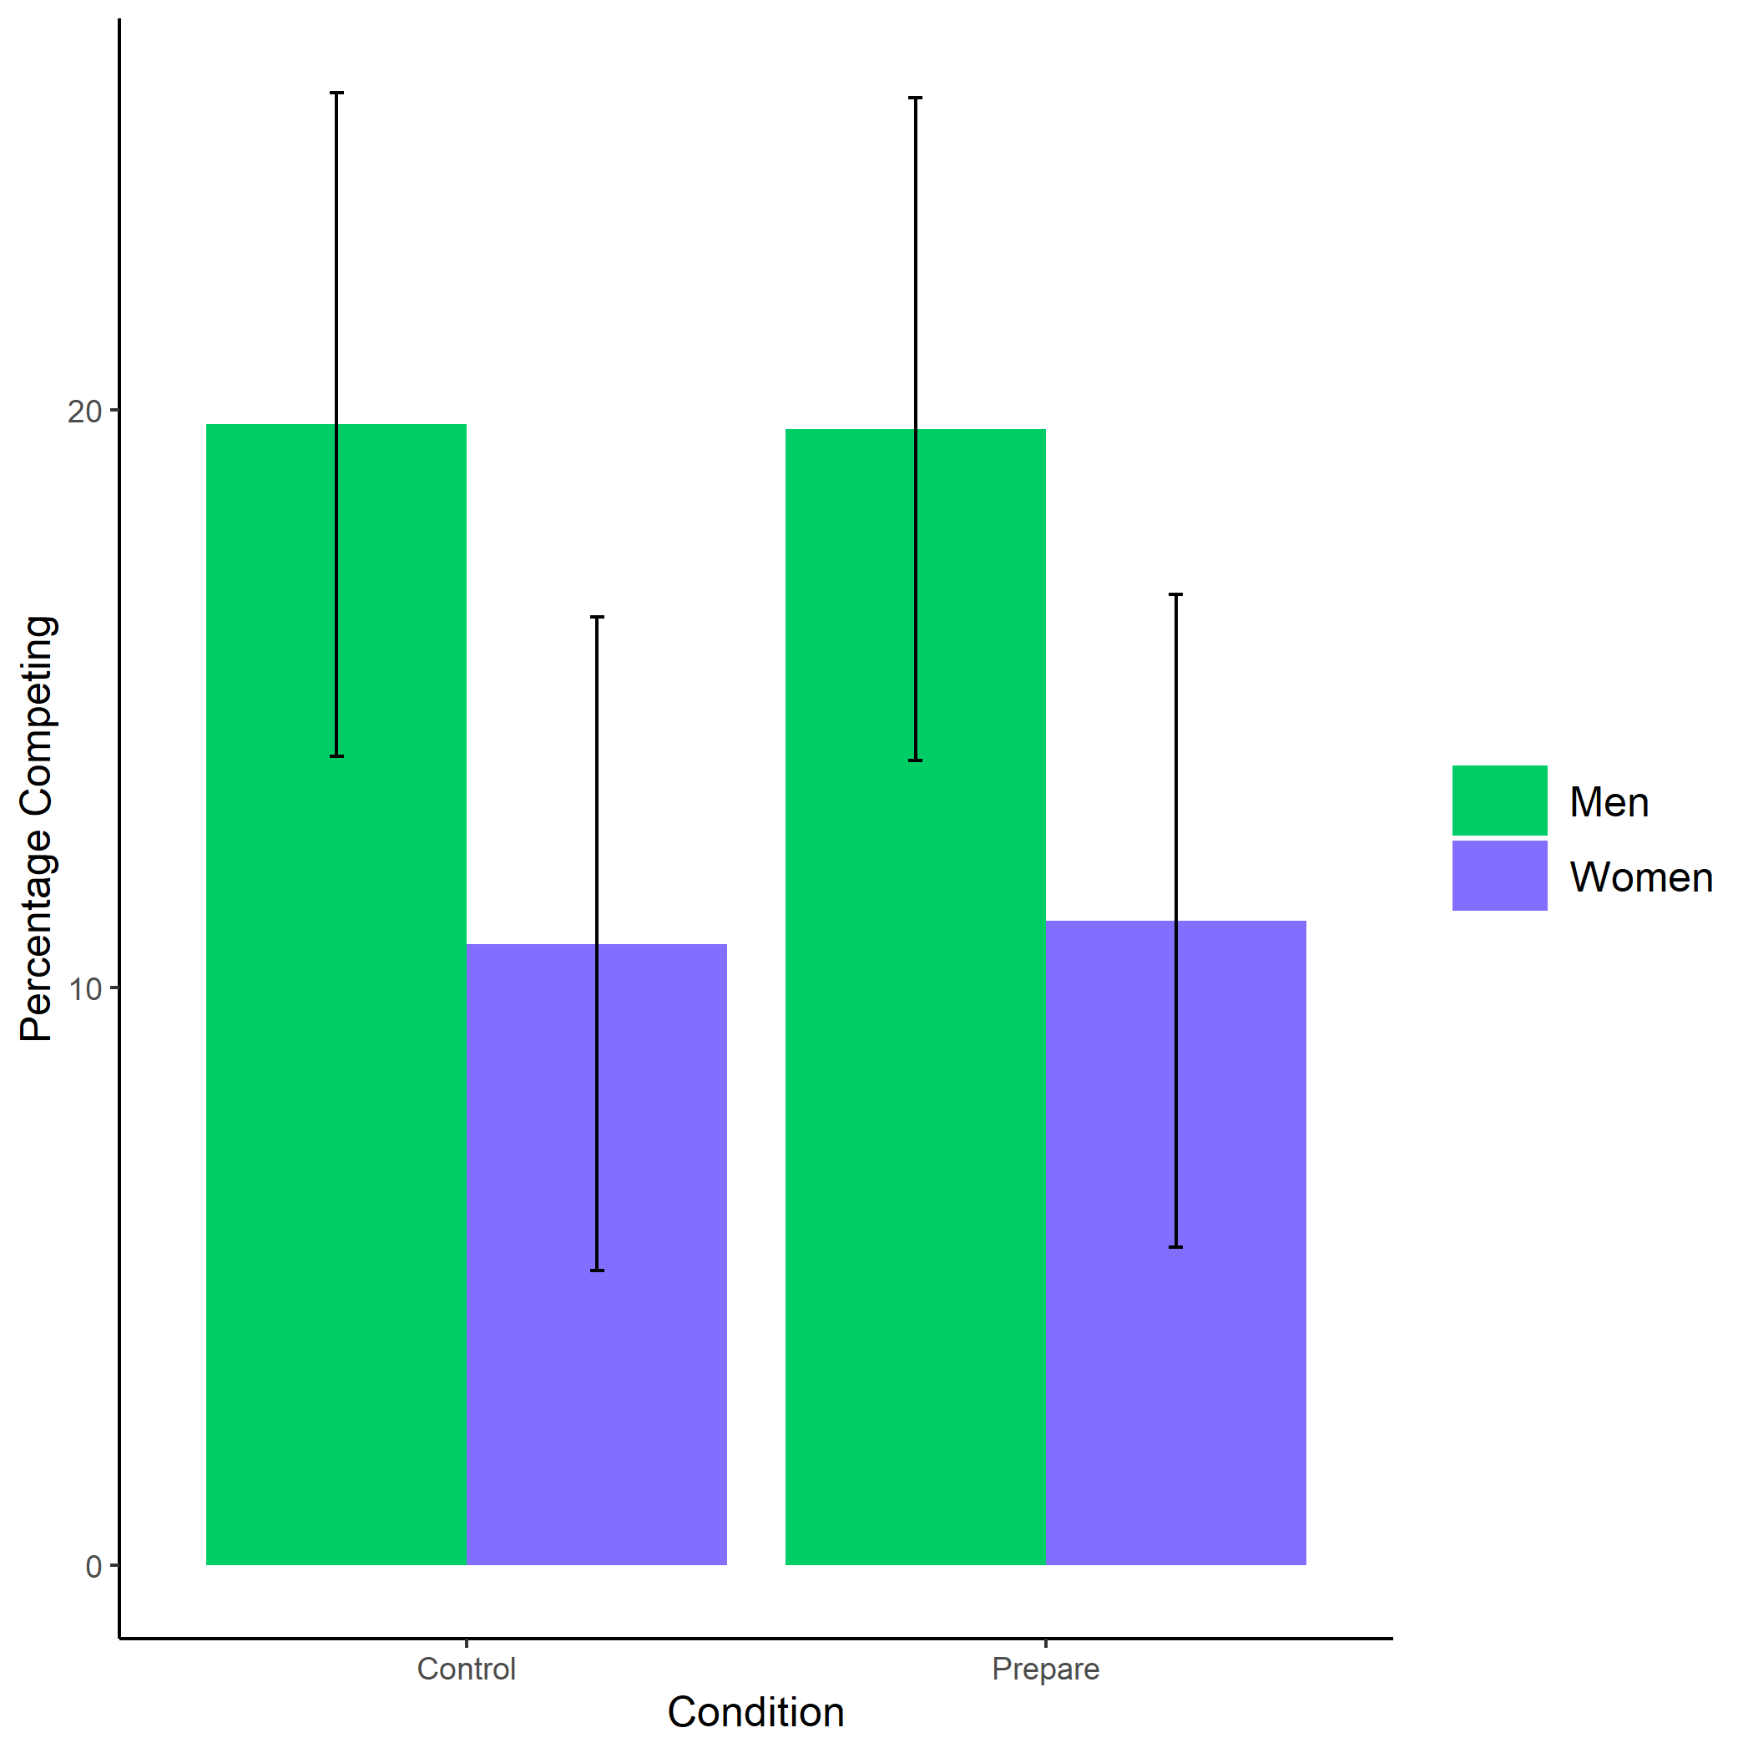

*Figure 1.1: Proportion of men and women who chose to compete by condition. Error bars represent standard errors.*

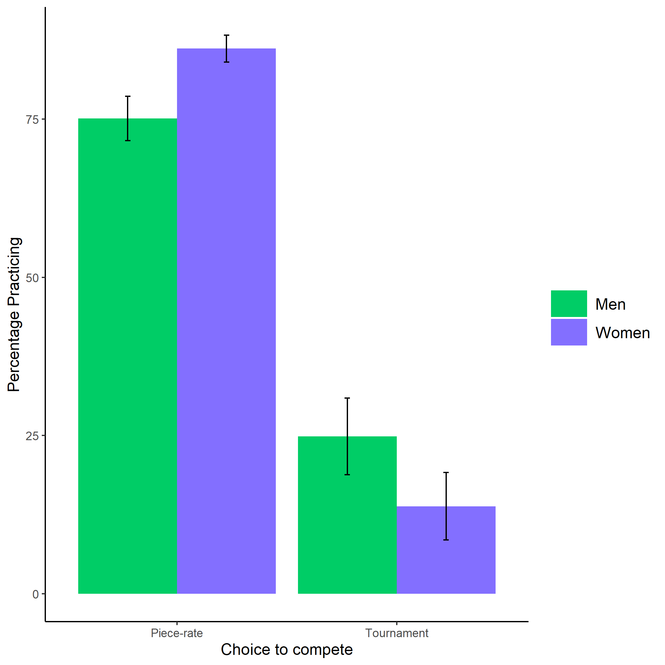

*Figure 1.2: Proportion of men and women who chose to prepare by choice to compete. Error bars represent standard errors.*

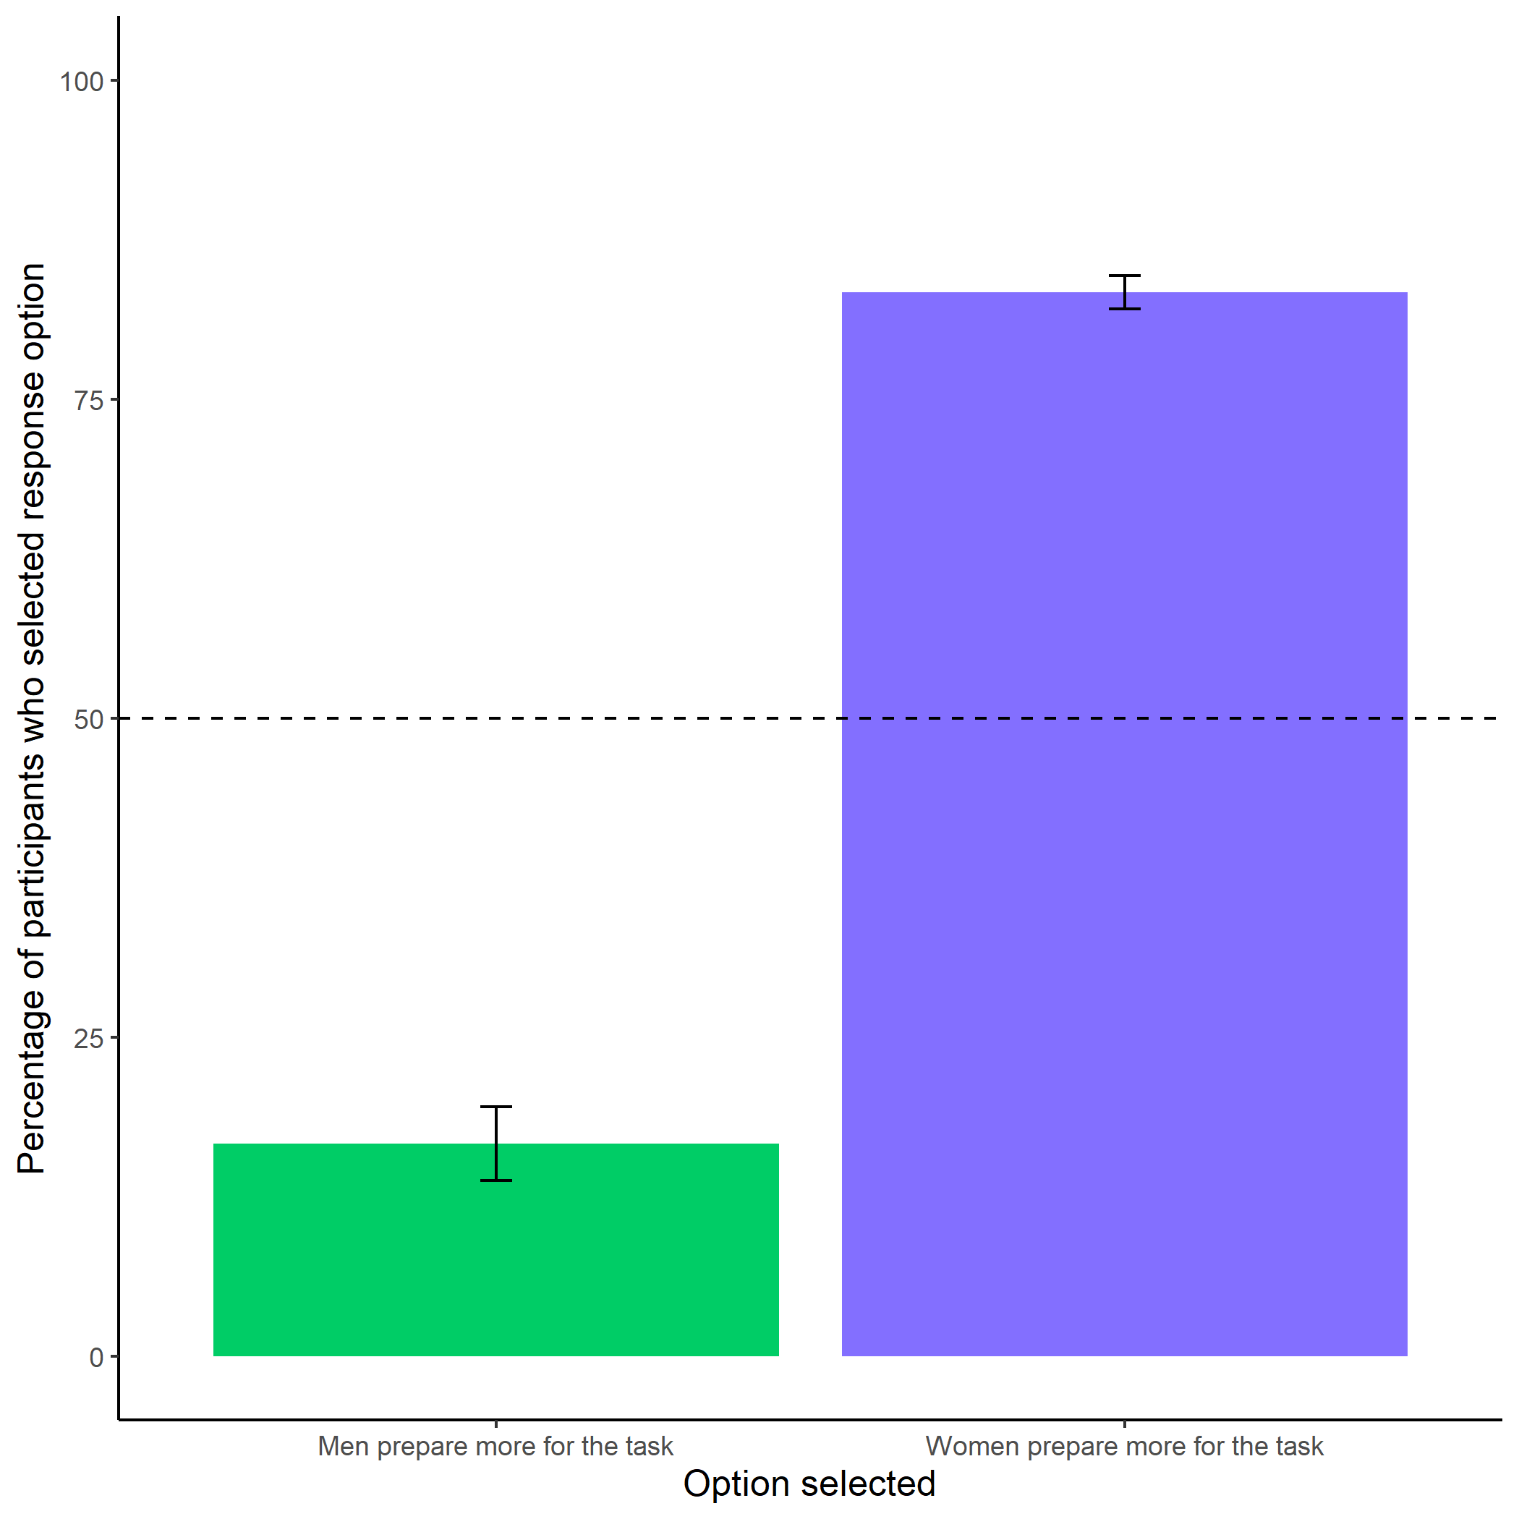

*Figure 1.3: Participants’ perceptions of gender differences in the choice to practice on the task. Error bars represent standard errors.*

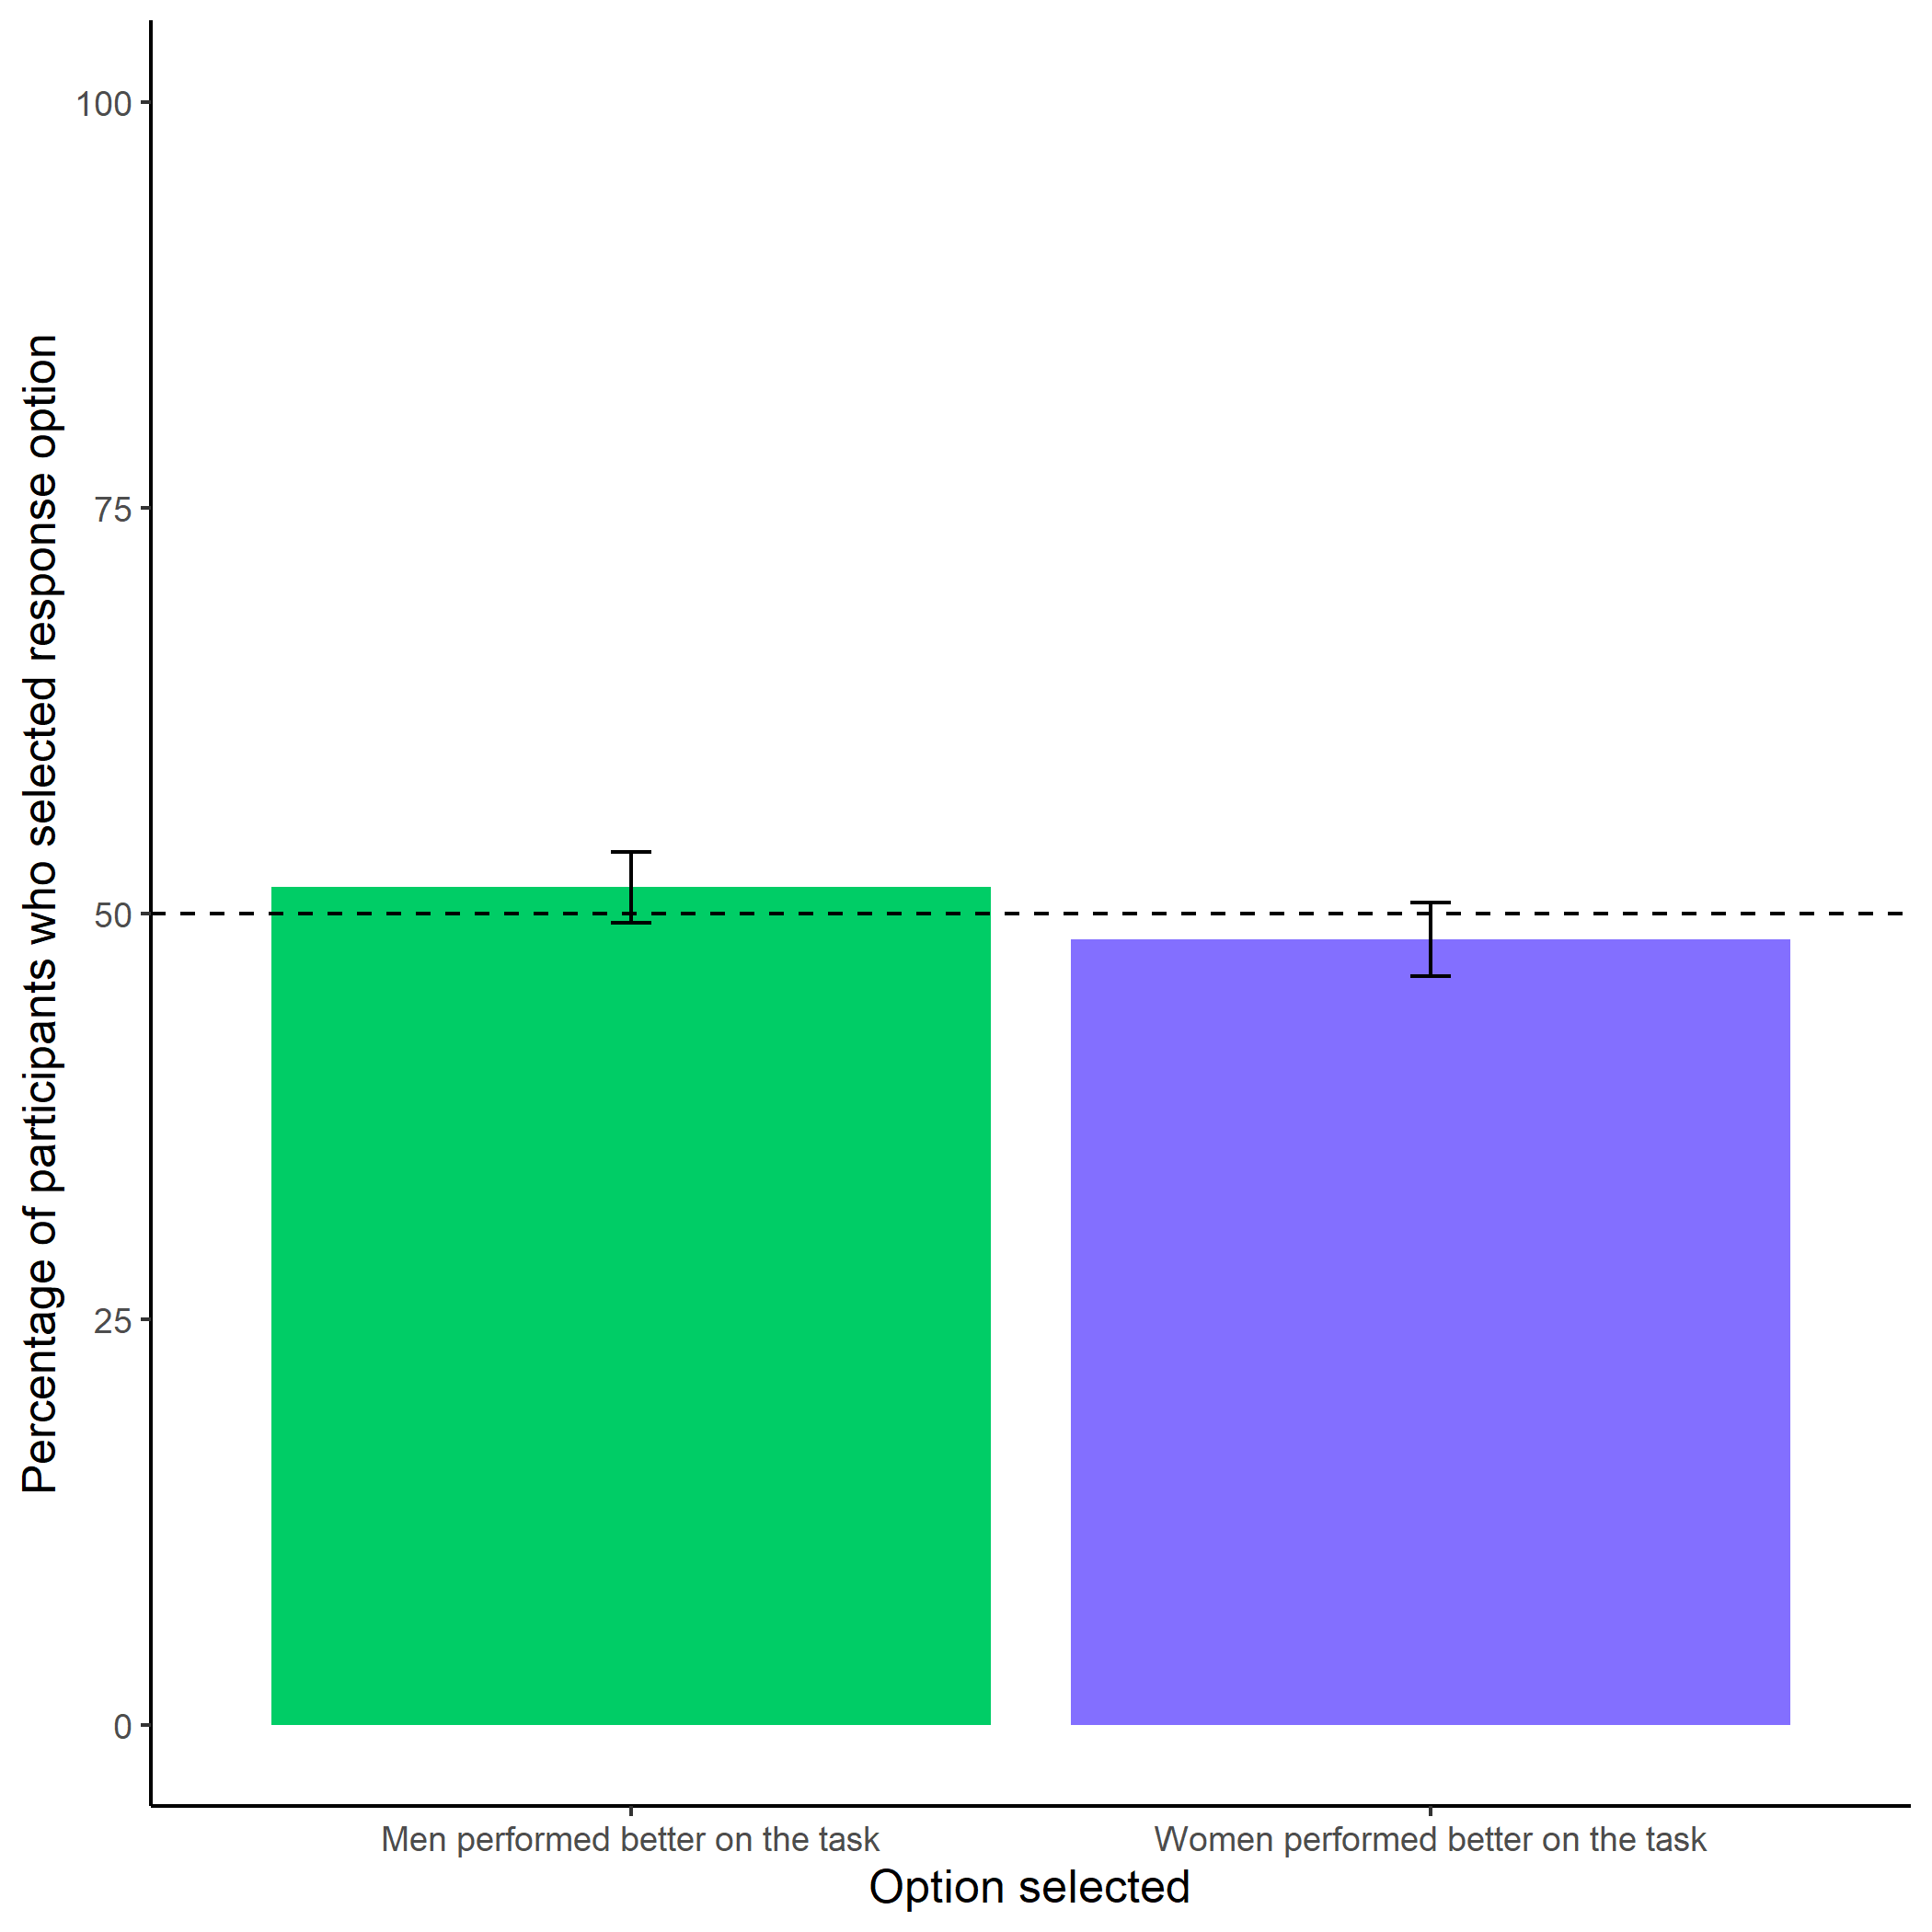

*Figure 1.4: Participants’ perceptions of gender differences in performance on the task. Error bars represent standard errors.*

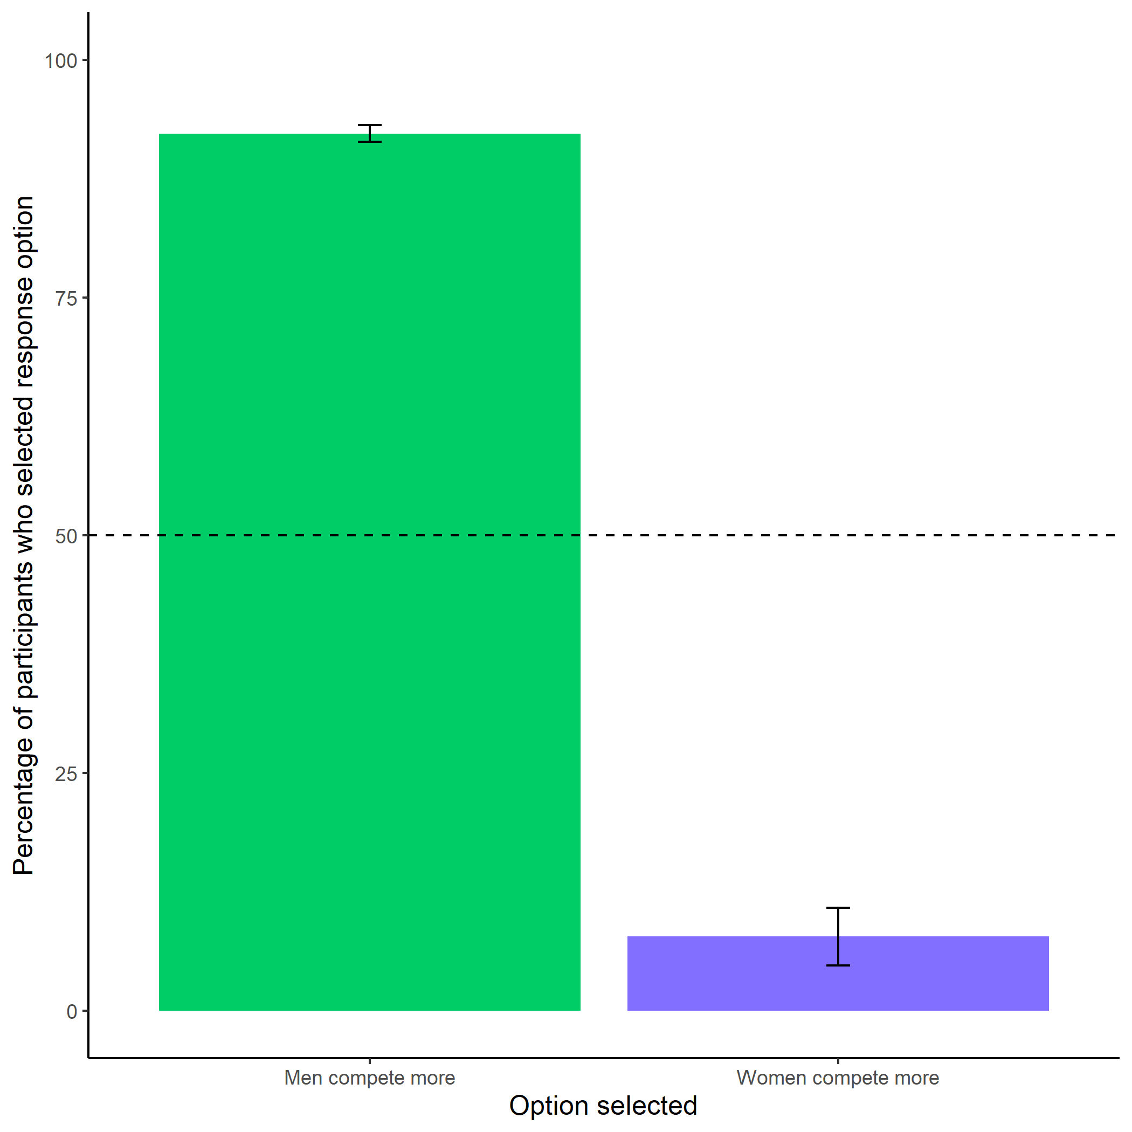

*Figure 1.5: Participants’ perceptions of gender differences in choice to compete. Error bars represent standard errors.*

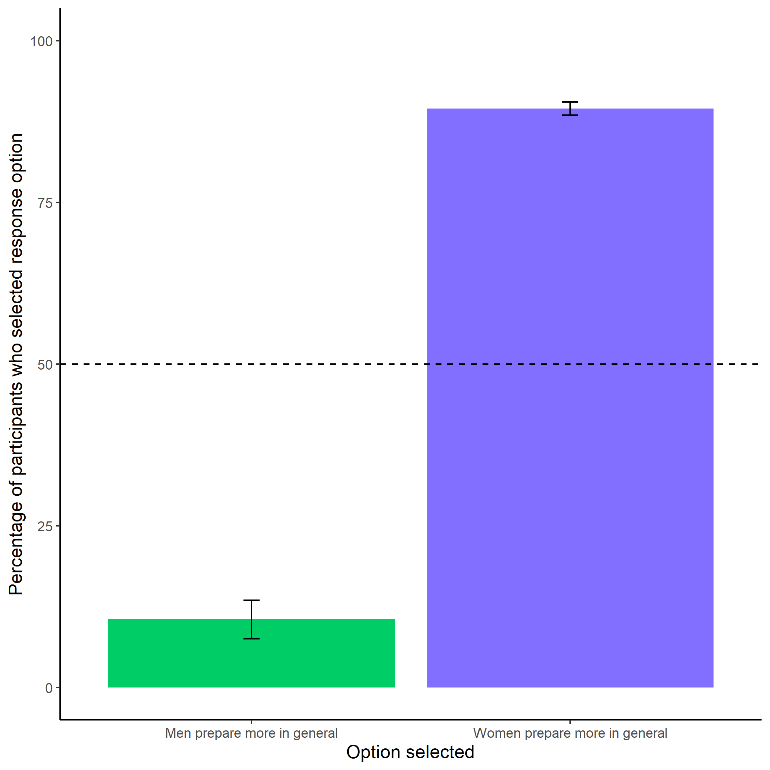

*Figure 1.6: Participants’ perceptions of general gender differences in choice to practice. Error bars represent standard errors.*

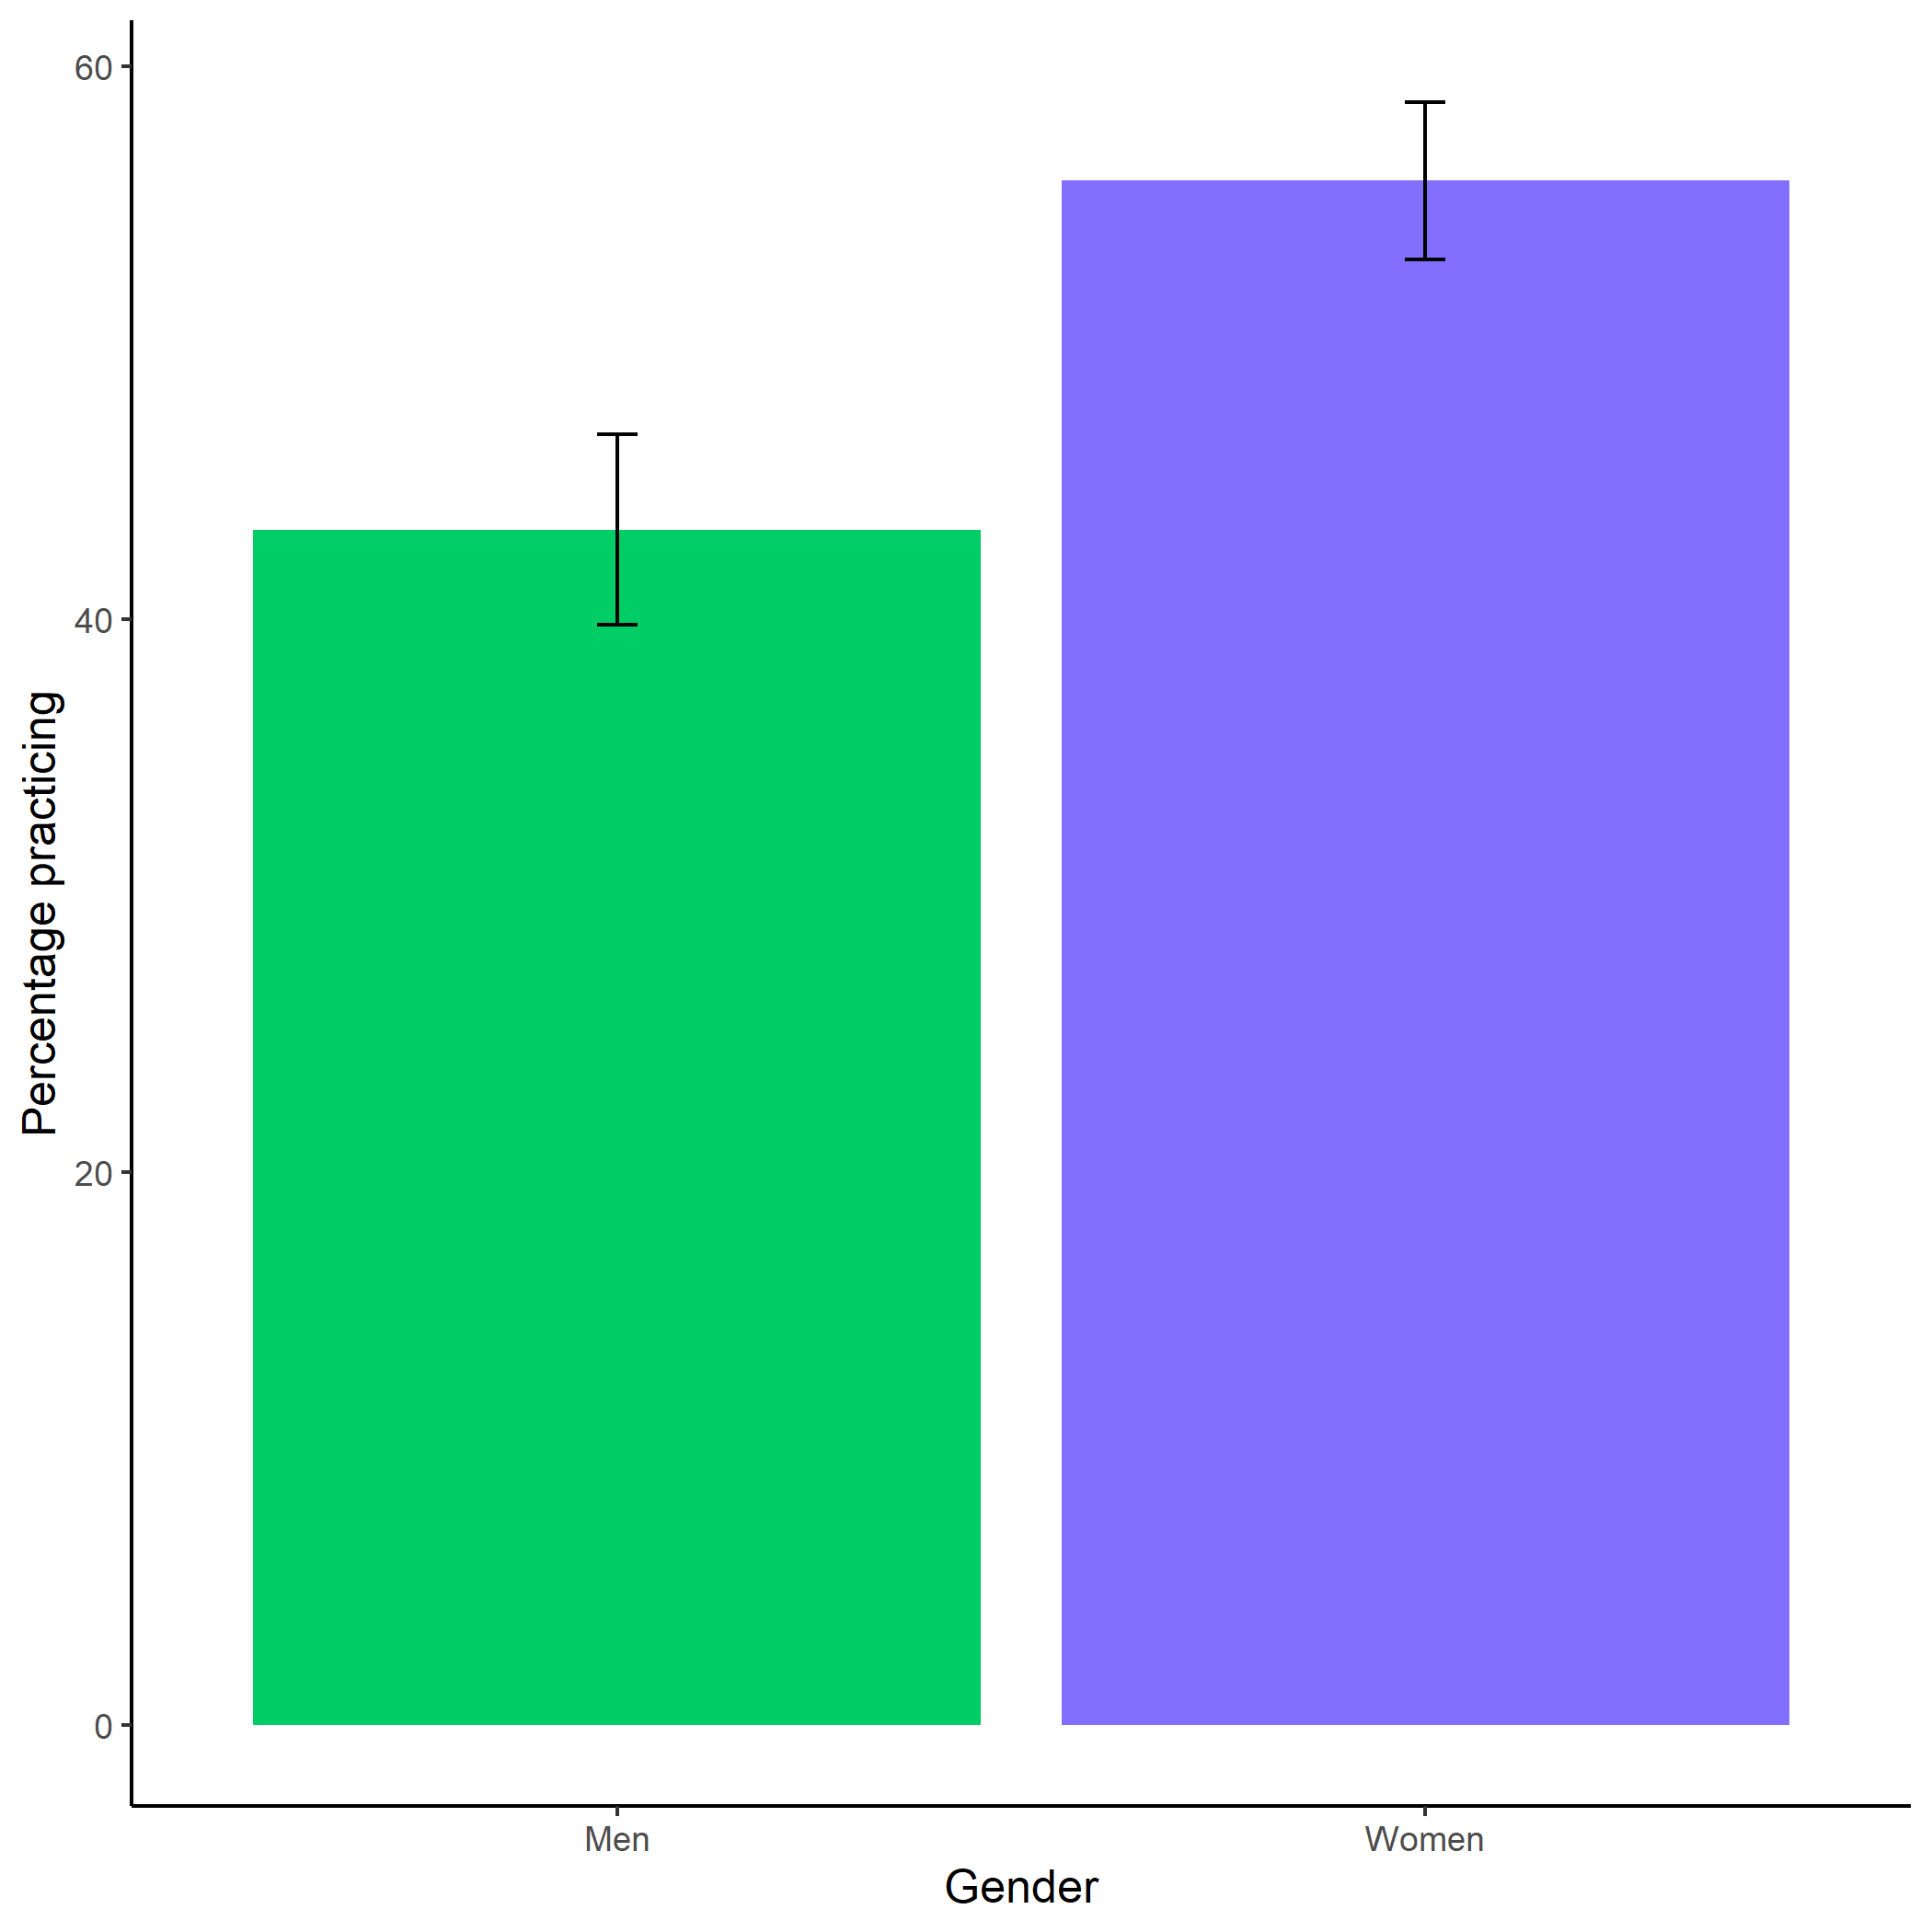

*Figure 1.7: Proportion of men and women who chose to prepare. Error bars represent standard errors.*

### 1.21.2 Tables

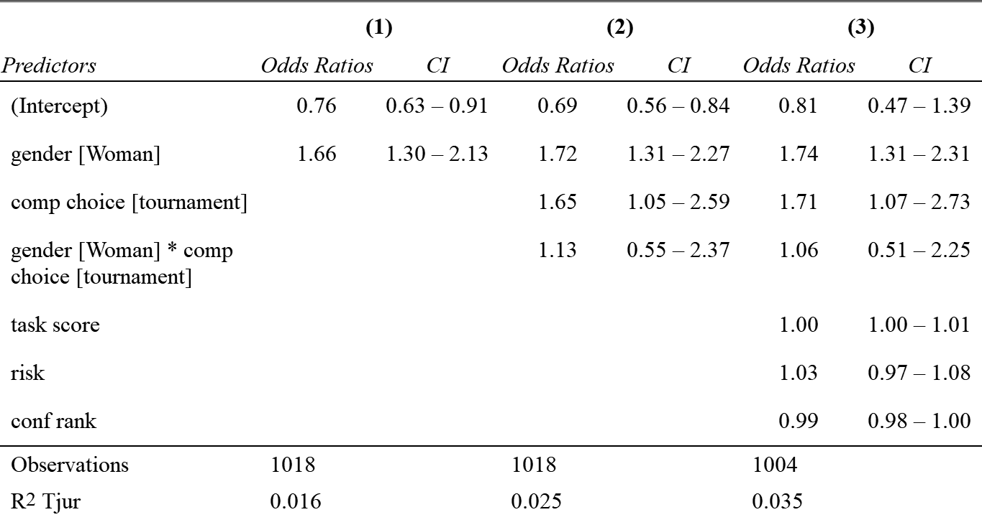

*Figure 1.8: effects changing*

Figure 1.9: Stopping cars

*Figure 1.9: Stopping cars*

Figure 1.10: Stopping

*Figure 1.10: Stopping*

## 1.22 Study 2

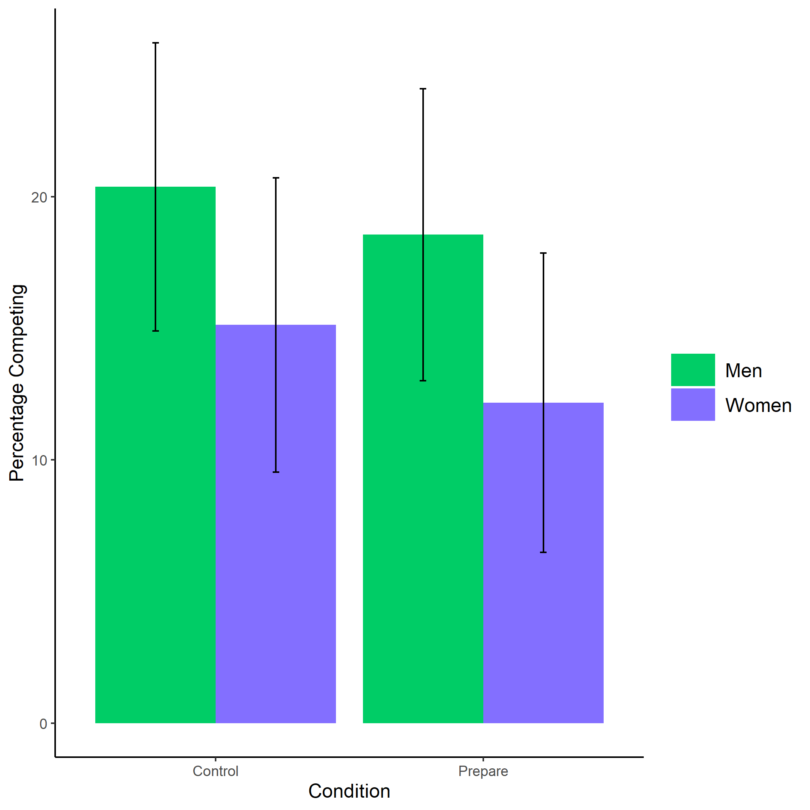

*Figure 1.11: Proportion of men and women who chose to compete by condition. Error bars represent standard errors.*

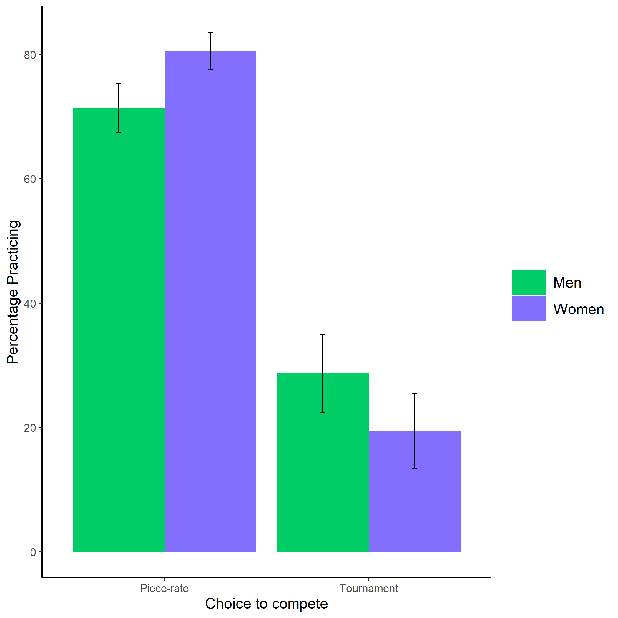

*Figure 1.12: Proportion of men and women who chose to prepare by choice to compete. Error bars represent standard errors.*

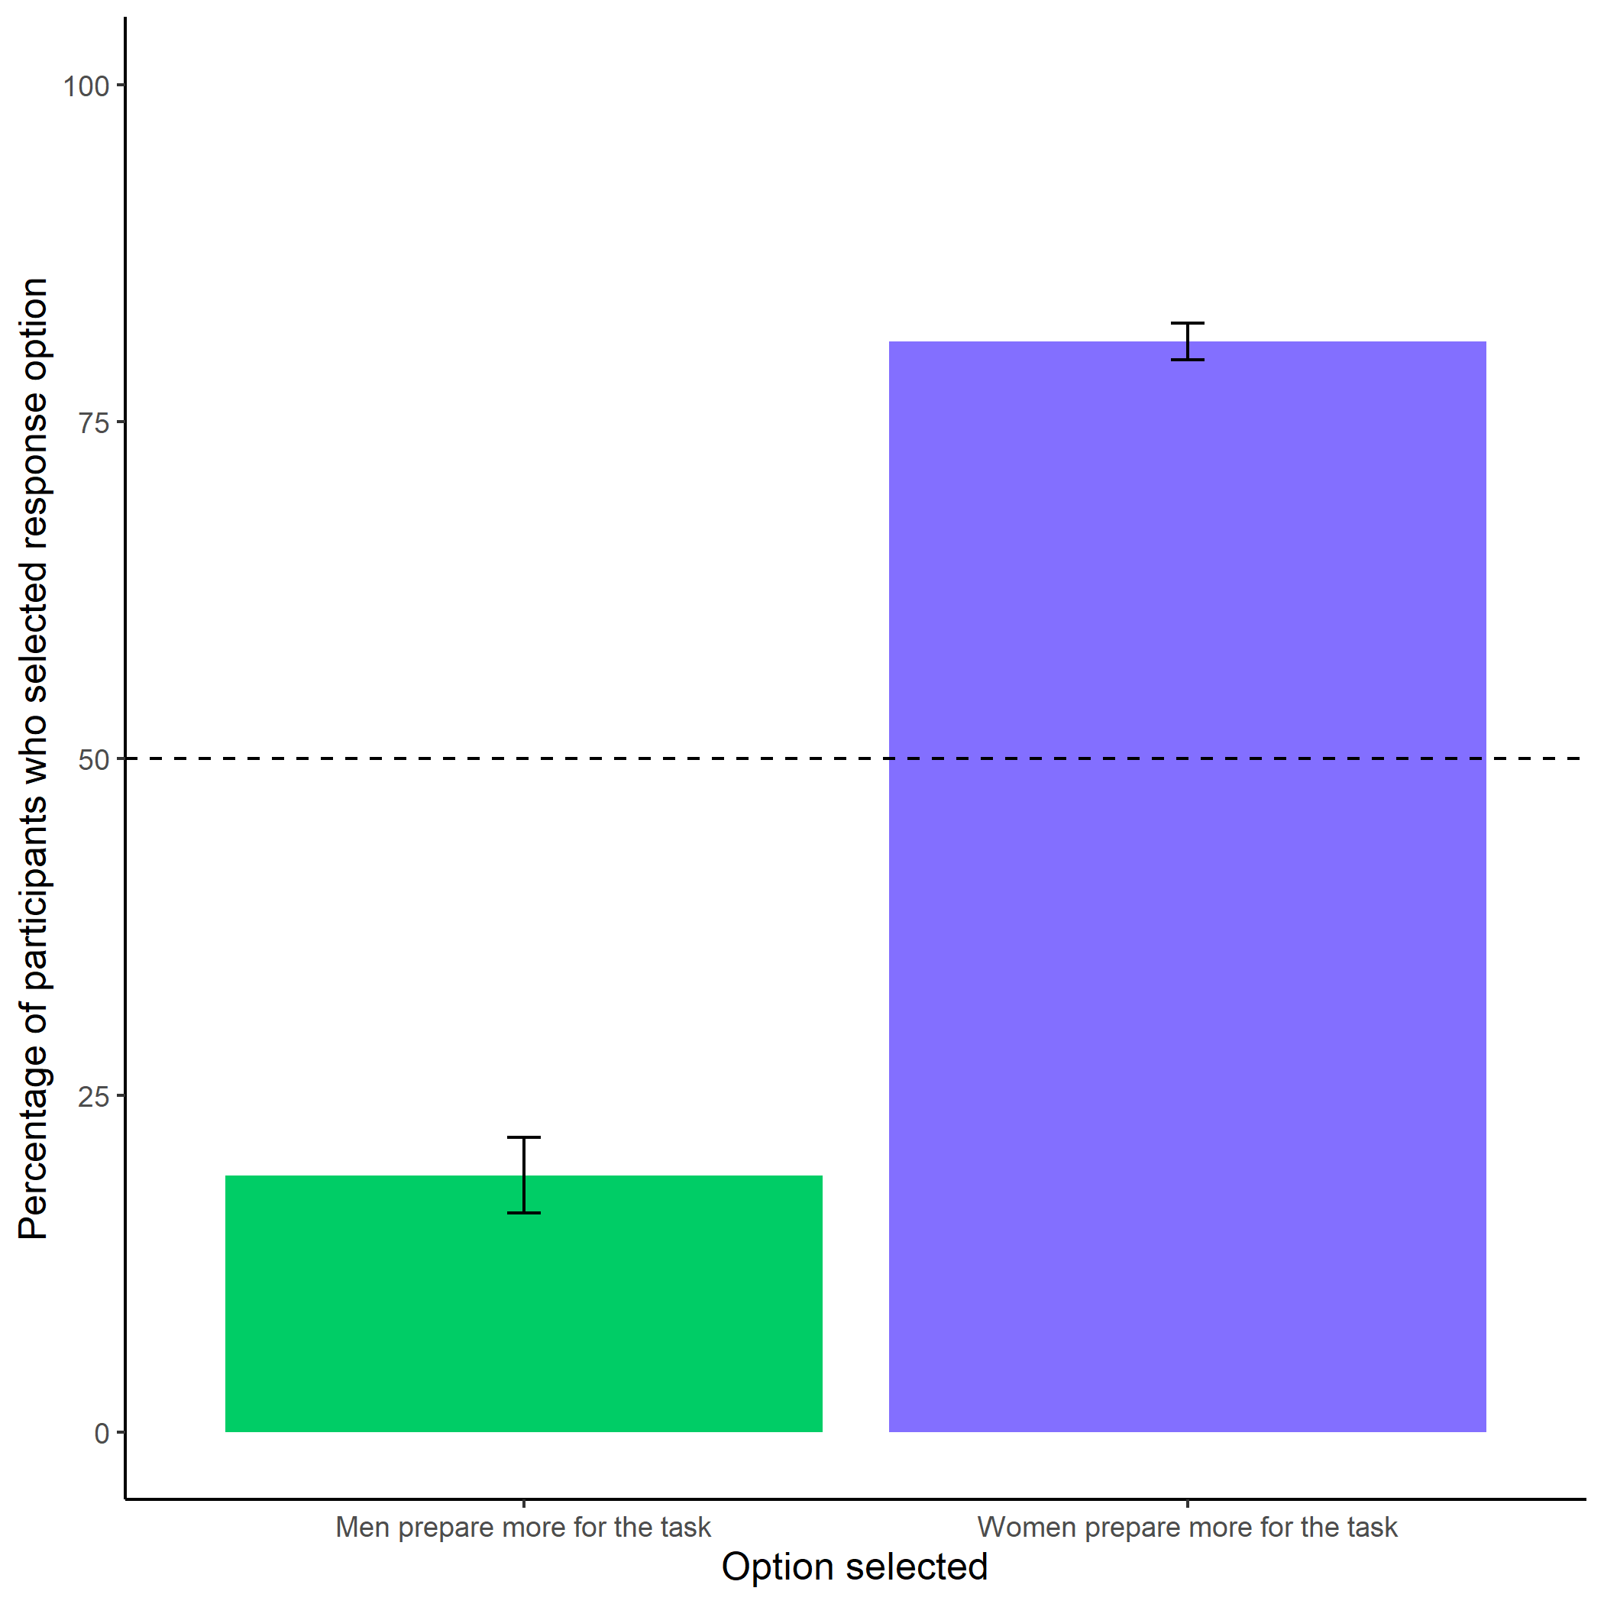

*Figure 1.13: Participants’ perceptions of gender differences in the choice to practice on the task. Error bars represent standard errors.*

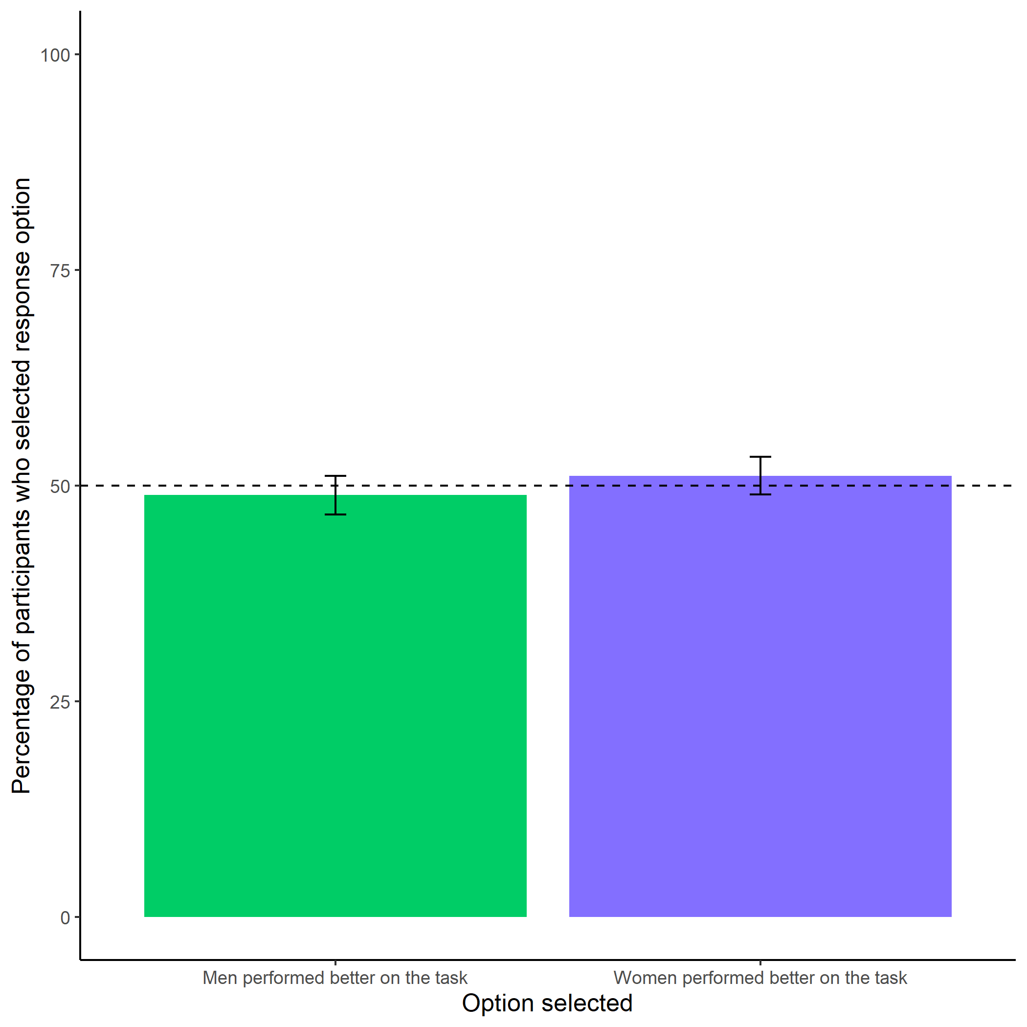

*Figure 1.14: Participants’ perceptions of gender differences in performance on the task. Error bars represent standard errors.*

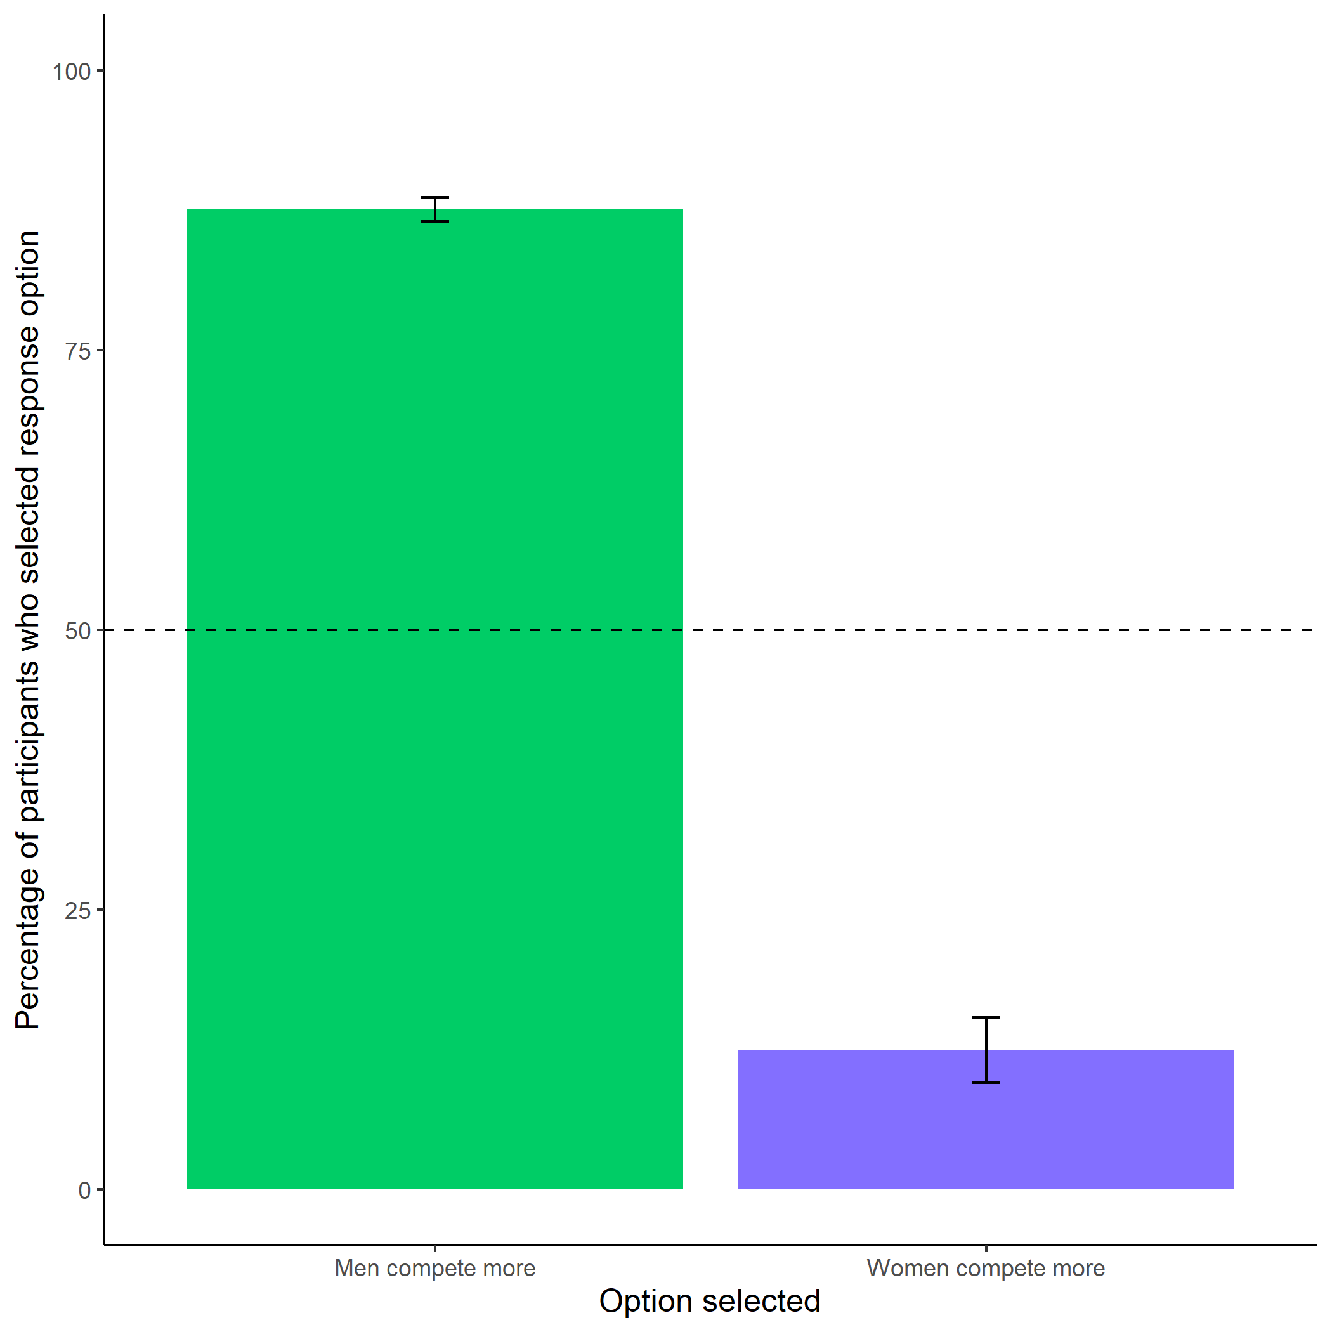

*Figure 1.15: Participants’ perceptions of gender differences in choice to compete. Error bars represent standard errors.*

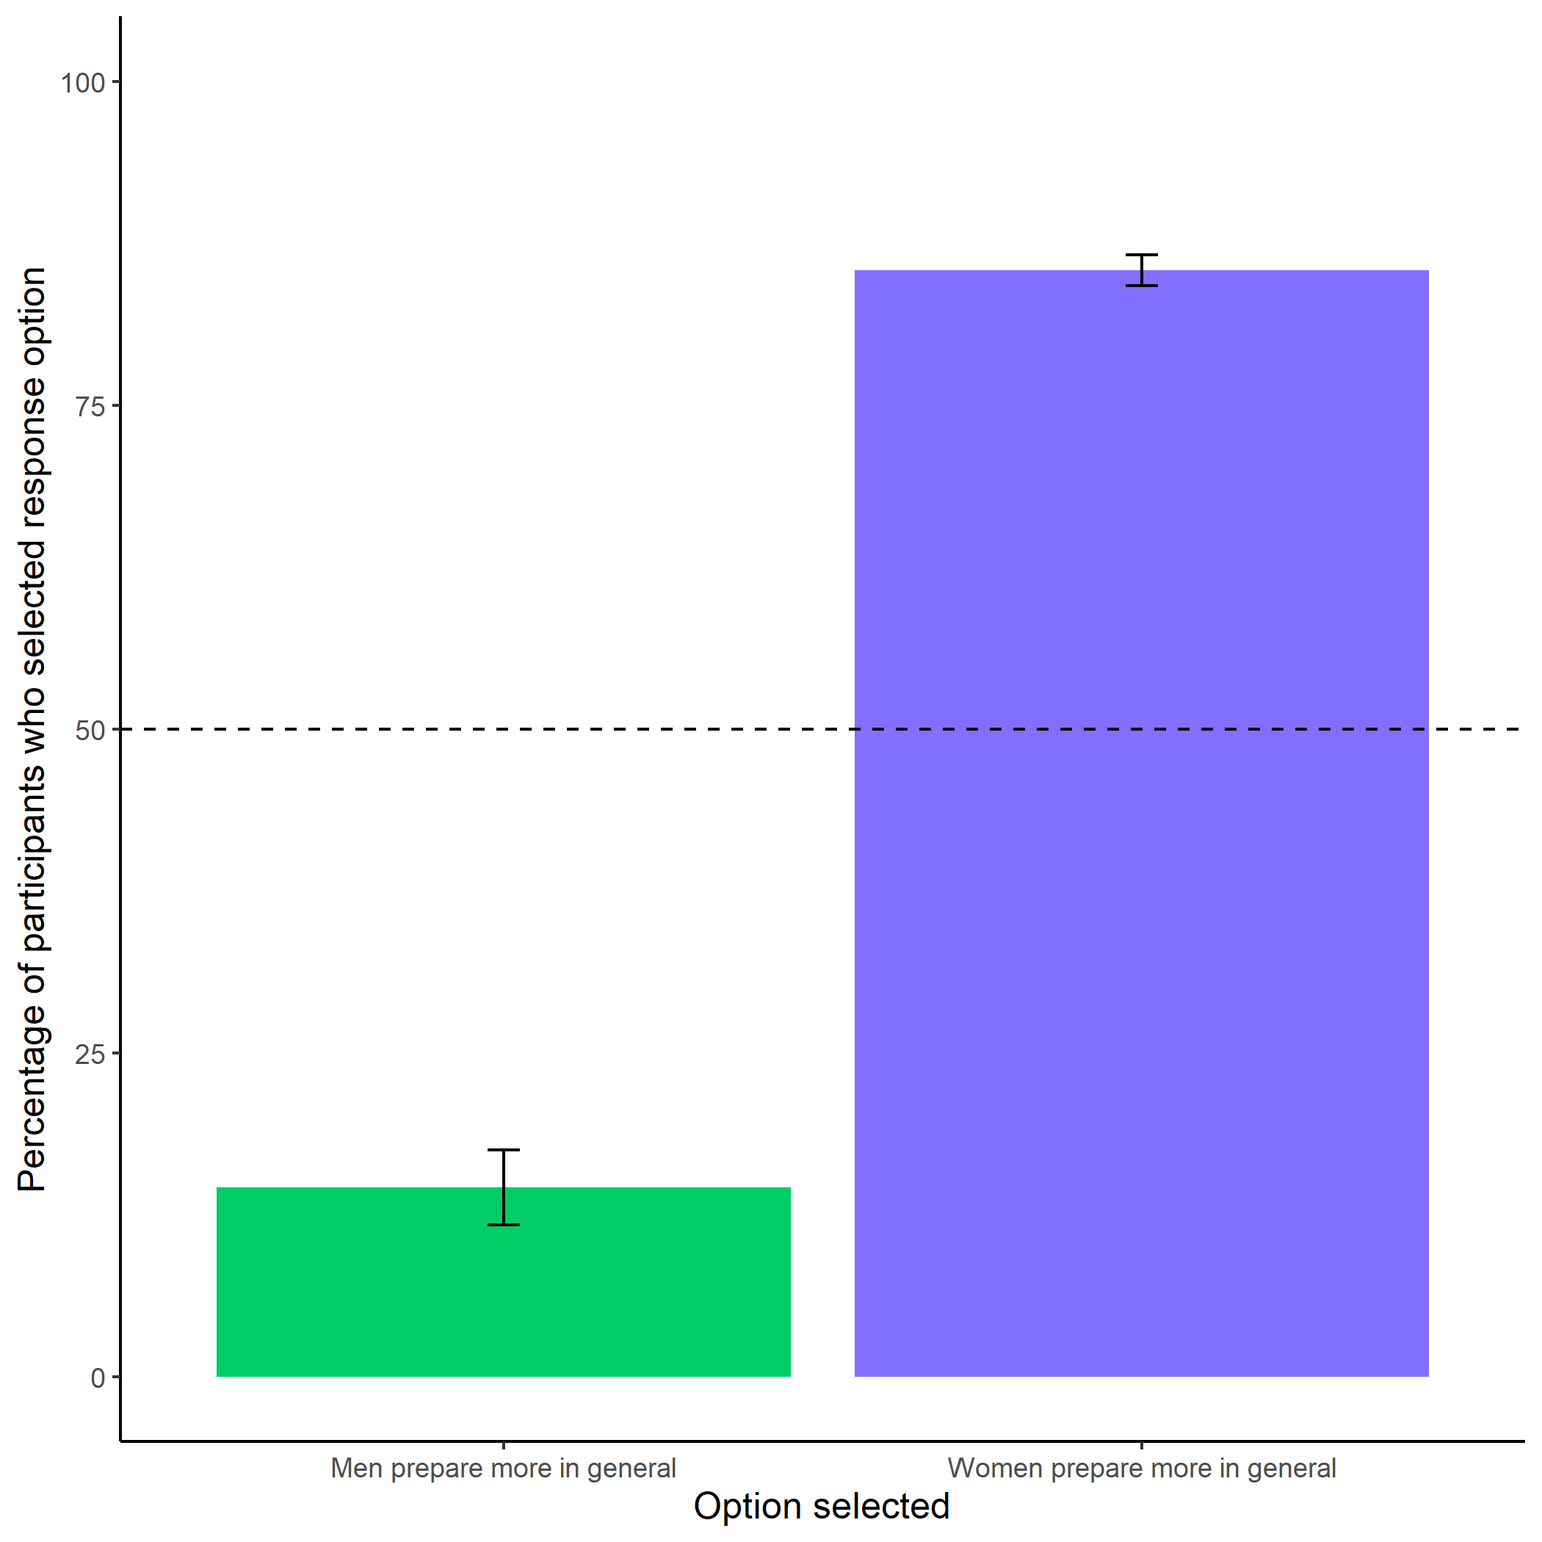

*Figure 1.16: Participants’ perceptions of general gender differences in choice to practice. Error bars represent standard errors.*

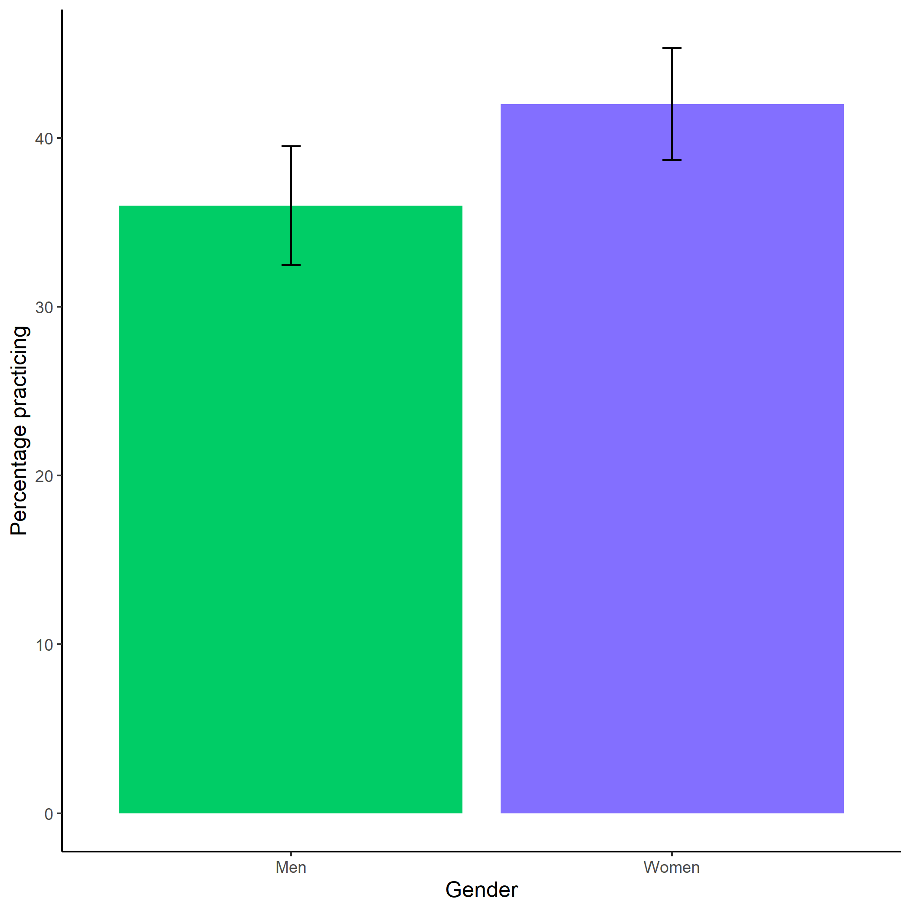

*Figure 1.17: Proportion of men and women who chose to prepare. Error bars represent standard errors.*

## 1.23 Study 3

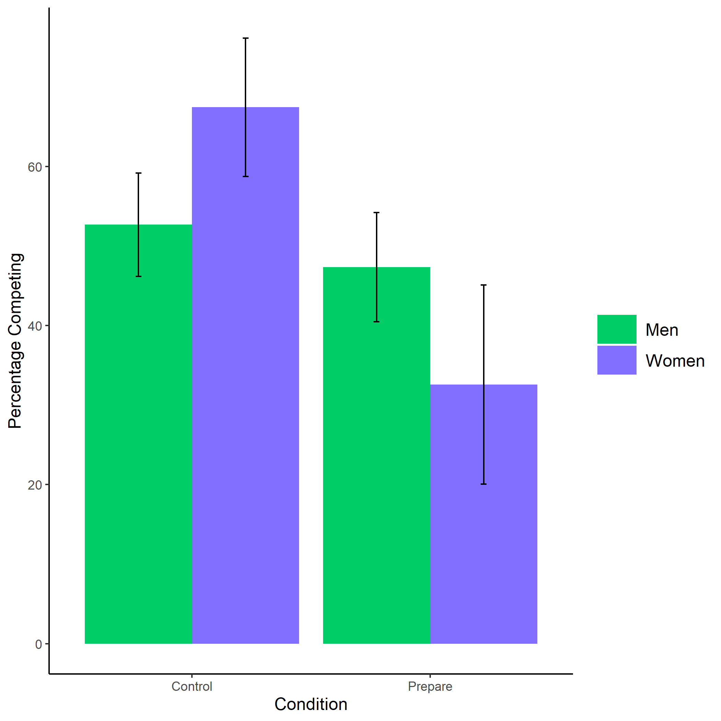

*Figure 1.18: Proportion of men and women who chose to compete by condition. Error bars represent standard errors.*

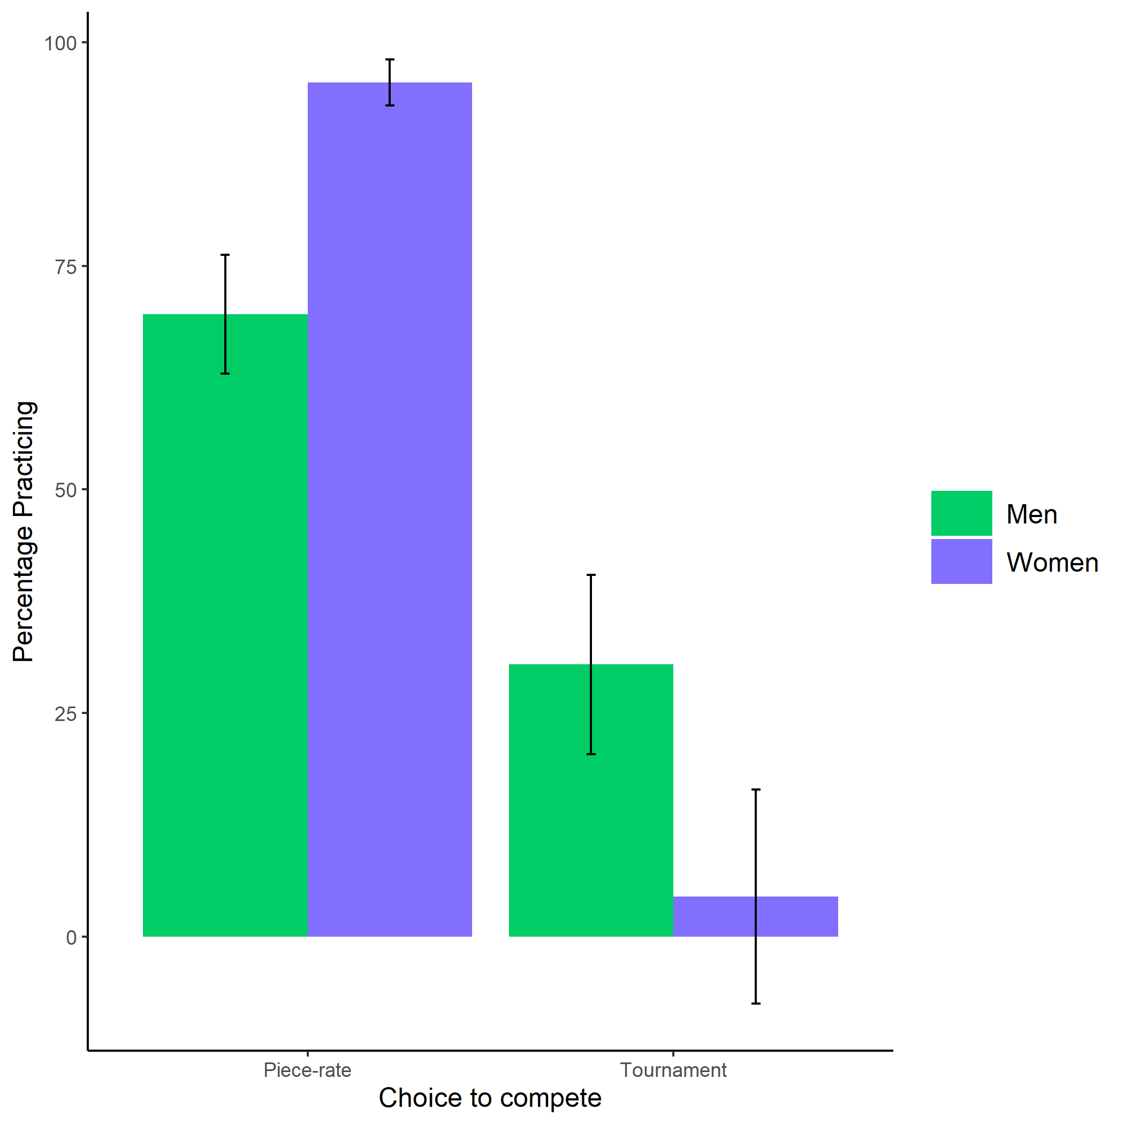

*Figure 1.19: Proportion of men and women who chose to prepare by choice to compete. Error bars represent standard errors.*

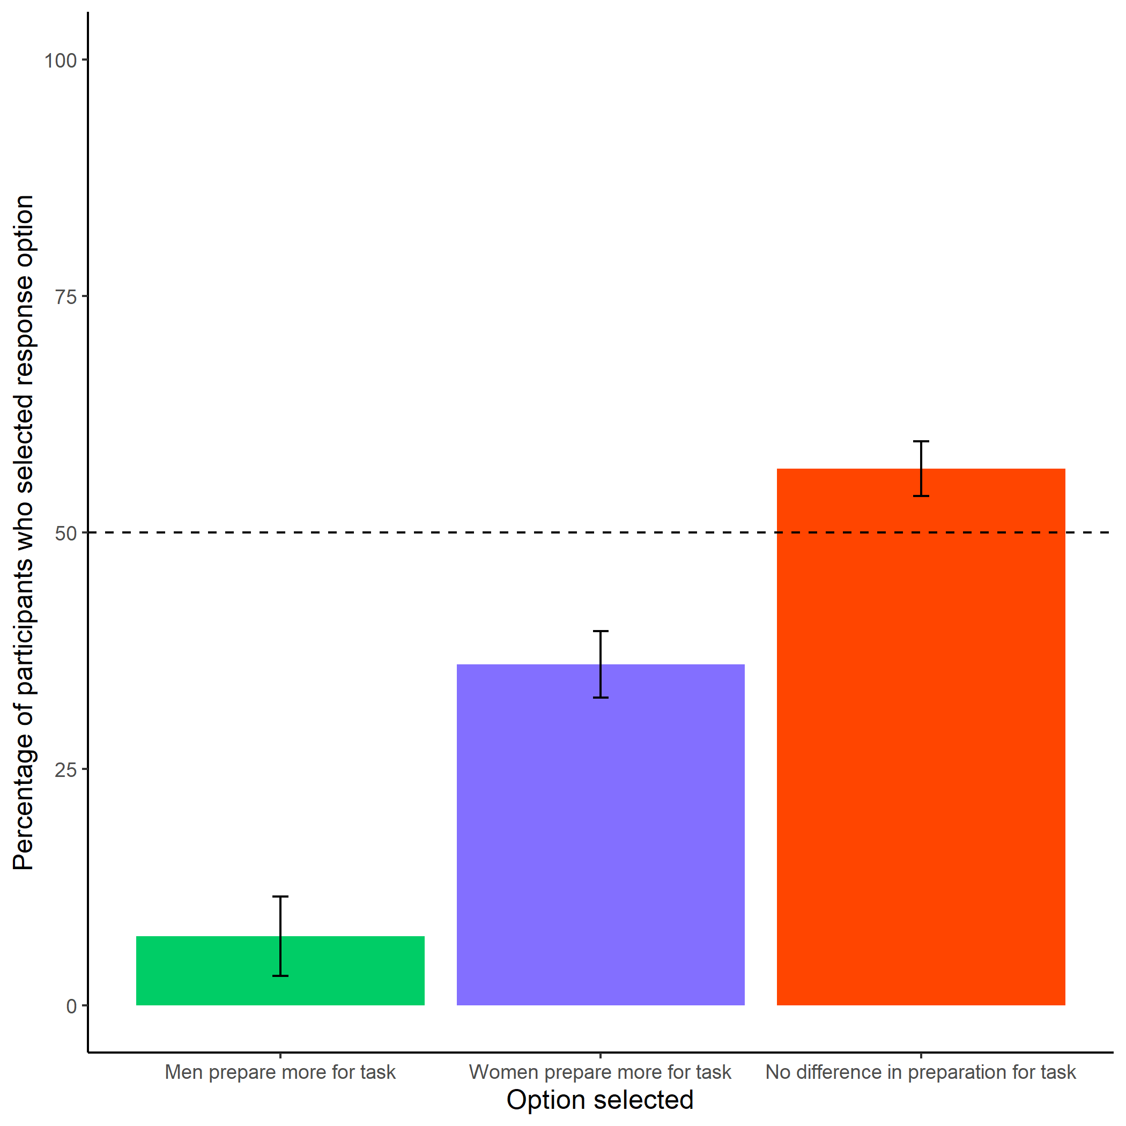

*Figure 1.20: Participants’ perceptions of gender differences in the choice to practice on the task. Error bars represent standard errors.*

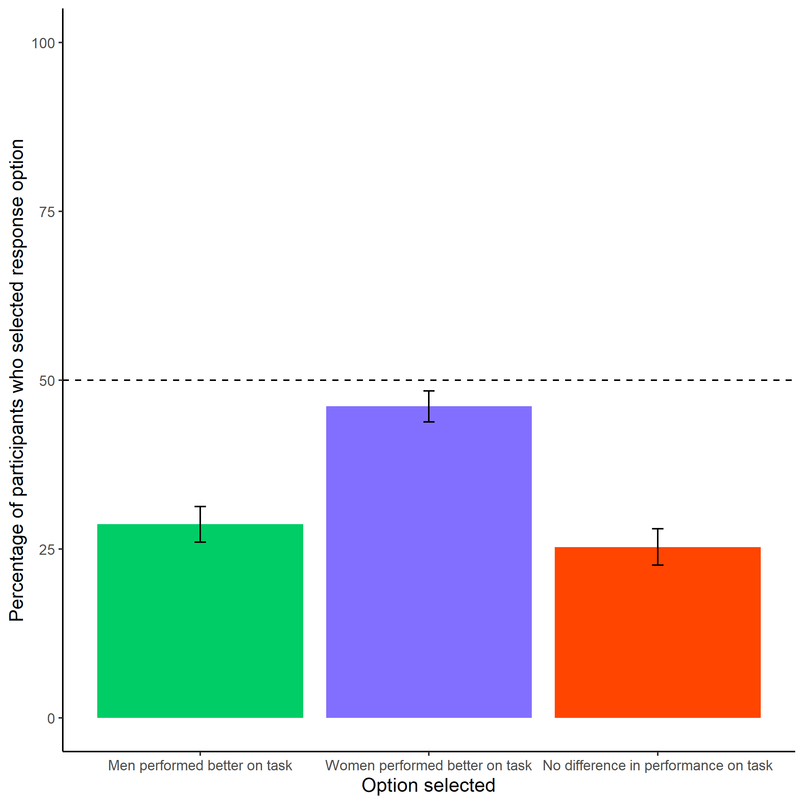

*Figure 1.21: Participants’ perceptions of gender differences in performance on the task. Error bars represent standard errors.*

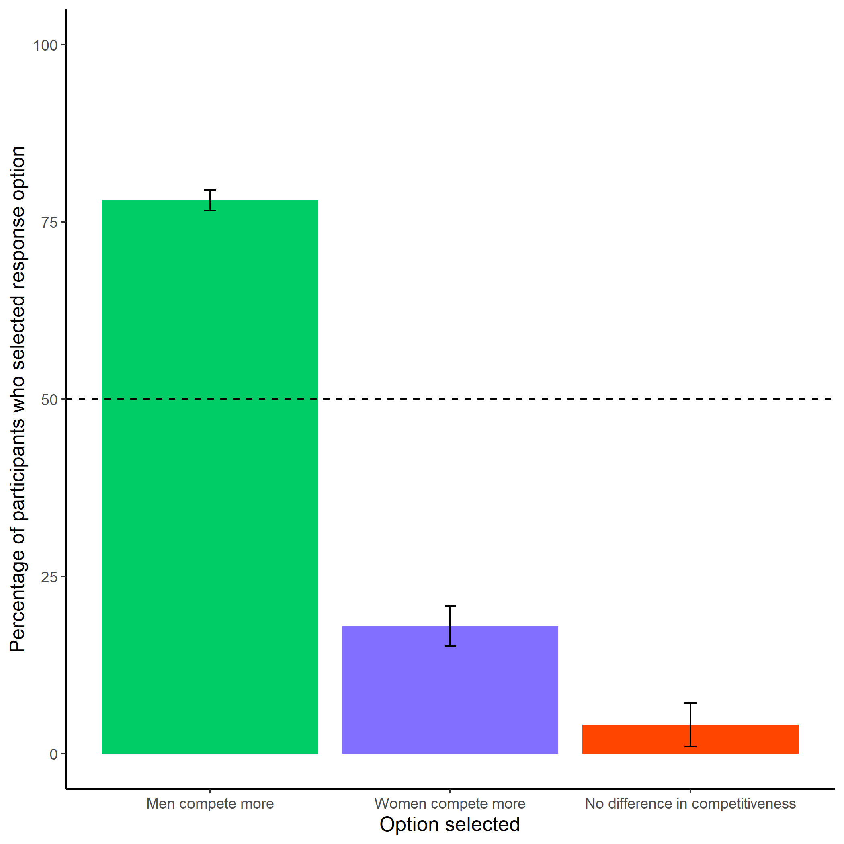

*Figure 1.22: Participants’ perceptions of gender differences in choice to compete. Error bars represent standard errors.*

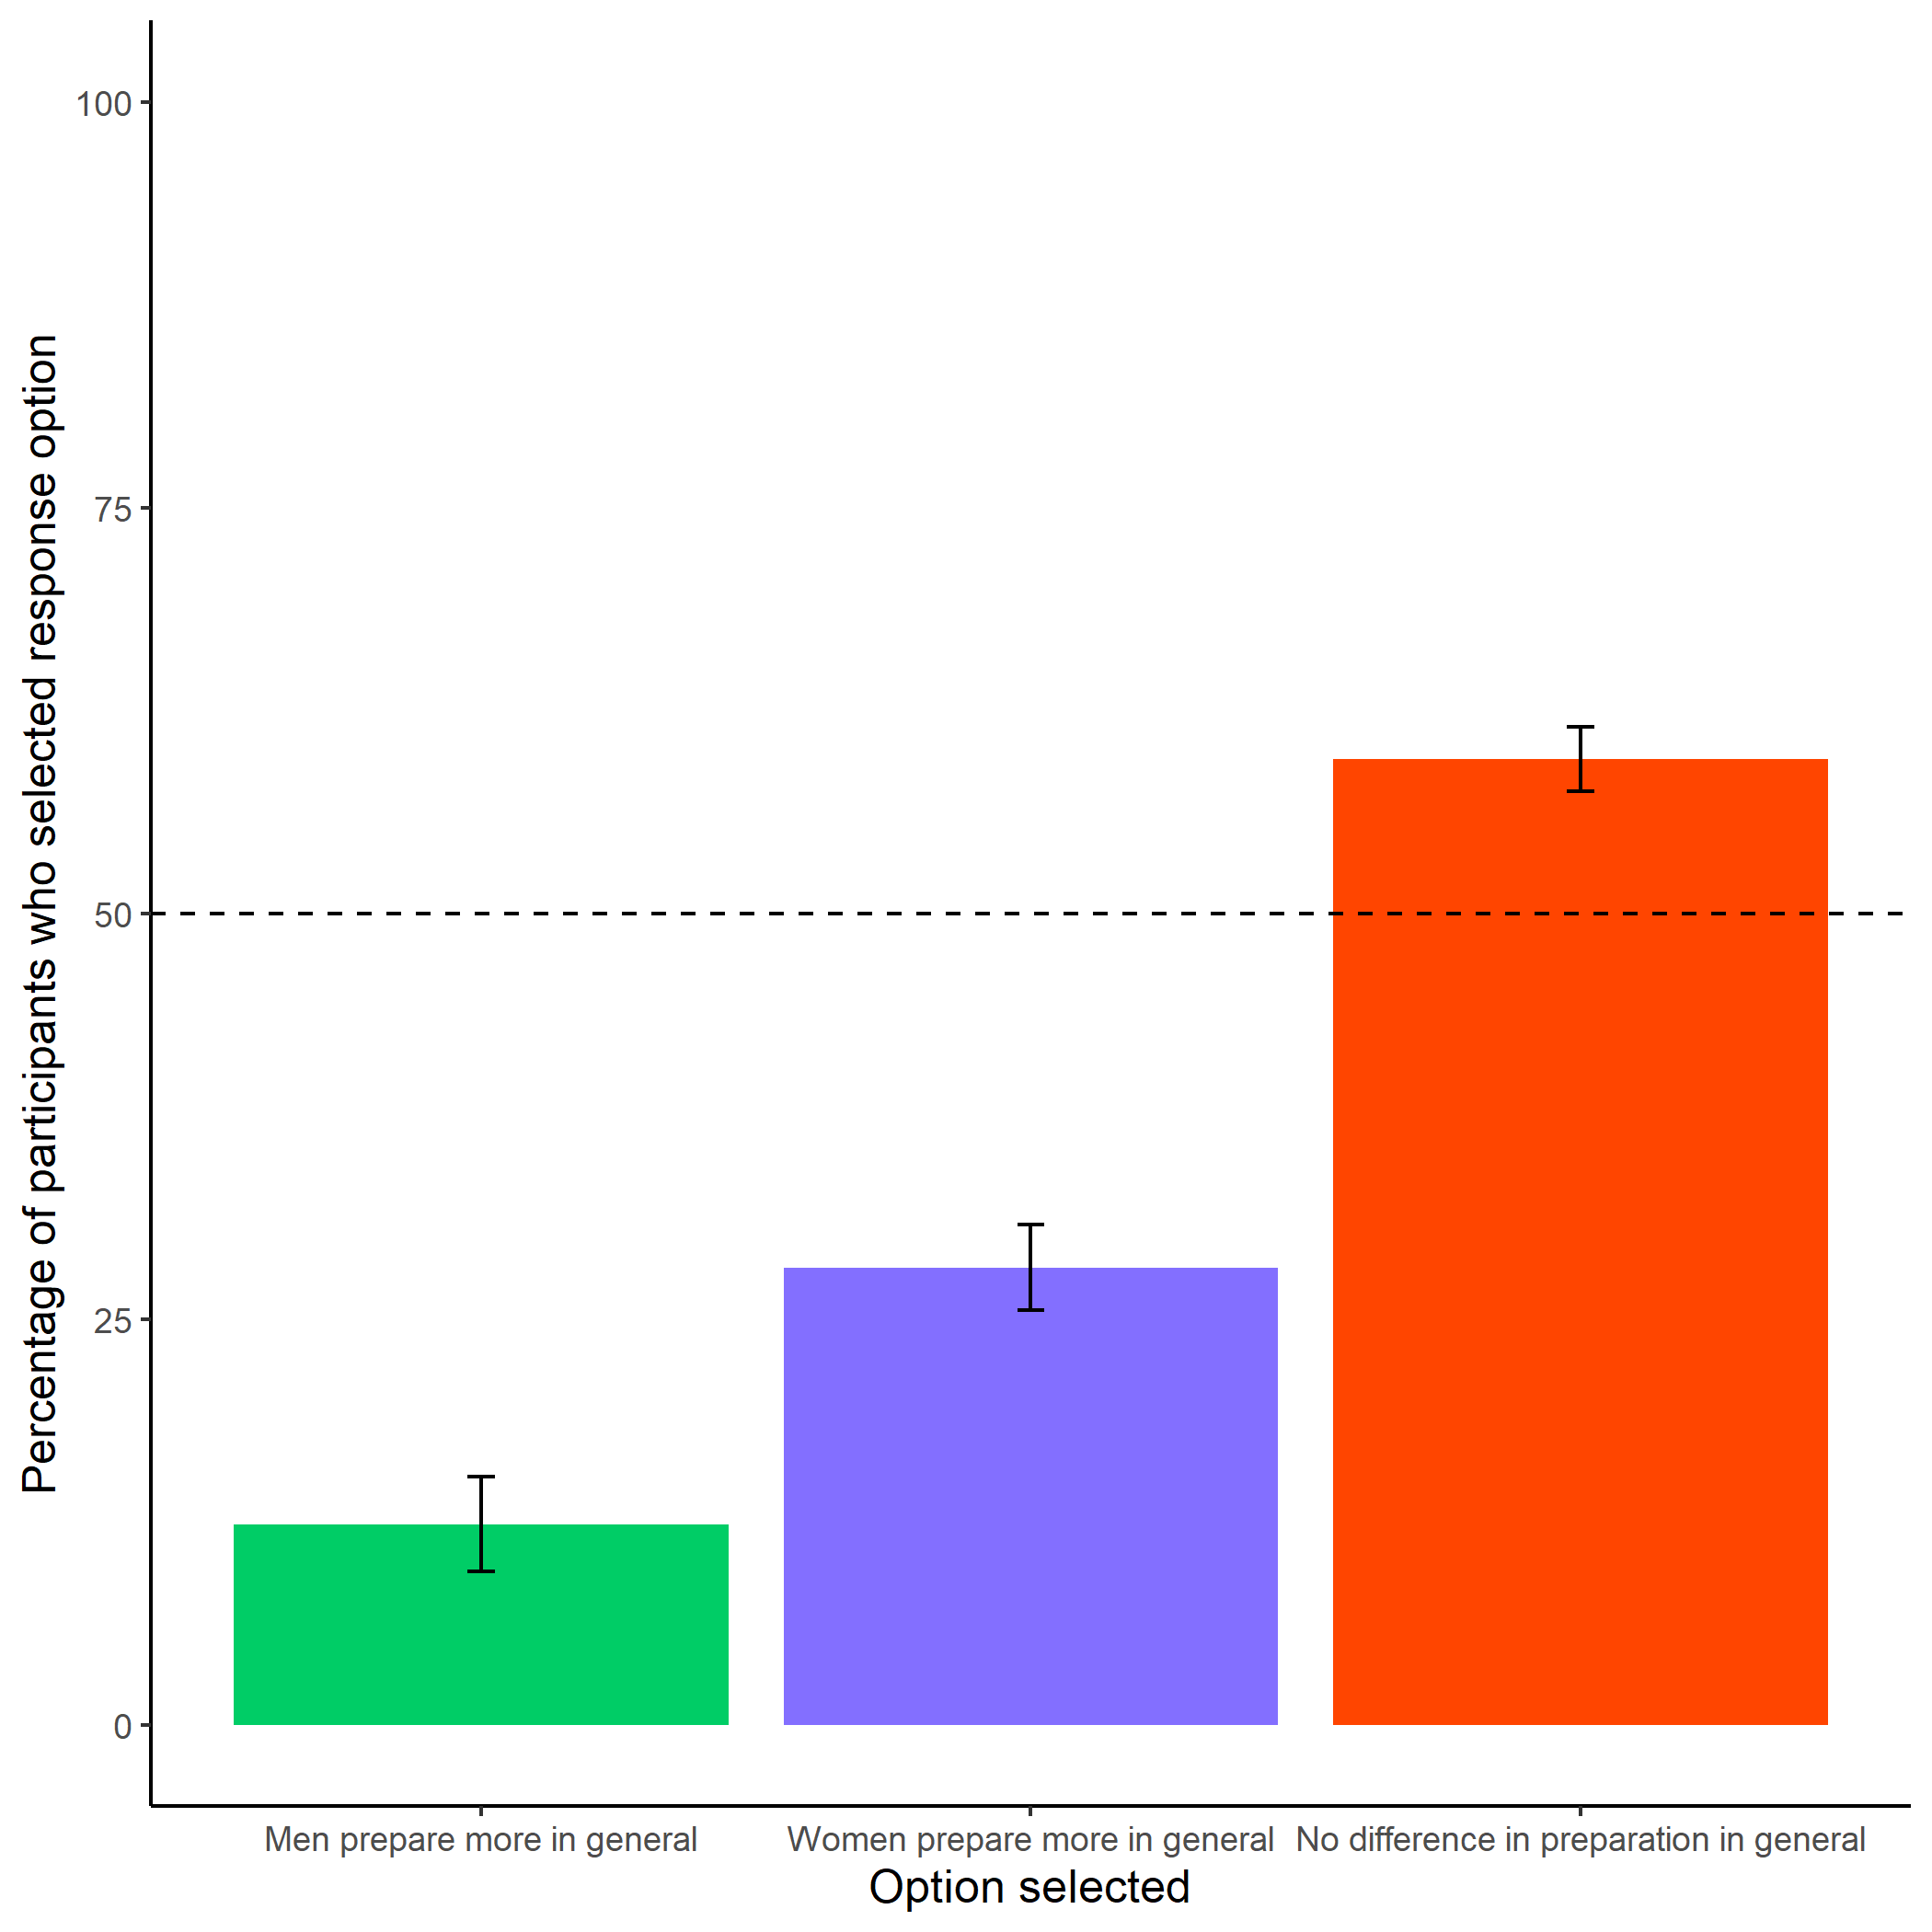

*Figure 1.23: Participants’ perceptions of general gender differences in choice to practice. Error bars represent standard errors.*

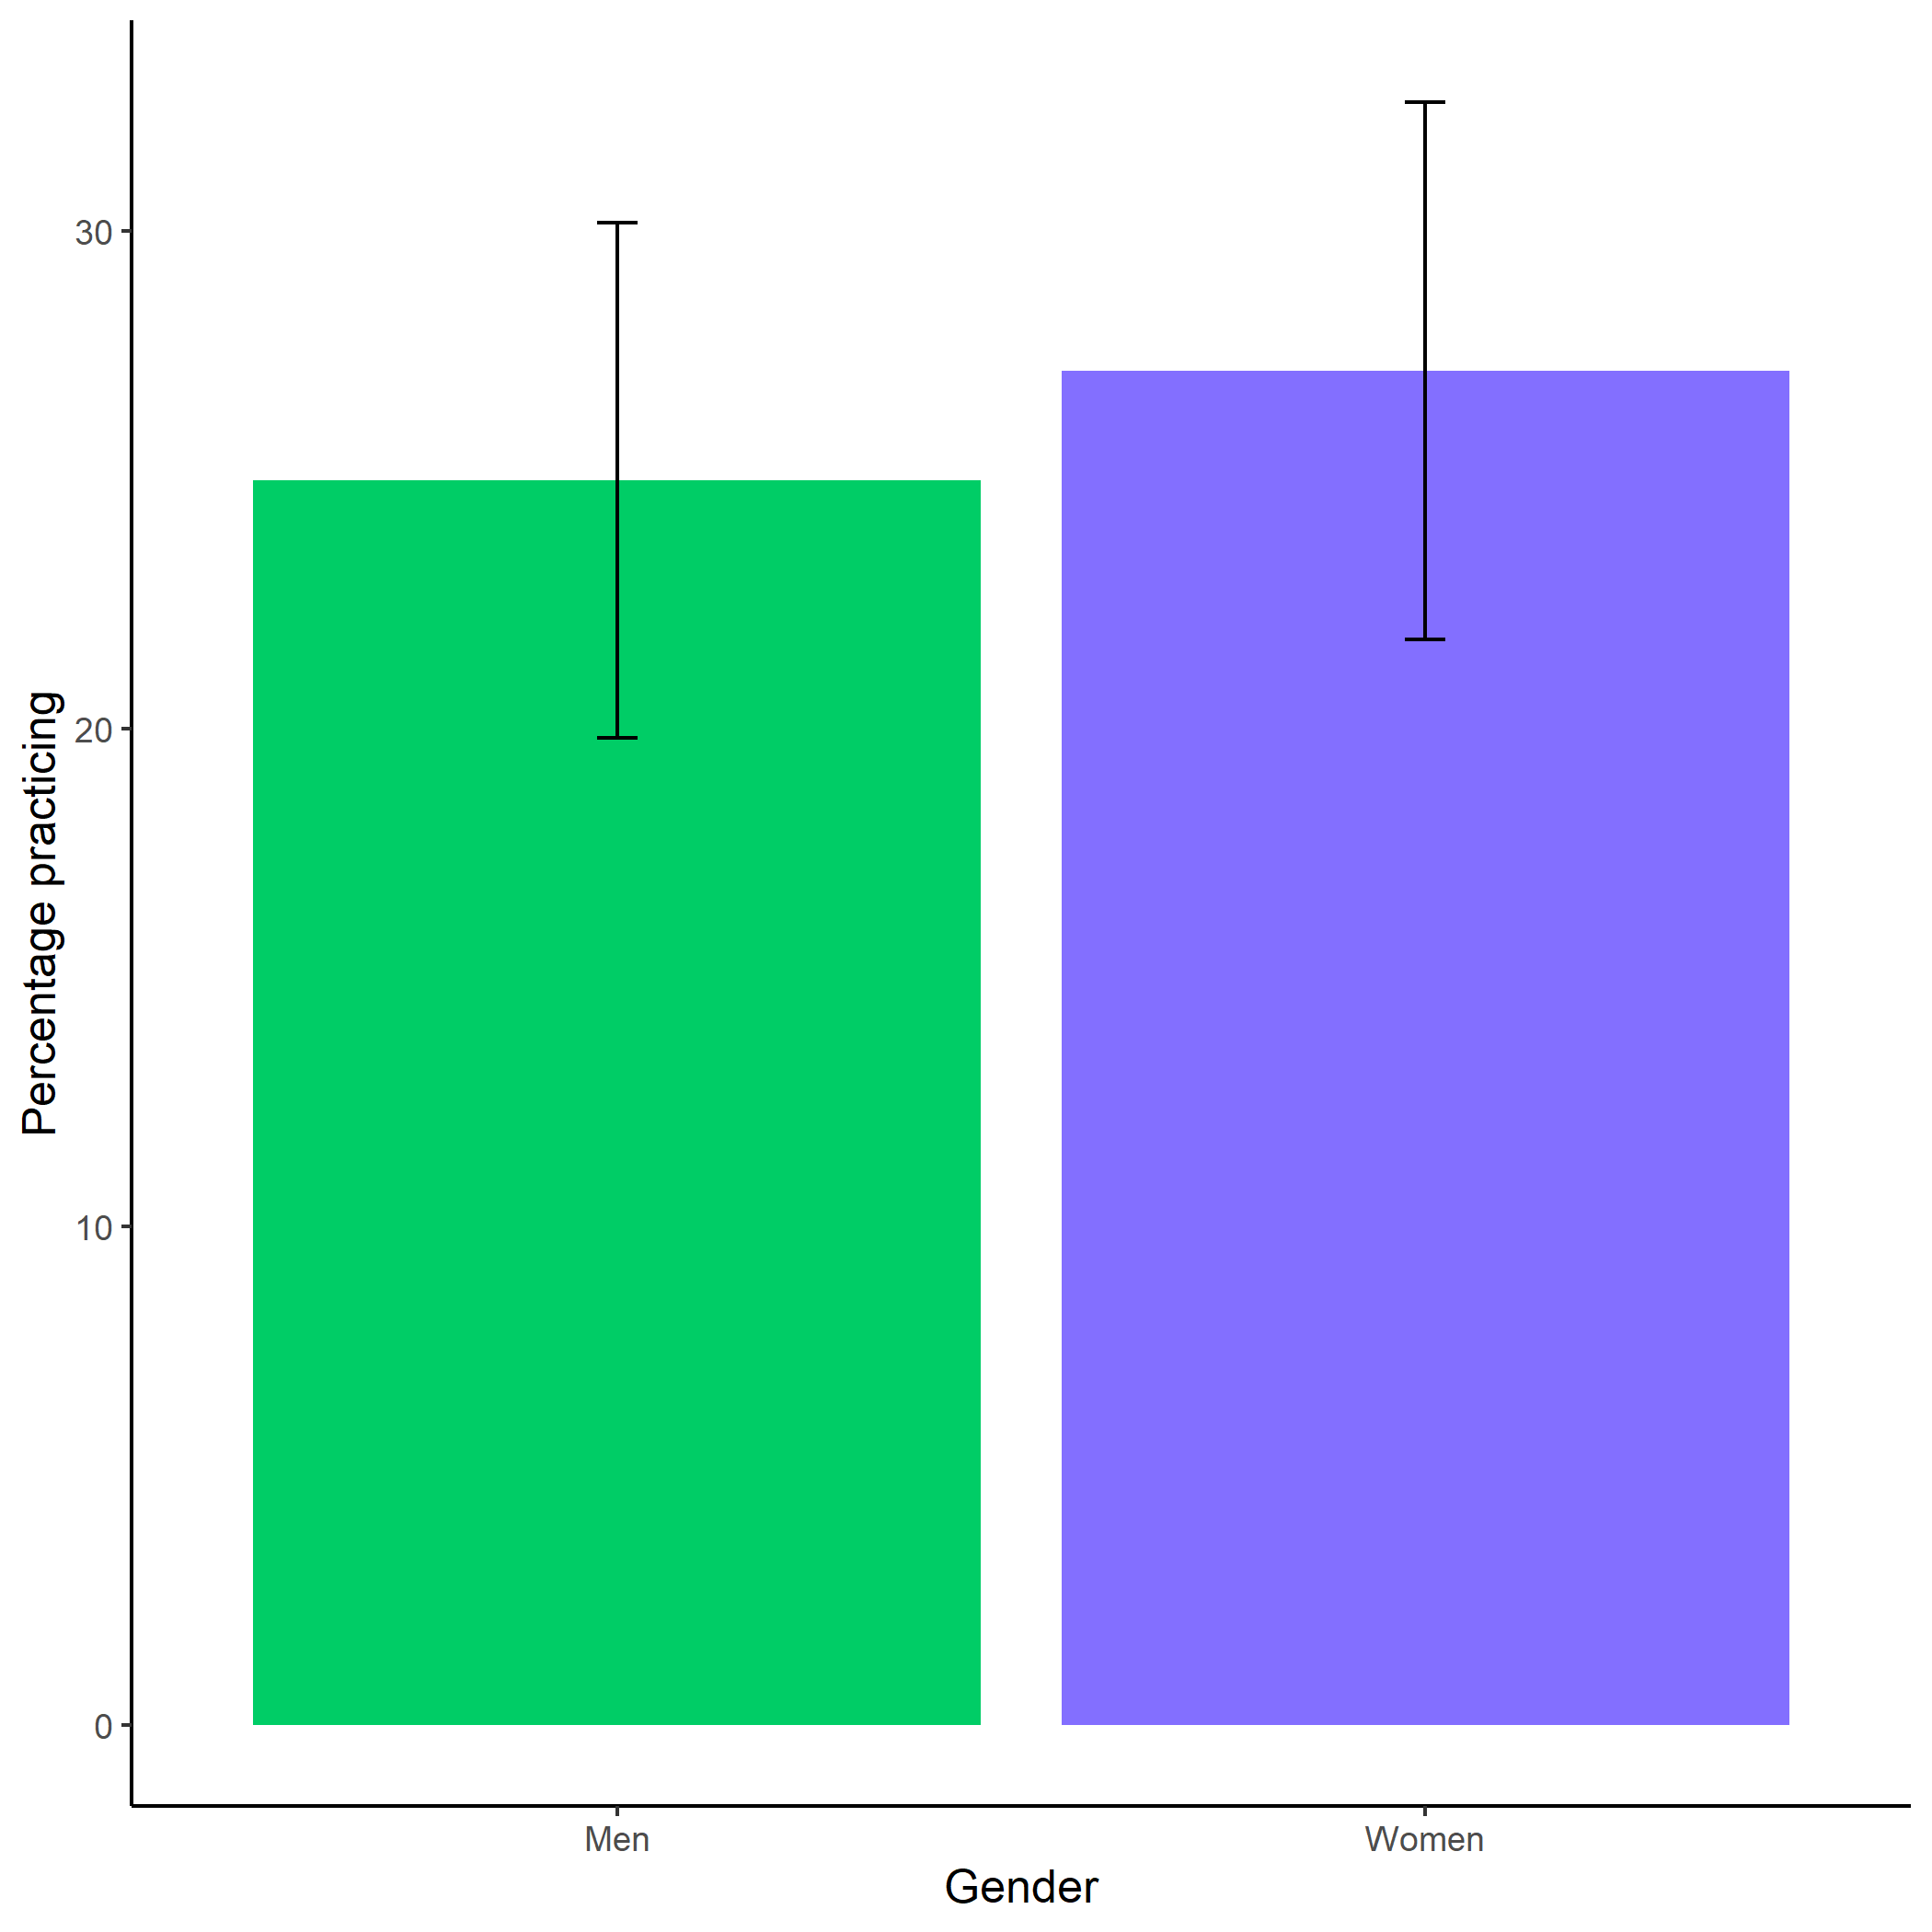

*Figure 1.24: Proportion of men and women who chose to prepare. Error bars represent standard errors.*

# 2 Chapter 2: Effects of competition on gender differences in the choice to prepare

## 2.1 Introduction

Competitions are increasingly prevalent in the global labor market (Lavy 2004; Lemieux, MacLeod, and Parent 2009) and the winners of competitions are disproportionately rewarded (Frank and Cook 2010). Much work on gender differences in competitiveness has focused on designing interventions that increase women’s willingness to compete. We test the viability of one such intervention in Chapter 1 of this dissertation by providing men and women opportunities to practice before competing. While the intervention ultimately did not increase women’s competitiveness, the studies in Chapter 1 revealed that women prepare more than men. Moreover, both men and women believed that women would be more likely to practice. Thus, a new gender difference in preparation was discovered. In the current Chapter, we ask whether competitions themselves disproportionately increase rates of practicing among women, such that women are especially likely to prepare before entering competitive environments relative to non-competitive environments. Additionally, we explore whether gender stereotypes may be driving the gender difference to practice. While considerable efforts have been made to understand why men are more likely than women to choose to compete, less attention has been paid to whether and how men and women may differentially respond to competitions. Yet, understanding downstream consequences of nudging or forcing women into competitions may too help address gender disparities in economic outcomes (Blau and Kahn 2017; Altonji and Blank 1999).

## 2.2 The gender gap in labor market outcomes and preferences for competition

Compensation packages based on performance pay, such as bonuses, commissions, and piece-rate payments, have risen in popularity relative to hourly/salaried pay, especially among workers in the highest tiers of occupations (Hall and Liebman 1998; Murphy 1999; Cuñat and Guadalupe 2005; Lemieux, MacLeod, and Parent 2009). There is evidence that the increasing use of performance pay lends itself to wage inequality. Lemieux, MacLeod, and Parent (2009) showed that an increased dependence on performance pay during the late 1970’s and early 1990’s accounted for 21% of the observed growth in variance of men’s wages. Bonuses and commissions, arguably the most competitive compensation schemes, may be especially important in driving the large disparity between the highest and lowest percentile earners within organizations (Bell and Van Reenen 2010; Bell and Van Reenen 2014; Bénabou and Tirole 2016). Importantly, performance pay may contribute to the gender wage gap too. Using data from the National Longitudinal Surveys of Youth, McGee, McGee, and Pan (2015) show that women are less likely to be employed in occupations that receive bonuses, and simultaneously are more likely to receive piece-rate pay – the least competitive of all forms of performance pay, where workers are paid based on their absolute output.

The gender wage gap refers to the difference in earnings between men and women, with men earning more, on average, than women worldwide. While the gender gap has decreased over the last three decades, the improvements have been modest. For instance, it is estimated that the ratio of women’s to men’s wages in the United States increased to only 67% in 2016 from 53% in 1986 (Gharehgozli and Atal 2020). While numerous factors have been implicated in contributing to the gap, including human capital variables (e.g., gender gaps in education and work experience) (Goldin 2006a), workforce interruptions and fewer hours among women (Blau and Winkler 2017), persistent gender segregation by field and occupation (Blau and Kahn 2017; Goldin 2014), along with discrimination (Blau and Kahn 2017), some researchers have looked to gender differences in men’s and women’s willingness to compete and to a lesser extent, behavior that results when required to enter a competition. An expanding literature in both psychology and experimental economics suggests that men, compared to women, are more willing to enter competitions. This finding was first documented in a foundational experiment by Niederle and Vesterlund (2007), and has since been replicated numerous times across populations [for reviews, see Croson and Gneezy (2009); Niederle and Vesterlund (2011), (**Niederle2017?**); and Shurchkov and Eckel (2018)), including among hunter-gatherers (Apicella and Dreber 2015).

Typically, researchers measure competitiveness as one’s willingness to enter a tournament where success and thus, earnings, depend on outperforming (an)other player(s). Participants who prefer tournament payment schemes over piece-rate payment schemes, where payments are solely determined by the number of successfully completed units, are said to be competitive (Niederle and Vesterlund 2007). Importantly, this laboratory measure of competitiveness predicts education and career choices, along with earnings outside the lab (Buser, Niederle, and Oosterbeek 2014, 2020; Zhang 2012; Buser, Peter, and Wolter 2017a; Samek 2019; Berge et al. 2015; Reuben, Sapienza, and Zingales 2015; Reuben, Wiswall, and Zafar 2017; Buser, Peter, and Wolter 2017b), and thus may help explain gender gap in labor market outcomes.

To date, most of the research on gender differences in competitiveness has focused on i) either explaining the sources of the gender difference – for instance, men tend to be more confident and risk-seeking than women (e.g., Veldhuizen 2017) or ii) designing interventions to encourage women to compete more (Balafoutas and Sutter 2012; Sutter et al. 2016; Cassar, Wordofa, and Zhang 2016; Brandts, Groenert, and Rott 2015, 2015; Niederle, Segal, and Vesterlund 2013; Healy and Pate 2011; Alan and Ertac 2018). For instance, Kessel, Mollerstrom, and Veldhuizen (2021) find that telling participants about the gender difference in willingness to compete as well as the implications on earnings, reduces the gender gap in competitiveness. Crucially, less consideration has been paid to how competitions may differentially, and perhaps negatively, impact women in other ways, such as lowered performance both during and after competition, reduced desire to enter future competitions, or potential opportunity costs related to time spent (over) preparing when required to compete.

The rest of this introduction briefly summarizes the literature on how men and women may differentially respond to competitions at three specific time points (i.e., before, during, and after competition) and highlights the need for more work on how men and women may behave differently *before* entering competitions. Second, we introduce several reasons for why preparation might be one specific behavior where gender differences before competition arise, with the expectation that women practice more than men, especially when competing. Finally, we introduce the current investigation, which experimentally tests whether and how competitions affect gender differences in preparation.

## 2.3 Gender differences in response to competitive environments

There are three major time points at which competition may affect men and women differently: before, during, and after competition. The majority of previous studies in this space have examined gender differences in response to competition during and after performance.

### 2.3.1 During competition

Many lines of work have explored the possibility of gender differences in performance under competitive pressure. Here, we summarize the work on different forms of competitive pressure, including studies that explicitly labeling one environment as competitive or, in other cases, impose certain rules or create performance contexts under which, although not explicitly labeled as competitive, reduce an individual’s probability of earning a specific reward or reduce the amount of the reward they can earn, and as such, impose competitive pressure.

Although competitions are generally motivating and designed to improve performance by increasing effort (Connelly et al. 2014; Murayama and Elliot 2012; A. R. Miller, Petrie, and Segal 2019), previous research suggests that men perform better under competitive payment schemes relative to non-competitive payment schemes, while women’s performance does not respond to competitions Dreber, Essen, and Ranehill (2011). U. Gneezy, Niederle, and Rustichini (2003) show that there is no gender difference in performance when participants are solving mazes following a piece-rate payment scheme, but a significant gender difference in performance arises under a tournament payment scheme, with men performing better. Günther et al. (2010) replicate the effect of competition on gender differences in performance for a male-typed task, but find no gender differences in performance during competition for female-typed or gender-neutral tasks.

Shurchkov (2012) finds evidence that two types of pressure may explain part of gender difference in competitiveness: task stereotypes and time constraints. Specifically, they find that women’s performance suffers when they compete against others on a male-typed math task with high time pressure (2 minutes to perform), while there are no significant gender differences in performance during competition on a female-typed verbal task with low time pressure (10 minutes to perform). Also, they find that women are significantly more likely to choose to compete when there is low time pressure in a math tournament, while men’s competition entry does not significantly vary based on the time pressure treatment.

There is also field evidence of gender differences in performance during competition. Paserman (2007) show that women’s probability of committing costly errors over the course of a tennis match increases at high-pressure moments, while men’s probability of committing such errors does not significantly change across the match.

There is also extensive work on gender differences in performance and effort under competitive pressure within academic contexts (Iriberri and Rey-biel 2019; Cai et al. 2019; Ors, Palomino, and Peyrache 2013; Azmat, Calsamiglia, and Iriberri 2016; Price 2008; see Niederle and Vesterlund 2010 for a review on gender differences in math tests scores). For instance, in a study of gender differences in responses to different levels of competitive pressure on a Korean quiz show for student scholarships, researchers find that when stress is kept to a minimum, there are no gender differences in performance, but when certain knock-out rules are applied, a difference emerges (Booth and Lee 2021). Morin (2015) show that effect of education reform that led to a double-cohort, and as such, increased competition for admission at the University of Toronto, increased men’s average grades and proportion of men who graduated on time relative to women, driven largely by men increasing their effort after the reform.

In a study examining performance during the GRE examination, Attali, Neeman, and Schlosser (2012) show that the gender gap in performance is significantly greater under the real GRE, which they demonstrated was driven by men increasing their effort, while women’s effort stayed the same. The real GRE is inherently more competitive and higher-stakes than a voluntary experimental section of the GRE, providing further support for gender differences in performance in response to competitive pressure in the field.

There is also a growing literature showing that women are less willing to guess on exams (Pekkarinen 2015; Baldiga 2014; Iriberri and Rey-Biel 2021), which in turn negatively impacts their performance on said exams, widening the gender gap in performance under competitive pressure. Riener and Wagner (2018) shows this phenomenon starts at an early age, with girls as young as eight years of age being significantly less willing to guess on exams relative to men.

### 2.3.2 After competition

During repeated competition, women tend to perform worse in subsequent performance rounds after losing, even if the monetary prize they lost was relatively meager, while men only perform worse in subsequent rounds if they lost the chance to win a large monetary prize (Gill and Prowse 2014). Other research suggests women stop competing altogether after losing if given the choice. Buser and Yuan (2019), who examine the effects of losing while competing in the Dutch Math Olympiad on the choice to compete in subsequent years, show that men are just as likely to compete even if they lost the previous year, while women are less likely to compete again if they lost before. In a separate study, Buser (2016) show that men react to losing during a competition by picking a more challenging target for their subsequent performance while women lower their performance.

Similarly, Shastry and Shurchkov (2021) performed an experiment among Economics professors where they received feedback in the form of a letter from the editor on a hypothetical journal submission, with randomized decision outcomes (i.e., revise and resubmit, reject and resubmit, reject). They find that among the assistant professors within the sample, a flat rejection during the review process reduced women’s beliefs in their probability of success in the future significantly more than men’s - as quantified by their rating of the probability of publishing the paper in the same journal or in any leading journal. This gender gap in confidence does not hold among associate or full professors, which they argue is likely driven by survivorship bias.

In another study of the effects of feedback on subsequent gender differences in behavior and beliefs, Katherine Coffman, Ugalde Araya, and Zafar (2021) examine both the role of task stereotypes (again through a female-typed verbal quiz and a male-typed math quiz) and feedback (positive or negative) on both confidence and choice in a compensation scheme (piece-rate or tournament payment). They find that women’s beliefs and choices after negative feedback are updated more negatively than men, regardless of their performance or choices before feedback. Overall, the current body of literature suggests that competitions may differentially impact women and men, both during and after said competitions.

### 2.3.3 Before competition

As mentioned previously, little research has examined how competitions may affect gender differences in behavior during another critical period: before an individual enters a competition, where they have the most control of their subsequent performance in the competition. Given previous research suggesting that women and men may respond differently during and after competitions, we expect that they will also employ different behaviors and have different perceptions of themselves and others in advance of a competition.

Our research in Chapter 1 suggests that women, compared to men, are more likely to prepare when given the opportunity. While the primary goal of this research was to experimentally test how preparation might influence gender differences in willingness to compete, a significant gender difference emerged in the choice to practice.[4] Notably, the gender difference was present regardless of the payment option scheme chosen (i.e., the competitive tournament payment scheme or non-competitive tournament piece-rate payment scheme), though such interaction effects may have been difficult to detect with the sample sizes employed. Moreover, because payment schemes were not randomized there may have been selection effects such that those who were more likely to compete may have also been less likely to prepare. Thus, whether tournament (relative to piece-rate) payment schemes lead women to prepare disproportionately more than men is still unknown.

#### 2.3.3.1 Does competition elicit a gender difference in preparation?

There are three non-mutually exclusive reasons to suspect that competition would be especially likely to increase women’s preparation before performance: the effects of competition on confidence, risk, and/or the stereotype that women prepare more than men.

##### 2.3.3.1.1 Confidence, risk, and rates of practicing

Women may spend more time preparing than men, especially before competitions, in part because they are, on average, less risk-seeking (Croson and Gneezy 2009; Dohmen et al. 2011; Eckel and Grossman 2008; Bertrand 2010; Shurchkov and Eckel 2018) and confident Bandiera et al. (2022) than men. Indeed, both confidence and risk attitude have been implicated in driving the gender gap in willingness to compete (Veldhuizen 2017; Gillen, Snowberg, and Yariv 2019; see Niederle and Vesterlund 2011 for review). The extent to which confidence and risk attitude account for the gender gap in willingness to compete is debated; some research suggests that competitiveness may be entirely explained by confidence and risk (Veldhuizen 2017; Gillen, Snowberg, and Yariv 2019) while other research suggests that there remains a residual gap in the choice to compete (Niederle and Vesterlund 2007). Regardless of whether competitiveness is a stand-alone trait, confidence and risk attitude may lead to differences in how men and women react to competitions, possibly including the decision to prepare before competitions.

Preparing for a competition, through either practicing or studying, may be a strategy individuals employ before entering a competition. Since competitions, by definition, compare the performance among two or more individuals, they naturally lead to self-evaluation and comparative judgments of self with others - processes that are intimately linked to confidence. Thus, less confident individuals may prepare more in order to reduce the negative feelings caused by low confidence independent of any ambitions to win, since mastery is an important driver of confidence (Gist and Mitchell 1992; Usher and Pajares 2008). Given the aforementioned evidence that women tend to be less (over)confident than men (Mobius et al. 2011; Niederle and Vesterlund 2011, 2007; Croson and Gneezy 2009; Lundeberg, Fox, and Puncochaf 1994; Bertrand 2010; Beyer 1990; Beyer and Bowden 1997), we may expect to see women preparing more than men, particularly in competitive contexts, which, again, naturally invoke self-other assessments.

Importantly, on top of their possible effects on preparation through confidence, competitions may also cause individuals who are more risk-averse to prepare more. Risk attitudes, as shown in Chapter 1, reflect the preference for a certain gain over a gamble, even if the gamble has an equal or greater monetary expectation (Kahneman and Tversky 1982). Since competitions, by definition, reduce the probability of earning the prize of said competition, even if the expected value of one’s earnings is equal to non-competitive payment schemes, competitive payment schemes are inherently more risky relative to non-competitive payment schemes. Thus, it is possible that the aforementioned gender differences in risk attitudes (Bertrand 2010; Croson and Gneezy 2009) may also lead women to be more likely to prepare before performing in a competition relative to men.

#### 2.3.3.2 Gender stereotypes and practicing

Gender differences in preparing may be driven by persistent stereotypes of men and women’s tendencies to prepare more before performance. Gender stereotypes derive from observers’ automatic tendency to make correspondent inferences about men and women’s dispositions (Gilbert and Malone 1995; Ross 1977; Jones and Harris 1967; Gawronski 2004), a process that appears to affect perceptions of others as early as two years of age (Poulin-Dubois et al. 2002; Serbin, Poulin-Dubois, and Eichstedt 2002). Stereotypes involve prescriptive, proscriptive, and descriptive components (Prentice and Carranza 2002), where prescriptive and proscriptive stereotypes reflect cognitive representations of the characteristics women and men should and should not have, respectively, while descriptive stereotypes are representations of the typical man and woman (Burgess and Borgida 1999). Gender stereotypes can encompass a variety of attributes, including physical (e.g., women are dainty), cognitive (e.g., men are analytical), and personality-based (e.g., women are nurturing) stereotypes (Cejka and Eagly 1999; Deaux and Lewis 1984).

Indeed, there is extensive evidence that gender stereotypes affect one’s beliefs about themselves and their performance, along with one’s behavior, such that behavior aligns more closely with gender stereotypes. For instance, Bordalo et al. (2019) found that individuals tend to overestimate actual performance gaps between genders based on stereotypes, such that women were far less confident in answering questions gender-incongruent domains (e.g., business, math, and sports) than they should have been given their performance. Katherine Coffman, Ugalde Araya, and Zafar (2021) further explore how belief updating is affected by positive or negative feedback about one’s performance, and show that receiving negative feedback in a gender-incongruent domain leads to a long-lasting negative effect on beliefs about performance (a week later), while negative feedback in gender-congruent domains does have such lasting effects. K. Coffman, Collis, and Kulkarni (2019) show similar effects, such that individuals tended to update their beliefs more in concordance with gender stereotypes, such that both men and women who receive positive feedback about their performance adjust their beliefs significantly more in line with gender stereotypes in gender-congruent domains than in gender-incongruent domains.

There is direct evidence that these beliefs can affect subsequent behavior and performance. For instance, Bian, Leslie, and Cimpian (2017) show that the gender stereotype that men tend to succeed in activities and fields that require brilliance leads girls as young as 6 years of age to avoid activities that supposedly require brilliance. Within the field, Guiso et al. (2008) find that the gender gap in math, in which boys typically outperform girls on math tests, disappears in more gender-equal societies, as measured through the World Economic Forum’s Gender Gap Index, which captures the opportunities, education, and well-being of women within a given country. Similarly, Breda et al. (2020) measure the stereotype that “math is not for girls” among students across 64 countries, and find that countries in which a larger proportion of students held this belief tended to have fewer women represented in math-intensive fields. Individuals are also less likely to engage in self-promotion behaviors in gender-incongruent domains. For instance, Katherine Baldiga Coffman (2014) show that both men and women are less likely to contribute ideas to a group decision in gender-incongruent decision-making domains (e.g., women contributing ideas to a decision in the domain of sports), even when the group would have made a better decision with their contribution. On the other hand, K. Coffman, Flikkema, and Shurchkov (2021) find that people are less likely to promote themselves when they are the gender minority in their group, presumably because they prefer to conform with perceived gender norms. Finally, Niederle and Vesterlund (2011) reviews an extensive literature showing that gender differences in competitiveness can be changed based on task type (usually male-typed math or female-typed verbal tasks), suggesting that stereotypes about the ability of one’s gender to perform on a task affects willingness to compete. Overall, research across fields shows that gender stereotypes affects gender differences in beliefs, performance, and behaviors.

We found in Chapter 1 that women not only prepared more than men, but that participants also correctly predicted that women would prepare more than men, suggesting that there are gender stereotypes about preparation in favor of women. Across three studies participants were monetarily incentivized to correctly guess which gender would choose to prepare for the paid multiplication task, such that their responses were unlikely influenced by desire to respond in a socially desirable way. Most participants in the three studies (Study 1: 83.37%, Study 2: 80.95%, Study 3: 56.7%) correctly predicted that women would practice more than men before performance on the multiplication task used in the studies and in general (Study 1: 89.51%, Study 2: 85.38% and Study 3: 59.5%).[5]

Given our evidence gender stereotypes about preparation, in combination with the evidence that gender stereotypes in general affect subsequent behavior to align with said stereotypes, it is entirely possible that gender stereotypes drive women’s tendency to prepare more than men.

Gender stereotypes about competitiveness in combination with gender stereotypes about preparation might also affect women’s preparation behaviors. That is, when women are forced to compete and are offered the opportunity to prepare before the competition, this would likely activate thoughts about gender stereotypes for both of those behaviors - that is, they will likely ask themselves 1) how typical is it for my gender to prepare? and 2) how typical is it for my gender to compete and/or perform well under competitive pressure? That is, if there’s a general belief that women prepare more than men (for which we find evidence in Chapter 1), but do not choose to compete or perform well under competitive pressure (that is, they are less competitive) (for which we find evidence in Chapter 1) - they might assume that they should prepare more to compensate for the discordance between how competitive they need to be to enter the competition and the typical level of competitiveness perceived in women according to gender stereotypes about competitiveness.

Overall, given the evidence that gender stereotypes can lead to behavior that aligns with stereotypes specific to one’s gender, we expect that participants’ perceptions of gender differences in preparation likely contribute to gender differences in actual preparation behavior, along with their perceptions of how much they prepare relative to others, especially in competitive settings.

## 2.4 The current experiment

Here, we study how women and men differentially respond to competition through preparation. We expect to see both gender differences in actual preparation behavior, along with gender differences in perceptions of relative preparation, especially when men and women are required to compete (relative to non-competitive environments). Specifically, we experimentally test whether competition exacerbates previously established gender differences in preparation by manipulating participants’ assigned payment scheme (i.e., competitive tournament payment scheme or non-competitive piece-rate payment scheme). We hypothesize that women will choose to practice problems at a higher rate than men, especially when assigned to the competitive tournament payment scheme (i.e., we anticipate a main effect of gender on the choice to practice, and an interaction between gender and condition, such that women will practice more than men in both conditions, but the difference-in-differences between practicing rates across genders will be greater in the competition condition).

While we did not find an interaction between gender and choice to compete on the decision to prepare in Chapter 1, the sample in those studies was likely too small to detect interaction effects. Moreover, participants were not randomized to their payment schemes. As such, selection effects may obscure actual relationships between gender and practicing by payment schemes. The current study expands on the results of in Chapter 1 by directly manipulating participants’ payment scheme and recruiting a sample large enough to detect interaction effects.

It is also entirely possible that women prepare more than men regardless of the payment scheme, possibly because of gender stereotypes that lead them to think they should prepare in advance of any type of performance, or perhaps because in general, they want to reduce the risk of earning nothing, even in the piece-rate payment scheme. Or, as suggested by the extensive literature showing that women’s performance does respond to competitive pressure [cites], women’s effort may not differ significantly across different levels of competitive pressure, while men’s effort may increase in response to competitive pressure. Thus, we may still find no evidence for an interaction effect between gender and choice to compete in the study in Chapter 2, suggesting that women’s preparation behaviors are insensitive to the payment scheme relative to men.

Not only do the aforementioned factors (i.e., gender differences in confidence and risk attitudes, and/or gender stereotypes likely affect gender differences in preparation behavior, but they likely also affect one’s *perceptions* of their relative rate of preparation. For instance, when an individual has less confidence in their ability to perform on a task, they may feel less capable, or in other words, less prepared, relative to others when it comes time to perform on said task. Given the likely effects of competitions on self-other assessments, they increase the likelihood an already less confident individual, who may feel as though they are not as capable as others on performing well without preparation, will suffer these feelings of relatively lower preparation. Similarly, in riskier contexts, such as competitions, an individual who is more risk averse than others may feel as though they are not preparing sufficiently relative to others to reduce the inherent risk of the situation. Finally, it would reason to assume that gender stereotypes drive not only preparation behavior, but perceptions of relative preparation - given the argument that our behavior is driven by perceptions of norms and how we stand relative to the norm.

For the above reasons, this study included a new measure of how much participants felt they prepared relative to other participants to test whether gender predicts participants’ perceptions of their relative amount of preparation. More concretely, we expected women will be more likely to assume they practice less than others compared to men (that is, the effect of gender on perceptions of relative practice will be negative), especially when assigned to the competitive tournament payment scheme (such that women in general will think that they practice less than other participants than men, but this difference will be exacerbated in the competition condition).

The research design, hypotheses, measures and analyses for this chapter were pre-registered on [OSF](https://osf.io/8bwfz/) and all analyses were conducted in R statistical software (version 4.0.4).

### 2.4.1 Methods

## 2.5 Participants

Participants were recruited on Amazon Mechanical Turk using the same screening criteria as all previous studies in Chapter 1. Like the last study of Chapter 1, we used Qualtrics’ fraud detection software to filter out responses that were suspicious either because they were likely 1) bots and/or 2) duplicate responses using the same exclusion criteria from before. These exclusions were applied for all main analyses reported in the results section.

The final dataset consists of 3980 participants (57.36% women), with an average age of 41.3 (*SD* = 13.2) years. Of the final sample, 75 participants (30.67% women) dropped out of the study before finishing and 192 participants were flagged by Qualtrics’ fraud detection software as suspicious based on the aforementioned criteria.

## 2.6 Procedures

Participants included in the study were told they would be completing a multiplication task. Notably, we aimed to recruit a larger sample to provide enough power to detect our anticipated interaction effects, and shortened the task from two minutes (as in Chapter 1) to 30 seconds (in the present study). Otherwise, the task used was identical to the ones used in previous studies.

Like the studies in Chapter 1, participants were first told about the rules for the multiplication task and were required to pass the same comprehension questions used in the previous studies before moving onto the main manipulation of payment scheme.

### 2.6.1 Manipulation of payment scheme

Unlike previous studies, participants were not able to choose a payment scheme. Instead, they were told about their random assignment to one of two payment schemes: the non-competitive, piece-rate payment, scheme or a competitive, tournament, payment scheme. Men and women were evenly assigned to both conditions. If they were assigned to the piece-rate payment scheme, they were paid $.10 per problem solved correctly. If they were assigned to the tournament payment scheme, they were randomly matched with another participant that was also assigned to that payment scheme and received $.20 per problem if they solved more problems than the other participant. Otherwise, they received nothing.

Again, we checked that condition was assigned evenly across participants (control= 50.21%) and genders included in the study. Of the men who completed the study, 50.53% were assigned to the control condition and of the women who completed the study, 49.98% were assigned to the control condition, $χ^{2}(1,n=3980)=0.10$, $p=.754$. We also assessed condition-dependent attrition by identifying the number of participants that dropped out during/after learning about condition and found that a relatively small proportion of participants out of the total sample dropped out after learning about their respective condition (*N* = 42; 0.35% of men dropped out after learning about assigned condition versus 0.7% of women dropped out after learning about assigned condition, $χ^{2}(1,n=3980)=1.14$, $p=.285$). Given the small sample that dropped out relative to the total number of participants in the study, we are not concerned that condition-dependent attrition is driving any of the effects found in this study.

### 2.6.2 Main dependent variables of interest: Measures of preparation and perceptions of relative preparation

After they were informed of their payment scheme, all participants were given the opportunity to spend unlimited time preparing before completing the paid multiplication task. The nature of the unlimited preparation was identical to that used in Study 3 of Chapter 1, where participants who chose to prepare were shown 10 multiplication problems that were created randomly by drawing from the pool of numbers used in the main multiplication task. Unlike the last study in Chapter 1, participants were not asked to explicitly indicate whether they would like to study the times tables. Instead, they were shown the times table right after the practice problems directly on the practice problems page and told they could check their answers using the table as desired. By including the option to check their answers, we hoped to make the practice itself more useful by providing participants a way to receive feedback on their responses. At the bottom of each practice page, participants were asked if they would like to continue practicing multiplication problems, with the option to continue as many times as desired or opt out at any point. The amount of time (in seconds) participants spent on each practice page was also recorded. Thus, like the previous studies, we have multiple measures of preparation, by design: 1) the actual decision to practice problems (before knowing what the practice entails), 2) the number of practice problems participants attempted (quantified as number of practice problems not left blank, irrespective of accuracy - with participants who did not opt into the practice having a value of zero), 3) the amount of time participants spent across all practice rounds they completed (where those who chose not to practice had a value of zero for this variable), and 4) the number of practice rounds participants completed. Since the practice structure in this study is identical to that of Study 3 in Chapter 1, the number of practice rounds variable was encoded in the same way as that study (*M* = 0.59, *SD* = 0.98).

After completing the practicing/studying, participants guessed how much their amount of practicing for the task compared to all other participants who completed the task by indicating the decile of their practice relative to other participants. We also asked participants to indicate their anticipated decile when their amount of practicing was compared to that of all participants who identified as men and women, respectively.

We used these decile questions to create the perceived practice deviation variables as follows: self-rated decile (either based on the question about practicing relative to all other participants, relative to only men, or relative to only women) - actual percentile based on number of practice problems completed. We subtracted percentile from decile here because it provides more variation in the variable, thus allowing us to be more precise in our estimates of the effects of various predictors on this variable. We chose to ask participants to indicate their decile rather than percentile because it would be cumbersome for participants and it is unlikely they would be able to provide concise responses. Overall, negative values for this variable indicate a participant expected to have practiced less, relative to other participants, than they actually did, and vice versa for positive values. A value of zero, therefore, indicates that a given participant was completely accurate in their guess of relative practicing.

### 2.6.3 Paid multiplication task and post-task measures

After practicing, participants completed the paid multiplication task, received feedback about their absolute (but not relative) performance, and completed many of the same follow-up questions used across Chapter 1, including risk attitudes, confidence, and perceptions of gender differences in preparation, competitiveness, and performance. Like Study 3 of Chapter 1, all questions had three response options (e.g., men are more likely to compete than women, women are more likely to compete than men, or there are no differences how much men or women would choose to compete). One of the perceptions of gender differences questions deviated slightly from the previous studies, which was edited for the sake of clarity. Instead of asking participants to indicate “Do you think men or women in this study chose the tournament payment option more often?” they were asked “If given the opportunity to choose between the two payment schemes (Piece Rate or Tournament), do you think men in this study would choose the piece rate or the tournament payment scheme more often?” with the options to indicate: “Men would choose tournament more often than piece rate,” “Men would choose piece rate more often than tournament,” or “Men would choose each payment scheme equally.” This question was repeated with respect to women in the study.

We paid participants to answer the questions about their confidence and perceptions of gender differences correctly at the same rate as previous studies. Finally, they completed the same demographic questions from Chapter 1 and provided feedback on the study before being paid for their participation.

### 2.6.4 Results

## 2.7 Describing main variables of interest

First, we explored the characteristics of the main practice variables in the dataset. Across conditions, 45.51% of all participants chose to practice, with 48.22% choosing to practice in the piece-rate payment condition and 49.73% choosing to practice in the tournament payment condition. This difference in the choice to practice across conditions is significant when condition is included as a predictor alone, $b=0.15$, 95% CI $[0.02$, $0.28]$, $z=2.35$, $p=.019$, but in the subsequent section we explain how the effect changes when including other predictors in the model. Participants spent an average of 29.12 seconds practicing across all rounds of practice.

Like all studies in the first chapter, we replicate the effect of gender on risk attitudes, $b=−0.86$, 95% CI $[−1.01$, $−0.70]$, $t(3920)=−10.71$, $p<.001$, and confidence, $b=−8.46$, 95% CI $[−10.12$, $−6.79]$, $t(3978)=−9.96$, $p<.001$, such that women were more risk averse and less confident relative to men.

Contrary to the majority of studies in the first chapter, we find a significant effect of gender on task score, Mwomen=10.45, SD=4.47; Mmen= 12.29, SD =7.28, $b=−1.83$, 95% CI $[−2.20$, $−1.47]$, $t(3929)=−9.75$, $p<.001$, even when including risk attitudes, confidence, and an interaction between gender and condition in the model, $b=−1.38$, 95% CI $[−1.89$, $−0.86]$, $t(3916)=−5.20$, $p<.001$. We explore this finding further in the discussion section for this study.

## 2.8 Effects of gender and condition on both practicing and perceptions of one’s relative practicing

We replicate the effect of gender on the choice to practice found in Chapter 1, where 51.26% of women chose to prepare via practice, relative to 37.81% of men, $b=0.55$, 95% CI $[0.42$, $0.68]$, $z=8.37$, $p<.001$ (see Figure 2.5). The gender effect holds in a logistic regression with gender, condition, and the interaction between the two predicting the binary choice to practice problems, $b=0.51$, 95% CI $[0.33$, $0.69]$, $z=5.49$, $p<.001$ (see Figure 2.1). However, we do not find an interaction between gender and condition, $b=0.08$, 95% CI $[−0.18$, $0.34]$, $z=0.60$, $p=.547$, contrary to our hypothesis that the gender difference in the choice to prepare would be exacerbated under the tournament payment scheme relative to the piece-rate payment scheme. Additionally, the aforementioned effect of condition on the choice to practice is no longer significant in the model including these additional predictors, $b=0.10$, 95% CI $[−0.09$, $0.30]$, $z=1.03$, $p=.302$. In a subsequent logistic regression that added confidence, risk attitudes, and task scores to explore whether they explain the gender difference in the choice to practice, we find that gender still significantly predicts the choice to practice when these variables are included in the model, $b=0.11$, 95% CI $[−0.09$, $0.30]$, $z=1.06$, $p=.290$.

We also examined other measures of practice to test the robustness of the effect of gender on practicing. We find that women, relative to men, completed a significantly higher number of practice problems, $b=0.39$, 95% CI $[0.35$, $0.43]$, $z=18.54$, $p<.001$, more rounds of practice, *b* = 0.31, CI [0.04, 0.59], *z* = 2.24, *p* = 0.03, and spent more time completing practice problems, $b=13.12$, 95% CI $[7.95$, $18.28]$, $t(3959)=4.98$, $p<.001$ while controlling for condition and the interaction between gender and condition. None of the interaction effects were significant across any of these dependent variables.

Based on previous literature on risk aversion and confidence affecting competition entry, we expected participants with especially high levels of risk aversion and/or low levels of confidence would be especially likely to choose to practice before entering a competition, and that this effect may interact with gender. Thus, we tested possible three-way interactions between gender, condition, and risk aversion or confidence on the choice to practice problems through two logistic regressions, but did not find evidence that risk aversion, INSERT, nor confidence, INSERT, interacted with gender and condition.[6].

## 2.9 Accuracy of levels of practicing based on participant gender

Next, we ran a linear regression with gender, condition, and the interaction between those two variables predicting the aforementioned perceived practice deviation variable (that is, subtracting each participants’ percentile based on number of practice problems completed from their self-rated decile) to test our second hypothesis that women would be more likely to assume they practice less than others compared to men, especially under the competitive tournament payment scheme. We find a significant effect of gender on perceived practice deviation, such that women (relative to men) were significantly less likely to assume they practice more than others, $b=−14.49$, 95% CI $[−19.43$, $−9.55]$, $t(3959)=−5.75$, $p<.001$, Mwomen=23.56, SD=56.11; Mmen= 39.69, sd=54.87 (see Figure 2.8). We do not observe a significant effect of condition on perceived relative practice, $b=−1.30$, 95% CI $[−6.61$, $4.00]$, $t(3959)=−0.48$, $p=.630$. Finally, we did not find evidence of the anticipated interaction effect between gender and condition on perceptions of relative preparation, $b=−3.25$, 95% CI $[−10.26$, $3.76]$, $t(3959)=−0.91$, $p=.364$.

Since this is the first time we have used the perceived practice deviation variable and are not able to attest to its robustness, we also explored another way of testing this hypothesized effect by using participants’ self-rated decile as the dependent variable instead of perceived practice deviation and then controlling for number of practice problems attempted (as a proxy for more precise estimate of amount of practicing) in a linear regression. We find that, regardless of the number of practice problems attempted, women are significantly less likely to say they practice more than others, compared to men, $b=−4.19$, 95% CI $[−7.12$, $−1.27]$, $t(3958)=−2.81$, $p=.005$.

We also explored how self-rated decile changes based on whether participants were asked to compare their amount of practicing to men or women in the study specifically, and find that participants’ perceptions of how much they practiced relative to women in the study are significantly lower than perceptions of much they practiced relative to men, $M_{d}=−8.09$, 95% CI $[−9.03$, $−7.14]$, $t(3,979)=−16.85$, $p<.001$.

## 2.10 Perceptions of gender differences in behavior

Like in Study 3 of Chapter 1, we ran both chi-square goodness of fit tests with all three response options for the questions about perceptions of gender differences, and if the test with all options was significant, we subsequently ran more targeted chi-square tests to perform pairwise comparisons. Across all measures of perceptions of gender differences in behavior, we replicate effects found in the previous studies. First, the majority of participants (59.57%) said that women would be more likely to practice/study for the task, $χ^{2}(2,n=3980)=1,782.43$, $p<.001$ (see Figure 2.2), which was significantly higher than the proportion of participants who said men would be more likely to practice/study than women (4.73%), $χ^{2}(1,n=3980)=1,837.76$, $p<.001$, and the proportion of participants that said there was no difference in the likelihood that men and women would practice/study (35.7%), $χ^{2}(1,n=3980)=235.00$, $p<.001$.

Similarly, participants were significantly more likely to say that women prepare more than men in general (68.28% of participants), $χ^{2}(2,n=3980)=2,464.02$, $p<.001$ (see Figure 2.4), relative to the proportion of participants that said men prepare more than women (4.41% of participants), $χ^{2}(1,n=3980)=2,200.99$, $p<.001$, or that there is no difference in how much men and women prepare (27.31% of participants), $χ^{2}(1,n=3980)=688.84$, $p<.001$.

Yet, participants did not expect a gender difference in performance on the main multiplication task used, $χ^{2}(2,n=3980)=781.11$, $p<.001$ (see Figure 2.3), where 54.17% of participants said that there was no difference in how many multiplication problems men and women correctly solved, while 20.56% said men correctly solved more multiplication problems than women, $χ^{2}(1,n=3980)=594.16$, $p<.001$, and 25.27% said women had a performance advantage over men, $χ^{2}(1,n=3980)=413.36$, $p<.001$.

Finally, 64.24% of participants expected women would be more likely to choose the piece-rate payment scheme than the tournament payment scheme, $χ^{2}(2,n=3980)=1,707.40$, $p<.001$ (see Figure 2.6), which was a significantly higher proportion of participants than those who expected women would choose each payment scheme equally (20.9%), $χ^{2}(1,n=3980)=865.27$, $p<.001$, and than those who expected women would choose tournament more often than piece rate, (14.86%), $χ^{2}(1,n=3980)=1,209.14$, $p<.001$. On the contrary, when asked about how much men in the study would compete, a significant majority of participants (63.5%) expected men to be more likely to choose the tournament payment scheme over the piece-rate payment scheme, $χ^{2}(2,n=3980)=1,620.33$, $p<.001$ (see Figure 2.7), relative to the proportion of participants who said men would choose each payment scheme equally (15.8%), $χ^{2}(1,n=3980)=1,125.25$, $p<.001$, and the proportion who said men would choose piece rate more often than tournament (20.7%), $χ^{2}(1,n=3980)=853.48$, $p<.001$.

### 2.10.1 Discussion

## 2.11 Main hypotheses:

First, we find that, like previous literature in this space and our own studies across Chapter 1, women are more risk-averse and less confident than men in this study. Yet, even when controlling for gender differences in risk attitudes and confidence, we replicate findings from the studies in Chapter 1 that women choose to prepare more than men. Interestingly, women chose to prepare more regardless of the payment scheme (competitive tournament, non-competitive piece-rate) they were randomly assigned to. Also, although participants overall were more likely to practice in the tournament scheme, we did not find evidence that assignment to either a tournament or piece-rate payment scheme significantly predicted the binary choice to practice problems, after including gender and the interaction between gender and condition in the model. Although we did not explicitly hypothesize a priori that condition would be a significant predictor of the choice to practice, it is nonetheless important to note that gender explains participants’ decision to practice problems over and above any effect of condition.

We also included other means of quantifying preparation (i.e., amount of time spent on the pages with practice problems and study tables, number of practice problems completed, and total number of practice rounds completed) to test the robustness of the gender effect, and find evidence across our multiple measures of preparation that women tended to prepare more than men– they spent more time completing practice problems and studying tables, completed a higher number of practice problems, and completed more rounds of practice.

One important consideration when interpreting the effect of gender on the choice to prepare before the task is that, contrary to our prior studies (Chapter 1), we find a significant effect of gender on task score, even while controlling for individual differences in risk attitudes and confidence, unlike two out of the three studies in the last chapter. It is possible that shortening the task contributed to this effect - especially considering evidence suggesting that women’s performance may suffer under more competitive pressure [cites]. There may be less pressure to perform well during a two-minute task (used in all of the studies of Chapter 1) relative to a 30-second task (used in the study in this Chapter). In support of this possibility, Shurchkov (2012) shows that womens’ performance significantly improves, to the extent that they outperform men, in a low time pressure competition.

We also found evidence for the hypothesized main effect of gender in our other primary pre-registered analysis, where women were more likely to assume they practice less than others compared to men. This effect held when using our pre-registered version of the analysis using the perceived practice deviation variable, representing the accuracy of participants’ guess of how much their level of practicing compared to others participants’ level of practicing, both among the full set of participants and among the subset of participants that chose to practice. We also wanted to test the robustness of the effect using a slightly different way of quantifying our relationship of interest, where we included participants’ raw self-reported practice decile as the main dependent variable of interest (instead of perceived practice decile) with gender and number of practice problems attempted as predictors. We replicate the aforementioned effect, where women tended to think they practice less than others, regardless of how many practice problems they actually attempted - although this effect only held among the full set of participants and not among the subset of participants who chose to practice.

We did not find the hypothesized interaction between gender and condition on perceived practice deviation - suggesting that, like actual decisions to practice, women’s tendency to perceive they are practicing less than others is not significantly affected by whether they are competing or not. Although it is not possible to draw strong conclusions from null effects, we explore possible reasons for the null interaction between gender and condition further in the subsequent general discussion summarizing results across all studies of the dissertation.

## 2.12 Perceptions of gender differences in performance, competition, and preparation

With respect to the questions asking participants to indicate their perceptions of gender differences about our main behavioral variables of interest, we replicate findings from all three studies in Chapter 1. Even though participants expected that women and men would not have a significant difference in task scores, they expected men to prefer the tournament payment scheme over the piece-rate payment scheme, while expecting women to both i) prefer the piece-rate payment scheme over the tournament payment scheme and ii) prepare more, both before completing the multiplication task used in this study and in general before most tasks. Again, with the exception of the general gender difference in practice questions, all of the other perception questions were incentivized for accuracy to reduce socially desirable responding. Our exploratory analysis of the new set of questions about perceptions of relative practicing compared to each gender included in the study of this Chapter support these general perceptions of gender differences in preparation. Given the targeted nature of the questions, we were able to test how participants’ responses changed based on whether they were asking to compare their level of practicing in the study to only participants that identified as women or only participants that identified as men, and find that participants were significantly more likely to indicate that they practiced less relative to women than relative to men.

## 2.13 Summary of takeaways

Overall, our results for the study in Chapter 2 suggest that women prepare more than men, regardless of whether they were assigned to a competitive tournament or non-competitive piece-rate payment scheme, and despite thinking they practice relatively less than men for the multiplication task used in the study. It is possible that gender stereotypes are driving these gender differences in behaviors and perceptions, given our replication of the findings from all three studies in Chapter 1 that participants expected women to prepare more both before the specific task used in the study and in general, along with the finding that participants’ tended to rate their relative practicing significantly lower when comparing themselves to women than men.

## 2.14 Figures

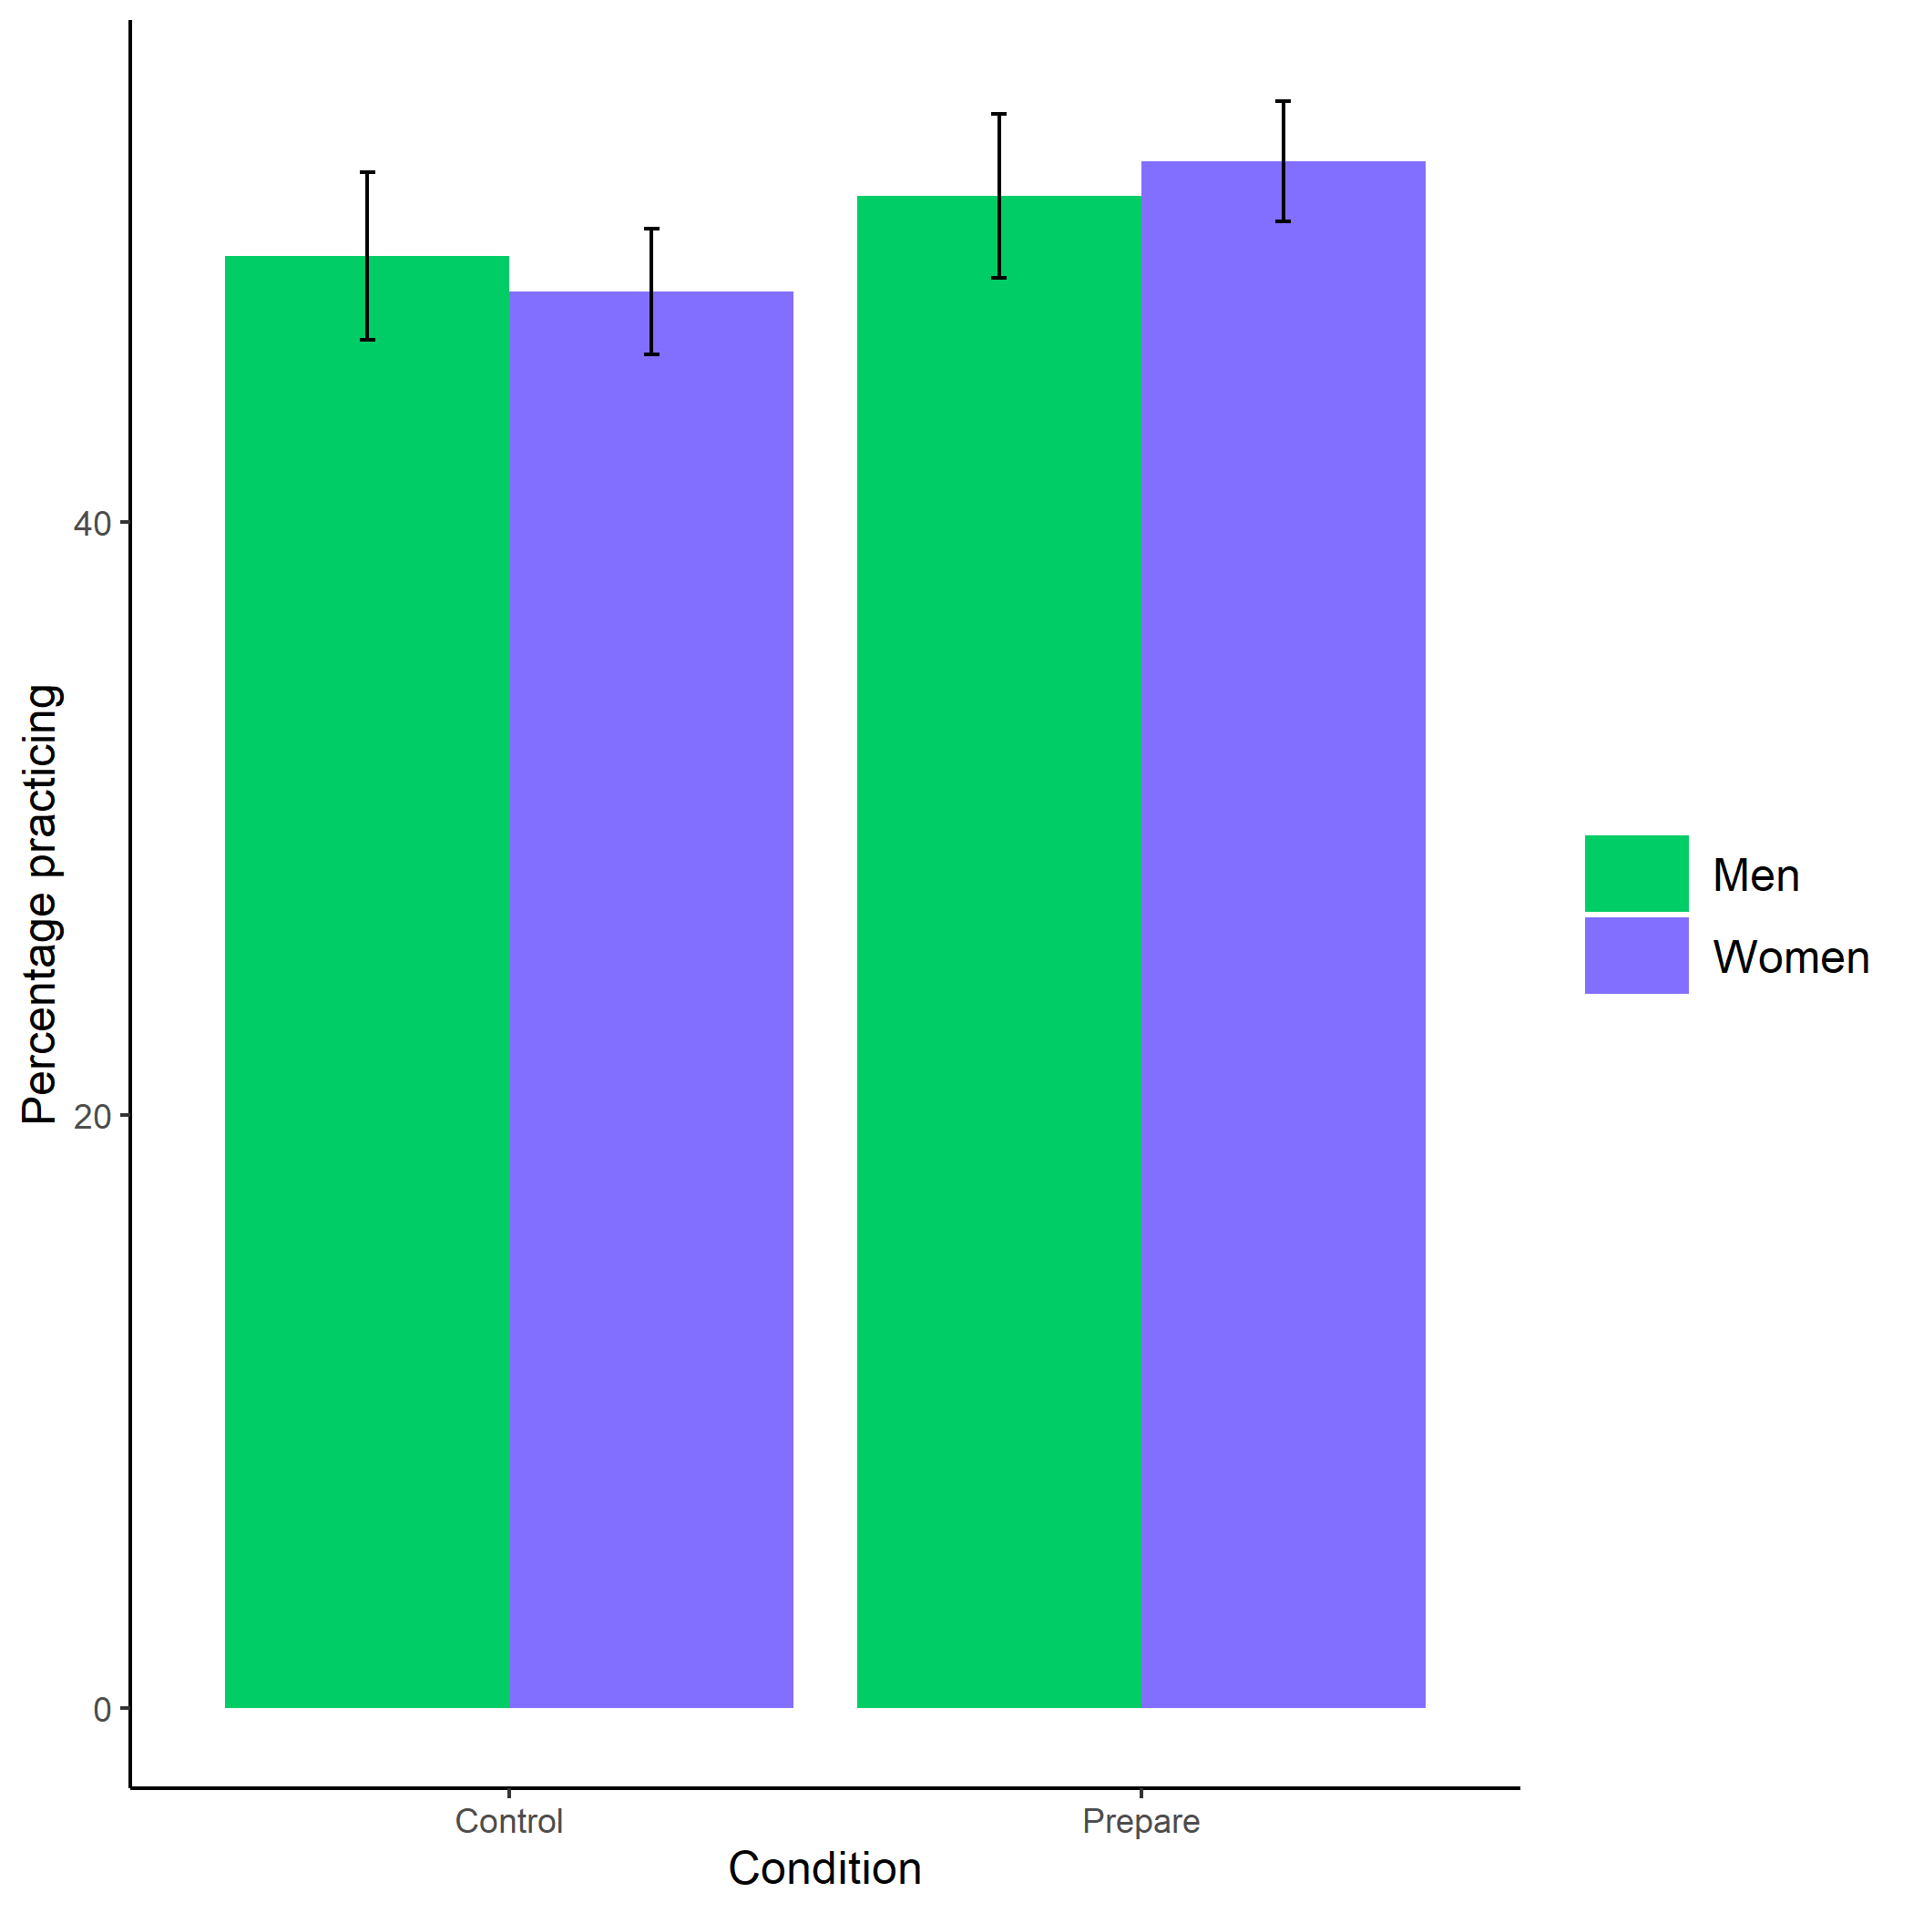

*Figure 2.1: Proportion of men and women who chose to prepare by condition. Error bars represent standard errors.*

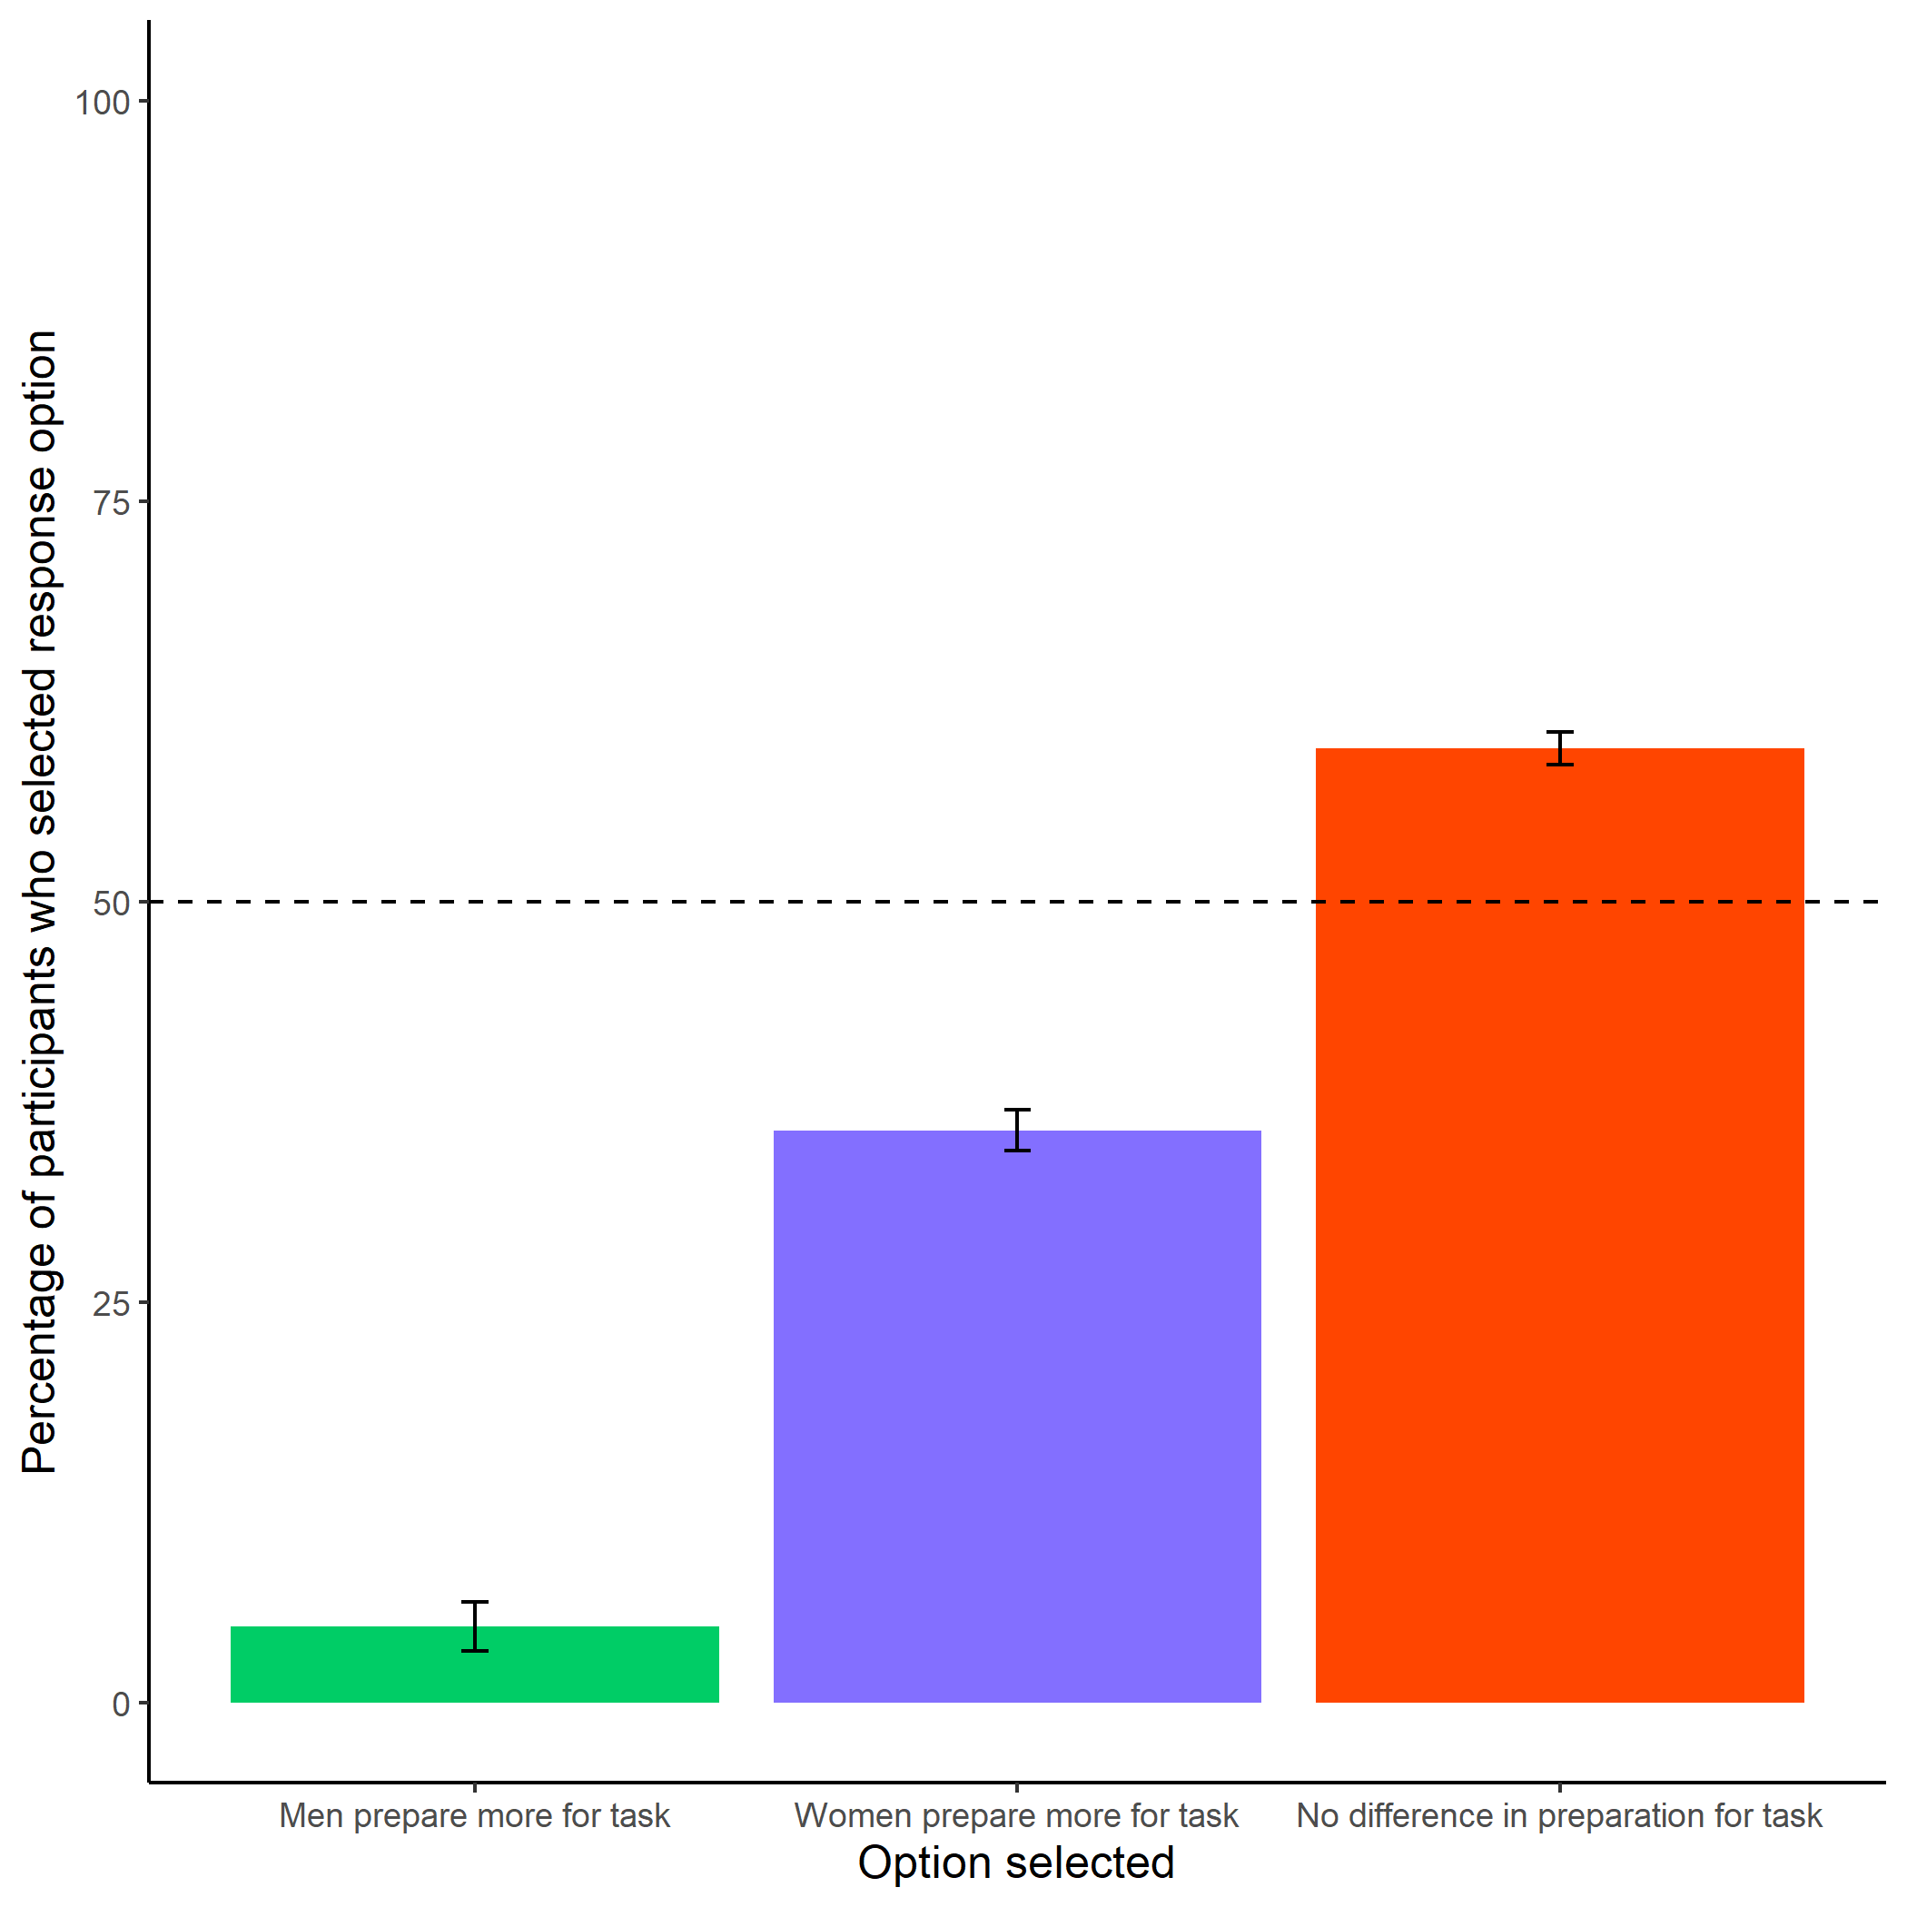

*Figure 2.2: Participants’ perceptions of gender differences in the choice to practice on the task. Error bars represent standard errors.*

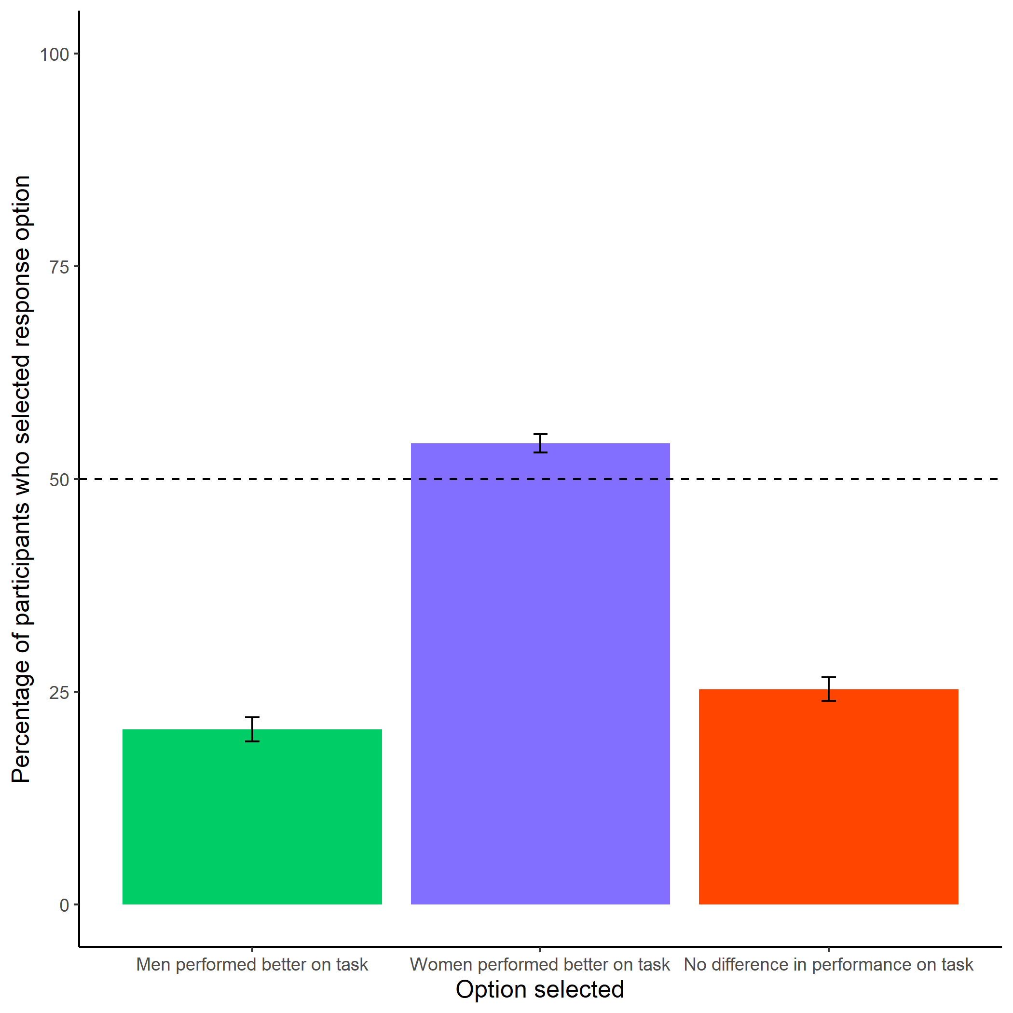

*Figure 2.3: Participants’ perceptions of gender differences in performance on the task. Error bars represent standard errors.*

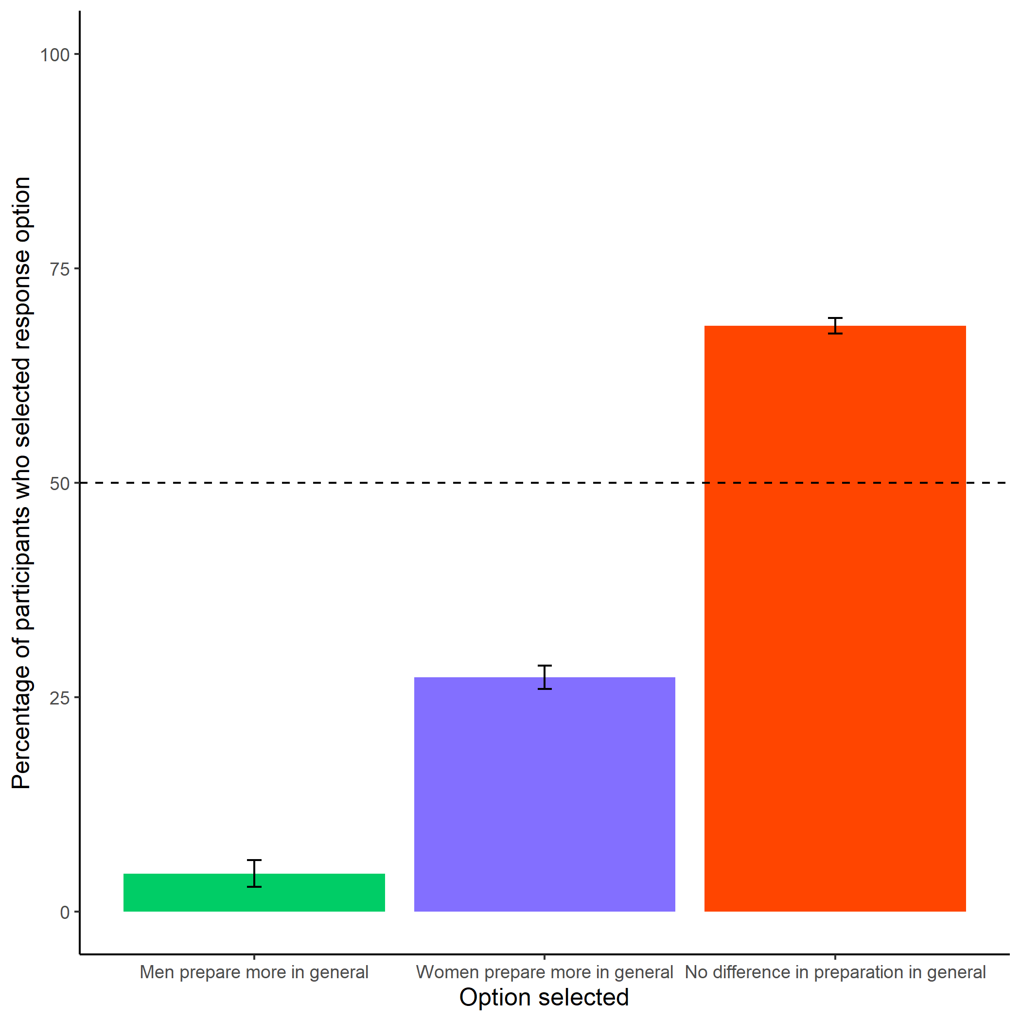

*Figure 2.4: Participants’ perceptions of general gender differences in choice to practice. Error bars represent standard errors.*

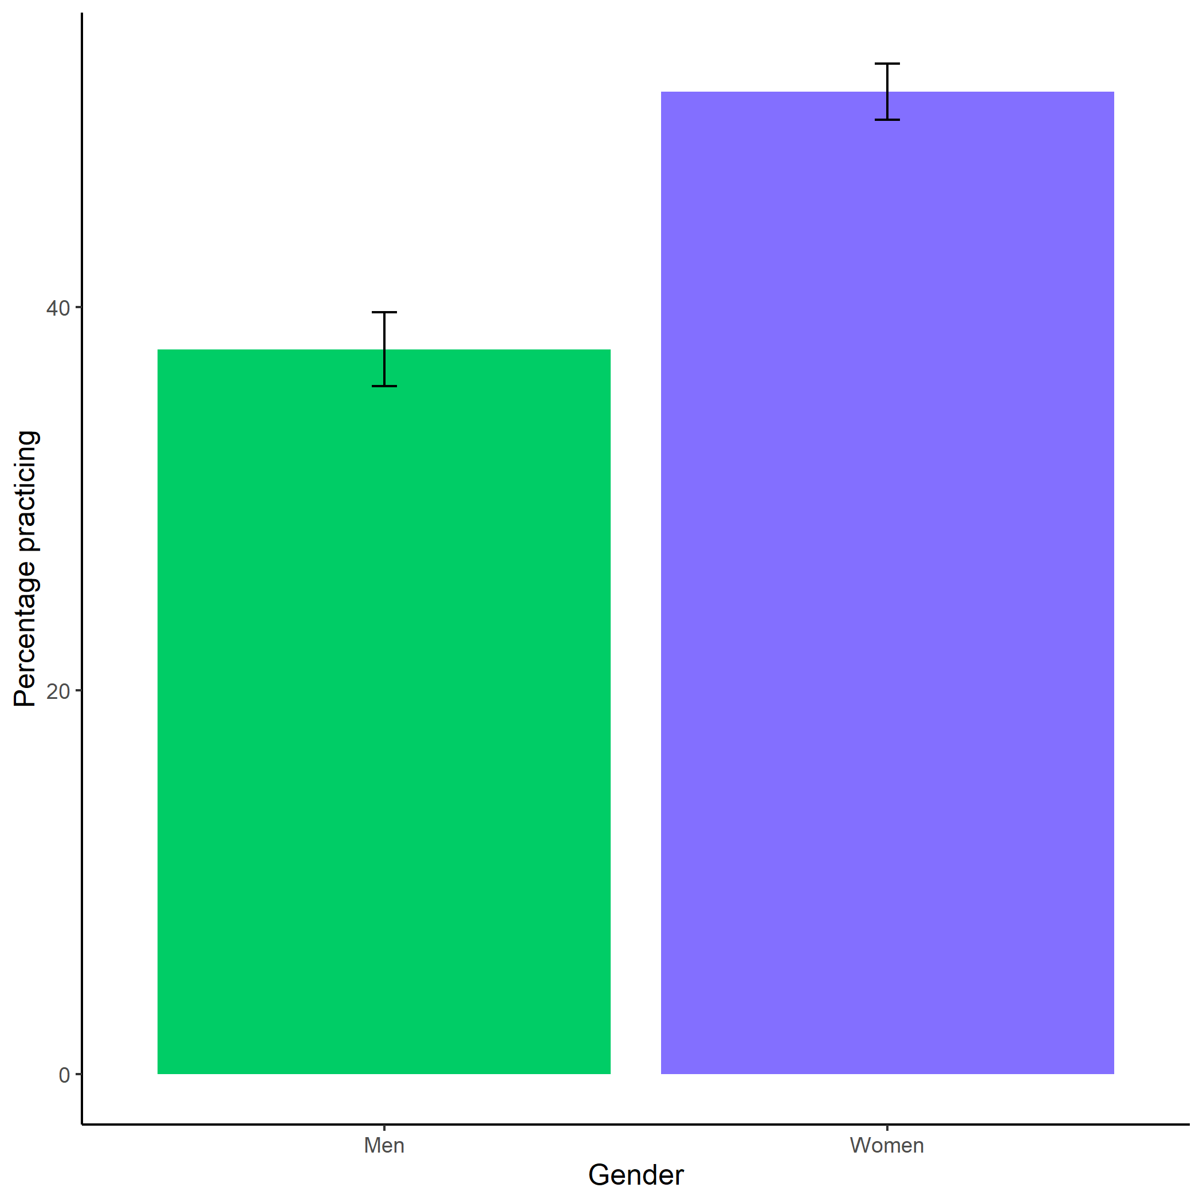

*Figure 2.5: Participants’ perceptions of general gender differences in choice to practice. Error bars represent standard errors.*

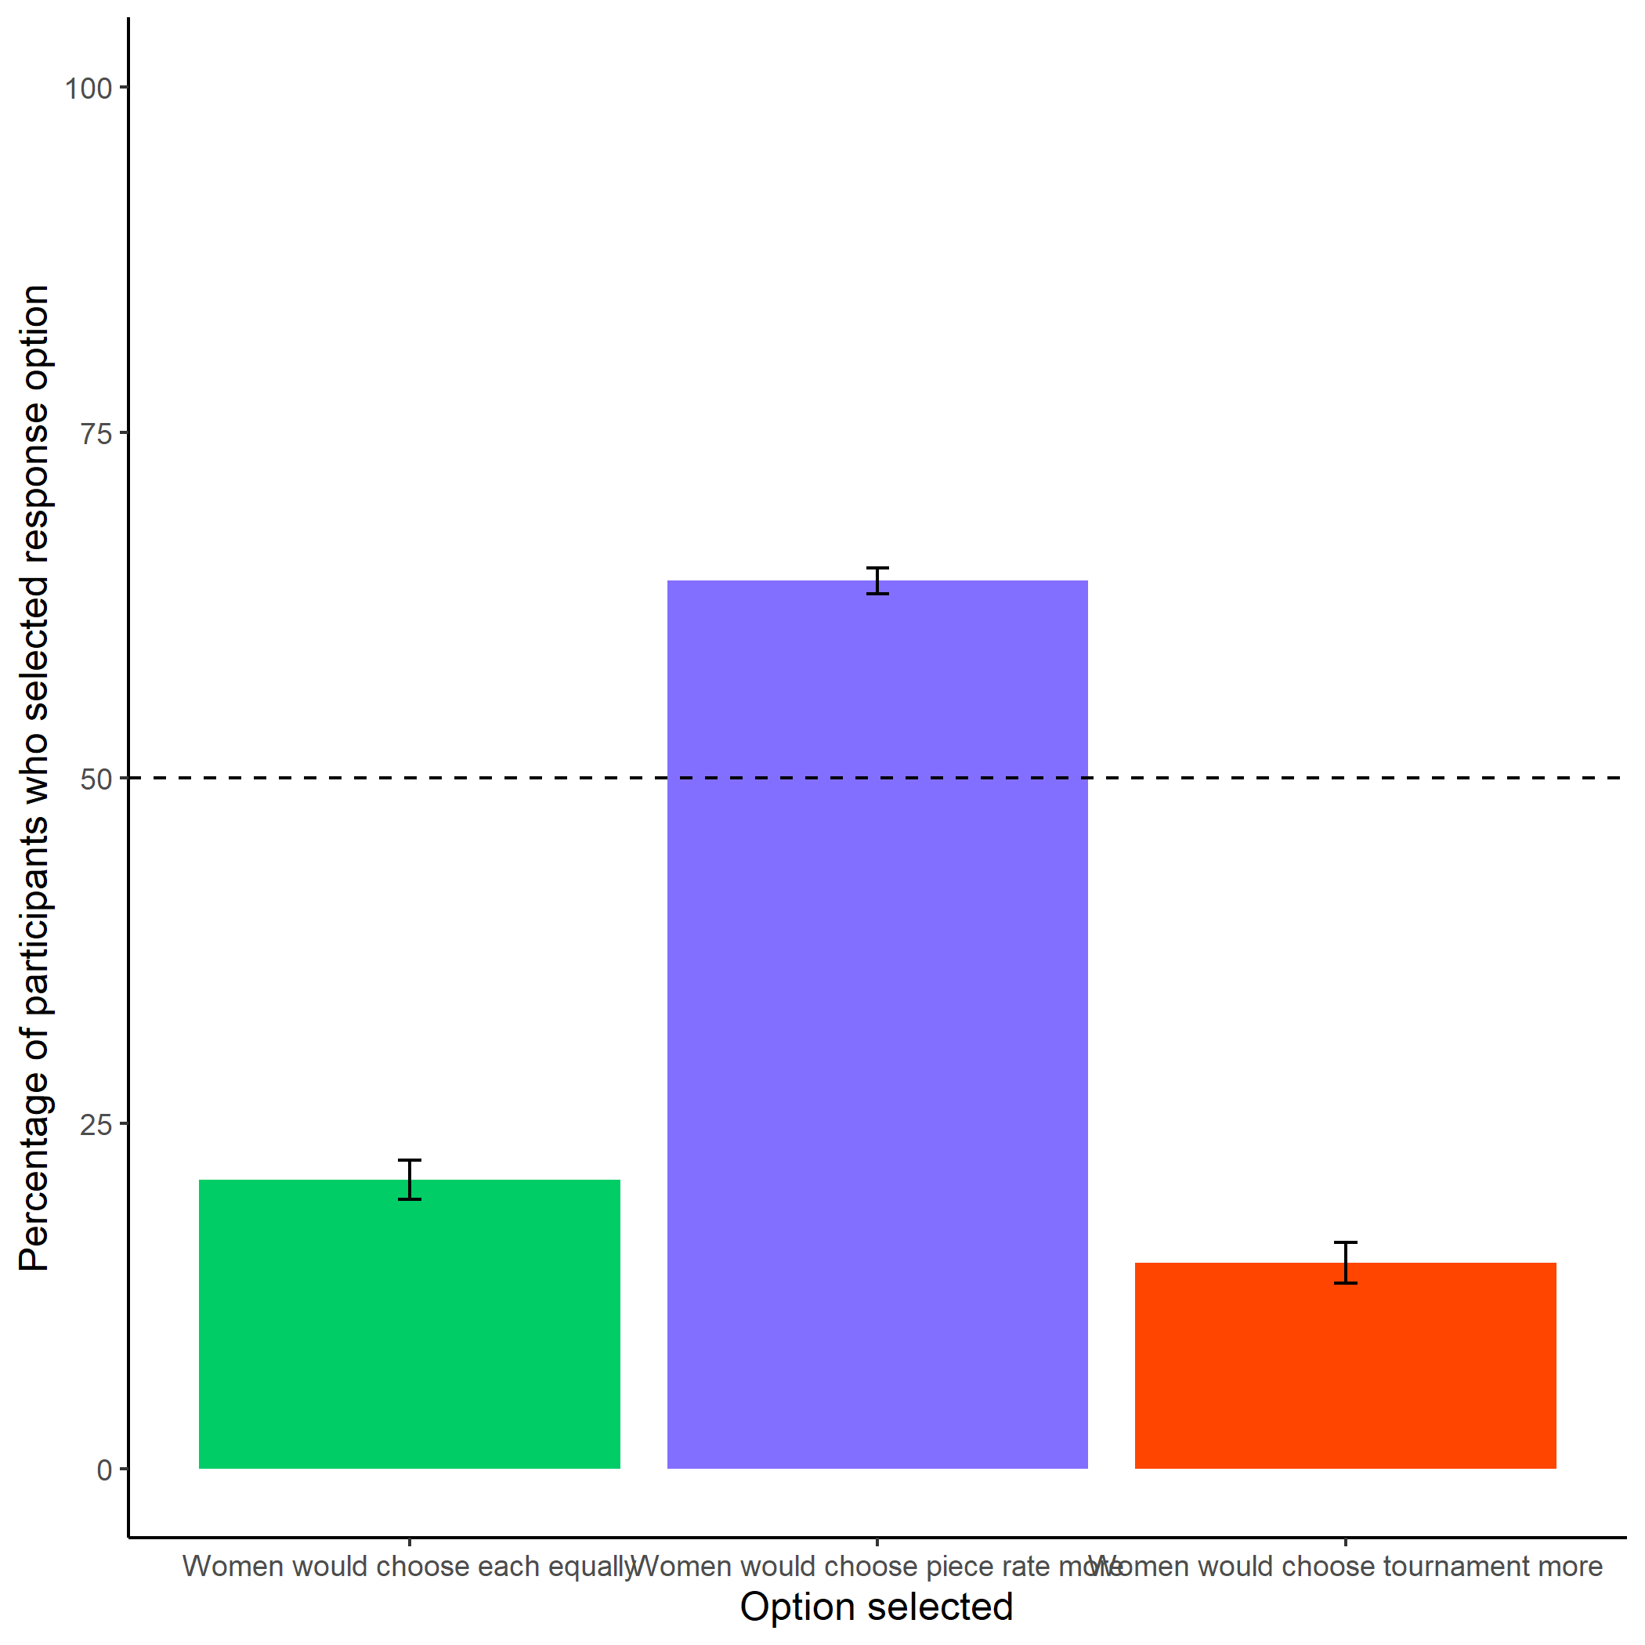

*Figure 2.6: Participants’ perceptions of women’s preferences between the competitive tournament payment scheme and non-competitive piece-rate payment scheme. Error bars represent standard errors.*

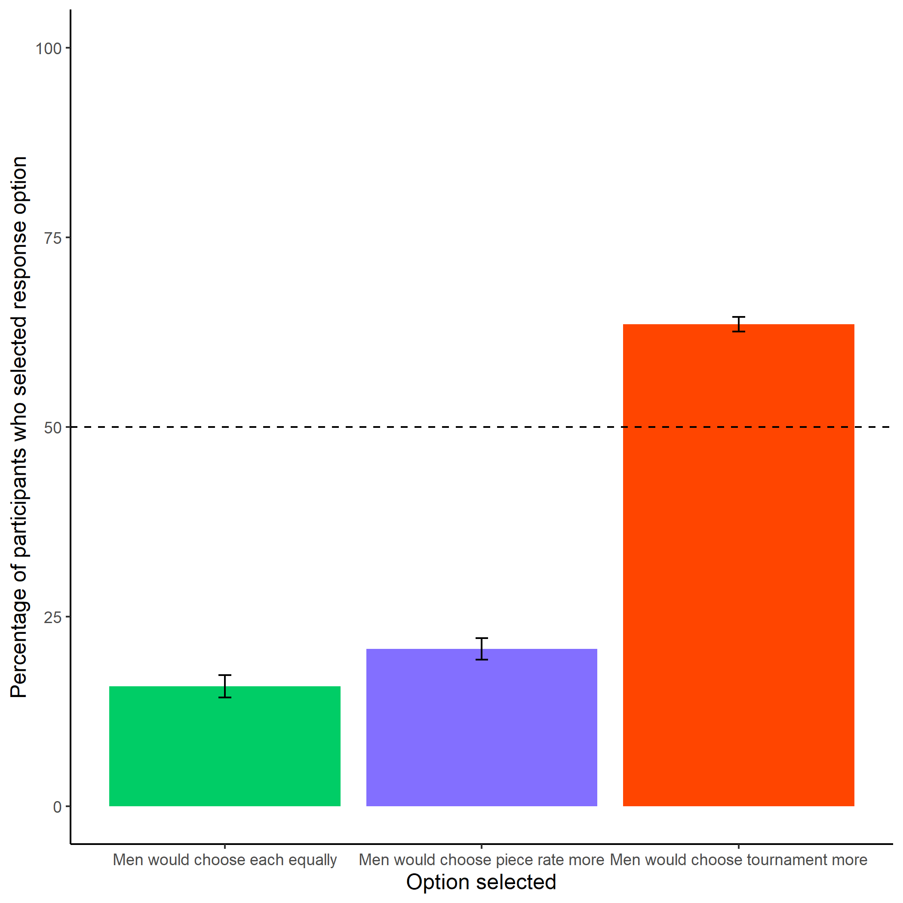

*Figure 2.7: Participants’ perceptions of men’s preferences between the competitive tournament payment scheme and non-competitive piece-rate payment scheme. Error bars represent standard errors.*

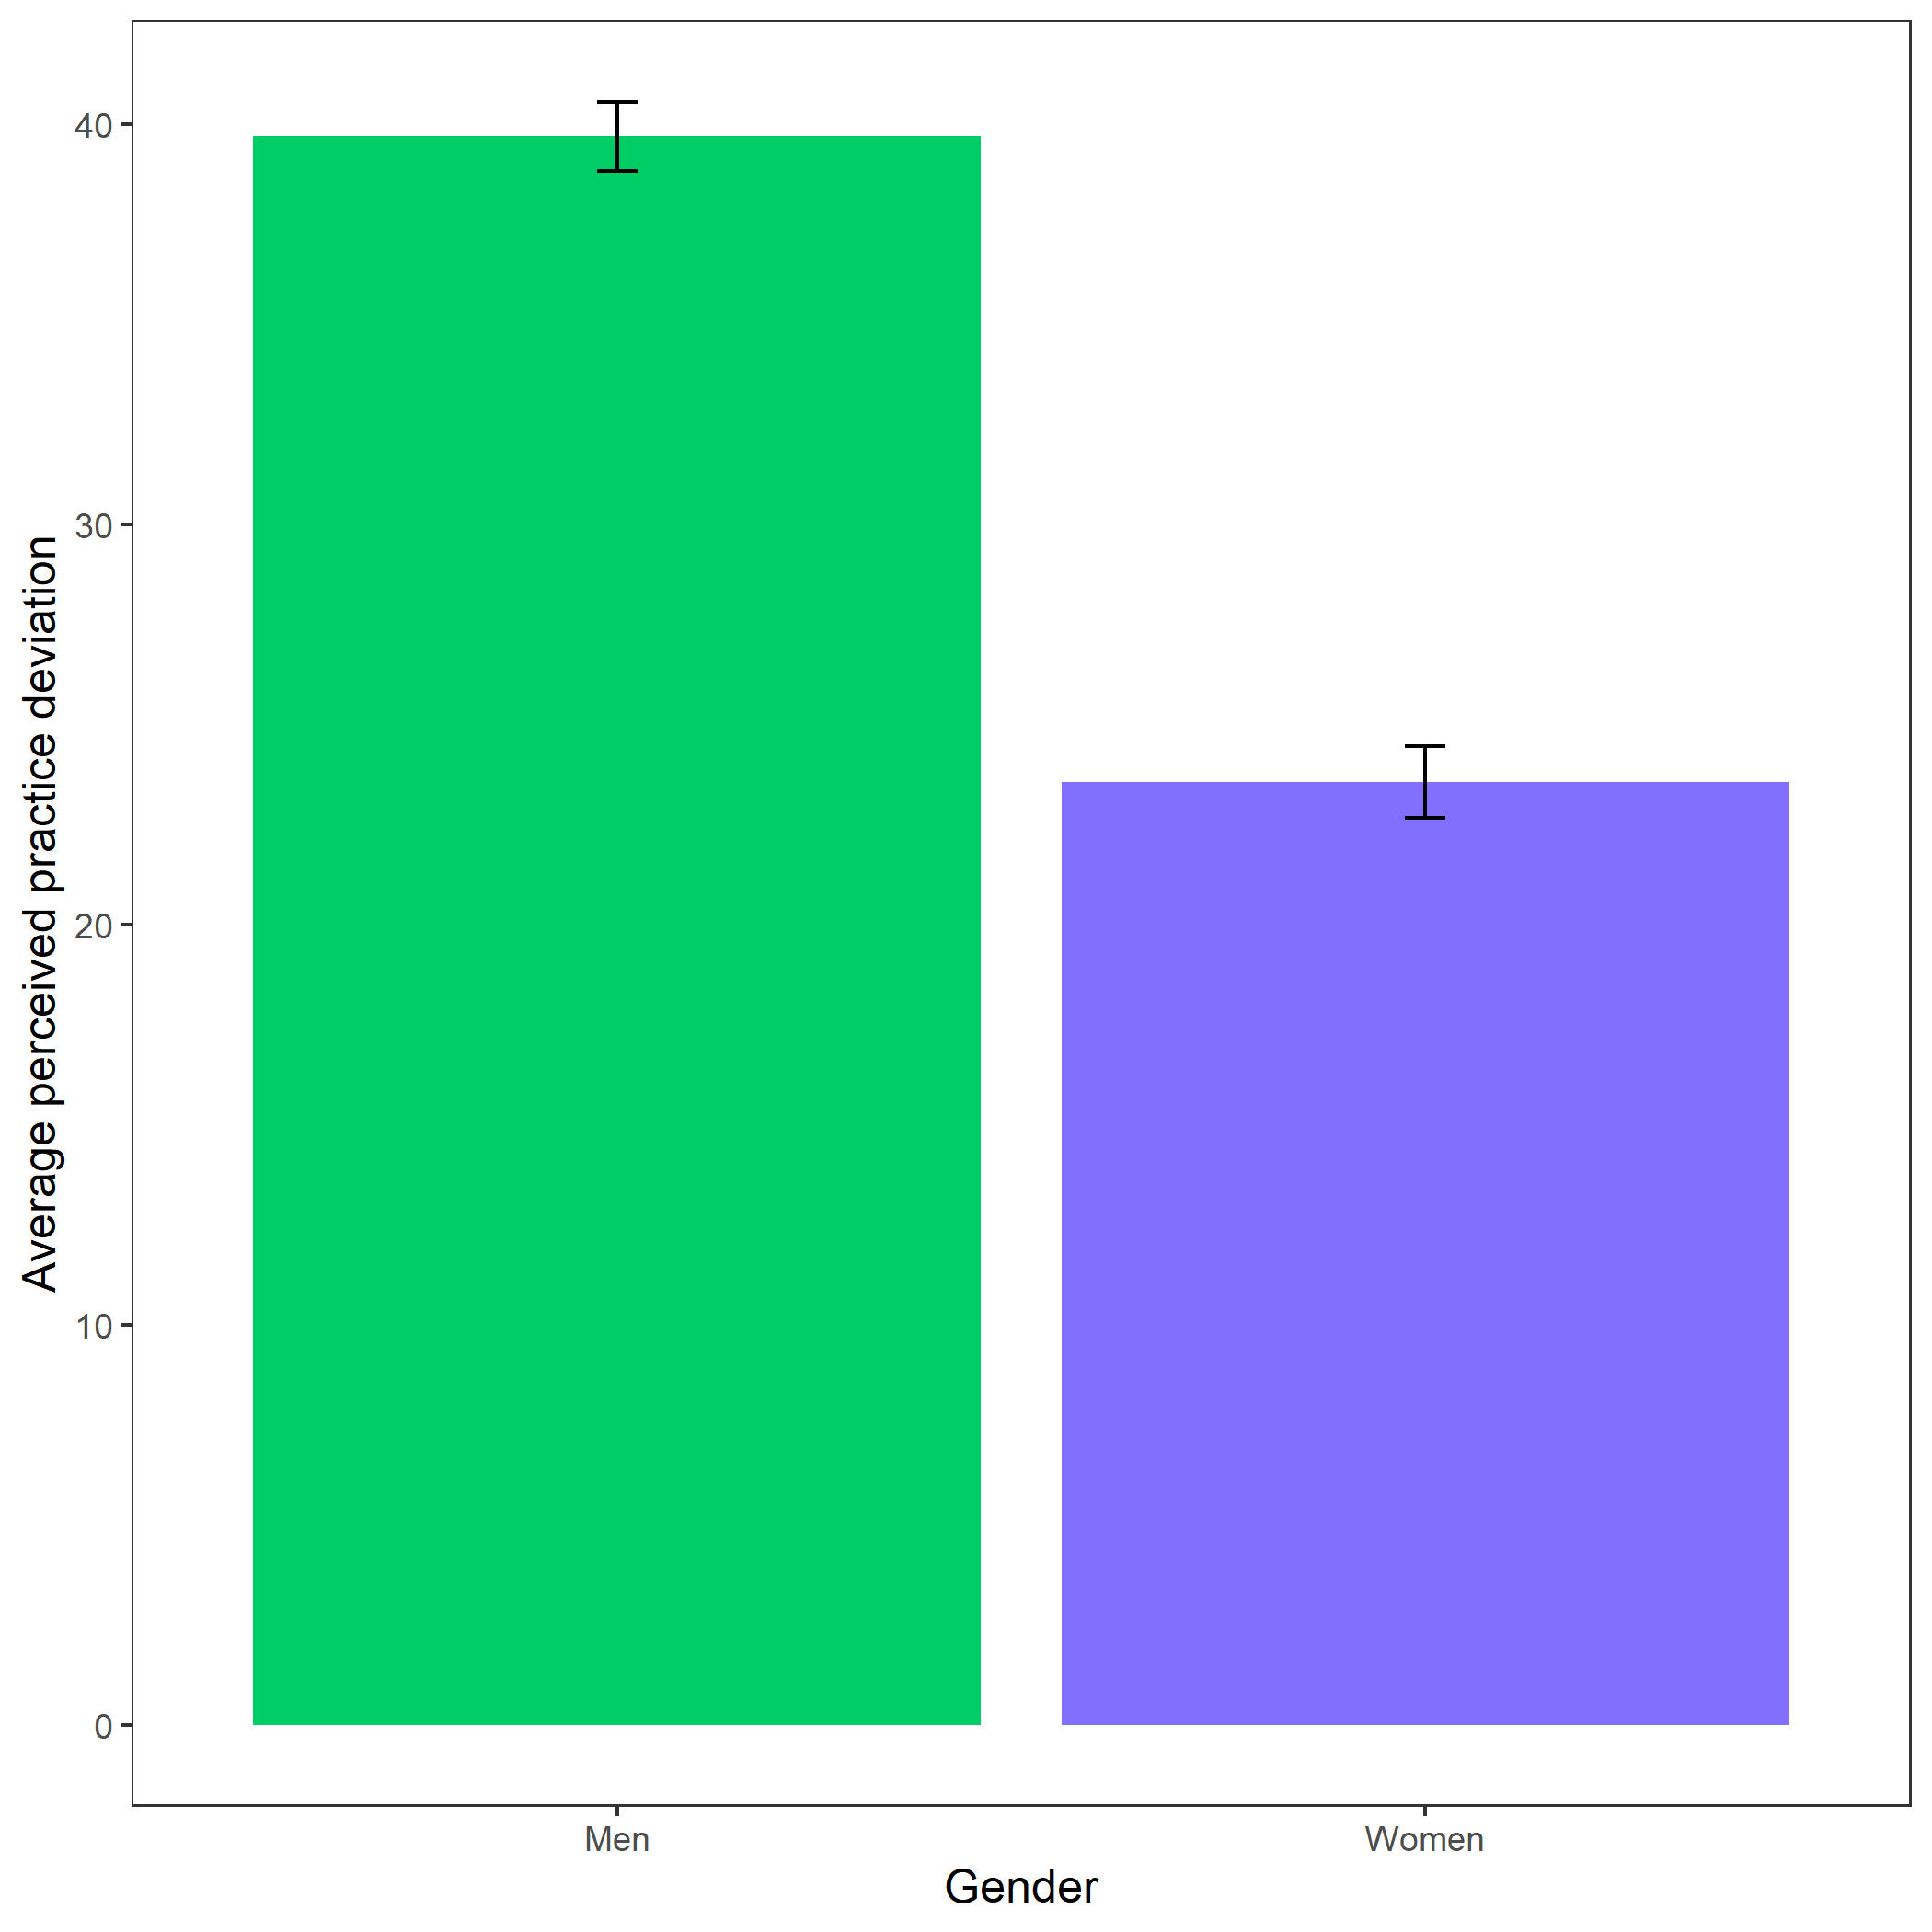

*Figure 2.8: Perceived practice deviation based on participant gender. Error bars represent standard errors - insert denominators for SE bars..*

# Discussion

### 2.14.1 Summary of main results across studies

When considered in general, the results of this research suggest that women prepare more than men before performing, regardless of whether they were being compensated based on individual performance (piece-rate) or relative to another individual (competition). And the novel gender difference in preparation discovered in this study aligns with participants’ beliefs about gender differences, suggesting that stereotypes may be contributing to gender differences,[7] both in preparation observed in this study and competitiveness observed in the literature, especially given the powerful effects of stereotypes and beliefs about identity-based behavior on one’s own behavior (cites). In fact, the effects found about gender stereotypes are more robust (that is, replicated across more studies) than the actual gender difference in preparation. Importantly, opportunities to prepare (in various forms) do *not* affect women’s willingness to compete. In the subsequent sections, we highlight the main findings that we replicate across studies, along with some study-specific findings.

#### 2.14.1.1 Effects of preparation conditions in Chapter 1 on gender differences in the choice to compete

We employed three manipulations of the opportunity to prepare in the studies of Chapter 1. First, the knowledge of preparation condition in Study 1 was a way to see if simply knowing about the opportunity to prepare, without experiencing it directly, would reduce the gender differences in the choice to compete. However, we found no evidence of effects of that manipulation on gender differences in competitiveness. Therefore, in Study 2 we tested whether the act of experiencing preparation firsthand through limited preparation for a pre-determined number of rounds would affect the gender gap in competitiveness. We expected that seeing the improvement in one’s performance over time may have been the key to increasing women’s competitiveness. Since the manipulation of preparation in a limited capacity did not show effects on the gender difference in competitiveness in Study 2, we explored unlimited preparation as our opportunity to prepare manipulation in Study 3. One could argue that participants in the limited preparation condition may have felt like they were not getting any additional preparation above and beyond what other participants were receiving because they could not choose the amount of time they prepared, and thus, they did not feel like the preparation would have helped their performance substantially more than it would have helped other participants. Therefore, the unlimited preparation manipulation may have helped participants who took advantage of the opportunity feel as though they had a chance to improve their performance far more than other participants, making them more willing to compete. Yet, we did not find effects of the unlimited preparation condition on gender differences in competitiveness in Study 3 either. Overall, across all three studies in Chapter 1, we do not find evidence that preparation increases men or women’s willingness to compete, despite finding evidence in Study 3 of Chapter 1 that participants believe practicing helps performance on the main task both based on their behavior and their responses to the manipulation check question. Thus, we do not find evidence that any forms of preparation used in the studies of Chapter 1 would serve as a viable intervention to increase women’s competitiveness.

#### 2.14.1.2 Does gender predict preparation? And tests of robustness of gender effect

Despite the lack of evidence for the effect of preparation on gender differences in the choice to compete, we discovered a sizable gender difference in preparation across multiple measures of preparation, where we find that women choose to prepare more often than men in three out of the four studies in the dissertation. Interestingly, we do not find evidence across any of the studies that the gender difference in preparation varies based on whether participants are competing, either by choice (Chapter 1 studies) or random assignment (Chapter 2 study) - that is, there is not a significant interaction between gender and the payment scheme participants were following on their choice to prepare across any of the studies. However, we find that being in a competitive environment by itself (whether by choice or not) reliably predicts the decision to prepare, regardless of participant gender.

Across studies, preparation was operationalized in several different ways (i.e., choice to practice multiplication problems, choice to study times tables, amount of time spent studying times tables). The effect of gender on preparation was most robust with the measure of preparation representing the choice to prepare, which was the most consistent measure of preparation used across all four studies of the dissertation. Importantly, the observed gender differences in the choice to practice are not explained by gender differences in risk, confidence, or task scores. Because risk, confidence, and task scores were measured after participants practiced, risk and confidence could still predict decisions to practice so we encourage future research to explore this possibility.

Finding the effect of gender on the decision to prepare is especially noteworthy because we are drawing from a participant pool (MTurk) where participants could be earning money for their participation through a nearly limitless supply of other studies, so the opportunity costs of preparing may be greater for MTurkers relative to other participant populations, suggesting that this effect could be even stronger when the opportunity costs are lower.

Importantly, across two out of the four studies, we find no gender difference in task performance when controlling for gender differences in risk and confidence, so the gender difference in the decision to prepare does not seem to be consistently driven by gender differences in the actual need to practice. In the Chapter 2 study, where we find a gender difference in performance on the multiplication task, we argue that one possible reason we find the gender difference was the use of a shortened task (30 seconds instead of two minutes), given previous research suggesting that gender differences in performance emerge under time pressure (cites). Future research should explore how much preparation is affected by gender stereotypes about the task - such that women may be especially likely to prepare before a male-typed task (e.g., math task) instead of a female-typed task (e.g., verbal task) or generally in settings where they may be susceptible to stereotype threat affecting performance (cites), especially in light of findings that gender differences in performance and decision-making vary based on whether gender stereotypes are prominent in a given context (cites - see NSF - Ctrl + F = “female-typed”).

##### 2.14.1.2.1 Possible reasons for Study 3 deviation

Notably, we do not replicate the effect of gender on the choice to practice problems in Study 3 of Chapter 1. Although we cannot be completely certain what may be underlying our inability to replicate the effect found in the other studies of the dissertation, we describe a few possible explanations here. First, all other studies in the dissertation measured the decision to complete practice problems *after* participants chose to (or in the case of the study in Chapter 2, were randomly assigned to) compete, while Study 3 measured the decision to practice problems *before* the decision to compete, as necessitated by the main manipulation within the study. Thus, the differences in the results across studies could be explained by the effects of the decision to compete on the choice to practice that are not captured in Study 3. In other words, not knowing they might not have to compete could have reduced motivation to practice. There are also fewer participants that are offered the opportunity to practice in Study 3 (N = INSERT) relative to Study 1 of Chapter 1 (N = INSERT), Study 2 of Chapter 1 (N = INSERT), or the study in Chapter 2 (N = INSERT), again by nature of the study design (i.e., manipulating unlimited opportunity to prepare) so Study 3 likely had less power to detect the effect than the other studies. Finally, the structure of practicing itself varied across the three studies. For instance, the other studies in the dissertation did not offer participants the opportunity to study multiplication tables as a separate decision from the choice to practice problems, whereas in Study 3 of Chapter 1, participants were first asked whether they would like to study multiplication tables, *then* afterwards were asked whether they would like to practice problems. Perhaps being asked whether they would like to study before being asked whether they would like to practice problems reduced participants’ interest in completing practice problems. Notably, regardless of what might be explaining the deviation for this study, we do not find evidence across any of the studies that men are significantly or even directionally more likely to prepare than women - across any of the measures of preparation used across studies.

##### 2.14.1.2.2 Describing previous literature with similar effects

To our knowledge, these studies are the first to demonstrate a gender difference in preparation among adults who must explicitly opt into preparation. However, previous findings within educational contexts have found that women are more likely than men to value dedication and mastery (Leslie et al. 2015; Kenney-Benson et al. 2006), emphasize the importance of hard work (Mccrea, Hirt, and Milner 2008; Hirt and Mccrea 2009; Mccrea et al. 2008), and spend more time preparing than men for an intellectual evaluation when they were told that practice improved future performance (Kimble and Hirt 2005). For instance, in a study examining school-aged children’s approach to learning math, researchers found that girls, compared to boys, reported being more motivated to “master” their schoolwork and engage in more effortful learning strategies (Kenney-Benson et al. 2006). Becker, Hubbard, and Murphy (2010) suggest that women have higher noncognitive skills (e.g., self-motivation) than men along many dimensions, which they argue is reflected in gender differences in a number of academic behaviors and outcomes, such as grades and number of hours worked on homework per week.

In one study looking at whether delaying competition affects gender differences in the willingness to compete while providing opportunity to study, Charness, Dao, and Shurchkov (2021) did not find a significant difference in the choice to prepare (*N* = 202). Although it is worth noting that, though the effect is non-significant, women are directionally more likely to prepare in their study. Since studying gender differences in the choice to prepare was not one of the main foci of their research, contrary to ours, it is entirely possible they did not have sufficient power to detect the effect of gender on the choice to prepare as a result.

Anaya and Zamarro (2020): Finally, we observe that girls, on average, exhibit more effort and take more time to complete the test than boys do

Napp and Breda (2022): “Recent research has shown that there exist gender stereotypes that portray men as more brilliant or inherently talented than women. We provide a large-scale multinational investigation of these stereotypes and their relation- ship with other gender gaps.” - among students across 72 countries - “We also show how gender norms regarding raw talent relate to and may explain other well-known gender differences regarding competi- tiveness, self-confidence, and willingness to work in male-dominated occupations that are stereotyped as requiring special abilities”

– logic behind why this stereotype would predict other vars: For example, believing that they are less talented than boys may hurt girls’ self-confidence and lead them to be self-protective and thus to avoid challenging situations and opportunities, and to choose studies and careers where success is not perceived to depend on special abilities. Hence, it may not be surprising that the countries where girls are the most likely to believe they lack talent (compared to boys) are also those where they shy away from prestigious or com- petitive careers.

* their way of measuring it: “When I am failing, I am afraid that I might not have enough talent.” Exploiting systematic differences between girls’ and boys’ answers to this question, and relying on double standards theory (19–21), we propose a measure of the magnitude of the stereotype associating talent with boys rather than girls. We obtain that there is a strong stereotype that girls lack talent, which is observed in almost all 72 PISA2018 participating countries.
* “Last, GTS do not reflect a lower perceived control over succeeding at school as girls agree more than boys with the assertion “if I put enough effort, I can succeed at school” (gender gap of −0.09 SD),"
* “Together, the comparison of the gender gaps in the items above suggests that there are no systematic gender differences in attributing success or failure to a personal characteristic, and that the tendency to do so for girls and boys depends on the characteristic at stake. When it is about “doing math,” girls are less likely than boys to attribute potential success to themselves. However, when it is about “putting effort” to succeed, then they are more likely than boys to consider they can do it."

“Gender-talent stereotypes may ac- tually also hurt boys. For example, it may lead them to rely too much on talent and quick learning, to underestimate the role of effort over ability in the perform ance of particular tasks, to despise hard and in-depth study, and to abandon school work in case of failure. Con- sistent with this hypothesis, we obtain on PISA data that the gender gap in homework, as well as the gender gap in the belief that “Try- ing hard at school is important,” both at the advantage of girls, in- crease with GTS. The gender gap in students’ ability to sustain their performance over the course of the PISA test, also at the advantage of girls [see (66)], is again positively correlated with GTS at the country level, suggesting further that gender-talent stereotypes may hinder boys’ ability to engage in a sustained effort"

These brilliance stereotypes may lead women to belief in the importance of hard work.

##### 2.14.1.2.3 Possible explanations for the gender difference in preparation

The gender difference in preparation observed in the majority of the studies here may be driven by women’s relatively greater desire to reduce uncertainty around their future performance (given their greater average risk aversion) and/or increase their performance (given their lower average confidence). Indeed, mastery is an important driver of confidence (for review, see Gist and Mitchell 1992; Usher and Pajares 2008). While it is possible that confidence and risk attitudes may be driving the gender difference in preparation and the choice to compete, it is important to note that preparation in our studies did not increase competitiveness in either men or women. Because participants were able to choose to prepare across studies before they completed the measures of risk attitudes and confidence, we are unable to identify whether preparation causally affected confidence and/or risk attitudes. Future work should examine the bidirectional relationships between confidence and preparation and risk and preparation. Of course, other explanations for the gender differences in preparation may also exist, including relative differences in real or perceived opportunity costs, how rewarding it is to prepare, and/or enjoyment on the task, and we encourage future work to explore these alternative explanations. Notably, given the consistency of perceptions of gender differences in preparation found across studies, our results directly speak to another possible explanation for the observed gender difference in preparation: stereotypes that women prepare more than men in general.

I think it is fine to argue this in the intro, but then I think if you add this in the intro, it would be good to revisit it in the discussion in light of the findings. In other words, why didn’t we observe this empirically? What else might be at play with the design of our study or the way this actually plays out psychologically for folks? In my view, one possibility is that the norms are more powerful and so women prepare regardless of contexts. I think this will be an especially strong argument if people who endorse stronger norms also prepare more.

#### 2.14.1.3 Summary of effects of perceptions of gender differences

On top of the gender differences in preparation observed, we find that participants *believe* that women prepare more, both in general and on the multiplication task (incentivized for accuracy) across all four studies. Thus, participants accurately predicted the observed gender differences in preparation, suggesting that they observe these gender differences in preparation directly in their own lives and/or have learned stereotypes surrounding gender differences in preparation. There is extensive work suggesting that beliefs about identity-based behavior and social norms affect subsequent behavior (Babcock, Bowles, and Bear 2012; Bowles, Babcock, and Lai 2007; Toosi et al. 2019; Smith and Huntoon 2014; Benjamin, Choi, and Strickland 2010; Bertrand, Kamenica, and Pan 2015; Akerlof and Kranton 2000). One possibility is that women may be preparing more because these beliefs may indirectly make women feel like they are expected to prepare more, and as a result, women may be overpreparing (relative to their actual skill level) before performing. If future work confirms this hypothesis, it would be important to consider interventions that focus on changing beliefs about gender differences in preparation, perhaps by changing norms, which has been shown to be an effective strategy for affecting subsequent behavior [D. T. Miller and Prentice (2016); insert other cites].

We also find that participants consistently say women tend to compete less than men (incentivized for accuracy) and perform just as well on the task as men (incentivized for accuracy). In combination with the beliefs about gender differences in preparation above, these results would suggest participants do not think are preparing more because they need to compensate for lower task scores or for a lower probability of earnings during competitions. Again, this alludes to the likelihood that women may prepare more than men, regardless of context, a stereotype that has been ingrained among the general population.

#### 2.14.1.4 Summarizing effects that relate to previous literature on gender differences

Our results also speak to previous literature on gender differences in competitiveness, risk attitudes, and confidence. First, we replicate the effect of gender on the choice to compete when gender is included as the only predictor in the model. In other words, women across the studies in Chapter 1 chose to compete less than men. However, the gender difference in the choice to compete disappears when controlling for task score, risk, and confidence across all three studies, suggesting that the effect of gender may be explained by other factors. Though the gender difference in competitiveness goes away when controlling for other predictors, we find evidence that gender consistently predicts risk and confidence across studies, replicating previous effects found within the literature (Croson and Gneezy 2009; Dohmen et al. 2011; Eckel and Grossman 2008; Bertrand 2010; Bertrand, Goldin, and Katz 2010; Lundeberg, Fox, and Puncochaf 1994; Mobius et al. 2011; Barber and Odean 2001).

##### 2.14.1.4.1 Contribution to the literature on gehnder differences in competitiveness, risk attitudes, and confidence

On top of the discovery of the gender difference in preparation, this set of studies also contributes to the general literature on competitiveness and gender differences in behavior and perceptions. First, we find that, relative to previous research in laboratory settings, there are a smaller proportion of participants that chose to compete overall. We hypothesize that one factor contributing to this discrepancy is the online nature of the competitions used in this study relative to previous studies, which were largely conducted in person. In fact, Apicella, Demiral, and Mollerstrom (2017) performs online and laboratory experiments of the same design and finds that more participants (48%; 37.5% women and 57.7% men) choose to compete under the traditional competition design in the laboratory setting relative to the proportion of participants (34.3%; 27.8% women and 40% men) that choose to compete in the online version of the experiment (see Table 1 Percentage Choosing Tournament Rate, by Treatment and Gender). Using the same online task as Apicella, Demiral, and Mollerstrom (2017), Charness, Dao, and Shurchkov (2021) find that only 27% of men and 28% of women chose to compete in their study. Thus, our research, in combination with the small set of studies that also test gender differences in competitiveness online, may provide insight into environmental characteristics that may increase (in-person, synchronous competition) or decrease (online, asynchronous competition) an individual’s competitiveness. Given the effects of the COVID-19 pandemic on the nature of work, both in the short-term and long-term, future research should explore this possibility experimentally.

In line with recent research attempting to determine whether competitiveness is a stand-alone trait or is fully explained by other factors (e.g., confidence or risk attitudes) (Gillen, Snowberg, and Yariv 2019; Veldhuizen 2017), we find that the effect of gender of the choice to compete is no longer significant when risk and confidence are included in the model. Thus, our work would suggest that competitiveness is not a stand-alone trait, and instead gender differences in risk attitudes and confidence are underlying the observed gender difference in competitiveness. In line with this possibility, we find robust gender differences in risk attitudes and confidence across all of the studies in this dissertation.

### 2.14.2 Implications for interventions on competitiveness/Potential drawbacks of competition in the workplace

Our research also has important implications for understanding how to shape interventions in a way that is more gender-inclusive. Much of the research on gender differences in competitiveness has focused on designing interventions that increase women’s willingness to compete. Less work has paid attention to the downstream consequences of said interventions for men and women. Our studies directly speak to the possible consequences of said interventions: in testing an intervention to reduce gender differences in competitiveness, we do not find that competition changed women’s preparation behaviors substantially, and in fact, we uncover a gender difference in preparation, suggesting that, when given the opportunity, women may spend more time preparing on average than men, and possibly overprepare.

INCORPORATE: It is possible that women are especially susceptible to feelings of underpreparation relative to others when they have unlimited time to prepare, which may lead to a range of possible adverse outcomes, such as unnecessary overpreparation.

If true, this would challenge prevailing views that gender differences in labor market outcomes could be reduced or eliminated by simple interventions focused on changing women’s competitiveness, and in fact, these interventions may actually negatively impact women. Indeed, there are opportunity costs to (over)preparing, including both economic and social costs, such as lost time with family and friends and missed advancement opportunities.

Relatedly, if women *expect* that they will prepare more in competitive environments, this may, in turn, impact whether they even enter competitive environments. Thus, while the studies in our dissertation suggest that merely giving women more time to prepare does not make them more willing to compete (Chapter 1), anticipated effort could still influence labor market outcomes by affecting women’s decisions to enter certain fields or compete for promotions, for instance. In our studies, we use relatively unimportant tasks that are unlikely to greatly impact one’s earnings. Yet, our work shows a gender difference in preparation, suggesting that our study likely *underestimates* gender differences in choices to prepare for tasks that are more important for one’s career and economic prospects. In this way, our study is providing a conservative test of the gender differences in effort and preparation in the real world.

Although there is evidence that competition in the workplace may increase performance [cites], it is important to consider the potential costs of having an exceedingly competitive workplace, especially considering the evidence that competitive workplaces may elicit high stress responses [cites] and long-term stress has severely negative effects on productivity and health [cites].

“- changing women’s preference is unlikely to be attainable or even desirable as a policy goal. - Furthermore, in some cases it may be rational for women (and men) to avoid being overly competitive. For example, NV point out that men compete too much based on their ability, thereby sacrificing earnings”

This observation leads us to the question: is focusing on competitiveness the best approach for improving academic and/or workplace happiness and productivity? Or instead of focusing on forcing individuals across society to accommodate to competitive environments, we make the competitive environments more inclusive of people from all backgrounds and with diverse preferences? Perhaps instead of focusing on other-competition, research should focus more on cooperation (Gagliarducci and Paserman 2022, insert others) or on self-competition (Bönte, Procher, and Urbig 2018; Carpenter, Frank, and Huet-Vaughn 2018; Klinowski 2019; Apicella, Demiral, and Mollerstrom 2017, 2020), assuming these settings do not cause stress or have other negative consequences in their own right, which would need to be tested experimentally. Importantly, cooperation and self-competition (again, trying to outperform one’s previous performance) could also positively impact businesses’ bottom line more so than competitions, both directly (e.g., by being more motivating) and indirectly (e.g., by avoiding toxic cultures that may be more common in competitive environments). We encourage future research to explore this possibility in the field.

Even if eliminating competitions from the workplace are not entirely possible, it is still possible to change the nature of competitions themselves, employing a “change the system,” instead of “change the women” approach. In fact, the findings from this study have implications for interventions that focus on individual-level, rather than system-level, institutional approaches. We show that the preparation intervention focused on encouraging women to compete, rather than changing the nature of competition or eliminating competition altogether, had no effect on women’s competitiveness.

Other work corroborates idea that change the women approaches can backfire: - Unlike Sandberg (2013), who takes a lean-in approach, there is in fact evidence that these approaches can backfire (Exley, Niederle, and Vesterlund 2020)

(see <https://www.nber.org/system/files/working_papers/w26345/w26345.pdf> conclusion section & Niederle2017a & Niederle2017b - FIXING INSTITUTIONS TO REDUCE THE GENDER GAP for more cites on changing the system approaches).

Iris Bohnet has list of recommendations in book: - <https://hbr.org/2016/07/designing-a-bias-free-organization> - <https://behavioralscientist.org/how-can-organizations-promote-gender-equality-iris-bohnet-on-what-works/> - What works: gender equality by design “Bohnet (2016) brings considerable research in behavioral economics to bear on the alter? native approach of institutional design. She argues that “de-biasing” institutions can ad? dress the gender gap more effectively than policies that are designed to change the way women behave. For example, in March 2016, the College Board changed the SAT so that guessing is no longer penalized (College Board 2016). This takes the risk out of guessing and should encourage more risk-averse test takers to guess, improving their scores and potentially eliminating the male advantage. Bohnet (2016) also notes that it can be rela? tively easy to remove triggers that activate performance-inhibiting stereotypes in class? room and work settings. Another area where improvements can be made is personnel practices. Personnel policies, such as blind auditions, can be implemented to limit the role of biases in evaluations of others. The considerable variance across countries in gen? der differences in performance suggests that there are some important cultural influ? ences at play"

INSERT difference between environments that are changed to increase women’s competitiveness or performance (eg, teams) vs. those that simply increase their outcomes during competition (eg quotas)

There is strong evidence that these change-the-system measures for increasing gender equality in the workplace are effective. For instance, He, Kang, and Lacetera (2021) show that women are more likely to compete when the default is to enter a competition, again suggesting that norms may be an incredibly important driver of behavior (also see Erkal, Gangadharan, and Xiao 2018).

Even if it is not entirely possible to modify real-world environments in the aforementioned ways, they can still be changed to make them more gender-inclusive. For instance, Niederle, Segal, and Vesterlund (2013) and Balafoutas and Sutter (2012) shows that requiring a certain number of women be represented among winners of a competition, that is, introducing a gender quota in competitions, significantly increases the proportion of women that choose to enter competitions, and contrary to potential criticisms of quotas, does not decrease overall performance among the winners of said competitions. An additional benefit of gender quotas is that they can reduce bias by increasing exposure to role models, an intervention that has been shown to encourage more women to enter environments that they would otherwise be hesitant or unlikely to enter (Busso and Frisancho 2021; Carpio and Guadalupe 2021). Thus, quotas likely initiate a positive feedback cycle, where increasing the number of women in a given context increases the likelihood that other women will enter that environment.

role model evidence: - Canaan and Mouganie (forthcoming) use data from a private 4- year US college in which undergraduates are randomly assigned to advisors. They find that being randomly matched with a female science advisor leads to greater female STEM enrolment and graduation. - Breda et al. (2020) expose students in French high schools to a female scientist (for one hour) and find a 30% increase in the share of Grade 12 girls enrolling in selective (male- dominated) STEM programs in higher education. - Porter and Serra (2020): having “successful and charismatic women who majored in economics at the same university” talk for 15 minutes in a Principles of Economics class led to an increased probability of girls enrolling in future economics classes and/or majoring in economics - Boneva et al. (2021): show causal effects - “we show that a randomized mentoring intervention that exposes low-SES children to predominantly female role models causally affects girls’ willingness to compete and narrows both the gender gap in competitiveness as well as the gender gap in earnings expectations.” - Ginther et al. (2020) - among female economics professors. - from Napp and Breda (2022): “Exposing boys and girls to successful and arguably talented female role models is also likely to be a successful practical solution [see, e.g., (36, 67, 68)]”

Finally, Katherine B. Coffman and Klinowski (2020) explore effects of a policy change in reducing the gender gap in test scores, which has been shown to be driven by the aforementioned gender difference in willingness to guess [insert cites from intro chapter 2]. The policy change, enacted for national college entry exams in Chile, removed penalties for wrong answers, which Katherine B. Coffman and Klinowski (2020) showed reduced gender differences in willingness to guess, and in turn, gender gaps in performance, especially among students who fell into the higher tiers of the distribution.

“For example, Shurchkov (2012) shows that reduced time pressure in a competitive setting increases selection into and performance in both math and verbal tournaments”

“Healy and Pate (2011) show that, independent of the sex of one’s partner, female subjects prefer to compete in teams, whereas male subjects prefer to compete as individuals. Dargnies (2012) also shows that team competitions eliminate the gender gap, as men choose to compete significantly less often when they have to compete in a team rather than alone. Kuhn and Villeval (2015) confirm that women choose team-based pay equally or more fre? quently than men.”

“The magnitude of the tournament prize can also play a role in closing the gender gap. Petrie and Segal (2015) show that if the rewards to competition are sufficiently large, women are willing to compete as much as men and win as many contests as men. In a sample of high school students, Azmat, Calsamiglia, and Iriberri (2016) exploit natural variation in the stakes of tests to find that female students outperform male students in all tests—but to a relatively larger degree when the stakes are low. Attali, Neeman, and Schlosser (2011) also show that males exhibit a larger difference in performance between the high- and low-stakes GRE tests than females, attributing this effect to the lower level of effort exerted by men in the low-stakes test.”

Effects of providing more information about competition: - “Wozniak et al. (2014) show that providing feed? back on relative performance can eliminate the gender gap in competition. Brandts, Valeska, and Rott (2014) show that advice by experienced and better-informed subjects significantly increases confidence and tournament entry of high-performing women and reduces entry of low-performing men. Finally, Cadsby, Servátka, and Song (2013) prime subjects with “professionalism” by asking questions about their expected salary or GMAT scores. They find that professional priming significantly impacts women’s beliefs and re? duces the gender gap in tournament entry." - Balafoutas and Sutter (2019) show that reducing ambiguity/uncertainty in tournaments significantly reduces gender gaps in performance - K. Coffman, Collis, and Kulkarni (2021): We provide field evidence that reducing ambiguity surrounding required qualifications reduces the gender gap in willingness to apply among qualified candidates, increasing both the diversity and talent of the applicant pool

In their review of the literature, Shurchkov and Eckel (2018) suggests that “Activation of gender stereotypes when the task is perceived to be male oriented seems to offer a more robust channel to explain the gender gap in tournament entry. Furthermore, culture and institutions may play an important role in driving gender differences in competitiveness.”

## 2.15 Considerations of this research

There are a few considerations that must be taken into account when interpreting our findings. First, we only included two genders in our study - participants who identified as men and women - so we are not able to attest to whether any of the results found across studies hold in other genders. We propose future research attempts to address this drawback by actively recruiting participants with a diverse set of gender identities.

Also, we used the same study population across all studies: participants recruited through Amazon Mechanical Turk. Although this population has been shown to provide results that closely resemble other participant populations (cite) and we took different measures to ensure high data quality across the studies (e.g., excluding duplicate IP addresses, including only CloudResearch approved participants that must pass screening tests, using Qualtrics’ fraud detection software to exclude potentially suspicious/fraudulent responses), it is still entirely possible that the data from these studies do not generalize to other participant populations. Future research should attempt to replicate these results in other populations.

Another unique characteristic of the study is that we employed a simple multiplication task as the main task participants were paid for. Although we originally chose the multiplication task because we predicted that, unlike other tasks, participants can easily see their improvement on the task as they practice, a drawback is that the task is not representative of tasks that are typically used in organizational contexts. Thus, some of the decisions participants made before and after completing the task may not be reflective of decisions made on tasks that may be more relevant in organizational contexts. For that reason, we encourage subsequent research to explore these effects using other, possibly more relevant, tasks (e.g., exploring gender differences in the choice to prepare for interviews). On an encouraging note, many studies within the literature on gender differences in competitiveness also employed math tasks (albeit addition) and the choice to compete in those tasks did predict earnings and career choices (Reuben, Wiswall, and Zafar 2017; Buser, Niederle, and Oosterbeek 2014), so if those results are at all reflective of the predictive validity of our results, our findings are likely relevant to other contexts. Similarly, in two of out of the four studies (i.e., Study 1 of Chapter 1 and Study study of Chapter 2), we find a significant gender difference in task scores, where women perform less well on the multiplication task than men - even when controlling for other possible contributing variables (i.e., risk, confidence, competition choice). Since gender differences in performance would likely contribute to gender differences in the choice to prepare on a given task, we encourage future research to employ different tasks to understand how the gender difference in the choice to prepare responds to different tasks, especially where performance is consistently the same on average for men and women. This would help us further understand how women’s decisions to prepare are responsive to the actual need to prepare given relative performance.

Finally, all of the experiments in this dissertation were performed online, largely to be able to recruit a large number of participants to maximize power in the shortest time possible. However, in-person behavior may be different from online behavior (possibly cite if found), so in-person equivalents of these studies should be run to assess whether these results would replicate when participants make these decisions in the presence of other participants that they may be competing against, for instance.

## 2.16 Future directions

There are a number of avenues for future research in this area. First, we encourage future research to test the robustness of gender differences in preparation outside of online and laboratory settings. Do these findings translate to real-world settings (e.g., through field experiments)? Exploring the gender difference in preparation cross-culturally (e.g., among hunter-gatherer populations (Apicella et al. 2014, 2012, 2018; Apicella, Crittenden, and Tobolsky 2017; Apicella and Dreber 2015; Apicella and Feinberg 2009; Apicella and Crittenden 2015; Apicella, Little, and Marlowe 2007; Apicella 2014, 2018; Apicella and Barrett 2016; Apicella, Feinberg, and Marlowe 2007)) would also shed light on the universality of the finding and help to identify cultural, ecological and social factors that exacerbate it.

A second important extension of the work would be to examine how anticipated preparation or workload influences women’s decisions to enter competitive environments. While we did not find that giving women time to prepare makes them more likely to compete, it is still possible that women know that they will end up preparing more in competitive situations and thus, select out of them. As mentioned earlier, there are opportunity costs to preparing.

A third extension of the current work would be to examine whether women are overpreparing. Does preparation negatively impact women? Does it help women? To determine whether men or women are preparing more (or less) than needed, future research should test whether gender and time chosen to prepare interact to affect a participants’ probability of winning a competition (see Niederle and Vesterlund 2007). Another follow-up study could manipulate whether there is a monetary cost for preparing to explore whether gender differences in the choice to prepare persist despite a clear cost, and whether this leads to gender differences in earnings within the study.

Finally, it would be important to explore the gender difference in preparation and general beliefs about gender differences in preparation further. For instance, manipulating beliefs about gender differences in preparation on subsequent preparation would show whether stereotypes/beliefs about gender differences causally affect the gender difference in preparation. Understanding the mechanisms underlying the phenomenon would be important to understand if (and how) interventions should be designed to alleviate any of the potentially negative consequences of choosing to prepare indiscriminately and spending too much time preparing when preparation is either costly or there are only marginal returns to preparation. We hypothesize that the gender difference in preparation could be driven by either gender differences in risk, confidence, or by gender stereotypes about gender differences in preparing, but since that was not a foci of our research, we likely did not have sufficient power either statistically and/or by design to identify the precise mechanism underlying this phenomenon and urge other researchers to tackle this question more directly (i.e., experimentally).

## 2.17 Summary

Previous research suggests that women tend to be more risk-averse (Croson and Gneezy 2009; Dohmen et al. 2011; Eckel and Grossman 2008; Bertrand 2010) and less confident than men (Bertrand, Goldin, and Katz 2010; Lundeberg, Fox, and Puncochaf 1994; Mobius et al. 2011; Barber and Odean 2001; Croson and Gneezy 2009), which contributes (at least in part) to gender differences in the decision to enter competitions (cites), and in turn, gender differences in earnings. Since confidence and risk attitudes may be affected by the opportunity to prepare, women may be more likely to compete when they have the opportunity to prepare before entering a competition. Through three experiments in Chapter 1, we experimentally tested whether the opportunity to prepare affects gender differences in competitiveness using three operationalizations of preparation (i.e., knowledge of preparation, limited opportunity to prepare, and unlimited opportunity to prepare). We also were interested in exploring the possibility that, perhaps driven by gender differences in confidence and risk attitudes, women may prepare more than men in general. The hypothesis that women prepare more than men in general also aligns with recent evidence that fields with lower representations of women tend to be fields that value brilliance, rather than hard work (Bian 2017; Bian, Leslie, and Cimpian 2017; Leslie et al. 2015; Meyer, Cimpian, and Leslie 2015), which in turn, as shown experimentally, deters women from entering said fields. Thus, across all studies in Chapter 1, we also explored whether there are gender differences in tendencies to prepare. Given the evidence across two out of three studies in Chapter 1 that women tend to prepare more than men, the study in Chapter 2 experimentally tests whether the effect of gender on preparation is exacerbated when participants are required to compete. We also measure participants’ perceptions of their relative practicing. We hypothesized that there may be gender differences in participants’ perceptions of their own preparation behaviors, such that women, relative to men, would be more inclined to think they prepare less than others, especially in competitive environments.

By using many of the same questions across studies we are able to test the robustness of our effects through replication, which has been proposed as an alternative with more benefits and fewer costs for researchers when compared to pre-analysis plans alone, with the exception of specific cases (e.g., expensive fieldwork) (L. C. Coffman and Niederle 2015). In fact, L. C. Coffman and Niederle (2015) show that pre-analysis plans do not always significantly decrease the false positive rate, and instead propose that researchers should place a higher priority on attempting to replicating previous results, which are far less susceptible to false positives even in the face of researcher bias (within at least three to five replications) and for which pre-analysis plans can serve as an exceptional guide to the replication process. Banerjee et al. (2020) proposes a different approach to address some of the drawbacks of pre-analysis plans, where researchers include a publicly available document separate from the main results included in the final paper highlighting results from tests specified in the pre-analysis, which we include in the Appendix (see “Pre-registered analyses”).

Here we show that preparation has no impact on willingness to compete. However, we have discovered a gender difference in preparation, along with robust perceptions of gender differences in preparation. While we built off an extensive literature on gender differences in competitiveness, we have unearthed a new gender difference in preparation. (Over)preparing may be costly if individuals do not adjust their level of preparation based on different environments. As this is a new area of research, there are many promising and exciting avenues for future exploration, all of which have the potential to inform policy. First, future work should explore whether these results generalize to other populations and tasks. Second, future work should examine the impact of preparation on payoffs. Do women overprepare relative to their potential payoffs? Do men underprepare? What are the opportunity costs of preparing? Also, it would be important to think about ways that women could be equally rewarded *without* having to compete - that is, reimagining how to support women, and students/workers generally, being productive in ways that work for them. Future work should explore the implications of these findings further in organizational contexts, where these effects may have a long-lasting impact on gender differences in economic outcomes.

# (APPENDIX) Appendix

## 2.18 Chapter 1

## 2.19 Chapter 2

# References

Akerlof, George A., and Rachel E. Kranton. 2000. “Economics and identity.” *The Quarterly Journal of Economics* 115 (3): 715–53.

Alan, Sule, and Seda Ertac. 2018. “Mitigating the gender gap in the willingness to compete: Evidence from a randomized field experiment.” *Journal of the European Economic Association* 17 (4): 1147–85.

Alicke, Mark D., and Olesya Govorun. 2013. “The better-than-average effect.” *The Self in Social Judgment*, 85–106. <https://doi.org/10.4324/9780203943250-11>.

Altonji, J. G., and R. M. Blank. 1999. “Race and gender in the labor market.” In *Handbook of Labor Economics*, 3143–3259.

Anaya, Lina, and Gema Zamarro. 2020. “The role of student effort on performance in PISA: Revisiting the gender gap in achievement.” *Education Reform Faculty and Graduate Students Publications*. <https://scholarworks.uark.edu/edrepub/116>.

Andersen, Steffen, Seda Ertac, Uri Gneezy, John A List, and Sandra Maximiano. 2013. “Gender, competitiveness, and socialization at a young age: Evidence from a matrilineal and a patriarchal society.” *Review of Economics and Statistics* 95 (4): 1438–43.

Apicella, Coren L. 2014. “Upper-body strength predicts hunting reputation and reproductive success in Hadza hunter-gatherers.” *Evolution and Human Behavior* 35 (6): 508–18. <https://doi.org/10.1016/j.evolhumbehav.2014.07.001>.

———. 2018. “High levels of rule-bending in a minimally religious and largely egalitarian forager population.” *Religion, Brain and Behavior* 8 (2): 133–48. <https://doi.org/10.1080/2153599X.2016.1267034>.

Apicella, Coren L., Eduardo M. Azevedo, Nicholas A. Christakis, and James H. Fowler. 2014. “Evolutionary origins of the endowment effect: Evidence from hunter-gatherers.” *American Economic Review* 104 (6): 1793–1805. <https://doi.org/10.1257/aer.104.6.1793>.

Apicella, Coren L., and H. Clark Barrett. 2016. “Cross-cultural evolutionary psychology.” *Current Opinion in Psychology* 7: 92–97. <https://doi.org/10.1016/j.copsyc.2015.08.015>.

Apicella, Coren L., and Alyssa N Crittenden. 2015. “Hunter-gatherer families and parenting.” In *The Handbook of Evolutionary Psychology*, 578–97.

Apicella, Coren L., Alyssa N. Crittenden, and Victoria A. Tobolsky. 2017. “Hunter-gatherer males are more risk-seeking than females, even in late childhood.” *Evolution and Human Behavior* 38: 592–603.

Apicella, Coren L., Elif E. Demiral, and Johanna Mollerstrom. 2017. “No gender difference in willingness to compete when competing against self.” *DIW Discussion Papers*.

———. 2020. “Compete with others? No, thanks. With myself? Yes, please !” *Economic Letters* 187: 1–3.

Apicella, Coren L., and Anna Dreber. 2015. “Sex differences in competitiveness: Hunter-gatherer women and girls compete less in gender-neutral and male-centric tasks.” *Adaptive Human Behavior and Physiology* 1 (3): 247–69. <https://doi.org/10.1007/s40750-014-0015-z>.

Apicella, Coren L., and D. R Feinberg. 2009. “Voice pitch alters mate-choice-relevant perception in hunter-gatherers.” *Proceedings of the Royal Society B: Biological Sciences* 276: 1077–82. <https://doi.org/10.1098/rspb.2008.1542>.

Apicella, Coren L., D. R. Feinberg, and F. W. Marlowe. 2007. “Voice pitch predicts reproductive success in male hunter-gatherers.” *Biology Letters* 3 (6): 682–84. <https://doi.org/10.1098/rsbl.2007.0410>.

Apicella, Coren L., Anthony C. Little, and Frank W. Marlowe. 2007. “Facial averageness and attractiveness in an isolated population of hunter-gatherers.” *Perception* 36 (12): 1813–20. <https://doi.org/10.1068/p5601>.

Apicella, Coren L., Frank W. Marlowe, James H. Fowler, and Nicholas A. Christakis. 2012. “Social networks and cooperation in hunter-gatherers.” *Nature* 481 (7382): 497–501. <https://doi.org/10.1038/nature10736>.

Apicella, Coren L., Paul Rozin, Justin T. A. Busch, Rachel E. Watson-Jones, and Cristine H. Legare. 2018. “Evidence from hunter-gatherer and subsistence agricultural populations for the universality of contagion sensitivity.” *Evolution and Human Behavior* 39 (3): 355–63. <https://doi.org/10.1016/j.evolhumbehav.2018.03.003>.

Attali, Y., Z. Neeman, and A. Schlosser. 2012. “Rise to the Challenge or Not Give a Damn: Differential Performance in High vs. Low Stakes Tests.” *Pinhas Sapir Center for Development, Tel Aviv University*.

Azmat, Ghazala, Caterina Calsamiglia, and Nagore Iriberri. 2016. “Gender differences in response to big stakes.” *Journal of the European Economic Association* 14 (December): 1372–1400. <https://doi.org/10.1111/jeea.12180>.

Babcock, Linda, Hannah Riley Bowles, and Julia Bear. 2012. “A model of when to negotiate: Why women don’t ask.” In *The Oxford Handbook of Economic Conflict Resolution*, 313–31. <https://doi.org/10.1093/oxfordhb/9780199730858.013.0022>.

Balafoutas, Loukas, and Matthias Sutter. 2012. “Affirmative action policies promote women and do not harm efficiency in the laboratory.” *Science* 335 (6068): 579–82.

———. 2019. “How uncertainty and ambiguity in tournaments affect gender differences in competitive behavior.” *European Economic Review* 118: 1–13. <https://doi.org/10.1016/j.euroecorev.2019.05.005>.

Baldiga, Katherine. 2014. “Gender differences in willingness to guess.” *Management Science* 60 (2): 434–48. <https://doi.org/10.1287/mnsc.2013.1776>.

Bandiera, Oriana, N. Parekh, B. Petrongolo, and M. Rao. 2022. “Men Are from Mars, and Women Too: A Bayesian Meta-Analysis of Overconfidence Experiments.” *Economica*. <https://www.cesifo.org/en/publikationen/2022/working-paper/men-are-mars-and-women-too-bayesian-meta-analysis-overconfidence>.

Bandura, Albert, Nancy E Adams, and Janice Beyer. 1977. “Cognitive processes mediating behavioral change.” *Journal of Personality and Social Psychology* 35 (3): 125–39.

Banerjee, A., E. Duflo, A. Finkelstein, L. F. Katz, B. A. Olken, and A. Sautmann. 2020. “In praise of moderation: Suggestions for the scope and use of pre-analysis plans for rcts in economics.” *NBER Working Paper* No. 26993.

Barber, Brad M., and Terrance Odean. 2001. “Boys will be boys: Gender, overconfidence, and common stock investment.” *The Quarterly Journal of Economics* 116 (1): 261–92.

Becker, Gary S., William H. J. Hubbard, and Kevin M. Murphy. 2010. “Explaining the worldwide boom in higher education of women.” *Journal of Human Capital* 4 (3): 203–41. <https://doi.org/10.1086/657914>.

Bell, Brian, and J. Van Reenen. 2010. “Bankers’ pay and extreme wage inequality in the UK.” *Centre for Economic Performance (CEPR)*, no. April: 1–34.

Bell, Brian, and John Van Reenen. 2014. “Bankers and their bonuses.” *Economic Journal* 124 (574). <https://doi.org/10.1111/ecoj.12101>.

Benjamin, Daniel J., James J. Choi, and A. Joshua Strickland. 2010. “Social identity and preferences.” *American Economic Review* 100 (4): 1913–28. <https://doi.org/10.1257/aer.100.4.1913>.

Berge, Lars Ivar Oppedal, Kjetil Bjorvatn, Armando Jose Garcia Pires, and Bertil Tungodden. 2015. “Competitive in the lab, successful in the field?” *Journal of Economic Behavior and Organization* 118: 303–17. <https://doi.org/10.1016/j.jebo.2014.11.014>.

Bertrand, Marianne. 2010. “New Perspectives on Gender.” In *Handbook of Labor Economics*, 4b:1545–92.

Bertrand, Marianne, Claudia Goldin, and Lawrence F. Katz. 2010. “Dynamics of the gender gap for young professionals in the financial and corporate sectors.” *American Economic Review* 2 (3): 228–55.

Bertrand, Marianne, and Kevin F Hallock. 2001. “The gender gap in top corporate jobs.” *Industrial and Labor Relations Review* 55: 3–21.

Bertrand, Marianne, Emir Kamenica, and Jessica Pan. 2015. “Gender identity and relative income within households.” *Quarterly Journal of Economics*, 571–614. <https://doi.org/10.1093/qje/qjv001.Advance>.

Beyer, Sylvia. 1990. “Gender differences in the accuracy of self-evaluations of performance.” *Journal of Personality and Social Psychology* 59 (5): 960–70. <https://doi.org/10.1037/0022-3514.59.5.960>.

Beyer, Sylvia, and Edward M. Bowden. 1997. “Gender differences in self-perceptions: Convergent evidence from three measures of accuracy and bias.” *Personality and Social Psychology Bulletin* 23 (2): 157–72.

Bénabou, Roland, and Jean Tirole. 2016. “Bonus culture: Competitive pay, screening, and multitasking.” *Journal of Political Economy* 124 (2): 305–70.

Bian, Lin. 2017. “The roots of gender gaps: Investigating the development of gender stereotypes about intelligence.” <https://doi.org/10.1037/0022-3514.51.6.1173>.

Bian, Lin, Sarah Jane Leslie, and Andrei Cimpian. 2017. “Gender stereotypes about intellectual ability emerge early and influence children’s interests.” *Science (New York, N.Y.)* 355 (6323): 389–91. <https://doi.org/10.1126/science.aah6524>.

Bianchi, Suzanne M., Liana C. Sayer, Melissa A. Milkie, and John P. Robinson. 2012. “Housework: Who did, does or will do it, and how much does it matter?” *Social Forces* 91 (1): 55–63. <https://doi.org/10.1093/sf/sos120>.

Bjorvatn, Kjetil, Ranveig Falch, and Ulrikke Hernæs. 2016. “Gender, context and competition: Experimental evidence from rural Uganda.” *Journal of Behavioral and Experimental Economics* 61: 31–37.

Blau, Francine D., Mary C. Brinton, and David B. Grusky. 2006. *The declining significance of gender?*

Blau, Francine D., Peter Brummund, and Albert Yung Hsu Liu. 2013. “Trends in occupational segregation by gender 1970-2009: Adjusting for the impact of changes in the occupational coding system.” *Demography* 50: 471–92. <https://doi.org/10.1007/s13524-012-0151-7>.

Blau, Francine D., M. A. Ferber, and A. Winkler. 2010. *The economics of women, men, and work*.

———. 2014. *The economics of women, men, and work*.

Blau, Francine D., and Lawrence M. Kahn. 2000. “Gender differences in pay.” *Journal of Economic Perspectives* 14 (4): 75–100. <https://doi.org/10.1257/jep.14.4.75>.

———. 2006. “The U.S. gender pay gap in the 1990s: Slowing convergence.” *Industrial and Labor Relations Review* 60 (1): 45–66.

Blau, Francine D., and Lawrence M Kahn. 2017. “The gender wage gap: Extent, trends, and explanations.” *Journal of Economic Literature* 55 (3): 789–865. <https://doi.org/10.1257/jel.20160995>.

Blau, Francine D., and Anne E. Winkler. 2017. “Women, work, and family.”

Boneva, T., T. Buser, A. Falk, and F. Kosse. 2021. “The origins of gender differences in competitiveness and earnings expectations: Causal evidence from a mentoring intervention.” *Tinbergen Institute Discussion Paper*.

Booth, Alison, and Jungmin Lee. 2021. “Girls’ and boys’ performance in competitions: What we can learn from a Korean quiz show.” *Journal of Economic Behavior and Organization* 187: 431–47. <https://doi.org/10.1016/j.jebo.2021.04.031>.

Booth, Alison, and Patrick Nolen. 2012. “Choosing to compete: How different are girls and boys?” *Journal of Economic Behavior and Organization* 81 (2): 542–55. <https://doi.org/10.1016/j.jebo.2011.07.018>.

———. 2022. “Gender and Psychological Pressure in Competitive Environments: A Laboratory-based Experiment.” *Economica*.

Bordalo, Pedro, Katherine Coffman, Nicola Gennaioli, and Andrei Shleifer. 2019. “Beliefs about gender.” *American Economic Review* 109 (3): 739–73. <https://doi.org/10.1257/aer.20170007>.

Boschini, Anne, Anna Dreber, Emma Von Essen, Astri Muren, and Eva Ranehill. 2019. “Gender, risk preferences and willingness to compete in a random sample of the Swedish population.” *Journal of Behavioral and Experimental Economics* 83 (September): 101467. <https://doi.org/10.1016/j.socec.2019.101467>.

Boschini, Anne, Anna Dreber, Emma von Essen, Astri Muren, and Eva Ranehill. 2014. “Gender and economic preferences in a large random and representative sample.” *SSRN Electronic Journal*. <https://doi.org/10.2139/ssrn.2443315>.

Bowles, Hannah Riley, Linda Babcock, and Lei Lai. 2007. “Social incentives for gender differences in the propensity to initiate negotiations: Sometimes it does hurt to ask.” *Organizational Behavior and Human Decision Processes* 103: 84–103. <https://doi.org/10.1016/j.obhdp.2006.09.001>.

Bönte, Werner, Vivien Procher, and Diemo Urbig. 2018. “Gender differences in selection into self-competition.” *Applied Economics Letters* 25 (8): 539–43. <https://doi.org/10.1080/13504851.2017.1343441>.

Brandts, Jordi, Valeska Groenert, and Christina Rott. 2015. “The impact of advice on women’s and men’s selection into competition.” *Management Science* 61 (5): 1018–35. <https://doi.org/10.1287/mnsc.2013.1877>.

Breda, Thomas, Elyès Jouini, Clotilde Napp, and Georgia Thebault. 2020. “Gender stereotypes can explain the gender-equality paradox.” *Proceedings of the National Academy of Sciences of the United States of America* 117 (49): 31063–69. <https://doi.org/10.1073/pnas.2008704117>.

Buhrmester, Michael, Tracy Kwang, and Samuel D Gosling. 2011. “Amazon’s mechanical turk: A new source of inexpensive, yet high-quality, data?” *Perspectives on Psychological Science* 6 (1): 3–5. <https://doi.org/10.1177/1745691610393980>.

Burgess, Diana, and Eugene Borgida. 1999. “Who women are, who women should be: Descriptive and Prescriptive Gender Stereotyping in Sex Discrimination.” *Psychology, Public Policy, and Law* 5 (3): 665–92. <https://doi.org/10.1037/1076-8971.5.3.665>.

Burow, Norma, Miriam Beblo, Denis Beninger, and Melanie Schroder. 2017. “Why do women favor same-gender competition? Evidence from a choice experiment.” *DIW Discussion Papers* 1662.

Buser, Thomas. 2016. “The Impact of Losing in a Competition on the Willingness to Seek Further Challenges.” *Management Science* 62 (12): 3439–49. <https://doi.org/10.1287/mnsc.2015.2321>.

Buser, Thomas, Muriel Niederle, and Hessel Oosterbeek. 2014. “Gender, competition and career choices.” *The Quarterly Journal of Economics* 129 (3): 1409–47. <https://doi.org/10.1093/qje/qju009.Advance>.

———. 2020. “Can Competitiveness Predict Education and Labor Market Outcomes? Evidence From Incentivized Choice and Survey Measures.” *SSRN Electronic Journal*. <https://doi.org/10.2139/ssrn.3671348>.

Buser, Thomas, Noemi Peter, and Stefan Wolter. 2017a. “Gender, Willingness to Compete and Career Choices Along the Whole Ability Distribution.” *Tinbergen Institute Discussion Papers*.

Buser, Thomas, Noemi Peter, and Stefan C Wolter. 2017b. “Gender, competitiveness, and study choices in high school: Evidence from Switzerland.” *American Economic Review: Papers & Proceedings* 107 (5): 125–30.

Buser, Thomas, and Huaiping Yuan. 2019. “Do women give up competing more easily? Evidence from the lab and the Dutch Math Olympiad.” *American Economic Journal: Applied Economics* 11 (3): 225–52.

Busso, Matias, and Veronica Frisancho. 2021. “Good peers have asymmetric gendered effects on female educational outcomes: Experimental evidence from Mexico.” *Journal of Economic Behavior and Organization* 189: 727–47. <https://doi.org/10.1016/j.jebo.2021.07.013>.

Cai, Xiqian, Yi Lu, Jessica Pan, and Songfa Zhong. 2019. “Gender gap under pressure: Evidence from China’s national college entrance examination.” *The Review ofEconomics and Statistics* 101 (2): 249–63. <https://doi.org/10.1162/rest>.

Carpenter, Jeffrey P, Rachel Frank, and Emiliano Huet-Vaughn. 2018. “Gender Differences in Interpersonal and Intrapersonal Competitive Behavior.” *Journal of Behavioral and Experimental Economics* 77: 170–76.

Carpio, Lucía Del, and Maria Guadalupe. 2021. “More Women in Tech? Evidence from a Field Experiment Addressing Social Identity.” *Management Science*.

Cassar, Alessandra, Feven Wordofa, and Y. Jane Zhang. 2016. “Competing for the benefit of offspring eliminates the gender gap in competitiveness.” *Proceedings of the National Academy of Sciences* 113 (19): 5201–5. <https://doi.org/10.1073/pnas.1520235113>.

Cejka, Mary Ann, and Alice H Eagly. 1999. “Gender-stereotypic images of occupations correspond to the sex segregation of employment.” *Personality and Social Psychology Bulletin* 25 (4): 413–23.

Chandler, Jesse, and Danielle Shapiro. 2016. “Conducting Clinical Research Using Crowdsourced Convenience Samples.” *Annual Review of Clinical Psychology* 12 (1): 53–81. <https://doi.org/10.1146/annurev-clinpsy-021815-093623>.

Charness, Gary, Lien Dao, and Olga Shurchkov. 2021. “Competing now and then: The effects of delay and the vanishing gender gap in competitiveness.” *SELL Journal* 5 (1): 55.

Charness, Gary, and Uri Gneezy. 2012. “Strong Evidence for Gender Differences in Risk Taking.” *Journal of Economic Behavior and Organization* 83 (1): 50–58. <https://doi.org/10.1016/j.jebo.2011.06.007>.

Coffman, K., M. Collis, and L. Kulkarni. 2019. “Stereotypes and belief updating.” *Harvard Business School*.

———. 2021. “Whether to Apply.” *Harvard Business School Working Paper*.

Coffman, K., C. B. Flikkema, and O. Shurchkov. 2021. “Gender stereotypes in deliberation and team decisions.” *Games and Economic Behavior* 129: 329–49.

Coffman, Katherine B., and David Klinowski. 2020. “The impact of penalties for wrong answers on the gender gap in test scores.” *Proceedings of the National Academy of Sciences of the United States of America* 117 (16): 8794–8803. <https://doi.org/10.1073/pnas.1920945117>.

Coffman, Katherine Baldiga. 2014. “Evidence on self-stereotyping and the contribution of ideas.” *The Quarterly Journal of Economics*, 1625–60. <https://doi.org/10.1093/qje/qju023.Advance>.

Coffman, Katherine, Maria Paola Ugalde Araya, and Basit Zafar. 2021. “A (Dynamic) Investigation of Stereotypes, Belief-Updating, and Behavior.” *SSRN Electronic Journal*. <https://doi.org/10.2139/ssrn.3944430>.

Coffman, Lucas C., and Muriel Niederle. 2015. “Pre-analysis plans have limited upside, especially where replications are feasible.” *Journal of Economic Perspectives* 29 (3): 81–98. <https://doi.org/10.1257/jep.29.3.81>.

Connelly, Brian L., Laszlo Tihanyi, T. Russell Crook, and K. Ashley Gangloff. 2014. *Tournament theory: Thirty years of contests and competitions*. Vol. 40. 1. <https://doi.org/10.1177/0149206313498902>.

Cotton, Christopher, Frank McIntyre, and Joseph Price. 2013. “Gender differences in repeated competition: Evidence from school math contests.” *Journal of Economic Behavior and Organization* 86: 52–66. <https://doi.org/10.1016/j.jebo.2012.12.029>.

Croson, Rachel, and Uri Gneezy. 2009. “Gender differences in preferences.” *Journal of Economic Literature* 47 (2): 448–74. <https://doi.org/10.1257/jel.47.2.448>.

Cuñat, Vicente, and Maria Guadalupe. 2005. “How does product market competition shape incentive contracts?” *Journal of the European Economic Association* 3 (5): 1058–82.

Datta Gupta, Nabanita, Anders Poulsen, and Marie Claire Villeval. 2013. “Gender matching and competitiveness: Experimental evidence.” *Economic Inquiry* 51 (1): 816–35. <https://doi.org/10.1111/j.1465-7295.2011.00378.x>.

Deaux, Kay, and Laurie L. Lewis. 1984. “Structure of gender stereotypes: Interrelationships among components and gender label.” *Journal of Personality and Social Psychology* 46 (5): 991–1004. <https://doi.org/10.1037/0022-3514.46.5.991>.

Dohmen, Thomas, Armin Falk, David Huffman, Uwe Sunde, Jürgen Schupp, and Gert G. Wagner. 2011. “Individual risk attitudes: Measurement, determinants, and behavioral consequences.” *Journal of the European Economic Association* 9 (3): 522–50. <https://doi.org/10.1111/j.1542-4774.2011.01015.x>.

Dreber, Anna, Emma Von Essen, and Eva Ranehill. 2011. “Outrunning the gender gap — boys and girls compete equally.” *Experimental Economics* 14 (4): 567–82. <https://doi.org/10.1007/s10683-011-9282-8>.

———. 2014. “Gender and competition in adolescence: Task matters.” *Experimental Economics* 17: 154–72. <https://doi.org/10.1007/s10683-013-9361-0>.

Dunning, David, Chip Heath, and Jerry M. Suls. 2004. “Flawed self-assessment implications for health, education, and the workplace.” *Psychological Science in the Public Interest, Supplement* 5 (3): 69–106. <https://doi.org/10.1111/j.1529-1006.2004.00018.x>.

Eagly, Alice H., Christa Nater, David Miller, Michele Kaufmann, and Sabine Sczesny. 2019. “Gender stereotypes have changed: A cross-temporal meta-analysis of U.S. Public opinion polls from 1946 to 2018.” *American Psychologist*, 1–15. <https://doi.org/10.1017/CBO9781107415324.004>.

Eckel, Catherine C, and Philip J Grossman. 2008. “Men, women, and risk aversion: Experimental evidence.” In *Handbook of Experimental Economics*, 1:1061–73. <https://doi.org/10.1016/S1574-0722(07)00113-8>.

England, Paula. 2010. “The gender revolution: Uneven and stalled.” *Gender and Society* 24 (2): 149–66. <https://doi.org/10.1177/0891243210361475>.

Erkal, Nisvan, Lata Gangadharan, and Erte Xiao. 2018. “Competing by Default: A New Way to Break the Glass Ceiling.”

Exley, C., M. Niederle, and L. Vesterlund. 2020. “Knowing When to Ask: The Cost of Leaning In.” *Journal ofPolitical Economy* 128 (3).

Filippin, Antonio, and Paolo Crosetto. 2016. “A reconsideration of gender differences in risk attitudes.” *Management Science* 62 (11): 3138–60. <https://doi.org/10.1287/mnsc.2015.2294>.

Frank, R. H., and P. J. Cook. 2010. *The winner-take-all society: Why the few at the top get so much more than the rest of us*.

Frick, Bernd. 2011. “Gender differences in competitiveness: Empirical evidence from professional distance running.” *Labour Economics* 18 (3): 389–98. <https://doi.org/10.1016/j.labeco.2010.11.004>.

Gagliarducci, Stefano, and M Daniele Paserman. 2022. “Gender Differences in Cooperative Environments? Evidence from The U.S. Congress.” *The Economic Journal* 132 (641): 218–57. <https://doi.org/10.1093/ej/ueab069>.

Gawronski, Bertram. 2004. “Theory-based bias correction in dispositional inference: The fundamental attribution error is dead, long live the correspondence bias.” *European Review of Social Psychology* 15: 183–217. <https://doi.org/10.1080/10463280440000026>.

Gharehgozli, Orkideh, and Vidya Atal. 2020. “Revisiting the gender wage gap in the United States.” *Economic Analysis and Policy* 66: 207–16. <https://doi.org/10.1016/j.eap.2020.04.008>.

Gilbert, Daniel, and Patrick Malone. 1995. “The correspondence bias.” *Psychological Bulletin* 117 (1): 21–38.

Gill, David, and Victoria Prowse. 2014. “Gender differences and dynamics in competition: The role of luck.” *Quantitative Economics* 5: 351–76. <https://doi.org/10.3982/QE309>.

Gillen, Ben, Erik Snowberg, and Leeat Yariv. 2019. “Experimenting with measurement error: Techniques with applications to the Caltech cohort study.” *Journal of Political Economy* 127 (4): 1826–63.

Ginther, Donna K., Janet M. Currie, Francine D. Blau, and Rachel T. A. Croson. 2020. “Can Mentoring Help Female Assistant Professors in Economics? An Evaluation by Randomized Trial.” *AEA Papers and Proceedings* 110: 205–9. <https://doi.org/10.1257/pandp.20201121>.

Gist, Marilyn E, and Terence R Mitchell. 1992. “Self-efficacy: A theoretical analysis of its determinants and malleability.” *The Academy of Management Review* 17 (2): 183–211.

Gneezy, By Uri, Kenneth L Leonard, and John A List. 2009. “Gender differences in competition: Evidence from a matrilineal and a patriarchal society.” *Econometrica* 77 (5): 1637–64. <https://doi.org/10.3982/ECTA6690>.

Gneezy, Uri, Muriel Niederle, and Aldo Rustichini. 2003. “Performance in competitive environments: Gender differences.” *The Quarterly Journal of Economics*, no. 1049-1074.

Gneezy, Uri, and Aldo Rustichini. 2004. “Gender and competition at a young age.” *The American Economic Review* 94 (2): 377–81.

Goldin, Claudia. 2006a. “The quiet revolution that transformed women’s employment, education, and family.” *American Economic Review* 96 (2): 1–21.

———. 2006b. “The rising (And then declining) Significance of gender.” In *The Declining Significance of Gender?*, 67–101. <https://doi.org/10.1177/009430610703600317>.

———. 2014. “A grand gender convergence: Its last chapter.” *American Economic Review* 104 (4): 1–30. <https://doi.org/10.1257/aer.104.4.1091>.

Grosse, Niels, and Gerhard Riener. 2010. “Explaining gender differences in competitiveness: Gender-task stereotypes.” *Jena Economic Research Papers*.

Guiso, Luigi, Ferdinando Monte, Paola Sapienza, and Luigi Zingales. 2008. “Culture, Gender, and Math.” *Science* 320 (May).

Günther, Christina, Neslihan Arslan Ekinci, Christiane Schwieren, and Martin Strobel. 2010. “Women can’t jump?-An experiment on competitive attitudes and stereotype threat.” *Journal of Economic Behavior and Organization* 75 (3): 395–401. <https://doi.org/10.1016/j.jebo.2010.05.003>.

Gysler, M., J. Brown Kruse, and R. Schubert. 2002. “Ambiguity and gender differences in financial decision making an experimental examination of competence and confidence effects.” *Working Papers/WIF*. <https://doi.org/10.3929/ethz-a-010025751>.

Hall, Brian, and Jeffrey Liebman. 1998. “Are CEOs really paid like bureaucrats?” *The Quarterly Journal of Economics* 113 (3): 653–91.

Harrison, Glenn W., Morten I. Lau, and E. Elisabet Rutström. 2007. “Estimating risk attitudes in Denmark: A field experiment.” *Scandinavian Journal of Economics* 109 (2): 341–68. <https://doi.org/10.1111/j.1467-9442.2007.00496.x>.

He, Joyce C., Sonia K. Kang, and Nicola Lacetera. 2021. “Opt-out choice framing attenuates gender differences in the decision to compete in the laboratory and in the field.” *Proceedings of the National Academy of Sciences of the United States of America* 118 (42). <https://doi.org/10.1073/pnas.2108337118>.

Healy, Andrew, and Jennifer Pate. 2011. “Can teams help to close the gender competition gap?” *The Economic Journal* 121 (555): 1192–1204. <https://doi.org/10.1111/J.1468-0297.2010.02409.X.>

Hegewisch, Ariane, and Heidi Hartmann. 2014. “Occupational segregation and the gender wage gap: A job half done.”

Hirt, Edward R, and Sean M Mccrea. 2009. “Man smart, woman smarter ? Getting to the root of gender differences in self-handicapping.” *Social and Personality Psychology Compass* 3: 260–74.

Iriberri, Nagore, and Pedro Rey-biel. 2019. “Competitive Pressure Widens the Gender Gap in Performance: Evidence from a Two-Stage Competition in Mathematics.” *The Economic Journal* 129 (620).

Iriberri, Nagore, and Pedro Rey-Biel. 2017. “Stereotypes are only a threat when beliefs are reinforced: On the sensitivity of gender differences in performance under competition to information provision.” *Journal of Economic Behavior and Organization* 135: 99–111.

———. 2021. “Brave boys and play-it-safe girls: Gender differences in willingness to guess in a large scale natural field experiment.” *European Economic Review* 131: 103603. <https://doi.org/10.1016/j.euroecorev.2020.103603>.

Jakobsson, Niklas, Minna Levin, and Andreas Kotsadam. 2013. “Gender and Overconfidence: Effects of Context, Gendered Stereotypes, and Peer Group.” *Advances in Applied Sociology* 03 (02): 137–41. <https://doi.org/10.4236/aasoci.2013.32018>.

Jones, Edward E., and Victor A. Harris. 1967. “The attribution of attitudes.” *Journal of Experimental Social Psychology* 3 (1): 1–24. <https://doi.org/10.1016/0022-1031(67)90034-0>.

Kahneman, Daniel, and Amos Tversky. 1982. “The psychology of preferences.” *Scientific American* 246 (1): 160–73.

Kenney-Benson, Gwen A, Eva M Pomerantz, Allison M Ryan, and Helen Patrick. 2006. “Sex differences in math performance: The role of children’s approach to schoolwork.” *Developmental Psychology* 42 (1): 11–26. <https://doi.org/10.1037/0012-1649.42.1.11>.

Kessel, Dany, Johanna Mollerstrom, and Roel Van Veldhuizen. 2021. “Can simple advice eliminate the gender gap in willingness to compete?” *European Economic Review* 138 (August 2020). <https://doi.org/10.1016/j.euroecorev.2021.103777>.

Kimble, Charles E, and Edward R Hirt. 2005. “Self-focus, gender, and habitual self-handicapping: Do they make a difference in behavioral self-handicapping?” *Social Behavior and Personality* 33 (1): 43–56.

Klinowski, David. 2019. “Selection into self-improvement and competition pay: Gender, stereotypes, and earnings volatility.” *Journal of Economic Behavior and Organization* 158: 128–46. <https://doi.org/10.1016/j.jebo.2018.11.014>.

Krueger, Norris Jr., and Peter R. Dickson. 1994. “How Believing in Ourselves Increases Risk Taking: Perceived Self-Efficacy and Opportunity Recognition.” *Decision Sciences* 25 (3).

Lavy, Victor. 2004. “Performance pay and teachers’ effort, productivity and grading ethics.” *NBER WORKING PAPER SERIES*.

Lemieux, Thomas, Bentley W. MacLeod, and Daniel Parent. 2009. “Performance pay and wage inequality.” *The Quarterly Journal of Economics* CXXIV (1): 1–49.

Lent, Robert W., Steven D. Brown, Mark R. Gover, and Sukhvender K. Nijjer. 1996. “Cognitive assessment of the sources of mathematics self-efficacy: A thought-listing analysis.” *Journal of Career Assessment* 4 (1): 33–46. <https://doi.org/10.1177/106907279600400102>.

Leslie, Sarah-Jane, Andrei Cimpian, Meredith Meyer, and Edward Freeland. 2015. “Expectations of brilliance underlie gender distributions across academic disciplines.” *Science* 347 (6219): 23–34. <https://doi.org/10.1081/E-EWS>.

Levanon, Asaf, and David B Grusky. 2016. “The persistence of extreme gender segregation in the twenty-first century.” *American Journal of Sociology* 122 (2): 573–619.

Lundeberg, Mary A, Paul W Fox, and Judith Puncochaf. 1994. “Highly confident but wrong: Gender differences and similarities in confidence judgments.” *Journal of Educational Psychology* 86 (1): 114–21.

Mayr, Ulrich, Dave Wozniak, Casey Davidson, David Kuhns, and William T. Harbaugh. 2012. “Competitiveness across the life span: The feisty fifties.” *Psychology and Aging* 27 (2): 278–85. <https://doi.org/10.1037/a0025655>.

Mccrea, Sean M, Edward R Hirt, Kristin L Hendrix, Bridgett J Milner, and Nathan L Steele. 2008. “The worker scale: Developing a measure to explain gender differences in behavioral self-handicapping.” *Journal of Research in Personality* 42: 949–70. <https://doi.org/10.1016/j.jrp.2007.12.005>.

Mccrea, Sean M, Edward R Hirt, and Bridgett J Milner. 2008. “She works hard for the money: Valuing effort underlies gender differences in behavioral self-handicapping.” *Journal of Experimental Social Psychology* 44: 292–311. <https://doi.org/10.1016/j.jesp.2007.05.006>.

McGee, Andrew, Peter McGee, and Jessica Pan. 2015. “Performance pay, competitiveness, and the gender wage gap: Evidence from the United States.” *Economic Letters* 128: 35–38.

Meyer, Meredith, Andrei Cimpian, and Sarah-Jane Leslie. 2015. “Women are underrepresented in fields where success is believed to require brilliance.” *Frontiers in Psychology* 6: 1–12. <https://doi.org/10.3389/fpsyg.2015.00235>.

Miller, Amalia R, Ragan Petrie, and Carmit Segal. 2019. “Does workplace competition increase labor supply? Evidence from a field experiment.” *Melbourne Institute Working Paper*, no. 14.

Miller, Dale T., and Deborah Prentice. 2016. “Changing Norms to Change Behavior.” *Ssrn*, 339–63. <https://doi.org/10.1146/annurev-psych-010814-015013>.

Milyavskaya, Marina, Brian M Galla, Michael Inzlicht, and Angela Duckworth. 2018. “More effort, less fatigue: How interest increases effort and reduces mental fatigue.”

Mobius, Markus M, Muriel Niederle, Paul Niehaus, and Tanya S Rosenblat. 2011. “Managing self-confidence: Theory and experimental evidence.” *NBER Working Paper*.

Moore, Don A, and Paul J Healy. 2008. “The Trouble With Overconfidence.” *Psychological Review* 115 (2): 502–17. <https://doi.org/10.1037/0033-295X.115.2.502>.

Moore, Don A, and Derek Schatz. 2017. “The three faces of overconfidence.” *Social Personality and Psychology Compass* 11: 1–12. <https://doi.org/10.1111/spc3.12331>.

Morin, Louis-Philippe. 2015. “Do Men and Women Respond Differently to Competition? Evidence from a Major Education Reform.” *Journal of Labor Economics* 33 (2): 443–91. <https://doi.org/10.1086/678519>.

Murayama, Kou, and Andrew J. Elliot. 2012. “The competition-performance relation: A meta-analytic review and test of the opposing processes model of competition and performance.” *Psychological Bulletin* 138 (6): 1035–70. <https://doi.org/10.1037/a0028324>.

Murphy, Kevin J. 1999. “Executive compensation.” In *Handbook of Labor Economics*, 2485–2563. papers3://publication/uuid/3DC06196-20D7-49BE-9E07-5779C52B93A7.

Napp, Clotilde, and Thomas Breda. 2022. “The stereotype that girls lack talent: A worldwide investigation.” *Science Advances*.

Niederle, Muriel. 2017a. “A gender agenda: A progress report on competitiveness.” *American Economic Review* 107 (5): 115–19. <https://doi.org/10.1257/aer.p20171066>.

———. 2017b. “Gender.” In *The Handbook of Experimental Economics*, edited by John H Kagel and Alvin E Roth, 2nd ed. <https://doi.org/10.1515/9781400883172-009>.

Niederle, Muriel, Carmit Segal, and Lise Vesterlund. 2013. “How costly is diversity? Affirmative action in light of gender differences in competitiveness.” *Management Science* 59 (1): 1–16. <https://doi.org/10.1287/mnsc.1120.1602>.

Niederle, Muriel, and Lise Vesterlund. 2007. “Do women shy away from competition? Do men compete too much?” *The Quarterly Journal of Economics* 122 (3): 1067–1101. [https://web.stanford.edu/{~}niederle/Niederle.Vesterlund.QJE.2007.pdf](https://web.stanford.edu/%7B~%7Dniederle/Niederle.Vesterlund.QJE.2007.pdf).

———. 2010. “Explaining the Gender Gap in Math Test Scores: The Role of Competition.” *Journal of Economic Perspectives* 24 (2): 129–44.

———. 2011. “Gender and competition.” *Annual Review of Economics* 3: 601–30. <https://doi.org/10.1016/j.labeco.2009.08.002>.

Nyhus, Ellen K, and Empar Pons. 2012. “Personality and the gender wage gap.” *Applied Economics* 44 (1): 105–18. <https://doi.org/10.1080/00036846.2010.500272>.

Oney, Emrah, and Gizem Oksuzoglu-Guven. 2015. “Confidence: A critical review of the literature and an alternative perspective for general and specific self-confidence.” *Psychological Reports* 116 (1): 149–63. <https://doi.org/10.2466/07.PR0.116k14w0>.

Ors, Evren, Frédéric Palomino, and Eloïc Peyrache. 2013. “Performance gender gap: Does competition matter?” *Journal of Labor Economics* 31 (3): 443–99. <https://doi.org/10.1086/669331>.

Paolacci, Gabriele, and Jesse Chandler. 2014. “Inside the Turk: Understanding Mechanical Turk as a Participant Pool.” *Current Directions in Psychological Science* 23 (3): 184–88. <https://doi.org/10.1177/0963721414531598>.

Paserman, M. Daniele. 2007. “Gender Differences in Performance in Competitive Environments? Evidence from Professional Tennis Players.” *IZA Discussion Paper*, no. 2834. <https://doi.org/10.2139/ssrn.997269>.

Pekkarinen, Tuomas. 2015. “Gender differences in behaviour under competitive pressure: Evidence on omission patterns in university entrance examinations.” *Journal of Economic Behavior and Organization* 115: 94–110. <https://doi.org/10.1016/j.jebo.2014.08.007>.

Porter, Catherine, and Danila Serra. 2020. “Gender Differences in the Choice of Major: The Importance of Female Role Models.” *American Economic Journal: Applied Economics* 12 (3): 226–54.

Poulin-Dubois, Diane, Lisa A Serbin, Julie A Eichstedt, Maya G Sen, and Clara F Beissel. 2002. “Men don’t put on make-up: Toddlers’ knowledge of the gender stereotyping of household activities.” *Social Development* 11 (2): 166–81.

Prentice, Deborah A, and Erica Carranza. 2002. “What women and men should be, shouldn’t be, are allowed to be, and don’t have to be: The contents of prescriptive gender stereotypes.” *Psychology of Women Quarterly* 26: 269–81.

Price, Joseph. 2008. “Gender Differences in the Response to Competition.” *SSRN Electronic Journal*. <https://doi.org/10.2139/ssrn.933667>.

Rand, David G. 2012. “The promise of Mechanical Turk: How online labor markets can help theorists run behavioral experiments.” *Journal of Theoretical Biology* 299: 172–79. <https://doi.org/10.1016/j.jtbi.2011.03.004>.

Reskin, B. F., and P. A. Roos. 2009. *Job queues, gender queues: Explaining women’s inroads into male occupations*.

Reuben, Ernesto, Paola Sapienza, and Luigi Zingales. 2015. “Taste for competition and the gender gap among young business professionals.” *NBER WORKING PAPER SERIES*.

Reuben, Ernesto, Matthew Wiswall, and Basit Zafar. 2017. “Preferences and Biases in Educational Choices and Labour Market Expectations: Shrinking the Black Box of Gender.” *Economic Journal* 127 (604): 2153–86. <https://doi.org/10.1111/ecoj.12350>.

Riener, Gerhard, and Valentin Wagner. 2018. “Gender differences in willingness to compete and answering multiple-choice questions—The role of age.” *Economics Letters* 164: 86–89. <https://doi.org/10.1016/j.econlet.2018.01.012>.

Roll, Ido, Vincent Aleven, Bruce M. McLaren, and Kenneth R. Koedinger. 2011. “Improving students’ help-seeking skills using metacognitive feedback in an intelligent tutoring system.” *Learning and Instruction* 21 (2): 267–80. <https://doi.org/10.1016/j.learninstruc.2010.07.004>.

Ross, Lee. 1977. “The intuitive psychologist and his shortcomings: Distortions in the attribution process.” <https://doi.org/10.1016/S0065-2601(08)60357-3>.

Rundus, Dewey. 1971. “Analysis of rehearsal processes in free recall.” *Journal of Experimental Psychology* 89 (1): 63–77.

Saccardo, Silvia, Aniela Pietrasz, and Uri Gneezy. 2018. “On the size of the gender difference in competitiveness.” *Management Science* 64 (4): 1541–54.

Samak, Anya C. 2013. “Is there a gender gap in preschoolers’ competitiveness? An experiment in the U.S.” *Journal of Economic Behavior & Organization* 92: 22–31.

Samek, Anya. 2019. “Gender differences in job entry decisions: A university- wide field experiment.” *Management Science* 65 (7): 3272–81.

Sayer, L. C. 2005. “Gender, time and inequality: Trends in women’s and men’s paid work, unpaid work and free time.” *Social Forces* 84 (1): 285–303. <https://doi.org/10.1353/sof.2005.0126>.

Schunk, Dale H. 1981. “Modeling and Attributional Effects on Children’s Achievement: A Self-Efficacy Analysis.” *Journal of Educational Psychology* 73 (1): 93–105.

———. 1982. “Progress Self-Monitoring: Effects on Children’s Self-Efficacy and Achievement.” *The Journal of Experimental Education* 51 (2): 89–93.

Serbin, Lisa A, Diane Poulin-Dubois, and Julie A Eichstedt. 2002. “Infants’ responses to gender-inconsistent events.” *Infancy* 3 (4): 531–42.

Shastry, G., and O. Shurchkov. 2021. “Reject or Revise: Gender Differences in Persistence and Publishing in Economics.” *Working Paper*.

Shurchkov, Olga. 2012. “Under pressure: Gender differences in output quality and quantity under competition and time constraints.” *Journal of the European Economic Association* 10 (5): 1189–1213.

Shurchkov, Olga, and Catherine C. Eckel. 2018. “Gender differences in behavioral traits and labor market outcomes.” *The Oxford Handbook of Women and the Economy*, 481–512. <https://doi.org/10.1093/oxfordhb/9780190628963.013.18>.

Smith, Jessi L, and Meghan Huntoon. 2014. “Women’s Bragging Rights: Overcoming Modesty Norms to Facilitate Women’s.” *Psychology of Women Quarterly* 38 (4): 447–59. <https://doi.org/10.1177/0361684313515840>.

Spencer, Steven J., Christine Logel, and Paul G. Davies. 2016. “Stereotype Threat.” *Annual Review of Psychology* 67 (1): 415–37. <https://doi.org/10.1146/annurev-psych-073115-103235>.

Spencer, Steven J., Claude M. Steele, and Diane M. Quinn. 1999. “Stereotype threat and women’s math performance.” *Journal of Experimental Social Psychology* 35 (1): 4–28. <https://doi.org/10.1006/jesp.1998.1373>.

Steele, Claude M. 1997. “A threat in the air: How stereotypes shape intellectual identity and performance.” *American Psychologist* 52 (6): 613–29. <https://doi.org/10.1037/0003-066X.52.6.613>.

Stoet, Gijsbert, and David C Geary. 2014. “Sex differences in academic achievement are not related to political, economic, or social equality.” *Intelligence* 48: 137–51. <https://doi.org/10.1016/j.intell.2014.11.006>.

Sutter, Matthias, and Daniela Glätzle-Rützler. 2015. “Gender differences in the willingness to compete emerge early in life and persist.” *Management Science* 61 (10): 2339–54. <https://doi.org/10.1287/mnsc.2014.1981>.

Sutter, Matthias, Daniela Glätzle-Rützler, Loukas Balafoutas, and Simon Czermak. 2016. “Cancelling out early age gender differences in competition: an analysis of policy interventions.” *Experimental Economics* 19 (2): 412–32. <https://doi.org/10.1007/s10683-015-9447-y>.

Sutter, Matthias, and Daniela Rutzler. 2010. “Gender differences in competition emerge early in life.” *Working Papers in Economics and Statistics*.

Toosi, Negin R, Shira Mor, Zhaleh Semnani-Azad, Katherine W Phillips, and Emily T Amanatullah. 2019. “Who can lean in? The intersecting role of race and gender in negotiations.” *Psychology of Women Quarterly* 43 (1): 7–21. <https://doi.org/10.1177/0361684318800492>.

U.S. Labor Bureau of Statistics. 2020. “Table A-1. Employment status of the civilian population by sex and age.”

Usher, Ellen L, and Frank Pajares. 2008. “Sources of self-efficacy in school: Critical review of the literature and future directions.” *Review of Educational Research* 78 (4): 751–96. <https://doi.org/10.3102/0034654308321456>.

Veldhuizen, Roel van. 2017. “Gender differences in tournament choices: Risk preferences, overconfidence or competitiveness?” *Dicussion Paper* 14.

Zhang, Y. Jane. 2012. “Can experimental economics explain competitive behavior outside the lab?” *Unpublished Manuscript*, 1–45. <https://doi.org/10.2139/ssrn.2292929>.

1. Note: We also ran a two-part hurdle model with gender, competition choice, and the interaction between those variables predicting the number of practice rounds variable with the assumption that there may be different decision-making processes underlying the choice to prepare when first offered the opportunity versus the choice to continue preparing thereafter. However, we do not find evidence of gender differences in the choice to continue preparing after the initial decision to prepare - that is, the gender predictor in the count part of the model did not show a significant effect on the dependent variable
2. Note: We ran the same two-part hurdle model described in Study 1 with gender, competition choice, and the interaction between those variables predicting the number of practice rounds variable. Again, we do not find evidence of gender differences in the choice to continue preparing after the initial decision to prepare
3. Note: Like the previous two studies in Chapter 1, we also ran a two-part hurdle model with gender, competition choice, and the interaction between those variables predicting the number of practice rounds variable (among participants in the practice condition) and again do not find evidence of gender differences in the choice to continue preparing after the initial decision to prepare
4. Note: The result was significant in only two of the three experiments conducted. In the experiment where the result was not significant, the women still practiced at a higher rate than men.
5. Note: The questions about general gender differences in willingness to prepare were not incentivized, as we could not directly attest to their accuracy. Also, part of the reason the percentages for Study 3 are lower than for the other studies is because participants were given the option to say there were no differences in gender preparation behaviors
6. Note: we run analyses with the same predictors using the other measures of preparation as dependent variables (i.e., number of practice problems completed, number of rounds of extra practice, and amount of time spent completing practice problems), and do not find evidence for interaction effects across any of those models
7. Though it is important to flag here that these results were not tested through an experiment, so we cannot directly attest to causality. See Future Research section for suggestions on testing causal effects of gender stereotypes on behavior.