# Abstract

## Part 1: Non-technical description of project

Competitions are increasingly prevalent in the global labor market, where winners are disproportionately rewarded. Prior work has suggested that gender differences in competitiveness, with women being less competitive, on average, than men, may contribute to persistent gender disparities in labor market outcomes. As a result, much of the research on gender differences in competitions has focused on i) understanding the sources of the gender difference and ii) designing interventions to encourage women to compete more. Less consideration, however, has been paid to whether and how women and men may differentially respond to competitions. Because past research suggests that women are less confident and more risk-averse than men, and this may, in part, explain their reluctance to compete, women may spend more time preparing for competitions when they do compete. The first aim of this dissertation is to examine whether women spend more time than men preparing for tasks where their performance will be evaluated, and specifically, when their performance is being evaluated against a competitor. The second aim of this dissertation is to test whether beliefs about gender differences in performance on a task, which have previously been shown to affect confidence and performance, also affect gender differences in preparation before competition. Experiments will be conducted using an online marketplace, where participants will be paid for their performance on various tasks. Understanding how individuals respond to competitive situations may help address economic disparities across groups, including persistent gender differences in labor market outcomes. If, for instance, competitions exacerbate gender differences in the amount of effort exerted (i.e., preparing) before performance, this may affect women’s labor output, career advancement, their ability to achieve a satisfying work-life balance, and even their decision to enter or stay in competitive environments. As this is a new area of research, there are many promising and exciting avenues for future exploration, all of which have the potential to inform policies that promote greater gender equality.

## Part 2: Technical description of project

Much of the research on gender differences in competitiveness is focused on designing interventions to increase women’s competitiveness, with less attention paid to potential downstream consequences of these interventions. Yet, understanding how women and men respond to competitions may also be crucial for addressing gender disparities in labor market outcomes. This dissertation builds on prior research by examining how competitions affect gender differences in the amount of time spent preparing before competitions. We hypothesize that women will spend more time preparing than men, especially before competitions, in part because they are, on average, less risk-seeking and confident than men. We will also test boundary conditions of the anticipated interaction by examining how beliefs about gender differences in performance shape decisions to prepare before competition. We experimentally test these hypotheses in an online marketplace where participant performance on the task is incentivized. In the first experiment we manipulate whether participants will be paid according to a competitive payment scheme (i.e., incentives for their performance are higher, but they must outperform another individual in the study to earn anything for their performance) or a non-competitive payment scheme (i.e., incentives for their performance are guaranteed, but lower). Participants will have the option to complete an unlimited amount of practice problems that closely resemble the incentivized task before entering the incentivized stage of the study. In the second experiment, we manipulate participants’ beliefs about gender differences in performance on a task under a competitive payment scheme. Specifically, participants will be randomly assigned to learn about results from a scientific article that either i) point to a male advantage or ii) point to a female advantage on the task. Similar to the first experiment, participants will have the option to complete an unlimited amount of practice problems before moving on to the competition. Across both studies, the main dependent variable of interest is amount of time spent preparing for the incentivized task. It is predicted that women will choose to prepare more than men before a competition, especially when they are led to believe that males may have a performance advantage. The proposed work will advance knowledge by providing the foundation for a fruitful line of work focused on how men and women differentially respond to competitions, and its possible economic ramifications for women.

# Budget impact statement

In light of the feedback on the original proposal, we have taken two measures to reduce the budget. Following the suggestions of reviewers 2 and 4, we have first reduced the sample size in both studies from 3250 participants to 1500, which, as shown in the power analysis below, provides power for larger and arguably, more practically relevant effects. Now, we have 83% power to detect interaction effects of *b* = .3 and 97% power to detect interaction effects of *b* = .4. Based on the feedback from reviewer 3 that the $.02 difference across the two payment schemes might not be large enough to adequately incentivize behavior, we have also raised the bonus payment for the competitive payment scheme across both studies. Participants will earn $.10 per question correct if they win under a tournament payment scheme and $.05 under a piece-rate payment scheme, which we anticipate will be a more motivating payment difference. The psychology department at the University of Pennsylvania has agreed to pay for the extra $411.75 over the reduced budget of $20,000.

## Updated budget:

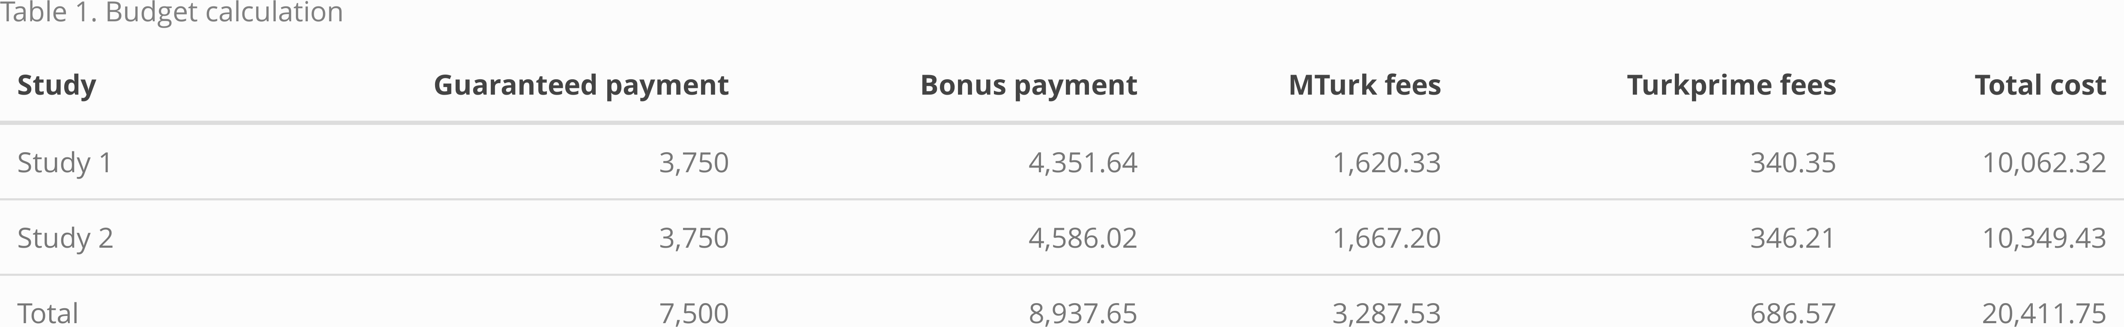

## Power analysis:

We conducted *a priori* power analyses in R to determine an adequate sample size for the main hypothesized interaction effect between gender and condition on log transformed time spent preparing before performance (simulations modeled after code from Hughes 2017). We ran 5000 simulations while varying the sample size (*N* = 1500, 2000) and the effect size for the interaction effect (*b* = .3, .4). We estimated power for these specific effect sizes because they approximate the effects we saw in our pilot studies. We held other input parameters, namely the effects of gender and condition, constant (both at *b* = .2) across simulations. Based on these simulated estimates, we will recruit 1500 participants across both studies to achieve at least 80% power for our anticipated interaction effects (*b* = .3).

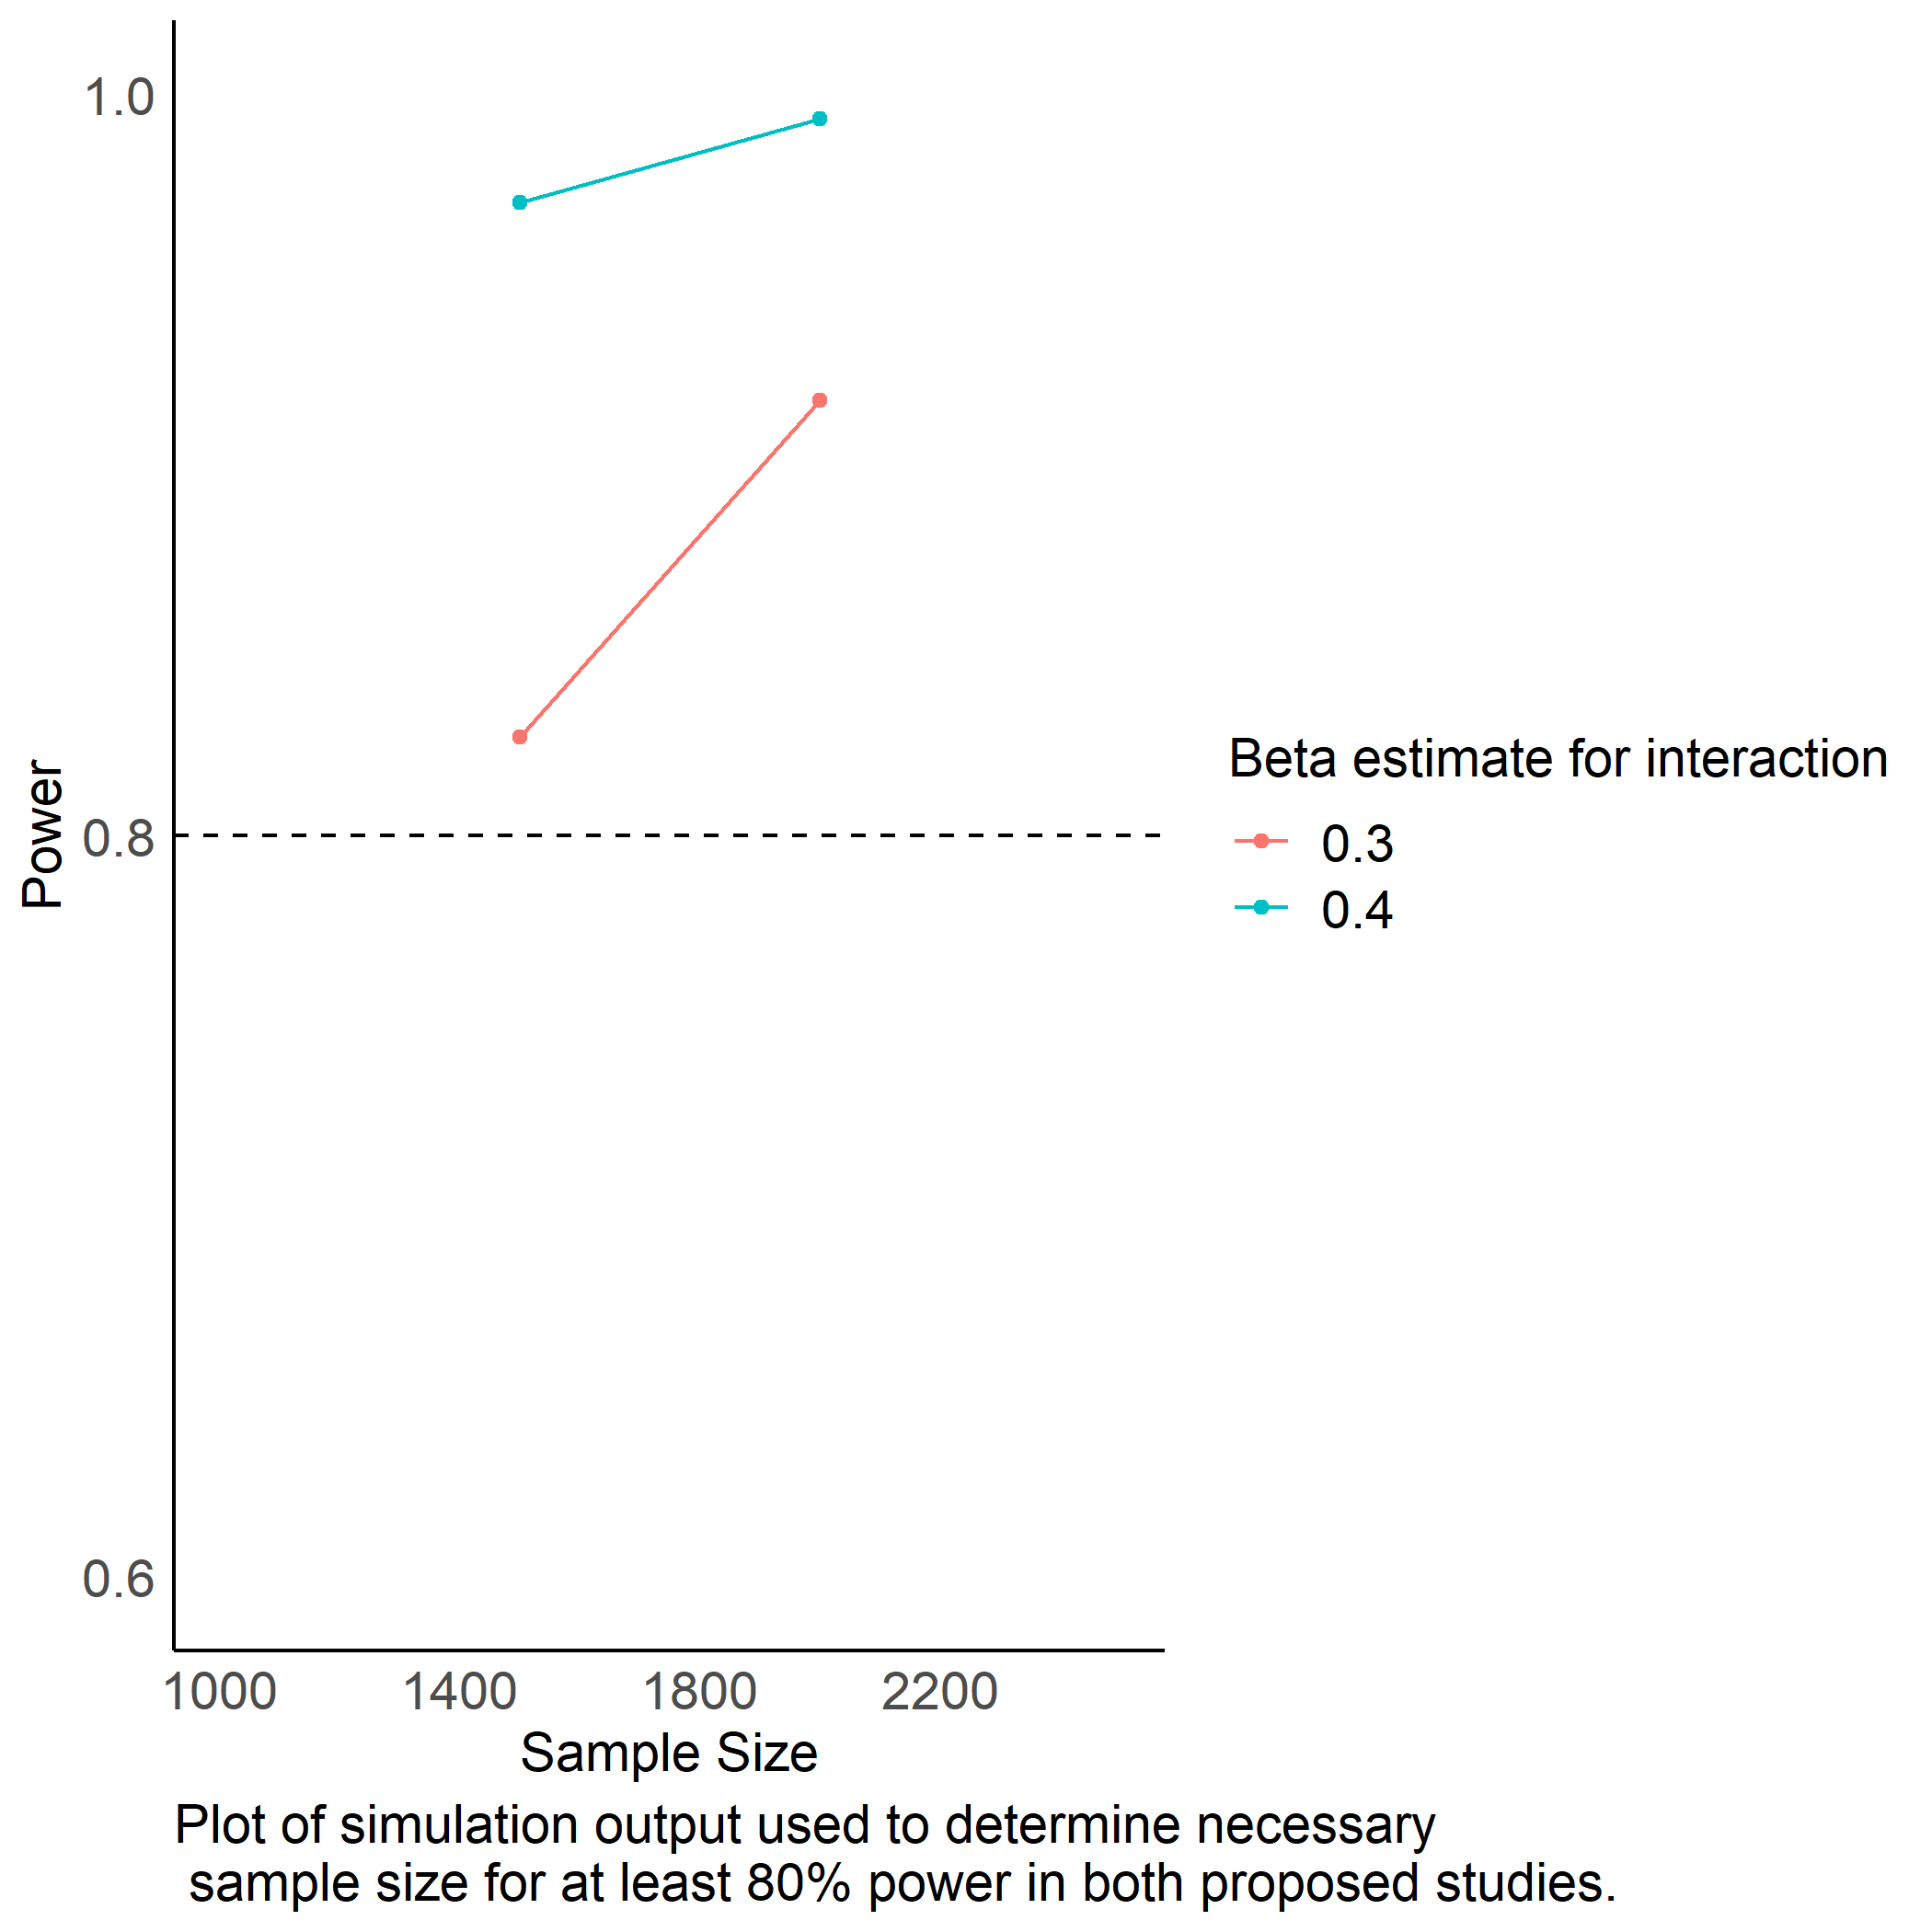

# Reference

Hughes, Jeff. 2017. “Running Power Simulations with the Power of R!” <http://disjointedthinking.jeffhughes.ca/2017/09/power-simulations-r/>.