# 1 Chapter 2: Effects of competition on gender differences in the choice to prepare

## 1.1 Introduction

Competitions are increasingly prevalent in the global labor market [@Lavy2004; @Lemiuex2009] and the winners of competitions are disproportionately rewarded [@Frank2010]. Much work on gender differences in competitiveness has focused on designing interventions that increase women’s willingness to compete. We test the viability of one such intervention in Chapter 1 of this dissertation by providing men and women opportunities to practice before competing. While the intervention ultimately did not increase women’s competitiveness, the studies in Chapter 1 revealed that women prepare more than men. Moreover, both men and women believed that women would be more likely to practice. Thus, a new gender difference in preparation was discovered. In the current Chapter, we ask whether competitions themselves disproportionately increase rates of practicing among women, such that women are especially likely to prepare before entering competitive environments relative to non-competitive environments. Additionally, we explore whether gender stereotypes may be driving the gender difference to practice. While considerable efforts have been made to understand why men are more likely than women to choose to compete, less attention has been paid to whether and how men and women may differentially respond to competitions. Yet, understanding downstream consequences of nudging or forcing women into competitions may too help address gender disparities in economic outcomes [@Blau2017; @Altonji1999].

### 1.1.1 The gender gap in labor market outcomes and preferences for competition

Compensation packages based on performance pay, such as bonuses, commissions, and piece-rate payments, have risen in popularity relative to hourly/salaried pay, especially among workers in the highest tiers of occupations [@Hall1998; @Murphy1999; @Cunat2005; @Lemiuex2009]. There is evidence that the increasing use of performance pay lends itself to wage inequality. @Lemiuex2009 showed that an increased dependence on performance pay during the late 1970’s and early 1990’s accounted for 21% of the observed growth in variance of men’s wages. Bonuses and commissions, arguably the most competitive compensation schemes, may be especially important in driving the large disparity between the highest and lowest percentile earners within organizations [@Bell2010; @Bell2014; @Benabou2016]. Importantly, performance pay may contribute to the gender wage gap too. Using data from the National Longitudinal Surveys of Youth, @McGee2015 show that women are less likely to be employed in occupations that receive bonuses, and simultaneously are more likely to receive piece-rate pay – the least competitive of all forms of performance pay, where workers are paid based on their absolute output.

The gender wage gap refers to the difference in earnings between men and women, with men earning more, on average, than women worldwide. While the gender gap has decreased over the last three decades, the improvements have been modest. For instance, it is estimated that the ratio of women’s to men’s wages in the United States increased to only 67% in 2016 from 53% in 1986 [@Gharehgozli2020]. While numerous factors have been implicated in contributing to the gap, including human capital variables (e.g., gender gaps in education and work experience) [@Goldin2006a], workforce interruptions and fewer hours among women [@Blau2017a], persistent gender segregation by field and occupation [@Blau2017; @Goldin2014], along with discrimination [@Blau2017], some researchers have looked to gender differences in men’s and women’s willingness to compete and to a lesser extent, behavior that results when required to enter a competition. An expanding literature in both psychology and experimental economics suggests that men, compared to women, are more willing to enter competitions. This finding was first documented in a foundational experiment by @Niederle2007, and has since been replicated numerous times across populations [for reviews, see @Croson2009; @Niederle2011, @Niederle2017; and @Shurchkov2018), including among hunter-gatherers [@Apicella2015].

Typically, researchers measure competitiveness as one’s willingness to enter a tournament where success and thus, earnings, depend on outperforming (an)other player(s). Participants who prefer tournament payment schemes over piece-rate payment schemes, where payments are solely determined by the number of successfully completed units, are said to be competitive [@Niederle2007]. Importantly, this laboratory measure of competitiveness predicts education and career choices, along with earnings outside the lab [@Buser2014; @Zhang2012; @Buser2017c; @Samek2019; @Berge2015; @Reuben2015; @Reuben2017; @Buser2017b; @Buser2020a], and thus may help explain gender gap in labor market outcomes.

To date, most of the research on gender differences in competitiveness has focused on i) either explaining the sources of the gender difference – for instance, men tend to be more confident and risk-seeking than women [e.g., @Veldhuizen2017] or ii) designing interventions to encourage women to compete more [@Balafoutas2012; @Sutter2016; @Cassar2016; @Brandts2015; @Niederle2013; @Brandts2015; @Healy2011; @Alan2018]. For instance, @Kessel2021 find that telling participants about the gender difference in willingness to compete as well as the implications on earnings, reduces the gender gap in competitiveness. Crucially, less consideration has been paid to how competitions may differentially, and perhaps negatively, impact women in other ways, such as lowered performance both during and after competition, reduced desire to enter future competitions, or potential opportunity costs related to time spent (over) preparing when required to compete.

The rest of this introduction briefly summarizes the literature on how men and women may differentially respond to competitions at three specific time points (i.e., before, during, and after competition) and highlights the need for more work on how men and women may behave differently *before* entering competitions. Second, we introduce several reasons for why preparation might be one specific behavior where gender differences before competition arise, with the expectation that women practice more than men, especially when competing. Finally, we introduce the current investigation, which experimentally tests whether and how competitions affect gender differences in preparation.

### 1.1.2 Gender differences in response to competitive environments

There are three major time points at which competition may affect men and women differently: before, during, and after competition. The majority of previous studies in this space have examined gender differences in response to competition during and after performance.

#### 1.1.2.1 During competition

Many lines of work have explored the possibility of gender differences in performance under competitive pressure. Here, we summarize the work on different forms of competitive pressure, including studies that explicitly labeling one environment as competitive or, in other cases, impose certain rules or create performance contexts under which, although not explicitly labeled as competitive, reduce an individual’s probability of earning a specific reward or reduce the amount of the reward they can earn, and as such, impose competitive pressure.

Although competitions are generally motivating and designed to improve performance by increasing effort [@Connelly2014a; @Murayama2012; @Miller2019a], previous research suggests that men perform better under competitive payment schemes relative to non-competitive payment schemes, while women’s performance does not respond to competitions [@Gneezy2003; @Gneezy2004; @Gunther2010; @Samak2013; @Booth2022; @Gneezy2004; see @Niederle2011 for review; along with @Cotton2013 and @Dreber2011 for exceptions]. @Gneezy2003 show that there is no gender difference in performance when participants are solving mazes following a piece-rate payment scheme, but a significant gender difference in performance arises under a tournament payment scheme, with men performing better. @Gunther2010 replicate the effect of competition on gender differences in performance for a male-typed task, but find no gender differences in performance during competition for female-typed or gender-neutral tasks.

@Shurchkov2012 finds evidence that two types of pressure may explain part of gender difference in competitiveness: task stereotypes and time constraints. Specifically, they find that women’s performance suffers when they compete against others on a male-typed math task with high time pressure (2 minutes to perform), while there are no significant gender differences in performance during competition on a female-typed verbal task with low time pressure (10 minutes to perform). Also, they find that women are significantly more likely to choose to compete when there is low time pressure in a math tournament, while men’s competition entry does not significantly vary based on the time pressure treatment.

There is also field evidence of gender differences in performance during competition. @Paserman2007 show that women’s probability of committing costly errors over the course of a tennis match increases at high-pressure moments, while men’s probability of committing such errors does not significantly change across the match.

There is also extensive work on gender differences in performance and effort under competitive pressure within academic contexts [@Iriberri2019; @Cai2019; @Ors2013; @Azmat2016; @Price2008; see @Niederle2010c for a review on gender differences in math tests scores]. For instance, in a study of gender differences in responses to different levels of competitive pressure on a Korean quiz show for student scholarships, researchers find that when stress is kept to a minimum, there are no gender differences in performance, but when certain knock-out rules are applied, a difference emerges [@Booth2021]. @Morin2015 show that effect of education reform that led to a double-cohort, and as such, increased competition for admission at the University of Toronto, increased men’s average grades and proportion of men who graduated on time relative to women, driven largely by men increasing their effort after the reform.

In a study examining performance during the GRE examination, @Attali2012 show that the gender gap in performance is significantly greater under the real GRE, which they demonstrated was driven by men increasing their effort, while women’s effort stayed the same. The real GRE is inherently more competitive and higher-stakes than a voluntary experimental section of the GRE, providing further support for gender differences in performance in response to competitive pressure in the field.

There is also a growing literature showing that women are less willing to guess on exams [@Pekkarinen2015; @Baldiga2014; @Iriberri2021], which in turn negatively impacts their performance on said exams, widening the gender gap in performance under competitive pressure. @Riener2018 shows this phenomenon starts at an early age, with girls as young as eight years of age being significantly less willing to guess on exams relative to men.

#### 1.1.2.2 After competition

During repeated competition, women tend to perform worse in subsequent performance rounds after losing, even if the monetary prize they lost was relatively meager, while men only perform worse in subsequent rounds if they lost the chance to win a large monetary prize [@Gill2014]. Other research suggests women stop competing altogether after losing if given the choice. @Buser2019, who examine the effects of losing while competing in the Dutch Math Olympiad on the choice to compete in subsequent years, show that men are just as likely to compete even if they lost the previous year, while women are less likely to compete again if they lost before. In a separate study, @Buser2016 show that men react to losing during a competition by picking a more challenging target for their subsequent performance while women lower their performance.

Similarly, @Shastry2021 performed an experiment among Economics professors where they received feedback in the form of a letter from the editor on a hypothetical journal submission, with randomized decision outcomes (i.e., revise and resubmit, reject and resubmit, reject). They find that among the assistant professors within the sample, a flat rejection during the review process reduced women’s beliefs in their probability of success in the future significantly more than men’s - as quantified by their rating of the probability of publishing the paper in the same journal or in any leading journal. This gender gap in confidence does not hold among associate or full professors, which they argue is likely driven by survivorship bias.

In another study of the effects of feedback on subsequent gender differences in behavior and beliefs, @Coffman2021 examine both the role of task stereotypes (again through a female-typed verbal quiz and a male-typed math quiz) and feedback (positive or negative) on both confidence and choice in a compensation scheme (piece-rate or tournament payment). They find that women’s beliefs and choices after negative feedback are updated more negatively than men, regardless of their performance or choices before feedback. Overall, the current body of literature suggests that competitions may differentially impact women and men, both during and after said competitions.

#### 1.1.2.3 Before competition

As mentioned previously, little research has examined how competitions may affect gender differences in behavior during another critical period: before an individual enters a competition, where they have the most control of their subsequent performance in the competition. Given previous research suggesting that women and men may respond differently during and after competitions, we expect that they will also employ different behaviors and have different perceptions of themselves and others in advance of a competition.

Our research in Chapter 1 suggests that women, compared to men, are more likely to prepare when given the opportunity. While the primary goal of this research was to experimentally test how preparation might influence gender differences in willingness to compete, a significant gender difference emerged in the choice to practice [1]. Notably, the gender difference was present regardless of the payment option scheme chosen (i.e., the competitive tournament payment scheme or non-competitive tournament piece-rate payment scheme), though such interaction effects may have been difficult to detect with the sample sizes employed. Moreover, because payment schemes were not randomized there may have been selection effects such that those who were more likely to compete may have also been less likely to prepare. Thus, whether tournament (relative to piece-rate) payment schemes lead women to prepare disproportionately more than men is still unknown.

### 1.1.3 Does competition elicit a gender difference in preparation?

There are three non-mutually exclusive reasons to suspect that competition would be especially likely to increase women’s preparation before performance: the effects of competition on confidence, risk, and/or the stereotype that women prepare more than men.

#### 1.1.3.1 Confidence, risk, and rates of practicing

Women may spend more time preparing than men, especially before competitions, in part because they are, on average, less risk-seeking [@Croson2009; @Dohmen2011b; @Eckel2008; @Bertrand2010a; @Shurchkov2018] and confident [@Bertrand2010; @Lundeberg1994; @Mobius2011; @Barber2001; @Croson2009; @Shurchkov2018, but see @Bandiera2022] than men. Indeed, both confidence and risk attitude have been implicated in driving the gender gap in willingness to compete [@Veldhuizen2017; @Gillen2019; see @Niederle2011 for review]. The extent to which confidence and risk attitude account for the gender gap in willingness to compete is debated; some research suggests that competitiveness may be entirely explained by confidence and risk [@Veldhuizen2017; @Gillen2019] while other research suggests that there remains a residual gap in the choice to compete [@Niederle2007]. Regardless of whether competitiveness is a stand-alone trait, confidence and risk attitude may lead to differences in how men and women react to competitions, possibly including the decision to prepare before competitions.

Preparing for a competition, through either practicing or studying, may be a strategy individuals employ before entering a competition. Since competitions, by definition, compare the performance among two or more individuals, they naturally lead to self-evaluation and comparative judgments of self with others - processes that are intimately linked to confidence. Thus, less confident individuals may prepare more in order to reduce the negative feelings caused by low confidence independent of any ambitions to win, since mastery is an important driver of confidence [@Gist1992; @Usher2008]. Given the aforementioned evidence that women tend to be less (over)confident than men [@Mobius2011; @Niederle2011; @Croson2009; @Lundeberg1994; @Niederle2007; @Bertrand2010a; @Beyer1990; @Beyer1997], we may expect to see women preparing more than men, particularly in competitive contexts, which, again, naturally invoke self-other assessments.

Importantly, on top of their possible effects on preparation through confidence, competitions may also cause individuals who are more risk-averse to prepare more. Risk attitudes, as shown in Chapter 1, reflect the preference for a certain gain over a gamble, even if the gamble has an equal or greater monetary expectation [@Kahneman1982]. Since competitions, by definition, reduce the probability of earning the prize of said competition, even if the expected value of one’s earnings is equal to non-competitive payment schemes, competitive payment schemes are inherently more risky relative to non-competitive payment schemes. Thus, it is possible that the aforementioned gender differences in risk attitudes [@Bertrand2010a; @Croson2009] may also lead women to be more likely to prepare before performing in a competition relative to men.

#### 1.1.3.2 Gender stereotypes and practicing

Gender differences in preparing may be driven by persistent stereotypes of men and women’s tendencies to prepare more before performance. Gender stereotypes derive from observers’ automatic tendency to make correspondent inferences about men and women’s dispositions [@Gilbert1995; @Ross1977; @Jones1967; @Gawronski2004], a process that appears to affect perceptions of others as early as two years of age [@Poulin-Dubois2002; @Serbin2002]. Stereotypes involve prescriptive, proscriptive, and descriptive components [@Prentice2002], where prescriptive and proscriptive stereotypes reflect cognitive representations of the characteristics women and men should and should not have, respectively, while descriptive stereotypes are representations of the typical man and woman [@Burgess1999]. Gender stereotypes can encompass a variety of attributes, including physical (e.g., women are dainty), cognitive (e.g., men are analytical), and personality-based (e.g., women are nurturing) stereotypes [@Cejka1999; @Deaux1984].

Indeed, there is extensive evidence that gender stereotypes affect one’s beliefs about themselves and their performance, along with one’s behavior, such that behavior aligns more closely with gender stereotypes. For instance, @Bordalo2019 found that individuals tend to overestimate actual performance gaps between genders based on stereotypes, such that women were far less confident in answering questions gender-incongruent domains (e.g., business, math, and sports) than they should have been given their performance. @Coffman2021 further explore how belief updating is affected by positive or negative feedback about one’s performance, and show that receiving negative feedback in a gender-incongruent domain leads to a long-lasting negative effect on beliefs about performance (a week later), while negative feedback in gender-congruent domains does have such lasting effects. @Coffman2019 show similar effects, such that individuals tended to update their beliefs more in concordance with gender stereotypes, such that both men and women who receive positive feedback about their performance adjust their beliefs significantly more in line with gender stereotypes in gender-congruent domains than in gender-incongruent domains.

There is direct evidence that these beliefs can affect subsequent behavior and performance. For instance, @Bian2017 show that the gender stereotype that men tend to succeed in activities and fields that require brilliance leads girls as young as 6 years of age to avoid activities that supposedly require brilliance. Within the field, @Guiso2008 find that the gender gap in math, in which boys typically outperform girls on math tests, disappears in more gender-equal societies, as measured through the World Economic Forum’s Gender Gap Index, which captures the opportunities, education, and well-being of women within a given country. Similarly, @Breda2020 measure the stereotype that “math is not for girls” among students across 64 countries, and find that countries in which a larger proportion of students held this belief tended to have fewer women represented in math-intensive fields. Individuals are also less likely to engage in self-promotion behaviors in gender-incongruent domains. For instance, @Coffman2014 show that both men and women are less likely to contribute ideas to a group decision in gender-incongruent decision-making domains (e.g., women contributing ideas to a decision in the domain of sports), even when the group would have made a better decision with their contribution. On the other hand, @Coffman2021a find that people are less likely to promote themselves when they are the gender minority in their group, presumably because they prefer to conform with perceived gender norms. Finally, @Niederle2011 reviews an extensive literature showing that gender differences in competitiveness can be changed based on task type (usually male-typed math or female-typed verbal tasks), suggesting that stereotypes about the ability of one’s gender to perform on a task affects willingness to compete. Overall, research across fields shows that gender stereotypes affects gender differences in beliefs, performance, and behaviors.

We found in Chapter 1 that women not only prepared more than men, but that participants also correctly predicted that women would prepare more than men, suggesting that there are gender stereotypes about preparation in favor of women. Across three studies participants were monetarily incentivized to correctly guess which gender would choose to prepare for the paid multiplication task, such that their responses were unlikely influenced by desire to respond in a socially desirable way. Most participants in the three studies (Study 1: 83.37%, Study 2: 80.95%, Study 3: 56.7%) correctly predicted that women would practice more than men before performance on the multiplication task used in the studies and in general (Study 1: 89.51%, Study 2: 85.38% and Study 3: 59.5%) [2].

Given our evidence gender stereotypes about preparation, in combination with the evidence that gender stereotypes in general affect subsequent behavior to align with said stereotypes, it is entirely possible that gender stereotypes drive women’s tendency to prepare more than men.

Gender stereotypes about competitiveness in combination with gender stereotypes about preparation might also affect women’s preparation behaviors. That is, when women are forced to compete and are offered the opportunity to prepare before the competition, this would likely activate thoughts about gender stereotypes for both of those behaviors - that is, they will likely ask themselves 1) how typical is it for my gender to prepare? and 2) how typical is it for my gender to compete and/or perform well under competitive pressure? That is, if there’s a general belief that women prepare more than men (for which we find evidence in Chapter 1), but do not choose to compete or perform well under competitive pressure (that is, they are less competitive) (for which we find evidence in Chapter 1) - they might assume that they should prepare more to compensate for the discordance between how competitive they need to be to enter the competition and the typical level of competitiveness perceived in women according to gender stereotypes about competitiveness.

Overall, given the evidence that gender stereotypes can lead to behavior that aligns with stereotypes specific to one’s gender, we expect that participants’ perceptions of gender differences in preparation likely contribute to gender differences in actual preparation behavior, along with their perceptions of how much they prepare relative to others, especially in competitive settings.

### 1.1.4 The current experiment

Here, we study how women and men differentially respond to competition through preparation. We expect to see both gender differences in actual preparation behavior, along with gender differences in perceptions of relative preparation, especially when men and women are required to compete (relative to non-competitive environments). Specifically, we experimentally test whether competition exacerbates previously established gender differences in preparation by manipulating participants’ assigned payment scheme (i.e., competitive tournament payment scheme or non-competitive piece-rate payment scheme). We hypothesize that women will choose to practice problems at a higher rate than men, especially when assigned to the competitive tournament payment scheme (i.e., we anticipate a main effect of gender on the choice to practice, and an interaction between gender and condition, such that women will practice more than men in both conditions, but the difference-in-differences between practicing rates across genders will be greater in the competition condition).

While we did not find an interaction between gender and choice to compete on the decision to prepare in Chapter 1, the sample in those studies was likely too small to detect interaction effects. Moreover, participants were not randomized to their payment schemes. As such, selection effects may obscure actual relationships between gender and practicing by payment schemes. The current study expands on the results of in Chapter 1 by directly manipulating participants’ payment scheme and recruiting a sample large enough to detect interaction effects.

It is also entirely possible that women prepare more than men regardless of the payment scheme, possibly because of gender stereotypes that lead them to think they should prepare in advance of any type of performance, or perhaps because in general, they want to reduce the risk of earning nothing, even in the piece-rate payment scheme. Or, as suggested by the extensive literature showing that women’s performance does respond to competitive pressure [cites], women’s effort may not differ significantly across different levels of competitive pressure, while men’s effort may increase in response to competitive pressure. Thus, we may still find no evidence for an interaction effect between gender and choice to compete in the study in Chapter 2, suggesting that women’s preparation behaviors are insensitive to the payment scheme relative to men.

Not only do the aforementioned factors (i.e., gender differences in confidence and risk attitudes, and/or gender stereotypes likely affect gender differences in preparation behavior, but they likely also affect one’s *perceptions* of their relative rate of preparation. For instance, when an individual has less confidence in their ability to perform on a task, they may feel less capable, or in other words, less prepared, relative to others when it comes time to perform on said task. Given the likely effects of competitions on self-other assessments, they increase the likelihood an already less confident individual, who may feel as though they are not as capable as others on performing well without preparation, will suffer these feelings of relatively lower preparation. Similarly, in riskier contexts, such as competitions, an individual who is more risk averse than others may feel as though they are not preparing sufficiently relative to others to reduce the inherent risk of the situation. Finally, it would reason to assume that gender stereotypes drive not only preparation behavior, but perceptions of relative preparation - given the argument that our behavior is driven by perceptions of norms and how we stand relative to the norm.

For the above reasons, this study included a new measure of how much participants felt they prepared relative to other participants to test whether gender predicts participants’ perceptions of their relative amount of preparation. More concretely, we expected women will be more likely to assume they practice less than others compared to men (that is, the effect of gender on perceptions of relative practice will be negative), especially when assigned to the competitive tournament payment scheme (such that women in general will think that they practice less than other participants than men, but this difference will be exacerbated in the competition condition).

The research design, hypotheses, measures and analyses for this chapter were pre-registered on [OSF](https://osf.io/8bwfz/) and all analyses were conducted in R statistical software (version 4.0.4).

### 1.1.5 Methods

#### 1.1.5.1 Participants

All studies measures described below are publicly available on OSF both as a [.pdf](https://osf.io/xbrvs/) and [.qsf](https://osf.io/4mvyr/). Participants were recruited on Amazon Mechanical Turk using the same screening criteria as all previous studies in Chapter 1. Like the last study of Chapter 1, we used Qualtrics’ fraud detection software to filter out responses that were suspicious either because they were likely 1) bots and/or 2) duplicate responses using the same exclusion criteria from before. These exclusions were applied for all main analyses reported in the results section.

The final dataset consists of 3980 participants (57.36% women), with an average age of 41.3 (*SD* = 13.2) years. Of the final sample, 75 participants (30.67% women) dropped out of the study before finishing (we use their data when available) and 192 participants were flagged by Qualtrics’ fraud detection software as suspicious based on the aforementioned criteria.

#### 1.1.5.2 Procedures

Participants included in the study were told they would be completing a multiplication task. Notably, we aimed to recruit a larger sample to provide enough power to detect our anticipated interaction effects, and shortened the task from two minutes (as in Chapter 1) to 30 seconds (in the present study). Otherwise, the task used was identical to the ones used in previous studies.

Like the studies in Chapter 1, participants were first told about the rules for the multiplication task and were required to pass the same comprehension questions used in the previous studies before moving onto the main manipulation of payment scheme.

##### 1.1.5.2.1 Manipulation of payment scheme

Unlike previous studies, participants were not able to choose a payment scheme. Instead, they were told about their random assignment to one of two payment schemes: the non-competitive, piece-rate payment, scheme or a competitive, tournament, payment scheme. Men and women were evenly assigned to both conditions. If they were assigned to the piece-rate payment scheme, they were paid $.10 per problem solved correctly. If they were assigned to the tournament payment scheme, they were randomly matched with another participant that was also assigned to that payment scheme and received $.20 per problem if they solved more problems than the other participant. Otherwise, they received nothing.

Again, we checked that condition was assigned evenly across participants (control= 50.21%) and genders included in the study. Of the men who completed the study, 50.53% were assigned to the control condition and of the women who completed the study, 49.98% were assigned to the control condition, , . We also assessed condition-dependent attrition by identifying the number of participants that dropped out during/after learning about condition and found that a relatively small proportion of participants out of the total sample dropped out after learning about their respective condition (*N* = 42; 0.35% of men dropped out after learning about assigned condition versus 0.7% of women dropped out after learning about assigned condition, , ). Given the small sample that dropped out relative to the total number of participants in the study, we are not concerned that condition-dependent attrition is driving any of the effects found in this study.

##### 1.1.5.2.2 Main dependent variables of interest: Measures of preparation and perceptions of relative preparation

After they were informed of their payment scheme, all participants were given the opportunity to spend unlimited time preparing before completing the paid multiplication task. The nature of the unlimited preparation was identical to that used in Study 3 of Chapter 1, where participants who chose to prepare were shown 10 multiplication problems that were created randomly by drawing from the pool of numbers used in the main multiplication task. Unlike the last study in Chapter 1, participants were not asked to explicitly indicate whether they would like to study the times tables. Instead, they were shown the times table right after the practice problems directly on the practice problems page and told they could check their answers using the table as desired. By including the option to check their answers, we hoped to make the practice itself more useful by providing participants a way to receive feedback on their responses. At the bottom of each practice page, participants were asked if they would like to continue practicing multiplication problems, with the option to continue as many times as desired or opt out at any point. The amount of time (in seconds) participants spent on each practice page was also recorded. Thus, like the previous studies, we have multiple measures of preparation, by design: 1) the actual decision to practice problems (before knowing what the practice entails), 2) the number of practice problems participants attempted (quantified as number of practice problems not left blank, irrespective of accuracy - with participants who did not opt into the practice having a value of zero), 3) the amount of time participants spent across all practice rounds they completed (where those who chose not to practice had a value of zero for this variable), and 4) the number of practice rounds participants completed. Since the practice structure in this study is identical to that of Study 3 in Chapter 1, the number of practice rounds variable was encoded in the same way as that study (*M* = 0.59, *SD* = 0.98).

After completing the practicing/studying, participants guessed how much their amount of practicing for the task compared to all other participants who completed the task by indicating the decile of their practice relative to other participants. We also asked participants to indicate their anticipated decile when their amount of practicing was compared to that of all participants who identified as men and women, respectively.

We used these decile questions to create the perceived practice deviation variables as follows: self-rated decile (either based on the question about practicing relative to all other participants, relative to only men, or relative to only women) - actual percentile based on number of practice problems completed. We subtracted percentile from decile here because it provides more variation in the variable, thus allowing us to be more precise in our estimates of the effects of various predictors on this variable. We chose to ask participants to indicate their decile rather than percentile because it would be cumbersome for participants and it is unlikely they would be able to provide concise responses. Overall, negative values for this variable indicate a participant expected to have practiced less, relative to other participants, than they actually did, and vice versa for positive values. A value of zero, therefore, indicates that a given participant was completely accurate in their guess of relative practicing.

##### 1.1.5.2.3 Paid multiplication task and post-task measures

After practicing, participants completed the paid multiplication task, received feedback about their absolute (but not relative) performance, and completed many of the same follow-up questions used across Chapter 1, including risk attitudes, confidence, and perceptions of gender differences in preparation, competitiveness, and performance. Like Study 3 of Chapter 1, all questions had three response options (e.g., men are more likely to compete than women, women are more likely to compete than men, or there are no differences how much men or women would choose to compete). One of the perceptions of gender differences questions deviated slightly from the previous studies, which was edited for the sake of clarity. Instead of asking participants to indicate “Do you think men or women in this study chose the tournament payment option more often?”, they were asked “If given the opportunity to choose between the two payment schemes (Piece Rate or Tournament), do you think men in this study would choose the piece rate or the tournament payment scheme more often?”, with the options to indicate: “Men would choose tournament more often than piece rate”, “Men would choose piece rate more often than tournament”, or “Men would choose each payment scheme equally”. This question was repeated with respect to women in the study.

We paid participants to answer the questions about their confidence and perceptions of gender differences correctly at the same rate as previous studies. Finally, they completed the same demographic questions from Chapter 1 and provided feedback on the study before being paid for their participation.

### 1.1.6 Results

## 1.2 Describing main variables of interest

First, we explored the characteristics of the main practice variables in the dataset. Across conditions, 45.51% of all participants chose to practice, with 48.22% choosing to practice in the piece-rate payment condition and 49.73% choosing to practice in the tournament payment condition. This difference in the choice to practice across conditions is significant when condition is included as a predictor alone, , 95% CI , , , , but in the subsequent section we explain how the effect changes when including other predictors in the model. Participants spent an average of 29.12 seconds practicing across all rounds of practice.

Like all studies in the first chapter, we replicate the effect of gender on risk attitudes, , 95% CI , , , , and confidence, , 95% CI , , , , such that women were more risk averse and less confident relative to men.

Like all studies in Chapter 1, we find a significant effect of gender on task score when included as a sole predictor, Mwomen=10.45, SD=4.47; Mmen= 12.29, SD =7.28, , 95% CI , , , . Contrary to the majority of studies in the first chapter, the effect of gender holds even after including risk attitudes, confidence, and an interaction between gender and condition in the model, , 95% CI , , , . We explore this finding further in the discussion section for this study.

## 1.3 Effects of gender and condition on both actual practicing and perceptions of one’s relative practicing

We replicate the effect of gender on the choice to practice found in Chapter 1, where 51.26% of women chose to prepare via practice, relative to 37.81% of men, , 95% CI , , , (see Figure 1.5). The gender effect holds in a logistic regression with gender, condition, and the interaction between the two predicting the binary choice to practice problems, , 95% CI , , , (see Figure 1.1). However, we do not find an interaction between gender and condition, , 95% CI , , , , contrary to our hypothesis that the gender difference in the choice to prepare would be exacerbated under the tournament payment scheme relative to the piece-rate payment scheme. Additionally, the aforementioned effect of condition on the choice to practice is no longer significant in the model including these additional predictors, , 95% CI , , , . In a subsequent logistic regression that added confidence, risk attitudes, and task scores to explore whether they explain the gender difference in the choice to practice, we find that gender still significantly predicts the choice to practice when these variables are included in the model, , 95% CI , , , .

We also examined other measures of practice to test the robustness of the effect of gender on practicing. We find that women, relative to men, completed a significantly higher number of practice problems, , 95% CI , , , , more rounds of practice, *b* = 0.31, CI [0.04, 0.59], *z* = 2.24, *p* = 0.03, and spent more time completing practice problems, , 95% CI , , , while controlling for payment scheme condition and the interaction between gender and payment scheme condition. None of the interaction effects were significant across any of these dependent variables, meaning that the effects of the payment scheme conditions on the preparation outcomes did not differ by gender.

Based on previous literature on risk aversion and confidence affecting competition entry, we expected participants with especially high levels of risk aversion and/or low levels of confidence would be especially likely to choose to practice before entering a competition, and that this effect may interact with gender. Thus, we tested possible three-way interactions between gender, condition, and risk aversion or confidence on the choice to practice problems through two logistic regressions, but did not find evidence that risk aversion, INSERT, nor confidence, INSERT, interacted with gender and condition.[3].

## 1.4 Accuracy of levels of practicing based on participant gender

Next, we ran a linear regression with gender, condition, and the interaction between those two variables predicting the aforementioned perceived practice deviation variable (that is, subtracting each participants’ percentile based on number of practice problems completed from their self-rated decile) to test our second hypothesis that women would be more likely to assume they practice less than others compared to men, especially under the competitive tournament payment scheme. We find a significant effect of gender on perceived practice deviation, such that women (relative to men) were significantly less likely to assume they practice more than others, , 95% CI , , , , Mwomen=23.56, SD=56.11; Mmen= 39.69, sd=54.87 (see Figure 1.8). We do not observe a significant effect of condition on perceived relative practice, , 95% CI , , , . Finally, we did not find evidence of the anticipated interaction effect between gender and condition on perceptions of relative preparation, , 95% CI , , , .

Since this is the first time we have used the perceived practice deviation variable and are not able to attest to its robustness, we also explored another way of testing this hypothesized effect by using participants’ self-rated decile as the dependent variable instead of perceived practice deviation and then controlling for number of practice problems attempted (as a proxy for more precise estimate of amount of practicing) in a linear regression. We find that, regardless of the number of practice problems attempted, women are significantly less likely to say they practice more than others, compared to men, , 95% CI , , , .

We also explored how self-rated decile changes based on whether participants were asked to compare their amount of practicing to men or women in the study specifically, and find that participants’ perceptions of how much they practiced relative to women in the study are significantly lower than perceptions of much they practiced relative to men, , 95% CI , , , .

## 1.5 Perceptions of gender differences in behavior

Like in Study 3 of Chapter 1, we ran both chi-square goodness of fit tests with all three response options for the questions about perceptions of gender differences, and if the test with all options was significant, we subsequently ran more targeted chi-square tests to perform pairwise comparisons. Across all measures of perceptions of gender differences in behavior, we replicate effects found in the previous studies. First, the majority of participants (59.57%) said that women would be more likely to practice/study for the task, , (see Figure 1.2), which was significantly higher than the proportion of participants who said men would be more likely to practice/study than women (4.73%), , , and the proportion of participants that said there was no difference in the likelihood that men and women would practice/study (35.7%), , .

Similarly, participants were significantly more likely to say that women prepare more than men in general (68.28% of participants), , (see Figure 1.4), relative to the proportion of participants that said men prepare more than women (4.41% of participants), , , or that there is no difference in how much men and women prepare (27.31% of participants), , .

Yet, participants did not expect a gender difference in performance on the main multiplication task used, , (see Figure 1.3), where 54.17% of participants said that there was no difference in how many multiplication problems men and women correctly solved, while 20.56% said men correctly solved more multiplication problems than women,, , and 25.27% said women had a performance advantage over men, , .

Finally, 64.24% of participants expected women would be more likely to choose the piece-rate payment scheme than the tournament payment scheme, , (see Figure 1.6), which was a significantly higher proportion of participants than those who expected women would choose each payment scheme equally (20.9%), , , and than those who expected women would choose tournament more often than piece rate, (14.86%), , . On the contrary, when asked about how much men in the study would compete, a significant majority of participants (63.5%) expected men to be more likely to choose the tournament payment scheme over the piece-rate payment scheme, , (see Figure 1.7), relative to the proportion of participants who said men would choose each payment scheme equally (15.8%), , , and the proportion who said men would choose piece rate more often than tournament (20.7%), , .

### 1.5.1 Discussion

## 1.6 Main hypotheses:

First, we find that, like previous literature in this space and our own studies across Chapter 1, women are more risk-averse and less confident than men in this study. Yet, even when controlling for gender differences in risk attitudes and confidence, we replicate findings from the studies in Chapter 1 that women choose to prepare more than men. Interestingly, women chose to prepare more regardless of the payment scheme (competitive tournament, non-competitive piece-rate) they were randomly assigned to. Also, although participants overall were more likely to practice in the tournament scheme, we did not find evidence that assignment to either a tournament or piece-rate payment scheme significantly predicted the binary choice to practice problems, after including gender and the interaction between gender and condition in the model. Although we did not explicitly hypothesize a priori that condition would be a significant predictor of the choice to practice, it is nonetheless important to note that gender explains participants’ decision to practice problems over and above any effect of condition.

We also included other means of quantifying preparation (i.e., amount of time spent on the pages with practice problems and study tables, number of practice problems completed, and total number of practice rounds completed) to test the robustness of the gender effect, and find evidence across our multiple measures of preparation that women tended to prepare more than men– they spent more time completing practice problems and studying tables, completed a higher number of practice problems, and completed more rounds of practice.

One important consideration when interpreting the effect of gender on the choice to prepare before the task is that, contrary to our prior studies (Chapter 1), we find a significant effect of gender on task score, even while controlling for individual differences in risk attitudes and confidence, unlike two out of the three studies in the last chapter. It is possible that shortening the task contributed to this effect - especially considering evidence suggesting that women’s performance may suffer under more competitive pressure [cites]. There may be less pressure to perform well during a two-minute task (used in all of the studies of Chapter 1) relative to a 30-second task (used in the study in this Chapter). In support of this possibility, @Shurchkov2012 shows that womens’ performance significantly improves, to the extent that they outperform men, in a low time pressure competition.

We also found evidence for the hypothesized main effect of gender in our other primary pre-registered analysis, where women were more likely to assume they practice less than others compared to men. This effect held when using our pre-registered version of the analysis using the perceived practice deviation variable, representing the accuracy of participants’ guess of how much their level of practicing compared to others participants’ level of practicing, both among the full set of participants and among the subset of participants that chose to practice. We also wanted to test the robustness of the effect using a slightly different way of quantifying our relationship of interest, where we included participants’ raw self-reported practice decile as the main dependent variable of interest (instead of perceived practice decile) with gender and number of practice problems attempted as predictors. We replicate the aforementioned effect, where women tended to think they practice less than others, regardless of how many practice problems they actually attempted - although this effect only held among the full set of participants and not among the subset of participants who chose to practice.

We did not find the hypothesized interaction between gender and condition on perceived practice deviation - suggesting that, like actual decisions to practice, women’s tendency to perceive they are practicing less than others is not significantly affected by whether they are competing or not. Although it is not possible to draw strong conclusions from null effects, we explore possible reasons for the null interaction between gender and condition further in the subsequent general discussion summarizing results across all studies of the dissertation.

## 1.7 Perceptions of gender differences in performance, competition, and preparation

With respect to the questions asking participants to indicate their perceptions of gender differences about our main behavioral variables of interest, we replicate findings from all three studies in Chapter 1. Even though participants expected that women and men would not have a significant difference in task scores, they expected men to prefer the tournament payment scheme over the piece-rate payment scheme, while expecting women to both i) prefer the piece-rate payment scheme over the tournament payment scheme and ii) prepare more, both before completing the multiplication task used in this study and in general before most tasks. Again, with the exception of the general gender difference in practice questions, all of the other perception questions were incentivized for accuracy to reduce socially desirable responding. Our exploratory analysis of the new set of questions about perceptions of relative practicing compared to each gender included in the study of this Chapter support these general perceptions of gender differences in preparation. Given the targeted nature of the questions, we were able to test how participants’ responses changed based on whether they were asking to compare their level of practicing in the study to only participants that identified as women or only participants that identified as men, and find that participants were significantly more likely to indicate that they practiced less relative to women than relative to men.

## 1.8 Summary of takeaways

Overall, our results for the study in Chapter 2 suggest that women prepare more than men, regardless of whether they were assigned to a competitive tournament or non-competitive piece-rate payment scheme, and despite thinking they practice relatively less than men for the multiplication task used in the study. It is possible that gender stereotypes are driving these gender differences in behaviors and perceptions, given our replication of the findings from all three studies in Chapter 1 that participants expected women to prepare more both before the specific task used in the study and in general, along with the finding that participants’ tended to rate their relative practicing significantly lower when comparing themselves to women than men.

## 1.9 Figures and Tables

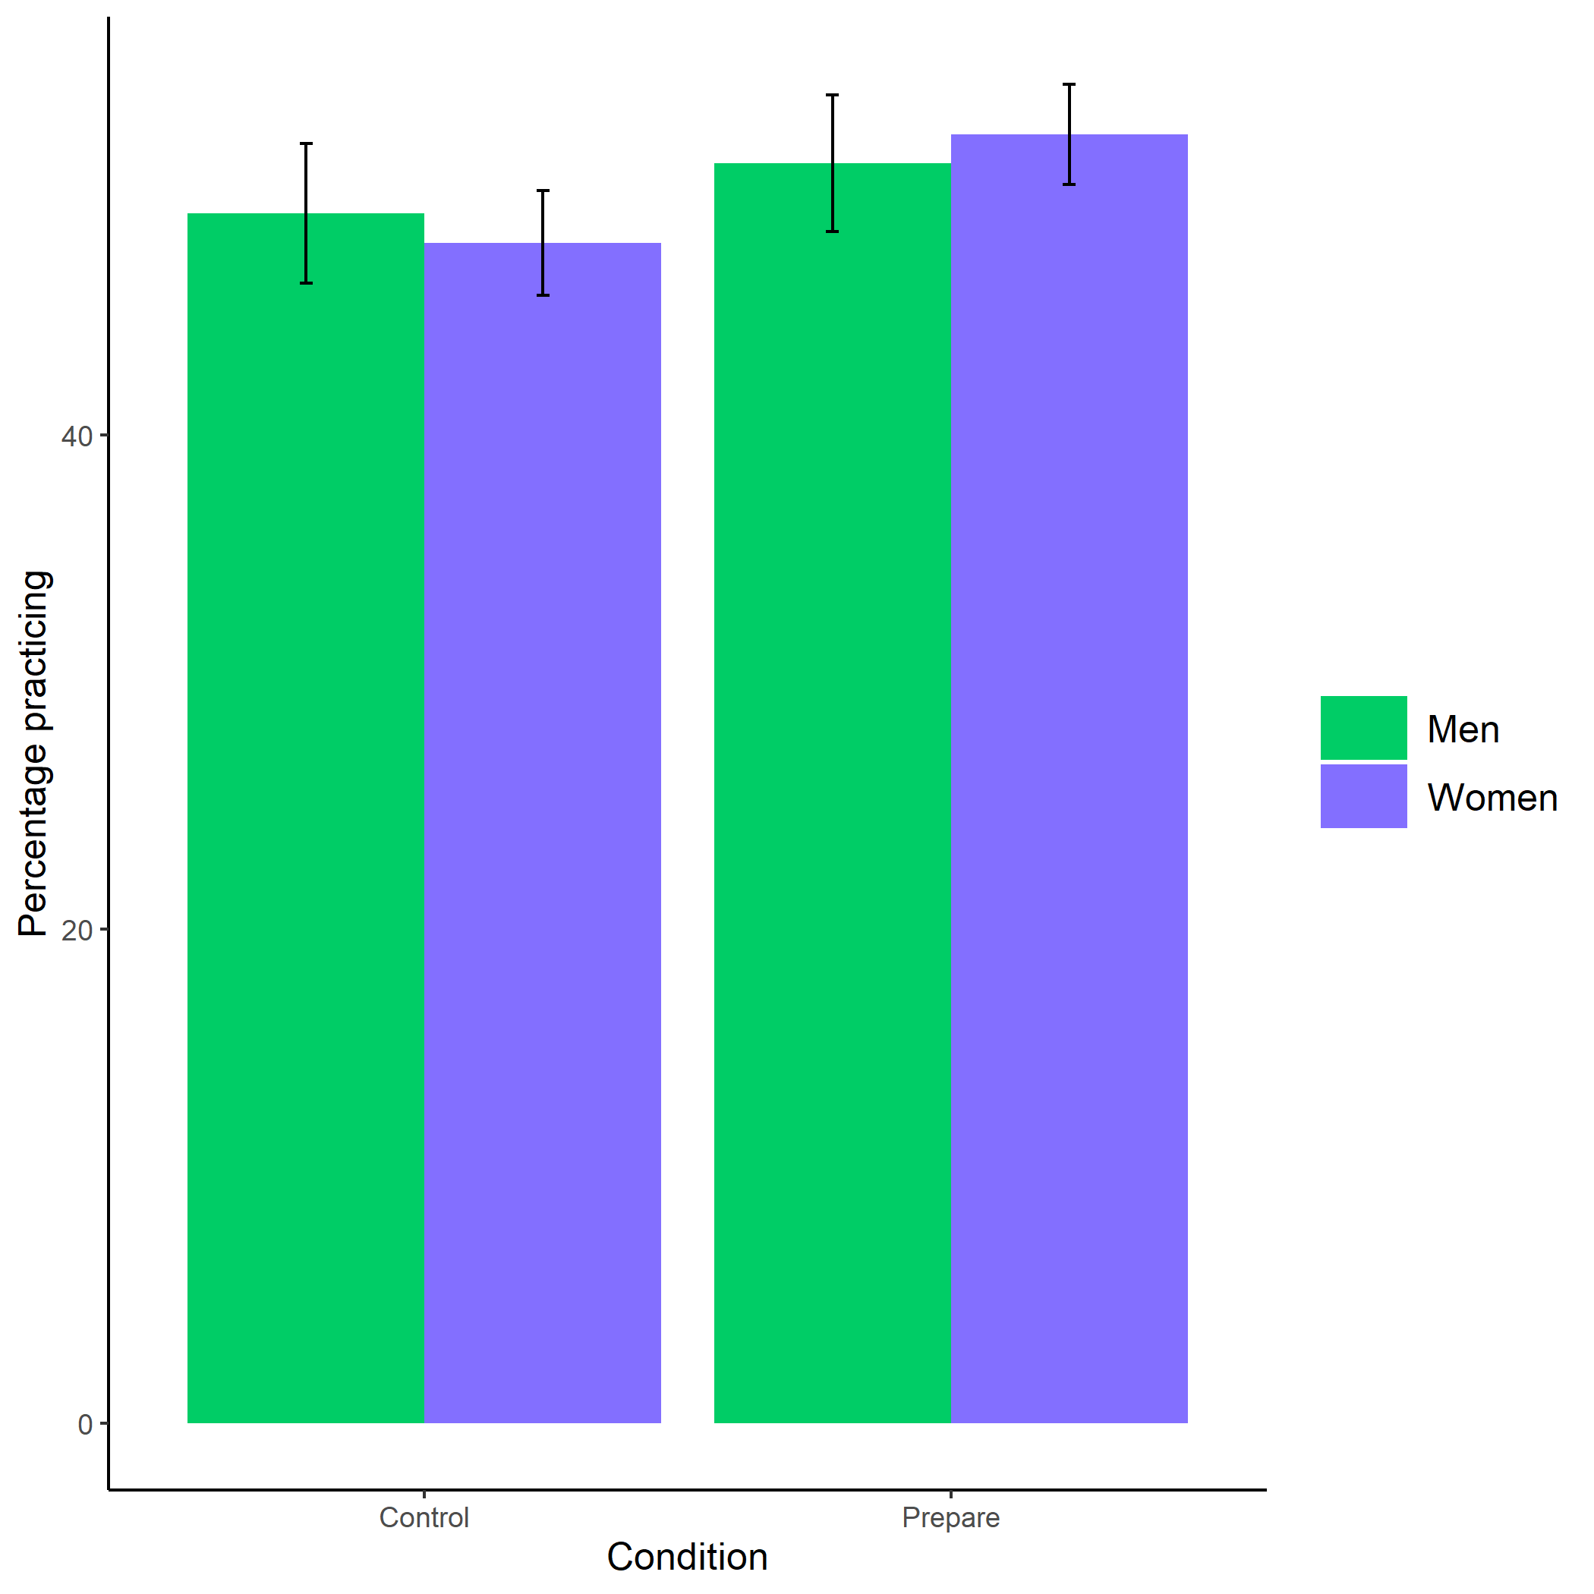

Figure 1.1: Proportion of men and women who chose to prepare by condition. Error bars represent standard errors.

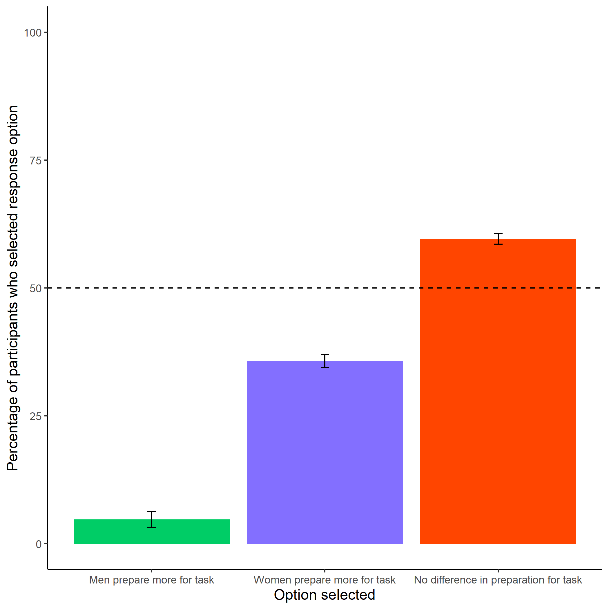

Figure 1.2: Participants’ perceptions of gender differences in the choice to practice on the task. Error bars represent standard errors.

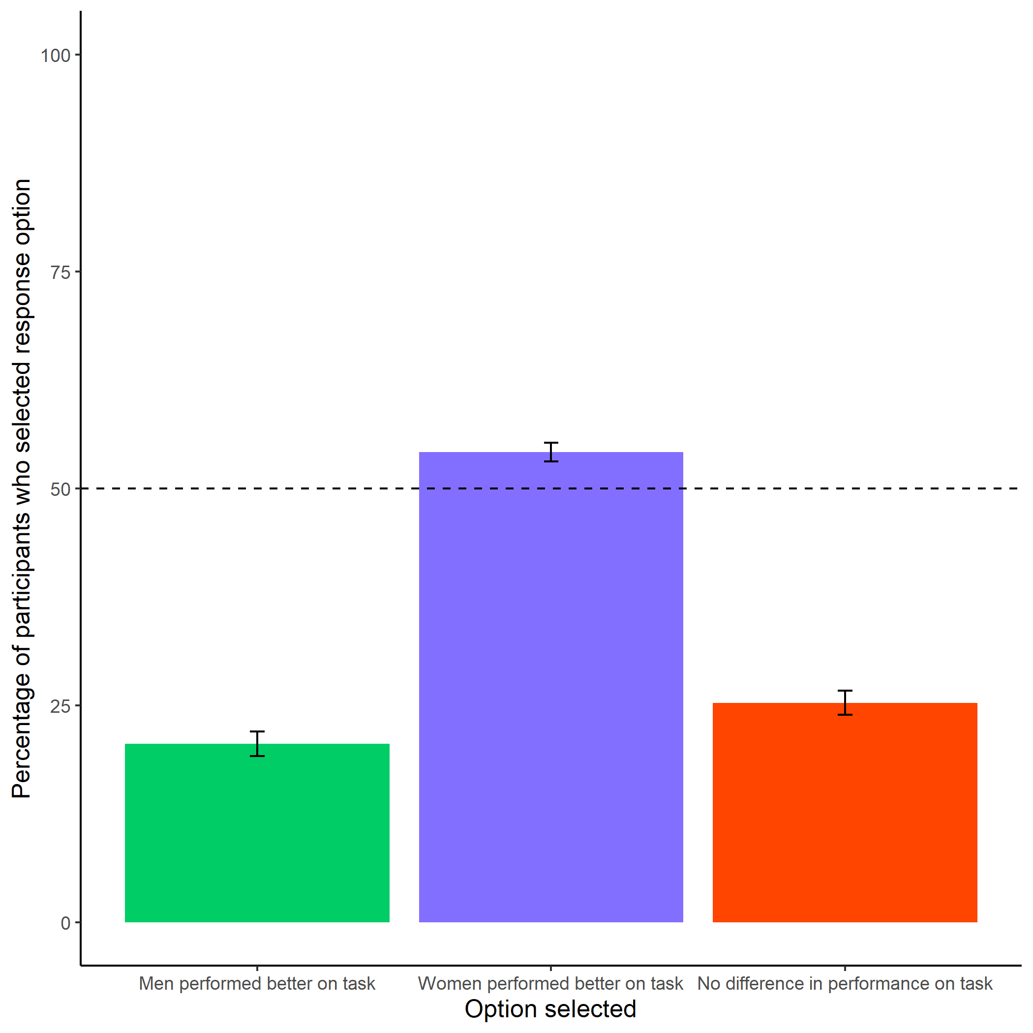

Figure 1.3: Participants’ perceptions of gender differences in performance on the task. Error bars represent standard errors.

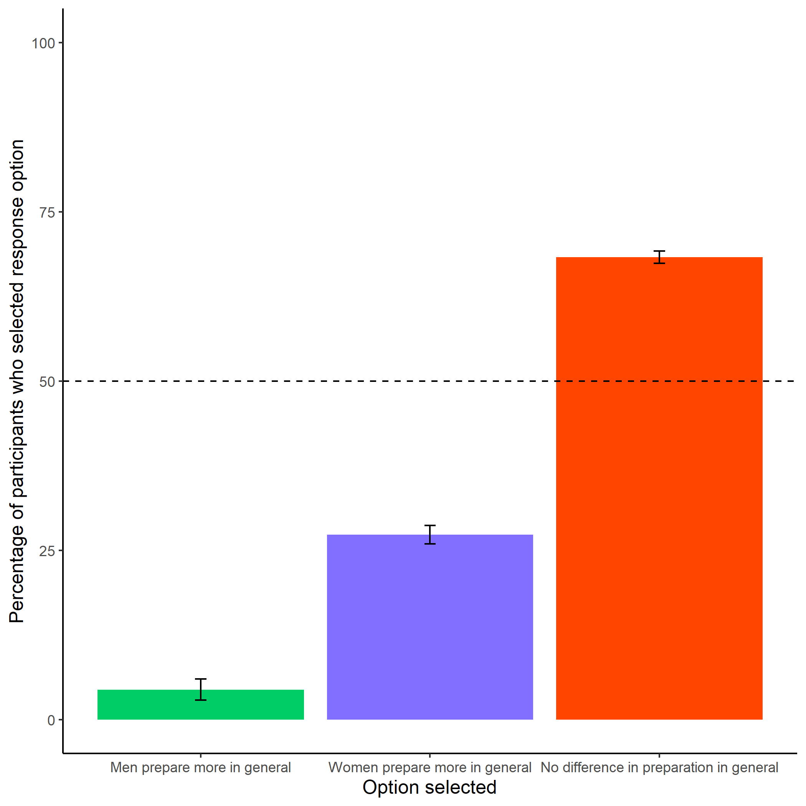

Figure 1.4: Participants’ perceptions of general gender differences in choice to practice. Error bars represent standard errors.

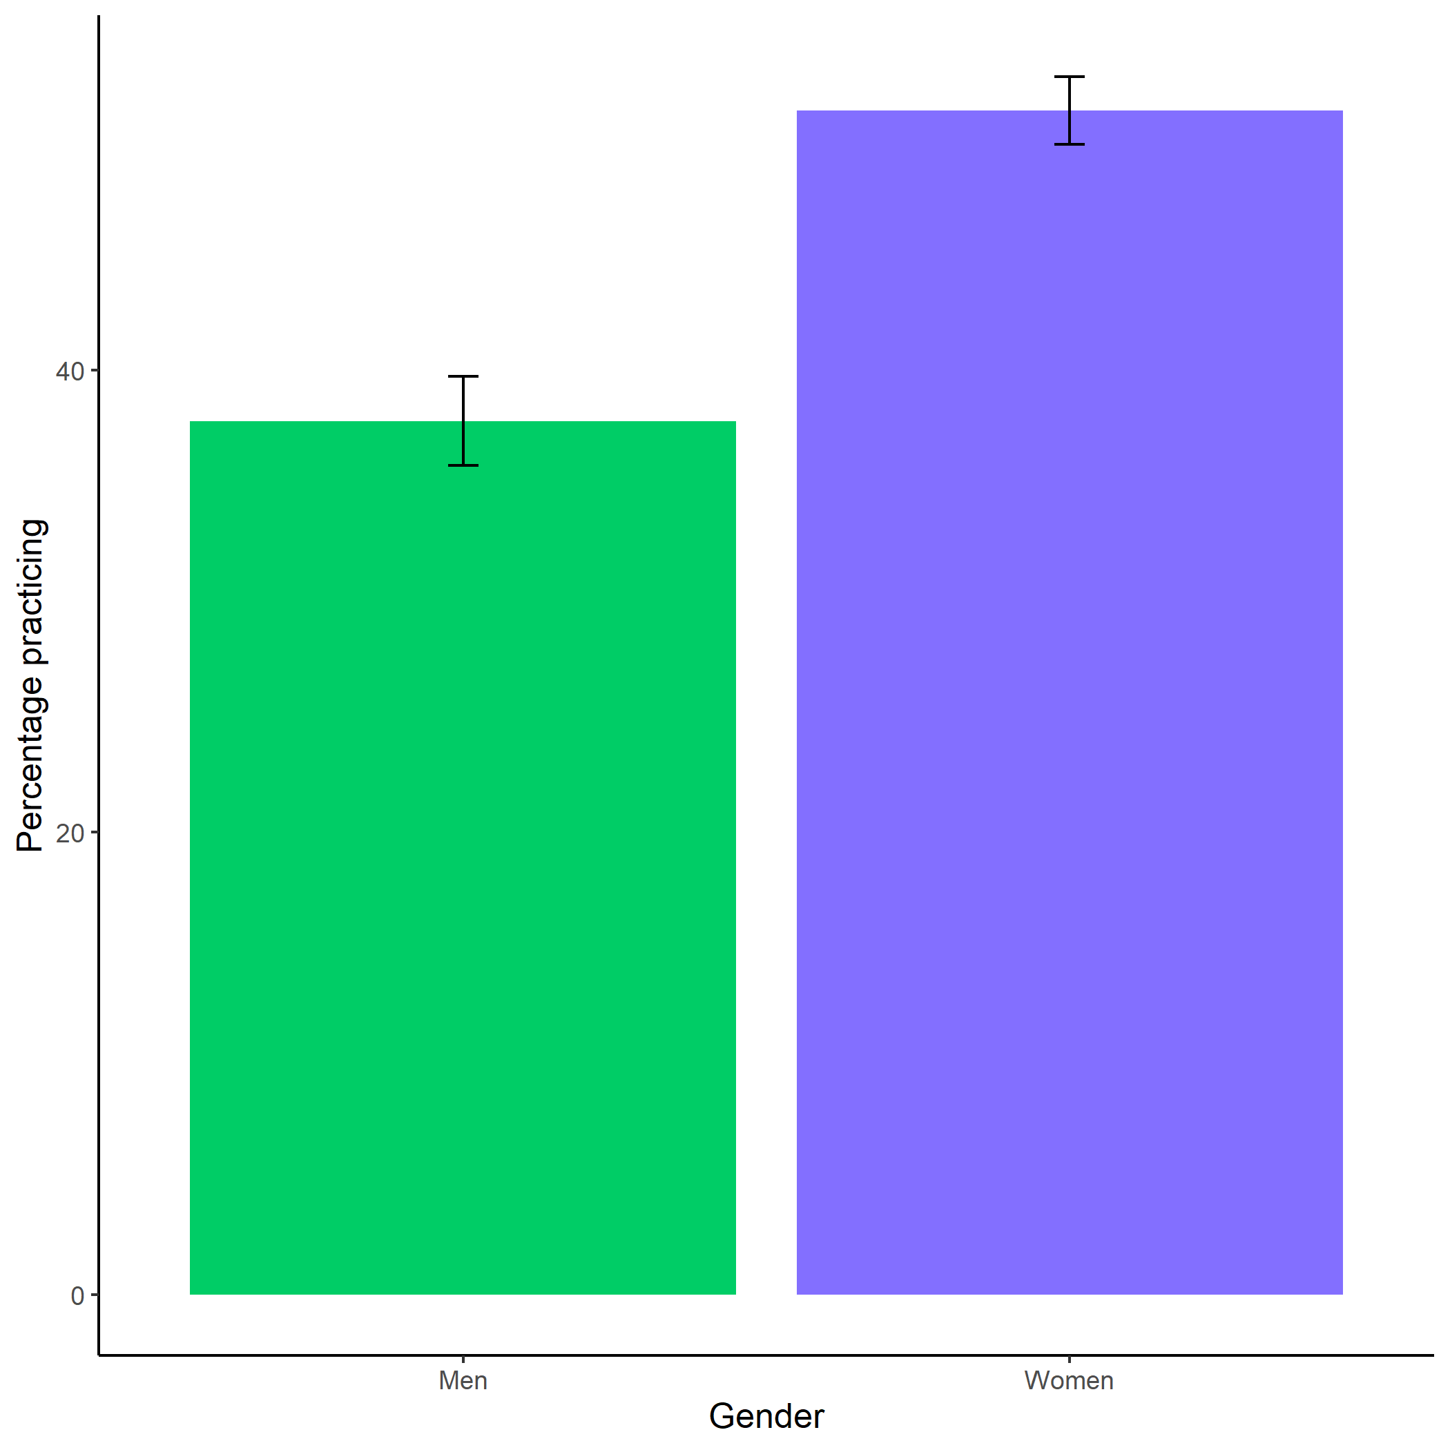

Figure 1.5: Participants’ perceptions of general gender differences in choice to practice. Error bars represent standard errors.

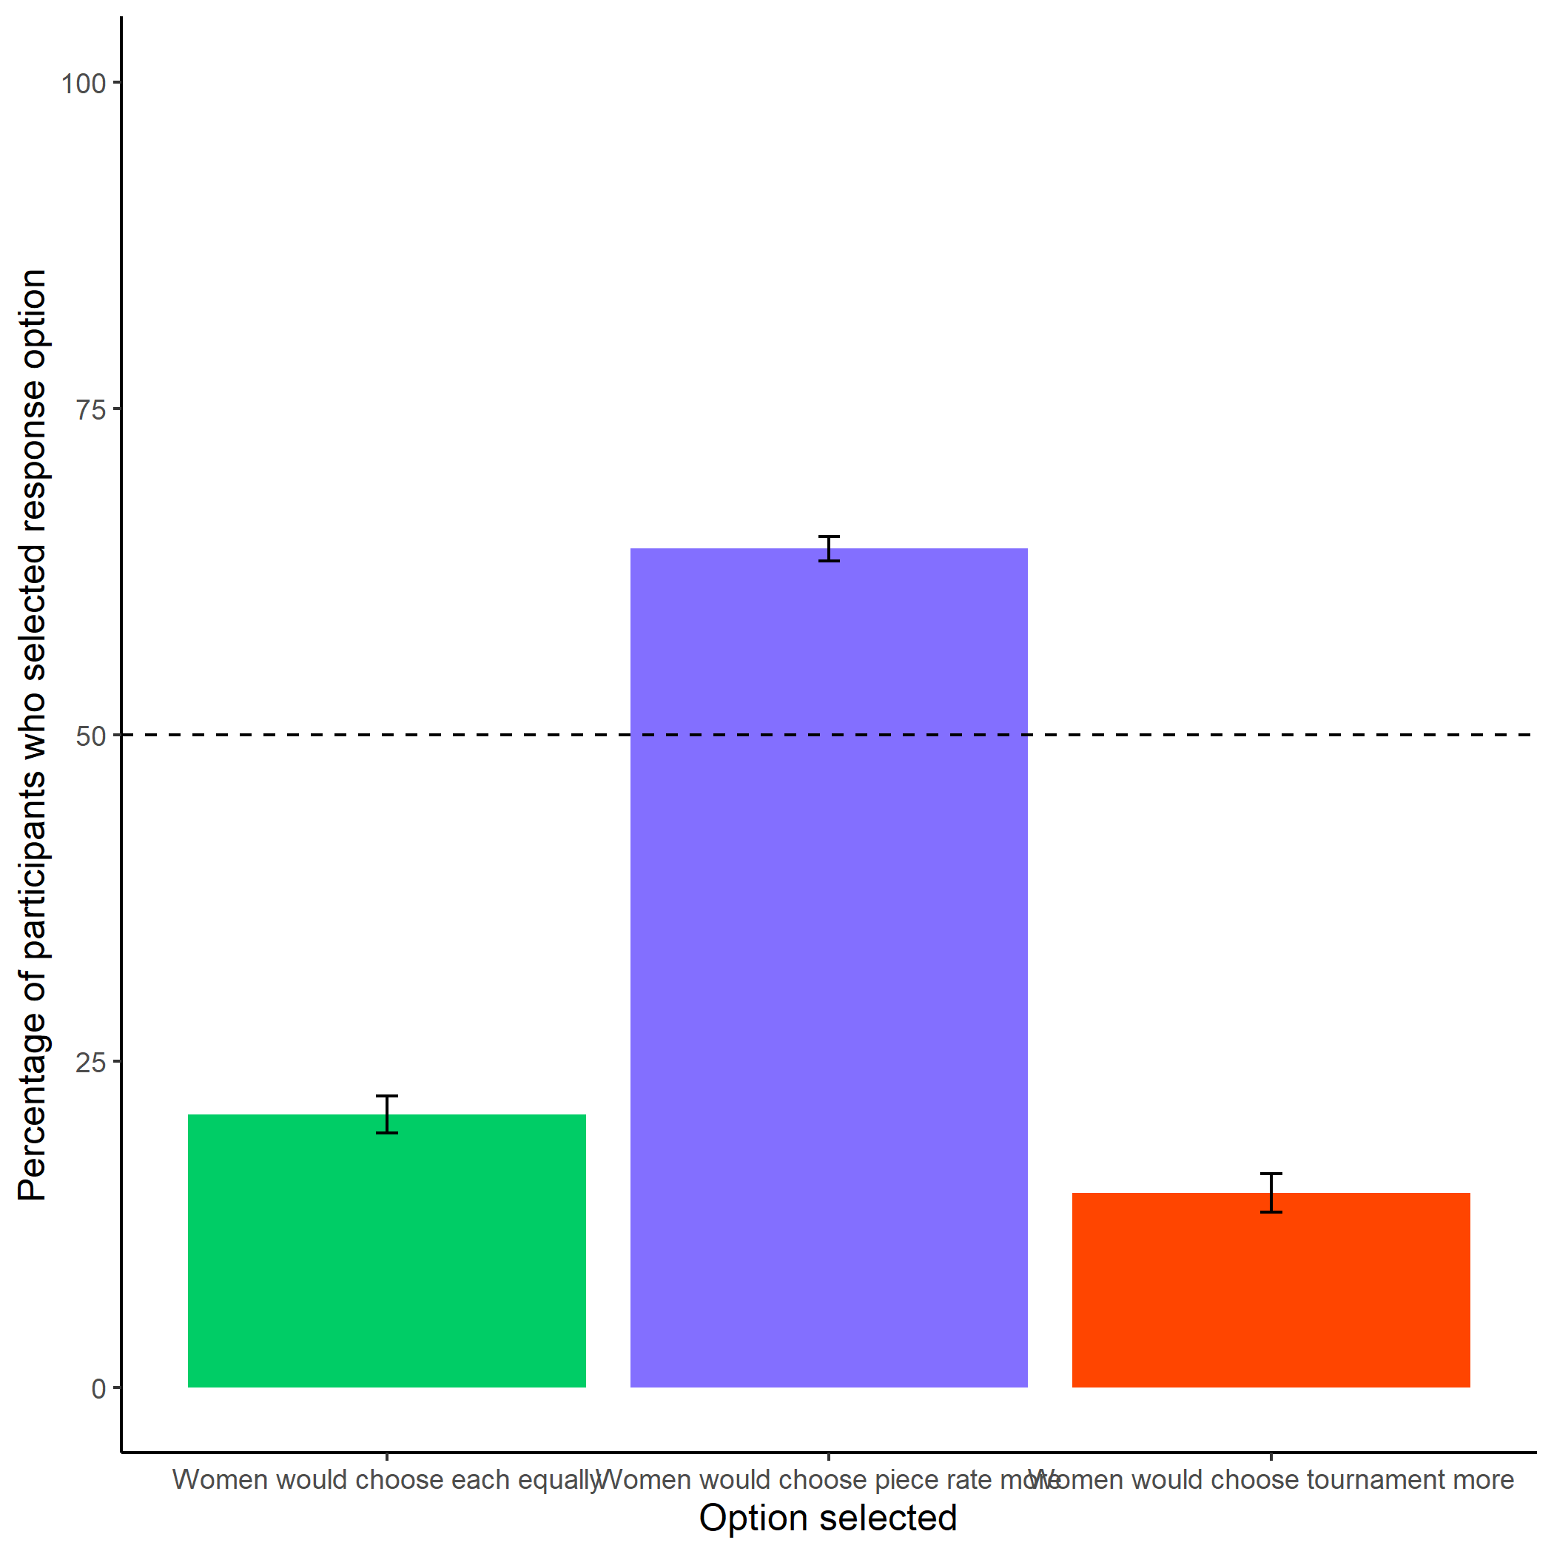

Figure 1.6: Participants’ perceptions of women’s preferences between the competitive tournament payment scheme and non-competitive piece-rate payment scheme. Error bars represent standard errors.

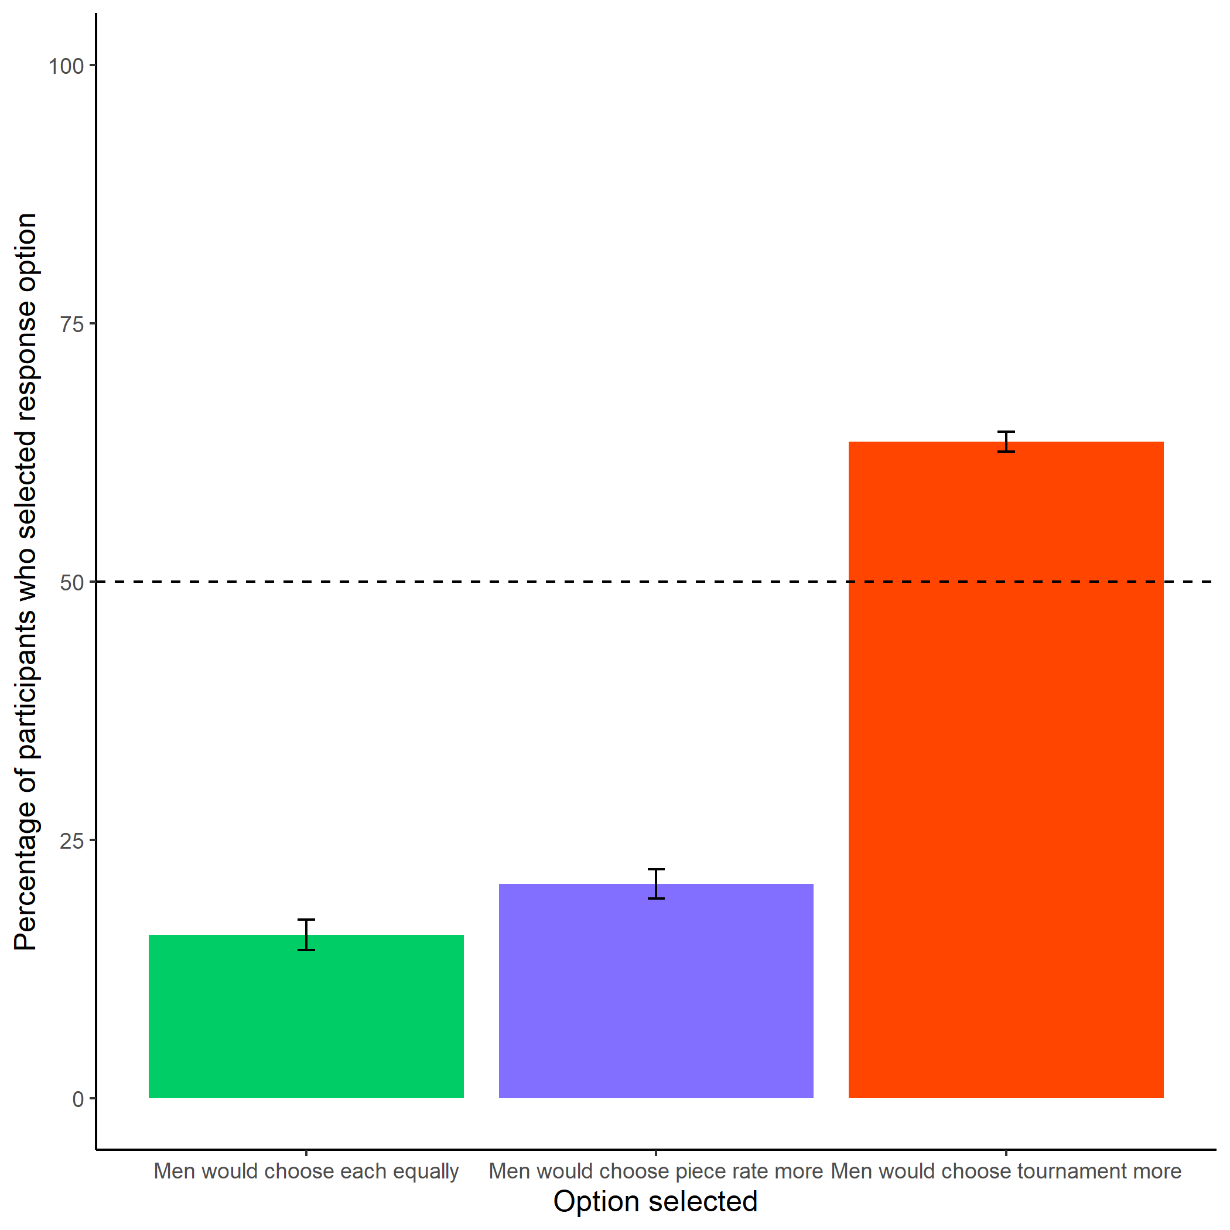

Figure 1.7: Participants’ perceptions of men’s preferences between the competitive tournament payment scheme and non-competitive piece-rate payment scheme. Error bars represent standard errors.

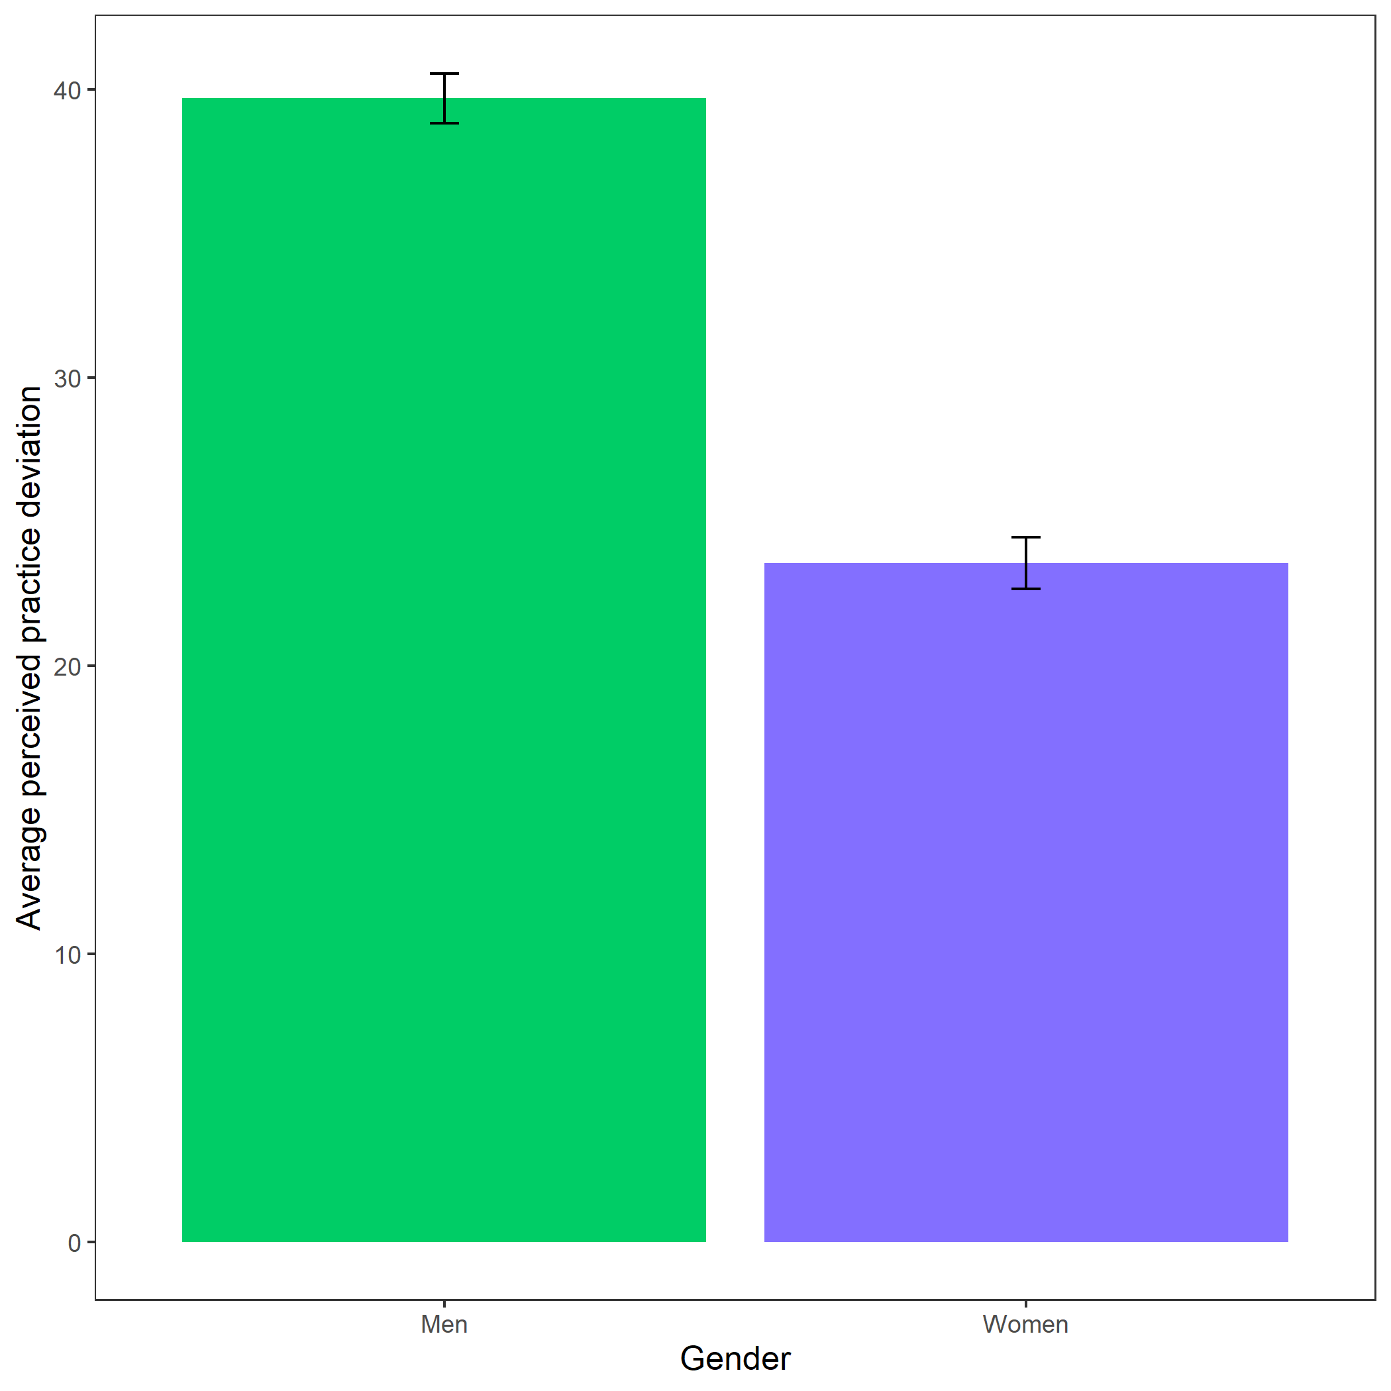

Figure 1.8: Perceived practice deviation based on participant gender. Error bars represent standard errors - insert denominators for SE bars..

1. Note: The result was significant in only two of the three experiments conducted. In the experiment where the result was not significant, the women still practiced at a higher rate than men.
2. Note: The questions about general gender differences in willingness to prepare were not incentivized, as we could not directly attest to their accuracy. Also, part of the reason the percentages for Study 3 are lower than for the other studies is because participants were given the option to say there were no differences in gender preparation behaviors
3. Note: we run analyses with the same predictors using the other measures of preparation as dependent variables (i.e., number of practice problems completed, number of rounds of extra practice, and amount of time spent completing practice problems), and do not find evidence for interaction effects across any of those models