# (APPENDIX) Appendix

## Pre-registered analyses across studies

### Study 1.1

knitr::include_graphics(here::here("study1", "figs", "pre-reg1.png"))

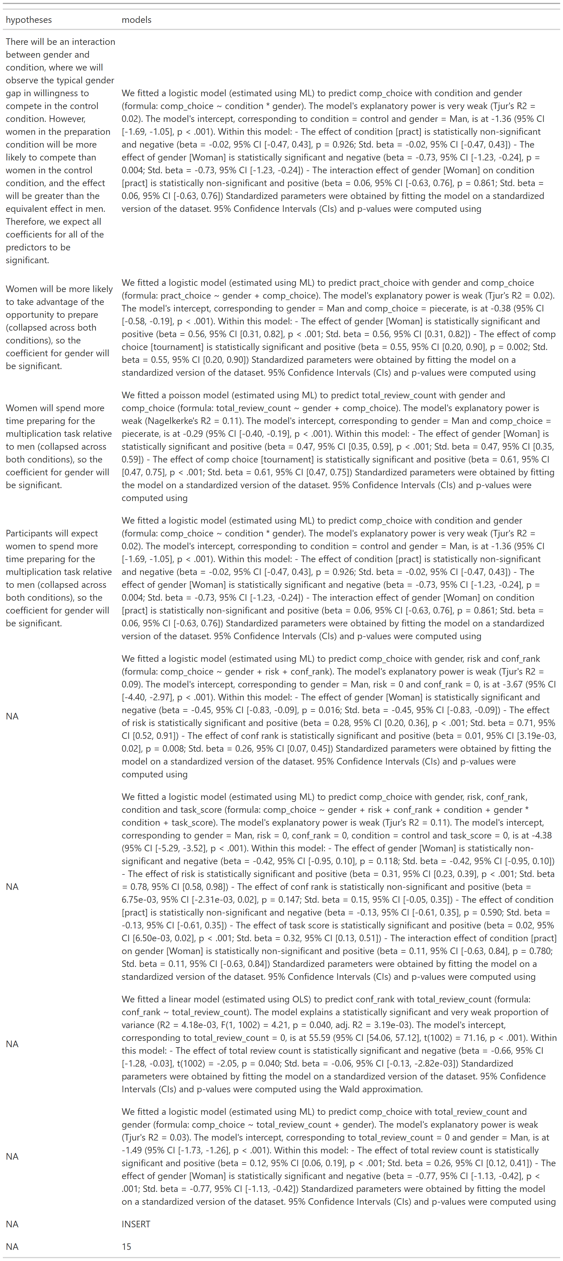

### Study 1.2

### Study 1.3

### Study 2.1

## Chapter 1

## Chapter 2