The effects of preparation on gender differences in willingness to compete

Keana Richards1, Gideon Nave1, & Coren Apicella1

1 University of Pennsylvania

Author note

Add complete departmental affiliations for each author here. Each new line herein must be indented, like this line.

Correspondence concerning this article should be addressed to Keana Richards, 3720 Walnut Street, Philadelphia PA 19104. E-mail: [keanari@sas.upenn.edu](mailto:keanari@sas.upenn.edu)

Abstract

One or two sentences providing a **basic introduction** to the field, comprehensible to a scientist in any discipline.

Two to three sentences of **more detailed background**, comprehensible to scientists in related disciplines.

One sentence clearly stating the **general problem** being addressed by this particular study.

One sentence summarizing the main result (with the words “**here we show**” or their equivalent).

Two or three sentences explaining what the **main result** reveals in direct comparison to what was thought to be the case previously, or how the main result adds to previous knowledge.

One or two sentences to put the results into a more **general context**.

Two or three sentences to provide a **broader perspective**, readily comprehensible to a scientist in any discipline.

*Keywords:* keywords

*Word count:* X

The effects of preparation on gender differences in willingness to compete

# Introduction

from RSF application:

Women have surpassed men in education outcomes, like college attendance and graduation rates (Blau & Kahn, 2017; Goldin, Katz, & Kuziemko, 2006; Stoet & Geary, 2014), but are still underrepresented in top management positions in nearly all sectors (Bertrand & Hallock, 2001) and a gender wage gap still persists (Blau & Kahn, 2017). Traditional economic variables account for some, but not all, of these disparities. As such, additional explanations have been proposed, including gender differences in willingness to compete. Previous research suggests that women are less willing to compete than men, even when they are equally, if not more, qualified (Niederle & Vesterlund, 2007, for reviews, see 2011, and @Croson2009). This effect has been established across numerous studies and appears to be driven by high ability women being less willing to compete compared to their male counterparts, creating higher total costs of pay-off inferior decisions (i.e., under-entry) for women compared to men (Niederle & Vesterlund, 2007).

Understanding how to address gender differences in competitiveness is important for reducing gender inequality that persists today. When women compete less than their male counterparts, they may be missing crucial economic opportunities, as demonstrated by the evidence suggesting competitiveness is relevant to one’s economic outcomes (Buser, Niederle, & Oosterbeek, 2014; Reuben, Sapienza, & Zingales, 2015; Zhang, 2012).

Women’s relatively lower levels of confidence in their performance partly explains this gender difference (Niederle & Vesterlund, 2011), so it is important to understand factors that may affect confidence prior to the decision to compete. Since prior research has shown that confidence can improve with preparation and training (Gist & Mitchell, 1992; Schunk, 1981, 1982), providing women with an adequate opportunity to prepare before a task may alleviate the gender gap in willingness to compete.

# Pilot study

## Methods

We recruited workers on Amazon Mechanical Turk for a study on decision-making. The workers who opted into the study had to pass several pre-screening questions to be included as participants in the paid portion of the study. Specifically, participants included in the study had to (i) pass three comprehension questions for the task they would be completing, (ii) be using a computer (rather than a phone or tablet), (iii) identify their nationality as American and live in the United States (to control for gender differences in competitiveness across cultures), and (iv) indicate that they were male or female (instead of responding “Other” when asked about their gender). The final sample consisted of 337 participants (56.97% women), with an average age of 37.40 (*SD* = 11.67) years.

Participants completed three paid rounds of a one-minute “key-entry task.” Throughout the task, participants were continuously shown a legend that associated five numbers with five randomly drawn letters. The task consisted of using the legend to match a series of 2-digit numbers to their corresponding letters as quickly as possible. For instance, if the letter “C” was associated with the number 1 and “R” was associated with the number 2, and participants were presented with the number 12, they would have to enter “CR” into a corresponding text box. Before the paid rounds, participants were shown an example problem with the correct answer and required to pass 3 comprehension questions, which were identical in structure to the questions asked during the incentivized rounds (each of which contained 36 questions).

In the first and second round of the task, participants were incentivized according to a piece-rate and tournament payment scheme, respectively (Niederle & Vesterlund, 2007). Under the piece-rate scheme, participants earned $.05 for each correct answer. Under the tournament payment scheme, participants earned $.10 for each correct answer, but were only paid if their score was greater than a randomly assigned, anonymous partner. In the third round, participants could choose between the two above payment schemes. We denote this decision as “willingness to compete” (Niederle & Vesterlund, 2007).

After the third round, participants completed a series of follow-up questions which measured confidence, risk aversion, and perceptions of gender differences in performance on the task. One of their responses to the confidence and perceptions of gender differences measures was randomly selected and if the selected guess was correct, they received a bonus of $.10.

As confidence measures, participants (i) indicate whether they thought their round 2 score was higher or lower than the person they had competed against; (ii) guess which decile their score might fall into relative to all men who completed the task during round 2; and (iii) repeat (ii) with respect to female participants. As a measure of risk aversion, participants were asked “How do you see yourself: Are you generally a person who is fully prepared to take risks or do you try to avoid taking risks?” (Dohmen et al., 2011) on a 0 (Not at all willing to take risks) to 10 (very willing to take risks) scale.

Finally, we asked about participants’ perceptions of the effects of practice, if offered, on task performance (i.e., “Do you think your score would have improved if you practiced the task beforehand?”), along with participants’ hypothetical willingness to practice the task beforehand, if given the opportunity. We operationalized this measure as their response to the question “If you had the chance to practice the task, would you have taken that opportunity?” If they responded yes, they were asked how long they would have practiced (in minutes) if they were given unlimited time to practice.

## Results

### Summary.

All hypotheses were [pre-registered](https://osf.io/q39a5/) unless otherwise stated and all analyses were conducted in R. We did not find evidence for the hypothesized gender difference in the choice to compete (see Figure 1). 34.48% of men chose to compete compared to 29.69% of women. Women were more likely to indicate that they would have taken the opportunity to practice the task than men (see Figure 2), despite no gender differences in performance or choice to compete.

### Pre-registered analyses.

*Primary hypothesis 1.* Using a logistic regression with gender predicting willingness to compete in round 3, we do not find significant evidence of gender differences in the choice to compete, , 95% CI , , , (see Figure 1). Note: the results for the chi-square test are similar: ,

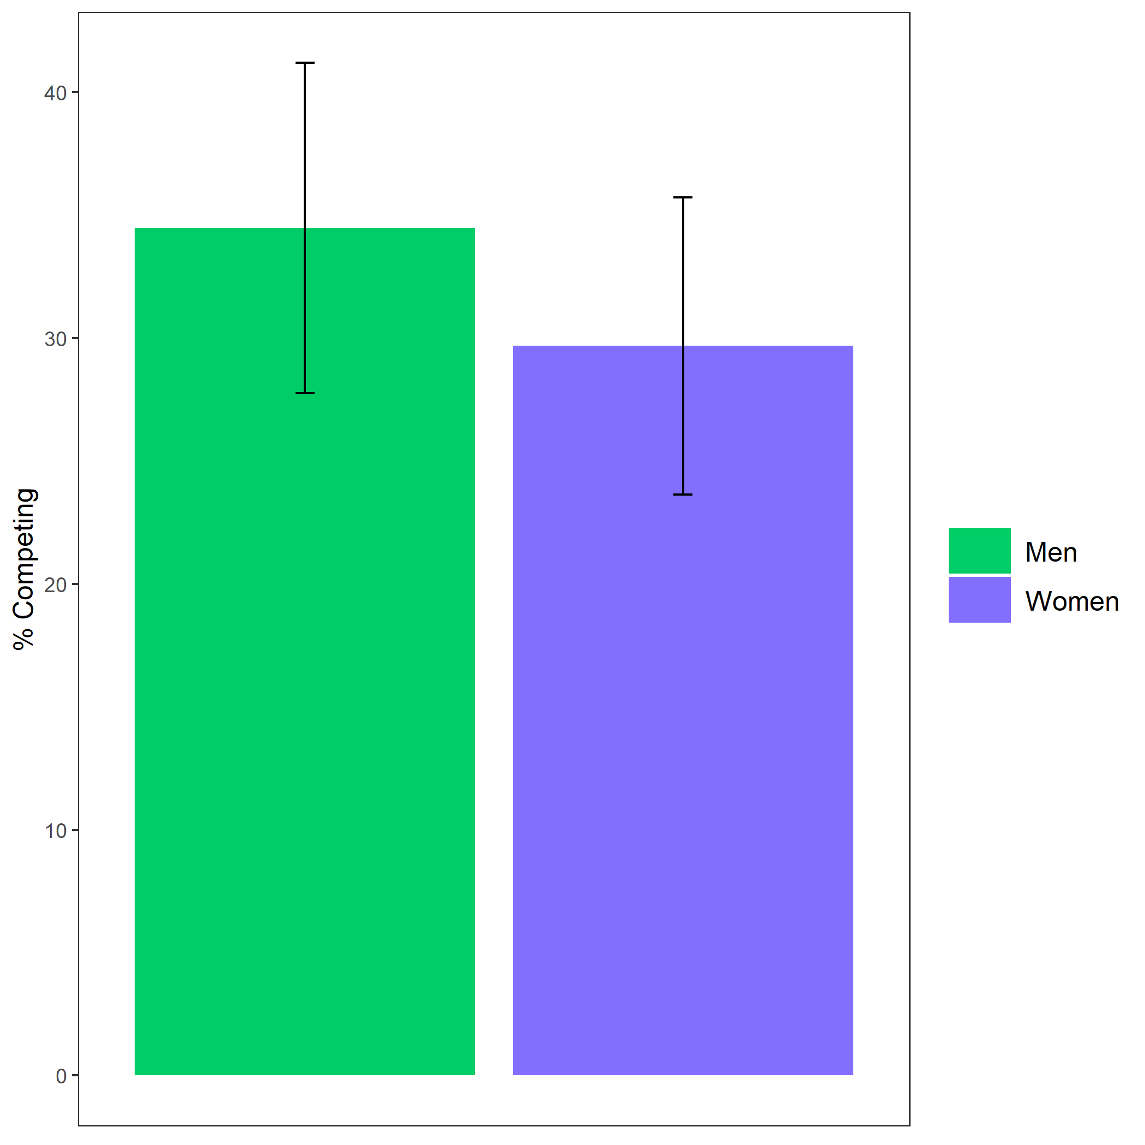

*Figure* *1.*  Proportion of participants who chose to compete based on participant gender. Error bars represent standard error.

Cross-Tabulation, Row Proportions  
cleancomp_choice

|  |  |  |  |  |  |
| --- | --- | --- | --- | --- | --- |
|  | clean$comp_choice | piecerate | tournament |  | Total |
| clean$gender |  |  |  |  |  |
| Man |  | 91 (62.8%) | 50 (34.5%) | 4 (2.8%) | 145 (100.0%) |
| Woman |  | 123 (64.1%) | 57 (29.7%) | 12 (6.2%) | 192 (100.0%) |
| Total |  | 214 (63.5%) | 107 (31.8%) | 16 (4.7%) | 337 (100.0%) |

### Exploratory analyses.

Using a logistic regression, we find that gender predicts (hypothetical) willingness to practice the task, , 95% CI , , , (see Figure 2).

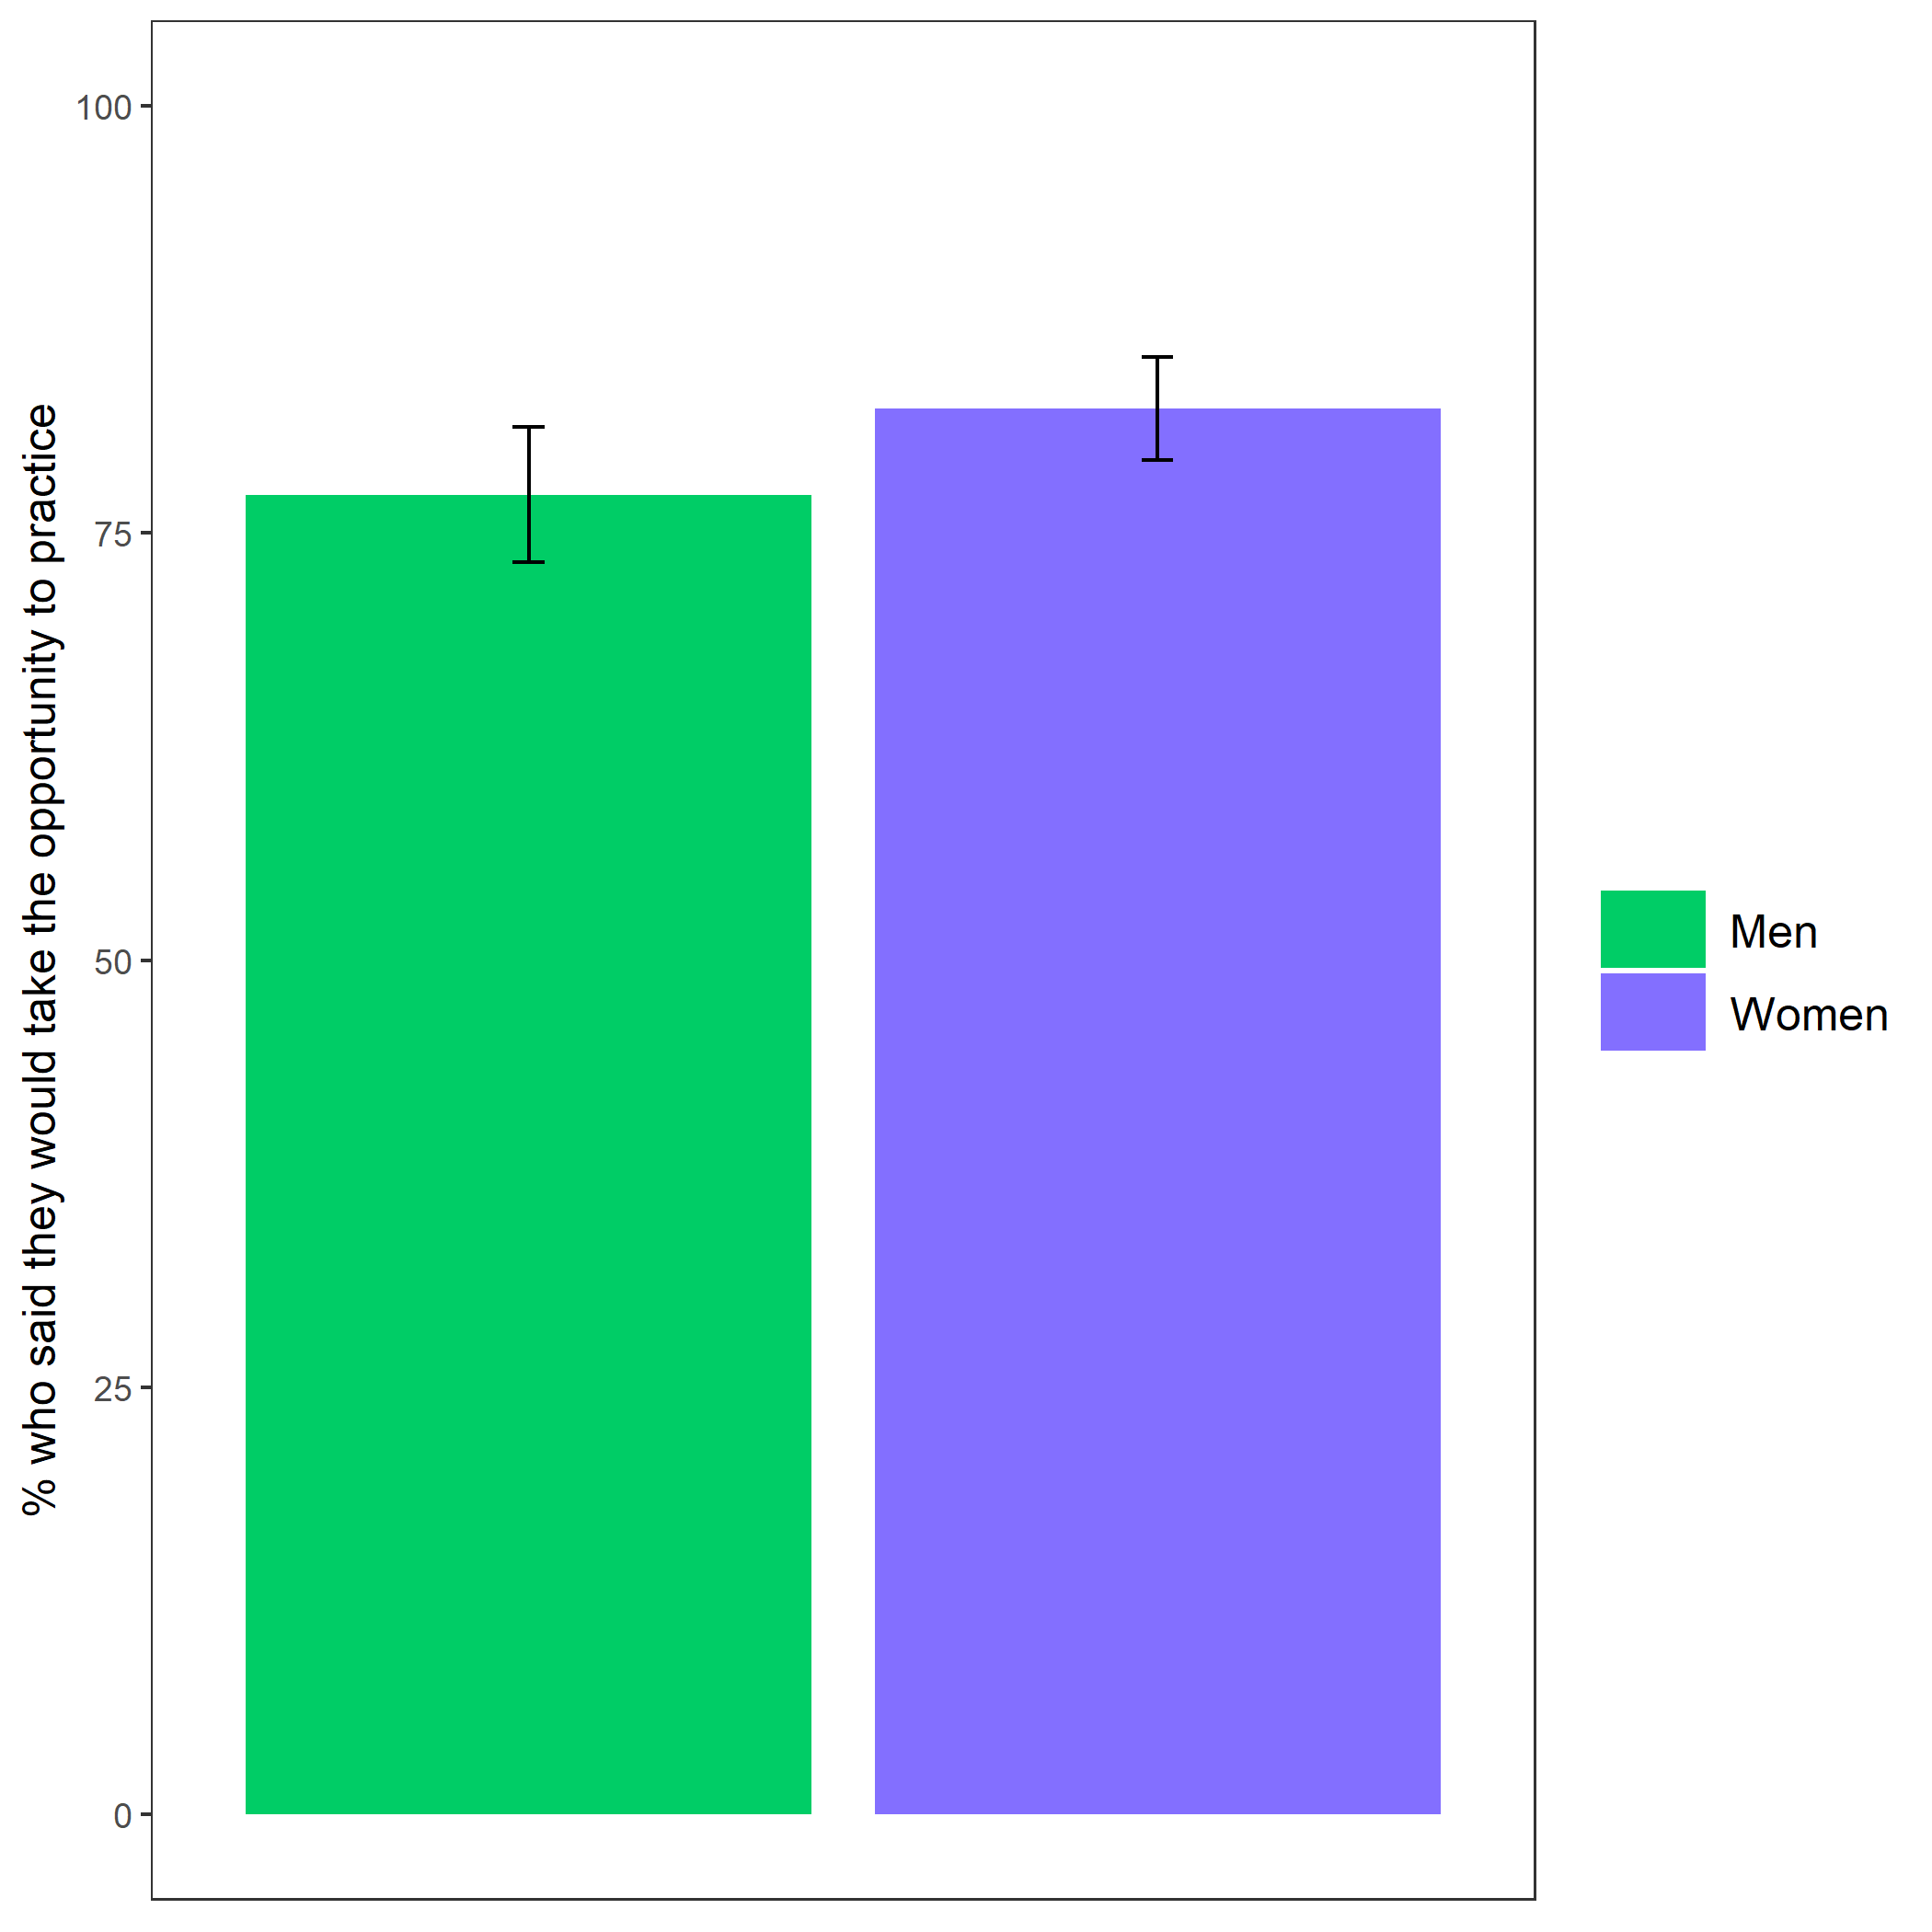

*Figure* *2.*  Proportion of participants who indicated they would have taken the opportunity to practice the key-entry task if provided based on participant gender. Error bars represent standard error.

Cross-Tabulation, Row Proportions  
cleanpract_choice

|  |  |  |  |  |  |
| --- | --- | --- | --- | --- | --- |
|  | clean$pract_choice | No | Yes |  | Total |
| clean$gender |  |  |  |  |  |
| Man |  | 29 (20.0%) | 112 (77.2%) | 4 (2.8%) | 145 (100.0%) |
| Woman |  | 21 (10.9%) | 158 (82.3%) | 13 (6.8%) | 192 (100.0%) |
| Total |  | 50 (14.8%) | 270 (80.1%) | 17 (5.0%) | 337 (100.0%) |

# Study 1

## Methods

Like the pilot study, we recruited workers on Amazon Mechanical Turk for a study on decision-making and performance. The pre-screening criteria were nearly identical to those in the pilot study, with the exception that workers were not excluded if they failed the comprehension questions to increase power. The final sample consisted of 1056 participants (53.60% women), with an average age of 37.74 (*SD* = 13.19) years.

Participants were told they would be completing a two-minute multiplication task where they would be able to choose how they would be paid for their performance. For the task, participants answered questions from the multiplication tables with numbers ranging from 1-12 (e.g., 1 X 5, 12 X 11) as quickly as possible. Then, they were provided examples and had to complete three comprehension questions, which they had to pass to proceed. After completing the comprehension questions, participants were randomly assigned to either a “knowledge of preparation” condition or a control condition based on their gender. Participants in the knowledge of preparation condition were presented the following text:

“There is an option to practice/study before completing the multiplication task that is available to all participants. If you take this opportunity to practice/study, we will provide you with materials that may help boost your performance in the multiplication task. You will have unlimited time to practice/study before completing the task. You can stop practicing/studying at any point.”

Participants assigned to the control condition simply proceeded without seeing this text. Then, all participants learned about the possible payment schemes that they could choose (either piece-rate or tournament) and had to pass several comprehension questions about the payment schemes before being choosing a payment scheme. For the tournament scheme, participants were paid $.20 per problem they answered correctly only if they beat a randomly assigned partner, while the piece-rate scheme paid participants $.10 per problem, regardless of other participants’ performance. In the preparation condition, participants were reminded that they had the option to prepare before completing the task, while participants in the control condition did not have this reminder. Then, participants made a payment scheme choice, where the order of presentation of the tournament and piece-rate payment options was randomized and counter-balanced for each condition. After choosing a payment scheme, participants in both conditions were given the chance to prepare before the multiplication task. If they chose to practice (described as the choice/decision to practice in subsequent analyses), participants were asked, for each multiplication table, if they wanted to practice problems from that specific multiplication table. If they chose to practice a specific multiplication table, they had the chance to practice all twelve combinations of numbers for that multiplication table. They could only proceed if they answered all practice questions correctly. Then, they were asked if they would like to continue practicing or move onto the next multiplication table, while a review table was displayed. This process was repeated for each multiplication table. The practice and review table for each multiplication table was presented in sequential order (i.e., starting at the 1 multiplication table up to the 12 multiplication table). We measured the number of rounds of preparation each participant completed for analyses (i.e., total practice count), which was calculated as the total number of times a participant agreed to complete a round of preparation (including the choice to repeat a table and the choice to prepare in the first place). Once finished practicing, participants completed as many problems as possible from the paid multiplication task for two minutes and received feedback about their absolute (but not relative) performance.

Before finishing the survey, participants completed a series of incentivized follow-up questions, including confidence and perceptions of gender differences. For these measures, participants were told one of these measures would be selected for a possible bonus payment, and if they answered the selected question correctly, they would earn a bonus of $.10. For the measure of confidence, participants guessed their relative performance compared to all other participants that completed the task by indicating the decile of their score. Participants were also asked to indicate their perceptions of gender differences in performance (i.e., “Do you think men or women in this study correctly solved more multiplication problems on average?”), willingness to prepare on the task (i.e., “Do you think men or women in this study spent more time practicing/studying before completing the multiplication task?”), willingness to prepare in general (i.e., “On most tasks, do you think men or women generally prepare (i.e., practice and/or study) more?”) and willingness to compete (i.e., “Do you think men or women in this study chose the tournament payment option more often?”). They also completed the same measure of risk aversion used in the pilot study. To determine whether cheating was a factor that participants relied on while completing the task, we also asked participants about their use of calculators and perceptions of calculator use on the multiplication task.

## Results

### Summary.

All hypotheses were [pre-registered](https://osf.io/q39a5/) unless otherwise stated and all analyses were conducted in R. We first examined whether gender was balanced across conditions. 49.59% of men and 49.29% of women were assigned to the control condition, while 49.80% of men and 49.12% of women were assigned to the practice condition, for a total of 49.43% of participants assigned to the control condition and 49.43% of participants assigned to the practice condition.

Unlike the pilot study, we found that men were significantly more likely to choose to compete, where 19.59% of men chose to compete compared to 10.78% of women. However, our primary hypothesis that there would be an interaction between gender and condition on the choice to compete was not supported, nor did we find support for a main effect of condition on the choice to compete (see Figure 3).

Although we did not find support for the hypothesized interaction, we found evidence for the hypothesized effect of gender on the choice to prepare (see Figure 4). Despite choosing to compete less frequently than men, women chose to prepare more for the multiplication task, which, as predicted, aligned with participants’ perceptions of gender differences in preparation (see Figure 6) and competition (see Figure 8), even though participants did not expect any gender differences in performance (see Figure 7).

### Pre-registered analyses.

Primary hypothesis 1: We do not find evidence of a significant interaction between gender and condition on the decision to compete , 95% CI , , , (see Figure 3). However, there was a main effect of gender on the decision to compete, , 95% CI , , , .

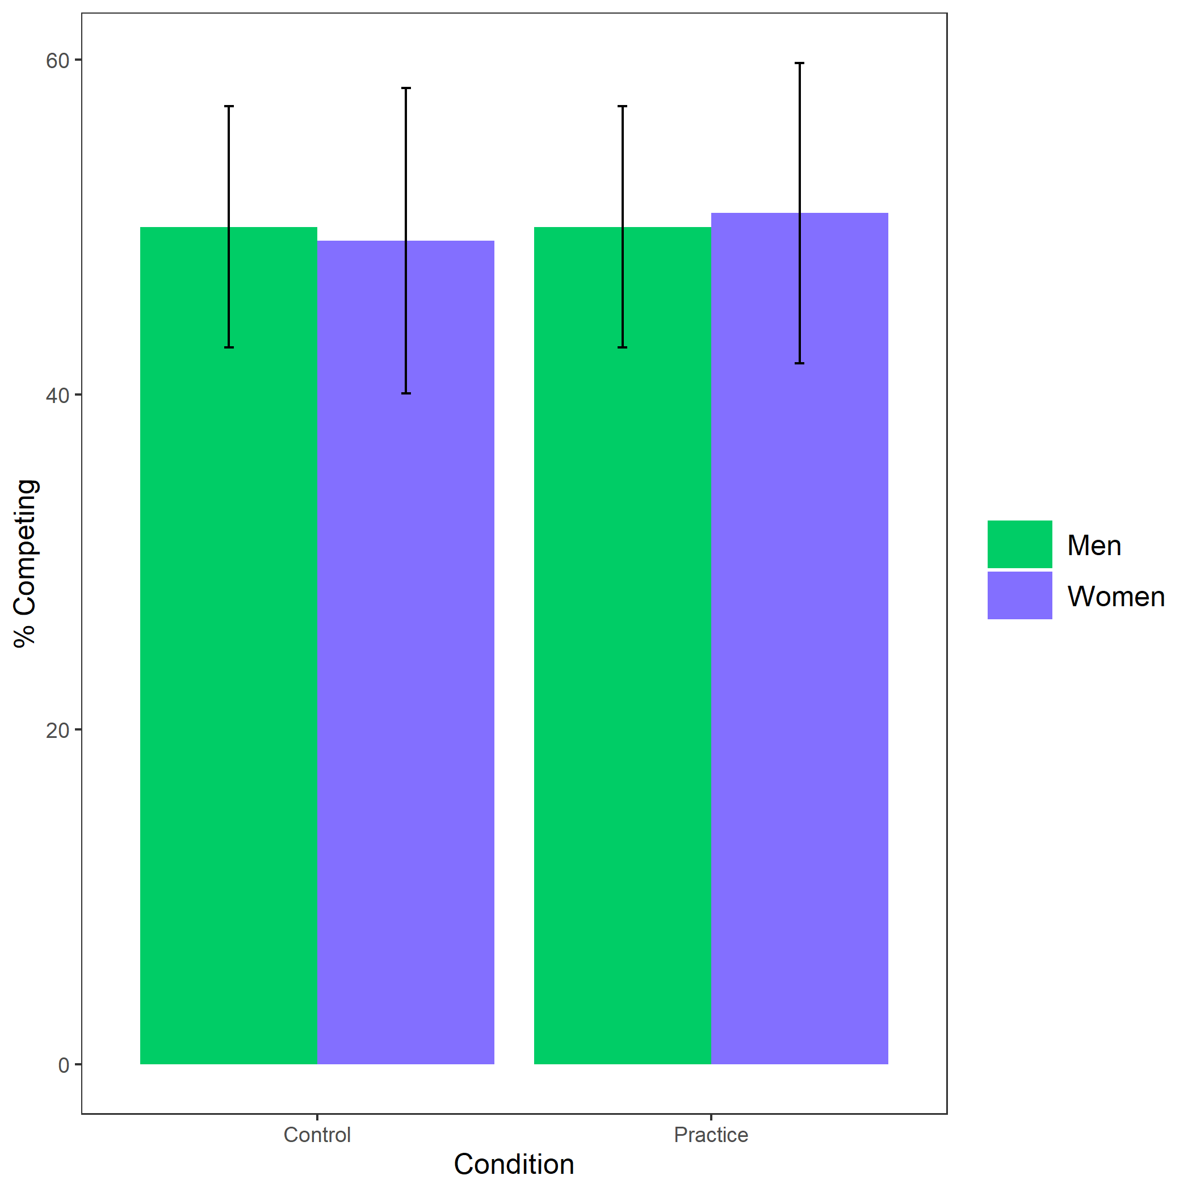

*Figure* *3.*  Proportion of participants who chose to compete based on participant gender and condition. Error bars represent standard error.

Cross-Tabulation, Row Proportions  
1L * 1L

|  |  |  |  |  |
| --- | --- | --- | --- | --- |
|  | 1L | control | pract | Total |
| 1L |  |  |  |  |
| Man |  | 187 (49.5%) | 191 (50.5%) | 378 (100.0%) |
| Woman |  | 243 (50.2%) | 241 (49.8%) | 484 (100.0%) |
| Total |  | 430 (49.9%) | 432 (50.1%) | 862 (100.0%) |

|  |  |  |  |  |
| --- | --- | --- | --- | --- |
|  | 2L | control | pract | Total |
| 1L |  |  |  |  |
| Man |  | 48 (50.0%) | 48 (50.0%) | 96 (100.0%) |
| Woman |  | 30 (49.2%) | 31 (50.8%) | 61 (100.0%) |
| Total |  | 78 (49.7%) | 79 (50.3%) | 157 (100.0%) |

Primary hypothesis 2: As, hypothesized, women were 75.47% more likely to take advantage of the opportunity to practice relative to men, , 95% CI , , , , while controlling for the decision to compete (see Figure 4). As an exploratory analysis, we tested whether gender and the choice to compete interact to predict the choice to prepare, but did not find evidence for an interaction, , 95% CI , , , .

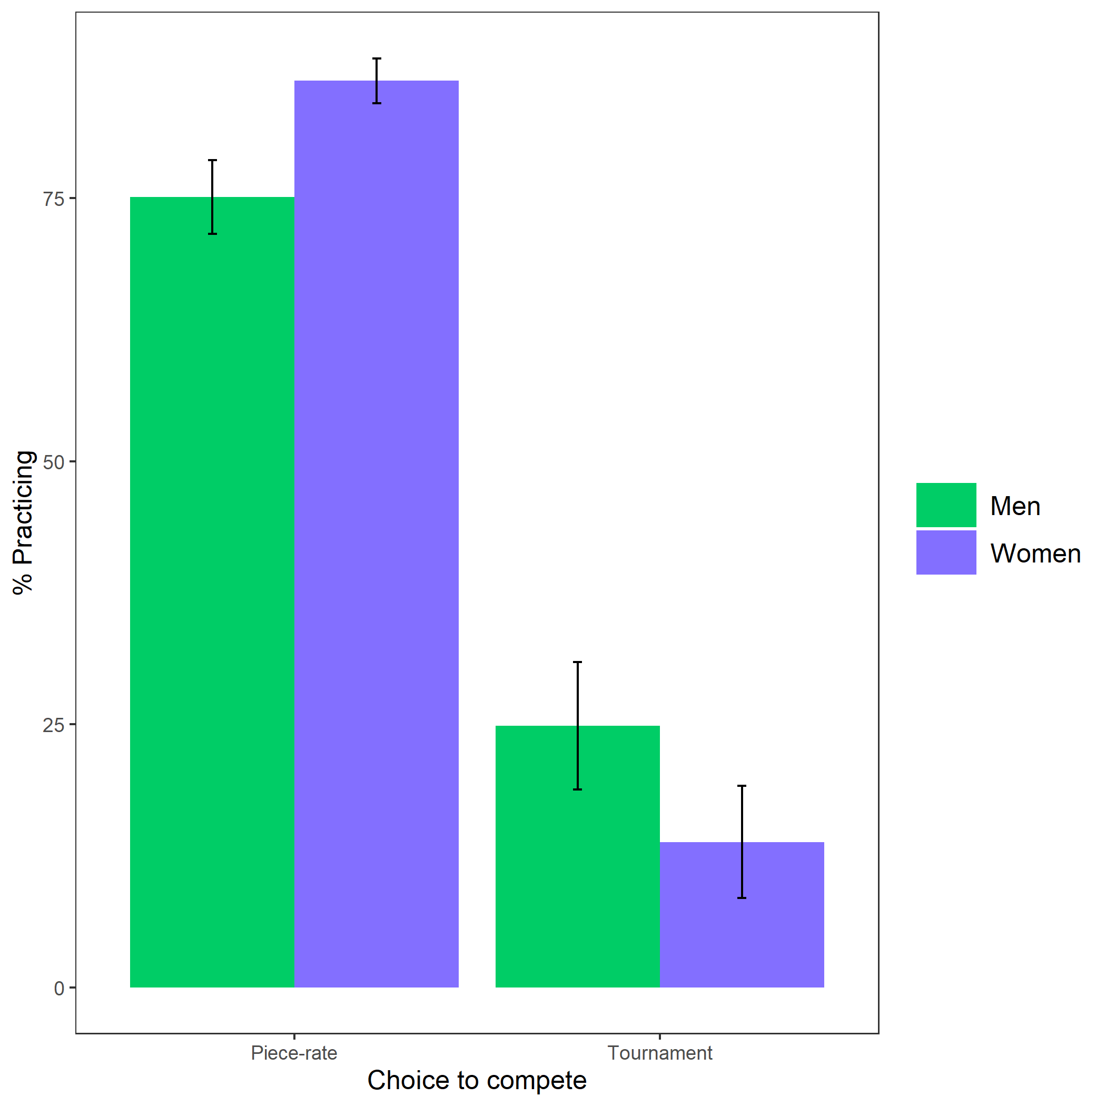

*Figure* *4.*  Proportion of participants who chose to prepare based on participant gender and choice to compete. Error bars represent standard error.

Cross-Tabulation, Row Proportions  
1L * 1L

|  |  |  |  |  |
| --- | --- | --- | --- | --- |
|  | 1L | piecerate | tournament | Total |
| 1L |  |  |  |  |
| Man |  | 224 (83.3%) | 45 (16.7%) | 269 (100.0%) |
| Woman |  | 221 (92.1%) | 19 ( 7.9%) | 240 (100.0%) |
| Total |  | 445 (87.4%) | 64 (12.6%) | 509 (100.0%) |

|  |  |  |  |  |
| --- | --- | --- | --- | --- |
|  | 2L | piecerate | tournament | Total |
| 1L |  |  |  |  |
| Man |  | 154 (75.1%) | 51 (24.9%) | 205 (100.0%) |
| Woman |  | 262 (86.2%) | 42 (13.8%) | 304 (100.0%) |
| Total |  | 416 (81.7%) | 93 (18.3%) | 509 (100.0%) |

Primary hypothesis 3: Women completed 68.59% more rounds of preparation relative to men, , 95% CI , , , (see Figure 5).

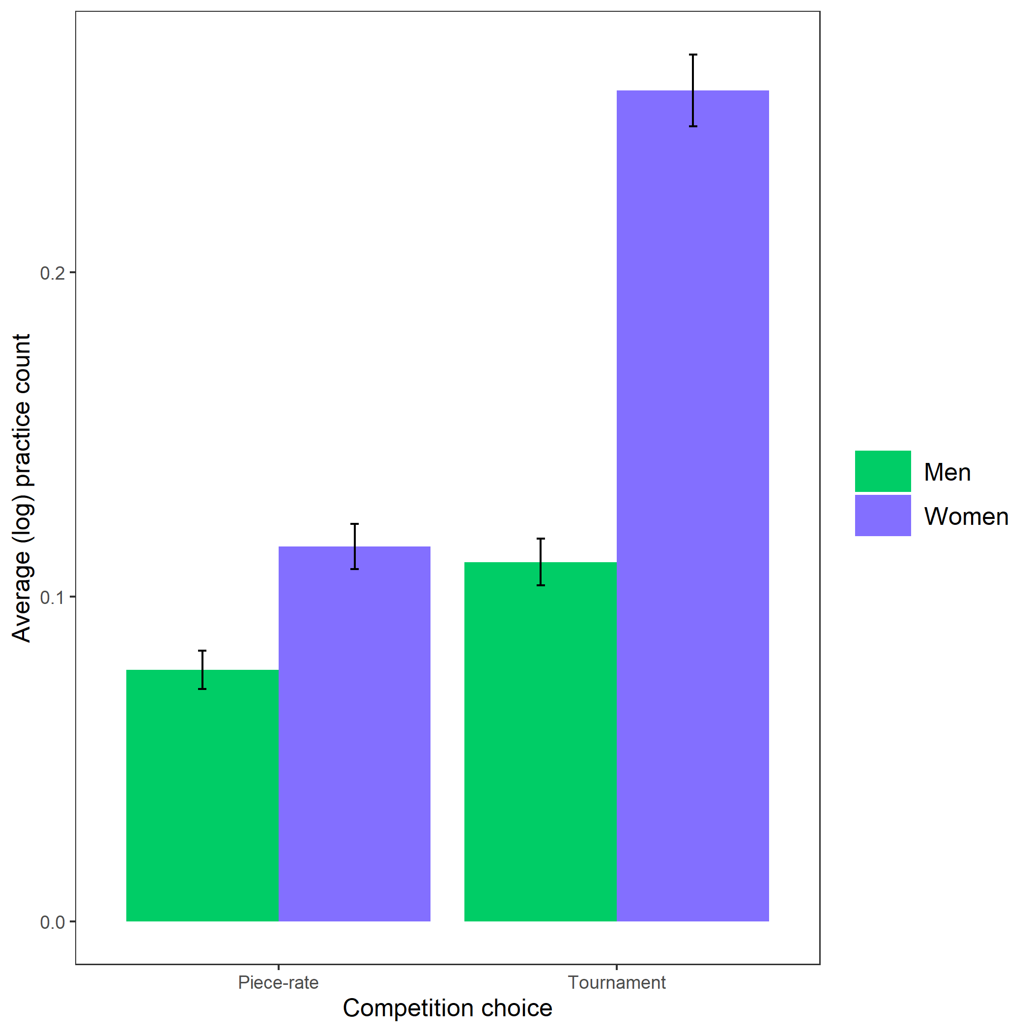

*Figure* *5.*  Average (log-transformed) practice count based on participant gender and competition choice. Error bars represent standard error.

Primary hypothesis 4: Participants expected women to spend more time preparing for the multiplication task relative to men, , (see Figure 6).

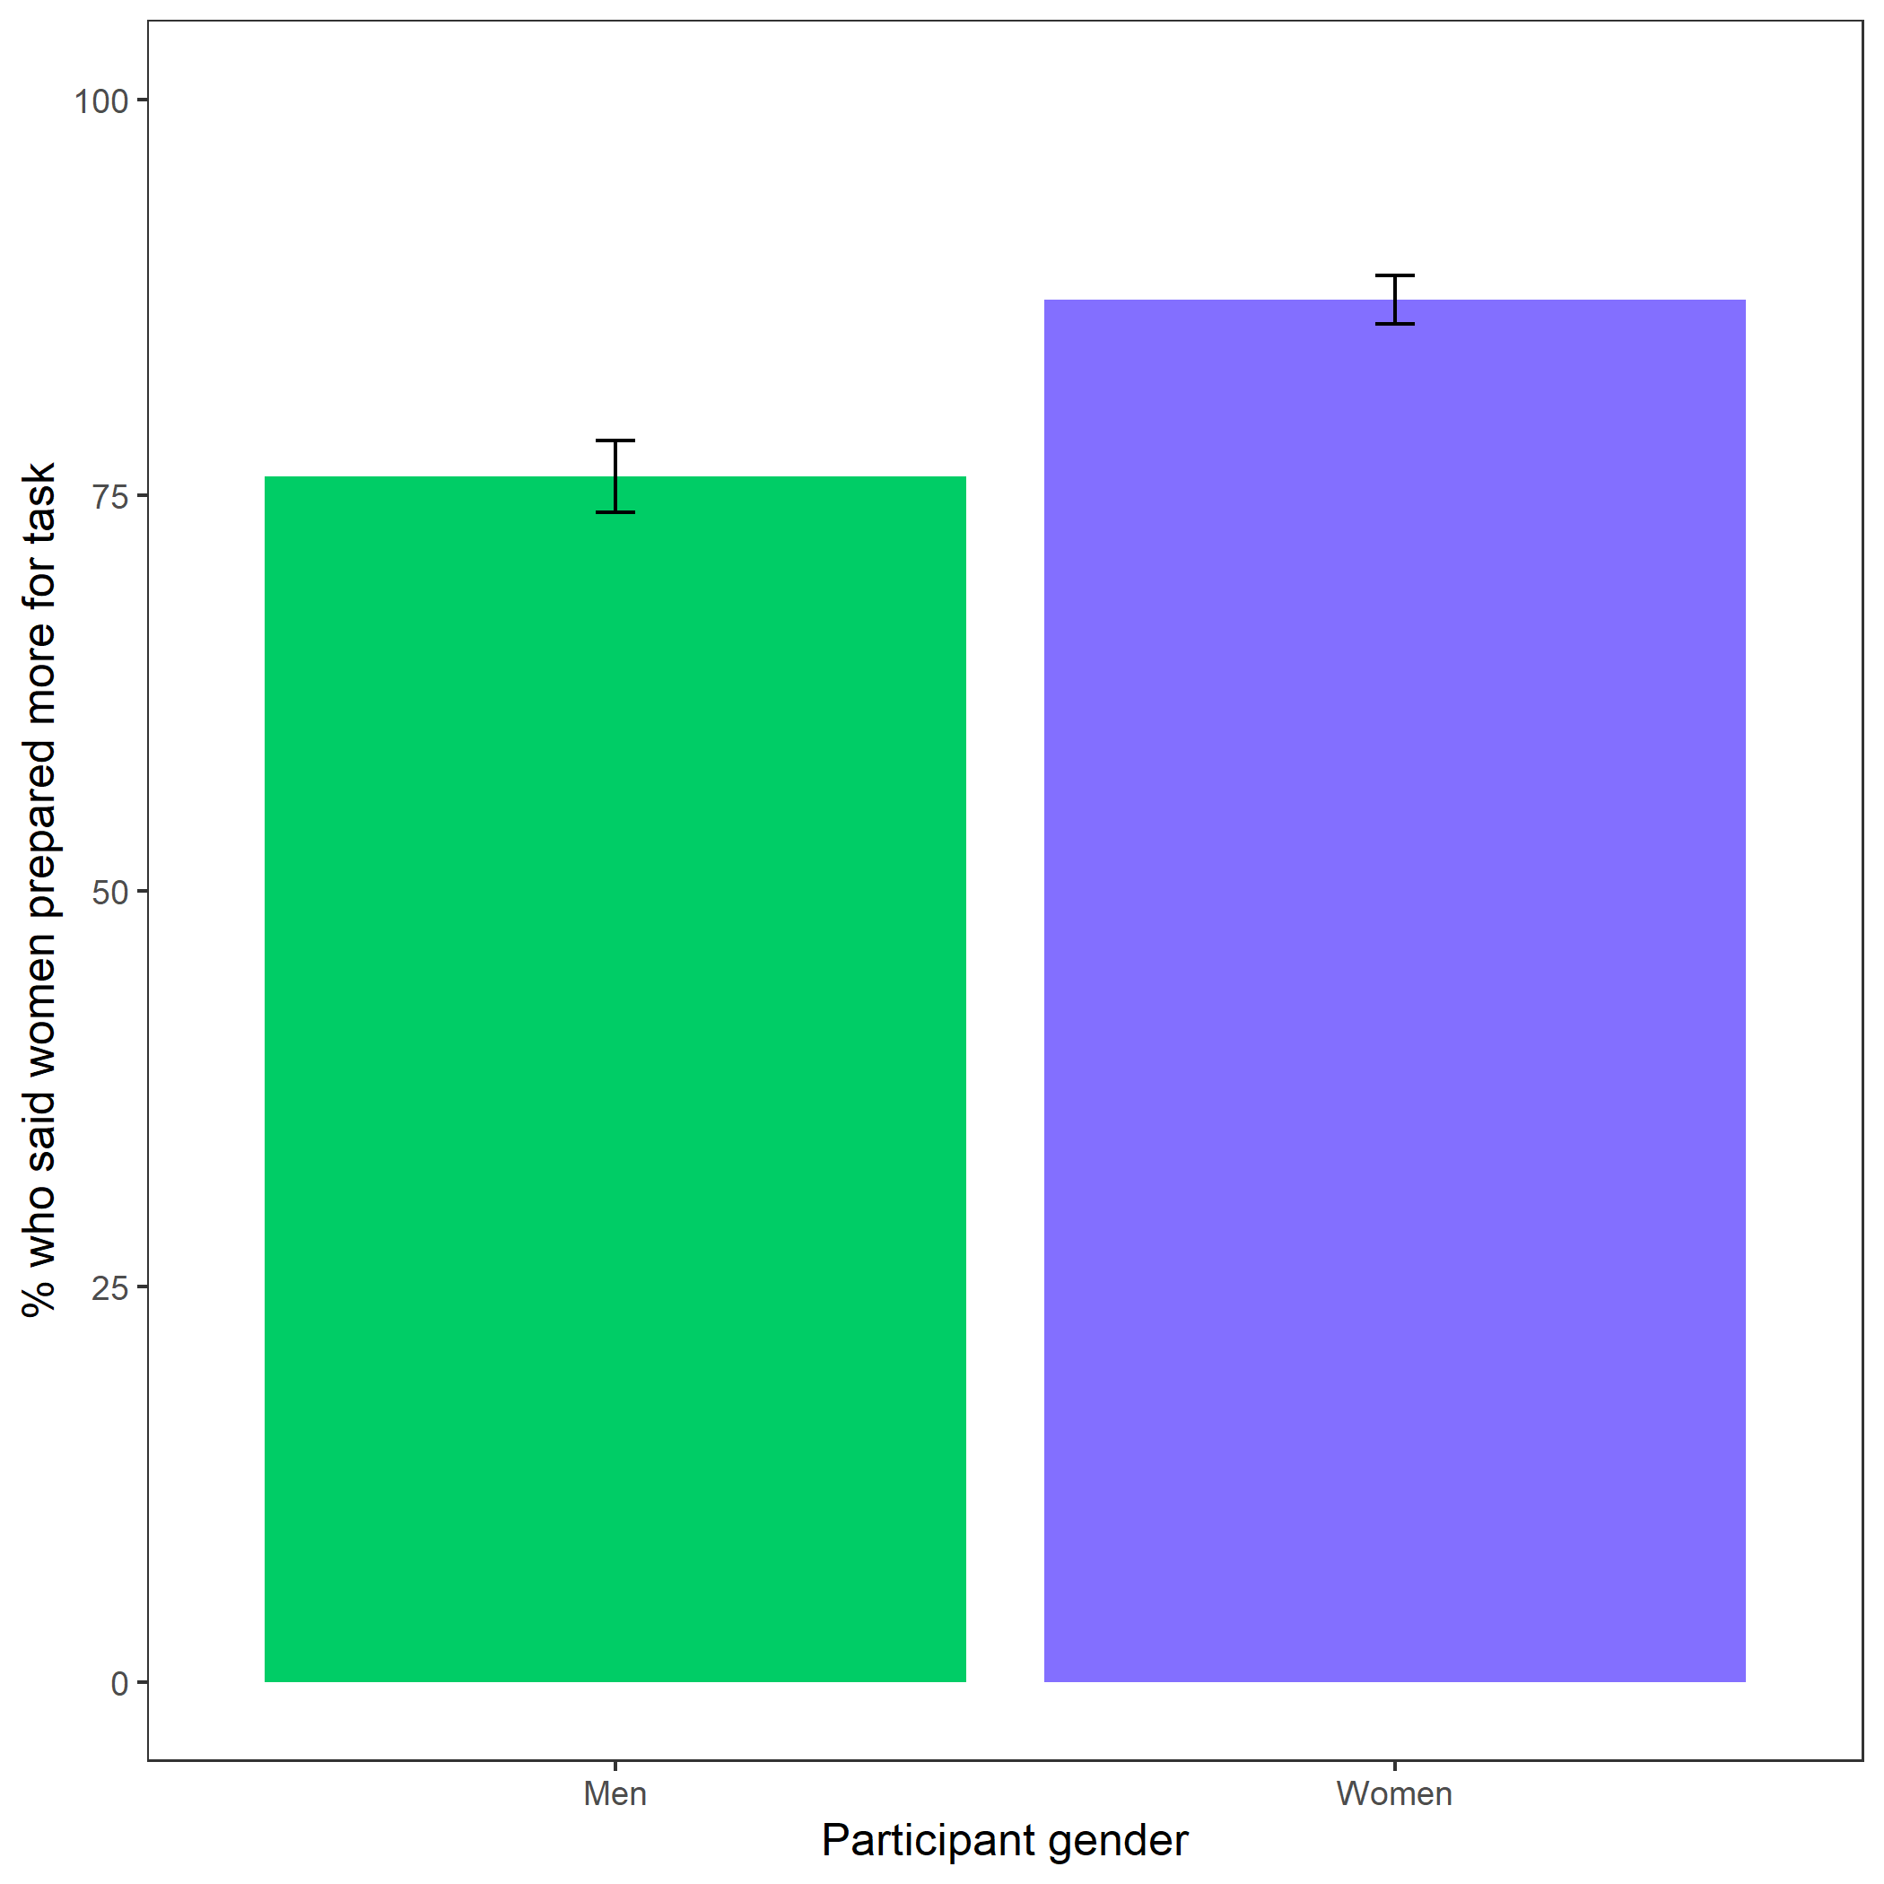

*Figure* *6.*  Participants’ perceptions of gender differences in the choice to practice on the task. Error bars represent standard error.

Cross-Tabulation, Row Proportions  
cleanperc_task_gender_pract

|  |  |  |  |  |  |
| --- | --- | --- | --- | --- | --- |
|  | clean$perc_task_gender_pract | Men | Women |  | Total |
| clean$gender |  |  |  |  |  |
| Man |  | 104 (21.2%) | 361 (73.7%) | 25 (5.1%) | 490 (100.0%) |
| Woman |  | 63 (11.1%) | 476 (84.1%) | 27 (4.8%) | 566 (100.0%) |
| Total |  | 167 (15.8%) | 837 (79.3%) | 52 (4.9%) | 1056 (100.0%) |

Exploratory analysis 7a: Participants did not expect any gender differences in performance on the task, , (see Figure 7).

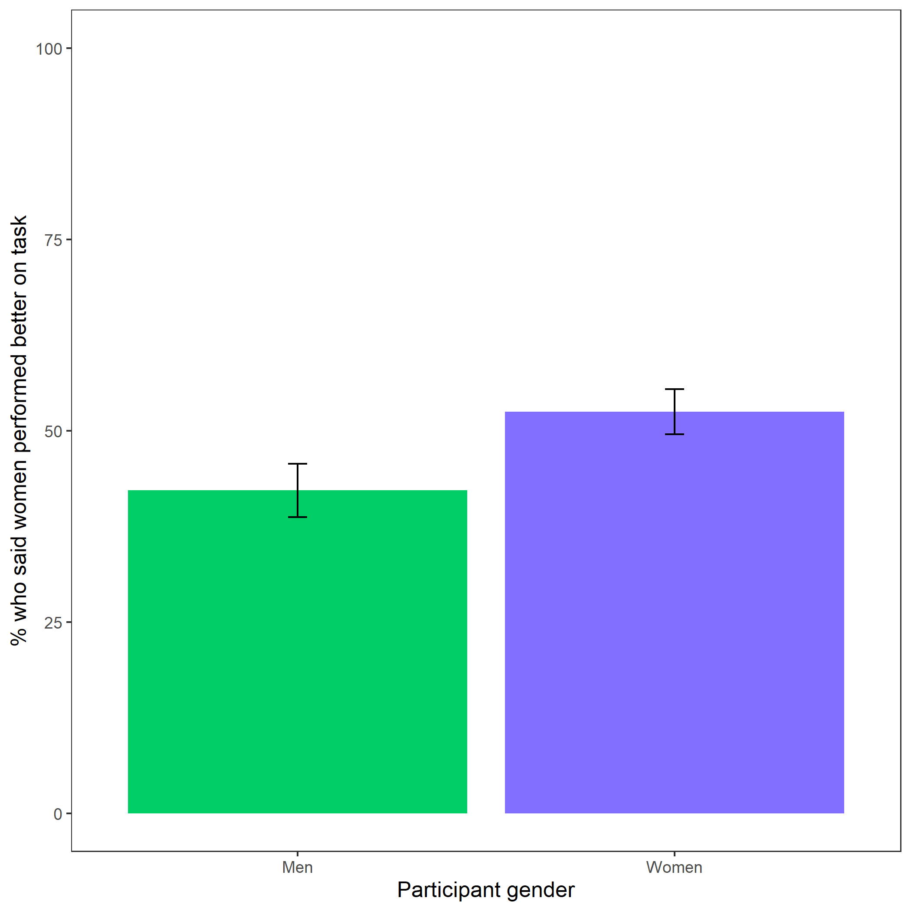

*Figure* *7.*  Participants’ perceptions of gender differences in performance on the task. Error bars represent standard error.

Cross-Tabulation, Row Proportions  
cleanbetter_gender_guess

|  |  |  |  |  |  |
| --- | --- | --- | --- | --- | --- |
|  | clean$better_gender_guess | Men | Women |  | Total |
| clean$gender |  |  |  |  |  |
| Man |  | 265 (54.1%) | 200 (40.8%) | 25 (5.1%) | 490 (100.0%) |
| Woman |  | 253 (44.7%) | 286 (50.5%) | 27 (4.8%) | 566 (100.0%) |
| Total |  | 518 (49.1%) | 486 (46.0%) | 52 (4.9%) | 1056 (100.0%) |

Exploratory analysis 7b: Participants were significantly more likely to expect men to choose to compete more often, , (see Figure 8).

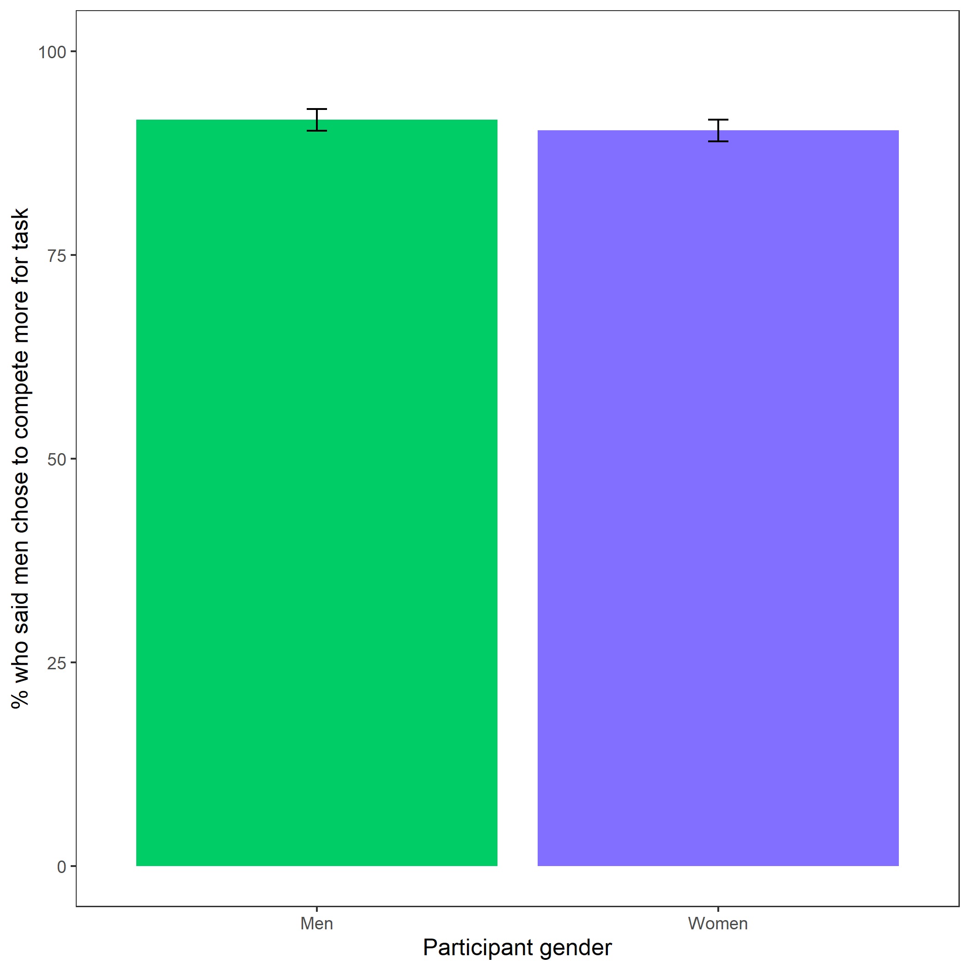

*Figure* *8.*  Participants’ perceptions of gender differences in choice to compete. Error bars represent standard error.

Cross-Tabulation, Row Proportions  
cleanperc_gender_comp

|  |  |  |  |  |  |
| --- | --- | --- | --- | --- | --- |
|  | clean$perc_gender_comp | Men | Women |  | Total |
| clean$gender |  |  |  |  |  |
| Man |  | 434 (88.6%) | 31 (6.3%) | 25 (5.1%) | 490 (100.0%) |
| Woman |  | 492 (86.9%) | 47 (8.3%) | 27 (4.8%) | 566 (100.0%) |
| Total |  | 926 (87.7%) | 78 (7.4%) | 52 (4.9%) | 1056 (100.0%) |

Exploratory analysis 7c: Participants were significantly more likely to expect women to choose to prepare in general, , (see Figure 9).

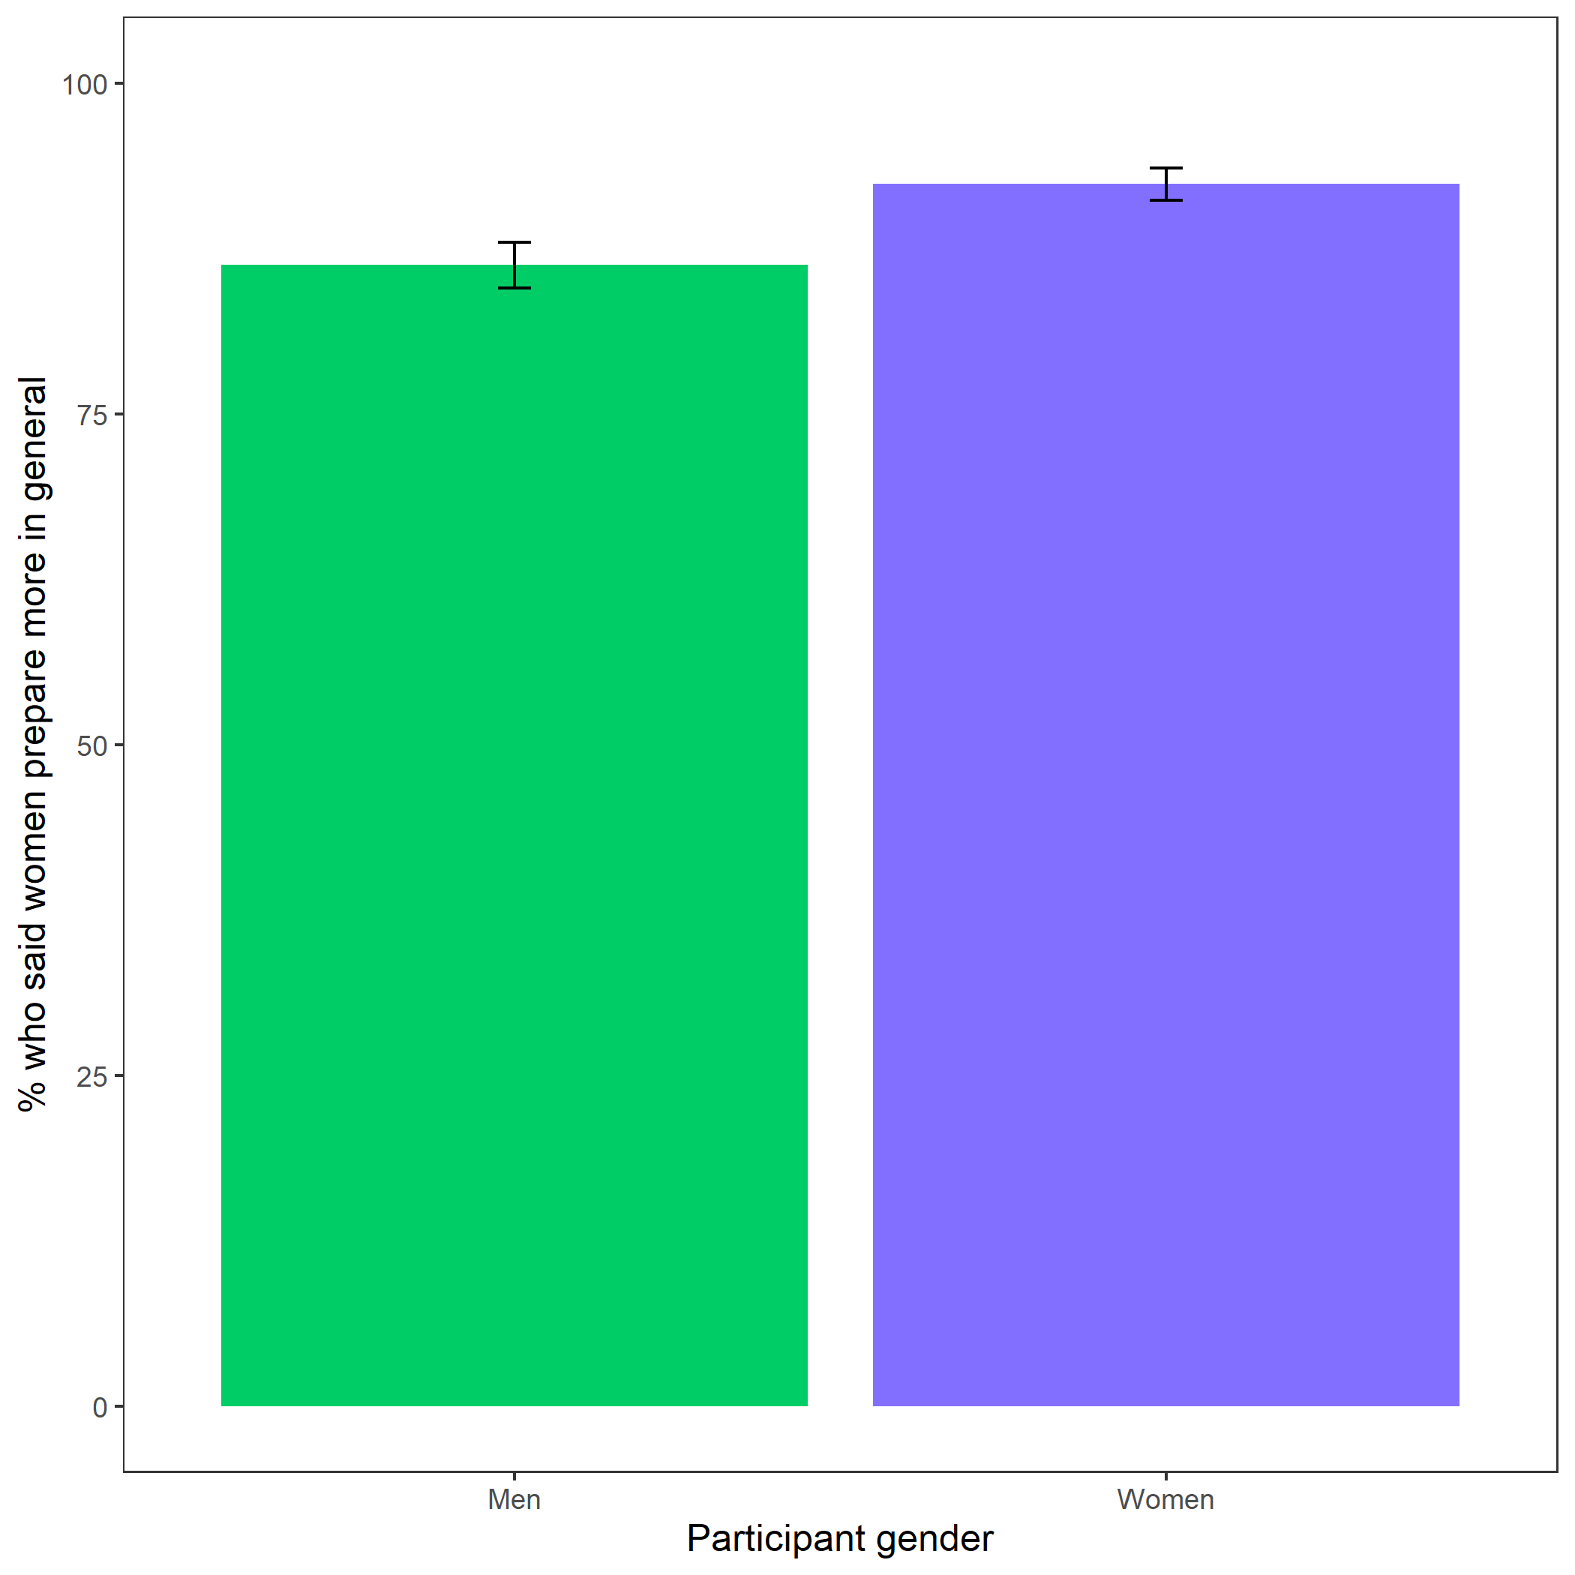

*Figure* *9.*  Participants’ perceptions of general gender differences in choice to practice. Error bars represent standard error.

Cross-Tabulation, Row Proportions  
cleanperc_gen_gender_pract

|  |  |  |  |  |  |
| --- | --- | --- | --- | --- | --- |
|  | clean$perc_gen_gender_pract | Men | Women |  | Total |
| clean$gender |  |  |  |  |  |
| Man |  | 64 (13.1%) | 401 (81.8%) | 25 (5.1%) | 490 (100.0%) |
| Woman |  | 41 ( 7.2%) | 495 (87.5%) | 30 (5.3%) | 566 (100.0%) |
| Total |  | 105 ( 9.9%) | 896 (84.8%) | 55 (5.2%) | 1056 (100.0%) |

# Study 2

## Methods

Participants were recruited on Amazon Mechanical Turk using the same pre-screening criteria as Study 1. The final sample consisted of 1076 participants (50.56% women), with an average age of 38.57 (*SD* = 12.52) years.

As in Study 1, participants included in the study were told they would be completing a two-minute multiplication task (identical to the one used in Study 1) and would be able to choose a payment scheme for their performance. After being told about the rules for the multiplication task and passing comprehension questions, participants were assigned to either a preparation condition, where they were told they would complete several rounds of practice before completing the multiplication task, or a control condition, where they were told they would complete several rounds of a counting task before moving on. As in Study 1, participants were randomly assigned to each condition based on their indicated gender. The participants in the preparation condition completed 12 rounds (one round per multiplication table), with 6 problems per round. The problems for each round were selected at random. For the counting task, participants in the control condition were asked to complete 5 questions where they counted the number of zeros in a matrix of zeros and ones. After a 30-second break following completion of their respective tasks, all participants chose a payment scheme for the multiplication task (order of presentation was randomized) and completed the paid multiplication task for two minutes. We included many of the same follow-up questions as in Study 1, including risk aversion, confidence, and perceptions of gender differences in preparation, competitiveness, and performance. We also asked participants if they wished they had more time to prepare for the multiplication task and included measures of their fatigue, field-specific ability beliefs, and interest in the multiplication task all on 1 (Strongly disagree) to 7 (Strongly agree) scales. For the fatigue scale, participants rated how fatigued and mentally exhausted they felt. Participants indicated the degree to which they “enjoyed completing the multiplication task” for the interest scale. Finally, to measure field-specific ability beliefs, we asked participants how much they perceived success in math depends on ability versus effort through six questions (e.g., “If you want to succeed in math, hard work alone just won’t cut it; you need to have an innate gift or talent”).

## Results

### Summary.

All hypotheses were [pre-registered](https://osf.io/q39a5/) unless otherwise stated and all analyses were conducted in R. We first examined whether gender was balanced across conditions. 49.44% of men and 49.26% of women were assigned to the control condition, while 49.44% of men and 49.26% of women were assigned to the practice condition, for a total of 49.35% of participants assigned to the control condition and 49.35% of participants assigned to the practice condition.

We replicated the effect of gender on the choice to compete: 19.36% of men chose to compete compared to 13.60% of women. However, our primary hypothesis women would be more likely to compete in the preparation condition was not supported (see Figure 10).

Despite no evidence for the effect of condition on the choice to compete among women, we replicate the effects found in Study 1, where women were significantly more likely to prepare for the task, even after being forced to prepare in the preparation condition (see Figure 14).

### Pre-registered analyses.

Primary hypothesis 1: We do not find evidence of a significant effect of condition on the choice to compete among women, *z* = -1.00, *p* = 0.16 (see Figure 10).

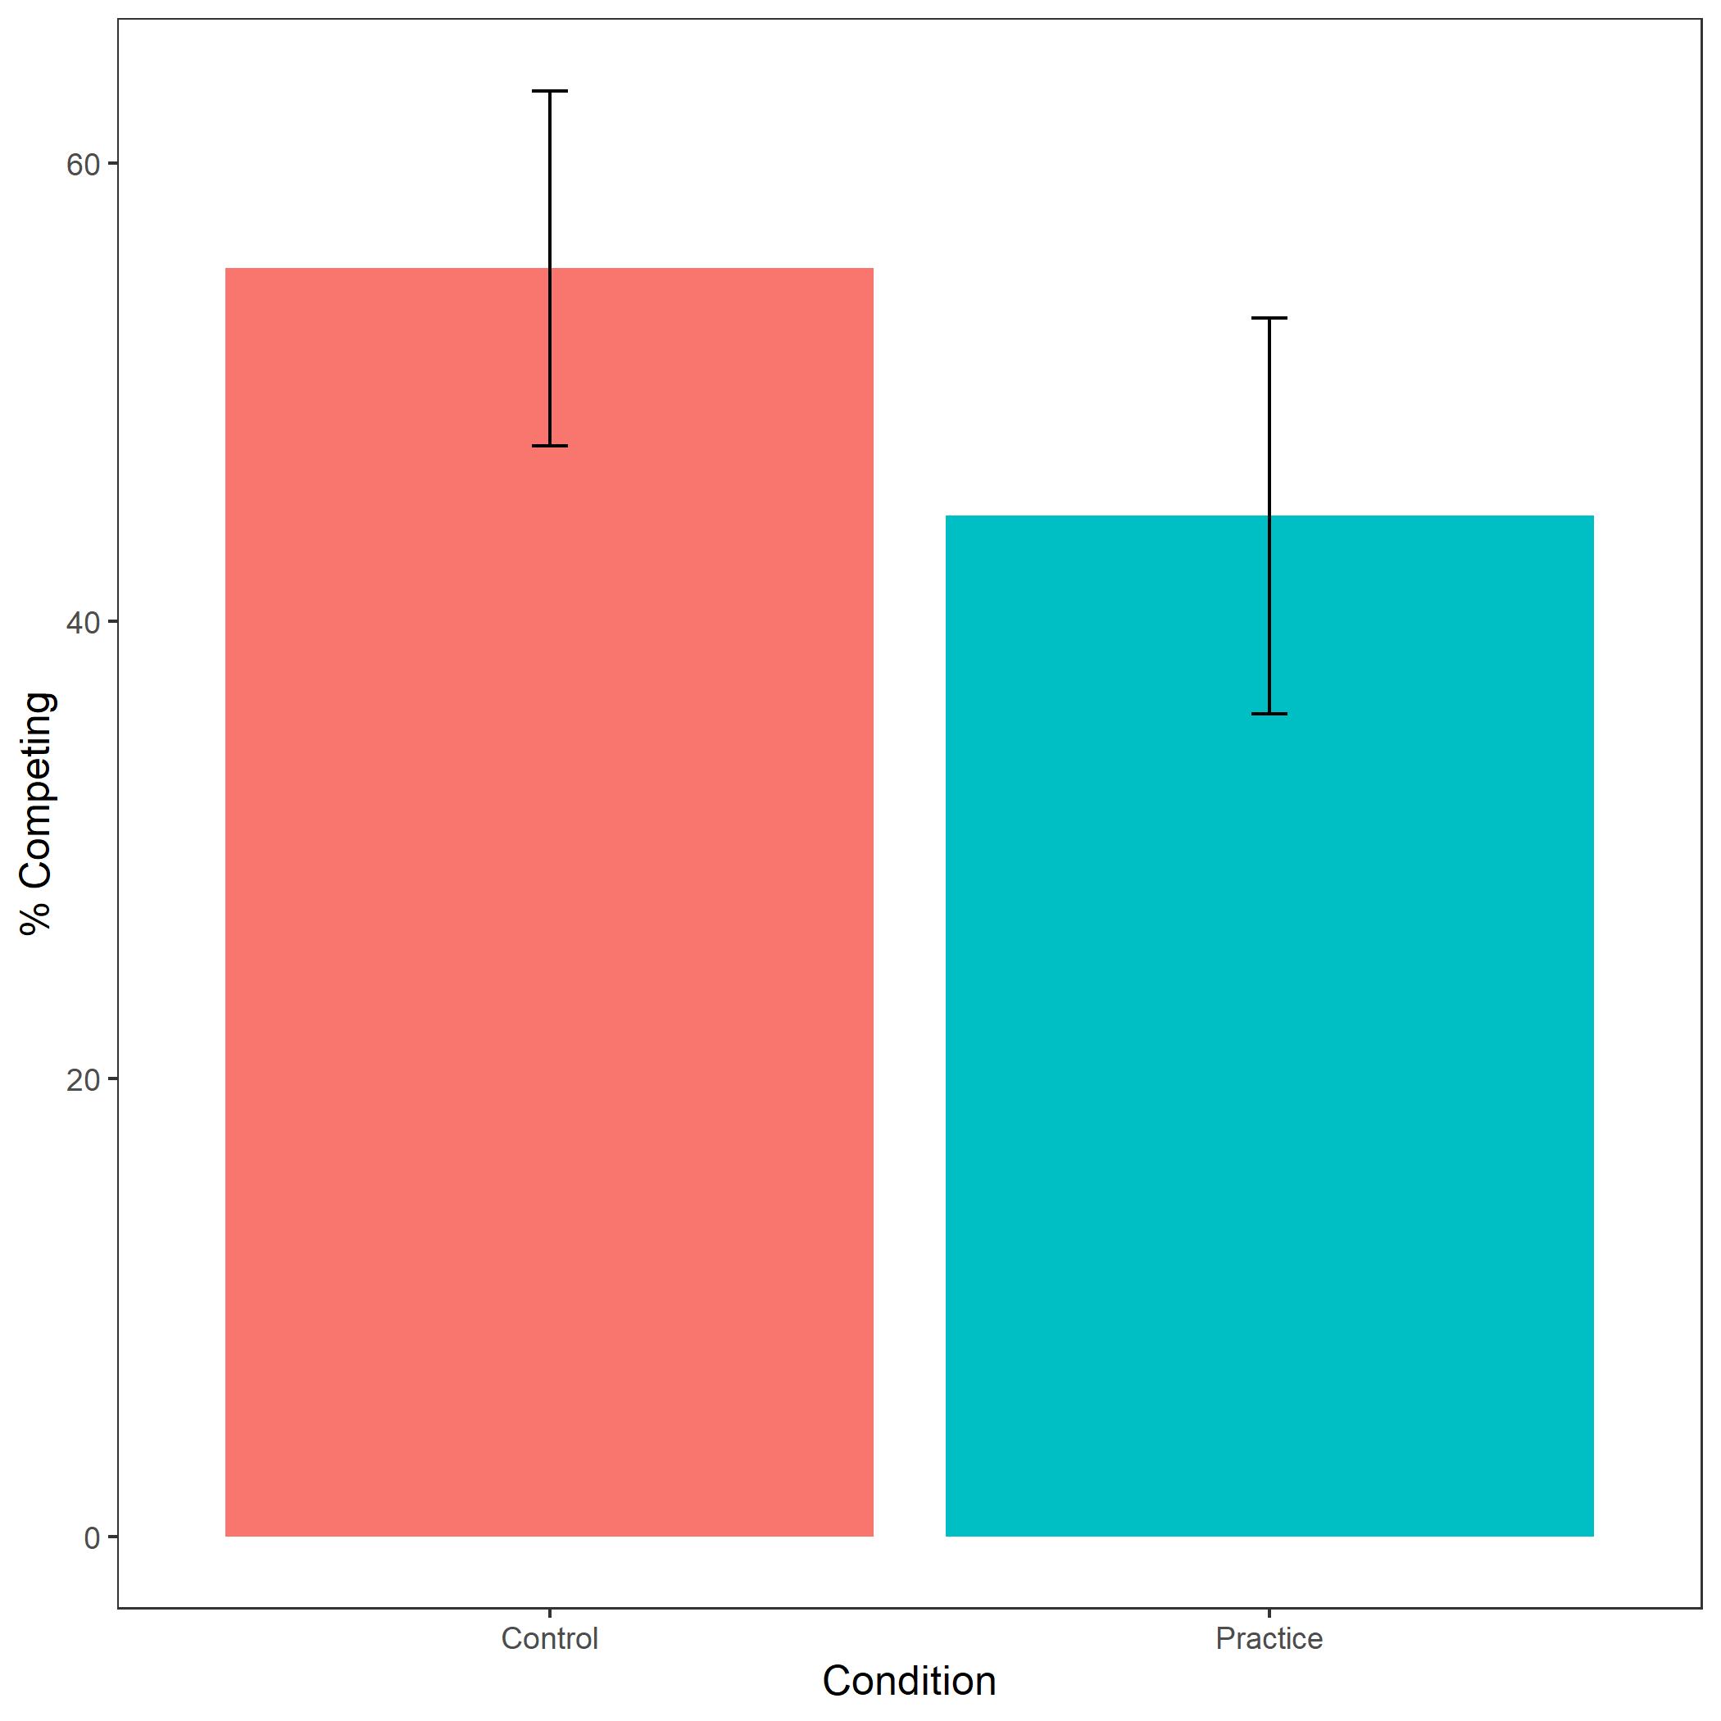

*Figure* *10.*  Proportion of female participants who chose to compete based on condition. Error bars represent standard error.

Cross-Tabulation, Row Proportions  
womancondition

|  |  |  |  |  |  |
| --- | --- | --- | --- | --- | --- |
|  | woman$condition | control | pract |  | Total |
| woman$comp_choice |  |  |  |  |  |
| piecerate |  | 220 (48.4%) | 235 (51.6%) | 0 ( 0.0%) | 455 (100.0%) |
| tournament |  | 41 (55.4%) | 33 (44.6%) | 0 ( 0.0%) | 74 (100.0%) |
|  |  | 7 (46.7%) | 0 ( 0.0%) | 8 (53.3%) | 15 (100.0%) |
| Total |  | 268 (49.3%) | 268 (49.3%) | 8 ( 1.5%) | 544 (100.0%) |

Exploratory analysis 3a: Participants did not expect any gender differences in performance on the task, , (see Figure 11).

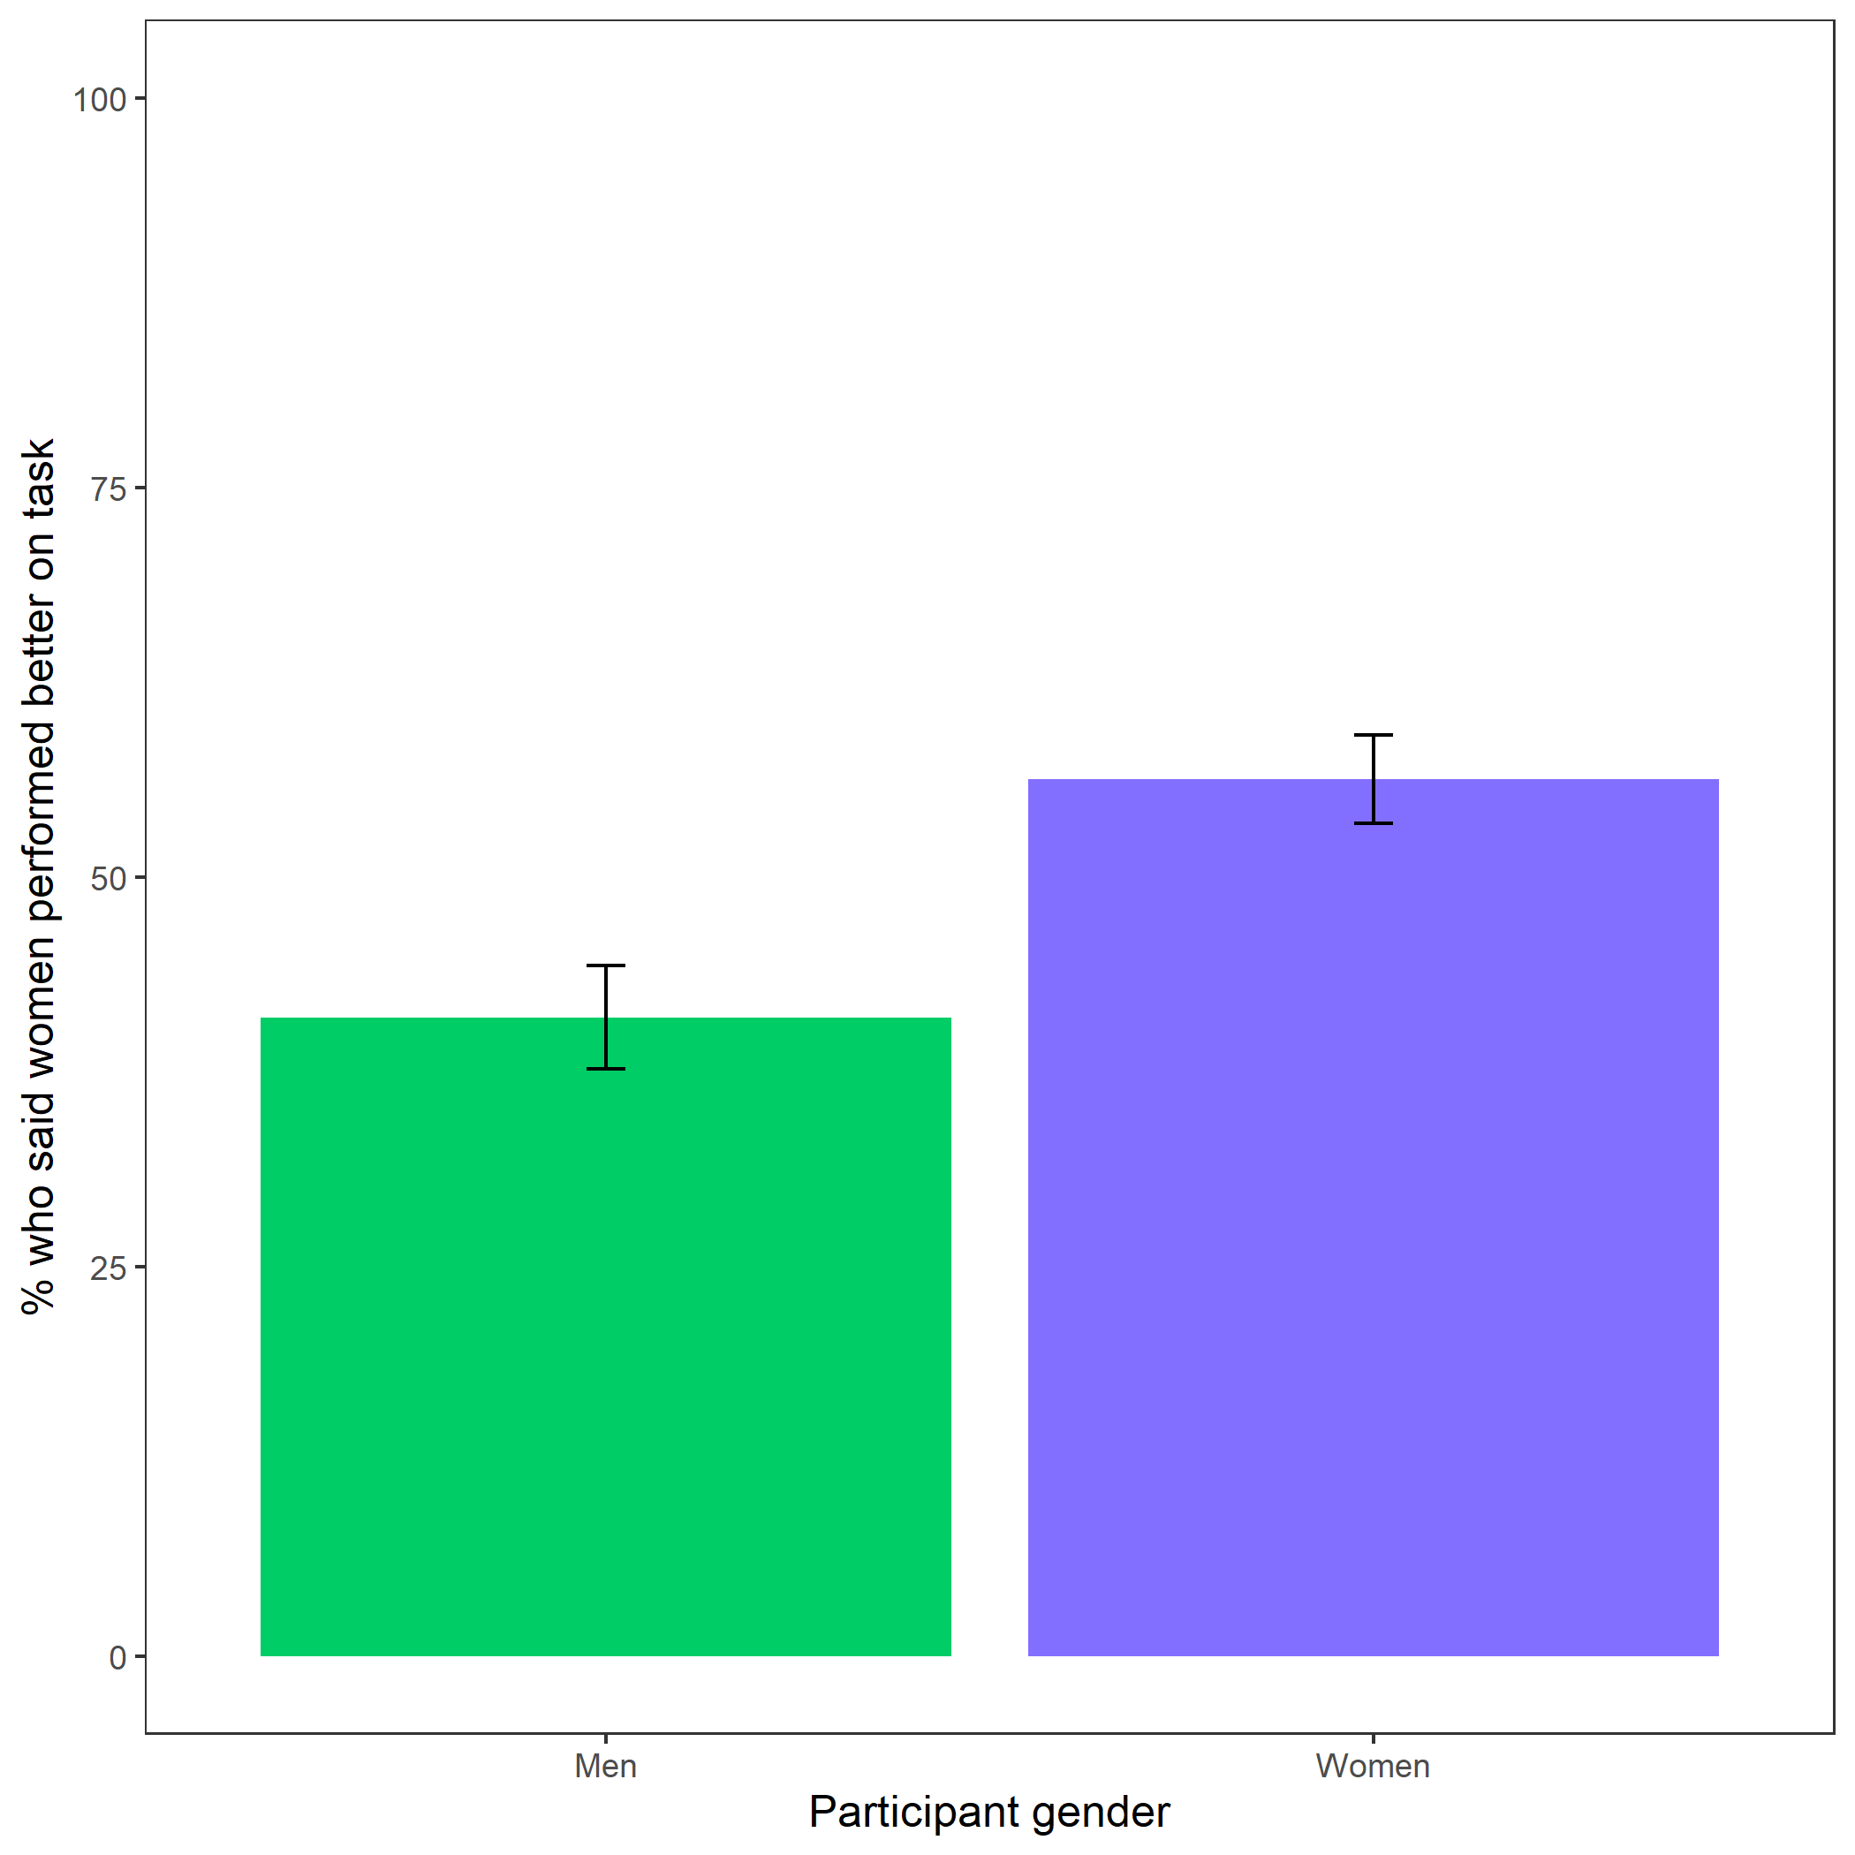

*Figure* *11.*  Participants’ perceptions of gender differences in performance on the task. Error bars represent standard error.

Cross-Tabulation, Row Proportions  
cleanbetter_gender_guess

|  |  |  |  |  |  |
| --- | --- | --- | --- | --- | --- |
|  | clean$better_gender_guess | Men | Women |  | Total |
| clean$gender |  |  |  |  |  |
| Man |  | 287 (53.9%) | 218 (41.0%) | 27 (5.1%) | 532 (100.0%) |
| Woman |  | 212 (39.0%) | 306 (56.2%) | 26 (4.8%) | 544 (100.0%) |
| Total |  | 499 (46.4%) | 524 (48.7%) | 53 (4.9%) | 1076 (100.0%) |

Exploratory analysis 3b: Participants were significantly more likely to expect men to choose to compete more often, , (see Figure 12).

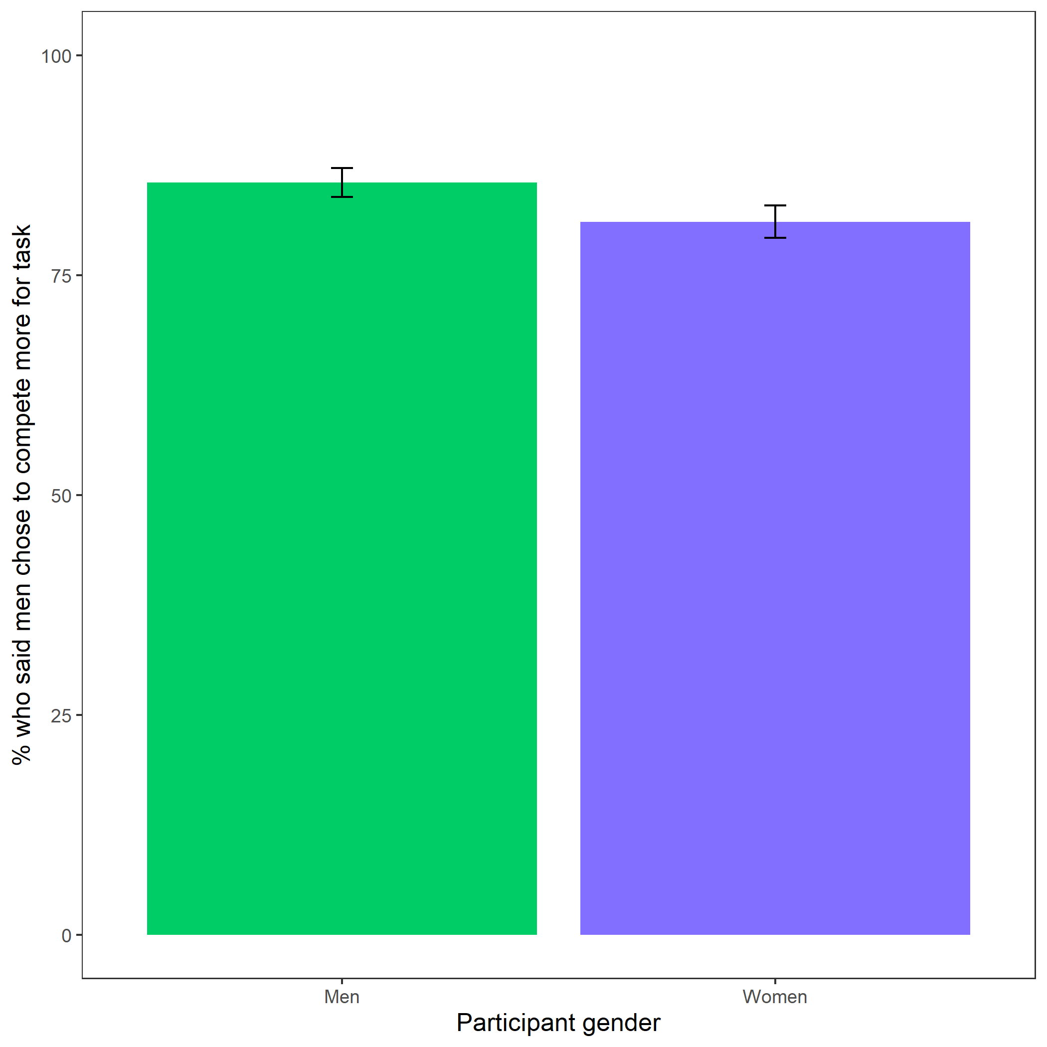

*Figure* *12.*  Participants’ perceptions of gender differences in choice to compete. Error bars represent standard error.

Cross-Tabulation, Row Proportions  
cleanperc_gender_comp

|  |  |  |  |  |  |
| --- | --- | --- | --- | --- | --- |
|  | clean$perc_gender_comp | Men | Women |  | Total |
| clean$gender |  |  |  |  |  |
| Man |  | 455 (85.5%) | 50 ( 9.4%) | 27 (5.1%) | 532 (100.0%) |
| Woman |  | 441 (81.1%) | 77 (14.2%) | 26 (4.8%) | 544 (100.0%) |
| Total |  | 896 (83.3%) | 127 (11.8%) | 53 (4.9%) | 1076 (100.0%) |

Exploratory analysis 3c: Participants were significantly more likely to expect women to choose to prepare in general, , (see Figure 13).

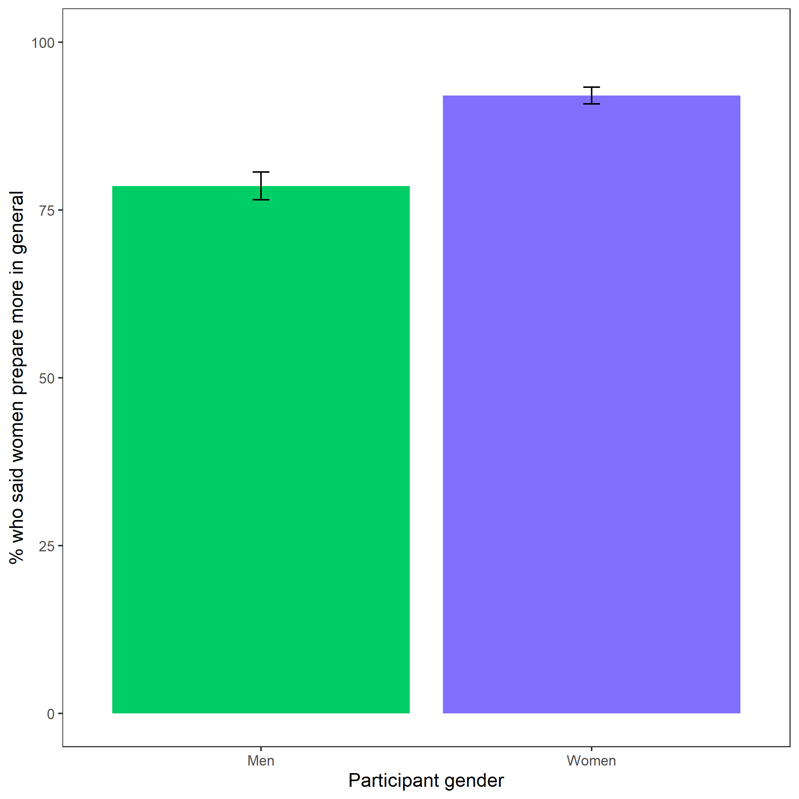

*Figure* *13.*  Participants’ perceptions of general gender differences in choice to practice. Error bars represent standard error.

Cross-Tabulation, Row Proportions  
cleanperc_gen_gender_pract

|  |  |  |  |  |  |
| --- | --- | --- | --- | --- | --- |
|  | clean$perc_gen_gender_pract | Men | Women |  | Total |
| clean$gender |  |  |  |  |  |
| Man |  | 108 (20.3%) | 396 (74.4%) | 28 (5.3%) | 532 (100.0%) |
| Woman |  | 41 ( 7.5%) | 475 (87.3%) | 28 (5.1%) | 544 (100.0%) |
| Total |  | 149 (13.8%) | 871 (80.9%) | 56 (5.2%) | 1076 (100.0%) |

### Exploratory analyses.

Exploratory analysis 1: Women were 18.62% more likely to take advantage of the opportunity to prepare relative to men , 95% CI , , , , while controlling for the decision to compete (see Figure 14).

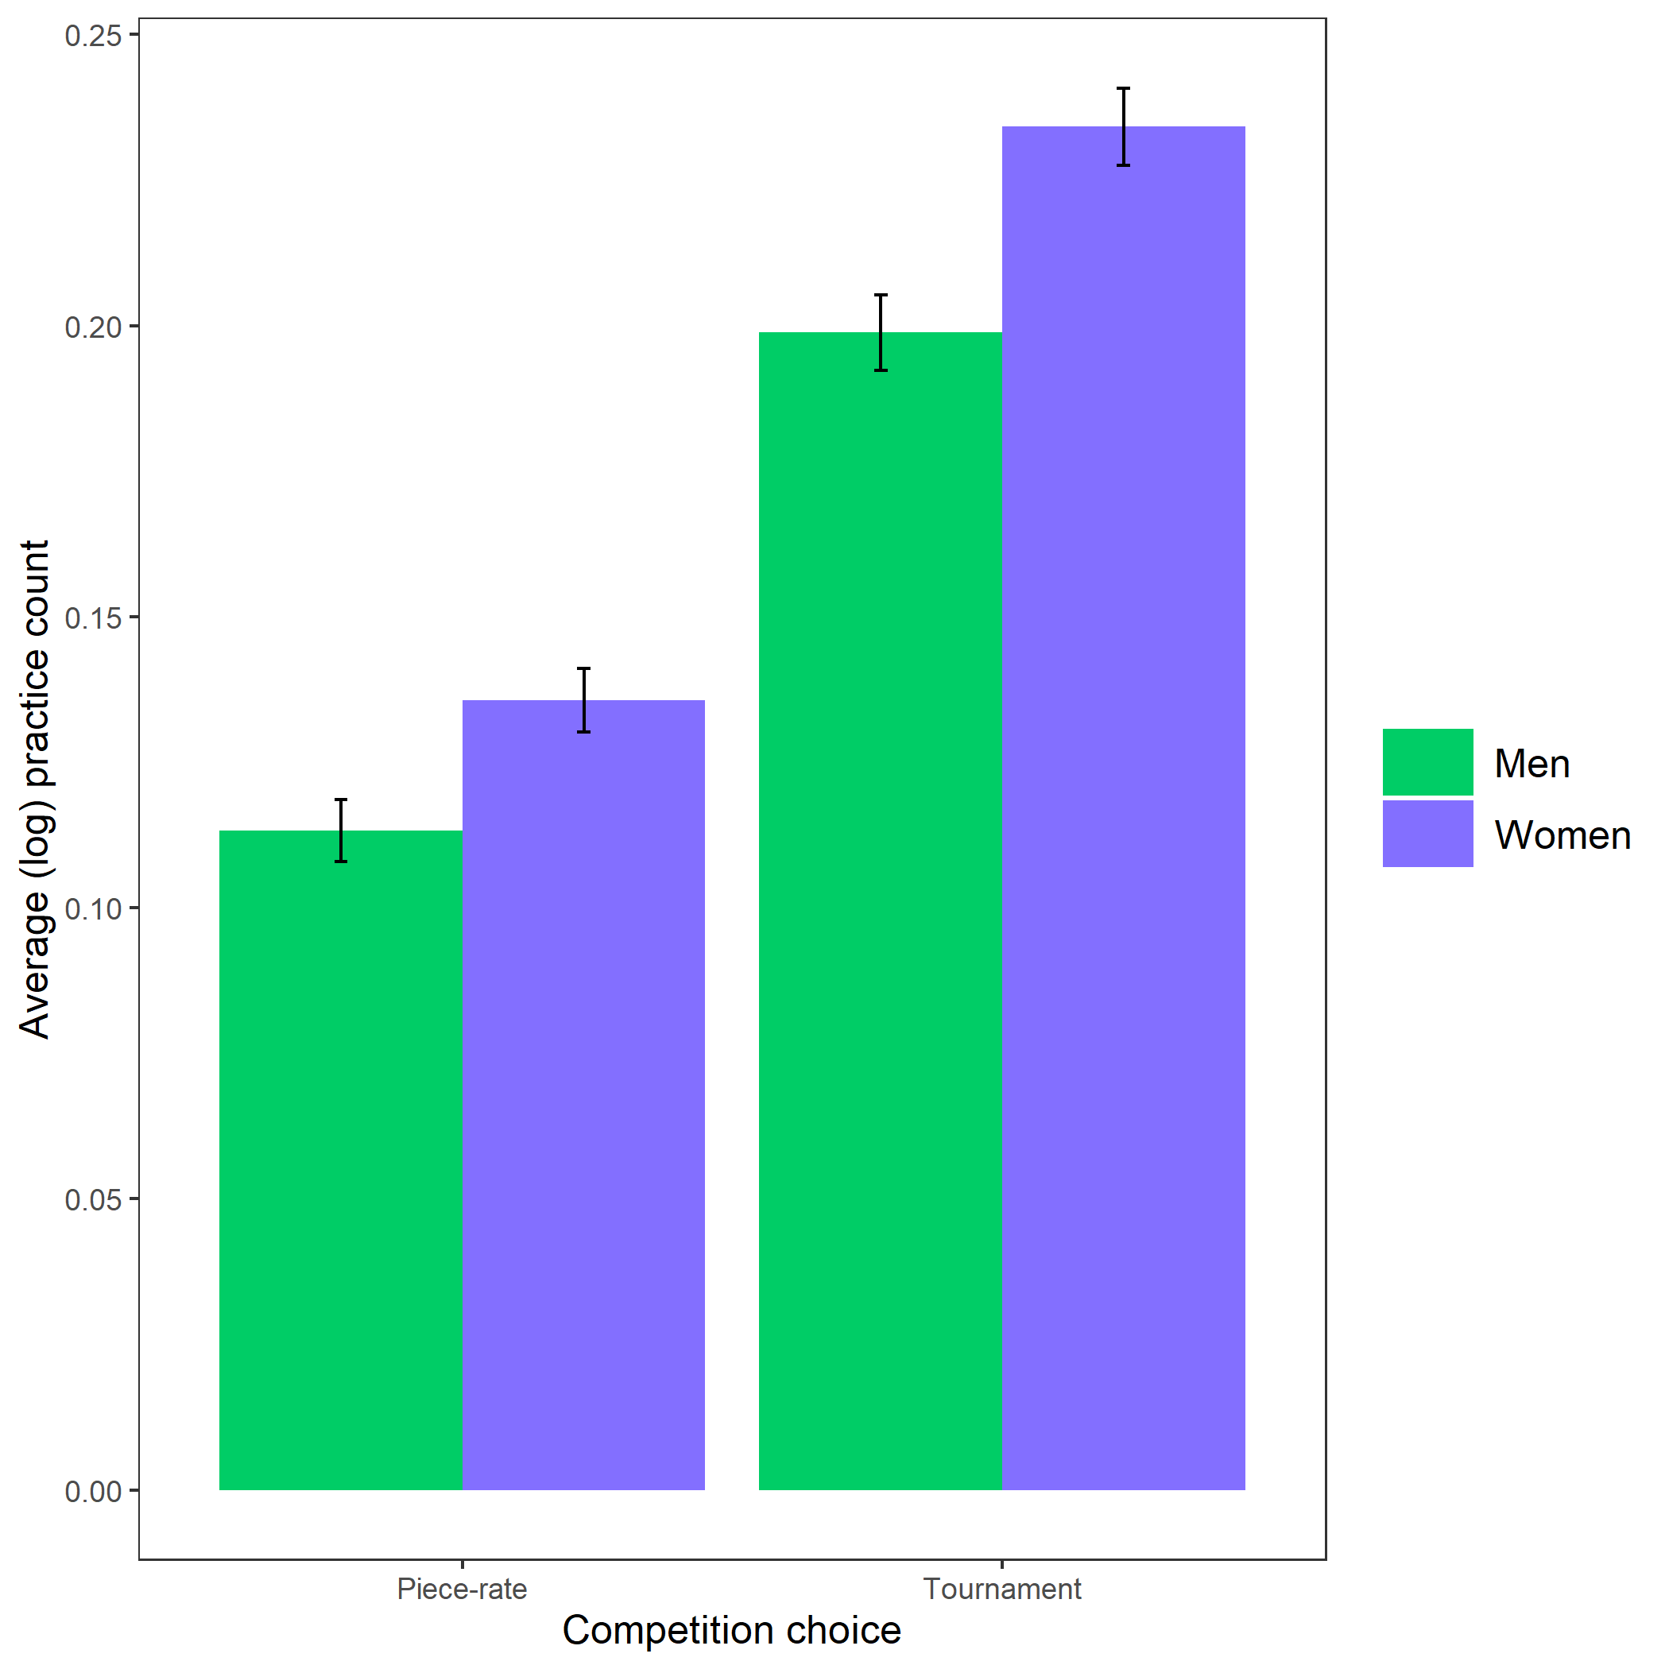

*Figure* *14.*  Gender differences in the number of extra practice rounds chosen across participants’ choice in a payment scheme. Error bars represent standard error.

# References

Bertrand, M., & Hallock, K. F. (2001). The gender gap in top corporate jobs. *Industrial and Labor Relations Review*, *55*, 3–21.

Blau, F. D., & Kahn, L. M. (2017). The gender wage gap: Extent, trends, and explanations. *Journal of Economic Literature*, *55*(3), 789–865. <https://doi.org/10.1257/jel.20160995>

Buser, T., Niederle, M., & Oosterbeek, H. (2014). Gender, competition and career choices. *The Quarterly Journal of Economics*, *129*(3), 1409–1447. <https://doi.org/10.1093/qje/qju009.Advance>

Croson, R., & Gneezy, U. (2009). Gender differences in preferences. *Journal of Economic Literature*, *47*(2), 448–474. <https://doi.org/10.1257/jel.47.2.448>

Dohmen, T., Falk, A., Huffman, D., Sunde, U., Schupp, J., & Wagner, G. G. (2011). Individual risk attitudes: Measurement, determinants, and behavioral consequences. *Journal of the European Economic Association*, *9*(3), 522–550. <https://doi.org/10.1111/j.1542-4774.2011.01015.x>

Gist, M. E., & Mitchell, T. R. (1992). Self-Efficacy: A Theoretical Analysis of Its Determinants and Malleability. *The Academy of Management Review*, *17*(2), 183–211.

Goldin, C., Katz, L. F., & Kuziemko, I. (2006). The homecoming of American college women: The reversal of the college gender gap. *Journal of Economic Perspectives*, *20*(4), 133–156. <https://doi.org/10.1257/jep.20.4.133>

Niederle, M., & Vesterlund, L. (2007). Do women shy away from competition? Do men compete too much? *The Quarterly Journal of Economics*, *122*(3), 1067–1101. Retrieved from [https://web.stanford.edu/{~}niederle/Niederle.Vesterlund.QJE.2007.pdf](https://web.stanford.edu/%7B~%7Dniederle/Niederle.Vesterlund.QJE.2007.pdf)

Niederle, M., & Vesterlund, L. (2011). Gender and competition. *Annual Review of Economics*, *3*, 601–630. <https://doi.org/10.1016/j.labeco.2009.08.002>

Reuben, E., Sapienza, P., & Zingales, L. (2015). Taste for competition and the gender gap among young business professionals. *NBER WORKING PAPER SERIES*.

Schunk, D. H. (1981). Modeling and Attributional Effects on Children’s Achievement: A Self-Efficacy Analysis. *Journal of Educational Psychology*, *73*(1), 93–105.

Schunk, D. H. (1982). Progress Self-Monitoring: Effects on Children’s Self-Efficacy and Achievement. *The Journal of Experimental Education*, *51*(2), 89–93.

Stoet, G., & Geary, D. C. (2014). Sex differences in academic achievement are not related to political, economic, or social equality. *Intelligence*, *48*, 137–151. <https://doi.org/10.1016/j.intell.2014.11.006>

Zhang, Y. J. (2012). Can experimental economics explain competitive behavior outside the lab? *Unpublished Manuscript*, 1–45. <https://doi.org/10.2139/ssrn.2292929>