## Study 1

knitr::include_graphics(here::here("study1", "figs", "fig00_comp-choice-by-gender-and-cond-bar.png"))

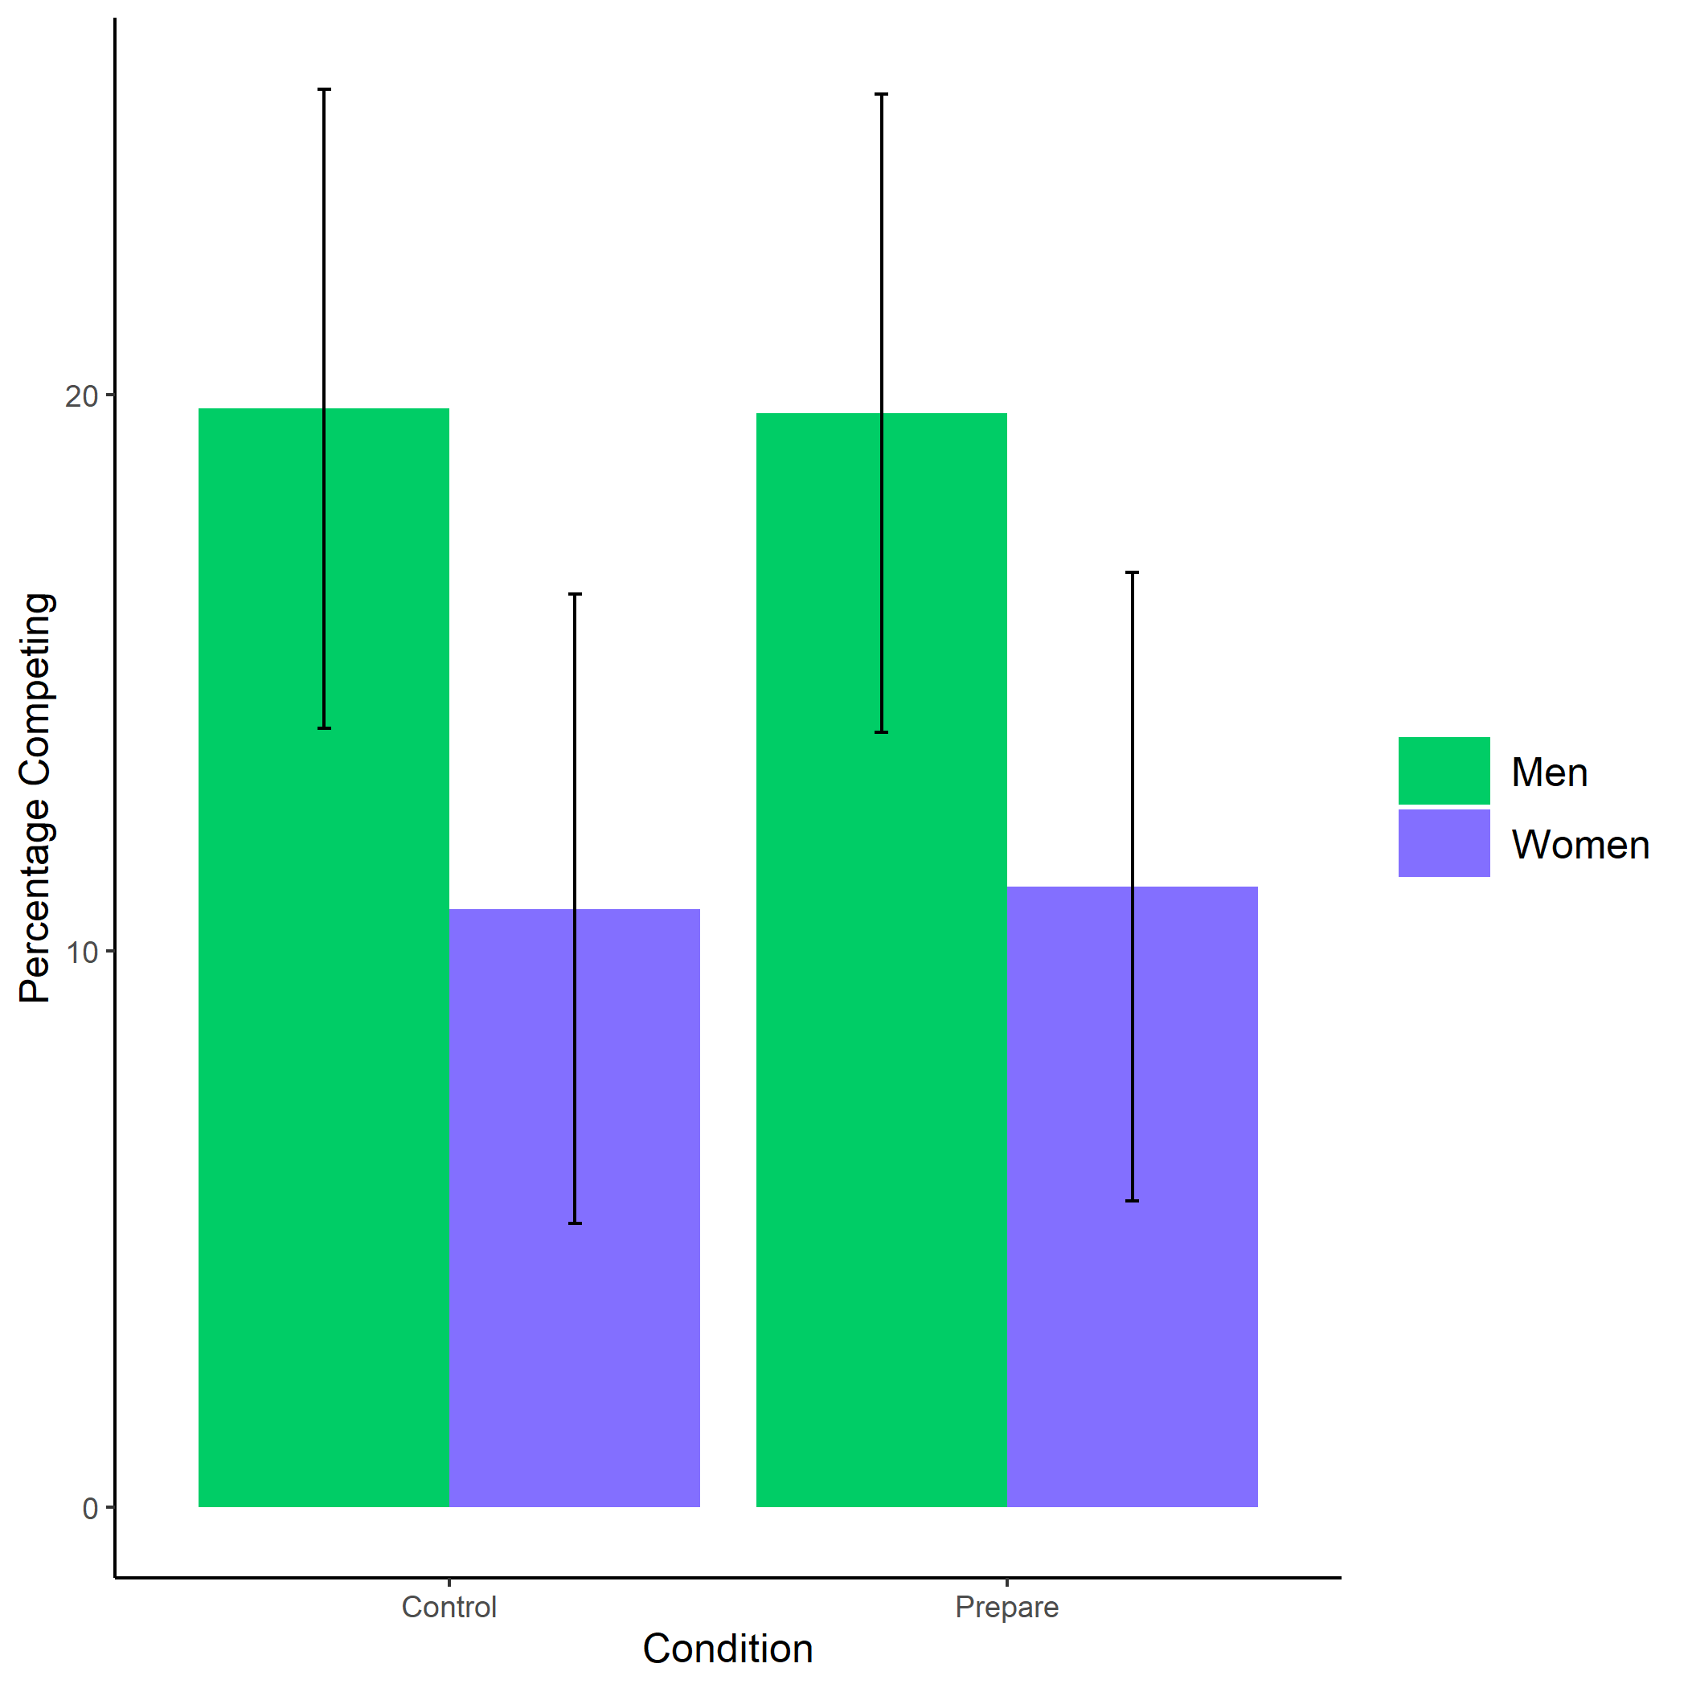

Proportion of men and women who chose to compete by condition. Error bars represent standard errors.

knitr::include_graphics(here::here("study1", "figs", "fig01_pract-choice-by-gender-and-comp-choice-bar.png"))

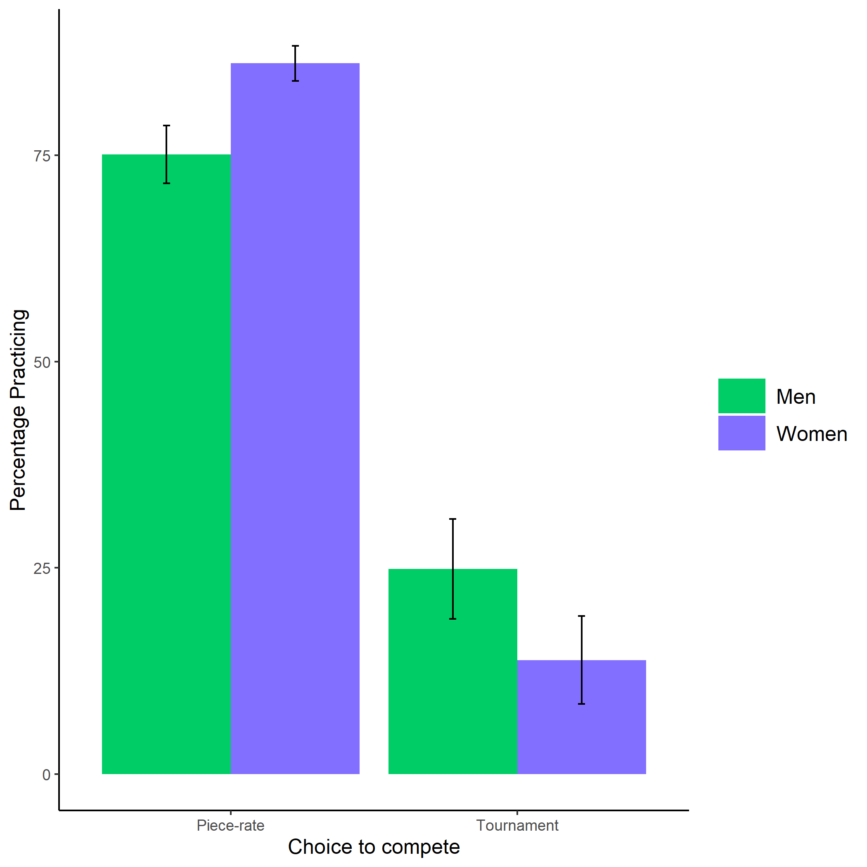

Proportion of men and women who chose to prepare by choice to compete. Error bars represent standard errors.

knitr::include_graphics(here::here("study1", "figs", "fig03_perc-task-gender-pract.png"))

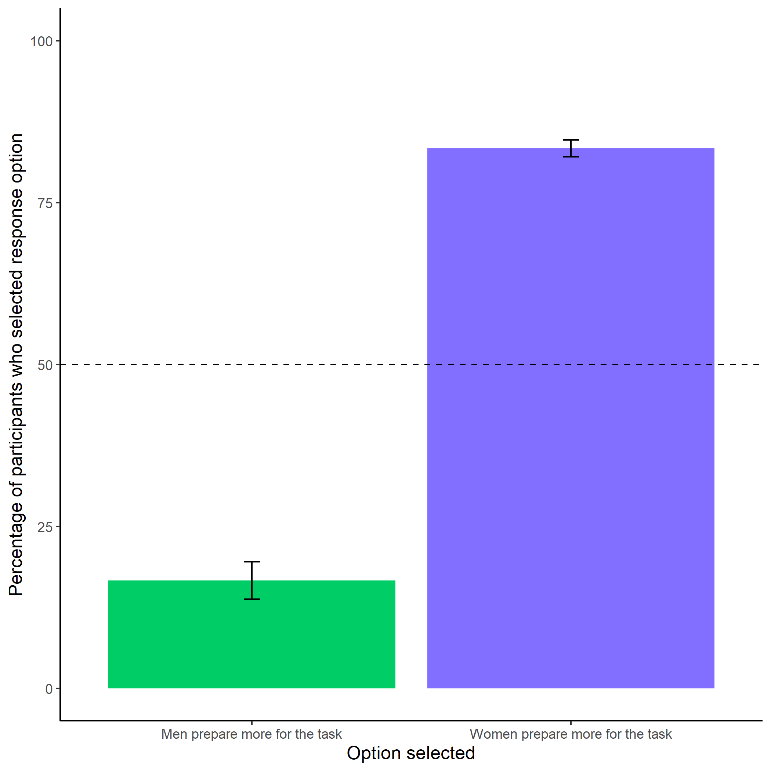

Participants’ perceptions of gender differences in the choice to practice on the task. Error bars represent standard errors.

knitr::include_graphics(here::here("study1", "figs", "fig04_better-gender-guess.png"))

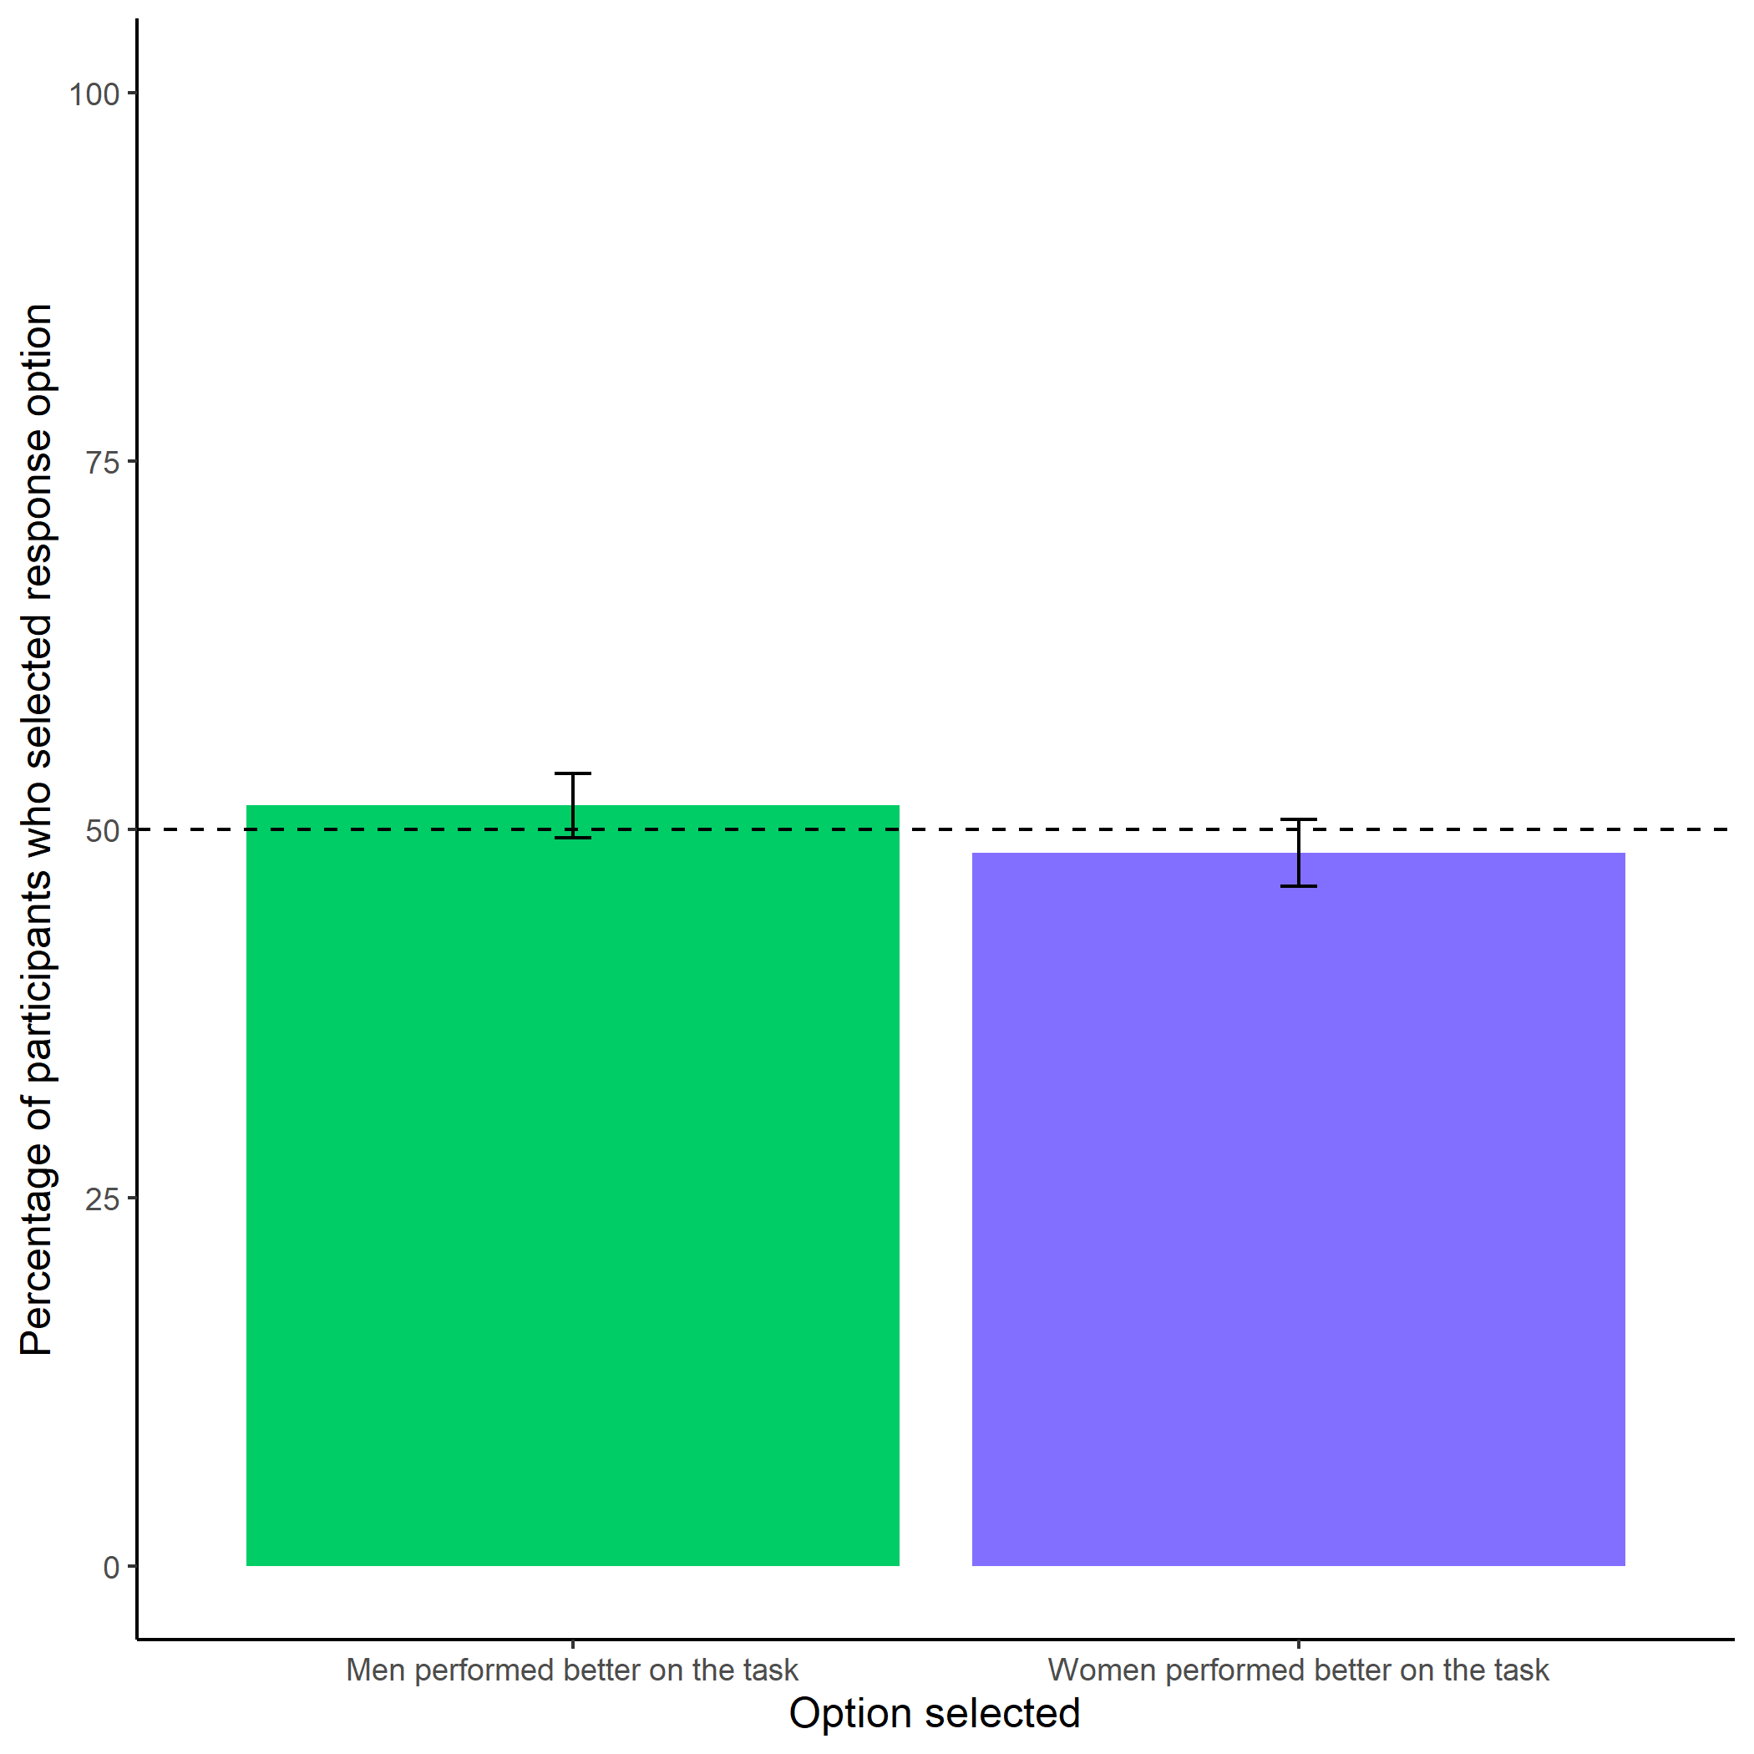

Participants’ perceptions of gender differences in performance on the task. Error bars represent standard errors.

knitr::include_graphics(here::here("study1", "figs", "fig05_perc-gender-comp.png"))

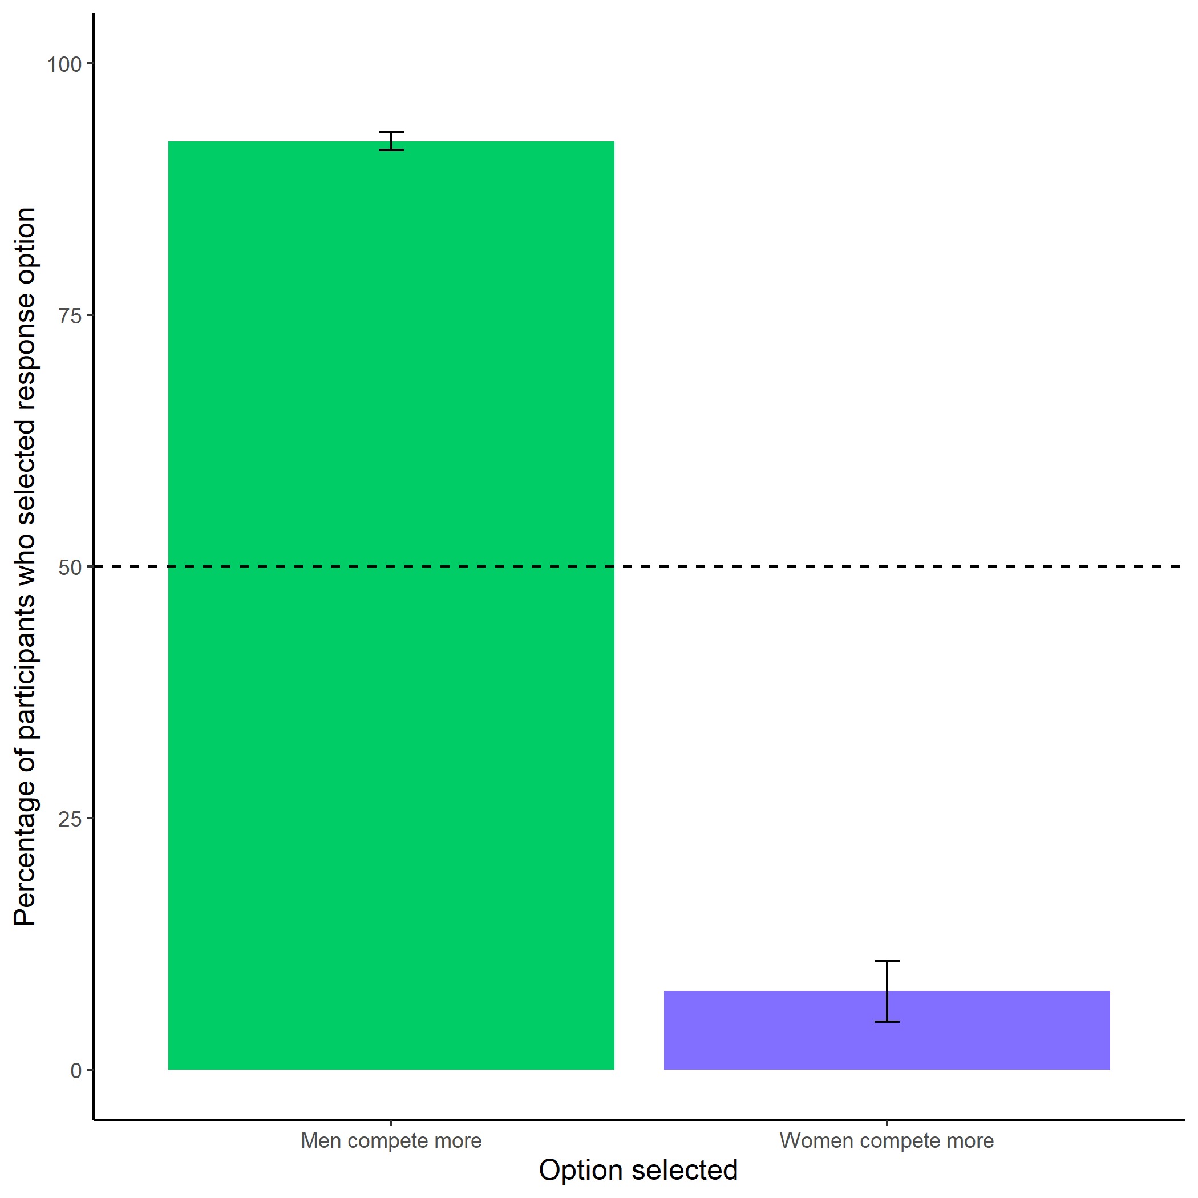

Participants’ perceptions of gender differences in choice to compete. Error bars represent standard errors.

knitr::include_graphics(here::here("study1", "figs", "fig06_perc-gen-gender-pract.png"))

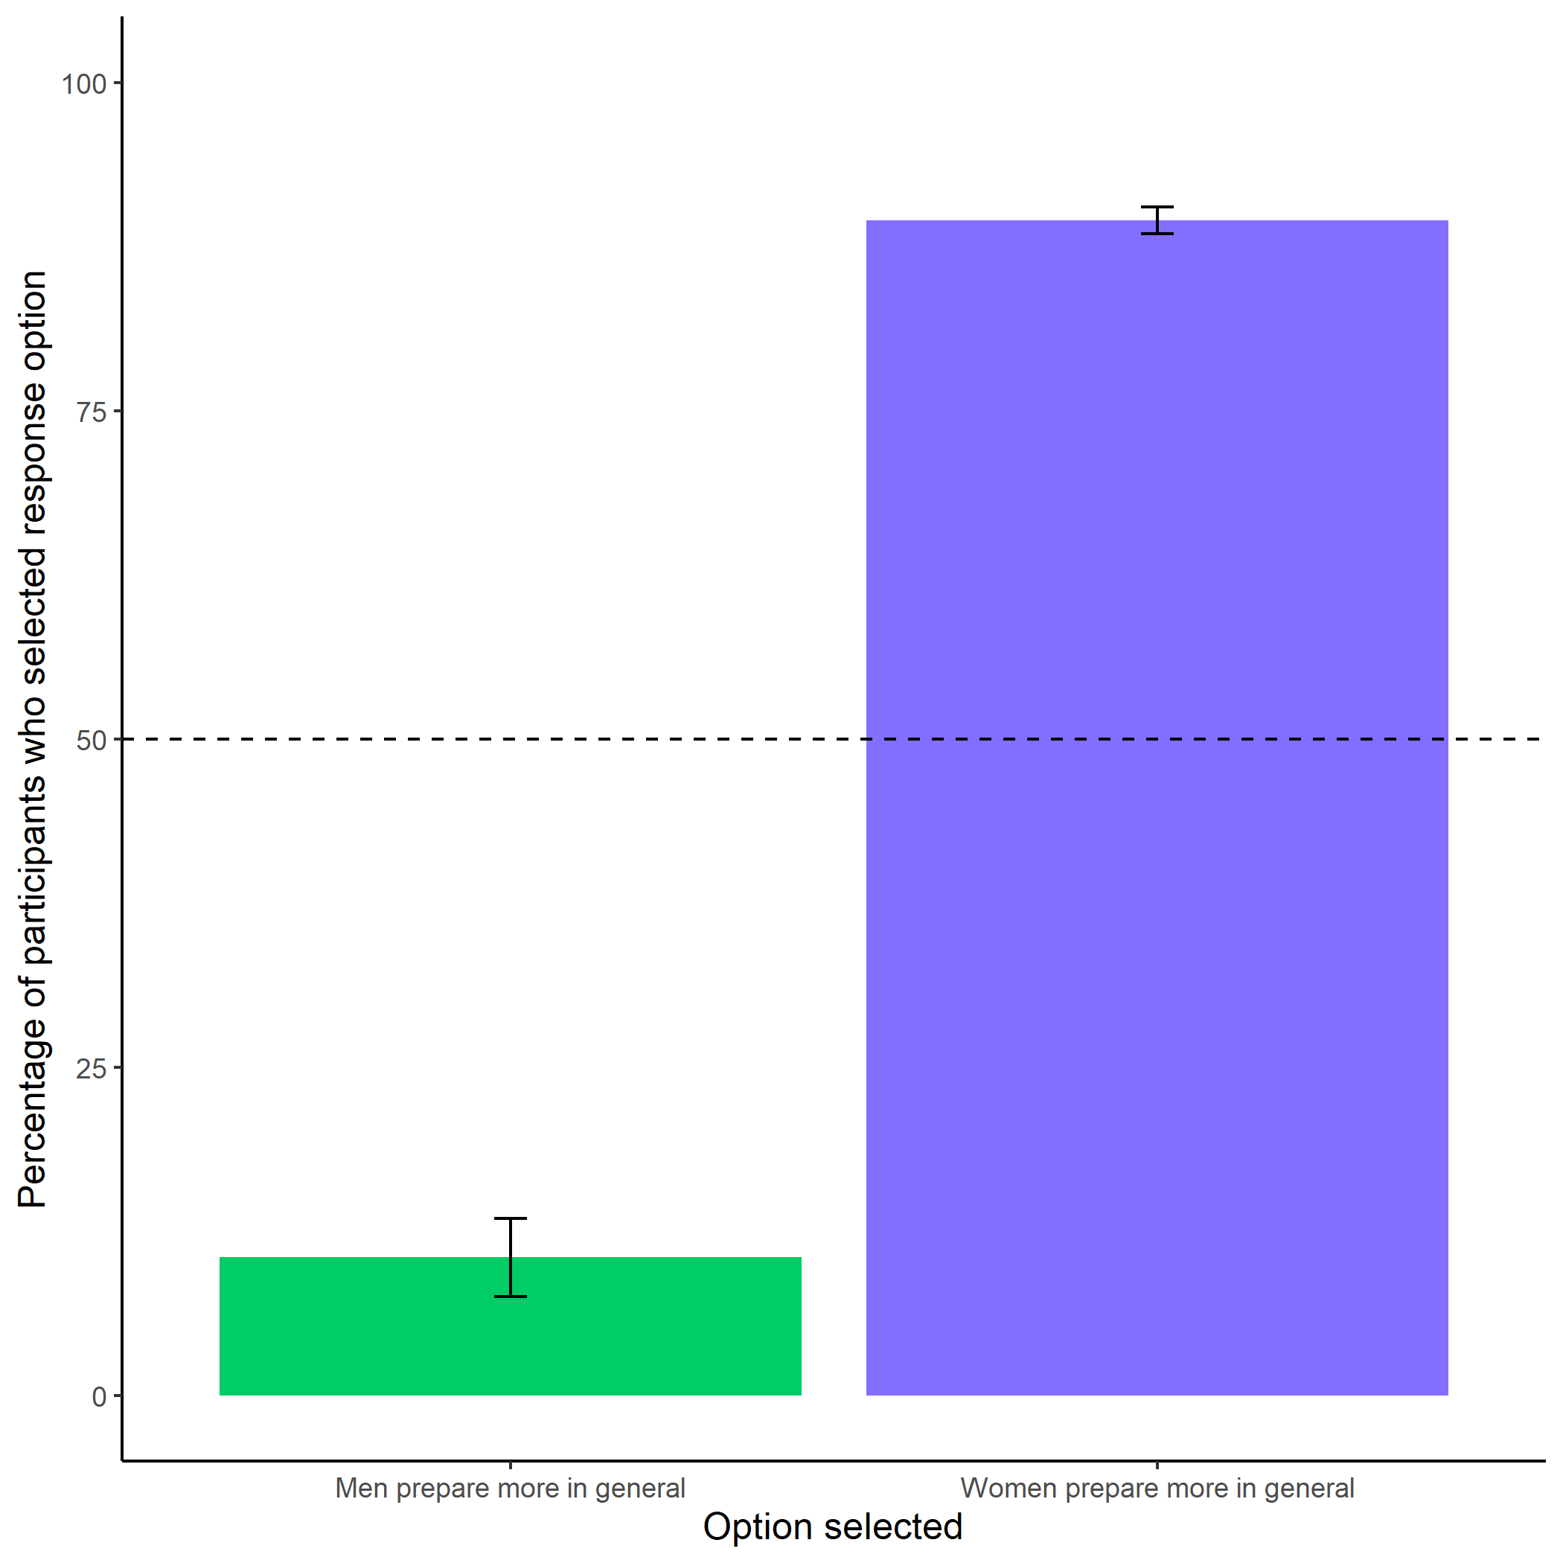

Participants’ perceptions of general gender differences in choice to practice. Error bars represent standard errors.

knitr::include_graphics(here::here("study1", "figs", "fig07_pract-choice-by-gender.png"))

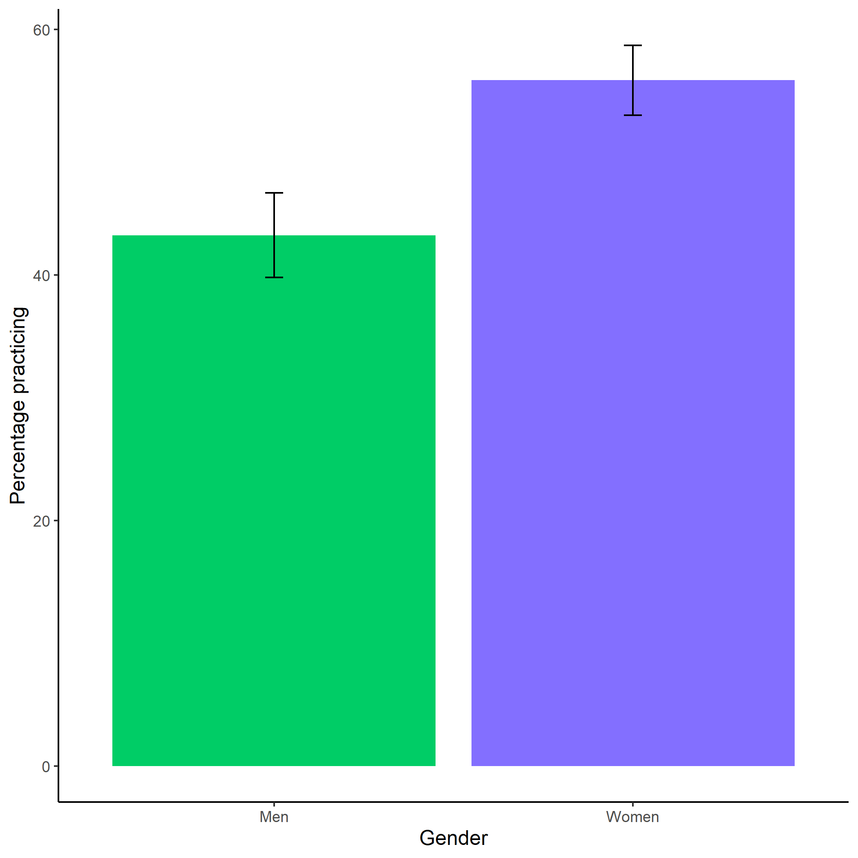

Proportion of men and women who chose to prepare. Error bars represent standard errors.

## Study 2

knitr::include_graphics(here::here("study2", "figs", "fig06_comp-choice-by-gender-and-cond-bar.png"))

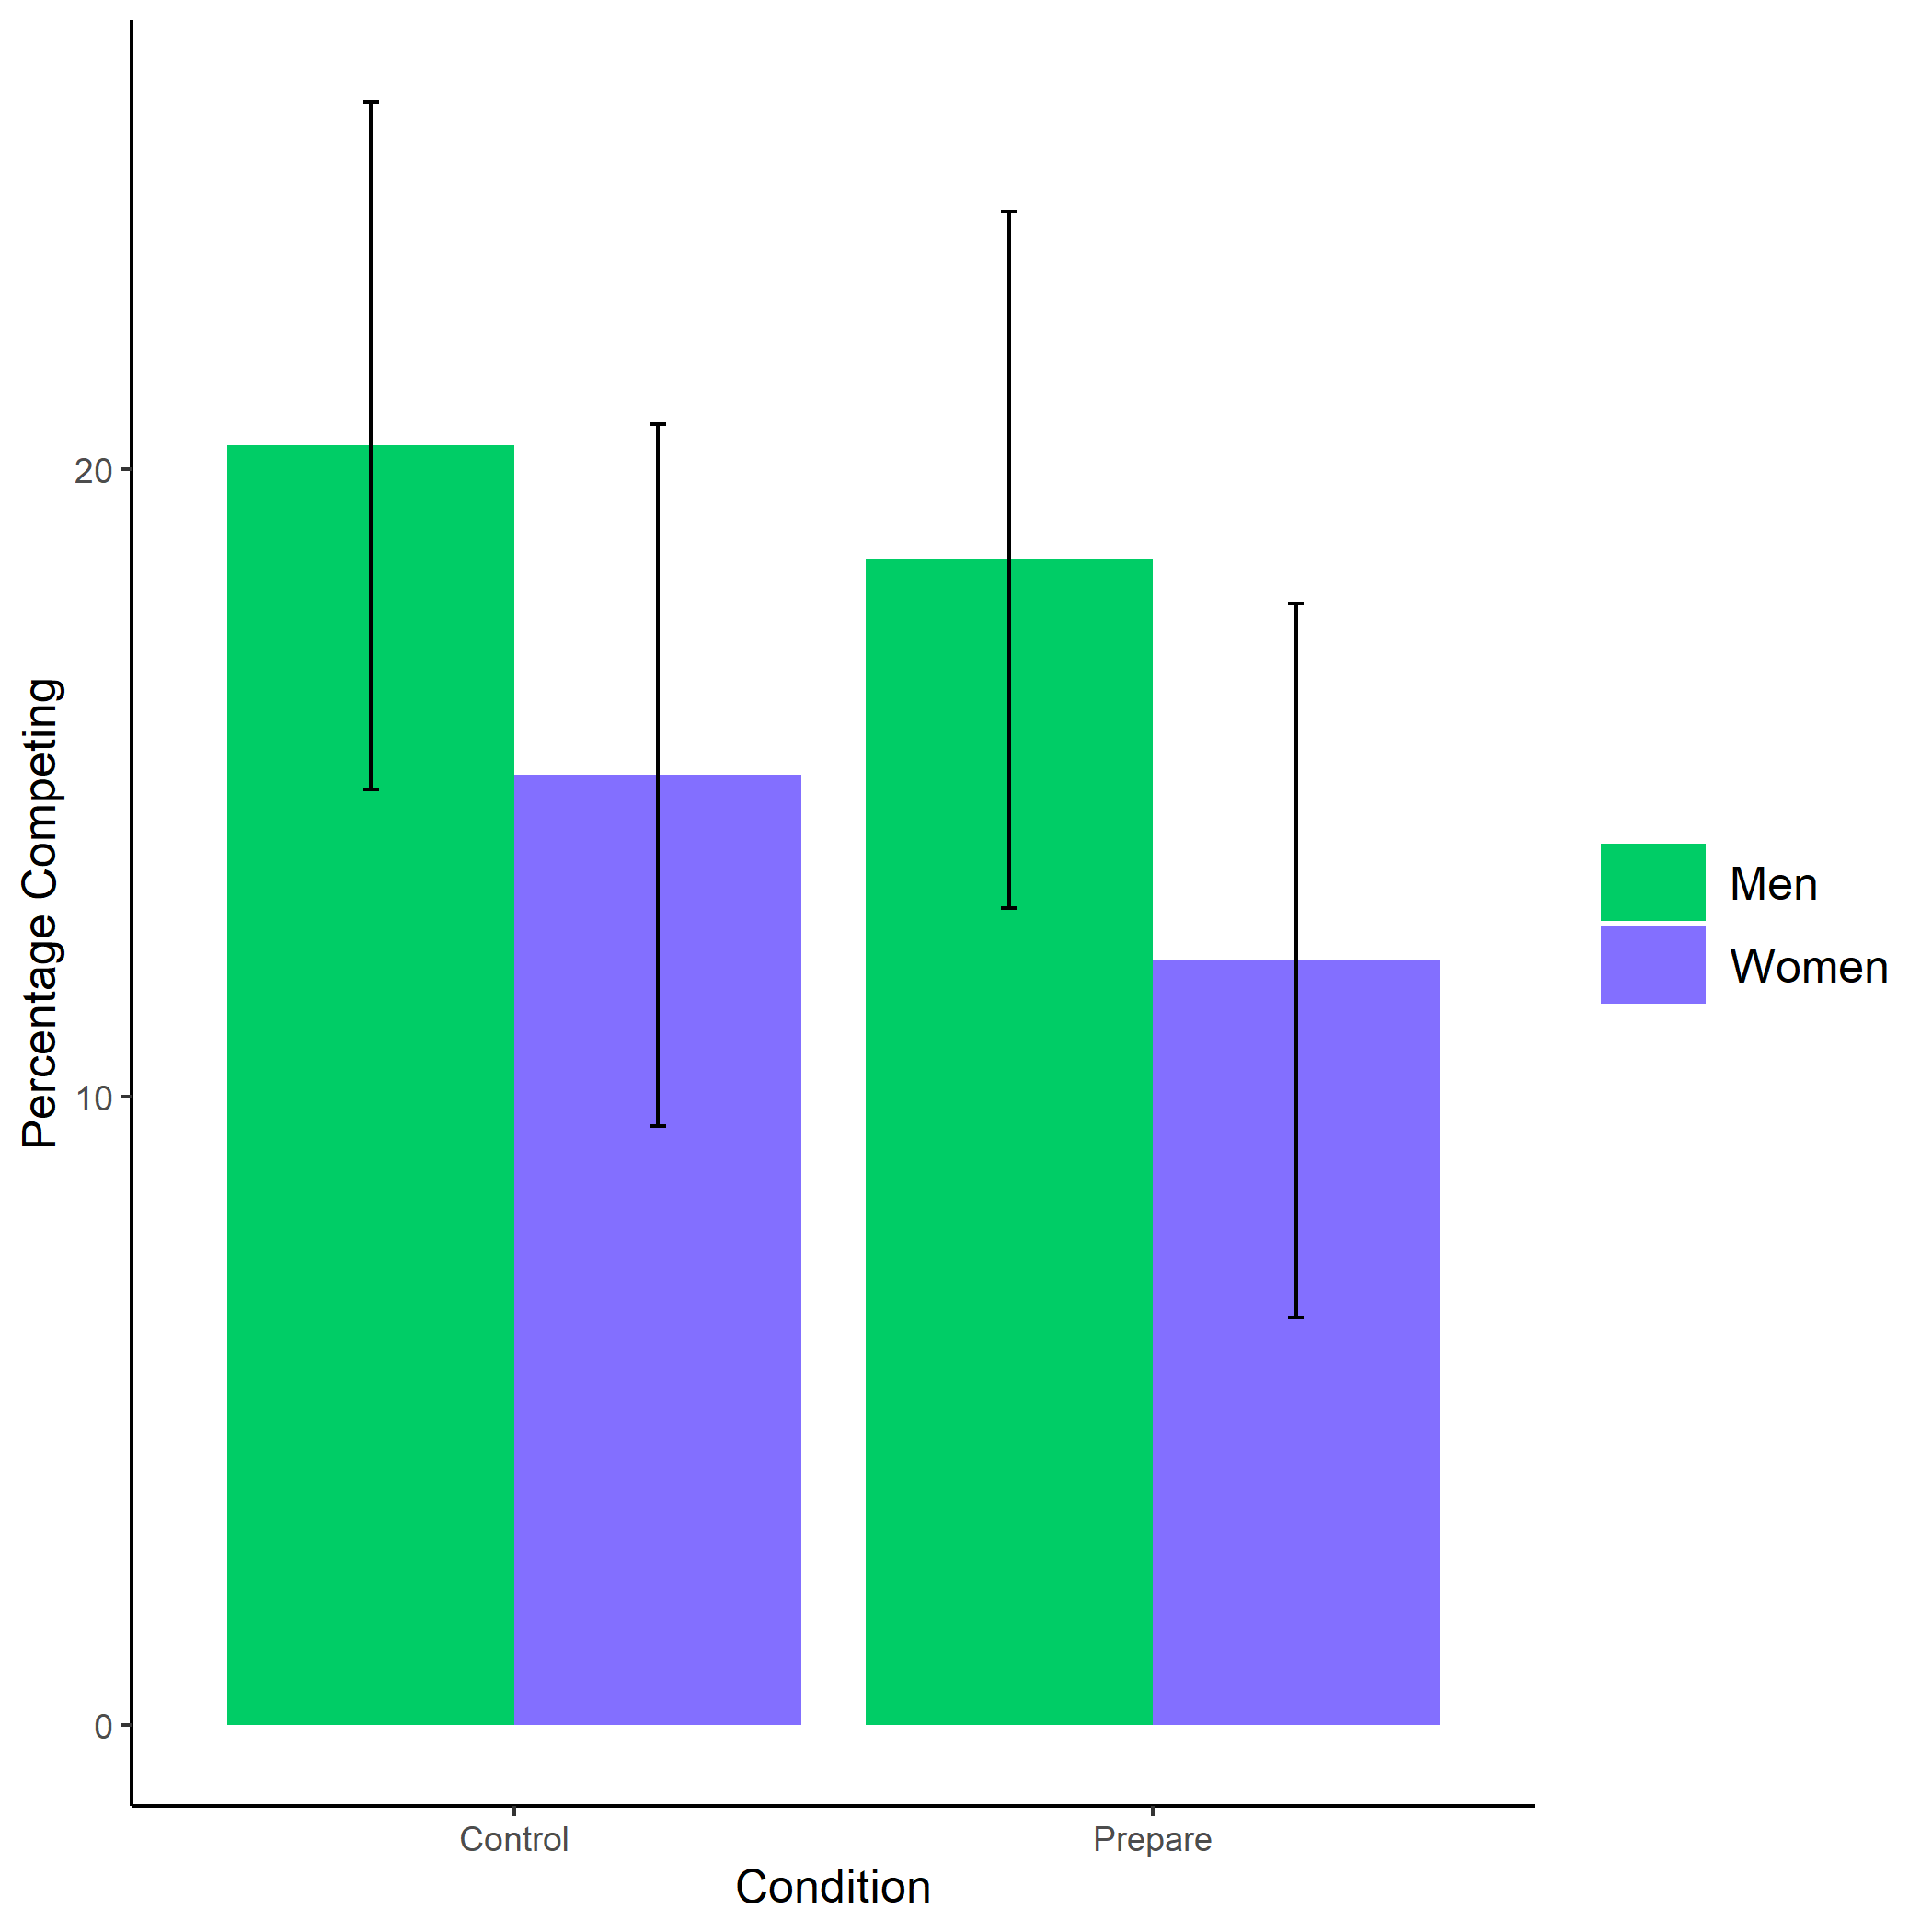

Proportion of men and women who chose to compete by condition. Error bars represent standard errors.

knitr::include_graphics(here::here("study2", "figs", "fig05_pract-choice-by-gender-and-comp-choice-bar.png"))

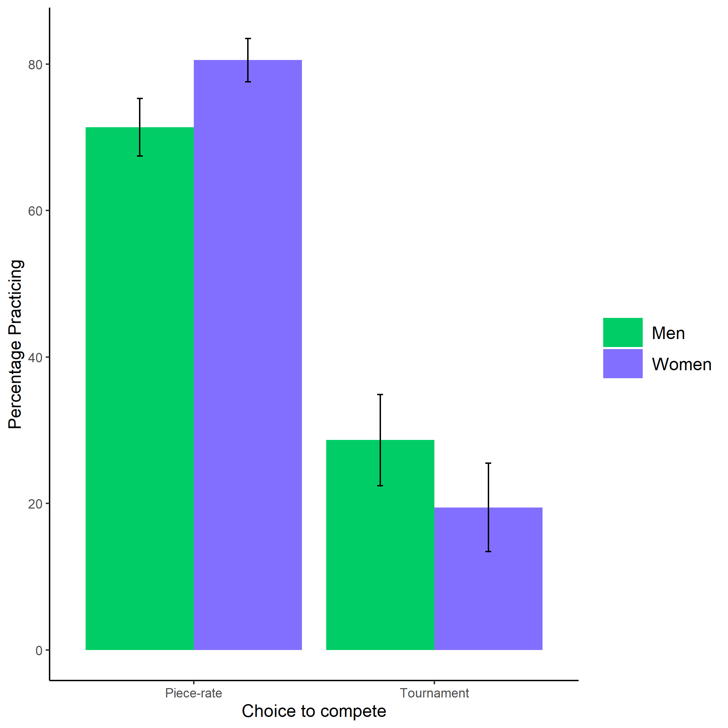

Proportion of men and women who chose to prepare by choice to compete. Error bars represent standard errors.

knitr::include_graphics(here::here("study2", "figs", "fig08_perc-task-gender-pract.png"))

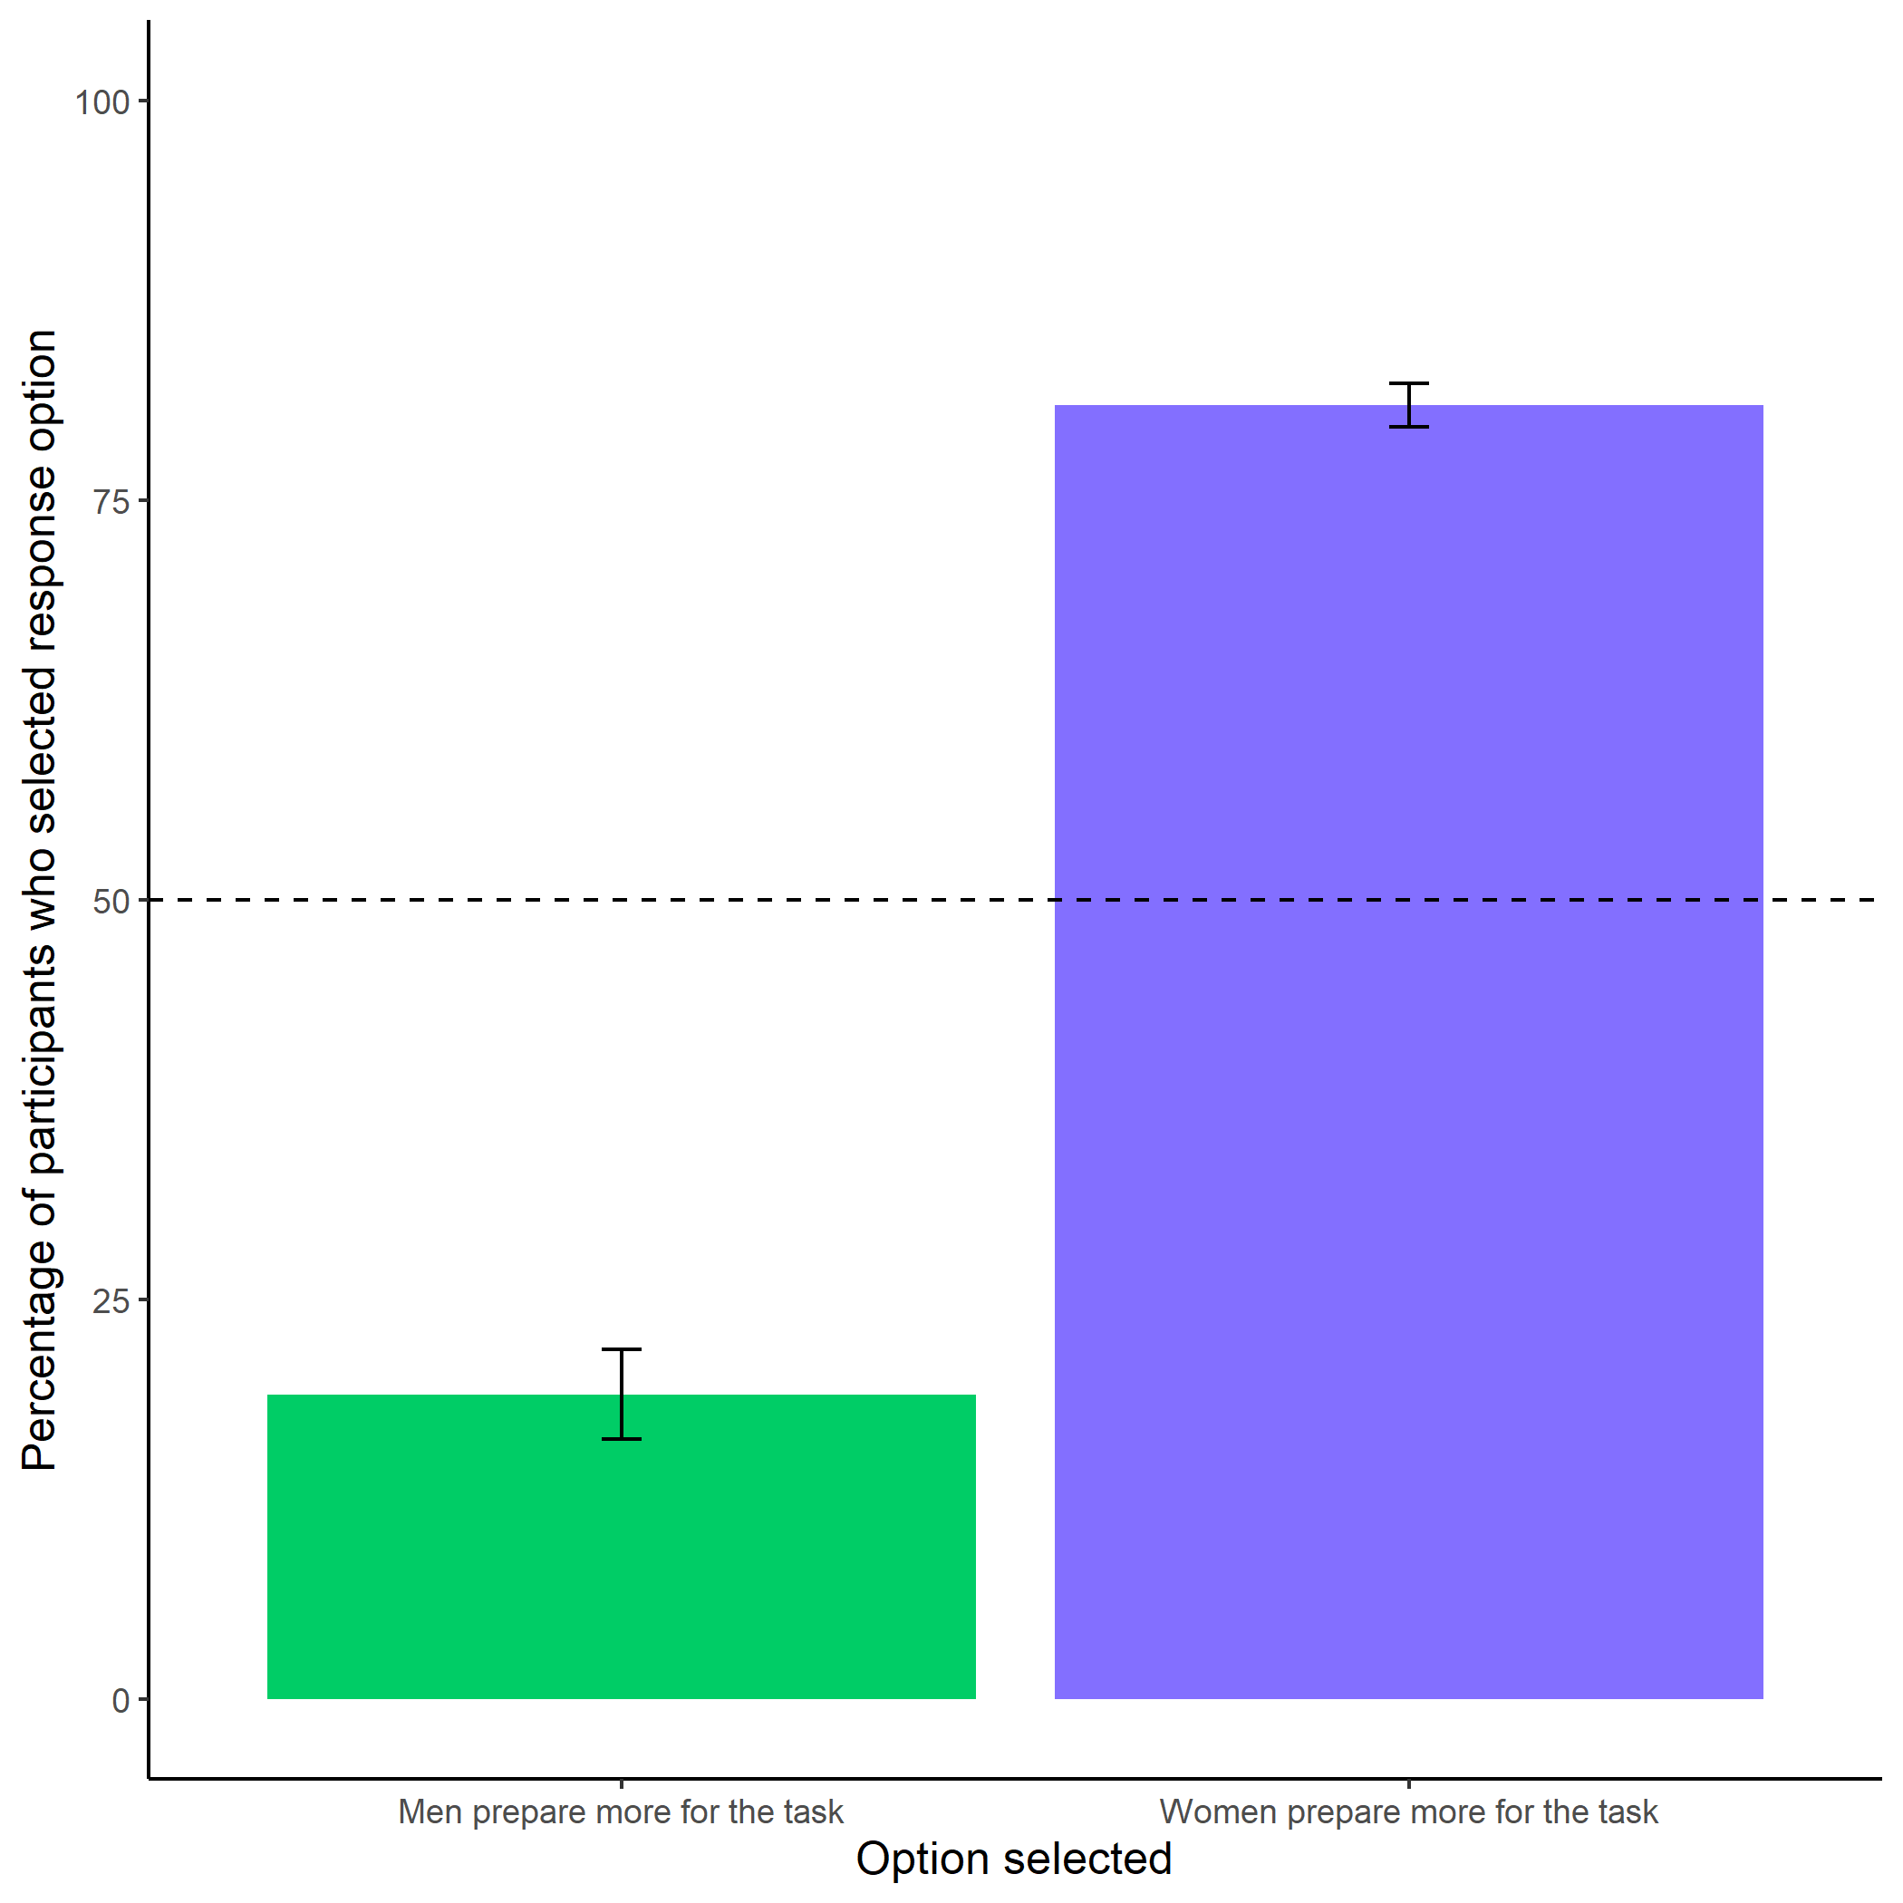

Participants’ perceptions of gender differences in the choice to practice on the task. Error bars represent standard errors.

knitr::include_graphics(here::here("study2", "figs", "fig01_better-gender-guess.png"))

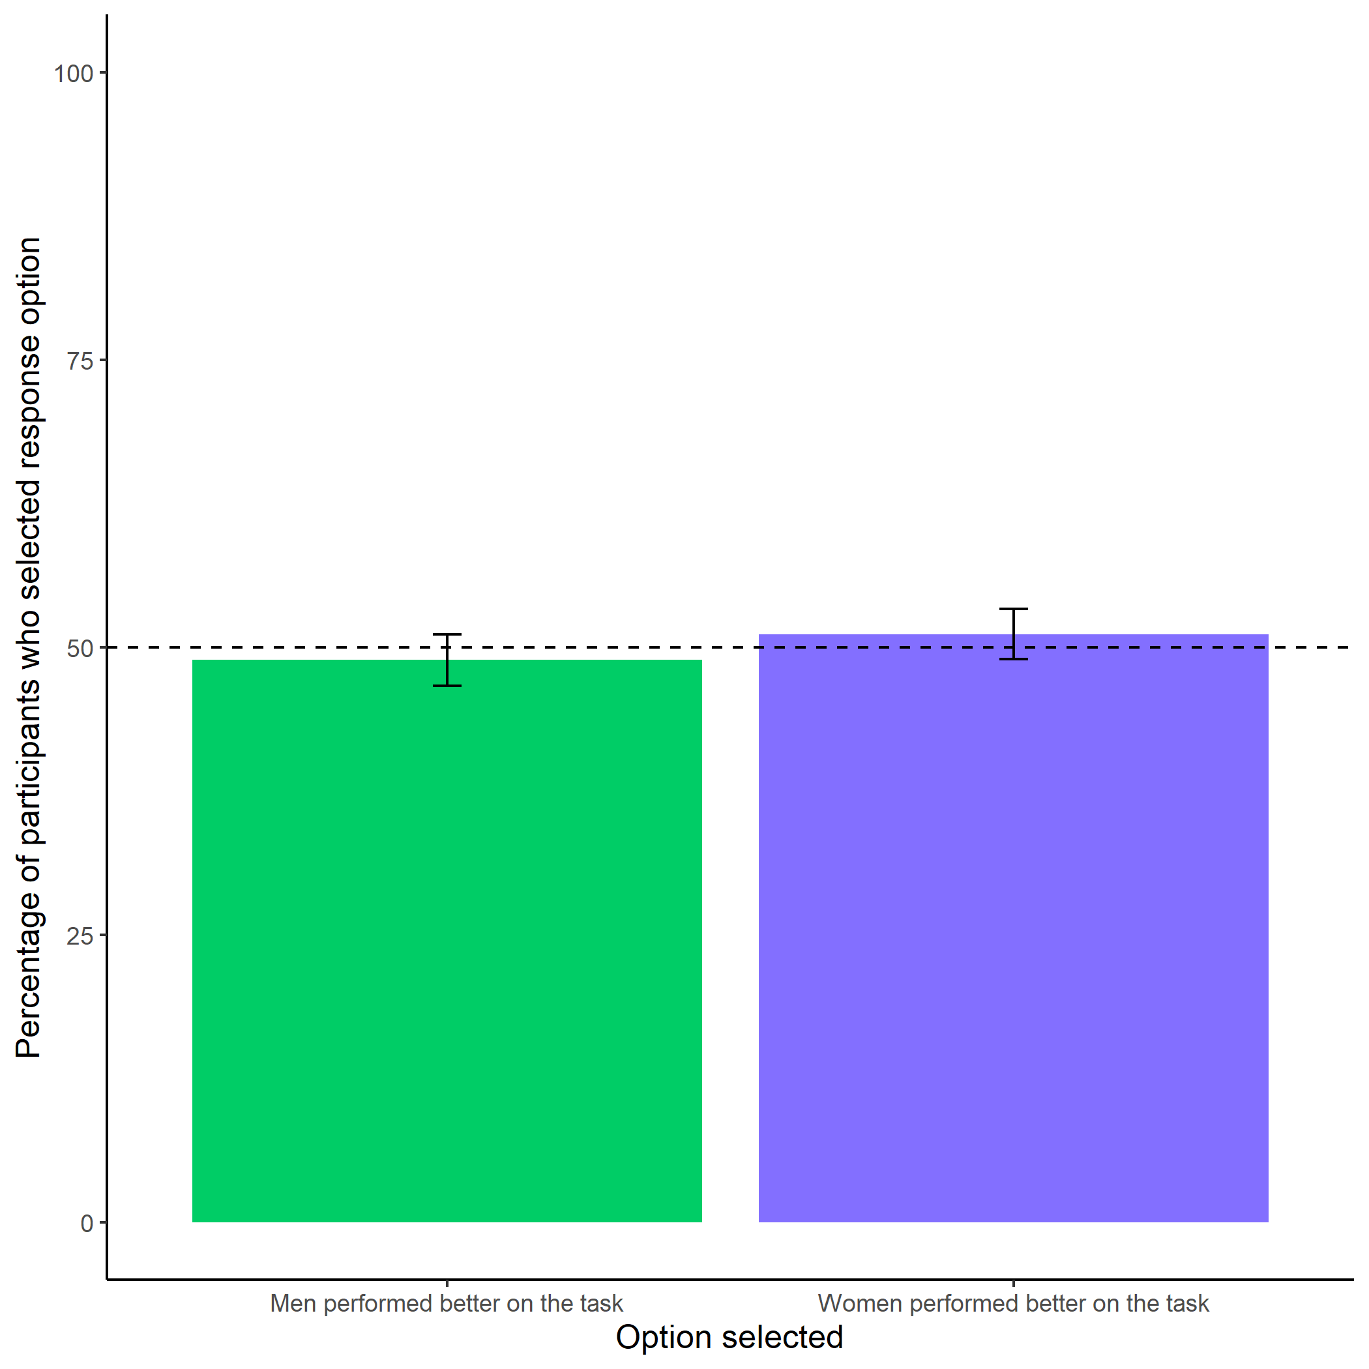

Participants’ perceptions of gender differences in performance on the task. Error bars represent standard errors.

knitr::include_graphics(here::here("study2", "figs", "fig02_perc-gender-comp.png"))

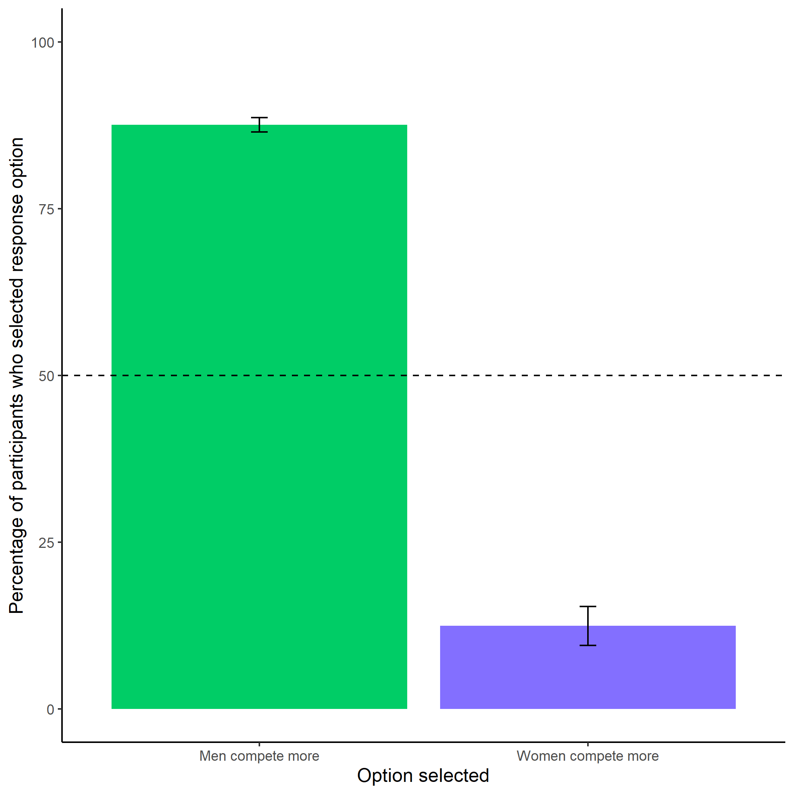

Participants’ perceptions of gender differences in choice to compete. Error bars represent standard errors.

knitr::include_graphics(here::here("study2", "figs", "fig03_perc-gen-gender-pract.png"))

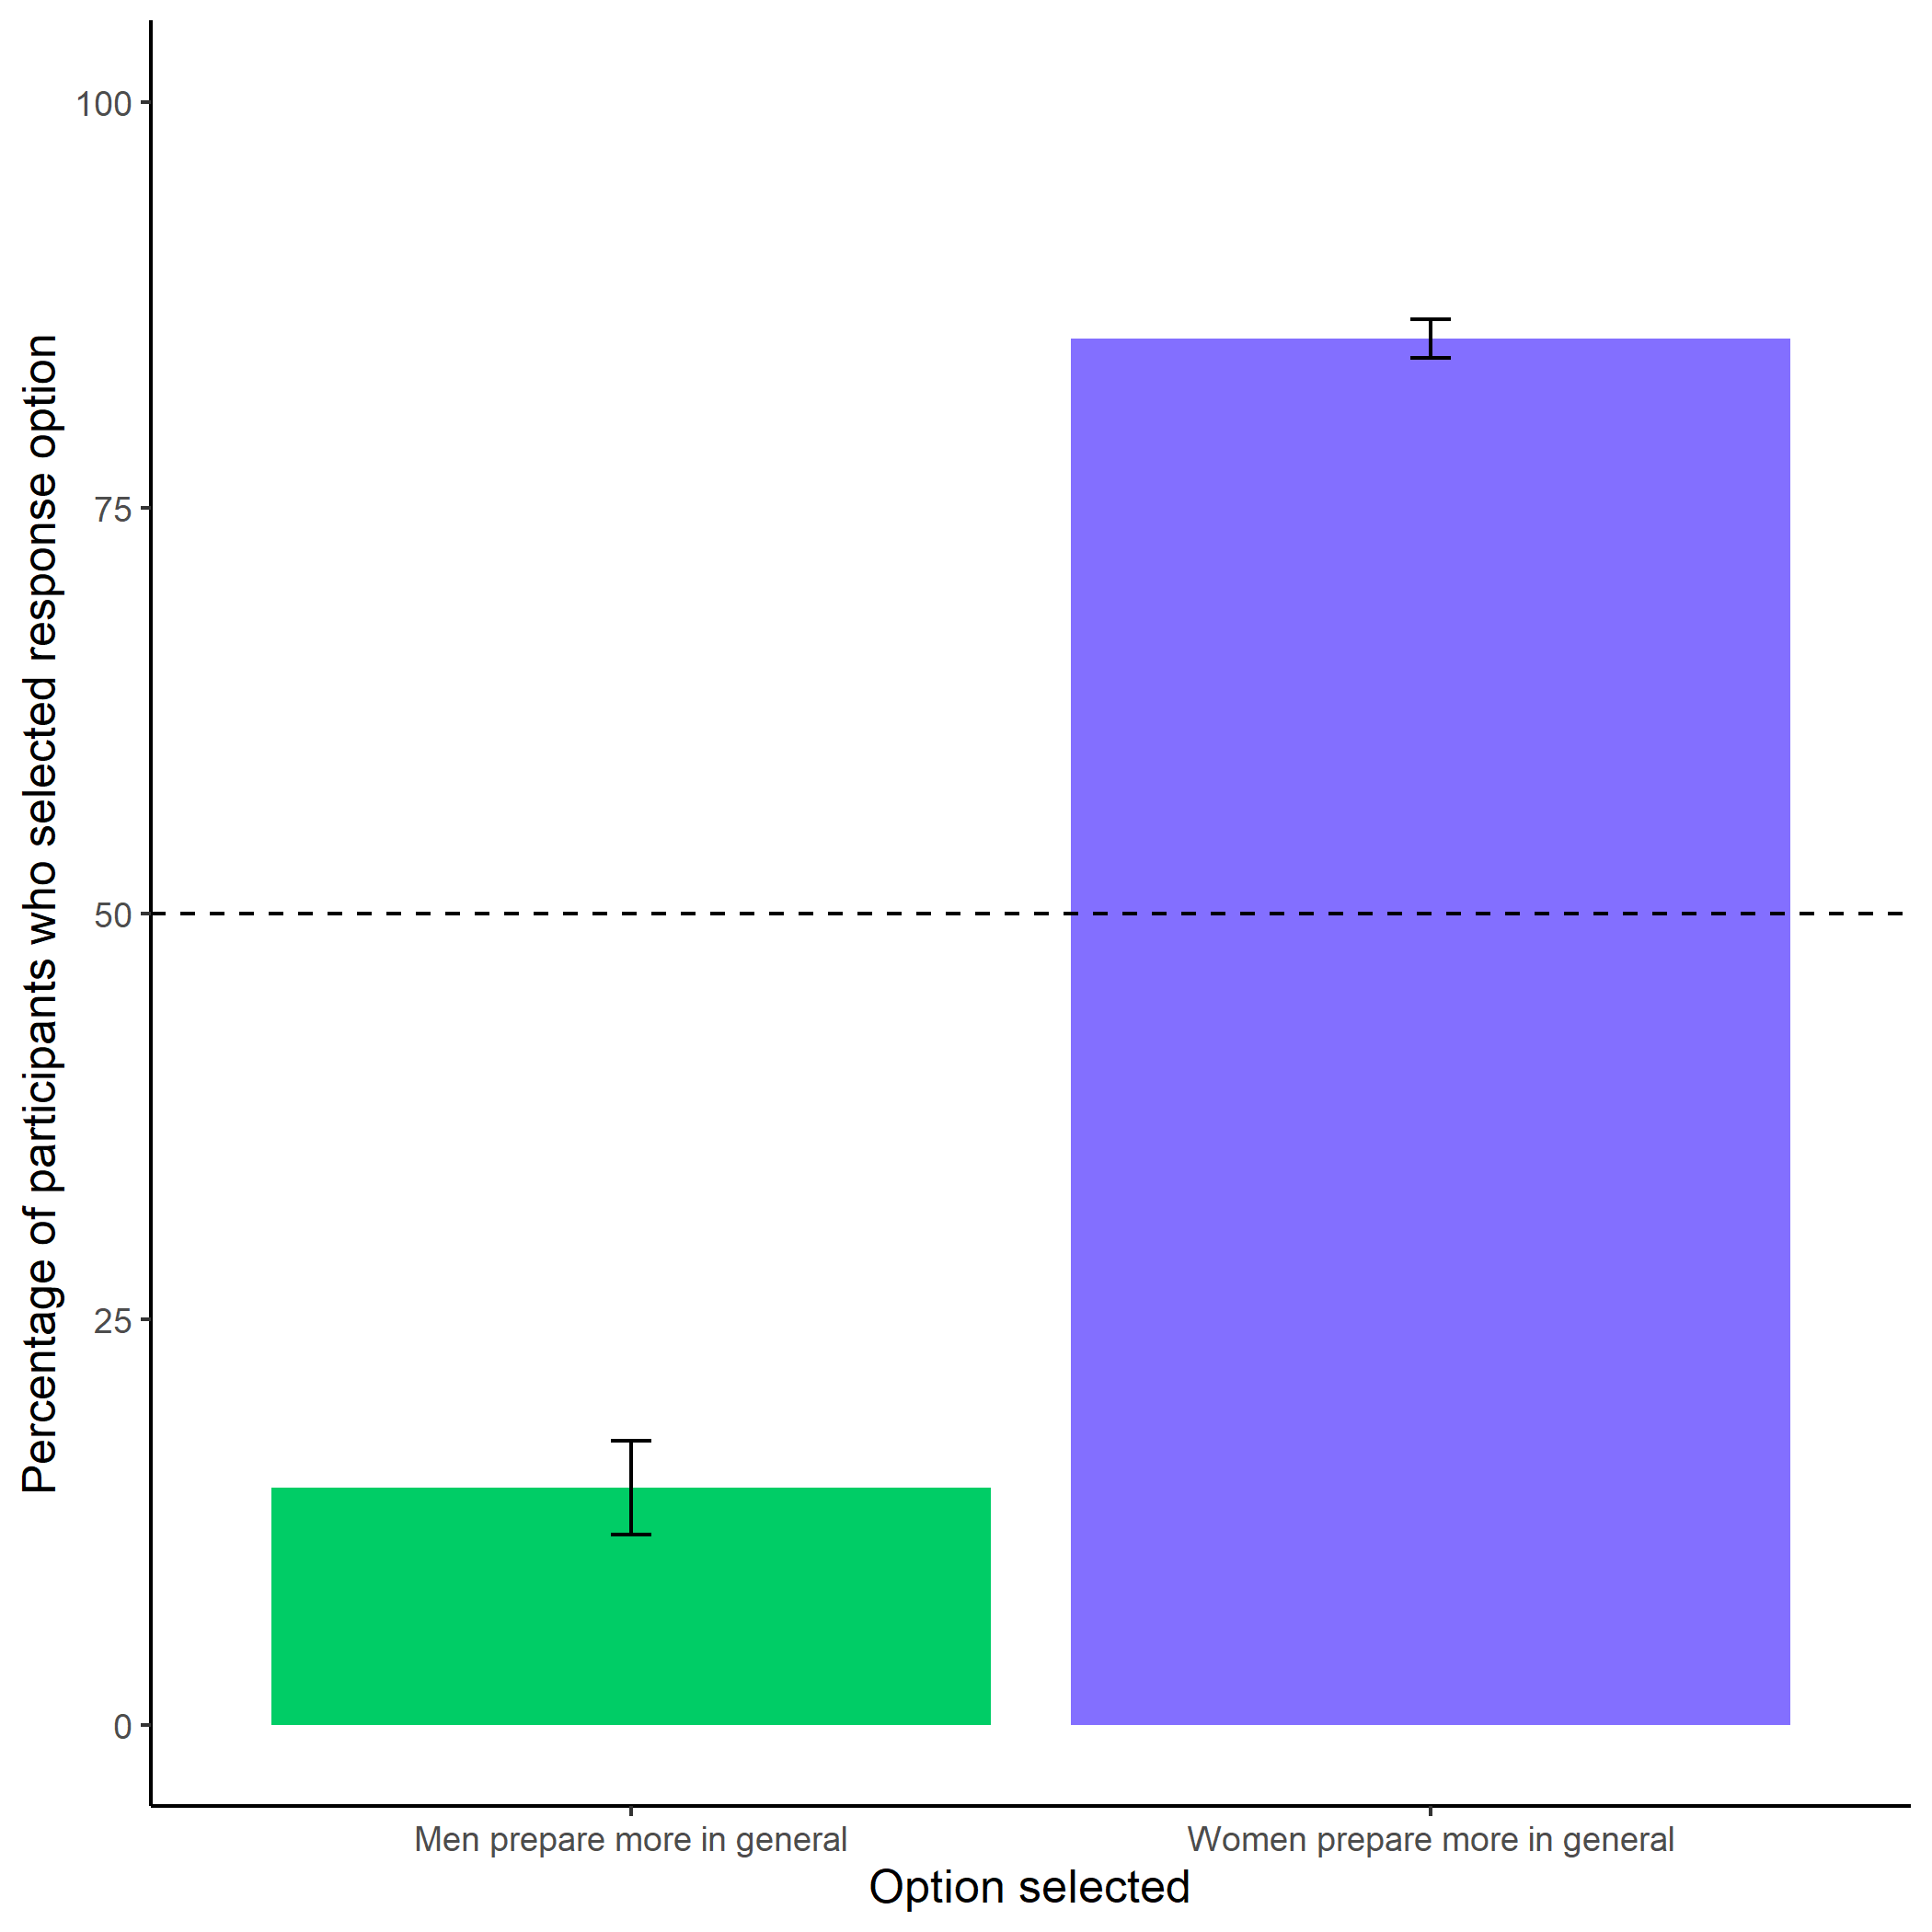

Participants’ perceptions of general gender differences in choice to practice. Error bars represent standard errors.

knitr::include_graphics(here::here("study2", "figs", "fig07_pract-choice-by-gender.png"))

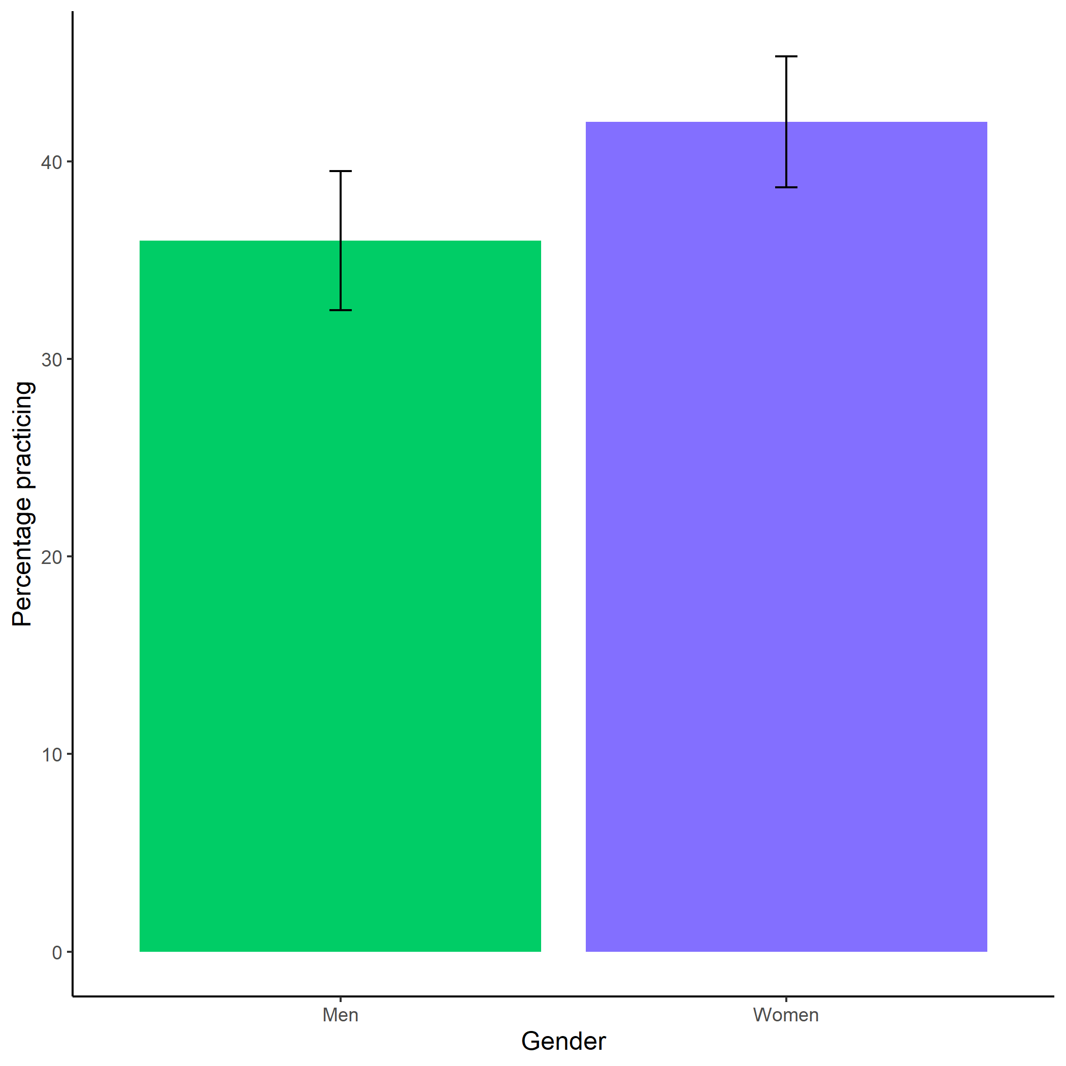

Proportion of men and women who chose to prepare. Error bars represent standard errors.

## Study 3

knitr::include_graphics(here::here("study4", "figs", "fig02_comp-choice-by-gender-and-cond-bar.png"))

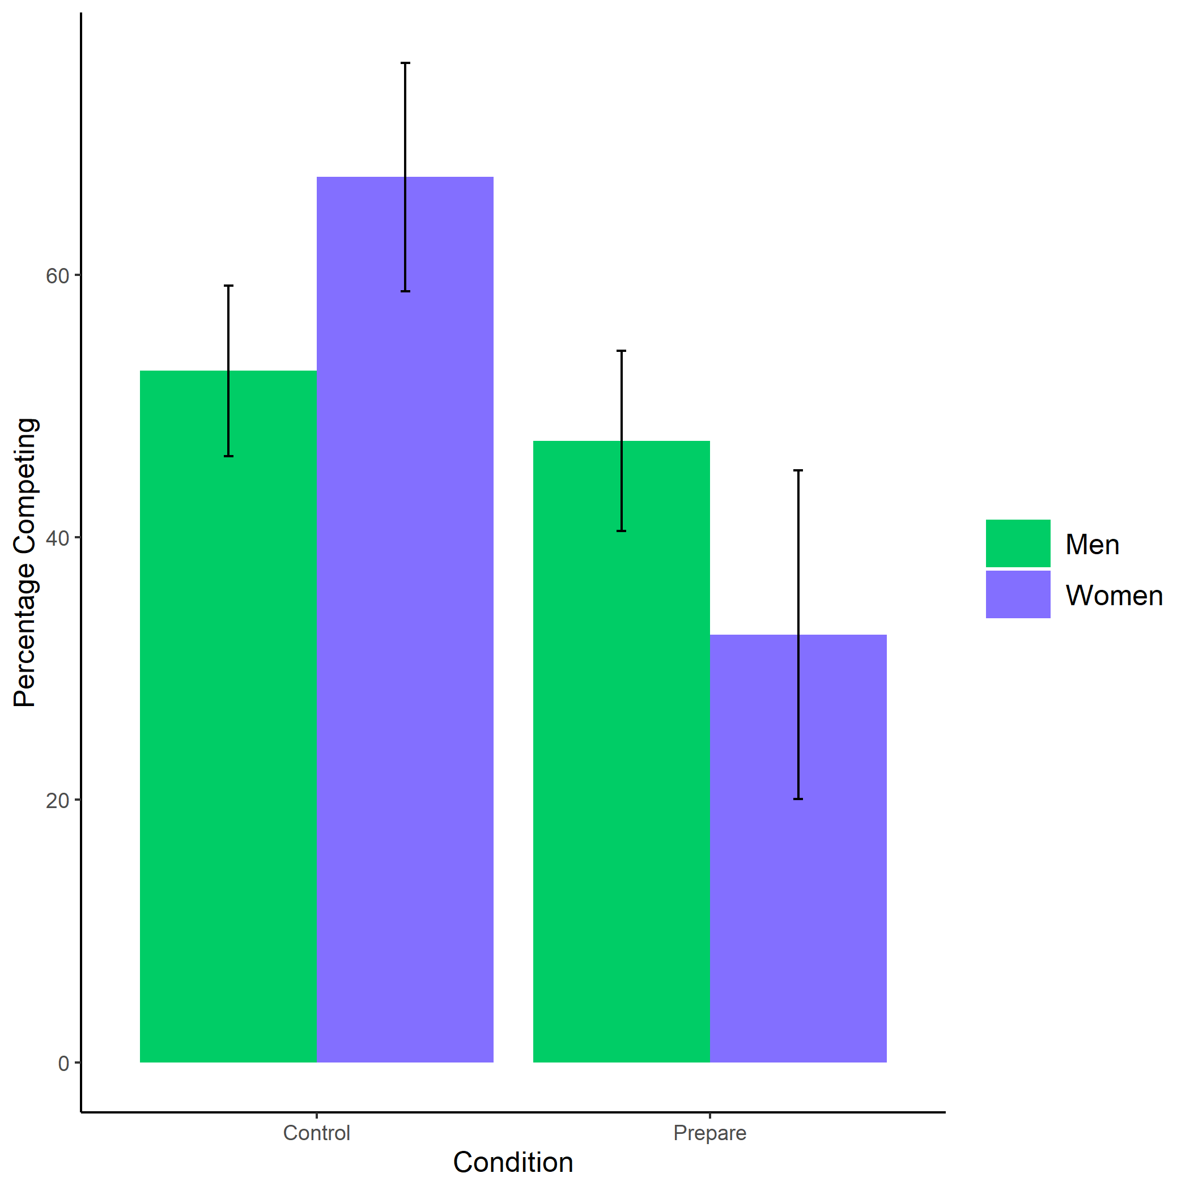

Proportion of men and women who chose to compete by condition. Error bars represent standard errors.

knitr::include_graphics(here::here("study4", "figs", "fig05_pract-choice-by-gender-and-comp-choice-bar.png"))

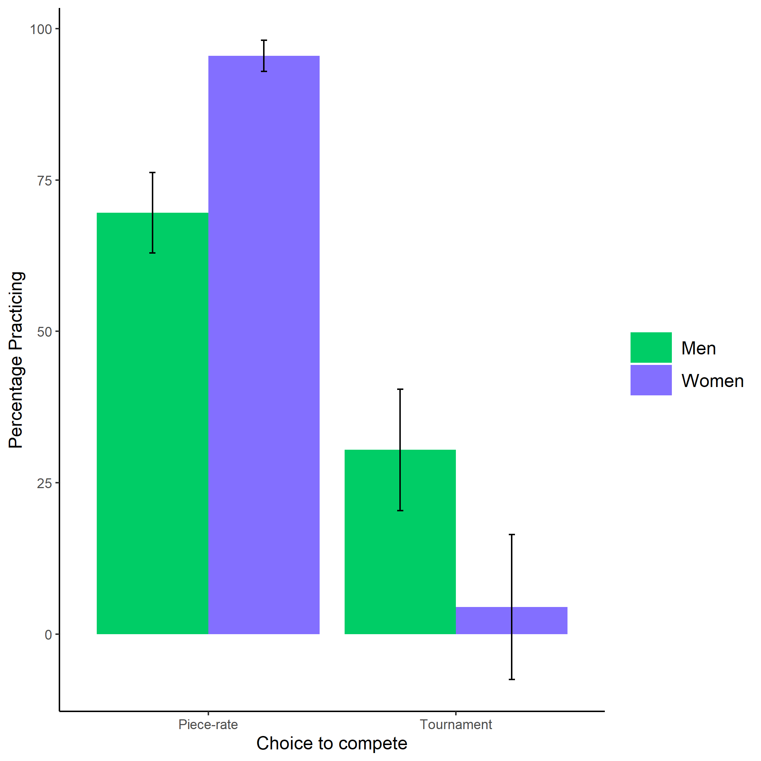

Proportion of men and women who chose to prepare by choice to compete. Error bars represent standard errors.

knitr::include_graphics(here::here("study4", "figs", "fig07_perc-task-gender-pract.png"))

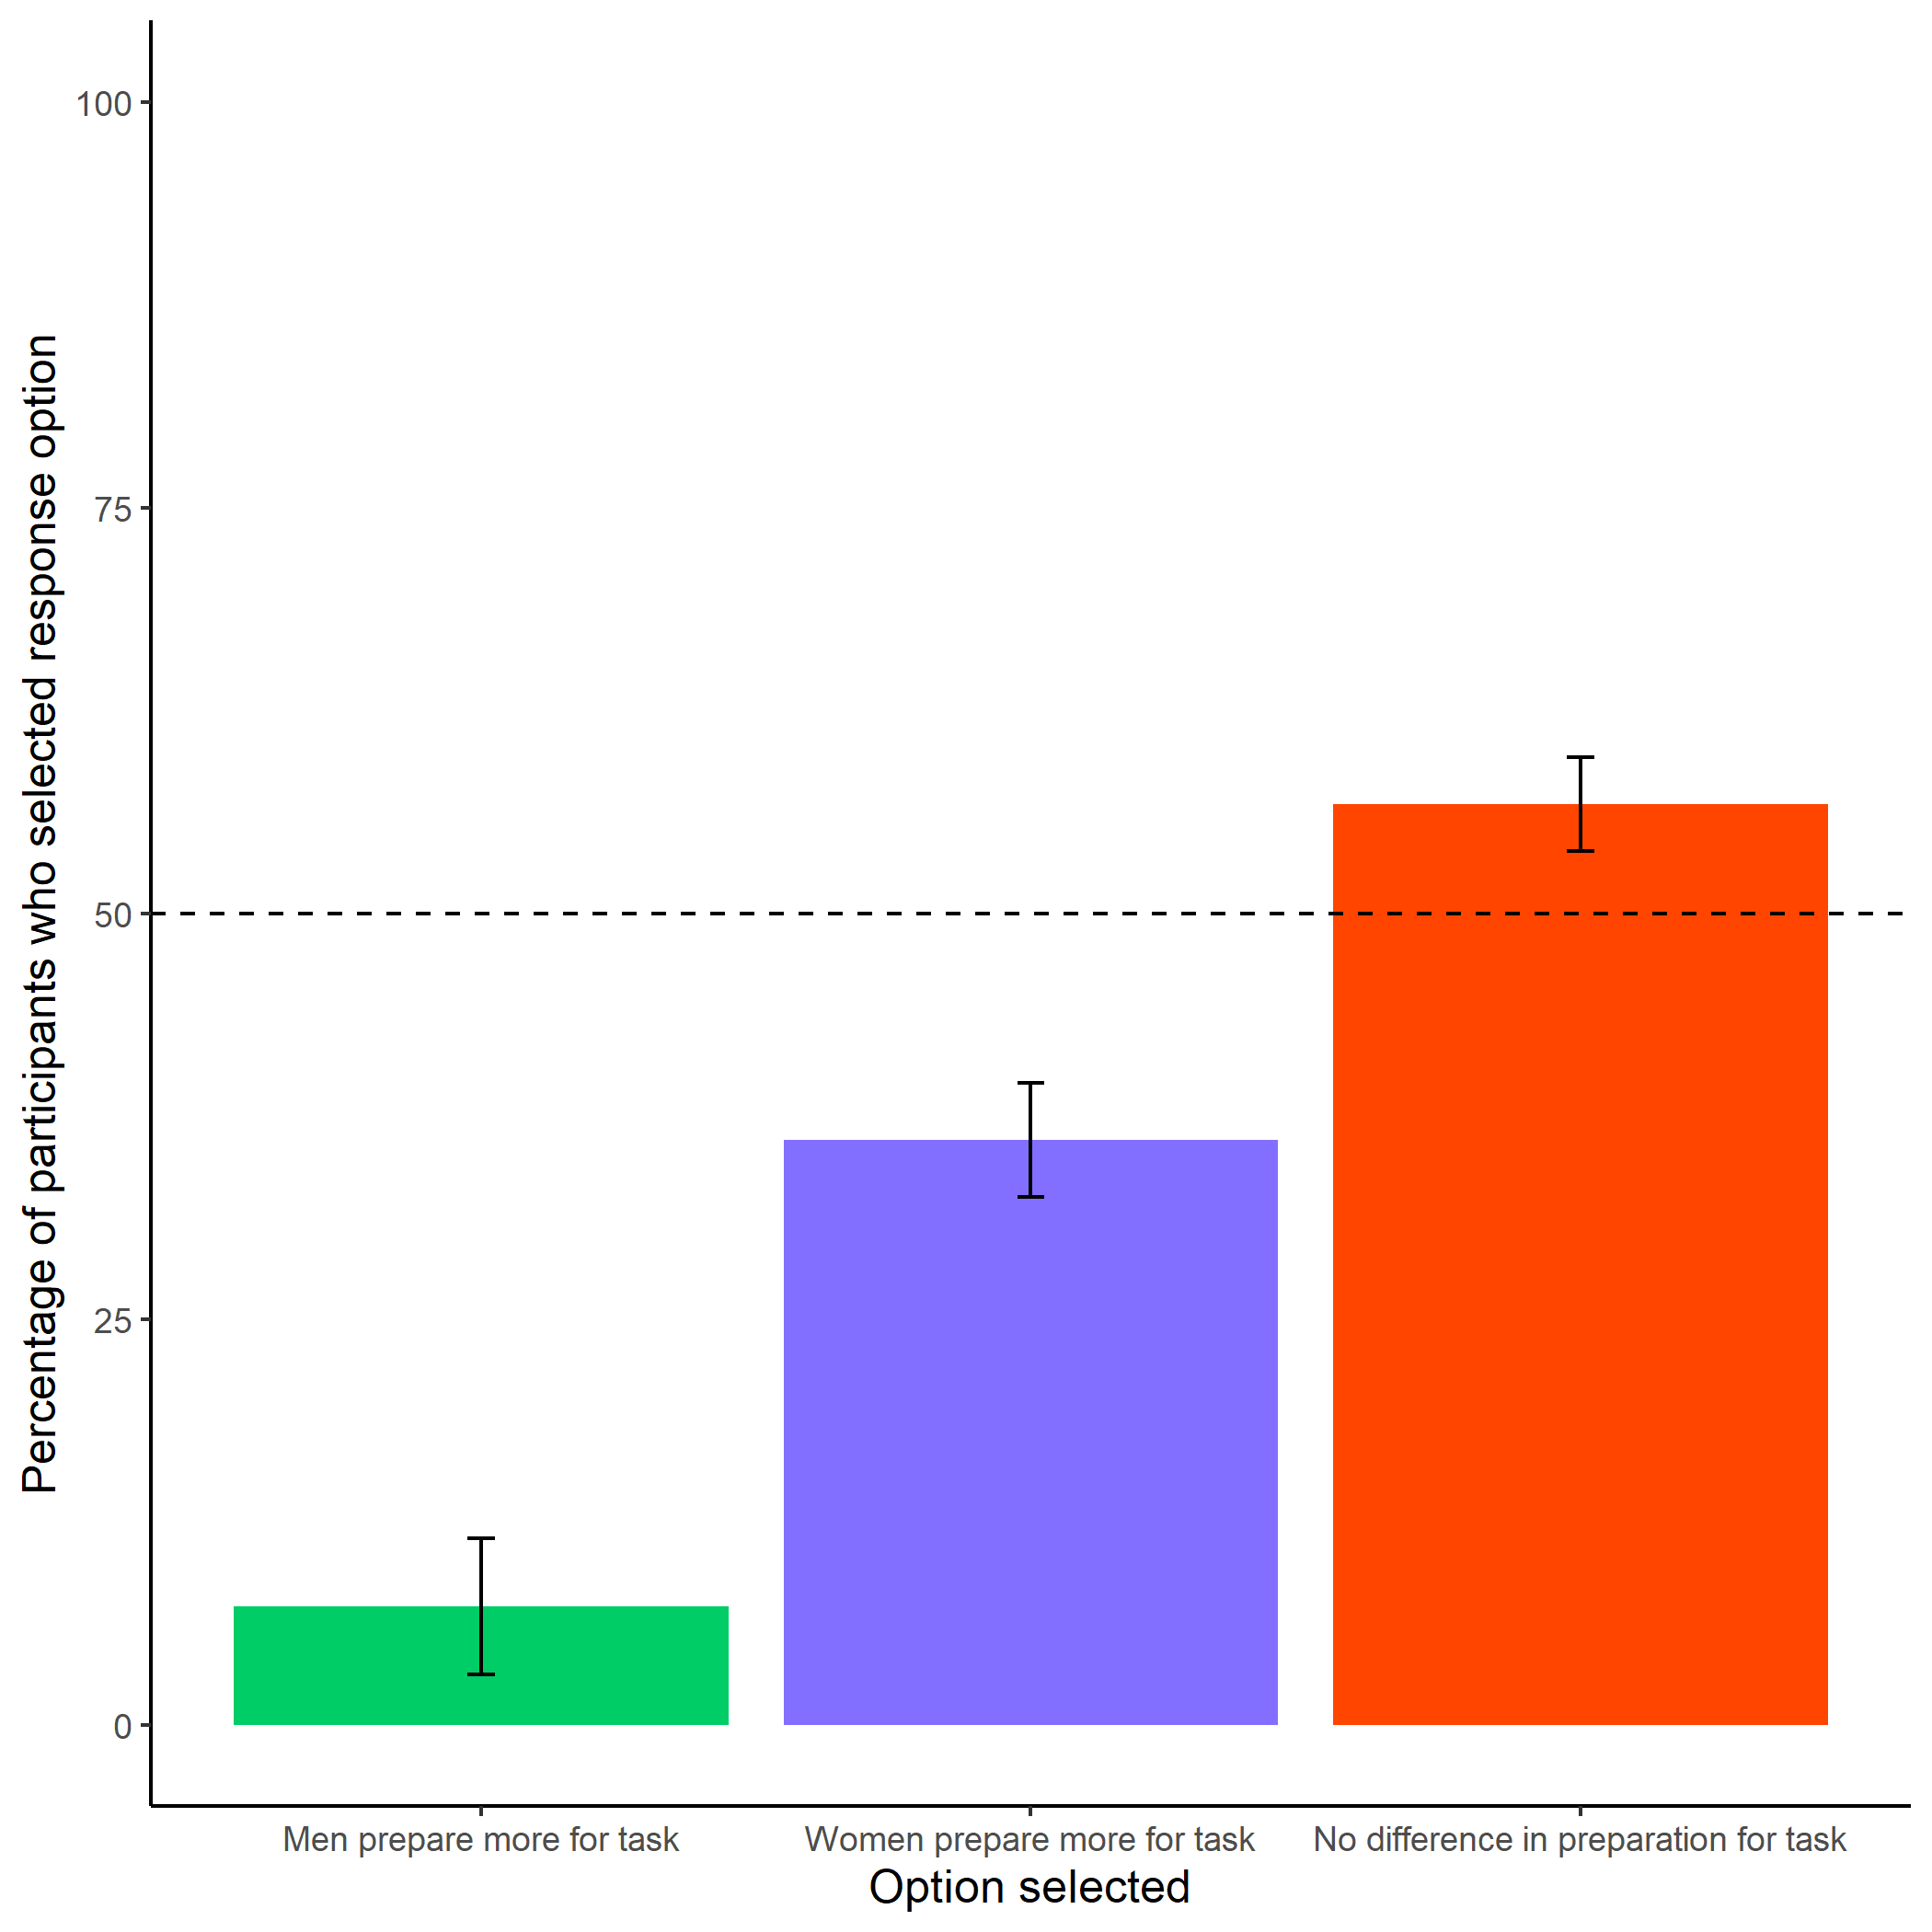

Participants’ perceptions of gender differences in the choice to practice on the task. Error bars represent standard errors.

knitr::include_graphics(here::here("study4", "figs", "fig10_better-gender-guess.png"))

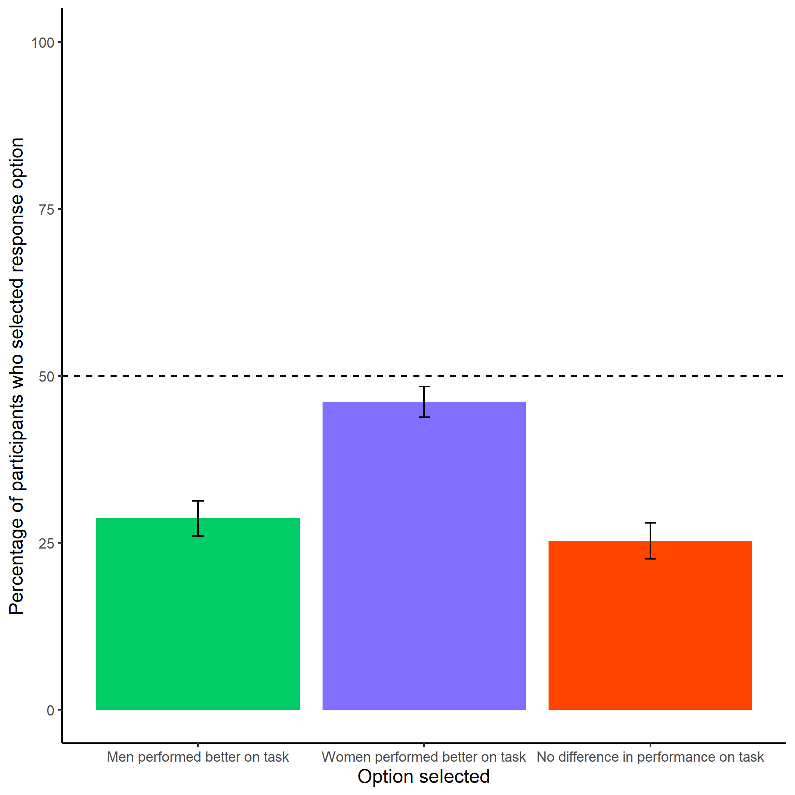

Participants’ perceptions of gender differences in performance on the task. Error bars represent standard errors.

knitr::include_graphics(here::here("study4", "figs", "fig09_perc-gender-comp.png"))

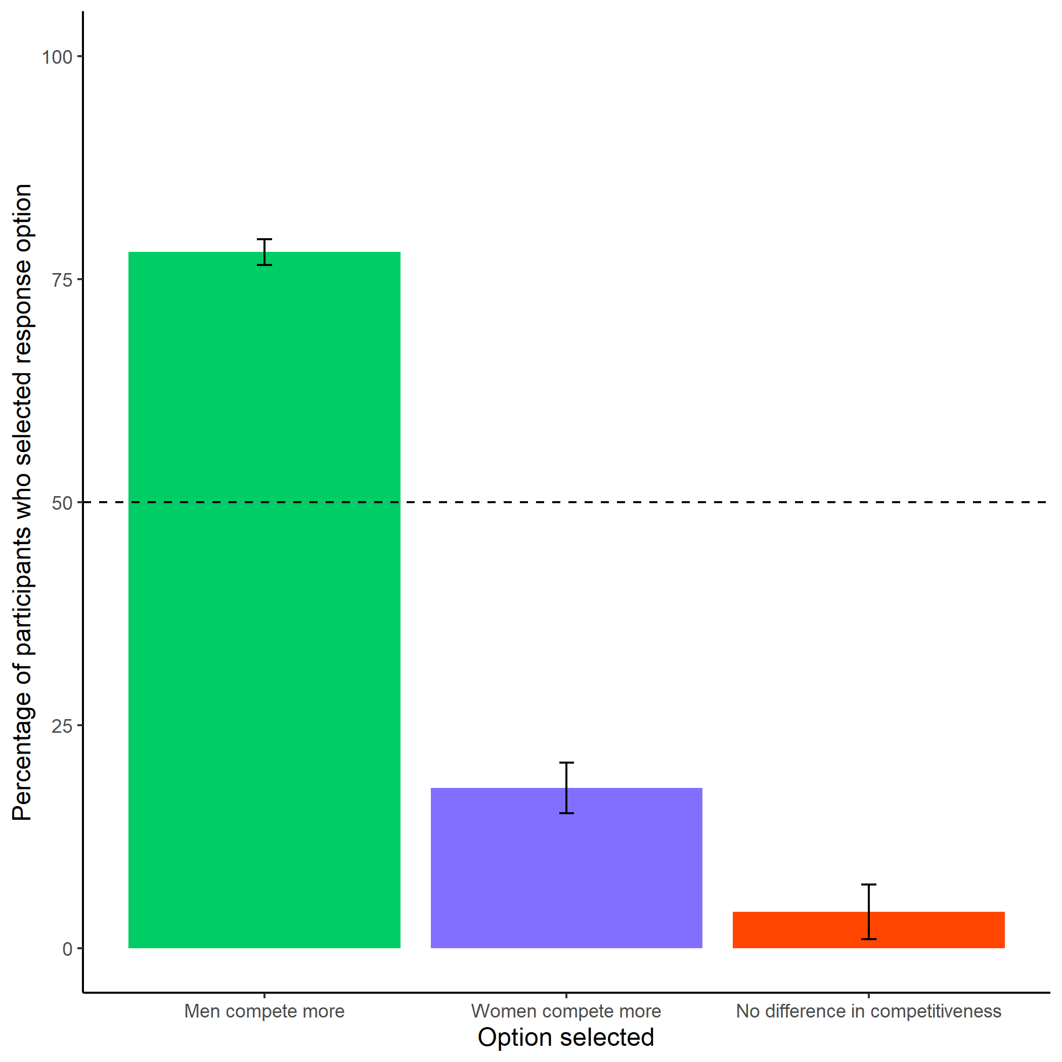

Participants’ perceptions of gender differences in choice to compete. Error bars represent standard errors.

knitr::include_graphics(here::here("study4", "figs", "fig08_perc-gen-gender-pract.png"))

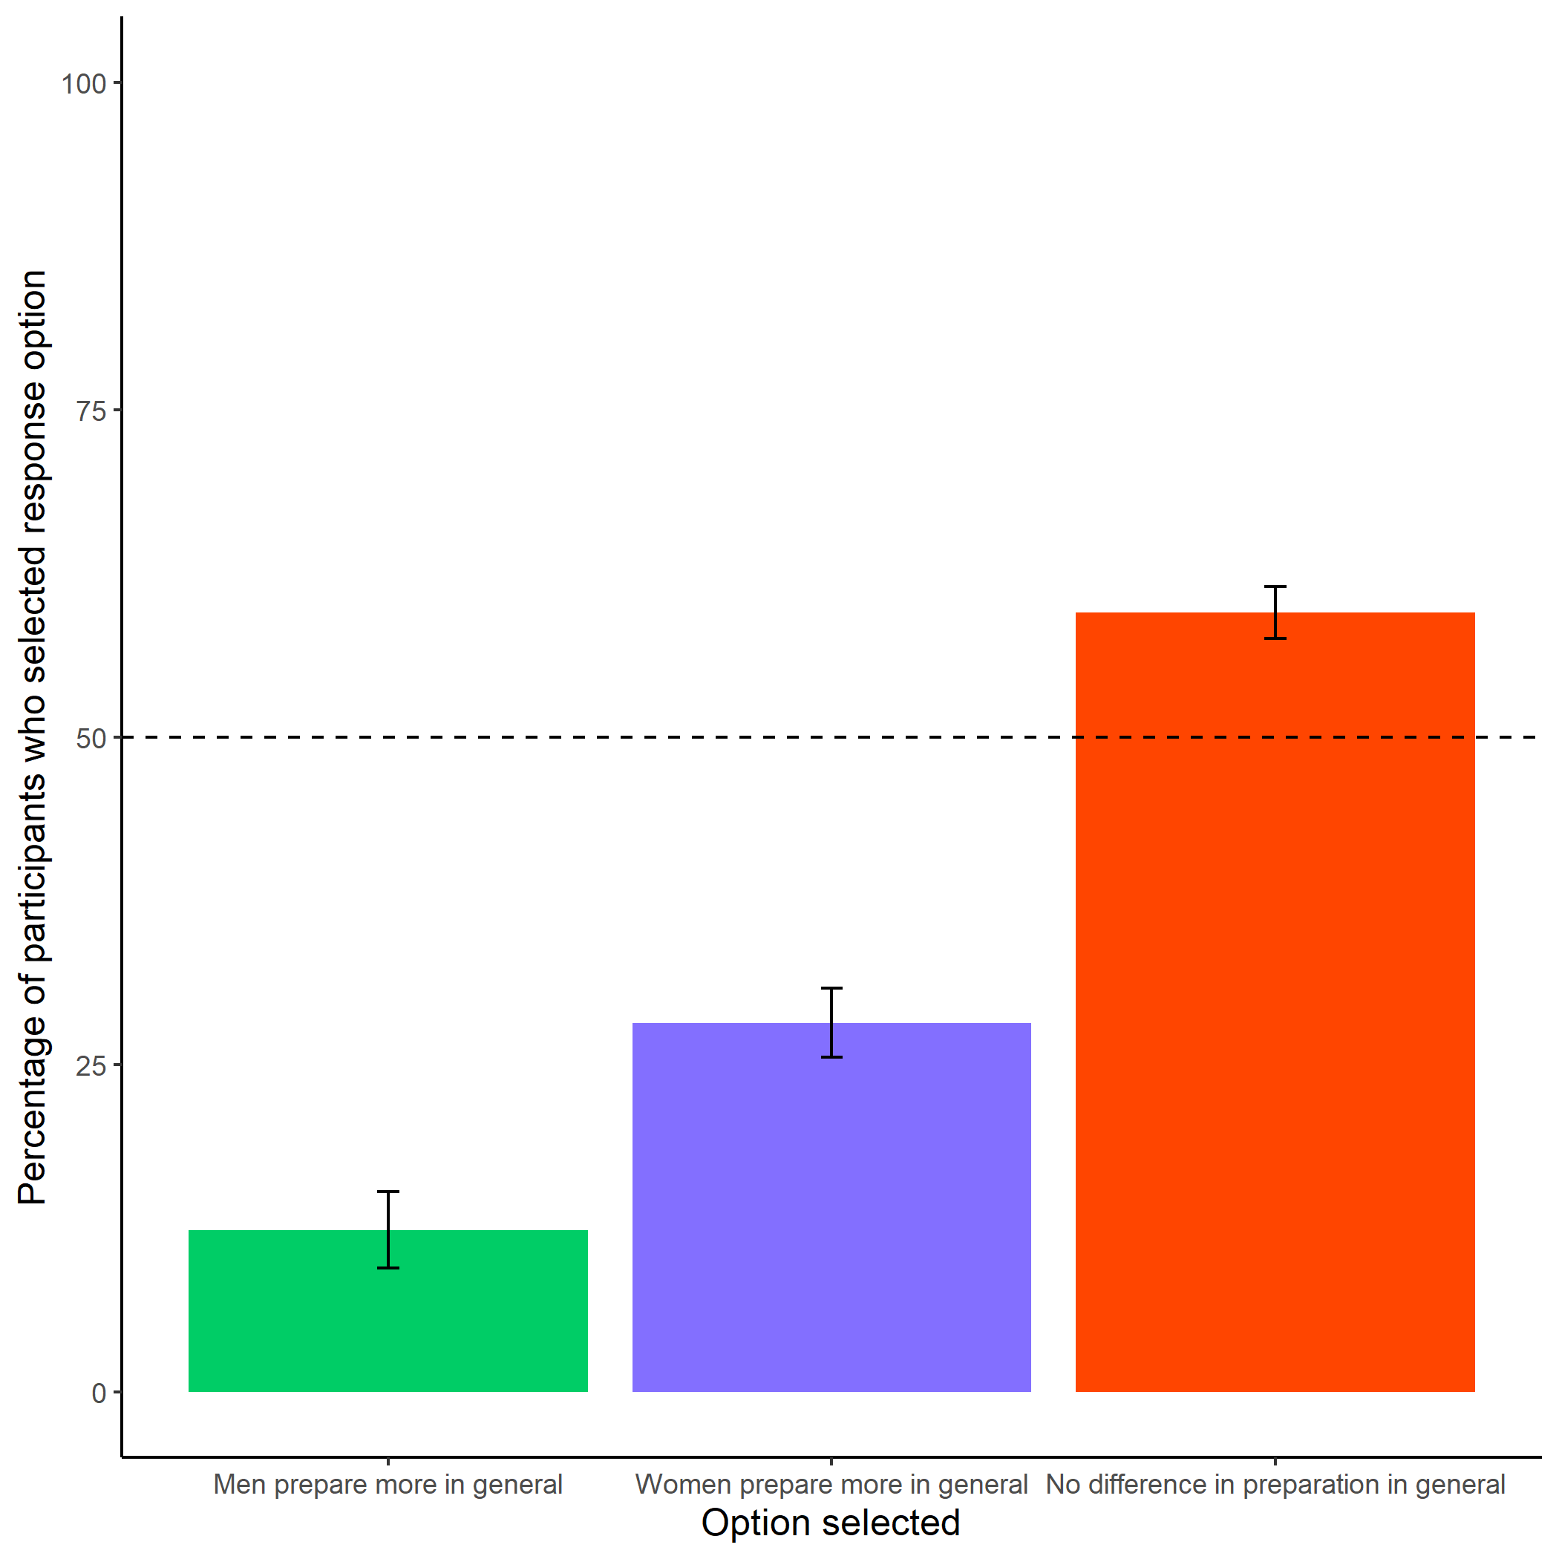

Participants’ perceptions of general gender differences in choice to practice. Error bars represent standard errors.

knitr::include_graphics(here::here("study4", "figs", "fig06_pract-choice-by-gender.png"))

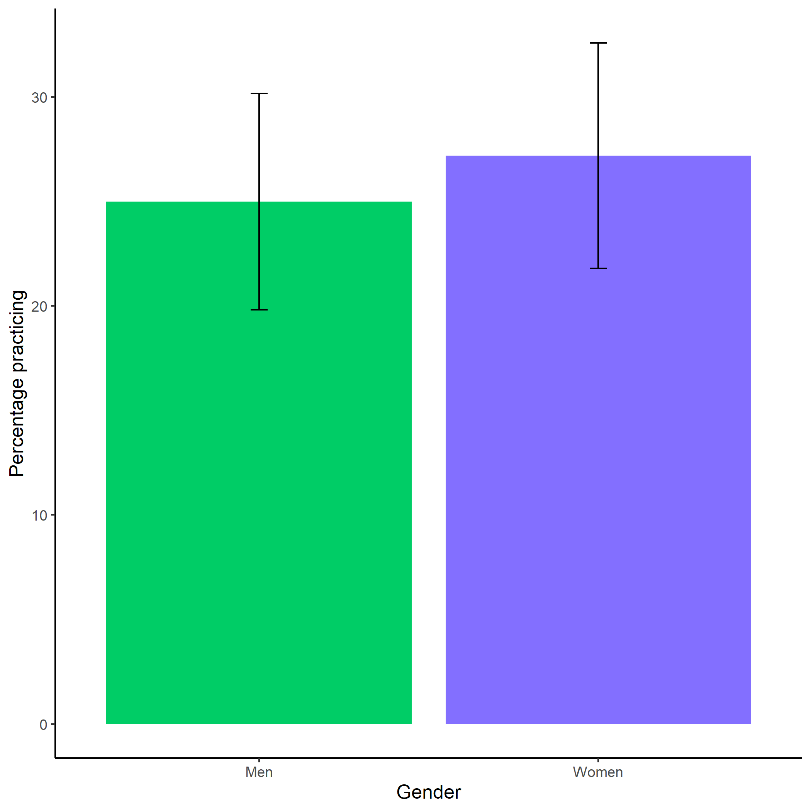

Proportion of men and women who chose to prepare. Error bars represent standard errors.