The effects of preparation on gender differences in choice to compete

Keana Richards1, Gideon Nave1, & Coren Apicella1

1 University of Pennsylvania

Author note

Add complete departmental affiliations for each author here. Each new line herein must be indented, like this line.

Correspondence concerning this article should be addressed to Keana Richards, 3720 Walnut Street, Philadelphia PA 19104. E-mail: [keanari@sas.upenn.edu](mailto:keanari@sas.upenn.edu)

Abstract

One or two sentences providing a **basic introduction** to the field, comprehensible to a scientist in any discipline.

Two to three sentences of **more detailed background**, comprehensible to scientists in related disciplines.

One sentence clearly stating the **general problem** being addressed by this particular study.

One sentence summarizing the main result (with the words “**here we show**” or their equivalent).

Two or three sentences explaining what the **main result** reveals in direct comparison to what was thought to be the case previously, or how the main result adds to previous knowledge.

One or two sentences to put the results into a more **general context**.

Two or three sentences to provide a **broader perspective**, readily comprehensible to a scientist in any discipline.

*Keywords:* keywords

*Word count:* X

The effects of preparation on gender differences in choice to compete

# Introduction

from RSF application:

Women have surpassed men in education outcomes, like college attendance and graduation rates (Blau & Kahn, 2017; Goldin, 2006; Stoet & Geary, 2014), but are still underrepresented in top management positions in nearly all sectors (Bertrand & Hallock, 2001) and a gender wage gap still persists (Blau & Kahn, 2017). Traditional economic variables account for some, but not all, of these disparities. As such, additional explanations have been proposed, including gender differences in choice to compete. Previous research suggests that women are less willing to compete than men, even when they are equally, if not more, qualified (Niederle & Vesterlund, 2007, for reviews, see 2011, and @Croson2009). This effect has been established across numerous studies and appears to be driven by high ability women being less willing to compete compared to their male counterparts, creating higher total costs of pay-off inferior decisions (i.e., under-entry) for women compared to men (Niederle & Vesterlund, 2007).

Understanding how to address gender differences in competitiveness is important for reducing gender inequality that persists today. When women compete less than their male counterparts, they may be missing crucial economic opportunities, as demonstrated by the evidence suggesting competitiveness is relevant to one’s economic outcomes (Buser, Niederle, & Oosterbeek, 2014; Reuben, Sapienza, & Zingales, 2015; Zhang, 2012).

Women’s relatively lower levels of confidence in their performance partly explains this gender difference (Niederle & Vesterlund, 2011), so it is important to understand factors that may affect confidence prior to the decision to compete. Since prior research has shown that confidence can improve with preparation and training (Gist & Mitchell, 1992; Schunk, 1981, 1982), providing women with an adequate opportunity to prepare before a task may alleviate the gender gap in choice to compete.

# Pilot study

## Methods

We recruited workers on Amazon Mechanical Turk for a study on decision-making. The workers who opted into the study had to pass several screening questions to be included as participants in the paid portion of the study. Specifically, participants included in the study had to (i) identify their nationality as American and live in the United States, (ii) identify as male or female, (iii) be using a computer (rather than a phone or tablet), and (iv) pass three comprehension questions about the task they would be completing. If they did not meet these criteria, they did not proceed to the paid portion of the study. Additionally, upon reviewing the data, we found that certain participants had a duplicate IP address, MTurkID, and gender, so we excluded the second response from those participants. Based on these criteria, 206 participants were excluded from the analyses. Thus, the final sample consisted of 337 participants (56.97% women), with an average age of 37.40 (*SD* = 11.67) years. Of this final sample, 17 participants (76.47% women) dropped out of the study before finishing. We include their data in analyses when available.

Participants were told that they would complete three rounds of a key-entry task where they would solve as many problems as they could within one minute and be paid based on their performance. The task required participants to use a legend to enter letters associated with a series of 2-digit numbers shown on the screen. The legend consisted of five numbers with their corresponding letters below them. The letters were randomly generated, and the legend was the same across all participants and rounds. For instance, if the letter “C” was associated with the number 1 and “R” was associated with the number 2, and participants were presented with the number 12, they would have to enter “CR” into a corresponding text box. Before the paid rounds, participants were shown an example problem with the correct answer. Following this, they were required to pass 3 practice problems to test their comprehension. Each of these problems was identical in structure to the problems they would receive during the paid rounds.

In the first and second round of the task, participants were incentivized according to a piece-rate and tournament payment scheme, respectively (Niederle & Vesterlund, 2007). Under the piece-rate scheme, participants were told that they would earn $.05 for each correct answer. Under the tournament payment scheme, participants were told that they would earn $.10 for each correct answer, but were only paid if their score was greater than the second-round performance of another anonymous, randomly matched opponent who was doing the same experiment with the same sequence of numbers. In the third round, participants could choose between the two above payment schemes. We denote this decision as “choice to compete” (Niederle & Vesterlund, 2007).

After the third round, participants completed a series of follow-up questions which measured confidence, perceptions of gender differences in performance on the task, and risk aversion.

We adapted previous measures of confidence (i.e., Niederle & Vesterlund, 2007) in our study by asking participants to (i) indicate whether they thought their round 2 score was higher or lower than the person they had competed against and (ii, iii) predict which decile their score might fall into relative to all men (women) who completed the task during round 2. To measure perceptions of gender differences, we asked participants to indicate whether they thought “women or men generally do better in the key-entry task” that they completed. We also asked if they thought their score would have improved if they practiced the task beforehand. Finally, we asked if they would they have taken the opportunity to practice the task, if offered. If they responded yes, they were asked how long they would have practiced (in minutes) if they were given unlimited time to practice. Participants were told that if they answered one of the confidence and perceptions of gender differences questions correctly they could receive a bonus. Specifically, we randomly selected one of their responses and if the selected prediction was correct, they received a bonus of $.10.

Finally, we measured risk aversion by asking participants “How do you see yourself: Are you generally a person who is fully prepared to take risks or do you try to avoid taking risks?” (Dohmen et al., 2011) on a 10 point scale, where 0 indicates participants are “Not at all willing to take risks,” while 10 indicates participants are “very willing to take risks.”

## Results

### Pre-registered analyses[1].

*Primary hypothesis 1.* Using a logistic regression with gender predicting choice to compete in round 3, we do not find significant evidence of gender differences in the choice to compete, $b=-0.17$, 95% CI $[-0.64$, $0.30]$, $z=-0.72$, $p=.474$, though men chose to compete more often (34.48%) compared to women (29.69%) (see Figure 1).

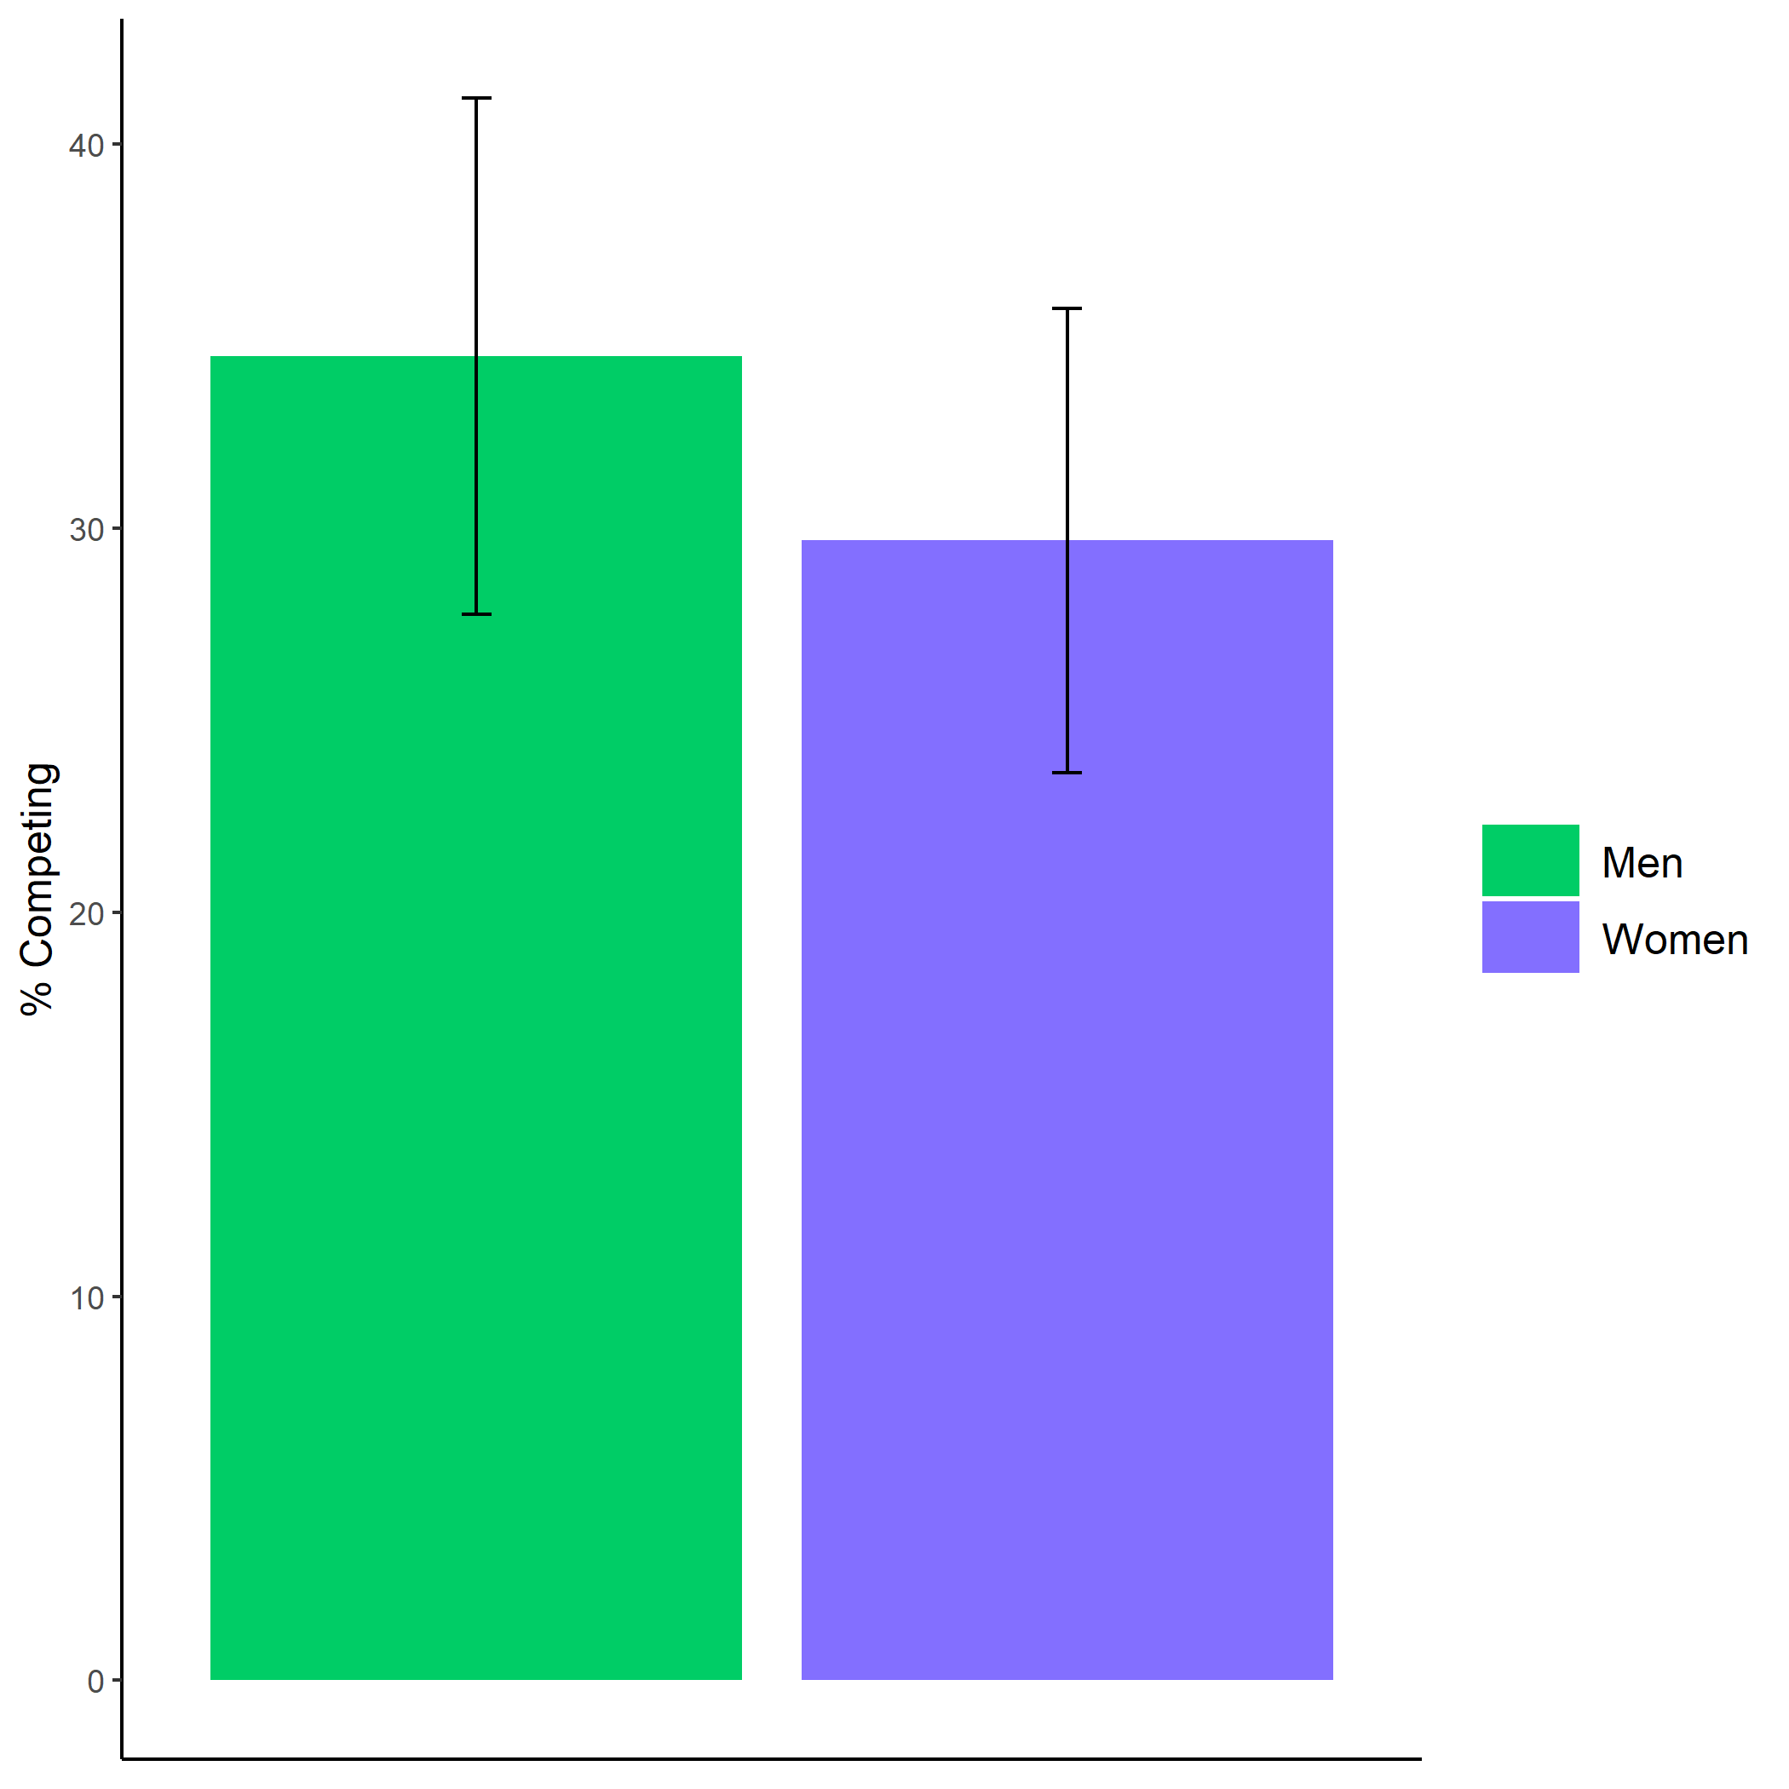

*Figure* *1.*  Proportion of participants who chose to compete based on participant gender. Error bars represent standard errors.

Cross-Tabulation, Row Proportions  
clean $gender*clean$ comp_choice

|  |  |  |  |  |  |
| --- | --- | --- | --- | --- | --- |
|  | clean$comp_choice | piecerate | tournament |  | Total |
| clean$gender |  |  |  |  |  |
| Man |  | 91 (62.8%) | 50 (34.5%) | 4 (2.8%) | 145 (100.0%) |
| Woman |  | 123 (64.1%) | 57 (29.7%) | 12 (6.2%) | 192 (100.0%) |
| Total |  | 214 (63.5%) | 107 (31.8%) | 16 (4.7%) | 337 (100.0%) |

*Secondary hypothesis 1.* Using a logistic regression with gender predicting choice to compete in round 3 while including confidence and risk aversion as controls, we do not find significant evidence of gender differences in the choice to compete, $b=0.16$, 95% CI $[-0.35$, $0.69]$, $z=0.63$, $p=.532$. Instead, confidence, $b=-1.33$, 95% CI $[-1.88$, $-0.80]$, $z=-4.87$, $p<.001$ and risk aversion, $b=0.21$, 95% CI $[0.12$, $0.32]$, $z=4.27$, $p<.001$ significantly predicted the decision to compete.

### Exploratory analyses.

We also ran exploratory analyses outside of the pre-registered analyses, which will be discussed briefly here. First, we explored whether there is a gender difference in participants’ willingness to practice, if given the chance. Using a logistic regression, we find that gender predicts (hypothetical) willingness to practice, $b=0.67$, 95% CI $[0.06$, $1.29]$, $z=2.14$, $p=.033$ (see Figure 2).

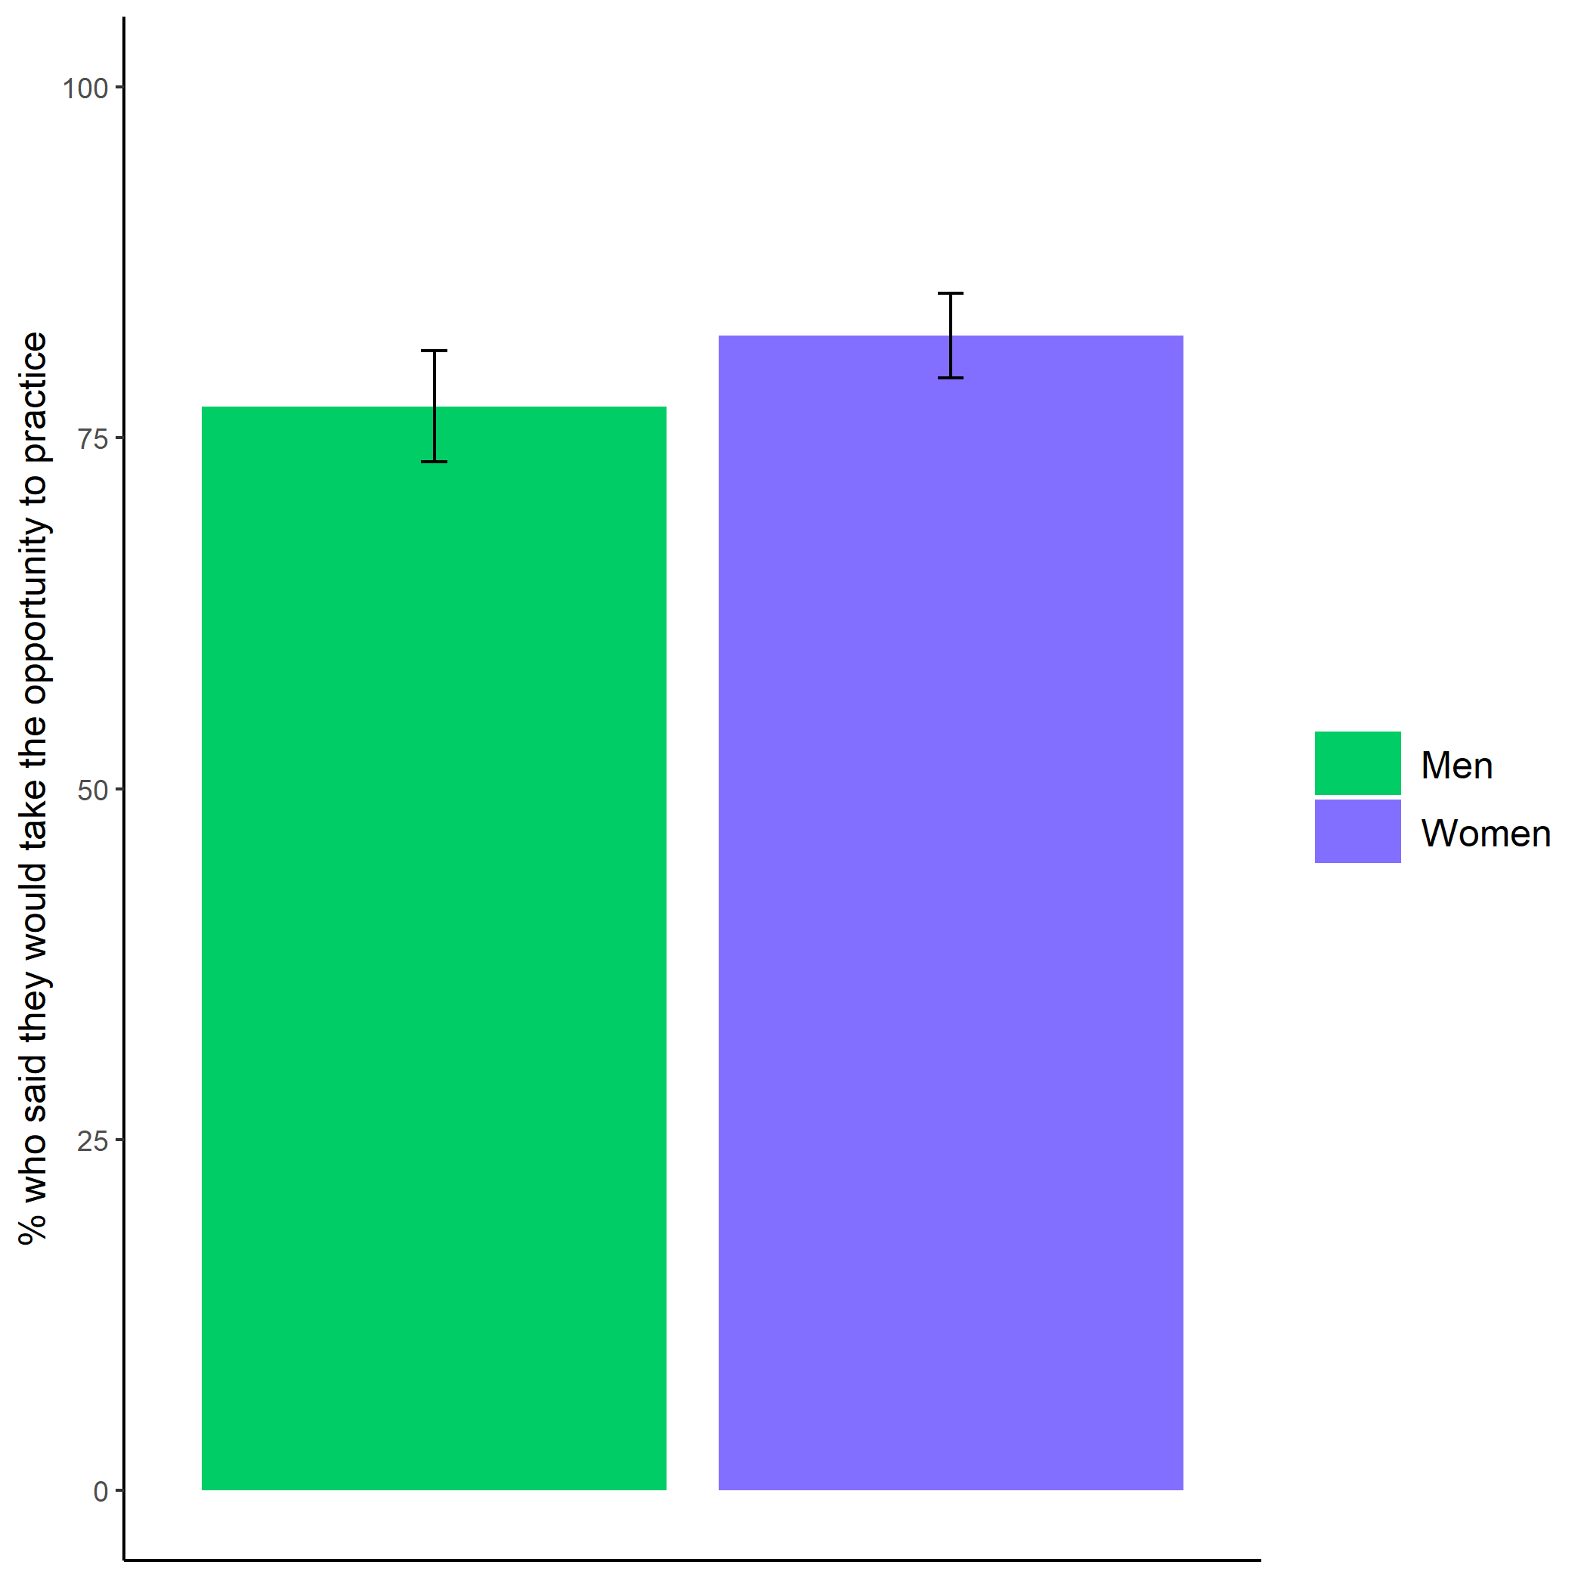

*Figure* *2.*  Proportion of participants who indicated they would have taken the opportunity to practice the key-entry task if provided based on participant gender. Error bars represent standard errors.

Cross-Tabulation, Row Proportions  
clean $gender*clean$ pract_choice

|  |  |  |  |  |  |
| --- | --- | --- | --- | --- | --- |
|  | clean$pract_choice | No | Yes |  | Total |
| clean$gender |  |  |  |  |  |
| Man |  | 29 (20.0%) | 112 (77.2%) | 4 (2.8%) | 145 (100.0%) |
| Woman |  | 21 (10.9%) | 158 (82.3%) | 13 (6.8%) | 192 (100.0%) |
| Total |  | 50 (14.8%) | 270 (80.1%) | 17 (5.0%) | 337 (100.0%) |

We also explored whether there were gender differences in the number of minutes participants said they would hypothetically practice with a t-test, but did not find evidence that there were gender differences in participants’ responses, $ΔM=-0.26$, 95% CI $[-2.08$, $1.56]$, $t(233.54)=-0.28$, $p=.776$.

Finally, we explored the questions about perceptions of gender differences through a series of chi-square tests. First, we tested whether participants were more likely to predict women or men would perform better on the task, and whether there were any gender differences in these perceptions. We find that participants were significantly more likely to believe that women outperformed men on the key-entry task, $χ^{2}(1,n=337)=64.80$, $p<.001$, and women were significantly more likely to make this prediction, $χ^{2}(1,n=337)=13.79$, $p<.001$, even though there were no gender differences in performance, $ΔM=3.92$, 95% CI $[-0.45$, $8.28]$, $t(307.07)=1.77$, $p=.078$. Additionally, the majority of participants believed that their score would have improved if they practiced the task beforehand, $χ^{2}(1,n=337)=112.81$, $p<.001$. There were no significant gender differences in these perceptions, $χ^{2}(1,n=337)=2.07$, $p=.150$.

# Study 1

## Methods

Like the pilot study, we recruited workers on Amazon Mechanical Turk for Study 1. The screening criteria were nearly identical to those in the pilot study, with the exception that workers were not excluded if they failed the comprehension questions. Instead of excluding participants for failing the comprehension check questions, they had to answer three comprehension questions correctly before they could proceed. Similar to the pilot study, if participants had a duplicate IP address, MTurkID, and gender, we excluded their second response. Based on these criteria, 240 participants were excluded from the analyses. The final sample consisted of 1056 participants (53.60% women), with an average age of 37.74 (*SD* = 13.19) years. 54 participants (53.70% women) dropped out of the study before finishing and we use their data when available.

Participants were told they would be completing a multiplication task where they would be able to choose how they would be paid for their performance. The task involved solving problems from the multiplication tables with numbers ranging from 1-12 (e.g., 1 X 5, 12 X 11) as quickly as possible within a two-minute period. They were provided an example of a question with the correct response and had to answer three practice problems correctly to proceed, as a test of their comprehension. After completing the comprehension questions, participants were randomly assigned to either a “knowledge of preparation” condition or a control condition.[2] Participants in the “knowledge of preparation” condition were presented the following text:

“There is an option to practice/study before completing the multiplication task that is available to all participants. If you take this opportunity to practice/study, we will provide you with materials that may help boost your performance in the multiplication task. You will have unlimited time to practice/study before completing the task. You can stop practicing/studying at any point.”

Participants assigned to the control condition simply proceeded without seeing this text. Then, all participants learned about the two possible payment schemes (either piece-rate or tournament) that they could choose from and had to correctly answer questions testing their comprehension of the payment schemes. The only difference between the payment schemes across the Pilot study and Study 1 is the amount participants were paid per problem. For the tournament scheme, participants were told they would be paid $.20 per problem they answered correctly only if they beat a randomly assigned competitor, while participants were told they would be paid $.10 per problem under the piece-rate scheme, regardless of other participants’ performance. In the knowledge of preparation condition, participants were reminded that they had the option to prepare before completing the task. Then, participants made a payment scheme choice, where the order of presentation of the tournament and piece-rate payment options was randomized and counter-balanced for each condition. After choosing a payment scheme, participants in both conditions were given the chance to prepare before the multiplication task. If they chose to practice (described as the choice/decision to practice in subsequent analyses), participants were asked, for each multiplication table, if they wanted to practice problems from that specific multiplication table. If they chose to practice a specific multiplication table, they had the chance to practice all twelve combinations of numbers for that multiplication table. For each multiplication table that participants chose to practice, they could only proceed if they answered all practice questions correctly. Then, they were asked if they would like to continue practicing or move onto the next multiplication table, while a review table was displayed. This process was repeated for each multiplication table. The practice and review table for each multiplication table was presented in sequential order (i.e., starting at the 1 multiplication table up to the 12 multiplication table). We measured the number of rounds of preparation each participant completed for analyses (i.e., total practice count), which was calculated as the total number of times a participant agreed to complete a round of preparation (including the choice to repeat a table and the choice to prepare in the first place). Once finished practicing, participants completed as many problems as possible from the paid multiplication task for two minutes and received feedback about their absolute (but not relative) performance.

After the multiplication task, participants completed a series of incentivized follow-up questions, including confidence and perceptions of gender differences. For these measures, participants were told one of these questions would be selected for a possible bonus payment, and if they answered the selected question correctly, they would earn a bonus of $.10. For the measure of confidence, participants guessed their relative performance compared to all other participants that completed the task by indicating the decile of their score. Participants were also asked to indicate their perceptions of gender differences in performance (i.e., “Do you think men or women in this study correctly solved more multiplication problems on average?”), willingness to prepare on the task (i.e., “Do you think men or women in this study spent more time practicing/studying before completing the multiplication task?”), willingness to prepare in general (i.e., “On most tasks, do you think men or women generally prepare (i.e., practice and/or study) more?”) and willingness to compete (i.e., “Do you think men or women in this study chose the tournament payment option more often?”).

Finally, participants completed the same measure of risk aversion used in the pilot study. To determine whether cheating was a factor that participants relied on while completing the task, we also asked participants about their use of calculators and perceptions of calculator use on the multiplication task. Neither of these measures was incentivized.

## Results

### Pre-registered analyses[3].

Primary hypothesis 1: We do not find evidence of a significant interaction between gender and condition on the decision to compete $b=0.06$, 95% CI $[-0.63$, $0.76]$, $z=0.18$, $p=.861$ (see Figure 3). Unlike the pilot study, we found that men were significantly more likely to choose to compete, where 19.59% of men chose to compete compared to 10.78% of women, $b=-0.73$, 95% CI $[-1.23$, $-0.24]$, $z=-2.90$, $p=.004$.

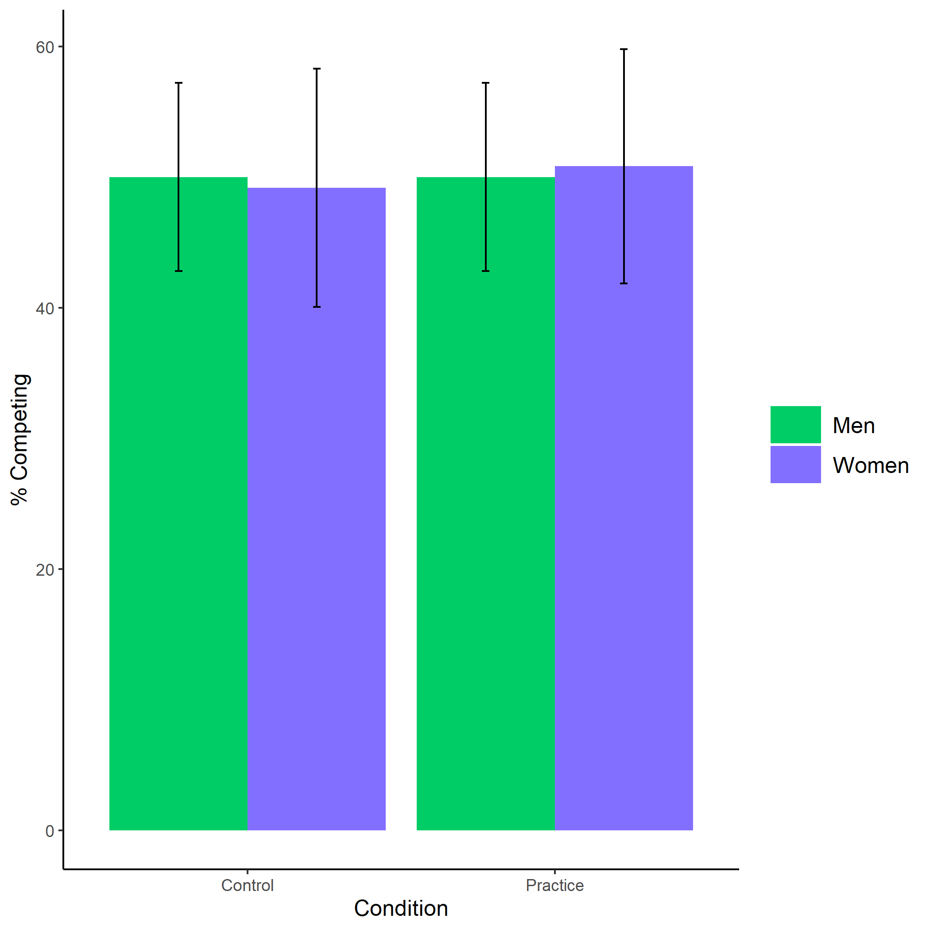

*Figure* *3.*  Proportion of participants who chose to compete based on participant gender and condition. Error bars represent standard errors.

Cross-Tabulation, Row Proportions  
1L * 1L

|  |  |  |  |  |
| --- | --- | --- | --- | --- |
|  | 1L | control | pract | Total |
| 1L |  |  |  |  |
| Man |  | 187 (49.5%) | 191 (50.5%) | 378 (100.0%) |
| Woman |  | 243 (50.2%) | 241 (49.8%) | 484 (100.0%) |
| Total |  | 430 (49.9%) | 432 (50.1%) | 862 (100.0%) |
|  | 2L | control | pract | Total |
| 1L |  |  |  |  |
| Man |  | 48 (50.0%) | 48 (50.0%) | 96 (100.0%) |
| Woman |  | 30 (49.2%) | 31 (50.8%) | 61 (100.0%) |
| Total |  | 78 (49.7%) | 79 (50.3%) | 157 (100.0%) |

Primary hypothesis 2: As hypothesized, women were 75.47% more likely to take advantage of the opportunity to practice relative to men, $b=0.56$, 95% CI $[0.31$, $0.82]$, $z=4.37$, $p<.001$, while controlling for the decision to compete (see Figure 4). As an exploratory analysis, we tested whether gender and the choice to compete interact to predict the choice to prepare, but did not find evidence for an interaction, $b=0.12$, 95% CI $[-0.60$, $0.86]$, $z=0.33$, $p=.740$.

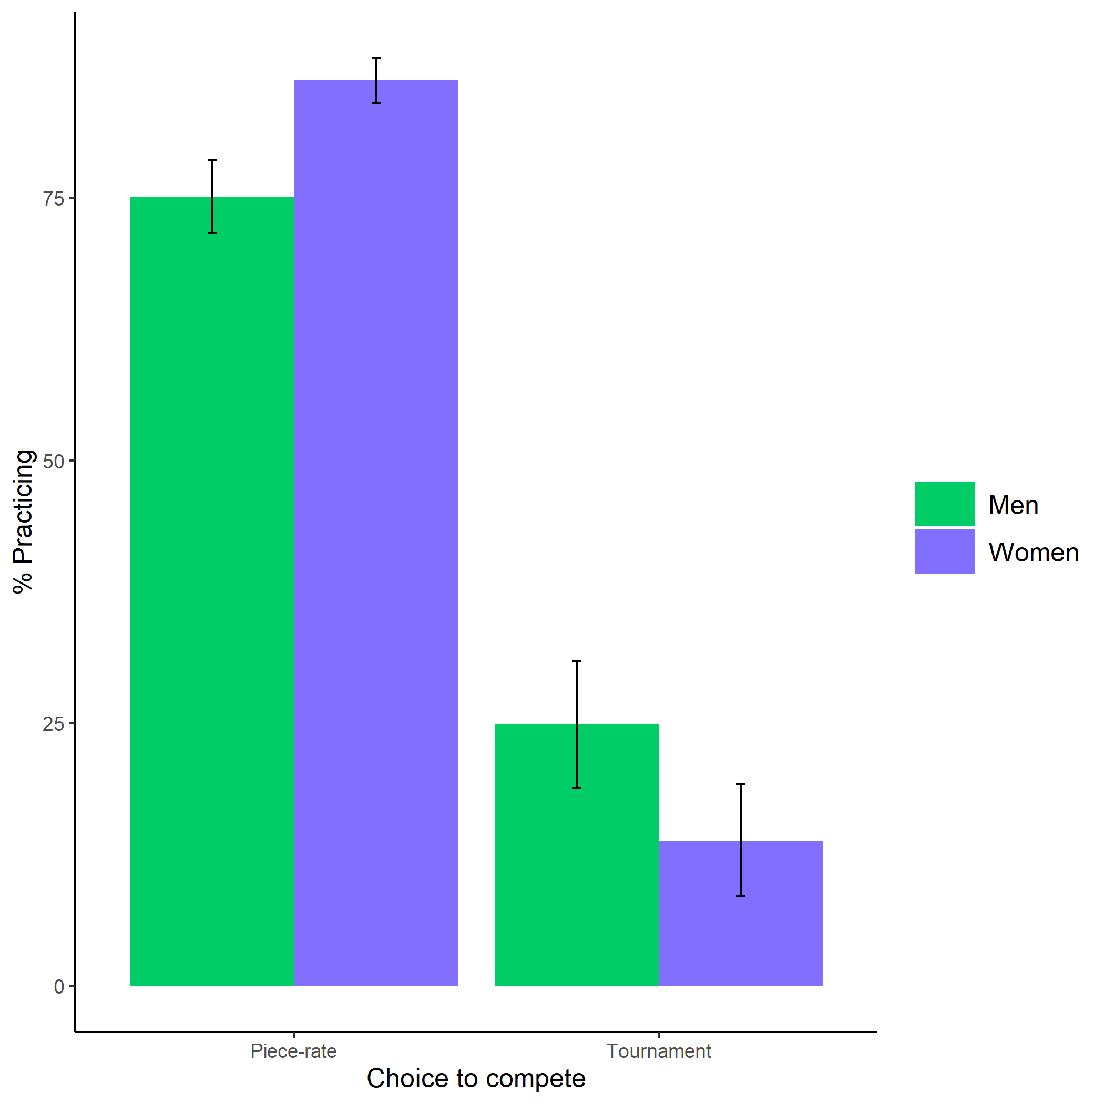

*Figure* *4.*  Proportion of participants who chose to prepare based on participant gender and choice to compete. Error bars represent standard errors.

Cross-Tabulation, Row Proportions  
1L * 1L

|  |  |  |  |  |
| --- | --- | --- | --- | --- |
|  | 1L | piecerate | tournament | Total |
| 1L |  |  |  |  |
| Man |  | 224 (83.3%) | 45 (16.7%) | 269 (100.0%) |
| Woman |  | 221 (92.1%) | 19 ( 7.9%) | 240 (100.0%) |
| Total |  | 445 (87.4%) | 64 (12.6%) | 509 (100.0%) |
|  | 2L | piecerate | tournament | Total |
| 1L |  |  |  |  |
| Man |  | 154 (75.1%) | 51 (24.9%) | 205 (100.0%) |
| Woman |  | 262 (86.2%) | 42 (13.8%) | 304 (100.0%) |
| Total |  | 416 (81.7%) | 93 (18.3%) | 509 (100.0%) |

Primary hypothesis 3: In concordance with our pre-registered hypothesis, women completed 68.59% more rounds of preparation relative to men, $b=0.56$, 95% CI $[0.31$, $0.82]$, $z=4.37$, $p<.001$ (see Figure 5).

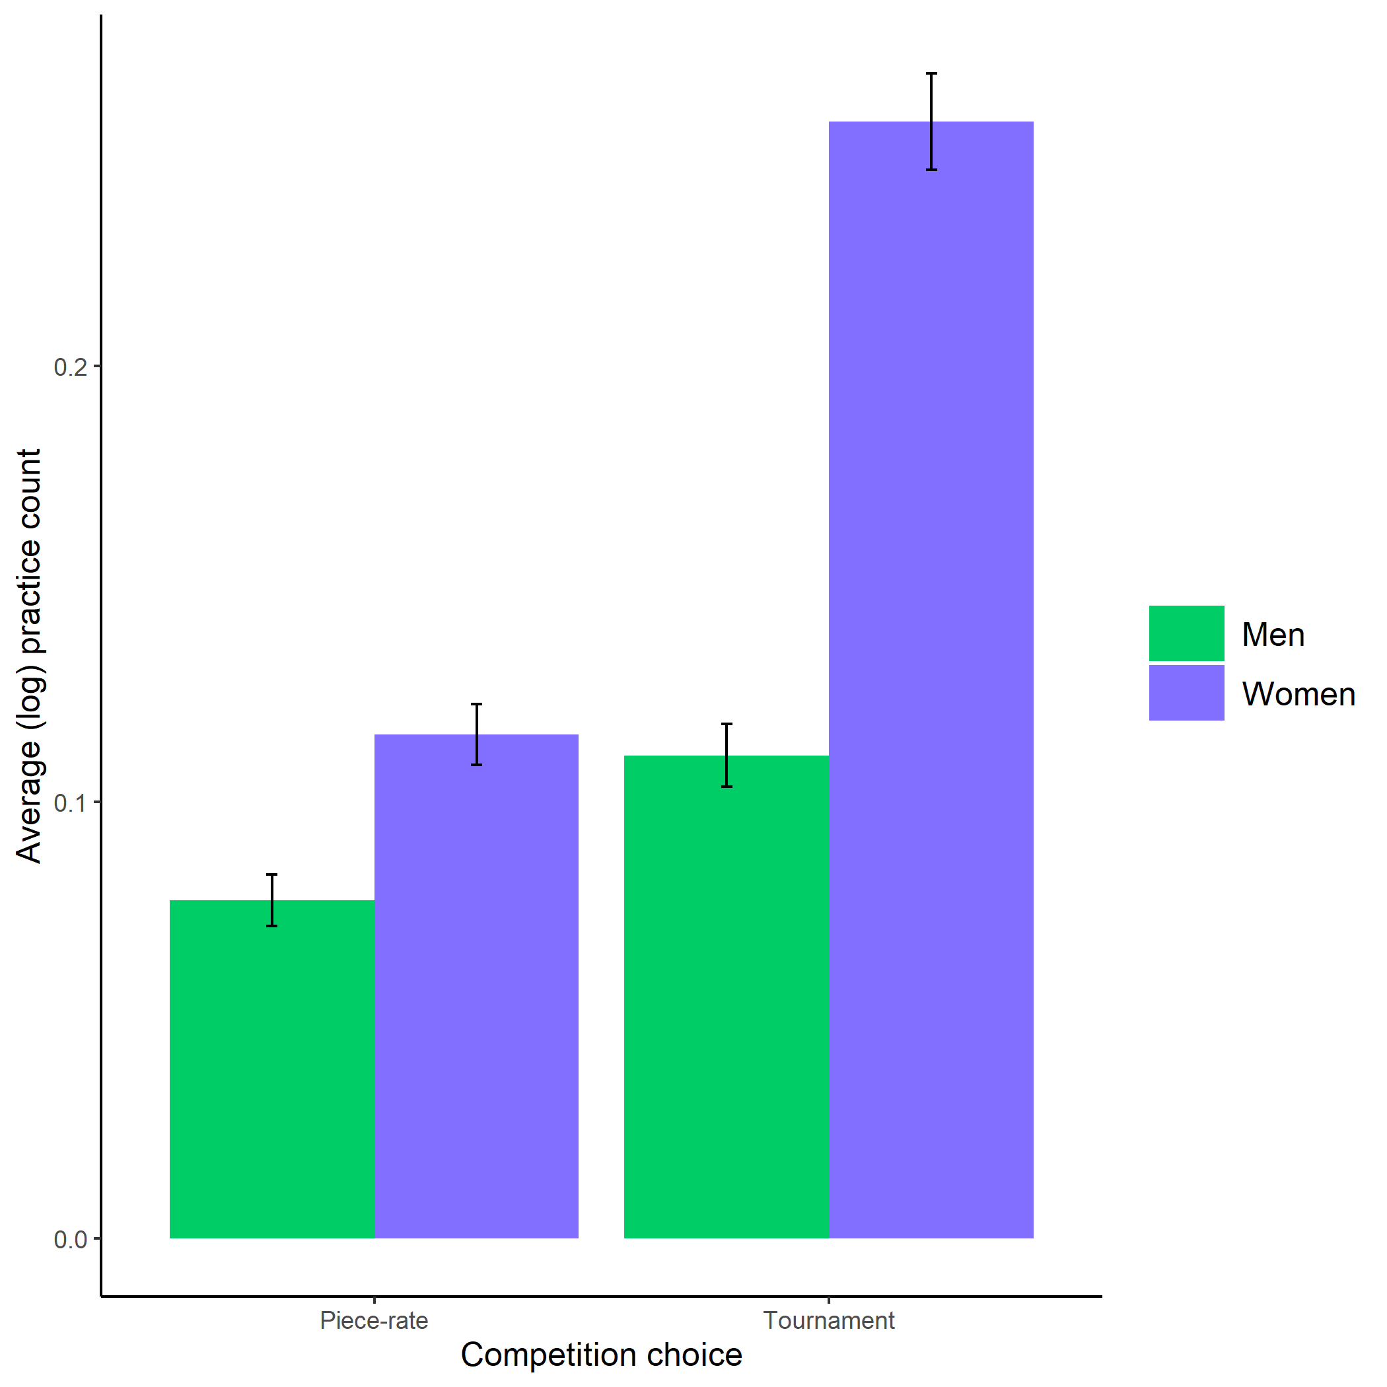

*Figure* *5.*  Average (log-transformed) practice count based on participant gender and competition choice. Error bars represent standard errors.

Primary hypothesis 4: As hypothesized, participants expected women to spend more time preparing for the multiplication task relative to men, $χ^{2}(1,n=1056)=15.67$, $p<.001$ (see Figure 6).

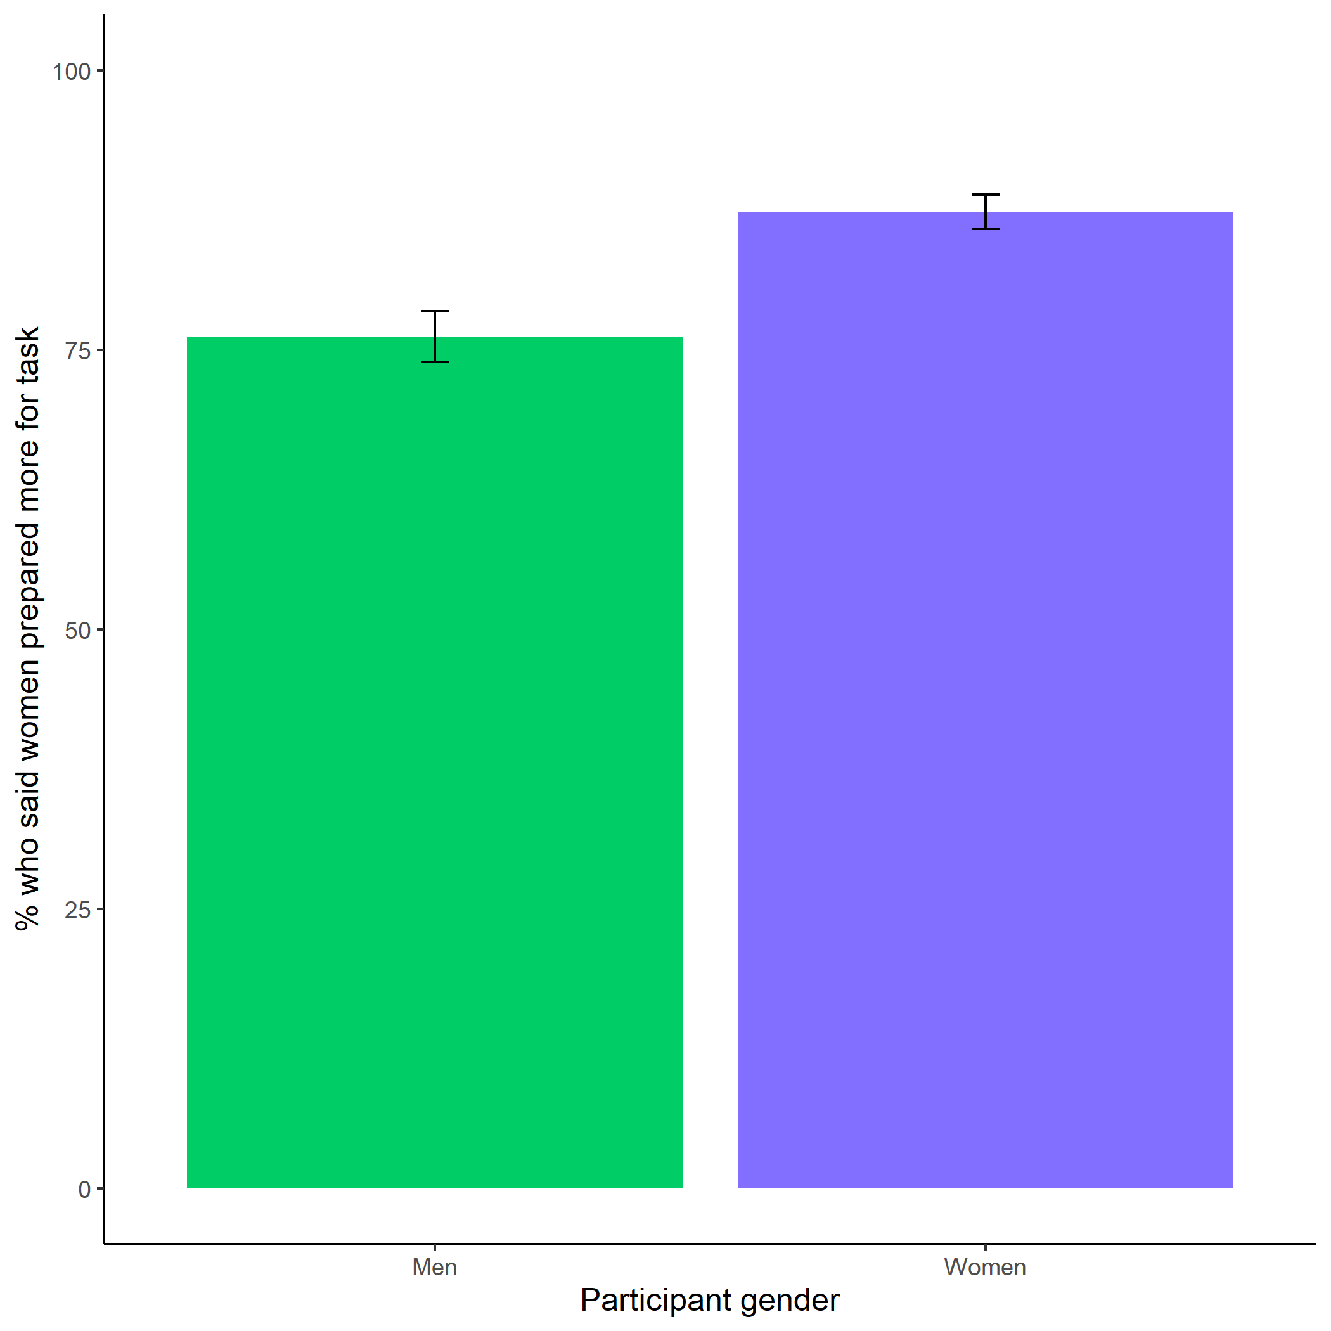

*Figure* *6.*  Participants’ perceptions of gender differences in the choice to practice on the task. Error bars represent standard errors.

Cross-Tabulation, Row Proportions  
clean $gender*clean$ perc_task_gender_pract

|  |  |  |  |  |  |
| --- | --- | --- | --- | --- | --- |
|  | clean$perc_task_gender_pract | Men | Women |  | Total |
| clean$gender |  |  |  |  |  |
| Man |  | 104 (21.2%) | 361 (73.7%) | 25 (5.1%) | 490 (100.0%) |
| Woman |  | 63 (11.1%) | 476 (84.1%) | 27 (4.8%) | 566 (100.0%) |
| Total |  | 167 (15.8%) | 837 (79.3%) | 52 (4.9%) | 1056 (100.0%) |

Exploratory analysis 7a: Participants did not expect any gender differences in performance on the task, $χ^{2}(1,n=1056)=1.02$, $p=.313$ (see Figure 7).

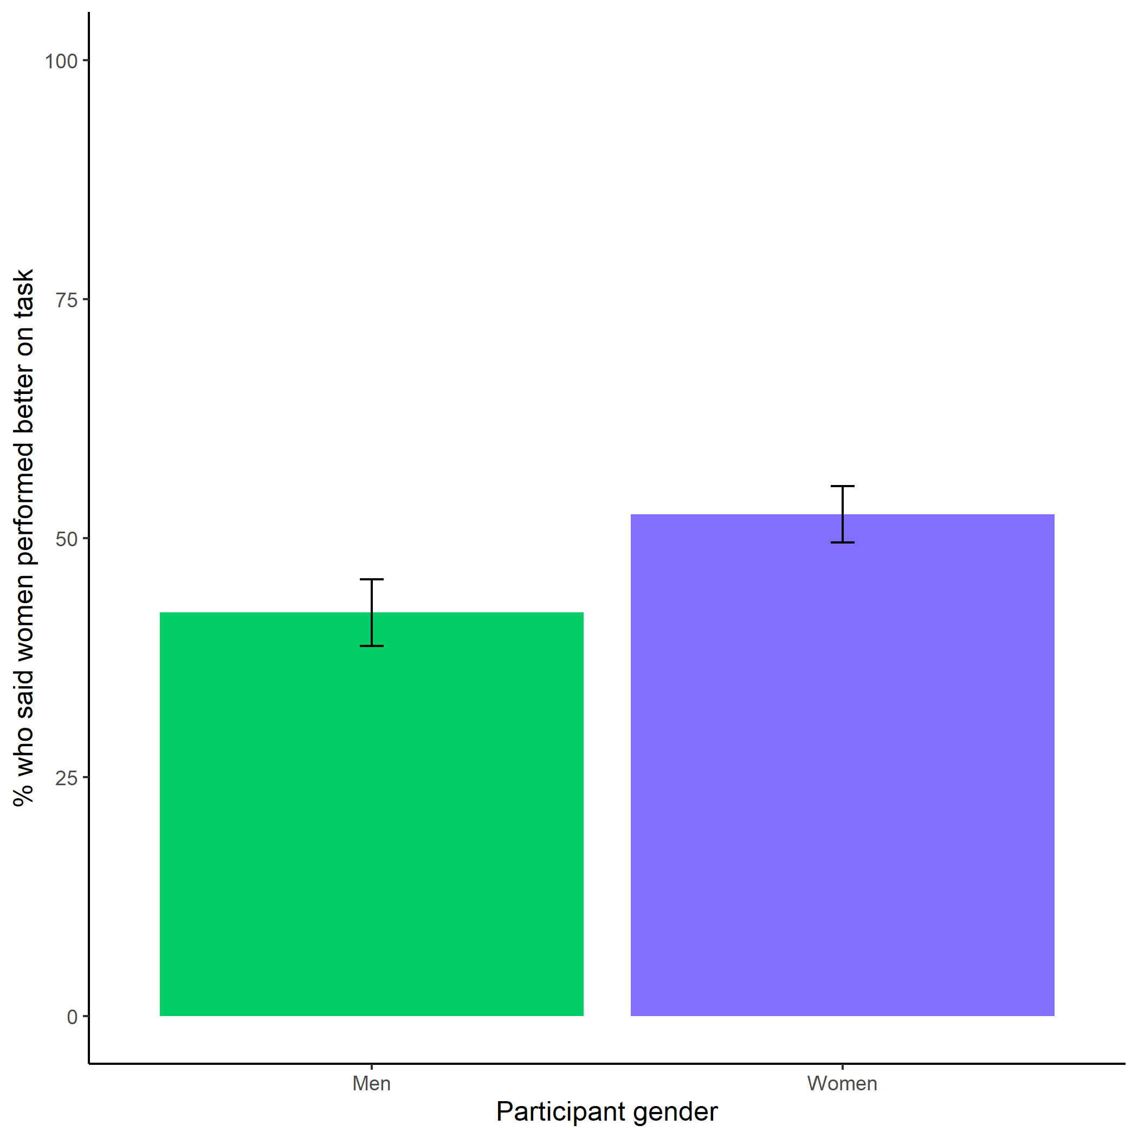

*Figure* *7.*  Participants’ perceptions of gender differences in performance on the task. Error bars represent standard errors.

Cross-Tabulation, Row Proportions  
clean $gender*clean$ better_gender_guess

|  |  |  |  |  |  |
| --- | --- | --- | --- | --- | --- |
|  | clean$better_gender_guess | Men | Women |  | Total |
| clean$gender |  |  |  |  |  |
| Man |  | 265 (54.1%) | 200 (40.8%) | 25 (5.1%) | 490 (100.0%) |
| Woman |  | 253 (44.7%) | 286 (50.5%) | 27 (4.8%) | 566 (100.0%) |
| Total |  | 518 (49.1%) | 486 (46.0%) | 52 (4.9%) | 1056 (100.0%) |

Exploratory analysis 7b: Participants were significantly more likely to expect men to choose to compete more often, $χ^{2}(1,n=1056)=716.24$, $p<.001$ (see Figure 8).

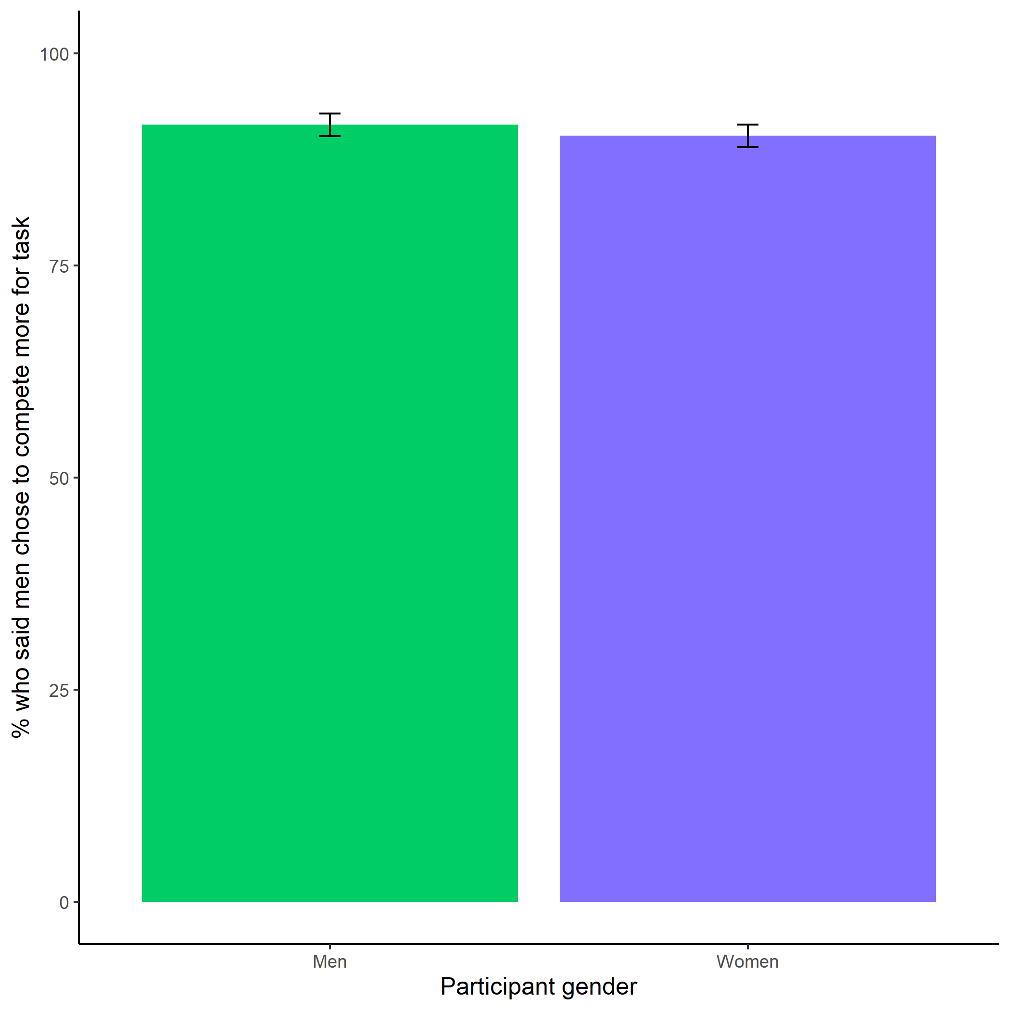

*Figure* *8.*  Participants’ perceptions of gender differences in choice to compete. Error bars represent standard errors.

Cross-Tabulation, Row Proportions  
clean $gender*clean$ perc_gender_comp

|  |  |  |  |  |  |
| --- | --- | --- | --- | --- | --- |
|  | clean$perc_gender_comp | Men | Women |  | Total |
| clean$gender |  |  |  |  |  |
| Man |  | 434 (88.6%) | 31 (6.3%) | 25 (5.1%) | 490 (100.0%) |
| Woman |  | 492 (86.9%) | 47 (8.3%) | 27 (4.8%) | 566 (100.0%) |
| Total |  | 926 (87.7%) | 78 (7.4%) | 52 (4.9%) | 1056 (100.0%) |

Exploratory analysis 7c: Participants were significantly more likely to expect women to choose to prepare in general, $χ^{2}(1,n=1056)=447.11$, $p<.001$ (see Figure 9).

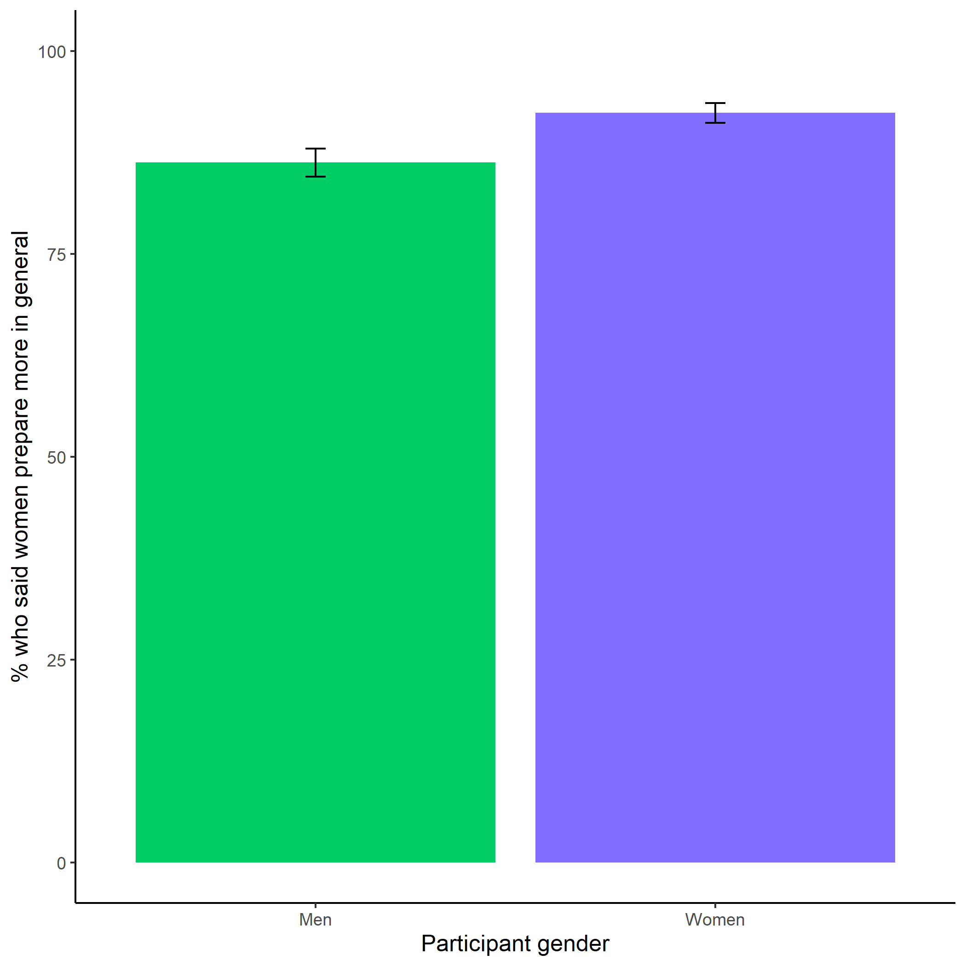

*Figure* *9.*  Participants’ perceptions of general gender differences in choice to practice. Error bars represent standard errors.

Cross-Tabulation, Row Proportions  
clean $gender*clean$ perc_gen_gender_pract

|  |  |  |  |  |  |
| --- | --- | --- | --- | --- | --- |
|  | clean$perc_gen_gender_pract | Men | Women |  | Total |
| clean$gender |  |  |  |  |  |
| Man |  | 64 (13.1%) | 401 (81.8%) | 25 (5.1%) | 490 (100.0%) |
| Woman |  | 41 ( 7.2%) | 495 (87.5%) | 30 (5.3%) | 566 (100.0%) |
| Total |  | 105 ( 9.9%) | 896 (84.8%) | 55 (5.2%) | 1056 (100.0%) |

# Study 2

## Methods

Participants were recruited on Amazon Mechanical Turk using the same screening criteria as Study 1. Also, if participants had an identical IP address, MTurkID, and gender, we excluded their second response. Based on these criteria, 180 participants were excluded from the analyses. The final sample consisted of 1076 participants (50.56% women), with an average age of 38.57 (*SD* = 12.52) years. 62 participants (51.61% women) dropped out of the study before finishing.

As in Study 1, participants included in the study were told they would be completing a two-minute multiplication task (identical to the one used in Study 1) and would be able to choose a payment scheme for their performance. The instructions and payment per question were identical to Study 1. After being told about the rules for the multiplication task and passing the same comprehension questions used in Study 1, participants were assigned to either a preparation condition, where they were told they would complete several rounds of practice before completing the multiplication task, or a control condition, where they were told they would complete several rounds of a counting task before continuing. As in Study 1, participants were randomly assigned to each condition[4]. The participants in the preparation condition completed 12 rounds (one round per multiplication table), with 6 problems per round. The problems for each round were selected at random. Participants in the control condition were asked to complete 5 questions where they counted the number of zeros in a matrix of zeros and ones. After a 30-second break following completion of their respective tasks, all participants chose a payment scheme for the multiplication task, where the order of presentation was counterbalanced. That is, half of participants saw the tournament scheme presented as the first option and half saw the piece-rate payment scheme presented first. Then, they completed the paid multiplication task for two minutes. We included many of the same follow-up questions as in Study 1, including risk aversion, confidence, and perceptions of gender differences in preparation, competitiveness, and performance. Participants were incentivized to answer the questions about their confidence and perceptions of gender differences correctly, and were paid at the same rate as Study 1. We also asked participants if they wished they had more time to prepare for the multiplication task and included measures of their fatigue, field-specific ability beliefs, and interest in the multiplication task all on 1 (Strongly disagree) to 7 (Strongly agree) scales. For the fatigue scale, participants rated how fatigued and mentally exhausted they felt (Milyavskaya, Galla, Inzlicht, & Duckworth, 2018). Participants indicated the degree to which they “enjoyed completing the multiplication task” for the interest scale (Milyavskaya et al., 2018). Finally, to measure field-specific ability beliefs, we asked participants how much they perceived success in math depends on ability versus effort through six questions (e.g., “If you want to succeed in math, hard work alone just won’t cut it; you need to have an innate gift or talent”) (Meyer, Cimpian, & Leslie, 2015).

## Results

### Pre-registered analyses[5].

Primary hypothesis 1: We replicated the effect of gender on the choice to compete: 19.36% of men chose to compete compared to 13.60% of women. However, we do not find evidence of a significant effect of condition on the choice to compete among women, *z* = -1.00, *p* = 0.16 (see Figure 10).

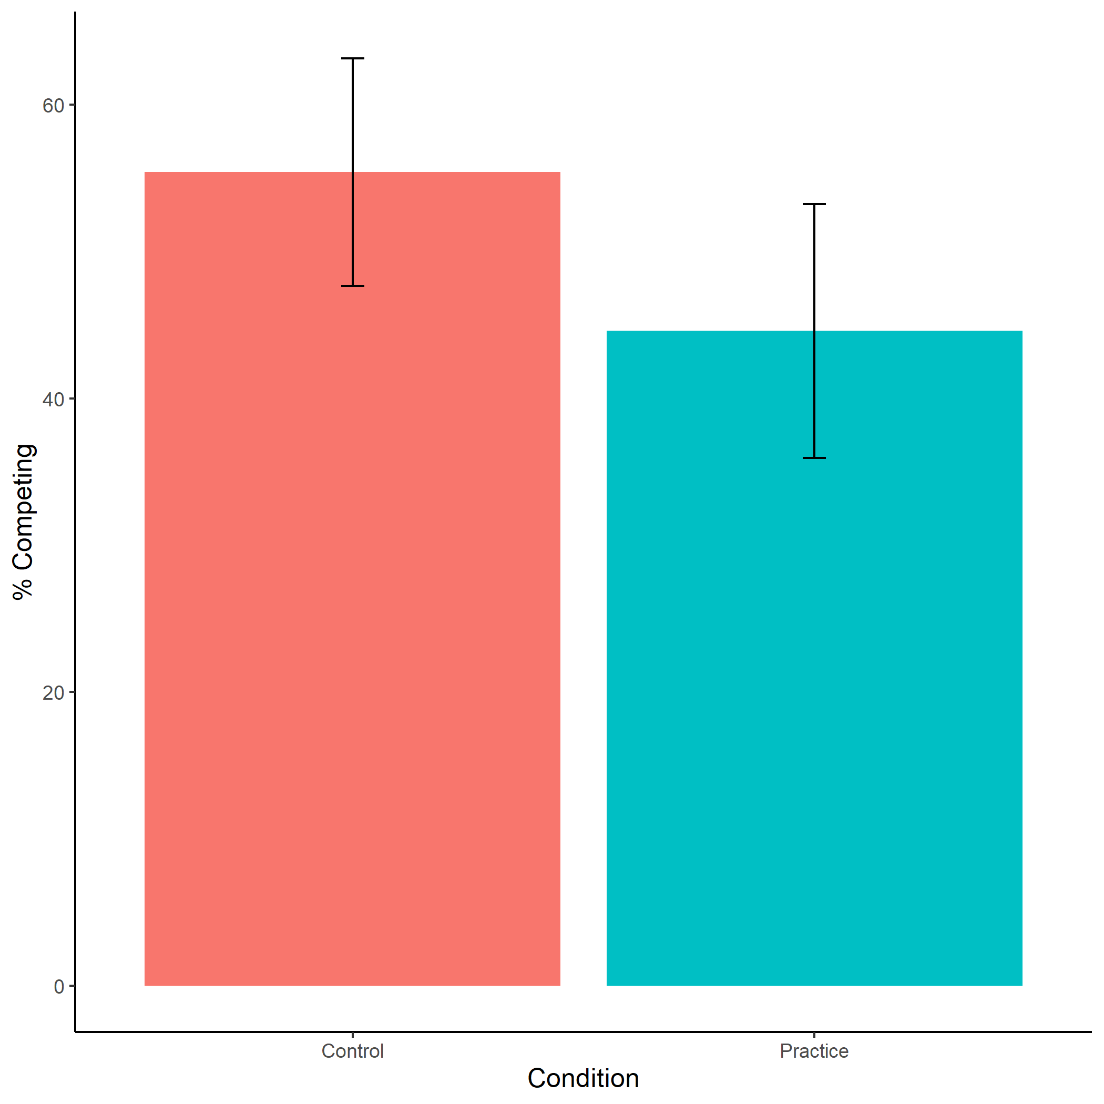

*Figure* *10.*  Proportion of female participants who chose to compete based on condition. Error bars represent standard errors.

Cross-Tabulation, Row Proportions  
woman $comp_{c}hoice*woman$ condition

|  |  |  |  |  |  |
| --- | --- | --- | --- | --- | --- |
|  | woman$condition | control | pract |  | Total |
| woman$comp_choice |  |  |  |  |  |
| piecerate |  | 220 (48.4%) | 235 (51.6%) | 0 ( 0.0%) | 455 (100.0%) |
| tournament |  | 41 (55.4%) | 33 (44.6%) | 0 ( 0.0%) | 74 (100.0%) |
|  |  | 7 (46.7%) | 0 ( 0.0%) | 8 (53.3%) | 15 (100.0%) |
| Total |  | 268 (49.3%) | 268 (49.3%) | 8 ( 1.5%) | 544 (100.0%) |

Exploratory analysis 3a: Participants did not expect any gender differences in performance on the task, $χ^{2}(1,n=1076)=0.61$, $p=.434$ (see Figure 11).

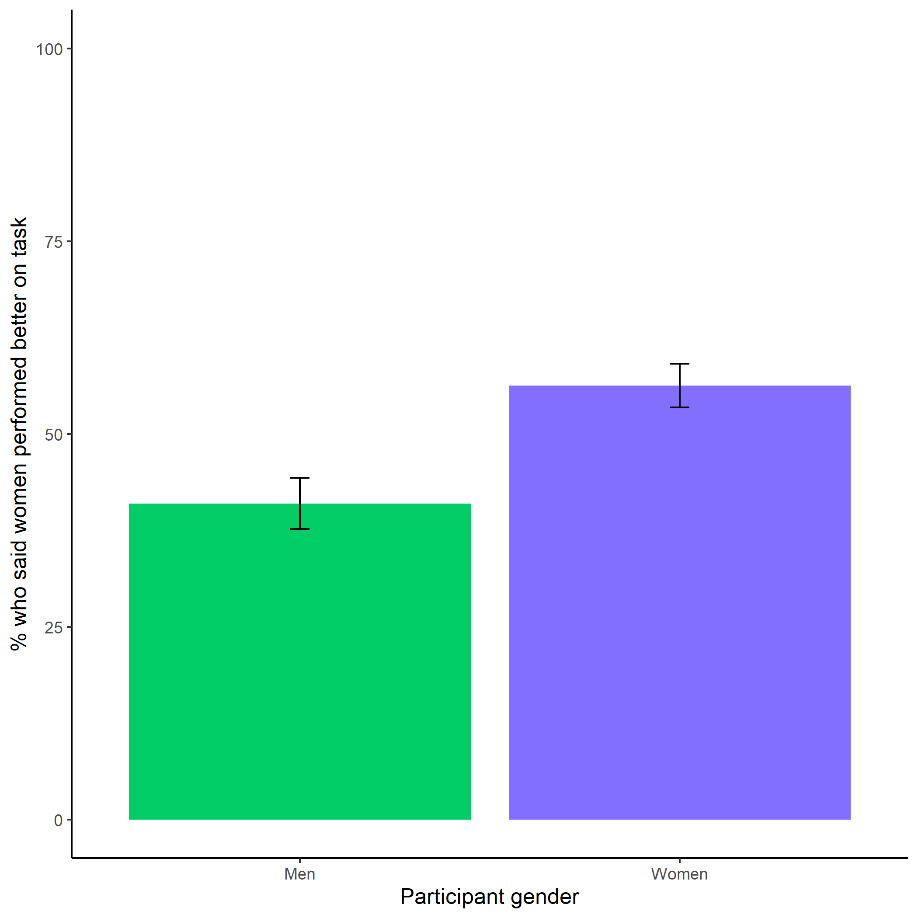

*Figure* *11.*  Participants’ perceptions of gender differences in performance on the task. Error bars represent standard errors.

Cross-Tabulation, Row Proportions  
clean $gender*clean$ better_gender_guess

|  |  |  |  |  |  |
| --- | --- | --- | --- | --- | --- |
|  | clean$better_gender_guess | Men | Women |  | Total |
| clean$gender |  |  |  |  |  |
| Man |  | 287 (53.9%) | 218 (41.0%) | 27 (5.1%) | 532 (100.0%) |
| Woman |  | 212 (39.0%) | 306 (56.2%) | 26 (4.8%) | 544 (100.0%) |
| Total |  | 499 (46.4%) | 524 (48.7%) | 53 (4.9%) | 1076 (100.0%) |

Exploratory analysis 3b: Participants were significantly more likely to expect men to choose to compete more often, $χ^{2}(1,n=1076)=578.07$, $p<.001$ (see Figure 12).

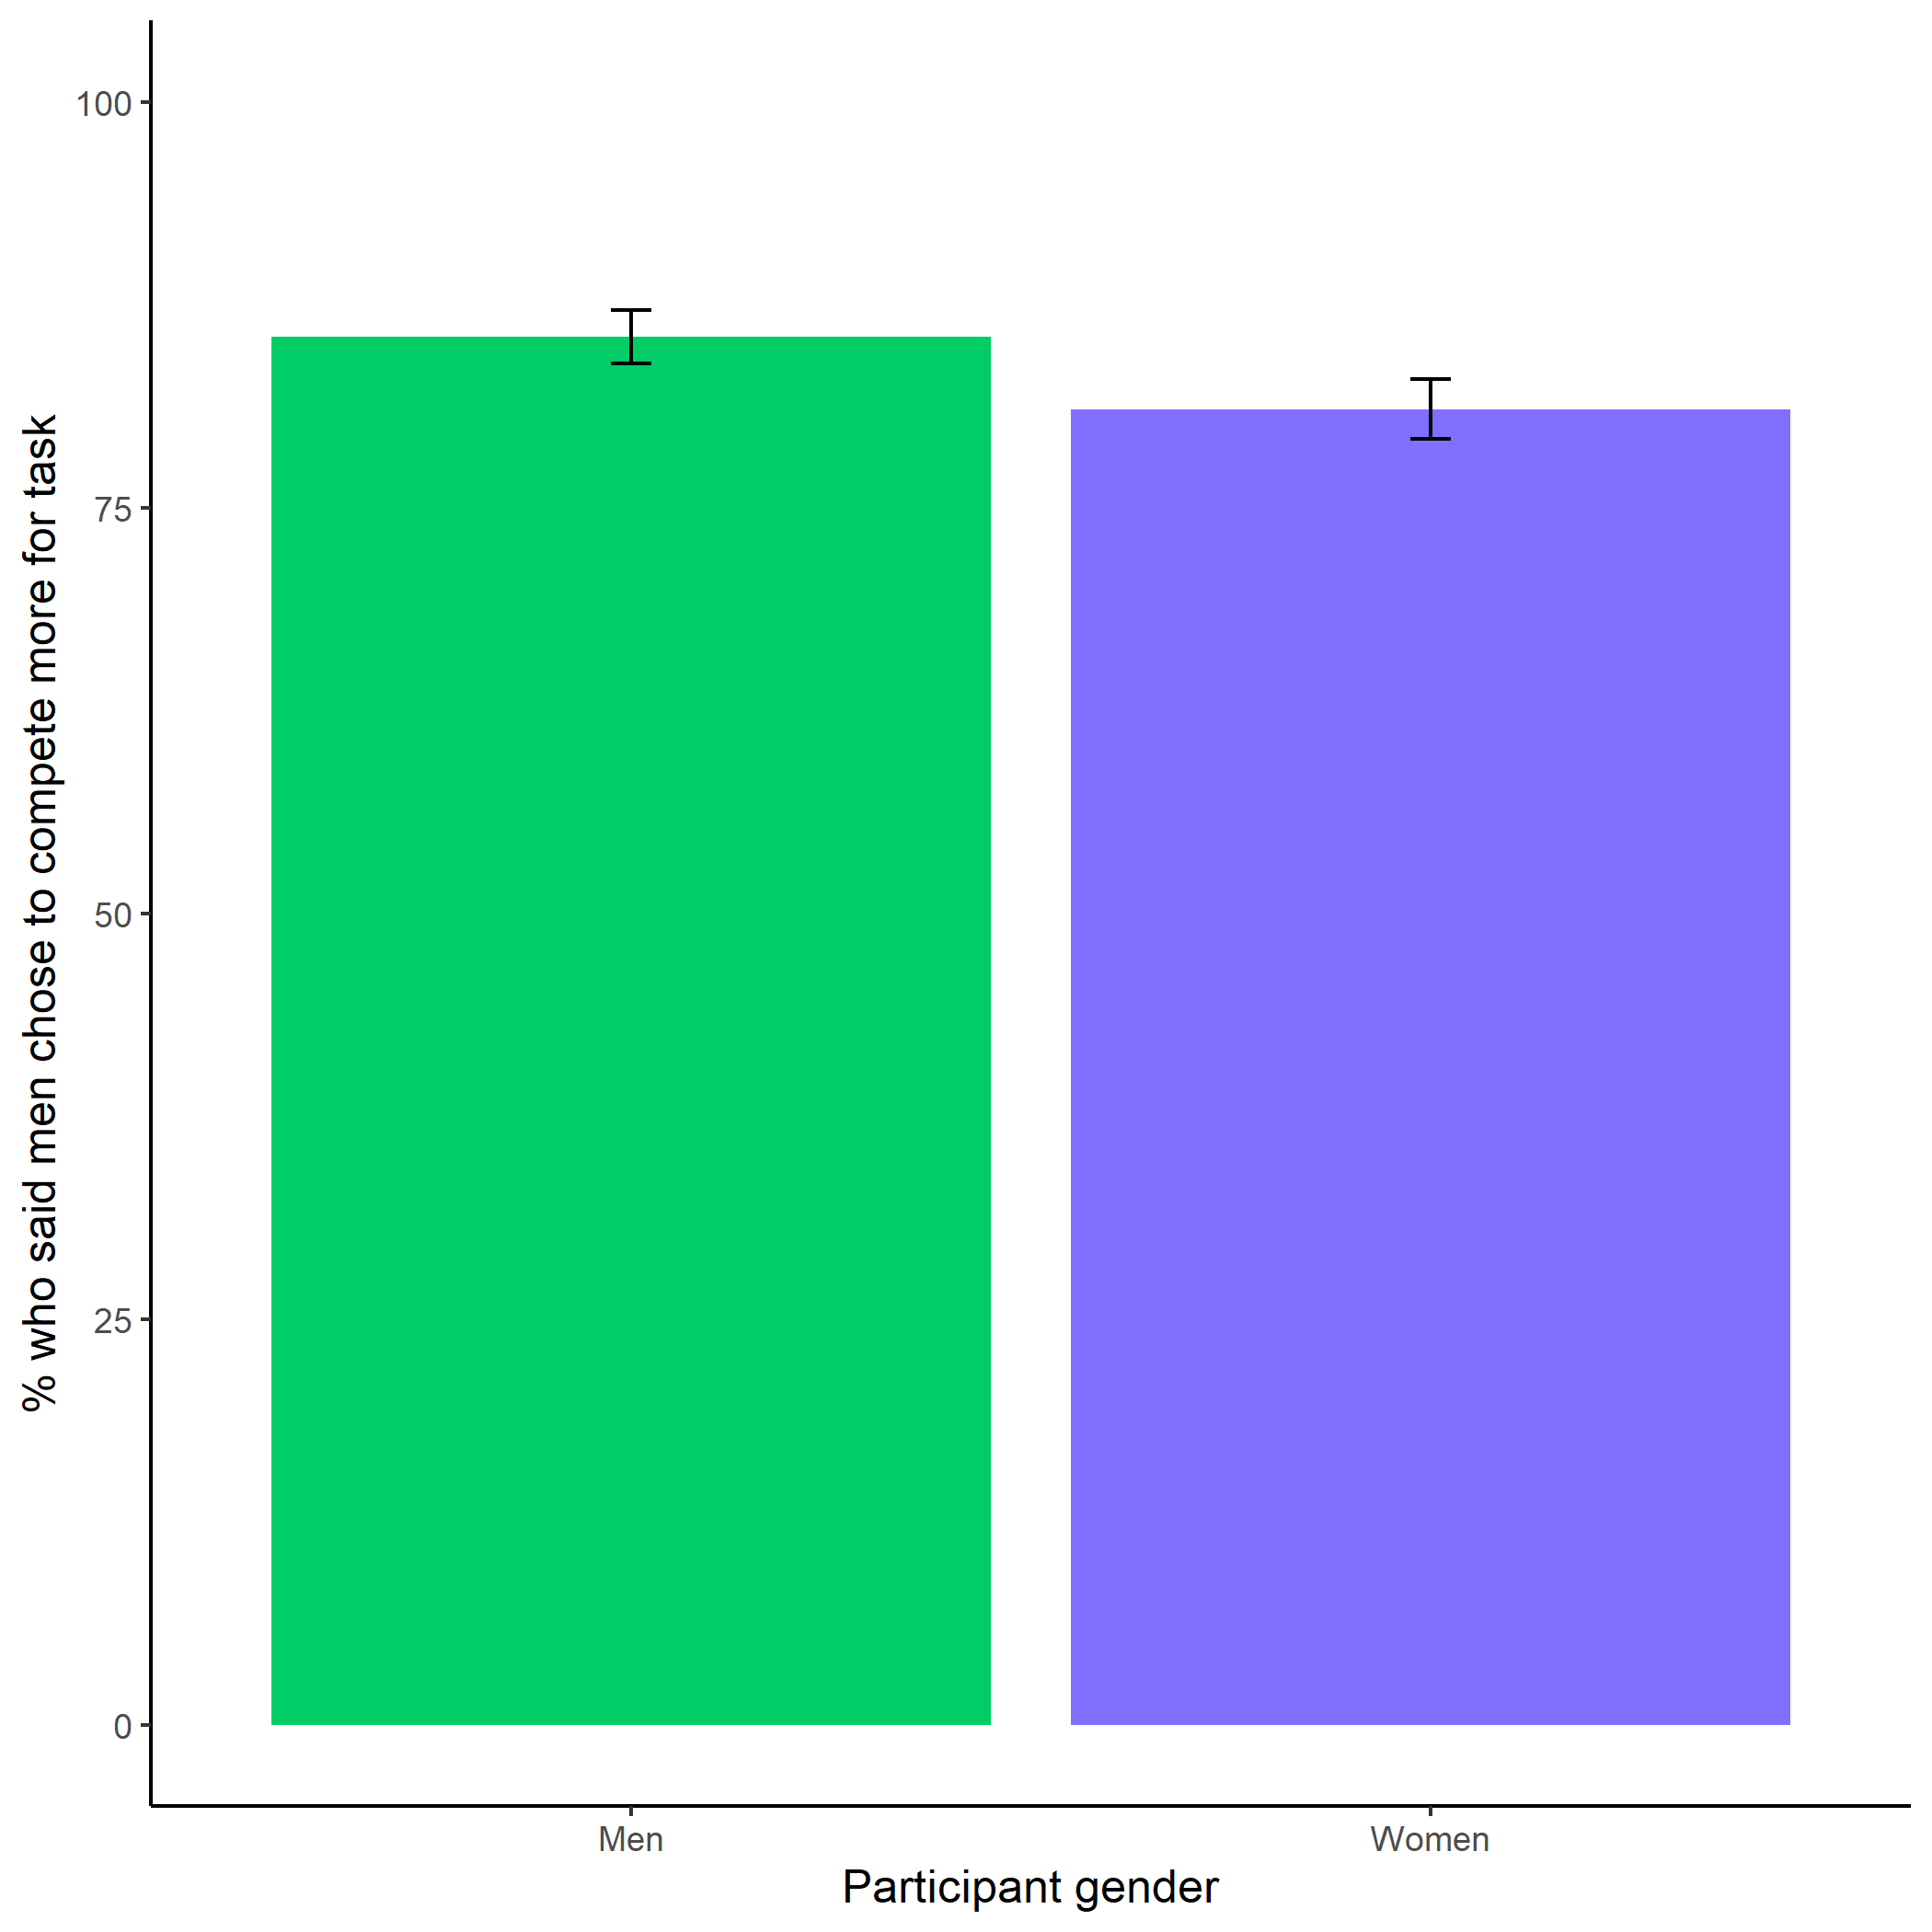

*Figure* *12.*  Participants’ perceptions of gender differences in choice to compete. Error bars represent standard errors.

Cross-Tabulation, Row Proportions  
clean $gender*clean$ perc_gender_comp

|  |  |  |  |  |  |
| --- | --- | --- | --- | --- | --- |
|  | clean$perc_gender_comp | Men | Women |  | Total |
| clean$gender |  |  |  |  |  |
| Man |  | 455 (85.5%) | 50 ( 9.4%) | 27 (5.1%) | 532 (100.0%) |
| Woman |  | 441 (81.1%) | 77 (14.2%) | 26 (4.8%) | 544 (100.0%) |
| Total |  | 896 (83.3%) | 127 (11.8%) | 53 (4.9%) | 1076 (100.0%) |

Exploratory analysis 3c: Participants were significantly more likely to expect women to choose to prepare in general, $χ^{2}(1,n=1076)=511.06$, $p<.001$ (see Figure 13).

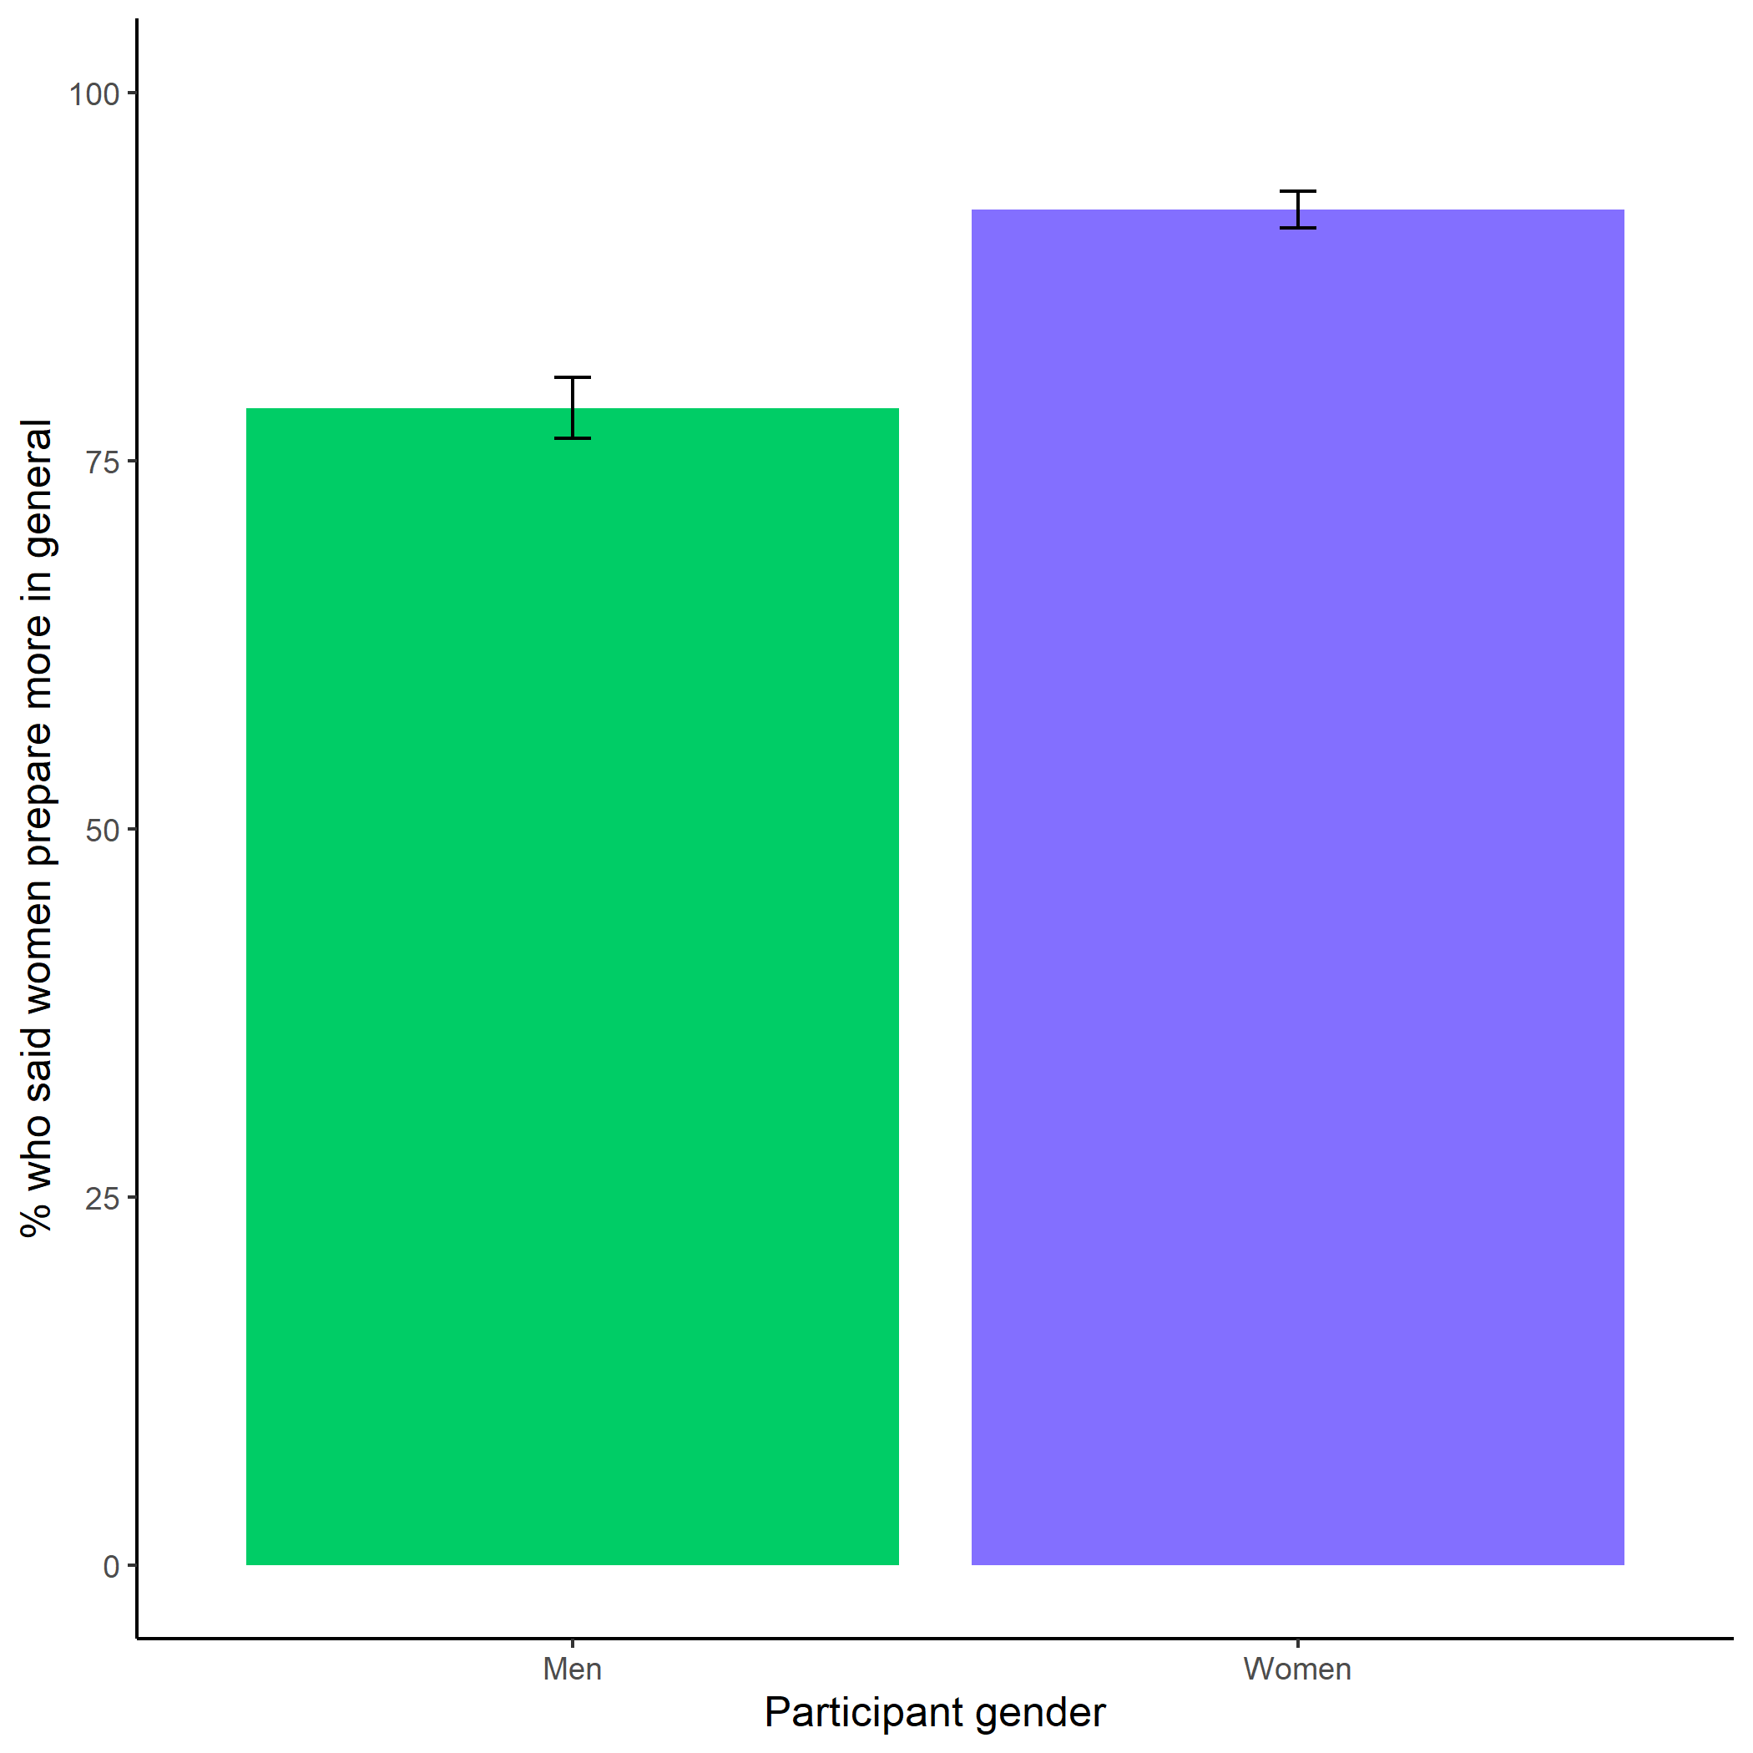

*Figure* *13.*  Participants’ perceptions of general gender differences in choice to practice. Error bars represent standard errors.

Cross-Tabulation, Row Proportions  
clean $gender*clean$ perc_gen_gender_pract

|  |  |  |  |  |  |
| --- | --- | --- | --- | --- | --- |
|  | clean$perc_gen_gender_pract | Men | Women |  | Total |
| clean$gender |  |  |  |  |  |
| Man |  | 108 (20.3%) | 396 (74.4%) | 28 (5.3%) | 532 (100.0%) |
| Woman |  | 41 ( 7.5%) | 475 (87.3%) | 28 (5.1%) | 544 (100.0%) |
| Total |  | 149 (13.8%) | 871 (80.9%) | 56 (5.2%) | 1076 (100.0%) |

### Exploratory analyses.

Exploratory analysis 1: Despite no evidence for the effect of condition on the choice to compete among women, we replicate the effects found in Study 1, where women were significantly more likely to prepare for the task, even after being forced to prepare in the preparation condition (see Figure 14). Women were 18.62% more likely to take advantage of the opportunity to prepare relative to men $b=0.11$, 95% CI $[-0.39$, $0.62]$, $z=0.45$, $p=.653$, while controlling for the decision to compete (see Figure 14).

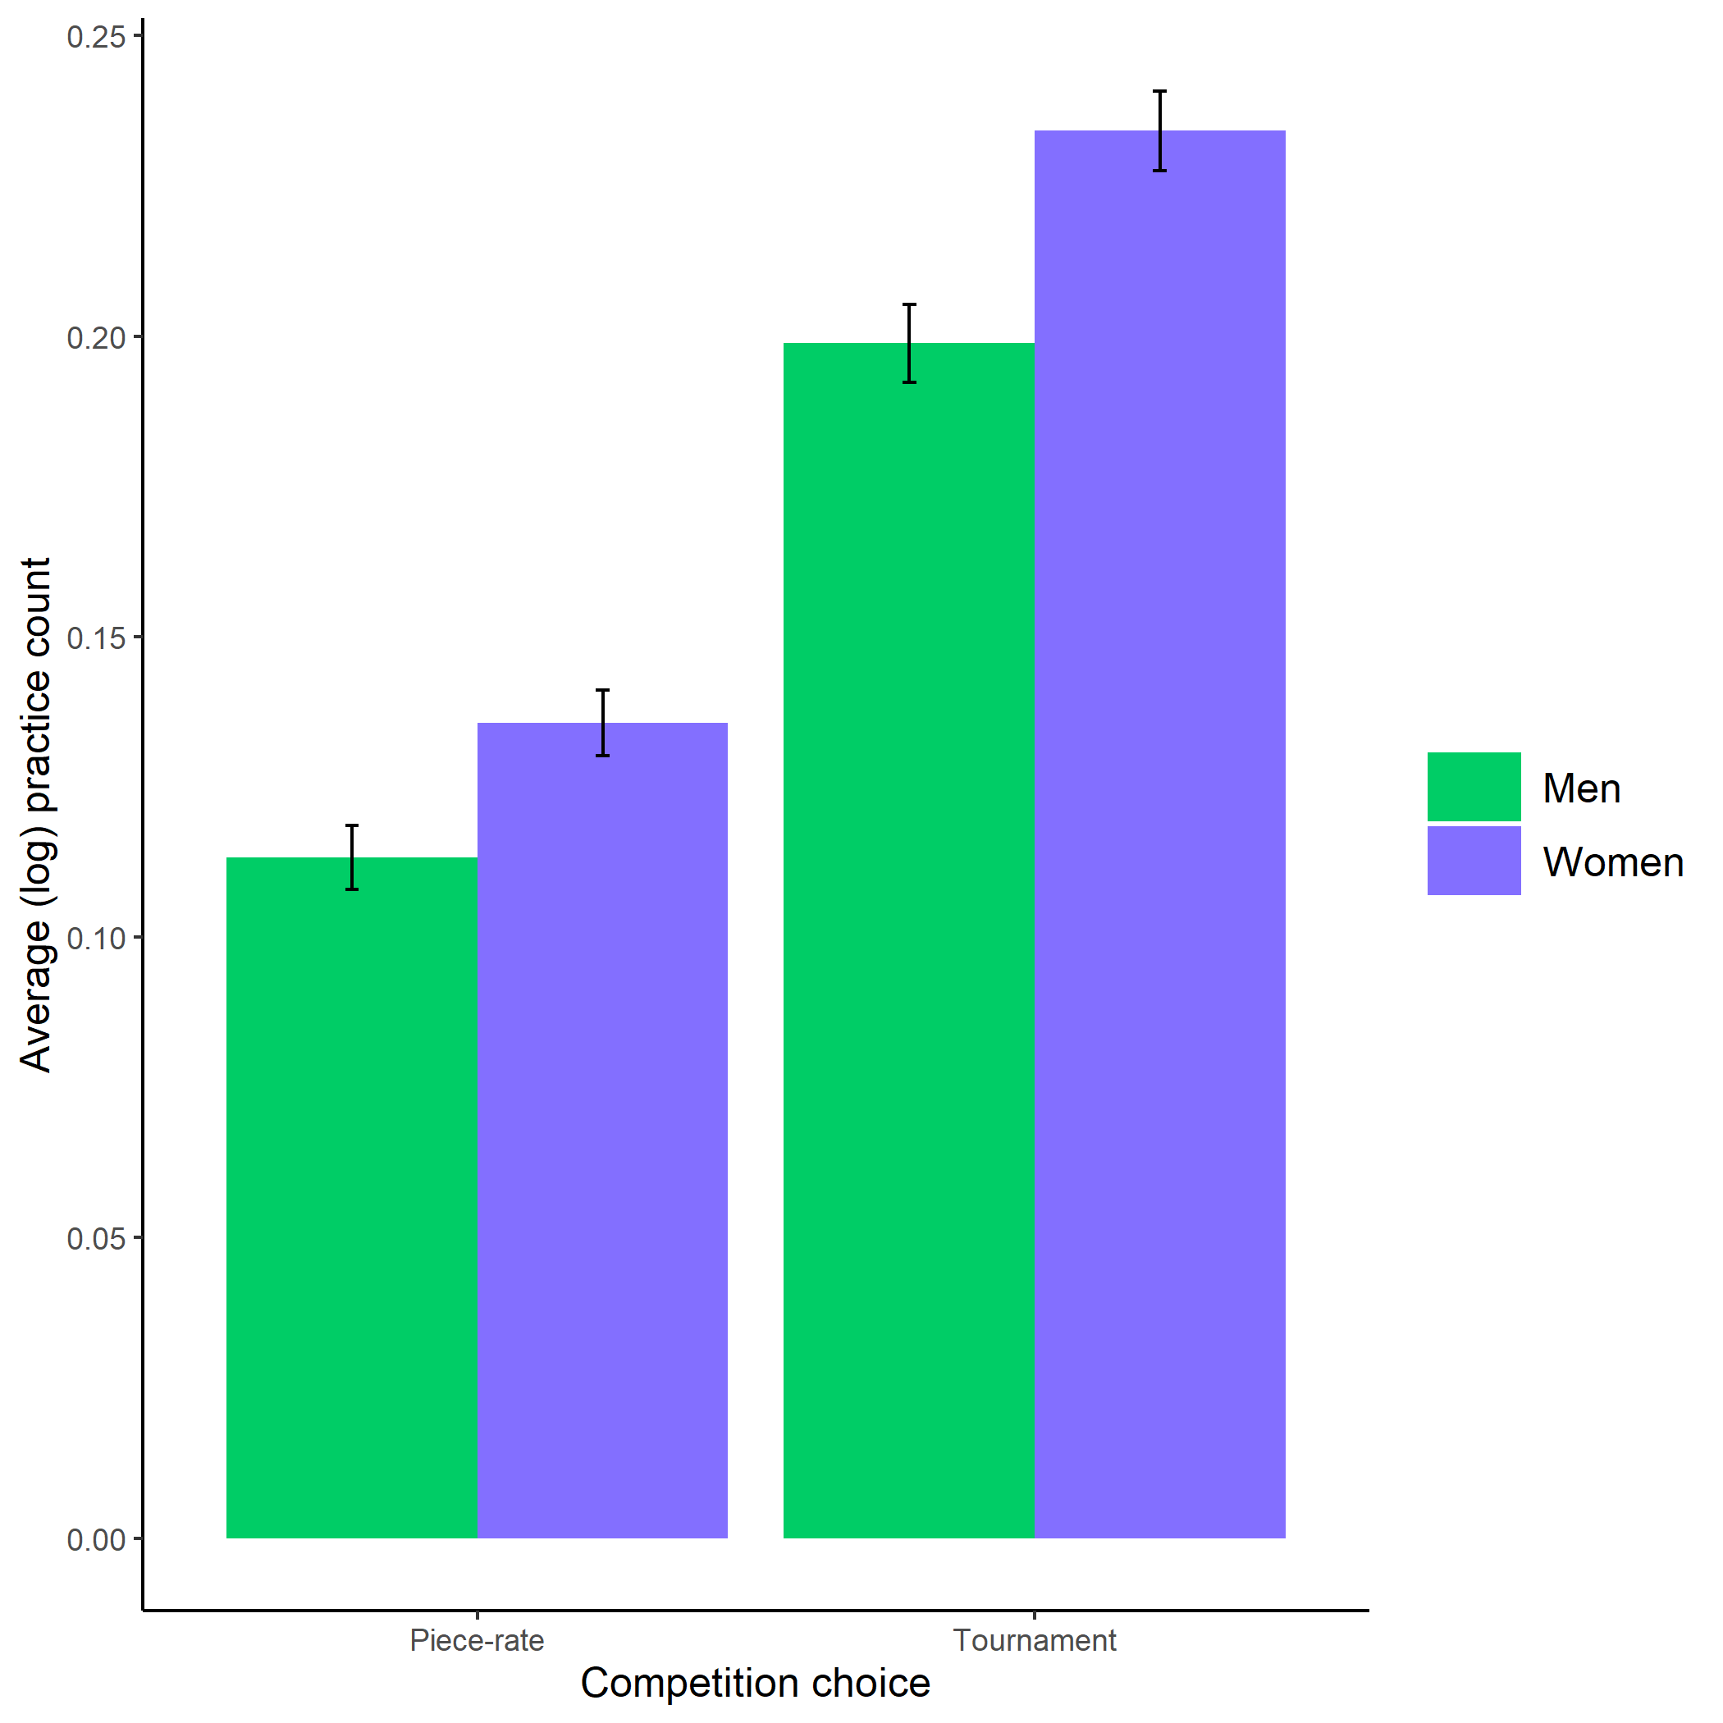

*Figure* *14.*  Gender differences in the number of extra practice rounds chosen across participants’ choice in a payment scheme. Error bars represent standard errors.

# References

Bertrand, M., & Hallock, K. F. (2001). The gender gap in top corporate jobs. *Industrial and Labor Relations Review*, *55*, 3–21.

Blau, F. D., & Kahn, L. M. (2017). The gender wage gap: Extent, trends, and explanations. *Journal of Economic Literature*, *55*(3), 789–865. <https://doi.org/10.1257/jel.20160995>

Buser, T., Niederle, M., & Oosterbeek, H. (2014). Gender, competition and career choices. *The Quarterly Journal of Economics*, *129*(3), 1409–1447. <https://doi.org/10.1093/qje/qju009.Advance>

Croson, R., & Gneezy, U. (2009). Gender differences in preferences. *Journal of Economic Literature*, *47*(2), 448–474. <https://doi.org/10.1257/jel.47.2.448>

Dohmen, T., Falk, A., Huffman, D., Sunde, U., Schupp, J., & Wagner, G. G. (2011). Individual risk attitudes: Measurement, determinants, and behavioral consequences. *Journal of the European Economic Association*, *9*(3), 522–550. <https://doi.org/10.1111/j.1542-4774.2011.01015.x>

Gist, M. E., & Mitchell, T. R. (1992). Self-efficacy: A theoretical analysis of its determinants and malleability. *The Academy of Management Review*, *17*(2), 183–211.

Goldin, C. (2006). The rising (And then declining) Significance of gender. In *The declining significance of gender?* (pp. 67–101). <https://doi.org/10.1177/009430610703600317>

Meyer, M., Cimpian, A., & Leslie, S.-J. (2015). Women are underrepresented in fields where success is believed to require brilliance. *Frontiers in Psychology*, *6*, 1–12. <https://doi.org/10.3389/fpsyg.2015.00235>

Milyavskaya, M., Galla, B. M., Inzlicht, M., & Duckworth, A. (2018). More effort, less fatigue: How interest increases effort and reduces mental fatigue.

Niederle, M., & Vesterlund, L. (2007). Do women shy away from competition? Do men compete too much? *The Quarterly Journal of Economics*, *122*(3), 1067–1101. Retrieved from [https://web.stanford.edu/{~}niederle/Niederle.Vesterlund.QJE.2007.pdf](https://web.stanford.edu/%7B~%7Dniederle/Niederle.Vesterlund.QJE.2007.pdf)

Niederle, M., & Vesterlund, L. (2011). Gender and competition. *Annual Review of Economics*, *3*, 601–630. <https://doi.org/10.1016/j.labeco.2009.08.002>

Reuben, E., Sapienza, P., & Zingales, L. (2015). Taste for competition and the gender gap among young business professionals. *NBER WORKING PAPER SERIES*.

Schunk, D. H. (1981). Modeling and Attributional Effects on Children’s Achievement: A Self-Efficacy Analysis. *Journal of Educational Psychology*, *73*(1), 93–105.

Schunk, D. H. (1982). Progress Self-Monitoring: Effects on Children’s Self-Efficacy and Achievement. *The Journal of Experimental Education*, *51*(2), 89–93.

Stoet, G., & Geary, D. C. (2014). Sex differences in academic achievement are not related to political, economic, or social equality. *Intelligence*, *48*, 137–151. <https://doi.org/10.1016/j.intell.2014.11.006>

Zhang, Y. J. (2012). Can experimental economics explain competitive behavior outside the lab? *Unpublished Manuscript*, 1–45. <https://doi.org/10.2139/ssrn.2292929>

1. All hypotheses were pre-registered (<https://osf.io/q39a5/>) unless otherwise stated and all analyses were conducted in R.
2. We examined whether gender was balanced across conditions. 49.59% of men and 49.29% of women were assigned to the control condition, while 49.80% of men and 49.12% of women were assigned to the practice condition, for a total of 49.43% of participants assigned to the control condition and 49.43% of participants assigned to the practice condition.
3. All hypotheses were pre-registered (<https://osf.io/q39a5/>) unless otherwise stated and all analyses were conducted in R.
4. 49.44% of men and 49.26% of women were assigned to the control condition, while 49.44% of men and 49.26% of women were assigned to the practice condition, for a total of 49.35% of participants assigned to the control condition and 49.35% of participants assigned to the practice condition
5. All hypotheses were pre-registered (<https://osf.io/q39a5/>) unless otherwise stated and all analyses were conducted in R.