The effects of preparation on gender differences in choice to compete

Keana Richards1, Gideon Nave1, & Coren Apicella1

1 University of Pennsylvania

Author note

Add complete departmental affiliations for each author here. Each new line herein must be indented, like this line.

Correspondence concerning this article should be addressed to Keana Richards, 3720 Walnut Street, Philadelphia PA 19104. E-mail: [keanari@sas.upenn.edu](mailto:keanari@sas.upenn.edu)

Abstract

Previous research suggests that women compete less than men, even though there are no gender differences in performance (Niederle & Vesterlund, 2011). These gender differences in competitiveness can lead to lower earnings (Niederle & Vesterlund, 2007; Reuben, Sapienza, & Zingales, 2015) and as such, may contribute to the well-established gender gap in wages (Blau & Kahn, 2017), among other important gender differences in economic outcomes. One mechanism for gender differences in competitiveness is confidence, which leads women to undercompete and men to overcompete (relative to their performance level) (Niederle & Vesterlund, 2007). Since mastery has been shown to be an important driver of confidence (Gist & Mitchell, 1992; Usher & Pajares, 2008), the current studies examine whether providing the opportunity to prepare before a competition will reduce gender differences in competitiveness. We did not find evidence that women compete more when they have the opportunity to prepare. However, we find a gender gap in preparation, where women are choosing to prepare more (Studies 2 and 3) and want to prepare more if given the opportunity (Study 1/Pilot), even though they chose to compete less (Studies 2 and 3) and even after they were forced to prepare (Study 3), which aligns with participants’ beliefs about gender differences in preparation (Studies 2 and 3). These findings suggest that women may value preparing intrinsically more than men, regardless of whether they plan on competing, with important implications for the opportunity costs of overpreparing.

*Keywords:* keywords

*Word count:* X

The effects of preparation on gender differences in choice to compete

# Introduction

from RSF application:

Women have surpassed men in education outcomes, like college attendance and graduation rates (Blau & Kahn, 2017; Goldin, 2006; Stoet & Geary, 2014), but are still underrepresented in top management positions in nearly all sectors (Bertrand & Hallock, 2001) and a gender wage gap still persists (Blau & Kahn, 2017). Traditional economic variables account for some, but not all, of these disparities. As such, additional explanations have been proposed, including gender differences in choice to compete. Previous research suggests that women are less willing to compete than men, even when they are equally, if not more, qualified (Niederle & Vesterlund, 2007, for reviews, see 2011, and @Croson2009). This effect has been established across numerous studies and appears to be driven by high ability women being less willing to compete compared to their male counterparts, creating higher total costs of pay-off inferior decisions (i.e., under-entry) for women compared to men (Niederle & Vesterlund, 2007).

Understanding how to address gender differences in competitiveness is important for reducing gender inequality that persists today. When women compete less than their male counterparts, they may be missing crucial economic opportunities, as demonstrated by the evidence suggesting competitiveness is relevant to one’s economic outcomes (Buser, Niederle, & Oosterbeek, 2014; Reuben, Sapienza, & Zingales, 2015; Zhang, 2012).

Women’s relatively lower levels of confidence in their performance partly explains this gender difference (Niederle & Vesterlund, 2011), so it is important to understand factors that may affect confidence prior to the decision to compete. Since prior research has shown that confidence can improve with preparation and training (Gist & Mitchell, 1992; Schunk, 1981, 1982), providing women with an adequate opportunity to prepare before a task may alleviate the gender gap in choice to compete.

The research design, hypotheses, measures and analyses were preregistered (<https://osf.io/q39a5/>) unless otherwise stated and all analyses were conducted in R statistical software (version 4.0.3).

# Pilot study

## Methods

We recruited workers on Amazon Mechanical Turk for a study on decision-making. The workers who opted into the study had to pass several screening questions to be included as participants in the paid portion of the study. Specifically, participants included in the study had to (i) identify their nationality as American and live in the United States, (ii) identify as male or female, (iii) be using a computer (rather than a phone or tablet), and (iv) pass three comprehension questions about the task they would be completing. If they did not meet these criteria, they did not proceed to the paid portion of the study. Additionally, upon reviewing the data, we had reason to suspect that some participants completed the study more than once. Specifically, some participants had the same IP address, MTurk ID, and were of the same gender. When entries matched on all three identifiers, we included only the first entry and excluded all subsequent entries. The final sample consisted of 337 participants (56.97% women), with an average age of 37.40 (*SD* = 11.67) years. 17 participants (76.47% women) dropped out of the study before finishing. We include their data in analyses when available.

Participants were told that they would complete three rounds of a key-entry task where they would solve as many problems as they could within one minute and be paid based on their performance. The task required participants to use a legend to enter letters associated with a series of 2-digit numbers shown on the screen. The legend consisted of five numbers with a corresponding letter below each number. The letters used were randomly generated. However, all participants saw the same legend and the legend did not change across rounds. For instance, the letter “Z” was associated with the number 1 and “A” was associated with the number 2. If participants were presented with the problem “1 2”, they would have to enter “C R” into the corresponding text box. Before the paid rounds, participants were shown an example problem with the correct answer. Following this, they were required to pass three practice problems to test their comprehension. Each of these problems was identical in structure to the problems they would receive during the paid rounds.

In the first and second round of the task, participants were incentivized according to a piece-rate and tournament payment scheme, respectively (Niederle & Vesterlund, 2007). Under the piece-rate scheme, participants were told that they would earn $.05 for each correct answer. Under the tournament payment scheme, participants were told that they would earn $.10 for each correct answer, but were only paid if their score was greater than the second-round performance of another anonymous, randomly matched opponent who was doing the same experiment with the same sequence of numbers. In the third round, participants were asked to choose between the two above payment schemes. We denote this decision as “choice to compete” (Niederle & Vesterlund, 2007).

After the third round, participants completed a series of follow-up questions which measured confidence, perceptions of gender differences in performance on the task, and risk aversion.

We adapted previous measures of confidence (i.e., Niederle & Vesterlund, 2007) in our study by asking participants to (i) indicate whether they thought their round 2 score was higher or lower than the person they had competed against and (ii, iii) predict which decile their round 2 score will fall into relative to all men (women) who completed the task during round 2. To measure perceptions of gender differences, we asked participants to indicate whether they thought “women or men generally do better in the key-entry task” that they completed. These answers were incentivized: participants were told that if they answered one of these questions correctly they could receive a bonus. Specifically, participants were told that one of their responses would be randomly selected for payment and they would receive a bonus of $.10 if their answer was correct.

Participants were asked whether they thought their score would have improved if they practiced the task beforehand. Additionally, we asked participants whether they would have practiced the task, if given the opportunity. If participants responded yes, they were asked how long they would have practiced for (in minutes) if they were given unlimited time.

Finally, we measured risk aversion by asking participants “How do you see yourself: Are you generally a person who is fully prepared to take risks or do you try to avoid taking risks?” (Dohmen et al., 2011) on a 10 point scale, where 0 indicates participants are “Not at all willing to take risks,” while 10 indicates participants are “Very willing to take risks.”

## Results

We first perform a logistic regression with gender predicting choice to compete in round 3. We find no significant evidence of gender differences in the choice to compete, , 95% CI , , , , though men chose to compete more often (34.48%) compared to women (29.69%) (see Figure 1). However, confidence, , 95% CI , , , , and risk aversion, , 95% CI , , , , significantly predict the decision to compete.

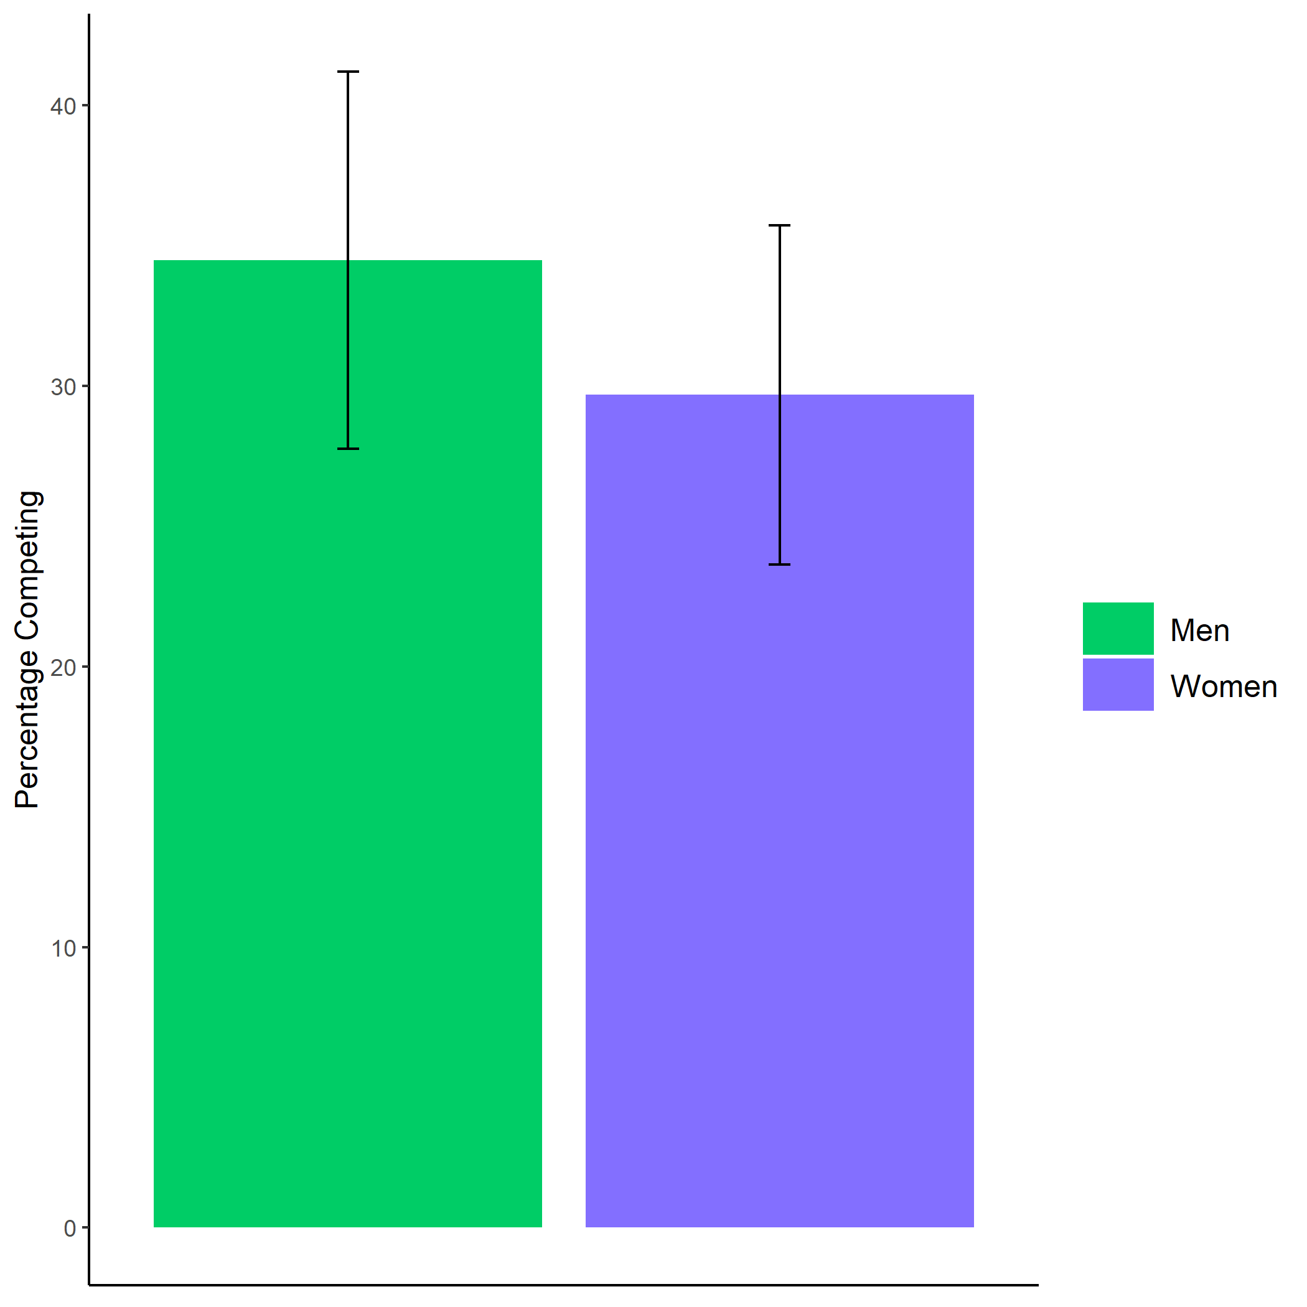

*Figure* *1.*  Proportion of male and female participants who chose to compete. Error bars represent standard errors.

Cross-Tabulation, Row Proportions  
cleancomp_choice

|  |  |  |  |  |  |
| --- | --- | --- | --- | --- | --- |
|  | clean$comp_choice | piecerate | tournament |  | Total |
| clean$gender |  |  |  |  |  |
| Man |  | 91 (62.8%) | 50 (34.5%) | 4 (2.8%) | 145 (100.0%) |
| Woman |  | 123 (64.1%) | 57 (29.7%) | 12 (6.2%) | 192 (100.0%) |
| Total |  | 214 (63.5%) | 107 (31.8%) | 16 (4.7%) | 337 (100.0%) |

We also performed exploratory analyses outside of the pre-registered analyses, which will be discussed briefly here. First, chi-square tests of independence show the majority of participants believed that their score would have improved if they practiced the task beforehand, , , and that these beliefs about improvement did not differ by gender, , . However, using a logistic regression, we do find that gender significantly predicts reported willingness to practice, , 95% CI , , , (see Figure 2). Women are 95 times more willing to practice than men. Of those participants who reported that they would have practiced, we found no significant evidence for gender differences in the amount of time they would have practiced, , .

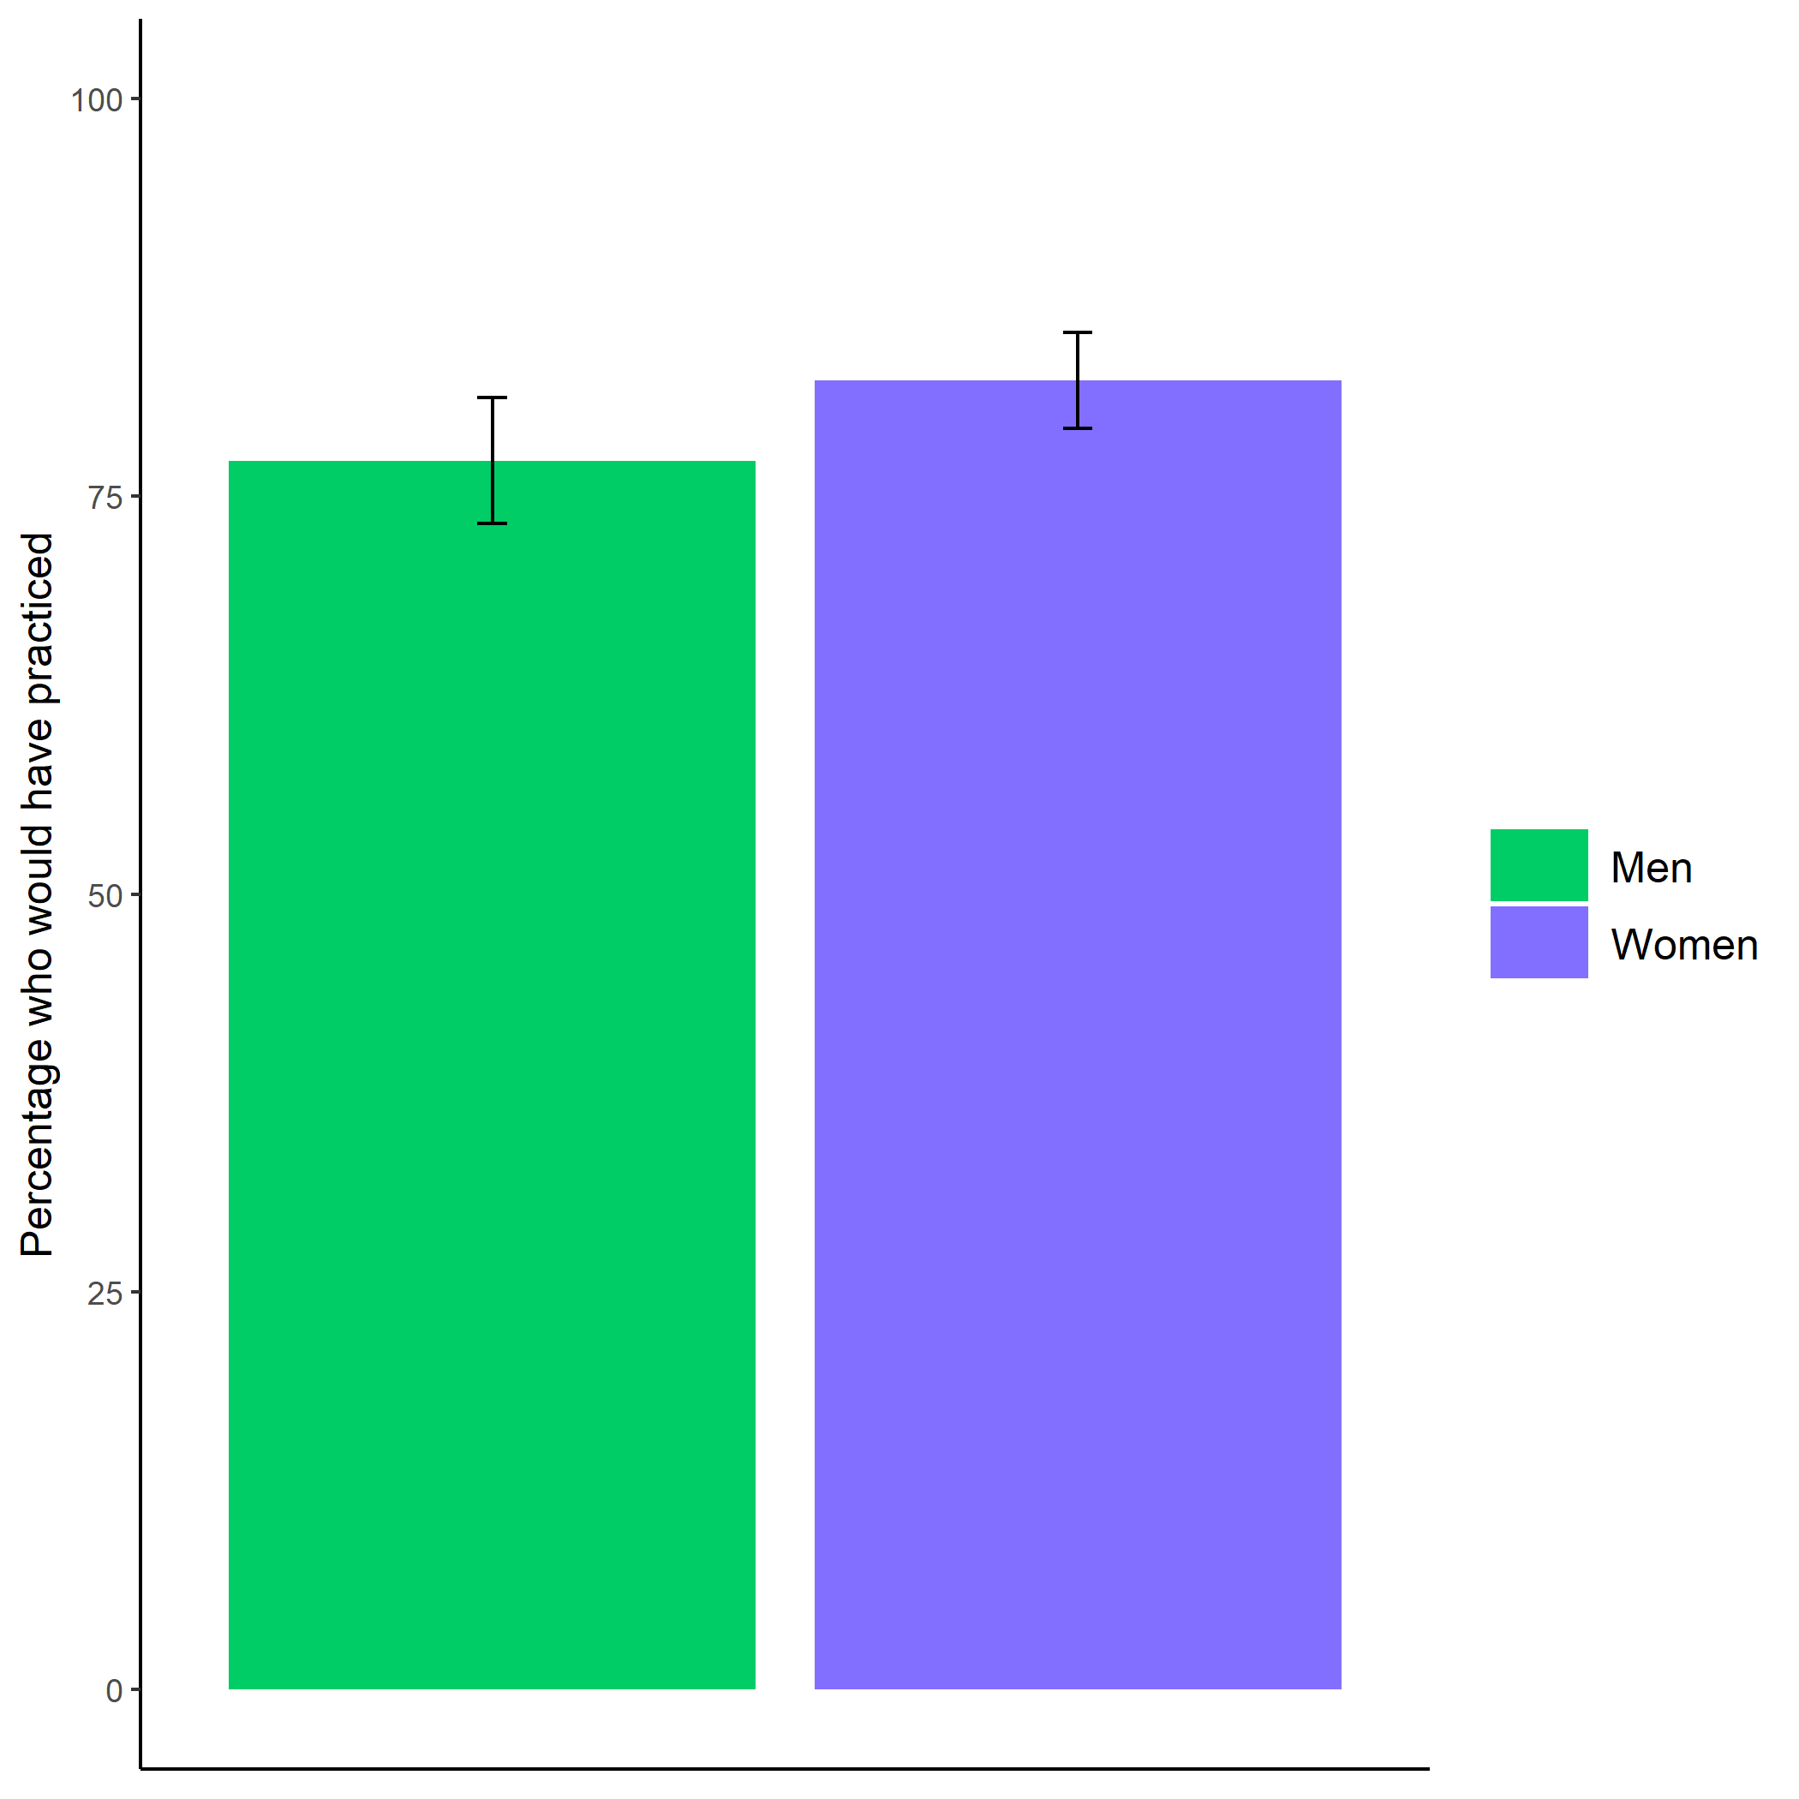

*Figure* *2.*  Proportion of male and female participants who indicated they would have taken the opportunity to practice the key-entry task. Error bars represent standard errors.

Cross-Tabulation, Row Proportions  
cleanpract_choice

|  |  |  |  |  |  |
| --- | --- | --- | --- | --- | --- |
|  | clean$pract_choice | No | Yes |  | Total |
| clean$gender |  |  |  |  |  |
| Man |  | 29 (20.0%) | 112 (77.2%) | 4 (2.8%) | 145 (100.0%) |
| Woman |  | 21 (10.9%) | 158 (82.3%) | 13 (6.8%) | 192 (100.0%) |
| Total |  | 50 (14.8%) | 270 (80.1%) | 17 (5.0%) | 337 (100.0%) |

Finally, we explored perceptions of gender differences. First, we use chi-square tests of independence to examine whether participants were more likely to predict that women or men would perform better on the task, and whether there were any gender differences in these perceptions. Participants were significantly more likely to believe that women would outperform men on the key-entry task, , . Additionally, women were significantly more likely than men to make this prediction, , , even though there were no gender differences in actual performance on the task (based on the sum of scores across all three rounds), , .

# Study 1

## Methods

We recruited workers on Amazon Mechanical Turk for Study 1, and those who opted into the study had to pass several screening questions. Specifically, participants included in the paid portion of the study had to (i) identify their nationality as American and live in the United States, (ii) identify as male or female, and (iii) be using a computer (rather than a phone or tablet). If they did not meet these criteria, they did not proceed to the paid portion of the study. Additionally, upon reviewing the data, we had reason to suspect that some participants completed the study more than once. Specifically, some participants had the same IP address, MTurk ID, and were of the same gender. When entries matched on all three identifiers, we included only the first entry and excluded all subsequent entries. The final sample consisted of 1056 participants (53.60% women), with an average age of 37.74 (*SD* = 13.19) years. 54 participants (53.70% women) dropped out of the study before finishing and we use their data when available.

Participants were told they would be completing a multiplication task where they would be able to choose how they would be paid for their performance. The task involved solving problems from multiplication tables 1-12 as quickly as possible within a two-minute period. They were provided an example of a question with the correct response and had to answer three practice problems correctly to proceed, as a test of their comprehension. After completing the comprehension questions, participants were randomly assigned to either a “knowledge of preparation” condition or a control condition. Participants in the “knowledge of preparation” condition were presented the following text:

“There is an option to practice/study before completing the multiplication task that is available to all participants. If you take this opportunity to practice/study, we will provide you with materials that may help boost your performance in the multiplication task. You will have unlimited time to practice/study before completing the task. You can stop practicing/studying at any point.”

Participants assigned to the control condition simply proceeded without seeing this text. Then, all participants learned about the two possible payment schemes (either piece-rate or tournament) that they would have the option to choose from and had to correctly answer questions testing their comprehension of the payment schemes.

Under the piece-rate scheme participants were told that they would be paid $.10 for every problem answered correctly. Under the tournament scheme, participants were told that they would be paid $.20 for every problem they answered correctly, but only if they answered more questions correctly than a randomly assigned competitor. Participants in the experimental condition were reminded that they had the option to prepare before completing the task. The order of presentation of the tournament and piece-rate payment options was randomized for participants.

After choosing a payment scheme, participants in both conditions were given an opportunity to prepare before the multiplication task. If they chose to prepare, participants were presented with each multiplication table, 1 through 12, in sequential order. Each multiplication table provided products of numbers up to 12. Thus, participants could use the table to study. Additionally, participants were asked if they wanted to complete practice problems. If they said yes, participants were asked to solve all multiples in that table and could only proceed to the next table if they answered all the questions correctly.

Once they completed all practice questions for a given times table, they were shown the multiplication table again and were asked if they would like to continue solving problems from that table or move onto the next multiplication table. This process was repeated for each multiplication table. Thus, we had two measures of preparation behavior: the decision to practice and the total number of times participants completed each multiplication table. The decision to practice measure conceptually captures a participants’ baseline willingness to prepare, before they know what the preparation will involve. Thereafter, the total number of preparation rounds reflects participants’ willingness to repeatedly prepare.

Following the preparation portion of the study, participants moved on to the paid portion of the study. They were required to solve as many problems as possible in two minutes. After completion, participants were told how many problems they answered correctly and completed a series of incentivized follow-up questions, including confidence and perceptions of gender differences. For these measures, participants were told one of these questions would be selected for a possible bonus payment, and if they answered the selected question correctly, they would earn a bonus of $.10. For the measure of confidence, participants were asked to correctly predict their relative performance compared to all other participants completing the task by indicating the decile of their score. Notably, the item was phrased so participants did not need to understand the word “decile,” but were asked instead: “If my performance is compared to that of all participants that completed the task, I think my score was…” with the options for responses ranging from “Better than all other participants” to “Better than none of the other participants” with 10% increments in between (e.g., “Better than 50% of participants”). Participants were also asked to correctly predict which gender 1) correctly solved more problems 2) spent more time practicing before completing the multiplication task, and 3) chose the tournament payment option more.

Finally, participants completed a measure of risk aversion, where they answered if they generally are willing to take risks or try to avoid taking risks (Dohmen & Falk, 2011) on a 10 point scale with 0 meaning participants are “Not at all willing to take risks” and 10 indicating participants are “Very willing to take risks.” To determine whether participants used additional tools to improve their performance on the task, we also asked participants about their use of calculators and perceptions of calculator use on the multiplication task. Neither of these measures was incentivized.

## Results

An equal number of participants were assigned to both conditions (control= 50%). Of the males who completed the study, 49.90% were assigned to the control condition. Of the females who completed the study, 50.09% were assigned to the control condition.

Cross-Tabulation, Row Proportions  
na_dropcondition

|  |  |  |  |  |
| --- | --- | --- | --- | --- |
|  | na_drop$condition | control | pract | Total |
| na_drop$gender |  |  |  |  |
| Man |  | 243 (49.9%) | 244 (50.1%) | 487 (100.0%) |
| Woman |  | 279 (50.1%) | 278 (49.9%) | 557 (100.0%) |
| Total |  | 522 (50.0%) | 522 (50.0%) | 1044 (100.0%) |

A minority of participants (15.41%) chose to compete. Notably, of the participants who chose to compete, a greater share of men (19.59%) compared to women (10.78%) chose to compete. A logistic regression revealed that this gender difference in the choice to compete is significant, , 95% CI , , , . However, we do not find evidence of a significant interaction between gender and condition on the decision to compete, , 95% CI , , , (see Figure 3).

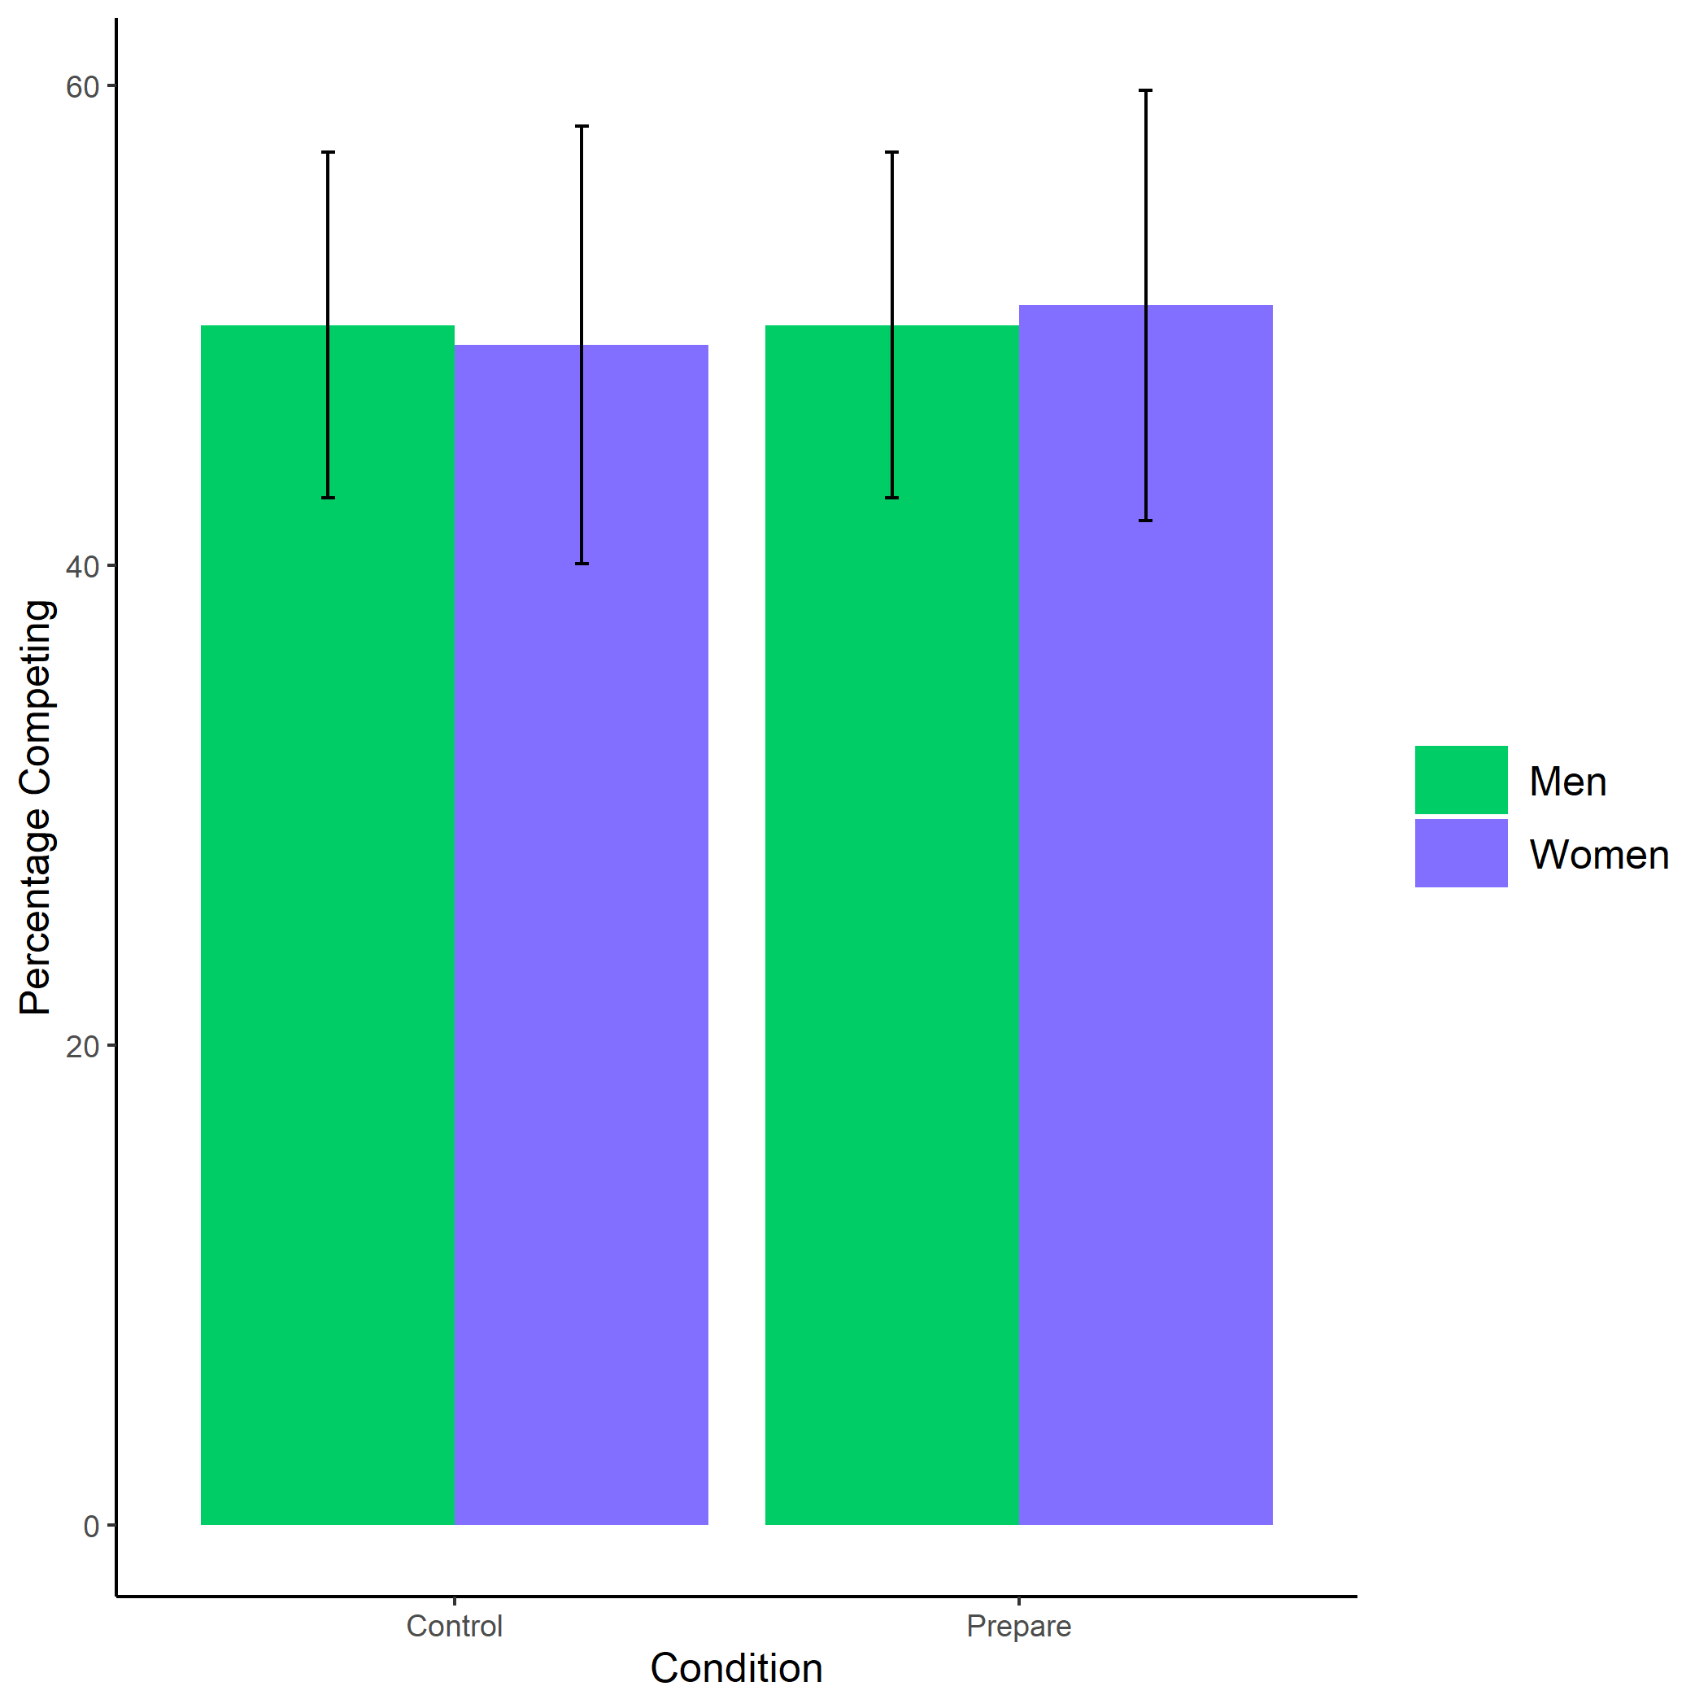

*Figure* *3.*  Proportion of male and female participants who chose to compete by condition. Error bars represent standard errors.

Cross-Tabulation, Row Proportions  
“Man” * “Man”

|  |  |  |  |  |
| --- | --- | --- | --- | --- |
|  | “Man” | control | pract | Total |
| “Man” |  |  |  |  |
| Man |  | 187 (49.5%) | 191 (50.5%) | 378 (100.0%) |
| Woman |  | 243 (50.2%) | 241 (49.8%) | 484 (100.0%) |
| Total |  | 430 (49.9%) | 432 (50.1%) | 862 (100.0%) |
|  | “Woman” | control | pract | Total |
| “Man” |  |  |  |  |
| Man |  | 48 (50.0%) | 48 (50.0%) | 96 (100.0%) |
| Woman |  | 30 (49.2%) | 31 (50.8%) | 61 (100.0%) |
| Total |  | 78 (49.7%) | 79 (50.3%) | 157 (100.0%) |

As hypothesized, women were 75.47% more likely to take advantage of the opportunity to practice relative to men, , 95% CI , , , , while controlling for the decision to compete (see Figure 4). As an exploratory analysis, we tested whether gender and the choice to compete interact to predict the choice to prepare, but did not find evidence for an interaction, , 95% CI , , , .

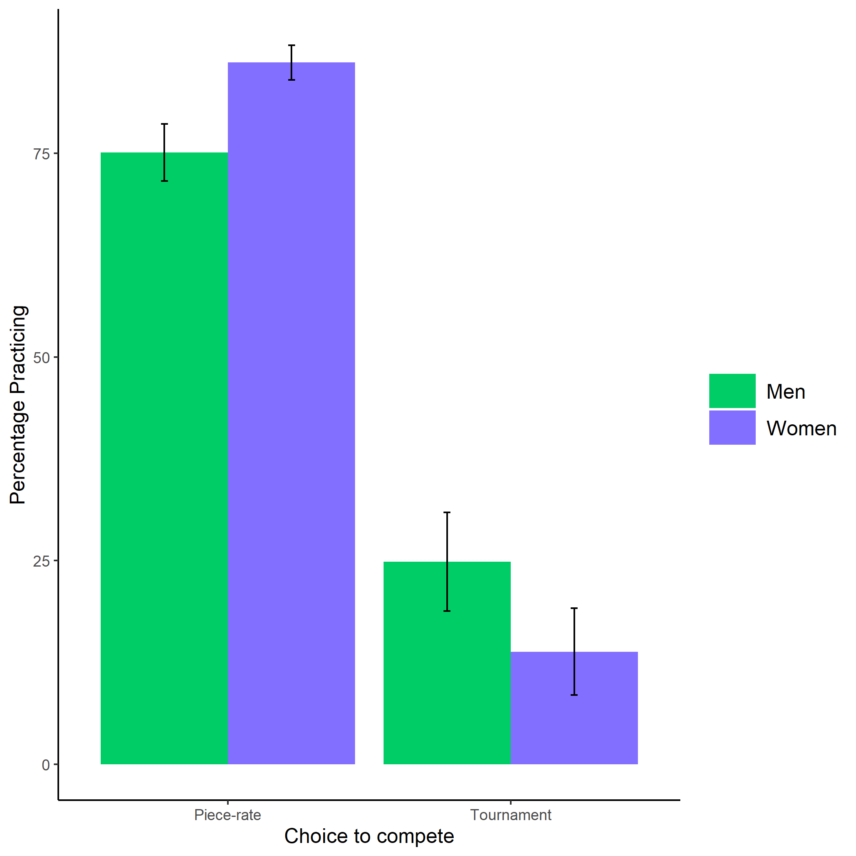

*Figure* *4.*  Proportion of male and female participants who chose to prepare by choice to compete. Error bars represent standard errors.

Cross-Tabulation, Row Proportions  
“Man” * “Man”

|  |  |  |  |  |
| --- | --- | --- | --- | --- |
|  | “Man” | piecerate | tournament | Total |
| “Man” |  |  |  |  |
| Man |  | 224 (83.3%) | 45 (16.7%) | 269 (100.0%) |
| Woman |  | 221 (92.1%) | 19 ( 7.9%) | 240 (100.0%) |
| Total |  | 445 (87.4%) | 64 (12.6%) | 509 (100.0%) |
|  | “Woman” | piecerate | tournament | Total |
| “Man” |  |  |  |  |
| Man |  | 154 (75.1%) | 51 (24.9%) | 205 (100.0%) |
| Woman |  | 262 (86.2%) | 42 (13.8%) | 304 (100.0%) |
| Total |  | 416 (81.7%) | 93 (18.3%) | 509 (100.0%) |

In concordance with our pre-registered hypothesis, women completed 68.59% more rounds of preparation relative to men, , 95% CI , , , (see Figure 5).

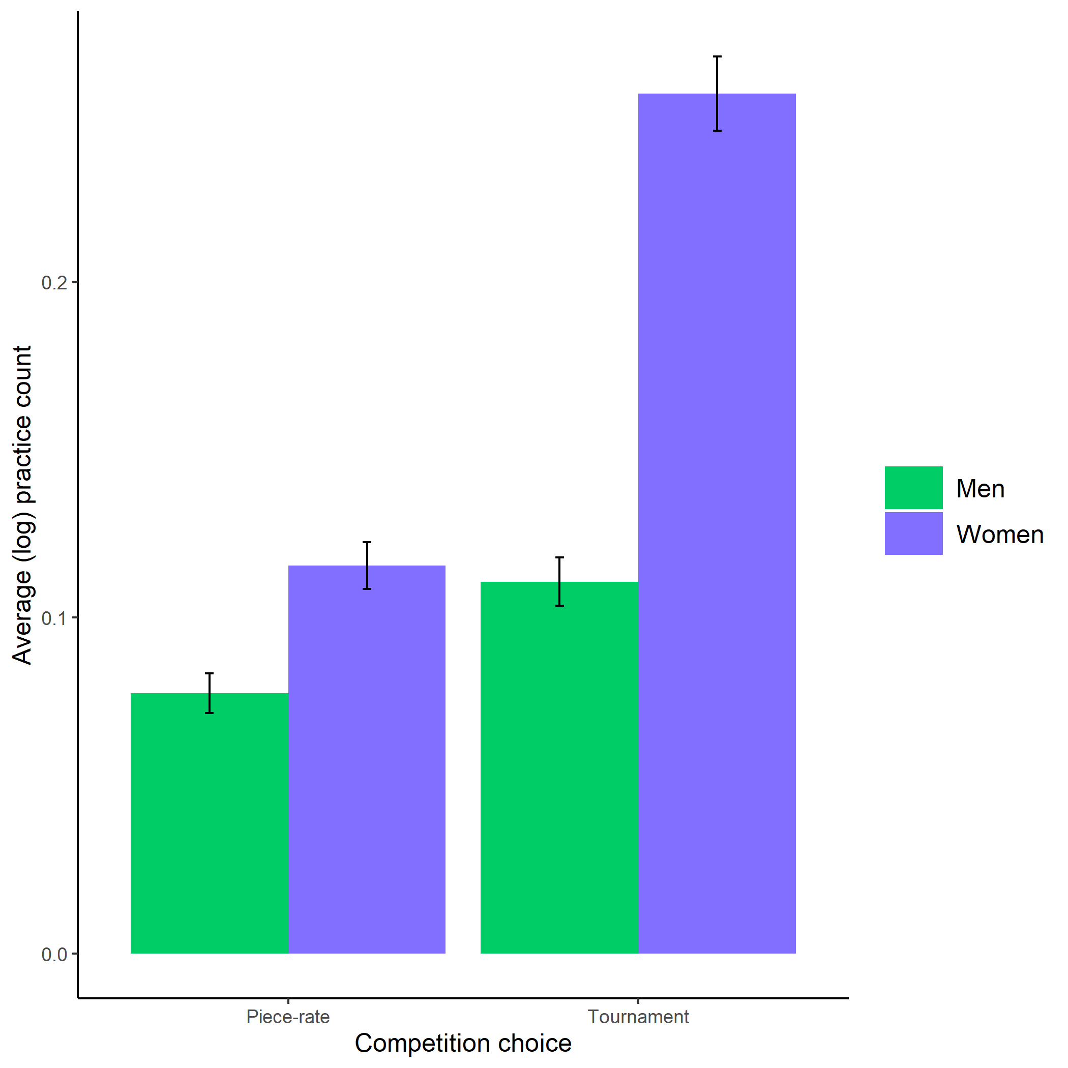

*Figure* *5.*  Average (log-transformed) practice count based on participant gender and competition choice. Error bars represent standard errors.

As hypothesized, participants expected women to spend more time preparing for the multiplication task relative to men, , (see Figure 6).

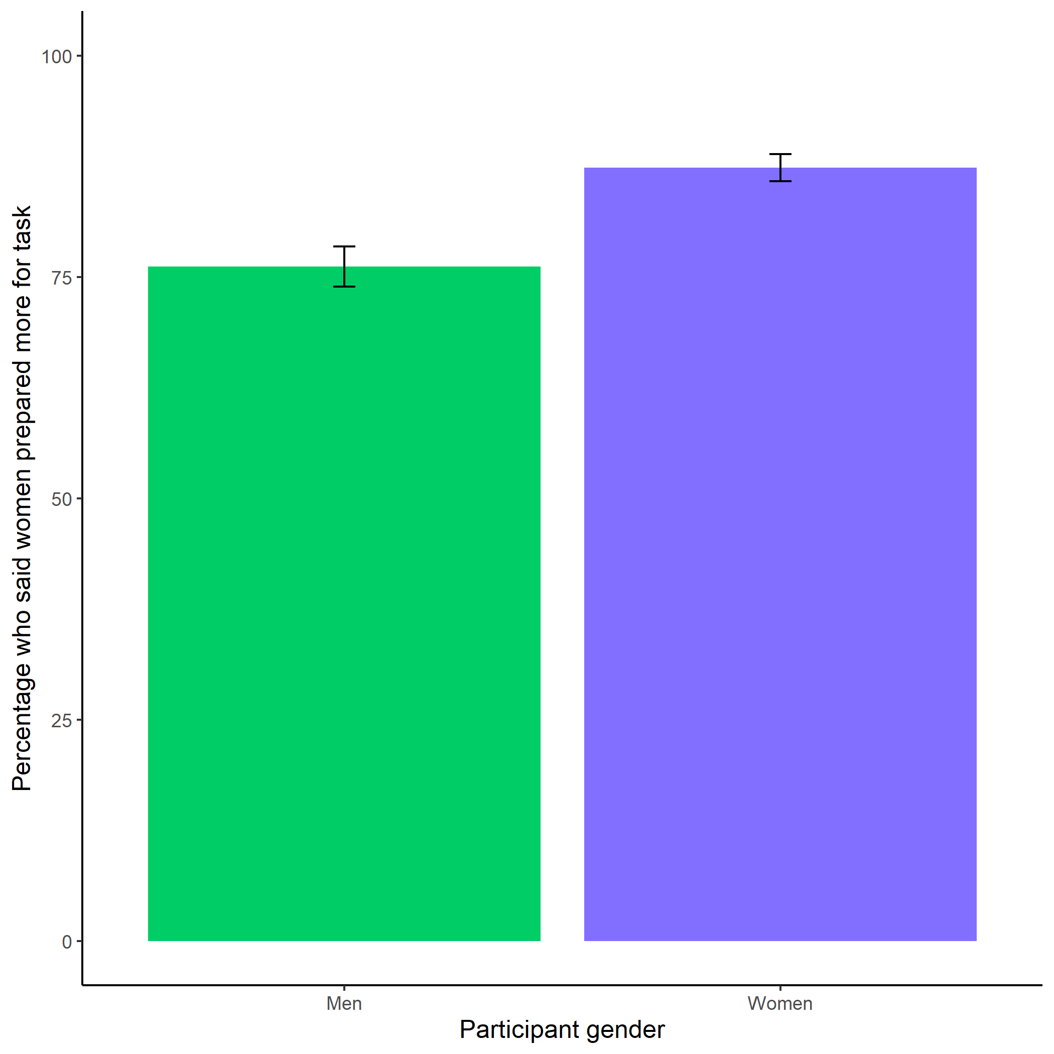

*Figure* *6.*  Participants’ perceptions of gender differences in the choice to practice on the task. Error bars represent standard errors.

Cross-Tabulation, Row Proportions  
cleanperc_task_gender_pract

|  |  |  |  |  |  |
| --- | --- | --- | --- | --- | --- |
|  | clean$perc_task_gender_pract | Men | Women |  | Total |
| clean$gender |  |  |  |  |  |
| Man |  | 104 (21.2%) | 361 (73.7%) | 25 (5.1%) | 490 (100.0%) |
| Woman |  | 63 (11.1%) | 476 (84.1%) | 27 (4.8%) | 566 (100.0%) |
| Total |  | 167 (15.8%) | 837 (79.3%) | 52 (4.9%) | 1056 (100.0%) |

Participants did not expect any gender differences in performance on the task, , (see Figure 7).

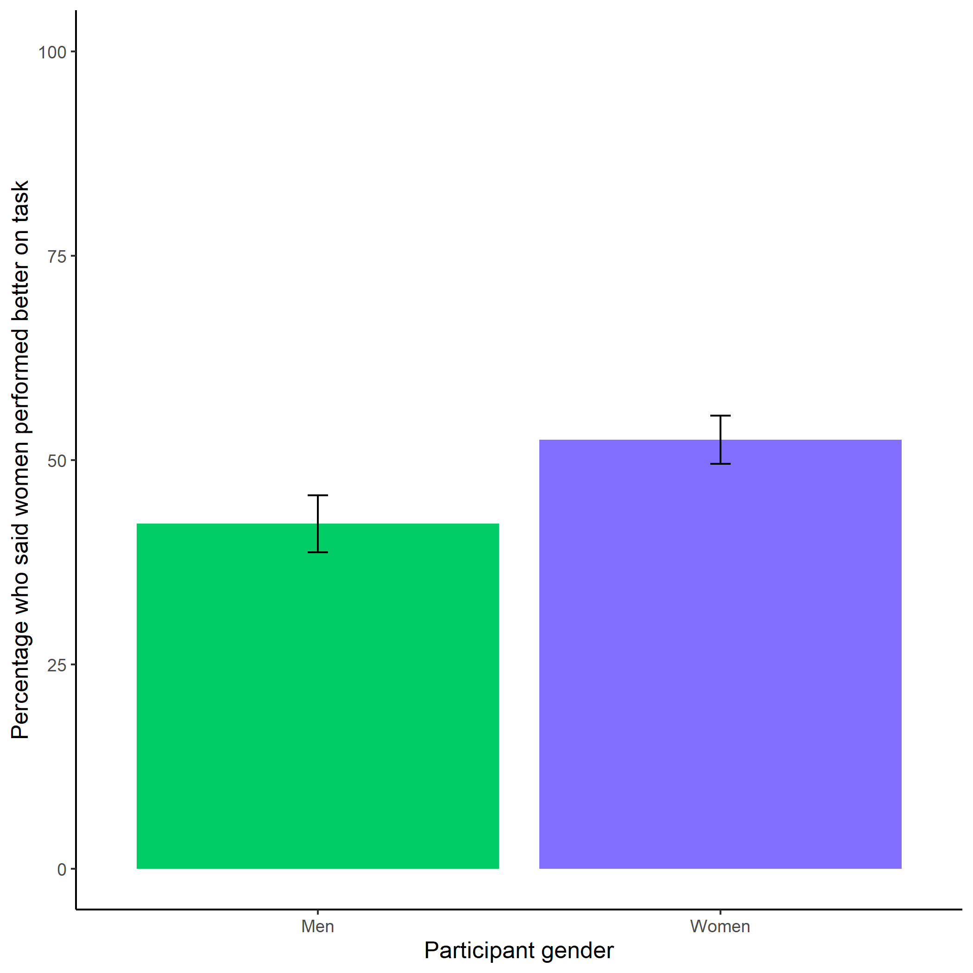

*Figure* *7.*  Participants’ perceptions of gender differences in performance on the task. Error bars represent standard errors.

Cross-Tabulation, Row Proportions  
cleanbetter_gender_guess

|  |  |  |  |  |  |
| --- | --- | --- | --- | --- | --- |
|  | clean$better_gender_guess | Men | Women |  | Total |
| clean$gender |  |  |  |  |  |
| Man |  | 265 (54.1%) | 200 (40.8%) | 25 (5.1%) | 490 (100.0%) |
| Woman |  | 253 (44.7%) | 286 (50.5%) | 27 (4.8%) | 566 (100.0%) |
| Total |  | 518 (49.1%) | 486 (46.0%) | 52 (4.9%) | 1056 (100.0%) |

Participants were significantly more likely to expect men to choose to compete more often, , (see Figure 8).

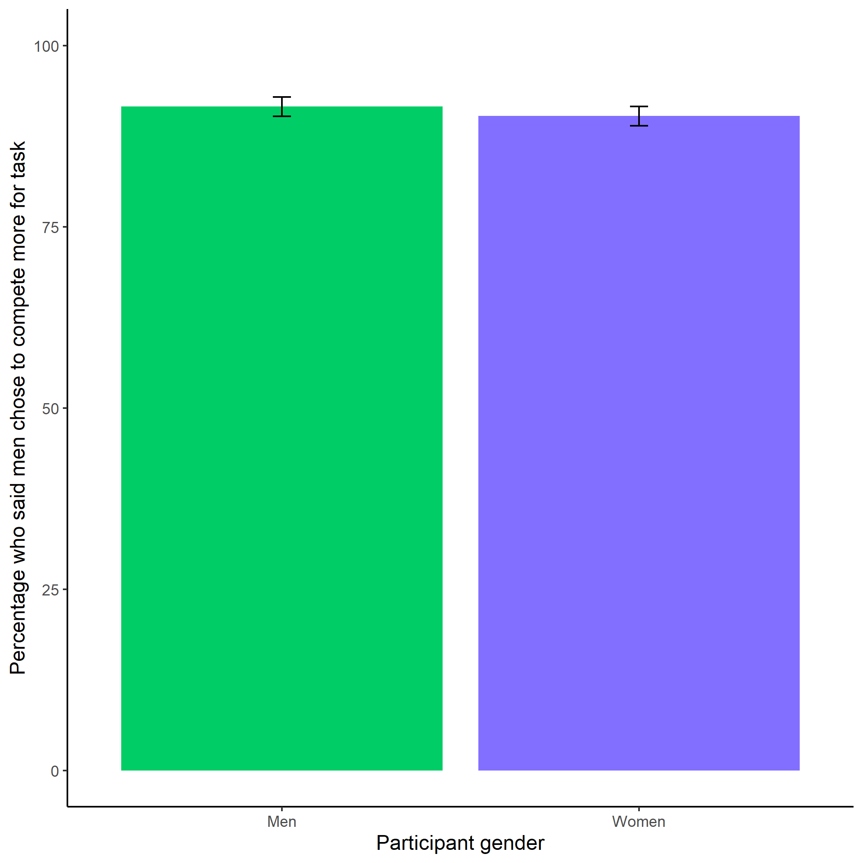

*Figure* *8.*  Participants’ perceptions of gender differences in choice to compete. Error bars represent standard errors.

Cross-Tabulation, Row Proportions  
cleanperc_gender_comp

|  |  |  |  |  |  |
| --- | --- | --- | --- | --- | --- |
|  | clean$perc_gender_comp | Men | Women |  | Total |
| clean$gender |  |  |  |  |  |
| Man |  | 434 (88.6%) | 31 (6.3%) | 25 (5.1%) | 490 (100.0%) |
| Woman |  | 492 (86.9%) | 47 (8.3%) | 27 (4.8%) | 566 (100.0%) |
| Total |  | 926 (87.7%) | 78 (7.4%) | 52 (4.9%) | 1056 (100.0%) |

Participants were significantly more likely to expect women to choose to prepare in general, , (see Figure 9).

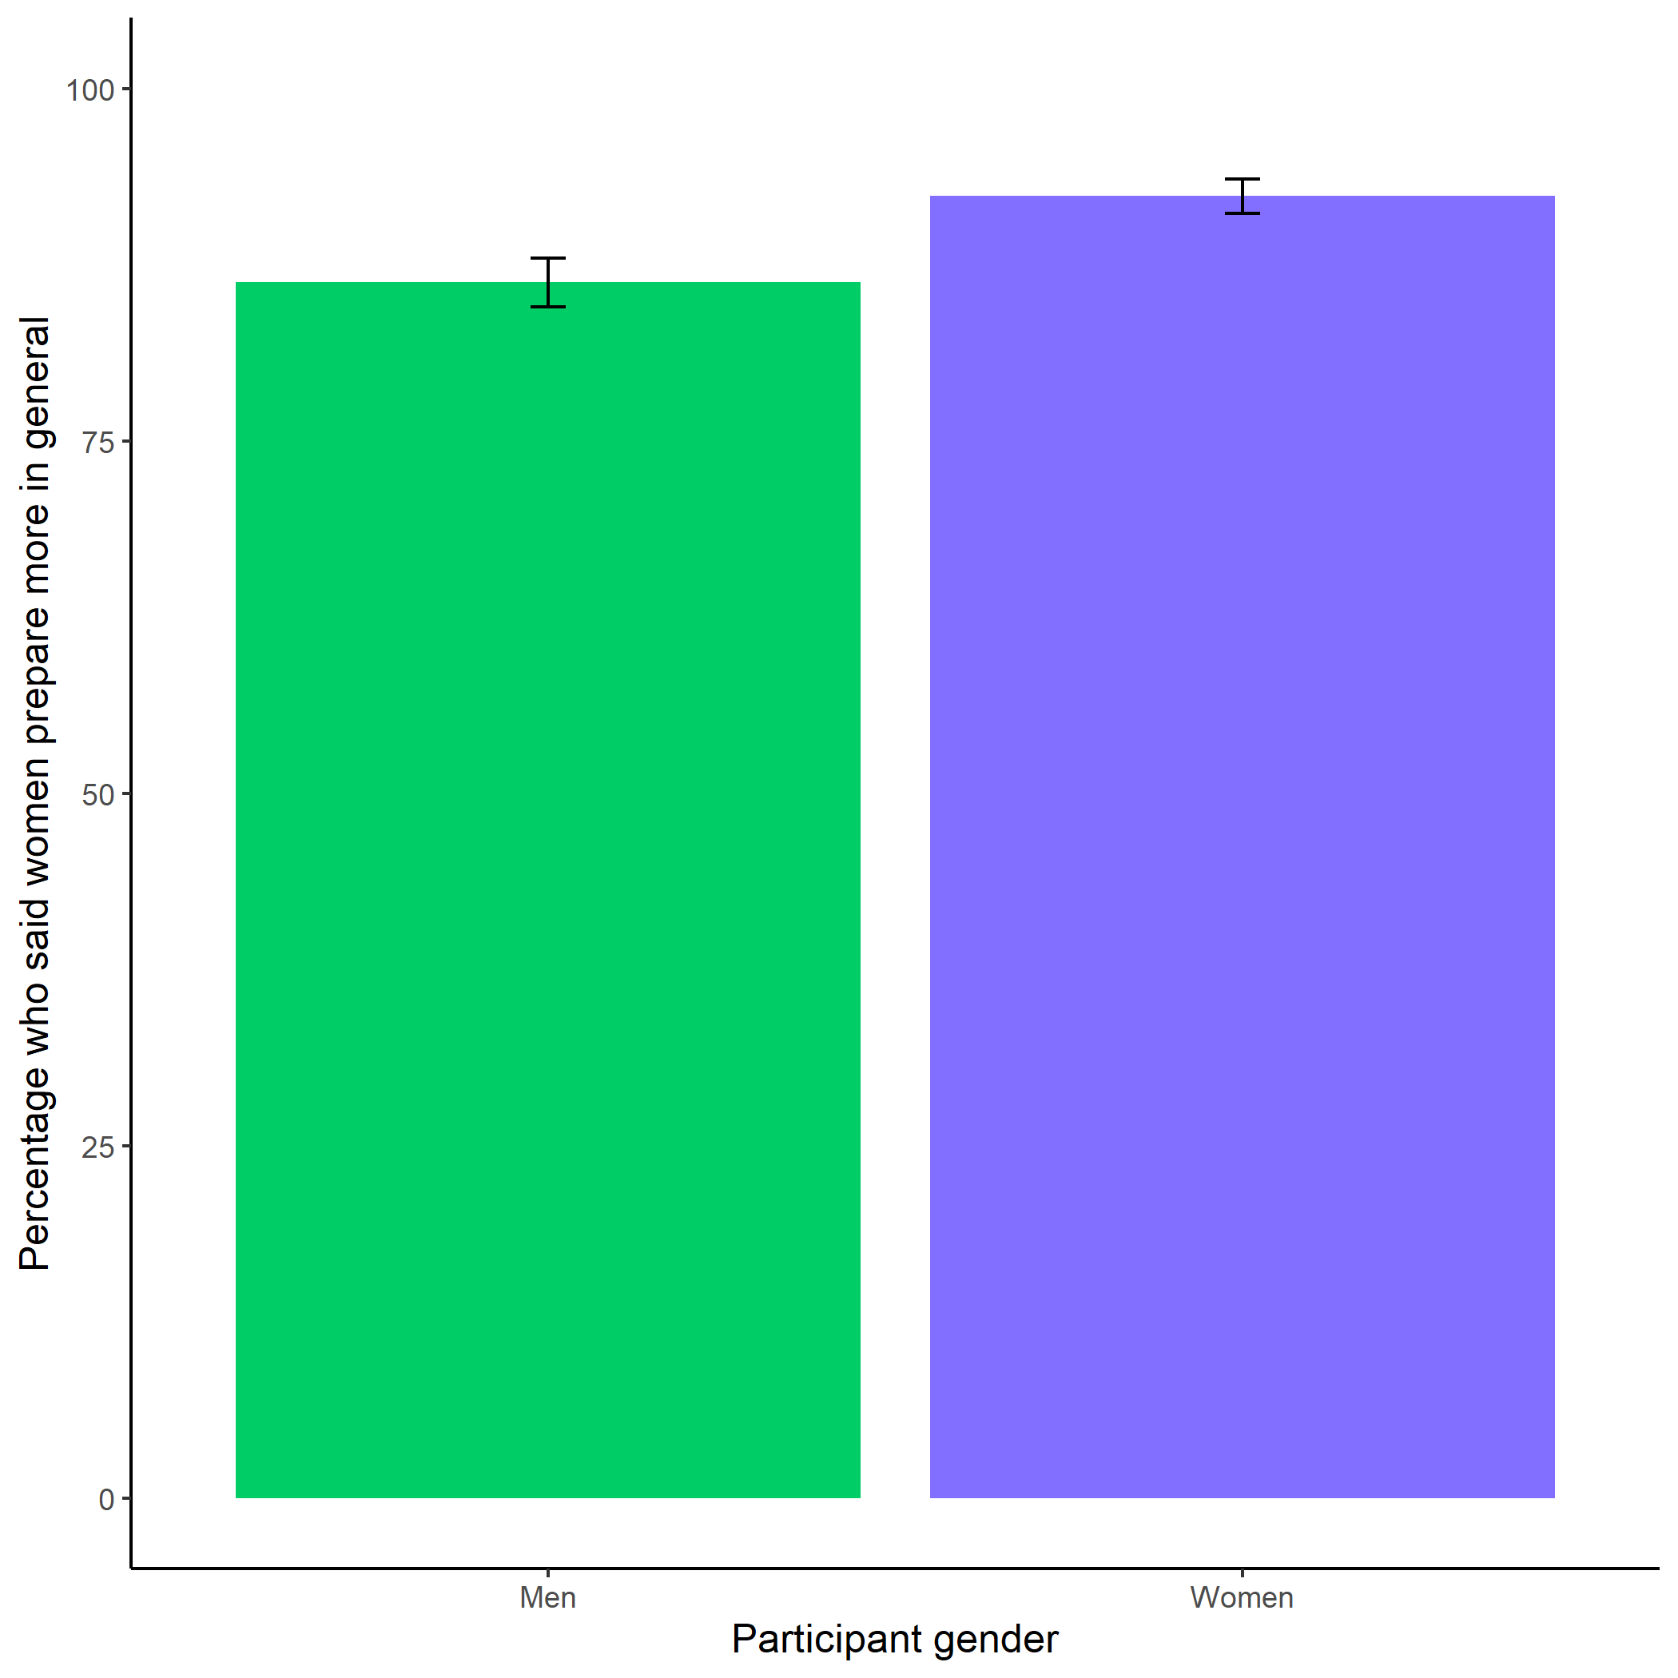

*Figure* *9.*  Participants’ perceptions of general gender differences in choice to practice. Error bars represent standard errors.

Cross-Tabulation, Row Proportions  
cleanperc_gen_gender_pract

|  |  |  |  |  |  |
| --- | --- | --- | --- | --- | --- |
|  | clean$perc_gen_gender_pract | Men | Women |  | Total |
| clean$gender |  |  |  |  |  |
| Man |  | 64 (13.1%) | 401 (81.8%) | 25 (5.1%) | 490 (100.0%) |
| Woman |  | 41 ( 7.2%) | 495 (87.5%) | 30 (5.3%) | 566 (100.0%) |
| Total |  | 105 ( 9.9%) | 896 (84.8%) | 55 (5.2%) | 1056 (100.0%) |

# Study 2

## Methods

Participants were recruited on Amazon Mechanical Turk using the same screening criteria as Study 1. Also, if participants had an identical IP address, MTurkID, and gender, we excluded their second response. The final sample consisted of 1076 participants (50.56% women), with an average age of 38.57 (*SD* = 12.52) years. 62 participants (51.61% women) dropped out of the study before finishing.

As in Study 1, participants included in the study were told they would be completing a two-minute multiplication task (identical to the one used in Study 1) and would be able to choose a payment scheme for their performance. The instructions and payment per question were identical to Study 1. After being told about the rules for the multiplication task and passing the same comprehension questions used in Study 1, participants were assigned to either a preparation condition, where they were told they would complete several rounds of preparation before completing the multiplication task, or a control condition, where they were told they would complete several rounds of a counting task before continuing. Participants were randomly assigned to each condition. The participants in the preparation condition completed 12 rounds (one round per multiplication table), with 6 problems per round. The problems for each round were selected at random. Participants in the control condition were asked to complete 5 questions where they counted the number of zeros in a matrix of zeros and ones. After a 30-second break following completion of their respective tasks, all participants chose a payment scheme for the multiplication task, where the order of presentation was counterbalanced. That is, half of participants saw the tournament scheme presented as the first option and half saw the piece-rate payment scheme presented first.

After choosing a payment scheme, participants in both conditions had the option to spend (extra) time preparing for the multiplication task. Again, we had two measures of preparation behavior: the decision to practice and the total number of times participants completed the multiplication table. If they chose to prepare, participants were given two minutes to complete a randomly selected set of problems from all 12 multiplication tables. Once they finished the first two-minute preparation round, participants could opt into 4 more rounds of preparation, each two minutes long, before they moved on to the paid portion of the study.

Then, participants completed the paid multiplication task for two minutes. We included many of the same follow-up questions as in Study 1, including risk aversion, confidence, and perceptions of gender differences in preparation, competitiveness, and performance. Participants were incentivized to answer the questions about their confidence and perceptions of gender differences correctly, and were paid at the same rate as Study 1. We also asked participants if they wished they had more time to prepare for the multiplication task and included measures of their fatigue, field-specific ability beliefs, and interest in the multiplication task all on 1 (Strongly disagree) to 7 (Strongly agree) scales. For the fatigue scale, participants rated how fatigued and mentally exhausted they felt (Milyavskaya, Galla, Inzlicht, & Duckworth, 2018). Participants indicated the degree to which they “enjoyed completing the multiplication task” for the interest scale (Milyavskaya et al., 2018). Finally, to measure field-specific ability beliefs, we asked participants how much they perceived success in math depends on ability versus effort through six questions (e.g., “If you want to succeed in math, hard work alone just won’t cut it; you need to have an innate gift or talent”) (Meyer, Cimpian, & Leslie, 2015).

## Results

An equal number of participants were assigned to both conditions (control= 50%). Of the males who completed the study, 50% were assigned to the control condition and of the females who completed the study, 50% were assigned to the control condition.

Cross-Tabulation, Row Proportions  
na_dropcondition

|  |  |  |  |  |
| --- | --- | --- | --- | --- |
|  | na_drop$condition | control | pract | Total |
| na_drop$gender |  |  |  |  |
| Man |  | 263 (50.0%) | 263 (50.0%) | 526 (100.0%) |
| Woman |  | 268 (50.0%) | 268 (50.0%) | 536 (100.0%) |
| Total |  | 531 (50.0%) | 531 (50.0%) | 1062 (100.0%) |

We replicated the effect of gender on the choice to compete: 19.36% of men chose to compete compared to 13.60% of women. However, we do not find evidence of a significant effect of condition on the choice to compete among women, *z* = -1.00, *p* = 0.16 (see Figure 10).

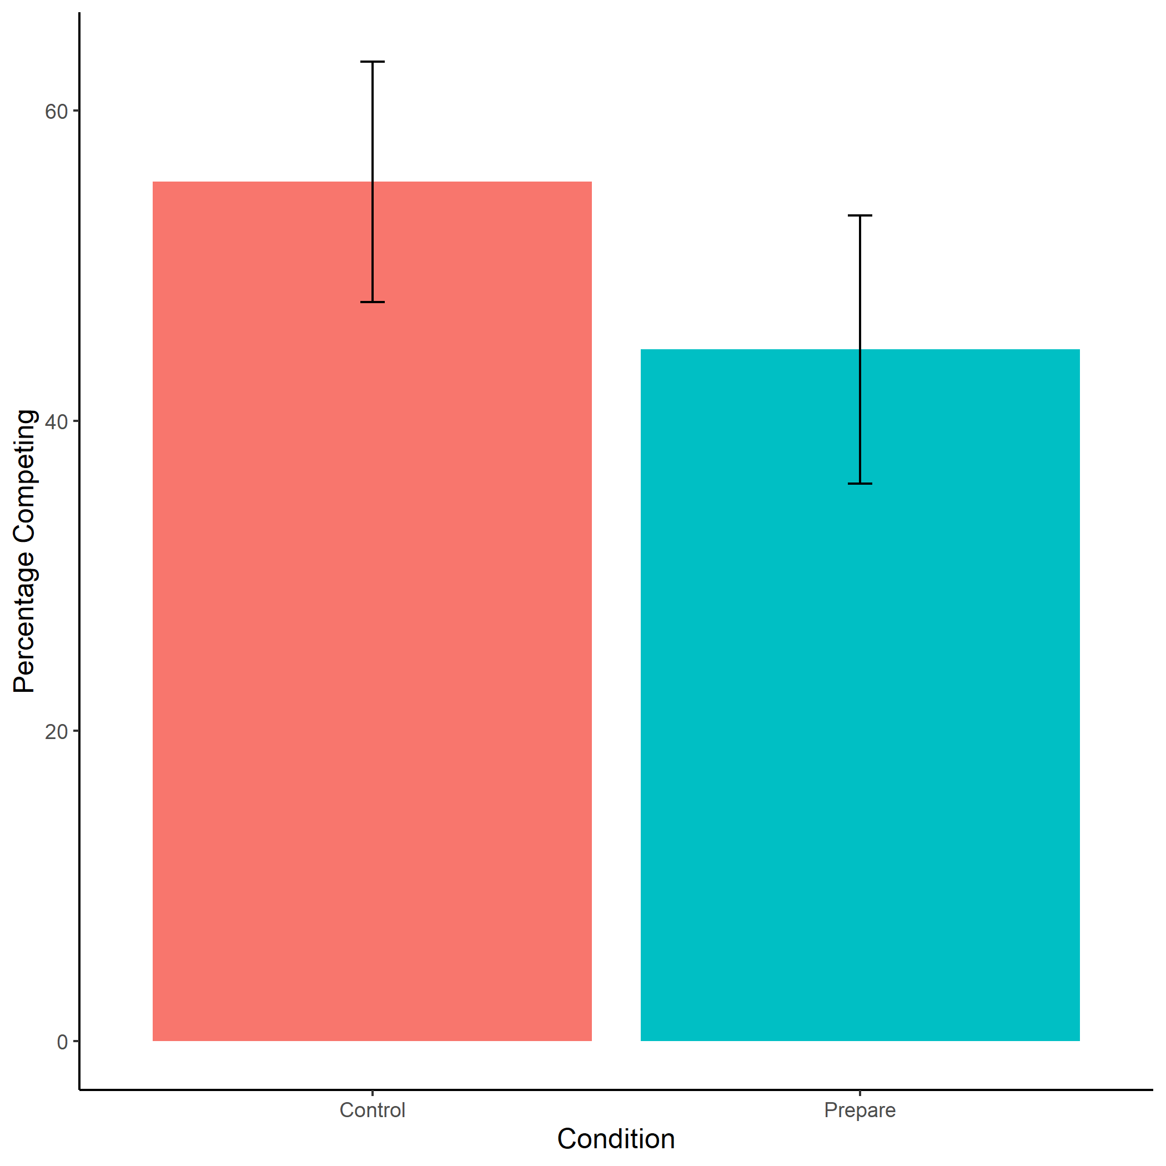

*Figure* *10.*  Proportion of female participants who chose to compete by condition. Error bars represent standard errors.

Cross-Tabulation, Row Proportions  
womancondition

|  |  |  |  |  |  |
| --- | --- | --- | --- | --- | --- |
|  | woman$condition | control | pract |  | Total |
| woman$comp_choice |  |  |  |  |  |
| piecerate |  | 220 (48.4%) | 235 (51.6%) | 0 ( 0.0%) | 455 (100.0%) |
| tournament |  | 41 (55.4%) | 33 (44.6%) | 0 ( 0.0%) | 74 (100.0%) |
|  |  | 7 (46.7%) | 0 ( 0.0%) | 8 (53.3%) | 15 (100.0%) |
| Total |  | 268 (49.3%) | 268 (49.3%) | 8 ( 1.5%) | 544 (100.0%) |

Participants did not expect any gender differences in performance on the task, , (see Figure 11).

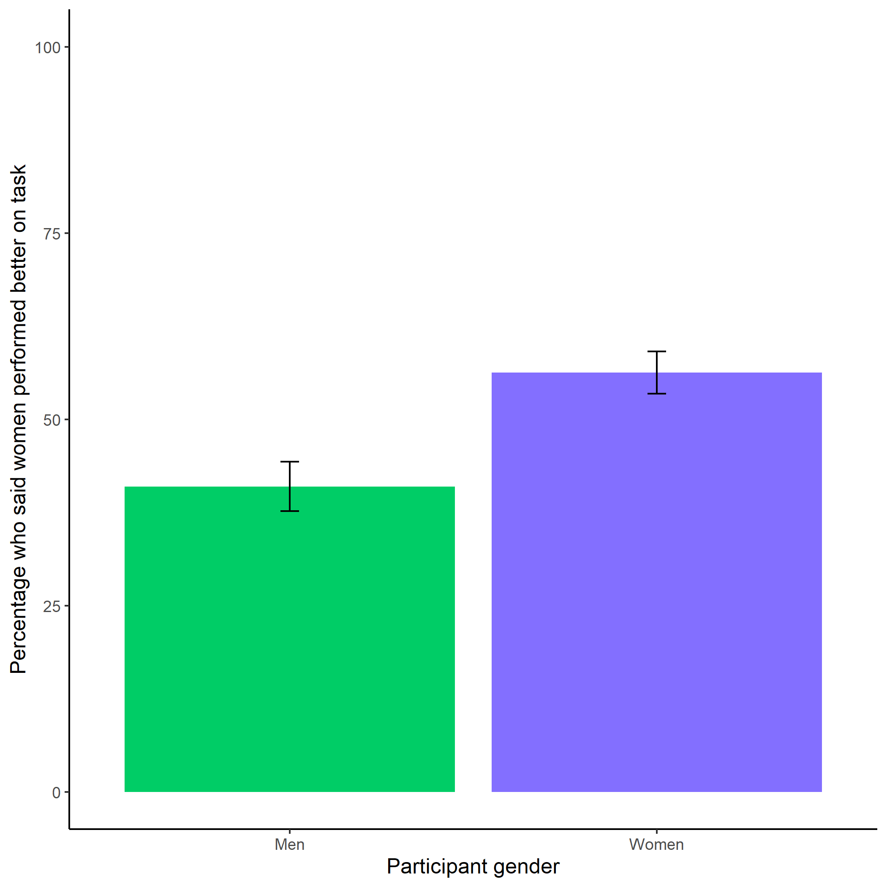

*Figure* *11.*  Participants’ perceptions of gender differences in performance on the task. Error bars represent standard errors.

Cross-Tabulation, Row Proportions  
cleanbetter_gender_guess

|  |  |  |  |  |  |
| --- | --- | --- | --- | --- | --- |
|  | clean$better_gender_guess | Men | Women |  | Total |
| clean$gender |  |  |  |  |  |
| Man |  | 287 (53.9%) | 218 (41.0%) | 27 (5.1%) | 532 (100.0%) |
| Woman |  | 212 (39.0%) | 306 (56.2%) | 26 (4.8%) | 544 (100.0%) |
| Total |  | 499 (46.4%) | 524 (48.7%) | 53 (4.9%) | 1076 (100.0%) |

Participants were significantly more likely to expect men to choose to compete more often, , (see Figure 12).

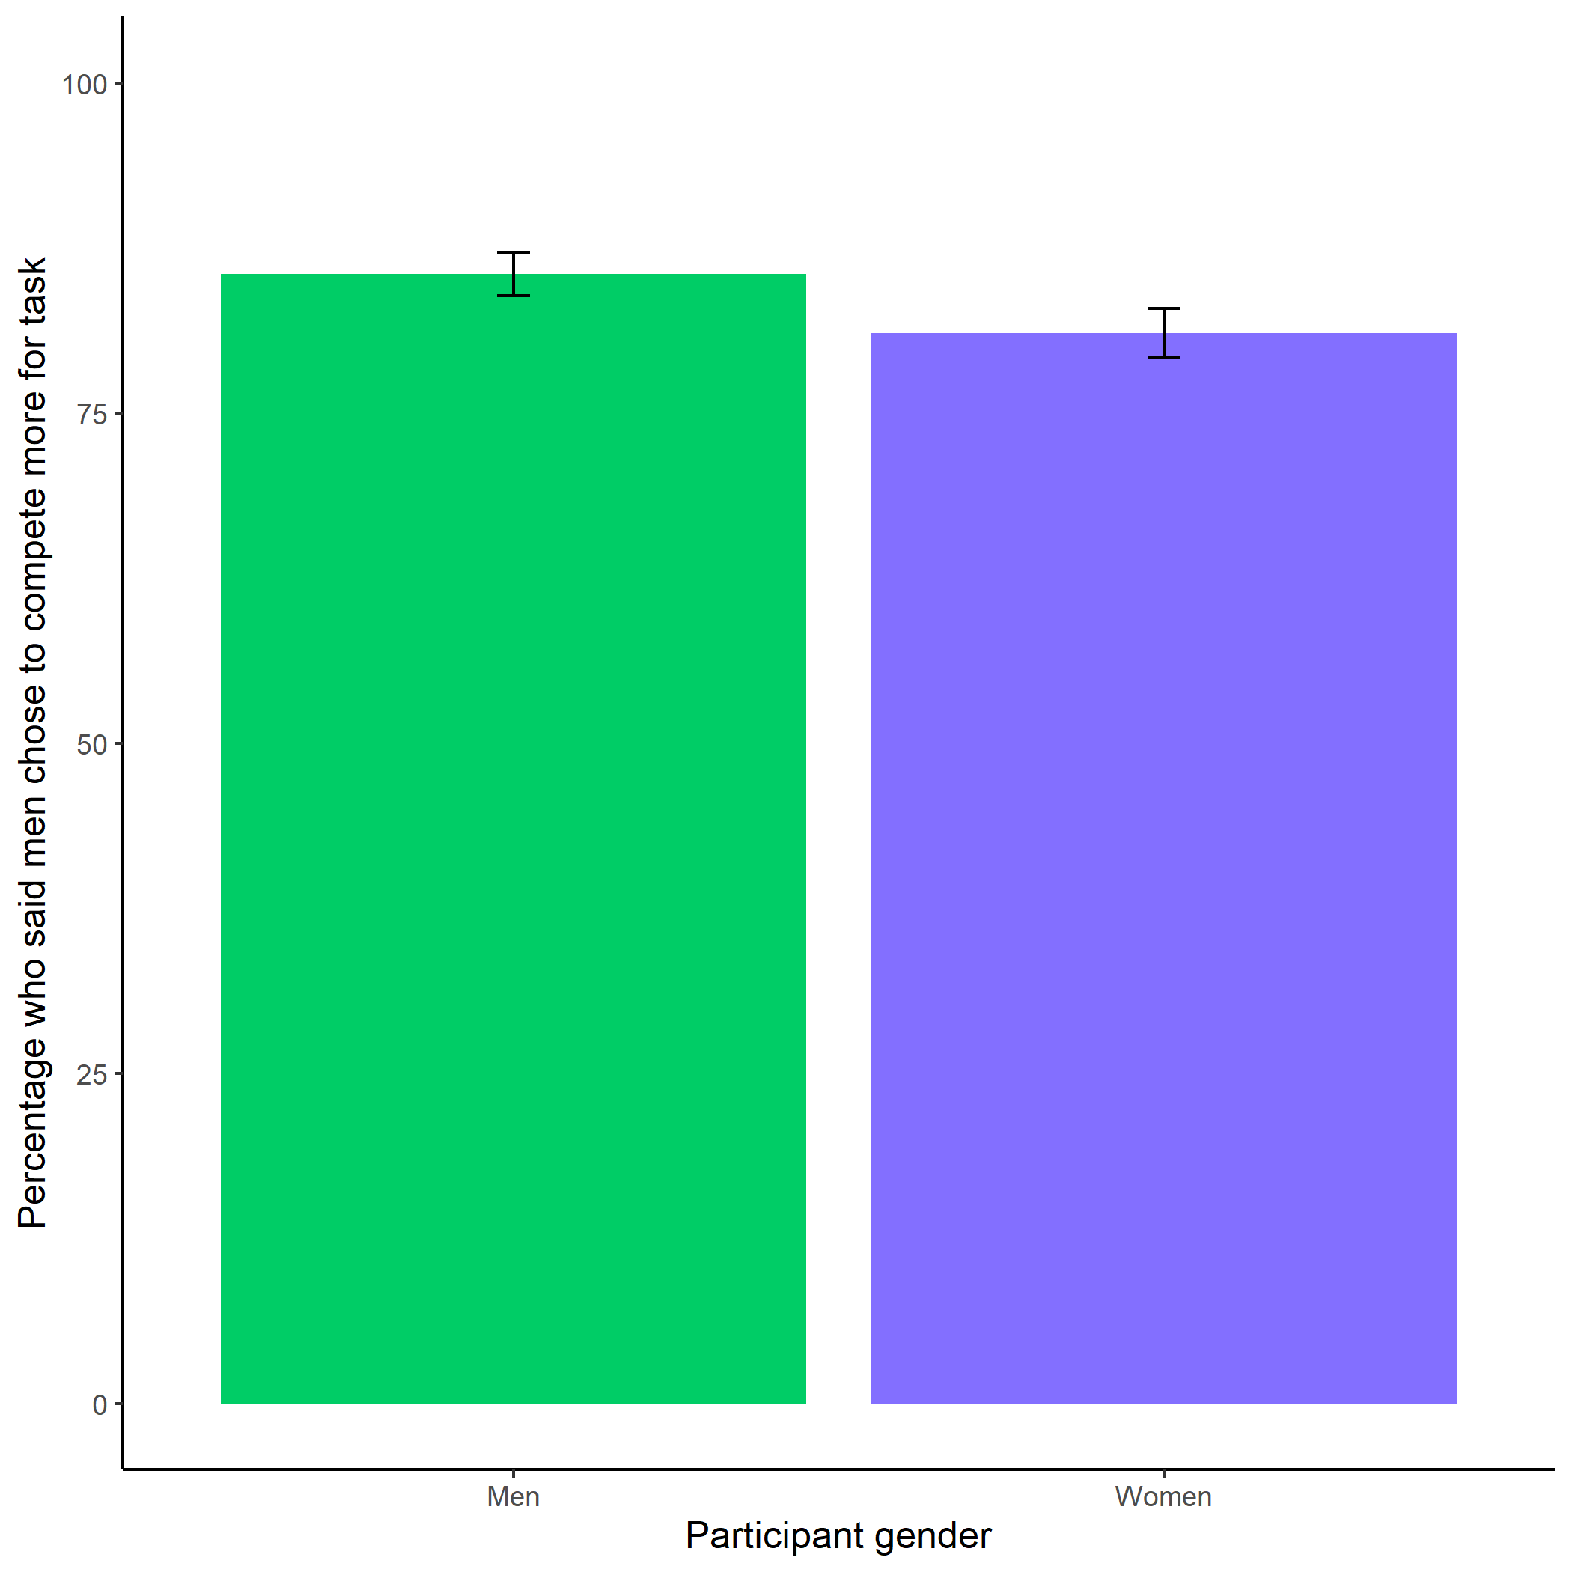

*Figure* *12.*  Participants’ perceptions of gender differences in choice to compete. Error bars represent standard errors.

Cross-Tabulation, Row Proportions  
cleanperc_gender_comp

|  |  |  |  |  |  |
| --- | --- | --- | --- | --- | --- |
|  | clean$perc_gender_comp | Men | Women |  | Total |
| clean$gender |  |  |  |  |  |
| Man |  | 455 (85.5%) | 50 ( 9.4%) | 27 (5.1%) | 532 (100.0%) |
| Woman |  | 441 (81.1%) | 77 (14.2%) | 26 (4.8%) | 544 (100.0%) |
| Total |  | 896 (83.3%) | 127 (11.8%) | 53 (4.9%) | 1076 (100.0%) |

Participants were significantly more likely to expect women to choose to prepare in general, , (see Figure 13).

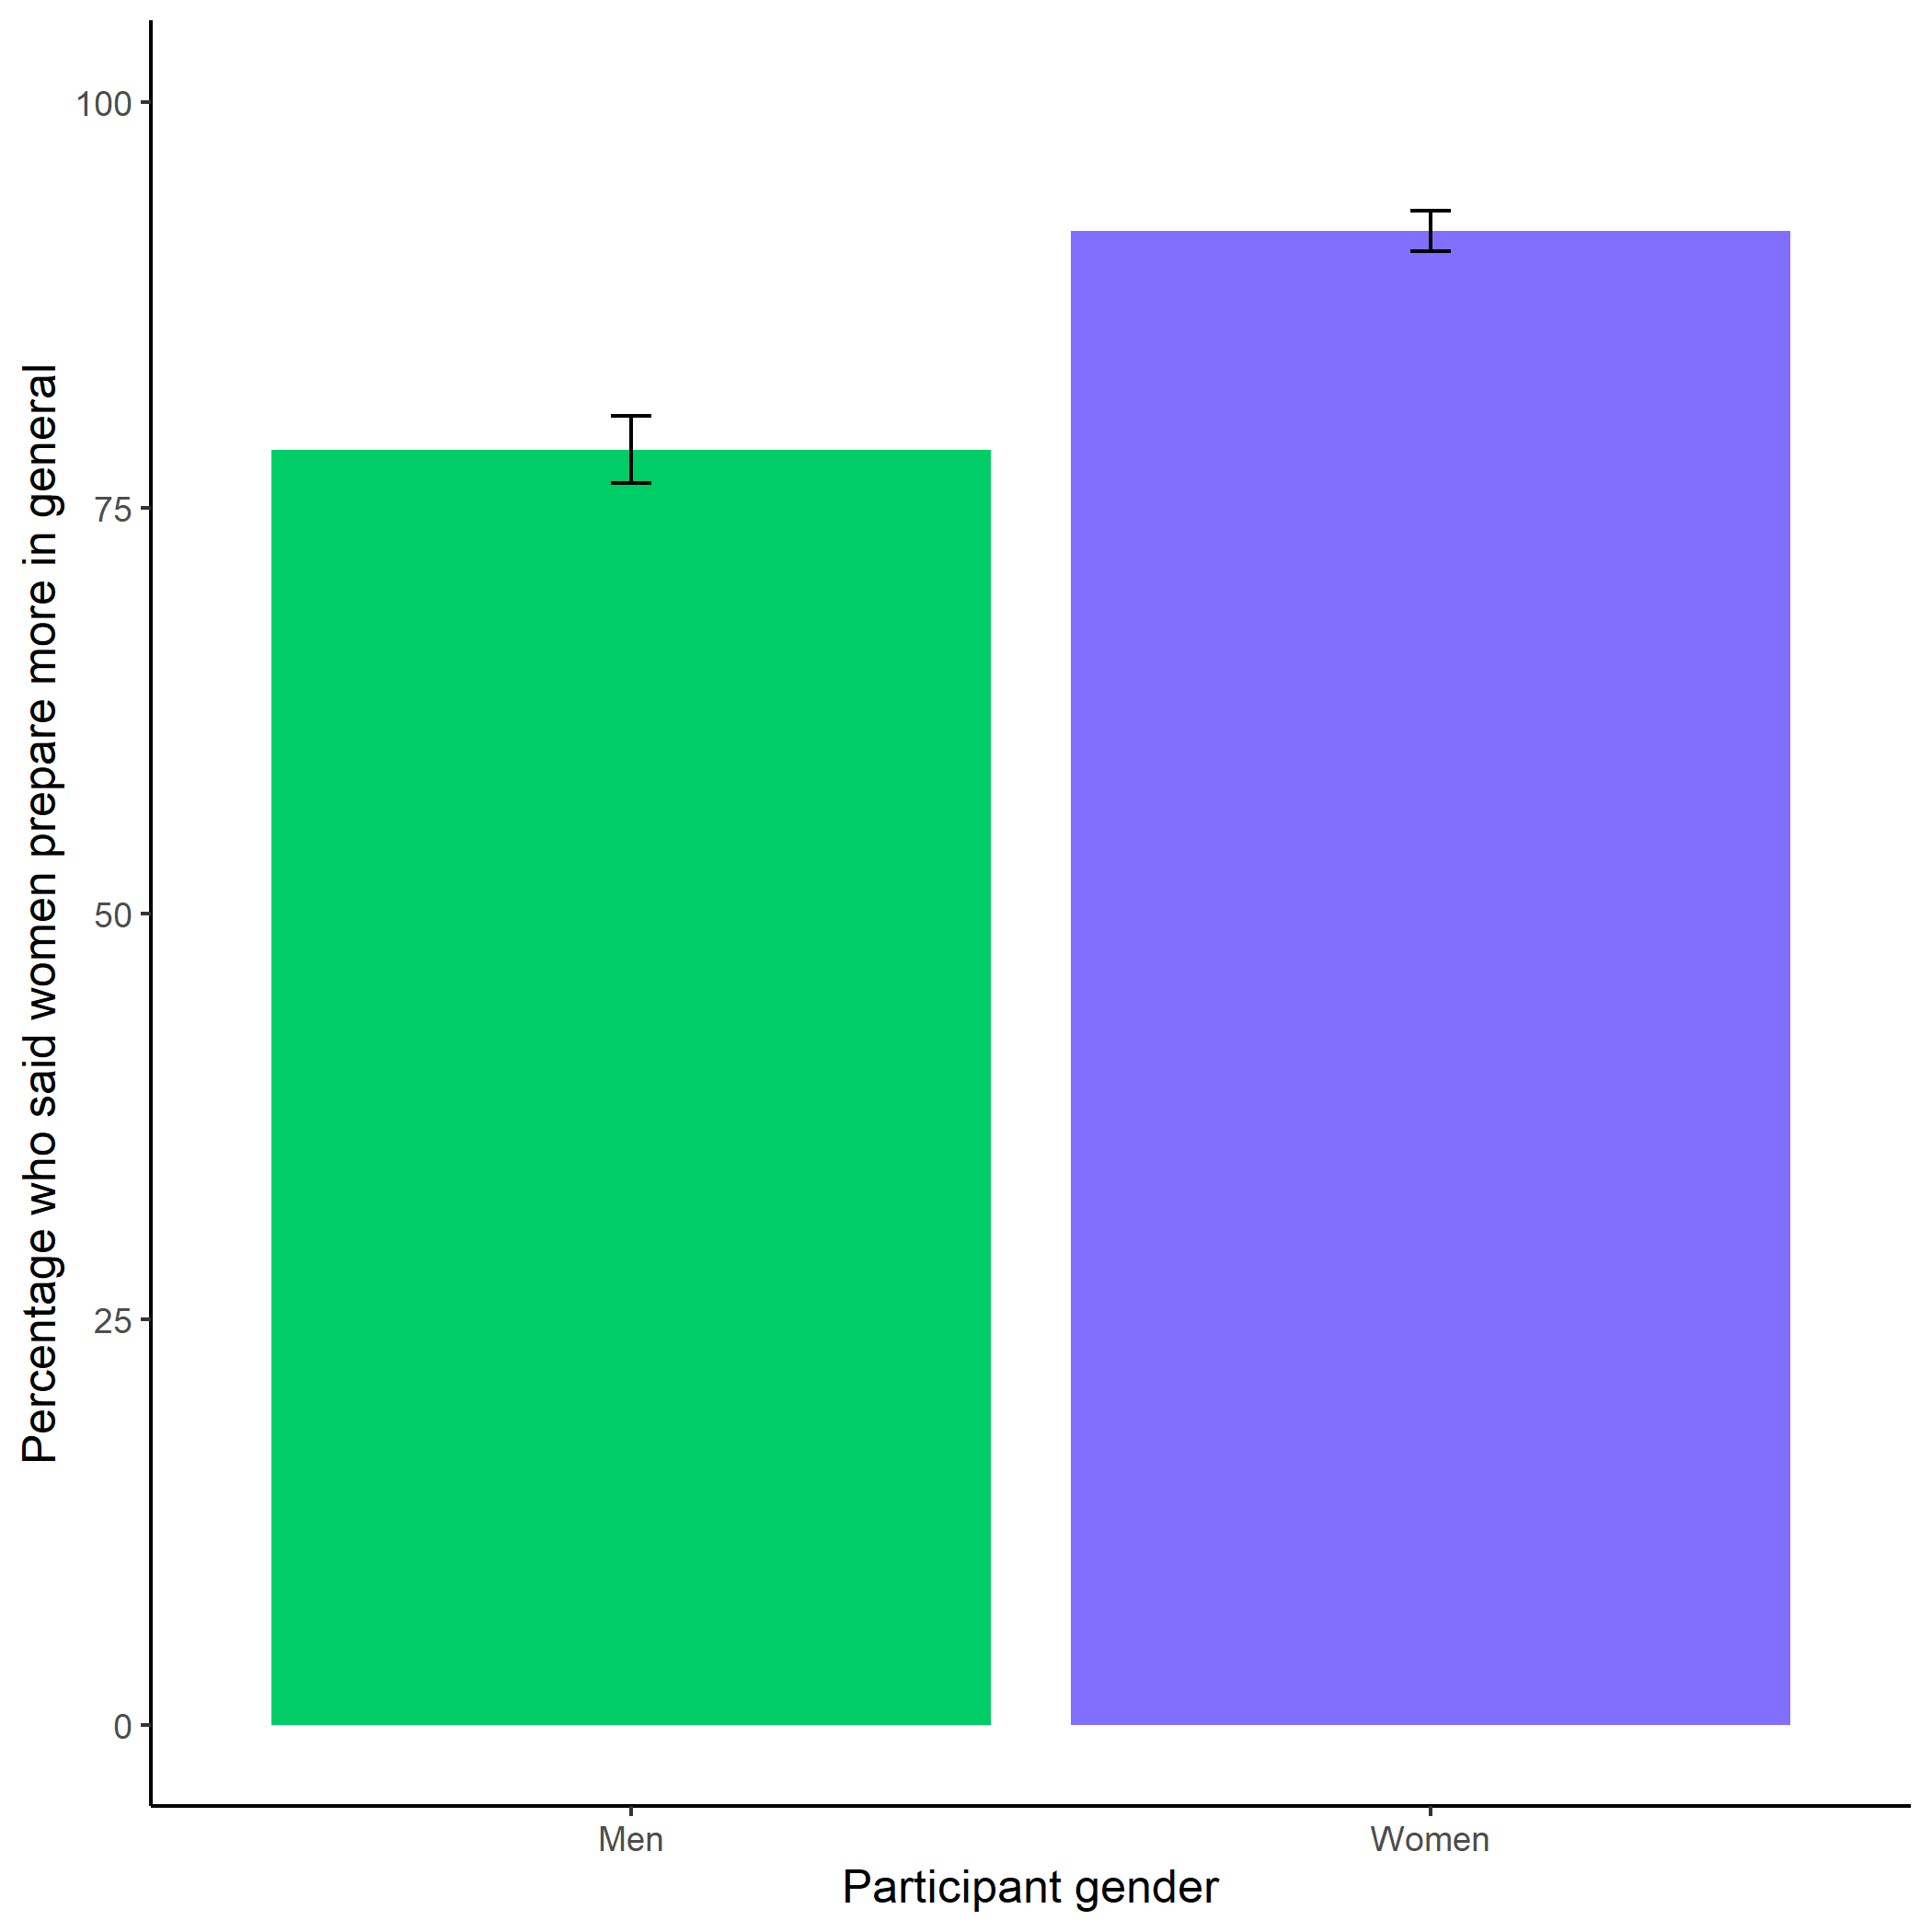

*Figure* *13.*  Participants’ perceptions of general gender differences in choice to prepare. Error bars represent standard errors.

Cross-Tabulation, Row Proportions  
cleanperc_gen_gender_pract

|  |  |  |  |  |  |
| --- | --- | --- | --- | --- | --- |
|  | clean$perc_gen_gender_pract | Men | Women |  | Total |
| clean$gender |  |  |  |  |  |
| Man |  | 108 (20.3%) | 396 (74.4%) | 28 (5.3%) | 532 (100.0%) |
| Woman |  | 41 ( 7.5%) | 475 (87.3%) | 28 (5.1%) | 544 (100.0%) |
| Total |  | 149 (13.8%) | 871 (80.9%) | 56 (5.2%) | 1076 (100.0%) |

Despite no evidence for the effect of condition on the choice to compete among women, we replicate the effects found in Study 1, where women were significantly more likely to prepare for the task, even after being forced to prepare in the preparation condition (see Figure 14). Women were 18.62% more likely to take advantage of the opportunity to prepare relative to men , 95% CI , , , , while controlling for the decision to compete (see Figure 14).

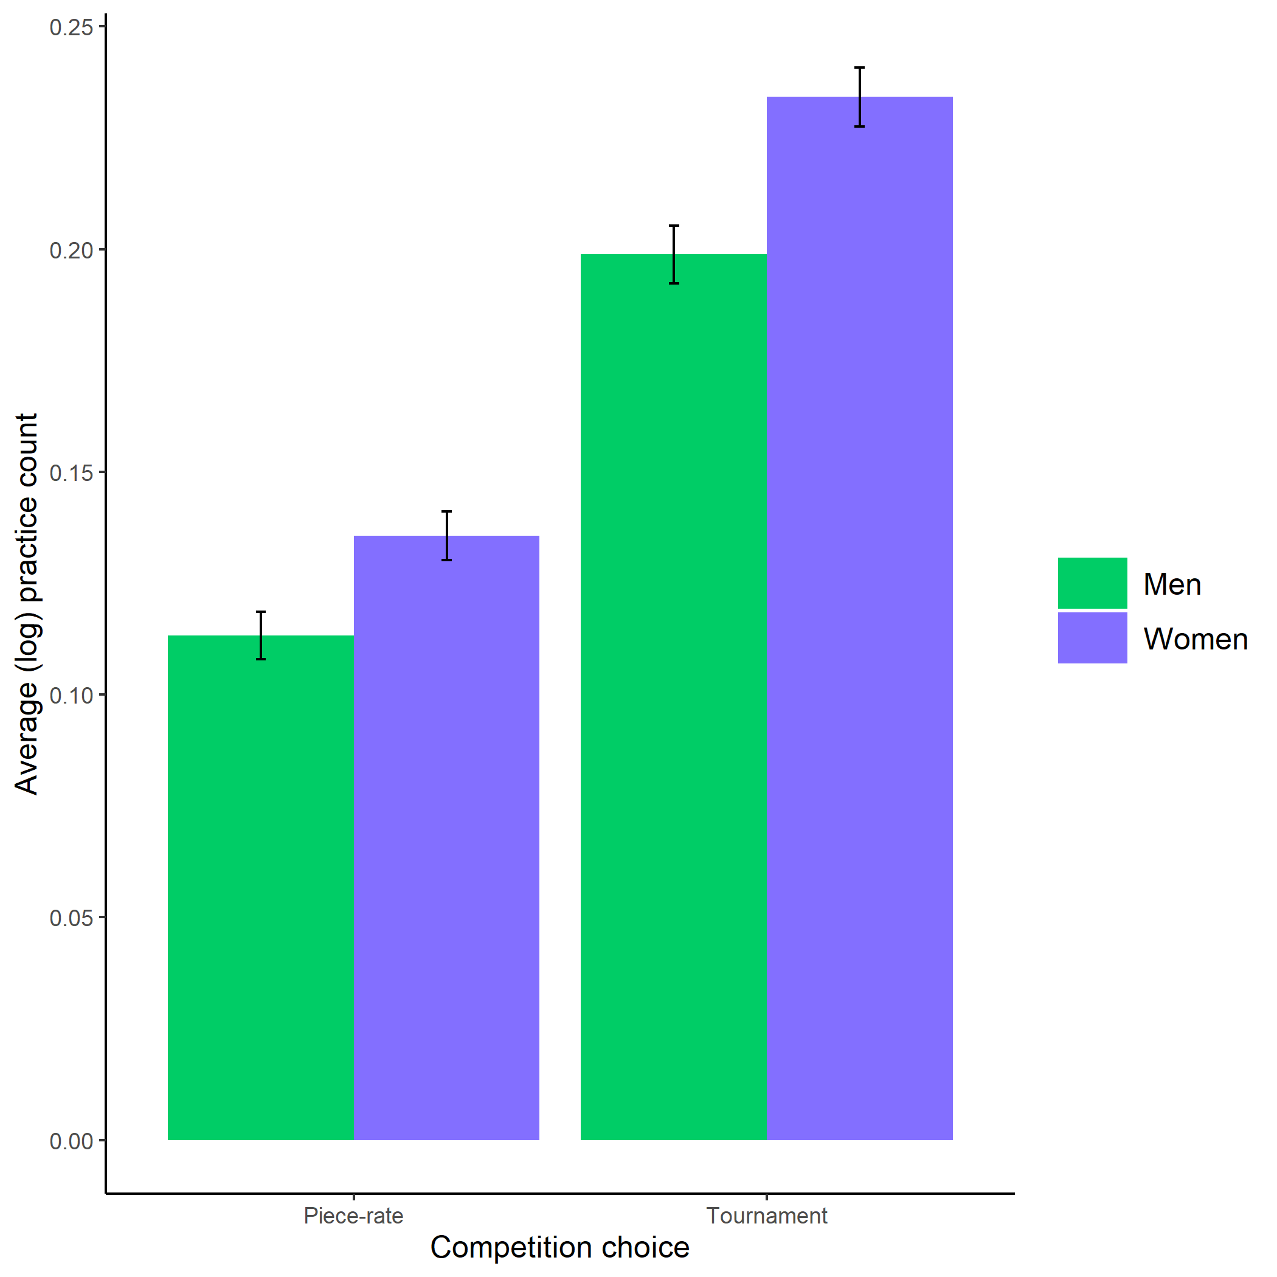

*Figure* *14.*  Gender differences in the number of extra preparation rounds chosen across participants’ choice in a payment scheme. Error bars represent standard errors.

# References

Bertrand, M., & Hallock, K. F. (2001). The gender gap in top corporate jobs. *Industrial and Labor Relations Review*, *55*, 3–21.

Blau, F. D., & Kahn, L. M. (2017). The gender wage gap: Extent, trends, and explanations. *Journal of Economic Literature*, *55*(3), 789–865. <https://doi.org/10.1257/jel.20160995>

Buser, T., Niederle, M., & Oosterbeek, H. (2014). Gender, competition and career choices. *The Quarterly Journal of Economics*, *129*(3), 1409–1447. <https://doi.org/10.1093/qje/qju009.Advance>

Croson, R., & Gneezy, U. (2009). Gender differences in preferences. *Journal of Economic Literature*, *47*(2), 448–474. <https://doi.org/10.1257/jel.47.2.448>

Dohmen, T., & Falk, A. (2011). Performance pay and multidimensional sorting: Productivity, preferences, and gender. *American Economic Association*, *101*(2), 556–590. <https://doi.org/http://dx.doi.org/10.1016/j.poly.2014.08.015>

Dohmen, T., Falk, A., Huffman, D., Sunde, U., Schupp, J., & Wagner, G. G. (2011). Individual risk attitudes: Measurement, determinants, and behavioral consequences. *Journal of the European Economic Association*, *9*(3), 522–550. <https://doi.org/10.1111/j.1542-4774.2011.01015.x>

Gist, M. E., & Mitchell, T. R. (1992). Self-efficacy: A theoretical analysis of its determinants and malleability. *The Academy of Management Review*, *17*(2), 183–211.

Goldin, C. (2006). The rising (And then declining) Significance of gender. In *The declining significance of gender?* (pp. 67–101). <https://doi.org/10.1177/009430610703600317>

Meyer, M., Cimpian, A., & Leslie, S.-J. (2015). Women are underrepresented in fields where success is believed to require brilliance. *Frontiers in Psychology*, *6*, 1–12. <https://doi.org/10.3389/fpsyg.2015.00235>

Milyavskaya, M., Galla, B. M., Inzlicht, M., & Duckworth, A. (2018). More effort, less fatigue: How interest increases effort and reduces mental fatigue.

Niederle, M., & Vesterlund, L. (2007). Do women shy away from competition? Do men compete too much? *The Quarterly Journal of Economics*, *122*(3), 1067–1101. Retrieved from [https://web.stanford.edu/{~}niederle/Niederle.Vesterlund.QJE.2007.pdf](https://web.stanford.edu/%7B~%7Dniederle/Niederle.Vesterlund.QJE.2007.pdf)

Niederle, M., & Vesterlund, L. (2011). Gender and competition. *Annual Review of Economics*, *3*, 601–630. <https://doi.org/10.1016/j.labeco.2009.08.002>

Reuben, E., Sapienza, P., & Zingales, L. (2015). Taste for competition and the gender gap among young business professionals. *NBER WORKING PAPER SERIES*.

Schunk, D. H. (1981). Modeling and Attributional Effects on Children’s Achievement: A Self-Efficacy Analysis. *Journal of Educational Psychology*, *73*(1), 93–105.

Schunk, D. H. (1982). Progress Self-Monitoring: Effects on Children’s Self-Efficacy and Achievement. *The Journal of Experimental Education*, *51*(2), 89–93.

Stoet, G., & Geary, D. C. (2014). Sex differences in academic achievement are not related to political, economic, or social equality. *Intelligence*, *48*, 137–151. <https://doi.org/10.1016/j.intell.2014.11.006>

Zhang, Y. J. (2012). Can experimental economics explain competitive behavior outside the lab? *Unpublished Manuscript*, 1–45. <https://doi.org/10.2139/ssrn.2292929>