Study 2

Keana Richards

6/12/2020

## Methods

1268 participants were recruited through Amazon Mechanical Turk. A total of 242 participants were excluded before analyses based on the same criteria as Study 1: 14 were excluded because they did not indicate they were American or lived in the United States, 5 were excluded for indicating “Other” for their gender, 155 were excluded for using a phone or tablet to complete the survey, and 68 were excluded for an incomplete survey. The final sample consisted of 1026 participants (50.58% women), with an average age of 38.54 (*SD* = 12.5) years.

As in Study 1, participants included in the study were told they would be completing a two-minute multiplication task (identical to the one used in Study 1) and would be able to choose a payment scheme for their performance. After being told about the rules for the multiplication task and passing comprehension check questions, participants were assigned to either a preparation condition, where they were told they would complete several rounds of practice before completing the multiplication task, or a control condition, where they were told they would complete several rounds of a counting task before moving on. As in Study 1, participants were randomly assigned to each condition based on their indicated gender. The participants in the preparation condition completed 12 rounds (one round per times table), with 6 problems per round. The problems for each round were selected at random. For the counting task, participants in the control condition were asked to complete 5 questions where they counted the number of zeros in a matrix of zeros and ones. After a 30-second break following completion of their respective tasks, all participants chose a payment scheme for the multiplication task (order of presentation was randomized), and completed the paid multiplication task for two minutes. We included many of the same follow-up questions as in Study 1, including risk aversion, confidence, and perceptions of gender differences in preparation, competitiveness, and performance. We also asked participants if they wished they had more time to prepare for the multiplication task and included measures of their fatigue, field-specific ability beliefs, and interest in the multiplication task all on 1 (Strongly disagree) to 7 (Strongly agree) scales. For the fatigue scale, participants rated how fatigued and mentally exhausted they felt. Participants indicated the degree to which they “enjoyed completing the multiplication task” for the interest scale. Finally, to measure field-specific ability beliefs, we asked participants how much they perceived success in math depends on ability versus effort through six questions (e.g., “If you want to succeed in math, hard work alone just won’t cut it; you need to have an innate gift or talent”).

## Results

### Summary

All hypotheses were [pre-registered](https://osf.io/q39a5/) unless otherwise stated and all analyses were conducted in R. We first examined whether gender was balanced across conditions. 50.49% of men and 49.52% of women were assigned to the control condition, while 49.51% of men and 50.48% of women were assigned to the practice condition, for a total of 50% of participants assigned to the control condition and 50% of participants assigned to the practice condition.

We replicated the effect of gender on the choice to compete: 19.92% of men chose to compete compared to 13.1% of women. However, our primary hypothesis women would be more likely to compete in the preparation condition was not supported (see Figure @ref(fig:s200)).

Despite no evidence for the effect of condition on the choice to compete among women, we replicate the effects found in Study 1, where women were significantly more likely to prepare for the task, even after being forced to prepare in the preparation condition (see Figure @ref(fig:s204)).

### Pre-registered analyses

Primary hypothesis 1: We do not find evidence of a significant effect of condition on the choice to compete among women, *z* = -0.87, *p* = 0.19 (see Figure @ref(fig:s200)).

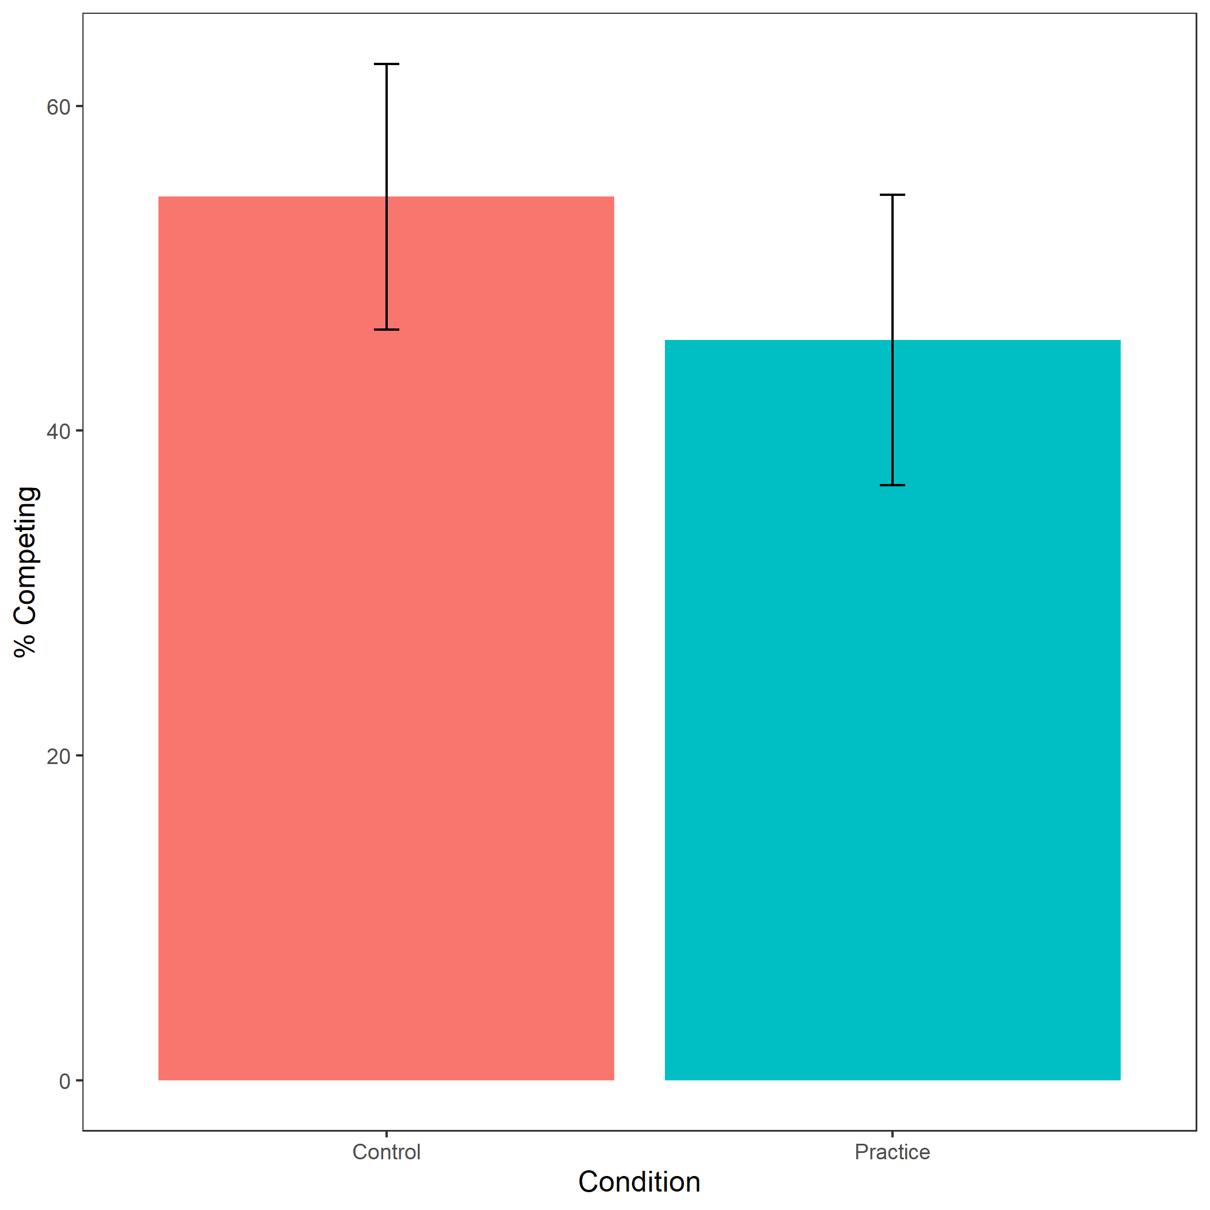

Proportion of female participants who chose to compete based on condition. Error bars represent standard error.

Cross-Tabulation, Row Proportions  
womancondition

|  |  |  |  |  |
| --- | --- | --- | --- | --- |
|  | woman$condition | control | pract | Total |
| woman$comp_choice |  |  |  |  |
| piecerate |  | 220 (48.8%) | 231 (51.2%) | 451 (100.0%) |
| tournament |  | 37 (54.4%) | 31 (45.6%) | 68 (100.0%) |
| Total |  | 257 (49.5%) | 262 (50.5%) | 519 (100.0%) |

Exploratory analysis 3a: Participants did not expect any gender differences in performance on the task, , (see Figure @ref(fig:s201)).

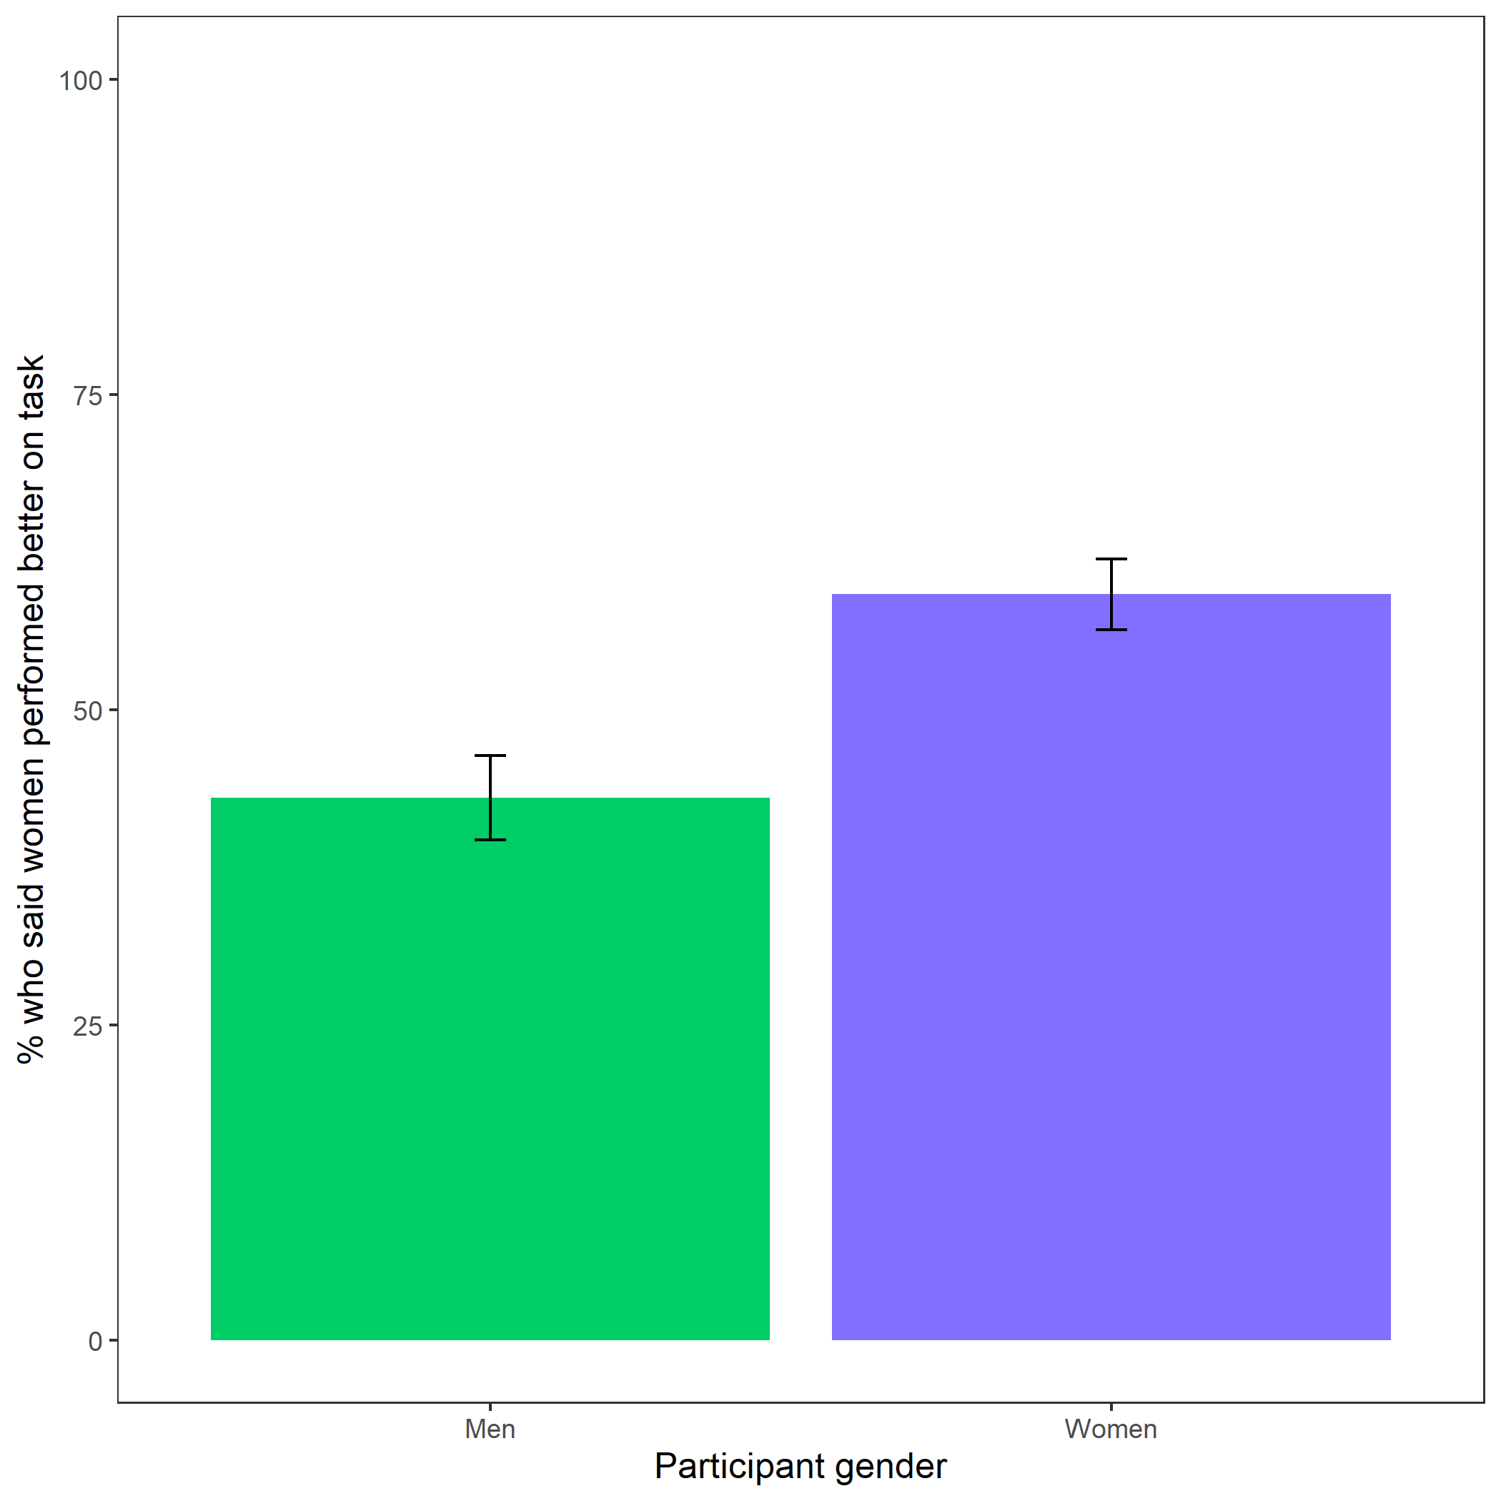

Participants’ perceptions of gender differences in performance on the task. Error bars represent standard error.

Cross-Tabulation, Row Proportions  
cleanbetter_gender_guess

|  |  |  |  |  |
| --- | --- | --- | --- | --- |
|  | clean$better_gender_guess | Men | Women | Total |
| clean$gender |  |  |  |  |
| Man |  | 289 (57.0%) | 218 (43.0%) | 507 (100.0%) |
| Woman |  | 212 (40.8%) | 307 (59.2%) | 519 (100.0%) |
| Total |  | 501 (48.8%) | 525 (51.2%) | 1026 (100.0%) |

Exploratory analysis 3b: Participants were significantly more likely to expect men to choose to compete more often, , (see Figure @ref(fig:s202)).

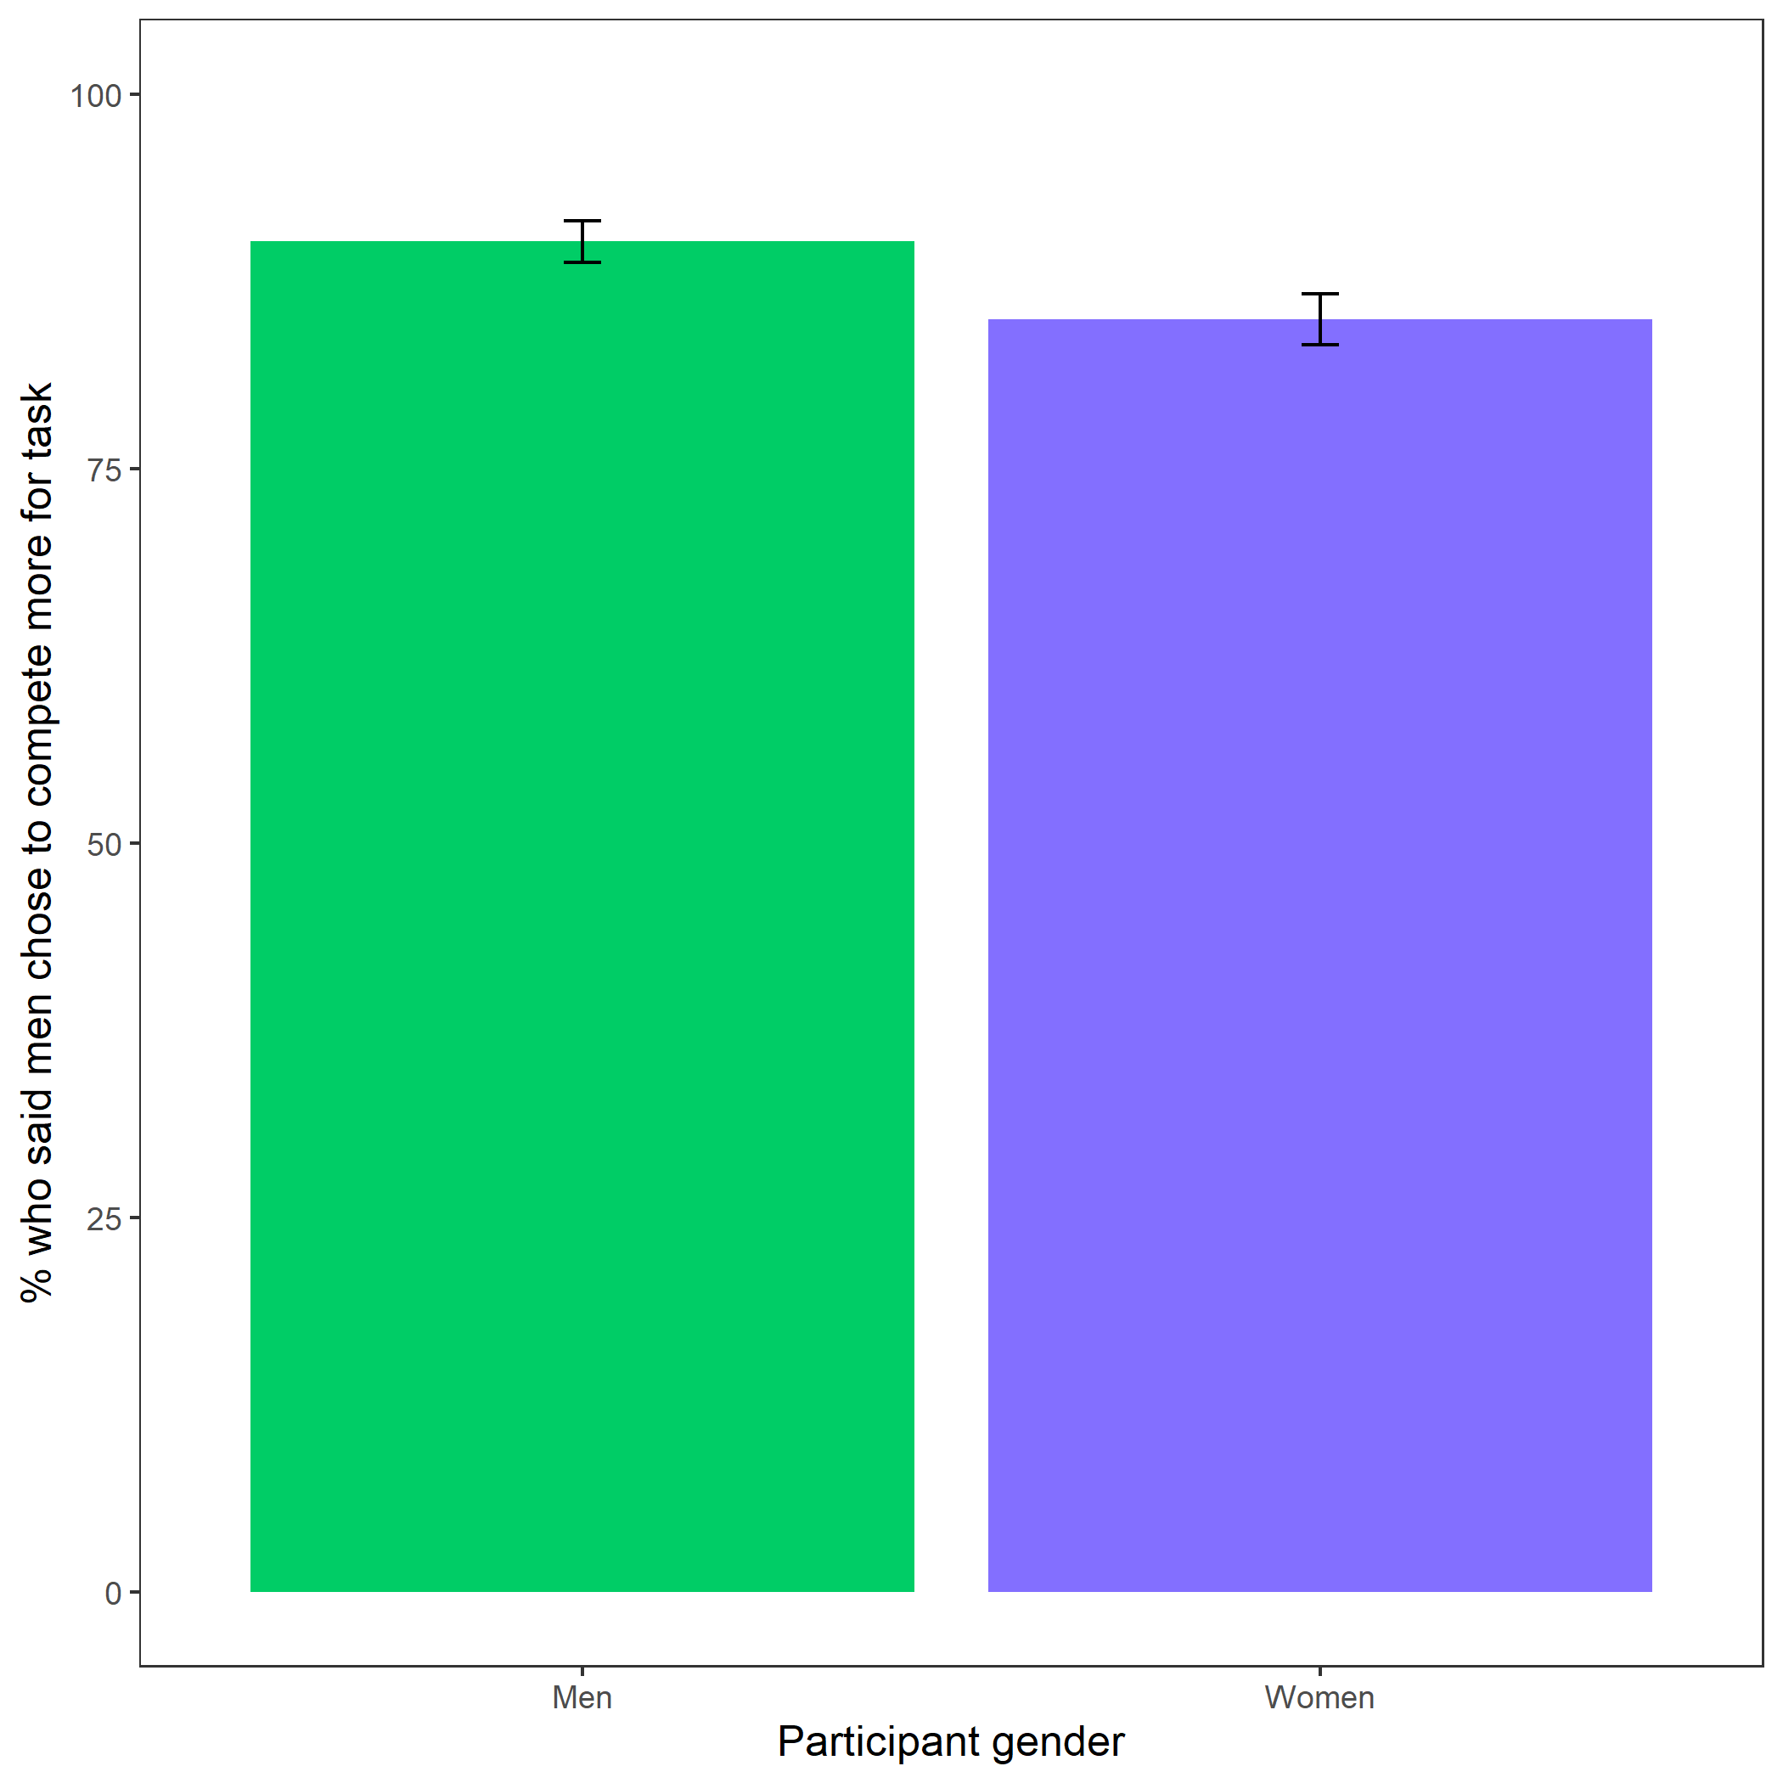

Participants’ perceptions of gender differences in choice to compete. Error bars represent standard error.

Cross-Tabulation, Row Proportions  
cleanperc_gender_comp

|  |  |  |  |  |
| --- | --- | --- | --- | --- |
|  | clean$perc_gender_comp | Men | Women | Total |
| clean$gender |  |  |  |  |
| Man |  | 457 (90.1%) | 50 ( 9.9%) | 507 (100.0%) |
| Woman |  | 441 (85.0%) | 78 (15.0%) | 519 (100.0%) |
| Total |  | 898 (87.5%) | 128 (12.5%) | 1026 (100.0%) |

Exploratory analysis 3c: Participants were significantly more likely to expect women to choose to prepare in general, , (see Figure @ref(fig:s203)).

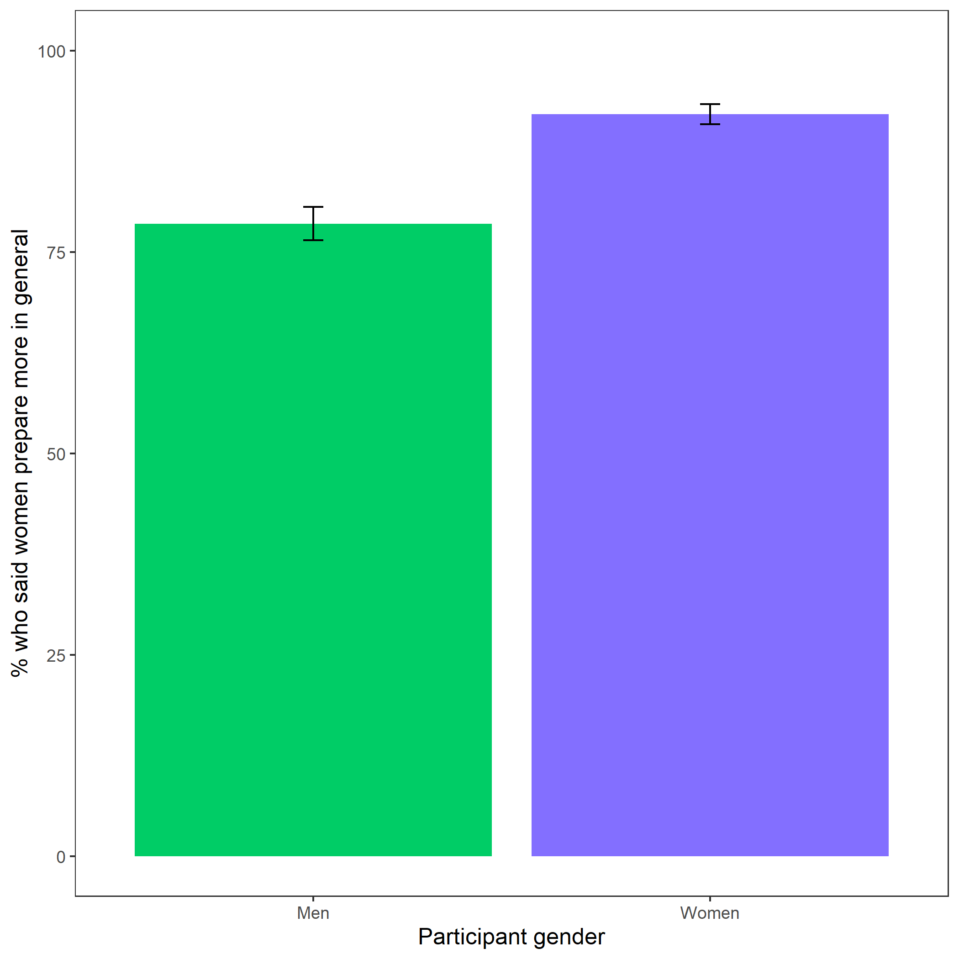

Participants’ perceptions of general gender differences in choice to practice. Error bars represent standard error.

Cross-Tabulation, Row Proportions  
cleanperc_gen_gender_pract

|  |  |  |  |  |
| --- | --- | --- | --- | --- |
|  | clean$perc_gen_gender_pract | Men | Women | Total |
| clean$gender |  |  |  |  |
| Man |  | 109 (21.5%) | 398 (78.5%) | 507 (100.0%) |
| Woman |  | 41 ( 7.9%) | 478 (92.1%) | 519 (100.0%) |
| Total |  | 150 (14.6%) | 876 (85.4%) | 1026 (100.0%) |

### Exploratory analyses

Exploratory analysis 1: Women were 19.59% more likely to take advantage of the opportunity to prepare relative to men , 95% CI , , , , while controlling for the decision to compete (see Figure @ref(fig:s204)).

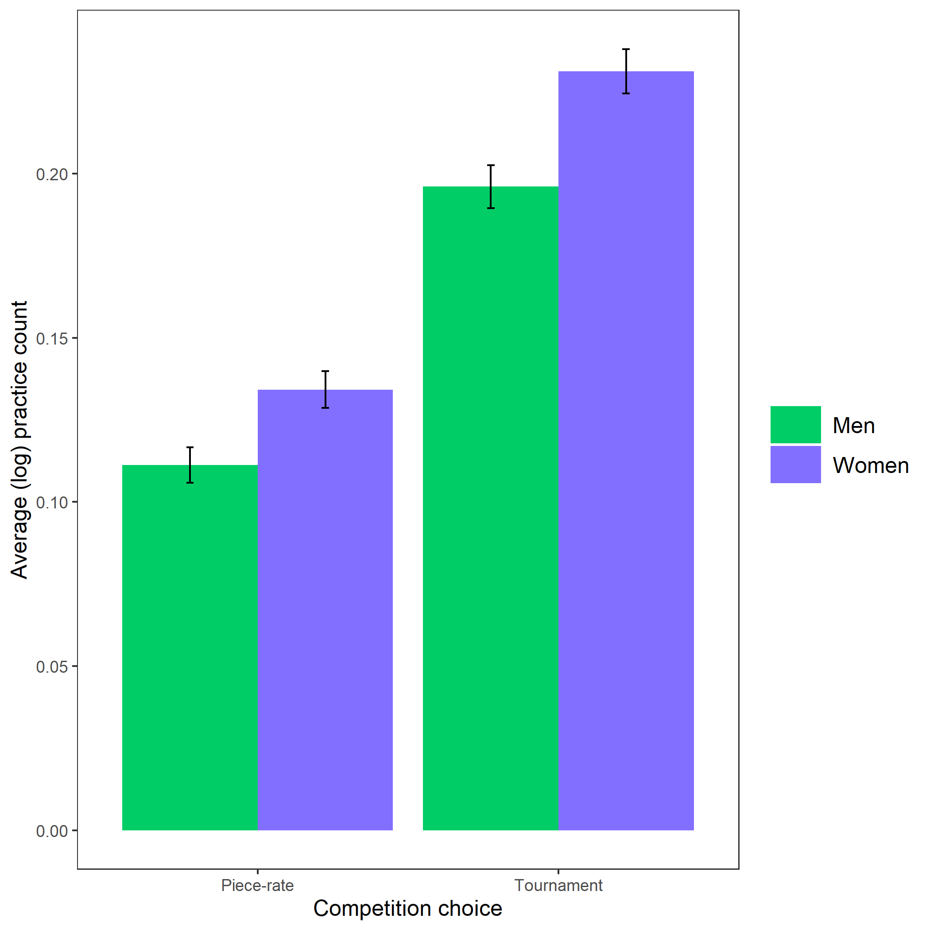

Gender differences in the number of extra practice rounds chosen across participants’ choice in a payment scheme. Error bars represent standard error.