results

Keana Richards

6/10/2020

### Summary

All hypotheses were [pre-registered](https://osf.io/q39a5/) unless otherwise stated and all analyses were conducted in R. We first examined whether gender was balanced across conditions. 49.68% of men and 49.36% of women were assigned to the control condition, while 50.32% of men and 50.64% of women were assigned to the practice condition, for a total of 49.51% of participants assigned to the control condition and 50.49% of participants assigned to the practice condition.

Unlike the pilot study, we found that men were significantly more likely to choose to compete, where 20.26% of men chose to compete compared to 11.23% of women. However, our primary hypothesis that there would be an interaction between gender and condition on the choice to compete was not supported, nor did we find support for a main effect of condition on the choice to compete (see Figure 1).

Although we did not find support for the hypothesized interaction, we found evidence for the hypothesized effect of gender on the choice to prepare (see Figure 2). Despite choosing to compete less frequently than men, women chose to prepare more for the multiplication task, which, as predicted, aligned with participants’ perceptions of gender differences in preparation (see Figure 4) and competition (see Figure 6), even though participants did not expect any gender differences in performance (see Figure 5).

### Pre-registered analyses

Primary hypothesis 1: We do not find evidence of a significant interaction between gender and condition on the decision to compete , 95% CI , , , (see Figure 1). However, there was a main effect of gender on the decision to compete, , 95% CI , , , .

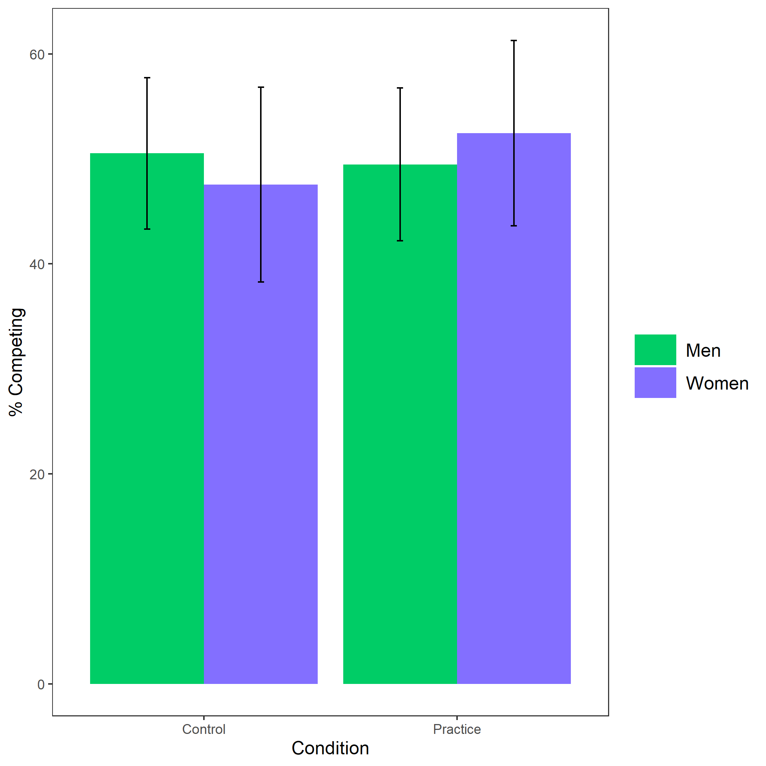

Figure 1: Proportion of participants who chose to compete based on participant gender and condition. Error bars represent standard error.

Cross-Tabulation, Row Proportions  
gender * condition  
Data Frame: clean  
Group: comp_choice = piecerate

|  |  |  |  |  |
| --- | --- | --- | --- | --- |
|  | condition | control | pract | Total |
| gender |  |  |  |  |
| Man |  | 185 (49.5%) | 189 (50.5%) | 374 (100.0%) |
| Woman |  | 239 (49.6%) | 243 (50.4%) | 482 (100.0%) |
| Total |  | 424 (49.5%) | 432 (50.5%) | 856 (100.0%) |

Group: comp_choice = tournament

|  |  |  |  |  |
| --- | --- | --- | --- | --- |
|  | condition | control | pract | Total |
| gender |  |  |  |  |
| Man |  | 48 (50.5%) | 47 (49.5%) | 95 (100.0%) |
| Woman |  | 29 (47.5%) | 32 (52.5%) | 61 (100.0%) |
| Total |  | 77 (49.4%) | 79 (50.6%) | 156 (100.0%) |

Primary hypothesis 2: As, hypothesized, women were 77.93% more likely to take advantage of the opportunity to practice relative to men, , 95% CI , , , , while controlling for the decision to compete (see Figure 2). As an exploratory analysis, we tested whether gender and the choice to compete interact to predict the choice to prepare, but did not find evidence for an interaction, , 95% CI , , , .

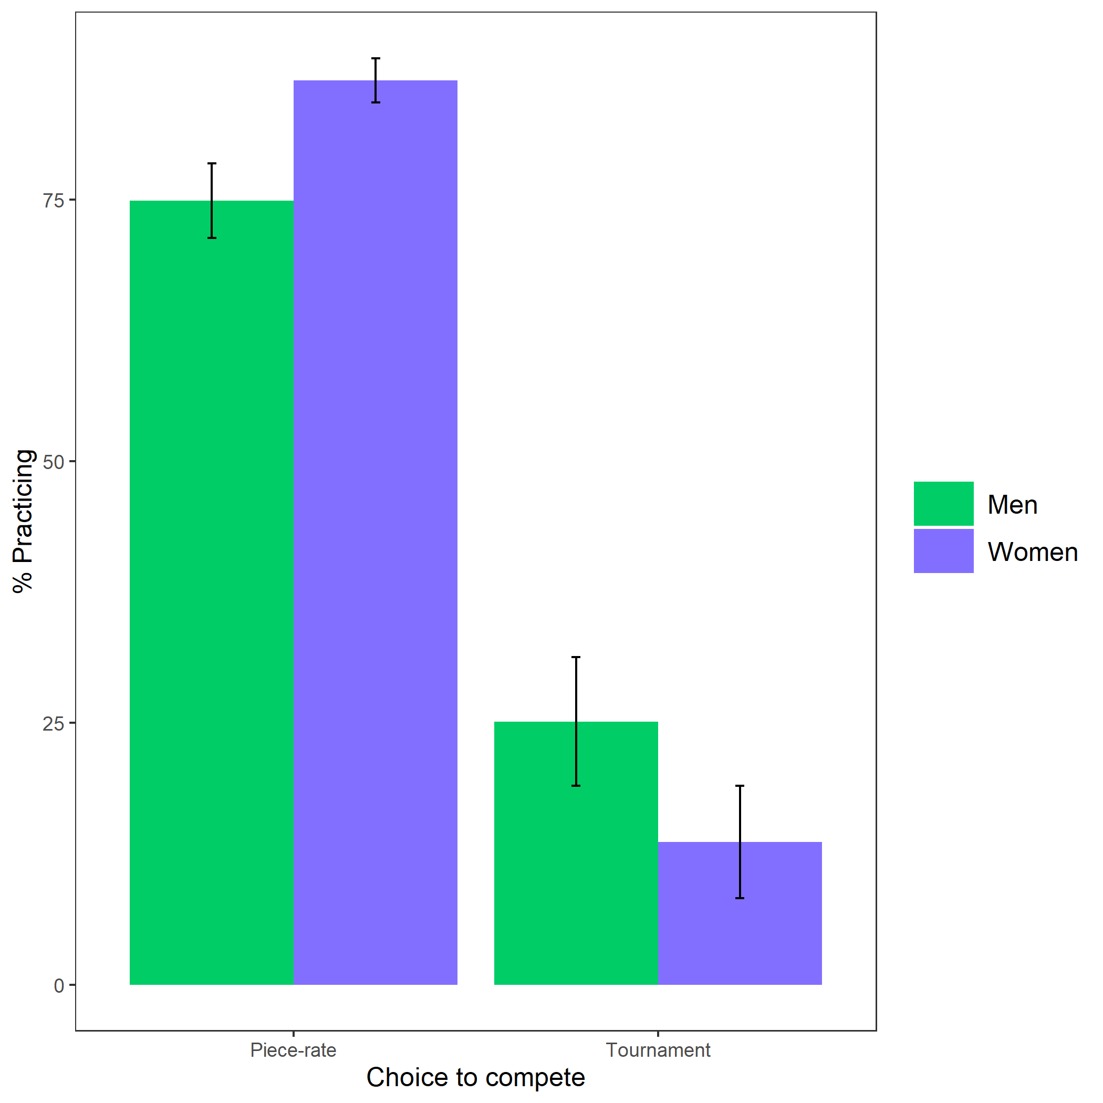

Figure 2: Proportion of participants who chose to prepare based on participant gender and choice to compete. Error bars represent standard error.

Cross-Tabulation, Row Proportions  
gender * comp_choice  
Data Frame: clean  
Group: pract_choice = No

|  |  |  |  |  |
| --- | --- | --- | --- | --- |
|  | comp_choice | piecerate | tournament | Total |
| gender |  |  |  |  |
| Man |  | 225 (83.3%) | 45 (16.7%) | 270 (100.0%) |
| Woman |  | 222 (91.7%) | 20 ( 8.3%) | 242 (100.0%) |
| Total |  | 447 (87.3%) | 65 (12.7%) | 512 (100.0%) |

Group: pract_choice = Yes

|  |  |  |  |  |
| --- | --- | --- | --- | --- |
|  | comp_choice | piecerate | tournament | Total |
| gender |  |  |  |  |
| Man |  | 149 (74.9%) | 50 (25.1%) | 199 (100.0%) |
| Woman |  | 260 (86.4%) | 41 (13.6%) | 301 (100.0%) |
| Total |  | 409 (81.8%) | 91 (18.2%) | 500 (100.0%) |

Primary hypothesis 3: Women completed 81.93% more rounds of preparation relative to men, , 95% CI , , , (see Figure 3).

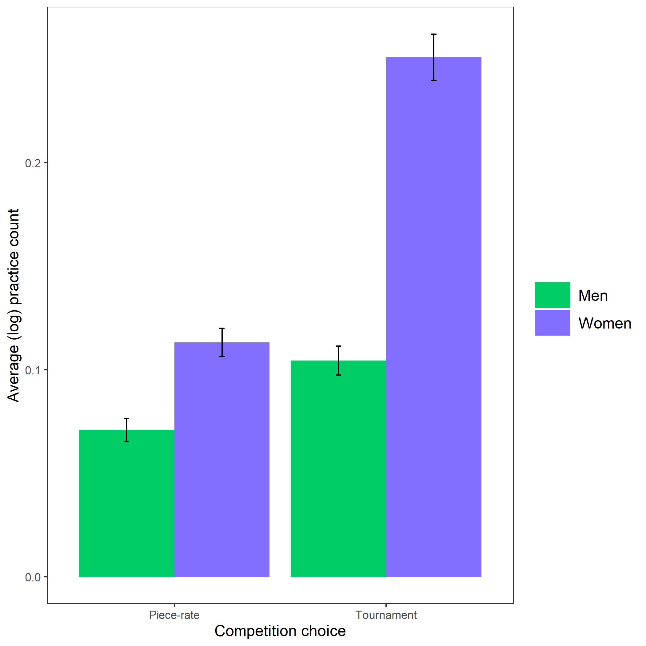

Figure 3: Average (log-transformed) practice count based on participant gender and competition choice. Error bars represent standard error.

Primary hypothesis 4: Participants expected women to spend more time preparing for the multiplication task relative to men, , (see Figure 4).

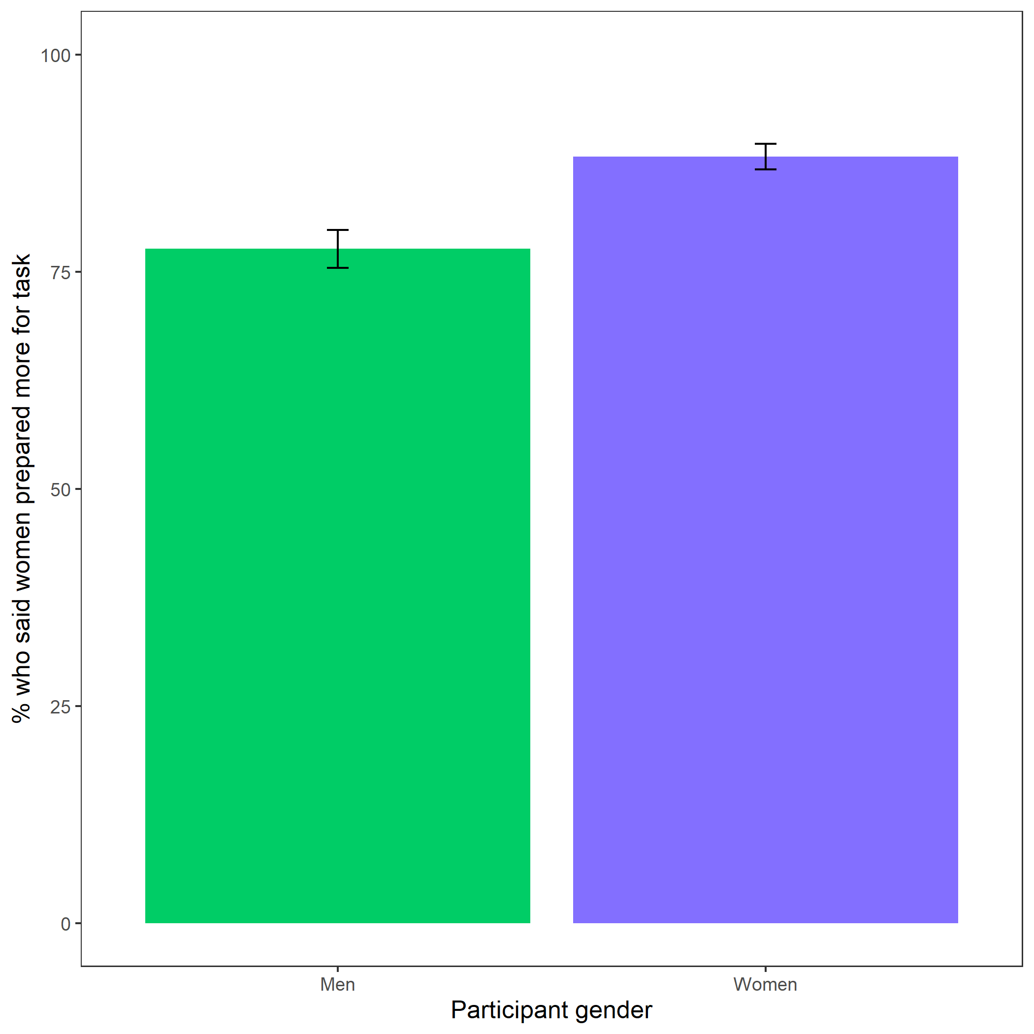

Figure 4: Participants’ perceptions of gender differences in the choice to practice on the task. Error bars represent standard error.

Cross-Tabulation, Row Proportions  
gender * perc_task_gender_pract  
Data Frame: clean

|  |  |  |  |  |
| --- | --- | --- | --- | --- |
|  | perc_task_gender_pract | Men | Women | Total |
| gender |  |  |  |  |
| Man |  | 105 (22.4%) | 364 (77.6%) | 469 (100.0%) |
| Woman |  | 64 (11.8%) | 479 (88.2%) | 543 (100.0%) |
| Total |  | 169 (16.7%) | 843 (83.3%) | 1012 (100.0%) |

Exploratory analysis 7a: Participants did not expect any gender differences in performance on the task, , (see Figure 5).

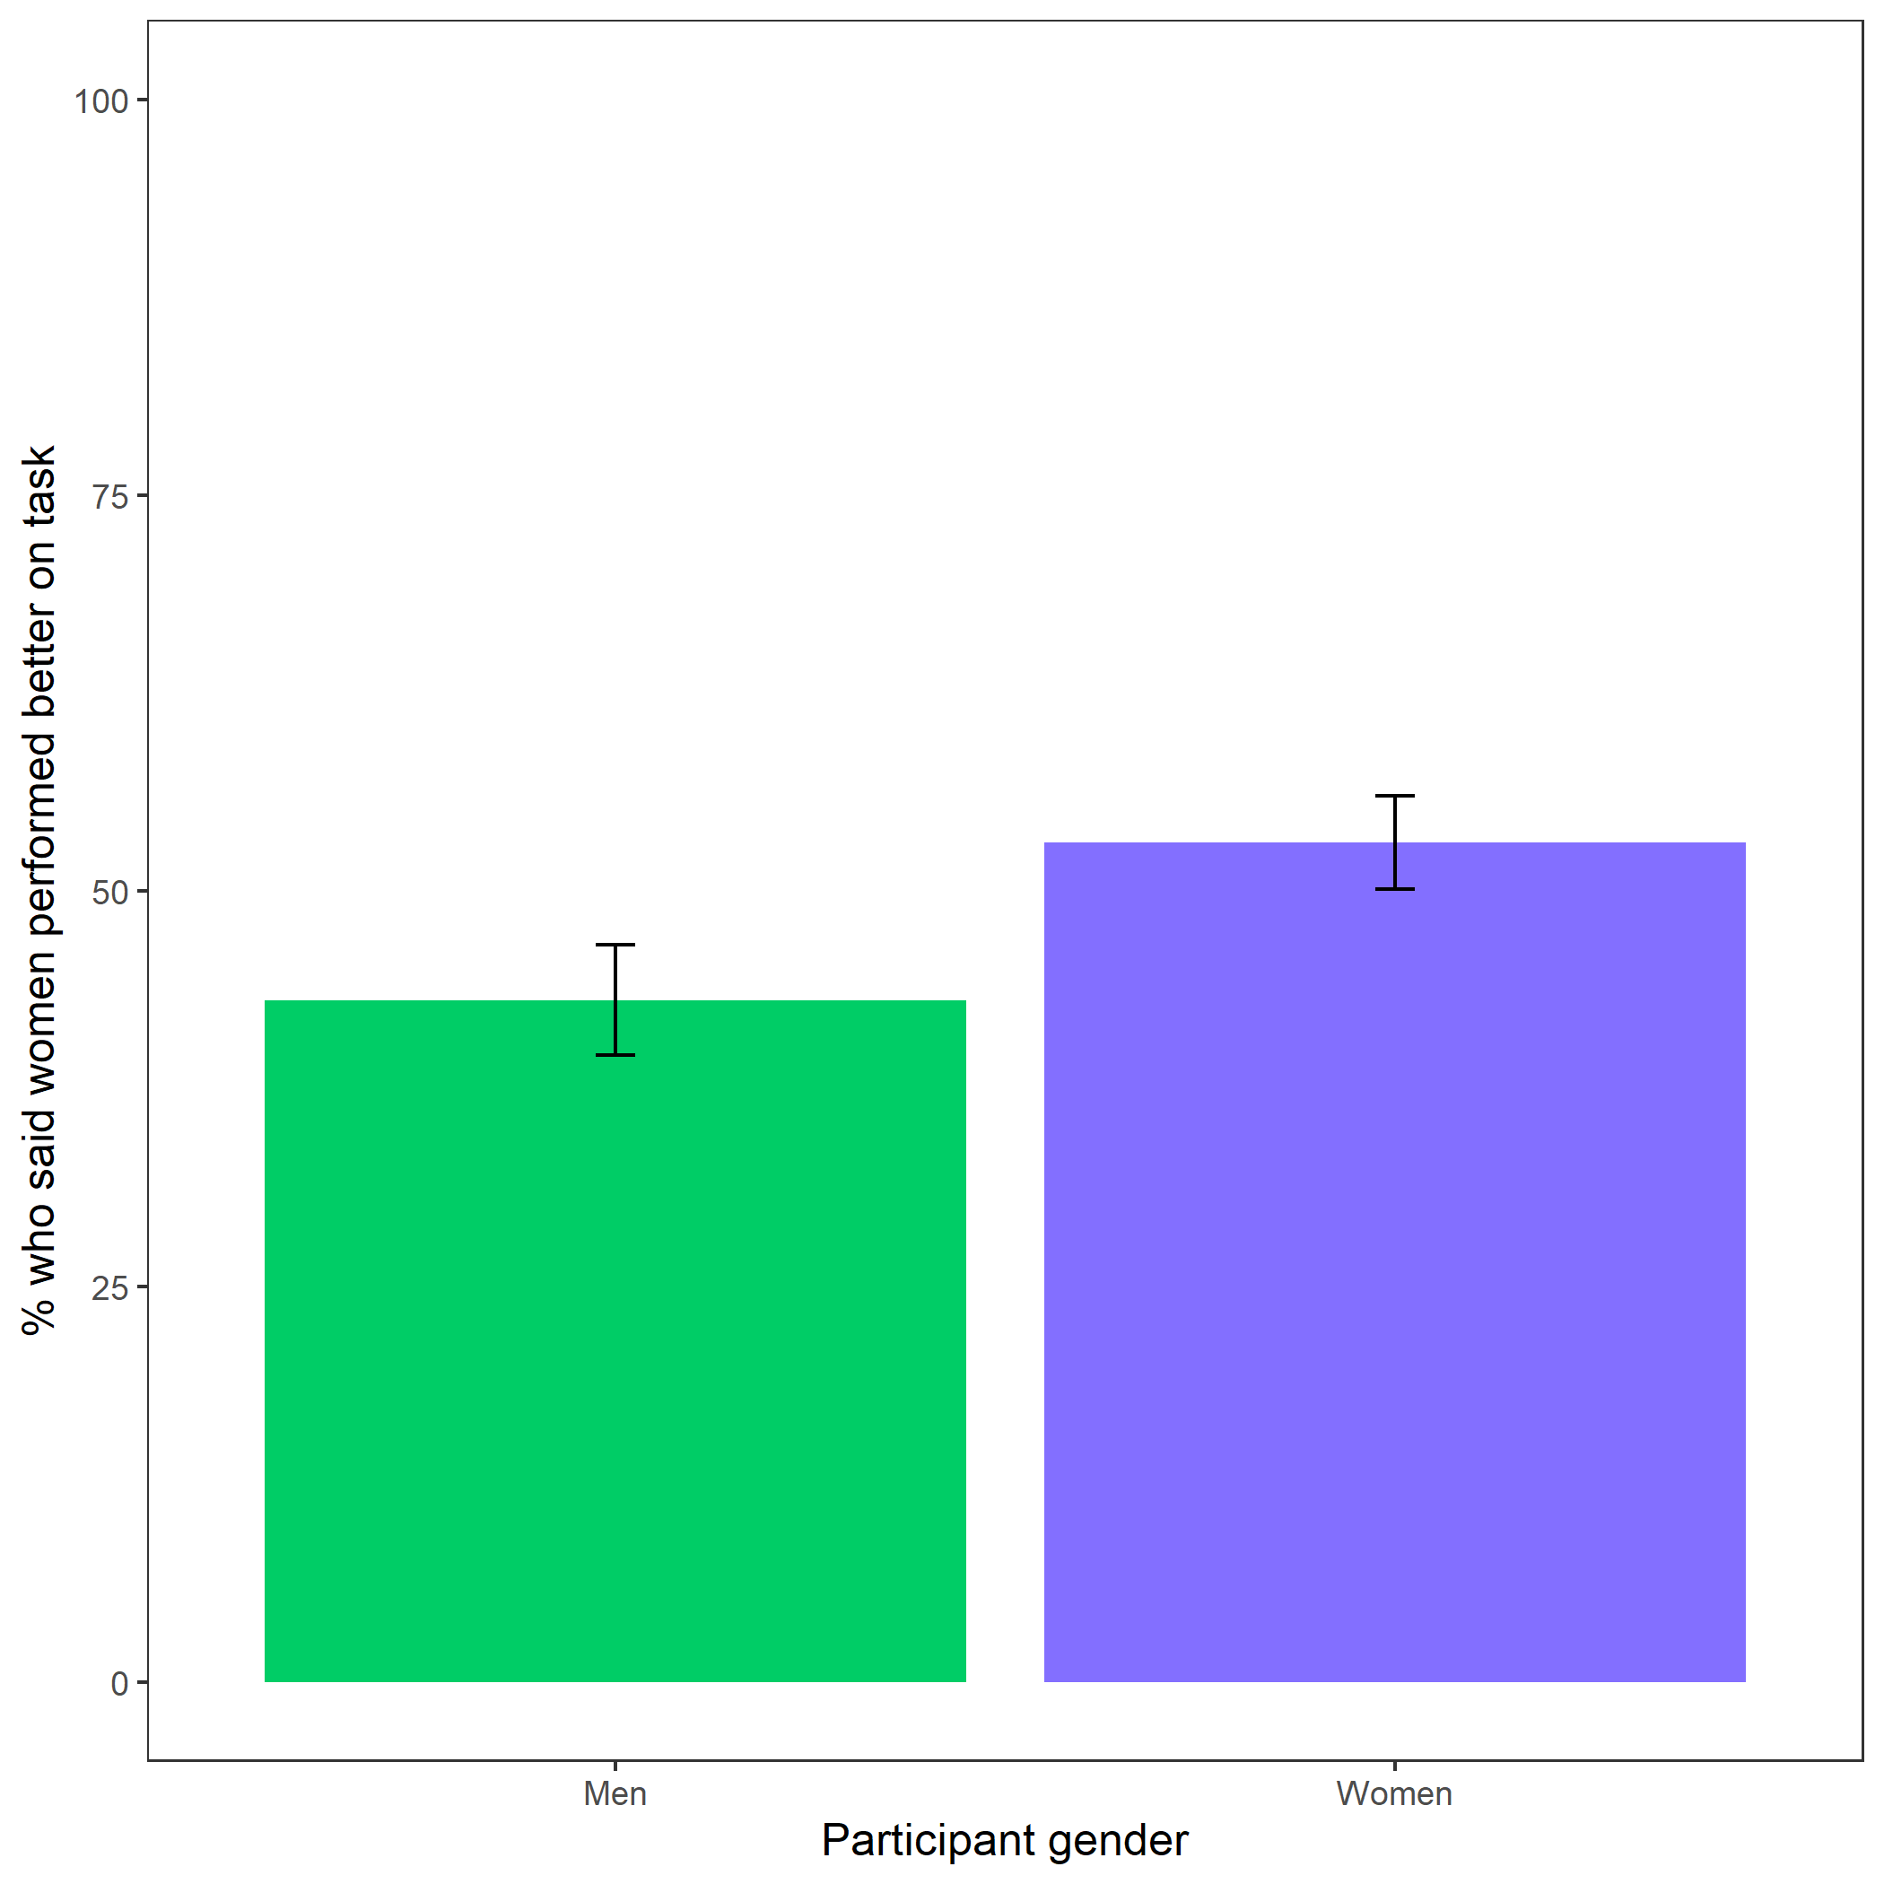

Figure 5: Participants’ perceptions of gender differences in performance on the task. Error bars represent standard error.

Cross-Tabulation, Row Proportions  
gender * better_gender_guess  
Data Frame: clean

|  |  |  |  |  |
| --- | --- | --- | --- | --- |
|  | better_gender_guess | Men | Women | Total |
| gender |  |  |  |  |
| Man |  | 267 (56.9%) | 202 (43.1%) | 469 (100.0%) |
| Woman |  | 255 (47.0%) | 288 (53.0%) | 543 (100.0%) |
| Total |  | 522 (51.6%) | 490 (48.4%) | 1012 (100.0%) |

Exploratory analysis 7b: Participants were significantly more likely to expect men to choose to compete more often, , (see Figure 6).

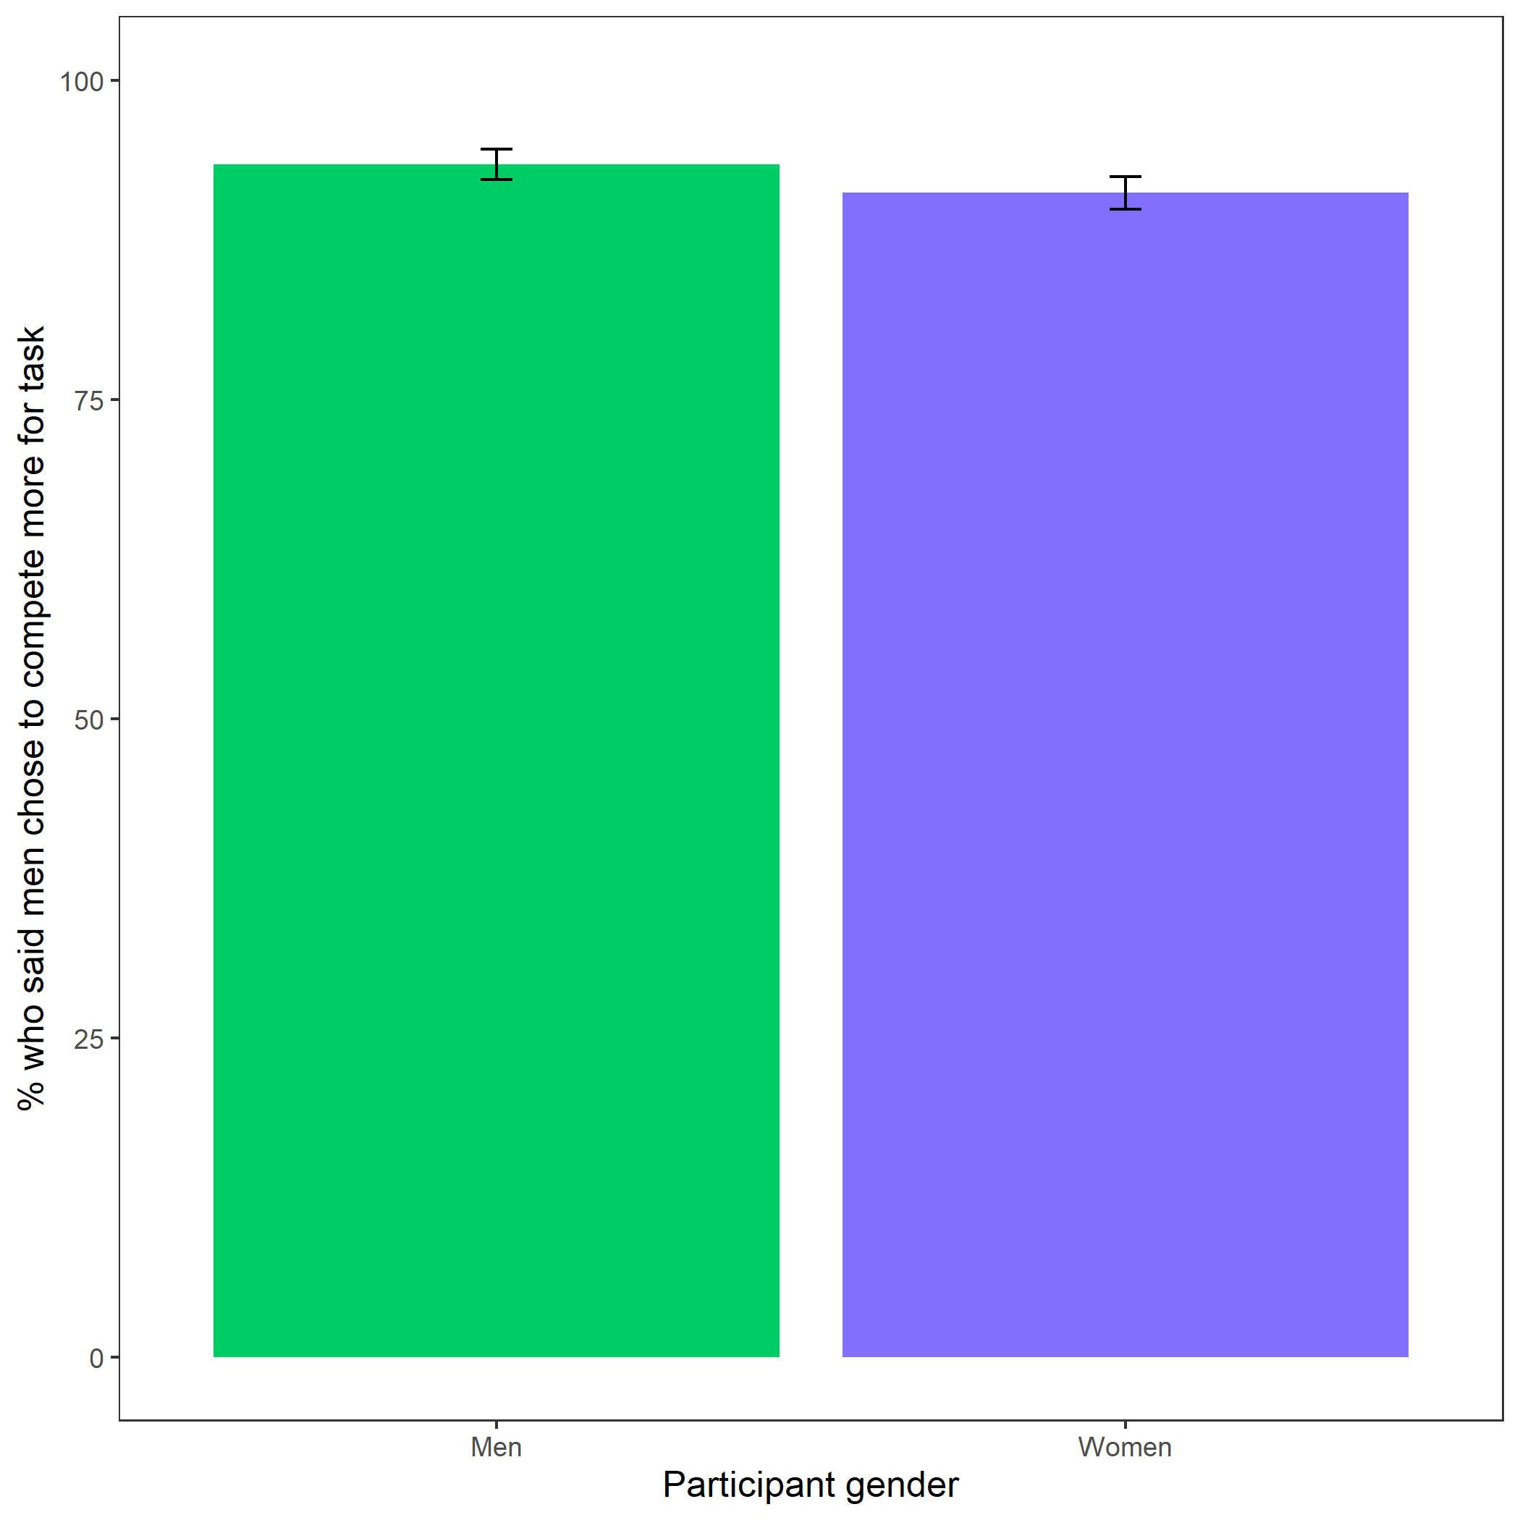

Figure 6: Participants’ perceptions of gender differences in choice to compete. Error bars represent standard error.

Cross-Tabulation, Row Proportions  
gender * perc_gender_comp  
Data Frame: clean

|  |  |  |  |  |
| --- | --- | --- | --- | --- |
|  | perc_gender_comp | Men | Women | Total |
| gender |  |  |  |  |
| Man |  | 438 (93.4%) | 31 (6.6%) | 469 (100.0%) |
| Woman |  | 495 (91.2%) | 48 (8.8%) | 543 (100.0%) |
| Total |  | 933 (92.2%) | 79 (7.8%) | 1012 (100.0%) |

Exploratory analysis 7c: Participants were significantly more likely to expect women to choose to prepare in general, , (see Figure 7).

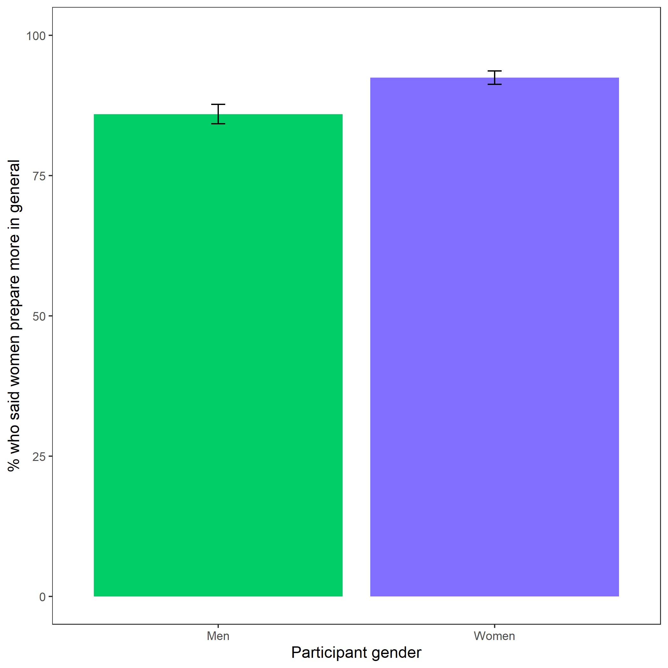

Figure 7: Participants’ perceptions of general gender differences in choice to practice. Error bars represent standard error.

Cross-Tabulation, Row Proportions  
gender * perc_gen_gender_pract  
Data Frame: clean

|  |  |  |  |  |  |
| --- | --- | --- | --- | --- | --- |
|  | perc_gen_gender_pract | Men | Women |  | Total |
| gender |  |  |  |  |  |
| Man |  | 66 (14.1%) | 403 (85.9%) | 0 (0.0%) | 469 (100.0%) |
| Woman |  | 41 ( 7.6%) | 500 (92.1%) | 2 (0.4%) | 543 (100.0%) |
| Total |  | 107 (10.6%) | 903 (89.2%) | 2 (0.2%) | 1012 (100.0%) |