**ALGORITMOS**

MARIA CAMILA NAVARRO

***DECLARAR VARIABLE***

***ARRAY***

KEVIN ANTONIO CEVALLOS

***IF***

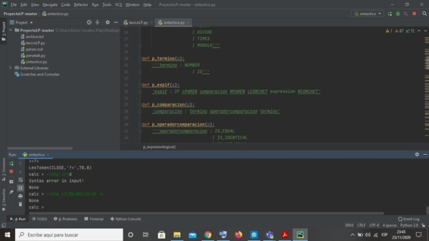

***EXPRESION MATEMATICA***

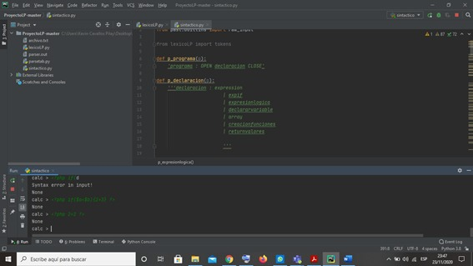

JOFFRE EMILIO RAMIREZ RISCO

***FUNCIONES***

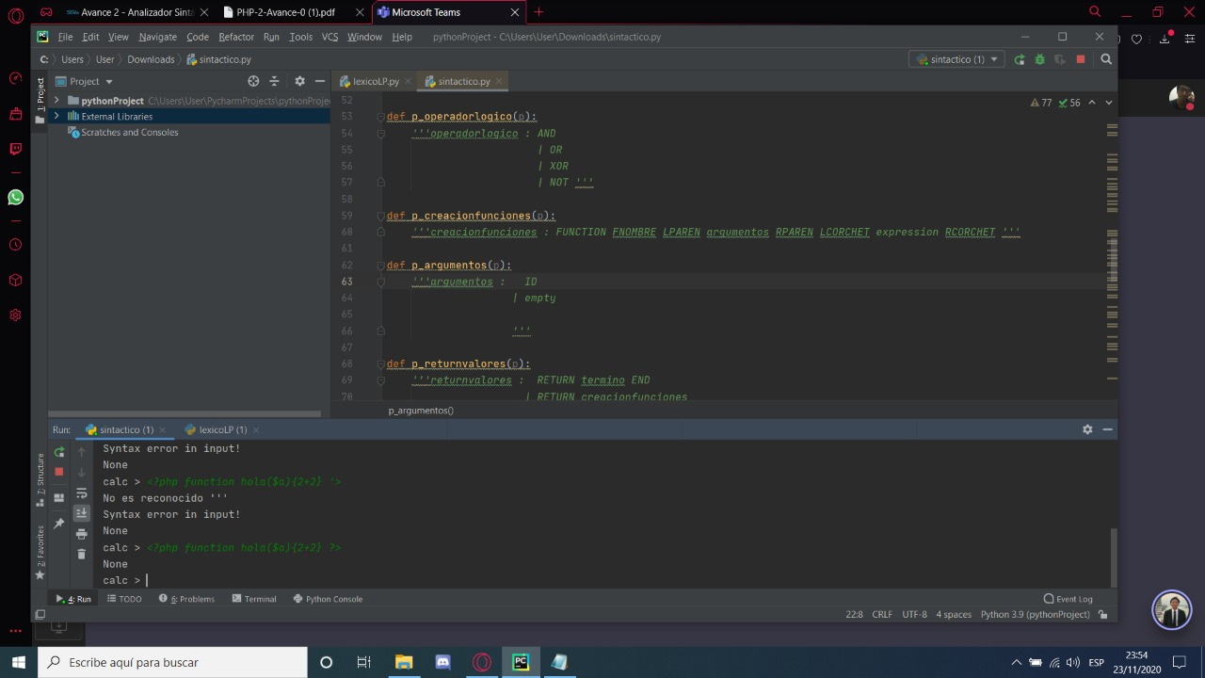

***ECO***