**Frequency Modulation System**

Table of Contents

Modulation 1

During Transmission 4

Demodulation 6

Recovery 8

% FM Code

clear all; clc; clf;

% INSTRUCTIONS

# Modulation

% Step 1: Generate a modulating signal

[y, fm] = audioread('TestAudio.wav');

sound(y,fm)

t = linspace(0, length(y)/fm, length(y));

figure;

plot(t, y);

xlabel('Time (s)');

ylabel('Amplitude');

title('Modulating Signal');

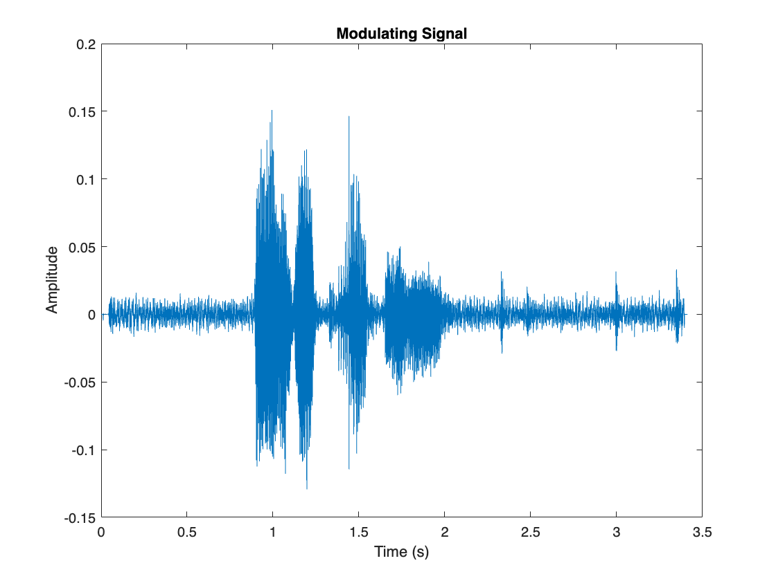

% Step 2: Apply Frequency Modulation

Fc = 10e3; % Carrier frequency

% Fs = 2*Fc;

% Set frequency deviations under test

devf1 = fm/2*0.5;

devf2 = fm/2*1;

devf3 = fm/2*2;

devf4 = fm/2*5;

devf5 = 75000/2;

% Apply frequency modulation

y_fmmod1 = fmmod(y,Fc,fm,devf1);

y_fmmod2 = fmmod(y,Fc,fm,devf2);

y_fmmod3 = fmmod(y,Fc,fm,devf3);

y_fmmod4 = fmmod(y,Fc,fm,devf4);

y_fmmod5 = fmmod(y,Fc,fm,devf5);

figure;

subplot(511)

plot(t, y_fmmod1); xlabel('Time (s)'); ylabel('Amplitude');

title(['Modulated Signal (\Deltam = ' num2str(devf1) ' Hz)']);

subplot(512)

plot(t, y_fmmod2); xlabel('Time (s)'); ylabel('Amplitude');

title(['Modulated Signal (\Deltam = ' num2str(devf2) ' Hz)']);

subplot(513)

plot(t, y_fmmod3); xlabel('Time (s)'); ylabel('Amplitude');

title(['Modulated Signal (\Deltam = ' num2str(devf3) ' Hz)']);

subplot(514)

plot(t, y_fmmod4); xlabel('Time (s)'); ylabel('Amplitude');

title(['Modulated Signal (\Deltam = ' num2str(devf4) ' Hz)']);

subplot(515)

plot(t, y_fmmod5); xlabel('Time (s)'); ylabel('Amplitude');

title(['Modulated Signal (\Deltam = ' num2str(devf5) ' Hz)']);

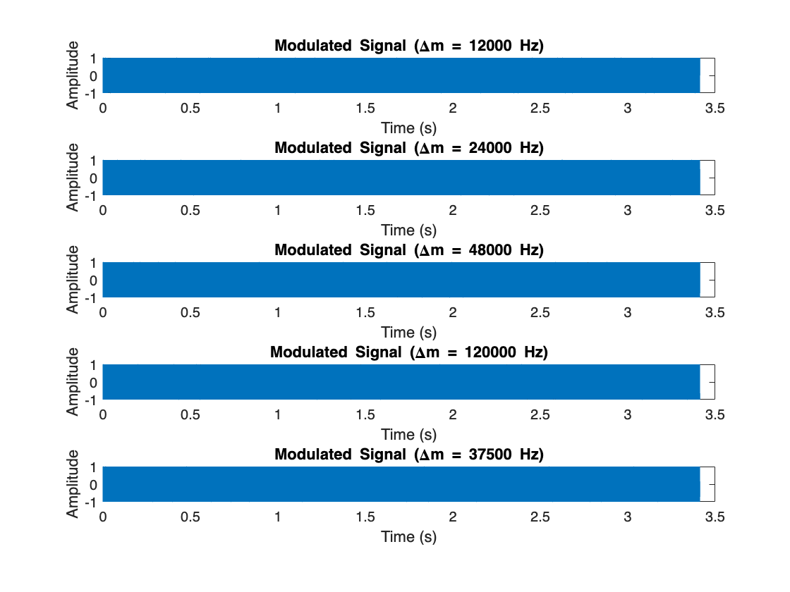

figure;

subplot(511)

fftplotM(y_fmmod1,fm)

subplot(512)

fftplotM(y_fmmod2,fm)

subplot(513)

fftplotM(y_fmmod3,fm)

subplot(514)

fftplotM(y_fmmod4,fm)

subplot(515)

fftplotM(y_fmmod5,fm)

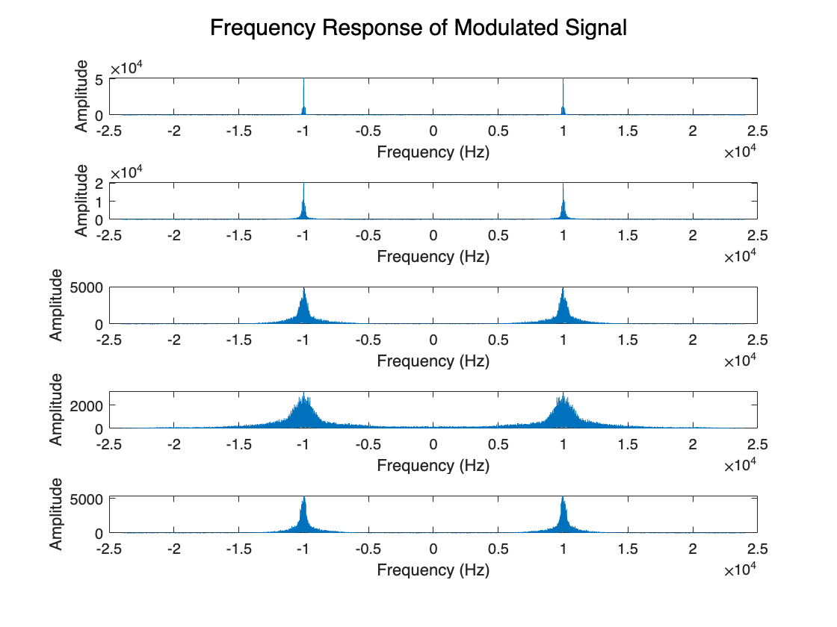

% Step 3: Amplify the modulated signals

Gfm = 1;

y_afmmod1 = Gfm*y_fmmod1;

y_afmmod2 = Gfm*y_fmmod2;

y_afmmod3 = Gfm*y_fmmod3;

y_afmmod4 = Gfm*y_fmmod4;

y_afmmod5 = Gfm*y_fmmod5;

# During Transmission

% Step 4: Add noise

% Define SNR values (in dB)

snr1 = 0;

snr2 = 2;

snr3 = 5;

snr4 = 10;

snr5 = -2;

snr6 = -5;

snr7 = -10;

snr8 = 70;

% Apply additive white gaussian noise

% For m = 0.5,

y_nafmmod11 = awgn(y_afmmod1,snr1);

y_nafmmod12 = awgn(y_afmmod1,snr2);

y_nafmmod13 = awgn(y_afmmod1,snr3);

y_nafmmod14 = awgn(y_afmmod1,snr4);

y_nafmmod15 = awgn(y_afmmod1,snr5);

y_nafmmod16 = awgn(y_afmmod1,snr6);

y_nafmmod17 = awgn(y_afmmod1,snr7);

y_nafmmod18 = awgn(y_afmmod1,snr8);

% For m = 1,

y_nafmmod21 = awgn(y_afmmod2,snr1);

y_nafmmod22 = awgn(y_afmmod2,snr2);

y_nafmmod23 = awgn(y_afmmod2,snr3);

y_nafmmod24 = awgn(y_afmmod2,snr4);

y_nafmmod25 = awgn(y_afmmod2,snr5);

y_nafmmod26 = awgn(y_afmmod2,snr6);

y_nafmmod27 = awgn(y_afmmod2,snr7);

y_nafmmod28 = awgn(y_afmmod2,snr8);

% For m = 2,

y_nafmmod31 = awgn(y_afmmod3,snr1);

y_nafmmod32 = awgn(y_afmmod3,snr2);

y_nafmmod33 = awgn(y_afmmod3,snr3);

y_nafmmod34 = awgn(y_afmmod3,snr4);

y_nafmmod35 = awgn(y_afmmod3,snr5);

y_nafmmod36 = awgn(y_afmmod3,snr6);

y_nafmmod37 = awgn(y_afmmod3,snr7);

y_nafmmod38 = awgn(y_afmmod3,snr8);

% For m = 5,

y_nafmmod41 = awgn(y_afmmod4,snr1);

y_nafmmod42 = awgn(y_afmmod4,snr2);

y_nafmmod43 = awgn(y_afmmod4,snr3);

y_nafmmod44 = awgn(y_afmmod4,snr4);

y_nafmmod45 = awgn(y_afmmod4,snr5);

y_nafmmod46 = awgn(y_afmmod4,snr6);

y_nafmmod47 = awgn(y_afmmod4,snr7);

y_nafmmod48 = awgn(y_afmmod4,snr8);

% For devf = 75 kHz,

y_nafmmod51 = awgn(y_afmmod5,snr1);

y_nafmmod52 = awgn(y_afmmod5,snr2);

y_nafmmod53 = awgn(y_afmmod5,snr3);

y_nafmmod54 = awgn(y_afmmod5,snr4);

y_nafmmod55 = awgn(y_afmmod5,snr5);

y_nafmmod56 = awgn(y_afmmod5,snr6);

y_nafmmod57 = awgn(y_afmmod5,snr7);

y_nafmmod58 = awgn(y_afmmod5,snr8);

# Demodulation

% Step 5: Demodulate

% For m = 0.5,

y_fmdemod11 = fmdemod(y_nafmmod11,Fc,fm,devf1);

y_fmdemod12 = fmdemod(y_nafmmod12,Fc,fm,devf1);

y_fmdemod13 = fmdemod(y_nafmmod13,Fc,fm,devf1);

y_fmdemod14 = fmdemod(y_nafmmod14,Fc,fm,devf1);

y_fmdemod15 = fmdemod(y_nafmmod15,Fc,fm,devf1);

y_fmdemod16 = fmdemod(y_nafmmod16,Fc,fm,devf1);

y_fmdemod17 = fmdemod(y_nafmmod17,Fc,fm,devf1);

y_fmdemod18 = fmdemod(y_nafmmod18,Fc,fm,devf1);

% For m = 1,

y_fmdemod21 = fmdemod(y_nafmmod21,Fc,fm,devf2);

y_fmdemod22 = fmdemod(y_nafmmod22,Fc,fm,devf2);

y_fmdemod23 = fmdemod(y_nafmmod23,Fc,fm,devf2);

y_fmdemod24 = fmdemod(y_nafmmod24,Fc,fm,devf2);

y_fmdemod25 = fmdemod(y_nafmmod25,Fc,fm,devf2);

y_fmdemod26 = fmdemod(y_nafmmod26,Fc,fm,devf2);

y_fmdemod27 = fmdemod(y_nafmmod27,Fc,fm,devf2);

y_fmdemod28 = fmdemod(y_nafmmod28,Fc,fm,devf1);

% For m = 2,

y_fmdemod31 = fmdemod(y_nafmmod31,Fc,fm,devf3);

y_fmdemod32 = fmdemod(y_nafmmod32,Fc,fm,devf3);

y_fmdemod33 = fmdemod(y_nafmmod33,Fc,fm,devf3);

y_fmdemod34 = fmdemod(y_nafmmod34,Fc,fm,devf3);

y_fmdemod35 = fmdemod(y_nafmmod35,Fc,fm,devf3);

y_fmdemod36 = fmdemod(y_nafmmod36,Fc,fm,devf3);

y_fmdemod37 = fmdemod(y_nafmmod37,Fc,fm,devf3);

y_fmdemod38 = fmdemod(y_nafmmod38,Fc,fm,devf3);

% For m = 5,

y_fmdemod41 = fmdemod(y_nafmmod41,Fc,fm,devf4);

y_fmdemod42 = fmdemod(y_nafmmod42,Fc,fm,devf4);

y_fmdemod43 = fmdemod(y_nafmmod43,Fc,fm,devf4);

y_fmdemod44 = fmdemod(y_nafmmod44,Fc,fm,devf4);

y_fmdemod45 = fmdemod(y_nafmmod45,Fc,fm,devf4);

y_fmdemod46 = fmdemod(y_nafmmod46,Fc,fm,devf4);

y_fmdemod47 = fmdemod(y_nafmmod47,Fc,fm,devf4);

y_fmdemod48 = fmdemod(y_nafmmod48,Fc,fm,devf4);

% For devf = 75 kHz,

y_fmdemod51 = fmdemod(y_nafmmod51,Fc,fm,devf5);

y_fmdemod52 = fmdemod(y_nafmmod52,Fc,fm,devf5);

y_fmdemod53 = fmdemod(y_nafmmod53,Fc,fm,devf5);

y_fmdemod54 = fmdemod(y_nafmmod54,Fc,fm,devf5);

y_fmdemod55 = fmdemod(y_nafmmod55,Fc,fm,devf5);

y_fmdemod56 = fmdemod(y_nafmmod56,Fc,fm,devf5);

y_fmdemod57 = fmdemod(y_nafmmod57,Fc,fm,devf5);

y_fmdemod58 = fmdemod(y_nafmmod58,Fc,fm,devf5);

% Design filter

n = 2;

Rs = 20;

Ws = 0.075;

[b,a] = cheby2(n,Rs,Ws);

% Apply filter

% For m = 0.5,

y_ffmdemod11 = filter(b,a,y_fmdemod11);

y_ffmdemod12 = filter(b,a,y_fmdemod12);

y_ffmdemod13 = filter(b,a,y_fmdemod13);

y_ffmdemod14 = filter(b,a,y_fmdemod14);

y_ffmdemod15 = filter(b,a,y_fmdemod15);

y_ffmdemod16 = filter(b,a,y_fmdemod16);

y_ffmdemod17 = filter(b,a,y_fmdemod17);

y_ffmdemod18 = filter(b,a,y_fmdemod18);

% For m = 1,

y_ffmdemod21 = filter(b,a,y_fmdemod21);

y_ffmdemod22 = filter(b,a,y_fmdemod22);

y_ffmdemod23 = filter(b,a,y_fmdemod23);

y_ffmdemod24 = filter(b,a,y_fmdemod24);

y_ffmdemod25 = filter(b,a,y_fmdemod25);

y_ffmdemod26 = filter(b,a,y_fmdemod26);

y_ffmdemod27 = filter(b,a,y_fmdemod27);

y_ffmdemod28 = filter(b,a,y_fmdemod28);

% For m = 2,

y_ffmdemod31 = filter(b,a,y_fmdemod31);

y_ffmdemod32 = filter(b,a,y_fmdemod32);

y_ffmdemod33 = filter(b,a,y_fmdemod33);

y_ffmdemod34 = filter(b,a,y_fmdemod34);

y_ffmdemod35 = filter(b,a,y_fmdemod35);

y_ffmdemod36 = filter(b,a,y_fmdemod36);

y_ffmdemod37 = filter(b,a,y_fmdemod37);

y_ffmdemod38 = filter(b,a,y_fmdemod38);

% For m = 5,

y_ffmdemod41 = filter(b,a,y_fmdemod41);

y_ffmdemod42 = filter(b,a,y_fmdemod42);

y_ffmdemod43 = filter(b,a,y_fmdemod43);

y_ffmdemod44 = filter(b,a,y_fmdemod44);

y_ffmdemod45 = filter(b,a,y_fmdemod45);

y_ffmdemod46 = filter(b,a,y_fmdemod46);

y_ffmdemod47 = filter(b,a,y_fmdemod47);

y_ffmdemod48 = filter(b,a,y_fmdemod48);

% For devf = 75 kHz,

y_ffmdemod51 = filter(b,a,y_fmdemod51);

y_ffmdemod52 = filter(b,a,y_fmdemod52);

y_ffmdemod53 = filter(b,a,y_fmdemod53);

y_ffmdemod54 = filter(b,a,y_fmdemod54);

y_ffmdemod55 = filter(b,a,y_fmdemod55);

y_ffmdemod56 = filter(b,a,y_fmdemod56);

y_ffmdemod57 = filter(b,a,y_fmdemod57);

y_ffmdemod58 = filter(b,a,y_fmdemod58);

# Recovery

% Recover the received signals.

% Comparison Graph 1: Using SNR = 0 dB with different modulation indices

figure;

subplot(511); plot(t,y_fmdemod11, t, y); grid on; xlim([0 3.4]); title("m = 0.5");

subplot(512); plot(t,y_fmdemod21, t, y); grid on; xlim([0 3.4]); title("m = 1");

subplot(513); plot(t,y_fmdemod31, t, y); grid on; xlim([0 3.4]); title("m = 2");

subplot(514); plot(t,y_fmdemod41, t, y); grid on; xlim([0 3.4]); title("m = 5");

subplot(515); plot(t,y_fmdemod51, t, y); grid on; xlim([0 3.4]); title("m = 1.5625");

sgtitle("Comparison of Signals for SNR = 0 dB with Different Modulation Index");

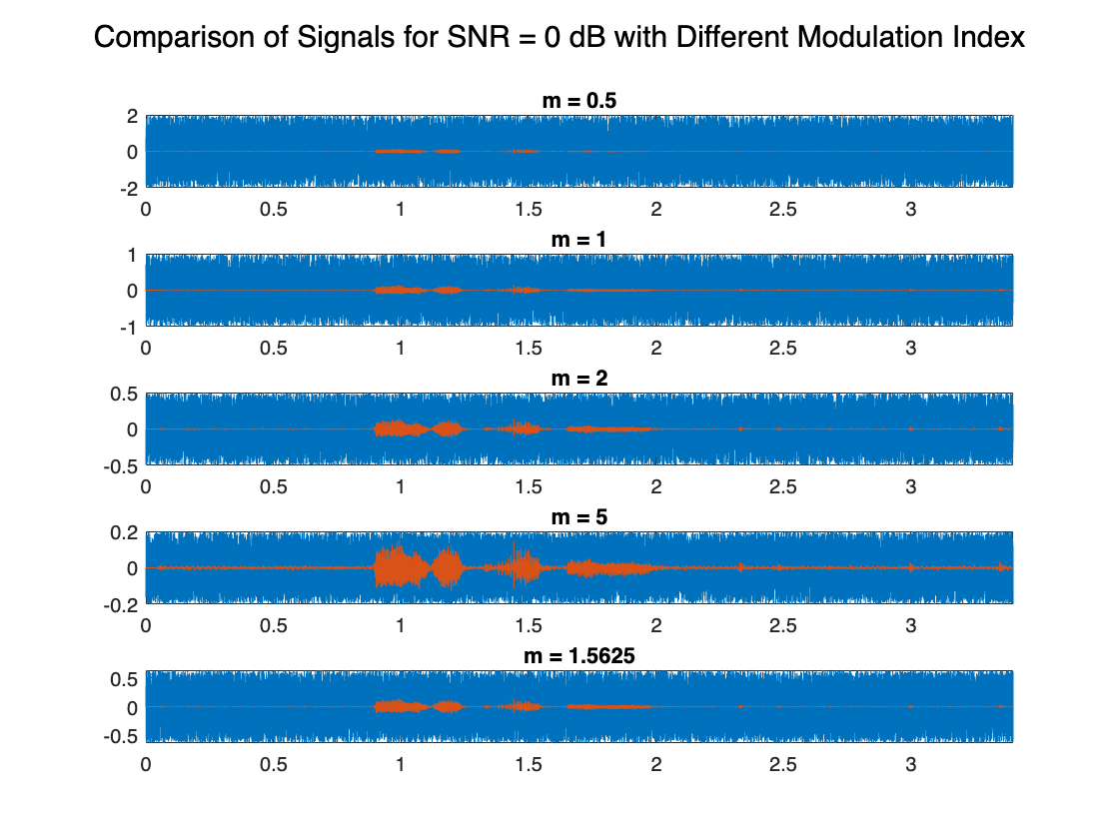

% Comparison Graph 2: Using SNR = 2 dB with different modulation indices

figure;

subplot(511); plot(t,y_fmdemod12, t, y); grid on; xlim([0 3.4]); title("m = 0.5");

subplot(512); plot(t,y_fmdemod22, t, y); grid on; xlim([0 3.4]); title("m = 1");

subplot(513); plot(t,y_fmdemod32, t, y); grid on; xlim([0 3.4]); title("m = 2");

subplot(514); plot(t,y_fmdemod42, t, y); grid on; xlim([0 3.4]); title("m = 5");

subplot(515); plot(t,y_fmdemod52, t, y); grid on; xlim([0 3.4]); title("m = 1.5625");

sgtitle("Comparison of Signals for SNR = 2 dB with Different Modulation Index");

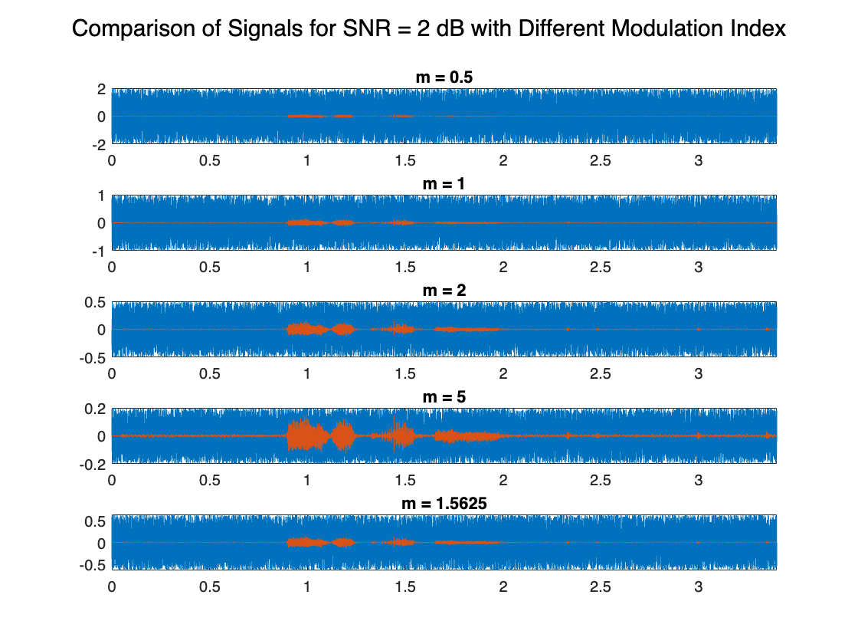

% Comparison Graph 3: Using SNR = 5 dB with different modulation indices

figure;

subplot(511); plot(t,y_fmdemod13, t, y); grid on; xlim([0 3.4]); title("m = 0.5");

subplot(512); plot(t,y_fmdemod23, t, y); grid on; xlim([0 3.4]); title("m = 1");

subplot(513); plot(t,y_fmdemod33, t, y); grid on; xlim([0 3.4]); title("m = 2");

subplot(514); plot(t,y_fmdemod43, t, y); grid on; xlim([0 3.4]); title("m = 5");

subplot(515); plot(t,y_fmdemod53, t, y); grid on; xlim([0 3.4]); title("m = 1.5625");

sgtitle("Comparison of Signals for SNR = 5 dB with Different Modulation Index");

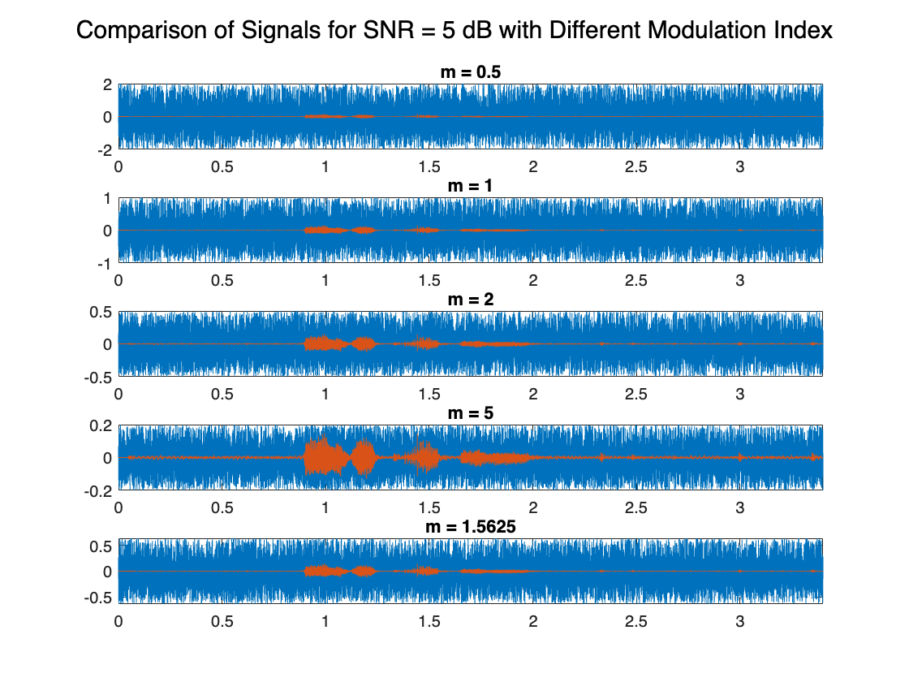

% Comparison Graph 4: Using SNR = 10 dB with different modulation indices

figure;

subplot(511); plot(t,y_fmdemod14, t, y); grid on; xlim([0 3.4]); title("m = 0.5");

subplot(512); plot(t,y_fmdemod24, t, y); grid on; xlim([0 3.4]); title("m = 1");

subplot(513); plot(t,y_fmdemod34, t, y); grid on; xlim([0 3.4]); title("m = 2");

subplot(514); plot(t,y_fmdemod44, t, y); grid on; xlim([0 3.4]); title("m = 5");

subplot(515); plot(t,y_fmdemod54, t, y); grid on; xlim([0 3.4]); title("m = 1.5625");

sgtitle("Comparison of Signals for SNR = 10 dB with Different Modulation Index");

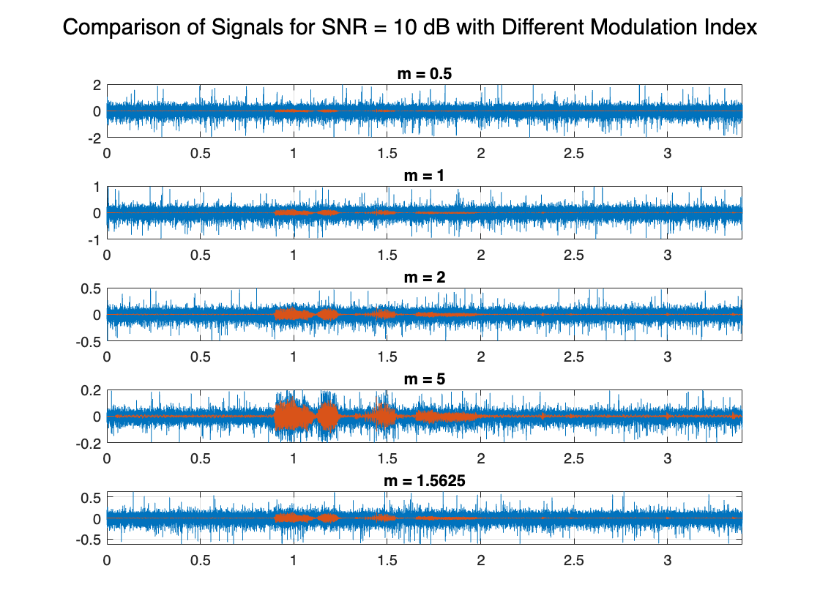

% Comparison Graph 5: Using SNR = -2 dB with different modulation indices

figure;

subplot(511); plot(t,y_fmdemod15, t, y); grid on; xlim([0 3.4]); title("m = 0.5");

subplot(512); plot(t,y_fmdemod25, t, y); grid on; xlim([0 3.4]); title("m = 1");

subplot(513); plot(t,y_fmdemod35, t, y); grid on; xlim([0 3.4]); title("m = 2");

subplot(514); plot(t,y_fmdemod45, t, y); grid on; xlim([0 3.4]); title("m = 5");

subplot(515); plot(t,y_fmdemod55, t, y); grid on; xlim([0 3.4]); title("m = 1.5625");

sgtitle("Comparison of Signals for SNR = -2 dB with Different Modulation Index");

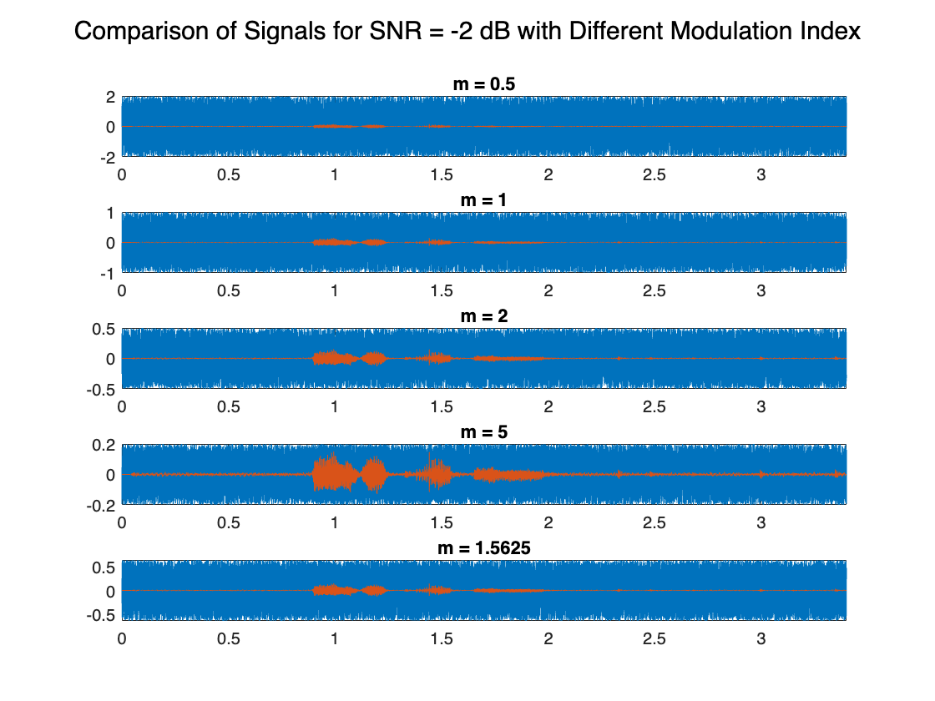

% Comparison Graph 6: Using SNR = -5 dB with different modulation indices

figure;

subplot(511); plot(t,y_fmdemod16, t, y); grid on; xlim([0 3.4]); title("m = 0.5");

subplot(512); plot(t,y_fmdemod26, t, y); grid on; xlim([0 3.4]); title("m = 1");

subplot(513); plot(t,y_fmdemod36, t, y); grid on; xlim([0 3.4]); title("m = 2");

subplot(514); plot(t,y_fmdemod46, t, y); grid on; xlim([0 3.4]); title("m = 5");

subplot(515); plot(t,y_fmdemod56, t, y); grid on; xlim([0 3.4]); title("m = 1.5625");

sgtitle("Comparison of Signals for SNR = -5 dB with Different Modulation Index");

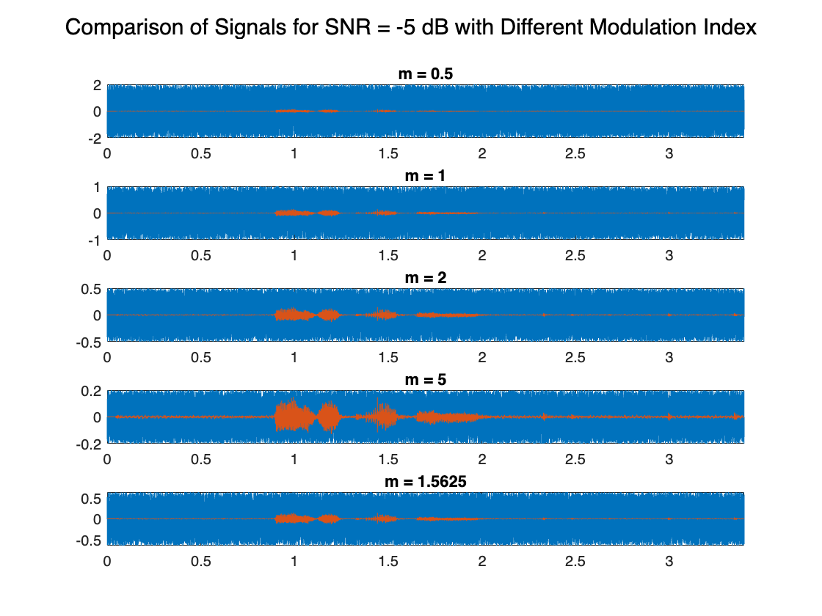

% Comparison Graph 7: Using SNR = -10 dB with different modulation indices

figure;

subplot(511); plot(t,y_fmdemod17, t, y); grid on; xlim([0 3.4]); title("m = 0.5");

subplot(512); plot(t,y_fmdemod27, t, y); grid on; xlim([0 3.4]); title("m = 1");

subplot(513); plot(t,y_fmdemod37, t, y); grid on; xlim([0 3.4]); title("m = 2");

subplot(514); plot(t,y_fmdemod47, t, y); grid on; xlim([0 3.4]); title("m = 5");

subplot(515); plot(t,y_fmdemod57, t, y); grid on; xlim([0 3.4]); title("m = 1.5625");

sgtitle("Comparison of Signals for SNR = -10 dB with Different Modulation Index");

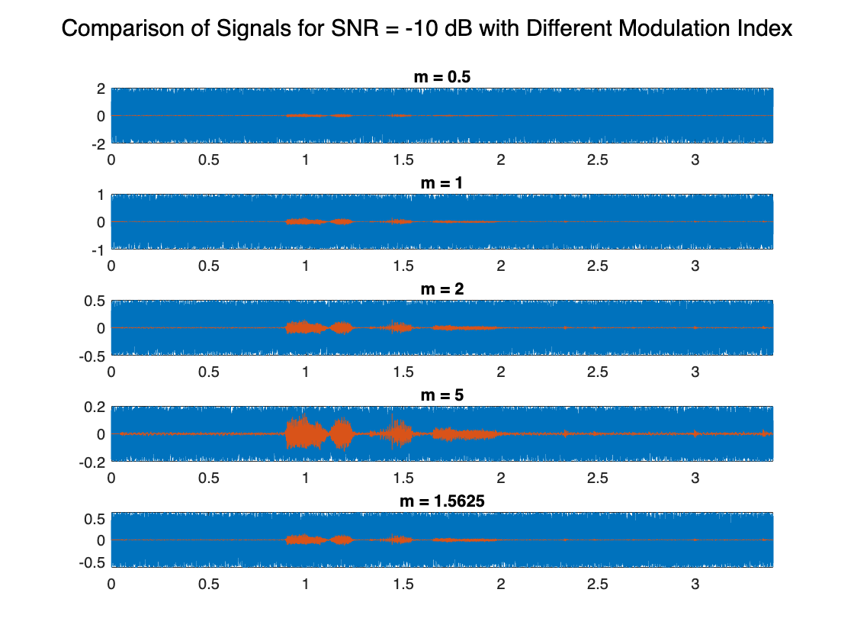

% Comparison Graph 8: Using SNR = 70 dB with different modulation indices

figure;

subplot(511); plot(t,y_fmdemod18, t, y); grid on; xlim([0 3.4]); title("m = 0.5");

subplot(512); plot(t,y_fmdemod28, t, y); grid on; xlim([0 3.4]); title("m = 1");

subplot(513); plot(t,y_fmdemod38, t, y); grid on; xlim([0 3.4]); title("m = 2");

subplot(514); plot(t,y_fmdemod48, t, y); grid on; xlim([0 3.4]); title("m = 5");

subplot(515); plot(t,y_fmdemod58, t, y); grid on; xlim([0 3.4]); title("m = 1.5625");

sgtitle("Comparison of Signals for SNR = 70 dB with Different Modulation Index");

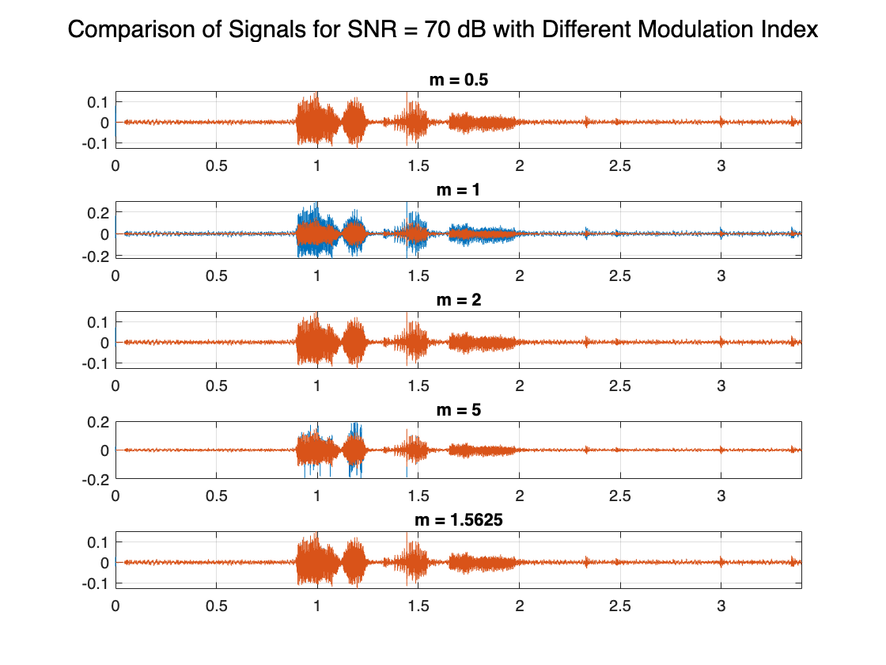

% FFT Plots 1: Using SNR = 0 dB with different modulation indices

figure;

subplot(511); fftplotD(y_fmdemod11, fm); title("m = 0.5");

subplot(512); fftplotD(y_fmdemod21, fm); title("m = 1");

subplot(513); fftplotD(y_fmdemod31, fm); title("m = 2");

subplot(514); fftplotD(y_fmdemod41, fm); title("m = 5");

subplot(515); fftplotD(y_fmdemod51, fm); title("m = 1.5625");

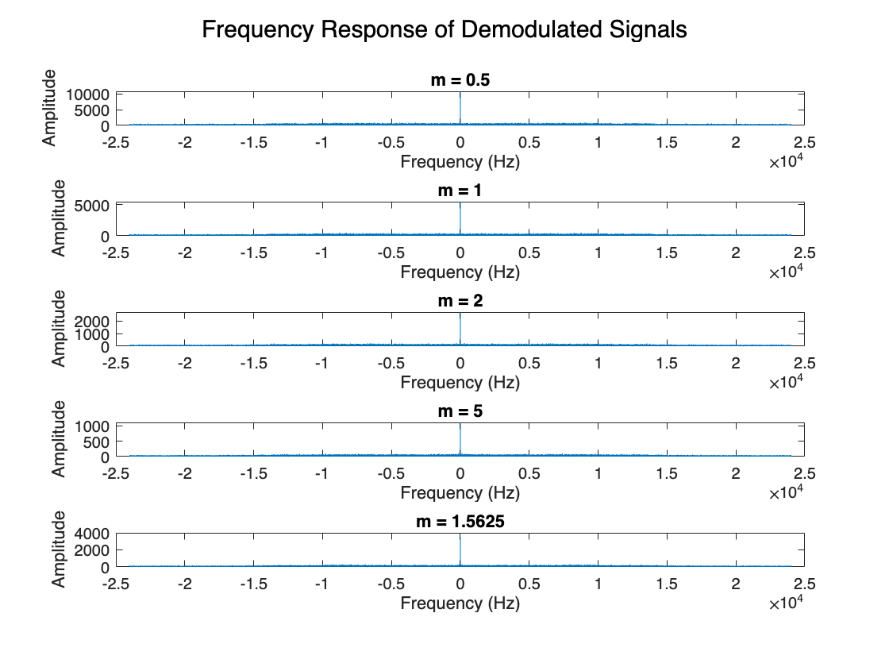

% FFT Plots 2: Using SNR = 2 dB with different modulation indices

figure;

subplot(511); fftplotD(y_fmdemod12, fm); title("m = 0.5");

subplot(512); fftplotD(y_fmdemod22, fm); title("m = 1");

subplot(513); fftplotD(y_fmdemod32, fm); title("m = 2");

subplot(514); fftplotD(y_fmdemod42, fm); title("m = 5");

subplot(515); fftplotD(y_fmdemod52, fm); title("m = 1.5625");

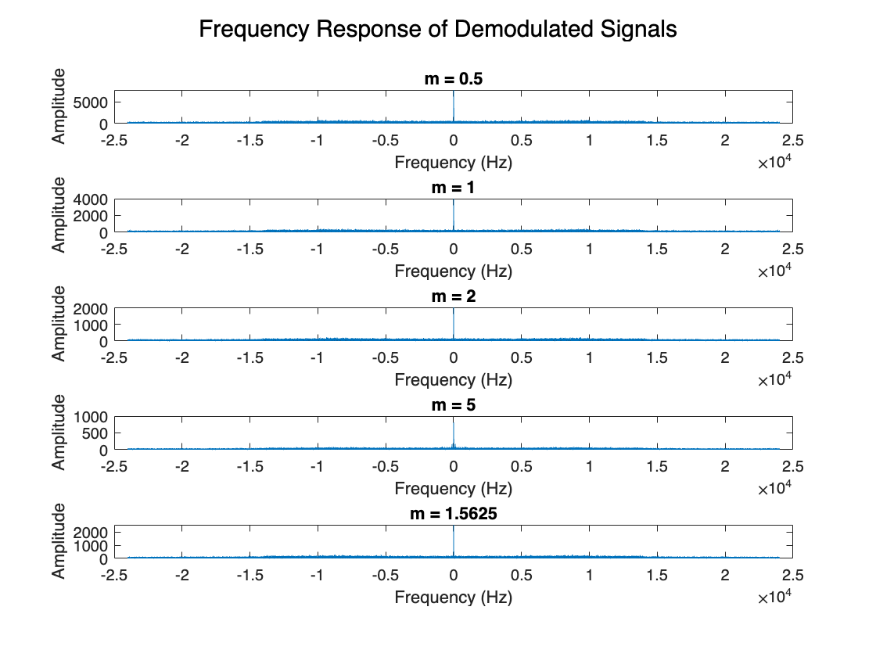

% FFT Plots 3: Using SNR = 5 dB with different modulation indices

figure;

subplot(511); fftplotD(y_fmdemod13, fm); title("m = 0.5");

subplot(512); fftplotD(y_fmdemod23, fm); title("m = 1");

subplot(513); fftplotD(y_fmdemod33, fm); title("m = 2");

subplot(514); fftplotD(y_fmdemod43, fm); title("m = 5");

subplot(515); fftplotD(y_fmdemod53, fm); title("m = 1.5625");

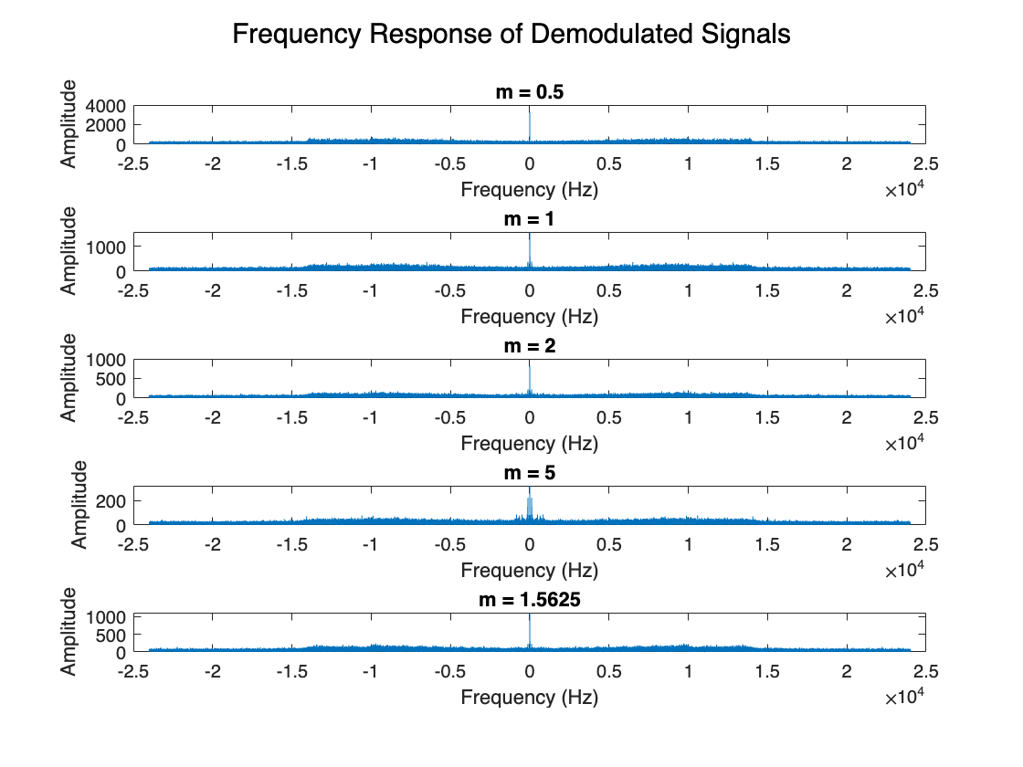

% FFT Plots 4: Using SNR = 10 dB with different modulation indices

figure;

subplot(511); fftplotD(y_fmdemod14, fm); title("m = 0.5");

subplot(512); fftplotD(y_fmdemod24, fm); title("m = 1");

subplot(513); fftplotD(y_fmdemod34, fm); title("m = 2");

subplot(514); fftplotD(y_fmdemod44, fm); title("m = 5");

subplot(515); fftplotD(y_fmdemod54, fm); title("m = 1.5625");

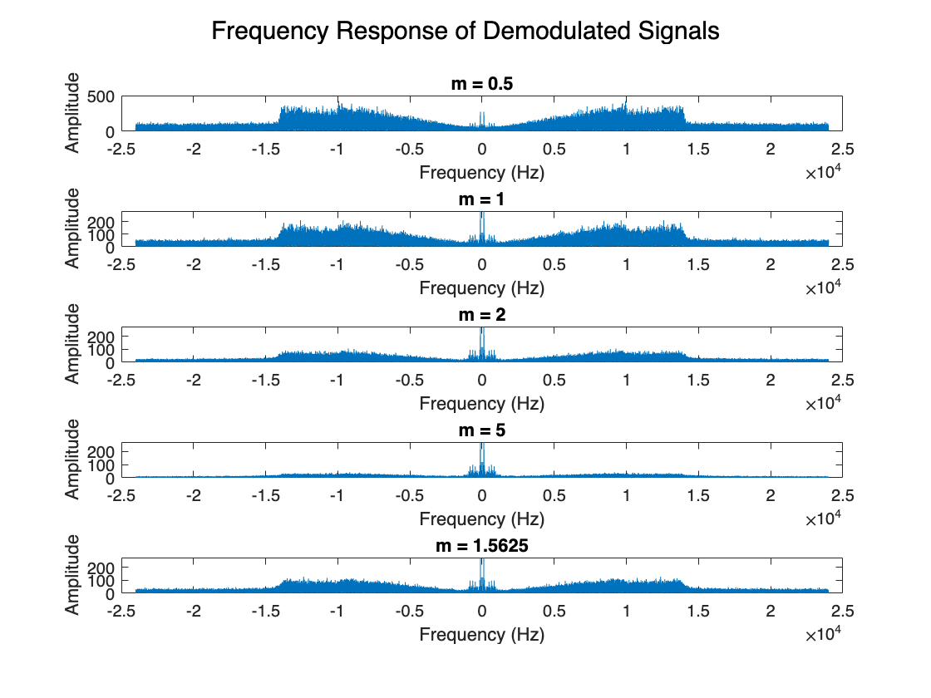

% FFT Plots 5: Using SNR = -2 dB with different modulation indices

figure;

subplot(511); fftplotD(y_fmdemod15, fm); title("m = 0.5");

subplot(512); fftplotD(y_fmdemod25, fm); title("m = 1");

subplot(513); fftplotD(y_fmdemod35, fm); title("m = 2");

subplot(514); fftplotD(y_fmdemod45, fm); title("m = 5");

subplot(515); fftplotD(y_fmdemod55, fm); title("m = 1.5625");

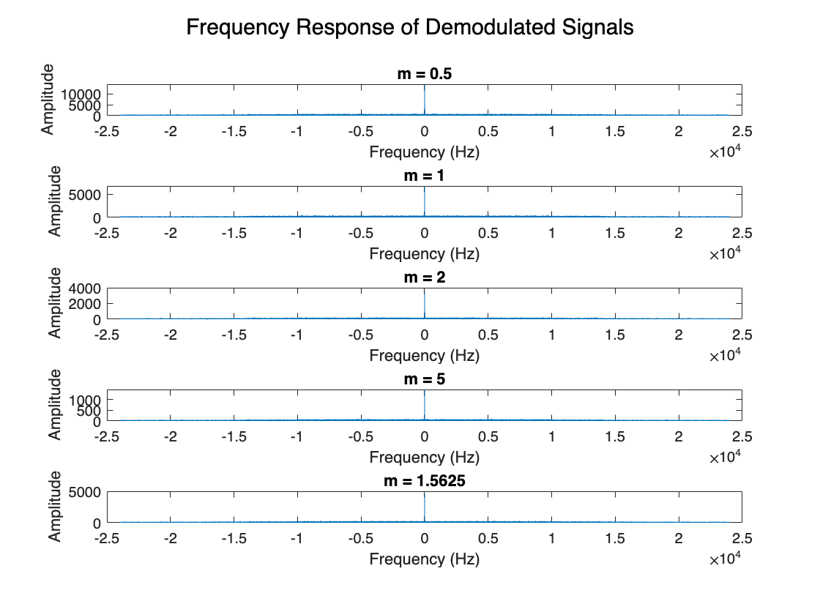

% FFT Plots 6: Using SNR = -5 dB with different modulation indices

figure;

subplot(511); fftplotD(y_fmdemod16, fm); title("m = 0.5");

subplot(512); fftplotD(y_fmdemod26, fm); title("m = 1");

subplot(513); fftplotD(y_fmdemod36, fm); title("m = 2");

subplot(514); fftplotD(y_fmdemod46, fm); title("m = 5");

subplot(515); fftplotD(y_fmdemod56, fm); title("m = 1.5625");

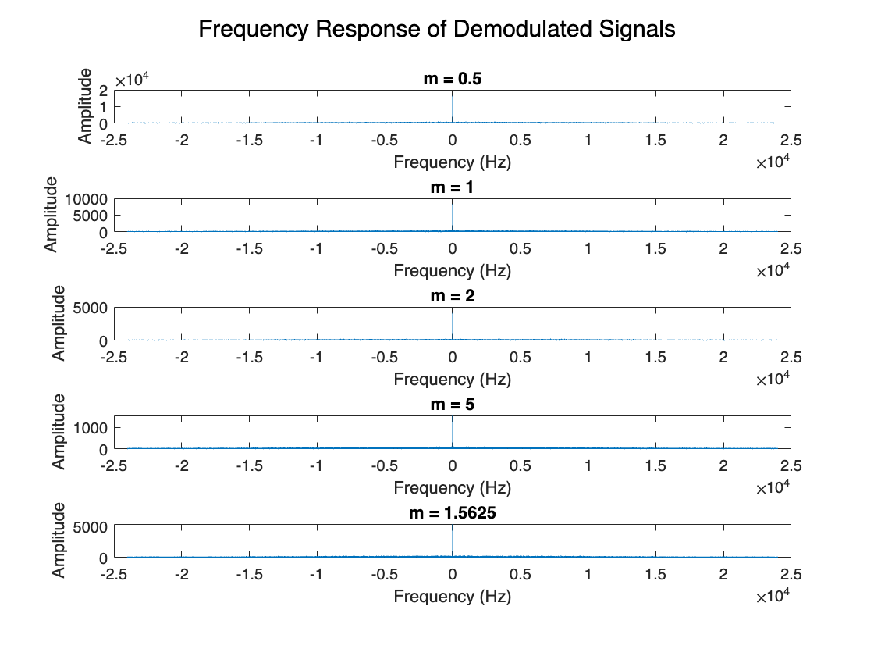

% FFT Plots 7: Using SNR = 70 dB with different modulation indices

figure;

subplot(511); fftplotD(y_fmdemod17, fm); title("m = 0.5");

subplot(512); fftplotD(y_fmdemod27, fm); title("m = 1");

subplot(513); fftplotD(y_fmdemod37, fm); title("m = 2");

subplot(514); fftplotD(y_fmdemod47, fm); title("m = 5");

subplot(515); fftplotD(y_fmdemod57, fm); title("m = 1.5625");

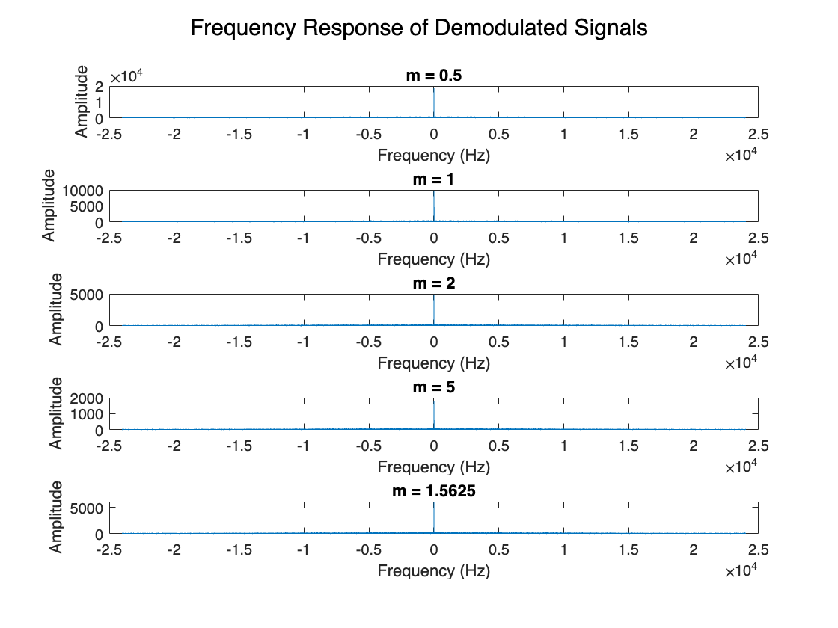

function fftplotM(signal,Fs)

[N,~] = size(signal);

t = -Fs/2:Fs/(N-1):Fs/2;

signalfreq = fftshift(fft(signal));

plot(t,abs(signalfreq)); xlabel("Frequency (Hz)"); ylabel("Amplitude");

sgtitle("Frequency Response of Modulated Signal")

end

function fftplotD(signal,Fs)

[N,~] = size(signal);

t = -Fs/2:Fs/(N-1):Fs/2;

signalfreq = fftshift(fft(signal));

plot(t,abs(signalfreq)); xlabel("Frequency (Hz)"); ylabel("Amplitude");

sgtitle("Frequency Response of Demodulated Signals")

end