Uncovering Patterns in Squirrel Behaviour: A Data Science Investigation
Group W10G04
Eiyrea Nabilla binti Azmi  COMP20008  eiyreanabillabinti.azmi@student.unimelb.edu.au | Farrell Aurelio William  COMP20008  farrellaurelio.william@student.unimelb.edu.au | Farah Aulia Zahra Irawan  COMP20008  firawan@student.unimelb.edu.au | Keane Manuel  COMP20008  keane.manuel@student.unimelb.edu.au

Executive Summary
This report investigates which behavioural and environmental factors are most strongly associated with squirrel approaches toward humans in Central Park, and whether this behaviour can be reliably predicted. Using the 2018 Central Park Squirrel Census dataset, a comprehensive pipeline was applied encompassing preprocessing, correlation analysis, supervised learning, and clustering. A severe class imbalance (5.9% positive class) was addressed through stratified undersampling. Pearson correlation and Normalised Mutual Information analyses identified human interaction disposition as the strongest predictor of approach behaviour. Two supervised learning models were trained and compared — a Decision Tree (DT) and K-Nearest Neighbours (KNN, k=19) — with the DT achieving superior minority class recall (0.778 vs 0.667). Three distinct behavioural clusters were identified, including a small human-approachers group with a disproportionately high approach rate. Findings suggest that squirrels with low alarm signalling and low avoidance scores are most associated with approach behaviour; causal conclusions cannot be drawn from observational data.

1. Introduction
Urban wildlife populations present a unique opportunity to study animal behaviour under conditions of prolonged human exposure. The eastern grey squirrel (Sciurus carolinensis) is among the most studied urban mammals in North American cities, valued for its ecological role in seed dispersal and its high visibility to the public. In dense urban parks such as Central Park, New York City, squirrels interact with humans daily, and their behavioural responses to human proximity vary considerably between individuals and contexts.
Understanding which factors predict whether a squirrel will approach or avoid humans is relevant to multiple domains. From an ecological perspective, habituation to humans may alter foraging strategies, predator vigilance, and reproductive success. From a public health perspective, squirrels that approach humans may be more likely to receive supplemental feeding, which can concentrate disease vectors. From a park management perspective, identifying patterns in approach behaviour can inform visitor education programmes.
This report addresses the following research question: Which behavioural and environmental factors are most strongly associated with squirrel approaches toward humans in Central Park, and can we reliably predict this behaviour? This question drives all analytical decisions, from feature selection in preprocessing through to model interpretation and cluster profiling.
The dataset used is the 2018 Central Park Squirrel Census, collected by trained volunteers across 350 hectares during October 2018 (City of New York, 2019). Three data files are used: squirrel.csv (3,023 individual sighting records with 31 columns including behaviour indicators and human interaction outcomes), hectare.csv (700 records of environmental conditions at the hectare level), and stories.csv (qualitative field notes). The primary analysis uses squirrel.csv augmented by hectare.csv to incorporate environmental context.
The dataset presents several analytical challenges: a severe class imbalance in the target variable (5.9% positive), predominantly binary feature representations, and the observational nature of the data which precludes causal inference. These challenges are addressed explicitly throughout the analysis. The report proceeds as follows: Section 2 details methodology; Section 3 presents results; Section 4 discusses and interprets findings; Section 5 addresses limitations; and Section 6 concludes.

2. Methodology

2.1 Data Preprocessing
All preprocessing decisions were guided directly by the research question, aiming to produce a clean, information-rich, and balanced feature set for predicting approach behaviour.
Column removal. Ten columns were removed. Columns with over 50% missing values — Color notes (94%), Other Activities (85%), Other Interactions (92%), Specific Location (84%) — were dropped rather than imputed, as imputation at this scale introduces substantial artificial bias. Lat/Long was removed as it is redundant with numeric X and Y coordinate columns. Unique Squirrel ID, Date, Hectare Squirrel Number, Highlight Fur Color, and Combination of Primary and Highlight Color were removed as identifiers or low-signal features. An alternative of retaining sparse columns with a binary missingness indicator was rejected as the marginal information gain was judged insufficient relative to added noise.
Data validation. The Above Ground Sighter Measurement column contained mixed-type entries: numeric heights (e.g., 10, 30 feet) alongside the string 'FALSE' indicating ground-level sightings. These were standardised by recoding 'FALSE' as 0 and converting to numeric type. Coordinate ranges were validated against expected Central Park bounds, confirming no outlier coordinates. Behaviour columns were verified to contain only true/false values after string-to-integer conversion.
Missing value imputation. Three columns with minor missingness were imputed using the column mode: Primary Fur Color (1.8%), Age (4.0%), and Location (2.1%). Mode imputation is appropriate for nominal categorical variables and avoids data loss from row deletion. Row deletion was rejected as 4% represents ~121 rows, non-trivial given only 178 positive-class observations.
Feature engineering. Three composite scores were constructed: Activity Score (sum of Running, Chasing, Climbing, Eating, Foraging), Vocal Score (sum of Kuks, Quaas, Moans, Tail flags, Tail twitches), and Human Interaction Score (sum of Indifferent and Runs from). These composites capture theoretically meaningful dimensions — activity level, alarm signalling, and human tolerance — and reduce dimensionality without loss of interpretability.
Data integration. squirrel.csv was merged with hectare.csv on Hectare and Shift keys via a left join, introducing environmental covariates: Sighter Observed Weather Data, Litter, Number of sighters, and Number of Squirrels. These features capture ecological context that may influence approach behaviour. Missing values from the merge were filled with the column mode (categorical) or median (numeric).
Handling class imbalance. The Approaches column is severely imbalanced: 178 positive (5.9%) versus 2,845 negative (94.1%). Three strategies were compared, as shown in Section 3.2. Stratified undersampling of the majority class was selected as the primary strategy, preserving the proportional distribution of Primary Fur Color to avoid demographic bias. SMOTE oversampling was considered but rejected to avoid generating synthetic squirrel observations with potentially implausible feature combinations.

2.2 Correlation Analysis
Two complementary correlation methods were applied to explore associations between features and the Approaches target variable.
Pearson correlation measures linear association between variables (range -1 to +1). It is appropriate for assessing directional relationships between binary features and a binary target, but assumes approximate linearity — a limitation for predominantly binary feature vectors. It was used as a first-pass screening tool.
Normalised Mutual Information (NMI) captures non-linear statistical dependencies regardless of relationship form, normalised to [0,1] for fair cross-feature comparison. Prior to NMI computation, continuous features were discretised into three equal-width bins using KBinsDiscretizer. The combination of Pearson and NMI provides a more complete picture: Pearson for linear relationships, NMI for features sharing non-linear information with the target.
A Pearson correlation heatmap across all behaviour features was also constructed to identify co-occurrence patterns. All findings use non-causal language throughout.

2.3 Supervised Learning Models
Two models were trained to predict Approaches on a stratified 80/20 train-test split of the balanced dataset.
Decision Tree Classifier. Selected for interpretability — decision rules can be visualised and feature importance scores directly indicate which features drive predictions. criterion='entropy' (Information Gain) was used, consistent with workshop methodology. max_depth=5 prevents overfitting on the ~285-row training set. class_weight='balanced' provides an additional misclassification cost adjustment for the minority class.
K-Nearest Neighbours (KNN). Selected as a conceptually distinct complement to the DT — distance-based rather than rule-based classification. All features were normalised using MinMaxScaler. To prevent data leakage during cross-validation, the scaler and KNN were wrapped in a Pipeline. The optimal k (k=19) was selected via 5-fold cross-validation on the training set optimising F1-score.
Evaluation. Models were evaluated using F1-score, Recall, Precision, and 5-fold stratified cross-validation F1. Accuracy was reported but not used as the primary metric due to the class imbalance context.

2.4 Clustering
Two clustering methods were applied to identify distinct behavioural profiles using 15 behaviour and interaction features, all normalised with MinMaxScaler.
KMeans clustering was chosen as the primary method for scalability and interpretable centroids. The optimal k was determined using the Elbow Method and validated by the Hierarchical Clustering dendrogram. The Silhouette Score was computed but showed a monotonically increasing pattern across k=2 to k=8; k=4 was therefore selected based on the Elbow Method inflection and dendrogram structure rather than the silhouette score alone.
Hierarchical Agglomerative Clustering (Ward linkage) was applied on a 200-row sample to validate the cluster structure and identify the natural cluster count via dendrogram. Ward linkage minimises within-cluster variance at each merge step. The Adjusted Rand Index (ARI) between KMeans and HC assignments was computed as a quantitative measure of method agreement.

3. Results Exploration and Analysis

3.1 Dataset Overview and EDA
The squirrel.csv dataset contains 3,023 sighting records. The target variable Approaches is severely imbalanced: 178 positive (5.9%) and 2,845 negative (94.1%). After stratified undersampling, the modelling dataset comprised approximately 356 observations.
As shown in Figure 1, Indifferent (48.1%) and Foraging (47.5%) were the most common behaviours. Alarm behaviours were rare: Tail twitches (14.4%), Kuks (3.4%), and Moans (<0.1%). Figure 2 shows categorical distributions: Gray squirrels (81.8%) dominated, with PM sightings slightly outnumbering AM (55.4% vs 44.6%).
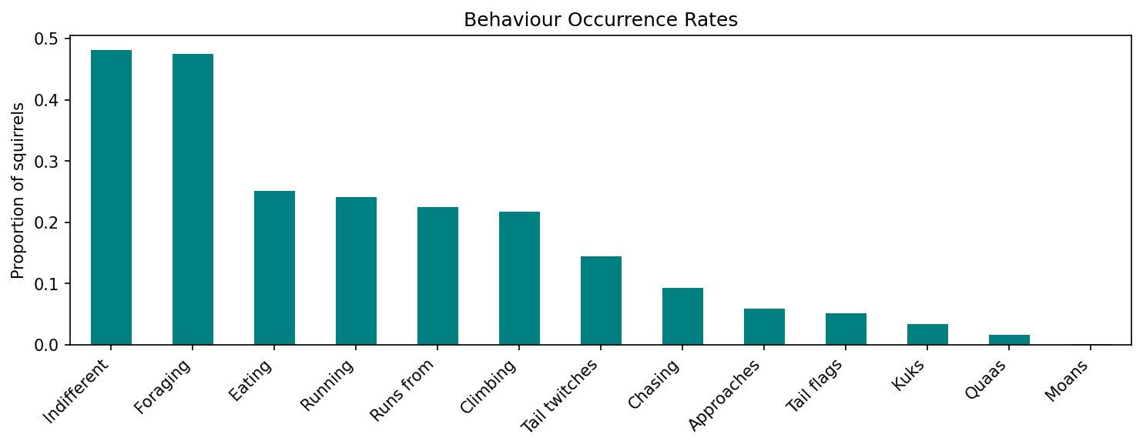
Figure 1: Behaviour occurrence rates across all 3,023 squirrel observations.
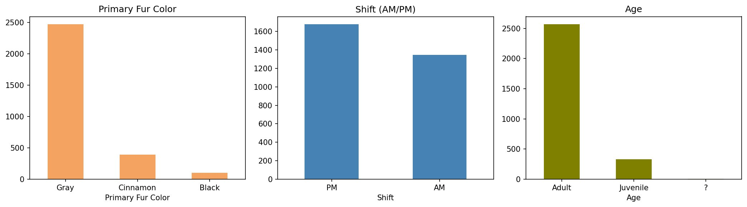
Figure 2: Distribution of primary fur colour, shift (AM/PM), and age across the dataset.
Figure 3 shows the spatial distribution of sightings coloured by Approaches. Approach events (red) appear scattered throughout Central Park with no obvious geographic clustering, suggesting location alone is not a strong predictor — confirmed by near-zero Pearson correlations for X and Y.
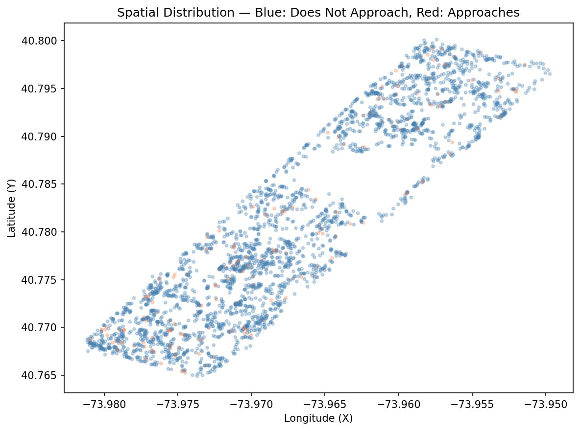
Figure 3: Spatial distribution of sightings — blue: does not approach, red: approaches.

3.2 Preprocessing Impact on Results
Table 1 presents the impact of class imbalance handling on Decision Tree performance.
Table 1: Impact of imbalance handling strategy on Decision Tree performance.
Strategy | Accuracy | F1 | Recall | Precision
Naive (no balancing) | 0.940 | 0.000 | 0.000 | 0.000
class_weight='balanced' | 0.800 | 0.330 | 0.840 | 0.200
Stratified undersampling | 0.761 | 0.767 | 0.778 | 0.757
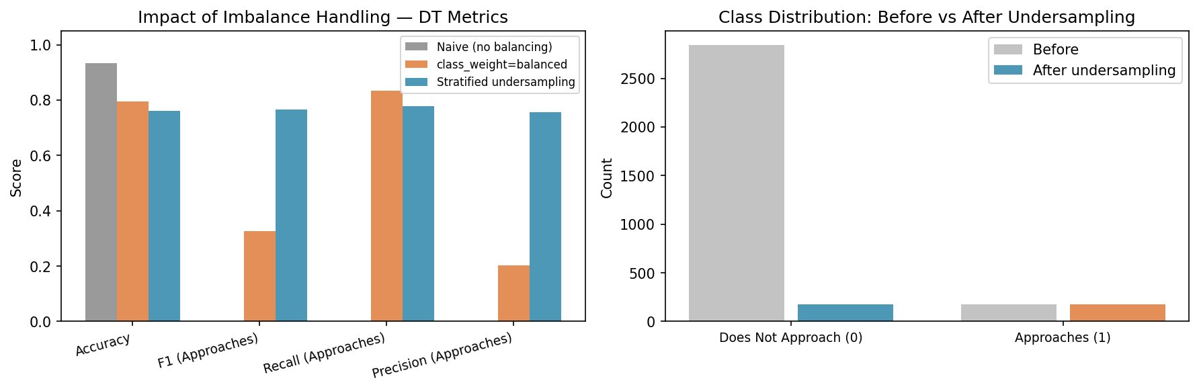
Figure 4: Impact of imbalance handling on DT metrics (left) and class distribution before vs after undersampling (right).
The naive model predicted zero positive cases despite 94% accuracy, rendering it useless for the research question. Stratified undersampling produced the highest F1 (0.767) and a balanced precision-recall trade-off. The class_weight approach showed high recall (0.840) but very low precision (0.200), indicating excessive false positives. These results confirm that the preprocessing decision to use stratified undersampling was decisive for model utility.

3.3 Correlation Analysis Results
Figure 5 shows Pearson correlations with Approaches. Human Interaction Score (r ≈ -0.50) and Indifferent (r ≈ -0.44) showed the strongest negative correlations. Runs from and Chasing also showed negative associations. Positive correlations were observed for Location_enc, Eating, Foraging, and Activity Score. Spatial features (X, Y) showed near-zero correlations, consistent with Figure 3.
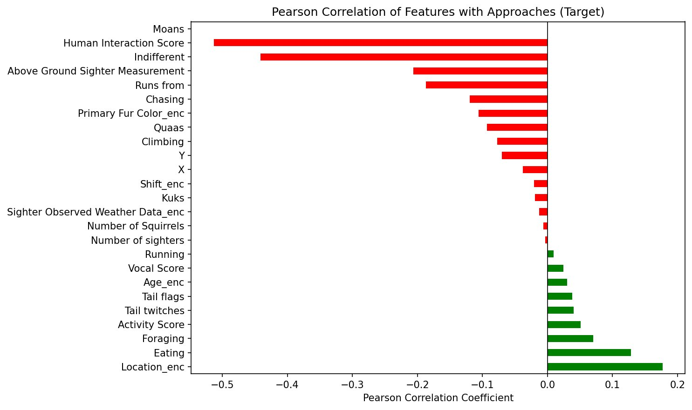
Figure 5: Pearson correlation of all features with Approaches (target variable).
NMI analysis (Figure 6) revealed a notably different ranking. Sighter Observed Weather Data_enc scored highest (NMI ≈ 0.65), followed by Human Interaction Score (NMI ≈ 0.25) and Indifferent (NMI ≈ 0.16). The very high NMI for weather data warrants caution: this likely reflects a discretization artefact or collinearity with other spatiotemporal variables rather than a genuine causal relationship between weather and squirrel approach behaviour. Human Interaction Score and Indifferent consistently ranked highly across both metrics, reinforcing their importance.
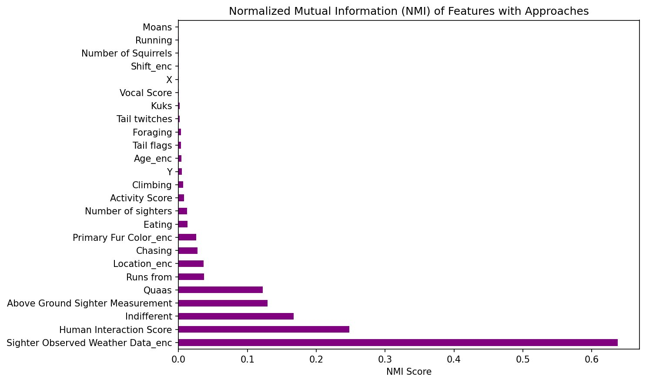
Figure 6: Normalised Mutual Information (NMI) scores for all features with Approaches.
Figure 7 shows the behaviour correlation heatmap. A coherent alarm cluster is visible: Tail twitches and Vocal Score are strongly correlated (r = 0.79), and Kuks and Tail flags show moderate co-occurrence (r = 0.40–0.45). Approaches and Indifferent are negatively correlated (r = -0.44), confirming they represent opposite response modes to human presence. All reported correlations represent associations, not causal relationships; confounders such as food availability and observer behaviour cannot be ruled out.
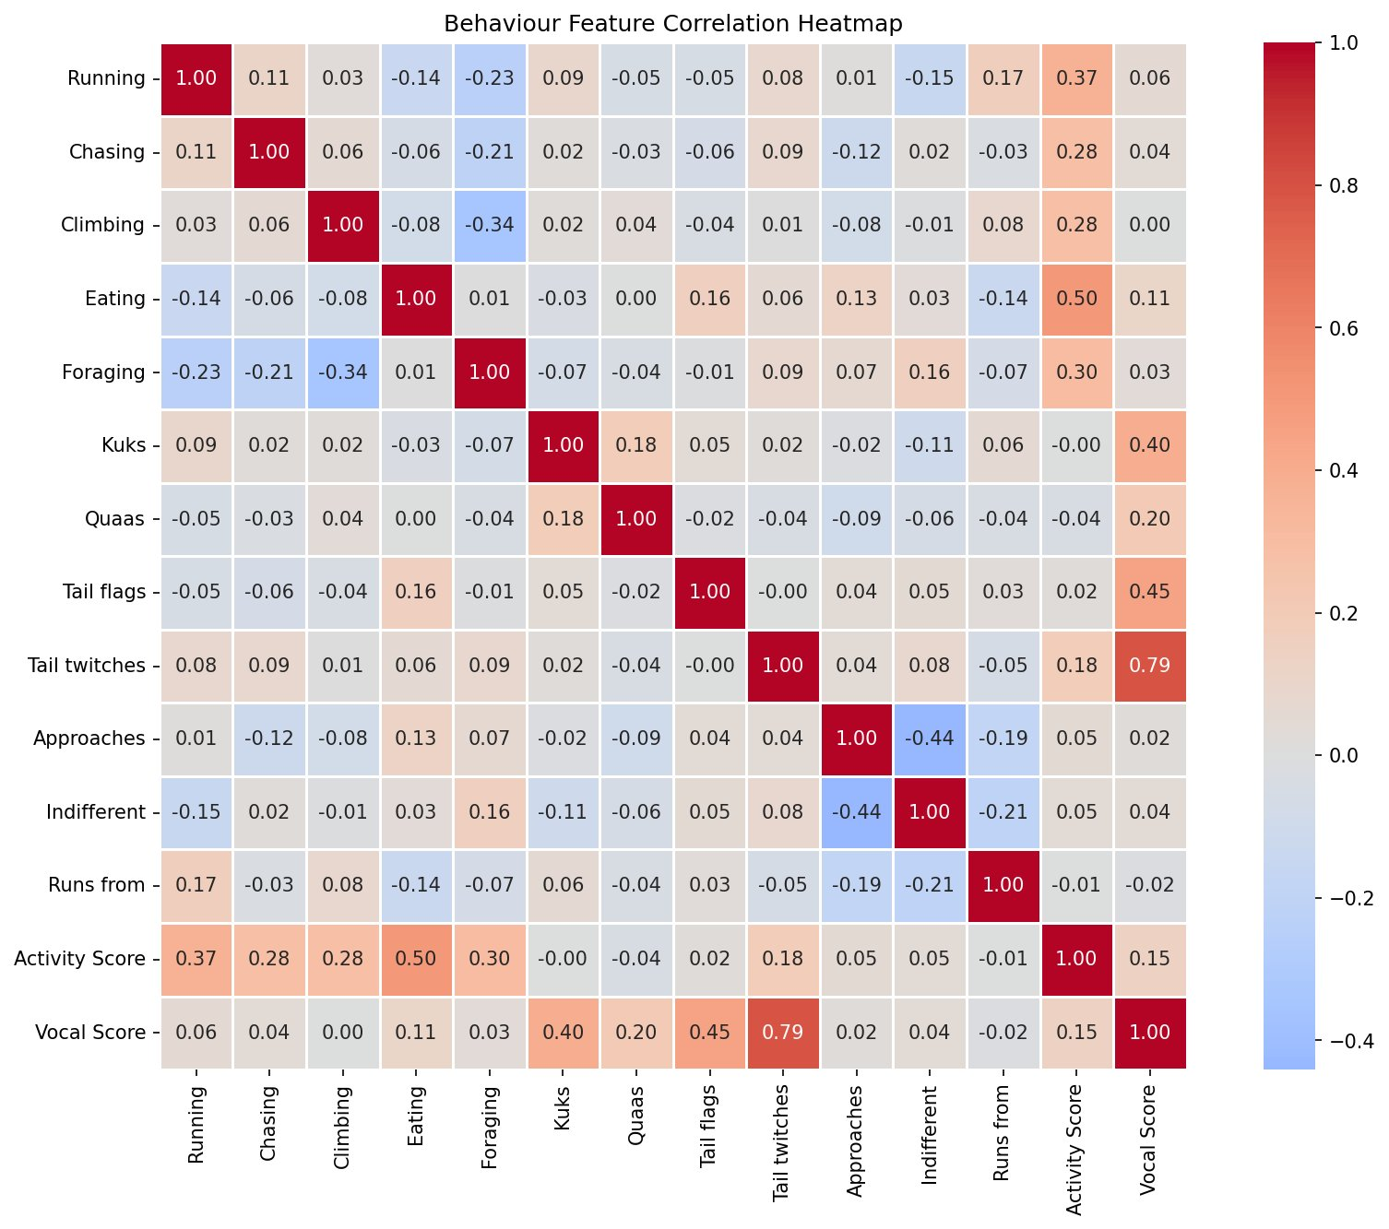
Figure 7: Pearson correlation heatmap across all behaviour features.

3.4 Supervised Learning Results
Table 2 presents model performance on the balanced test set.
Table 2: Decision Tree vs KNN (k=19) performance on balanced test set.
Model | Accuracy | F1 | Recall | Precision | CV F1 ± std
Decision Tree (depth=5) | 0.761 | 0.767 | 0.778 | 0.757 | 0.749 ± 0.035
KNN (k=19) | 0.761 | 0.738 | 0.667 | 0.828 | 0.758 ± 0.036
Both models achieved identical accuracy (0.761), but the DT outperformed KNN on F1 (0.767 vs 0.738) and Recall (0.778 vs 0.667). KNN achieved higher Precision (0.828 vs 0.757), meaning its positive predictions were more reliable, but it missed more true approachers. For the research question, recall is the more important metric — identifying squirrels that genuinely approach humans — giving the DT a practical advantage. Interestingly, KNN marginally outperformed DT on cross-validation F1 (0.758 ± 0.036 vs 0.749 ± 0.035), suggesting KNN may generalise slightly better across folds. However, this CV advantage did not translate to the held-out test set, where DT achieved higher F1 (0.767 vs 0.738). This discrepancy highlights the importance of evaluating models on a truly held-out test set rather than relying solely on cross-validation.
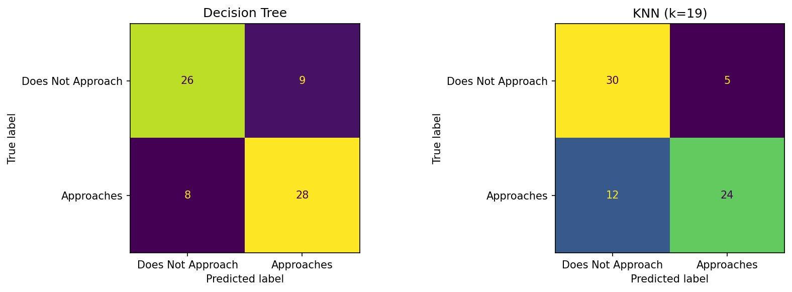
Figure 8: Confusion matrices for Decision Tree (left) and KNN k=19 (right) on the balanced test set.
Figure 9 shows the Decision Tree visualisation (top 3 levels). The root split is on Human Interaction Score <= 0.5 — squirrels with zero human interaction events are routed to the approach-positive branch. This is biologically meaningful: a squirrel that has neither avoided nor ignored humans in this sighting is most likely to approach. Figure 10 shows KNN cross-validation F1 scores across k=1 to k=20, with k=19 selected as optimal.
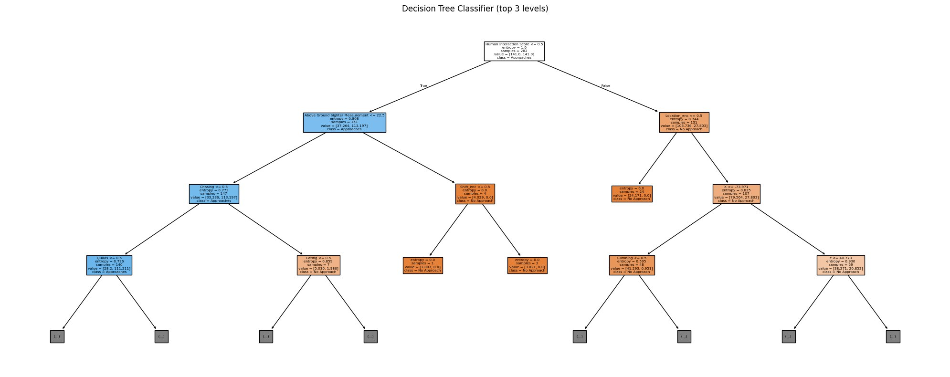
Figure 9: Decision Tree visualisation (top 3 levels, criterion=entropy).
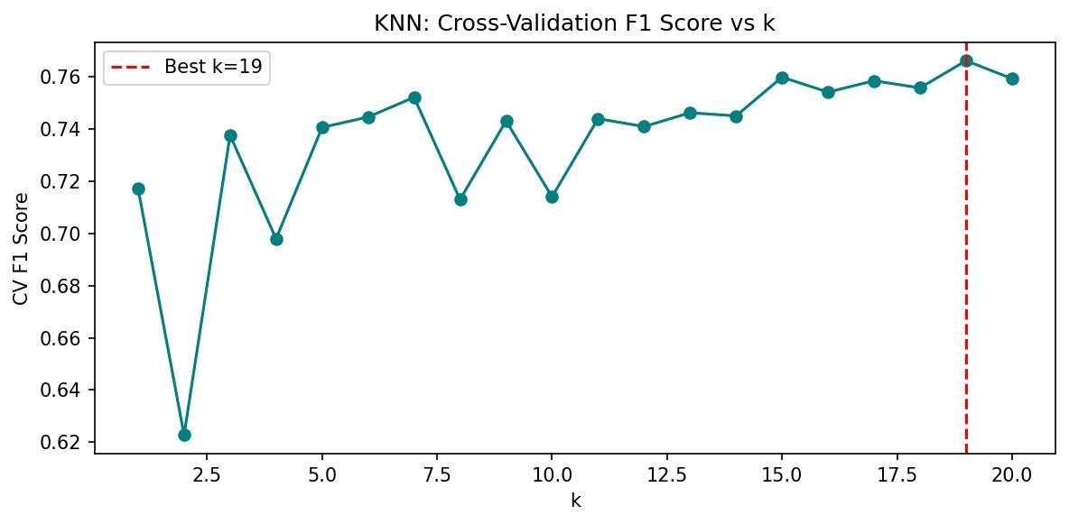
Figure 10: KNN cross-validation F1 score vs k; best k=19 indicated by dashed line.
Feature importance analysis (Figure 11) identified Human Interaction Score as overwhelmingly the most important feature (importance ≈ 0.50), followed distantly by Location_enc and Above Ground Sighter Measurement. This directly answers the research question: a squirrel's composite human interaction disposition is the primary predictive signal. Spatial features (X, Y) contributed minimally, consistent with the near-zero Pearson correlations.
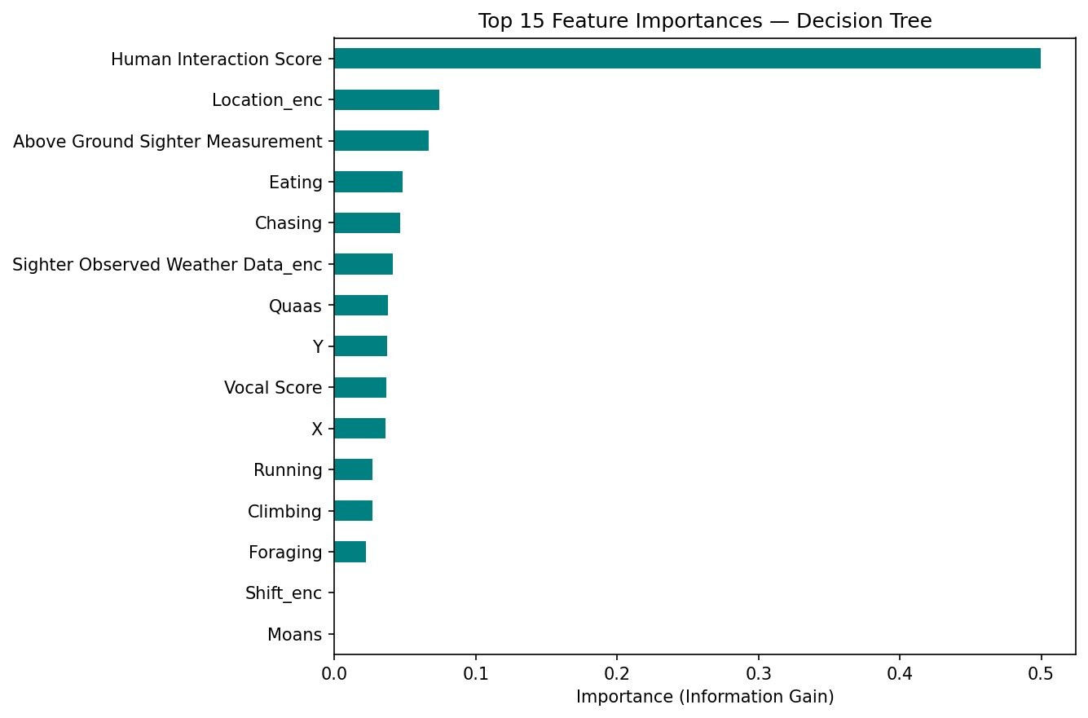
Figure 11: Top 15 feature importances from Decision Tree (Information Gain criterion).

3.5 Clustering Results
The Elbow Method (Figure 12) showed a notable inflection at k=4, with distortion declining more slowly thereafter. The Silhouette Score (Figure 13) increased monotonically from k=2 to k=8, not confirming a single optimal k. In this case, the Elbow Method and the Hierarchical Clustering dendrogram (Figure 14) were used as the primary selection criteria, with k=4 supported by both. The dendrogram shows a clear four-cluster structure with a large merge distance gap at the four-to-three cluster transition (distance ≈ 8.0).
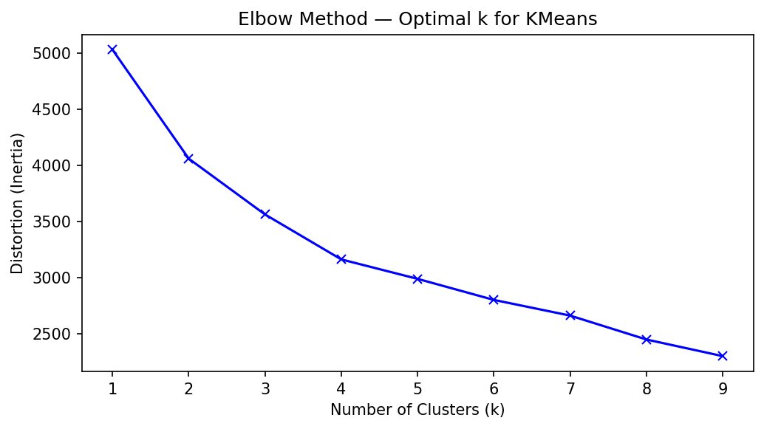
Figure 12: Elbow Method — distortion (inertia) vs k for KMeans.
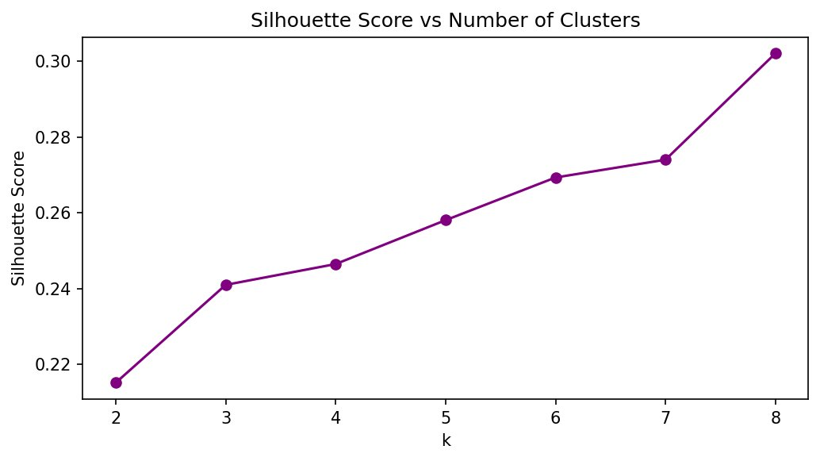
Figure 13: Silhouette Score vs k — monotonically increasing, not confirmatory for k=4.
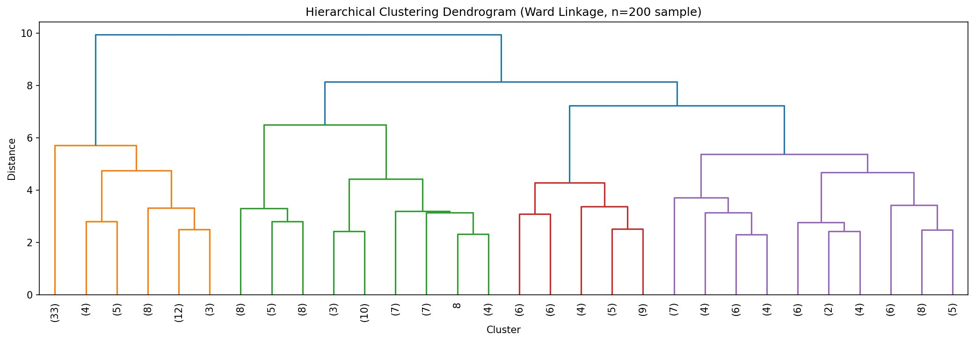
Figure 14: Hierarchical Clustering dendrogram (Ward linkage, n=200 sample).
Table 3 summarises the three interpretable cluster profiles identified from the KMeans solution. Figure 15 shows the normalised cluster profile comparison and Figure 16 the PCA 2D projection.
Table 3: KMeans cluster profiles and approach rates.
Cluster | Activity | Vocal | Approach Rate | Runs from | Dominant Feature
Human-approachers | Med | Low | High | Low | High Approaches, low avoidance
Human-avoiders | High | High | Low | High | High Runs from, high Vocal Score
Passive observers | High | Low | Low | Low | High Foraging, Indifferent
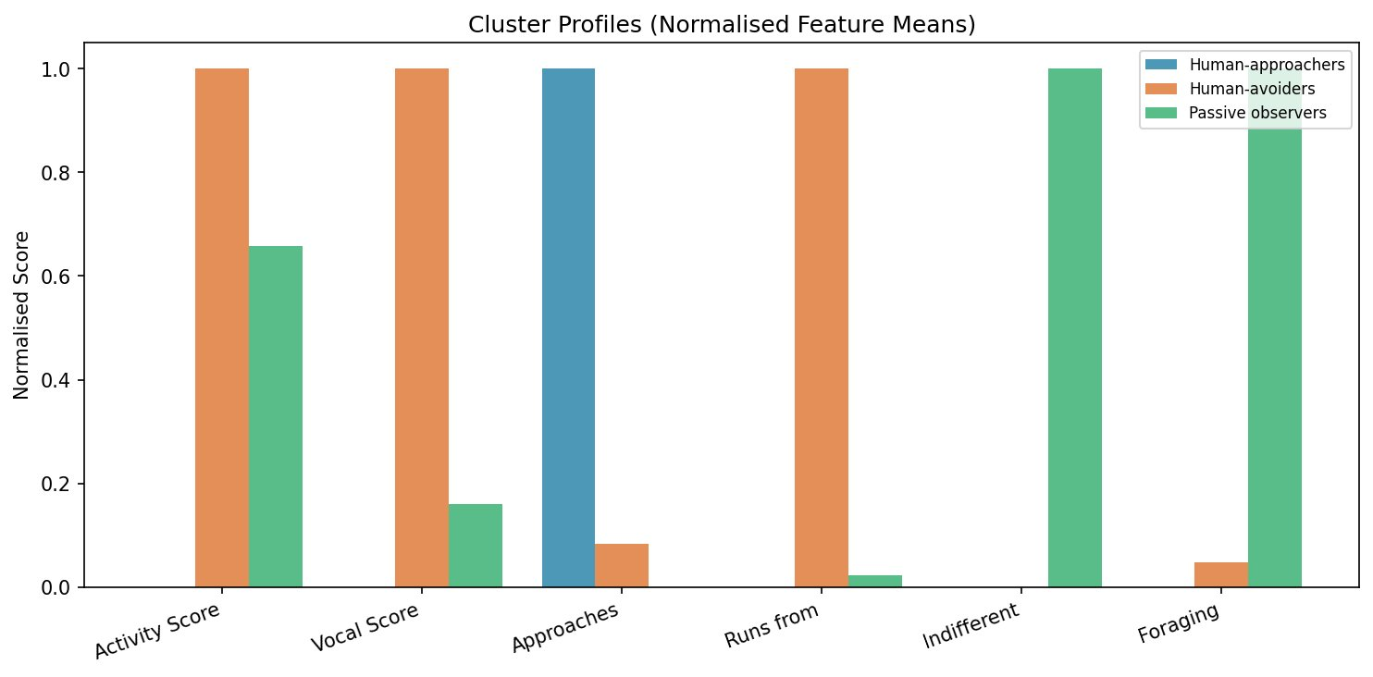
Figure 15: Normalised cluster profile comparison across key features.
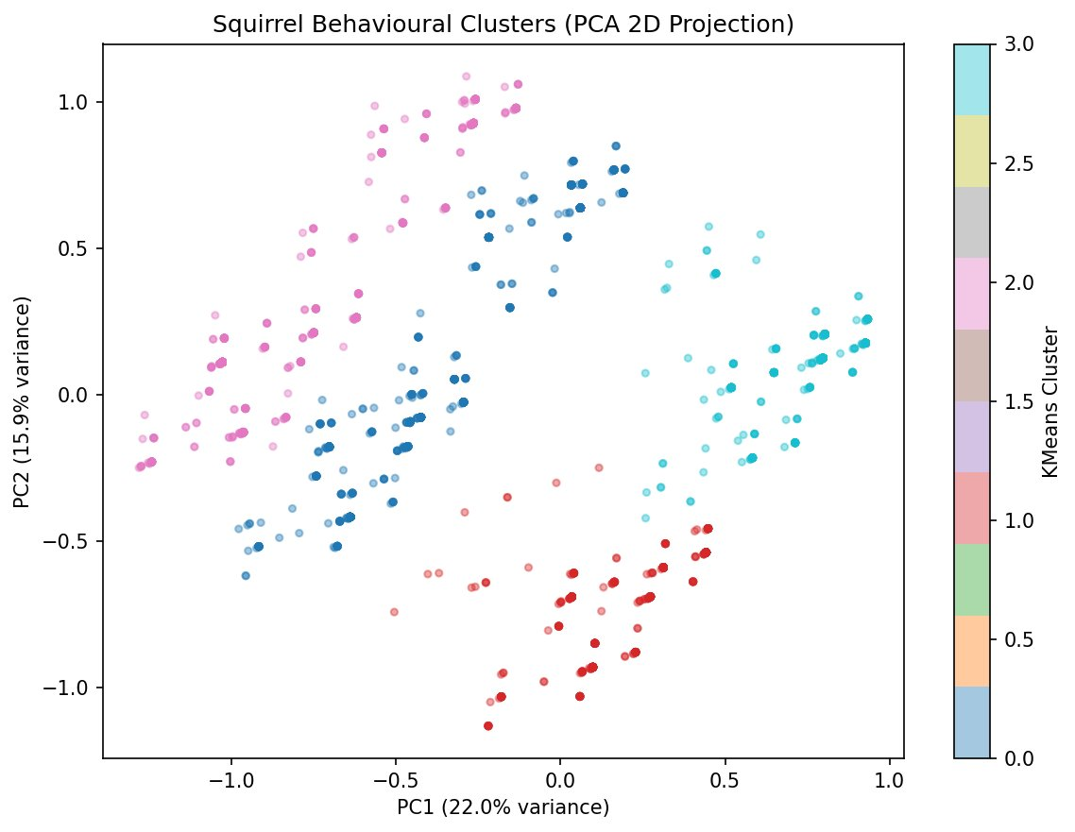
Figure 16: PCA 2D projection of KMeans clusters (PC1=22.0%, PC2=15.9% variance).
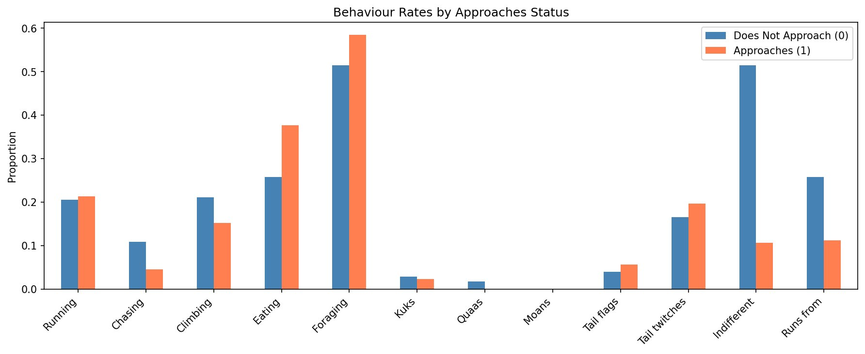
Figure 17: Behaviour rates by Approaches status — comparing squirrels that approach vs do not approach.

4. Discussion and Interpretation

4.1 Preprocessing Decisions and Their Impact
The preprocessing pipeline had a decisive and quantifiable impact on downstream model performance. Table 1 demonstrates that the naive model, despite 94% accuracy, identified zero positive cases — a complete failure for the research question. The class_weight approach achieved high recall (0.840) but very low precision (0.200), meaning 80% of positive predictions were false alarms. Stratified undersampling produced the most balanced result (F1=0.767), achieving both high recall and high precision. This comparison makes concrete the consequences of each preprocessing choice: without imbalance handling, the model fails; with class weighting, it is trigger-happy; with undersampling, it is well-calibrated.
The feature engineering decisions also proved consequential. Human Interaction Score dominated both DT feature importance (~0.50) and Pearson correlation rankings, confirming that aggregating Indifferent and Runs from into a composite captures a meaningful behavioural dimension more effectively than either individual feature alone. Had the composite not been created, the most important signal would have been distributed across two correlated features, potentially reducing the clarity of the DT's first split.
Data integration with hectare.csv introduced Sighter Observed Weather Data_enc, which ranked unusually high in NMI (≈0.65). This warrants careful interpretation: rather than a genuine causal relationship between weather and approach behaviour, this likely reflects a combination of discretization effects and collinearity with temporal or spatial variables that co-vary with weather. This highlights a key limitation of NMI with discretised features — equal-width bins may create artefactual associations when the continuous distribution is heavily skewed. Pearson correlation for weather was near zero, confirming the NMI score does not reflect a strong linear signal.

4.2 Correlation Findings and Interpretation
The consistent dominance of Human Interaction Score across Pearson, NMI, and DT feature importance provides strong convergent evidence that a squirrel's disposition toward human presence — not its activity level or location — is the primary correlate of approach behaviour. Squirrels with zero Indifferent and zero Runs from events in a sighting appear to occupy an 'active engagement' state that predisposes approach.
The behaviour heatmap (Figure 7) reveals a coherent alarm cluster: Tail twitches and Vocal Score are strongly correlated (r=0.79), and Kuks and Tail flags show moderate co-occurrence (r=0.40–0.45). This supports the interpretation that alarm behaviours function as a coordinated response system. Squirrels displaying one alarm behaviour in a sighting are likely displaying others simultaneously, explaining the consistency of the negative association between Vocal Score and Approaches across all three analytical methods.
The negative correlation between Approaches and Indifferent (r=-0.44, Figure 7) is noteworthy: these are not opposite ends of a single dimension but distinct response modes. A squirrel can be neither approaching nor indifferent — it may be foraging, climbing, or engaged in other activities. This multidimensionality motivates the clustering analysis, which captures combinations of behaviours that the pairwise correlation analysis cannot.
All associations are interpreted cautiously. Key potential confounders include: (1) food provisioning — squirrels habituated to human feeding may approach regardless of baseline fear response; (2) observer proximity and movement during the census window; (3) individual personality variation in boldness, which is not recorded in the census.

4.3 Model Evaluation and Comparison
Both models achieved identical accuracy (0.761), but this masks meaningful differences in their predictive profiles. The DT's higher recall (0.778 vs 0.667) means it correctly identified more true approachers — the outcome most relevant to the research question. KNN's higher precision (0.828 vs 0.757) means its positive predictions were more reliable, but at the cost of missing one-third of actual approachers.
Beyond metrics, the DT offers a critical interpretability advantage: its feature importance scores and visualisable decision rules (Figure 9) directly answer which factors drive approach behaviour. The root split on Human Interaction Score <= 0.5 is scientifically meaningful and biologically plausible. KNN cannot provide this insight — it classifies based on neighbourhood similarity in a 25-dimensional feature space without revealing which dimensions are most discriminative.
KNN's lower recall likely reflects the curse of dimensionality. With 25 features and ~285 training examples, nearest neighbour distances become less meaningful, as the ratio of max-to-min distances converges in high-dimensional spaces. The optimal k=19 — unusually high for a ~285-point training set — is consistent with this interpretation: larger k provides more robust averaging over noisy distance estimates. Future work could apply PCA prior to KNN to reduce dimensionality while retaining 90% of variance.
Alternative models not implemented include Random Forest, which would likely improve performance through ensemble averaging, and Logistic Regression, which would provide probability calibration and interpretable coefficients. Both were considered but deferred in favour of the workshop-aligned DT and KNN implementations.

4.4 Cluster Interpretation and Relevance to Research Question
The three interpretable clusters identified by KMeans provide complementary, unsupervised evidence for the research question. The Human-approachers cluster has a disproportionately high approach rate, low Runs from, and low Vocal Score — a profile consistent with habituation: calm engagement with humans without fear signalling. Critically, this cluster was identified without using the Approaches label as a clustering input, confirming that approach-prone squirrels have a distinctive multivariate behavioural signature.
The Human-avoiders cluster shows the opposite profile: high Vocal Score, high Runs from, and high Activity Score. These squirrels are not passive — they are actively signalling alarm and fleeing. The high activity may reflect escape locomotion rather than foraging activity, consistent with a threat-response interpretation. The Passive observers cluster is characterised by high Foraging and high Activity Score with low human interaction — task-focused behaviour with indifference to human presence.
The PCA projection (Figure 16) shows moderate but not clean cluster separation, with PC1 and PC2 together explaining 37.9% of variance. The remaining variance in higher dimensions suggests the clusters have structure that the 2D projection does not fully capture — a limitation of PCA visualisation for high-dimensional clustering results.
The dendrogram (Figure 14) confirmed the four-cluster structure, with a large merge distance gap at the four-to-three transition (distance ~8.0), indicating the fourth cluster is genuinely distinct. The monotonically increasing Silhouette Score is consistent with the feature space being dominated by a few continuous scores (Activity Score, Vocal Score), which tend to produce smoothly varying distances that favour more clusters. The dendrogram and elbow method, being less sensitive to this property, are more informative for selecting k in this context.

5. Limitations and Improvement Opportunities
Cross-sectional data. The dataset represents a two-week snapshot in October 2018. Squirrel behaviour varies substantially across seasons, and findings cannot be assumed to generalise beyond autumn. Longitudinal tracking would enable analysis of individual behavioural trajectories and true habituation effects.
Individual non-independence. The same squirrel may appear multiple times (the census records sightings, not unique individuals). This violates the independence assumption of most methods used. The extent of duplication is unknown; individual tagging would enable mixed-effects models properly accounting for repeated measures.
Observational bias. Census takers were volunteers, introducing potential inter-observer variability. Observer behaviour (movement speed, proximity, food odour) was not standardised and likely influenced squirrel responses. Squirrels in more trafficked park areas may be over-represented.
Class imbalance limits model power. Despite undersampling, the positive class contains only 178 observations. Models trained on such small positive-class samples exhibit high variance. The CV F1 standard deviations reflect this instability. More labelled approach events would substantially improve reliability.
NMI discretization artefacts. The high NMI score for Sighter Observed Weather Data_enc likely reflects an artefact of equal-width binning on a non-uniformly distributed variable rather than a genuine association with approach behaviour. NMI results should be interpreted alongside Pearson correlations to identify such discrepancies.
Clustering limitations. The monotonically increasing Silhouette Score meant this metric could not independently confirm k=4; the choice relies on the Elbow Method and dendrogram. The HC validation used only 200 rows. Different feature sets (e.g., including spatial features) would likely produce different cluster structures. The PCA projection explains only 37.9% of variance, potentially misrepresenting cluster boundaries.
Model limitations. No hyperparameter search (GridSearchCV) was performed; a systematic search could improve both models. The DT with max_depth=5 may underfit complex interactions. KNN with k=19 is susceptible to the curse of dimensionality; PCA preprocessing could improve its performance.

6. Conclusion
This report investigated which behavioural and environmental factors are most strongly associated with squirrel approaches toward humans in Central Park. Across correlation analysis, supervised learning, and clustering, a consistent finding emerged: a squirrel's composite human interaction disposition — captured by Human Interaction Score, Indifferent, and Runs from — is the primary driver of approach behaviour. Spatial location, fur colour, and general activity level are comparatively weak predictors.
The Decision Tree classifier (F1=0.767, Recall=0.778) outperformed KNN (k=19) on minority class metrics and provided interpretable feature importance scores, with Human Interaction Score identified as the dominant feature. Clustering analysis identified three distinct behavioural profiles — Human-approachers, Human-avoiders, and Passive observers — with Human-approachers showing a disproportionately high approach rate consistent with the habituation hypothesis.
These findings are consistent with urban wildlife ecology literature on boldness gradients and habituation. Future work should incorporate longitudinal individual tracking to separate habituation from personality effects, apply NLP to field notes for additional features, and explore ensemble methods to improve predictive performance.

References
City of New York. (2019). 2018 Central Park Squirrel Census – Squirrel Data. NYC Open Data. https://data.cityofnewyork.us/Environment/2018-Central-Park-Squirrel-Census-Squirrel-Data/vfnx-vebw
Pedregosa, F., Varoquaux, G., Gramfort, A., Michel, V., Thirion, B., Grisel, O., Blondel, M., Prettenhofer, P., Weiss, R., Dubourg, V., Vanderplas, J., Passos, A., Cournapeau, D., Brucher, M., Perrot, M., & Duchesnay, E. (2011). Scikit-learn: Machine learning in Python. Journal of Machine Learning Research, 12, 2825–2830.
McKinney, W. (2010). Data structures for statistical computing in Python. In S. van der Walt & J. Millman (Eds.), Proceedings of the 9th Python in Science Conference (pp. 56–61).
Hunter, J. D. (2007). Matplotlib: A 2D graphics environment. Computing in Science & Engineering, 9(3), 90–95.
Waskom, M. L. (2021). Seaborn: Statistical data visualization. Journal of Open Source Software, 6(60), 3021.

