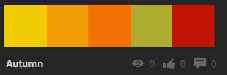

Color-1 = #F2CB05  
Color-2 = #F29F05  
Color-3 = #F27405  
Color-4 = #AEAC30  
Color-5 = #BF1304